2qqwq
AGGREGATE LEVEL ASSOCIATION BETWEEN PRENATAL CARE AND INFANT MORTALITY RATE

by
Yongxu Huang
B.S., Tsinghua University, China, 2010

Submitted to the Graduate Faculty of
Department of Health Policy & Management
Graduate School of Public Health in partial fulfillment
of the requirements for the degree of
Master of Public Health

University of Pittsburgh
2012

UNIVERSITY OF PITTSBURGH
GRADUATE SCHOOL OF PUBLIC HEALTH

This essay is submitted
by
Yongxu Huang

on

December 11th, 2012
and approved by
Essay Advisor:
Mark S. Roberts, M.D., MPP ________________ ____________________
Professor and Chair of Health Policy and Management, Graduate School of Public Health
Professor of Medicine, School of Medicine
Professor of Industrial Engineering, School of Engineering
Professor of Clinical and Translational Science, Schools of the Health Sciences
University of Pittsburgh

Essay Reader:
Martha Ann Terry, BA, MA, PhD ______________________________________
Assistant Professor
Director, Master of Public Health Program
Department of Behavioral and Community Health Sciences
Graduate School of Public Health
University of Pittsburgh

Essay Reader:
Julia Driessen, PhD ______________________________________
Assistant Professor
Department of Health Policy & Management
Graduate School of Public Health
University of Pittsburgh

Copyright © by Yongxu Huang
2012
Objectives: The objectives of this study include understanding the association between adequate prenatal care and the infant mortality rate (IMR) at the aggregate level and studying the effects of other factors, such as race and income, on the association.
Mark S. Roberts, M.D., MPP

AGGREGATE LEVEL ASSOCIATION BETWEEN PRENATAL CARE AND INFANT MORTALITY RATE
Yongxu Huang, MPH
University of Pittsburgh, 2012
Methodology: IMR and the rate of pregnant women who receive prenatal care during the first trimester (PNC) were examined. Annual state-level aggregate data from 1997 to 2005 were extracted. Covariance of IMR and PNC was calculated. Scatterplots of IMR versus PNC were drawn. Two-variable and multivariable regressions were used to study the effects of several factors, including PNC on IMR.
Results: Substantial differences were observed in IMR and PNC across states within the US. An insignificant inverse association between PNC and IMR was observed at the aggregate level for data from 1997 to 2005. Significant inverse associations were observed between IMR and the percentage of Non-Hispanic White population, the percentage of Hispanic population, and income level.
Conclusions: Differences in IMR and PNC across states were observed. PNC has a modest effect on reducing IMR. Race and income level may have more significant impacts on IMR.
Public health relevance: High infant mortality leads to high social and economic costs. Previous studies suggested that inadequate prenatal care is associated with adverse birth outcomes, such as preterm birth and infant mortality. It is possible that ensuring the availability of early prenatal care during the first trimesters could help reduce IMR. In addition, reducing health disparities between different racial and income groups could help reduce the IMR in the US.

TABLE OF CONTENTS
preface x
1.0 Introduction 1
2.0 Background 8
3.0 Methods 11
4.0 results 15
5.0 discussion 24
6.0 Conclusion 31
Appendix A: Imr BY STATE: US, 1997-2005 36
Appendix B: pnc by state: us, 1997-2005 37
Appendix C: variable used in multivariable regression 38
Appendix D: percent of live births with little or no prenatal care by race and state, us, 2007 39
Appendix E: median income by race, us, 1970-1998 41
bibliography 42

List of tables

Table 1. Percentage of respondents aged 18-64 years without health insurance, by selected demographic characteristics - National Health Interview Survey, US, 2004 and 2008 3
Table 2. States using 2003 revision of birth certificate 13
Table 3. IMR and PNC of states with and without missing data of PNC 18
Table 4. Covariance between IMR and PNC, no imputation 18
Table 5. Results from two-variable regression include PNC and IMR from 1997 to 2005, no imputation 22
Table 6. Results from multivariable regression including IMR, PNC, percentage of Non-Hispanic White population, percentage of Hispanic population, and median-income, no imputation 23
Table 7. Health facts of New Hampshire, 2010 – 2011 (Kaiser Family Foundation, 2012) 25
Table 8. Health facts of Massachusetts, 2010 - 2011 (Kaiser Family Foundation, 2012) 26
Table 9. Health facts of Rhode Island, 2010 - 2011 (Kaiser Family Foundation, 2012) 26
Table 10. IMRs by state: US, 1997-2005 (Division of Vital Statistics, 2005) 36
Table 11. PNC by state: US, 1997-2005 (Division of Vital Statistics, 2005) 37
Table 12. Non-Hispanic White percentage, Hispanic percentage, Average IMR, Average PNC, and 9-year average median income from 1997 to 2005 (Cassidy & Grieco, 2001; The Census Bureau, 2011) 38
Table 13. Percent of live births with late or no prenatal care stratified by race and state 39
Table 14. Median income from 1970 to 1998, US, by race 41

List of figures

Figure 1. Infant mortality, by race, 1915 - 1997, US (Wegman, 2001) 4
Figure 2. Infant mortality, by race of mother, US (MacDorman & Mathews, 2012) 5
Figure 3. The annual state-average IMR, 1997-2005, no imputation 19
Figure 4. The annual state-average PNC, 1997-2005, no imputation 20
Figure 5. Scatterplot of IMR versus PNC, no imputation 21
Figure 6. Scatterplot of IMR versus PNC, with linear imputation 22

preface

I would like to express my deep gratitude to Dr. Roberts, Dr. Terry, and Dr. Driessen, my essay advisor and essay readers, for their patient guidance, enthusiastic encouragement and valuable critiques of the research work. I would also like to thank them for their advice and assistance in keeping my progress on schedule. My grateful thanks are also extended to Mr. Li, Shuai and Mr. Tiberi, Orrin, for their generous help in checking the grammar, sentence structure, and spelling of my essay, to Ms. Pegher, Joanne, who helped me format my essay very patiently and kindly.
I would also like to extend my thanks to all professors and staff members of the Department of Health Policy and Management in the University of Pittsburgh, who have taught me and helped me during my master’s studies.
Finally, I wish to thank my parents for their support and encouragement throughout my study.

Introduction
Infant mortality rate (IMR) is an important indicator of the overall health of a nation. It reflects the outcome of the integrated national health delivery system. IMR is intertwined with various factors including nutrition, maternal health, prenatal care, insurance coverage, and access to quality health care, in addition to a series of economic and environmental factors (MacDorman, 2008).
IMR varies largely in the world. According to United Nations’ (UN) longitudinal data, the 2005-2010 average IMR ranged from 2.60 per 1,000 live births in Singapore to 144.01 deaths per 1,000 live births in Afghanistan (UN, Department of Economic and Social Afairs, 2011).
Historically, the United States (US) IMR had declined rapidly during the 20th century because of improvements in medical and reproductive care. The IMR in 1900 was 100 per 1,000 live births, while the IMR in 2000 was 6.89 per 1,000 live births (MacDorman, 2008). While progress has been made in reducing infant mortality in the US, during the period from 2005 to 2010, the US IMR (7.07 per 1,000 live births) still ranked 34th in the world, an unallowable placement given the US health spending ranked 1st (based on the 2008 data) (World Health Organization [WHO], Department of Health Statistics and Informatics, 2011). In the US, the total health spending per capita in 2008 was $7,164, and the total health spending accounted for 15.2% of the nation’s Gross Domestic Product (GDP) in 2010 (World Health Organization [WHO], Department of Health Statistics and Informatics, 2011). In comparison, Singapore has the lowest IMR, 2.6 per 1000 live births, less than half of the US rate. In Singapore, the total care spending per capital was only $1,833 in 2008, and the total health spending only accounted for 3.3% of the GDP (World Health Organization [WHO], Department of Health Statistics and Informatics, 2011).
This made researchers curious: why does the US spend more money on health than anyone else in the world, but lose more lives than many other developed nations? Though there is no clear reason for this difference, it can be explained in several possible ways. Although the health spending in the US is tremendous, a small portion of the population accounts for the majority of costs. For example, one study suggested that health spending is much higher in seniors than young people: for people aged 0 – 18, the per capita public spending on health care is only $1,225 per year; for people 19 – 64, the per capita public spending on health care is $2,327; for people 65+, the per capita public spending on health care is $6,921 (Selden & Sing, 2008). In addition to inequality of health spending between the young and the old, inequality also exists in insurance coverage between whites and minorities. Data from the 2011 National Health Interview Survey show that Hispanics and African Americans are more likely to be uninsured than White people (Centers for Disease Control and Prevention [CDC], 2012). (See Table 1)

Table 1. Percentage of respondents aged 18-64 years without health insurance, by selected demographic characteristics - National Health Interview Survey, US, 2004 and 2008
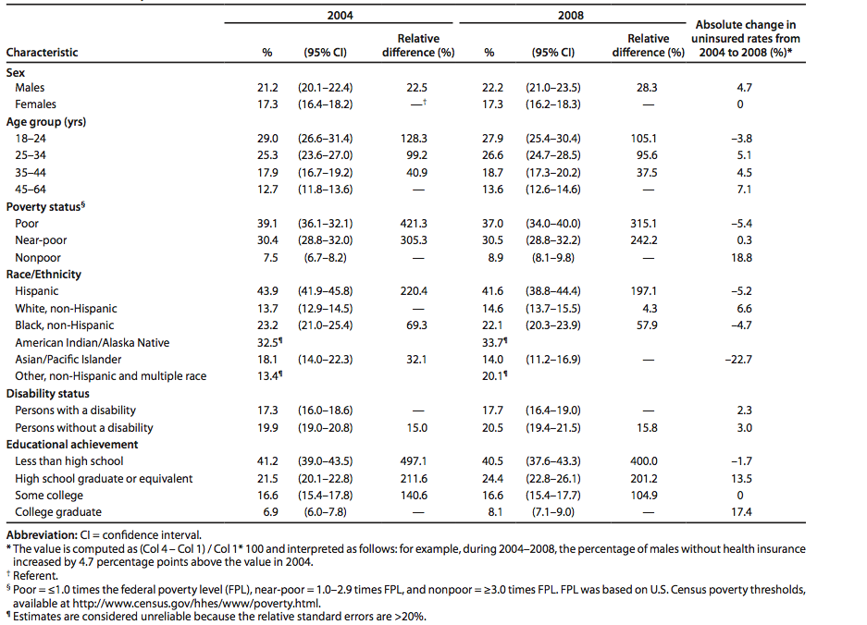

Figure 1 shows that infant mortality of all races decreased from 1915 to 1995, but African American IMR was consistently higher than White IMR. Also, since 1970, African American IMR seemed to decrease less dramatically than White IMR (Wegman, 2001).
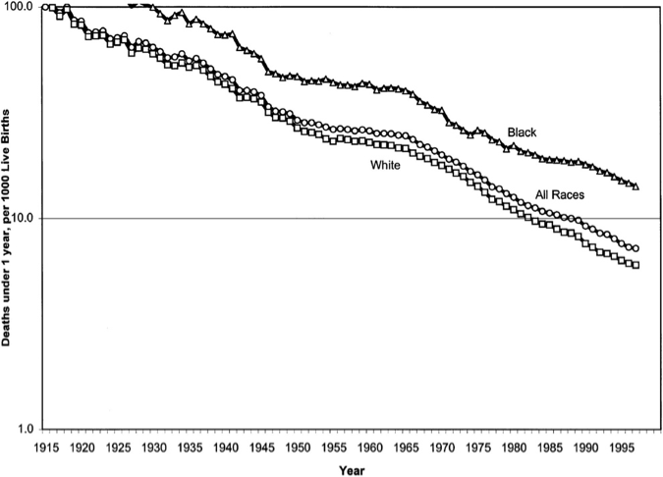
Figure 1. Infant mortality, by race, 1915 - 1997, US (Wegman, 2001)

Figure 2 compares infant mortality of different racial groups in the US based on 2000 and 2008 data. Figure 2 indicates that Non-Hispanic African-Americans had the highest IMR, which was more than twice that of Asian or Pacific Islanders, Hispanics, and Non-Hispanic Whites (MacDorman & Mathews, 2012).
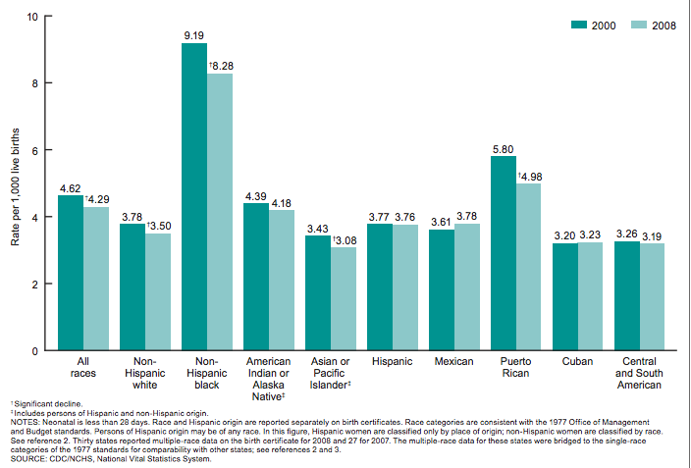
Figure 2. Infant mortality, by race of mother, US (MacDorman & Mathews, 2012)

It is possible that the inequalities of public spending on health and insurance coverage may increase IMR. Previous research has also found that high income inequality, residential segregation by income levels, and less parental leave are associated with high IMR, which were observed in developed countries (Spencer, 2004). Table 1 shows the results from National Health Interview Survey in 2004 and 2008: more than 30 percent of people who identified themselves as poor and near-poor are uninsured, and the number does not change much from 2004 to 2008; 40 percent of people who did not finish high school were uninsured.
High IMRs are preventable. Studies show that interventions provided as adjuncts to the standard prenatal care substantially contribute to improved birth outcomes. These interventions include nutritional supplementation and social support programs among socially disadvantaged women in high-income countries (Brocklehurst, Hollowell, Gray, Kurinczuk, & Oakeley, 2011).
There are several guidelines for practicing prenatal care in the US, such as those published by the American College of Obstetricians and Gynecologists (ACOG) and the position statements regarding obstetrical care published by the American College of Nurse-Midwives (University of Nevada, 2004). All of the guidelines have the same aim: to ensure the safety and health of mothers and babies.
The recommended schedule of prenatal care in the US suggests a first visit within six to eight weeks of conception, monthly visits for weeks four through 28, visits twice a month from 28 to 36 weeks of pregnancy, weekly visits after week 36 and then delivery at week 38 to 40 (Akkerman, et al., 2012). In addition to standard prenatal care, researchers and clinicians also developed other prenatal interventions including nutritional supplementation programs, substance abuse cessation, and case management / care coordination (Akkerman, et al., 2012). Prenatal care is beneficial for the health of both mothers and babies. Improving women’s nutrition during pregnancy, for example with multivitamin and folic acid supplementation, can protect the fetus from nutritional deficiency. Providing women with proper immunizations and helping women maintain healthy lifestyles can protect the fetus from exposure to pathogens and harmful chemicals. In addition, monitoring babies’ health through medical examinations can potentially detect congenital defects and help parents plan to deliver in appropriate facilities. For example, a baby with a prenatally diagnosed life-threatening condition including congenital heart diseases may need a group of specialists to closely monitor the mother and the baby during the course of the pregnancy and plan a specialized delivery.
Prenatal care can treat preexisting conditions, for instance diabetes, and control for lifestyle factors that could possibly lead to poor birth outcomes. Prenatal care can also identify pregnancy complications that may put women at high risk for adverse pregnancy outcomes, and may reduce preterm births and infant mortality (Heaman, 2008). Improving the health of pregnant women and their unborn children can also prevent children from developing diseases later in life. In the long run, prenatal care can save society money by reducing the medical and financial burdens of unhealthy pregnancies and babies on society.
The study aims at illustrating the trends in IMR and PNC in the US from 1997 to 2005 and identifying the association between IMR and PNC at the aggregate level. The period from 1997 to 2005 was chosen because of data availability. Moreover, the trend in IMR during this period goes up and down. Increases and decreases in IMR reflect changes in influencing factors, which is convenient in studying the associations between IMR and its influencing factors.

Background
Research has studied risk factors for high infant mortality. Preterm birth and low birthweight are two main contributors to infant mortality (EI-Mohandes, Gantz, Kiely, & Khorazaty, 2010). Sex of infant influences infant mortality: IMR is higher in male infants than female infants in the US (Atkinson & MacDroman, 1998). Maternal smoking during pregnancy also increases infant mortality (Wilcox, 1993). Teenage mothers and unmarried mothers are at higher risk of adverse birth outcomes (Mor-Yosef, Seidman, Samueloff, & Schenker, 1990). Low level of maternal education also increases infant mortality (Mathews & Ventura, 1997). Maternal racial status also influences IMR: Blacks have higher IMR than Non-Hispanic Whites in the US (Hauck, Moon, & Tanabe, 2011). Women who receive inadequate prenatal care are at increased risk for adverse birth outcomes (Bremby, Morrissey, & Saddi, 2007).
In one study, Kronebusch and Schlesinger (1990) observed an increase in IMR in the US in the 1980s and that the IMR of some regions in the US even resembled the IMR in developing countries, though IMR had continuously decreased after World War II (Kronebusch & Schlesinger, 1990). During the same time period, the percentage of women who received prenatal care only in their third trimester also increased (Kronebusch & Schlesinger, 1990). This worried policy-makers. To combat this problem Congress used a series of expansions of Medicaid eligibility in attempting to improve IMR (Kronebusch & Schlesinger, 1990). However, study results are inconsistent regarding the effects of those eligibility expansions on improving women’s timely access to prenatal care and birth outcomes. Another study found slight improvements in initiation of prenatal care and birth outcomes in California but no improvements in South Carolina (Epstein & Newhouse, 1998). This study suggested that lack of improvement may be due to insufficient outreach among low-income communities.
Several studies find that adequate prenatal care is associated with better birth outcomes. A randomized controlled trial found that behavior interventions targeting women’s lifestyle factors such as smoking and drinking could improve birth outcomes (EI-Mohandes, Gantz, Kiely, & Khorazaty, 2010). Another study showed that participation in New York State’s Prenatal Care Assistance Program (PCAP) is associated with greater use of prenatal services and improved birth outcomes among low-income women (Joyce, 1999).
Liu (1998) estimated effectiveness of prenatal care by analyzing vital statistics of all induced abortions and live births in the Commonwealth of Virginia in 1984. He found that delay of prenatal care by one month causes an average loss of 160 grams in birth weight. However, the results of this study were subject to the influence of women’s healthcare-seeking behaviors. For example, women with poor health before pregnancy tend to seek more prenatal care, which could attenuate the association between birth weight and prenatal care (Liu, 1998).
Investigators have studied factors that could affect the quality and accessibility of prenatal care. One study suggested women with insurance at early pregnancy are more likely to receive prenatal care during their first trimester compared to those who have no insurance or get insurance late in their pregnancy (Braveman & Marchi, 2003). The study also suggested that delay in receiving prenatal care could be caused by unknown pregnancy status, low level of education, unwanted pregnancy and financial difficulties (Braveman & Marchi, 2003).
Capitman (2007) found that maternal race could affect the amount and quality of prenatal care received. He observed great disparities between white and minority women in prenatal care and birth outcomes. He also found other factors causing inadequate prenatal care: less than 12 years of education, public insurance, and age below 20 years old (Bengiamin, Capitman, & Ruwe, 2007). Many of these factors affecting prenatal care are hard to change, suggesting that a national policy change needs to happen to support the health of mothers and babies.
Previous research has studied the relationship between IMR and PNC either at the individual level or at the aggregate level but confined to only a certain region or state. Few studies examined the relationship between IMR and PNC by analyzing the aggregate-level data of the 50 states and D.C. during a ten-year period. Most of the previous studies are consistent regarding the effects of adequate prenatal care on reducing infant mortality. This study aims to investigate whether the effects are visible at the aggregate level.

Methods
A literature search was conducted using PubMed. “Prenatal Care/statistics and numerical data,” “Prenatal Care/trends,” “Prenatal Care/utilization,” “infant, Low Birth Weight,” and “infant mortality” were used as MeSH terms for searching the database. Papers about prenatal care and its association with IMR were reviewed.
Infant mortality and prenatal care data were obtained from the website of the CDC. National vital statistics reports were collected, and the data were organized into tables by years and states (Table 10 and Table 11). The nine-year average IMR and the average rate of women receiving prenatal care during the first trimester from 1997 to 2005 were calculated at the state and national levels. States with the maximum and minimum values were identified for each year. Trends of annual IMRs and prenatal care rates were statistically depicted at the national level from 1997 to 2005 (Figure 3 and Figure 4). The trends were compared to study the association between IMR and the rate of pregnant women who receive prenatal care during their first trimesters.
In order to examine the association between IMR and prenatal care use at the aggregate level, the author compared states with extreme rates of infant mortality and prenatal care uptake to illuminate the overlap. Variance of infant mortality and prenatal care were calculated both within and across states. Covariance between IMR and prenatal care use was calculated to see how much the two variables change together. A scatterplot with IMR as the vertical axis and prenatal care rate as the horizontal axis was made. Two regression models were used to study the effect of PNC on IMR. A two-variable regression model included IMR and PNC only. Included in a multivariable regression were the percentage of population that is Hispanic in each state, the percentage of population that is Non-Hispanic White in each state, the PNC, and median household income from 1997 to 2005. All statistical analysis were performed on Stata/SE 12.0.
Data on state-level IMR and prenatal care uptake were extracted from National Vital Statistics Reports published by the US Department of Health and Human Services. Data reliability is ensured by 100 percent of the birth certificates annually in reported states and the District of Columbia (Hamilton, Menacker, Martin, Munson, Sutton, & Ventura, 2003).
In 2003, changes were made to the US Standard Certificates of Live Birth, including wording and data source for prenatal care. For instance, the beginning of prenatal care was redefined and recorded as the date of the first prenatal visit instead of the month prenatal care began. In addition, the 2003 revision of the US Standard Certificates of Live Birth recommended collecting prenatal care data from medical records, whereas the 1989 revision did not identify a consistent source of prenatal care data. Before 2003, all states reported vital statistics based on data items in the 1989 revision of the US Standard Certificate of Live Birth. Since 2003, some states adopted 2003 revision and the prenatal care data of states using 2003 revision were excluded in the paper. States using 2003 revision of birth certificate are displayed in Table 2 (Hamilton, Menacker, Martin, Munson, Sutton, & Ventura, 2003).

Table 2. States using 2003 revision of birth certificate
Year | 2003 revision | The percent of US births reported by 2003 revision
2003 | Pennsylvania and Washington (N=2) | 6%
2004 | Idaho, Kentucky, New York (excluding New York City), South Carolina, Tennessee, Florida, New Hampshire, Pennsylvania and Washington (N=9) | 20%
2005 | Florida, Idaho, Kansas, Kentucky, Nebraska, New Hampshire, New York (excluding New York City), Pennsylvania, South Carolina, Tennessee, Texas, Washington, and Vermont (N=13) | 31%

Prenatal care use data for excluded years were recorded as missing. The IMR and PNC of states with and without missing data of prenatal care use are displayed and compared in Table 3. Figure 5 shows good linearity (R²=0.8977) between national average prenatal care use and year. Assume the linearity remains on the state level. Therefore, linear regression was used for estimating missing data of prenatal care use. To test how much the missing data of PNC affect the association between IMR and PNC, scatterplot of IMR versus PNC with and without linear imputation were displayed. Because the effect is small, data without imputation were used in the analysis.
There is no change between the 1989 and 2003 revision in data collection of IMR (Hamilton, Menacker, Martin, Munson, Sutton, & Ventura, 2003). Thus, the data of IMR are comparable between the two revisions, and IMRs of all 50 states and the District of Columbia from 1997 to 2005 were included in the discussion.
Racial data were extracted from summary distributions from Census 2000 on the population by race and Hispanic origin. Data on race and Hispanic origin in Census 2000 are collected and presented according to the guidelines established by the Office of Management and Budget (OMB) in October 1997 (Cassidy & Grieco, 2001). Hispanic or Latino is defined as “a person of Cuban, Mexican, Puerto Rican, South or Central American, or other Spanish culture or origin regardless of race.” Census 2000 uses five race categories: White; African American; American Indian or Alaska Native; Asian; and Native Hawaiian or Other Pacific Islander (Cassidy & Grieco, 2001). Census 2000 was chosen because the study period is from 1997 to 2005.
Income data from 1997 to 2005 were from the Annual Social and Economic Supplement (ASEC) of the Current Population Survey (CPS). The Census Bureau mainly collects CPS labor force data about the civilian noninstitutionalized population living in the US (The Census Bureau, 2011). The number of interviewed housing units ranges from 50,300 in 1997 to 76,500 in 2005. Linear interpolation is used to estimate median incomes from 1997 to 2005 (The Census Bureau, 2011).
‘Prenatal care rate/use’ refers to the rate of pregnant women who receive prenatal care during their first trimesters. Neonatal mortality is defined as infant deaths under 28 days. Postneonatal mortality is defined as infant deaths from 28 days to a year.

results
Below are the results from analysis of IMR, PNC, racial, and income data, and the results are shown in tables and figures.
Results shown in Table 10 in Appendix A and Table 11 in Appendix B:
Infant mortality:
IMR (12.56/1000) was the highest in the District of Columbia during the period 1997 to 2005, and babies born in the District of Columbia were 80.5% more likely to die than babies born in other states in the US.
The second highest average IMR during the period from 1997 to 2005 was in Mississippi. The IMR is continuously above 10 per 1000 births during 1997-2005 except 2004. Babies born in Mississippi are 50.6% more likely to die than babies born in other states in the US.
The lowest average IMR (4.92 per 1000 live births) was in New Hampshire during 1997-2005 followed by Massachusetts (4.97/1000) and Utah (5.21/1000).
The data in Table 10 indicate that the trend of IMR was relatively stable during 1997-2005 with small variation throughout time. To obtain the state-average standard deviation of IMR of the date rage ($\overline{SDs\left(IMR\right)}$, the following formula was used:
$$\overline{SDs\left(IMR\right)}=\frac{\sum_{s=1}^{51}{SDs\left(IMR\right)}}{51}$$
SD_{s}(IMR) is the standard deviation of IMR of the date rage for a certain state. The sum of SD_{s}(IMR) for 50 states and D.C. is divided by the number of states, and the result is 0.54. To obtain the nine-year-average standard deviation of IMR of all states ($\overline{SDt\left(IMR\right)}$), the following formula was used:
$$\overline{SDt\left(IMR\right)}=\frac{\sum_{t=1}^{9}{SDt\left(IMR\right)}}{9}$$
SDt(IMR) is the state-average standard deviation of IMR of a certain year. SDt(IMR) for all nine years were summed and divided by the number of years, and the result is 1.60.
In general, the state-average standard deviation of IMR of the date rage ($\overline{SDs\left(IMR\right)}$) is smaller than the nine-year-average standard deviation of IMR of all states ($\overline{SDt\left(IMR\right)}$. That is, the within-state variance is smaller than the between-state variance of infant mortality. This indicates that there is a regional disparity of IMR between states. Moreover, that changes of IMR are small over time and it may take many years to reduce a state’s IMR.
Prenatal care:
The highest average percentage of mothers receiving prenatal care during their first trimester was in New Hampshire (90.86%) between 1997 and 2005, followed by Rhode Island (90.28%) and Massachusetts (89.51). The lowest average percentage of adequate prenatal care was in New Mexico (68.97%), followed by District of Columbia (74.22%) and Nevada (75.19%).
Mothers in New Hampshire are 8.93% more likely to receive adequate prenatal care during their first trimester than mothers who live in other states of the US. Mothers in New Mexico are 17.31% less likely to receive adequate prenatal during their first trimester than mothers living in other states of the US.
The data in Table 11 indicate that the trend of prenatal care coverage is stable. Likewise, to obtain the state-average standard deviation of prenatal care rate (PNC) of the date rage ($\overline{SDs\left(PNC\right)}$, the following formula was used:
$$\overline{SDs\left(PNC\right)}=\frac{\sum_{s=1}^{51}{SDs\left(PNC\right)}}{51}$$
SD_{s}(PNC) is the standard deviation of PNC of the date rage for a certain state. The sum of SD_{s}(PNC) for 50 states and D.C. is divided by the number of states, and the result is 1.21. To obtain the nine-year-average standard deviation of PNC of all states ($\overline{SDt\left(PNC\right)}$), the following formula was used:
$$\overline{SDt\left(PNC\right)}=\frac{\sum_{t=1}^{9}{SDt\left(PNC\right)}}{9}$$
SDt(PNC) is the state-average standard deviation of PNC of a certain year. SDt(PNC) for all nine years were summed and divided by the number of years, and the result is 4.42.
In general, the state-average standard deviation of PNC of the date rage ($\overline{SDs\left(PNC\right)}$) is smaller than the nine-year-average standard deviation of PNC of all states ($\overline{SDt\left(PNC\right)}$. Prenatal care received by women can be influenced by multiple factors, such as race, income level, distance to health facilities, and insurance status. It may take years’ efforts to affect these factors in order to improve prenatal care.
In general, the results shown in Table 10 and Table 11 suggest that the differences of prenatal care coverage between states are smaller than the differences of IMR between states. States that had higher average prenatal care coverage during women’s first trimesters also had lower average IMRs during 1997-2005, for example, New Hampshire and Massachusetts. States that had lower average prenatal care coverage during women’s first trimesters also had higher average IMRs during 1997-2005, for example, the District of Columbia. However, from 1997-2005, New Mexico had the lowest average prenatal care coverage (68.97%), but also had a lower than average IMR (6.41 per 1000 live births). The regression in Figure 5 shows New Mexico is

an outlier, which has low prenatal care use, but a low IMR. It is likely that other factors other than prenatal care reduces the IMR in New Mexico.
States with and without missing data of PNC:
Table 3 shows the characteristics of states with and without missing prenatal care use data. Table 3 suggests that IMR is 6.0% lower and PNC is 2.1% higher in states with missing data of prenatal care use (use 2003 revision of birth certificate for at least one year) compared to states without missing data of PNC.
Table 3. IMR and PNC of states with and without missing data of PNC
 | States with missing data | States w/o missing data
No. of states | 15 | 36
9-year average PNC (%) | 84 | 82.3
9-year average IMR (per 1,000 living births) | 6.87 | 7.31

Covariance:
Table 4 displays the covariance of IMR and prenatal care at each year and on average from 1997 to 2005. The covariance is consistently negative, which suggests a higher IMR tends to be paired with a lower prenatal care rate. For some years such as 1997 and 1999, the covariance is lower than -2, indicating a strong negative association. And for some years such as
2003 and 2005, the covariance is higher than -1, indicating a relatively weak association. On average, the covariance is about -1.5.
Table 4. Covariance between IMR and PNC, no imputation
Time | 1997 | 1998 | 1999 | 2000 | 2001 | 2002 | 2003 | 2004 | 2005 | Average (1997~2005)
Covariance | -2.9227 | -1.762 | -2.635 | -1.137 | -0.9808 | -1.0745 | -0.9478 | -1.349 | -0.554 | -1.512

Results shown in Figure 3 and Figure 4:
Figure 3 depicts the trend of average annual IMRs for 50 states and D.C. during the period from 1997 to 2005. The x-axis represents the year and the y-axis represents average annual IMR for 50 states and D.C. This figure exhibits a decreasing trend of annual average IMRs with exceptions during 2001-2002 and 2004-2005. A 5.1% decline in IMR from 1997 to 2005 can also be observed from Figure 3.

Figure 3. The annual state-average IMR, 1997-2005, no imputation

Figure 4 depicts the trend of the average annual rate of pregnant women receiving prenatal care during the first trimester for 50 states and the District of Columbia from 1997 to 2005. The x-axis represents the year and the y-axis represents the average annual rate of women receiving prenatal care during the first trimester for 50 states and the District of Columbia. The figure exhibits an overall trend of an increasing average annual rate of women receiving prenatal care during the first trimester with insignificant decrease during 1999-2000 and 2003-2004. The decrease from 2003 to 2005 may be due to the exclusion of states using the 2003 revision of birth certificate, as Table 3 shows that the excluded states have higher prenatal care use than the rest of the states.

Figure 4. The annual state-average PNC, 1997-2005, no imputation

The two figures show an inverse relationship between the average IMR and the average rate of women receiving prenatal care during the first trimester from 1997 to 2005. This observation should be interpreted cautiously, because the inverse relationship shown by the figure could be a real one, a simple coincidence, or be confounded by other factors such as race, age, and maternal education. However, it should be noted that the increase of infant morality occurred a year after decrease in prenatal care uptake, indicating that prenatal care might affect infant mortality.
Results from scatterplots Figure 5 and Figure 6:
The slope of the fitted line is negative, which suggests that IMR is inversely associated with PNC. The 95% CI is relatively narrow, which shows that the fitted line is precise. Comparing Figure 5 and Figure 6, the shape of scatterplots, fitted values, and 95% CI look very similar with and without the linear imputation. This indicates that the missing data of PNC does not have a significant impact on the association between IMR and PNC. The outliers of states nine and 32 also remain the same in Figure 5 and Figure 6. The District of Columbia is marked as nine, which has a low PNC but a very high IMR. New Mexico is marked as 32, which has a low PNC but a low IMR.
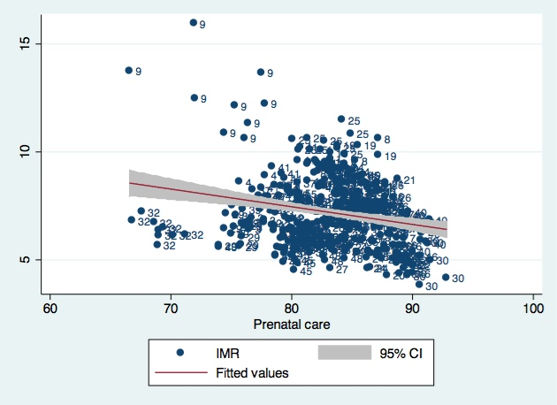
Figure 5. Scatterplot of IMR versus PNC, no imputation

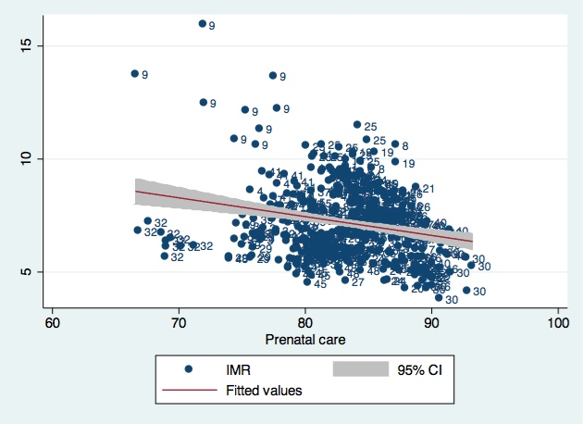
Figure 6. Scatterplot of IMR versus PNC, with linear imputation

Results shown in Table 5 and Table 6:
Table 5 shows the results from two-variable regression including only PNC and IMR. The R-squared is small (0.0498), which suggests that PNC only explains a very small portion of variation of IMR. The coefficient is -0.0818, which indicates that PNC is inversely associated with IMR. However, the p-value is smaller than 0.001, which suggests that the association is significant.
Table 5. Results from two-variable regression include PNC and IMR from 1997 to 2005, no imputation
Table 6 shows the results from multivariable regression including the percentage of the Non-Hispanic White population, the percentage of the Hispanic population, median income, PNC, and IMR. The R-squared is 0.6059, which indicates the multivariable model well explains the variation of IMR. The coefficients for the percentage of the Non-Hispanic White population, the percentage of Hispanic population, median income level, and PNC are negative, which indicates that these variables are inversely associated with IMR. P-values of all variables are smaller than 0.001, which indicates that the inverse associations between IMR and all the variables are significant. Comparing beta values of independent variables, the percentages of the Non-Hispanic White population and the Hispanic population have greater impacts on IMR compared to median income level and prenatal care.
Table 6. Results from multivariable regression including IMR, PNC, percentage of Non-Hispanic White population, percentage of Hispanic population, and median-income, no imputation

discussion
The Healthy People 2010 target goal for the US IMR is 4.5 infant deaths per 1,000 live births, however, the 2005 US rate was 50% higher than the goal. The impact of infant mortality is considerable: there are more than 28,000 annual deaths to children under one year of age in the US.
Table 10 presents the percentages of live births whose mothers received little or no prenatal care, stratified by state and by race. The data indicate that in most states, African American and Hispanic pregnant women are less likely to receive adequate prenatal care. Table 11 shows that states with a high proportion of whites, such as New Hampshire (93.9%), Rhode Island (81.4%), and Massachusetts (84.1%), have high prenatal care rates (90.86%, 90.28%, and 89.51%, respectively). States with a high proportion of minority populations such as New Mexico (46% Latino) and the District of Columbia (50.7% African American) have low prenatal care rates (70.2%, and 66.6%, respectively) (Schmitt, 2009). Racial disparity can affect women’s prenatal care through the influence of a series of socioeconomic factors. Table 14 indicates that African Americans and Hispanics had lower median incomes compared to White people from 1970 to 1998. One study shows that lower income is associated with other factors such as little access to medical care, low education level, and lack of insurance, which all contribute to delays of prenatal care (Cummings, Huang, & Regenstein, 2005). This finding implies that addressing racial disparity is important to improve prenatal care.

Prenatal care may not be the only explanation for the difference in IMR within the US. Table 7, Table 8, and Table 9 show the demographic and health data of New Hampshire (NH), Massachusetts (MA), and Rhode Island (RI) based on the data from 2010 to 2011 (Kaiser Family Foundation, 2012). These three states have the lowest IMRs during the period from 1997 to 2005. Compared to the national level, the percentage of population living in poverty and the percentage of uninsured population and children are lower in these three states, and the median annual income and health spending per capital are higher in these states. Roughly speaking, these facts indicate that high health spending, income levels and insurance coverage may be associated with a low IMR.

Table 7. Health facts of New Hampshire, 2010 – 2011 (Kaiser Family Foundation, 2012)
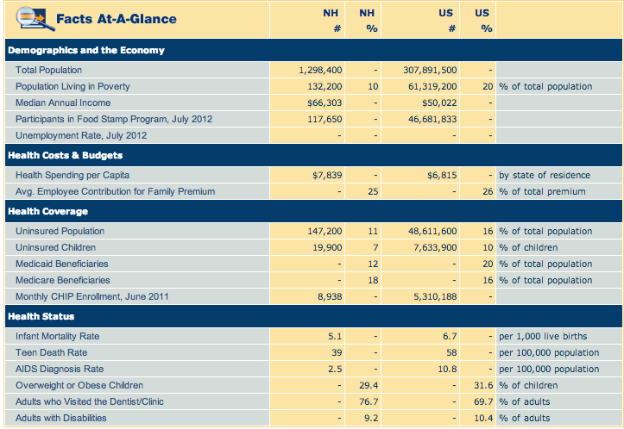

Table 8. Health facts of Massachusetts, 2010 - 2011 (Kaiser Family Foundation, 2012)
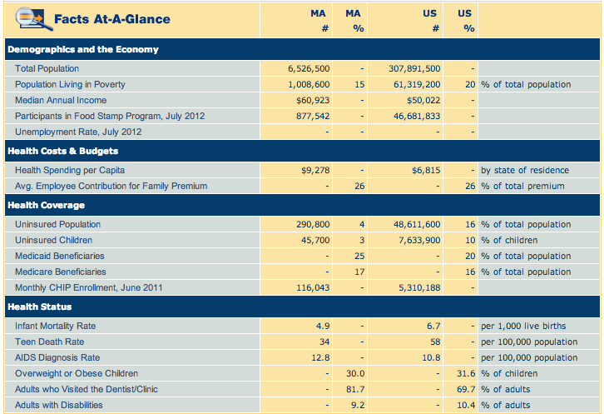

Table 9. Health facts of Rhode Island, 2010 - 2011 (Kaiser Family Foundation, 2012)
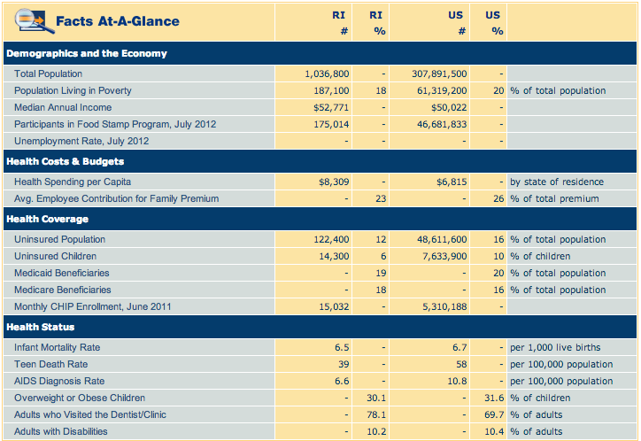
Furthermore, the average variation of the IMR and PNC of the date range for a state was smaller than that between states in a year. That is, the health care system of one state is relatively stable over time and there are large between-state variations in IMRs and prenatal care rates. The inequality in distribution of health care resources within the US may be due to multiple reasons such as medical staff shortage and underdeveloped health facilities. Other than that, low socioeconomic status, minority status, distance to health facilities, and lack of insurance can be barriers for women to obtain adequate prenatal care.
Moreover, from 1997 to 2005, an inverse trend was observed between the average IMR and the average rate of women receiving prenatal care during their first trimesters. It indicates that inadequate prenatal care could be associated with poor birth outcomes such as high IMR. As a policy implication, the pregnant women with delayed prenatal care are at a high risk of poor birth outcomes. Therefore, they should be closely monitored and targeted by preventive efforts such as diet counseling and smoking and alcohol cessation, in order to reduce low-birthweight, preterm birth, and as a result, IMR.
In addition, the results from two-variable and multivariable regression models suggest that PNC is inversely associated with IMR. Therefore, improving the percentage of women who receive prenatal care during their first trimesters is helpful in reducing infant mortality. Results from multivariable regression suggest that other factors including race and income also have substantial impacts on IMR. Furthermore, in the multivariable regression, the beta values of race and income level are more significant than that of prenatal care. It should be noted that race and income level might be correlated with prenatal care. For example, a high-income level can be related to a high percentage of initiation of prenatal care in the first trimester of pregnancy.
In this aggregate-level analysis, racial status is a strong predictor for IMR. Being a Non-Hispanic White or a Hispanic is associated with a low IMR compared to other racial groups in the US. Income level is another strong predictor for IMR, and a high-income level is associated with a low IMR. These findings indicate that IMR gaps exist between different racial and income groups. It is possible that a high IMR in vulnerable groups largely contributes to the high IMR in the US. This is consistent with Spencer’s (2004) finding that high income inequalities are associated with high IMRs in developed countries. It would be helpful to solve health disparities between socioeconomic groups in order to reduce IMR in the US.
As expected, an inverse trend was observed between IMR and PNC, and the effect of PNC on IMR is significant. These findings indicate that prenatal care plays an important role in the determination of infant mortality even at the aggregate level. The covariance analysis and regression models also supported the inverse association between IMR and prenatal care use at the aggregate level.
An unexpected result from the scatterplots shows that the average IMR of New Mexico was relatively low compared to the national level, though its prenatal care rate (68.97%) was the lowest among all the reported states in the study period. Results from the multivariable regression further confirmed the phenomenon by showing that the percentage of Hispanic population of a state is inversely related to the IMR of the state.
One possible explanation could be the “Latina Paradox,” also called “Epidemiology Paradox,” which means that the Latino population has a low IMR in spite of limited access to prenatal care. New Mexico has a high Latino population (46.3%), and low infant mortality in the Latino population may account largely for the state’s low infant mortality. So far, no evidence has been confirmed to explain the mortality advantage of the Latino population. Some possible explanations include: Latino women are less likely to drink alcohol, use drugs and smoke compared to White and African American women (McGlade, Saha, & Dahlstrom, 2004). Researchers also found that Latino women who adopted a western lifestyle were losing the mortality advantage, which could inspire researchers to think of other ways to reduce infant mortality, such as interventions targeting women’s risky behaviors.
This essay studied the association between IMR and PNC at the state level and examined the effects of racial status and income levels. However, this essay has some limitations. The multivariable regression model included only factors such as race, income level and PNC. Further adjustment of other factors needs to be conducted in order to confirm the inverse association between IMR and PNC. Future studies could examine some maternal factors including diet, smoking, drinking, age at birth, preconception health status, and socioeconomic status during pregnancy.
Furthermore, analytical studies such as case-control studies, cohort studies, and random controlled trials are necessary to examine and quantitate the relationship between prenatal care use and infant mortality, and to study the roles of other factors played in determining the relationship. It is likely that an optimal amount of prenatal care use for a population exists. The relationship between infant mortality and prenatal care use is moderate, and confounded by other factors such as women’s racial status and income level. A common-sense approach would be to conduct an intervention trial and randomly assign women to two groups with different amounts of prenatal care. However, ethical issues could be barriers to conduct an experimental study that must make random assignments of some pregnant women to a control group receiving little prenatal care.
As mentioned above, some states have implemented new revisions of birth certificate since 2003, and other states have been using 1989 revised birth certificates. Prenatal care data collected using the 2003 revision are excluded from the discussion because the definition and measurement of prenatal care were changed and not comparable between the two revisions of birth certificates. Although the exclusion of PNC data does not have a significant impact on the overall association between PNC and IMR, bias due to the incompleteness of reported data could affect the generalizability of the study’s findings.

Conclusion
In summary, access to prenatal care during the first trimester may be beneficial for improving the neonatal survival rate of babies at the aggregate level. Health disparities in infant mortality and prenatal care across regions need to be addressed.
A continued focus on low-income and other marginalized groups should help improve rates of care and reduce IMR. As mentioned above, insurance status is associated with the timing of prenatal care. Government funded programs including Medicaid are important for increasing the early insurance coverage of pregnant women, especially low-income women. Some practical barriers in applying for Medicaid need to be addressed by policy-makers.
In addition to expand public health insurance, it is also important to make private insurance more affordable and beneficial to consumers. Some people will be left out even if public insurance programs are expanded. For those who are not eligible for public insurance and don’t have employer-sponsored insurance, such as self-employers or people who work for small companies, they will have to buy insurance through the private market. In this case, they may choose not to have insurance, because they may think private insurance are too expensive or the benefits are not good enough. Health insurance exchange promoted by President Obama is an insurance market where consumers can compare insurance plans and cannot be denied coverage because of a preexisting condition. Hopefully, health insurance exchanges in the Patient Protection and Affordable Care Act (ACA) will help consumers make more informed decisions in choosing insurance.
Family planning services may be useful to reduce unintended pregnancies and improve adequate prenatal care. Other issues beyond the immediate reach of the health sector such as low educational attainment and poverty also generate profound influences on health and health care. The usage of trained professionals in the field would be especially beneficial. To increase the use of family planning services, it is crucial that people understand their importance and trust healthcare practitioners. Low-income women, minority women and women with disabilities are more likely to receive inadequate prenatal care (Misra, 2001). Intentionally targeting these high-risk groups by providing them with education on prenatal health and improving their medical literacy may help improve birth outcomes.
In sum, sufficient political will, support from federal policies, attention to the multi-faceted nature of barriers of care, and understanding complex health system are necessary to improve prenatal care. This kind of support will help make further progress toward the goal of improving prenatal care among pregnant women and birth outcomes.
Healthy People is a series of ten-year objectives aimed at improving the health of all Americans, developed by Office of Disease Prevention of Health Promotion (Office of Disease Prevention and Health Promotion, 2011). Healthy People 2020’s target is to reduce all infant deaths within one year from 6.7 infant deaths per 1,000 live births to 6.0 infant deaths per 1,000 live births (Office of Disease Prevention and Health Promotion, 2011).
The effectiveness of prenatal care in reducing infant mortality and improving birth outcomes has been a longstanding and quite controversial issue in the Unites States. Ensuring that every pregnant woman receives adequate prenatal care is important to reduce adverse birth outcomes such as infant deaths. In the US, prenatal care has evolved over time, from giving birth at home and care by midwives to giving birth in hospitals and care by professional medical staff, from medical care only given during childbirth to a set of services including preconception counseling, screening, visits during pregnancy until childbirth. The evolution of prenatal care not only tells a story of the changing values of America but also the constantly changing external factors that influence political and judicial decisions. Broad ranges of individuals are impacted by this issue and therefore bring different opinions to the discussion.
The State Children’s Health Insurance Program (SCHIP) is a program administered by the US Department of Health and Human Services. This program provides insurance to pregnant women and children from families whose incomes were too high to qualify for Medicaid (household incomes were 200 percent of the federal poverty level or higher) (United States Department of Health and Human Services). This program and its expansion (Children's Health Insurance Reauthorization Act of 2009) served an additional four million children and pregnant women, which is an important step in providing insurance to pregnant women and children from low-income families (United States Department of Health and Human Services).
The Patient Protection and Affordable Care Act, public law 111-148, which was passed on March 23, 2010, has brought women’s reproductive health to the forefront of US politics once again. This law addresses concerns regarding reproductive health, insurance coverage, and health disparities. Women’s pregnancy and childbearing decisions are strongly associated with health care policies. There are a number of important regulations in Affordable Care Act (ACA) that will help improve women’s health, see Table 3 (National Partnership for Women & Families, 2011). The ACA also makes significant investments in community health centers to ensure uninsured and underserved women can access high quality, affordable health care services. (National Partnership for Women & Families, 2011; Misra, 2001)
Recently there have been debates on federal funding for organizations like Planned Parenthood of America Federation that offers health services including prenatal care. ACA has not only made this topic a hot spot for politician but also for the media. Coverage of recent news serves a dual role. It can be an educational tool used to help subscribers understand health services and current events, but it can also be used as a chisel that shapes ideas and perceptions solely based on opinions and sentiment.
Insurance coverage is pertinent to the issue of prenatal care. The relationship between insurance coverage and prenatal care use involves affordability, coverage and quality of prenatal care service. In general, women earn less than men and are more likely to live below the federal poverty level. The poverty rates among unmarried women with children are highly rising since 1996. Usually, women undertake more caregiver responsibilities, which reduces their work hours. Many women spend less on their own health but more on helping relatives and friends. More women (52%) compared to men (39%) reported delayed care because of cost (National Partnership for women & Families, 2011).
Racial status also has an impact on women’s socioeconomic status, which indirectly influences women’s insurance status. 28% and 27% of African American and Hispanic women respectively live below the poverty line compared to 11% of white women (National Partnership for Women & Families, 2011).
In addition to financial limitations, women have been traditionally charged more by insurance companies because of high reproductive costs. In most states, women pay more for insurance than men for the same plan, which is referred to as gender rating. Gender rating is widely accepted by the states, with the exceptions of 12 states on the individual market and one state on the group market. Women are also more vulnerable to losing access to employer-sponsored insurance, as they are more likely to be covered as dependents (National Partnership for Women & Families, 2011).
The healthcare demands are huge, while the healthcare resources are limited. High IMR has its origin in social and economic inequalities (Spencer, 2004). Probably, expanding public insurance programs alone is not enough to meet the healthcare needs of all people. The main things are to address socioeconomic inequalities and improve the capability and efficiency of health delivery system. Avendano (2012) suggested that social policies could reduce infant mortality through redistribution of resources. It is likely that social policies fuel resources to the poor could reduce infant mortality in society, especially in the poor.
Decisions made within the healthcare profession are not solely based on the issues at hand. The US political system is configured in such a way that political climate, timing, and leadership are pertinent in determining what changes will be seen in legislation. The perception of health care is constantly changing. People may be more aware of the importance of prenatal care in birth outcomes today than that in the 19th century, but the controversy about the effectiveness and efficiency prenatal care still persists. Health insurance, healthcare reform, and media coverage have shaped this issue in the 21st century. Recommendations for the future should best serve the majority of Americans and be focused on sustainability for future generations.

IMR by state: US, 1997-2005
Table 10. IMRs by state: US, 1997-2005 (Division of Vital Statistics, 2005)



PNC BY STATE: US, 1997-2005
Table 11. PNC by state: US, 1997-2005 (Division of Vital Statistics, 2005)


variables used in multivariable regression
Table 12. Non-Hispanic White percentage, Hispanic percentage, Average IMR, Average PNC, and 9-year average median income from 1997 to 2005 (Cassidy & Grieco, 2001; The Census Bureau, 2011)
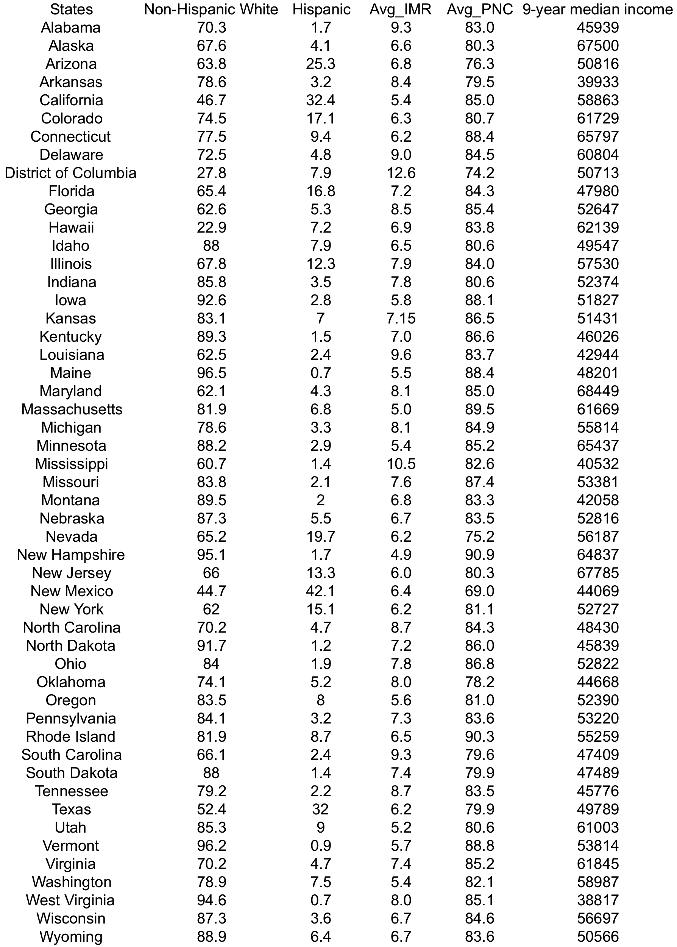

Percent of live births with late or no prenatal care by race and state, us, 2007
Table 13. Percent of live births with late or no prenatal care stratified by race and state

Notes: Data are for all live births, regardless of maternal age.
All Minority women include Black, Hispanic, Asian American and Native Hawaiian/Pacific Islander, American Indian/Alaska Native women, and women of two or more races.
Disparity score greater than 1.00 indicates that minority women are doing worse than White women. Disparity score less than 1.00 indicates that minority women are doing better than White women. Disparity score equal to 1.00 indicates that minority and White women are doing the same. Data are derived from the Kaiser Family Foundation report, Putting Health Care Disparities on the Map, available at: http://www.kff.org/womensdisparities/.

Sources: Centers for Disease Control and Prevention, National Center for Health Statistics, National Vital Statistics System; Health, United States, 2007.

median income by race, us, 1970 to 1998
Table 14. Median income from 1970 to 1998, US, by race
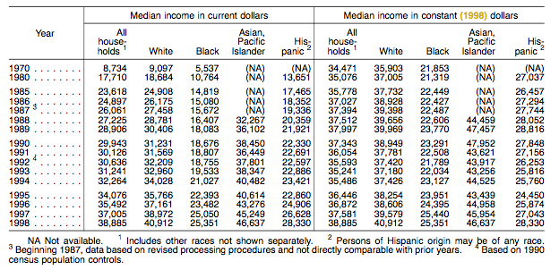
Source: US Census Bureau, Current Population Reports, P60-206; and Internet site <http://www. census.gov/hhes/income/histinc/ho5.html> (accessed 17 May 2000).

bibliography

Adams-Taylor, S., Fine, A., & and Mills, C. A. (1989). Monitoring Children's Health: Key Indicators. American Public Health Association.
Adler, N., & Newman, K. (2002). Socioeconomic disparities in health: pathways and policies . Health Affairs , 60-76.
Akkerman, D., Cleland, L., Croft, G., Eskuchen, K., Heim, C., Levine, A., et al. (2012). Routine prenatal care. Institute for Clinical Systems Improvement.
Alexander, G., & Cornely, D. (1987). Prenatal care utilization: its measurement and relationship to pregnancy outcome. Am J Prev Med. , 243-53.
Atkinson, J., & MacDroman, M. (1998). Infant mortality statistics from the 1996 period linked birth/infant death data set. CDC.
Avendano, M. (2012). Correlation or causation? Income equality and infant mortality in fixed effects models in the period 1960-2008 in 34 OECD countries. Social Science & Medicine , 75, 754-760.
Ayman A.E. EI-Mohandes, M. K.-E. (2010). Very preterm birth is reduced in women receiving an integrated behavioral intervention: a randomized controlled trial. Maternal Child Health Journal , 19-28.
Bengiamin, M., Capitman, J., & Ruwe, M. (2007). Prenatal care and birth outcomes: Challenges to growing a more nurturing San Joaquin Valley. Fresno: Central Valley Health Policy Institute.
Braveman, P., & Marchi, K. (2003). Promoting access to prenatal care: lessons from the California experience. The Henry J. Kaiser Family Foundation.
Bremby, R. L., Morrissey, R. J., & Saddi, E. W. (2007). Adequacy of prenatal care utilization index Kansas, 2007. Topeka: Kansas Department of Health and Environment.
Brocklehurst, P., Hollowell, J., Gray, R., Kurinczuk, J., & Oakeley, L. (2011). The effectiveness of antenatal care programmes to reduce infant mortality and preterm birth in socially disadvantaged and vulnerable women in high-income countries: a systematic review. BMC Pregnancy Childbirth .
C. Arden Mills, A. F.-T. (1989). Monitoring Children's Health: Key Indicators. American Public Health Association.
Cassidy, R., & Grieco, E. (2001). Overview of race and Hispanic origin . US Census Bureau.
Centers for Disease Control and Prevention [CDC]. (2012). Lack of health insurance coverage and type of coverage. Centers for Disease Control and Prevention.
Cummings, L., Huang, J., & Regenstein, M. (2005). Barriers to prenatal care: findings from a survey of low-income and uninsured women who deliver at safety net hospitals. Washington, DC: National Public Health and Hospital Institute .
Division of Vital Statistics. (2005). National vital statistics reports. CDC.
EI-Mohandes, A. A., Gantz, M. G., Kiely, M., & Khorazaty, M. N.-E. (2010). Very preterm birth is reduced in women receiving an integrated behavioral intervention: a randomized controlled trial. Maternal Child Health Journal , 19-28.
EL-Mohandes, A. A., Gantz, M. Z., Kiely, M., & Khorazaty, M. N.-E. (2010). Very preterm birth is reduced in women receiving an integrated behavioral intervention: a randomized controlled trial. Maternal Child Health Journal , 19-28.
Epstein, A., & Newhouse, J. (1998). Impact of Medicaid expansion on early prenatal care and health outcomes. Health Care Financing Review , 85-99.
Hamilton, B. E., Menacker, F., Martin, J. A., Munson, M. L., Sutton, P. D., & Ventura, S. J. (2003). National Vital Statistics Reports. Hyattsville: U.S. Department of Health & Human Services.
Hauck, F., Moon, R., & Tanabe, K. (2011). Racial and ethnic disparities in infant mortality. Seminars in Perinatology , 209-220.
Heaman, M. I. (2008). Inadequate prenatal care and and its association with adverse pregnancy outcomes: A comparison of indices. BMC Pregnancy and Childbirth .
Hughes, D., Johnson, K., & and Rosenbaum, S. (1988). Maternal and child health services for medically indigent children and pregnant women. Medical Care , 26, 315-332.
Joyce, T. (1999). Impact of augmented prenatal care on birth outcomes of Medicaid recipients in New York City. Journal of Health Economics , 31-67.
Kaiser Family Foundation. (2012). Retrieved December 3, 2012, from State health facts: www.statehealthfacts.org
Kiely, J., & Kogan, M. (n.d.). Prenatal care. Reproductive health of women , 105-118.
Kronebusch, K., & Schlesinger, M. (1990). The failure of prenatal care policy for the poor. Health Affairs , 9 (4), 91-111.
Liu, G. G. (1998). Birth outcomes and the effectiveness of prenatal care. Health Service Research , 805-823.
MacDorman, M. F. (2008, October). Recent Trends in Infant Mortality in the United States. Retrieved September 2012, from Center for Disease Control and Prevention: www.cdc.gov/nchs/data/databriefs/db09.htm
MacDorman, M. F. (2008). Recent Trends in Infant Mortality in the United States. Hyattsville: U.S. DEPARTMENT OF HEALTH AND HUMAN SERVICES, National Center for Health Statistics.
MacDorman, M., & Mathews, T. (2012). Infant mortality statistics from the 2008 period linked birth/death data set. U.S. Department of Health and Human Services.
Mathews, T., & Ventura, S. (1997). Birth and fertility rates by educational attainment: United States, 1994. Hyattsville, Maryland: National Center for Health Statistics.
McGlade, M., Saha, S., & Dahlstrom, M. (2004). The Latino paradox: an opportunity for restructuring prenatal care delivery. Am J Public Health , 2062-5.
Mor-Yosef, S., Seidman, D., Samueloff, S., & Schenker, J. (1990). The effect of maternal age and socioeconomical background on neonatal outcome. Int J Gynecol Obstet (33), 7-12.
Nancy E. Reichman, D. L. (1997). Maternal age and birth outcomes: Data from New Jersey. Family Planning Perspectives , 268-272 & 295.
Office of Disease Prevention and Health Promotion. (2011, April 4). Objective development of Healthy People 2020. Retrieved October 28, 2012, from Healthpeople.gov: www.healthypeople.gov
Schmitt, J. (2009, March 6). Prenatal care fact sheet. Retrieved November 26, 2012, from Womens Health: www.womenshealth.gov/publications/our-publications/fact-sheet/prenatal-care.cfm
Selden, T. M., & Sing, M. (2008, July). The distribution of public spending for health care in the United States, 2002. Health Affairs , 349-359.
Spencer, N. (2004). The effect of income inequality and macro-level social policy on infant mortality and low birthweight in developed countries - a preliminary systematic review. Child: Care, Health and Development , 30, 699-709.
The Census Bureau. (2011). Current Popolation Survey, 2012 Annual Social and Economic (ASEC) Supplement.
The Centers for Disease Control and Prevention. (2005). QuickStats: leading causes for neonatal and postneonatal deaths - United States, 2002.
UN, Department of Economic and Social Afairs. (2011, June 28). World population prospects, the 2010 revision. Retrieved November 18, 2012, from UN: esa.un.org/unpd/wpp/Excel-Data/mortality.htm
United States Department of Health and Human Services. Children's Health Insurance Program. Baltimore: United States Department of Health and Human Services.
University of Nevada. (2004, November 5). Leading Social Indicators in Nevada. Retrieved July 20, 2012, from Justice & Democracy forum: http://cdclv.unlv.edu/healthnv/prenatalcare.html
Wegman, M. (2001). Infant mortality in the 20th century, dramatic but uneven progress. The Journal of Nutrition , 401S-408S.
Wikimedia Foundation, Inc. (2010, Aug 31). infant mortality. Retrieved Sep 2, 2012, from wikipedia: http://en.wikipedia.org/wiki/Infant_mortality
Wikimedia Foundation, Inc. (2012, August 24). Wikipedia. Retrieved October 21, 2012, from Prenatal care in the United States: en.wikipedia.org/wiki/Prenatal_care_in_the_United_States
Wikipedia Foundation, Inc. (2012, October 24). State Chilren's Health Insurance Program. Retrieved October 31, 2012, from Wikipedia: en.wikipedia.org/wiki/State_Children's_Health_Insurance_Program
Wilcox, A. (1993). Birthweight and perinatal mortality: the effect of maternal smoking. Am J Epidemiol , 137, 1098-1104.
World Health Organization [WHO], Department of Health Statistics and Informatics. (2011, May 13). World Health Statistics 2011. Retrieved November 18, 2012, from WHO: www.who.int/whosis/whostat/2011/en/index.html

