THE RELATIONSHIP BETWEEN LOCAL TEMPERATURE RANGE AND ANNUAL SEASONALITY OF MEASLES IN THE UNITED STATES: 1924 - 1948

by
Erin Maureen Jenkins
BA in Natural Science, Trinity College Dublin, 2005

Submitted to the Graduate Faculty of
Department of Epidemiology
Graduate School of Public Health in partial fulfillment
of the requirements for the degree of
Master of Public Health

University of Pittsburgh

2012

UNIVERSITY OF PITTSBURGH
GRADUATE SCHOOL OF PUBLIC HEALTH

This essay is submitted

by

Erin Maureen Jenkins

on

December 9, 2012

and approved by

Essay Advisor:
Willem G. van Panhuis, MD PhD _________________________________
Assistant Professor
Department of Epidemiology
Graduate School of Public Health
University of Pittsburgh

Essay Reader:
Daniel J. Bain, PhD _________________________________
Assistant Professor
Department of Geology and Planetary Science
School of Arts and Sciences
University of Pittsburgh

Copyright © by Erin Jenkins
2012

Measles epidemics exhibit annual seasonality in which epidemics start in the autumn and peak in the spring. Current theories regarding factors driving seasonal transmission fail to fully account for historical observations from as far back as the 17th century. In this study, we explored the potential influence of annual climate cycles in driving measles seasonality. Data was used from 72 United States cities which range across a large range of climate types. Local temperature range was used as the indicator of climate seasonality and the relationship between this factor and measles epidemics across the US was assessed using wavelet analysis as well as more direct methods of comparison. Synchrony of epidemics among cities was assessed by using wavelet techniques to reconstruct the annual signal of measles time series data and by calculating the mean cumulative progression of epidemics for all cities. A high level of synchrony was seen among all cities and the year-to-year variability that was observed had no association with local temperature range. Local wavelet spectrum analysis was used to compare dominant periodicities among the cities. Great variability of dominant periodicity was observed but showed no obvious association with local temperature range.
Wilbert van Panhuis, MD PhD

THE RELATIONSHIP BETWEEN LOCAL TEMPERATURE RANGE AND ANNUAL SEASONALITY OF MEASLES IN THE UNITED STATES: 1924 - 1948
Erin Maureen Jenkins, MPH
University of Pittsburgh, 2012

Establishing the relationship between measles seasonality and climate contributes to public health by adding to the information on the biology of the measles virus and by increasing our understanding of the key mechanisms driving measles transmission. This information can be used to develop early warning systems and to tailor vaccination programs for communities which continue to experience regular epidemics around the world.

TABLE OF CONTENTS
preface viii
1.0 Introduction 1
2.0 mETHODS 6
3.0 RESULTS 11
4.0 discussion 20
5.0 Conclusion 24
bibliography 25
List of figures
Figure 1. Time series of measles incidence rate (per 100 people) and the log-transform (measles incidence rate) of all cities (grey) and total across all cities (black). ……..………………………7
Figure 2. Cities with sufficient data for analysis. Dot size corresponds with the temperature range (climate seasonality) of each city. ……………………………..…………………...……....9
Figure 3. Available weekly log-transformed measles incidence rate from 1924 to 1948 for each of the cities included in the final analysis. …...……………………………..…………….……..12
Figure 4. Annual signal of normalized log-transformed measles incidences rate reconstructed using a band-pass filter scaled to 45 to 55 weeks. ……………………………...………...……..14
Figure 5. Median annual signal of measles incidence (grey) and temperature (pink) by calendar week for all cities. ……………………………………………………………...………...……..15
Figure 6. Boxplots of all weeks of the measles-year during which 50% cumulative log-transformed incidence rate (IR) occurred for each city sorted by temperature seasonality. …...16
Figure 7. Mean number of weeks into the measles-year at which 10 – 90% cumulative log-transformed incidence rate (IR) occurred in each city sorted by climate seasonality. ……….....17
Figure 8. Boxplots of the temperatures calculated for all weeks of the measles-year during which 50% cumulative log(IR) occurred for each city sorted by climate seasonality. ………………..18
Figure 9. Percent variability attributable to different periodicities (frequencies) for each city sorted by climate seasonality. …………………………………………………………………..19
preface
I would like to thank the World History Center, in particular Dr. Patrick Manning, for financial support. I would also like to thank the Bill & Melinda Gates Foundation Vaccine modeling Initiative-funded Tycho project for use of preliminary data. Further thanks go to my project supervisors, Dr. Wilbert van Panhuis and Dr. Daniel Bain, for their assistance with all aspects of this project including project guidance and editing of this paper.

Introduction
Many infectious diseases exhibit a seasonal pattern. Such patterns can recur with various periodicities, ranging from multiple years (multi-annual) to months (intra-annual). Although seasonality can have a direct impact on disease management strategies such as the design of vaccination programs, its causes in diseases with no vectors are poorly understood. In the case of vector-borne diseases, periodicity is often directly linked to vector abundance often driven by environmental factors. Potential causes in other diseases can be summarized as cyclical environmental factors and periodic changes in host behavior and immune response. To dat, much of the research on disease seasonality has been conducted using measles data due to the availability of long-term datasets from several countries at high spatiotemporal resolution.
Measles is an infection caused by a virus of the Morbillivirus genus. Although it is considered a childhood disease, infections are also possible at later ages. The mean age of infection is about 9-12 months but varies among countries in large part due to differences in passive immunity provided from mother to child through transplacental antibody transfer, childhood nutrition and national vaccination schedules. Long-term datasets for measles have been generated in many countries where the disease has been a mandatory reported disease since the early 20th century. Reports based on clinical diagnoses are generally considered reliable due to the well-defined clinical presentation of the disease including a fever which persists through the onset of a distinctive rash.⁶ Although vaccine initiatives have had considerable success in reducing its impact, measles continues to be a serious global health burden. The disease cause more than 130,000 deaths in 2010, mostly in low-income countries of Africa and Asia.⁷ In addition to being an ongoing threat in the developing world, developed nations that had achieved measles elimination in the 1990’s, such as the United States, have recently experienced an increasing number of outbreaks due to decreasing vaccination rates.⁸
In earlier studies, pre-vaccine measles incidence often exhibited a strong annual or biannual pattern. Epidemics begin as early as September and as late as December or January. The epidemics peak in the spring, often in late March or early April. This intra-annual seasonal pattern has been described since the 17th century with epidemics noted as peaking at the vernal equinox, March 21.⁹ The opening and closing of school terms is currently postulated as the primary cause of the autumnal increase in measles cases and transmission in England and Wales and in New York City and Baltimore, MD.⁵ Certain questions remain regarding this theory. Dowell noted that crowding in summer camps do not result in similar outbreaks even though they cause similar crowding of young people.¹ In addition, Duncan, Duncan and Scott determined low autumnal temperatures as a likely precipitator of epidemics as far back as 1700.¹² Given that the intra-annual pattern of measles epidemics pre-date the onset of universal education, it seems unlikely that school seasons are the only driver of measles intra-annual seasonality. It is possible that this is a cyclical factor that can be correlated with measles epidemic cycles without necessarily causing it. We hypothesize that environmental factors such as climate patterns are a more plausible explanation due to consistent external forcing over time and space.
Several analytical methods have been used to evaluate potential drivers of measles seasonality. Mathematical models have been developed and refined to trace the multi-annual variability and seasonality found in pre- and post-vaccination measles data. The “law of mass action” established that the trajectory of an epidemic was dependent on the proportion of the population susceptible to disease.¹⁰ In 1957, Bartlet^{t 15} addressed the inherent stochasticity of model parameters and allowed community size to influence the model. These early models evolved into the susceptible-infected-recovered (SIR) and susceptible-exposed-infected-recovered (SEIR) models which are the basis for modern modeling efforts.
Although the modeling techniques outlined above can aid in the identification of primary factors influencing disease epidemiology, frequency analysis can reduce signal complexity to a measure of periodicity and enable comparison of more than one cyclical function. A variety of spectral analysis techniques have been used to identify and isolate the most common periodicities within time series data; however, these methods assume that the period is stationary, occurring at exactly the same time every interval. Much ecological data, including epidemiological time series, are not stationary but transient, with epidemics occurring at variable points in the year when they happen at all. Wavelet analysis has recently been identified as an appropriate approach for exploration of ecological time series. It does not assume stationarity and can assess changes in periodicity over time. These features have made wavelet techniques increasingly important in the analysis of long-term historical disease data.¹⁷⁻²⁰ Wavelet analysis can be used to both identify the temporal spectrum of periodicity in a time series and to reconstruct specific periodicities across time series.¹⁶ The former process allows for the analysis of coherency of periodicity between two distinct time series and enables significance testing of this coherence against random data sets generated using bootstrapping methods. The latter process isolates the signal associated with a specific period, for example, the annual cycle.
Several epidemiological studies have used wavelet analysis to assess spatial synchrony and temporal coherency between multi-annual disease dynamics and large scale and local climate variation. Grenfell, et al^{. 18} used the technique to establish a pattern of travelling waves of measles in the UK from large city centers to less-densely populated outlying areas. Broutin, et al^{. 21} explored spatial synchrony and asynchrony of pertussis incidence in 12 countries in order to examine global spatial disease dynamics and determine whether vaccination efforts have resulted in more regularly timed outbreaks. Wavelet analysis has also been used to assess the relationship between the El Nino/Southern Oscillation (ENSO) and cholera in Bengladesh¹⁹ and dengue in Puerto Rico, Mexico and Thailand.²⁰ Johansson, et al^{. 20} assessed the relationship between local temperature and precipitation, dengue incidence and ENSO indices in order to validate any potential relationships found using these methods.
Much of the research on disease seasonality has been constrained by geographic or temporal data availability. The Tycho database contains 120 years of weekly US disease surveillance data that have been digitized over the past several years, providing a wealth of historical disease data at high spatiotemporal resolution. (Van Panhuis, et. al., submitted) This long-term, fine spatial-scale data from a large geographic area enables us to explore more thoroughly the question of what might cause disease seasonality. Local weather patterns across the United States are much more variable than in England and Wales, the temperate region most closely studied up to date. The variability in the US allows for the examination and comparison of epidemics in cities in a wide-range of climates. Because disease incidence changed after the introduction of the measles vaccine, we have chosen to examine data available for the first half of the 20th century and determine whether this data elucidates any relationship between local temperature range and measles epidemics on a city-level geographic scale.
A better understanding of the interaction between climate variability and measles annual seasonality will contribute to public health by adding to the fundamental biological knowledge of the measles virus. In addition, understanding this relationship will aid in the identification of the primary mechanisms driving measles epidemics, factors which can be used to inform vaccination schedules and help public health professionals anticipate epidemics and preemptively organize vaccination campaigns. Such preemptive actions might include the incorporation of this information into early warning systems in nations where measles is continues to have a significant impact on child health.

mETHODS
The measles data used in this study were taken from the Tycho database and originated from reports published in the Public Health Record by the United States Public Health Service. The Tycho database consists of digitized weekly reports of diseases for the United States as published in the CDC Morbidity Mortality Weekly Report (MMWR) and it’s precursors, all of which can be found online in PDF format. Records in the database go as far back as 1888; however, weekly reports of measles case numbers were available only from 1900 to 1948 for 144 cities. (Van Panhuis et al. submitted) Duplicate reports occurred for some cities and weeks due to data processing and updating in the Tycho database or due to duplicate reports in the source reports. Identical duplicates were excluded and in case of non-identical duplicate reports, the mean number of cases was used. All measles data available for 1900 – 1950 are shown in Figure 1a. Annual city-level population estimates were linearly interpolated from available decadal census data.²⁴ Our study period was limited to 1924-1948 according to data availability.
Climate data corresponding to the spatiotemporal scales of measles data was obtained for each city using the National Climatic Data Center’s (NCDC) Web Climate Services Version 2.1. The name of each location was entered as “City, State” and all available daily data for all available years was downloaded.²⁵ Maximum and minimum temperatures and precipitation were determined to be the most consistently available weather measurements and were used for all analyses reported here. Many cities had several stations with overlapping periods of reported data. All station data was kept and all measurements during these overlap periods were averaged to estimate city-wide values.
Daily weather data was aggregated into a weekly time step for each city according to the epidemiological dates of reported measles data. Daily minimum and maximum temperatures were converted to average weekly minimum and maximum temperatures and daily precipitations were summed to weekly scales. Sufficient data could not be found for all 144 cities for the examination of the relationship between local weather and disease incidence. Measles incidence rates (IR) were computed as number of cases per 100 population and were log transformed (logIR) as log10(cases+1/population (in 100s)) to obtain more normal distributions. (Figure 1)

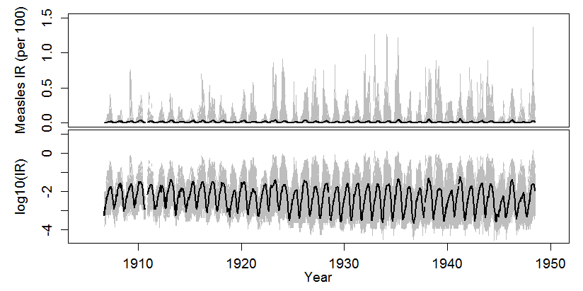
Figure 1. Time series of measles incidence rate (per 100 people) and the log-transform (measles incidence rate) of all cities (grey) and total across all cities (black).

Wavelet analysis was used to reconstruct annual seasonality and determine the impact of this periodicity on each time series as compares to other periodicities. Wavelet analysis requires a continuous dataset with no missing data. For each city, the longest stretch of consecutive years with at least 28 weeks (50% of the year) of reported data per year was used for this analysis. Sensitivity analyses tested a stricter cutoff of 39 weeks (75% of the year) and resulted in more limited data but little change in median IR. The limited difference in results led us to believe that much of the missing data were unreported zero values and to deem the stricter criterion unnecessary. Missing values within these years were imputed by randomly sampling with replacement from values of the same week from other years. Only cities with 15 consecutive years of measles data and at least 10 years of climate data within the same timeframe were included in wavelet analysis. 72 cities had sufficient data for wavelet analysis and were the only cities included in all subsequent analyses (Figure 2).

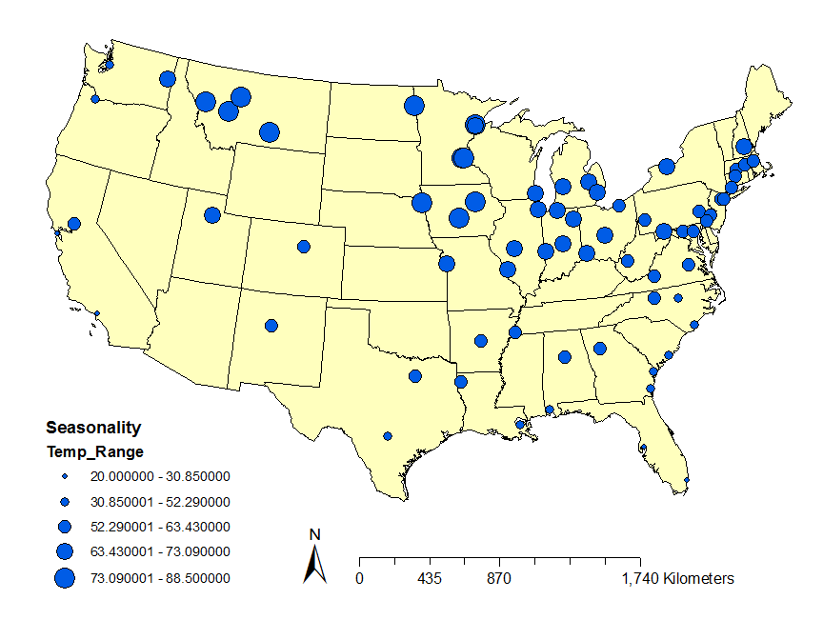
Figure 2. Cities with sufficient data for analysis. Dot size corresponds with the temperature range (climate seasonality) of each city.

Normalized log-transformed incidence data were used for all wavelet analyses. Log transformed IR were normalized according to the following equation:
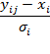
where y is the log-transformed IR, x is the mean log-transformed IR and is the standard deviation for each time point (j) and city (i).
Measles epidemics often span two calendar years, ranging from September to May. In order to compare epidemics, we established a measles-year starting on week 35 of the calendar year (the week which most often had the fewest cases of measles) and ending on week 34 of the next. For each city, seasonality was defined as outlined below:
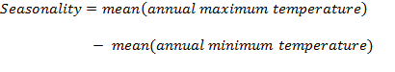
When calculating seasonality, only values for weekly maximum temperature were considered in order to avoid complications due to local differences in daily temperature range. For each city the number of weeks of the measles-year to 10, 20, 30, 40, 50, 60, 70, 80, and 90% cumulative logIR was calculated. The mean number of weeks to these thresholds was then calculated. The progression from 10 to 90% incidence was plotted in order of climate seasonality.
Wavelet techniques were used to isolate the annual signal from each normalized log-transformed measles time series and to determine how much of each time series’ variability was explained by each of a range of periodicities. All wavelet analysis was conducted using the morlet wavelet as the basis of all transformations. The annual signal of each series was isolated by performing a band-pass filter and reconstruction with a scale of 45 to 55 weeks. Local wavelet power spectrums at a range of frequencies, or periodicities, were calculated for each time series. The percent variability explained by each periodicity was calculated by dividing the period-specific local wavelet power spectrum by the sum of the values of all local wavelet power spectrums.
All data management and analyses were conducted in R.²⁶ The Dendrochronology Program Library in R was used for wavelet transformations and analysis.²⁷

RESULTS
Weekly measles reports were available for most cities starting in the late 1910’s and early 1920’s (Figure 1). To ensure comparability of epidemics among cities, analysis was confined to 1924 to 1948. The multi-annual seasonality and amplitude of measles epidemics varied throughout time and between cities with no obvious association with climatic seasonality (Figure 3).

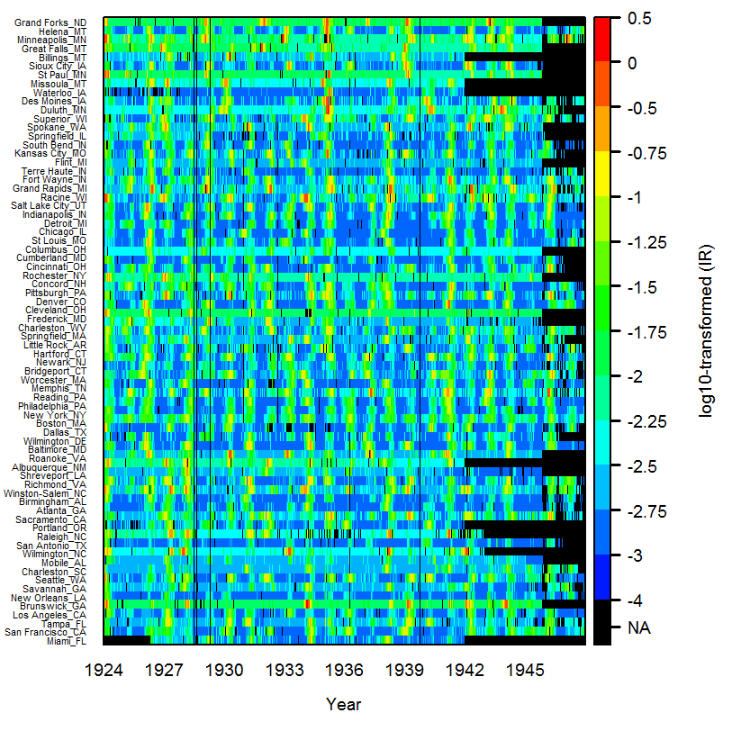
Figure 3. Available weekly log-transformed measles incidence rate from 1924 to 1948 for each of the cities included in the final analysis.

The annual signal for each city was found to be relatively synchronous across time (Figure 4 & 5). The asynchrony observed at the beginning and end of the time series are consistent with the edge effect expected from a wavelet transformation where the analysis of periodicity is limited at both ends of a time series. The amplitude of the annual signal varied across time and by city. The annual component of epidemics for each city do not exhibit any year-to-year uniformity in temporal shift in peak epidemic signal across the climatic seasonality from the city with the greatest range of temperatures, Grand Forks, ND, to the city with the smallest range, Miami, FL. This suggests that annual seasonality of measles incidence is not determined by seasonality of temperature. Variability is noted in the strength and timing of the annual measles epidemic cycles in different cities, but this does not seem to be related to different climate patterns in these cities.

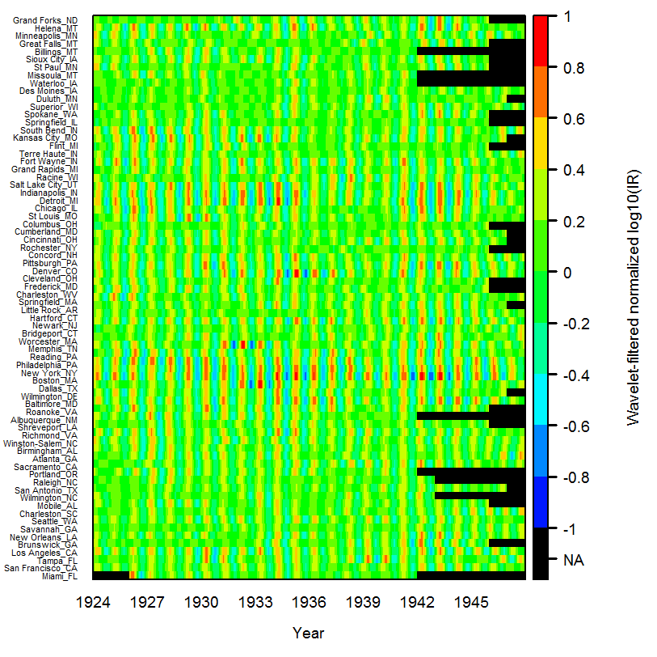
Figure 4. Annual signal of normalized log-transformed measles incidences rate reconstructed using a band-pass filter scaled to 45 to 55 weeks.

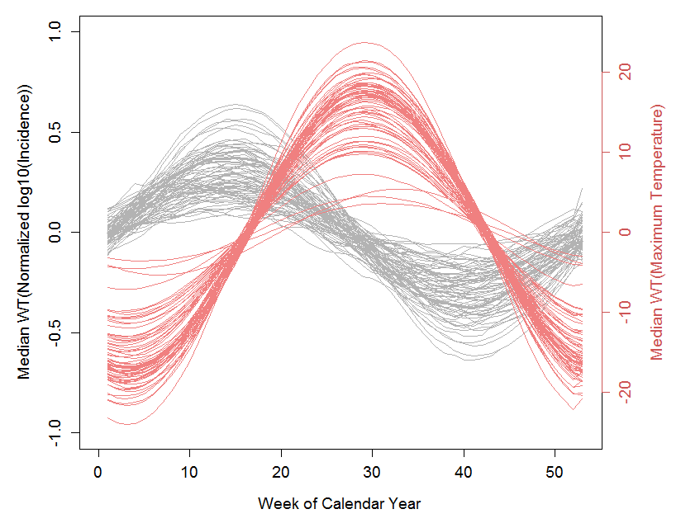
Figure 5. Median annual signal of measles incidence (grey) and temperature (pink) by calendar week for all cities.

The average number of weeks to 50% cumulative logIR was compared among cities. We found considerable overlap between the weeks to 50% among cities suggesting that epidemic progression occurs at roughly the same rate regardless of geographic location. The cities with the highest range of temperatures seem to have a wider distribution of weeks during which 50% cumulative logIR is reached (Figure 6). The similarity in the rate of epidemic progression across cities is consistent across all stages of the epidemic from 10 to 90% incidence within one measles year (Figure 7). Although local variability within each city is not captured, the similarity in epidemic progression across all 72 cities does not appear sensitive to national-scale variability in temperature regimes.

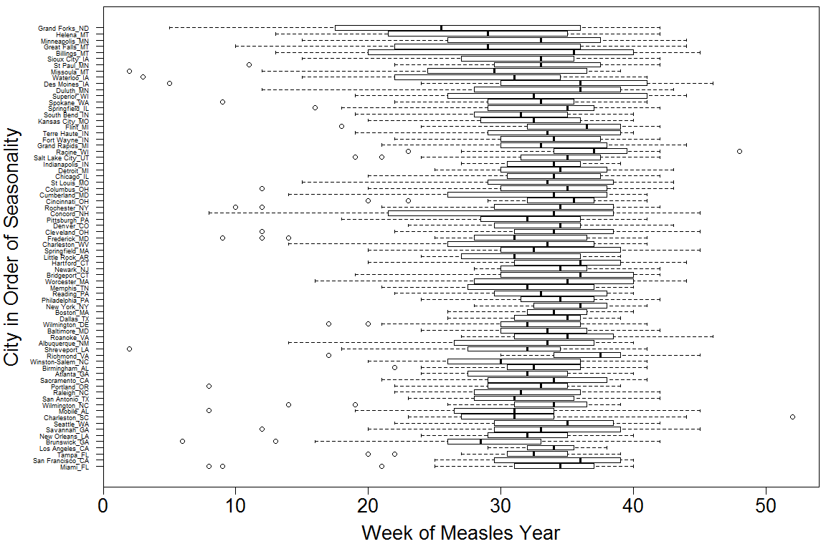
Figure 6. Boxplots of all weeks of the measles-year during which 50% cumulative log-transformed incidence rate (IR) occurred for each city sorted by temperature seasonality.

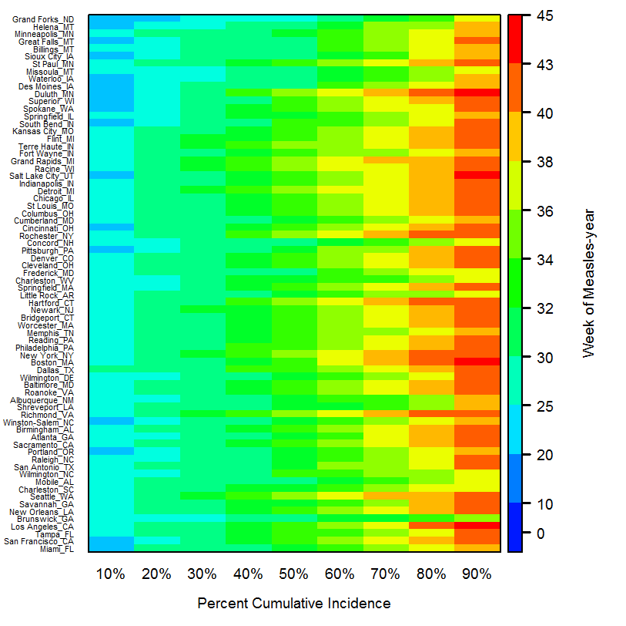
Figure 7. Mean number of weeks into the measles-year at which 10 – 90% cumulative log-transformed incidence rate (IR) occurred in each city sorted by climate seasonality.

A second analysis was conducted in order to explore the temperature variability that is necessarily masked by our definition of seasonality as a range of temperatures. To this end, we explored the range of temperatures which occurred at 50% cumulative logIR for each city (Figure 8). Temperature ranges were not significantly different among cities. This similarity of temperature ranges do not suggest temperature modulation of epidemics, however, as the inter-quartile range of temperatures for many cities span up to 20° Fahrenheit with some spanning up to 40°.

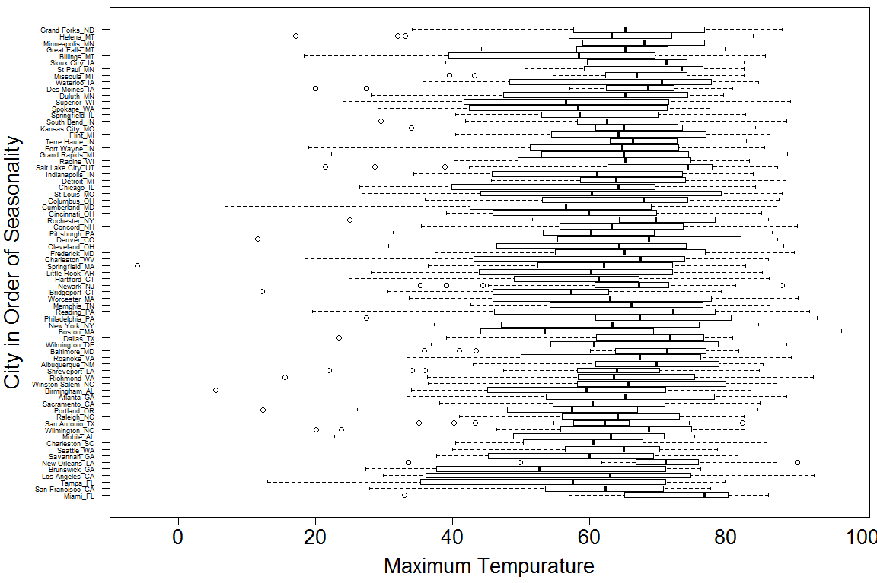
Figure 8. Boxplots of the temperatures calculated for all weeks of the measles-year during which 50% cumulative log(IR) occurred for each city sorted by climate seasonality.

The relative dominance of various periodicities was assessed by comparing multiple local wavelet spectrum analyses on each time series. Annual periodicity was prominent in all cities; however, cities otherwise exhibited a high level of variability in the dominant periodicity (Figure 9). Specific multi-annual periodicities were not associated with temperature seasonality.
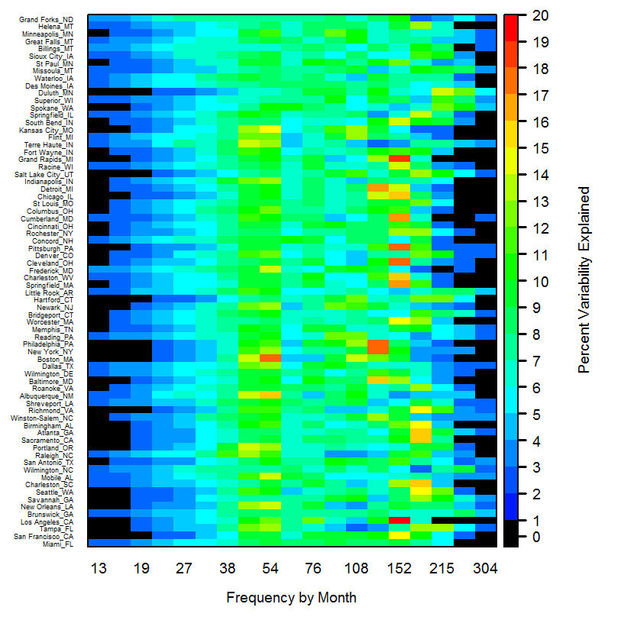
Figure 9. Percent variability attributable to different periodicities (frequencies) for each city sorted by climate seasonality.

discussion
Wavelet analysis found overall similarity in annual measles seasonality with year-to-year variation among cities. No association was found between annual seasonality of measles epidemics and seasonality of local temperature. Annual measles epidemics progress through the “measles-year” at similar accumulative rates across the US. This, too, exhibits variability among cities which cannot be directly associated with local temperature range.¹³
Newly available measles data for cities across the US provide an opportunity for retrospective assessment of pre-vaccine epidemics in locations straddling a gradient of climate types. Unfortunately, climatic variability cannot be adequately distilled into a single descriptive variable. The climates of the cities examined here also vary in factors other than temperature, such as precipitation and humidity. Given available data, however, other metrics require, at best, additional assumptions and, at worst, are not currently possible and remain unexplored in this analysis. Continued examination of these other factors may explain the measles seasonality, but are beyond the scope of this work. The challenges of this analysis are also compounded by the strict seasonal cycle of both temperature and measles epidemics which regularly begin in autumn and peak in spring (Figure 5). Assessment of disease progress by percent cumulative incidence found similar progression across the US (Figure 7). Some variability was observed but it was not associated with local temperature range. In order to assess any potential patterns between temperature and measles time series, wavelet band-pass filtering was used to isolate the annual signal in each measles time series. These signals were fairly synchronous across cities.
Unfortunately, although this filtering technique ensures comparison of only the pertinent part of the measles epidemic and temperature cycles, it does not resolve the issue presented in analysis of two tightly coupled cycles. The coupling cannot be mistaken for a causal link and current analysis techniques have limited capacity to determine any meaningful relationship between temperature and measles.
Previous work has associated measles with low autumnal temperatures as early as the 17th century.¹² These results, however, are countered by several studies successfully modeling measles transmission parameters capable of reconstructing time series which closely track school-terms in England and Wales, even reflecting short-term school breaks. Such modeling efforts generally include an external seasonal forcing co-efficient which is often based on the school-term. However, several variables that may influence the intra-annual seasonality, including both climatic factors and the school year, are cyclical on an annual level. Further analysis is required to fully discern the influence of each factor on measles intra-annual seasonality.
A clear definition of “low autumnal temperatures” is difficult in this analysis due to the wide range of temperature zones included in this analysis. Week 42 of the calendar year is associated with mid-October; median maximum temperatures are highly variable for this week, e.g. the median value for Miami, FL is 84°F and for Grand Forks, ND it is 55°F. The data discussed in this report provide an excellent starting point for testing the generalizability of the school-term forcing theory.
Although temperature seasonality was not associated with annual measles epidemic cycles, it could be related to temporal-spatial heterogeneity in measles transmission rates. Transmission indicators such as the basic reproductive rate or the force of infection can be computed from disease surveillance data in combination with birth rates. However, such analysis requires additional data, including city-level birth rates at a minimum, in order to estimate susceptible populations within each city over time.
Wavelet analysis of the available data was successfully extended to allow exploration of multi-annual variability for each city. Substantial variability, ranging from 1 to 4.5 years, in the dominant epidemic periodicities was discovered among cities. This variability may be associated with the population size of each city. established the critical community size (CCS) for persistence of measles between epidemics as roughly 250,000 people for communities in England, Wales and the United States. These studies assessed the relationship between community size and mean period between epidemics and number of fade-out events. More recent studies have established epidemic periodicity as primarily a function of the rate of disease transmission, temporally variable birth rates and demographic stochasticity such as unpredictable immigration of cases into communities where measles have faded out. Large and small cities were found to have different drivers of multi-annual periodicity. The external seasonal forcing coefficient, mentioned earlier, had a stronger effect on large city multi-annual epidemic cycles rather than on smaller city periodicities.²⁹ Similarly, the rate of introduction of new susceptibles into a community has been shown to be an important factor modulating annual measles epidemics in larger communities.
26 of the 72 cities included in the present study had populations greater than 250,000. Future exploration of the data presented here might shed further light on long-term disease dynamics but these analyses require city-level birth rate data for the early 20th century which are not readily available.

Conclusion
Although we could not demonstrate temperature seasonality as a driver of measles annual seasonality, consistent historical reports of measles epidemic seasonality prevent us from regarding school-term forcing as the only driver of such patterns. We suggest that currently undetected factors may play a strong role in the annual seasonality of epidemics. In addition, city-to-city variability of multi-annual periodicity of measles epidemics also presents some compelling questions. Additional high resolution data, in the form of city-level birth rate and annual population estimates, are required to perform the necessary analyses to answer such questions.

bibliography

