THE ECONOMIC BURDEN OF CUTANEOUS LEISHMANIASIS AND HIV CO-INFECTION IN BRAZIL AND POTENTIAL IMPACT OF NEW DRUG THERAPIES

by

Stephanie Kruchten

B.A., Johns Hopkins University, 2011

Submitted to the Graduate Faculty of

the Epidemiology Department

Graduate School of Public Health in partial fulfillment

of the requirements for the degree of

Master of Public Health

University of Pittsburgh

2013

UNIVERSITY OF PITTSBURGH

GRADUATE SCHOOL OF PUBLIC HEALTH

This essay is submitted
by
Stephanie D. Kruchten

on

April 15, 2013
and approved by

Essay Advisor:
Nancy W. Glynn, PhD ______________________________________
Research Assistant Professor
Department of Epidemiology
Graduate School of Public Health
University of Pittsburgh

Essay Reader:
Bruce Y. Lee, MD, MBA ______________________________________
Associate Professor
Departments of Medicine, Epidemiology, and Biomedical Informatics
School of Medicine and Graduate School of Public Health
University of Pittsburgh

Essay Reader:
Linda Rose Frank, PhD, MSN, ACRN, FAAN______________________________________
Associate Professor of Public Health, Medicine, and Nursing
Department of Infectious Diseases and Microbiology
Graduate School of Public Health
University of Pittsburgh

Copyright © by Stephanie D. Kruchten
2013
Nancy W. Glynn, PhD

THE ECONOMIC BURDEN OF CUTANEOUS LEISHMANIASIS AND HIV CO-INFECTION IN BRAZIL AND POTENTIAL IMPACT OF NEW DRUG THERAPIES

Stephanie D. Kruchten, MPH
University of Pittsburgh, 2013
ABSTRACT
Co-infection of HIV and cutaneous leishmaniasis (CL), an opportunistic disease among those with compromised immune systems, has emerged as an important public health concern in Brazil, due to an increase in the incidence of both infections. Pentavalent antimonials, amphotericin B, and miltefosine are all used for CL treatment among HIV positive individuals; however the utilized dosages vary between medical professionals and no designated treatment regimen for co-infected individuals exists. Due to the limited information available on the co-infection of these diseases, two Markov decision analytic computer models were created to evaluate the additional cost of CL in those co-infected with HIV when using currently available treatments and when a theoretical new treatment is used to treat CL/HIV co-infection. Results indicated that the least expensive lifetime cost per co-infection case is 14.4 times greater ($1,345) than the most expensive single infection case ($93). When comparing the current treatment options to the different scenarios of a theoretical new treatment, it is clear that focusing on new drug development effective for treating CL patients co-infected with HIV would provide considerable benefits. If CL incidence and the likelihood of CL/HIV co-infection continue to rise in Brazil, the total economic burden of CL due to co-infection (currently estimated between $0.2-6.8 million) will likely continue to increase, indicating a further need for research and development efforts for a safe effective drug to treat CL among those co-infected with HIV.
TABLE OF CONTENTS
1.0 introduction 1
1.1 CUTANEOUS LEISHMANIASIS 1
1.2 HIV in brazil 3
1.3 brazil and co-infection 4
2.0 Methods 6
2.1 model structure: co-infection model 8
2.2 model structure: new treatment model 13
2.3 Model Parameters 14
2.4 Sensitivity analyses 16
3.0 Results 18
3.1 Co-Infection model 18
3.2 new treatment model 21
4.0 Discussion 25
5.0 limitations 28
6.0 public health significance 29
6.1 public health policy 29
6.2 health care system 30
6.3 health care practitioners 32
7.0 Conclusion 33
BIBLIOGRAPHY 34

List of tables
Table 1: Model Inputs 7
Table 2: Cost per Co-Infection Case 19
Table 3: Cost per Co-Infection Case with New Treatment 22

List of figures
Figure 1: Transitional Health States 8
Figure 2: Cutaneous Leishmaniasis Model Structure 10
Figure 3: HIV/CL Co-Infection Model Structure 12
Figure 4: New Treatment Co-Infection Model Structure 14
Figure 5: Net Present Value of Countrywide CL-Related Costs due to CL/HIV Co-Infection vs. Percent of Cases with CL/HIV Co-Infection 20
Figure 6: Net Present Value of Countrywide CL-Related Costs Due to CL/HIV Co-Infection Utilizing a New Treatment vs. Percent of Cases with CL/HIV Co-Infection 23

introduction
Leishmaniasis is a parasitic neglected tropical disease seen in the tropics, subtropics, and parts of southern Europe. The infection is caused by the Leishmania parasite spread through the bite of female phlebotomine sand flies and can also spread from person to person through open wounds . There are two main forms of Leishmania infection: visceral leishmaniasis (VL) and cutaneous leishmaniasis (CL) with a worldwide prevalence of 12 million cases . Globally, the disease is underestimated and is on the rise in several countries . If left untreated, VL can be deadly and both VL and CL are considered to be an opportunistic disease for those with HIV . The World Health Organization (WHO) considers the leishmaniases a severe parasitic disease, and many groups including the World Health Assembly advocate on behalf of control and elimination of the disease .

CUTANEOUS LEISHMANIASIS
Cutaneous leishmaniasis is a significant problem in many parts of the developing world, affecting nearly 90 countries, and is separated into two categories: New World (the Americas) and Old World (Europe, Asia, Africa) . It is estimated that there are 1 – 1.5 million new cases of CL per year worldwide but due to under reporting, the actual number of new cases may be much higher . There are approximately 62,000 new cases that occur in South and Central America yearly . While 26,008 cases of CL have been reported per year between 2003 and 2007 in Brazil, it is believed the actual annual incidence of CL is between 72,800 and 119,600 due to under reporting . CL presents itself as a papule that develops 1 to 12 weeks after initial infection . The papule grows into an ulcer between 0.5 and 3 cm in diameter and typically those infected have more than one lesion . Most lesions caused by CL heal spontaneously within a few months but leave scars in their place . It has been noted that there is a seasonality associated with the disease, with increasing incidence during warmer months between May and September . Topical, systemic, and non-pharmacological treatments have all been used for CL but intralesional injections of pentavalent antimonials are the most common form of first line treatment .
After having a CL episode, a patient can develop mucocutaneous leishmaniasis (MCL) and diffuse cutaneous leishmaniasis (DCL) years after the initial lesion has healed. MCL is considered to be a chronic form of CL that is mainly seen in South America . The disease spreads into the mucous membranes of the nose, mouth, and throat and can cause large amounts of damage and disfiguration . Some risk factors for the development of MCL are gender, age, disease length, nutrition, genetics, skin lesion location, presence of other diseases, and no previous treatment for CL . The mucocutaneous form never self-heals, can be incredibly difficult to treat, causes disfiguration, and in some cases can even cause death . DCL is a form of CL that causes non-ulcerative nodules that are positive for parasites and have disseminated throughout the entirety of the body . It is considered a rare form of the disease with very few cases diagnosed each year in Brazil .
The three main species of Leishmania that affect Brazil’s population, L. braziliensis, L. amazonensis, and L. guyanensis are each associated with varying risks of severe disease outcomes . Nearly 60% of CL cases in Brazil are due to L. braziliensis and 1-3% of those cases will develop MCL . Approximately 20% of CL cases are due to L. amazonensis and 30% of those cases will develop DCL .

HIV in brazil
Although Brazil’s first case of HIV was thought to have occurred in the 1970s and the first known case of AIDS in the country was reported in 1980 in Sao Paulo . There has been an increased incidence of HIV throughout Brazil over the past few decades specifically among women, uneducated, and poor populations, due in part to the decrease in the mortality rate associated with HIV and AIDS in Brazil . Brazil started implementing HIV education programs and campaigns to educate the nation on HIV and ways to protect yourself against infection . These programs targeted the at-risk populations such as injection drug users, men who have sex with men, and sex workers . In response to the high cost of AIDS treatment in the 1990s (exceeding $10,000 USD per patient annually), Brazil began to develop highly active antiretroviral therapy (HAART) and has provided access to free HIV/AIDS care since 1996 . In 1996, the Brazilian Congress enacted a law that stated all individuals with AIDS would be granted free treatment . Brazil produces non-patented versions of generic antiretroviral therapies as well as negotiates lower prices on patented therapies to lower the countrywide cost for treating HIV/AIDS . Brazil is one of two countries that have sustained nationwide access to drug therapies for HIV . By 2004, Brazil was able to reduce AIDS mortality by 50% and hospitalizations due to AIDS decreased by 80% since 1996 . In 2009, there were approximately 660,000 people living with HIV/AIDS and the number continues to rise, especially among the risk populations in Northeastern Brazil .

brazil and co-infection
Brazil has a population of over 193 million people . HIV and CL are both significant health problems in Brazil. The incidence of HIV was documented as 12.3 per 100,000 people in 2001 and incidence of cutaneous leishmaniasis was noted as 23 per 100,000 people in 2004 resulting in over 1.1 million people with HIV and 8 out of 100,000 Brazilians dying from the disease . The burden of these diseases has been further exacerbated by the increase in occurrence of co-infection. Since 1990, 31 countries have reported cases of leishmania and HIV co-infection . The number of leishmania and HIV co-infection cases has increased more rapidly than the number of reported AIDS cases during the same period of time, indicating a need for further surveillance and monitoring .
By 2003, nearly 100 cases of leishmania HIV co-infection had been presented in formal literature . All cases were followed up by the WHO’s global network for the surveillance of Leishmania/HIV co-infection and it was discovered that 63% of the co-infection cases were due to either CL or MCL with 37% attributable to VL . Approximately 70% of all cases were present in people between the ages of 20 and 40 . As the co-infection of the diseases is fairly new, the best treatment regimen is still debated as detailed accounts of treatment and outcomes for co-infection cases have been rarely documented, most being anecdotal . Pentavalent antimonials, amphotericin B, and miltefosine have all been used to treat CL or MCL co-infection with HIV .

Methods
Two Markov decision analytic computer simulation models were constructed utilizing TreeAge Pro 2012 (TreeAge Software, Williamstown, MA) to quantify the additional burden of co-infection, effect of this additional burden on national estimates, and the potential benefits of new treatment development in Brazil. One model focused on comparing the single disease of CL to the co-infection between CL and HIV using the cost and probabilities of current treatment for CL (the Co-Infection Model). A second model was developed to determine the potential cost/economic benefit of a theoretical new treatment for CL was developed targeting those with the co-infection (the New Treatment Model). The New Treatment Model was utilized to illustrate the potential variations in drug developments while being economically beneficial and establish future targets for drug development. The age at which individuals entered the model was determined by a triangular distribution with a range between 1 and 62 and a mean of 37 where individuals would cycle until death. The inputs of both Markov decision trees can be seen in Table 1, separated by single infection, co-infection, or seen in both. All past and future costs were converted to 2013 US$ utilizing a discount rate of 3% .

Table 1: Model Inputs
Parameter |  | Value | Reference
Single CL Infection
 | Lifetime risk of MCL | 2%
 | Lifetime risk of DCL | 6%
 | Cure Rate: Pentavalent Antimonials (CL) | 61%ª (40-86%)
 | Cure Rate: Pentavalent Antimonials (MCL) | 67%ª (28-94%)
 | Cure Rate: Pentamidine (CL) | 75%ª (71-87%)
 | Cure Rate: Pentamidine (MCL) | 93%
 | Cure Rate: Amphotericin B (MCL) | 89%
 | Cure Rate: Any Treatment (DCL) | (0-10%)^{b}
 | Cost: Pentavalent Antimonials (CL) | $169.37^{c}
 | Cost: Pentavalent Antimonials (MCL/DCL) | $254.06^{c}
 | Cost: Pentamidine (CL/MCL/DCL) | $0^{c}
 | Cost: Amphotericin B (MCL/DCL) | $150^{c}
CL and HIV Co-Infection
 | Cure Rate: Pentavalent Antimonials (CL) | 50-100%^{b}
 | Cure Rate: Amphotericin B (CL) | 90%ª (75-100%)
 | Cure Rate: Miltefosine (CL) | 64%ª (50-100%)
 | Relapse Rate: Pentavalent Antimonials (CL) | 75-100%^{b}
 | Relapse Rate: Amphotericin B (CL) | 25%ª (0-100%)
 | Relapse Rate: Miltefosine (CL) | 88%ª (75-100%)
 | Cost: Pentavalent Antimonials (CL) | $254.05^{c}
 | Cost: Amphotericin B (CL) | $81-150^{b}
 | Cost: Miltefosine (CL) | $119-144^{b}
 | Side Effects: Elevated Liver Enzymes – Miltefosine | 1-10%^{b}
 | Side Effects: Elevated BUN and Creatinine^{d} - Miltefosine | 0.01-1%
 | Side Effects: Death - Miltefosine | 0.9%
Utilized in All
 | Cost: Lab Materials per Day | $0.50
 | Cost: Hospital Bed per Night | $18.67^{c}
 | Side Effects: Renal Toxicity – Amphotericin | 15%
 | Probability of Having CL and HIV | 32%
 | Probability of Having MCL and HIV | 68%
ª Triangular distribution
^{b} Uniform distribution
^{c} All costs are calculated in 2013 US dollars
^{d} Both BUN and Creatinine levels are used to determine kidney functionality

model structure: co-infection model
The Co-Infection Model compares the single infection of cutaneous leishmaniasis with the co-infection of CL and HIV. Figure 1 illustrates the various ways individuals can transition between health states in the Co-Infection Model.

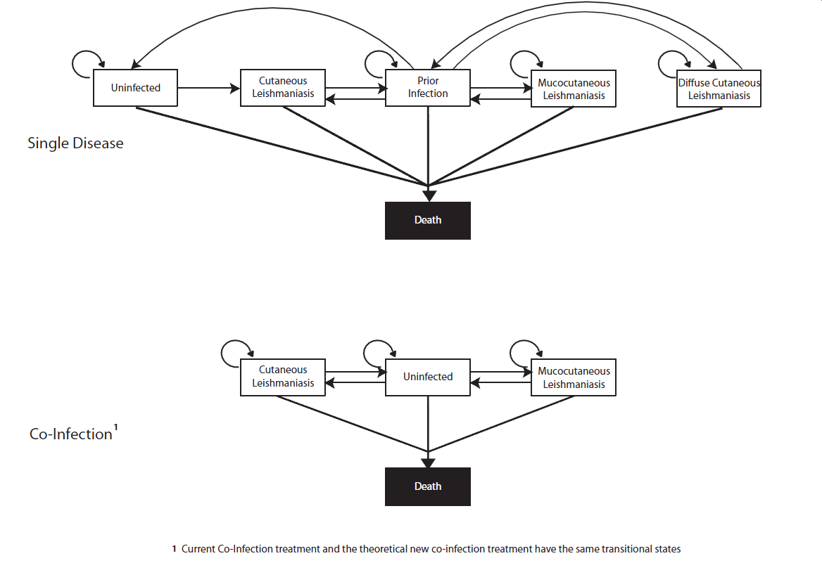
Figure 1: Transitional Health States
NOTE: Single Disease transitional states based upon previous model in Bacon et al 2013 [41]

Individuals in the single disease path had the ability of transitioning between six mutually exclusive Markov states :
- Uninfected: Healthy individuals, not infected with CL.
- Cutaneous Leishmaniasis: Individuals currently infected with CL that could only stay in this state for one year.
- Prior Infection: Individuals who have recovered from CL, MCL, or DCL. Individuals can stay in this state for a maximum of ten years or until they have died or contracted CL, MCL, or DCL.
- Mucocutaneous Leishmaniasis: Individuals currently infected with MCL, only contracted after an initial case of CL.
- Diffuse Cutaneous Leishmaniasis: Individuals currently infected with DCL, only contracted after an initial case of CL.
- Death: Individuals died and are unable to continue to cycle through the model.

All individuals are entered into the model as infected with CL. At the end of the year, they transition out of the CL state into either death or prior infection. While in prior infection, individuals have the probability of dying, contracting CL, MCL, or DCL, remaining in the prior infection state, or transitioning into the uninfected state after having been in the prior infection state for ten years. Individuals in the uninfected state can transition to death, CL, or remain as uninfected. The transitioning of MCL and DCL are similar; individuals can either transition into death, prior infection, or remain infected with either MCL or DCL. A more complete diagram of the transitions and model structure for the single CL infection can be seen in Figure 2. As depicted in Figure 2, individuals can be treated for their infection, be cured of infection, have side effects from treatment, or continue to be infected without medical assistance. In the diagram, ‘kidney’ refers to the renal toxicity occasionally seen when amphotericin treatment is used for MCL and DCL. All probabilities and costs have been listed in Table 1.
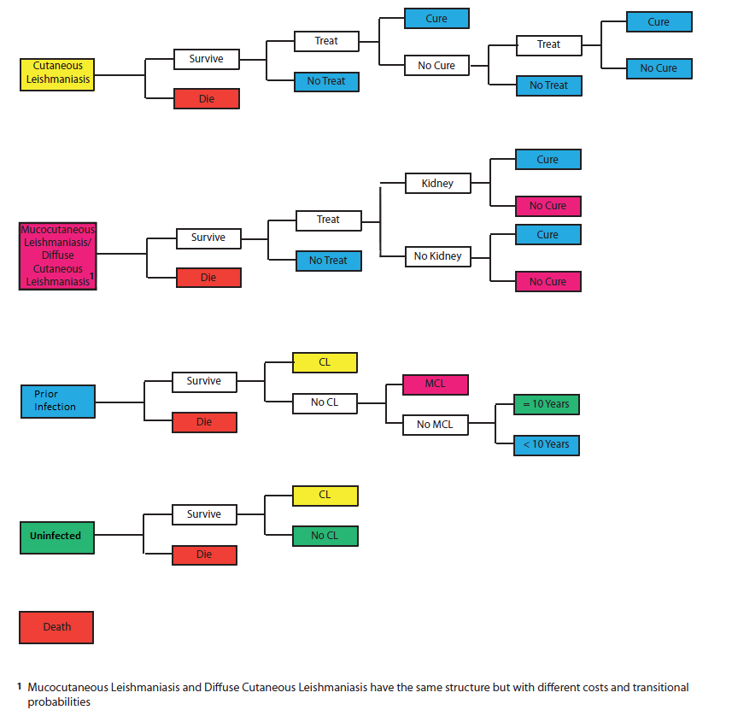
Figure 2: Cutaneous Leishmaniasis Model Structure

While these transition states hold true for a mono-infection case of leishmaniasis, the co-infection path has four mutually exclusive Markov states that those with HIV can transition between:
- Uninfected: Individuals do not suffer from CL but are still HIV positive.
- Cutaneous Leishmaniasis: Individuals with both CL and HIV. Unlike the single CL infection, individuals are not required to leave this state after one year.
- Mucocutaneous Leishmaniasis: Individuals with both CL and HIV. Unlike the singular CL case, individuals do not need a prior CL infection before contracting MCL.
- Death: Individuals died and are unable to continue to cycle through the model.

All individuals are sent into the model as infected with either CL or MCL. While in either the CL or MCL states, individuals can transition to the states of death, uninfected, or remain in either CL or MCL. Both states have similar transitions but with differing probabilities and costs associated with treatment, cure, and side effects (Table 1). Individuals in the uninfected health state can either transition to death, CL, MCL, or remain as uninfected. A more complete diagram of the transitions and model structure for the co-infection can be seen in Figure 3. Unlike individuals in the single infection branch, individuals in the co-infection branch have the probability of dying due to miltefosine treatment, although this probability is fairly small. Additionally, once a side effect has been recorded for an individual, they may not receive the same medication again. The side effects are labeled as Liver and Creatinine in the miltefosine treatment and Kidney for the amphotericin treatment. Liver refers to elevated liver enzymes and creatinine refers to elevated creatinine and BUN levels in the blood after taking miltefosine. As with the single infection for MCL and DCL, Kidney refers to renal toxicity after taking amphotericin.
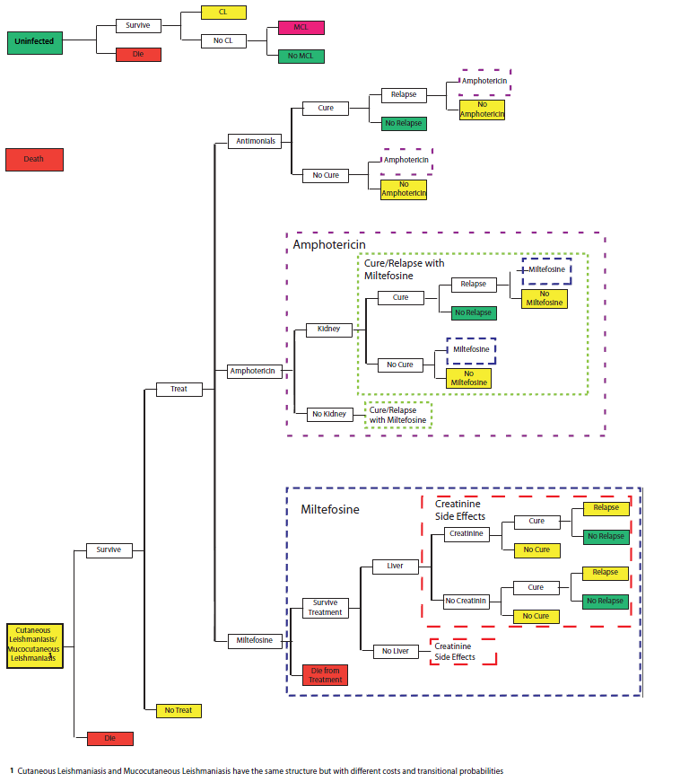
Figure 3: HIV/CL Co-Infection Model Structure

model structure: new treatment model
The New Treatment Model compares the co-infection branch as depicted in the Co-Infection Model with a new Markov state that uses a theoretical new treatment for CL for those infected with HIV. The transitional health states of the new treatment are similar to those of the co-infection transitions depicted in Figure 1. There are four mutually exclusive Markov states that those with the new treatment can pass through, similar to those with the co-infection:
- Uninfected: Individuals do not suffer from CL but are still HIV positive.
- Cutaneous Leishmaniasis: Individuals with both CL and HIV. Unlike the single CL infection, individuals are not required to leave this state after one year.
- Mucocutaneous Leishmaniasis: Individuals with both CL and HIV. Unlike the singular CL case, individuals do not need a prior CL infection before contracting MCL.
- Death: Individuals died and are unable to continue to cycle through the model.

Again, individuals are entered into the model infected with either CL or MCL. While the transitions are the same, the treatments received have varied and thus so have the costs and probabilities. Those in the new treatment branch have received a theoretical new treatment aimed to reduce the effects of CL in those who are HIV positive. Figure 4 has a more complete model structure and transition states. Individuals in the New Treatment Model do not have associated hospital costs for treatment, as it is assumed the theoretical treatment would not require an extended stay. As in the Co-Infection Model, if individuals experienced side effects from treatment, they were not given the treatment again. However, unlike the Co-Infection Model, no other treatments were offered after the presentation of side effects.
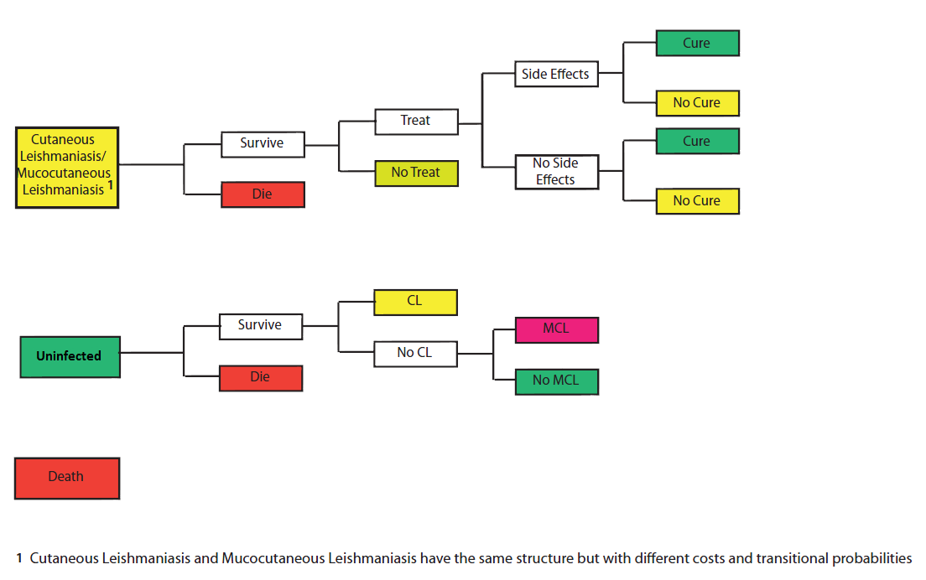
Figure 4: New Treatment Co-Infection Model Structure

Model Parameters
A literature review on cutaneous leishmaniasis co-infection with HIV in Brazil was conducted using MEDLINE and the following terms: cutaneous leishmaniasis, HIV, and co-infection. The most current information was collected and compiled into Table 1.
Those with CL alone sought treatment for the infection 20-60% of the time compared to those who suffered from MCL or DCL who sought treatment 40-100% of the time. Those who were treated initially received the WHO recommended dose of 20 mg/kg of pentavalent antimonials over a 20 day span . Individuals were retreated with either another regimen of pentavalent antimonials or pentamidine after a relapse . After two treatment failures (i.e. two relapses), individuals no longer sought treatment for their infection. Those with MCL or DCL initially received a 30 day regimen of pentavalent antimonials while pentamidine and miltefosine were given if the disease relapsed . After 4 treatment relapses per MCL or DCL episode, treatment was discontinued.
Individuals who were previously infected with HIV that contracted CL had a very different treatment regimen than those with a mono CL infection, requiring stronger medications and larger dosages. The co-infected individuals initially received a regimen of a total of 30g of pentavalent antimonials . If treatment did not work or the individual relapsed, 540 mg – 1g of amphotericin B was administered . Again, if treatment was unsuccessful or relapse occurred a regimen of 5,500mg of miltefosine was administered .
Many of the drugs used to treat CL can be highly toxic and are associated with a variety of side effects that add additional costs to treatment. Amphotericin B has a known side effect of renal toxicity that has an associated additional hospital stay between 1 and 127 days with an average of 10 . Miltefosine too has associated side effects of either an elevated BUN and creatinine levels or elevated liver enzymes in conjunction with a small probability of death due to treatment . Once an individual presents with a side effect, the medication is removed from their list of possible treatment options. Finally, there is no limit on the number of times individuals can seek treatment within the co-infection branch.
The New Treatment Model has individuals receiving a theoretical treatment instead of current treatment options for co-infection. The transition probabilities are similar to those of co-infection but the costs, cure rate, and the rate of side effects differ.
Several assumptions have been made throughout the two models. First, those with co-infection do not become immune to treatment. While development of immunity to drug therapies is entirely possible in a real world situation, it cannot be taken into consideration in these models. Pentavalent antimonials can also lose effect once treatment fails and an individual relapses but the models assume that all treatment will work just as effectively each time they are used. Second, side effects for high dosages of pentavalent antimonials have been recorded. However, there are no incidence rates for Brazil specifically among those with CL and HIV. Third, in the New Treatment Model individuals only have treatment costs associated with co-infection without associated hospital costs. It is assumed that the new treatment will not require a hospital stay. Finally, the small sample sizes found in peer reviewed journals are indicative of the larger co-infection population in Brazil, that they are typical cases of co-infection. The cases presented throughout the literature are few compared to the severity of the population, therefore the assumption that the cases that have been studied are similar to the cases that have not been.

Sensitivity analyses
Several sensitivity analyses were run on the Co-Infection Model to ensure a wide range of data could be collected. Analyses were run on the probability of seeking treatment (10-90%), the multiplicative factor between MCL cure rates and CL cure rates (10-90%), and the multiplicative factor between the treatment cost of MCL and CL (1-3).
- Probability of Seeking Treatment: 10% – 90%
- Factor Between MCL and CL Cure Rates: 0.1 – 0.9
- Factor Between MCL and CL Treatment Costs: 1 – 3

Sensitivity analyses were also performed on the New Treatment Model to ensure a wide range of treatment options to compare to existing co-infection treatment for CL, assess thresholds of cost savings or cost-effectiveness, and develop minimum criteria for efficacy and cost. Analyses were run on the probability of seeking treatment, the cost of the new treatment, the probability of side effects from treatment, and the probability of being cured from the treatment.
- Probability of Seeking Treatment: 10% – 90%
- Cost of New Treatment: $40.50 – 508.10
- Probability of Treatment Side Effects: 1% – 30%
- Cure Rate for Treatment: 0.3 – 1.0

Results
The net present value per case of CL is substantially higher for individuals infected with HIV ($1,345-12,854) compared to individuals with no co-existing infections ($93). These findings in conjunction with current CL/HIV co-infection prevalence estimates suggest that the total economic burden of CL due to co-infection in Brazil over the lifetime of those currently infected (the net present value) is approximately $0.2 million. Alarmingly, a slight increase in prevalence of co-infection (0.4% increase) caused the countrywide costs to increase by 5 fold to $1 million. Use of the theoretical new treatment for CL/HIV co-infection resulted in substantially less lifetime costs being accrued per co-infection case across the range of treatment seeking probabilities, costs, cure rate, and side effect risks. A new treatment could potentially save as much as $48.1 million in current and future CL treatment-related costs in Brazil among currently infected cases alone.

Co-Infection model
When the currently available CL treatments are used, the cost per co-infection case in Brazil for the Co-infection Model ranges from $1,345-45,374 depending on the probability of seeking treatment, the factor between MCL and CL treatment costs, and the factor between MCL and CL cure rates. The values can be seen in Table 2 depicting the cost per case of co-infection in the Brazilian population. As the probability of seeking treatment increases, the cost per co-infection case increases. Additionally, as the factor between MCL and CL treatment costs increases the cost per co-infection case increases as well. The significant ranges follow:
- Lowest Cost per Case: $1,345 – 1,482
- Midpoint Cost per Case: $7,154 – 14,244
- Highest Cost per Case: $12,854 – 45,374

Table 2: Cost per Co-Infection Case
Factor Between MCL and CL Treatment Costs | Probability of Seeking Treatment
Factor Between MCL and CL Treatment Costs | 10% | 30% | 50% | 70% | 90%
1.0 | $1,345-1,482 | $3,074-4,385 | $4,091-7,724 | $4,700-11,688 | $5,088-16,321
1.5 | $1,800-2,006 | $4,187-5,602 | $5,618-10,980 | $6,457-16,765 | $7,054-23,604
2.0 | $2,256-2,529 | $5,313-7,864 | $7,154-14,244 | $8,245-21,869 | $9,002-30,843
2.5 | $2,716-3,051 | $6,425-9,604 | $8,681-17,489 | $10,041-26,996 | $10,917-38,108
3.0 | $3,169-3,580 | $7,527-11,360 | $10,235-20,751 | $11,797-32,021 | $12,854-45,374

The net present value per CL mono-infection case in the Co-Infection model was approximately $93. Table 2 shows the cost co-infection case was much larger than the cost per single infection as lowest cost per co-infection case was $1,345, nearly 14.4 times greater than that of the highest cost per CL case for the single disease.

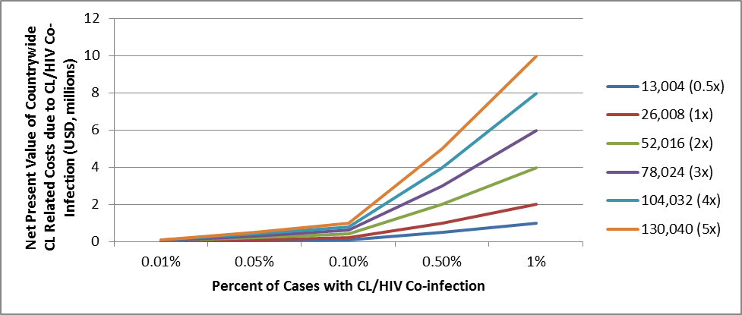
Total Number of CL Cases (Current Value Reference)
Current
Figure 5: Net Present Value of Countrywide CL-Related Costs due to CL/HIV Co-Infection vs. Percent of Cases with CL/HIV Co-Infection

As both the incidence of CL and HIV are on the rise separately, it is likely co-infection will increase as well, making it important to look at the possible total societal costs for CL and HIV co-infection. Figure 5 shows the impact of increasing the percent of cases with co-infection by the total number of CL cases on the societal cost. A baseline value per cost of co-infection case was set with a factor of 1.5 between MCL and CL treatment costs, a factor of 0.7 between MCL and CL cure rates, and a 70% probability based upon common trends seen within the mono-infection. It is clear from Figure 5 that the total societal costs have the potential of being several million dollars per year for Brazil. Even with only 13,004 CL cases, half of the current annual amount, if 1% of those cases were co-infections Brazil would have an increase of nearly $1 million. It is evident that the percent of co-infection cases needs to remain below 0.10% as the total costs increase rapidly for all number of CL cases. These costs, presented in the millions, have the potential of growing rapidly as the probability of co-infection increases. The costs presented are only indicative of co-infection cases and not of all CL, HIV, and co-infection cases in total. Furthermore, these costs are a conservative estimate for the societal cost perspective as they do not take into consideration the cost of medical personnel, maintenance, transportation, and materials.

new treatment model
The costs per co-infection case with the new treatment range between $39 – 1,627 as seen in Table 3, where the ranges represent the variation that occurred over the values evaluated for the probability of side effects. As the probability of seeking treatment increases, the cost per case increases. However, the probability of seeking treatment had a greater impact on the cost per case than the cost of the theoretical new treatment. Conversely, as the cure rate increases, the cost per co-infection case decreases as there are fewer relapses. The highest discrepancy seen between current co-infection treatment and theoretical new treatment has current treatment 1,163.4 times more expensive per case than the new treatment. Additionally, the theoretical new treatment would result in a more beneficial cost per case than current single infection at nearly all new treatment costs. The significant ranges follow:
- Lowest Cost per Case: $39 – 66
- Midpoint Cost per Case: $231 – 272
- Highest Cost per Case: $1,535 – 1,627

Table 3: Cost per Co-Infection Case with New Treatment
Cure Rate |  | Probability of Seeking Treatment
 |  | 10% | 30% | 50% | 70% | 90%
Cost of New Treatment = $40.50
 | 30% | $63-108 | $101-174 | $115-197 | $121-209 | $125-216
 | 50% | $49-84 | $69-118 | $75-128 | $77-133 | $79-136
 | 70% | $41-70 | $54-92 | $57-98 | $58-100 | $59-102
 | 90% | $39-67 | $50-86 | $53-91 | $55-93 | $56-95
 | 100% | $39-66 | $49-84 | $52-89 | $53-91 | $54-92
Cost of New Treatment = $81.00
 | 30% | $124-169 | $200-273 | $226-308 | $240-327 | $248-338
 | 50% | $97-132 | $136-185 | $147-201 | $153-208 | $156-213
 | 70% | $81-110 | $106-144 | $112-153 | $116-158 | $117-160
 | 90% | $78-105 | $100-135 | $106-143 | $108-147 | $110-149
 | 100% | $76-103 | $98-132 | $103-140 | $106-143 | $107-145
Cost of New Treatment = $167.53
 | 30% | $256-301 | $411-484 | $465-547 | $492-579 | $509-598
 | 50% | $199-234 | $279-328 | $302-356 | $313-369 | $320-378
 | 70% | $166-196 | $217-256 | $231-272 | $237-279 | $241-284
 | 90% | $160-188 | $205-241 | $217-255 | $223-261 | $226-265
 | 100% | $157-184 | $201-235 | $212-248 | $217-255 | $220-258
Cost of New Treatment = $254.05
 | 30% | $388-432 | $622-694 | $704-786 | $745-832 | $769-860
 | 50% | $302-337 | $422-472 | $457-511 | $475-531 | $484-541
 | 70% | $252-281 | $329-367 | $349-391 | $359-402 | $365-408
 | 90% | $242-270 | $310-346 | $322-366 | $337-376 | $342-381
 | 100% | $238-265 | $304-338 | $321-357 | $329-366 | $333-371
Cost of New Treatment = $508.10
 | 30% | $773-818 | $1,241-1,315 | $1,406-1,487 | $1,485-1,573 | $1,535-1,627
 | 50% | $601-364 | $842-892 | $913-967 | $947-1,003 | $968-1,025
 | 70% | $502-532 | $656-649 | $698-739 | $717-759 | $728-771
 | 90% | $483-510 | $619-655 | $656-693 | $672-711 | $682-721
 | 100% | $474-502 | $606-641 | $640-677 | $657-694 | $665-704

Figure 6 illustrates the impact of increasing the population of CL cases co-infected with HIV and the number of CL cases on the total lifetime cost of CL cases using the new treatment for CL/HIV co-infection in Brazil. Baseline values used for countrywide estimates included $167.53 for the new treatment, 70% probability of seeking treatment, 70% drug cure rate, and 10% for probability of side effects. The new treatment decreased the societal cost of co-infection substantially despite the increase in both CL and HIV incidence. While the societal costs drastically increased at 0.10% for the current co-infection trajectory (Figure 5), the values do not significantly increase until 1% of cases with co-infection with the new treatment regimen (Figure 6).

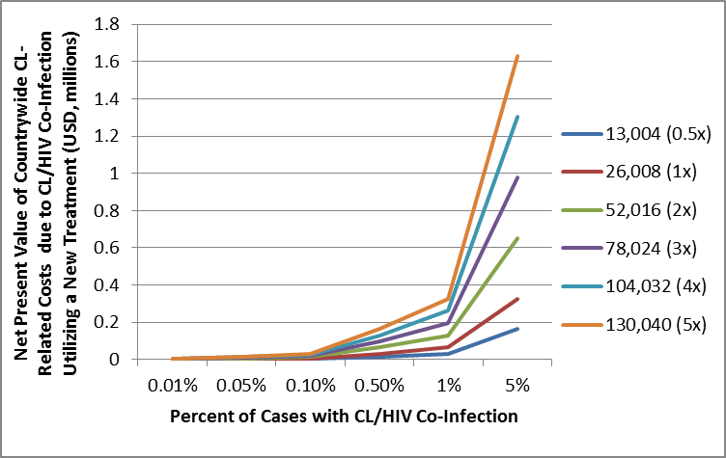
Total Number of CL Cases (Current Value Reference)
Current
Figure 6: Net Present Value of Countrywide CL-Related Costs Due to CL/HIV Co-Infection Utilizing a New Treatment vs. Percent of Cases with CL/HIV Co-Infection

Currently in Brazil, there are 26,008 newly reported cases per years and 0.10% of those cases are co-infection cases. Figure 5 shows the highest net present value possible at the current percent of CL/HIV co-infection at approximately $1 million at 130,040 total number of CL cases, 5 times the current number of reported cases. In order for the economic burden to reach the same value using the new theoretical treatment for co-infection, the total number of CL cases would need to be 78,024 (3 times current number of reported CL cases) with 5% of those cases having co-infection. At the current percent of CL/HIV cases, the new treatment would save between $0.02 and 9.63 million depending on the total number of CL cases but the new treatment has the potential of saving up to $48.15 million with 130,040 cases of CL with 5% being co-infection cases.

Discussion
The results indicate that the economic burden for co-infection utilizing current treatment options is substantially higher than the economic burden of a theoretical new treatment options when varying a combination of treatment costs, cure rates, and side effect risks. Currently Brazil has 26,008 reported cases of CL yearly but it is estimated that the true incidence is between 72,800 and 119,600 due to under reporting with a current probability of co-infection at 0.1% . As the incidence increase, the total societal cost of co-infection increases substantially. For those with HIV in Brazil, an endemic infection such as cutaneous leishmaniasis is considered to be an opportunistic disease, infecting many with compromised immune systems. Determining the best possible treatment regimen for those infected with both CL and HIV is necessary. Currently there is substantial debate on the best treatment practice as the majority of co-infection cases have not had proper scientific documentation of treatment regimens. Utilizing the current case estimate of 26,008, our model results suggest a conservative estimate of societal cost of between $0.2 – 6.8 million assuming the current CL/HIV co-infection risk (0.1%) in Brazil. Increasing the probability of co-infection to 10% causes a dramatic increase in countrywide costs, totaling $681 million.
The development of a new treatment could be extremely beneficial to Brazil. The costs per case are drastically lower for the new treatment compared to the current treatment at nearly all the different sensitivity analyses. It is clear that Brazil should invest in a new treatment to cure CL targeting those with HIV. Between 2008 and 2012, Brazil had a health expenditure of 9% of the total GDP, for a total of over $710 billion USD . Developing a new and effective treatment for those with co-infection, several million dollars could be saved over the remaining lifetime of those currently infected.
Compared to the single infection of CL, the co-infection of CL and HIV is over 14 times greater than the least expensive co-infection per case. When comparing the two most expensive costs per case between the single infection and the co-infection, the co-infection is nearly 485 times greater per case than the single infection. Additionally, the new treatment was almost always less costly than currently available co-infection treatment options. The development of a new theoretical treatment would not only be beneficial for co-infection of CL and HIV but for mono-infection of CL. The increasing costs of treating co-infection with current treatment, the increasing number of people contracting both CL and HIV simultaneously, and the inability for current treatment to cure CL for those with co-infection make the development of a new treatment option more appealing and economically beneficial.
This economic analysis of treatment for HIV and CL co-infection in Brazil is informative for drug developers, funders, government officials, and decision makers in determining financial benefits of specific cut offs. The analyses performed show that a new treatment could cost as high as $508.10, a low cure rate of 30%, and a 30% probability of treatment and still cost less than the current treatment regimen. Only at a probability of 50% or higher with a similar cost of treatment and cure rate would the new treatment not be beneficial compared to the current treatment at a 10% probability of seeking treatment and a factor of 1.0 between MCL and CL treatment costs. At all other iterations of the Co-Infection Model, the New Treatment Model is less expensive per co-infection case.

limitations
Models are based upon assumptions and are therefore a simplistic representation of the real world. Additionally, limited information available about the co-infection of cutaneous leishmaniasis and HIV required assumptions to be made where no data was present which could cause model results to deviate from the real world. Furthermore, additional information is needed regarding the relationship between CL treatment and MCL treatment. Many of the single infections demonstrate that MCL is 1.5 times more expensive than CL however; this difference remains unknown for those who are co-infected. Studies evaluating the differences in CL and CL/HIV co-infection and the effect of treatment regimens on co-infection are recommended to maximize treatment effectiveness while minimizing costs.

public health significance
As the incidence of both HIV and CL mono-infections are on the rise, it is imperative to take a closer look at the burden of those with both CL and HIV simultaneously. By looking into the current situation in Brazil and anticipating a new treatment for those with the co-infection, this paper aims to illustrate the importance of continued drug development. As newer scientific reports emerge, these models can be adapted to include new information, increasing their accuracy. Those infected with HIV are now living longer and becoming infected with other diseases such as CL, an opportunistic disease for those with lowered immune system functionality. Brazil is one of the major contributors to global cases of CL and MCL and while the HIV programs have been successful, the incidence of HIV is still increasing. Therefore, analyzing the effects of the two diseases simultaneously becomes important to help researchers, medical practitioners, and governmental officials better prepare themselves for handling patients with co-infections.

public health policy
Development and implementation of a new treatment targeting individuals with CL and HIV co-infection could have an impact on public policy. Current policy would need to be reviewed and perhaps amended to ensure that all individuals with HIV will have access to the current medication regimens if they become infected with CL. Currently, HIV medications are provided by the Brazilian government. Developing a new medication regimen for treatment for co-infection could save Brazil significant costs as seen by the net present value difference of $0.02 million at current reported number of CL cases (26,008) and percent of co-infection (0.1%). If Brazilian government provides the treatment for CL to HIV patients, health expenditures will decrease through better medication practices (i.e. no more trial and error), fewer medication regimens, and less expensive treatment. A possible approach would be to mandate all government subsidized clinics providing ART to supply the theoretical new treatment. While the financial resources to implement such a policy change would be needed, the policy has the potential of saving resources in the long term. Medications would need to be readily available to prescribing clinicians. Ideally, co-infection should be able to be treated at the same clinic where ART is prescribed along with medical visits.

health care system
The health care system would need to be adapted to better suit the ever growing need for co-infection treatment. Local health clinics would need to be fully supplied with the newest treatment regimen options, especially those in areas of higher than countrywide incidence. Access to medications can be challenging in rural areas of Brazil, therefore it is recommended that the health facilities treating those using ART should also have the new treatment for CL/HIV co-infection. Ensuring treatment for CL/HIV co-infection will place a larger burden on the health facilities. Therefore, the health care system would need to expand, especially in rural areas of Brazil with limited resources but high CL incidence rates. Further burden is placed upon health facilities specializing in ART as the numbers of those with co-infection are expected to increase. While the current treatment options for co-infection require hospital stays, the theoretical new treatment would treat patients on an out-patient basis, alleviating some of the potential costs to the health care system. Therefore, health facilities would need to increase their capacity for short term treatment. In areas of Brazil with high co-infection rates it may become necessary to expand the facility to include staff dedicated solely to the treatment of patients with co-infection.
The health system should consider issuing an official guide to medication and dosage for practitioners to follow to ensure quality control and proper medication use throughout the country. Current treatment practices for co-infection are heavily disjointed, as treatment regimens vary by physician. Issuing a standardized treatment guide would enable consistent treatment plans throughout Brazil, enabling those co-infected to access clinical services from different facilities and receive the same standard of care. The guide should also include a list of all side effects possible from treatment and intervention to alleviate or reduce these effects.
In general the Brazilian health care system would need to adapt for the growing number of co-infection cases. However, the development of a new treatment could lessen the burden. Fully providing health facilities with the new medication regimen and increased medical staff, providing free CL treatment to those with co-infection, expanding certain facilities around the country, and standardizing medication regimens are some of the steps the health care system would need to take.

health care practitioners
Health care practitioners would need to be well educated regarding current treatment protocols, guidelines, and best practices as well as the theoretical new treatment for individuals presenting with CL and HIV co-infection. Health workers need to be skilled to diagnose CL cases quickly and administer proper treatment as soon as possible to reduce dissemination throughout the body of infected individuals. They will also need to be aware of any potential side effects of medications and the ways those side effects can effect HIV treatment or the health of an HIV infected individual. While side effects of medications for those uninfected with HIV can be a handled easily, those with HIV could experience more severe complications making their treatment more difficult.
The changes to the health care system and addition of CL treatment for those with HIV may also result in a higher demand for medically trained health practitioners on these specific interventions. The theoretical new treatment, while reducing overnight hospital stays, will increase the demand on out-patient facilities.
The development and policy change surrounding a new theoretical treatment would minimize treatment inconsistencies by allowing medical personnel to follow one standard treatment regimen for those with CL/HIV co-infection. This set protocol would lessen the burden on physicians of having to determine proper medication dosage and enable a unification of treatment plans.

Conclusion
The cost of the current treatment for CL and HIV co-infection per case is much larger that the single CL infection. The lowest cost per co-infection case is 14.4 times greater ($1,345 per case) than that of the highest cost per single CL infection. The new theoretical treatment for Leishmania and HIV co-infection in Brazil is less costly per co-infection case compared to current treatment for nearly all scenarios evaluated. For all scenarios the new treatment was always less costly when the current co-infection model had a 30% or higher probability of seeking treatment with a factor of 1.0 or greater between the cost of treating MCL and CL. The utilization of a theoretical new treatment would reduce the economic burden on Brazil by about $0.2 million at current reported number of CL cases and percent co-infection rates and can save as much as $48.15 million under certain circumstances. Developing a new treatment for cutaneous leishmaniasis for those co-infected with HIV would be beneficial and cost savings for Brazil.

BIBLIOGRAPHY

