THE USE OF ROOT CAUSE ANALYSIS IN AMERICAN HOSPITALS AND ITS APPLICATION ON CHINESE HOSPITALS

by

Guangyu Luo

Bachelor Degree of Medicine, Shanghai University of Traditional Chinese Medicine,

China, 2011

Submitted to the Graduate Faculty of

Department of Health Policy and management

Graduate School of Public Health in partial fulfillment

of the requirements for the degree of

Master of Public Health

University of Pittsburgh

2013

UNIVERSITY OF PITTSBURGH

GRADUATE SCHOOL OF PUBLIC HEALTH

This essay is submitted

by

Guangyu Luo

on

April 15, 2013

and approved by

Essay Advisor:
Nicholas G. Castle, MHA, PhD. _______________________________________
Professor
Department of Health Policy and Management
Graduate School of Public Health
University of Pittsburgh

Essay Reader:
Steven M. Handler, MD, PhD, CMD _______________________________________
Assistant Professor
Department of Biomedical Informatics and Department of Medicine
School of Medicine
University of Pittsburgh
Copyright © by Guangyu Luo
2013
Abstract
Nicholas G. Castle, MHA, PhD

THE USE OF ROOT CAUSE ANALYSIS IN AMERICAN HOSPITALS AND ITS APPLICATION ON CHINESE HOSPITALS

Guangyu Luo, MPH

University of Pittsburgh, 2013
As one of the main public health significances, safety and quality of healthcare used to be underestimated in China. In recent years, an increasing number of conflicts between physicians and patients in China brought a great concern of the terrible medical environment to the public. In this essay, Root Cause Analysis (RCA) is introduced as a tool which works well in American hospital to create a safety and high-quality environment in the hospitals. The issue of how to apply this quality control tool into Chinese hospitals will also be discussed below.
RCA is a system-based approach to investigate and analyze an adverse event concentrating on the system defects other than human errors and to find out the root causal factors of the problems in the event. The aim of RCA is to create a preventative solution to the problem so that similar adverse events are likely to be avoided in the future.
In modern US hospitals, RCA is a major process for Patient Safety Officers to deal with nosocomial diseases and injuries. It also helps both administrators and clinicians in the hospital improve the quality of care at the system level. It is always the case that several issues from different procedures could be pushed to the surface by the RCA of a single event so that many problems can be solved simultaneously and efficiently. The hospitals in the United States, which are considered to have a good quality of health care among the world, are benefited much from this useful tool.
Since Chinese hospitals plan to improve their quality of care in a short time, RCA is a must-have tool to help them against a large number of medical errors and patients’ dissatisfactions. However, how Chinese hospitals apply RCA on Chinese situations may be a brand new field since the health care system in China is so different than it in the US. The possible applications and barriers of RCA use in China will also be discussed in this essay.

TABLE OF CONTENTS
Introduction 1
Theory of Root Causes 2
A Systematical Analysis for Prevention 4
The use of RCA in American Hospitals 7
Case 1 8
Case 2 12
Case 3 15
Brief Summary 17
Adverse events and their solutions in China 19
An Example of Adverse events in China 21
An application of RCA on the Example 23
Barriers of using RCA in China 26
bibliography 28

List of tables
Table 1. Six Steps of RCA Process 2
Table 2. Five Rules of RCA Causation 4

List of figures
Figure 1. Problem Tree Model 3
Figure 2. Swiss Cheese Model 5
Figure 3. Fish Diagram for Breast Milk Error 11
Figure 4. Fish Diagram for Falls 14
Figure 5. Fish Diagram for Wrong Patient Error 25

Introduction
Root Cause Analysis (RCA) is a problem solving tool to analysis one or a series of adverse events. Initially designed to deal with industrial accidents, RCA is now widely used in many other fields such as public health and medical areas to deal with adverse events and prevent future incidents (Heidi Wald et al. 2001). In this essay, I will give a brief introduction of its theory and features.
In 1999, the U.S. Institute of Medicine published a report called To Err is Human which raised the public awareness of U.S. medical errors. Based on a series of studies and analysis by a variety of organizations, this report concluded that about 44,000 to 98,000 people die each year related to preventable adverse event in medical care (National Research Council. 2000). Another study showed the annual death of illicit drug use in the same year was 17,000. The preventable adverse events have brought estimated $ 17,000,000,000 to $ 29,000,000,000 national costs according to the report (Mokdad Ali et al. 2000).
The facts in To Err is Human gave people an alert of medical errors and to reduce the preventable adverse events is equal to save lives. Then the question becomes to how to avoid the adverse events and create a safe healthcare environment to the public.
Traditionally, when facing a medical error, the most common process is to find out the most direct problem and then to get it solved. However, there may be some other insignificant or indirect defects underneath that are easy to be neglected in some cases. Moreover, the solution of current problem also has impacts on other parts of the work, which means a simple change has a possibility to cause unexpected issues leading to another problem. In this way investigation into one process could be conducted several times for responding to a variety of issues.
The process of RCA can be described in six steps (Geoff Vorley MSc. MCQI. 2008)
Table 1. Six Steps of RCA Process
- Defining the Problem: the very first step to lock the target
- Collecting data: gathering all the evidence and talking with all related people to get as much details as possible
- Understanding the Problem: making a time frame with all the details based on 5 W (when, where, who, what, why)
- Identifying the root causes: drawing a cause-and-effect diagram to clarify the root causes
- Corrective action: an action plan to make things right
- Monitor the system: after implementation, keeping an eye on the new policy to make sure there is no side effect

RCA is a revolutionary methodology because all contributory factors associated with the target events are identified, gathered and analyzed symmetrically (James J. Rooney et al. 2004). Comparing to the traditional problem solving process, RCA focuses more on developing contributing factors from all aspects and resulting in a preventive action plan.

Theory of Root Causes
Root Cause Analysis is based on the idea that a problem is like a tree. Those bad outcomes in the hospital are the twigs of the problem tree. No matter how many times we cut off all the twigs, they will come out again and again from their roots. And therefore, to deal with roots of the problem are the main idea of Root Cause Analysis. Only if we dig out the root of the problem tree and remove it can the whole problem be completely wiped out.
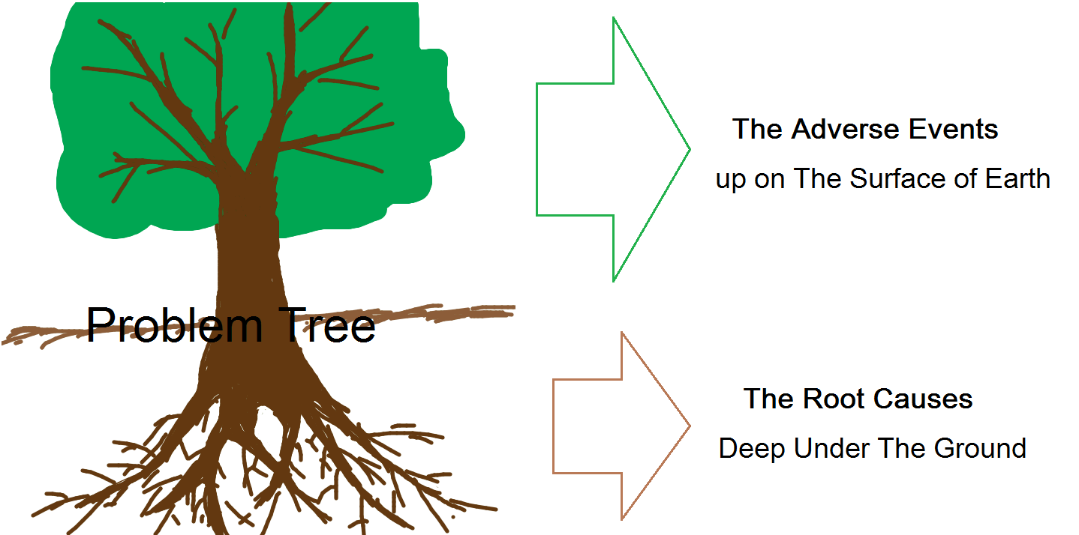
Figure 1. Problem Tree Model
Therefore, the process of RCA concentrates on looking for all the related causes that may have effects on the problem and eliminating these risk factors. The problem on the surface could be a simple one such as giving a wrong medicine to a patient by mistake. And then the nurse should apologize to the patient and she would be punished for this mistake. This punishment cannot stop another nurse making a similar mistake next time. Actually, when we dig into the details of this event, the root causes may be a confusing labeling, a pharmacy error or working fatigue. We are able to correct this mistake and prevent any other potential ones if we clear out all the root causes.
Since not all the roots could grow up to a problem tree, we need to find out and cut the roots which work as the foundation for their tree. Therefore, the root causes having a cause and effect relationship with the adverse issue are our targets. After the root causes are identified, there are 5 rules of causation to push the RCA team developing the causes deeper (Joseph F. Dyro. 2004).
Table 2. Five Rules of RCA Causation
Rule 1 | Causal Statements must clearly show the "cause and effect" relationship. The link between factors and outcomes should be clear to all the RCA group members.
Rule 2 | Negative descriptors are not used in causal statement. To make the description more accuracy, negative descriptors such as poorly and improper are not recommended to be used.
Rule 3 | Each human error must have a preceding cause. It is the cause of error that we need to make preventable action plan to deal with, not the error itself.
Rule 4 | Each procedural deviation must have a preceding cause. To eliminate one systematic deficiency can lead to several possible individual errors avoided. For example, an individual mistake such as a confusing handwriting of a physician could cause a sporadic event of giving a wrong medicine, while a medical order system that tolerates this kind of confusion without any warnings will cause a variety of medical errors from time to time
Rule 5 | Failure to act is only causal when there was a pre-existing duty to act. The duty is usually formed by the policies and standards for practice. For instance, residents fatigue is resulted from long working hours which are regulated by the hospital.

A Systematical Analysis for Prevention
Another noticeable feature of RCA is that RCA had a systematical view of the problems. The investigation of RCA usually involves all the procedures related to the problem and it is believed every defect in the system resulting in the final bad outcome. The Swiss Cheese model is a dominant paradigm to explain the multiple errors at system level.
The Swiss Cheese model originally propounded by James Reason is a risk management model for analyzing human errors. In this model, the systematic defenses against errors are just like slices of Swiss cheese and the holes on every slice of cheese are considered to be human defects. Only when all these holes located at every slice of cheese are set on a line, can the hazard pass through all the layers of defenses and lead to the failure (Reason, James. 1997).
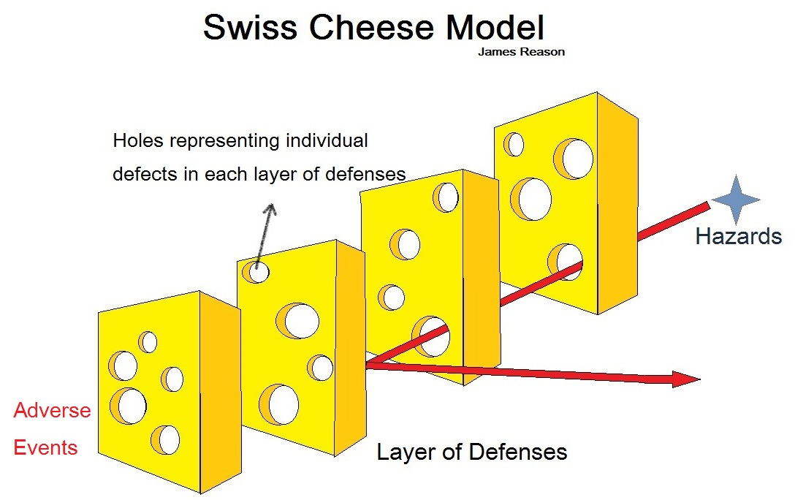
Figure 2. Swiss Cheese Model
From this diagram we can see a single defect on a certain layer of defenses is not able to result in a bad outcome because of the protection of other layers of defenses. That means that the failures we can observe intimate a series of defects in all levels of the system. The root causes we are looking for are hidden across the whole organization, which require a lot of time and efforts to find them out.

Furthermore, RCA focus on preventing future incidents rather than dealing with current ones. After all the root causes are identified, the next step is to make a corrective action plan. As a quality improvement tool, RCA is meaningful because it always concludes with a feasible plan to prevent similar adverse events having any chance to occur. In the previous bad handwriting example, we can avoid any confusion resulting from handwriting by mandating all medical orders typed into the computer and signed by the physician. This solution is what we have learned from this event and would effectively reduce the handwriting impact on the accuracy of giving medical orders.

The use of RCA in American Hospitals
RCA has been included in the accreditation process of the Joint Commission on the Accreditation of Healthcare Organizations (JCAHO) to investigate sentinel events in their accredited hospitals since 1997 (JCAHO).
I had my internship in the safety and quality department of West Pennsylvania Allegheny health system (WPAHS), which has 5 campuses around Allegheny County. The system has an adverse event responding team and a structured process to deal with adverse events, which make the system working effectively in quality improvement and patient safety.
In WPAHS, if there is something happened to patients in hospital, it will soon be reported to the campus Patient Safety Officer (PSO). The PSO then starts to investigate this event and identify it as an adverse event or a near miss. The campus PSO will collect every detail of the events by pulling out all the related files and talking to physicians, nurses and staff participating in the events. After all the information is ready, it will be put in order of timeline and a cause-and-effect diagram that are needed to be discussed during RCA meeting. PSO will call for a RCA meeting inviting all participants in this event to discuss every point on the timeline and find the root causes there. One adverse event may need several RCA meetings to dig up all the root causes and it ends up with a practical plan to solve the preventable errors. The PSO will implement the plan by communicating with the functional

departments and the vice president of quality and safety in the WPAHS corporate will also give a hand from leadership level to make the plan work.
Here I have three cases using RCA process to deal with adverse events from WPAHS.

Case 1
The first case is a nursing error in the neonatal unit. Nurse A fed baby A a bottle of breast milk labeled as baby A and then found mom B’s label under the baby A label. She immediately contacted nurse B who is responsible for baby B. Nurse B told nurse A this bottle should be a mom B breast milk, but it was mislabeled to baby A by accident. Nurse A then reported this event to her supervisor, the nursing manager of this unit. Nursing manager tried to communicate with mom A and make the things up. At the same time, she also reported the error to the patient safety office.
This event did not cause much trouble because nurse A talked to mom A about the current situation directly after it happened and apologize for the error. In addition, nurse A also told mom A that the results of all tests about baby A were good after the breast milk event and mom B is very healthy with so that her breast milk is completely safe for baby A. Mom A accepted her explanation and apology.
After the quality and safety team took over this case, a RCA meeting was held by the campus PSO in the following week. One physician and several nurses in neonatal unit including nurse A and nurse B, nursing manager in this unit, and the Vice President (VP) of quality and safety from corporate office attended this meeting. PSO started the meeting by a short review of what has happened. Then she explained the aim of this RCA meeting. Though RCA is well known for patient safety professionals, Front line workers such as physicians and nurses have very little knowledge about it. The PSO used the Swiss cheese model to show there must be many defects in all procedures to make a mistake finally turn to a bad outcome. And she said the main purpose of RCA is to locate all these defects and remove them so that similar errors would not appear again made by other people in the hospital.
After the purpose of this meeting was clarified, the second part of the meeting is about the timeframe.
Scene 1: Mom B left her breast milk labeled B at nurse station, and someone (this person could be any person in the unit) picked it and put it into the baby B’s box in the refrigerator.
Issues: No mistakes occurred here in this case, but we noticed that anyone could put the milk into the refrigerator without any records. If something goes wrong, this person cannot be identified to see if he or she put the milk in the right box.
Scene 2: Nurse B found a new breast milk bottle labeled mom B in her box so she wanted to label it. She brought the breast milk to baby B’s bedside and found the labels there. She assumed the labels to be baby B’s and put the labels on the milk bottle without double-check. Then nurse B took the milk bottle back to refrigerator and put it into baby B’s boxes.
Issues: The labels at baby B’s bedside turned out to be baby A’s. The staff who delivered the labels to bedside mad the first mistake. Moreover, nurse B didn’t check before put the label on milk bottle, which made the mistake move to the next slice of cheese.
Scene 3: Nurse A checked the refrigerator to see if there was any new milk there. When she saw a bottle labeled baby A in baby B’s box, she thought it was just someone put her milk in baby B’s box by mistake. She then changed this bottle from baby A’s box into baby B’s box.
Issues: Nurse A found there was an error when putting the milk bottle into the refrigerator at this time and the error could have been stopped here if she brought this question out. However, nurse A did not took the error seriously and just change the bottles into the box as what she thought to be. She is the one who pushed the error to get through the next slice of cheese.
Scene 4: At baby A’s feeding time, nurse A brought the target milk bottle to baby A’s bedside. She checked the label on the bottle (the wrong label from baby B’s bedside) and made sure it was the baby A’s name on it. She then fed baby A with this bottle of breast milk and baby A finished the whole bottle of milk.
Issues: The bad outcome came after all the errors above. Though nurse A checked baby A’s name on the bottle, She did not checked the mom’s name because she assumed it was the right milk when she put it into A’s box.
Scene 5: When nurse A was about to dispose of the milk bottle, she happened found that there was mom B’s label under baby A’s label. Mom B’s label was mostly covered by the baby’s label so that nurse A did not see it at first time. Nurse A talked to nurse B immediately and verified all they did to locate where the error came from. They took out the labels at baby B’s bedside and found baby A’s name on them.
Issues: There was an over-label in this case. Nurses in the neonatal unit usually put baby’s label on the mom’s label with the assumption that everyone has checked names of both mom and baby before put the label on the bottle. In fact this assumption does not happen every time and over-labeling made nurses hard to check both names.
After reviewed the timeframe, the PSO concluded all these issues with a cause-and-effect diagram (also known as fishbone diagram) as following.
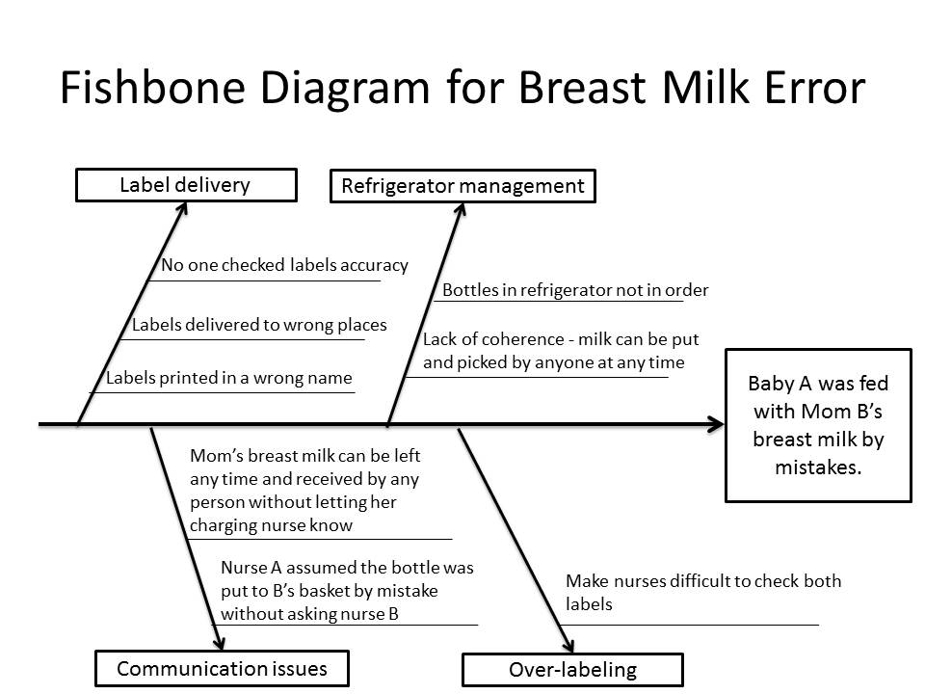
Figure 3. Fish Diagram for Breast Milk Error
This fishbone diagram showed the root causes for this error that we were able to fix. When it reviews and discussed by all RCA team members and they reach consent on it, the next step was to make an action plan according to this diagram. In this case, the RCA team made several new rules for the daily work in neonatal unit as following.
1. Charging nurses should print and deliver all the labels themselves for the babies they are responsible for. Nursing managers in neonatal unit need to check labels for every new patient at the day the baby is sent in.
2. Every put-in and pick-up of the breast milk bottles should be recorded on the sheets sticking on refrigerator with the mom’s name, baby’s name, name of the person who have moved the bottle and the time.
3. The boxes in refrigerators should be put in a certain order such as in alphabetical order. And both mom and baby’s names should be on each box.

4. If one person in neonatal unit has any confusions or possible mistakes, he or she should contact the relevant people or their supervisor immediately. Any assumptions are not tolerated in medical services.
5. No over-labeling on bottles or any other places. Every label should be clear and easy for review. Contact technology department to see if barcode is able to be put on the labels so that the barcode can be scanned to verify the identification before using the breast milk.
After the rules were carried out after RCA meeting, the campus patient safety office would monitor the rules working in the unit and make some changes if needed. The patient safety office planned to make an evaluation for the outcomes of these new rules three months later.

Case 2
The second RCA meeting was called for a 61-year-old male patient falling down at the bathroom in his ward. The fallen patient was hospitalized for heart disease. At the third night in his hospitalization, he fell down to the ground in his bathroom when taking shower by himself. He soon called the nurse and was sent to take a MRI test at the next day. The results showed that he got coccyx fracture from this fall.
Since falls happened from time to time in the hospital and this time it led to a bad outcome, A RCA team for this fall case was made by physicians, nurses and staff who had experienced patient falls before. The campus PSO held the RCA meeting and safety and quality VP from corporate office joined in the meeting to give leadership support.
At the RCA meeting, the PSO clarified the purpose of this meeting and the use of RCA. The timeframe and discussions in RCA show as following.
Scene 1: The patient was admitted to hospital for heart disease. He could walk by himself and had no cognitive issues. He received treatment every day in the hospital and needed no extra help for other daily routines.
Issues: This patient did not get a fall risk evaluation at admission. There was no policy that this evaluation should be taken by every patient but only when necessary. If fall risk evaluation was not necessary for everyone, what kind of patient in what condition needed to take this evaluation?
Scene 2: The patient was taking shower that night and he slipped to fall when he stepped out of the shower enclosure. He felt his tailbone hitting the ground and a sharp pain coming after the hit.
Issues: There was a small warning sign in the bathroom just aside of the shower enclosure but the patient did not notice the sign at that time. There was a handle on the door of shower enclosure but the patient failed to catch it when he was falling.
Scene 3: He then rang for the nurses from bathroom. Nurses came to see him in two minutes and called his physician immediately. The patient got a MRI check as soon as possible and the result showed he had a coccyx fracture. He received proper treatment after that.
Issues: The responding time of nurses and physicians was very short in this case. However, it takes time for nurses and physicians to take care of the patients in most other falls happening in WPAHS hospitals. Moreover, this patient called nurses right after the injury but some other patients did not contact nurses for small injuries. When a small injury was ignored, it may become a serious one and cause a lot of pain.
Some other issues were brought into the RCA meetings from former experience of other nurses and physicians. The problems concentrated on the hospital environment for people with fall risk and the fall risk evaluation. Falls are common injuries in the hospital which are considered not possible to be stopped completely by RCA, but the preventive suggestion could push the quality improvement of hospitals forward.
The fishbone diagram of falls is as following.
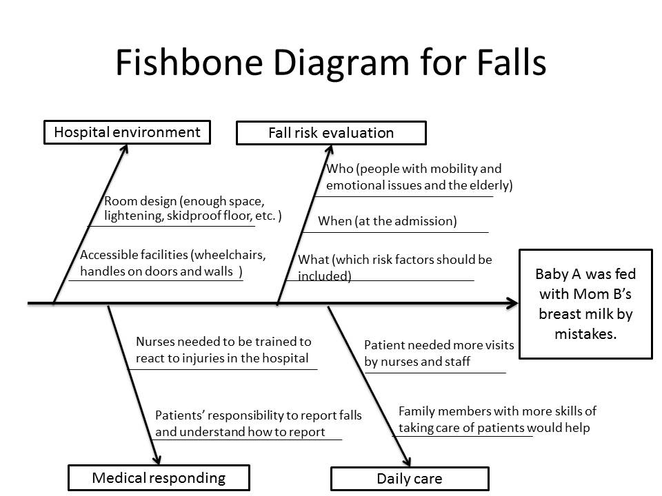
Figure 4. Fish Diagram for Falls
According to this fishbone diagram, a preventable action plan was discussed and consented by RCA group members. There are eight main points of the action plan:
- Change some regular rooms into fall preventive rooms on every floor in all hospitals. The special room should be designed with consideration of every possibility of patients’ falls.
- A simple survey about falls should be filled out by patients or their family members. The questions in the survey would include if they want to make a fall risk assessment, if they have had falls or other injury in hospital before and if they have conditions that usually causing falls.
- A fall risk evaluation should be finished by patients who are considered to do it according to their surveys and patients who want to do it.
- Based on the results of fall risk evaluation, patients are arranged to special rooms or get some fall preventive equipment such as wheelchairs and fall preventive beds.
- Send nurses to fall prevention training.
- Educate patients about fall prevention and how to call for help when being harmed at admission.
- Provide information about fall risks and prevention to family members so that they are able to help take care of patient both in the hospital and at home.
- Increase nursing rounds from 2 times a day to 4 times a day to observe patients more frequently and to discover issues more timely.
This action plan could be used across all campuses of WPAHS to prevent falls in the future. The incidents of falls are reported to patient safety office regularly. The statistics can be monitored to observe if the incident rate of falls will decrease after this action plan is taken into effect.

Case 3
Sometimes a pre-RCA meeting could be called to make clear of the facts right after an adverse event has occurred and discus the next step to deal with the event. Usually an RCA meeting is held about one week after the event because it needs time to collect information and invite relevant people. However, some information needs to be collected from fresh memories at once especially when serious events or emergencies occur. Every accurate detail from the events could make a difference in the analysis of the problem and may also help tp bring out a useful policy for the action plan.
A pre-RCA meeting was called for a wrong site surgery event in the late afternoon of the day it happened. Both resident and attending involved in this event were invited to the meeting. And so did the manager of operating room, the nurses in the operating room and the patient safety professionals.
The resident described the event to the rest people and the attending provided some supplements from his point of view.
The patient in this event was a female patient in her 50’s. She had a scheduled surgery on her right hand and she would have a right arm block before the surgery. On the day before surgery, the resident from anesthesiology department talked to the patient about the arm block which would be done by him and his attending. And the resident made a mark of the block arm that was the right arm as a preparation for the surgery on the next day.
On the surgery day, the patient was sent to the operating room for the arm block. The nurse in the operating room and the resident checked with patient that she was about to do an arm block on her right arm. At that time another operating room nurse who was a friend of the patient just got off from her shift. This nurse friend talked with the resident about the patient’s surgery in the operating room while the on-shift nurse out was draping on the left arm of the patient. When resident came back from the talk with patient’s friend, he could just see the draped arm and assumed that was the right arm.
After the attending came into the operating room the resident asked him if the arm block procedure could start. The attending let the resident start to do the procedure without calling a time-out. The nurse as a friend of the patient was in that operating room all the time during the procedure, occasionally talking with the resident.
After the arm block was done and the drape was removed from patient’s arm, the resident suddenly realized it was the left arm of the patient that he just did the block on. He spoke the issue out and both the friend of patient and the attending then noticed about the wrong site issue. It was reported to the manager of operating room immediately. Resident apologized to the patient after the procedure and told her that she might need to do the right arm block again.
The members of pre-RCA meeting discussed this adverse event with bad outcome from beginning to the end and pointed several serious issues in the event.
- The resident did not look for the mark he made the day before to make sure that the draping part was the right site.
- The attending did not call a time-out (a checklist in operating room used to ensure everything correct before the procedure starts). Time-out which was the last step that could discover the mistakes before a real harm was totally missing in this event.
- The off-shift nurse as a friend of patient was in the operating room all the time through the procedure. She distracted the resident by talking with him. The off-shift nurse should be regarded as a common family member of the patient that was not allowed to enter the operating room.
- After this pre-RCA meeting, the PSO would use the information and comments from group members to make a cause-and-effect diagram to discuss at the next RCA meeting one week later. An action plan including some new policies would be concluded from the formal RCA meeting.

Brief Summary
From those three cases above we can see RCA does not aim to make a change immediately but provide a guideline to form a better future. Though no accurate statistics have been published that to what extend patients and hospitals benefit from RCA, physicians, RCA is welcomed because patients and nurses find their voice can be heard and their suggestion can be taken from RCA meetings. Moreover, patients will tell the difference when the action plan taken into effect to provide them more protection and better service in the hospital although they know nothing about RCA

Adverse events and their solutions in China
Adverse events had not attracted enough attention to the public until the regulation for medical malpractice was released in 2002. However, no visible change has been seen since then and the conflict between physicians and patients has been intensified. The regulation was a wake-up call for healthcare providers to realize it is their responsibility to offering a good quality of medical care and protect patient safety. Since then, China launched a medical service quality watchdog program in 2009 (Xinhua 2009) and WHO Patient Safety Curriculum Guide in 2012 (Lulu Ding et al. 2012) to emphasize the health reform in quality and safety.
After the surveillance system was brought in China, it has not made any visible difference in Chinese hospitals yet (Ruifeng Jiang et al. 2004). Even the adverse events are reported to the health department, the health department would not give any suggestions or guidelines for the hospitals to deal with these events. The statistics in the reporting system may only be used for epidemiology research. The current condition of Chinese hospitals is they have no idea about how to deal with adverse events not even think to prevent future incidents.
When some bad outcomes come after a medical service in hospital, the physicians or nurses tend to be comfort patient themselves. If patients do not accept their explanations and apologies and bring the issue to the hospital, the hospitals usually use compensation to make the patients get over the event. Therefore, the adverse events always end with a certain amount of compensation for the patients which make patients happy about the additional money and make hospitals maintain their reputation. The physicians or nurses who take charge of the patient or lead to the adverse event are usually punished by the hospitals no matter the problems come directly from them or not.
Medical professionals working in the hospitals have so many complaints about the punishment on them though some are not their faults. Some physicians event express that it is not possible for them to make no mistakes because they have too many things to take care of at the same time (Jianfeng Bai 2007).
From hospitals point of view, the adverse events occurs mostly because of the slack of physicians and nurses. The hospitals carry out all kinds of punishment to prevent their employees (all physicians, pharmacist and nurses are employed by the hospitals in China) making more mistakes. These discipline policies have only made medical professionals more depressed about their work (Jianfeng Bai 2007).
Patients also think it is all faults made by physicians and nurses to increase their pain from diseases. And in their minds, hospitals are accomplices of physicians and nurses and always cover their crimes by hush money. However, most patients are willing to get this money rather than make things widely-known if they have reason to get it.
Hospitals and medical workers in China are now looking for a better method to solve adverse events rather than the only magic weapon of compensation. This method should have ability to show the public that the hospitals have learned from the events and will provide a more satisfying medical environment for patients. This method also should make the hospitals not that shame for the adverse events as they used to be because they could push the events forward to a positive way. Moreover, they do not need to give compensation to cover things up after a bad outcome.

I believe RCA is a best way to help Chinese hospitals to develop a healthy quality improvement system. RCA is a problem solving method focusing not on the adverse event itself but on how much we can learn from the events. Chinese hospitals are able to use the action plan of RCA to show the patients that hospitals and physicians are willing to improve themselves and provide better medical services by achieve the action plan. There are so many trust issues between health providers and patients now in China. I think a well-structured problem solving tool can make things more transparent to both physicians and patients. Patients may have more understanding and trust on hospitals and physicians if they positively face their mistakes and try to build a safe medical environment for them.

An Example of Adverse events in China
An example of how Chinese hospitals solve problems is like this. It was an event from my own experience when I was working in a Shanghai hospital as a medical student in my final-year rotation.
The former patient E of bed 39 was discharged in that morning and a following patient F who had been assigned to bed 39 came at the same time. The medical student who was responsible for bed 39 finished all the paperwork for patient E ahead of time and typed the medical orders for F written by the physician into the medical order system right after morning rounds. After all the orders were typed into computers, the medical student told the nurses that orders were ready. And then nurses printed out the labels out and put the labels on the blood samples that they had already got from patient F. The delivery man took the blood samples away from the nurse station and sent them to the lab.
In the afternoon, when the physician of patient F wanted to check the blood results of patient F, he could not find anything in the computer. The physician asked his medical student if he did put the medical orders into system and if nurses did take the blood samples. The medical students asked around and found the blood samples were taken and sent to lab but nothing came up in the computer. He phoned the lab and people from the lab said they did not receive blood sample from patient F.
After repeated investigation about the blood samples of patient F both at nurse station and at the lab, the medical student finally found that he typed the medical orders under bed 39 before E’s information was pulled out from bed 39. This means all the medical orders were under E’s name and the blood samples labeled as E were actually from patient F. Moreover, the family member of patient E had paid all these blood tests which was about ￥4000 ($600) without noticing this part of bill was not belong to E. In China, bills of hospitalization should be fully paid before discharge.
This event was reported to the administrators of the hospital. When the truth finally came to them as both E and F had no idea what had happened, the leadership of the hospitals decided to cover things up. They called IT department to pull the blood results of patient E and change them to the name of patient F. And the hospital disciplined the nurse who got the blood samples from patient F without checking the name of the labels. The medical student who typed the medical orders to the wrong bed 39 was blamed for this mistake. All the medical students were educated to check the names of patients before typing anything into computer in the next student rotation meeting. Since patient E had left hospital and paid all the bills, the hospital decided not to contact him about this event unless patient E discovered this error himself.
To conclude, this name mistake finally caused no harm to anyone except patient E with a certain amount of money loss and the nurse who got a deduction in her wages. This nurse may learn from this mistake by check patients’ names more carefully in future work, but other nurses have possibility to make the same mistakes again. In addition, this was not the first mistake medical students made about getting a wrong name in that year, and it was believed it would not be the last one. Though we as medical students were educated again and again to check names before every step we made, it was easy for us to make such a mistake for the reason of some distraction or fatigue. And not like physicians and nurses, medical students only have one-year rotation in the hospital and the next year students without any experience of these mistakes would make the same errors just as we did.

An application of RCA on the Example
The RCA tool with a systematic view may provide a better option for hospitals to prevent this kind of mistakes, though it cannot help about the loss of patient E which was not the main point of this essay. If this event could be investigated using RCA, a more complex analysis of root causes would be carried out like this.
Scene1:
Patient E left the unit after morning rounds. Patient F came earlier than expected with an empty stomach and asked nurses to get his blood samples so that he could eat breakfast. The nurse on duty that day got all the regular blood samples and let the patients go out for breakfast. The nurse told the medical student in charge of bed 39 that she had already had the blood samples and waited the medical orders to print the labels for the samples. The medical student asked the physician for bed 39 to give the medical orders as soon as possible because of the blood samples. The physicians fully understood the situation.
Issues: The sequence here was totally in chaos. Firstly, the blood samples under empty stomach condition should be taken in the next morning after the admission because these samples should be required by the medical orders coming out in the afternoon of admission. Getting empty stomach blood samples at the admission was impossible in a regular sequence. Secondly, nurses should take blood samples according to medical orders from physicians. The nurse in this case took the blood samples assuming the physicians would give the regular orders at admission. This was not allowed by the procedure rules and hospital policy but occurred really often in hospital daily work. Finally, the tubes of blood samples should be labeled before filled with blood. Nurses would need the medical orders and the labels to check patient’s name and the testing items of blood sample.
Scene 2: The medical student got the written orders from the physician for patient F and typed it into computer under bed 39. When he finished the typing, he told the nurse station that orders for bed 39 was ready. The nurses in the nurse station confirmed the orders from nursing system and printed out the labels for blood test. The labels then were put on the tubes of blood samples of patient F.
Issues: The medical student did not check the patient’s name but only the bed number before typing the medical orders into system. The nurses in the nurse station did not check the name either when they confirmed the orders. In the electronic medical order system of this Shanghai hospital, orders should be approved by both a physician account and a nurse account to ensure a double check. However, the nurses failed to make it work. No one checked the name even when the labels were printed out.
Scene3: The delivery man took the blood samples to the lab. The lab got the samples and did their work the electronic orders required. No one discovered the medical orders under a wrong bed 39 until the physician was looking for the blood test results but found nothing.
Issues: After the physician and the nurses found the blood samples were missing, they first suspected the delivery man did not take the blood samples to the lab. However, the lab had no records of the time and items for deliveries. It took a little time before they finally found that the blood samples labeled E were the blood from patient F that they were looking for. Besides that, the lab did nothing wrong in this case because they could not check the names.

Based on my own analysis of the root causes, a cause-and-effect diagram could be made like this.

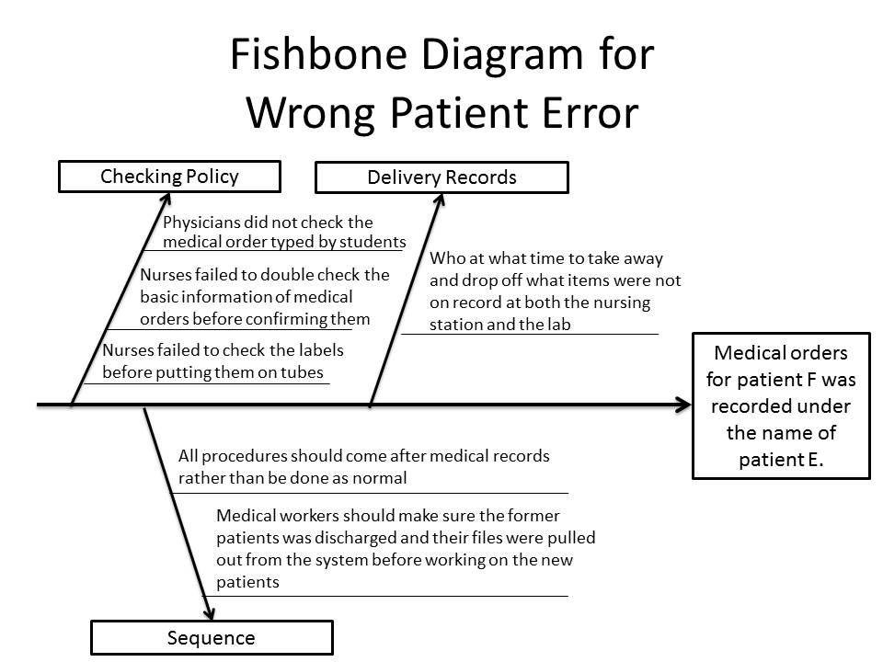
Figure 5. Fish Diagram for Wrong Patient Error
According to the fishbone Diagram, an action plan may come out concentrating on regulating the sequence of admission and reinforcing checking policy. Though I have no idea to what extent the leadership of Chinese hospitals would support this kind of change, an ideal action plan might be as following:
- Educate the proper sequence of admission and discharge to physicians, medical students and nurses.
- Make a policy to regulate the performance of the procedure sequence and add safety rounds to monitor it.
- Look for IT support to make empty stomach blood test only available after the first day in hospital for normal patients.
- Make a new policy to regulate physicians and nurses to sign on the screen after reviewing the medical orders typed in by students.
- Make records for samples delivery both at nurse station and at lab about the name of delivery man, the time and the items.
If this action plan is able to be taken into effect, a mess of admission and discharge like the above case would not appear frequently and this kind of mistakes could be reduced by that. Part of this action plan was easy to achieve such as the IT change, but people did not think of this idea because they did no analysis after the event but only making up for the current issue. RCA has ability to bring a fresh air to Chinese hospitals because its purpose is to make people think of possible solutions using the analysis of root causes in a preventive view.

Barriers of using RCA in China
There are still some barriers that block RCA entering Chinese hospital.
The first one is that the awareness of quality and safety in Chinese hospitals is very weak for both front line professionals and leadership. As mentioned before, terms such as adverse events and quality improvement are just new words for the hospital management in China. Health professionals now have little knowledge about the relationship between hospital management and injury in the hospital. The present condition of Chinese hospitals is similar to the one of American hospitals 15 years ago or event worse. RCA as a quality improvement would meet obstacles from all aspects before Chinese people can finally accept this idea.
Moreover, RCA could hardly get leadership support in China currently because the administrators in Chinese hospitals are usually promoted from clinical roles and most of them have no management knowledge at all. This norm of clinical professionals doing administrative jobs makes modern methodology of hospital management such as patient safety and quality control more than difficult to penetrate into Chinese hospitals.
Another barrier is that Chinese hospitals have no such a quality control team or a patient safety team to do the RCA work. For most of Chinese hospitals, medical records checking and infection control are the only two things related to quality and safety. Quality tools such as Root Cause Analysis and Lean Six Sigma are never been heard of in medical administration area. When searching ‘program of health administration’, we can find only few schools in China have such a program and most of them started after 2010. The fact that China is lack of professionals in healthcare administration area leads to the absence of a structured quality control team in the hospital.

bibliography
Barbara Gregory, Victoria S. Kaprielian. Anatomy of an error. Duke University of Medical Center. Available at: http://patientsafetyed.duhs.duke.edu/module_e/swiss_cheese.html. Accessed Jan, 15, 2013.

Ding Lulu, Mao Yaqing. China Launches WHO Patient Safety Curriculum Guide. CRI English. 2012-07-19. Available at: http://english.cri.cn/7146/2012/07/19/2702s712511.htm. Accessed Jan, 28, 2013.

Geoff Vorley MSc. MCQI. Mini Guide To Root Cause Analysis. Guildford Surrey, United Kingdom. Quality Management & Training Limited. 2008

Heidi Wald, Kaveh G. Shojania, Chapter 5. Root Cause Analysis. Making Health Care Safer: A Critical Analysis of Patient Safety Practices. Evidence Report/Technology Assessment, No. 43. AHRQ Publication No. 01-E058, July 2001. Agency for Healthcare Research and Quality, Rockville, MD. Available at: http://www.ahrq.gov/clinic/ptsafety/ Accessed Dec, 28, 2013.

James J. Rooney, Lee N. Vanden Heuvel. Root Cause Analysis For Beginners. Quality Progress. July 2004, 45-53

白剑峰(Jianfeng Bai). (2007). 积极看待医患生态(A Positive Way to See The Environment Around Physicians and Patients). Beijing: Peking Union Medical College press.

Joint Commission on the Accreditation of Healthcare Organizations. Sentinel event policy and procedures. Available at: http://www.JCAHO.org/sentinel/se_pp.html. Accessed Dec, 30, 2012.

Joseph F. Dyro. (2004). Clinical Engineering Handbook (Biomedical Engineering). Connecticut: Trinity College – Hartford

Mokdad Ali, James Marks, Donna Stroup, Julie Gerberding. Actual Causes of Death in the United States. JAMA (Journal of the American Medical Association) 291 (10): 1238–45, 2000

National Research Council. (2000). To Err Is Human: Building a Safer Health System. Washington, DC: The National Academies Press.

Reason, James (1997). Managing The Risks of Organizational Accidents. Aldershot: Ashgate.蒋瑞峰(Ruifeng Jiang), 李鲁(Lu Li). 医疗不良事件报告制度的建立(The Construction of Medical Adverse Events Reporting System). Chinese Journal of Hospital Administration, Vol20, No.3, March 2004

Xinhua. Medicine watchdog launches pharmaceutical safety program. China Daily. 2009-07-18 Available at: http://www.chinadaily.com.cn/business/2009-07/18/content_8445594.htm. Accessed Jan, 28, 2013.

