DYNAMICS OF US STEEL’S CLAIRTON COKE WORKS EMISSIONS AFFECTING THE LIBERTY-CLAIRTON NON-ATTAINMENT AREA

by
Michael Reilly
Biology B.S., University of Pittsburgh, 2011

Submitted to the Graduate Faculty of
Environmental and Occupational Health
Graduate School of Public Health in partial fulfillment
of the requirements for the degree of
Master of Public Health

University of Pittsburgh
2013

UNIVERSITY OF PITTSBURGH
GRADUATE SCHOOL OF PUBLIC HEALTH

This essay is submitted
by
Michael Reilly

on

April 15, 2013
and approved by

Essay Advisor:
Kyra Shields Ph. D ______________________________________
Assistant Professor of Public Health Practice
Environmental and Occupational Health
Graduate School of Public Health
University of Pittsburgh

Essay Reader:
Ravi Sharma Ph. D ______________________________________
Associate Director of Public Health
Behavioral and Community Health Sciences
Graduate School of Public Health
University of Pittsburgh

Copyright © by Michael Reilly
2013

Kyra Shields, Ph.D
DYNAMICS OF US STEEL’S CLAIRTON COKE WORKS EMISSIONS AFFECTING THE LIBERTY-CLAIRTON NON-ATTAINMENT AREA
Michael Reilly, MPH
University of Pittsburgh, 2013
ABSTRACT
In 1997, the Environmental Protection Agency began classifying areas with high levels of air pollution as within or not within attainment of the National Ambient Air Quality Standards. The Liberty-Clairton non-attainment area is a distinct region inside the Pittsburgh non-attainment area that has been given specific attention due to high levels of particulate matter pollution. The vast majority of the pollution is attributed to US Steel’s Clairton Coke Works plant, a coke manufacturing facility one mile from the Liberty Boro monitor. This essay will explore the relationship between Clairton Coke Works and the Liberty-Clairton non-attainment area, attempting to connect source to exposure and health effects. In a larger respect it will demonstrate the impact of air pollution on public health.

Table of Contents

1.0 Introduction 1
1.1 Purpose 1
1.2 Scope 2
2.0 General Information Regarding Air Pollution 3
2.1 Industrial Air Pollution 3
2.1.1 Carbon Monoxide 3
2.1.2 Lead 3
2.1.3 Nitric Oxides 4
2.1.4 Ozone 4
2.1.5 Sulfur Dioxide 5
2.1.6 Particulate Matter 5
2.2 Health Effects of Particulate Matter Exposure 7
2.2.1 Acute Health Effects 7
2.2.2 Chronic Health Effects 8
2.2.3 Factors that Increase Risk 9
3.0 Clairton Mill Emissions and the Liberty-Clairton Area 11
3.1 Clairton Coke Works 11
3.1.1 The Process of Making Coke 11
3.1.2 Emissions Associated with Clairton Coke Works 11
3.1.3 Clairton Coke Works in the 1970s 12
3.1.4 Standards for Air Pollution 15
3.2 The Liberty-Clairton Non-Attainment Area 17
3.2.1 Location and PM_{2.5} Level 17
_{3.2.2} Factors Leading to High Levels of PM_{2.5} 18
3.2.2.1 Factor 1: Emissions 18
3.2.2.2 Factor 2: Air Quality Data 18
3.2.2.3 Factor 3: Meteorology and Topography 20
3.2.3 Atmospheric Factors Effecting Plume 21
4.0 Mapping Health Risk in Liberty-Clairton Area using GIS software 23
4.1 Map 1 23
4.2 Map 2 25
4.3 Map 3 26
4.4 Map 4 28
4.5 Map 5 30
5.0 Moving Forward 31
5.1 ACHD Anticipates 2014 Attainment 31
5.2 Activists Groups Expect Continued Non-Attainment by 2014 32
6.0 Conclusion 35
6.1 Summary 35
6.2 Further remarks 35
Bibliography 38

List of Tables
Table 1. NAACS for the sic criteria pollutants.⁴⁹ 16
Table 2. Total Emissions from Clairton Coke Works in 2004. ⁵⁰ 18
Table 3. Comparison levels for sites in an ACHD study. ⁵² 19
Table 4. Point source emissions for Clairton Coke Works for 2007 and 2014. ⁶⁰ 33

List of Figures
Figure 1. Size difference between classes of particulate matter.¹⁵ 6
Figure 2. PM_{2.5} Concentrations for Allegheny County and Surrounding Area.⁵ 19
Figure 3. The Liberty Clairton monitor in relation to Clairton Coke Works.⁵⁰ 20
Figure 4. Topographical map of the Liberty-Clairton non-attainment area 21
Figure 5. An illustration of how an inversion caps air rising from a plume.⁵³ 22
Figure 6. Thematic map representing total cancer risk in individual municipalities of Allegheny County. 24
Figure 7. Same thematic map as Figure 6, but with TRI sites overlaid. 25
Figure 8. Thematic map representing total cancer risk attributed to coke oven emissions in individual municipalities of Allegheny County. 27
Figure 9. One, two, and three mile buffers around Clairton Coke works. 28
Figure 10. EPA image of the Liberty Boro monitor and the Clairton monitor in relation to Clairton Coke Works.⁵⁰ 29
Figure 11. Hot Spot Analysis over Total Cancer Risk. Clairton Coke Works is the blue dot and Liberty Boro is the municipality highlighted in blue. 30
Figure 12. Historical and anticipated values for average 24-hour PM_{2.5} at the Liberty Boro monitor.⁵⁹ 32

- Introduction
The Environmental Protection Agency (EPA) was created in December 1970 by the Nixon administration in almost direct response to the heavy task of implementing the statutes the Clean Air Act passed by Congress earlier that year.¹The Clean Air Act of 1970 instructed the EPA to impose heavy regulations on both stationary and mobile sources of air pollution.² Mobile sources reflect emissions from automobiles, while stationary sources refer to point source emissions from industry. The 1977 Amendments to the Clean Air Act of 1970 included provisions to determine if areas are within attainment or not of the National air Quality Standards created by the EPA.³ Those areas not within attainment are subject to greater attention and regulation by the agency.
  - Purpose
To this day many areas are still not within attainment standards regarding air pollution. In Pennsylvania, many of these non-attainment zones can be described at the county level or even across multiple counties, but the area that is furthest from attainment standards regarding particulate matter (PM) includes only a handful of municipalities located in Allegheny County approximately ten miles from Pittsburgh.⁴ This area is widely referred to as the Liberty-Clairton area, and a main source of the elevated pollution is associated with the enormous amount of coke produced at the United States Steel Clairton Coke Works Plant. Clairton Coke Works has had a rich history with the EPA as well as the Pennsylvania Department of Environmental Protection (DEP) and the Allegheny County Health Department (ACHD). The struggle between these agencies and US Steel to reduce Clairton plant emissions is testimony to the overall battle air-quality.
  - Scope
This paper is meant to link pollution emitted from USSC and exposure to the residents of the Liberty-Clairton Area. We will begin by accessing existing literature regarding the type of air pollution generated by Clairton Coke Works and the health effects associated with such exposure. We will then undergo a brief history of Clairton Coke Works during the time it first began to acknowledge imposed regulations; and, discuss existing regulations for air quality while discussing the struggle to get the Liberty-Clairton area within attainment. The latter section of this paper will attempt to visualize the scenario, as well as further establish the link between exposure and health effects with the use of Global Information Systems (GIS).

- General Information Regarding Air Pollution
  - Industrial Air Pollution
According to the DEP’s website, there are six principle pollutants that act as indicators for air quality in our county.⁵ These indicators include Carbon Monoxide (CO), Lead (Pb), Nitrogen Oxides (NO_{x}), Ozone (O₃), Sulfur Dioxide (SO₂), and Particulate Matter (PM). The sections below discuss each of the indicators further.
    - Carbon Monoxide
Carbon Monoxide, CO, pollution is produced from the incomplete combustion of carbon-containing fuels.⁶ This encompasses a wide variety of sources, including coal burning in power plants and other industries. CO is colorless and odorless, therefore acute exposure is most often lethal, and of greatest concern. CO has a high affinity for hemoglobin and acts as a competitive inhibitor for oxygen; this interferes with oxygen release at the tissues causing asphyxia and eventually death.⁷
    - Lead
Lead, Pb, is a highly toxic metal that has been associated with adverse health outcomes for both ingestion and inhalation. Historically, Pb was released into the atmosphere primarily from burning gasoline that contained lead to reduce engine knock. In 1985, the EPA promulgated an effort to successfully reduce the amount of Pb in gasoline, which significantly reduced the health burden from Pb exposure.⁸ Pb and other toxic metals are naturally found in coal, and are hence released into the atmosphere if not properly controlled during combustion. Trace metals, including lead, are considered a primary component of ultrafine particles. These particles can deposit deep into the lungs and cause oxidative stress along with greater toxic exposure.⁹ More on ultrafine particles will be found below.
    - Nitric Oxides
Nitric oxides, or NO_{x} refers to a class of pollutants that is made from burning fossil fuels at a very high temperature. NO_{x} refers mainly to nitric oxide (NO) and nitrogen dioxide (NO₂). NO is emitted from automobile exhaust, power plants, and other industries that burn coal. NO is converted in the atmosphere to NO₂, which is a reddish brown gas that is highly toxic.¹⁰ NO₂ also plays a major role in the generation of ground-level ozone. NO exposure is associated with adverse respiratory effects at low levels of exposure.
    - Ozone
Ozone is generated naturally in the stratosphere by a reaction between solar radiation and molecular oxygen. In the stratosphere, ozone prevents ultraviolet radiation from entering the troposphere, thus protecting us from UV B and UVC radiation, which causes sun burns and DNA changes in our skin that cause cancer.¹¹ Ozone is considered a secondary pollutant in the troposphere given that it is created primarily through a reaction with NO₂ and volatile organic compounds (VOCs). VOCs are emitted from a variety of sources which include gasoline combustion. With intense sunlight and plentiful NO₂, ozone can be generated at a pace to reach a high enough concentration to expose humans over a very large distance. Acute exposure can cause irritation to the eyes as well as have consequences on breathing; long term exposure has been associated with cardiovascular disease and pulmonary disease.¹²

    - Sulfur Dioxide
Sulfur dioxide or SO₂ is a pollutant that is emitted into the atmosphere primarily by power plants and industries that burn coal that contains sulfur. Exposure to SO₂ can cause symptoms of respiratory distress. SO₂ has been the cause of many catastrophes resulting in widespread mortality. One such incidence was the London fog in December 1952, where over 4,000 people were killed prematurely of hypoxia, and over 100,000 individuals had symptoms of respiratory illness.¹³ Much of the morbidity and mortality from this event may be due to the ability of SO₂ to form into particulate sulfates.
    - Particulate Matter
Particulate matter or PM, the main focus of this essay, rationale substantiated here, consists of a microscopic array of solid and liquid particles suspended in the air. PM pollution is made up of acids, metals and dusts. PM is generated from automobile exhaust, agriculture, construction, power plant and industrial emissions, among others.¹⁴ While any airborne particle can cause adverse health effects, particles that are 10 micrometers or less in diameter can absorb deeper into the lung than larger particles. Though PM_{10-2.5} can reach the tracheobronchial tree, particles less than 2.5 micrometers in size have the ability to reach the smaller airways and into the alveoli. In 1997, the EPA included PM_{2.5} regulations to reduce the burden of lung cancer and respiratory effects associated with long term exposure.¹⁵ Figure 1 demonstrates the size difference between particulate matter of different category, note that PM_{2.5} is 1/30th the size of a human hair.
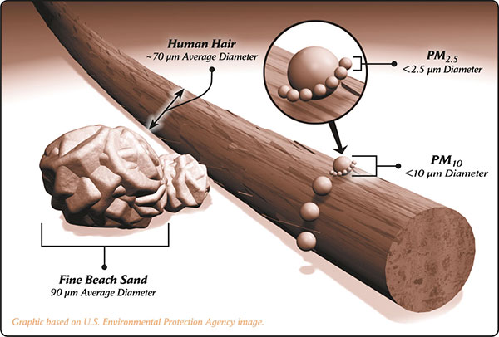
Figure 1. Size difference between classes of particulate matter.⁶¹
PM_{10-2.5} is considered coarse particles and is generated mostly from natural resources, for instance fungal spores and pollen grains. PM_{2.5} is primarily generated via combustion of fossil fuels. Emissions can be from either primary or secondary particles. Primary particles like diesel soot are emitted directly into the atmosphere; whereas secondary sources of PM pollution are formed from the formation of particles made up of SO₂ and NO_{x} that are emitted into the atmosphere by combustion of coal and other fossil fuels from automobile exhaust, power plants and other industries that burn coal. PM less than 0.1 micrometer in size is generated via combustion of fossil fuels; these particles are referred to as ultrafine particles or UFPs. Exposure to UFPs will result in large scale diffusion into the alveolus and therefore increased absorption into the blood stream.¹⁶ Greater absorption, even if the particle is not toxic, can cause oxidative stress and impose severe complications on the cardiovascular and pulmonary systems.¹⁷ After release from a source, UFPs generally coalesce into larger particles before they can reach a vulnerable population.¹⁵ As we consider the distance in this paper of the source and the vulnerable population, speculations of ultrafine exposure may be warranted but will not be considered here.
The rest of our discussion regarding air pollution will focus on PM_{2.5}, given the Liberty-Clairton area is out of attainment specifically for PM_{2.5}. The section above was used as a general overview of the six main constituents of air pollution. Most, if not all, of these pollutants tie together in some form of way. For example, PM_{2.5} emitted from Clairton Coke Works is majorly secondary PM_{2.5} made up from the formation of NO_{x} and SO₂ as well as organic and elemental carbon. Metals like lead and others can be part of a particulate matter complex, so metal absorption and toxicity must be considered along with PM_{2.5} exposure. The next sections will focus on the acute and chronic health effects resulting from with PM_{2.5} exposure.
  - Health Effects of Particulate Matter Exposure
    - Acute Health Effects
Many studies have found an association between abrupt exposure to PM and adverse health outcomes. The two largest epidemiological studies are the National Morbidity and Mortality Air Pollution Study (NMMAPS)¹⁸ and the Air Pollution and Health: A European Approach (APHEA-2)¹⁹ studies.²⁰ These studies observed health outcomes for 50 million people in the 20 largest cities in the US, and 48 million people in 29 cities across Europe. Each study found an elevated risk for death from acute cardiovascular events associated with cities that had higher levels of particulate matter. These studies were based on PM₁₀, one might have expected an increased risk if the technology existed to detect PM_{2.5}.
PM_{2.5} diffuses deep into the lung into the alveoli where it can be absorbed very easily into the circulatory system. Transition metals, toxins attached to the particles or the particle itself can initiate pulmonary oxidative distress or an inflammatory response on the cardiovascular system. These acute responses initiate atherosclerosis by rupturing atherosclerotic plaque in the vascular system, as well as thrombosis and other ischemic events.²¹ These events can trigger myocardial infarction or an ischemic stroke which are common in epidemiological studies covering this type of acute exposure.²²
    - Chronic Health Effects
Studies suggest that long term exposure to PM has a high risk for developing cardiovascular disease and lung cancer. The Harvard six cities²³ study by Dockery et al. conducted a large metropolitan based study over six cites that was able to show how long term exposure to PM led to adverse health outcomes after adjusting for factors like smoking. Death attributed to cardiovascular disease, pulmonary disease, and lung cancer were associated with cities that had higher levels of particulate matter pollution. Pope et al. conducted a very large study based on results from the ASC Cancer prevention II²⁴ study population. They found that for every 10-µg/m³ elevation in fine particulate air pollution, there was approximately a 4%, 6%, and 8% increase in risk of all-cause, cardiopulmonary, and lung cancer mortality, respectively.²⁵ Toxicological explanations for the observed health outcomes are explained below.
Chronic PM exposure increases the inflammatory response of the pulmonary and circulatory systems.²⁶ Fine particles get lodged deep into the lung where it can damage alveoli. The inflammation associated with such exposure can cause mucus build up which can further inhibit the lungs ability to perform gas exchange with the blood. Alveolar inflammation increases blood coagulability, which is an increase in the density of the blood.²⁷ Systemic inflammation is also associated with increased vasoconstriction. Vasoconstriction accompanied by higher blood density puts more stress on the heart which leads to long term cardiovascular disease.²⁸ Studies have linked chronic exposure to PM with atherosclerosis as well as individuals having an increased risk for stroke.^{21,29}
Mounting evidence suggests there is a relationship between particulate matter exposure and an increase of systemic reactive oxygen species. Shukla et al. found that early and persistent increases in intracellular oxidants were observed in epithelial cells exposed to PM_{2.5} and ultrafine carbon black particles.³⁰ Oxidative stress occurs when these reactive intermediates are not detoxified by the body before they cause considerable damage to cells. Peroxides and free radicals can destroy lipids, proteins, and DNA to the extent where the cell is so damaged that it initiate programmed cell death, or apoptosis. When a cell does not recognize that it should undergo apoptosis, and rather proliferates, it initiates tumor growth. An above normal generation of reactive oxygen species can lead to a heightened risk for malignancy and further proliferation.³¹ This mechanism is the framework for linking particulate matter exposure to cancer.
    - Factors that Increase Risk
Negative health effects from both acute and chronic exposure to PM are amplified in individuals who have certain risk factors. Pope et al. found a significant increase in the elderly and in acute cardiac events resulting in death in individuals with low economic status.²⁵ Kim et al. found that the elderly were four times more susceptible than younger children to oxidative stress when exposed to PM_{2.5.}³² Whether these studies and others that have found a higher risk for the elderly is due to increased age or other underlying risk factors is yet to be discerned. Goldberg et al. found that mortality risk increased linearly as concentrations of particles increased for persons who were predisposed to acute lower respiratory diseases, chronic coronary artery diseases (especially in the elderly), and congestive heart failure.³³ Studies have also found an increased risk for acute cardiovascular events with individuals who have diabetes mellitus.³⁴ The risk for developing long term cardiovascular and pulmonary problems and death from exposure to PM_{2.5} increases nearly synergistically with tobacco smoking status. For a host of long term cardiovascular problems, Pope et al. found that a 10-μg/m³ elevation in fine PM was associated with 8% to 18% increases in mortality risk.³⁵ Smoking increased the risk significantly.

- Clairton Mill Emissions and the Liberty-Clairton Area
  - Clairton Coke Works
    - The Process of Making Coke
US Steel’s Clairton Coke Works sits on the Monongahela River just above Donora, the site of a famous air pollution tragedy,1948.³⁶ In the 1970s, the mill was the largest coke producer in the world; it is now the largest coke producing plant in the western hemisphere.³⁷ Coke is essential for the steel making process: it is made by heating coal to a very high temperature (~2000°C) to remove impurities. Metallurgical coke is produced by the destructive distillation of coal in coke ovens. Prepared coal is heated with coke oven gas in an oxygen-free atmosphere until the most volatile components in the coal are removed. The material remaining is a carbon mass called coke. Coke is used in iron and steel industry processes (primarily in blast furnaces) to reduce iron ore to iron.³⁸ The majority of coke produced in the United States comes from wet-charge, by-product coke oven batteries.³⁹ A battery is composed of many long, brick fire ovens with heating chambers to fire coke. Clairton Coke Works currently has 12 batteries operating composed of 816 different ovens.⁴⁰ After the coke is smelted, it is loaded on to railroad carts where it is doused with water, called quenching. The coke is then shipped to adjacent mills in the surrounding areas to make steel.
    - Emissions Associated with Clairton Coke Works
There are two controls that keep particulate matter and gas pollution from exiting the battery during the cooking process that favor industries compliance. First, low sulfur coal must be used; fortunately coal that is high in sulfur has several undesirable effects in the steel making process. Second, all of the openings in the oven where the coke is loaded must be shut; again for reasons that greatly improves the efficiency of the process.⁴¹ The origin of how particulate matter emissions are released from the coke plant is complex; but, principally, handling the coke during and after cooking, leaking oven lids, combustion stacks, and quenching are the main activities that result in emissions. Chemicals that are associated with emissions are VOCs, NO_{x}, and SO₂; while hazardous air pollutants (HAPs) emitted as a result of leaking oven gas include benzene, toluene, xylenes, cyanide compounds, naphthalene, phenol, and POM. Fine particles like fly ash are emitted as a result of the quenching process.⁴²
    - Clairton Coke Works in the 1970s
Charles Jones’s book “Clean Air: The Policies and Politics of Air Pollution”⁴³ covers the history of the Clairton Coke Works as it began to face environmental regulation propagated by the EPA enforcing the Clean Air Act. The story embodies the struggle between state and local officials, environmental action groups, the EPA, and industry. In the early 1970’s, Clairton Coke Works had approximately twice the number of batteries it has today 23, with nearly 1375 ovens producing 21,500 tons of coke per day. US Steel was and still is a major job creator in the Mon Valley, at the time employing over 30,000 in the Clairton Coke Works alone, not to mention the countless other jobs in other mills that were directly affected by this massive coke producing facility, since coke was needed to produce steel. Other industries from the average barber to the school teacher was dependent on Clairton Coke Works to fuel their economy, accounting for an additional 75,000 other jobs.⁴³
At that time, one of the most evident sources of pollution came from the process of quenching coke after it had been baked. The water used for quenching had previously been used during the baking process to wash out the volatile constituents from coal.⁴⁴ Since the water was prohibited to be released into the river, it was recycled and used to cool off hot coke. Approximately 3.5 million gallons of quenching fluid was used per day to cool the massive amount of product the mill made daily. The fluid was a mix of various chemicals that included phenol, ammonia, hydrogen sulfide, and cyanide. Clairton Coke Works was in violation of the Allegheny County Health Department’s phenol.⁴³ This prompted lawsuits from local and state officials; to avoid shutdowns Clairton Coke Works applied for a variance from this regulation.
A one year variance was granted by the Allegheny County appeals board if the source did not threaten public health, technology was not sufficient to bring the emissions within regulation, or the economic impact of enforcing the regulations would negatively affect the public.⁴⁵ There was no question that the source did indeed pose a health threat to the public. As for technology, local and state officials testified that the quenching fluid could be pretreated with ammonia and phenol strippers to remove 90-99% of the harmful constituents. US Steel acknowledged this fact but cited that it was against the cooperate interest to invest financial capital if the technology did not fully bring them within regulation, thus leaving US Steel subject to further fines and criminal liabilities. It was noted that the board was willing to grant a variance if US Steel would agree to install the technology, but US Steel still would not waiver given their case for the economic impact of closing Clairton Coke Works.⁴³
It was not uncommon during cases questioning industry’s compliance with environmental regulations for industry to allude to the jobs and the positive economic impact it had on the area it supplied; therefore in the courtroom the plaintiff frequently used the term “economic blackmail”.⁴⁵ US Steel stood firm to make no investment in infrastructure and refused to acknowledge the enormous amounts of toxic emissions they spewed into the air daily. Instead, they held the jobs impacted over the environmental authorities, and for 15 months the appeals court deliberated and ruled not to grant a one year variance. US Steel appealed the decision and the case went to the Allegheny County court of equity in 1972.⁴⁶
During the 15 month duration, the variance board took to make a decision to grant a one year variance; US Steel was unaffected by any regulation or lawsuit that would deter Clairton Coke from running at full capacity. The appeals process would give them even more time to pump out as much coke with no environmental responsibility. With this lopsided form of justice, industry can easily take advantage of the system. Knowing full well how delaying time favors industry, Judge Silvestri, who would preside over the case for the rest of its existence, gave local and state agencies and US Steel 40 days to find a compromise to reduce emissions without closing Clairton Coke Works.⁴³ By mid fall 1972, an agreement was reached where US Steel would implement the best of available technology to bring Clairton Coke Works within standards for SO₂ emissions, while also pretreating the quenching fluid for ammonia and phenol. With this compromise, US Steel would have a ten year immunity from state and federal government regulations.⁴³ This was fine for state and local officials to solve the immediate problem, but the EPA had to sign off on the agreement. The EPA was not about to give up the power to enforce 25,000 dollar daily fines on US Steel for a ten year window while technology would improve and science would better understand the health impacts of air pollution. Nevertheless, a deal was struck between state and local officials with US Steel, and it was triumphed as one of the first real wins for environmentalists.
One year after the deal was struck, US Steel was brought back into court for making minimal, if any, attempts to improve emissions at Clairton. GASP and state and local officials sued US Steel for making barely any capital investment and no improvements in infrastructure.⁴⁵ US Steel responded by saying the technology still didn’t exist to improve emissions, and again used “economic blackmail” as their best defense. From that point on, the processes of litigation, negotiations, and appeals highlight the history of Clairton Coke Works while the company continued to make massive amounts of Coke.⁴⁶ Not until 1997, when the EPA began to enforce National Ambient Air Quality Standards (NAAQS) would any real regulations significantly improve emissions from Clairton.⁴⁷
    - Standards for Air Pollution
In 1997, the EPA propagated its powers to enforce the Clean Air Act by enforcing standards across the United States for the six criteria pollutants discussed above. These standards are denoted as NAAQS, and they are used to designate if a geographic area is within standards for any of the six pollutants.⁴⁸ Table 1 provides the values for acceptable amounts of exposure to pollutants over a given period of time.⁴⁹ If an area meets the standards, it is categorized as within attainment; if the area exceeds the standards, it is labeled as a non-attainment area. The Liberty-Clairton area has shared a non-attainment status for particulate matter pollution since 1997; the next section will explore what characteristics give this area a distinctively elevated risk.

Table 1. NAACS for the sic criteria pollutants.⁴⁹
Pollutant  [final rule cite] |  | Primary/  Secondary | Averaging Time | Level | Form
Carbon Monoxide  [76 FR 54294, Aug 31, 2011] |  | primary | 8-hour | 9 ppm | Not to be exceeded more than once per year
 |  | primary | 1-hour | 35 ppm | Not to be exceeded more than once per year
Lead  [73 FR 66964, Nov 12, 2008] |  | primary and  secondary | Rolling 3 month average | 0.15 μg/m³ ⁽¹⁾ | Not to be exceeded
Nitrogen Dioxide  [75 FR 6474, Feb 9, 2010]  [61 FR 52852, Oct 8, 1996] |  | primary | 1-hour | 100 ppb
  98th percentile, averaged over 3 years
 |  | primary and  secondary | Annual | 53 ppb ⁽²⁾ | Annual Mean
Ozone  [73 FR 16436, Mar 27, 2008] |  | primary and  secondary | 8-hour | 0.075 ppm ⁽³⁾ | Annual fourth-highest daily maximum 8-hr concentration, averaged over 3 years
Particle Pollution  Table 1 Cont.  Dec 14, 2012 | PM_{2.5} | primary | Annual | 12 μg/m³ | annual mean, averaged over 3 years
Particle Pollution  Table 1 Cont.  Dec 14, 2012 | PM_{2.5} | secondary | Annual | 15 μg/m³ | annual mean, averaged over 3 years
Particle Pollution  Table 1 Cont.  Dec 14, 2012 | PM_{2.5} | primary and  secondary | 24-hour | 35 μg/m³ | 98th percentile, averaged over 3 years
Particle Pollution  Table 1 Cont.  Dec 14, 2012 | PM₁₀ | primary and  secondary | 24-hour | 150 μg/m³ | Not to be exceeded more than once per year on average over 3 years
Sulfur Dioxide  [75 FR 35520, Jun 22, 2010]  [38 FR 25678, Sept 14, 1973] |  | primary | 1-hour | 75 ppb ⁽⁴⁾ | 99th percentile of 1-hour daily maximum concentrations, averaged over 3 years
 |  | secondary | 3-hour | 0.5 ppm | Not to be exceeded more than once per year

  - The Liberty-Clairton Non-Attainment Area
    - Location and PM_{2.5} Level
The Liberty-Clairton area is composed of five municipalities including Liberty Boro, Glassport, Clairton, Port Vue, and Lincoln Boro. The area is located in Allegheny County, about ten miles south of Pittsburgh in Allegheny County. The Liberty-Clairton non-attainment area is fully surrounded by the Pittsburgh non-attainment area.⁵⁰ In 1997, the EPA felt it necessary, based on its extraordinarily high NAAQS for PM_{2.5}, to make this area a distinct non-attainment area.⁵¹ By the year 2005, the EPA categorized this area as moderate non-attainment source. The PM_{2.5} level at the monitor located at a site in Liberty Boro gave an average 24-hour reading of 60.9 μg/m³, which far exceeded the design value for the 24-hour PM_{2.5} of 35 μg/m³. At that time, the Liberty-Boro monitor’s level for PM_{2.5} was much greater than in any of the seven other monitors located in the Pittsburgh non-attainment area, which had design levels between 34 and 40 μg/m³ in the year 2005. The Liberty-Clairton monitor is about one mile northeast of Clairton Coke works, the high concentrations at the monitor is strongly associated with the point source.⁵⁰
    - Factors Leading to High Levels of PM_{2.5}
To better understand the association between Clairton Coke Work’s emissions and the high levels of PM_{2.5} affecting the Liberty-Clairton Area, the EPA evaluated the Liberty-Clairton area based on a weight of evidence approach regarding nine factors that the EPA considers for relevant information. A summary of the factors that the EPA found to contribute to the high pollution at the Liberty-Clairton area will be useful for our purposes, and are discussed below.
      - Factor 1: Emissions
Table 2, below, sums up the total estimated amount of emissions from Clairton Coke Works in 2004.
Table 2. Total Emissions from Clairton Coke Works in 2004. ⁵⁰

      - Factor 2: Air Quality Data
Figure 2 provides a visual representation of how the Liberty Boro monitor compares to surrounding monitors in the Pittsburgh non-attainment area as well as with levels found at other monitors in the surrounding counties. The monitors with a blue number have insufficient data. Units for the concentrations shown are μg/m³.
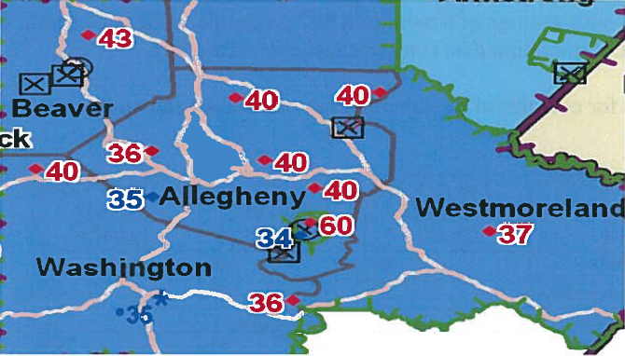
Figure 2. PM_{2.5} Concentrations for Allegheny County and Surrounding Area.⁵

The Allegheny County Health Department conducted an 18 month study comparing the Liberty-Clairton monitor with the Lawrenceville monitor, one that is associated with high levels of urban air pollution. It found that the Liberty-Clairton monitor had much higher peaks in organic and elemental carbon on days associated with high PM for both sites.⁵² They further compared the Liberty-Clairton monitor to other monitors in the surrounding vicinity; Table 3 shows how the number between sites compare.
.
Table 3. Comparison levels for sites in an ACHD study. ⁵²
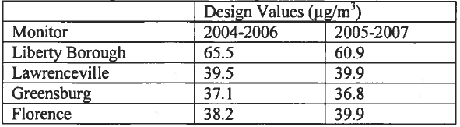

      - Factor 3: Meteorology and Topography
To determine the prevailing wind direction affecting the Liberty-Clairton Area, the EPA conducted what they call a “pollution rose”. During times associated with highest levels of PM_{2.5} at the Liberty-Clairton monitor, the prevailing winds came predominately from the southwest.⁵⁰ Figure 3 shows where the Liberty Boro monitor is in relation to Clairton Coke Works.
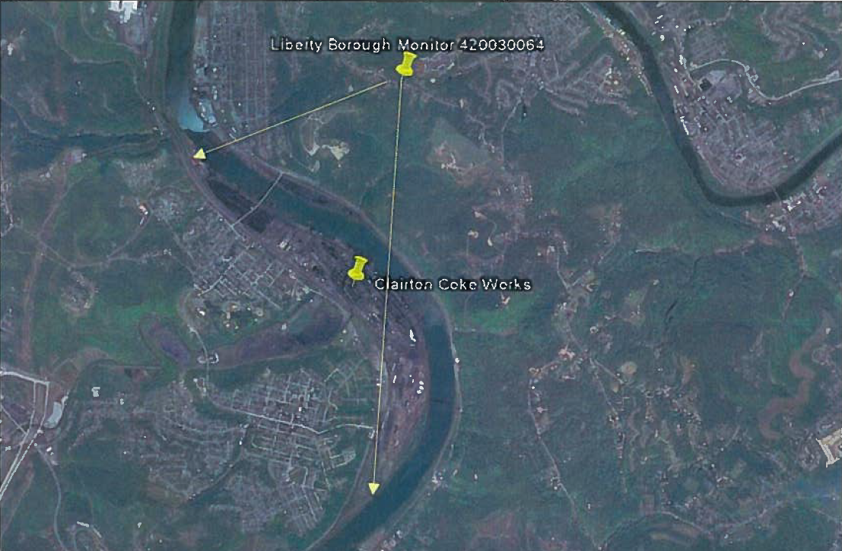
Figure 3. The Liberty Clairton monitor in relation to Clairton Coke Works.⁵⁰

Clairton Coke Works sits at about 700 feet above sea level adjacent to the Monongahela River. Across the river, the landscape sharply rises in elevation to 1100 feet above sea level. The Liberty Boro monitor shares this elevation about a mile away from the site. The Youghiogheny River borders the Liberty-Clairton area along its north eastern edge. Figure 4 is a topographical map that illustrates the unique terrain of the area.
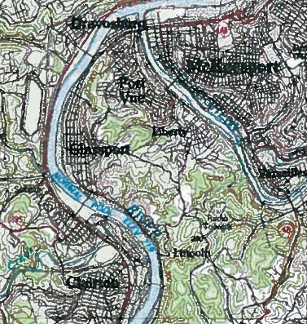
Figure 4. Topographical map of the Liberty-Clairton non-attainment area

    - Atmospheric Factors Effecting Plume
To account for the effective concentration that will reach the Liberty Boro monitor from the Clairton Coke Works point source, a plume model based on the Gaussian distribution can be employed.. The problem with this approach is that there are many stability classes and contrasts in the terrain to account for that it would be very difficult to apply a model for this situation. One can emphasize the influence of atmospheric stability on the concentrations reaching the monitor. A relatively stable atmosphere indicates that the air released in the plume will not be permitted to mix or go higher into the atmosphere. As a plume rises and cools, it normally follows its adiabat where the air cools as it gets higher.⁵³ If an inversion layer exists where at a certain height in the atmosphere the air is warmer than the air close to the earth, air can get trapped by the dense warm air and be constricted from rising. This is referred to as an inversion cap. When constituents of a plume are trapped by the inversion cap, they remain close to the ground until turbulence or a cool, less dense air front breaks it up.⁵⁴ The unique terrain surrounding the Liberty-Clairton area, especially the rivers that tend to cap cool air at the surface during certain times of the day, has a substantial effect on the amount of PM reaching the monitor. Figure five shows how a stable atmosphere with an inversion cap can affect how a plume remains in an area.
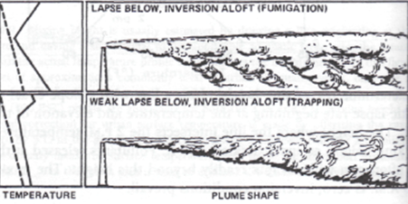
Figure 5. An illustration of how an inversion caps air rising from a plume.⁵³

- Mapping Health Risk in Liberty-Clairton Area using GIS software
The preceding concerned some of the literature associated with exposure to PM_{2.5} and specifically covered the Liberty-Clairton non-attainment area and its connection Clairton Coke Works. Now we will make use of data available from the EPA’s National Air Toxic Assessment (NATA) to illustrate the connection between exposure and risk for adverse health effects in the Liberty-Clairton Area. Arcmap10, a form of Global Information Systems (GIS) software, was used for this section. Data is taken from NATA’s 2002 assessment results for overall cancer risk.⁵⁵ This is nationwide data that gives risk values for every municipality in the United States. To make the data more accessible, I used only data for municipalities in Allegheny County. 2010 US Census Bureau shape files⁵⁶ were used in ArcMap to represent the total population in individual municipalities of Allegheny County.
  - Map 1
In ArcMap, I joined the NATA risk data to shape files from the Census Bureau. Figure 6 is a thematic quintile map representing total risk for cancer over the individual municipalities of Allegheny County. I used natural breaks (jenks) to create categories for most risk. The EPA defines the category of total risk as representing the sum of all carcinogens in assessment and individual pollutant contributions to total risk. (e.g. 1.60E-05 represents a risk of 16 in a million; 1.17E-06 represents a risk of 1.17 in a million).⁵⁷ The names of the individual municipalities are overlaid on the map to identify the five municipalities with highest risk: Liberty Boro, Glassport, Clairton, Lincoln and Port Vue. They are seen at the bottom of the map. The municipality of Clairton has the highest cancer risk with 762 individuals per million or 7.26E-04.
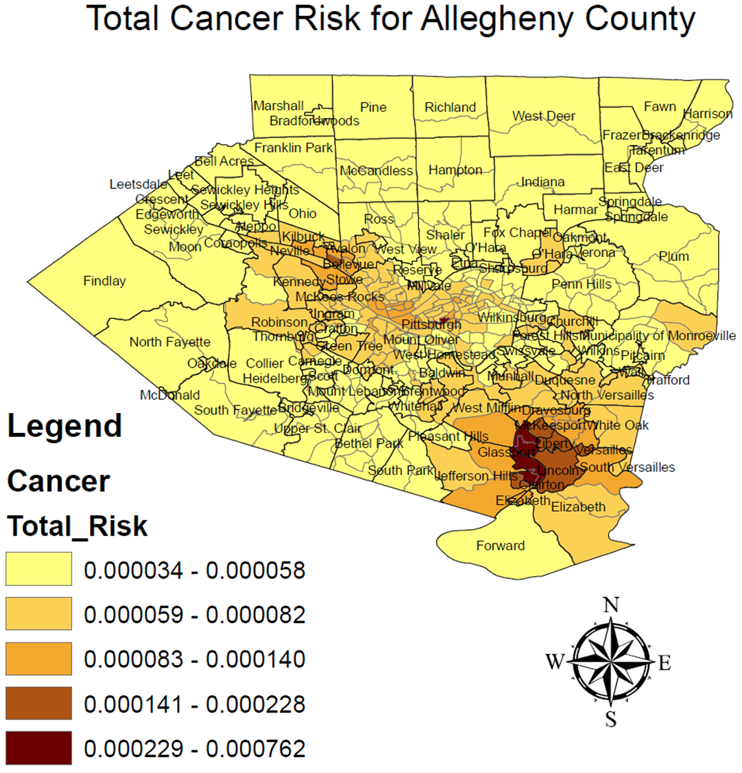
Figure 6. Thematic map representing total cancer risk in individual municipalities of Allegheny County.

  - Map 2
In the next map, I overlaid a shape file for Toxic Release Inventory (TRI)⁵⁸ sites over the thematic map for total cancer risk in Allegheny County without municipality labeling. This map identifies Clairton Coke Works as the bottom green dot, located in the five dark brown municipalities.
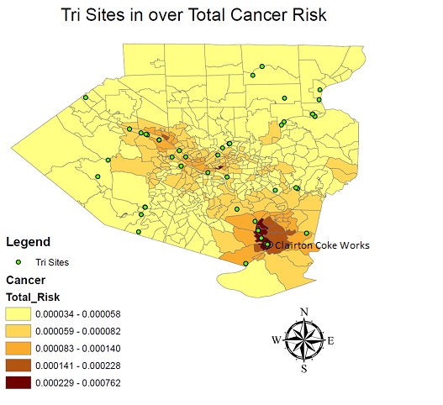
Figure 7. Same thematic map as Figure 6, but with TRI sites overlaid.

  - Map 3
The NATA Total Risk for cancer category reflects cancer risk from hundreds of air pollutants. NATA gives data for individual pollutants that make up the total risk. They did not have a category that was solely PM_{2.5}, but they did have a category called Coke Oven Emissions. This category reflects all the constituents discussed above that are released in coke oven emissions. Figure 8 is a thematic quintile map that was made the same way Figure 7 was, only with Coke Oven Emissions as the main variable for cancer risk. The map looks quite similar to Figure 6, with a reflection that the majority of cancer risk in the Liberty-Clairton area is from coke oven emissions. Clairton has the highest risk, which is 653 individuals million.
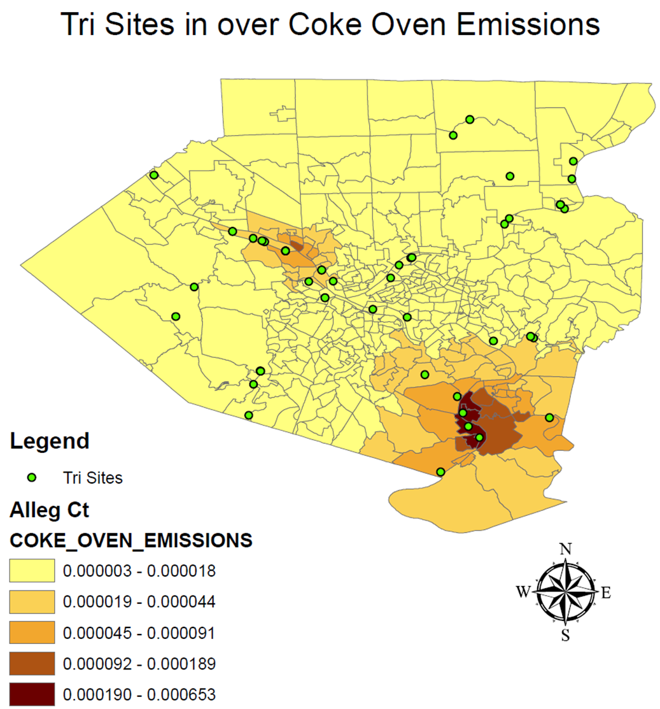

Figure 8. Thematic map representing total cancer risk attributed to coke oven emissions in individual municipalities of Allegheny County.

  - Map 4
This map has a one, two, and three mile buffer overlaid over the total cancer risk map and added the names of the municipalities being affected. The buffers are useful because one can see that the risk for cancer diminishes as you move south of the Clairton Coke Works, which reflects how the prevailing northwest winds affect the transport of emissions. Liberty Boro is highlighted in blue since the monitor was placed there.
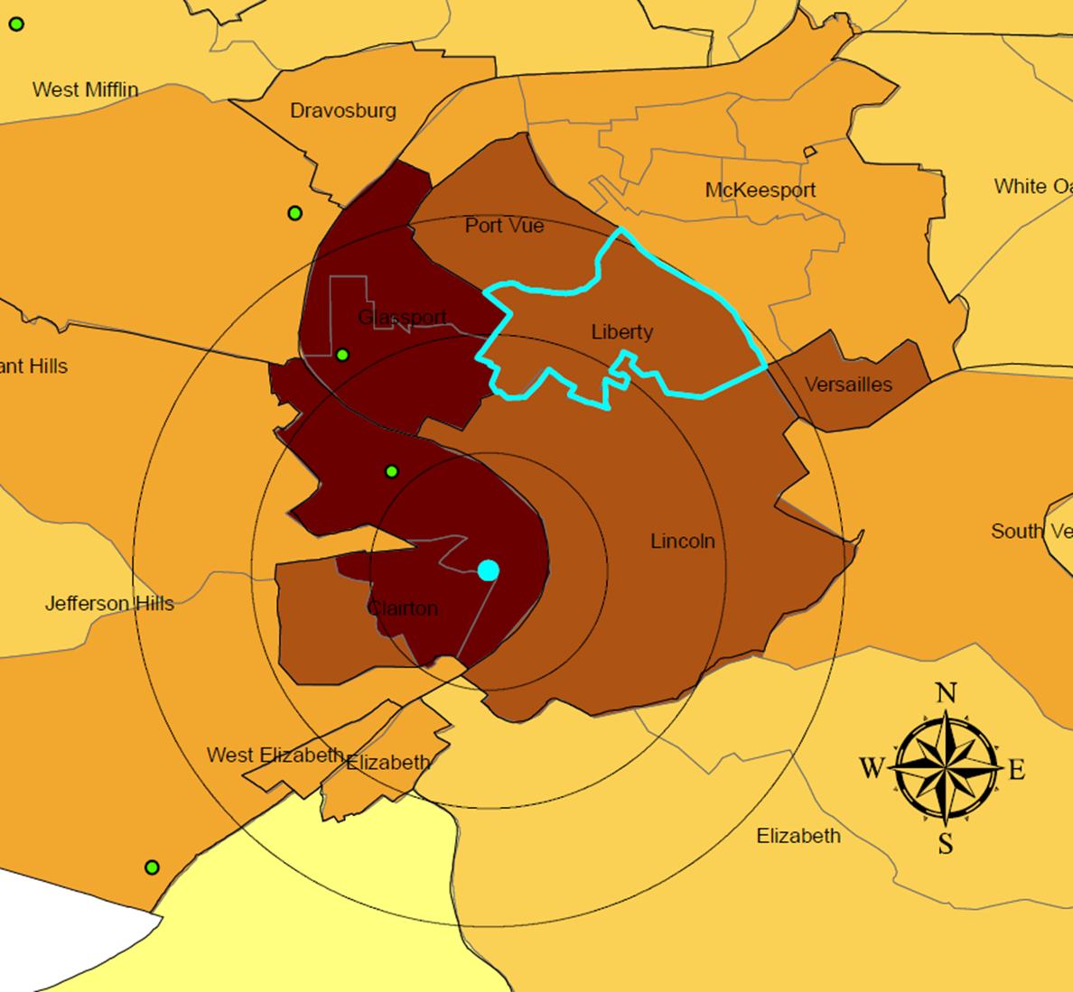
Figure 9. One, two, and three mile buffers around Clairton Coke works.
In the previous map, one can see that the municipalities of Liberty Boro and Lincoln show a decreased cancer risk compared toother municipalities that are part of the Liberty Clairton non-attainment area. From our discussion above, there is a large amount of evidence that shows that the Liberty Boro municipality is most exposed to PM_{2.5.} Thus one would think that cancer risk in this area would be the highest. This may be due to a flaw in the data: if the data reflects emissions data instead of data collected from monitors then the municipality of Clairton would have the highest risk for cancer. In fact, this is the opposite. Since Clairton Coke Works is on the southern edge of Clairton, the prevailing winds push emissions away from the municipalities and in the direction of Lincoln and Liberty Boro. This phenomenon is supported by the PM_{2.5} concentrations at the north of Clairton Coke Works Liberty Boro monitor and the South of Clairton Coke Works Clairton monitor, which were 60.9μg/m³ and 34 μg/m³, respectively.⁵⁰ Figure 10 shows an image from the EPA that shows both monitors in relation to Clairton Coke Works.
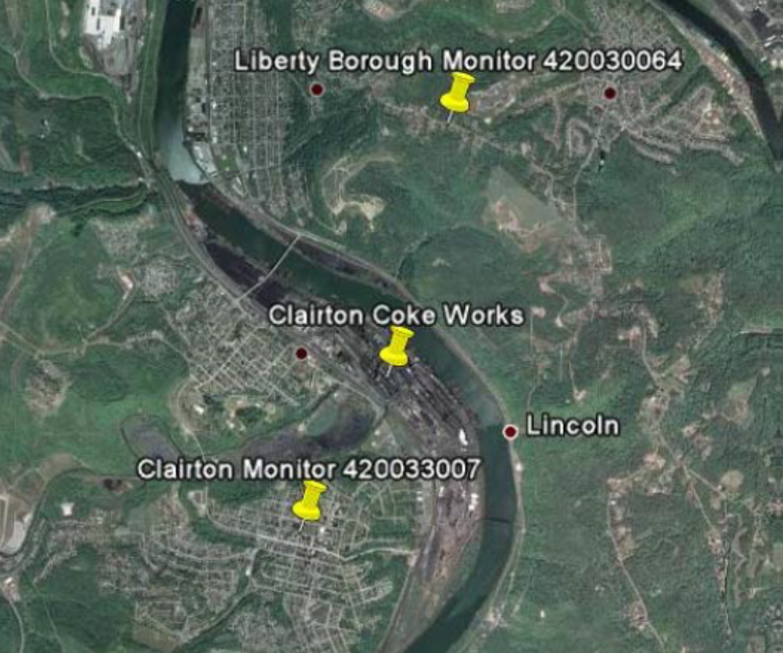
Figure 10. EPA image of the Liberty Boro monitor and the Clairton monitor in relation to Clairton Coke Works.⁵⁰
  - Map 5
The next map uses hot spot analysis to see if there are clusters in the data, giving a closer approximation of risk in the area really might look like. This map shows how emissions are carried predominately north and spread out over the unique terrain in both east and west directions. Although the only monitor north of Clairton Coke Works is in Liberty Boro, one can speculate from this map that all of these municipalities can be potentially exposed to emissions from there.
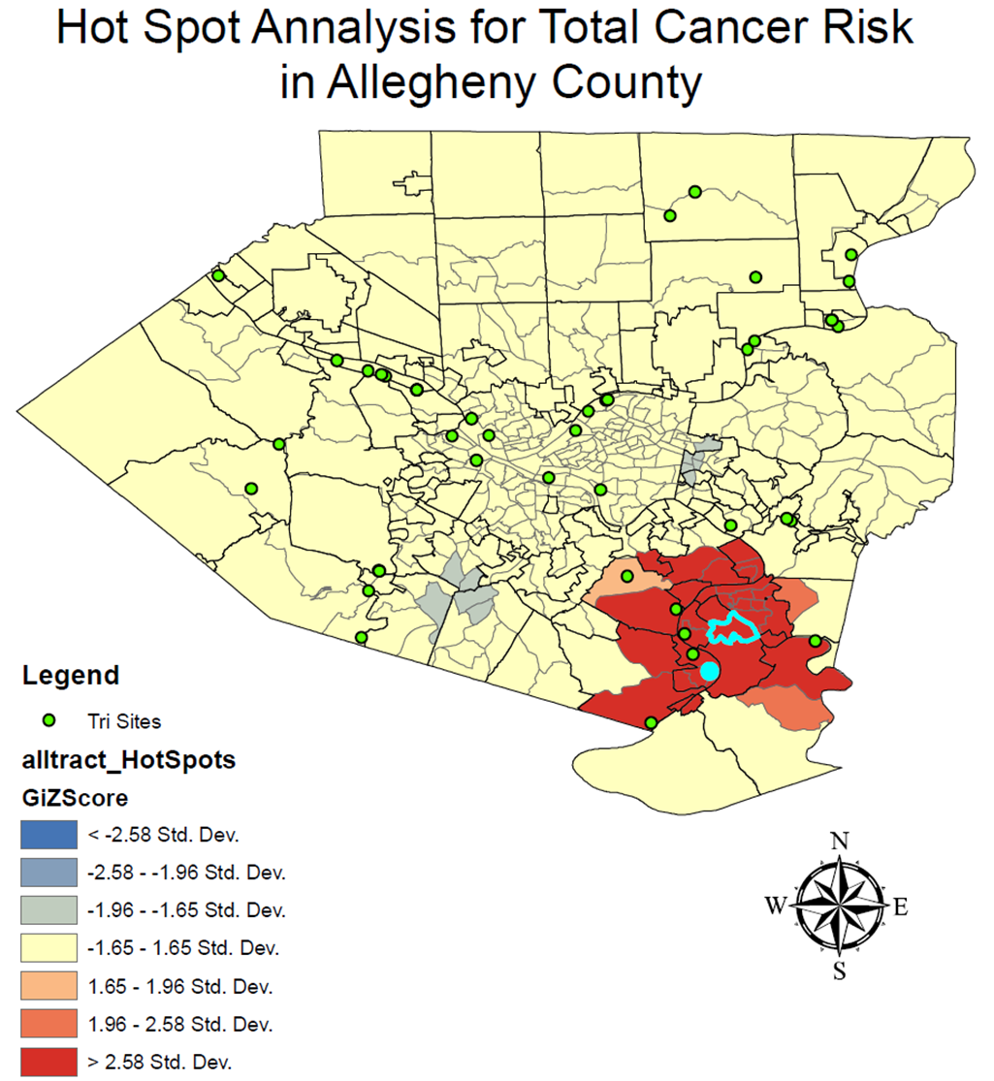
Figure 11. Hot Spot Analysis over Total Cancer Risk. Clairton Coke Works is the blue dot and Liberty Boro is the municipality highlighted in blue.
- Moving Forward
  - ACHD Anticipates 2014 Attainment
In order to improve air quality in a nonattainment area, states must draft a plan known as a state implementation plan (SIP). The plan outlines the measures that the state will take in order to improve air quality. In 2009, the state became responsible for bringing the Liberty-Clairton Area into attainment within a five year period; if it does not reach attainment, the EPA will classify this area as a severe area, which will involve imposing strict emission control through closing of batteries at Clairton Coke Works along with further law suits. The Allegheny County Health Department has worked closely with US Steel to reduce emissions at Clairton Coke to bring them within attainment by the December 2014 deadline.⁵⁹ In 2009, US Steel temporarily shut down three of its batteries at Clairton Coke Works, and a consent agreement between ACHD and US Steel led to permanent shut downs of these batteries. US Steel has also invested over 500 million dollars to upgrade the facilities at Clairton Coke Works. This includes building a state of the art battery that is supposed to greatly reduce emissions as well as bringing quenching towers up to date to significantly reduce SO₂ and ammonia emissions. On January 9th, 2013, ACHD released a report stating that the Liberty-Clairton Area will reach attainment by the deadline in 2014.⁵⁹ Figure 11 shows the anticipated levels they expect for the Liberty-Clairton Area based on emission reduction at the Clairton Coke Works point source. If the Liberty-Clairton area does reach attainment status, then the area will be categorized as a maintenance zone and will be much less subject to EPA intervention.
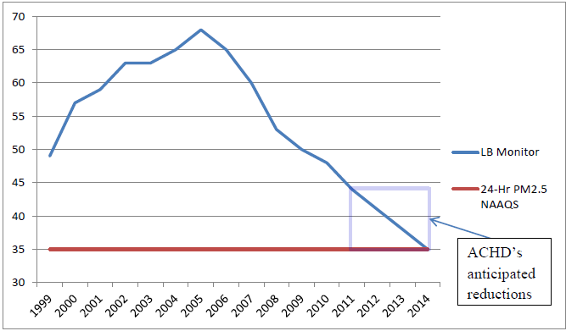
Figure 12. Historical and anticipated values for average 24-hour PM_{2.5} at the Liberty Boro monitor.⁶⁰
  - Activists Groups Expect Continued Non-Attainment by 2014
In response to the January report by ACHD, The Clean Air Council (Council), Group Against Smog and Pollution (GASP), Sierra Club, and other groups submitted a report on March 5th to the EPA regarding the validity of the ACHD report. The groups show that the anticipated levels are not accurate and emissions will not reach attainment by the date.⁶⁰ The report points out several flaws and assumptions the ACHD is making when considering the level of emissions from Clairton Coke Works and the levels reaching the Liberty Boro monitor. They state that ACHD is citing that the permanent shutdown of the three batteries mentioned earlier will significantly reduce emissions, even though they have been shut down for over three years now. Therefore, a double-counting effect of these closings is placed in their PM calculation. The March report also shows that the actual level of emissions coming from the point source is projected to be a very moderately reduction from the levels in the year 2007. Table 4 shows the 2007 values and the projected values for 2014, comparing emissions from Clairton Coke Works to all other sources in the Liberty Clairton Area.

Table 4. Point source emissions for Clairton Coke Works for 2007 and 2014. ⁶⁰
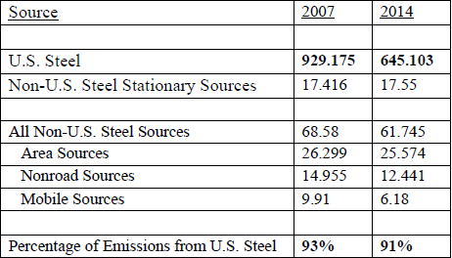

An expert committee weighed in on the commenters’ report and found further reason to believe that the Liberty-Clairton Area will not reach attainment by the deadline. It pointed out that the most recent data from the Liberty Boro monitor shows nonattainment of the 24-hour standard through 2011. In fact, the Liberty Boro monitor had a 2011 design value of 44 μg/m³, which is 9 μg/m³ over the 24-hour standard of 35 μg /m3. New data is needed to determine whether the Liberty-Clairton concentrations have approached the attainment level, until then assumptions, are misleading. The commenters’ expert report also identifies a series of errors that lead to a strong likelihood of ACHD’s model significantly undercounting PM_{2.5}. ACHD uses the unauthorized modeling module “Plume-in-Grid” instead of EPA’s recommended AERMOD module. ACHD also uses CAMx modeling, which has proven to be inaccurate in estimating concentrations from large point sources. They likewise point out ACHD’s inappropriate blame on the areas meteorology for causing the nonattainment; therefor citing that inversion events cause the high levels of PM. From the text of the document “The non-attainment is not caused by meteorology,” excess emissions in the immediate area cause the non-attainment. Inversions may aggravate, but if there were inversions without emissions, there would be no nonattainment. If you have an inversion and there is no particulate matter in the air, then the inversion will not cause nonattainment for PM_{2.5}. It is only because the particulate matter exists that you have nonattainment. So the answer is to remove the particulate matter.”⁶⁰

- Conclusion
  - Summary
This paper was meant to draw a link between source and exposure by considering the situation between US Steel’s Clairton Coke Works and the Liberty-Boro non-attainment area. The chemistry, toxicology, and epidemiology considering air pollution has been discussed. These fields were further explored in regards to PM_{2.5}. The regulatory entities attached to the Liberty-Clairton example were skimmed and a brief history of Clairton coke works in the 1970s was discussed. The dynamics of how the source affects the exposed was explored by taking a look at emission levels as well how PM is transported over the unique terrain of the Liberty-Clairton area. GIS mapping was used to illustrate that the health outcome risk for cancer is significantly higher for residents who live in the Liberty-Clairton area opposed to residents in the rest of Allegheny County. The data used in the map also reaffirmed our speculation that Clairton Coke Works was the culprit for the high risk in the area. This essay closed by recognizing the still evolving policies and politics that engulf this issue.
  - Further remarks
There is a building understanding through the immense amount of literature available focused on the health effects associated with poor air quality. We have come far through technology to better understand the transport of chemicals through the air. We can model emissions and make assumptions that give us a reasonable idea of how much of a chemical is reaching a population. We have a growing data base that allows us to construct associations between source and exposure. The one thing we lack is efficient policy. One does not need a modeling program or GIS mapping skills to smell the foul air that has continuously been spewed over the residents of the Liberty-Clairton area. One does not need databases full of data to know that a factory neglected to invest any money towards renovation over the last half century when it knew full well it could. And one does not need to calculate a confidence interval to see that a disproportionate amount of lives were taken too soon in Liberty Boro and the surrounding municipalities. To the people of those areas, all of this is just common sense. They have become accustomed to the smoke, powerless since industry reinforces that the smoke allows them to survive, a slogan full of “economic blackmail”.
To affect policy making, we need to use the best science at our fingertips, but how do we translate that into efficient pressure on our government to do what’s right. How can, for over fifty years, a company skirt around the rules when all the evidence points towards them? And now that they’re finally complying, we let our guard down and pretend that the old history never happened. When you have acute instances like Donora and the London Smog, where thousands of people lost their lives because of high levels of pollution, policy seems to come a bit swifter. Public outcry seems to be the only thing that can ignite policy change. Will the history books ever account for an industry that fought regulation for over fifty years while being responsible for the premature deaths of perhaps just as many people as the acute incidences did with the same fervor? With the ACHD giving US Steel an easy pass, I doubt it.
The purpose of the response to the January Allegheny County Department of Health was to illustrate that the Liberty-Clairton area will not reach attainment status by the deadline. It shows that ACHD may be guilelessly trusting of the promises from an industry that has historically broken its promises to clean up the air it infects. It leads one to recollect the history of ACHD pandering towards US Steel, consistently worrying about the economy rather than human health. Ultimately, the EPA will investigate if the Liberty-Clairton Area has truthfully reached attainment status, but the debate that has recently fired up between interest and environmentalist groups against ACHD and Clairton Coke Works is telling that this issue will continue to be hard fought as long as Clairton keeps people in the Mon Valley employed as well as spewing toxic filth into the air.

Bibliography
- Varney, R. (2005, December 2). Cleaner Air, Water & Land - EPA's 35 Year Legacy & Future Promise. Retrieved November 19, 2012, from http://www.epa.gov/region1/ra/column/archive/2005/epa_35yrs_20051202.html e.
- Crandall, R. W. (1983). Controlling industrial pollution: The economics and politics of clean air.
- U. S. Environmental Protection Agency. (2012, February 17) History of the Clean Air Act. Retrieved November 19, 2012, from http://epa.gov/air/caa/caa_history.html.
- Pennsylvania Department of Environmental Protection. (2012, August 30) Attainment Status by Principal Pollutants. Retrieved Novemeber 19, 2012, from http://www.dep.state.pa.us/dep/deputate/airwaste/aq/attain/status.htm.
- Pennsylvania Department of Environmental Protection. (2011, June 25). Department of Environmental Protection Ambient Air Monitoring Network Plan -2012. Accessed November 19, 2012, from http://www.dep.state.pa.us/dep/deputate/airwaste/aq/aqm/docs/PA_Air_Monitoring_Network_Plan_for_2012_final_07-20-2011.pdf.
- Dahmann D, Morfeld P, Monz C, Noll B, Gast F. (2009). Exposure assessment for nitrogen oxides and carbon monoxide in German hard coal mining. Int Arch Occup Environ Health Apr 8:DOI 10.1007/s00420-009-0418-5.
- Ruth-Sahd, L. A., Zulkosky, K., & Fetter, M. E. (2011). Carbon Monoxide Poisoning: Case Studies and Review. Dimensions of Critical Care Nursing, 30(6), 303.
- Kragie, S. X., Ryan, P. B., Bergin, M. H., & Wang, S. (2011). Airborne trace metals from coal combustion in Beijing. Air Quality, Atmosphere & Health, 1-9.
- Linak WP, Yoo J-I, Wasson SJ, Zhu W, Wendt JOL, Huggins FE et al (2007) Ultrafine ash aerosols from coal combustion: characterization and health effects. Proc Combust Inst 31(2):1929–1937.
- U.S. EPA. Air Quality Criteria for Oxides of Nitrogen (Final, 1993). U.S. Environmental Protection Agency, Washington, D.C., EPA/600/8-91/049aF-cF, 1993.
- U. S. Environmental Protection Agency. (2010, July 1). UV Radiation. Retrieved December 7, 2012, from http://www.epa.gov/sunwise/doc/uvradiation.html.
- Jerrett, M., Burnett, R. T., Pope III, C. A., Ito, K., Thurston, G., Krewski, D., ... & Thun, M. (2009). Long-term ozone exposure and mortality. New England Journal of Medicine, 360(11), 1085-1095.
- Bell, M. L., Davis, D. L., & Fletcher, T. (2004). A retrospective assessment of mortality from the London smog episode of 1952: the role of influenza and pollution. Environmental health perspectives, 112(1), 6.
- http://www.epa.gov/airnow/airqualityguideparticles.pdf
- Brook, R. D., Franklin, B., Cascio, W., Hong, Y., Howard, G., Lipsett, M., ... & Tager, I. (2004). Air pollution and cardiovascular disease: A statement for healthcare professionals from the expert panel on population and prevention science of the American Heart Association. Circulation, 109(21), 2655-2671.
- Donaldson, K., Stone, V., Clouter, A., Renwick, L., & MacNee, W. (2001). Ultrafine particles. Occupational and environmental medicine, 58(3), 211-216.
- Romieu, I., Castro-Giner, F., Kunzli, N., & Sunyer, J. (2008). Air pollution, oxidative stress and dietary supplementation: a review. European Respiratory Journal, 31(1), 179-197.
- Samet, J. M., Dominici, F., Curriero, F. C., Coursac, I., & Zeger, S. L. (2000). Fine particulate air pollution and mortality in 20 US cities, 1987–1994. New England journal of medicine, 343(24), 1742-1749.
- Katsouyanni, K., Touloumi, G., Samoli, E., Gryparis, A., Le Tertre, A., Monopolis, Y., ... & Schwartz, J. (2001). Confounding and effect modification in the short-term effects of ambient particles on total mortality: results from 29 European cities within the APHEA2 project. Epidemiology, 12(5), 521-531.
- Dominici, F. (n.d.) Statistical Methods for Time Series Analysis of Air Pollution and Health. Accessed December 12, 2012, from http://www.jhsph.edu/research/centers-and-institutes/center-for-excellence-in-environmental-health-tracking/francescapresentation8_3_05.pdf.
- Pope III, C. A., Muhlestein, J. B., May, H. T., Renlund, D. G., Anderson, J. L., & Horne, B. D. (2006). Ischemic heart disease events triggered by short-term exposure to fine particulate air pollution. Circulation, 114(23), 2443-2448.
- Wellenius, G. A., Schwartz, J., & Mittleman, M. A. (2005). Air pollution and hospital admissions for ischemic and hemorrhagic stroke among medicare beneficiaries. Stroke, 36(12), 2549-2553.
- Dockery, D. W., Pope, C. A., Xu, X., Spengler, J. D., Ware, J. H., Fay, M. E., ... & Speizer, F. E. (1993). An association between air pollution and mortality in six US cities. New England journal of medicine, 329(24), 1753-1759.
- Pope, C. A., Thun, M. J., Namboodiri, M. M., Dockery, D. W., Evans, J. S., Speizer, F. E., & Heath, C. W. (1995). Particulate air pollution as a predictor of mortality in a prospective study of US adults. American journal of respiratory and critical care medicine, 151(3), 669-674.
- Pope III, C. A., Burnett, R. T., Thun, M. J., Calle, E. E., Krewski, D., Ito, K., & Thurston, G. D. (2002). Lung cancer, cardiopulmonary mortality, and long-term exposure to fine particulate air pollution. JAMA: the journal of the American Medical Association, 287(9), 1132-1141.
- Suwa, T., Hogg, J. C., Quinlan, K. B., Ohgami, A., Vincent, R., & van Eeden, S. F. (2002). Particulate air pollution induces progression of atherosclerosis. Journal of the American College of Cardiology, 39(6), 935-942.
- Seaton, A., Godden, D., MacNee, W., & Donaldson, K. (1995). Particulate air pollution and acute health effects. The Lancet, 345(8943), 176-178.
- Junker, R., Heinrich, J., Ulbrich, H., Schulte, H., Schönfeld, R., Köhler, E., & Assmann, G. (1998). Relationship between plasma viscosity and the severity of coronary heart disease. Arteriosclerosis, thrombosis, and vascular biology, 18(6), 870-875.
- Künzli, N., Jerrett, M., Mack, W. J., Beckerman, B., LaBree, L., Gilliland, F., ... & Hodis, H. N. (2005). Ambient air pollution and atherosclerosis in Los Angeles. Environmental health perspectives, 113(2), 201.
- Shukla, A., Timblin, C., BeruBe, K., Gordon, T., McKinney, W., Driscoll, K., ... & Mossman, B. T. (2000). Inhaled particulate matter causes expression of nuclear factor (NF)-kappaB-related genes and oxidant-dependent NF-kappaB activation in vitro. American journal of respiratory cell and molecular biology, 23(2), 182.
- Halliwell, B. (2007). Oxidative stress and cancer: have we moved forward?. Biochem. J, 401, 1-11.
- Kim, K., Park, E. Y., Lee, K. H., Park, J. D., Kim, Y. D., & Hong, Y. C. (2009). Differential oxidative stress response in young children and the elderly following exposure to PM 2.5. Environmental health and preventive medicine, 14(1), 60-66.
- Goldberg, M. S., Burnett, R. T., & Bailar, J. C. 3. (2001). Identification of persons with cardiorespiratory conditions who are at risk of dying from the acute effects of ambient air particles. Environmental health perspectives, 109(Suppl 4), 487.
- Zanobetti, A., & Schwartz, J. (2001). Are diabetics more susceptible to the health effects of airborne particles?. American journal of respiratory and critical care medicine, 164(5), 831-833.
- Pope III, C. A., Burnett, R. T., Thurston, G. D., Thun, M. J., Calle, E. E., Krewski, D., & Godleski, J. J. (2004). Cardiovascular Mortality and Long-Term Exposure to Particulate Air Pollution Epidemiological Evidence of General Pathophysiological Pathways of Disease. Circulation, 109(1), 71-77.
- Hamill, Sean D. "Unveiling a Museum, a Pennsylvania Town Remembers the Smog That Killed 20", The New York Times, November 1, 2008. Accessed November 2, 2012.
- U.S. Environmental Protection Agency. (2008, May). Coke Production. Accessed December 30, 2012, from www.epa.gov/ttnchie1/ap42/ch12/final/c12s02_may08.pdf.
- Trauth, J. M. (1994). Case Study of Health Risk Communication: What the Public Wants and What It Gets, A. Risk, 5, 49.
- Valia, H. (n.d.) Coke Production For Blast Furnace Ironmaking. Accessed December 30, 2012, from http://www.steel.org/en/Making%20Steel/How%20Its%20Made/Processes/Processes%20Info/Coke%20Production%20For%20Blast%20Furnace%20Ironmaking.aspx.
- Cole, G. (2007, June 8). Health Dept. Announces Clean Air Agreement with U.S. Steel. Accessed December 30, 2012, from http://www.achd.net/pr/pubs/2007release/steel.html.
- Liang, Y. Z., & Kvalheim, O. M. (1996). Robust methods for multivariate analysis—a tutorial review. Chemometrics and intelligent laboratory systems, 32(1), 1-10.
- Weitkamp, E. A., Lipsky, E. M., Pancras, P. J., Ondov, J. M., Polidori, A., Turpin, B. J., & Robinson, A. L. (2005). Fine particle emission profile for a large coke production facility based on highly time-resolved fence line measurements. Atmospheric Environment, 39(36), 6719-6733.
- Jones, C. O. (1978). Clean air: The policies and politics of pollution control. University of Pittsburgh Press.
- Allen, J. E. (1974). U.S. Patent No. 3,843,461. Washington, DC: U.S. Patent and Trademark Office.
- Group Against Smog and Pollution. (n.d.) Group Against Smog and Pollution Records. Accessed January 3, 2013, from http://www.gasp-pgh.org/wp content/uploads/2008/06/710704hotline.pdf.
- Reed, C. (2004, October) Group Against Smog and Pollution Records. Accessed January 3, 2013, from http://digital.library.pitt.edu/cgi-bin/f/findaid/findaid-idx?c=ascead;cc=ascead;q1=Environment;rgn=main;view=text;didno=US-PPiU-ais197921.
- Corso, P. (2008). Coke, Clairton and Cancer: A Three-Decade Push for Reforms. Western Pennsylvania History, 91(1), 40-49.
- South Carolina Department of Health and Environmental Control. (n.d.). National Ambient Air Quality Standards (NAAQS). Accessed January 3, 2013, from http://www.scdhec.gov/environment/baq/docs/factsheets/national%20ambient%20air%20quality%20standards.pdf.
- U. S. Environmental Protection Agency. (2012, December 14). National Ambient Air Quality Standards (NAAQS). Accessed January 3, 2013, from http://www.epa.gov/air/criteria.html.
- U. S. Environmental Protection Agency. (2009). EPA Technical Analysis for Liberty-Clairton Area. Accessed January 11, 2013, from http://www.epa.gov/pmdesignations/2006standards/rec/letters/03_PA_EPAMOD3.pdf.
- Esworthy, R. (2007 May 9). Particulate Matter (PM2.5): Implementation of the 1997 National Ambient Air Quality Standards (NAAQS) www.nationalaglawcenter.org/assets/crs/RL32431.pdf.
- PM 2.5Chemical Speciation and Related Comparisons at Lawrenceville and Liberty: 18-Month Results,” dated June 7, 2005, prepared by Jason Maranche, Allegheny County Health Department, and available at http://www.achd.net/airguallpubs/pdfYspeciation_report.pdf.
- Hemond, H. F., & Fechner-Levy, E. J. (2000). Chemical fate and transport in the environment. Academic Press.
- Environmental Engineering. (2011, January 11). Accessed February 19, 2013, from http://envi-scie.blogspot.com/2011/01/temperature-inversion.html.
- U. S. Environmental Protection Agency. (2010, September 9). 2002 National-Scale Air Toxics Assessment. Accessed October 25, 2012, from http://www.epa.gov/ttn/atw/nata2002/tables.html#table1.
- United States Census Borough. (2010). TIGER Products. Accessed October 11, 2012, from http://www.census.gov/geo/maps-data/data/tiger.html.
- U. S. Environmental Protection Agency. (2002). 2002 National-Scale Air Toxics Assessment: Data Tables. Accessed October 11th, 2012, from http://www.epa.gov/ttn/atw/nata2002/02pdfs/datatablesreadme.pdf.
- U. S. Environmental Protection Agency. (2013, March 13). 2011 TRI National Analysis Report Now Available. Accessed March 23, 2013, from www.epa.gov/tri/.
- Allegheny County Health Department (2013, January 9). Draft Revision to the Allegheny County Portion of the Pennsylvania State Implementation Plan. Accessed March 21, 2013, from http://www.achd.net/airqual/Liberty-ClairtonPM25SIP2006Stds-Draft.pdf.
- Group Aggainst Smog and Pollution. (2013, March 5). Re- Draft Revision to the Allegheny County Portion of the Pennsylvania State Implementation Plan. Accessed March 25, 2013, from http://www.cleanair.org/sites/default/files/Comments%20on%20Liberty-Clairton%20Attainment%20Demonstration.pdf.
- Santa Barbara County Air Pollution Control District. (2009). Air Pollutants and Our Health. Accessed March 27th, 2013, from http://www.sbcapcd.org/sbc/pollut.htm.

