CONNECTING LOCAL FOOD TO STUDENTS: A FORMATIVE AND IMPACT EVALUATION PROPOSAL of the FARM TO SCHOOL PROGRAM

by
Kristen Taylor Yates
B.S. Biological Sciences, Elizabethtown College, 2010

Submitted to the Graduate Faculty of
the Graduate School of Public Health in partial fulfillment
of the requirements for the degree of
Master of Public Health

University of Pittsburgh
2013

UNIVERSITY OF PITTSBURGH
Graduate School of Public Health

This essay was submitted

by

Kristen Taylor Yates

on June 2013
and approved by

Essay Advisor
Christopher R. Keane, ScD, MPH _________________________________
Assistant Professor
Behavioral and Community Health Sciences
Graduate School of Public Health
University of Pittsburgh

Essay Reader
Judith Dodd, MS, RD, LDN, FADA _________________________________
Adjunct Assistant Professor
School of Health and Rehabilitation Sciences
University of Pittsburgh

Copyright © by Kristen Yates
2013
ABSTRACT
This essay addresses evaluations of a promising ecological school intervention, Farm to School, aiming to improve child nutrition and incorporate local healthy foods in the school meal system, while creating a sustainable market for local farmers. By providing an overview of Farm to School program interventions, this essay first identifies gaps and limitations in evaluations designs, which include the inability to compare results due to variation in program activity design, lack of experimental evaluation designs to determine dietary impact, the absence of organization relationship measures, and lack of documentation on the effect of school policies and involvement of caregivers. Theoretically, exposure to nutritious foods should lead to improved student dietary behavior, but there is a lack of peer-reviewed evaluation results in recent literature to support this claim.
Christopher R. Keane, ScD, MPH

CONNECTING LOCAL FOOD TO STUDENTS: A FORMATIVE AND IMPACT EVALUATION PROPOSAL of the FARM TO SCHOOL PROGRAM

Kristen Taylor Yates, MPH
University of Pittsburgh, 2013

The second goal of the paper is to propose a formative and impact evaluation to attain more conclusive results and to aid Farm to School directors in assessing an individual program’s processes. The formative evaluation for use of Farm to School program directors aims to evaluate programs from a socio ecological framework. The proposed formative evaluation tool includes both existing questionnaires used by current Farm to School programs and surveys that have been adapted to fit Farm to School needs. These surveys identify the effect of caregiver involvement, the strength of a program’s organizational capacity, community readiness, policy strength and assessments of the school environment. In addition, this essay proposes a quasi-experimental impact evaluation design that may be used for future programs to obtain conclusive results of the program’s effects on student dietary behavior and attitudes towards healthy lifestyles and the local community. The proposed impact evaluation, when implemented, will show which program activities have the greatest effect on student behavior and knowledge, the environmental factors that help best facilitate desired results, and give conclusive student dietary impact results that may fuel future funding opportunities and expansion of the Farm to School movement. These evaluations hold the public health significance of strengthening research in Farm to School process and impact analysis, which can lead to changes in policy and the school environment that improve current and future student nutrition behavior.

TABLE OF CONTENTS
preface ix
1.0 Introduction 1
2.0 Background 3
3.0 Farm to school program overview 7
3.1 Theory 8
3.1.1 Social Cognitive Theory 8
3.1.2 Socio-Ecological Model 10
3.1.3 Interorganizational Relations Theory 12
3.2 farm to school program Activities 13
3.3 Farm to school Program Outcomes 16
4.0 farm to school evaluation 19
5.0 Methodology for formative and impact Evaluations of Farm to School programs 25
5.1 Farm to school formative evaluation proposal 25
5.1.1 Policy Level Formative Evaluation 26
5.1.2 Community Level Formative Evaluation 28
5.1.2.1 Community Readiness Model 29
5.1.2.2 Community Capacity and Interorganizational Measure 31
5.1.3 Institutional Level Formative Evaluation 33
5.1.3.1 School Staff Formative Measure 34
5.1.3.2 Farmer Formative Evaluation Measures 35
5.1.4 Parent/Caregiver Formative Evaluation 36
5.1.5 Student Formative Evaluation 38
5.2 Farm to School Impact Evaluation proposal 39
6.0 CONCLUSION 44
6.1 Strengths and Limitations 44
6.2 Public Health Significance 45
Appendix A: wellness SCHOOL ASSESSMENT TOOL 47
Appendix b: WILDER COLLABORATION FACTORS INVENTORY 54
APPENDIX C: STUDENT PRE-POST INVERVENTION...................................................58
bibliography 62
List of tables

Table 1. Comprehensive List of Farm to School Activities 13
Table 2. Farm to School Program Outcomes 16
Table 3. Farm to School Program Impact Evaluation Results 19
Table 4. Community Readiness Assessment Interview Questions 30

preface
This essay was written from a budding interest in the field of community nutrition. Living in a city environment that provides farmers markets and community gardens, I believe it is truly imperative to provide education and access of fresh local foods to students of all ages. I would like to thank first and foremost, my parents for supporting my venture in attaining my graduate degree and reminding me to always be true to my passions. My growth as a public health professional would not be complete without fellow graduate students who supported the classroom presence of my farmers market bags full of pumpkins and tomatoes, and those who met for social drinks and conversation to help relieve stress. I have nothing but endless gratitude for my supporters near and far: Liz, Rob, Josh, Mac, Stu, Jeff, Lane, Mike, and Melissa.
In particular, this paper would not be possible without the essay readers. I would like to thank Dr. Keane for his patience and classroom enthusiasm and Judy Dodd for advice and her inspirational involvement in community nutrition.
Finally, I thank Pittsburgh coffee shop establishments for continually providing a quiet place of work and a nonstop supply of caffeine.

Introduction
In the past two decades, an intervention model, known as Farm to School, has been gaining momentum in serving students attending elementary through high school. This program aims to connect schools with local or regional farmers in bringing nutritious food to its students through cafeteria meals, with the possible addition of nutrition education and other activities. The program addresses both local agriculture sustainability and nutritious food choices for children attending schools. Theoretically, exposure to the locally produced foods should lead to improved student dietary behavior, but there is a lack of peer-reviewed evaluation results in recent literature to support this claim. In addition, due to variation in program activity design, Farm to School programs across the country may lack resources in evaluating all processes of the program.
In light of recent literature, this paper first outlines the purpose and goals of Farm to School programs and proceeds to give an overview of program theories, activities, and outcomes. The objective of providing a detailed explanation of the Farm to School program’s design and desired impact is to inform a discussion on recent evaluation methods and results. The second objective of this essay is to identify gaps and limitations in Farm to School evaluation tools, which informs the third objective of proposing an evaluation tool that can be used across programs. This evaluation tool is comprised of formative measures on all socio ecological levels, which includes five areas: policy, community, institution, familial or home environment, and the individual. By using the measures supplied, Farm to School program directors will be able to assess program processes and identify areas of success and needed improvement as identified by all stakeholders.
Finally, a second evaluation design is proposed to measure impact on student dietary behaviors. This quasi-experimental design should provide conclusive results not yet determined through comparisons of control and experimental groups. In addition, an impact evaluation may shed light on which activities produce the most desired outcome in student dietary behavior. This design can later adopted to research other aspects of Farm to School interventions including community and farmer impacts. If positive, the results of this impact design replicated in various regions may increase funding opportunities and expand the reach of Farm to School programs across the country.

Background
Obesity is on the rise in America, and it is beginning in childhood. One out of three children is considered overweight or obese, and this trend is a result of an accelerated increase in recent years . As of 2009-2010, the National Health and Nutrition Examination Survey (NHANES) reported that 18.4% of children and adolescents aged 12 to 19 are considered obese, which is more than triple the rate of obesity found in adolescents in 1980 . Childhood obesity is associated with many costs, both to the individual’s health and the United States economy. The increasing childhood obesity rates are associated with diabetes, social problems, and psychological problems, and it is estimated that 61% of overweight youth display additional risk factors for heart disease . These factors may lead to shorter life expectancies . Additionally, overweight youth are more likely to be so as adults. These risk factors and problems associated with obesity cost the United States economy 117 billion dollars in the year 2000, and it will continue to rise if obesity is not prevented .
There are many factors that can contribute to the development of obesity, and it varies by individual. Obesity is often caused by an increase in caloric intake coupled with a decrease in energy expenditure , so targeting the food environment or physical activity would be a quality approach to prevention. In addressing environmental and policy changes to help control and prevent childhood obesity through access to healthful foods, the Institute of Medicine states the school system is a primary place to implement changes . Over 95% of American youth are enrolled in schools, so schools can serve to reach a wide audience in nutritional eating . More than 54 million children attend school daily, and youth consume between 19-50% or higher of their daily recommended caloric food intake at school . Neumark-Sztainer, French et al. (2005) states schools lie in the middle of the proximal and distal factors that can influence an individual within the ecological model. Thus, if applied to the food environment of an individual, school nutritional food environments can have an influence on an individual’s choices and behaviors. In addition, the American Diabetes Association, School of Nutrition Association, and Society for Nutrition Education have released a recent statement, affirming schools as a key partner in health promotion .
In order to address childhood obesity and child health, communities have been called to develop strategies and interventions impacting diet and physical activity (Feenstra and Ohmart 2012). Kubik,, Lytle et al. (2003) notes that unhealthy diets, constituted by being low in fruits and vegetables and high in fats, are most the most frequently occurring chronic disease risk behavior among youth aged 12-17 years. By standards explained by the United States Department of Agriculture (USDA) 2010 Dietary Guidelines, “A healthy eating pattern limits intake of sodium, solid fats, added sugars, and refined grains and emphasizes nutrient-dense food and beverages-[such as] vegetables, fruits, whole grains, fat-free or low-fat milk and milk products, seafood, lean meats and poultry, eggs, beans and peas, and nuts and seeds” (USDA and HHS 2010). Fruit and vegetable consumption has been shown to be imperative to child health development, as it may help reduce chronic disease risk (Feenstra and Ohmart, 2012) and impact weight management and healthy weight loss . Healthy People 2020 recognizes the national need to increase fruit and vegetable intake by setting specific objectives:
NWS-14 Increase the contribution of fruits to the diets of the population aged 2 years and older
NWS-15 Increase the variety and contribution of vegetables to the diets of the population aged 2 years and older .
Many research recommendations consist of developing an environmental approach to increase access of fruits and vegetables, namely school-based obesity prevention programs . Previous literature has found that classroom-based nutrition education and hands-on gardening is associated with an increase in knowledge and preference for vegetables compared to students in a control group with neither activity . In addition to these school based garden activities and education, another prevention approach has gained momentum in the past decade, known as the Farm to School program.
Farm to School programs were first developed in the 1990s after the realization of the existence of high obesity rates in children. As these obesity trends began to increase in the 1980s, there was an opposite trend appearing in the agricultural business. Coupled with farm debt and global competition favoring large scale farms, many small and medium scale farms, those with sales between $2,500 and $499,999, decreased in number . Prevention of farmland loss and creating regional agriculture not dependent on the global food system has emerged as strategies to support community food systems . The potential of forming partnerships between community farmers and school districts began to emerge as farms sought alternative markets to maintain sales and schools sought to change their food environment . Thus, the Farm to School program came into fruition to fulfill both community health needs.
Joshi, Azuma et al. (2008) define the Farm to School program as a “school-based program that connects schools (K-12) and local farms with the objectives of serving local and healthy meals in school cafeterias or classrooms, improving student nutrition, providing health and nutrition education opportunities, and supporting small and medium-sized local and regional farmers”. While there are many forms and activities that make up farm to school programs, the fundamental component is that locally grown farm products are supplied at meals and during snacks (Hinrichs and Schaft 2008). Additionally, these programs can address agricultural awareness, improve local economy, and support student involvement in the community .

Farm to school program overview
Farm to School programs are based on the premise that students will eat more healthy foods, including fruits and vegetables, if the product is locally grown and freshly picked at the peak of its season while supplemented with nutritional education in the classroom and community . They aim to improve child’s health and create a reliable and sustainable market for local food producers (Feenstra and Ohmart 2012; Izumi, Rostant et al. 2006; Valliantos, Gottlieb et al. 2004). Additionally, Joshi and Ratcliffe (2012) state the built in strategies of the program “may help secure and sustain community-wide support for and participation in school-based obesity prevention efforts”. This may be achieved through the creation of a new market for local farmers at schools, a decrease in the environmental impacts of long distance food travel, and possible positive effects on job growth, economic growth, and health . With these similar goals in mind, farm to schools require cooperative partnerships between various stakeholders, evidence-based implemented activities, and evaluation execution. The following section describes the overarching theories that inform the program’s activities, the Farm to School program activities, and Farm to School program outcomes.

Theory
In order to understand how farm to school programs aim to improve children’s overall health and supporting local farmers, the theory must first be explored. Programs developed based on theory are more likely to produce behavior change as well as allow for proper implementation and evaluation . Through understanding theory, one can begin to develop comprehensive evaluation tools that address all aspects of the program, for it provides knowledge on effects of a program and the factors that influence these effects (Berlin, Kolodinsky et al. 2010). Farm to School programs work on multiple levels that may encompass the use of several theories. Recent research has led to the use of several theories in the development of programs, and these include the Social Cognitive Theory, the Socio-Ecological Model, and the Interorganizational Relations Theory.
Any evaluation tool needs to address all aspects of a program in order to be comprehensive. Farm to School programs provide an evaluation challenge in that theory not only informs its activities delivered to students to produce behavior change, but theory also informs the collaboration development process between various organizations. Simply evaluating one aspect would not be sufficient. Thus, comprehensive outcomes and process evaluations need to address relationship and community coalition aspects as well as student and community health outcomes.

Social Cognitive Theory
The social cognitive theory has been used to inform Farm to School program activities due to its useful framework in developing youth-related food and nutrition interventions. This theory helps to explain how student behavior change can be achieved. Social cognitive theory is built on the three factors of environment, personal characteristics, and personal experience, which work to influence one another through reciprocal determinism (Berlin, Kolodinsky et al. 2010; Roche, Conner et al. 2012; Glanz, Rimer et al. (eds) 2008). In addition, this theory is based on several constructs including outcome expectations, self-efficacy, observational learning, incentive motivation, facilitation and self-regulation. In regards to Farm to School programs, these constructs relate to adopting healthful behaviors and increasing fruit and vegetable consumption as follows (Berlin, Kolodinsky et al. 2010; Glanz, Rimer et al. (eds) 2008):
- Outcome Expectations- individuals act to maximize benefits, so to produce change, youth must have beliefs about outcomes of consuming a healthy diet consisting of locally grown food
- Self-efficacy- if youth believe they have the capacity to influence their choices and are confident in consuming fruits and vegetables
- Observational Learning- Youth are exposed to new behaviors through interpersonal relationships and peer modeling and learn to increase fruit and vegetable consumption as well as adopt healthful diet practices through locally produced food
- Incentive Motivation- Through reinforcement provided to youth, their consumption of fruits and vegetables are more likely to increase
- Facilitation- Tools provided will equip youth with knowledge and skills needed for behavior change
- Self-Regulation- Through self-monitoring, goal-setting, feedback, self-reward, social support, and adjustment of youth’s behavior, youth can gain control of local fruit and vegetable consumption

Socio-Ecological Model
While Social Cognitive theory is used to inform how Farm to School programs work to affect student behavior change, the processes may not be successful if goals are not implemented across all fields. The socio ecological model aims to describe the transactional relationship in how individual behavior is affected by the social environment and also how individual behavior affects the environment. The transactional relationship of an individual and the environment acts on various levels. These include the intrapersonal level as signified by knowledge, behavior, and self-concept; the interpersonal level signified by an individual’s social network of family and friends; the institutional level as signified by social institutions and organizations; the community level signified by the relationship of organizations; and the public policy level . Thus, in the context of a nutrition education intervention, a program needs to integrate physical activity, nutritional messages, and healthy habits within the children’s environment and community in order to see progress. Literature on fruit and vegetable consumption has focused on individual behaviors, but by using a socio-ecological framework, environmental, cultural, economic, and policy factors are considered, as these influence nutrition education . In a joint paper statement, the American Dietetic Association, the School Nutrition Association, and Society for Nutrition Education noted that integrated, comprehensive nutrition services in the schools are essential, and services best produce behavior change when they include multiple components based on the socio-ecological model .
Schools provide access to all facets of a community, which theoretically supports the multi-dimensional setting of the Farm to School intervention. It is imperative, through the interdependent relationship, that all facets support the nutrition education and local agriculture message in order to expect behavior modification . For example, a school promoting fruit and vegetable consumption but contains vending machines with available competitive foods sends contradictory messages given in the classroom . Here, the various levels are not supportive of each other, and the message may not be as effective. In addition to the school environment, public policy levels also affect Farm to School programs. Schneider, Chriqui et al. (2012) conducted a cross sectional analysis of the number of elementary school Farm to School programs in states with or without formally enacted laws on the inclusion of Farm to School programs or local grower procurement enacted laws encouraging the purchase of locally grown produce. This study found less than one in five elementary schools operate Farm to School programs, but these existing programs are more common in states with passed laws. Thus, the political environment may help facilitate the presence of Farm to School programs in the nation’s school systems by working at the policy level.
There is a lack of peer reviewed articles on the evaluation of Farm to School programs from a theoretical standpoint. However, similar programs have found the socio-ecological model helpful in the school setting . One prime example was the Chomitz, McGowan et al. (2010) community based participatory intervention implemented to address healthy weight and fitness habits by adopting the socio-ecological model. By implementing changes through local food preference policies, advocacy, food procurement from a local farm, conduction of taste tests, family nutrition counseling, and fitness progress reports, the study aimed to promote healthy lifestyles. The results of the three year intervention found that the multidimensional intervention with children at the individual, school, and community levels, may curb or prevent obesity. Thus, with programs aiming to promote healthy behaviors in children, it is shown that utilizing the socio ecological model helps develop a comprehensive educational program based at all levels, such as the Farm to School program.

Interorganizational Relations Theory
While there has been discussion and research built on how social cognitive theory and the socio ecological model works to explain the way in which Farm to School or school nutritional programs affect student behavior change, there are few to no articles discussing how Farm to School programs work across the various organizations involved. It is imperative to understand the relations between various stakeholders because a Farm to School program’s success depends upon cooperative partnerships . It is the collaboration among community organizations that lead to a comprehensive Farm to School approach. Several constructs that are critical to the formation of partnerships as informed by the interorganizational relations theory include the recognition for necessary coordination, available resources such as time, staff and money, mandates from a regulatory source, and mutually shared goals, values, and interests (Glanz, Rimer et al. (eds) 2008). In alignment with the factors of the interorganizational relations theory, Farm to School programs often cite that success is due to resourceful use of assets, available funding and staff, and shared underlying values of human health and environmental and economic sustainability . Most importantly, Farm to School programs appeal to many stakeholders, and they may need a coalition in building long-term alliances across different organizations that work on the local and regional level . The various stakeholders of Farm to School programs include school administration made up of teachers, staff, and food service directors, farmers or the agricultural business, community development advocates, distributors, government agencies, and parents or caregivers (Feenstra and Ohmart 2012). Building relationships between these various stakeholders not only allows for a more successful program, but stakeholders have cited these partnerships as a strong factor in their decision to participate in Farm to School programs .

farm to school program Activities
While Farm to School programs maintain a central theme of purchasing locally produced foods and incorporating these foods in the school environmental, there is a large variation in activities implemented to achieve this goal (Taylor and Johnson 2013). Table 1 gives an overview of activities used in implementing farm to school program activities.
Table 1. Comprehensive List of Farm to School Activities
ACTIVITY | JOURNAL | THEORY CONSTRUCT or TARGET BEHAVIOR
Build/Maintain/Harvest School Garden | Ratcliffe (2012)  Evans, Ranjit et al. (2012)  Berlin, Kolodinsky et al. (2010)  Joshi and Ratcliffe (2012)  Taylor and Johnson (2013)  Joshi and Paxton (2011)  Joshi, Kalb et al. (2006) | SCT: environment and intrapersonal factors  Facilitation  Positive Reinforcements  Expectancies  Self-efficacy  Increase children’s knowledge  Increase development of life skills  Long-term: Academic Achievement
Serve Locally Produced Foods in Cafeteria (includes presence of salad bar) | Ratcliffe (2012)  Evans et al. (2012)  Berlin, Kolodinsky et al. (2010)  Taylor and Johnson (2013)  Joshi and Paxton (2011) | Facilitation  Self-efficacy  Locus of control  Reciprocal Determinism  Taste preference  School environment change  Self-efficacy
In class lessons/Nutrition Education | Evans, Ranjit et al. (2012)  Berlin, Kolodinsky et al. (2010)  Joshi and Ratcliffe (2012)  Joshi and Paxton (2011)  Joshi, Kalb et al. (2006) | Positive Reinforcements  Expectations  Self-Efficacy  Knowledge  Individual outcome expectation (motivation)
Farmer Visits to Schools | Evans, Ranjit et al. (2012)  Berlin, Kolodinsky et al. (2010)  Table 1 Continued  Joshi and Ratcliffe (2012)  Joshi, Kalb et al. (2006) | Expectancies  Motivation
Taste-Testing Component | Evans, Ranjit et al. (2012)  Joshi and Ratcliffe (2012)  Taylor and Johnson (2013)  Joshi and Paxton (2011) | Motivation  Taste Preference
Field trip to local/regional farms | Evans,Ranjit et al. (2012)  Berlin, Kolodinsky et al. (2010)  Joshi and Ratcliffe (2012)  Taylor and Johnson (2013)  Joshi and Paxton (2011)  Joshi, Kalb et al. (2006) | Reciprocal determinism  Knowledge  Outcome expectation (motivation)
Teachers Model by eating school lunch | Berlin, Kolodinsky et al. (2010) | Observational Learning
In-class food preparation/cooking | Berlin, Kolodinsky et al. (2010)  Joshi and Ratcliffe (2012)  Taylor and Johnson (2013)  Joshi, Kalb et al. (2006) | Observational learning  Self-Efficacy  Facilitation
Train food service staff on procurement, preparation, service, and promotion of local foods | Joshi and Ratcliffe (2012) | Not noted
Train Teachers/Staff on Nutrition Education | Joshi and Ratcliffe (2012) | Not noted
Parent opportunities to volunteer | Joshi and Ratcliffe (2012) | Not noted
Provide information and nutrition education to parents/caregivers through events at school or PTA Night | Joshi and Ratcliffe (2012)  Joshi, Kalb et al. (2006) | Not noted
Community mandate for local foods/Community-wide forum | Joshi and Paxton (2011)  Joshi and Ratcliffe (2012) | Enhancing Community Capacity
Develop and display posters showing crop cycle | Joshi, Kalb et al. (2006) | Raise awareness of agriculture
Offer CSA to parents/caregivers at affordable price | Joshi, Kalb et al. (2006) | Engage parents/caregivers in order to address family and community component

A Farm to School program may only address serving local foods in the cafeteria lunches, or a program may choose to implement multiple activities to achieve individually defined outcomes. This translates to a variety of programs that may be in existence. In addition, while the list of activities is comprehensive, the current literature fails to address vital activities to a program’s success. As shown, many programs concentrate on activities that affect children’s food choice and academic behavior, while failing to address the process of developing and maintaining cooperative partnerships between the various stakeholders. Furthermore, there is a lack in the literature documenting the involvement of caregivers in these programs and activities related to family or caregiver actions. However, if Farm to School programs are informed using the socio ecological model, parental relationships and involvement both in and outside of school should also be considered in the intervention. Parental involvement in early schooling is significantly associated with long term success , and school-focused parent involvement at home is also associated with child academic achievement . Thus, including parent activities may help improve outcomes for student behavior change as Farm to School programs hope to impact.
Due to a high number of possible activities a Farm to School program may adopt, it is difficult to evaluate which individual component makes an impact. Is there one or two that have a significantly higher outcome impact? How many activities are needed to produce the same outcomes in students? There is little research done in this area of Farm to School evaluation, and comparative studies highlighting these effects on children’s food choices is needed (Joshi, Azuma et al. 2008).
In attempt to address this gap in research, Evans, Ranjit et al. (2012) conducted a study to determine the effects of individual intervention components as well as the combined effect of the components on fruit and vegetable consumption in middle school aged youth. The intervention consisted of in class lessons, locally grown vegetables incorporated in cafeteria lunch, farmer visits, taste-testing, after school garden program, and field trips to farms. This multi-component intervention analysis concluded that students exposed to one or more components scored significantly higher on knowledge measures compared to students with no exposure to the intervention. In addition, students exposed to two or more components scored significantly higher on fruit and vegetable intake, self-efficacy, and knowledge measures and lower on unhealthy food preference scale compared to students exposed to less than two components. Evans, Ranjit et al. (2012) concluded that exposure to at least two components are necessary to produce behavior change. However, this is only the beginning in determining the most effective recipe of activities, and more research is needed on which activities produce the greatest impact.

Farm to school Program Outcomes
The activities performed in Farm to School programs are designed to address specific intended outcomes. With the overarching goals of improving health and nutrition of school children and supporting local and regional farms, various outcomes and indicators can be supported. Table 2 provides a list of the numerous outcomes that have been established or that may result from previously mentioned activities.
Table 2. Farm to School Program Outcomes
Outcomes | Study
Student Changes
Participation and uptake of school meal lunches by students | Taylor and Johnson (2013), Vallianatos, Gottleib et al. (2004), Joshi, Azuma et al. (2008), Joshi and Paxton (2011)
Participation rates of salad bar option during lunch | Taylor and Johnson (2013)
Fruit and Vegetable Consumption in school | Taylor and Johnson (2013) Vallianatos, Gottleib et al. (2004), Joshi, Azuma et al. (2008), Ratcliffe (2012), Joshi and Ratcliffe (2012), Ozer (2007), Joshi and Paxton (2011), Joshi, Kalb et al. (2006), The Food Trust (2007)
Student Dietary Behaviors outside of school | Joshi, Azuma et al. (2008), The Food Trust (2007)
Student Lifestyle Changes (social skills, self-esteem, physical activity) | Joshi, Azuma et al. (2008), Ratcliffe (2012), Joshi and Ratcliffe (2012)
Student academic and cognitive skills | Ratcliffe (2012), Ozer (2007)
Student Knowledge of growing cycles and agriculture | Joshi, Azuma et al. (2008), Ratcliffe (2012), Joshi and Ratcliffe (2008), Ozer (2007), Joshi and Paxton (2011), Joshi, Kalb et al. (2006)
Student knowledge of nutrition | Joshi, Azuma et al. (2008), Joshi and Ratcliffe (2012), Ozer (2007), Joshi and Paxton (2011), The Food Trust (2007)
Body Mass Index measures | Joshi, Azuma et al. (2008), The Food Trust (2007)
Snacking behaviors  Table 2 Continued | Joshi and Ratcliffe (2012)
Student attitudes toward eating produce | Joshi, Azuma et al. (2008), Joshi and Ratcliffe (2012), Ozer (2007), The Food Trust (2007)
Student bonding with school community | Ozer (2007)
School System Changes (including personnel)
Teacher/staff dietary changes | Joshi, Azuma et al. (2008), Ratcliffe (2012)
Participation in school lunches by teachers/staff | Vallianatos, Gottleib et al. (2004)
Knowledge/attitudes of food service workers | Joshi, Azuma et al. (2008), Joshi and Paxton (2011), Joshi, Kalb et al. (2006)
Participation in composting, recycling, waste reduction strategies | Joshi and Ratcliffe (2012), Joshi and Paxton (2011), Joshi, Kalb et al. (2006)
Funding Opportunities/Availability | Joshi and Paxton (2011), Joshi, Kalb et al. (2006)
Farmers
Distribution patterns | Joshi and Ratcliffe (2012), Joshi, Kalb et al. (2006)
Farmer Revenues | Vallianatos, Gottleib et al. (2004), Joshi, Azuma et al. (2008), Joshi and Paxton (2011), Joshi, Kalb et al. (2006)
New or Future Farmer market opportunities | Ratcliffe (2012)
Purchasing from local food producers | Joshi and Ratcliffe (2012)
Farmer perspectives | Joshi and Paxton (2011)
Parent/Family Changes
Parent lifestyle changes in grocery shopping patterns | Joshi, Azuma et al. (2008), Ozer (2007), Joshi, Kalb et al. (2006), The Food Trust (2007)
Parent knowledge about health food and nutrition importance | Joshi, Azuma et al. (2008), Ozer (2007), Joshi, Kalb et al. (2006)
Parent attitudes/beliefs about healthy food | Joshi, Azuma et al. (2008), Joshi, Kalb et al. (2006), The Food Trust (2007)
Community Level
Policy impacts | Joshi, Azuma et al. (2008), Joshi and Ratcliffe (2012)
Development of Cooperatives | Joshi, Kalb et al. (2006)
Decreasing obesity and obesity related diseases | Ratcliffe (2012), Ozer (2007)
Community wide events highlighting Farm to School activities | Joshi and Ratcliffe (2012), Joshi and Paxton (2011)
Community involvement and volunteerism | Joshi and Ratcliffe (2012), Ozer (2007)
Ties between school and community | Ozer (2007), Joshi and Paxton (2011)

Program outcomes tend to focus on changes in student knowledge, perceptions, attitudes and behavior. While a shared goal of Farm to School programs is to improve children health and nutrition in hopes of decreasing obesity rates, Farm to School also hopes to accomplish changes in the community food system by supporting local farmers. Some indicators suggested for these outcomes include changes in parent behavior and knowledge, changes in teacher participation and knowledge, farmer revenue and attitudes toward schools, and community capacity. While these outcomes may be intuitive through the development and implementation stages, there has been little evaluation completed to assess their impacts . However, these higher level outcomes are necessary in terms of a socio ecological framework. In addition, it may be important to note a possible outcome mentioned in the literature that has not yet been measured or included in program logic model. This is student bonding or attachment. Ozer (2007) states the connection between students and their respective school can have positive impacts on their socialization and decrease levels of emotional stress and risky behavior. If students feel connected with their school through the activities of Farm to School, such as presence of school gardens, farm visits, farmer visits, or salad bars, then this bonding may lead to improvements in behavior and academia (Ozer 2007). Thus, student bonding may be an additional construct for future programs to include in development, implementation, and evaluation.
Table 2 provides the range of outcomes that has been researched and recorded in the recent literature. It may provide a list for developing programs or programs in process that may need direction in including all aspects of a comprehensive multi-component intervention. In addition, these outcomes may be used as starting points for developing indicators to be used in program evaluation.

farm to school evaluation
The most common form of Farm to School program evaluations in present literature have been impact evaluations. As the program has only just gained momentum in the past decade, the possible effects on student health behaviors have been the major concern and push for implementing these school based programs. Table 3 provides an outline of the program evaluation results in present literature.
Table 3. Farm to School Program Impact Evaluation Results
Study | School | Intervention | Outcome Evaluation
 |  |  | Student | School Environment | Parents/Caregivers | Farmers
Joshi, Kalb, Beery (2006) | Riverside Farm to School Salad Bar Program-California | -Daily salad bar-stocked with local produce  -Nutrition edu.  -Taste testing | -Increase 9% in overall school meal participation  -Students choosing the salad bar eat 58% more servings of fruits and vegetables than students eating hot lunch | -Increased from serving 6 to 11 teachers per day = increase in revenue
Joshi, Kalb, Beery (2006) | District 97 schools in Oak Park, Illinois-implemented by Seven Generations Ahead | -Healthy curriculum modules  -Tours of local organic farms  -Meet the Farmer  -Local Chef demonstrations  -School based organic garden development | -Increase in # of students eating >3 servings of fruits and vegetables  -No substantial change in awareness of where food grows |  | -reported children eating healthier meals at home
Joshi, Kalb, Beery (2006) | Contoocook Valley School District in New Hampshire  Table 3 Continued | -Production scratch kitchens  -Recipe Contest  -Fruit of the Month event |  | -Increased total meal revenue from 600,000 to 1 million over three years
Joshi and Paxton (2011) | Springfield School District, Oregon | -School garden sessions  -Garden-enhanced nutrition curriculum  -Farm field trips  -Tasting Tables  -Harvest Days | -Student fruit consumption increased >0.5 servings/day  -Avg. increase of 2.37 in test scores on student knowledge of food and agriculture from baseline  - | -Teachers stated time constraint in introducing more education in classroom
Joshi and Paxton (2011) | Union 74 School District, Maine | -local foods offered in cafeteria  -community wide forum  -Harvest of the Month taste tests | -Increase in student meal participation | -Increase in teacher meal participation
Joshi and Paxton (2011) | Riverside Unified School District | -Salad bar | -salad bar consumers ate 2x more fruit and 1.66 more servings of vegetables than hot bar consumers | -Improved perception food service staff had of jobs and roles in school  -no decrease in productivity of staff |  | -$381,017 paid to 5 local farmers over year 2008-2009  -Facilitated formation of farmer cooperative
Slusser and Neumann (2001) (as cited in Vallianatos, Gottlieg et al. 2004) | Los Angeles Unified School District (14 schools) | Farm to school salad bar program | -Over two years, significant increase in fruit and vegetable consumption from an average 2.8 to 4.2 per day
Joshi and Azuma (2009) | Review of evaluation studies | Range | -Change in student knowledge regarding gardening; healthy eating; source of food, and regional food  -Change in student preference for new healthy foods (fruits and vegetables)  -Increase in F & V consumption (0.99 to 1.3servings/day)  Table 3 Continued  -Reduce time watching TV  -Increased social skills and self-esteem | -Increase school meal participation (3% to 16% range)  -Increased revenue due to increased participation  -Increase in food preparation of food service staff  -Increase interest in involvement by food service staff | -Positive changes in grocery shopping to incorporate healthy foods | -Average income represents 5% of sales  -Diversification of market  -Positive relationships with community/ school  -Cooperatives established for institutional markets
Graham, Feenstra et al. (2001) | Three Davis Joint Unified School District elementary schools | -Farmers’ market salad bars  -farm tours  -Garden activities integrated with classroom curricula |  | -Increase school meal participation in schools with salad bar (37.4%) than in non-salad bar schools (27%)in first year of implementation  -Savings of $6,230 in disposal fees due to waste reductions (through composting system)
The Food Trust (2007) | Six Philadelphia Elementary Schools | -Parental involvement  -train teachers  -access to locally grown fruits and vegetables  -classroom education | -Significant difference in average fruit consumption  -Proportion of students who knew where local food is grown doubled from pre to post-test (33% to 88%) |  | -After intervention, more than 90% of parents felt they changed their shopping habits  -78% reported an increase in awareness for child’s fruit and vegetable consumption
Moss et al. (2013) | Illinois Elementary School | -Introduced two nutritional education sessions  -Farm visit/tour portion  -Compared survey scores for control (no farm visit included) and experimental groups  Table 3 Continued | -Significant relationship between pre/post surveys for fiber and fruit and vegetable vitamin knowledge components  -Significant increase for score of increased vegetable consumption at school

Although student behaviors, teacher and school service staff behaviors and knowledge, farmers, parent behaviors and attitudes, and community awareness have been researched and evaluated, more is needed. There has not been any studies specifically evaluating policy impact and very few on extensive community impacts. Additionally, in a review of evaluation programs, Joshi and Azuma (2009) note only three programs of twenty-six included parent education components. Other needed areas of evaluation include monetary, economic development and benefits to farmers, policy change, and role of the community in Farm to School success (Joshi and Azuma 2009).
In addition to impact evaluations, programs have also used assessments to determine facilitators, barriers, and motivations or benefits to participating in a Farm to School program. Qualitative surveys have been utilized to determine facilitators and barriers to participating in Farm to School programs across the country. These allow for participants to explicitly state their concerns. For example, in a survey sent to University of California Cooperative Extension advisors, participants were asked to cite reasons for success and barriers of their respective Farm to School programs. Scherr et al. (2013) found that the most cited facilitators to success were community volunteers, outside funding, and enthusiastic staff, and the most cited barriers were lack of time, lack of teacher/staff experience, and lack of teacher/staff knowledge. However, in a survey of Pennsylvania school food service directors, challenges stated were seasonality and availability of local produce and issues pertaining to quality, safety, and delivery of local foods (Hinrichs and Schafft 2008). Likewise, a Michigan survey concluded that the most cited concerns in purchasing local foods were cost, reliability and seasonality of local supply, and food safety . The need for regional evaluations appears to hold importance due to the variations seen across staff responses.
Studies have also attempted to define the reasons and motivations for schools to participate in Farm to School programs. Izumi, Alaimo et al (2010) conducted interviews with Upper Midwest and Northeast school food service professionals to find that main reasons for involvement included offering nutritious, fresh food that children will eat, competitively priced farmer products in comparison with mainstream distributor products, and supporting local farmers. School food service professionals attributed children’s preference of locally procured food to improved quality and relationships with farmers giving symbolic meaning to their food. Other benefits included a shortened supply chain in terms of transporting produce, an increase in variety of produce, and connecting student to food sources .
In a different survey of Pennsylvania public school food service directors, benefits of local food purchasing were cited as supporting local farms and enhancing the relationship of the school and the outside community. Reasons pertaining to children’s fruit and vegetable intake and decreasing child obesity rates were less stated (Hinrichs and Schafft 2008). Like Pennsylvania food service directors, food service directors in Michigan quoted motivations as supporting local economies and good public relations. However, they also expressed interest in farm to school programs for access to fresher, higher quality food (Izumi, Rostant et al. 2006). These various results further support the notion that Farm to School programs have no single form across the national level, but they tend to reflect local needs for a given school district (Hinrichs and Schafft 2008). Thus, it would be helpful for the development of a formative evaluation to help inform schools if present processes are working for a given district across all stakeholders, particularly one that can be adapted for each individual program.

Methodology for formative and impact Evaluations of Farm to School programs
As shown in the literature, evaluations of Farm to School programs are few in number, and there is a lack of peer-reviewed articles assessing impacts and processes (Joshi, Azuma et al 2008; Vallianatos, Gottlieb et al. 2004). Those that have been published tend to evaluate student behavior change in fruit and vegetable consumption, preference, knowledge, cost, farmer revenue, and school meal participation rather than the perceptions and attitudes of caregivers, school food service workers, farmers, and the community. In order to inform an effective, comprehensive program, all aspects should be addressed from the socio ecological framework as this is the model informing the design of Farm to School programs. Thus, a comprehensive formative evaluation to be used and adapted per Farm to School program will be proposed. In addition, a quasi-experimental impact evaluation will also be proposed to address the gap in impact research.

Farm to school formative evaluation proposal
Formative evaluations are used to gather information for program improvement and optimizing program’s effectiveness. Measures gathered in formative evaluations may relate to the program’s design, its implementation process, impact, or the program’s efficiency . Most evaluations published for Farm to School programs center around program impact and outcomes , but there has been surveys individually produced in assessing viewpoints of school food service directors and farmers . Compiling surveys to gather various types of information from more than one source would be helpful for existing Farm to School programs in conducting a program evaluation. Because programs are designed and informed through theory, the following evaluation is designed to address different levels of Farm to School program theory . In this case, the socio-ecological model provides the evaluation framework, and all five levels of policy, community, institution, family or caregivers, and the individual are addressed. The following measures are comprehensively organized to help individual Farm to School programs assess their processes, organizational readiness and capacity, and the viewpoints of growers and family.

Policy Level Formative Evaluation
Enacting public policies at the local, state, and federal levels is among the main mechanisms of enacting environmental change, facilitating the implementation of individual and group based interventions . In terms of Farm to School programs, it has been shown that these programs are more common in school districts where specific Farm to School program inclusion policies and laws have been passed , and policy strength influences program implementation and practice improvement . However, the literature review of Farm to School evaluations by Joshi and Azuma (2009) found that no evaluation focused on policy outcome assessment. Thus, the evaluation literature and existing programs would benefit from a systematic measure of policy presence and implementation.
Evaluation frameworks for obesity prevention policy programs have been introduced. In particular, the Center for Disease Control and Prevention’s Center of Excellence for Training and Research Translation proposed using cyclical, emergent logic models. Through the development of these logic models, practitioners can locate specific areas of progression in policy-forming through new inputs, activities, and outputs . While this is helpful in informing a single program, it may oversimplify real-world situations where policies may interact. Another assessment was developed to help systematically compare state policies based on the school nutrition environment . However, Farm to School policies may vary by regions within states, so a tool measuring the quality of school policies on a local, state, and/or federal level while offering a comprehensive coding system would be ideal.
In order to effectively assess the policy environment for Farm to School programs, both strength and comprehensiveness of policies should be considered. The Wellness School Assessment Tool (Appendix A) is a coding system proposed to evaluate local school policies on both these factors as well as provide coding scores that can be compared across programs . Thus, this would be useful in identifying areas of strong enacted policies and areas that need improvement. The Wellness school Assessment Tool is comprised of 96 test items that cover the following seven sections: nutrition education, standards for USDA child nutrition programs and school meals, nutrition standards for competitive and other foods and beverages, physical education, physical activity, communication and promotion, and evaluation. Depending on the individual Farm to School program, certain sections of the tool may be eliminated, such as physical education and physical activity because Farm to School initiatives mostly center around child nutrition and food behavior. Assessment test items are scored either as a zero, one, or two. Zero represents no mention of the topic in local school policy, one represents the mention of the topic with one recommendation or vague language, ad two represents a topic that is specifically and directly addressed. The strength and comprehensiveness scores are calculated for each individual subscale, and the total scores are also calculated. This tool has been found to have good internal consistency and interrater reliability .
This measure will not only help to inform the strength and comprehensiveness of a single Farm to School program, but if this tool is utilized by different food service directors, then Farm to School policies can be compared across programs. In turn, the results can help identify what policies aid in the successful implementation of a Farm to School program and which policies aid in the achievement of desired program outcomes.

Community Level Formative Evaluation
There are two evaluation methods in measuring the community component of the socio ecological framework. First, a measure of community readiness will be proposed. This tool can be used for a program that is at the beginning stages of implementation or one that is already in process. Secondly, an interview guide will be proposed for assessing community capacity and relations between the various stakeholders that work together for the implementation of a Farm to School program.

Community Readiness Model
When considering implementing Farm to School programs or if one is in process, it is important to understand how the community perceives existing prevention efforts, knowledge of existing prevention efforts, leadership, community knowledge of the issue, and resources available to support the prevention effort . These six dimensions influence a community’s readiness in addressing a problem. Community readiness has been used in multiple areas of health interventions, and it has recently been used in assessing how ready a community is in initiating childhood obesity prevention plans . Frerichs, Brittin et al. (2012) has used the community readiness model as a supply and demand indicator, measuring how much members in the community demand such an intervention, perceive it as a problem, and who is able to supply resources needed to implement the program.
The Community Readiness Model (CRM) was developed by the Tri-Ethnic Center for Prevention Research at Colorado State University. In evaluating community readiness, this measure has found to be a highly reliable tool that can aid in directing efforts towards an effective and sustainable community intervention . The previously mentioned six components of the CRM are assessed through semi-structured interviews conducted with key informants in the community. The interview questions (Table 4) may be altered to fit the particular type of program, and some may be omitted if relevance is low . The CRM suggests that three to four informants are sufficient to get the needed information for assessment . In the case of Farm to School programs, key informants would include but are not limited to: school food service directors, teachers, school administration, farmers, nurses, parents or caregivers, and community members interested in child nutrition. In performing the CRM, initiators of Farm to School programs can identify key community members with high interest in nutrition or the Farm to School movement that otherwise may have been overlooked . With a wide variety of people to interview, more than four interviews may need to be conducted. Interviews are then coded between two analysts, who discuss their scores and rational until they decide on a final score. By finding an overall average of the scores in the six dimensions, the community readiness is labeled as being one of nine stages, which are accompanied by strategies to begin or inform a program implementation .
Table 4. Community Readiness Assessment Interview Questions
A. Community Efforts (programs, activities, policies, etc.) and B. Community Knowledge of Efforts
1. Using a scale from 1-10, how much of a concern is this issue in your community (with 1 being “not at all” and 10 being “a very great concern”)? Please explain. (NOTE: this figure between one and ten is NOT figured into your scoring of this dimension in any way – it is only to provide a reference point.)
2. Please describe the efforts that are available in your community to address this issue. (A)
3. How long have these efforts been going on in your community? (A)
4. Using a scale from 1-10, how aware are people in your community of these efforts (with 1 being "no awareness" and 10 being "very aware")? Please explain. (NOTE: this figure between one and ten is NOT figured into your scoring of this dimension in any way – it is only to provide a reference point.) (B)
5. What does the community know about these efforts or activities? (B)
6. What are the strengths of these efforts? (B)
7. What are the weaknesses of these efforts? (B)
8. Who do these programs serve? (Prompt: For example, individuals of a certain age group, ethnicity, etc.) (A)
9. Would there be any segments of the community for which these efforts/services may appear inaccessible? (Prompt: For example, individuals of a certain age group, ethnicity, income level, geographic region, etc.) (A)
10. Is there a need to expand these efforts/services? If not, why not? (A)
11. Is there any planning for efforts/services going on in your community surrounding this issue?
If yes, please explain. (A)
12. What formal or informal policies, practices and laws related to this issue are in place in your community, and for how long? (Prompt: An example of “formal” would be established policies of schools, police, or courts. An example of “informal” would be similar to the police not responding to calls from a particular part of town, etc.) (A)
13. Are there segments of the community for which these policies, practices and laws may not apply? (Prompt: For example, due to socioeconomic status, ethnicity, age, etc.) (A)
14. Is there a need to expand these policies, practices and laws? If so, are there plans to expand them? Please explain. (A)
15. How does the community view these policies, practices and laws? (A)
C. Leadership
16. Who are the "leaders" specific to this issue in your community?
17. Using a scale from 1 to 10, how much of a concern is this issue to the leadership in your community (with 1 being “not at all” and 10 being “of great concern”)? Please explain.
(NOTE: this figure between one and ten is NOT figured into your scoring of this dimension in any way – it is only to provide a reference point.)
Table 4 Continued
18. How are these leaders involved in efforts regarding this issue? Please explain. (For example: Are they involved in a committee, task force, etc.? How often do they meet?)
19. Would the leadership support additional efforts? Please explain.
D. Community Climate
20. Describe ________________________________ (name of your community).
21. Are there ever any circumstances in which members of your community might think that this issue should be tolerated? Please explain.
22. How does the community support the efforts to address this issue?
23. What are the primary obstacles to efforts addressing this issue in your community?
24. Based on the answers that you have provided so far, what do you think is the overall feeling among community members regarding this issue?
E. Knowledge about the Issue
25. How knowledgeable are community members about this issue? Please explain. (Prompt: For example, dynamics, signs, symptoms, local statistics, effects on family and friends, etc.)
26. What type of information is available in your community regarding this issue?
27. What local data are available on this issue in your community?
28. How do people obtain this information in your community?
F. Resources for Prevention Efforts (time, money, people, space, etc.)
29. To whom would an individual affected by this issue turn to first for help in your community? Why?
30. On a scale from 1 to 10, what is the level of expertise and training among those working on this issue (with 1 being “very low” and 10 being “very high”)? Please explain. (NOTE: this figure between one and ten is NOT figured into your scoring of this dimension in any way – it is only to provide a reference point.)
31. Do efforts that address this issue have a broad base of volunteers?
32. What is the community’s and/or local business’ attitude about supporting efforts to address this issue, with people volunteering time, making financial donations, and/or providing space?
33. How are current efforts funded? Please explain.
34. Are you aware of any proposals or action plans that have been submitted for funding that address this issue in your community? If yes, please explain.
35. Do you know if there is any evaluation of efforts that are in place to address this issue?
If yes, on a scale of 1 to 10, how sophisticated is the evaluation effort (with 1 being “not at all” and 10 being “very sophisticated?”)? (NOTE: this figure between one and ten is
NOT figured into your scoring of this dimension in any way – it is only to provide a reference point.)
36. Are the evaluation results being used to make changes in programs, activities, or policies or to start new ones?

Community Capacity and Interorganizational Measure
In order to evaluate the community capacity and organizational component of a specified, in process Farm to School program, a series of interview questions that can be completed through means of a paper survey or by one-on-one interviews will be given to the major stakeholders in a coalition. These questions will be modeled after a local capacity evaluation of a youth obesity prevention program written by Alfonso, Nickelson et al. (2008). The evaluation is modeled after the four components of community capacity, which are community, knowledge, resources, and power . In terms of Farm to school programs, some flexibility in the recipients of the questions may be required, but the stakeholders who should fill these out include food service directors, farmers, distributors (if used), and any other key members in program implementation. These key members may be a local food cooperative or invested non-profit organizations. In addition to the core questions of community capacity, interview questions regarding the interorganizational factors of mutual, shared goals and available resources will also be reviewed (Glanz, Rimer et al. (eds) 2008). Interview or survey questions would be as follows (Alfonso, Nickelson et al. 2008):
Community:
- What aspects of your Farm to School collaboration made it easy or difficult to implement?
- What is the most important factor that would encourage your continued participation in Farm to School programs?

Knowledge
- What knowledge sets and skills were needed to implement the Farm to School program?
- What types of tech support would have made Farm to School easier?
Resources
- What resources were needed to implement Farm to School?
- What resources would make implementation of Farm to School easier?
Power
- To what extent do you feel a sense of ownership of the Farm to School program? Please elaborate.
Mutual Goals
- What goals did you have at the beginning of Farm to School implementation? Were these goals met?
- Did you find your goals in contention with other stakeholders? Please explain.
In addition to the interview questions, the Wilder Collaboration Factors Inventory (Appendix B) would be utilized to measure twenty factors in successful coalitions. By way of a Likert Scale, it uses average rating scores for each factor to identify strengths (those of 4.00 or greater), areas that may need attention (average scores of 3.00 to 3.99), and areas of concern (average scores of 2.99 or below). These calculations give descriptive factor scores to help identify specific component strengths and weaknesses rather than a total collaboration score (Alfonso, Nickelson et al. 2008).

Institutional Level Formative Evaluation
Within the socio-ecological framework, the third component affecting individual behavior is at the institutional level. The main institutions involved in Farm to School programs include the school system and the regional farmers. Thus, both systems should be evaluated. This section describes a tool to measure the school staff and environment and a tool to evaluate the farmers’ point of view.

School Staff Formative Measure
Focus groups will be conducted to inform the process from the perspective of school staff. Those invited to participate would include teachers, nurses, school food service staff, and school administration of the respective school implementing the Farm to School program. Focus groups will allow the program director to gather qualitative information from those who are implementing the program on a day to day basis. Questions will address staff perceptions of student behavior and school community impact as well as barriers and facilitators to program implementation. Each focus group should contain six to twelve participants, and each will last around one hour and a half. The discussion should be recorded, transcribed, and coded. The results can be used to inform the school processes and identify barriers and facilitators to the Farm to School program at the ground level. The following questions will be asked:
1. As a result of the Farm to School implementation, what changes have you seen in student attitudes and knowledge concerning fruits, vegetables, farming, and nutrition? What are some examples?
2. What changes have you seen in the school community overall?
3. What benefits have you seen from this program? What do you see as facilitators of the Farm to School program implementation?
4. What are some barriers in implementing the Farm to School program into the school curriculum?
5. What resources would be helpful in making the program more effective? How can it be improved?

Farmer Formative Evaluation Measures
As a major stakeholder in the Farm to School programs, regional farmers are the suppliers. It is important to understand their motivations for participating in a Farm to School program and to understand their individual role in providing food for the schools. Farmers have been shown to express enthusiasm in participating due to the opportunity to create relationships in the community and gain additional sales through networking with other venues . An existing survey conducted by the Institute for Agriculture and Trade Policy in Minnesota assesses farmer perceptions, challenges, and strategies to help increase benefits from participation in Farm to School programs . This survey may serve as an additional way to measure supply from farmers by directly assessing their interest in selling produce to schools or in visiting schools for direct marketing to the students. The following survey questions would be delivered to individual farmers in the region to fill out, regardless of whether or not they sell their product to local schools :
1. What products do you produce?
2. How many years have you been farming?
3. How do you sell your produce?
4. In a typical year, what is your gross annual revenue from agricultural activities?
5. How much liability insurance do you carry?
6. Have you sold any products directly to K-12 schools in the past?
a. If so, what was the dollar value of products you sold directly to schools or school districts in the past year?
b. In general, how do the prices you have received from K-12 schools compare to the price you receive from other wholesale or institutional accounts for comparable product?
c. Overall, how would you rate your experience?
7. For what reasons are you interested in selling to schools?
8. Is your farm interested in having students visit your operation?
9. From your perspective, what challenges do you face in selling to schools?
10. In the future, how interested would you be in selling to K-12 schools overall?
11. If a school or district made a commitment to purchase your product, how interested would you be in growing specifically for that school?
12. If you were going to grow a product for a specific school, at what time of year would you need to know what product they want?
13. What kind of information or learning opportunities would help you work more with K-12 schools?
14. What else should we know about your hopes for selling to schools or barriers that you see or experience?

Parent/Caregiver Formative Evaluation
Parent and caregiver attitudes and perceptions evaluation are lacking with only three studies of thirty-eight studies reviewed containing a parent education evaluation component . The parents, caregivers, or immediate family level is the closest level to the individual in the socio ecological model, and its impact and role should be determined. It has yet to be conclusively established if a parent component in a Farm to School intervention significantly impacts child food preference and consumption behavior. However, including process measures on parent involvement or education and satisfaction surveys may help add to Farm to School program development. This measure may vary due to the varying activities in Farm to School programs. Some programs may include parent education sessions as an activity, while others choose to omit it. Depending on the individual program’s logic model, process measures can include parent attitudes and beliefs on healthy eating and the Farm to School program’s ability to change student behaviors. Hard data to be gathered may include (depending on the program activities): the number of caregivers attending Farm to School community events, the number of caregivers volunteering with Farm to School program functions, and the number of caregivers receiving educational materials out of the total number of caregivers with participating students.
In order to gather information on the process measures of parent attitudes and beliefs on healthy eating, surveys can be given at the end of the intervention or the end of an education session if the activity is included in the program’s model. The following questions could be included in a post survey, with particular questions omitted or changed at an individual evaluator’s discretion:
Educational Session
1. Did you receive educational materials at the Farm to School parent session?
2. How satisfied are you with the presented information on a scale of 1 to 5, with 1 being least satisfied and 5 being most satisfied?
3. What did you learn at the educational session?
4. What aspects of your lifestyle do you hope to change due to what you learned at the educational session?
5. Do you believe the lessons on nutrition and farms presented to students will affect children’s long term food choices?

End of Farm to School Program
1. On a scale of 1 to 5 (with 1 being the least satisfied and 5 being the most satisfied), how satisfied are you with your child’s knowledge gained from the Farm to School program?
2. On a scale of 1 to 5 (with 1 being the least satisfied and 5 being the most satisfied), how satisfied are you with your child’s attitudes toward fruits and vegetables?
3. On a scale of not at all, a little, to some degree, very much, and a great deal, did the participation of your child in the Farm to School program change:
a. your child’s eating habits? If so, please explain.
b. your family’s eating habits? If so, please explain.
c. your grocery shopping habits? If so, please explain.
d. your and your family’s fruit and vegetable consumption? If so, please explain.
4. What is the best way that our Farm to School program can help caregivers learn about healthy lifestyles and local foods?
5. Purchasing locally grown food is: very important, somewhat important, somewhat unimportant, or not important?
These questions have been adapted from possible process evaluation questions and the “Healthy City Parent Survey” .

Student Formative Evaluation
The final level in the socio ecological model is the individual, which is the student in Farm to School programs. Measures to help inform the success and guide improvement of Farm to School programs include process indicators and short term outcome indicators directly related to students, such as changes in student knowledge, preference, and self-efficacy regarding fruit and vegetables. Process indicators include the number of classes taught, the number of students reached or participating in the program’s activities, and the number of educational materials supplied to the students. In order to measure the percent increase in preference, knowledge, and self-efficacy, a pre and post intervention survey is to be given and answers analyzed by a statistical database, such as SPSS. Surveys have been utilized in various evaluation programs, and three have been compiled for this proposed formative evaluation tool. The survey (Appendix C) is designed to measure knowledge, preference, and self-efficacy, as compiled by the California Department of Public Health (2012). To accurately measure the changes in student knowledge, preference, and self-efficacy, it is important these surveys remain short so that students will maintain attention in answering the questions .

Farm to School Impact Evaluation proposal
While it is important to develop a formative evaluation plan for utilization by existing or new Farm to School programs, the largest gap in research is in determining impact on students and farmers. Conclusive results cannot be stated due to the variation of evaluation designs and lack of rigorous experimental designs containing controls . Joshi and Azuma (2009) call for an experimental design in determining student dietary behavior change in their review of current Farm to School evaluations. Most evaluations performed presently are pre-post studies. The results of these evaluations may be an inaccurate representation of the Farm to School program’s impacts as they may be reporting trends occurring regardless of the intervention. Pre-post studies are appropriate for short term impact assessments, but better evaluation designs are required for longer periods of time because outside processes may obscure program effects . Since Farm to School interventions normally occur throughout the school year, an experimental design is required to properly record impact resulting from the program itself.
Randomized control designs are most ideal in evaluation, but in terms of evaluating school interventions, these may not be the most feasible. Because Farm to School programs are incorporated into the school cafeteria, it would be difficult to randomize students in the same school. Thus, a quasi-experimental design is proposed to evaluate program impact on student dietary behavior. In a quasi-experimental design, the outcomes of targets receiving the Farm to School intervention would be compared to the outcomes of a control group of selected, non-randomly assigned targets that would not receive the Farm to School intervention. This design should take place between two schools located in the same school district, as the two populations need to resemble each other on a number of relevant characteristics. These characteristics include climate, types of seasonal produce, ethnicity, socio economic status, age or school grade of student participants, and school setting (urban vs. suburban vs. rural). By taking place in the school district, the regional characteristics will be similar. These characteristics should be aggregately matched so that the overall distribution on each variable is matched in the intervention and control groups. In addition, by implementing a quasi-experimental evaluation design, selection bias needs to be corrected for .
Moss, Smith et al. (2013) conducted a recent quasi experimental evaluation of a nutrition and Farm to School program in an Illinois elementary school. Students showed a significant increase in knowledge of fiber presence of vitamins in fruits and vegetables as well as an increase in self-report consumption of vegetables. However, when comparing students who received a farm tour to those who had not, there was no significant relationship with fruit and vegetable consumption. A waste examination of the study indicated less waste, but this result was not conclusively reported. The Kindergarten Initiative conducted by the Food Trust in Philadelphia (2007) also utilized an evaluation design comparing outcomes between three experimental schools and three control schools using pre and post assessments. It is advised for return of the control schools’ participation, the Farm to School program would be implemented at the control school during the year following the evaluation. A majority of parents stated their shopping habits changed, and students in the experimental arm consumed more weekly servings of fruits and nuts than those attending control schools (The Food Trust 2007). These results show it is possible to implement a quasi-experimental evaluation design on schools in the same region and receive significant results.
While these studies are a step in the right direction, more experimental designs are needed. Moss, Smith et al. (2013) researched the impact on a small sample size of third graders attending the same elementary school. By proposing an impact evaluation comparing a control school to an experimental school, the entire Farm to School program effects can be determined. Comparing two schools can allow an evaluator to detect differences in program activities such as including locally grown food in the cafeteria, parental nutrition education, and in class cooking lessons. If quasi-experimental evaluations of various Farm to School programs are conducted, more conclusive results can be recorded in determining the intervention’s impact, rather than relying on pre-post indicators. In addition, the evaluation may help narrow down which activities have the greatest effect on student behavior and knowledge, as well as what environmental factors help best facilitate desired results.
In determining the various factors to be compared, indicators found in the student formative evaluation would be included. The student attitude, preference, and self-efficacy surveys would be administered pre and post intervention and statistically analyzed for significant score changes. This can be calculated within each group and compared between control and experimental arms in the quasi-experimental design. In addition, student fruit and vegetable consumption should be evaluated. There are multiple methods to determine dietary behavior. These include food diaries, food frequency questionnaires, 24 hour dietary recall, and mealtime observation . These methods all have strengths and limitations. Taylor and Johnson (2013) question the accuracy of children self-report intake when using the methods of 24 hour dietary recall and food frequency questionnaires, and the authors name mealtime observations as more accurate and are more applicable to school settings. However, mealtime observations only measure intake during one meal of the day and require man power, resources, and time to directly observe a room full of students. Best practices for measuring student dietary behavior may depend on the feasibility for a particular school district and the age group of students participating in the Farm to School program.
In a systematic review of the validity of dietary assessments in children, Burrows, Martin et al. (2010) found varying results when factoring in the age group of the participants. Some methods require parent or caregiver participation in recording the child’s diet. For example, it is recommended to use parents or caregivers as proxies for dietary intake in children aged eight or younger. This review concluded, based on validity, that a 24 hour multiple pass recall over three days including both weekdays and weekend meals is best for the age group of four to eleven years old; weighed food records are best for children aged five and younger; and diet history is best for adolescents 16 years of age or older .
Based on which method is chosen, the student dietary assessment should be completed at the beginning and end of the implementation of the Farm to School program in the timeframe of one school year. In addition, an evaluator might choose to include a dietary assessment halfway through the year, so the time difference between assessments is not too long that outside influences cannot be detected. By comparing the results from pre intervention to post intervention between control and experimental arms, the Farm to School program can be better supported through the rigor and validity applied in the quasi-experimental research design.

CONCLUSION
Farm to School programs were developed to address childhood obesity while supporting a sustainable economy through the supply of local farmers. As the implementation of such programs grow in popularity throughout the nation, it is necessary to complete comprehensive evaluations. These evaluations should be designed to help inform existing programs of their processes and their impact. The tools provided should be utilized by existing Farm to School programs to help improve program processes and determine conclusive outcomes so that their number will continue to grow.

Strengths and Limitations
The surveys and evaluation designs proposed add to the relatively new Farm to School evaluation literature. The formative evaluation proposed attempts to address all aspects of a Farm to School program, making it comprehensive and all encompassing. This is the first evaluation proposal that includes a section on community capacity across the organizations involved in the Farm to School intervention, as well as a proposal for policy evaluation. These help add to the Farm to School literature through a socio-ecological framework evaluation. The formative evaluation also provides tools that can be adapted to each individual program. As noted, Farm to School programs tend to reflect local needs for a given school district and activities vary across regions and individual schools . Thus, this tool was designed so that it may be used across programs.
The impact evaluation proposed is of a quasi-experimental design, which has its own limitations. A major limitation in quasi-experimental design is the possibility of selection bias. In addition, the impact evaluation proposed in this paper focuses solely on student behavior impact. While the initial and main goal of Farm to School programs is to bring local produce to children attending schools in order to increase fruit and vegetable consumption, there are many key players in these programs, as highlighted throughout this paper. Farmer impacts, teacher impacts, and community level impacts also need to be evaluated. However, this paper attempts to address the lack of experimental designs in evaluating student behavior changes. Conclusive results in student change may help increase future funding opportunities and show the importance of Farm to School presence in the community.
Another limitation to both the formative and impact evaluation is that they both require time and extra resources. By addressing all aspects of the socio-ecological model, the formative evaluation requires the user to conduct a thorough look on many levels. This requires time to both collect and analyze the data acquired. However, the result will provide a wide picture of the various players and can greatly inform a Farm to School director in its process, highlighting areas of strengths and needed improvement.

Public Health Significance
With the rise in childhood obesity, the importance for comprehensive, multi-level interventions also grows. A risk factor for present and later in life health problems for children is poor diet quality. As stated, Farm to School programs attempt to address this issue through the integration of locally produced food in the cafeteria. With the large variety of programs and lack of substantial, conclusive impact results, the proposed evaluations aim to help fill these research and evaluation gaps. By utilizing the formative evaluation, developing or existing programs may better inform their processes and stakeholder relations. The proposed quasi-experimental evaluation design will aid in developing conclusive impacts on student behavior or attitudes toward healthier food options. By strengthening the research on Farm to School impact, policies and school environments can change to improve student nutrition behavior and support pro-longed healthy lifestyles.

Wellness school assessment tool
Nutrition Education
1. Includes goals for nutrition education that are designed to promote student wellness in a manner that the local education agency
determines is appropriate (Federal Requirement)
2. Nutrition curriculum provided for each grade level
3. Coordinates nutrition education with the larger school community
4. Nutrition education extends beyond the school environment
5. District provides nutrition education training for all teachers
6. Nutrition education is integrated into other subjects beyond health education
7. Nutrition education teaches skills that are behavior focused and/or interactive and/or participatory
8. Specifies number of nutrition education courses or contact hours
9. Nutrition education quality is addressed
Standards for United States Department of Agriculture (USDA) Child Nutrition Programs and School Meals
10. Assures that guidelines for reimbursable school meals shall not be less restrictive than USDA school meal regulations (Federal Requirement)
11. Addresses access to and/or promotion of the USDA School Breakfast Program
12. Addresses access to and/or promotion of the Summer Food Service Program
13. Addresses nutrition standards for school meals beyond USDA (National School Lunch Program/School Breakfast Program) minimum standards
14. Specifies use of low-fat versions of foods and/or low-fat methods for preparing foods
15. Specifies strategies to increase participation in school meal programs
16. Optimizes scheduling of meals to improve student nutrition
17. Ensures adequate time to eat
18. Addresses access to hand-washing before meals
19. Requires nutrition qualifications of school food service staff
20. Ensures training or professional development for food service staff
21. Addresses school meal environment
22. Nutrition information for school meals (eg, calories, saturated fat, sugar) is available
Nutrition Standards for Competitive and Other Foods and Beverages
23. Includes nutrition guidelines for ALL foods available on school campus during the school day with the objective of promoting student health and reducing childhood obesity (Federal Requirement)
24. Regulates vending machines
25. Regulates school stores
26. Regulates food service a` la carte
27. Regulates food served at class parties and other school celebrations
28. Regulates food from home for the whole class
29. Regulates food sold before school
30. Regulates food sold after school that is not part of a district-run after school program
31. Regulates food sold at evening and community events on school grounds
32. Regulates food sold for fundraising
33. Addresses limiting sugar content of foods
34. Addresses limiting fat content of foods
35. Addresses limiting sodium content of foods
36. Addresses limiting calorie content per serving size of foods
37. Addresses limiting serving size of foods
38. Addresses increasing “whole foods,” eg, whole grains, unprocessed foods, or fresh produce
39. Addresses limiting the use of ingredients with questionable health effects in food or beverages (eg, artificial sweeteners, processed or artificial foods, trans fats, high fructose corn syrup)
40. Addresses food not being used as a reward and/or withheld as a punishment
41. Nutrition information (eg, calories, saturated fat, sugar) available for foods other than school meals
42. Addresses limiting sugar content of beverages
43. Addresses limiting fat content of drinks (other than milk)
44. Addresses limiting calorie content per serving size of beverages
45. Addresses limiting regular (sugar-sweetened) soda
46. Addresses limiting beverages other than soda containing added caloric sweeteners such as sweetened teas, juice drinks, energy drinks,
and sports drinks
47. Addresses limiting sugar/calorie content of flavored milk
48. Addresses limiting fat content of milk
49. Addresses serving size limits for beverages
50. Addresses limiting caffeine content of beverages (with the exception of trace amounts of naturally occurring caffeine substances)
51. Addresses access to free drinking water
Physical Education
52. Addresses physical education curriculum for each grade level
53. Addresses time per week of physical education for elementary school students
54. Addresses time per week of physical education for middle school students
55. Addresses time per week of physical education for high school students
56. Physical education promotes a physically active lifestyle
57. Specifies competency assessment (ie, knowledge, skills, practice)
58. Addresses physical education quality
59. Physical education promotes inclusive play
60. Addresses physical education classes or credits
61. Addresses frequency of required physical education (daily)
62. Addresses teacher–student ratio for physical education
63. Addresses safe and adequate equipment and facilities for physical education
64. Addresses amount of time devoted to moderate to vigorous activity in physical education
65. Addresses qualifications for physical education instructors
66. District provides physical education training provided for teachers
67. Addresses physical education waiver requirements (eg, substituting physical education requirement with other activities)
68. Requires students to participate in an annual health assessment (eg, fitness or body mass index)
Physical Activity
69. Includes goals for physical activity that are designed to promote student wellness in a manner that the local education agency determines is appropriate (Federal Requirement)
70. Physical activity provided for every grade level
71. Includes physical activity opportunities for school staff
72. Regular physical activity opportunities are provided throughout the school day (not including recess)
73. Addresses physical activity through intramurals or interscholastic activities
74. Addresses community use of school facilities for physical activity outside of the school day
75. Addresses safe active routes to school
76. Addresses not using physical activity (extra or restricted) as punishment
77. Addresses recess frequency or amount in elementary school
78. Addresses recess quality to promote physical activity
Communication and Promotion
79. Involves parents, students, and representatives of the school food authority, the school board, school administrators, and the public in the development of the school wellness policy (Federal Requirement)
80. Includes staff wellness programs specifically addressing the health of staff
81. Addresses consistency of nutrition messages
82. Encourages staff to role model healthy behaviors
83. Specifies who in the district is responsible for wellness/health communication beyond required policy implementation reporting
84. Specifies district use of Centers for Disease Control and Prevention’s Coordinated School Health model or other coordinated/comprehensive method
85. Addresses methods to solicit or encourage input from stakeholder groups (eg, two-way sharing)
86. Specifies how district will engage parents or community to meet district wellness goals
87. Specifies what content/information district communicates to parents
88. Specifies marketing to promote healthful choices
89. Specifies restricting marketing of unhealthful choices
90. Establishes a health advisory committee or school health council that is ongoing beyond policy development
Evaluation
91. Establish a plan for measuring implementation of the local wellness policy, including designation of one or more persons within the local educational agency or at each school, as appropriate, charged with operational responsibility for ensuring that the school meets
the local wellness policy (Federal Requirement)
92. Addresses a plan for policy implementation, including a person or group responsible (initial or ongoing)
93. Addresses a plan for policy evaluation, including a person/group responsible for tracking outcomes
94. Addresses the audience and frequency of a report on compliance and/or evaluation
95. Identifies funding support for wellness activities or policy evaluation
96. Identifies a plan for revising the policy

Wilder collaboration factors inventory
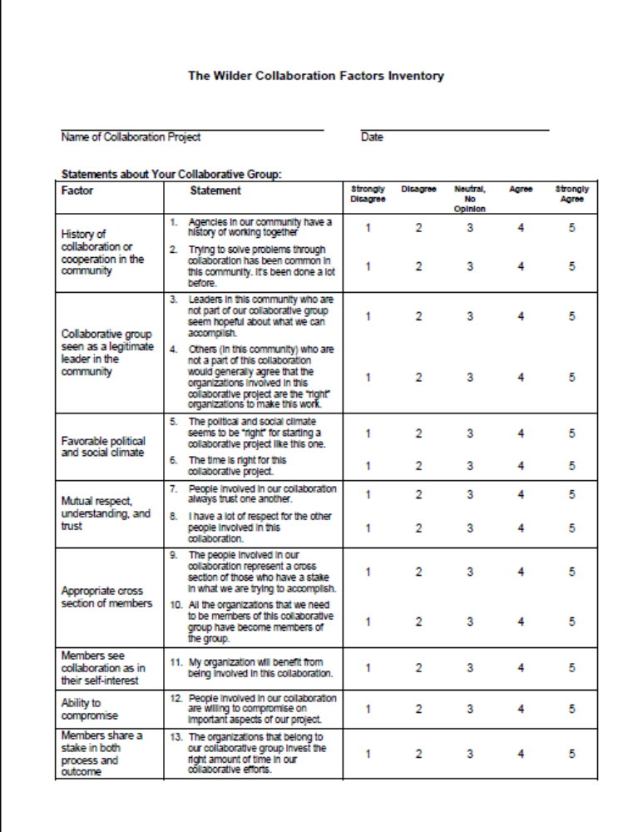
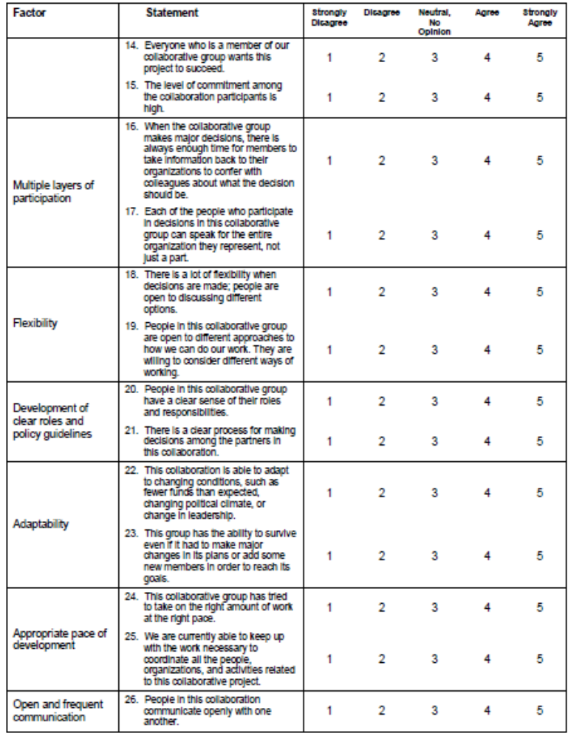
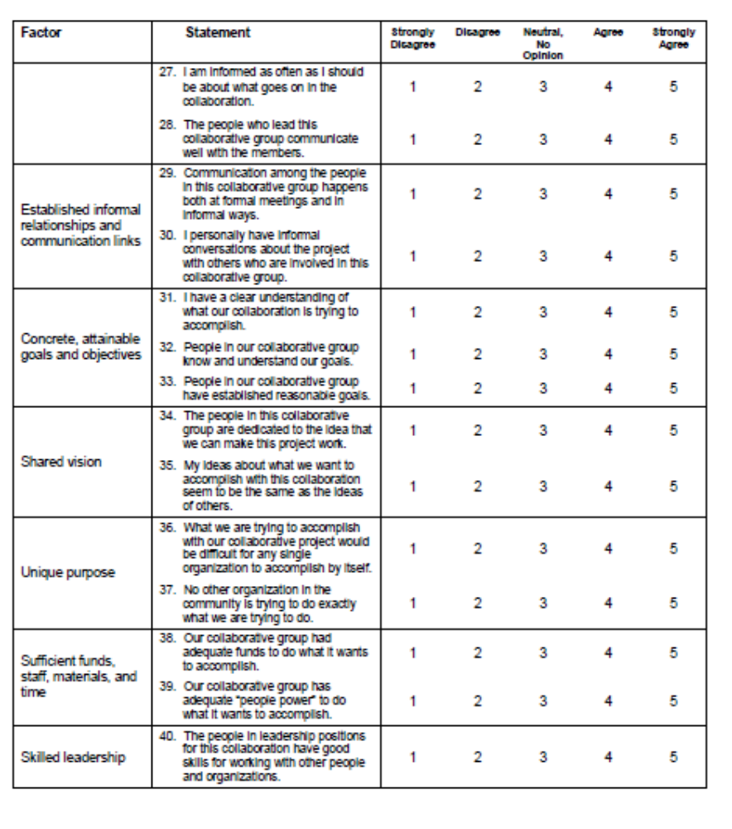

APPENDIX C
STUDENT PRE-POST INTERVENTION SURVEY
- Knowledge
Directions: This is a survey to find out what you know. Circle the letter of the one best answer.
1. Fruits and vegetables contain vitamins and _________.
a. protein
b. fiber
c. cholesterol
d. fat
e. I don’t know
2. Fruits and vegetables that are high in Vitamin A are ________ in color.
a. red and white
b. blue and light brown
c. yellow-orange and dark green
d. brown and purple
e. I don’t know
3. Which ONE of these foods is a healthy snack?
a. Ice cream
b. Potato chips
c. Fresh fruit
d. Fruit Roll-ups
e. I don’t know
4. The healthiest juice to buy has ___________ on the label.
a. 100% fruit juice
b. contains fruit juice
c. 100% fruit punch
d. tastes great
e. I don’t know
5. A fruit salad will be higher in Vitamin C if you add _____ to it.
a. apples
b. grapes
c. bananas
d. oranges
e. I don’ t know

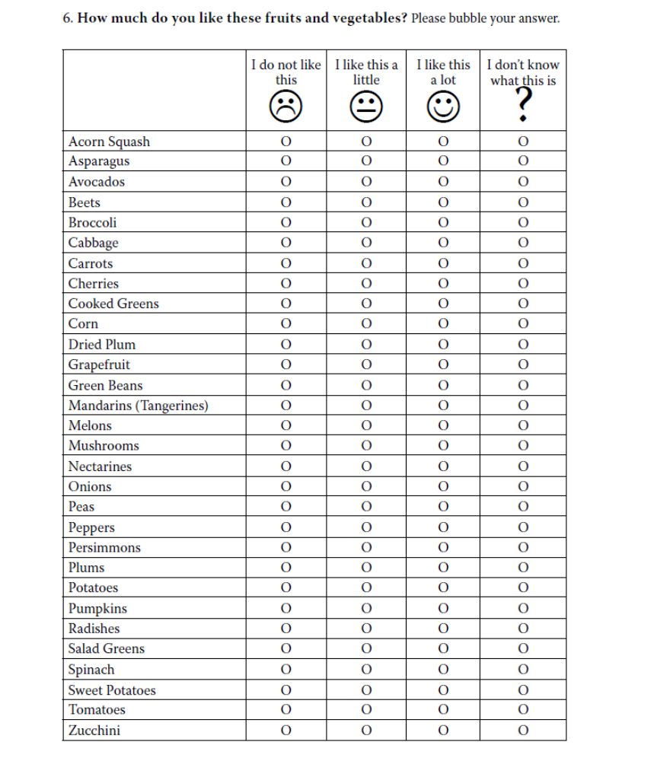
- STUDENT PREFERENCE

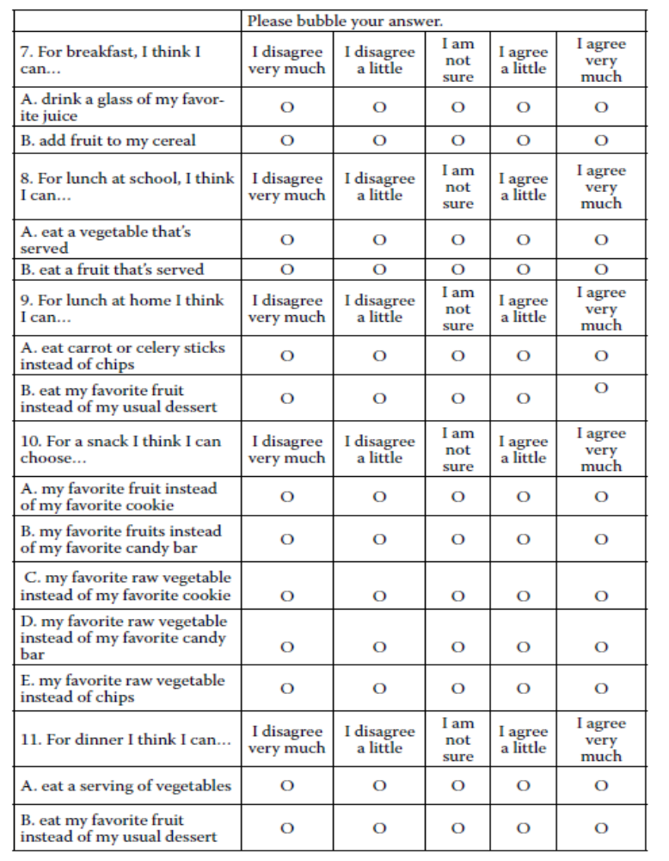
- Self Efficacy
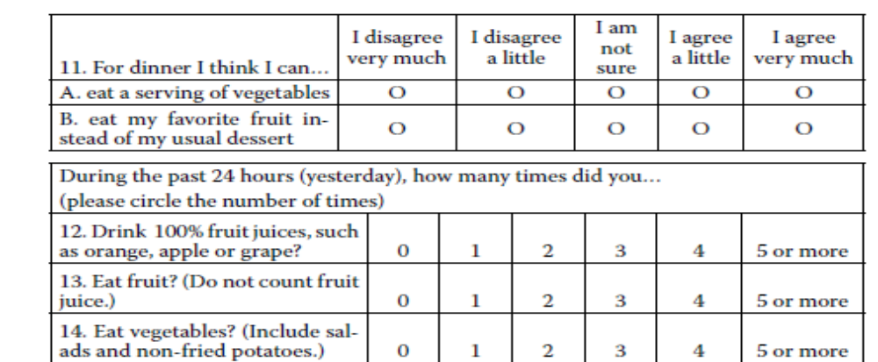
Self Efficacy continued

bibliography
Alfonso, M. L., J. Nickelson, D. L. Hogeboom, J. French, C. A. Bryant, R. J. McDermott and J. A. Baldwin (2008). Assessing local capacity for health intervention. Evaluation and Program Planning, 31(2), 145-159.

Barnard, W. M. (2004). Parent involvement in elementary school and educational attainment. Children and Youth Services Review, 26(1), 39-62.

Berkenkamp, J. (2012). Grower perspectives on farm to school: A survey of interested farmers, ranchers and other producers. Minnesota, Institute for Agriculture and Trade Policy: 1-9.

Berlin, L., J. M. Kolodinsky, K. Norris and A. Nelson (2010). "Farm-to-school: Implications for Child Nutrition." Food System Research Collaborative: Opportunities for Agriculture Working Paper Series, 1(1), 1-8.

Briefel, R. R., M. K. Crepinsek, C. Cabili, A. Wilson and P. M. Gleason (2009). School food environments and practices affect dietary behaviors of US public school children. J Am Diet Assoc, 109 (2 Suppl), S91-107.

Briggs, M. (2010). Position of the American Dietetic Association, School Nutrition Association, and Society for Nutrition Education: Comprehensive School Nutrition Services. Journal of the American Dietetic Association, 110 (11), 1738-1749.

Burrows, T. L., R. J. Martin and C. E. Collins (2010). A systematic review of the validity of dietary assessment methods in children when compared with the method of doubly labeled water. J Am Diet Assoc, 110(10), 1501-1510.

Butterfoss, F. D., R. M. Goodman and A. Wandersman (1993). Community coalitions for prevention and health promotion. Health Educ Res, 8(3), 315-330.

California Department of Health (2012, October 1). Compendium of surveys for nutrition education and obesity prevention. Retrieved from http://www.cdph.ca.gov/programs/cpns/Documents/Compendium%20of%20Surveys.pdf

Chomitz, V. R., R. J. McGowan, J. M. Wendel, S. A. Williams, H. J. Cabral, S. E. King, D. B. Olcott, M. Cappello, S. Breen and K. A. Hacker (2010). Healthy Living Cambridge Kids: A Community-based Participatory Effort to Promote Healthy Weight and Fitness. Obesity, 18(S1), S45-S53.

Edwards, R. W., P. Jumper-Thurman, B. A. Plested, E. R. Oetting and L. Swanson (2000). Community readiness: Research to practice. Journal of Community Psychology, 28(3), 291-307.

Evans, A., N. Ranjit, R. Rutledge, J. Medina, R. Jennings, A. Smiley, M. Stigler and D. Hoelscher (2012). Exposure to multiple components of a garden-based intervention for middle school students increases fruit and vegetable consumption. Health Promot Pract, 13(5), 608-616.

Feenstra, G. and J. Ohmart (2012). The evolution of the School Food and Farm to School Movement in the United States: connecting childhood health, farms, and communities. Child Obes, 8(4), 280-289.

Findholt, N. (2007). Application of the Community Readiness Model for childhood obesity prevention. Public Health Nurs, 24(6), 565-570.

FoodTrust (2007). Kindergarten initiative evaluation report. T. F. Trust. Philadelphia, PA, The Food Trust: Building Strong Communities Through Healthy Food.

Fox, M. K., A. H. Dodd, A. Wilson and P. M. Gleason (2009). "Association between school food environment and practices and body mass index of US public school children." J Am Diet Assoc, 109(2 Suppl), S108-117.

Frerichs, L., J. Brittin, C. Stewart, R. Robbins, C. Riggs, S. Mayberger, A. Cervantes and T. T. K. Huang (2012). SaludableOmaha: Development of a Youth Advocacy Initiative to Increase Community Readiness for Obesity Prevention, 2011-2012. Prev Chronic Dis 9.

Fryar, C. D., M. D. Carroll and C. L. Ogden (2012). Prevalence of obesity among children and adolescents: United States, trends 1963-1965 through 2009-2010.

Glanz, K., Rimer, B., and Viswanath K. (eds). (2008). Health behavior and health education: Theory, research, and practice. San Francisco, Jossey-Bass.

Graham, H., G. Feenstra, A. Evans and S. Zidenberg-Cherr (2001). Davis school program supports life-long healthy eating habits in children. California Agriculture, 58(4), 200-205.

HHS (2013). Healthy People 2020. Washington D.C.

Hinrichs, C. and K. Schafft (2008). Farm to school programs in Pennsylvania. The Center for Rural Pennsylvania.

Izumi, B. T., K. Alaimo and M. W. Hamm (2010). Farm-to-school programs: perspectives of school food service professionals. J Nutr Educ Behav, 42(2), 83-91.

Izumi, B. T., O. S. Rostant, M. J. Moss and M. W. Hamm (2006). Results from the 2004 Michigan Farm-to-School Survey. J Sch Health, 76(5), 169-174.

Joshi, A. and A. M. Azuma (2009). Bearing fruit: Farm to school program evaluation resources and recommendations. Los Angeles, CA, Occidental College, Urban and Environmental Policy Institute, Center for Food and Justice.

Joshi, A., A. M. Azuma and G. Feenstra (2008). Do farm-to-school programs make a difference? Findings and future research needs. Journal of Hunger & Environmental Nutrition, 3 (2-3), 229-246.

Joshi, A. and M. M. Ratcliffe (2012). Causal pathways linking Farm to School to childhood obesity prevention. Child Obes, 8(4), 305-314.

Kubik, M. Y., L. A. Lytle, P. J. Hannan, C. L. Perry and M. Story (2003). The association of the school food environment with dietary behaviors of young adolescents. Am J Public Health, 93(7), 1168-1173.

Leeman, J., J. Sommers, M. Vu, J. Jernigan, G. Payne, D. Thompson, C. Heiser, R. Farris and A. Ammerman (2012). An evaluation framework for obesity prevention policy interventions. Prev Chronic Dis, 9, E120.

Masse, L. C., M. M. Frosh, J. F. Chriqui, A. L. Yaroch, T. Agurs-Collins, H. M. Blanck, A. A. Atienza, M. L. McKenna and J. F. Igoe (2007). Development of a School Nutrition-Environment State Policy Classification System (SNESPCS). Am J Prev Med, 33(4 Suppl), S277-291.

Mattessich, P., Murray-Close, M., & Monsey, B. (2001). Wilder Collaboration Factors Inventory. St. Paul, MN: Wilder Research.

McLeroy, K. R., D. Bibeau, A. Steckler and K. Glanz (1988). An ecological perspective on health promotion programs. Health Educ Q, 15(4), 351-377.

Moss, A., S. Smith, D. Null, S. Long Roth and U. Tragoudas (2013). Farm to School and Nutrition Education: Positively Affecting Elementary School-Aged Children's Nutrition Knowledge and Consumption Behavior. Child Obes, 9(1), 51-56.

Neumark-Sztainer, D., S. A. French, P. J. Hannan, M. Story and J. A. Fulkerson (2005). School lunch and snacking patterns among high school students: associations with school food environment and policies. Int J Behav Nutr Phys Act, 2(1), 14.

Ozer, E. J. (2007). The effects of school gardens on students and schools: conceptualization and considerations for maximizing healthy development. Health Educ Behav, 34(6), 846-863.
Plested, B. A., R. W. Edwards and P. Jumper-Thurman (2006). Community readiness: A handbook for successful change. Fort Collins, CO, Tri-Ethnic Center for Prevention Research.

Ratcliffe, M. M. (2012). A sample theory-based logic model to improve program development, implementation, and sustainability of Farm to School programs. Child Obes, 8(4), 315-322.

Roche, E., D. Conner, J. M. Kolodinsky, E. Buckwalter, L. Berlin and A. Powers (2012). Social cognitive theory as a framework for considering Farm to School programming. Child Obes, 8(4), 357-363.

Rogers, M. A., J. Theule, B. A. Ryan, G. R. Adams and L. Keating (2009). Parental involvement and children's school achievement: Evidence for mediating processes. Canadian Journal of School Psychology, 24(1), 34-57.

Rossi, P. H., M. W. Lipsey and F. H. E. (2004). Evaluation: A systematic approach. Thousand Oaks, California, Sage Publications.

Schaub, J. and M. Marian (2011). Reading, writing, and obesity: America's failing grade in school nutrition and physical education. Nutr Clin Pract, 26(5), 553-564.

Scherr, R. E., R. J. Cox, G. Feenstra and Zidenberg-Cherr (2013). Integrating local agriculture into nutrition programs can benefit children's health. California Agriculture, 67(1), 30-37.

Schmidt, M. C. and J. M. Kolodinsky (2006). The Burlington School food project, final evaluation report. Center for Rural Studies.

Schneider, L., J. Chriqui, L. Nicholson, L. Turner, C. Gourdet and F. Chaloupka (2012). Are Farm-to-School Programs More Common in States With Farm-to-School-Related Laws? Journal of School Health, 82(5), 210-216.

Schwartz, M. B., K. E. Henderson, J. Falbe, S. A. Novak, C. M. Wharton, M. W. Long, M. L. O'Connell and S. S. Fiore (2012). Strength and comprehensiveness of district school wellness policies predict policy implementation at the school level. J Sch Health, 82(6), 262-267.

Schwartz, M. B., A. E. Lund, H. M. Grow, E. McDonnell, C. Probart, A. Samuelson and L. Lytle (2009). A comprehensive coding system to measure the quality of school wellness policies. J Am Diet Assoc, 109(7), 1256-1262.

Story, M., K. M. Kaphingst and S. French (2006). The role of schools in obesity prevention. Future Child, 16(1), 109-142.
Taylor, J. C. and R. K. Johnson (2013). Farm to School as a strategy to increase children's fruit and vegetable consumption in the United States: Research and recommendations. Nutrition Bulletin, 38(1), 70-79.

U.S. Department of Agriculture and U.S. Department of Health and Human Services (December 2010). Dietary guidelines for Americans 2010. 7th Edition, Washington, DC: US Government Printing Office.

Vallianatos, M., R. Gottlieb and M. A. Haase (2004). Farm-to-school - Strategies for urban health, combating sprawl, and establishing a community food systems approach. Journal of Planning Education and Research, 23(4), 414-423.

Wechsler, H., M. L. McKenna, S. M. Lee and W. H. Dietz (2004). The role of schools in preventing childhood obesity. State Education Standard, 5(2), 4-12.

