SIMPLE SELF-EXAM BROCHURE TO SCREEN FOR ORAL CANCER: A PUBLIC HEALTH MODEL AND BETA-TEST

by
Raha Yousefi
BS, University of Maryland, College Park, 2003
DDS, Howard University College of Dentistry, 2010

Submitted to the Graduate Faculty of
Graduate School of Public Health in partial fulfillment
of the requirements for the degree of
Master of Public Health

University of Pittsburgh
2013

UNIVERSITY OF PITTSBURGH
GRADUATE SCHOOL OF PUBLIC HEALTH

This essay is submitted
by
Raha Yousefi

on

June 24, 2013
and approved by

Essay Advisor:
Ronald LaPorte, PhD ______________________________________
Director
Multidisiplinary Master of Public Health Program
Graduate School of Public Health
University of Pittsburgh

Essay Reader:
Pouran Famili, DMD, MDS, MPH, PHD ______________________________________
Director
Department of Periodontics
School of Dental Medicine
University of Pittsburgh

Copyright © by Raha Yousefi
2013
Ronald LaPorte, PhD

SIMPLE SELF-EXAM BROCHURE TO SCREEN FOR ORAL CANCER: A PUBLIC HEALTH MODEL AND BETA-TEST

Raha Yousefi, MPH
University of Pittsburgh, 2013

Abstract
The purpose of this essay is to report on the initial reception and efficacy of an educational brochure that details both the importance of screening for oral cancer and how readers should perform self-examinations. This highly treatable disease often goes unnoticed until later stages of the disease at which point the survival rate of the disease drops considerably. Screenings that would detect the disease in the early stages are common practice in many current dental offices and consequentially people who visit the dentist biannually are more likely to have the disease detected early. Unfortunately a large portion of the general public does not regularly visit the general dentist. These individuals often lack the knowledge of the importance of oral cancer screenings and are generally unaware of current oral cancer screening methods. While other brochures regarding oral cancer exist, they are not addressed to the general public and none give a visual walkthrough on how to perform an oral cancer screening. The purpose of this study was to develop a simple self-exam brochure to screen for oral cancer and determine brochure usability with patients.
Methods and Materials: 50 new patients (18 male, 32 female) seen in the Department of Periodontics at the University of Pittsburgh were given the self-exam brochure and asked to answer a 14 question survey regarding the readability of the brochure and usefulness of the pictures in the brochure.
Results: 78% of patients contended that the brochure was useful for self-screening, while 98% of patients acknowledged that the brochure increased their personal knowledge of oral cancer. Ultimately 100% of patients surveyed said they would recommend the brochure to others.
Conclusion: Due to the positive reviews of the brochure it is recommended that a final copy of the brochure be published to increase awareness of oral cancer and allow for individuals of the population to conduct self-screening exams on their own. Fabrication of this brochure has a public health significance of fostering oral cancer awareness in the community and also providing a means for those who cannot afford regular dental care to screen themselves for oral cancer.

TABLE OF CONTENTS
preface ii
1.0 Introduction 2
2.0 PurPOSE 4
2.1 Materials and Methods 5
2.2 Results 6
3.0 DISCUSSION 9
Appendix: DISTRIBUTED ORAL CANCER BROCHURE 11
bibliography 13
List of tables
Table 1. Population Characteristics 7
Table 2. Education level predicting whether the brochure was considered helpful for
self-screening 8

List of figures
Figure 1. Front page of distributed brochure 11
Figure 2. Inside spread of distributed brochure 12

preface

The author would like to thank her cousin Mitra Yousefi for her valuable opinions and help with organizing and analyzing the epidemiological data. Additionally she would like to thank Dr. Pouran Famili for her help and support in organizing and implementing this project; without her this project would not have come to fruition.

Introduction
Each year 640,000 people worldwide and 40,000 people in the United States alone are diagnosed with oral cancer (Neville et. al, 2008). The disease is highly treatable if detected early in the disease progression. Accounting for about two percent of new-cancer diagnoses in the United States, oral cancer is particularly dangerous because it often goes un-diagnosed until the later stages of the disease. If detected early and while the disease is localized, five-year survival can be as high as 82 percent, similar to rates for the mildest breast malignancies. Early signs of the disease are often easily detectable, including a white or red tissue patches in the mouth or small ulcers that may look like canker sores (Neville et. al, 2008). Unfortunately most oral cancer warning signs and symptoms go unnoticed, unrecognized, or unheeded and more than half of oral cancers remain undiagnosed until the cancer has spread to regional tissues or the lymph nodes. With localized spread, oral cancer five-year survival drops to 53 percent and with more metastatic spread, five-year survival drops to less than 28 percent (Neville et. al, 2008).
Oral cancer screenings are a routine procedure in up-to-date dental practices. Individuals who maintain a regular six- or twelve-month visit schedule with their dentist have a better chance of detecting the disease early. Nevertheless in a large collective of people who are at risk for oral cancer and do not attend regular dental visits oral cancer often goes undetected. This can be related to state-funded dental insurances that have become increasingly restrictive, funding fewer classes of individuals (for instance, only children) and fewer kinds of procedures (for instance, only emergency care [extractions] for adults). Additionally, preventive care services have been slashed from state-funded dental insurances and private dental insurances from an employer, in addition to being dependent on having an employer, are frequently as inadequate in the services they will subsidize. Collectively this leaves a large portion of the population without access to regular dental care and subsequently at risk for undetected oral cancer.
There is not yet a comprehensive program in the US to opportunistically screen for oral cancer and without that, late-stage discovery will remain the norm. Close to 40,000 Americans will be diagnosed with oral or pharyngeal cancer this year. The cancer will kill more than 8,000 individuals, roughly one person each hour, every hour (Oral Cancer Foundation, 2001). The common misconception is that older male (ages 50-70) smokers are the large majority of the population at risk for oral cancer while in actuality the prevalence of oral cancer has increased in a younger and more varied demographic. Some strong evidence suggests that smokers who are also heavy drinkers, consuming more than three alcoholic drinks a day, are at the greatest risk due to the synergistic effects of these substances. This occurs due to the ability of alcohol to act as a solvent for the carcinogens in tobacco and thus the dissolved carcinogens are more effectively delivered to the oral tissues. Also metabolites of alcohol can form adducts with DNA which interferes with DNA synthesis and repair (Poschl G, Seitz HK, 2004). Two distinct etiologies lead to oral cancer, one through tobacco (including smokeless) and alcohol, and another via the human papillomavirus, particularly HPV-16. This version of HPV is sexually transmitted and the most oncogenic among several versions of human papillomavirus. The same virus, HPV-16, is responsible for cervical cancers in women. HPV-related oral cancer is the fastest-growing among oral cancers and is increasingly common in younger people and non-smokers. A review by Kreimer et al.(2005) found that HPV infection was found in 25 percent of oral cancer patients, with numbers expected to rise. Smith et al. (1998) found that an increasing number of various tumor lines had HPV present in those who did not use alcohol or tobacco. Hence oral cancer is of increasing concern amongst the general population including those who do not regularly smoke or drink. Collectively these risk factors stress the importance of public knowledge of this disease, and the combination of this brochure and manuscript is one such attempt to increase public action against oral cancer.

Purpose
Identifying a need for a self-exam brochure was determined after a review of existing literature and brochures was conducted. Many organizations exist that promote education on oral cancer and have available a variety of brochures for practitioners and patients. Brochures available for practitioners come in the form of a guide explaining how to conduct an oral cancer screening on a patient and most have descriptive words only. Brochures available for patients tend to be directed towards a specific group within the population such as tobacco users both smokers and snuff, and African American males; groups that tend to have higher incidences of oral cancer. However, no brochures were found that were geared towards patients of the general population and that gave a comprehensive background of what signs to look for and how to perform a self-screening for oral cancer. This information is increasingly important to the general population due to the rise in oral cancers that are unrelated to smoking and alcohol use.
After conducting a search of existing literature and brochures and determining that there is a void of readily accessible information available to the general public on how to perform self oral cancer screening exams, it was decided to create a brochure. The brochure was designed in a way to educate individuals on oral cancer and illustrate how to conduct a self-screening exam. It gives both a pictorial and verbal description of how patients can screen themselves for oral cancer and also shows patients what they should look for when performing self-screening exams.

Methods and Materials
The contents of the brochure highlight individuals that are at most risk, detail the epidemiology of the disease, describes the importance of self-screening, and it provides information on where to turn to for more information or help in scheduling an appointment with a healthcare provider specific to the University of Pittsburgh community. The most important feature of the brochure is to illustrate to the reader how to conduct an oral cancer screening at home. A panel with this information details a step by step procedure of how to perform this oral cancer screening. This panel depicts each step verbally and gives pictures of a subject performing each step of the exam so that patients can see a visual on how to perform the exam and also read and comprehend what they should be doing. These pictures in the brochure were printed in color and have a descriptive caption for clarity.
Brochures were presented to new patients prior to their initial screening appointment at the Graduate Department of Periodontology at the University of Pittsburgh. Patients were asked to take their time to read through the brochure and then complete a fourteen-question survey during the same visit to the Department of Periodontology. The survey inquired about the demographics and lifestyle of the patients and asked patients to detail the effectiveness of the brochure. Fifty patients (18 male, 32 female) between the ages of 21 and over 70 participated.
To determine if the brochure was universally effective for use at home, we considered whether the brochure was considered helpful by the participants performing self-screening for oral cancer regardless of their education level. Given that the survey gathered this information via a Yes/No response, statistics were employed from a logistic regression to test if level of education of the participants was associated with whether the brochure was helpful in performing self-screening of oral cancer. Education level was categorized into “high school or less”, “some college”, and “associate degree, bachelor degree, or postgraduate degree”, with the latter group set as the reference.

Results
Of the fifty participants in this study, 18 were male and 32 were female. Most of the participants ranged from 35 to 70 years of age, 40% had an associate degree or a higher level of education, and 76% visited the dentist for regular check ups (every 6 months or once a year). 80% of patients had never read or received a brochure on oral cancer before. While every participant said that they would recommend the brochure to others, 78% said that they found it specifically helpful for oral cancer self-screening. Patient answers to brochure questions are listed in the table on the following page:

Table 1. Population characteristics

Variable | N | %
Sex Male | 18 | 36
Female | 32 | 64
Age 21-35 | 9 | 18
35-55 | 23 | 46
55-70 | 17 | 34
>70 | 1 | 2
Dental Visits
Every 6 months | 22 | 44
Once per year | 16 | 32
Only for emergency | 12 | 24
Education
High School or less | 14 | 28
Some college | 16 | 32
Association degree or higher | 20 | 40
Former Tobacco User Yes | 20 | 40
Tobacco user Yes | 12 | 24
Consume alcohol daily Yes | 1 | 2
Brochure increased oral cancer knowledge Yes | 49 | 98
Performed self-screening using brochure Yes | 12 | 24
Routine oral cancer screening Yes | 12 | 24
No | 4 | 8
Don’t know | 34 | 68
Brochure helpful for self-screening Yes | 39 | 78
Recommend brochure to others Yes | 50 | 100

Upon analysis of the data gathered from the surveys that were dispersed, no statistical significance was found between education level and whether the brochure was found helpful in self-screening for oral cancer. Statistical findings are given on the following page:

Table 2. Education level predicting whether the brochure was considered helpful for self-screening.

Variable | Estimate  (Odds Ratio) | Standard Error | P-Value
Intercept | 1.10 | 0.52 | 0.03
High School of less Vs. Associate Degree or Higher | 1.47 (4.3) | 1.16 | 0.21
Some college Vs. Associate Degree or Higher | -0.31 (0.7) | 0.75 | 0.68

Discussion
The results indicate that this beta test of the brochure was successful. The positive reception of the brochure recommends that the brochure be kept as is with 100 percent of patients saying that they would recommend the brochure to others, 96 percent of patients indicating that the brochure increased their knowledge of oral cancer, and 78 percent of patients feeling that the pictures in the brochure would help them perform an exam. Among the two patients who responded that the brochure did not increase their knowledge of oral cancer, one of such patients had previously been diagnosed with the disease which indicates that the brochure may be even more efficacious than the above percentages indicate. Statistically, education level was not correlated to the patients’ reception of the brochure which indicates that the brochure is an accessible source of information for all types of patients and does not cater specifically to either those who are highly educated or those who have little education. Results indicate that the self-screening brochure should be dispersed to a larger patient base to better evaluate the efficacy of the brochure and to increase sampling size to correct for outliers in the population.
In future studies the brochures will be given to patients to take home. This should increase the amount of patients who perform the self-screening exam. In the current study brochures were given to patients and the patients were asked to fill out the survey in the same visit. Consequently in order for patients to actually screen themselves patients would have to go to the public restroom in the dental school. We believe this limited the patients ability to perform a self-screening and thus resulted in a low percentage of patients actually performing the screening (24%) at the time the survey was completed. Allowing patients to take the brochure home would increase the percentage of patients who screen themselves as patients could then perform exams in the convenience of their own homes instead of in a public bathroom of the dental school.
A future goal for the brochure is a large longitudinal type of study with an increased number of patients and over a prolonged time period. From this type of study, long term results could be obtained regarding the effectiveness of the brochure in helping patients detect oral cancer in their own mouths. Surveys given to patients for the longitudinal study would detail quantitative aspects of oral cancer diagnostics and include information regarding alcohol and tobacco use and also prevalence of the human papillomavirus in the patient pool. Due to the success of the beta test, questions as to whether the patients liked the brochure would no longer be used and instead the survey given to patients would ask them questions regarding if and how often they performed a self-screening exam. This would help indicate if patients or a health care provider found incidences of oral cancer, and even could detail the effectiveness of the brochure in detecting oral cancer earlier in the disease progression. This could lead to a more favorable mortality rate amongst those who screen themselves versus those who rely on health care providers to diagnose the disease.

APPENDIX: DISTRIBUTED ORAL CANCER BROCHURE

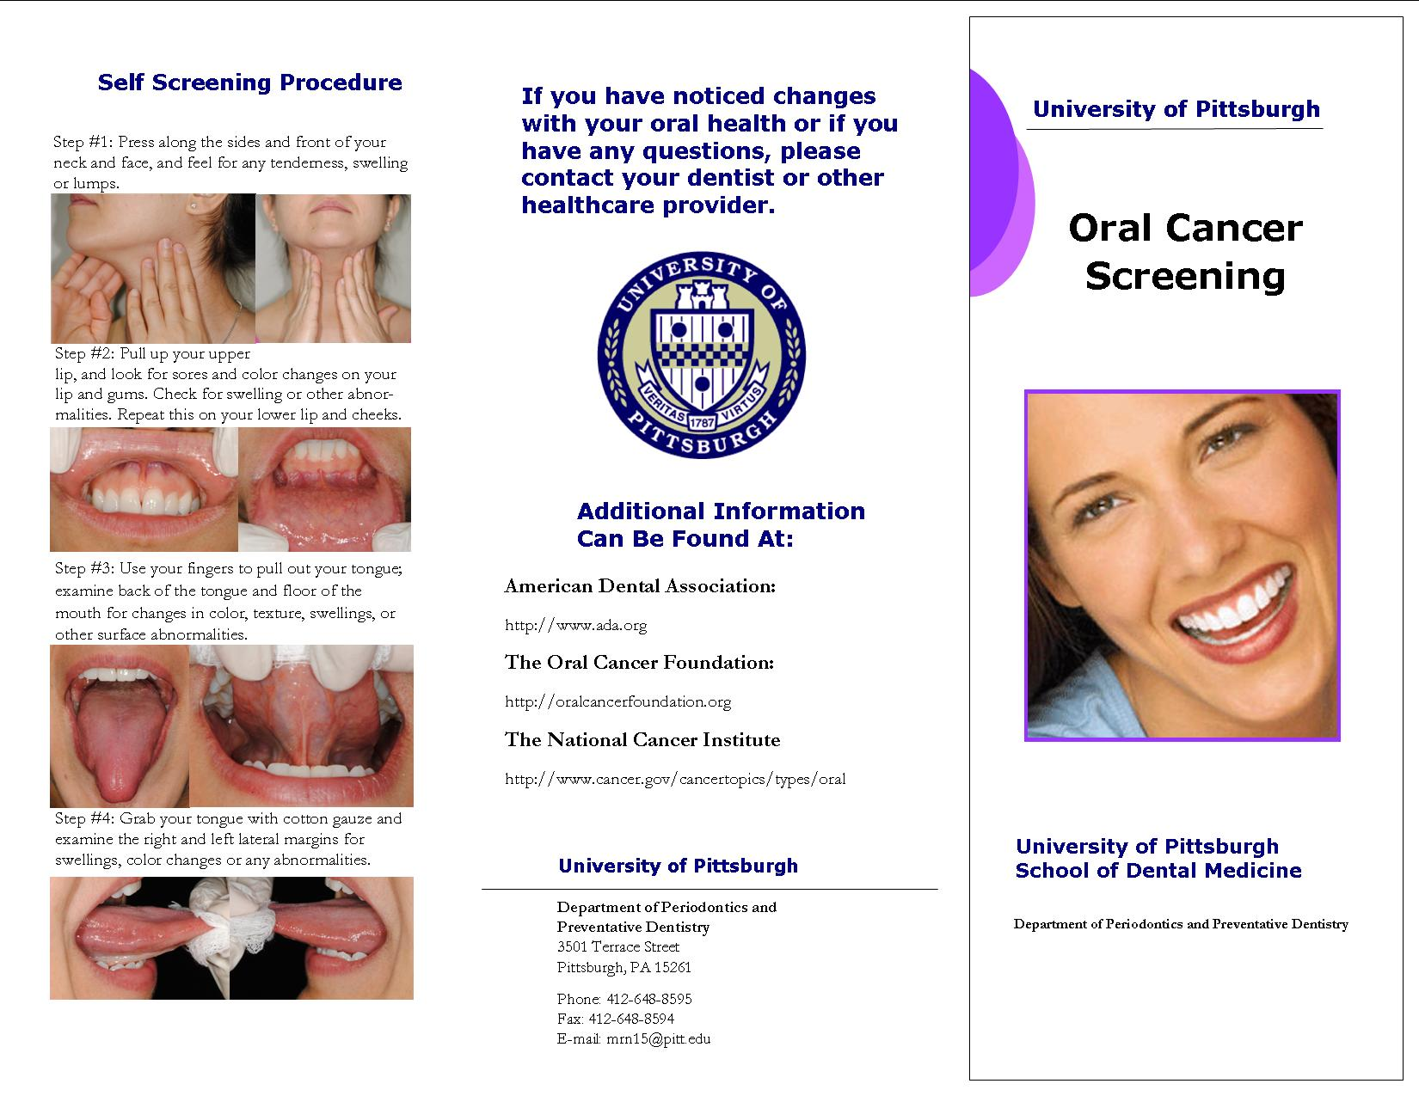
Figure 1. Front page of distributed brochure.
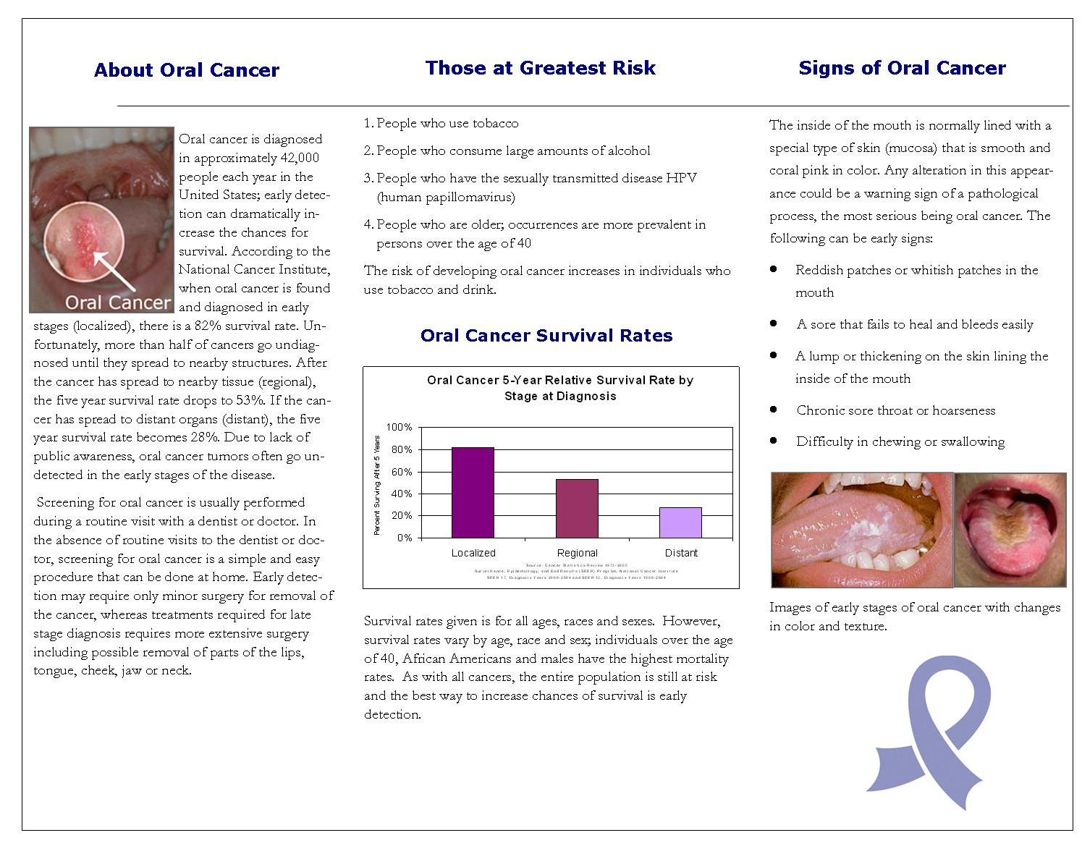
Figure 2. Inside spread of distributed brochure.
bibliography
Neville et. al, (2008). Oral and Maxillofacial Pathology (3rd ed.). Philadelphia: W.B. Saunders Company.
(2001, June 10). Oral Cancer Facts. The Oral Cancer Foundation. Retrieved May 15, 2013, from http://oralcancerfoundation.org/
Poschl G, Seitz HK. (2004). Alcohol and cancer. Alcohol, 39 (3), 155-165.
Kreimer AR, Glifford GM, Boyle P et al. (2005) Human papillomavirus typers in head and neck squamosus carcinomas worldwide: a systematic review. Cancer Epidemiol Biomark Prev, 14, 467-475.
Smith EM, Hoffman HT, Summersgill KS et al (1998). Human papilloma virus and risk of oral cancer. Laryngoscope, 108, 1098-1103.

