AN EVALUATION OF POINTS-OF-DISPENSING TRAINING:
A MIXED METHODS APPROACH

by
Lauren M. Staffen
BS, Microbiology, Texas A&M University, 2012

Submitted to the Graduate Faculty of
the Department of Infectious Diseases and Microbiology
Graduate School of Public Health in partial fulfillment
of the requirements for the degree of
Master of Public Health

University of Pittsburgh
2013

UNIVERSITY OF PITTSBURGH
GRADUATE SCHOOL OF PUBLIC HEALTH

This essay is submitted
by
Lauren M. Staffen

on

December 11, 2013
and approved by

Essay Advisor:
Jeremy Martinson, DPhil ______________________________________
Assistant Professor
Infectious Diseases and Microbiology
Graduate School of Public Health
University of Pittsburgh

Essay Reader:
Christopher Keane, ScD ______________________________________
Assistant Professor
Behavioral and Community Health Sciences
Graduate School of Public Health
University of Pittsburgh

Copyright © by Lauren M. Staffen
2013
ABsTRACT
In the event of a public health emergency, the Allegheny County Health Department may have to activate points-of-dispensing (POD) sites in order to distribute life-saving medical countermeasures, such as antibiotics or vaccine. In January 2013, ACHD began a series of mandatory trainings to orient employees to working in a POD. The training focused on an overview of POD operations, POD setup, and core staffing functions. At the conclusion of the program, participants completed a written survey examining prior POD experience or training, perceived ability to work in a POD, perceived understanding, and overall satisfaction in order to determine program effectiveness. After the training, 92.1% of employees reported that they are confident in their ability to work in a POD; of those employees, 49.5% had no prior formal training or experience working at a POD. Of those surveyed, 89.6% of participants reported feeling satisfied with the training program. Interactive and hands-on activities are well received as training methods. Health Department employees feel confident in their ability to set up a POD and perform key staffing duties. Evaluation indicated that the Head of Household screening form and corresponding prophylaxis algorithm is cumbersome to use and should be revised in order to increase efficiency in the screening process. More evidence of historical POD operations should be incorporated into future training modules to address participants’ concern about the dispensing capabilities of the POD model. In evaluation of future training, a comparison of pre- and post-training skill assessments will better measure training effectiveness and allow for a more in-depth analysis of understanding of training materials. The public health significance of this evaluation is that it will aid in improving current training methods and bettering public health preparedness capabilities for an array of different infectious disease emergencies for Allegheny County.
Jeremy Martinson, DPhil

AN EVALUATION OF POINTS-OF-DISPENSING TRAINING:
A MIXED METHODS APPROACH

Lauren M. Staffen, MPH
University of Pittsburgh, 2013

TABLE OF CONTENTS
preface xi
1.0 Introduction 1
2.0 Background 3
2.1 Review of Relevant Literature 3
2.1.1 Points of Dispensing 3
2.1.1.1 POD Logistics and Location 3
2.1.1.2 POD Setup and Flow 7
2.1.1.3 Staffing 9
2.1.1.4 Best Practices 10
2.1.2 Communication with the Public 12
2.1.3 Training Implementation and Cost Effectiveness 13
2.2 Federal Guidelines for Mass Dispensing of Medical Countermeasures 15
2.2.1 Cooperative Agreements and Cities Readiness Initiative (CRI) 15
2.2.2 Public Health Preparedness Capabilities 16
3.0 Overview of Training program 17
3.1 training goals 17
3.2 training sessions 17
3.2.1 Training Modules 18
3.2.1.1 POD Overview (30 minutes) 18
3.2.1.2 POD Set Up (20 minutes) and Setup Activity (30 minutes) 18
3.2.1.3 Work in a POD (30 minutes) and Screening Activity (30 minutes) 18
4.0 Overview of program evaluation 20
4.1 evaluation objectives 21
4.2 Evaluation approach and administration 22
5.0 analysis and results 23
5.1 Training Evaluation 24
5.2 Training Effectiveness 26
5.2.1 Do participants feel comfortable working in a POD after attending training? 26
5.2.2 Were participants satisfied with the training that was provided? 28
5.2.3 Is there a relationship between ease of understanding and perceived ability to work in a POD? 29
5.2.4 Qualitative Data and Analysis 34
5.2.4.1 Most enjoyable part of training 34
5.2.4.2 Least helpful part of training 34
5.2.4.3 Additional comments 35
6.0 discussion of key findings 36
6.1 Limitations 38
6.2 Recommendations 38
6.2.1 Training Recommendations 38
6.2.2 Evaluation Recommendations 39
7.0 Conclusions 41
Appendix A: Sample Agenda From Training 42
Appendix B: Evaluation tool 43
Appendix C: Head of Household Form and Corresponding Prophylaxis algorithm 44
bibliography 47
List of tables

Table 1. Descriptions of POD staff positions 9
Table 2. Variables assessed by the written evaluation tool 22
Table 3. Breakdown of attendees' program of employment and division within the ACHD 23
Table 4. Breakdown of ratings for "ease of understanding" and "increased knowledge or skills" by module 26
Table 5. Qualitative Responses from the POD Training Evaluation Tool 35
List of figures

Figure 1. Sample POD layout used by the Allegheny County Health Department for pill dispensing (Allegheny County Health Department, 2009) 8
Figure 2. Percentage of participants that reported feeling comfortable working in a POD after training 24
Figure 3. Overall satisfaction ratings for training program 25
Figure 4. Previous POD exposure of respondents who are comfortable working at a POD 27
Figure 5. Types of prior POD exposure by perceived comfort levels 28
Figure 6. Satisfaction ratings by perceived comfort level 29
Figure 7. Overall ratings of ease of understanding by module 30
Figure 8. Ratings of ease of understanding by module by perceived comfort 31
Figure 9. Ratings of ease of understanding by module by perceived comfort and overall satisfaction 32
Figure 10. Ratings of ease of understanding by module, separated 33
preface
I would like to thank the Emergency Preparedness and Response Division staff of the Allegheny County Health Department. Thank you to Tom Mangan, for allowing me to assist with POD trainings during my practicum and perform the evaluation for this project. Special thanks to Jamie A. Sokol, MPH, for all the guidance she has provided throughout my experience at the ACHD and during the writing of this evaluation. I would also like to thank my essay readers for their quick responses and assistance editing this essay. Lastly, I would like to acknowledge Jennifer Harmon for the comic relief and moral support she has provided while at the Graduate School of Public Health.

Introduction
In the late 1990s there was a shift in attention in preparedness from natural disasters to bioterrorism after the rise in international occurrence . The concept of mass postexposure prophylaxis in response to a bioterrorism attack was understood but not very well planned. As early as 1997, the Centers for Disease Control and Prevention (CDC) confirmed there was economic justification for having prevention and postattack intervention measures in place . To test the readiness of top government officials to respond to terrorist attacks, a $3 million TOPOFF drill was conducted in May 2000 . The drill utilized the point-of-dispensing (POD) model, but revealed large insufficiencies in the plans in place, and started the movement for more guidelines regarding leadership, decision-making, prioritization, and distribution of pharmaceutical materials . The growing fear of bioterrorism was proven legitimate after the anthrax attacks in September 2001. This event caused public health institutions to reevaluate the capacity to counter such events.
The Allegheny County Health Department (ACHD) has 50 designated POD sites in the 43 school districts in the county. In a worst-case scenario, the activation of all 50 of these PODs should be able to provide prophylaxis to the entire county within 48 hours. However, in smaller scale emergencies only a handful of sites may be activated. The ACHD staff and Medical Reserve Corps (MRC) volunteers are responsible for manning a large portion of the working positions at these sites. To prepare for these duties, ACHD conducts POD trainings that are mandatory for all employees.
This evaluation focuses on training of staff for PODs so that the ACHD can better its ability to respond to a bioterrorism attack or infectious disease outbreak, such as pandemic influenza. Covered in the second chapter are the foundations of PODs; general considerations for POD planning and logistics; POD location, layout, staffing, and best practices; communication with the public; and training implementation. The third chapter summarizes the training program goals, lectures, and activities. The fourth chapter contains the evaluation goals, objectives, and approach. The fifth chapter discusses the analysis of the collected data and how it directly answers the objectives. The sixth chapter discusses the analysis and interprets key findings, limitations, and recommendations. The seventh, and final chapter is the conclusion of the evaluation.

Background

Review of Relevant Literature

Points of Dispensing
Mass dispensing of postexposure prophylaxis is not a concept solely accomplished by PODs, however, this model is still considered a paradigm for dispensing during a bioterrorism event .

POD Logistics and Location
There are an immense number of strategies and options to consider when preparing plans for mass prophylaxis using the POD model, and many of the aspects are dependent on the details of the incident . Below are basic questions that must be answered before decisions on the course of action can occur. The questions are modeled for a bioterrorism attack but can be adjusted for an infectious disease outbreak as well.
- Was the attack overt or covert?
Minimizing the amount of time from exposure to prophylaxis is critical to reducing morbidity and mortality . An overt event, one where the attack is undisguised or known, can give authorities a small head start in responding. Events where law enforcement is notified beforehand fall into the overt category. With covert events, on the other hand, the concealed nature of the attack can severely limit the amount of time health departments have to respond to the situation before significant illness or loss of life begin to occur.
- What is the incubation period?
The incubation period is the time between exposure to the agent and onset of illness. Usually, with an overt attack, the incubation period serves as a buffer so that prophylaxis can occur before any signs or symptoms . However, the first sign of a covert attack may be index cases of a disease; in these cases there will likely be more hospitalizations and possibly deaths as this incubation period buffer runs out before a public health response can really begin .
- Does treatment require oral antibiotics or vaccination?
The type of treatment is used to determine which POD set up to use. (See POD Setup.)
- What is the radius of exposure or number of people exposed?
Multiple POD sites may be opened to accommodate large numbers of people. If the affected area is small or there is limited exposure (e.g. being in a certain building at a certain time), a single POD site may suffice.
      - Will it be a closed POD site?
When a site is not used for the general public, it is called a closed POD. Often times PODs will first be used to give prophylaxis to the staff and first responders, if necessary. The PODs used for the anthrax mailings in 2001 were limited to media outlets, postal workers, and hospital employees in certain locations .
- Is the agent contagious?
The mode of transmission is another element to consider because it can have an impact on the number of people requiring prophylaxis due to secondary exposure ; this will likely increase public anxiety and panic. Also, prophylaxis must be given to POD staff due to close proximity to large numbers of potentially contagious individuals. Recommended use of personal protective equipment (PPE) would be expected in this situation.
- Will the POD be segmented or unsegmented?
An unsegmented POD is one where all the components are in one location. A segmented POD typically has a primary assembly point where screening, triage, and medical evaluation occur, and a secondary location where the dispensing of medical countermeasures occurs . Transportation must be provided from the first to the second location of segmented PODs, while people travel directly to unsegmented PODs .
- Is there potential for another attack?
One reason for using a segmented POD is to prevent a potential secondary attack from disrupting POD operations . Because the POD site is a location in which large numbers of people are gathered, it is a prime target for an attack . Having a second location which is not directly accessed by the general public can be a way to secure a site and control the number of people in the location at any given time .
Selecting a POD site is critical to the success of the operation . The ACHD has chosen 50 sites at schools across Allegheny County; this is one element that can be almost completely planned out well before any emergency occurs . Furthermore, it should take into consideration a number of factors to perform optimally:
- Distance
The POD should be in a convenient location for the population it will be serving, but it should not be somewhere that might be contaminated (e.g. when dealing with anthrax spores) . The location should be relatively close to patients traveling to it, if unsegmented. The secondary location should be separated enough from the primary site so that it is secure from attacks, if segmented .
- Accessibility
Access to the POD site should be as easy as possible. Factors to consider include how easy and clear driving directions are, having enough entrances and exits for vehicles, population density and minimizing commute times .
- Building size and amenities
The venue should be able to hold hundreds, maybe thousands of people to provide shelter from inclement weather, and have enough space for those with disabilities, wheelchairs, or large families . There should also be enough bathrooms to accommodate the expected number of people, about one for every 40 persons .
- Transportation and parking
To determine parking needs, take the most common modes of transportation into consideration. Rural areas, where people primarily drive their own vehicles, require more parking than urban areas, where mass public transit is widely used .
- Population demographics
The site should be adapted to the population it is serving . While enough space for those with wheelchairs or large families is always very important as previously mentioned, it may be something to note if the population has a large average household size or high proportion of elderly individuals. Accommodations may also include extra translators or interpreters for areas with large ethnic neighborhoods.

POD Setup and Flow
Finding the ideal set up to fit the situation is also necessary for quick patient processing and its effects on throughput are significant. The POD proper contains stations for registration, triage or screening, medical evaluation, and dispensing of antibiotics; other POD-related stations can include briefing, investigative, mental or behavioral health, first aid, security, management (command and control). In some instances, station functions may be combined, altered, or eliminated depending on necessity, staff availability, and size of POD (see ); the ACHD POD plan combines triage and screening as shown below by Figure 1.
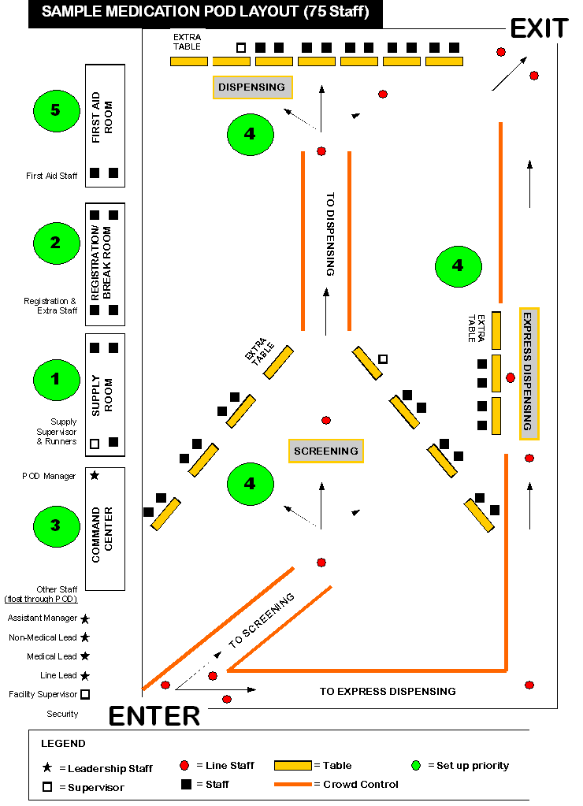
Figure 1. Sample POD layout used by the Allegheny County Health Department for pill dispensing

Staffing
Staffing is one of the most important but complex aspects of planning and running a POD. There are many types of mathematical models and statistical algorithms to predict staffing needs and the ability of the communities to fill the necessary positions. Finding the ideal balance and placement of staff is difficult, and models or key findings are not always easily applied to different communities because of dissimilar plans, potential staff pools, or population size. The basic positions that must be present are presented below in Table 1. One unfavorable phenomenon that sometimes occurs is bottlenecking, where a backing up of clients due to reduced flow causes lines to form; redistributing staff usually alleviates this issue .

Table 1. Descriptions of POD staff positions
Screeners | Ask patients about allergies to antibiotics, health conditions, current medications, pregnancy, or about children's weight for proper dosing
Dispensers | Dispense medications as indicated by screening form and give dosing instructions.
Medical Personnel | Physicians, nurses, pharmacists, or other licensed medical professionals supervise and answer questions.
Mental Health Professionals | Either at a station or floating, provide mental health services, like counseling, to those who are experiencing anxiety or stress.
Flow Monitors | Ensure smooth flow through POD and answer general questions; also called flow managers or line staff.
Security | Secure the medicines and supplies and secure location against potential threats such as further bioterrorism attacks . Can also be placed outside POD to direct vehicles exiting the premises .
Management Positions | Can include the POD manager, any coordinators or team leaders, and registration personnel.  Serve as the administrative backbone, but may not interact directly with persons going through the POD.

Best Practices
New York City evaluated their implementation of PODs during the anthrax attacks in 2001. They used six different closed PODs to contain the situation - four at media outlets after reports of cutaneous anthrax, one at a USPS site due to inhalational cases reported in New Jersey and Washington D.C., and one at a hospital after a reported case of inhalational anthrax . Analysis of the event showed:
- POD success is distinguished by clarity in all aspects of POD operations, communication and collaboration among all involved, coordination of staff and supplies, and careful selection of POD location .
- Moving epidemiological and criminal investigation, mental health, and briefing stations to outside the POD improved flow. Also, conducting interviews before entering alleviated concerns about medical confidentiality .
- Providing written information sheets instead of a verbal briefing may improve throughput .

While drills may not provide as much insight as a real event, valuable information can still be gathered from their evaluation. Philadelphia used a simulation to field test a head-of-household (HoH) POD model. This strategy allows one person to enter a POD and pick up medication for multiple individuals, which in theory would increase number of people receiving antibiotics in a shorter time frame. During this simulation:
- The importance of security was demonstrated; HoHs instructed to attempt to steal medication were successful .
- Express dispensing, adapting staff to POD demands, and HoH lines that did not cross all contributed to rapid flow .
- Line staff must direct flow according to intake forms and resist influence from upset or inquisitive HoHs .
- The importance of reducing anxiety among the population through rapid distribution of prophylaxis, utilizing behavioral health professionals, and media updates (see Communication with the Public) was demonstrated; transit times increased for HoHs that were nervous .
- Streamlining intake forms and POD layout showed improved flow . This included incorporating multilingual people as flow monitors to he rather than at a separate language station, and moving the mental health activities to the first aid room outside the flow of the POD.
- The importance of adequate line staff was demonstrated. Plans were altered to increase the number of line staff .

A field exercise comparison among counties in Georgia tested RealOpt©, a decision support system that aids in planning PODs for large-scale emergencies . During this drill, DeKalb County used the system, while the other eight counties used traditional (manual) planning methods. This drill also utilized the HoH strategy. Important observations included:
- The DeKalb County POD reached significantly more households than traditionally planned PODs, and showed that the system was accurate and useful for planning ahead .
- The disruption in POD flow due to language problems was overcome by utilizing large multi-language signs .
- Clear traffic routes are crucial even for segmented PODs. Some bus drivers became lost even though security officers were directing traffic .
- Having paths that did not cross improved flow when compared to previous drills .
- Client should write their number and time stamp on the sign out sheet, rather than looking for the number on a roster, to prevent lines from forming in the exit queue .

Some similarities among employed strategies or lessons learned among the reviewed exercises, namely the adoption of the HoH strategy and non-crossing paths. While these similarities exist, best practices remain largely inconclusive. It seems that best practices are relatively individualized for each health department due to unique strengths, weaknesses, and populations. Though each scenario is different, all reflect the fundamental quality of the POD: flexibility .

Communication with the Public
Risk communication and dispensing information during a bioterrorism or other infectious disease event is just as critical as dispensing medication . However, messages must be carefully crafted and released because the circulation of inaccurate, contradictory, or confusing information can negatively affect response campaigns initiated by health officials or institutions . Health education during bioterrorism was analyzed in New Jersey during the anthrax attacks in 2001. Focus groups and needs assessments revealed the health belief model (HBM) was used to develop education materials and methods, even though due to time constraints during the event a formal model was not used . The main HBM variables observed were susceptibility, severity of threat, barriers to postexposure prophylaxis (PEP), and benefits of PEP . Specific topics addressed - lack of knowledge of the agent and disease, unpleasant side effects, and lack of perceived susceptibility - were all potential barriers to antibiotic adherence .
Lack of or low perceived risk or susceptibility is a delicate situation to deal with; in some cases it may be unclear whether it is reasonably based on low actual risk or due to elimination of fear by denial or defensive avoidance . Utilizing models to increase perceived severity as a means to improve likelihood of adherence may backfire in cases where denial is rooted in fear . Other analyses of emotional responses related to the events of September 11, 2001 suggest, "those experiencing anger are generally more optimistic than are those experiencing fear and dread" . It is likely that each outbreak will differ in many aspects, and study findings reinforce the necessity of identifying gaps in public knowledge and communication methods to respond optimally .

Training Implementation and Cost Effectiveness
Training is an essential part of efficient POD function. The ability to function properly involves pre-existing skills, psychological state of mind, and familiarity with similar scenarios , most of which can be received through pre-training. This is especially true in events that have low probability of occurring but high impact should the event occur . Recently, evaluations of virtual pre-training have shown that its use appears promising as a cost-effective replacement to traditional training methods . Some limitations of this virtual approach may include the lack of virtual-reality based computer skills and lack of practice working together in the situation ; however the combination of virtual training and full-scale, hands-on drills and exercises may alleviate concerns about staff not having experience working as a team.
While the importance and benefits of pre-training staff has been demonstrated , just-in-time training (JITT) is also considered a "critical element of emergency mobilization for interventions like mass prophylaxis" . Some events may not justify full, pre-event training or exercising; may need a much greater workforce than trained; or require event specific responses that necessitate staff training regardless of prior preparedness . Some approaches combine both pre-training and JITT with successful outcomes; staff in leadership positions that had already received training could effectively provide JITT for other POD staff . Potential limitations of using JITT as the sole form of training arise from the high mental stress level staff would experience during an emergency . The training information may cause staff to feel overwhelmed by the amount or type of information taught in the short period of time before working at a POD .
PODs are shown to significantly reduce mortality and cost per life-year earned during an infectious disease emergency compared to no intervention , and this cost-effectiveness is largely determined by local dispensing capacities . The number of dispensing sites and number of individuals able to be processed per hour, or throughput, determine local dispensing capacities . Improving throughput is even more cost-effective than other methods, such as increasing local antibiotic or vaccine stockpiles . Having trained staff is a factor in reducing throughput times. Also, the cost of training and maintenance for each dispensing site remain the same regardless of the probability of an attack occurring . Thus, improving training programs can be a particularly cost-effective way to improve the public health response to a bioterrorism attack or infectious disease outbreak.

Federal Guidelines for Mass Dispensing of Medical Countermeasures

Cooperative Agreements and Cities Readiness Initiative (CRI)
Although a few preparedness cooperative agreements were in existence since 1999 , the creation of the Public Health Emergency Preparedness Cooperative Agreements Program (PHEP) in 2002 gave states and certain cities substantial funding. In addition, the funds were contingent upon the submission and approval of detailed plans for mass prophylaxis distribution centers that met 17 critical benchmarks for preparedness planning .
In 2004, the PHEP began funding the Cities Readiness Initiative (CRI), which was a program of the Division of the Strategic National Stockpile (DSNS) within the CDC . The CRI provides funding to all states, which then allocate the funds to local health departments, and four cities (Washington DC, New York, Chicago, and Los Angeles) that are directly funded . The ACHD first received funding through the CRI in 2004; Pittsburgh was one of the original 21 metropolitan statistical areas (MSAs) in the pilot program . As part of the CRI, MSAs are required to undergo a thorough review and analysis of their mass dispensing of medical countermeasures plan. This review, called a technical assistance review (TAR), is performed annually, and serves to quantify preparedness capacities . A score is assigned based on a rubric, and a major component of this TAR is training and exercises. MSAs are required to report all POD training initiatives. Thus, POD training is critical for continued funding through the CRI, and evaluation of this training is necessary to maximize impact.

Public Health Preparedness Capabilities
The CDC released formal capabilities in March 2011 as a way to give even more structure to preparedness planning programs nationwide. Capability eight specifically addresses dispensing of medical countermeasures. Preparedness programs that receive funding must demonstrate the ability to perform the following functions :
- Identify and initiate medical countermeasure dispensing strategies
- Receive medical countermeasures
- Activate dispensing modalities
- Dispense medical countermeasures to identified population
- Report adverse events

This training program specifically focuses on Function 4; within this function, the ACHD must maintain protocol to screen individuals and dispense antibiotics or vaccines to the entire population in Allegheny County.

Overview of Training program

training goals
By the end of the program:
- All health department staff will be able to describe points-of-dispensing and their role in an infectious disease emergency.
- Participants will demonstrate their ability to organize and open a POD during the POD Setup Activity.
- Participants will be able to perform several POD core staffing functions, including screening and monitoring flow.

training sessions
This evaluation will include the following training dates during the year 2013:
- January - 9, 16, 22, 23
- February - 5, 11, 14, 19
- March - 5, 7, 20

For a sample training agenda see Appendix A.

Training Modules

POD Overview (30 minutes)
The POD Overview gave a brief introduction to the ACHD plans for mass dispensing of medical countermeasures. The presentation touched on the basic components of a POD, what supplies are necessary, how the CDC and the state are involved with planning, and some examples of prior POD implementation.

POD Set Up (20 minutes) and Setup Activity (30 minutes)
How to Set Up a POD addressed flow and efficiency with regards to facility setup. The recommended set up of tables and chairs, depending on type of prophylaxis, was shown. Specific considerations, including placement of barriers for line control and corresponding line staff, was also demonstrated. Finally, the module addressed the designation of support areas, such as the pharmacy, first aid and mental health, administration, command and control, supplies/storage, and security.
During the POD Setup Activity, groups of participants were given an alternative floor plan of a POD. Applying what they learned in the first two modules, the groups were instructed to determine optimal setup and patient flow for a pill dispensing scenario. For this series of trainings, semicircle and L-shaped were used, reflecting school cafeterias or gymnasiums throughout Allegheny County. Groups then compared and discussed their setups.

Work in a POD (30 minutes) and Screening Activity (30 minutes)
How to Work in a POD discussed roles of core POD staff. Using anthrax as the hypothetical public health threat, the following staffing functions were explained: screening patients for antibiotics, dispensing prophylaxis, and monitoring flow of clients throughout the POD. Improving flow and efficiency were addressed with regards to staffing. For Screening Practice, pairs of participants were given filled out Head of Household Forms to simulate answers from individuals that may be encountered at a real POD. One person practiced screening by following the algorithm questions while the second person answered as indicated by the form. After concluding which drugs should be dispensed, the roles were switched.
The Guest Lectures were selected to provide real life context to the POD training. Topics presented include: pandemic versus seasonal influenza, biological and chemical threats to public health, and behavioral health during disasters.

Overview of program evaluation
The evaluation provided insight into the ACHD POD training program. Specifically, the outcome evaluation focused on demonstrated successes and strategies to improve the training program. The following questions were answered:
- Do participants feel comfortable working in a POD after attending the training?
This is a critical question to answer because one's level of self-efficacy has been found to have a strong, positive correlation with the ability to perform a task . Self-report measures, like self-efficacy, can be an effective indicator of learning or skill development during training . Therefore, for the purposes of this evaluation, reported perceived comfort level translates to perceived self-efficacy and ability; the terms will be used interchangeably.
  - Is perceived comfort related to prior POD training or work experience?
The evaluation will look at prior POD training or real-time work experience to determine if perceived comfort level is a direct result of attending this program.
- Were participants satisfied with the training that was provided?
Overall satisfaction with the training program will be assessed. More specifically, the evaluation will address the following question:
  - Is there a relationship between level of satisfaction and perceived ability to work in a POD?
Level of satisfaction is a measure of the quality of training rather than a direct measure of learning. It may or may not correlate with perceived ability to work in a POD, and thus will be measured separately. Although the causal link has not been proven, a reaction evaluation - or measure of satisfaction - has still been considered a variable with the potential to affect transfer of learned training skills . Therefore this variable could affect overall ability to work in a POD, and a comparison of the two variables may provide insight into this possible relationship.
- Which training modules were the easiest to understand?
Participants will be asked to rate their ability to understand each training module.
  - Is there a relationship between ease of understanding and perceived ability to work in a POD or overall satisfaction?
Ease of understanding must be measured, as it the ultimate barrier to learning and transfer of knowledge or skills to any realistic application. By examining this measure in the context of perceived ability to work in a POD and/or overall satisfaction, important insights into training successes and failures can be obtained.

evaluation objectives
Specifically, program objectives to be measured by this outcome evaluation are as follows:
- By the end of the training program, 75% of participants will report feeling comfortable working at a POD.
- By the end of the training program, at least 50% of participants will report being either satisfied or very satisfied.
- No participants will rate any of the training modules with a score of “1".

Evaluation approach and administration
A written survey was used to evaluate the overall success of the training program (see Appendix B). Since all employees are required to attend a training session, and completion of the survey was presented as the last exercise, a very high response rate was anticipated and achieved. All information was collected anonymously; trainees completed the forms and turned them in face down on a table as they left the training room. Quantitative data was collected in the form of yes and no questions and a variety of ordered category items. Qualitative information was gathered using open-ended questions, which were coded and summarized.

Table 2. Variables assessed by the written evaluation tool
Variable Measured | Type
Prior formal POD training | Yes/No
Previous experience working at a POD | Yes/No
Comfortable working at a POD after completion of training | Yes/No
ACHD program of employment | Open ended
Was emergency preparedness was addressed in program of employment | Yes/No
Overall satisfaction with the training session | Ordered category item
Perceived increase in knowledge or skills (by module) | Likert-type item
Ease of understanding (by module) | Likert-type item
Enjoyed most about the training | Open-ended
Least helpful part of the training | Open-ended
Additional comments | Open-ended

analysis and results
A total of 259 employees attended the 11 training sessions from January 9 to March 20, 2013, and 246 evaluation forms were collected. As anticipated, the response rate was 95%. For the purpose of this analysis, the total number of evaluation forms used was 241, as five participants did not indicate a program of employment and therefore were unable to be categorized.

Table 3. Breakdown of attendees' program of employment and division within the ACHD
ACHD Program of Employment | n | Division
Administration* | 15 | Administration  n=45
Epidemiology and Biostatistics | 4 | Administration  n=45
Human Resources | 3 | Administration  n=45
Policy Development and Assessment | 4 | Administration  n=45
Print Shop | 2 | Administration  n=45
Public Health Laboratory | 12 | Administration  n=45
Public Information | 5 | Administration  n=45
Air Quality | 30 | Environmental Health  n=89
Food Safety | 19 | Environmental Health  n=89
Housing and Community Environment | 25 | Environmental Health  n=89
Public Drinking Water and Waste Management | 15 | Environmental Health  n=89
Chronic Disease and Injury Prevention | 2 | Human Health  n=107
Dental | 4 | Human Health  n=107
Infectious Diseases | 20 | Human Health  n=107
Lead Safety | 2 | Human Health  n=107
Maternal and Child Health | 23 | Human Health  n=107
Pharmacy | 2 | Human Health  n=107
Sexually Transmitted Diseases** | 12 | Human Health  n=107
Women, Infants, and Children | 42 | Human Health  n=107
Total | 241
*Includes Administration, Accounting, Director's Office, Fee and Permit
** HIV included in Sexually Transmitted Diseases

Training Evaluation
This section directly answers the question of whether or not the evaluation objectives were met.
- Objective 1: By the end of the training program, 75% of participants will report feeling comfortable working at a POD.
Although presented as a yes or no question, a number of participants wrote the term "somewhat" next to the answer choices, so this third answer was included in the data collection and analysis (see Evaluation Recommendations). After receiving training, 93.3% (n=225) of participants responded that they felt at least somewhat comfortable working in a POD; 92.1% (n=222) responded with "yes" as shown below in Figure 2. When broken down by division, 93.3% (n=42) of the Administrative Division, 89.9% (n=80) of the Environmental Division, and 93.5% (n=100) of the Human Health Division reported feeling comfortable working in a POD after attending the training.
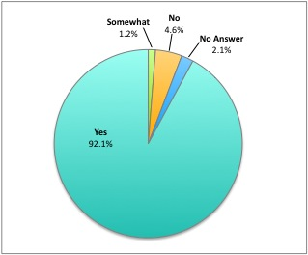
Figure 2. Percentage of participants that reported feeling comfortable working in a POD after training

- Objective 2: By the end of the training program, at least 50% of participants will report being either satisfied or very satisfied.
Figure 3 shows that 89.6% (n=216) of all participants responded that they were satisfied or very satisfied with the training they received. The Administrative and Environmental Health Divisions were slightly less satisfied at 88.9% (n=40) and 86.5% (n=77), respectively; 92.5% (n=99) of the Human Health Division responded with "satisfied" or "very satisfied."
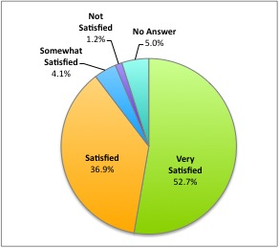
Figure 3. Overall satisfaction ratings for training program

- Objective 3: No participants will rate any of the training modules with a score of "1".
Screening Practice was the only module to receive any ratings of "1" for ease of understanding. While the "increased knowledge or skills" measure is not a focus of this report, it is interesting to note that at least one rating of "1" was received in each module. The Environmental Health Division was responsible for 13 of the 14 ratings of "1". Two participants from the Housing and Community Environment program rated every module with a "1" for "increased knowledge or skills." Two participants, one each from the Housing and Community Environment program and the Administration program, gave the only low ratings for "ease of understanding."

Table 4. Breakdown of ratings for "ease of understanding" and "increased knowledge or skills" by module
Module | Measure | Rating
Module | Measure | 1 | 2 | 3 | 4 | No Answer
Module | Measure | Disagree | Somewhat Agree | Agree | Highly Agree | No Answer
Introduction to PODs | Easy to Understand | 0 | 7 | 94 | 136 | 4
Introduction to PODs | Increased Knowledge or Skills | 3 | 12 | 104 | 112 | 10
How to Set Up a POD | Easy to Understand | 0 | 6 | 84 | 147 | 4
How to Set Up a POD | Increased Knowledge or Skills | 2 | 13 | 85 | 130 | 11
POD Setup Activity | Easy to Understand | 0 | 7 | 85 | 145 | 4
POD Setup Activity | Increased Knowledge or Skills | 2 | 9 | 88 | 130 | 12
How to Work in a POD | Easy to Understand | 0 | 9 | 82 | 145 | 5
How to Work in a POD | Increased Knowledge or Skills | 2 | 12 | 89 | 125 | 13
Screening Practice | Easy to Understand | 2 | 13 | 93 | 127 | 6
Screening Practice | Increased Knowledge or Skills | 3 | 14 | 85 | 124 | 15

Training Effectiveness

Do participants feel comfortable working in a POD after attending training?
As indicated in Figure 2, 92.1% (n=222) of participants reported feeling comfortable working in a POD after attending a training session. Of those respondents, 49.5% (n=110) had neither prior formal training nor previous work experience at a POD, as shown by Figure 4.
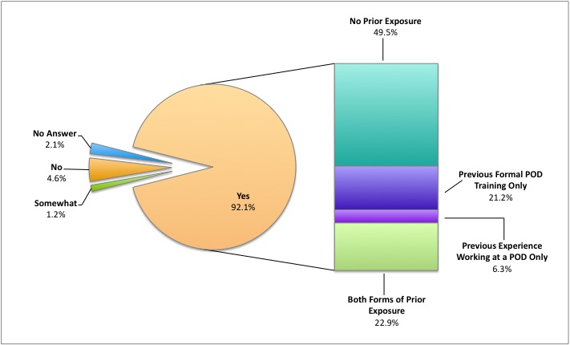
Figure 4. Previous POD exposure of respondents who are comfortable working at a POD

A further breakdown is shown below in Figure 5. All participants who had previous experience working in a POD, in some cases combined with prior formal training, responded that they felt comfortable working in a POD after attending a training session. The numbers within the bar graph indicate the actual number of respondents rather than the percentage, which is indicated on the vertical axis. While specific types of prior exposure were not assessed, these findings suggest that the program reinforced previous training and work experience. For those who did not have any prior exposure to PODs, the training was effective.
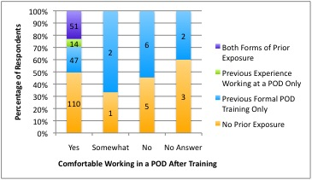
Figure 5. Types of prior POD exposure by perceived comfort levels

Were participants satisfied with the training that was provided?
Of the 4.6% (n=11) that reported they were not comfortable working in a POD, 72.7% (n=8) still indicated that they were satisfied with the training program, as shown in Figure 6. (Note that only responses are indicated; evaluations that did not choose an answer were excluded.) For a second comparison, a numerical rating scale was assigned to the existing ordered category item (not satisfied, somewhat satisfied, satisfied, and very satisfied), where "not satisfied" was converted to "1" and "very satisfied" to "4". Scores for overall satisfaction in those who were not comfortable working in a POD were 2.727 (mean) and 3 (median), while those who were comfortable had scores of 3.540 (mean) and 4 (median). This finding suggests that there is a relationship between perceived ability and overall satisfaction; participants who expressed comfort were more satisfied with the training than those who did not.
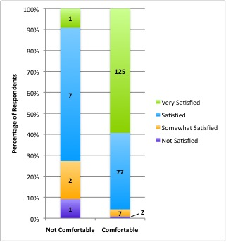
Figure 6. Satisfaction ratings by perceived comfort level

Is there a relationship between ease of understanding and perceived ability to work in a POD?
As indicated in Figure 7, How to Set Up a POD lecture was the highest rated module, with a mean ease of understanding score of 3.595. The Screening Practice activity received the lowest ratings (mean = 3.468), but it should be noted that only 15 participants scored it at a "1" or "2". Thus, even though it was the lowest rated module, the majority of participants reported that the module was easy to understand, which is a positive outcome.
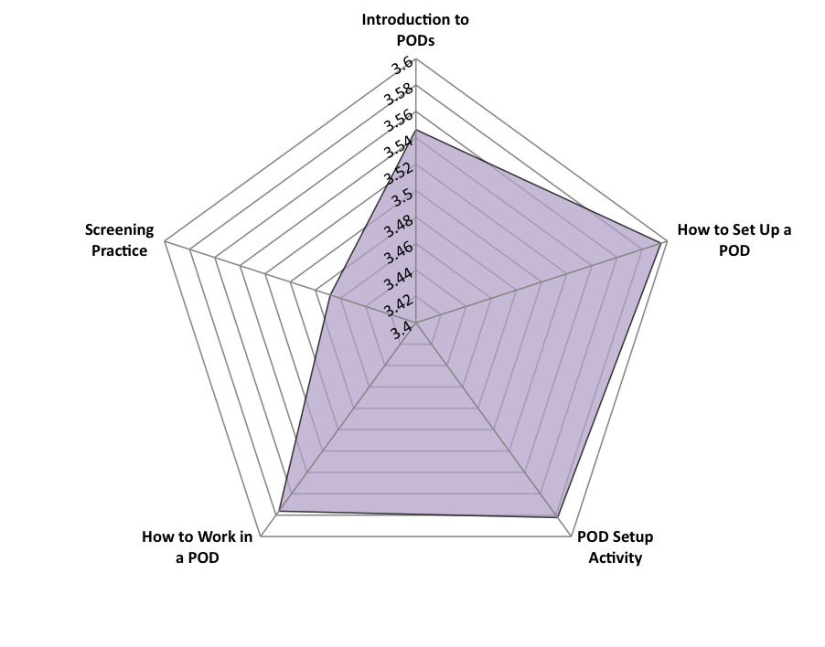
Figure 7. Overall ratings of ease of understanding by module
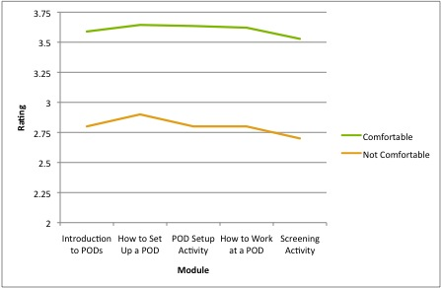
Figure 8. Ratings of ease of understanding by module by perceived comfort

Figure 8 compares ease of understanding with perceived comfort level. There is a notably large difference in levels of understanding with regard to participants' perceived ability to perform core POD staffing roles.
The Screening Activity still received the lowest ratings (3.528 for comfortable, 2.7 for not), indicating that the module should be looked at for potential revisions. Overall, comfort level is related to ease of understanding for all training modules. Whether or not this is a causal relationship remains unknown.
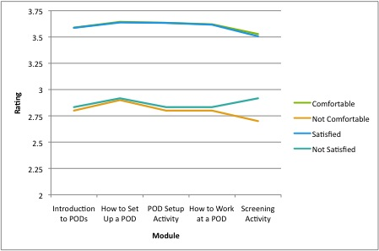
Figure 9. Ratings of ease of understanding by module by perceived comfort and overall satisfaction

Figure 9 shows a comparison of ease of understanding for the responses "satisfied" and "not satisfied", which shows a trend very similar to perceived comfort level. Level of satisfaction is also appears to be related to ease of understanding for all training modules.
However, not all participants who responded that they were comfortable working in a POD after attending the training coincide with those who were satisfied with the training program, as shown back in Figure 6. Figure 10 shows a clearer relationship among perceived comfort, overall satisfaction, and ratings of training modules by separating participants into four groups: comfortable and satisfied, comfortable and not satisfied, not comfortable and satisfied, and not comfortable and not satisfied.
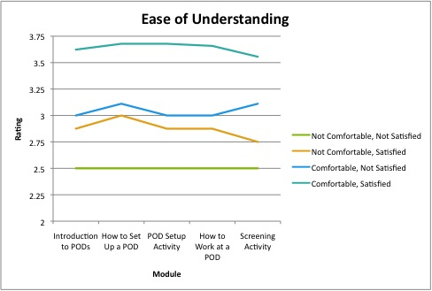
Figure 10. Ratings of ease of understanding by module, separated

In Figure 10, those who are both comfortable and satisfied reported higher levels of understanding while those who were neither comfortable nor satisfied reported lower levels, as anticipated. The difference occurs in the two categories where comfort and satisfaction levels are not matched. These findings suggest that ease of understanding plays a larger role in determining perceived comfort; the correlation between ease of understanding and overall satisfaction is not as strong. Higher levels of understanding correlate with feeling comfortable, but not necessarily satisfied.

Qualitative Data and Analysis
The open-ended questions were used to gather additional information about participants' experience during the training program. They also provided an opportunity for staff to share thoughts, concerns, and any other comments that did not fit into the quantitative section of the survey. The responses were coded for common themes using key terms and, and whenever possible, related directly to quantitative findings. For examples of participant responses, see Table 5.

Most enjoyable part of training
There were a significant number of comments (n=44) identifying the POD Setup Activity as the most enjoyable part of the training. Key terms were: set, setup, design, drawing, layout, blueprint, planning. Other common responses used "hands on" (n=16), "interactive" (n=17), referring to activities or exercises in general (n=23), "groups" or "team" (n=7), and screening and related terms (n=15). In addition, there were four comments about the casual, relaxed nature of the training sessions. It should be noted that many participants stated that "all was helpful" indicating that the question may have been interpreted as asking about the most helpful part of training as well.

Least helpful part of training
A considerable number of participants (n=18) stated that the least helpful part of the training was related to the screening practice. Specifically, the Head of Household form (see Appendix C) proved to be troublesome for participants to use and many recommended that it should be revised for future use. Key terms included: screening, interview, forms, Head of Household. Another common response was that the Screening Practice activity was confusing, although it is possible that this could be the result of the confusion surrounding the Head of Household form. This is also demonstrated by low quantitative ratings for overall understanding for the Screening Practice activity (see Figure 7). A few participants noted that the training, as a whole, was too long.

Additional comments
There was a much lower response rate for this section of the survey. Responses generally involved enthusiasm for learning about PODs and the training material. A request for more information about individual POD assignments was mentioned as well as interest in a larger scale simulation activity. These findings were expected, as the training only addressed three general staffing roles, and recent POD exercises have only included staff that work in the Emergency Preparedness program.

Table 5. Qualitative Responses from the POD Training Evaluation Tool
What did you enjoy most about today’s training?
"The activities because it gave the learner an opportunity to practice skills."
"Great hands on activities without actually being [in a] POD. Very nice presentations and I really liked the group activities."
"Hands on practice setting up POD and screening."
What was the least helpful part of today's training?
“The drug Head of Household forms are poorly made/designed.”
“The screening practice was a bit confusing.”
“The screening form was the least helpful [part of the training]. Though at least we are aware of its deficiencies.”
Please share any additional comments.
"Good presentation, good ideas, please pressure the county for more training and resources to put the training into practice."
"I think this is a very important topic, and I'm glad that people are being informed."
"I would like to know if possible which team or POD units I will be assigned to before I need to be activated."
"Would love to get hands on training at a POD setup drill!"

discussion of key findings
Analysis of the data collected during this evaluation demonstrates that two of the three outcome objectives (see section 4.1) were surpassed by a large margin. The final objective, however, was not met. Certain activities were more successful than others. The POD Setup Activity and the How to Set Up a POD module were both well received; this is reflected in both quantitative and qualitative analysis. The two scores of "1" for ease of understanding both described the Screening Practice activity. Upon examining the qualitative data, it is likely that the low ratings were the result of the confusion using the Head of Household form. However, as demonstrated in Table 4, the majority of participants were able to understand all the trainings, indicating overall program success.
The data showing that approximately half the participants that reported feeling comfortable did not have any form of prior exposure to PODs could indicates that the material presented during the training sessions is well received by Health Department staff. All modules were proven to be effective, demonstrating that the training program is achieving its objectives. Overall satisfaction amongst this group could also indicate that there was a lack of sufficient training prior to program implementation; however, data on prior trainings was not readily available at the time of this analysis. More information should be gathered before concluding that the training is the sole factor for high levels of perceived comfort.
A major finding of this analysis is that hands-on experience (e.g. activities, drills, or simulations) reinforces concepts presented in training modules. This finding is well supported by both the quantitative and qualtiative data, which demonstrated that hands-on activities (Pod Setup; Screening Practice) were most effective and most enjoyable. It is also highlighted by the overwhelming positive perceived ability to work in a POD amongst those who had previous work experience.
It is important to note that while perceived comfort level after training and overall satisfaction showed similar trends in responses, the two variables did not have exactly the same results on their own. By further examining these variables in the context of ease of understanding, a more fundamental relationship was revealed. There is a correlation between higher levels of understanding and perceived comfort; a similar correlation is demonstrated between higher levels of increased knowledge or skills and overall satisfaction. Perceived comfort and satisfaction have a complex relationship; they are not completely independent but not necessarily dependent either. Though the relationship is unsurprising and likely documented in the literature, it proves the value of understanding in training as related to translated ability to successfully work in a POD.
Increasing levels of understanding should increase percieved comfort level, which should therefore improve the training and evaluation outcome. Qualitative responses provided the best insight into the barriers to understanding. Most notably, the screening form and corresponding prophylaxis matrix or flow chart hindered participants' ability to learn the screening process effectively. Necessary changes to these documents are noted in the Recommendations section. In addition, the need for providing an opportunity to apply newly learned skills in a real-time, full-scale simulation is evident.

Limitations
Although participants demonstrated skills via hands-on activities, such as during the POD Setup activity, the casual behavioral observation that occurred is not an ideal measurement of skill composition and compilation; a more measureable approach is needed . There is no available data for comparing perceived comfort level or actual knowledge gained before the training program was conducted. Furthermore, perceived effectiveness was not measured.
While perceived comfort level was used as an indicator of ability to successfully work in a POD, there is any number of other factors potentially affecting the outcome. It is important to remember that perceived abilities are a subjective measure; thus, this will always be a limitation of evaluation.
As this was a pilot program and evaluation, there were certain aspects of the training or questions that could have been better addressed in the survey, possibly affecting the answers received by participants. Specifically, the qualitative question, "What did you enjoy most about today's training?" was at times interpreted as asking what was most helpful.

Recommendations

Training Recommendations
The Head of Household form for an anthrax exposure must be revised in the following areas to eliminate confusion and reflect current practices in screening:
- Additional questions about allergies to second and third line antibiotics; and
- Whether the patient is taking the drug tizanidine (brand name Zanaflex®)
Upon receiving qualitative responses and further reviewing the Head of Household form and prophylaxis dispensing algorithm, it is suggested that the ACHD consider combining the two into one screening tool.
While a full-scale, hands-on POD simulation would be the best way to address participants’ concern about the dispensing capabilities of the POD model, it is not always feasible. More evidence of historical POD operations should be incorporated into all training modules. In addition, drawing on past experiences of participants who have worked in a POD may be a valuable approach.

Evaluation Recommendations
A pre-assessment of certain skills and perceived abilities should be conducted before the training in order to better measure outcome and impact. Additionally, prior POD experience and exposure, such as formal training or work, should be identified more specifically. Collecting this type of data will allow for a more in-depth program evaluation, and will shed important light on potential causal relationships. Furthermore, the ability to separate actual versus perceived knowledge gained would be a significant advantage.
Perceived comfort should be rated using a Likert-type item rather than asked as a yes-or-no question, which some participants demonstrated by writing "somewhat" rather than choosing one or the other. By using the same scale on both the pre- and post-assessments, data will be easily comparable and easily applied across variable.
In the future, further analysis should be done to see if there were divisions or programs that were overrepresented in any lower scoring categories. Completing this type of analysis would inform training staff of specific needs for additional training amongst specific groups. It could also serve as an opportunity to identify potential leaders during an emergency response.

Conclusions
This evaluation clearly demonstrates the importance of gathering both quantitative and qualitative data to answer evaluation questions. Relationships among perceived comfort, overall satisfaction, knowledge gained, and ease of understanding are shown to affect training effectiveness and success. Best practices for the training of ACHD employees involve interactive and hands-on activities that apply newly learned skills. Revision or combination of the Head of Household form and corresponding prophylaxis dispensing algorithm will reduce confusion and increase accuracy when screening clients. A comparison of pre- and post-training skill assessments will better measure training effectiveness and allow for a more in-depth analysis of understanding of training materials.
Overall, the points-of-dispensing employee training program implemented by the Emergency Preparedness and Response Division of the Allegheny County Health Department was successful. This report will aid in improving current training methods and bettering public health preparedness capabilities for an array of different infectious disease emergencies.

Sample agenda from training
Allegheny County Health Department
POD Training Agenda
January 16, 2013
Clack Building 7

9:30 – 9:45 | Welcome | All
9:45 – 10:15 | Introduction to Points of Dispensing | Tom Mangan
10:15 -10:30 | Open discussion: Planning & Communication | All
10:30 – 10:50 | How to Set Up a POD | Jamie Sokol
10:50 – 11:00 | Break | All
11:00 – 11:30 | POD Setup Activity | All
11:30 – 12:30 | Lunch | All
12:30 – 1:00 | How to Work in a POD | Jamie Sokol
1:00 – 1:30 | Seasonal vs. Pandemic Influenza | Lauren Staffen
1:30 – 2:00 | Screening practice | Jamie Sokol, Lauren Staffen
2:00 – 2:15 | Q&A/Review | Jamie Sokol
2:15 – 2:30 | Evaluations | Jamie Sokol

Instructors:
Tom Mangan, Emergency Preparedness and Response Manager
Jamie Sokol, Preparedness Training and Exercise Coordinator
Lauren Staffen, University of Pittsburgh Graduate School of Public Health, Department of Infectious Diseases and Microbiology

Evaluation tool
Evaluation: Allegheny County Health Department POD Training
January 16, 2013

- Before today, have you had any formal training about PODs? YES NO
- Have you ever worked at a POD? YES NO
- After today’s training, do you feel comfortable working at a POD? YES NO
- In what ACHD program do you work? ___________________________________________
- Has emergency preparedness ever been addressed within your program? YES NO
- Please rate your overall satisfaction with today’s training:
Not satisfied Somewhat satisfied Satisfied Very satisfied
- Please rate each module using the scale on the top left corner of the chart.
1 = disagree  2 = somewhat agree  3 = agree  4 = highly agree | The module was easy to understand. | The module increased my knowledge and skills.
Introduction to PODs
(Tom Mangan)
How to Set Up a POD
(Jamie Sokol)
POD Setup Activity
How to Work in a POD
(Jamie Sokol)
Pandemic vs. Seasonal Flu
(Lauren Staffen)
Screening Practice

- What did you enjoy most about today’s training?
- What was the least helpful part of today’s training?
- Please share any additional comments.

Head of Household Form and Corresponding Algorithm
(on next page)
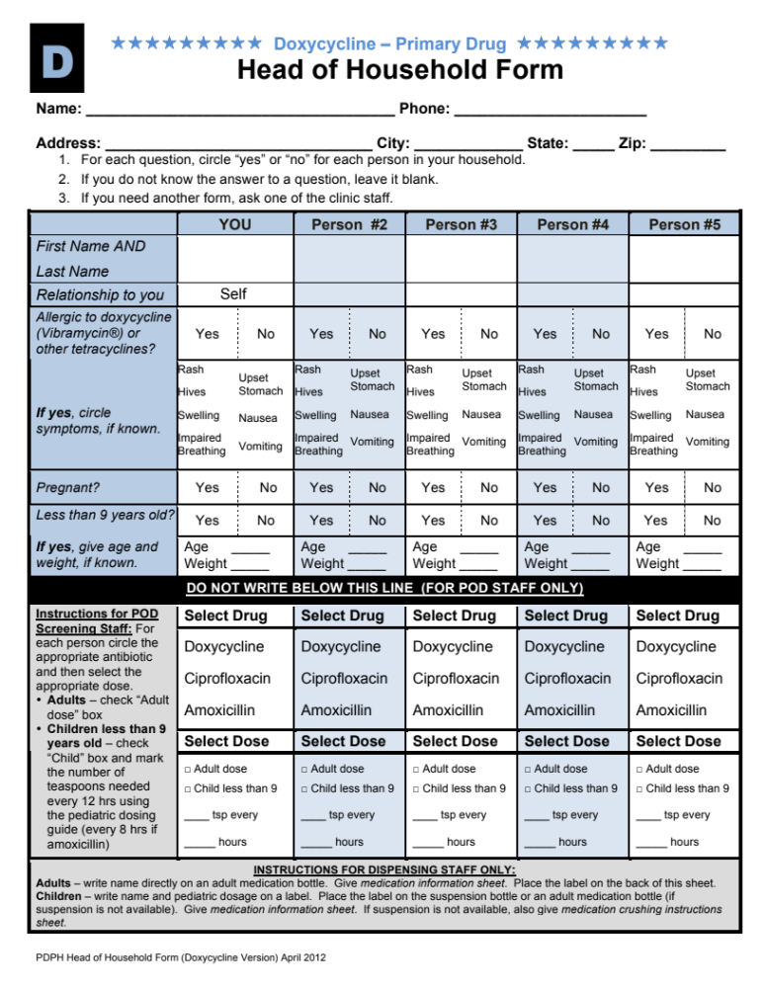
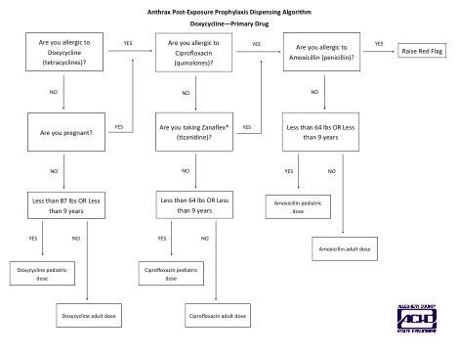
bibliography
Agocs, M., Fitzgerald, S., Alles, S., Sale, G. J., Spain, V., Jasper, E., … Chernak, E. (2007). Field Testing a Head-of-Household Method to Dispense Antibiotics. Biosecurity and Bioterrorism: Biodefense Strategy, Practice, and Science, 5(3), 255-267. doi: 10.1089/bsp.2006.0022

Allegheny County Health Department, E. P. a. R. D. (2009). Point of dispensing (POD) operations manual. Allegheny County Health Department.

Blank, S., Moskin, L. C., & Zucker, J. R. (2003). An Ounce of Prevention is a Ton of Work: Mass Antibiotic Prophylaxis for Anthrax, New York City, 2001. Emerging Infectious Diseases, 9(6), 615-622.

Bravata, D. M., Zaric, G. S., Holty, J. C., Brandeau, M. L., Wilhelm, E. R., McDonald, K. M., & Owens, D. K. (2006). Reducing Mortality from Anthrax Bioterrorism: Strategies for Stockpiling and Dispensing Medical and Pharmaceutical Supplies. Biosecurity and Bioterrorism: Biodefense Strategy, Practice, and Science, 4(3), 244-262
.
Centers for Disease Control and Prevention. (2004a). Cities Readiness Initiative - Attachment K. Retrieved November 24, 2013, from http://www.cdc.gov/phpr/documents/coopagreement-archive/FY2004/cri-attachk.pdf

Centers for Disease Control and Prevention. (2004b). Mass Antibiotic Dispensing: A Primer. Mass Antibiotic Dispensing [Satellite Broadcast].

Centers for Disease Control and Prevention. (2010, May 20). Cities Readiness Initiative. Retrieved November 24, 2013, from http://emergency.cdc.gov/cri/

Centers for Disease Control and Prevention. (2011). Public Health Preparedness Capabilities: National Standards for State and Local Planning. Retrieved November 24, 2013, from http://www.cdc.gov/phpr/capabilities/DSLR_capabilities_July.pdf

Glass, T. A., & Schoch-Spana, M. (2002). Bioterrorism and the People: How to Vaccinate a City against Panic. Clinical Infectious Diseases, 34(2), 217-223.

Glik, D. C. (2007). Risk communication for public health emergencies. Annual Review of Public Health, 28, 33-54. doi: 10.1146/annurev.publhealth.28.021406.144123

Hsu, E. B., Li, Y., Bayram, J. D., Levinson, D., Yang, S., & Monahan, C. (2013). State of Virtual Reality Based Disaster Preparedness and Response Training. PLoS Currents, 5. doi: 10.1371/currents.dis.1ea2b2e71237d5337fa53982a38b2aff

Inglesby, T. V., Grossman, R., & O'Toole, T. (2001). A Plague on Your City: Observations from TOPOFF. Clinical Infectious Diseases, 32(3), 436-445.

Kaufmann, A. F., Meltzer, M. I., & Schmid, G. P. (1997). The Economic Impact of a Bioterrorist Attack: Are Prevention and Postattack Intervention Programs Justifiable? Emerging Infectious Diseases, 3(2), 83-94.

Khan, S., & Richter, A. (2012). Dispensing Mass Prophylaxis - The Search for the Perfect Solution. Homeland Security Affairs, 8, 19
.
Kraiger, K., Ford, J., & Salas, E. (1993). Application of Cognitive, Skill-Based, and Affective Theories of Learning Outcomes to New Methods of Training Evaluation. Journal of Applied Psychology, 78(2), 311-328.

Lee, E. K., Maheshwary, S., Mason, J., & Glisson, W. (2006). Large-Scale Dispensing for Emergency Response to Bioterrorism and Infectious-Disease Outbreak. Interfaces, 36(6), 591-607. doi: 10.1287/inte.1060.0257

Lien, O., Maldin, B., Franco, C., & Gronvall, G. K. (2006). Getting Medicine to Millions: New Strategies for Mass Distribution. Biosecurity and Bioterrorism: Biodefense Strategy, Practice, and Science, 4(2), 176-182.

Lim, D., & Morris, M. (2006). Influence of trainee characteristics, instructional satisfaction, and organizational climate on perceived learning and training transfer. Human Resource Development Quarterly, 17(1), 85-115.

Miro, S., & Kaufman, S. G. (2005). Anthrax in New Jersey: A Health Education Experience in Bioterrorism Response and Preparedness. Health Promotion Practice, 6(4), 430-436. doi: 10.1177/1524839904263673

National Center for Infectious Diseases. (2000). National Bioterrorism Preparedness and Response Initiative. Powerpoint Presentation. Centers for Disease Control and Prevention. Retrieved from https://www.hsdl.org/?view&did=3959

Rebmann, T., & Coll, B. (2008). Infection prevention in points of dispensing. American Journal of Infection Control, 37(9), 695-702. doi: 10.1016/j.ajic.2009.09.001

Spitzer, J. D., Hupert, N., Duckart, J., & Xiong, W. (2007). Operational Evaluation of High-Throughput Community-Based Mass Prophylaxis Using Just-in-Time Training. Public Health Reports, 122(5), 584-591.
Stajkovic, A. D., & Luthans, F. (1998). Self-efficacy and work-related performance: A meta-analysis. Psychological Bulletin, 124(2), 240-261. doi: 10.1037/0033-2909.124.2.240

U.S. Department of Health and Human Services. (2002a). Bioterrorism Preparedness Grants of Entry [News Release]. Retrieved from http://wayback.archive-it.org/3926/20130930184629/http://archive.hhs.gov/news/press/2002pres/20020606b.html
U.S. Department of Health and Human Services. (2002b). HHS Announces $1.1 Billion in Funding to States for Bioterrorism Preparedness of Entry [News Release]. Retrieved from http://wayback.archive-it.org/3926/20130930185012/http://archive.hhs.gov/news/press/2002pres/20020131b.html
Whitworth, M. H. (2006). Designing the Response to an Anthrax Attack. Interfaces, 36(6), 562-568. doi: 10.1287/inte.1060.0241

Witte, K., & Allen, M. (2000). A meta-analysis of fear appeals: Implications for effective public health campaigns. Health Education & Behavior, 27(5), 591-615. doi: 10.1177/109019810002700506

Zaric, G. S., Bravata, D. M., Holty, J. C., McDonald, K. M., Owens, D. K., & Brandeau, M. L. (2008). Modeling the Logistics of Response to Anthrax Bioterrorism. Medical Decision Making, 28(3), 332-350. doi: 10.1177/0272989X07312721

