PREVENTION OF SEXUALLY TRANSMITTED INFECTIONS AMONG NIGERIAN YOUNG ADULTS IN UNIVERSITY OF LAGOS: A PLAN FOR INTERVENTION
(REAL TALK PROJECT)

by
Oluwaseun Jewoola
M.B.B.S. University of Lagos, Nigeria, 2006

Submitted to the Graduate Faculty of
the Graduate School of Public Health in partial fulfillment
of the requirements for the degree of
Master of Public Health

University of Pittsburgh
2013

UNIVERSITY OF PITTSBURGH
GRADUATE SCHOOL OF PUBLIC HEALTH

This essay is submitted
by
Oluwaseun Jewoola

on

October, 2013
and approved by

Essay Advisor:
Anthony Silvestre, PhD ______________________________________
Professor
Department of Infectious Diseases and Microbiology
Graduate School of Public Health
University of Pittsburgh

Essay Reader:
Lawrence Kingsley, PhD _____________________________________
Professor
Department of Infectious Diseases and Microbiology
Graduate School of Public Health
University of Pittsburgh

Essay Reader:
Patricia Documet, MD, DrPH ______________________________________
Assistant Professor
Department of Behavioral and Community Health Sciences
Graduate School of Public Health
University of Pittsburgh

(If you have an extra reader, add their info; you can adjust the spacing on this page to fit it.)

Copyright © by OLUWASEUN JEWOOLA
2013
ABSTRACT
According to the World Health Organization (WHO) 2005 estimates, there are 448 million new cases of curable sexually transmitted diseases (STD) yearly in youths aged 15-49 years worldwide. This excludes other incurable STDs and HIV. Nigeria is Africa’s most populous country with the third highest number of people living with HIV/AIDS (PLWHA) comprising mostly youths. Multiple factors contribute to the high rate of STDs and HIV in the country and a there is a need for public health intervention that will promote prevention of STDs among Nigerian young adults.
Anthony Silvestre, PhD
PREVENTION OF SEXUALLY TRANSMITTED INFECTIONS AMONG NIGERIAN YOUNG ADULTS IN UNIVERSITY OF LAGOS: A PLAN FOR INTERVENTION (REAL TALK PROJECT)
Oluwaseun Jewoola, MPH
University of Pittsburgh, 2013

An intervention program was designed based on a previous review of the literature to assess the present situation of sexually transmitted infections of young adults. The program applies lessons learned in intervention of sexual health of University of Lagos young adults. The design was based on the adaptation of the CDC’s Health Communicator’s Social Media ToolKit and National AIDS Minority council program plan.
Literature showed a high level of awareness of (about 92.7%) among young adults which was acquired mostly through the media. Young adults in rural settlements had higher misconceptions about disease transmission compared to their urban counterparts. Most health intervention programs have focused on HIV neglecting of education on other STDs proven to be strong indicators for HIV transmission. Low perception of personal risk for acquisition of HIV was associated with low condom use. Social norms and religious beliefs hinder proper sexuality education. Women are still victims of sexual abuse and domestic violence reducing their likelihood of making better choices for safe sexual practices. Increasingly high rate of unemployment and social hardship puts young adults promotes trading sex for money or incentives among young adults to meet their basic needs.
To effect a change in the sexual health on young adults, this intervention plan focuses on: increasing awareness of other STDs; use of social media to link individuals to youth friendly sexual health service provider; and use to reduce social stigma associated with sexual issues and STDs.

TABLE OF CONTENTS
PREFACE x
1.0 INTRODUCTION 1
1.1 STD TRENDS 1
1.2 YOUNG ADULTS 3
1.3 AIM AND OBJECTIVES 9
2.0 LITERATURE REVIEW 10
2.1 PREVALENCE OF STDS AMONG YOUNG ADULTS 10
2.2 KNOWLEDGE, ATTITUDES AND PERCEPTION OF STDS 11
2.3 RISK AND PROTECTIVE FACTORS 14
2.4 CURRENT PROGRAMS 19
2.5 USE OF MEDIA IN NIGERIA 20
3.0 REAL TALK PROJECT 26
3.1 TARGET POPULATION 26
3.2 GOALS AND OBJECTIVES 27
3.3 FUNDING SOURCES 27
3.4 LOGIC MODEL 28
3.5 PROGRAM DESIGN 32
3.6 PROGRAM PLAN 36
3.7. BUDGET 41
3.8 PROPOSED METHODOLOGY AND ANALYSIS 45
4.0 EVALUATION 52
5.0 CONCLUSION 55
BIBLIOGRAPHY 57
List of tables
Table 1: Descriptive Statistics of Health Message Frames (Beaudoin, 2007) 23
Table 2: Personnel 39
Table 3: Personnel Costs 42
Table 4: Calculation of Full time equivalent hours 42
Table 5: Intervention operating costs 43
Table 6: Program capital costs 43
Table 7: Site and facilities costs 44
Table 8: Budget Summary 44
Table 9: Gantt chart for Initial Activities towards Output 48
List of figures
Figure 1: Map of Nigeria showing geopolitical zones and poverty rates 8
Figure 2: Age distribution and Male to Female ratio of Facebook users in Nigeria 8
Figure 3: Total number of reports on issues of S/SH/SR in 5 daily Nigerian newspapers 24
Figure 4: Behavior logic model 30
Figure 5: Evaluation Logic Model 31
Figure 6: Website to facilitate interaction with participants 32
Figure 7: A fact sheet for young adults on HIV 33
Figure 8: An online reference tool for Clinicians 34
Figure 9: Organizational Chart 39
Figure 10: Performance Measures 53
Figure 11: Indicator Data Collection Plan 54
preface
This essay is in partial fulfilment of the requirements for a Master’s degree in Public Health. It contains an analysis of the risk factors of sexually transmitted diseases (STD) in Nigerian Young adults and a plan for intervention through the Real Talk Project. The essay is the sole work of the author. Information utilized in the program design was based on published articles and work done by other researchers. I have provided appropriate references for research conducted by others.
The aim of this essay was to design an intervention that will bridge an identified gap not currently filled by existing STD control programs existing in Nigeria. The target population for this project is young adults at the University of Lagos with a long term dream of rolling it out nationally.

Acknowledgements
I am most grateful to God and my family for the support and opportunity to pursue the degree. I would like to thank my Essay advisor, Dr Anthony Silvestre, for his mentoring, ideas and constant encouragement. I am also grateful for his frequent communication, and availability for impromptu meetings.
Thanks also to Dr Lawrence Kingsley for his guidance in meeting necessary requirements and supervision of the essay. Finally, lots of thanks to Dr Documet for accepting to read the essay on such short notice and giving her best recommendations.

Introduction
Sexually transmitted diseases (STDs) are a group of diseases acquired through any sexually related activity or behavior. The route of transmission is largely dependent on individual behavior. More than just laboratory testing and hospital treatment to is needed to curtail the spread of STDs. There are over thirty types of sexually transmitted diseases infecting humans worldwide. Microbial pathogens responsible for STDs include parasites, bacteria, viruses and fungi. Most are curable with treatment except STDs of viral origin which range from mild presentation such as genital herpes to debilitating diseases like HIV/AIDS. HIV/AIDS is the highest cause of death in Sub-Saharan Africa . STDs increase the risk of acquiring HIV/AIDS ten times than without the infection.

STD TRENDS
STDs affect all age groups, from unborn babies to the elderly. They contribute largely to preventable causes of infertility in young people. They rank fifth as the most common reason why adults seek care in developing countries . Despite the broad age distribution of STDs, different age groups are not affected equally. Yearly, 448 million new infections of curable bacterial STDs (chlamydia, gonorrhea, syphilis, and trichomoniasis) occur among youths aged 15-49 years worldwide. A larger proportion of those affected in this group are young adults. This has increased from 340 million estimated by the World Health Organization in 2001 .
Young adults aged 15 to 24 years constitute about 18% of the world’s population which is 1.1 billion young adults. The majority (85%) of young adults reside in developing countries. About 255 million of the majority of young adults lives in 19 countries with the highest poverty rates. 15 out of these 19 countries are in Sub-Saharan Africa which includes Nigeria .
A comprehensive review of literature by the WHO assessed factors affecting reproductive health of adolescents in developing countries. Over 11,000 articles were found but only 1.4% of them met the basic criteria for review. Of the 158 article chosen, 6 were from Nigeria. The review concluded that factors which mattered most were: education and schooling; knowledge and attitudes related to condoms and contraception; perceived sexual behavior of friends; and partner approval/support for using condoms and contraception .
Incidence of STDs in Africa was estimated to be 69 million new cases, second highest to South & Southeast Asia. Sub-Saharan Africa ranked the highest in number of cases at 119 cases per 1000 persons. A significant amount of data has been generated from different African countries, including etiology, syndromic STD management for specific populations. Studies also analyzed socioeconomic and geographical factors. Many countries in the continent lack functional national surveillance systems that monitor STD burden in the region
A commendable effort towards a national STD surveillance in South Africa was the use of sentinel studies which reported high burden of STDs in the country . Data from African countries differ in diagnostic standards used, and populations considered in a research study. This defect may be attributed to lack of adequate skilled personnel and resource to analyze and apply the data. A total of eleven countries published prevalence of syphilis amongst pregnant women attending antenatal clinics from 2005 to 2006. Results ranged between 0.9% in Botswana to 5.3% in Madagascar. This data is representative of less than 25% of a continent with a high burden of STDs .

YOUNG ADULTS
Approximately 50% of the new STD cases were found between the ages of 15-24years which is about 25% of youths aged between 15-49 years. Many factors can be associated to the disproportionate number of cases attributed to young adults. They include cultural, anatomical, economic, and psychological factors that may adversely affect health seeking behavior, among others. Adolescents fall within this group and they tend to be experimental and are more likely to engage in risky behavior. Factors responsible for acquisition of an STD differ within societies, suggesting that incorporation of behavioral indicators must be factored into development of strategies.
The burden of high STD prevalence is common to both high and low income countries. In the US, prevalence of STDs is still considered high especially in young females and young black adults. In the US, the Centers for Disease Control and Prevention (CDC), through a functional surveillance system is able to monitor the trends of the diseases in adolescents and young adults which aid evaluation of intervention programs . This is not the case in a low income country like Nigeria.
Young adults constitute a significant proportion of the workforce and future of nations. STDs are strong indicators of increased HIV transmission which is a leading cause of death, preventable infertility and other comorbidities that should be reduced to barest minimum through local and global efforts.

Nigeria
Nigeria is a West African nation bordered by Niger, Chad, Benin, Cameroun and the Atlantic Ocean. It consists of six geopolitical zones: North Central, North East, North West, South East, South South, and South West shown in Figure 1 below. Ironically, states with wider geographic space are sparsely populated compared to states with less land mass which are densely populated. Poverty rate is highest in Northern region . The national youth policy issued in 2001 defined Nigerian youths as individuals between the ages of 18 to 35 years . A large group of people (10 -17 years and 36-49 years) who are at higher risk of STD/HIV were not included in this definition.
People aged between 15-64 years make up 55.9% of total population of Nigerians estimated at 170 million (CIA World Factbook, 2012). An earlier survey conducted in 2006 National Demographic & Health and Survey, (NDHS) reported over 140 million people with an estimated yearly increase of 3.2% . The NDHS 2008 found earlier sexual debut with youths in rural areas more often than in urban areas. Earlier sexual debut was also noted to be higher in the northern part of the country than the other zones. The literacy level of people aged between 15-24 years is defined by those who can read and write a short statement with understanding . This was estimated to be 65.33% in females and 78.15% in males which is low compared to what is observed in western countries.
One-third of the population lies between 10-24 years and are referred to as young people . Many factors have been associated with risk factors for STD/HIV in Nigerian young adults such as: economic factors, socio-cultural factors, literacy level, and low perception of personal risk of infection. There are existing programs trying to increase awareness and STD prevention amongst youth , but they are not structured to accommodate out of school youths that are increasingly roaming the streets of the nation.
A review of online literature on sexually transmitted diseases among Nigerian young adults assessed many factors that affected sexual health. They include: sexual debut, gender, religion, geographical location, family setting, socioeconomic status, and governmental policy. There are ongoing intervention programs structured to control spread of STD/HIV/AIDS. Gaps identified from existing programs include: inadequacy in meeting the needs of university students and vulnerable adolescents; absent parent-focused programs; lack of programs addressing sexual harassment and violence; and the need to link programs to broader issues of poverty .
Resources are continually getting scarce in Nigeria and this necessitates more innovative ways of reaching out to this fast growing population. Social media has been used by governmental agencies and academic institutions in the western world for health promotion . The use of social media is on the rise in Nigeria and its impact has been experienced in many sectors of the country. This tool may be of great use in the dissemination of information and changing perceptions of people. Many young adults gain knowledge of sexual issues mostly through their mass media and their peers . It is important to utilize this to a public health advantage. The Nigerian environment is clandestine about discussion of sex and related topics . The social media creates an opportunity for young adults to gain information and interact on pertinent issues.
The most widely used social networking media in Nigeria is Facebook . Other frequently used websites are: Google, Yahoo, Google.com.ng, YouTube, Blogspot.com, Twitter, Vanguard Newspaper, Wikipedia, and Nairaland . There are about 5.3 million Nigerian Facebook followers who are active every month. Close to 2 million are young adults and more males than females constitute this number. This potential is yet to be fully explored. Figure 2 shows the current age and gender distribution of Facebook users in Nigeria. The largest age group is currently 18-24, followed by the users in the age of 25-34. There are 67% male users and 33% female users in Nigeria compared to 48% and 52% in Poland and 49% and 51% in Chile .
Mass media, specifically radio and television have been used to promote messages on HIV/AIDS but they are expensive and sometimes affected by power outages during television programs.
There is need for a prevention program that captures young adults’ interest and delivers services in a friendly fashion. It may also pave the way for future integration of services and programs. This project hopes to increase awareness of STDs as well locally available resources for control of STDs.

Study Population
Nigeria has 40 federal government owned universities which are the most densely populated institutions and also comprise the most prestigious schools in the country. The project is geared towards prevention of STDs among students of the University of Lagos (UNILAG). It was established in 1962, and commonly known as UNILAG. It is comprised of two campuses in Lagos State, the former federal capital. The main campus is largely surrounded by the scenic view of the Lagos lagoon and is located on 802 acres (3.25 km²) of land in Akoka, North Eastern part of Yaba, Lagos, “state of excellence”. The number of students has increased from 131 students in 1962, to over 39,000 students in the 21st century. The university is composed of nine Faculties and a College of Medicine The school of medicine is affiliated with one of the biggest teaching hospital which also has a specialized STD clinic .

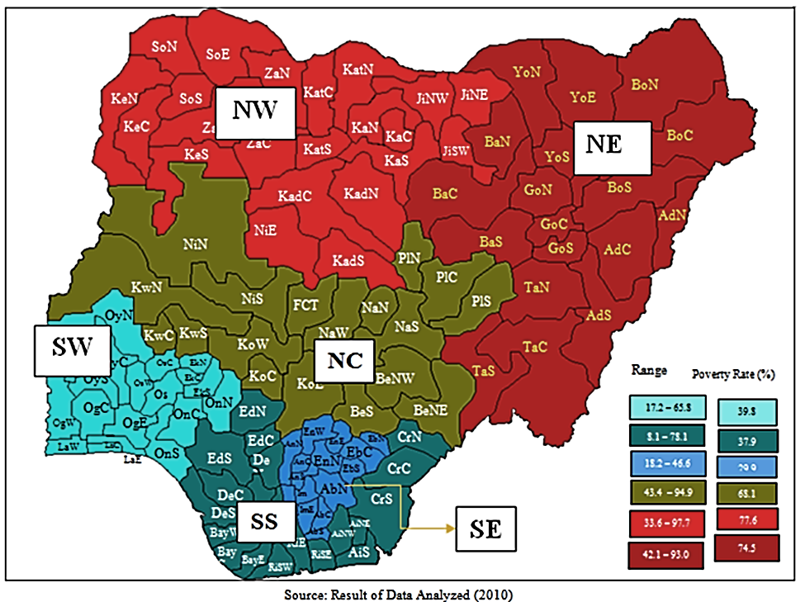
Figure 1: Map of Nigeria showing geopolitical zones and poverty rates

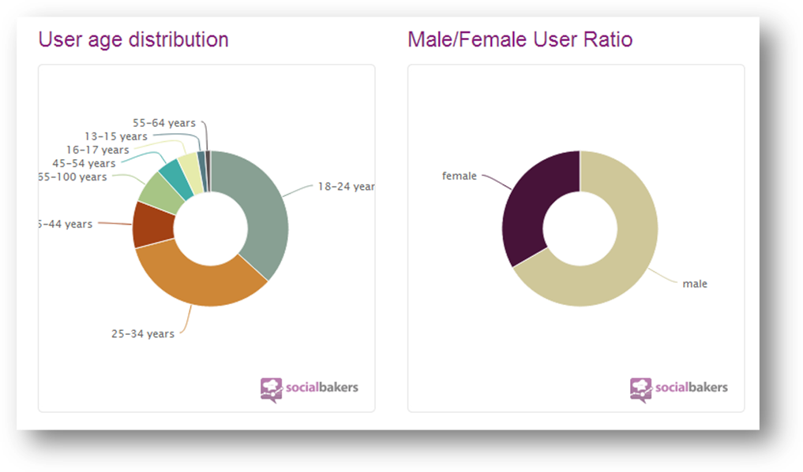
Figure 2: Age distribution and Male to Female ratio of Facebook users in Nigeria
.
The largest age group is currently 18-24, followed by the users in the age of 25-34. There are 67% male users and 33% female users in Nigeria.

AIM AND OBJECTIVES
AIM:
To improve the sexual health of UNILAG young adults aged 15-24 years through sexuality education, awareness, enhancement of positive behavior and integration with health providers and treatment services.
Objectives: The program is proposed to commence January 2014.
- By March 2014, STD knowledge gaps of UNILAG young adults will be identified through focus groups sessions
- By August 2014, there will be a 5 percentage point increase in knowledge of STDs of UNILAG young adults.
- By November 2014, there will be an increase in the personal risk perception of STDs by and use of condoms by 10 percentage points.
- By December 2014, increase in health seeking behavior of UNILAG young adults regarding STDs will be statistically significant.

LITERATURE REVIEW
Articles reviewed were from published online articles. They focused on prevalence of STDs, risk factors and use of social media in health promotion.

Prevalence of STDS AMONG YOUNG ADULTS
Nigeria presently lacks a national surveillance system to monitor trends in sexually transmitted diseases. This is due to many factors including inadequate diagnostics tests for diagnosis of STD. WHO syndromic management is the treatment guideline adopted by many hospitals. This management entails treatment of suspected syndromes of STDs with a pre-outlined antimicrobial treatment without laboratory diagnosis or confirmation. This makes it arduous to collect appropriate data on rates of specific STDs. Since advent of HIV and tremendous support from international non-profit organizations, there are services for testing and treatment of the incurable disease available to the general population. Available resources for STD management and its delivery to young adult is still a long way from being satisfactory. This is a cause for concern bearing in mind that other STDs are a strong contributing risk factor for acquisition of HIV/AIDS.
The NDHS survey based its STD prevalence on the self-report of STD symptoms from men and women within the past 12 months. Women had a higher rate of 5% compared to men at 3%. Women in urban areas had higher rates compared to their counterparts in the rural areas . Prevalence of HIV/AIDS by the National Agency for the Control of AIDS (NACA). The national prevalence has declined from 6% in 2001 to 4.1% in 2010. Prevalence of young adults aged 15-24 years is extrapolated from women who are seen at the antenatal clinic (ANC). The prevalence rate in this age group has also declined to about 4.3% and has plateaued since then . Another study in south-south Nigeria studied prevalence of STDs in young adults through an intervention program that engaged 12 schools. Intervention in the participants aged 14-20 years was through education and community participation. Prevalence of self-report STDs was recorded to have decreased in the intervention group from 33.1% to 22.0% and 31.1% to 28.5% in the control group of schools.

Knowledge, attitudes and perception of stds
Most of the articles reviewed for this study examined HIV/AIDS as the STD of interest. Eight articles assessed knowledge of STIs along with other objectives such as perception of risk, prevention methods adopted by young adults and success of program intervention. In a group of schools in western Nigeria , the knowledge of HIV/AIDS and its different routes of transmission were estimated between 61.7% - 87.8% for both sexes. The use of abstinence as an endorsed method of prevention was highest at 88% amongst participants aged 10-19 years. Perceived reasons for not adopting abstinence by non-abstinent young adults included: peer pressure, sexual urges and financial benefits.
Young adults had a fairly good knowledge of HIV/AIDS and its severity but perceived themselves to be at low personal risk as described by Oyeyemi YA and colleagues in a study on secondary school children. This finding is in keeping with what has been reported about teenagers in the developing world . Most the participants got information about STD mostly through mass media, internet, television and brochures. Females reported to have been educated by siblings, physicians, and parents more than males. Though they wanted to know about proper use of condom as prevention, most participants rejected the idea of it being taught or distributed in schools. Overall, there was higher knowledge about HIV/AIDS and higher rate of abstinence among females than males.
Different studies have shown high level of awareness of HIV/AIDS in adolescents as high as 92.0% and the mass media as the highest source of information. This means of education has not been able to give comprehensive information about the disease and answer misconceptions. About 70% had good knowledge of the disease while others had some misconceptions about its route of transmission such as mosquito bites or seating on toilet seats. A higher percentage of 48.3% perceived themselves as not being vulnerable to acquiring an infection despite high awareness of the disease. About one third (35.7%) believed they were vulnerable while 16.0% were unsure if they were vulnerable or not. Testing was generally low among respondents which were partly attributed to the fact that free testing was not being readily available. Articles reviewed agree that high awareness of HIV/AIDS but low perception of personal risk impedes a positive behavioral change suggesting that more intervention may be required to increase awareness as a means of inciting change.
Awareness seemed to have increased from earlier studies in 2006 from 48-52% to 87.8% - 92.0% . Nigeria like many other countries is culture bound and issues surrounding sex are not openly discussed. Sexuality education is not incorporated in many school curriculums and most young adults are left to fill in the gaps from peers who may not have the right information. The USAID evaluation of adolescent reproductive sexual health (ASRH) models used in Nigeria reports that the family life HIV education (FLHE) has the ability to reach all in school adolescents but has faced challenges through inadequate training of teachers and availability of the program it in school curriculums. A review of sexuality education and its benefits to in school and out of school young adults reported increase in awareness of HIV, and positive attitude to people living with HIV/AIDS (PLWHA).
The last NDHS survey in 2008 assessed knowledge, transmission and prevention methods in youth aged 15-49 years. Youths who have never been married and/or who are non-abstinent have higher awareness of HIV/AIDS than those who were married or abstinent. There were more men (94%) than women (86%) that had heard about HIV/AIDS and overall knowledge was 87% in young adults aged 15-24%. Awareness of HIV/AIDS is highest in the southern part of the country and awareness has been associated with higher uptake of prevention methods.
A study conducted in western Nigerian to examine urban and slum young adults inhabitants reported high rate of HIV/AIDS. They had little knowledge about other sexually transmitted diseases and misconceptions about diseases such as gonorrhea, warts, and syphilis . In general, many studies conducted were in the southwestern part of the country and most were school based, living little room for assessment of young adults on the streets or special cohorts like the military personnel.

RISK AND PROTECTIVE FACTORS
Alongside general risk factors for STDs in young adults such as: a higher incidence of STDs, and experimentation with high risk sexual practices, there are unique risk factors faced by young adults in the Nigerian population. There is diversity in what is culturally acceptable across the nation and this has influenced age of sexual debut, exposure to contraceptive methods, and gender empowerment in different zones. In Nigeria, it is illegal to have sexual relations with same sex. Such stringent laws make it more tasking to reach out to sub-groups within the young adult population. Homosexuals face a jail term of 14 years by the legal constitution. There is little or no report of transgender except for a few who live outside the country. There is still a lot of stigma associated with other groups like; people living with HIV/AIDS (PLWHA), and female sex workers (FSW).

2.3.1 Sexual Debut
Age of first sexual intercourse varies between gender and across region. Overall, females between the ages 15 – 24 years had an earlier median age of sexual debut than males. Before the age of 24 years, 16.2% of females in the survey had had their sexual debut compared with 6.2% of males. Women also had earlier median age at marriage and shorter amount of years between sexual debut and marriage but men had an average of 6 years between sexual debut and marriage. Women in the urban settlements had a median age of first sexual intercourse 3 years later than those in the rural settlements and by region, females in the northwest part of the country had a sexual debut of 15.4 years while it was 20.4years for women in the south east . Later age of sexual intercourse was also associated with higher level of education and higher socio-economic class. The reverse is the case for men in terms of region, men aged 25-59 in the south eastern parts had a lower age at sexual debut than their counterparts in the North West region. There is an ongoing attempt by the Nigerian House of Senate to pass into law the ‘underage marriage bill’. This law allows adult men to marry minors and it accepts they are ‘of age’ once they are married.

2.3.2 Family

Different studies have tried to associate the type of family setting with sexual behavior or practices of young adults and they sometimes contradict each other. Families have an important role to play in enlightening the young adults about sex education , STD prevention methods and contraception. Education is highly valued in Nigeria but sex education is not a widely accepted approach as cultures in most regions largely frown at pre-marital sexual intercourse, though the percentage of adolescents is consistently rising. Students from a group of different secondary schools in the north central region reported higher sexual activity in students: from polygamous setting; who had lower scores of parent connectedness; dead parent; and a lower socio-economic status . A later study found no association between polygamous family and sexual practice of young adults but associated higher sexual practices with young adults from affluent homes or lower educational .

2.3.3 Religion
The two main religions practiced in the country are Christianity and Islam. In general, religion seems to play a protective role in young adults. Youths interviewed in focus group discussions also report religion, especially Christianity as a reason for adopting abstinence . In the national survey of health, prevalence of testing was also found to be higher among Christians than Muslims.

2.3.4 Region
In all regions young adults aged 15-24 years were reported by the NDHS to have a generally low prevalence of HIV testing at 10%. In the south, they were reported to have a higher rate compared to those in the north and this finding was also reported to be higher in men (7.2%) than women (3.1%). A study which analyzed correlates between region of residence and sexual practices also showed higher prevalence of testing in urban dwellers than rural dwellers . This may be explained by more availability of intervention programs and health care facilities.

2.3.5 Gender
Nigeria is a patriarchal society where cultural norms favor men much more than women. Unrelenting advocacy by activist groups have helped to increase the literacy level among women and empower girls. Women are vulnerable and are usually victims of sexual or domestic violence. Cultural norms also condone extramarital affairs by married men as well as marriage to many wives which further promotes transfer of infection to women than men. Gender violence such as rape against women seems socially acceptable and victims were sometimes blamed for such acts . Male control also influenced the use of condoms in relationships between men and women. Refusal of women to have sex without condoms sometimes led to dissolution of such relationships. The anatomy of the female body also puts them at higher risk of infection than men in heterosexual intercourse. Men are more likely to seek treatment for a STD than women but usually from informal sources such as traditional healers whereas women who were less likely to seek treatment do so through formal sources like clinics . Men also felt less comfortable being treated by a female provider and favored traditional healer over clinic because of faster service and cheaper services.

2.3.6 Socio-economic status
Lower socio-economic class is associated with earlier age of sexual debut, less condom use in sexual activity and less information about STD prevention . Poverty and high rates of unemployment among young adults increase the likelihood of sexual activity for financial benefit or sex work.

2.3.7 Condom use
The knowledge of contraception through traditional or modern method is widespread among both sexes (72-90%). Despite knowledge and awareness of STD/HIV in young adults, condom use as a means of protection is relatively low because of low personal risk perception. A Nigerian study evaluated predictors of condom use among never married males aged between 15-24 years. It reported 43% of participants to be sexual active and 15% of this proportion used a condom at first intercourse. Use of condoms was much lower among males aged 15-19 years than those aged 20-24 years .

2.3.8 Health care system
Rural communities have less access to STD/HIV specialized centers that are better equipped to manage STDs and provide antiretroviral therapy for infected persons. Young people in the urban settlement are more exposed to the media and better education through which they are enlightened about STDs and its prevention.

2.3.9 High risk groups
Many observational studies and intervention programs are conducted in school based settings. High risk young adults like men who have sex with men and female sex workers, are underserved. Other special cohorts of young adults in prisons, military personnel, and out of school adolescent are also underserved. Studies on FSW reported high awareness of associated risk and prevalence of HIV/AIDS. FSW prioritized the needs of their clients above the need to protect themselves against infections through use of condoms. Some knowing their positive status still continued to have unprotected sexual intercourse with clients .

CURRENT PROGRAMS
There are series of programs available in the country targeted towards young adults and their sexual reproductive health needs. Positive results have been reported from interventions through sexuality education and improving awareness to effect behavioral change. However, Nigerian young adults still face lots of challenges and they are still disproportionately burdened by STD/HIV. A review of programs and their designs done in conjunction with USAID described five models on which these programs are based. The youth friendly health services (YFHS) reviewed are: In school family life and HIV education; stand-alone sexual reproductive health/life skill programs; information education and communication (IEC) integrated with livelihood skills; IEC integrated with health services; and mass media /information communication technologies (ICT). The review identified strengths and gaps related to each model. Gaps identified were: inadequacy in meeting the needs of university students and vulnerable adolescents; absent parent-focused programs; lack of programs addressing sexual harassment and violence; and the need to link programs to broader issues of poverty .

USE OF MEDIA IN NIGERIA
The use of all forms of media in Nigeria has gone through varying stages like in the rest of the world. Advances in technology have largely been influenced by the developed countries and globalization. A survey assessed the relationship between old gender inequities and new media. Analysis showed that more men read newspaper or listened to radio compared to women. Women were also more likely to get information solely from the television than men. The study showed that new media technology is yet to tackle issues of gender equity in regards to information. Despite equal access to information, women seemed to be getting less of it .
However, in the past few years, use of social media has changed the face of communication in nearly all sectors of business. A recent survey was conducted in 2012 by the broadcasting board of governors to study the use of social media in the country. In their findings, it was noted that there a vast increase in “connectedness” between people in the past few years. In the past, there was a huge gap between Hausa-speakers who resided more in the northern region and non-Hausa speakers. There are now more Hausa individuals in possession of a mobile phone.
The study has reported an average of 20% frequent use of internet weekly. This varied according to age, gender and location. Use of internet has also increased due to use of smart phones which are more accessible. The use of internet via mobile phone was also noted for activities such as news sharing by SMS, Web, and social networking. Importantly, television and radio broadcast media still dominate for news. Through the survey, almost 9 in 10 Nigerians (87.4%) say they listened to radio in the past week, and about 7 in 10 (72.5%) watched television. Radio broadcast still dominates the media followed competitively by TV broadcast. The use of mobile devices is largely increasing across all demographics which will translate into further evolution in the use of media in the future .

Impact of social media in Nigeria
Nigerians over the last sixty years have been through cyclical hoops of military and civilian government. The context of freedom of speech under these regimes is not similar. This influence greatly affected the media in the country and messages that could be made available to the public. Since consistent democratic government in the last fourteen years, media in Nigeria has evolved in a useful tool for education to the public and the government is being pressured to show more transparency in their dealings.
Since the last democratic presidential election in April 2011, the use of social media took the nation by huge surprise. Young adults have become more attentive and active in political issues. The use of social media has also been used to mobilize young citizens to stand up for what they believe in. The use of this form of media hasn’t been without its downsides in the country. It has also been a tool to disseminate rape or sexual assault videos of young females, lambast government officials, disseminate threat messages by Islamic terrorist sect to mention a few. There is little or no restriction applied to internet content by the government at the moment. In 1999, there were about 100,000 internet users in the country . The number of users grew rapidly close to 11million in 2008 and approximately 46 million users were reported in 2011. Likewise, mobile internet subscriptions reached 7.3 million users by 2008 with an added 25% increase by October 2011.
Despite this development the quality of service remains still unsatisfactory. Many users complain about their inability to enjoy the data services. The video-sharing website YouTube, social-networking site Facebook, Twitter, and various international blog-hosting services are free to users and are among the most popular websites in the country.

Use of media in adolescent sexual health promotion
Stigma is a factor affecting sexual health of young adults. People living with HIV/AIDS (PLWHA) are still rejected and ostracized and this has affected uptake of treatment services for some positive. It has been shown that increase in awareness of people through mass media has a positive effect on behavior change . In a bid to improve quality of health promotion in Nigeria, a national health promotion policy was developed in 2006. This resulted from external criticism which highlighted the major weaknesses in this sector. A few are: poor communication design; lack of management and system planning of health education interventions and lack of resources from the government to support health education/promotion .
Apart from minimal resource and little coordination among all tiers of governmental health and non-governmental organizations, there is also an observed pattern in quality of health messages. This is not peculiar to Nigeria alone but also to the rest of sub-Saharan Africa. Health messages from fifteen African countries were assigned six codes; sources, consequences, preventive means, self-efficacy, benefits and barriers. Health messages addressed barriers the least. The barrier frame code involved messages to help overcome problems hindering prevention . An example of a barrier frame would be, ‘Condoms are readily available at your local health clinic’. Use of condoms is low among young adults in Nigeria and pattern of message delivery may be a contributing factor.
Table 1: Descriptive Statistics of Health Message Frames
 | Mean | SD | Prevalence
Source | 0.46 | 0.94 | 25.00
Preventive means | 0.66 | 0.99 | 41.95
Consequences | 0.28 | 0.56 | 22.03
Benefits | 2.12 | 0.62 | 26.27
Self-efficacy | 0.98 | 0.78 | 68.60
Barriers | 0.09 | 0.33 | 1.53
(Beaudoin, 2007)
An extensive report on the media and sexuality/sexual rights/sexual health (S/SR/SH) in Nigeria showed sexuality education as the least covered aspect of reproductive health in media. The study suggests a need for more information on issues of S/SH/SR for more public enlightenment. Particularly for young adults, the study suggested a magazine with knowledge-based information appropriate for this target group .

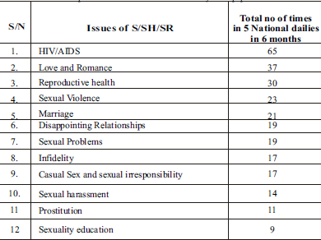
Figure 3: Total number of reports on issues of S/SH/SR in 5 daily Nigerian newspapers

The figure above shows the frequency of issues on sexuality, sexual health and sexuality education in five Nigerian national dailies over a period of 6 months. Sexuality education was the least in this group and the highest, HIV. Sexual health promotion in Nigeria appears to be skewed towards just HIV education without adequate education on sexuality and prevention of other STDs. Less emphasis was also placed on issues surrounding prostitution, and sexual harassment that affect females more. This further emphasizes the barriers women face in negotiating condom use in this patriarchal society.

2.5.3 STDs and media in UNILAG
The quality of sexual health among UNILAG students is not very different from that of the rest of the country. Low sexuality education continues to be an obstacle in the improvement of sexual health. Females tend to negotiate more condom utilization than males . Social networking in UNILAG follows the pattern in Nigeria. It is consistently growing and more versatility is being applied by both students and alumni. Networks shared include; Facebook, Twitter, Lagbook, Unilag Net.
It is important to apply this forum to continue to educate our young adults and increase awareness of S/SH/SR to help improve the quality of life overall.

real talk PROJECT
The real talk was construed out of an identified need to abate the mortality and morbidity from STDs in young adults. Real Talk Project also hopes to reduce the adverse effects of social norms, low governmental resources, on adoption of safe sexual services. Real Talk hopes to bridge the gap through use of evidence based practices and modern social networks.

TARGET POPULATION
The University of Lagos (UNILAG) was established in 1962. It is located in the commercial capital of the nation and it is publicly acclaimed as the “the University of First Choice and the Nation’s Pride” . From 131 students in 1962, it is now home to over 39,000 students . Real Talk aims to combat STDs among young adults through a social media prevention campaign. Existing health programs in the country are yet to effectively engage university students . Sexuality education and condom utilization are still not at desirable levels among these young adults. UNILAG young adults are in close proximity to a specialized STD centers, and an on campus radio station. They have access to social networks and the Real Talk Project will integrate these strengths to hopefully produce a synergistic effect that can be rolled out nationally.

GOALS AND OBJECTIVES
Goal
To improve the sexual health of UNILAG young adults aged 15-24 years through sexuality education, awareness, enhancement of positive behavior and integration with health providers and treatment services.
Objectives: The program is proposed to commence January 2014.
a. By March 2014, STD knowledge gaps of UNILAG young adults will be identified through focus groups sessions
b. By June 2014, there will be an increase in the recognition of the Real Talk project assessed through analytics of online followers.
c. By September 2014, there will be an increase in the perception of personal risk of STDs and use of condoms through ‘Real Talk’ social media tools and free condom distribution.
d. By December 2014, increase in health seeking behavior of UNILAG young adults regarding STDs will be statistically significant.

FUNDING SOURCES
The sustainability of Real Talk project and execution of its long term goals will depend on the ability to obtain resources. General sources of funding include: community fund-raising, foundation grants, government grants and contracts. The sample resource and webbing forms by the National AIDS Minority Council (NAMC) will be adapted to identify resources/ sponsors and raise funds from them.
Community fund raising will involve people, business owners whose mission align with the goals of the project. Telecommunication companies will also be likely supporters who can provide incentives and free services for the project.
Government sources will involve: the federal hospitals; adolescent sexual and reproductive health, health promotion and youth development arm of the ministry of health.

LOGIC MODEL
Two logic models have been developed to lay out plan to elicit a behavior change and to monitor activities of the project.
- Behavior change logic model: this is adapted from the WILLOW logic model used by one of the CDC effective intervention programs and proven with evidence to create change among women. This model will be adapted for the Real Talk Project. For behavior change, the social network contagion theory was chosen organizational and community norms that affect sexuality education, gender equity, young adult empowerment and adoption of safe sexual practices. Aspects of relations between individuals and their networks, influence individual perceptions and promote clusters of like-minded social networks. This has been shown in adoption of specific types of technology or fashion trends by groups or communities.

The second theory to be adapted into the model is the Diffusion of Innovation theory. It is based on the premise that the new idea of promoting sexuality education, safe sexual practices and integration with health services can be disseminated to a group of young adults through use of social media. The stages of adoption of the idea vary among group members.
- Communication channels: word of mouth, telephone, Internet, newsletters, Multimedia messages, and radio.
- Opinion leaders: respected people will be sought to can assist in disbursing the innovation or message. For example, health providers, and young celebrities.
- Time and process required : for the innovation to reach group members, individuals accept these messages at varying times; Innovators, Early Adopters, Early Majority, Late Majority and Laggards
- Social network to link members: diffusion process will be fostered through social networks: Peers, significant others, family, friends, respected persons, school board.

Theoretical Foundation
Social Network Contagion Theory (SNCT) and Diffusion of Innovation (DOI)
- Provision of peer networks and influence (i.e., social networks of young adults in UNILAG) would enable youths freely discuss sexual issues (SNCT)
- Provision of information about to promote STDs/HIV/AIDS prevention, transmission reduction and treatment (SNCT) would result in reduction of risky sexual behavior
- A forum for positive interactions would increase perception of risk and reduce risky sexual behavior (SNCT)
- Opportunities for decision-making, problem solving and goal setting (SNCT) can reduce risky sexual behavior
- Media for education on sexuality education on proper condom use and communications skills can enhance positive across networks (DOI)
- If health providers directly contribute to the health of young adults, and learn how to improve doctor-youth relationships (DOI), they can contribute to decrease risky sexual behaviors
- A platform for opinion leaders about sexual issues can promote change among young adults. (DOI)
- An STD prevention campaign implemented through social networks of peers, family and friends (DOI) will be well-received by youth.

Intervention Activities
- Conduct focus group discussions to prioritize messages and identify barriers to adoption of innovation
- Provide online information on strategies to reduce transmission of STDs and HIV reinfection
- Modeling decision-making, problem solving and goal setting
- Use opinion leaders, to facilitate implementation of the intervention
- Discussing safe and risky behaviors and other social issues that impact ability to young adults’ to make healthy decisions
- Defining types of social support, identifying young adults ‘social networks and discussing sources of social support
- Providing information on available health services and messages to health providers on peculiarities of a young adult client.
Behavioral Determinants of Risk
- Low personal perception of risk (SNCT)
- Inadequate knowledge and skills to negotiate abstaining from sex and risk-reduction (SNCT)
- Lack of knowledge about STD and HIV transmission reduction, personal risks and safer sex (SNCT)
- Limited social support networks and that positively impacting ability to practice safer sex (DOI)
- Limited forum to freely discuss issues of sex (DOI)

Risky Behaviors

Outcomes
- Increased knowledge about STD and HIV prevention, transmission and risk reduction
- Increase perception of personal risk for STD/HIV
- Fewer partner-related and social barriers to using condoms
- Lower stigma associated with sexuality education and higher condom uptake.
- Reported increase in utilization of available health service
- Reported increase in social support networks
- Success of program to be disseminated to other universities nationally
Figure 4: Behavior logic model

Inputs | Activities  (program does) | Outputs  (program products) | Initial Outcomes  (knowledge, attitudes and skills) | Intermediate Outcomes  (behavior) | Long-Term Outcomes  (condition, status)
Resources  Needs assessment, personnel,  health messages, budget,  internet access,  web communication tools,  Constraints  Endorsement of program by university authority, support from clinic, radio and website | Within a 3 month period:  Recruit personnel,  Conduct four focus groups to prioritize message needed.  Develop Facebook, twitter and YouTube pages to promote knowledge of STDs, Facilitate  interaction with health providers  Quarterly seminars at STD clinics for health providers. Make related messages available online  Locate sites for condom and flier distribution and stock them  Collect data on STD trends among participants | Four personnel recruited: IT analyst, planning director, statistician and a financial administrator  Finalized messages by audience type and content  Number of tweets, re- tweets, Facebook comments, YouTube videos and comments.  Increase in followers on each web profile.  Number of seminar participants.  Number of health professional who access online topics.  Increase in condoms and fliers picked up from distribution sites  Focus group report | Increase the knowledge of STDs of students by 5 percentage points.  Increase the self-perceived of risk for infection by 10 percentage points  Increase knowledge of available services in the state by 10 percentage points.  Increase in knowledge and skills of health professional in offering young adult friendly services.  After 9 months  reduce stigma associated with sexual issues | After a 9-12 month period:  Increase condom use and safe sexual practices of participants to statistical significance.  Increase the young adult clientele of STD clinic to statistical significance  After 6 months period;  Increase interaction between young adults and health providers through social media | Increase the availability and access to young adult friendly sexual health services among UNILAG young adults.  Improve the sexual health of UNILAG young adults  Roll out intervention nationally.
Figure 5: Evaluation Logic Model

3.5 PROGRAM DESIGN

The program design is based on a detailed needs assessment through focus groups and literature search. Health messages will be structured to encompass identified needs presented in a format that’s recommended by the study population. Messages will take into account slang and trends appealing to these students. The website will also afford individuals to ask personalized questions and also access to qualified health providers. Examples of such messages are:
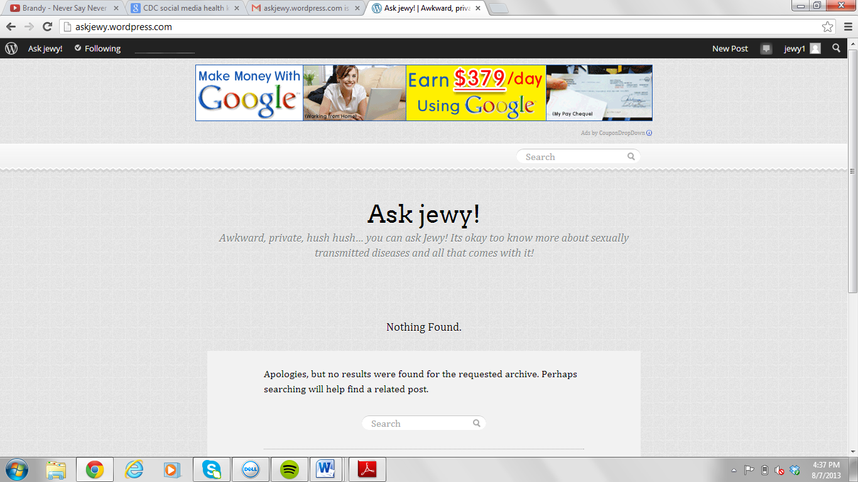
Figure 6: Website to facilitate interaction with participants
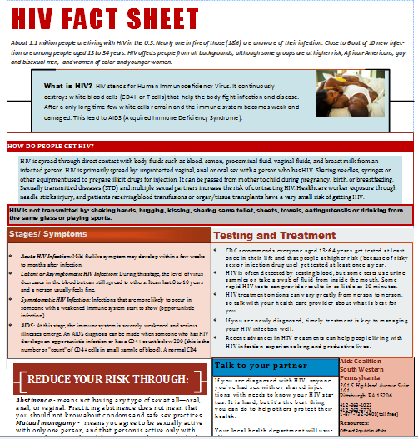
Figure 7: A fact sheet for young adults on HIV
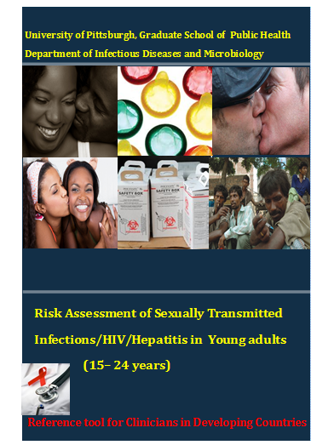
Figure 8: An online reference tool for Clinicians

3.5.1 Dissemination
The dissemination plan will be in two parts. The first part will involve the use of dissemination strategies to engage participants and stakeholders in the intervention. The second part is the bulk of the dissemination plan. It explores how findings and lessons learned may be rolled nationally or used to modify future policies for young adults.
Goal: To aid other sexual health agencies with lessons learned and roll out intervention nabtionally.
Audience: Young adults in other universities, Health agencies, Ministry of Health, International non profit organizations, Sponsors and community.
Medium: What is the most effective way to reach each audience? What resources does each group typically access?
Execution: The positive findings should be made available to participants bi-annually while the annual report will be made available to other audiences. Sponsors or partners in the media will be responsible for dissemination activities to the public. Program coordinators will be responsible for disseminating findings to the academic body, health agencies, health institutions. There should be caution in disseminating details that may be deemed confidential.
Strategies for dissemination plan will include; media coverage, research summary document, flyers, posters, brochures and research briefs, policy briefs, study newsletters, community agency publications and websites and local events, seminars, conferences, community meetings and online letter of thanks to study participants.

PROGRAM PLAN

3.6.1 Action Plan
This will be laid out using the CDC’s social media communications strategy sheet .
- Target Audience:
Young adults aged 15-24 years in University of Lagos, Nigeria (UNILAG)

- Determine your objective:
- Provide information through; to encourage health behaviors, to encourage interaction between health providers and young adults, reinforce health messages, to obtain feedback and collaboration with partners.
- SMART version
Specific – increase awareness of STDs and increase perception of personal risk of STDs and promote use of treatment centers among young adults in UNILAG
Measurable- awareness quantified through number of online viewers, no of clientele in specialized clinics, and evaluation through feedback.
Attainable/Achievable-project will be a pilot study achievable over a 12 month period
Relevant- prevention and control of STD among young adults
Time – 12 months

Summary of objectives
- By March 2014, identify STD knowledge gaps of UNILAG young adults through focus groups sessions.
- By August 2014, there will be a 5 percentage point increase in knowledge of STDs of UNILAG young adults.
- By September 2014, there will be a 5 percentage point increase in the recognition of the project through online survey and analysis of online followers.
- By November 2014, there will be an increase in the personal risk perception of STDs by and use of condoms by 10 percentage points.
- By November 2014, health seeking behavior of young adults in UNILAG will increase to a point of statistical significance.
- By December 2014, to increase the young adult clientele of the university’s STD clinic to statistical significance

- Define Audience and communication needs:
- Little sexuality education, low perception of risk and social norms are some risks factors for STDs in Nigerian young adults.
- Literature highlights Facebook as the most used form of social media by young adults. Other most used websites are: Google, Yahoo, Google.com.ng, YouTube, Blogspot.com, Twitter, Vanguard Newspaper, Wikipedia, and Nairaland. Question and answer mobile service used in the past was not so successful.
- Population is young adults that mostly use FB, TW as a means of communication. Free services are better patronized by young adults.
Social media to be considered: FACEBOOK, TWITTER, YOUTUBE, WORDPRESS

- Goal Integration:
To improve the sexual health of UNILAG young adults aged 15-24 years through sexuality education, awareness, enhancement of positive behavior and integration with health providers and treatment services.
- The stated objectives will help to improve the control of STD through increase in knowledge, better access to young adult friendly information and increased link to available health services.
- The use of social media kit at a intervention tool will complement the already growing use of social network to reach vast number of young adults in the nation.

- Message Development:
Examples:
- Is it just a kiss?
- Sexing and Testing
- Perks of abstinence
- Resources and Capacity:
Determine who in your organization will be responsible for implementation, and determine the number of hours they can allocate for content creation and maintenance.

Table 2: Personnel
ROLE | RESPONSIBILITY | HOURS
Executive Director | - Implements and oversees the activities of other personnel  - Develops messages for the social media tools  - Grant writing  - Conduct focus group sessions  - Data Analysis (e.g. focus groups) | - 30 hours weekly
Planning Director | - Organize focus group sessions  - Responsible for logistics  - Implementation of activities | - 20 hours weekly
Financial administrator | - Record keeping of finances  - Auditing | - 20 hours weekly
IT Analyst | - Web maintenance and analytics | - 20 hours weekly

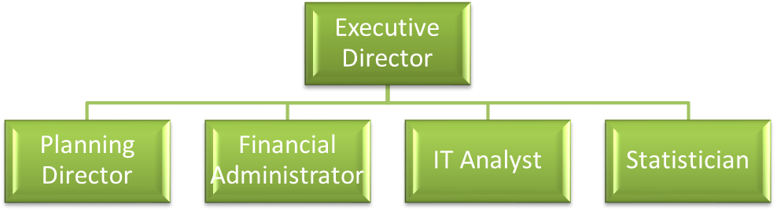
Figure 9: Organizational Chart

7. Identify Social Media Tools:
Determine what tools will effectively reach your target audience.
- Facebook
- Twitter
- Word press
- YouTube

8. Define Activities:
Based on all of the elements above, list the specific activities you will undertake to reach your communication goals and objectives.
- Conduct four focus groups to prioritize the type of message needed on media tools.
- Develop and implement Facebook, Twitter, Wordpress and YouTube pages to promote knowledge of STDs and encourage interaction with certified health providers
- Organize quarterly on site seminars at STD clinics for health professionals. Make related messages available online
- Locate sites for condom and flier distribution and stock them
- Collect data on pre and post surveys from participants
.

3.7. BUDGET

- Personnel Total: N1,930,000

Ms. Oluwaseun Jewoola, MPH, the Executive Director, will devote 60% effort to this project. She will direct the overall operation of the STD prevention campaign. Specifically, she will select the advertising agency and oversee the planning director, finance administrator, Statistician and IT analyst. In consultation with the social media expert and the statistical analyst, she will design the questionnaire forms for the online pre and post surveys. She will also develop questions for the focus group questions and analyze results. She will develop the content of messages to be posted online.
Planning Director Bsc. She will devote 50% effort to the project. She will oversee the gathering, tabulating, and interpreting of questionnaire and be responsible for overall program and staff and program evaluation. She will be responsible for ensuring necessary reports/documentation is submitted to the government funding agency. She will be responsible for scheduling appointments, organizing workshops and stocking of condom distribution sites.
Finance Administrator, B.A., will devote 30% effort and oversee payment of the ad agency, and the media. She/he will be responsible for record keeping for grant funds.
IT Analyst, B.Sc., will devote 50% of his/her effort to this project. He will be responsible for social media tasks, web design and analytics needed for evaluation.
Statistician, B.Sc., will devote 40% effort to the project. She/he will perform the analyses of surveys.
Table 3: Personnel Costs
Title | Full-Time Equivalent | Salary | Dates
Executive director | 30 hrs x 52 weeks = 1560 | N65,000 x 12 | Jan – Dec 2014
Planning Director | 20 x 52 = 1040 | N50,000 x 12 | Jan – Dec 2014
Financial  Administrator | 20 x 52 = 1040 | N45, 000 x 12 | Jan – Dec 2014
Statistician | 20 x 30 = 600 | N250,000
IT Analyst | 20 x 52 = 1040 | N45,000 x 12 | Jan – Dec 2014
Total | 4,680 | N1,930,000

- Fringe Benefits = 30% of total salary
Personnel Fringe Benefits Budget Total: N579000
30% of Total Salaries = Fringe Benefits (N1,930,000 x 0.30 = N579000)

Table 4: Calculation of Full time equivalent hours
FTE Calculation
Hours: Focus group 1: 50
Hours: Creation of health messages 1000
Hours: web maintenance 500
Hours: Free Condom distribution 100
Hours: Quarterly seminars at clinic 50
Hours: Data Analysis 600
Hours: Meetings 300
Hours: Evaluation 300
Hours Report writing 50
Hours: Data Dissemination 20
Hours: Total 2,970
Table 5: Intervention operating costs
Budget Category | Item name | Cost | Number | Total
Website Registration | Real talk | 40,000 | 1 | 40000
Condoms | Condoms | 5 | 20000 | 100000
Advertising | Flyers | 20 | 1000 | 20000
Advertising | Radio | 15,000 | 12 | 180000
Meetings | Meetings | 1,000 | 10 | 10000
Focus group | Food | 10,000 | 10 | 100000
Total |  |  |  | N450000

Table 6: Program capital costs
Equipment costs
Item | Purpose | Cost | Number | Total
Laptop | Social media tasks | 100,000 | 3 | 300000
Printer | Administrative | 40,000 | 1 | 40000
Office Supplies | Administrative | 50,000 | 1 | 50000
Projector | Seminars | 150,000 | 1 | 150000
Audiotape Recorder | Focus Groups | 10,000 | 1 | 10000
Total |  |  |  | N550000

Table 7: Site and facilities costs
Item | Purpose | Cost (N) | Number | Total
Internet access | Social media tasks | 30,000 | 12 | 360000
Rent | Meetings | 2,500 | 30 | 75000
Total |  |  |  | N435000

Table 8: Budget Summary
Site and facilities costs | 435000
Program capital costs | 550000
Intervention operating costs | 450000
Personnel costs | 1,930,000
Fringe Benefits | 579000
Evaluation | 180,000
Total Budget | N4124000

3.8 PROPOSED METHODOLOGY AND ANALYSIS

In the first three months of the project, focus group sessions will be held to determine the most important STD issues to young adults (15 -24 years) at the university.
After the initial needs assessment with the focus groups, quantitative forms of analysis will also be used. Ongoing monitoring of the activities will be monitored through:
- Online surveys for young adults who register on the website. To assess knowledge and feedback about the campaign. Online surveys will also be used to identify needs of health providers in reaching out to young adults.
- Analysis of web activities will also recorded through number of followers on web pages, number of clicks and web hits.

Focus Group Methodology
Questions will be formed for each session
  - Each session will comprise of 6-10 students
  - Each session will last an hour to 1.5 hours
- There will be 4 sessions: two sessions of male and females between 15-19 years and two sessions for males and females between 20- 24 years randomly selected from the university. The three main tribes (Hausa, Ibo and Yoruba) will be represented.
- Participants will be selected by invitation only. All will be participants will be currently enrolled students within the ages of 15 to 24 years.
- Forms of data to note: Conversation, including tone of voice; Silences (words and issues); Body language.
- Data collection methods: Memory, field notes, audio recorder, Notebook or laptop computer.
An Audiotape will be used to record the session. Conversations will be transcribed into written form and analyzed. Memories of reactions will be noted on paper or computer immediately after each session. A research assistant will also take notes during session.
- Moderator will be flexible yet focused. Session will follow an interview guide and future sessions will be modified on early sessions
Formats for reporting or analysis: data collected will be retrieved and analyzed. Specific codes will be allotted to selected quotations and frequency of major themes will be noted. For a detailed understand of the issue, a systematic analysis using full transcripts and a formalized coding (Initial and focused) scheme will be used.
Focus group introduction
Welcome to this gathering of undergraduate students of university of Lagos. We have come here today to hear what your views are about factors that affect prevention of sexually transmitted diseases in young adults. We also want to identify STD related diseases that are of most interest to you.
My name is Dr Seun Jewoola, a resident physician and I will be moderating the focus group. Let’s go around the room and introduce ourselves, and it would be helpful if everyone would write down his/her first name on the tent card. I will be asking you a series of general questions, and [Jocelyn, my research assistant] will be taking notes. We will use your comments to help develop a better a STD prevention campaign website. All comments and information given will remain anonymous and confidential. Feel free to speak up at any time, but one at a time. Feel free to address one another, not just the moderator. Both positive and negative comments are welcomed. There is no right or wrong answer.
The session will go on no longer than one hour and 30 minutes, with no break. If you need to use a rest room, they are located outside in the hallway. Please help yourself to small chops and beverages during the session.
You are representing the young adult undergraduate students at University of Lagos. Other groups who are being queried are undergraduate students from all other faculties. We are hoping that the users of this website can help contribute to its content and design, and make it as relevant and as usable as possible, by our future target users.

Questions
Education/Access to services and social media
- How would you define sexual health and STDs?
- Where do you and your friends get information about sex, HIV, STDs, and pregnancy?
- Tell me the kind of information about sexual health you and your friends need right now?
- What locations in the city would you recommend for free condom distribution or pick up?
- Tell me what may stop you and your friends from going to a doctor or health center?
- What might make it easier to get services for birth control, condoms and STD/HIV testing and treatment?
- In your opinion, what form of social media do you think will appeal most young adults?
- What features and services would you hope to see through this medium?
- What are your general recommendations to improve sexual health?
Evaluation design
- Sampling: this will be a random sampling. The study will be introduced to two classes per faculty that were randomly selected. A number/email contact will be provided and randomly selected by balloting.
- Timeline for the evaluation will be monitored using a gantt chart, when data will be collected (pre-post, post only, longitudinal—multiple times, and/or follow-up).

Table 9: Gantt chart for Initial Activities towards Output
Months  Weeks | May June July August September October November December January
Months  Weeks | 22 | 44 | 86 | 88 | 110 | 112 | 114 | 116 | 118 | 220 | 222 | 224 | 226 | 228 | 330 | 332 | 334 | 336 | 338 | 440
Prepare Logic model,
Write proposal to sponsors and school for endorsements. Recruit personnel,
Organize twelve focus groups to prioritize needs and information for website.
Develop Facebook, twitter, YouTube pages to promote knowledge of STDs and interaction with health providers.
Table 10 Continued
Locate sites for condom and flier distribution
Advertise website and distribution sites
Measure web analytics, make surveys available. First seminar for health providers
Commence interaction between subscribers and health providers. Promote education and behavior change through website
Do a record review of National HIV surveillance data,
Report writing of progress so far
Proposed analysis
- Analysis of the focus groups will be qualitative using categorical analysis. Participants’ speech will be coded into initial categories. The initial coding will comprise many categorical codes as the analyst reads contributions from sessions. Many responses may be assigned to a code. Next stage is the focused coding which will aggregate the initial coding categories, and look for repeating themes that connect codes. Final codes will be limited to thirty. Frequencies of each code will be used to prioritize most pertinent issues.
- Surveys will be designed, collected and analyzed using the Survey Monkey software .

Limitations

- Endorsement: the entire project is largely dependent on the permission to use this study population for the proposed project. Timelines of bureaucracy that entails the endorsement can’t be controlled by the researcher.
- Funds: sustainability of the project relies of provision of funds from likely sponsors and partners. It is hard to project on proposed funding from organizations. Lack of funds will affect recruitment of personnel, equipment, supplies and smooth running of the project.
- Data methodology and Analysis: Focus groups participation in sessions is entirely voluntary and the turn out will determine the quality of messages made available. Also the social factors relating to discussion on sexual issues may affect the authenticity information provided. If surveys are not filled at each entry will affect the strength of data gathered. If surveys are also made compulsory, it could deter some participants.
Content: Articles reviewed are all web based and may be subject to publication bias. Studies of special cohorts like prisons, military personnel and female sex workers that may include young adults in the age group of interest were not included because of the generalization of conclusions from such studies.

EvALUATION
Level | Performance Measures
Client | - 120 University of Lagos (UNILAG) students recruited for twelve focus groups [(Minimum: 6 young adults/session; Maximum: 10 young adults/session) and (% relative to capacity: Minimum 60%; Maximum: 100%)]  - 5,000 young adult followers on Facebook page, You Tube and Twitter. [(Minimum: 600 young adults within a year; Maximum: 1,000 young within a year) and (% relative to capacity: Minimum 60%; Maximum: 100%)]  - Health Professionals participating in quarterly seminars.  Goal: 75% of healthcare professionals in the Sexually Transmitted Infections clinic should have attended at least one onsite seminar within the first six months.)
Program | - 90% of personnel needed for the intervention will be recruited.  - All web pages or accounts (Facebook, twitter and YouTube) will be developed and implemented to promote knowledge of STDs among young adults, health providers and encourage interaction with certified health providers.  - 90% of online educational content on STD prevention and control developed and 75 % uploaded through social media kit.  - Identify 10 free condom distribution sites. Minimum - 4 local sites; Maximum- 10 local sites
PM # | Data Source | Data Collection Methods | Person Responsible | Timeline
 |  |  |  | Collect | Monitor | Report
1. | Students of University of Lagos aged 15 – 24 years | Focus groups to identify students’ needs | Executive Director | Before development and implementation of web pages | Annually | Before development of web pages
 | Young adults followers on developed web pages | Track followers and hits on websites, likes on Facebook | Executive director and IT Analyst | Before access to online materials | Before survey’s test | Before/after surveys’ test  Before/after final survey collection
  2.
3. | Young adults followers on developed web pages | Web audience analytics to determine number of followers and activities | IT Analyst | At each online entry | Monthly | Quarterly
4. | Health care providers at affiliated STD clinic | Surveys | Executive director, Planning Director | Before each seminar and at each online access to online seminar:  Survey to identify challenges of providers with creating young adult friendly treatment center.  Survey to identify challenges in STD diagnosis management | Before surveys’ test | Before/after surveys’ test  Before/after final survey collection
5. | Attendance record of Health care providers at affiliated STD clinic | Record review | Planning Director | Before training/ After training sessions | Quarterly | After each training session
Notes for Performance Measures: Before implementation of web pages, focus groups from different school departments will be conducted to identify needs of students in relation to sexual health. Health care providers in the STD center affiliated the university will be given quarterly trainings to assist in building young adult friendly clinics. Website account will be created to execute an STD prevention campaign that will promote integration of young adults to services and foster collaboration with other partners.

Figure 10: Performance Measures

Outcome Level | Indicators
Initial | 1a. Increase the knowledge of STDs young adult participants by 5 percentage points and Increase the self-perceived of risk for STD by 10percentage points.
Intermediate | 2. Increase condom use of young adult participants and increase the young adult clientele of affiliated STD clinic by 10 percentage points.
Long Term | 3. Improve the sexual health of UNILAG young adults decrease the number of young adult diagnosed with STD or other health complications associated with unprotected sex to a statistically significant level.
Indicator # | Data Source | Data Collection Methods | Person Responsible | Timeline
 |  |  |  | Collect | Monitor | Report
1. | Young adults followers on developed web pages | Online survey test | IT Analyst | Before/ After tests | Monthly | Every 6 months
2. | Young adult online followers  Free condom  distribution sites | Self-report  Number of condoms picked up at distribution sites | IT Analyst  Planning Director | ongoing | Every 6 months | Annually
3. | National HIV  surveillance data  Demographic records from STD centers in the State | Record review | Executive director | quarterly | Every nine months | Annually
Notes for Indicators: The STD Prevention and Control Project embodies the following interventions: (i) Increasing the knowledge of STDs self-perceived of risk for STD among UNILAG young adults; (ii) Increase condom use and young adult clientele of available STD clinic at UNILAG (iii) Improve the sexual health of UNILAG young adults.
Figure 11: Indicator Data Collection Plan

conclusion
Sexually transmitted diseases and its impact on young adult is a public health concern. Nigerian young adults aged 15-24 years make up about a third of the entire population accounting for about 57million people. They are most vulnerable to acquiring new sexually transmitted infection. Studies reviewed show a high level of awareness of HIV/AIDS acquired mostly through the media. Other sources of knowledge include peers, siblings, parents, health provider. Young adults in rural settlement had a higher percentage of misconceptions about STD/HIV than their urban counterparts. Though there continues to be increase in awareness of young adult to HIV/AIDS most programs neglect other STD which are strong indicators for acquiring HIV/AIDS. The media which is also the most common form of education is unable to give a comprehensive education about the subject and other related social issues related to sex topics. Introduction of sexuality education has not been incorporated fully into schools partly due inadequate training of teachers and reluctance as a result of cultural norms.
Sexual activity among young adult increases with exposure to media but low condom use is still relatively common due to low perceived personal risk. Many young adults have reported recent sexual activity without protection. Also, some lack experience in appropriate ways to use condoms and have no formal channel to get appropriate knowledge. Local culture and religion generally frown at premarital sex making it difficult to educate young adults without being perceived as encouraging premarital sexual practices. Regardless, they engage in these practices which predispose them to unwanted pregnancies and infections. Although religion was also shown to have a protective factor against HIV/AIDS, parents and society in general need to find a balance and devise ways that sustain culture but still address the reality and vulnerability of young adults.
Women compared to men are viewed to have fewer rights and are less positioned in making decisions in relationships. Women are also victims of sexual and domestic violence putting them at an increased risk of infections. The girl child needs to be continually educated on empowerment, self-esteem and negotiation of sex. The legal system needs to take responsibility for the judicial system and create an environment that is safe. just and punish perpetrators of such acts.
Beyond the awareness, perception and cultural norms, the needs of the people are still are put up barriers that needs to addressed. There is a high rate of employment, putting young adults especially females in compromising situations for financial benefit. Meeting basic needs will aid young adults in making decision that align with a safe and brighter future.
Social media is fast growing in the nation accessible to many young adults. In the face of constraints of resource, infrastructure and a growing need to improve health in the nation; this program is designed to bridge the gap between young adults and access to sound sexuality education, health services and healthier future.

bibliography

