THE ACCEPTABILITY OF OFFERING EMERGENCY CONTRACEPTION
TO DOMESTIC VIOLENCE SHELTER CLIENTS

by
Laura Elizabeth Yantz
BS, Michigan State University, 2012

Submitted to the Graduate Faculty of
the Department of Epidemiology
Graduate School of Public Health in partial fulfillment
of the requirements for the degree of
Master of Public Health

University of Pittsburgh
2013

UNIVERSITY OF PITTSBURGH
GRADUATE SCHOOL OF PUBLIC HEALTH

This essay is submitted
by
Laura Elizabeth Yantz

on

December 9, 2013
and approved by

Essay Advisor:
Catherine Haggerty, PhD, MPH ______________________________________
Associate Professor of Reproductive Epidemiology
Department of Epidemiology
Graduate School of Public Health
University of Pittsburgh

Essay Reader:
Elizabeth Miller, MD, PhD ______________________________________
Associate Professor
Behavioral and Community Health Sciences
Graduate School of Public Health
University of Pittsburgh

Copyright © by Laura Elizabeth Yantz
2013

Public Health Significance Approximately 36% of women in the United States will experience Intimate Partner Violence (IPV) in her lifetime. Reproductive Coercion (RC), a component of IPV, involves birth control sabotage, male partner attempts to impregnate a woman against her wishes, as well as controlling the outcomes of a pregnancy, and is experienced by 9% of women in the US. Reproductive coercion increases risk for unintended pregnancies, meaning pregnancies that are mistimed, unwanted or unplanned. Women experiencing IPV are more likely to have used emergency contraception (EC) to prevent pregnancy, but studies to date have not examined the need for EC among women seeking shelter for IPV. This pilot study assessed the acceptability and feasibility of offering EC to women during IPV shelter intake.
Catherine Haggerty, PhD, MPH

THE ACCEPTABILITY OF OFFERING EMERGENCY CONTRACEPTION
TO DOMESTIC VIOLENCE SHELTER CLIENTS
Laura Yantz, MPH
University of Pittsburgh, 2013
ABSTRACT
Methods Shelter staff received training on reproductive coercion (RC) and EC. Surveys were administered before, immediately after, and three months after training. Surveys assessed staff perceptions and comfort level offering EC to clients. During a six-week period, clients were asked about RC and pregnancy tests and EC were offered during shelter intake. Clients completed a survey to assess their satisfaction with having these resources available.
Results On a scale of 1 to 4, with 4 being very helpful, on average, women rated the helpfulness of knowing that EC was available as a 3.16. Between the training and the administration of the post-training survey, shelter staff increased their distribution of safety cards explaining the impact of violence on women’s health from 0% to 86% of staff reporting ‘all of the time.’ Assessment of clients’ health concerns as part of shelter intake increased from 50% to 86% of staff assessing ‘all of the time.’ Staff reported an increase in asking clients about EC, referring clients to family planning services, and assessing for RC, from 0% to 43% selecting ‘all of the time.’
Conclusion Shelter staff were able to adopt a routine practice of assessing women for RC and reported an increased comfort level regarding EC. Offering pregnancy testing and EC in shelter was met with great acceptance among both shelter staff and clients.

TABLE OF CONTENTS
preface x
1.0 Background 1
1.1 intimate partner violence and sexual violence 2
1.2 intimate partner violence and reproductive coercion 3
1.2.1 Reproductive Coercion Outside of Sexual Intercourse 3
1.2.2 Reproductive Coercion During of Sexual Intercourse 4
1.2.3 Reproductive Coercion After Conception 5
1.2.4 American College of Obstetricians and Gynecologists Recommendations 6
1.3 women seeking shelter 6
1.4 project details 7
2.0 project approach 9
3.0 project results 11
3.1 client surveys 11
3.2 staff surveys 12
4.0 discussion 20
5.0 conclusion 23
Appendix A safety card 24
Appendix B surveys administered to shelter staff and clients 26
bibliography 43
List of tables
Table 1. Demographics Data of Shelter Staff 15
Table 2. Advocate Reports of Health Assessment with Clients: Pre- and Post- Training Comparison 16
List of figures
Figure 1. Percent change in advocate reports of health assessment with clients Pre- and Post- training regarding safety card distribution 16
Figure 2. Percent change in advocate reports of health assessment with clients Pre- and Post- training regarding the assessment of health concerns of clients 16
Figure 3. Percent change in advocate reports of health assessment with clients Pre- and Post- training regarding direct asking about unprotected intercourse 17
Figure 4. Percent change in advocate reports of health assessment with clients Pre- and Post- training regarding offering emergency contraception to clients 17
Figure 5. Percent change in advocate reports of health assessment with clients Pre- and Post- training regarding referral of clients to family planning clinics 18
Figure 6. Percent change in advocate reports of health assessment with clients Pre- and Post- training regarding reproductive coercion assessment 18
preface
Acknowledgements: I would like to express my very great appreciation to Dr. Elizabeth Miller for her advice and assistance during the planning and development of this research work. Her willingness to give her time so generously has been very much appreciated.
I would also like to express my deep gratitude to Dr. Catherine Haggerty for her enthusiastic encouragement and useful critiques of this research work.
My grateful thanks are also extended to Women’s Center and Shelter of Greater Pittsburgh for their imperative assistance in the implementation of this intervention.
Finally, I would like to thank Dr. Miller’s research team at the Division of Adolescent Medicine at Children’s Hospital of Pittsburgh of UPMC. Without their continuing encouragement and support, I would not have been able to complete this project.

Background
Intimate Partner Violence is a serious public health concern affecting the lives of many women in the United States and around the world. The World Health Organization (WHO) defines Intimate Partner Violence (IPV) as physical (slapping, kicking, choking, threatening with weapons), sexual (forced or coerced sex, sexual humiliation), psychological (threats, insults, intimidation), and controlling (isolation, ignoring, jealousy, requiring permission for daily decisions) behaviors by an intimate partner.¹ In the report released at the end of 2011, the National Intimate Partner and Sexual Violence Survey (NISVS) found that 36% of American women have experienced rape, physical violence or stalking by an intimate partner in her lifetime, totaling approximately 43.4 million women.² IPV does not significantly vary by race or educational level,³ with young women ages 16 to 24 reporting the greatest prevalence.^{4,5} IPV costs the health care industry $5.8 billion annually on mental and physical health expenditures and lost productivity.⁶ IPV is the cause of 2 million injuries and 1,300 deaths each year,⁶ with two-thirds of women murdered during IPV seeking medical services in the year prior to their death.^{7,8} IPV greatly affects women’s health, with abused women reporting significantly lower health status, decreased quality of life, and higher health care service utilization than their non-abused peers.^{4,9} Women experiencing IPV often experience at least two types of abuse, including physical, sexual, or psychological,⁸ with sexual violence being a large portion of IPV. Reproductive coercion, or the attempt of impregnating a woman against her will, stems from sexual violence due to IPV and is the basis for this project. The purpose of this project was to assess the acceptability and feasibility of offering emergency contraception to women entering a local domestic violence shelter.

intimate partner violence and sexual violence
Sexual violence is an important component of IPV, with 22% of women who report physical abuse in the past year also reporting sexual abuse.⁴ The prevalence is even higher among women who reported physical abuse at any point in their lifetime, with 44% of those women ever experiencing sexual abuse.⁴ Women experiencing IPV are significantly more likely to contract sexually transmitted infections (STIs), including human immunodeficiency virus (HIV).^{10,11} Additionally, women experiencing IPV often report having non-monogamous partners,^{12,13} engaging in risky sexual behaviors including inconsistent condom use by their partners,^{8,14-20} condom non-use,²¹⁻²⁴ fear of negotiating condom use with their partner^{8,22,24,25} and lower sexual communication self-efficacy.²⁴ Women experiencing IPV are significantly more likely to engage in other risky sexual behaviors such as sex with multiple partners, unprotected intercourse, and inconsistent condom use when compared to their non-abused peers.^{8,10,23,26,27} In a cross-sectional study of 143 Latina or African American sexually active women, victims of IPV were 4.2 times more likely to have sexual intercourse with a risk-taking partner, including injection-drug users, HIV positive partners, and partners that have had sex with other men.²⁸ With limited control over their lives and sexual decision making, women experiencing IPV are less able to make informed decisions regarding how to protect themselves from infections, contraceptive use, and decisions regarding their reproductive health care.⁸

intimate partner violence and reproductive coercion
Women experiencing partner and sexual violence may also experience reproductive coercion (RC). The American College of Obstetricians and Gynecologists (ACOG) defines sexual and reproductive coercion as “behavior intended to maintain power and control in a relationship related to reproductive health by someone who is, was, or wishes to be involved in an intimate or dating relationship with an adult or adolescent, including explicit attempts to impregnate a partner against her will, control the outcomes of a pregnancy, coerce a partner to have unprotected sex, and interfere with contraceptive methods.”²⁹ In the National Intimate Partner and Sexual Violence Survey (NISVS) released at the end of 2011, 9% of women reported experiencing RC in the United States, translating to 10.3 million American women.² Reproductive coercion leads to decreased contraceptive use, increased unwanted pregnancies, births, and abortions, and a loss of control over one’s sexuality.^{30,31} Abusive male partners may actively encourage pregnancy through behaviors before intercourse, during intercourse, and after conception.

Reproductive Coercion Outside of Sexual Intercourse
Even prior to acts of intercourse, coercive reproductive behaviors may include verbal pressures to become pregnant, birth control sabotage, or blocked access to contraception prior to intercourse. Abusive male partners have been reported to withhold money for contraception, accuse partners of infidelity if she requests to use condoms, or violently react if contraceptives are found.²⁵ Of women reporting physical or sexual violence, 15% also reported birth control sabotage.¹⁹ Birth control sabotage can include flushing birth control pills down the toilet, physically removing hormonal vaginal contraceptive rings or intrauterine devices (IUDs), or taking off contraceptive patches.^{25,30} These acts of RC may result in women fearing violence if contraceptives are discussed with her partner. Abusive partners have also been reported to threaten to forcibly impregnate their female partners when she does not want to be.³⁰

Reproductive Coercion During of Sexual Intercourse
Reproductive coercion can occur during intercourse. Abusive partners may refuse to use condoms, purposefully make condoms ineffective (breaking or poking holes in condoms), take condoms off without telling their female partners,²⁰ not withdrawing when that was the agreed-upon method of contraception^{30,31} or coercing partners into having sex without a condom.³⁰⁻³² In a survey of 1,318 men in Boston, abusive men reported forcing or coercing a partner to have unprotected sex significantly more than non-abusive men.²¹ These behaviors are especially concerning as women experiencing IPV are twice as likely to report using condoms as their primary method of contraception.³ While IPV is not associated with low self-efficacy scores for using condoms, it is associated with low sexual assertiveness scores, and fear of partner’s response to negotiating condoms.¹² This results in higher pregnancy rates among victims in comparison to non-victims, with adolescent pregnancies and unwanted pregnancies being associated with IPV.^{11,23,33} Women experiencing IPV are more likely to have used emergency contraception when compared to their non-abused peers.⁶

Reproductive Coercion After Conception
Reproductive coercion also occurs after conception. Male partners may attempt to control pregnancy outcomes through violent attempts to induce miscarriage and to verbally coerce a partner into either termination or continuation of the pregnancy.²⁰ In the 12 months before conception or during pregnancy, unintended or unwanted pregnancies are 2 to 3 times more likely to be associated with abuse than an intended pregnancy,²⁵ and pose a greater risk for violence than intended pregnancies.³⁰ Of women who had become pregnant in the last 5 years, 40% that had reported IPV had also reported that the pregnancies were unwanted, in comparison with 8% of women that did not report IPV.^{3,34,35} When surveyed, more than 1 in 4 participants had reported being in significant conflict with their partner involved with their pregnancy, with 1 in 5 reporting physical abuse at least once by their male partner.³⁶ IPV is associated with an increased probability of having induced or repeat abortion,^{1,36,37} and was nearly 3 times greater in women seeking an abortion in 2007 in contrast to women continuing their pregnancies.^{29,38} Additionally, men reporting perpetration more often had more involvement in their female partner’s abortion, with 1 in 3 participants reporting involvement in an aborted pregnancy, in comparison to non-abusive men,²¹ Males that reported IPV perpetration were also more likely to report conflicts regarding decisions related to seeking abortions with their pregnant female partners.²¹

American College of Obstetricians and Gynecologists Recommendations
In February 2013, the American College of Obstetricians and Gynecologists (ACOG) released a committee opinion acknowledging RC and sexual coercion.²⁹ This committee opinion recommended interventions that involve educating women on the effect of sexual and reproductive coercion on women’s choices and health. ACOG recommended counseling on strategies for harm reduction by helping women to reduce their risk for unintended pregnancy while increasing their safety and offering longer acting reversible contraceptives that are invisible to partners.²⁹ Following these recommendations, this project focused on emergency contraception access as a harm reduction strategy to reduce the risk for unintended pregnancy among women seeking shelter services.

women seeking shelter
Some women experiencing IPV may choose to escape their abusive partner and seek refuge in a domestic violence shelter. Women seeking shelter tend to experience more severe violence than women seeking refuge elsewhere.³⁹ In a study of 115 women reporting IPV in Massachusetts, 22% of women experiencing IPV sought help from a shelter, with about 75% using more than 2 services, ranging from medical care to restraining orders.³ Women that reside in shelter are less likely to be employed or to have an income and have lower education levels,³⁹ and are less likely to have health insurance versus women living outside of shelter.⁴⁰ A study conducted in 2011 of a sample of women aged 19-57 residing in a shelter for IPV found a high prevalence of birth control sabotage, forced sex, and interference with their access to healthcare by their partners.⁴¹ Women seeking shelter are also more likely to be pregnant than women experiencing IPV but not seeking shelter.³⁹ While limited research is available on women seeking health care services while in shelter, in practice, community-based domestic violence shelters have sought to offer more extensive health care services. For example, when residential and outpatient oral healthcare procedures were offered to shelter clients in the Dale and Broward counties of Florida, clients in three shelters expressed great enthusiasm.⁴² Given these findings and the highly complicated situations facing many women seeking shelter in the context of abusive relationships, offering access to an array of services is likely to be critically important for helping women in recovery from an abusive relationship.

project details
To our knowledge, no studies have been conducted regarding access to reproductive health care for women in shelter. Due to the high likelihood that women in shelter have experienced sexual violence (including unprotected intercourse) as well as reproductive coercion, offering EC to shelter clients is a necessary component in incorporating reproductive services into the care provided in shelter. EC is a Food and Drug Administration (FDA)-approved drug for pregnancy prevention after unprotected sexual intercourse, containing a high-dose of estrogen or estrogen-progesterone combination in a single pill. These high doses of hormones disrupt ovulation, interfere with fertilization and embryo transport into the uterus, or inhibit implantation of an embryo, however, they do not terminate a pregnancy that has already occurred. This medication can be taken up to 5 days after unprotected intercourse, although the sooner this drug is taken, the more effective it is at preventing pregnancy. This project aimed to explore the acceptability and feasibility of offering EC to clients during shelter intake by staff, while monitoring client response. As this option has not been offered before, the perceptions of shelter clients and staff were unknown.

project approach
This intervention was developed by a team of shelter staff and researchers in collaboration with Futures Without Violence, a national non-profit violence prevention organization. The study was approved by the University of Pittsburgh IRB (PRO13010571). The Women’s Center and Shelter of Greater Pittsburgh agreed to participate in this formative research. The shelter staff received a 1 hour in-service training on emergency contraception and reproductive coercion. The training content included statistics regarding reproductive coercion, how it affects women’s health, and tactics used by abusive partners to impregnate women. Training materials also explained the use of emergency contraception, how it differed from an abortion pill, and why it is imperative to offer this resource to women experiencing violence.
The study was intended to assess acceptability and feasibility of implementing a reproductive coercion and EC provision intervention during shelter intake with surveys of both providers and clients. The Pre-Training Survey was given to shelter staff immediately prior to the training to evaluate beliefs about EC as well as current barriers to addressing health concerns of shelter clients. Directly following the training, the Training Satisfaction Survey was administered to training attendees to elicit feedback on the training content. Three months following the training, a Post-Training Survey was administered to staff members to monitor the changes in opinions about EC and barriers related to addressing the need for EC at shelter intake.
Throughout a six-week period after the training, home pregnancy test kits and emergency contraception were offered to all shelter clients at intake. Shelter staff assessed clients for reproductive coercion and educated clients about the safety and effectiveness of EC using an Intake Assessment Tool (see Appendix). This assessment tool asked clients specifically about whether they felt they needed emergency contraception or a pregnancy test. If the client needed a pregnancy test, a home pregnancy test kit would be given to them. If a client needed EC, a system was set up for an EC packet to be delivered to the shelter by a local reproductive health care provider. Clients were also asked to complete a Client Satisfaction Survey immediately after the shelter intake to assess client perceptions regarding the intervention, whether it was helpful to know that pregnancy tests and emergency contraception were available to them if needed, and the ease of obtaining emergency contraception.

project results

client surveys
Seventeen clients completed an Intake Assessment Tool by herself or with a shelter staff member assisting her, depending on the preferences of the client. The average age of shelter clients was 30.5 years. No clients requested emergency contraception during intake, and the majority of clients (88%) did not ask for a pregnancy test. The shelter staff gave a safety card to all but two clients (see Appendix). Staff reported being uncertain with intakes conducted with two clients, i.e., not knowing whether to give them the intake assessment tool - one was visibly pregnant at intake and another reported being in a lesbian relationship.
Fifteen clients completed a Client Exit Survey. Fourteen clients reported being asked if they needed a pregnancy test or emergency contraception. One client requested a pregnancy test, but ultimately did not need to use the test kit as her menses started shortly thereafter. No clients requested emergency contraception at intake. Thirteen clients reported receiving a safety card from a shelter advocate. Clients found it helpful to learn that emergency contraception was available to them if needed. On a scale or 0 to 4, with 0 being ‘not helpful at all’ and 4 being ‘very helpful’, clients reported an average score of 3.16 (SD=1.53).

staff surveys
Six shelter staff members completed a Pre-Training Survey. Four (67%) staff members reported previously attending development sessions on providing domestic and sexual violence advocacy care (specific to asking clients about about health and health care). The purpose of the pre-training survey was to assess shelter staff’s opinions on emergency contraception and pregnancy tests prior to intervention implementation and to gauge barriers to asking clients about their health related concerns. All respondents strongly agreed that asking a woman if she was worried about her partner getting her pregnant when she does not want to be should be part of her safety plan. Four (67%) staff members agreed that pregnancy testing should be something offered in shelter or domestic violence advocacy programs, with two (33%) remaining undecided. All staff members disagreed with the statement “emergency contraception causes abortion.” All staff members reported being comfortable with talking to clients about pregnancy options. Qualitative reasons that health concerns may not be addressed with a client at intake included too little time, not having a policy in place at the shelter, and clients having more predominant concerns than their healthcare at intake.
Structural information regarding shelter protocols and existing services was assessed. Three (50%) staff members reported that the shelter had specific protocols regarding asking clients about health related concerns, while two (33%) reported not having such protocols, and one (17%) reported “don’t know.” Five (83%) staff members reported having a means to connect clients to clinical services, and one (17%) reported “don’t know.” Four (67%) staff members stated that their shelter did not provide emergency contraception to clients, and one (17%) staff member reported “don’t know.” One (17%) staff member reported that educational materials regarding the health impact of DV/SV/RC were available in languages most commonly spoken at their agency, two (33%) reported not having these materials and three (50%) reported “don’t know.” When asked about ongoing support needed to confidently incorporate discussion on health related concerns with clients, five (83%) staff members included a list of clinical services and whom to call with questions, protocols that included questions to ask, and case consultation. Four (67%) staff members included workshops and training sessions, and two (33%) staff members included online training into their needed ongoing support.
Six shelter staff members completed a Training Satisfaction Survey immediately following the training to extract feedback on the training content. All (100%) staff members agreed that the training increased their understanding of how to assess for sexual violence and reproductive coercion among clients. All (100%) staff members reported an increased understanding the integration of assessing health related concerns with a client at intake. Five (83%) staff members reported an increased understanding of partnering with local family planning services to facilitate client access to emergency contraception, and one (17%) staff member remained undecided. All (100%) staff members reported an increased understanding of the safety card regarding the impact of DV/SV/RC on women’s health. Five (83%) staff members reported an increased understanding on the assessment of clients’ health concerns as part of intake, and one (17%) staff member reported “strongly disagree.” Five (83%) staff members reported an increased understanding of directly asking new clients about unprotected intercourse in the past week, and one (17%) staff member remained undecided. Five (83%) staff members reported an increased understanding asking new clients whether they would like emergency contraception, and one (17%) staff member remained undecided. All (100%) staff members reported an increased understanding in the referral of clients to local family planning services. All (100%) staff members reported an increased understanding of how to assess for reproductive coercion. When asked about actions staff members intended to do differently after the training, one (17%) staff member reported making educational materials on the health impact of DV/SV/RC available, four (67%) staff members reported making safety cards available to all clients, and three (50%) reported setting up a protocol regarding the referral of clients to a clinic for emergency contraception or pregnancy testing. When asked what ongoing support staff members needed to confidently incorporate the discussion of health related concerns into intake assessments, qualitative answers included additional training and education, role playing scenarios, aiding in language use, addressing misconceptions, and how to implement the procedures.
Seven shelter staff members completed the Post Training Survey three months after the training occurred. All (100%) staff members reported that they were currently providing direct care to clients. The structural policies and services of the shelter were assessed. Six (86%) staff members reported that specific protocols exist regarding the assessment of health related concerns with clients. All (100%) staff members reported a means of connecting clients to clinical services. All (100%) staff reported that, despite having EC readily available for clients (via a local reproductive health provider), their agency did not provide emergency contraception to clients. All staff (100%) reported that educational materials were available on the health impact of DV/SV/RC in the most commonly spoken languages at the agency.
Changes in the comfort levels of staff members since the training were also assessed. Six (86%) staff members reported feeling more confident asking clients about general health related concerns, and one (14%) remained undecided. Six (86%) staff members reported feeling more confident asking a client about reproductive coercion or birth control sabotage, and one (14%) remained undecided. Four (57%) staff members reported feeling more confident educating a client on longer acting contraceptive methods, and three (43%) remained undecided. Six (86%) staff members reported feeling more confident connecting a client to local family planning services, and one (14%) remained undecided. Six (86%) staff members reported feeling more confident assessing clients’ need for emergency contraception, and one (14%) remained undecided. Six (86%) staff members reported feeling more confident talking to clients about pregnancy options since the training, and one (14%) remained undecided.

Table 1. Demographics Data of Shelter Staff
Age | 20-39 | 50.0%
Age | 40-59 | 17%
Age | 60+ | 17%
Sex | Female | 100%
Race | Caucasian | 33%
Race | African American | 33%
Race | Multi-Racial | 17%
Years Providing Service | Less than 5 | 67%
Years Providing Service | Greater than 10 | 33%
Training Background | Social Worker | 33%
Training Background | Mental Health Specialist | 17%
Training Background | Domestic Violence/Sexual Assault Victim Services Advocate | 83%
Training Background | Other | 17%

Table 2. Advocate Reports of Health Assessment with Clients: Pre- and Post- Training Comparison
Question | Pre Training (n=6) | Post Training (n=7)
Q1: How often are you giving your clients a safety card about the impact of domestic violence, sexual violence and reproductive coercion on women’s health? | 17% | 86%
Q2: How often do you assess clients’ health concerns as a part of your intake assessment with clients? | 83% | 86%
Q3: How often do you ask new clients directly about unprotected intercourse in the past week? | 0% | 29%
Q4: How often do you ask new clients whether they would like emergency contraception? | 0% | 71%
Q5: How often do you refer clients to local family planning services? | 0% | 57%
Q6: How often do you assess for reproductive coercion (for instance, ask if someone might be messing with their birth control)? | 0% | 57%
(% respondents choosing “most of the time” or “all of the time”)

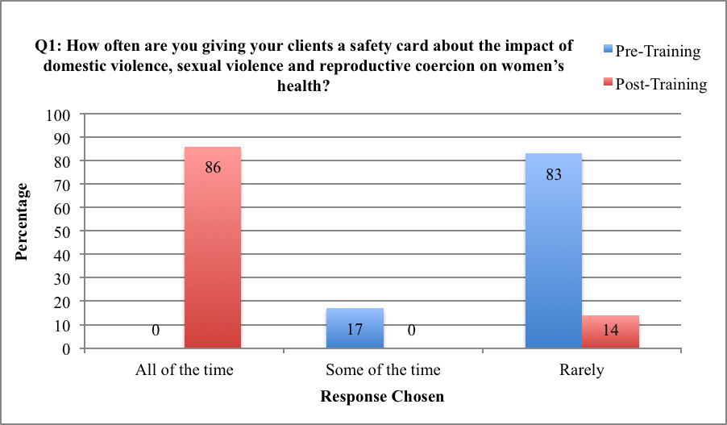
Figure 1. Percent change in advocate reports of health assessment with clients Pre- and Post- training regarding safety card distribution

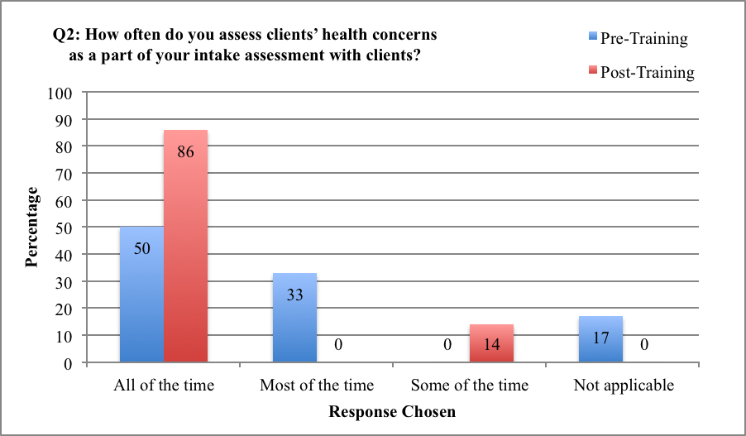
Figure 2. Percent change in advocate reports of health assessment with clients Pre- and Post- training regarding the assessment of health concerns of clients
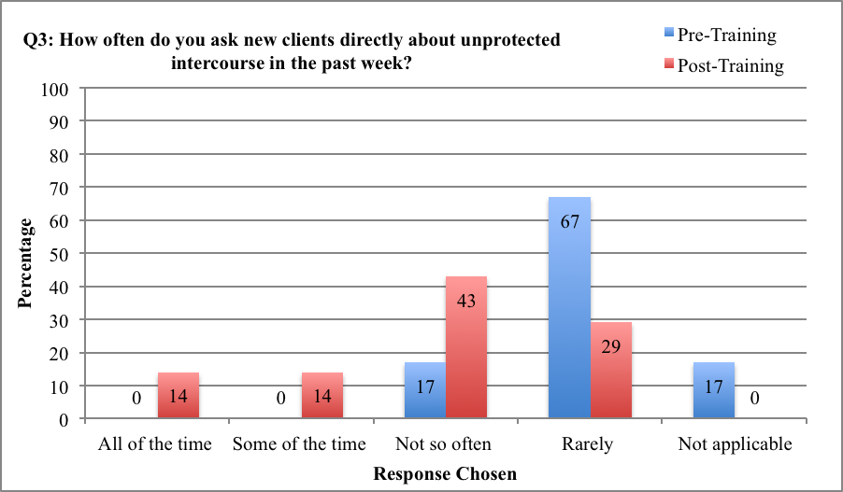
Figure 3. Percent change in advocate reports of health assessment with clients Pre- and Post- training regarding direct asking about unprotected intercourse

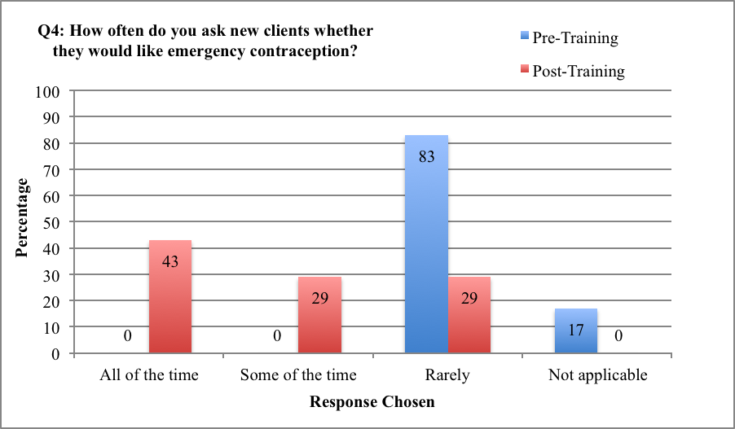
Figure 4. Percent change in advocate reports of health assessment with clients Pre- and Post- training regarding offering emergency contraception to clients
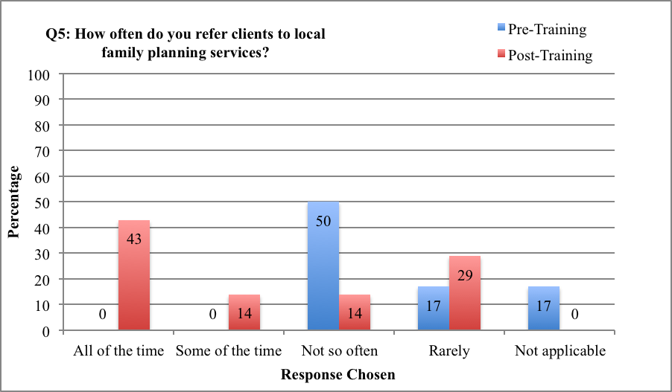
Figure 5. Percent change in advocate reports of health assessment with clients Pre- and Post- training regarding referral of clients to family planning clinics

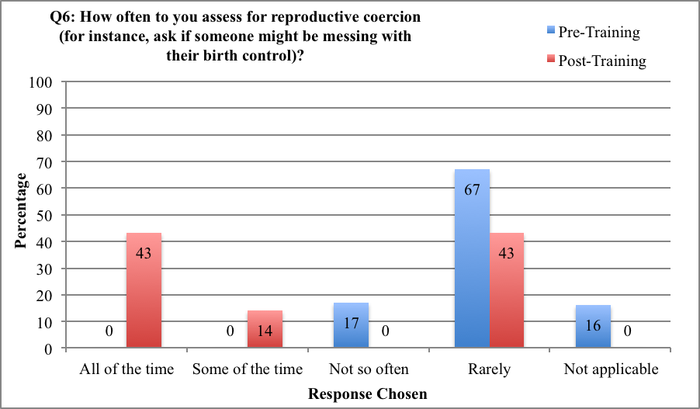
Figure 6. Percent change in advocate reports of health assessment with clients Pre- and Post- training regarding reproductive coercion assessment

discussion
This exploratory pilot project was intended to assess acceptability and feasibility of assessing for reproductive coercion and offering EC in a shelter setting. The overall response at the study shelter was highly positive for both clients and staff. Clients found it helpful to know resources including pregnancy tests and EC were available if to them if needed. No hesitation among staff was identified. All staff members found the training to be useful and the training resulted in changes in the intake process. Changes from the Pre- to Post-Training surveys demonstrate that staff experienced an overall increase in comfort levels in several areas of reproductive health assessment. Staff reported a large increase in distribution of the safety card to clients (Figure 1), the addressing of health concerns with clients (Figure 2), asking clients about unprotected intercourse (Figure 3), asking clients if they needed emergency contraception (Figure 4), referring clients to local family planning services (Figure 5), and assessing for reproductive coercion (Figure 6).
Overall, staff members reported that offering these services was beneficial to shelter clients. Staff reported that of the 17 women screened at intake, it was uncomfortable to screen for RC in two situations. In one situation, the client was clearly in her third trimester of pregnancy, and the other involved a client in a lesbian relationship.
Notably, this domestic violence shelter did not dispense any medications, creating a logistical challenge for the study team. Additionally, no pharmacies were within walking distance to send clients with a gift card to purchase EC. For this pilot, the shelter arranged for a local reproductive health provider to deliver EC to shelter if a client requested the medication. Other options being considered as this project continues in this shelter is to have a locked box containing available EC to clients if needed (clients would be given the code for the lockbox to take as needed). The provision of EC in a timely manner that does not require the woman to leave shelter to obtain EC is an important consideration in this work.
Shelter clients also provided significant insight into how to improve this project. With this small pilot, there were no requests for EC and only one request for a pregnancy test (that was ultimately not needed), but women expressed how helpful it was to know that this service was available. Staff wondered whether clients were hesitant to ask for the EC during intake. It may be prudent to try a lockbox (as described above) where clients are given the code to get the medication if needed confidentially (without staff knowledge). Educational safety cards were handed out to every woman but two. Shelter staff stated that no women were insulted with the offer of EC, while clients stated that it was overall very helpful to know that this service was available to them.
Limitations exist in this study. This qualitative exploratory study was a convenience sample of staff and survivors conducted only at one domestic violence shelter with a small number of responses. This project was intended only to assess acceptability and feasibility of offering EC to shelter clients. The population at this shelter cannot be generalized across all domestic violence shelters in the United States. Additionally, this study has no longitudinal outcomes from shelter clients to assess any impact on their health. We also did not assess the women’s histories of sexual violence and reproductive coercion.
Assessing for the need for pregnancy testing and EC in a DV shelter is acceptable and feasible. Next steps include implementing a similar process across multiple DV/SA agencies to assess common barriers and identify strategies for making pregnancy testing and EC more readily available for women seeking care in shelter. Following up with women via interviews may also be helpful to explore clients’ experiences with accessing reproductive health services once in shelter. Following clients longitudinally in a larger sample across multiple sites will be necessary to assess the impact of EC provision and connection to reproductive health services for women in shelter. Additionally, ongoing staff training needs will need to be monitored with future implementation.

conclusion
In summary, shelter staff members had an increased comfort level in assessing incoming clients for reproductive coercion and offering EC. Overall, clients found it helpful to know that resources including pregnancy tests and EC were available to them. This project is new territory and as many domestic violence shelters do not have any partnerships with medical clinics, family planning clinics, or pharmacies, a logistical challenge in medication delivery exists. Finally, this pilot project was an assessment of only the acceptability and feasibility of offering EC to shelter clients at intake. Next steps include broadening the project to multiple sites and longitudinal assessment of the impact on the health and wellbeing of shelter clients.

SAFETY CARD

surveys administered to shelter staff and clients

          - intake assessment tool to promote health and wellness
Today’s Date: _______
AGE of Client: _______
(To Be Administered Within First 24 hours Upon Shelter Intake)

Many women who come to our program have experienced situations putting them at risk for unwanted or unplanned pregnancies. There is a safe medication that you can take called emergency contraception (some call it the morning after pill) up to five days after unprotected sex to prevent pregnancy.

To better understand who may need or want this medication we ask these questions of all our clients.

Emergency contraception is available if:

- You had unprotected sex with a man (without condoms or any form of birth control) in the past 5 (five) days?
- You had sex in the last 5 days and experienced a condom breaking, being pulled off or fallen off?
- If your nuvaring or contraceptive patch should have been replaced with a new one in the last 5 days and was not?
- You have forgotten to take your birth control birth control pills in the last 5 days?
- You are worried that your partner was trying to get you pregnant when you did not want to be by having sex with you when you weren’t protected with birth control, tampering with your birth control, not pulling out when he said he would?

Would you like to receive EC or the morning after pill to help prevent pregnancy?
- Yes
- No

Sometimes women have had unprotected sex or things happen with birth control or condoms multiple times in one month so they are not sure if they are pregnant or not.

Would you like a pregnancy test today, we have one here for you to take and use if you are interested?

- Yes, I would like to take a test
- NO, not at this time

“Thank you for helping us understand what your needs were today.”

FOR OFFICE STAFF TO FILL OUT:

“In addition to the questionnaire you just filled out, we also give out this card (safety card mentioned below) to all of our clients so they have information for themselves and they know how to help a friend or family member if they are ever worried about a partner trying to get them pregnant when they don’t want to be.” Futures, “Did You Know your Relationship Affects Your Health?” safety card given?

- Yes
- No
*If yes to EC, then contact Dr. Miller’s office at 412-543-8789 for EC delivery.

          - client exit survey
We are trying to improve the care we provide to women. Please take a few minutes to answer the following questions. You can skip questions you don't want to answer. This is totally voluntary and won't affect the care you receive here. Please do not write your name on this. It is totally private, no names attached. THANK YOU!

- Today, did your advocate give you a form to fill out asking you if needed or wanted a pregnancy test?
- No
- Yes
If yes, did you request a pregnancy test on the form?
- No
- Yes
If yes, did they give you a pregnancy test?
- No
- Yes
- Today, did your advocate give you a form asking if you needed emergency contraception or the morning after pill?
- No
- Yes
If yes, did you request emergency contraception on the form?
- No
- Yes
If yes, were you told how the advocate was going to make sure you got this medication within 24 hours?
- No
- Yes

- Today, did your advocate give you a little folded card called 'Do You Know Your Relationship Affects Your Health?' talking about abuse and how it connects to your reproductive health and pregnancy?
- No  - Yes | 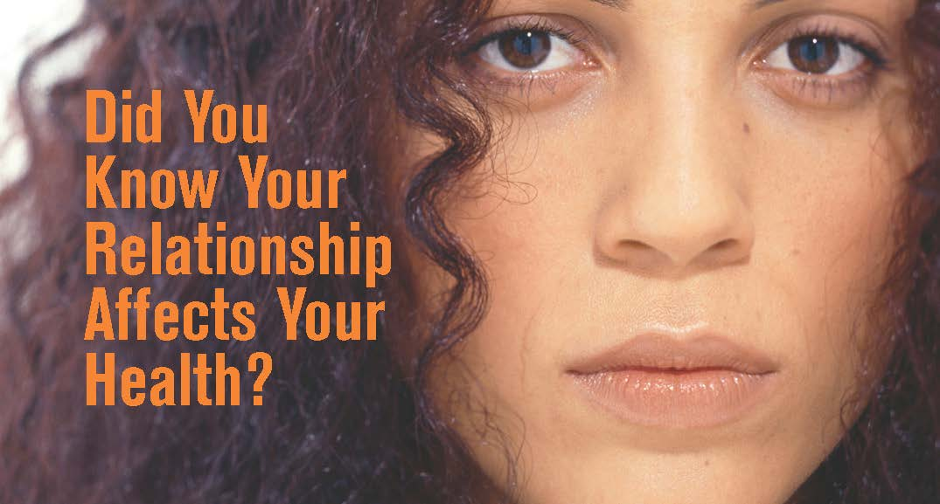

- On a scale of 0 to 4, how helpful or unhelpful was it to learn emergency contraception was available to you if you needed it? Please circle a number below:

0 | 1 | 2 | 3 | 4
not helpful |  |  |  | helpful

- On a scale of 0 to 4, how easy or difficult was it to get the EC pill today?

- Not applicable, I did not get the emergency contraception (EC) pill today

0 | 1 | 2 | 3 | 4
difficult |  |  |  | easy

          - pre-training survey for advocates
Thank you very much for joining us!
As you know, lifetime exposure to violence is associated with multiple poor health outcomes, and is likely to impact the lives of many of the clients you work with and counsel. We are developing strategies for incorporating clinical services into the services provided by Domestic Violence (DV) and Sexual Assault (SA) agencies.
We would like to ask you a few questions about your experiences as a DV/SA advocate talking to your clients about how exposure to DV/SA may have affected their health, and in what areas you would like to have additional training and support.
Please take a few moments to answer the following questions. Your responses will be kept confidential. You may skip any questions that you do not want to answer, and can stop taking the survey at any time.
We would also like to contact you in a few months to find out how useful this training was to you in practice, whether you were able to use any of the components presented, and to have you reflect on additional training, resources, and supports you want to see.
We greatly appreciate your taking the time to answer these questions for us as we aim to improve the integration of DV/SA services with public health programs.

Date: ________________________________________________
State:________________________________________________
Location: _____________________________________________
- Have you ever attended any professional development sessions specific to asking about health and health care in the context of providing domestic and sexual violence (DV/SV) advocacy services?
A) Yes
B) No

- Are you currently providing direct care to survivors of DV/SA? (This includes counseling, advocacy, shelter services, case management.)
- Yes
- No

Please tell us how much you agree with these statements:
- Asking a woman (either shelter or nonresident support programs) about if she was worried about her partner getting her pregnant when she does not want to be should be part of helping her safety plan.
- Strongly Agree
- Agree
- Undecided
- Disagree
- Strongly Disagree

- Pregnancy testing should be something offered in shelter/in domestic violence advocacy programs.
- Strongly Agree
- Agree
- Undecided
- Disagree
- Strongly Disagree

- Emergency contraception causes abortion.
- Strongly Agree
- Agree
- Undecided
- Disagree
- Strongly Disagree

- I am comfortable talking to my clients about pregnancy options (carrying to term, adoption or abortion).
- Strongly Agree
- Agree
- Undecided
- Disagree
- Strongly Disagree

- How often are you giving your clients a safety card about the impact of domestic violence, sexual violence and reproductive coercion on women’s health?
  - All of the time (100%)
  - Most of the time (75% or more)
  - Some of the time (25% - 75%)
  - Not so often (10% - 25%)
  - Rarely (less than 10%)

- How often do you assess clients’ health concerns as a part of your intake assessment with clients?
- All of the time (100%)
- Most of the time (75% or more)
- Some of the time (25% - 75%)
- Not so often (10% - 25%)
- Rarely (less than 10%)

- How often do you ask new clients directly about unprotected intercourse in the past week?
- All of the time (100%)
- Most of the time (75% or more)
- Some of the time (25% - 75%)
- Not so often (10% - 25%)
- Rarely (less than 10%)

- How often do you ask new clients whether they would like emergency contraception?
- All of the time (100%)
- Most of the time (75% or more)
- Some of the time (25% - 75%)
- Not so often (10% - 25%)
- Rarely (less than 10%)

- How often do you refer clients to local family planning services?
- All of the time (100%)
- Most of the time (75% or more)
- Some of the time (25% - 75%)
- Not so often (10% - 25%)
- Rarely (less than 10%)

- How often to you assess for reproductive coercion (for instance, ask if someone might be messing with their birth control)?
- All of the time (100%)
- Most of the time (75% or more)
- Some of the time (25% - 75%)
- Not so often (10% - 25%)
- Rarely (less than 10%)

We want to understand your thinking and how we can help other advocacy programs and you as staff as we move forward in our work. Outside research staff will be reviewing these forms, not DV agency staff, so please give as much description as possible.

- What are reasons that you may not address health concerns when conducting an intake of a survivor of domestic or sexual violence (DV/SV)? (circle all that apply)
- Not enough time
- Worried about upsetting the client
- Not sure how to connect a client to clinical services
- Not sure how to ask questions without seeming too intrusive
- It is against the policy of the shelter/agency where I work
- Other (Please specify) __________________________________________________________________

- In your shelter/agency are there specific protocols about how to ask a client about health related concerns?
- Yes
- No
- Not applicable
- Don’t know

- In your shelter/agency, do you have a way to connect clients to clinical services (other than an emergency room or urgent care)?
- Yes
- No
- Not applicable
- Don’t know

- In your shelter/agency, do you provide emergency contraception to clients who wish to prevent pregnancy?
- Yes
- No
- Not applicable
- Don’t know

- Are educational materials available on the health impact of domestic and sexual violence (DV/SV) and reproductive coercion (RC) in the languages most commonly spoken in your agency?
- Yes
- No
- Not applicable
- Don’t know

- What ongoing support do you need to confidently incorporate discussion of health related concerns when serving your clients? (circle all that apply)
- Workshops and training sessions
- Protocols that include specific questions to ask
- List of clinical services and who to call with questions
- Case consultation
- Online training
- Other (Please specify)____________________________________________________

Additional Comments: ____________________________________________________________________________________________________________________________________________________________________________________________________________________________________________________________________________________________________________

Optional: Please tell us a little about yourself. This information will help us better understand who we are reaching with these trainings. Please remember this information is anonymous and confidential, no names attached.

- What is your training background? (circle all that apply)
- Social worker
- Mental health specialist
- DV/SA victim services advocate
- Promotora or community health worker
- Clinic administrator/Practice manager
- Other _______________________________

- How many years have you been providing DV/SA advocacy services?
- Less than 5 years
- 5-10 years
- Greater than 10 years

- How do you describe your gender?
- Female
- Male
- Transgender
- Other

- How do you describe your ethnic background (circle all that apply)?
- Caucasian/White
- African American/Black
- Native American/Native Hawaiian
- Asian American
- Pacific Islander American
- Hispanic/Latino(a)
- Multi-racial
- Other _______________________________

- What is your age?
- Less than 20 years
- 20-39 years
- 40-59 years
- Greater than 60 years

Thank you for your time!
          - training satisfaction survey for advocates
The training today increased my understanding of:
- how to assess for sexual violence and reproductive coercion among clients.
A. Strongly Disagree B. Disagree C. Undecided D. Agree E. Strongly Agree
- how to discuss contraceptive methods that are not partner dependent (i.e., longer acting contraceptives).
A. Strongly Disagree B. Disagree C. Undecided D. Agree E. Strongly Agree
- how to integrate asking about health related concerns in an intake with a client.
A. Strongly Disagree B. Disagree C. Undecided D. Agree E. Strongly Agree
- how to partner with a local family planning service to facilitate client access to emergency contraception.
A. Strongly Disagree B. Disagree C. Undecided D. Agree E. Strongly Agree

Following the training today, I am more likely to:
- offer clients a safety card about the impact of domestic violence, sexual violence and reproductive coercion on women’s health.
A. Strongly Disagree B. Disagree C. Undecided D. Agree E. Strongly Agree
- assess clients’ health concerns as a part of my intake assessment.
A. Strongly Disagree B. Disagree C. Undecided D. Agree E. Strongly Agree
- ask new clients directly about unprotected intercourse in the past week.
A. Strongly Disagree B. Disagree C. Undecided D. Agree E. Strongly Agree

- ask new clients whether they would like emergency contraception.
A. Strongly Disagree B. Disagree C. Undecided D. Agree E. Strongly Agree

- refer clients to local family planning services.
A. Strongly Disagree B. Disagree C. Undecided D. Agree E. Strongly Agree

- assess for reproductive coercion.
A. Strongly Disagree B. Disagree C. Undecided D. Agree E. Strongly Agree
- Please circle at least one action item that you intend to do differently following the training today:
  - Make educational materials on the health impact of DV/SV/RC available
  - Make safety cards available to all clients
  - Offer an in-service training for all of my staff on DV/SV/RC
  - Set up a protocol for referring clients to a clinic for emergency contraception or pregnancy testing visits
  - Set up new partnership with local family planning/health clinics
  - Other (please be as specific as you can) ______________________________________________________________________________________________________________________________

- What ongoing support do you need to confidently incorporate discussion of health related concerns in all your intake assessments?
________________________________________________________________________________________________________________________________________________________________________________________________________________________

Additional Comments: ________________________________________________________________________________________________________________________________________________
________________________________________________________________________

Thank you for your time!

          - post-training survey for advocates
Please take a few moments to answer the following questions referring back to the training in which you participated several months ago on addressing health related concerns in domestic violence and sexual assault agencies.

Your responses will be kept confidential. You may skip any questions that you do not want to answer, and you can stop taking the survey at any time. We greatly appreciate your taking the time to answer these questions for us as we aim to improve the integration of DV/SA services with public health programs.
Date: _______________________________________________
State:________________________________________________
Location: ____________________________________________

- Are you currently providing direct care to survivors of DV/SA? (This includes counseling, advocacy, shelter services, case management.)
- Yes
- No

Please tell us how much you agree with these statements:
- Since the training, I feel more confident asking a client about general health related concerns.
- Strongly Agree
- Agree
- Undecided
- Disagree
- Strongly Disagree

- Since the training, I feel more confident asking a client about reproductive coercion or birth control sabotage.
- Strongly Agree
- Agree
- Undecided
- Disagree
- Strongly Disagree

- Since the training, I feel more confident educating a client on longer acting contraceptive methods.
- Strongly Agree
- Agree
- Undecided
- Disagree
- Strongly Disagree

- Since the training, I feel more confident connecting a client to local family planning services.
- Strongly Agree
- Agree
- Undecided
- Disagree
- Strongly Disagree

- Since the training, I feel more confident assessing for clients' need for emergency contraception?
- Strongly Agree
- Agree
- Undecided
- Disagree
- Strongly Disagree

- Since the training, I feel more confident talking to my clients about pregnancy options (carrying to term, adoption or abortion).
- Strongly Agree
- Agree
- Undecided
- Disagree
- Strongly Disagree

- How often are you giving your clients a safety card about the impact of domestic violence, sexual violence and reproductive coercion on women’s health?
- All of the time (100%)
- Most of the time (75% or more)
- Some of the time (25% - 75%)
- Not so often (10% - 25%)
- Rarely (less than 10%)

- How often do you assess clients’ health concerns as a part of your intake assessment with clients?
- All of the time (100%)
- Most of the time (75% or more)
- Some of the time (25% - 75%)
- Not so often (10% - 25%)
- Rarely (less than 10%)

- How often do you ask new clients directly about unprotected intercourse in the past week?
- All of the time (100%)
- Most of the time (75% or more)
- Some of the time (25% - 75%)
- Not so often (10% - 25%)
- Rarely (less than 10%)

- How often do you ask new clients whether they would like emergency contraception?
- All of the time (100%)
- Most of the time (75% or more)
- Some of the time (25% - 75%)
- Not so often (10% - 25%)
- Rarely (less than 10%)

- How often do you refer clients to local family planning services?
- All of the time (100%)
- Most of the time (75% or more)
- Some of the time (25% - 75%)
- Not so often (10% - 25%)
- Rarely (less than 10%)

- How often to you assess for reproductive coercion (for instance, ask if someone might be messing with their birth control)?
- All of the time (100%)
- Most of the time (75% or more)
- Some of the time (25% - 75%)
- Not so often (10% - 25%)
- Rarely (less than 10%)

- In your shelter/agency are there specific protocols about how to ask a client about health related concerns?
- Yes
- No
- Not applicable
- Don’t know

- In your shelter/agency, do you have a way to connect clients to clinical services (other than an emergency room or urgent care)?
- Yes
- No
- Not applicable
- Don’t know

- In your shelter/agency, do you provide emergency contraception to clients who wish to prevent pregnancy?
- Yes
- No
- Not applicable
- Don’t know

- Are educational materials available on the health impact of domestic and sexual violence (DV/SV) and reproductive coercion (RC) in the languages most commonly spoken in your agency?
- Yes
- No
- Not applicable
- Don’t know

Additional Comments: ________________________________________________________________________________________________________________________________________________________________________________________________________________________________________________________________________________________________

Thank you for your time!
            - Appendix subsect
bibliography
1. Garcia-Moreno, C, Jansen, HAFM, Ellsberg, M, Heise, L, & Watts, C (2006). WHO Multi- Country Study on Women’s Health and Domestic Violence Against Women. Geneva, Switzerland: World Health Organization (WHO).

2. Black, M, Basile, K, Breiding, M, et al. (2011) The National Intimate Partner and Sexual Violence Survey (NISVS): 2010 Summary Report Atlanta, GA: National Center for Injury Prevention and Control, Centers for Disease Control and Prevention.

3. Hathaway, J. Mucci, L., Silverman, J., Brooks, D., Mathews, R., Pavlos, C. (2000) Health Status and Health Care Use of Massachusetts Women Reporting Partner Abuse. American Journal of Preventative Medicine. 2000: 19(4) pages 302-307.

4. Tjaden, P, Thoennes, N, & Allison, CJ (1999). Comparing violence over the life span in samples of same-sex and opposite-sex chronicity in adult women. Violence & Victims, 14(4), 413-425.

5. Rennison, CM, & Welchans, S (2000). Intimate Partner Violence, Washington, DC: Bureau of Justice Statistics, US Department of Justice.

6. Gee, R., Mitra, N., Wan, F., Chavkin, D., Long, J. (2009) Power over parity: intimate partner violence and issues of fertility control. American Journal of Obstetrics and Gynecology, 2009: 201(148) pages e 1-7.

7. Sharps, P, Kozoil-McLain, K, Campbell, JC, McFarlane, J, & Sachs, C (2001). Health care providers’ missed opportunities for preventing femicide. Preventative Medicine, 33, 373- 380.

8. Coker, A (2007). Does physical intimate partner violence affect sexual health? A systematic review. Trauma, Violence & Abuse, 8(2), 149-177.

9. Kramer, A., Lorenzon, D., Mueller, G. (2004) Prevalence of Intimate Partner Violence and Health Implications for Women Using Emergency Departments and Primary Care Clinics. Women’s Health Issues. 2004: 14 pages 19-29.

10. Champion, JD, Poper, J, Shain, RN, Perdue, ST & Newton, ER (2001) Minority women with sexually transmitted diseases: Sexual abuse and risk for pelvic inflammatory disease. Research in Nursing and Health 24, 38-43.

11. Raj, A, Liu, R, McCleary-Sills, J & Silverman, JG. (2005). South Asian victims of intimate partner violence more likely than non-victims to report sexual health concerns. Journal of Immigrant Health. 7(2), 85-91.

12. Raj, A, Silverman, JG & Amaro, H. (2004). Abused women report greater male partner risk and gender-based risk for HIV: Findings from a community based study with Hispanic women. AIDS Care, 16(4), 519-529.

13. Parish, WL, Wang, T, Laumann, EO, Pan, S, & Lou, Y (2004). Intimate partner violence in China: National prevalence, risk factors and associated health problems. International Family Planning Perspectives, 174(3), 903-907.

14. Decker, MR, Silverman, JG, Raj, A (2005). Dating violence and sexually transmitted disease/HIV testing and diagnosis among adolescent females. Pediatrics, 116(2), e272-
276.

15. Raj, A, Silverman, JG, Amaro, H (2000). The relationship between sexual abuse and sexual risk among high school students: Findings from the 1997 Massachusetts Youth Risk Behavior Survey. Maternal and Child Health, 4(2), 125-134.

16. Gazmaraian, JA, Petersen, R, Spitz, AM, Goodwin, MM, Saltzman, EL, Marks, JS (2000). Violence and reproductive health: current knowledge and future research directions. Maternal and Child Health Journal, 4(2), 79-84.
17. Eisenstat, SA, Bancroft, L, (1999). Domestic Violence. The New England Journal of Medicine, 341(12), 886-892.

18. Shrier, LA, Pierce, JD, Emans, SJ, DuRant, RH. (1998). Gender differences in risk behaviors associated with forced or pressured sex. Archives of Pediatrics and Adolescent Medicine, 152(1), 57-63.

19. Miller, E., Decker, M., McCauley, H., Tancredi, D., Levenson, R., Waldman, J., Schoenwald, P., Silverman, J. (2011) A family planning clinic partner violence intervention to reduce risk association with reproductive coercion. Contraception. 2011: 83(3) pages 274-280.

20. Miller, E., Silverman, J. (2010) [2] Reproductive coercion and partner violence: implications for clinical assessment of unintended pregnancy. Expert Review of Obstetrics and Gynecology. 2010: 5(5) pages 511-515.

21. Silverman, J., Decker, M., McCauley, H., Gupta, J., Miller, E., Raj, A., Goldberg, A. (2010) Male Perpetration of Intimate Partner Violence and Involvement in Abortions and Abortion-Related Conflict. American Journal of Public Health. 2010: 100(8) pages 1415- 1417.

22. Wingood, GM, DiClemente, R. (1997). The effects of an abusive primary partner on the condom use and sexual negotiation practices of African-American Women. American Journal of Public Health, 87(6), 1016-1018.

23. Silverman, JG, Raj, A, Mucci, LA, & Hathaway, JE (2001). Dating violence against adolescent girls and associated substance use, unhealthy weight control, sexual risk behavior, pregnancy, and suicidality. Journal of the American Medical Association. 2863, 572-579.

24. Sales, J, Salazar, L, Wingood, G, DiClemente, R, Rose, E, Crosby, R (2008). The mediating role of partner communication skills of HIV/STD-associated risk behaviors in young African American females with a history of sexual violence. Archives of Pediatrics and Adolescent Medicine, 62(5), 432-438.

25. Miller, E., Decker, M., Reed, E., Raj, A., Hathaway, J., Silverman, J. (2007) Male Partner Pregnancy-Promoting Behaviors and Adolescent Partner Violence: Findings from a Qualitative Study with Adolescent Females. Ambulatory Pediatrics. 2007: 7(5) pages 360-366.

26. Collins, RL, Ellickson, PL, Orlando, M, & Klein, DJ, (2005). Isolating the nexus of substance use, violence and sexual risk for HIV infection among young adults in the United States. AIDS & Behavior, 9, 73-87.

27. Weinreb, L, Goldberg, R, Lessard, D, Perloff, J, & Bassuk, E (1999) HIV-risk practices among homeless and low-income housed mothers. Journal of Family Practice, 48(11), 859-867.

28. El-Bassel, N, Gilbert, L, Krishnan, S, Schilling, R, Gaeta, T, Purpura, S, et al. (1998). Partner violence and sexual HIV-risk behaviors among women in an inner-city emergency department. Violence & Victims, 13(4), 377-393.

29. American College of Obstetricians and Gynecologists. Screening Tools: Domestic Violence. 2013. http://www.acog.org.About%20ACOG/ACOG%20Departments/Violence%
20Against%20Women/Screening%20Tools%20%20Domestic%20Violenc e.aspx. Accessed July 15, 2013.

30. Moore, A., Frohwirth, L., Miller, E. (2010) Male reproductive control of women who have experienced intimate partner violence in the United States. Social Science and Medicine. 2010: 70 pages 1737-1744.

31. Miller, E., Decker, M., McCauley, H., Tancredi, D., Levenson, R., Waldman, J., Schoenwald, P., Silverman, J. (2010) Pregnancy coercion, intimate partner violence and unintended pregnancy. Contraception. 2010: 81 pages 316-322.

32. Silverman, J., McCauley, H., Decker, M., Miller, E., Reed, E., Raj, A. (2011) Coercive Forms of Sexual Risk and Associated Violence Perpetrated by Male Partners of Female Adolescents. Perspectives on Sexual and Reproductive Health. 2011: 43(1) pages 60-65.

33. Taft, AL, Watson, LF, & Lee, C, (2004). Violence against young Australian women and association with reproductive events: A cross-sectional analysis of a national population sample. Australian & New Zealand Journal of Public Health, 28(4), 324- 329.

34. McFarlane, J, Malecha, A, Watson, K, Gist, J, Batten, E, Hall, I, et al. (2005) Intimate partner sexual assault against women: Frequency, health consequences, and treatment outcomes. Obstetrics & Gynecology, 105(1), 99-108.

35. Lang, DL, Salazar, LF, Wingood, GM, DiClemente, RJ, Mikhail, I. (2007). Associations between recent gender-based violence and pregnancy, sexually transmitted infections, condom use practices, and negotiation of sexual practices among HIV-positive women. Journal of Acquired Immune Deficiency Syndromes, 46(2): 216-221.

36. Fisher, W., Singh, S., Shuper, P., Carey, M., Otchet, F., MacLean-Brine, D., Del Bello, D., Gunter, J. (2005) Characteristics of women undergoing repeat induced abortion. Canadian Medical Association Journal. 2005: 172(5) pages 637-641.

37. Janssen, PA, Holt, VL, Sugg, NK, Emanuel, I, Critchlow, CM, & Henderson, AD (2003). Intimate partner violence and adverse pregnancy outcomes: A population-based study. American Journal of Obstetrics & Gynecology, 188(5), 1341-1347.

38. Bourassa, D, Berube, J (2007). The prevalence of intimate partner violence among women and teenagers seeking abortion compared with those continuing pregnancy. Journal of Obstetrics & Gynecology – Canada, 29, 415-423.

39. Grossman, S., Lundy, M. (2011) Characteristics of Women Who Do and Do Not Receive Onsite Shelter Services From Domestic Violence Programs. Violence Against Women. 2011: 17(8) pages 1024-1045.

40. Kamimura, A., Parekh, A., Olson, L. (2013) Health Indicators, Social Support, and Intimate Partner Violence Among Women Utilizing Services at a Community Organization. Women’s Health Issues. 2013: 23(3) pages 179-185.

41. Theil de Bocanegra, H., Rostovtseva, D., Khera, S., Godhwani, N. (2010) Birth Control Sabotage and Forced Sex: Experiences Reported by Women in Domestic Violence Shelters. Violence Against Women. 2010: 16(5) pages 601-612.

42. Abel, S., Crosby Kowal, H., Brimlow, D., Uchin, M., Gerbert, B. (2011) A Collaboration to Enhance Oral Health Care for Survivors of Domestic Violence: Women’s Domestic Violence Shelters and Nova Southeastern University’s College of Dental Medicine. Journal of Dental Education. 2011: 76(10) pages 1334-1341.

Some staff members had multiple training backgrounds.

