EFFECTIVENESS OF CERTIFICATE OF NEED POLICY AT CONTROLLING UTILIZATION AND HEALTHCARE EXPENDITURES IN AN UNHEALTHY AND RURAL POPULATION: A CASE STUDY FOR THE STATE OF KENTUCKY

by
Karalyn M. Smith
BA, Africana Studies, University of Pittsburgh, 2011

Submitted to the Graduate Faculty of
Health Policy and Management
Graduate School of Public Health in partial fulfillment
of the requirements for the degree of
Master of Health Administration

University of Pittsburgh
2014

UNIVERSITY OF PITTSBURGH
GRADUATE SCHOOL OF PUBLIC HEALTH

This essay is submitted
by
Karalyn Smith

on

April 17, 2014
and approved by

Essay Advisor:
Nicholas Castle, MHA, PhD ______________________________________
Professor
Health Policy and Management
Graduate School of Public Health
University of Pittsburgh

Essay Reader:
Otto Salguero, PhD ______________________________________
Adjunct Faculty
Industrial Engineering
Swanson School of Engineering
University of Pittsburgh

Copyright © by Karalyn Smith
2014
ABSTRACT
Nicholas Castle, PhD
EFFECTIVENESS OF CERTIFICATE OF NEED POLICY AT CONTROLLING UTILIZATION AND HEALTHCARE IN AN UNHEALTHY AND RURAL POPULATION: A CASE STUDY FOR THE STATE OF KENTUCKY

Karalyn M. Smith, MHA
University of Pittsburgh, 2014

Controlling healthcare spending and utilization is of significant importance in today’s healthcare industry and has public health relevance as the country moves from a system aimed at treating the sick to a system of population health. This goal is only achieved through effective healthcare policy that aligns the needs of a population with the reality of today’s healthcare system. Without proper federal and state healthcare policy that can effectively control utilization and thus healthcare spending, our nation faces both budgetary and public health risks, especially in existing unhealthy and rural populations. In order to achieve this goal, lawmakers must evaluate existing policies for effectiveness in controlling healthcare utilization. One of these policies is Certificate of Need; a policy that gained momentum in the 1970’s and aims to controls the supply of various healthcare facilities. This essay with examine the effectiveness of Certificate of Need policy in controlling healthcare utilization and spending in an unhealthy and rural population by using the Commonwealth of Kentucky as a case study. I conclude with suggesting alternative methods to Certificate of Need that focus on a health systems approach through utilizing and incentivizing outpatient services.

TABLE OF CONTENTS
Introduction 1
1.1 History of Con 2
1.2 Kentucky: A Case Study 7
1.2.1 The Commonwealth’s Certificate of Need Policy 8
1.2.2 Utilization of Acute Care and Nursing Facility Services 10
1.2.3 Impact of Certificate of Need on Quality of Care 13
1.2.4 Political Implications of Certificate of Need Policy 15
2.0 Alternatives to facility focused policy 18
2.1.1 Expanding outpatient care delivery 18
2.1.2 Home and Community Based Delivery of Long Term Care 19
2.1.3 Expanding Managed Care 22
3.0 Conclusion 24
bibliography 26
List of figures
Figure 1: Overview of State CON Laws 7
Figure 2: Inclusions of Kentucky's CON Policy Relative to Contiguous States 9
Figure 3: Kentucky Service Utilization Relative to HHS Region IV for Selected Facility Type 10
Figure 4: Supply of Acute Care and Nursing Facility Beds for CON vs. Non-CON States 11
Figure 5: Acute Care and Nursing Facility Utilization for CON vs. Non-CON States 12
Figure 6:Comparison of Kentucky's Acute Care Beds in Service per 10,000 Population and Occupancy relative to Contiguous States 13
Figure 7: Relationship between provider scale, patient satisfaction, and occupancy within Kentucky 15
Figure 8: Comparison of Contiguous State MRI and PET Utilization for CON and Non-CON states 16
Figure 9: MFP Re-institutionalizations by Participating States 22
Figure 10: HMO Penetration Rate by State 23

Introduction
As healthcare spending approaches 20% of the United States’ gross domestic product, the need to control healthcare spending is critical and ranks high on the nation’s policy agenda with the implementation of the Patient Protection and Affordable Care Act. However, efforts to control healthcare spending have long existed in the healthcare industry. This paper will examine the history of healthcare policy as it relates to the development of Certificate of Need Policy. Since the development of this policy, the healthcare industry and the healthcare delivery environment has changed significantly, and this paper will examine the implications of such changes on the ability of CON policy to effectively manage utilization and cost. The Commonwealth of Kentucky, a state with an unhealthy, rural population and a stringent CON policy, will be used as a case study to understand the policy’s effectiveness in today’s healthcare system at controlling utilization and cost. A global analysis would be too comprehensive and complex. Instead, analyzing the behavior and impact of CON in Kentucky and comparing it to a similar cohort of states will help to identify critical factors dealing with CON impact.
CON has impact at all stages of care across the continuum of care. For the purpose of this paper, I will take a phased approach and focus on the impact of the policy on the following:
• Acute Care Services
• Skilled Nursing Facilities
• Ambulatory Surgical Centers
• Home Health
• Outpatient Diagnostics
Other CON regulated services in Kentucky include hospice care, rehab facilities, neonatal intensive care units, radiation therapy and transplant and coronary by-pass services.
Based on the review and analysis of the findings from the investigation of the aforementioned regulated services facilities, alternatives to CON policy will be proposed in the form that focuses on controlling healthcare spending and utilization by moving from facility based regulation called for under CON policy to a systems approach focusing on incentivizing outpatient care and improving care management.

History of Con
Federally funded proliferation of hospital facilities began in the late 1940’s with the introduction of the Hospital Survey and Construction Act of 1946, or Hill-Burton Act, which was implemented to provide better access to healthcare for World War II factory employees, the poor, and those residing in rural areas⁷. The act aimed to increase access to healthcare facilities by providing authorized grants to the states for surveying state health needs, developing state plans for construction of public and voluntary nonprofit hospitals and public health centers, and assisting in the constructing and equipping of such facilities¹⁸. These provisions led to an increase in the number of hospital beds for 3.8 beds per thousand individuals to 4.5 beds per thousand individuals⁷. Additionally, any hospital that received Hill Burton funding had to provide a “reasonable volume” of uncompensated care and make medical services available to all persons residing in the facilities service area²⁰. According to study by Chung, et al, the Hill-Burton Act resulted in in a 15% growth in total hospital beds from 1948 to 1975⁷. This large growth in volume also led to an exponential increase in healthcare expenditures with a one day hospital stay rising from $16.00 in 1950 to $45.00 in 1965 to $128.00 in 1974, which represents a growth that exceeded that of inflation by six percent ^{9,14}. Moreover, the large distribution of funds to the states for surveying purposes and the mandatory provision of providing care resulted in a decrease in voluntary, private funding for the development of healthcare facilities, and thus, a growing role of state health planning agencies. This also had a negative effect on health planning, as hospitals regulated by these agencies could now collectively “determine the size of a community's hospital bed supply” and “allocate areas of responsibility both geographically and by activity” and thereby engage in output restriction and market division through hospital associations⁷. As a result, hospital support for health planning agencies grew and the both the federal and state governments recognized the need for “teeth” in their health planning efforts in order to combat hospital control and political influence on the market The planning agencies objective was to eliminate the cost increases that resulted from unnecessary duplication of healthcare resources due to growing facility supply, and most importantly, planning agencies wanted to ensure access and meet the needs of its residents.
At a state level, New York pioneered this effort. In 1964, New York passed the Metcalf-McCloskey Act of 1964, which required “mandatory need determinations” be made “prior to hospital and nursing home construction”, thus giving “teeth” to its health planning policy and laying the ground for Certificate of Need policies⁹. Soon after in 1968-1969, Maryland, Rhode Island, California, and Connecticut adopted similar policies. Hospitals remained in favor of these regulations, which was demonstrated by the American Hospital Association’s (AHA) continuous support of the regulatory model. At the time, tighter control was needed on healthcare facility supply following the growth experienced under the Hill Burton Act.
At a federal level, congress sought to strengthen control over state health planning agencies as well. In 1972, amendments made to Social Security under section 1122, excluded Medicare, Medicaid, and Child and Maternal Health reimbursement of capital costs, depreciation, or interest from healthcare organizations that failed to receive approval of capital expenditures in excess of $100,000 without approval from its state health planning agency. The federal government expanded on this effort in 1974, with the passing of the National Health Planning and Resources Development Act (NHPRD) which stated “neither the public or private sector has been successful in dealing with the lack of uniformly effective methods of delivering health care, maldistribution of health care facilities and man power, and the increasing cost of health care”¹⁸. The act built on and strengthened the Hill-Burton Act, of which ended on June 30, 1974, and the Regional Medical and Comprehensive Planning programs, which were created out of amendments made to the Public Health Services Act in 1965 and 1966. The previous Regional Medical program’s goal was to “establish regional cooperative agreements among health care facilities, medical schools, and research institutions” in order to “make available advances in the diagnosis and treatment of heart disease, cancer, stroke and kidney disease to patients” and better facilitate the “dissemination of knowledge to health care providers”²⁰. Whereas, the Comprehensive Health Planning program aimed to provide “grants to state for the support of statewide comprehensive health planning programs, project grants to public and nonprofit private agencies for areawide health planning, and project grants to public and other organizations to cover all of party of the costs of training, studies, and demonstration projects to improve health planning”²⁰. Congress noted “the massive infusion of Federal funds into the existing health care system has contributed to the inflationary increases in the cost of health care and failed to produce an adequate supply or distribution of health resources, and consequently, has not made possible equal access of everyone to such resources”¹⁸.
Focusing on the aims of the three previous initiatives and unifying them under the National Health Planning and Resources Development Act, the new law was to achieve its goals with four main changes, all of which were focused around changing the structure by which healthcare planning was implemented and achieved. These changes were: (1) Established the National Council on Health Planning and Development to advise the secretary of Health, Education, and Welfare; (2) Created and provided funds for the development of 205 health service areas to be overseen by Health Systems agencies; (3) Provided funding for the development of State health Planning and Development Agencies that would develop state health plans and administer Certificate of Need programs; (4) Required that states implement and administer Certificate of Need statues in order to receive federal funds for health planning¹⁷. Following the passing of the National Health Planning and Resource Development Act, state implementation of CON statute increased from twenty states in 1975 to all states by 1980⁶. Despite state adoption of CON measures to restrict facility supply, the healthcare system was changing in a way independent of supply, as physicians and hospitals continued to be reimbursed based on costs incurred. Thus, inefficiencies and duplication in the delivery of services was occurring systematically as a result of reimbursement policy and methods, a problem that CON legislation did not address and was not addressed federally until 1983 with the establishing of Diagnostic Related Groups (DRGs).
At the root of Certificate of Need policy is Roemer’s Law, which states, “a bed built, is a bed filled”. Hence, limited the supply of healthcare facilities through CON legislation should result in a decrease in facility utilization and healthcare expenditures. However, the efficacy of Certificate of Need policy on whether or not it is successful in controlling healthcare spending and promotes access and quality has been heavily debated since the 1970’s. In 1976, David Salkever and Thomas Bice stated that “CON laws do not dampen total hospital investment”⁵. A point that which has been argued by many, and following the repeal of the NHPRD’s mandated compliance with Section 1122 of the Social Security Act and establishment of CON policies, was the reason behind fourteen states eliminating their policies to seek other cost control methods. It is important to note that inefficiencies in healthcare delivery continued due to lack of incentives to promote efficient care, thus, “need” as determined by state health planning agencies through its CON policy could have been skewed due to existing facilities not operating at full capacity.
Currently thirty-six states maintain some form of a CON program, however, the debate on the effectiveness of CON legislation continues as states seek to control healthcare spending in the face of health care reform. The following section will provide a case study of the Commonwealth of Kentucky for the effectiveness of Certificate of Need policy in today’s healthcare environment for controlling the utilization of services of an unhealthy and disadvantaged population.
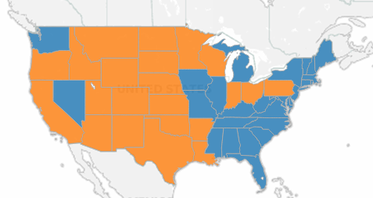
Figure 1: Overview of State CON Laws⁸

Kentucky: A Case Study
As of 2013, the Commonwealth of Kentucky is 45th in the United States in terms of overall health . Included in this composite ranking is a ranking for 40th for obesity, 41st in diabetes, 50th in cancer deaths, and 49th in cardiac heart disease². Given the poor health status of the state, an estimated number 640,000 people uninsured, and 831,292 currently enrolled in Medicaid, improving the health of the state while controlling healthcare spending is on the top of its political agenda^{4,11}. In 2012, governor Steve Beshear took the first step towards this goal by stating that Kentucky would expand Medicaid to 276,000 people in the state calling it “the single-most important decision in our lifetime for improving the health of Kentuckians” With Medicaid expansion and an estimate of 55%, or 320,000 people, of its uninsured population entering the healthcare system by 2016, Kentucky had to be certain that is had both a sufficient level of healthcare facilities and healthcare professionals⁴. The investigation into facility adequacy requires a critical investigation of the Commonwealth’s Certificate of Need Policy as it relates to accommodating the influx of individuals into the healthcare system.
Kentucky imposed its first Certificate of Need requirements in 1972 with the purpose of “prevent[ing] the proliferation of health care facilities, health services and major medical equipment that increase that cost quality healthcare in the commonwealth”¹¹. At this time, the payment to healthcare providing organizations was based on their acceptable Medicare costs plus a percentage, which incentivized providers to have higher costs for higher reimbursement. Under this environment, it made sense to place controls on the expansion and creation of services. Currently, the Commonwealth’s CON policy regulates eighteen different facility types and services on criteria of determined need, capital expenditure thresholds, addition and subtraction of bed count, and repurposing facility to serve purpose other than what was originally applied for¹¹. Given Kentucky’s wide inclusion of services, acute care hospitals and nursing facility beds will be focused on for the purpose of analyzing the Commonwealth’s CON policy. Together, acute care and nursing facilities made up 82% of the Commonwealth’s Medicaid budget in 2011, hence, expansion of Medicaid has a large impact on the utilization of and cost of these services.

The Commonwealth’s Certificate of Need Policy
Examination of Kentucky’s CON policy relative to its contiguous states, reveals that Kentucky’s policy is more inclusive and stringent that its cohorts (Figure 2). However, inclusivity of the state’s policy does not provide indication of effectiveness.

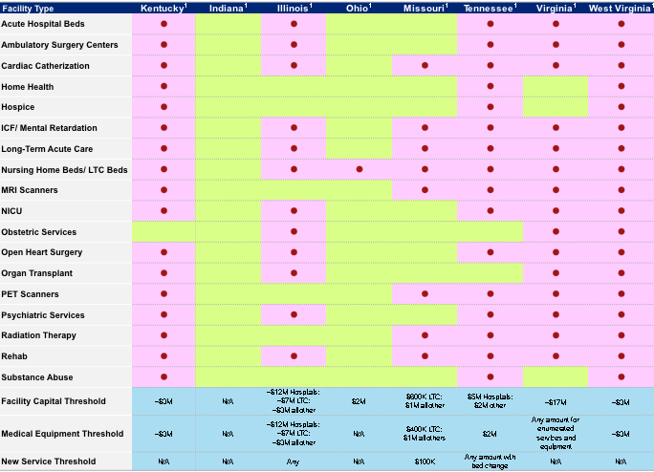

Figure 2: Inclusions of Kentucky's CON Policy Relative to Contiguous States⁸

Based on a study done by Deloitte Consulting LLC in 2013 aimed at examining Kentucky’s healthcare facility capacity, the Commonwealth’s utilization of healthcare services was compared to that of states in Health and Human Services (HHS) region IV, which were regions assigned based on assumed similarities in regards to patient population served, presence of chronic illness, rural versus urban populations, and overall access to care⁸. States included with Kentucky in this region are Alabama, Florida, Georgia, Mississippi, North Carolina, South Carolina, and Tennessee, of which five out of eight are ranked in the bottom of all states for health status. The results of this study for acute care facilities, nursing facilities, home health services, and ambulatory surgery centers can be observed in Figure 3. Relative to its comparative cohort, Kentucky has more nursing facility residents and home health patients served with 54 per 10,000 population compared to 42 per 10,000 for nursing facility residents and 1276 per 10,000 population compared to 1005 per 10,000 population for home health services⁸. However, most importantly, despite being above national average for acute care admissions, Kentucky has a low utilization of ambulatory surgery centers, a point that will be farther examined later in this analysis. Based on utilization alone, Kentucky’s strict CON policy does not seem to be controlling utilization relative to national and HHS Region IV averages, and where it does; control is skewed toward outpatient services.
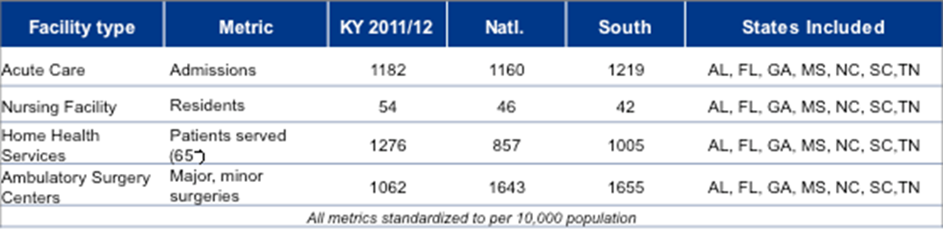
Figure 3: Kentucky Service Utilization Relative to HHS Region IV for Selected Facility Types⁸

Utilization of Acute Care and Nursing Facility Services
Referring back to Roemer’s law, utilization is related to the supply of beds. Using data from Kaiser Family Foundation and an analysis done by Deloitte Consulting, the supply of acute care beds and nursing facility beds, both of which were higher in KY relative to national and HHS Region IV, were compared between CON and Non-CON states. The results show that the median number of acute care beds per population is 20% higher in non-CON and states than CON states. There is also a slight increase in the median number nursing facility beds per 10,000 in non-CON compared to CON states⁸. Both of these comparisons reveal that the presence of CON legislation has been successful in limiting the supply of acute care and nursing facility beds, even if slightly (Figure 4).
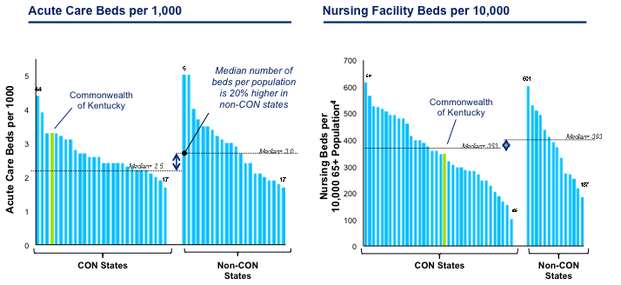

Figure 4: Supply of Acute Care and Nursing Facility Beds for CON vs. Non-CON States⁸

Moreover, additional data obtained from Kaiser Family Foundation also reveals that CON legislation has limited control on actual utilization for acute care and nursing facilities, with CON states having a median inpatient days per 1,000 of 631 compared to 638 days for non- CON states. Similarly, a small level of control is seen in nursing facilities with 304 residents aged sixty-five and older per 10,000 for CON states compared to 308 residents aged sixty-five and older per 10,000 for non-CON states (Figure 5) ⁸.

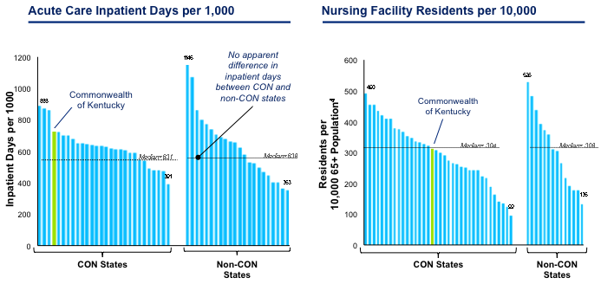

Figure 5: Acute Care and Nursing Facility Utilization for CON vs. Non-CON States⁸

Examining Kentucky’s supply and utilization based on the aforementioned metrics, Kentucky utilization is in the top quartile for all CON states in the supply and utilization of acute care facilities and at the median for the supply and utilization of nursing facilities, which suggests that despite slight gains observed across all CON states, Kentucky’s CON policy is not as effective. The lack of control of Kentucky’s own policy for the two healthcare service areas that are most costly requires that the state critically examines its methods for controlling facility supply and utilization.
Moreover, Kentucky’s inpatient hospital bed supply reveals that it has the highest beds per 10,000 population relative to its contiguous states, however, an occupancy rate of only 53%, further suggesting the presence of excess supply despite a stringent CON policy (Figure 7) ⁸. Given these findings and the fact that Kentucky’s CON policy is more robust and inclusive than its contiguous states, it is an ideal state to question the effectiveness of CON policy and explore methods for improved utilization management.

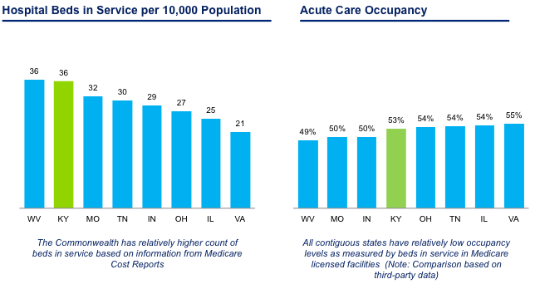

Figure 6: Comparison of Kentucky's Acute Care Beds in Service per 10,000 Population and Occupancy relative to Contiguous States⁸

Impact of Certificate of Need on Quality of Care
In addition to limited effectiveness on the control of supply and utilization, opponents of CON policy often state that the policy is ineffective at facilitating improved quality care, a historical goal of the policy. The definition of quality healthcare has evolved since the implementation of the first CON policies, with an original definition pertaining to the improvement and control of population health. Examining the effectiveness of Kentucky’s CON policy through the lens of population health control as a measure for quality provides an adequate proxy for whether or not Kentucky’s current CON policy is effective. Using data obtained from Kaiser Family Foundation State Health Facts, deaths per 100,000 from diabetes and infant deaths per 1,000 live births were examined for the purpose of this essay to determine Kentucky’s ability to control population health, and thus quality, under these health metrics . Compared to the other states in HHS IV, the Commonwealth had the second highest death from diabetes per 100,000 with 26.0 and an infant mortality rate of 6.8, which is lowest out of HHS IV, but still exceeds the national benchmark of 6.6 ^{12,19}.
These findings coupled with a poor national health ranking, although used as a proxy, suggest that quality of service delivery based on population health could be improved significantly relative to HHS IV and national benchmarks for diabetes deaths and infant mortality. Improved quality corresponds to higher occupancy rates. It has been shown that improved hospital operations, which are seen in larger hospitals that are able to operate more efficiently, are associated with higher occupancy rates and patient satisfaction. Thus, examining the necessity of small hospitals and the possibility of repurposing can be helpful at reducing unnecessary expenditures and supply, an area of failure of the current CON policy. In addition, by only controlling the development of new services, CON does not address re-engineering and re-sizing of current services to create higher levels of efficiency nor does it create incentives for providers to become efficient and deliver higher quality services.

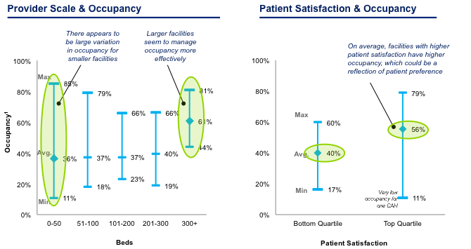

Figure 7: Relationship between provider scale, patient satisfaction, and occupancy within Kentucky⁸

Political Implications of Certificate of Need Policy
Political influence on the market is also a known drawback of CON policies. This influence can be dated back prior to the passing of NHPRD, as it relates to hospital associations attempting to sway policy in their favor. The unstated political influences further hinder competition in a market relative to the presence of a CON alone. These influences fail to consider that competitive providers coming into the market may provide more value to customer and therefore result in demand for their services. As a result, current providers will have to increase value to match the services provided by new competitors. The end result will be a continuous pursuit for improvement in efficiency, effectiveness and quality.
The impact of politics and the anti-competitive nature that can exist under a CON policy can be observed by looking at Kentucky’s control on the supply of diagnostic imaging centers. Currently, Kentucky requires CON approval for capital expenditures exceeding $3million, of which the majority of PET, MRI, and MRE equipment falls¹¹. However, physician owned diagnostic imaging equipment is not subjected to CON review and additional purchase of MRI equipment is only limited by capital expenditure rather than a formal determination of need¹¹. Thus, physician owned diagnostic imaging centers are provided a competitive advantage. Also, more importantly in the case of MRI, existing MRI providers can proliferate freely without determining need, thus, inhibiting the entry of new providers that may offer enhanced, higher quality services. Utilization of MRI and PET services reveals that, compared to its contiguous states in regards to CON presence and utilization, CON states have 50% higher utilization of PET services, with Kentucky having the highest . On the other hand, CON seems to have little to no control on MRI utilization compared across CON and non-CON states⁸. The PET results suggest that overprescribing as a result of competitive advantage could be impacting utilization of these services. Additionally, the comparable averages of MRI utilization across contiguous states in regards to CON presence indicate that MRI utilization could be properly managed under normal market forces and does not need CON intervention.
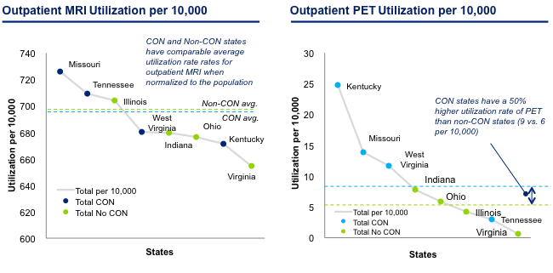

Figure 8: Comparison of Contiguous State MRI and PET Utilization for CON and Non-CON states⁸

Examining the case of Kentucky’s stringent certificate need policy as a means to control healthcare supply and utilization within an unhealthy and disadvantage population, indicates that the policy may not be effective at controlling current supply and utilization and facilitating quality, especially in smaller hospitals. This is a particular point of concern as the state is soon to absorb hundreds of thousands of patients into the health care system. The following section will examine alternative means for better managing population health, controlling the utilization of costly services, and decreasing healthcare expenditures by moving from facility focused regulation to an overall health system approach. Methods that will be explored are expanding outpatient care delivery, utilizing Medicaid waiver programs for additional funding to manage Medicaid populations in outpatient settings, and improving the presence of managed care organizations.

Alternatives to facility focused policy
The following section will examine alternative means for better managing population health, controlling the utilization of costly services, and decreasing healthcare expenditures by moving from facility focused regulation to an overall health system approach. Methods that will be explored are expanding outpatient care delivery through the use of ambulatory care, utilizing Medicaid waiver programs for additional funding to manage Medicaid long term care patients in a community based setting, and improving the presence of managed care organizations.

Expanding outpatient care delivery
Healthcare leaders and policymakers agree on one thing: outpatient care is the future of healthcare delivery. This point can be observed by examining the cost associated with treating diabetes. According to a study done by the American Diabetes Association, the economic cost of treating diabetes has grown 41% from $174 billion in 2007 to $245 billion in 2012¹. Contained in the $245 billion dollar cost is $176 billion of direct medical costs, of which 43% is related to direct inpatient hospital care, compared to 9% associated with physician office visits and 12% for antidiabetic agents and diabetes supplies¹. The cost of inpatient in the treatment represents double the cost of primary interventions performed in an outpatient setting including medicinal costs, of which part can be attributed to medicines administered in an inpatient setting. The case of diabetes highlights the fact that improved population management through outpatient services can have a significant impact on hospital costs and utilization at a state and federal level.
Applying this logic to Kentucky, of which is ranked 41st in the United States for diabetes prevalence, outpatient care should be supported and encouraged. However, this is not the case under its existing CON policy, which limits the supply of Ambulatory Care Centers. As on 2012, Kentucky’s ambulatory care centers located in underserved region have an occupancy upwards of 175%, which is almost 100% higher than the average of Louisville and Lexington, the state’s largest urban areas⁸. This indicates a large demand by Kentucky’s rural population, of which the prevalence of chronic disease is highest. Thus, significant cost savings could be achieved by removing these facilities from CON control. Despite pent up demand, competitive barrier prevent the proliferation of ASC’s under the Commonwealth’s existing policy. Since 2003, forty-three applications have been submitted; however, none were approved based on the need requirements outlined in the state’s CON policy, suggesting criteria that require revision. Removal of CON limitations on ambulatory care facilities would better position the Commonwealth for the future of healthcare while lowering healthcare expenditures and improving population health of its rural areas⁸.

Home and Community Based Delivery of Long Term Care
Similar to the transition of patients from an acute care setting to an outpatient setting, transitioning nursing facility residents to home and community based care amidst the Commonwealth’s CON policy also poses a challenge that could be addressed through alternative means. As of 2013, the Commonwealth’s nursing facilities had occupancy levels ranging from 89-92%; however, the expansion of Medicaid necessitates tighter control and oversight of Medicaid spending, of which 42% is attributed to inpatient nursing facility utilization⁸. The high utilization rate indicates CON policy that is effective at controlling supply and facilitating high utilization of existing services; however, as the population ages and the Medicaid budget tightens, other methods must be explored to manage its 65 and older population. Two ways of doing this is through moratoriums on long term care facilities and taking advantage of federally funded transition grants, of which the latter will be focused on.
A moratorium on long term care facilities requires for the development of other loci of care for the Commonwealth’s aging population, particularly in a home health setting. Medicaid’s Money Follows the Person (MFP) program is aimed at transitioning nursing facility residents into a home health setting. The goals of the MFP program are to 1) Increase the use of home and community-based services and reduce the use of institutionally-based services; 2) Eliminate barriers in State law, State Medicaid plans, and State budgets that restrict the use of Medicaid funds to let people get long-term care in the settings of their choice; 3) Strengthen the ability of Medicaid programs to provide HCBS to people who choose to transition out of institutions; 4)Put procedures in place to provide quality assurance and improvement of HCBS¹⁵. The MFP program was piloted in 2007 and, under the Affordable Care Act, has been extended to September 2016 with funding of $2.25 billion from the federal government. Eligible participants are individuals who have been in institutional care longer than 90 days (prior to ACA requirement was 180 days)¹⁵. Participating states must allocate funds to help transition eligible individuals; these funds are then matched by the MFP program with the goal of enhancing these services.
Kentucky enrolled in the MFP program in 2008. Since then, its transition program, Kentucky Transitions, has been relatively successful at balancing the nursing facility residents in relation to home health based on the proportion of patients in each facility; however, early data from the MFP program suggests limitations to the Commonwealth’s ability to provide adequate home health services. Results from 2011 data from the MFP program revel that 48% of Kentucky’s transitioned patients were “re-institutionalized” or “any admission to hospital, nursing home, intermediate care facility for the intellectually and developmentally disabled (ICF-IDD), or institution for mental disease, regardless of length of stay”, suggesting a need for investment into home and community based services¹⁵. Moreover, it is suggested that individuals residing in areas where home health services are readily available utilize these services more often, thus investment into home health services would likely be met with adequate demand. Kentucky’s current investment into HCBS waivers is the lowest out of states contained in HHS Region IV, thus, savings achieved from a moratorium on long term care facility could be reinvested into home health waiver programs in order to treat nursing facility patients in an outpatient setting.

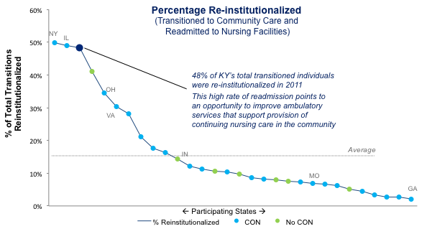
Figure 9: MFP Re-institutionalizations by Participating States¹⁵

Expanding Managed Care
Along with decreasing expenditures, improving population health through improved management of care is a goal of all states, especially states with populations at risk for developing chronic illnesses. Managed care organizations are proven to decrease healthcare expenditures while improving the delivery of care, especially in a primary care setting. Using data from Kaiser Family Foundation, HMO penetration was examined. Results from the inquiry showed that the Commonwealth has the lowest HMO penetration of its contiguous states and ranks 36th overall in regards to HMO penetration nationally⁸. Many would argue HMO penetration does not necessarily mean less management; however, existing presence of managed care organizations has been helpful in today’s healthcare as organizations implement Accountable Care Organizations (ACO’s). A study examining ACO’s presence across states reveals that the Commonwealth’s low HMO rate corresponds to its low ACO adoption with only 1-3% of all ACO patients being serviced in Kentucky¹⁶. Thus, rather than investing time into the administration of CON law to control utilization and cost, the Commonwealth could bolster its managed care arm of healthcare delivery, a point that is supported by Kentucky’s adoption of a Medicaid Managed Care model in 2012.

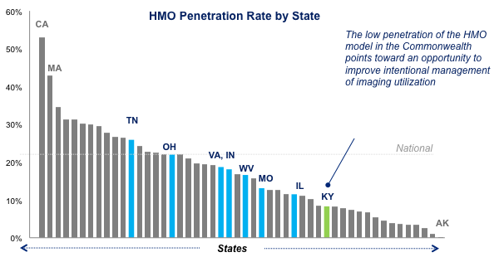
Figure 10: HMO Penetration Rate by State⁸

Under all of the alternatives proposed in this section, it is important for regulatory controls to be in place to prevent providers from selecting services that are profitable and leaving current care providers with high cost services in order to foster healthy competition in the wake of CON. An example of this would be regulatory controls that require all ASCs to offer a full range of services as needed by the population, rather than focusing on services that only yield a profit.

Conclusion
The aforementioned sections examined the history of certificate of need policy and the effectiveness of controlling cost and utilization through a critical examination of Kentucky’s healthcare utilization as it seeks to manage an at risk population. Although CON policy was effective and praised at the time of its creation to combat the growth of healthcare facilities under the Hill-Burton Act, the current healthcare landscape requires new methods in order to improve population health, control healthcare spending, and advance the quality of healthcare. Three alternatives for improving these methods were explored through the context of the Commonwealth: increase availability of ambulatory care sites, invest in transition programs, and increase the presence of managed care in the state. Although these are not the only alternative methods, they are methods that are aligned with today’s healthcare demands and impact areas that utilize the majority of the state’s Medicaid budget. Removing the CON policy and adopting other methods designed to manage population health, reduce health expenditures, and improve the quality requires effective leadership and cooperation across political ties. As Massachusetts, the state with the lowest healthcare costs, highest percentage of uninsured, and largest presence of managed care organizations passes healthcare care legislation, Governor Deval Patrick Stated that “We become the first to crack the code on cost. And we have come this far together"¹³. Thus, for other states, including Kentucky, hoping to improve the population of its state while remaining fiscally responsible, state leaders must be determined in their vision and government representatives must be able to work together across political lines to facilitate change, may come in the form of revisiting older policies and adopting new ones to meet the demand of today’s healthcare needs.

bibliography
- American Diabetes Association. (2013). Economic costs of diabetes in the u.s. in 2012. Diabetes Care, Retrieved from http://care.diabetesjournals.org/content/36/4/1033.long

- America's health rankings. (2013). Retrieved from http://www.americashealthrankings.org/KY

- Bechtel, S. Kentucky Cabinet for Health and Family Services, Department of Medicaid Services. (2013).Ms-264 report supplement characteristics of medicaid beneficiaries. Retrieved from website: http://chfs.ky.gov/NR/rdonlyres/91C42601-CBEB-458F-9D1F-5F20AEACCED5/0/Jan2013.pdf

- Beshear, S. Kentucky Cabinet for Health and Family Services, (2013). Analysis of the affordable care act (aca) medicaid expansion in kentucky. Retrieved from website: http://governor.ky.gov/healthierky/Documents/MedicaidExpansionWhitePaper.pdf

- Bosse, G. (2012). Do certificate of need laws reduce costs or hurt patients? Josiah Bartlett Center for Public Policy, Retrieved from http://www.jbartlett.org/wp-content/uploads/2012/02/Irrational-Certificate-of-Need-Laws.pdf

- Cauchi, R. (2013, Nov). Certificate of need: State health laws and programs. Retrieved from http://www.ncsl.org/research/health/con-certificate-of-need-state-laws.aspx

- Chung, A., Gaynor, M., & Richards-Shubik, S. (2013). Subsidies and structure: The lasting impact of the hill-burton program on the hospital industry. (Unpublished doctoral dissertation, Carnegie Mellon University). Retrieved from http://ldi.upenn.edu/uploads/media_items/subsidies-and-structure-the-lasting-impact-of-the-hill-burton-program-on-the-hospital-industry.original.pdf

- Deloitte Consulting LLC. Kentucky Cabinet for Health and Family Services, (n.d.). Healthcare facility capacity study. Retrieved from website: http://healthbenefitexchange.ky.gov/Documents/KY_Health_Care_Facility_Capacity_Report_2013_[2].pdf

- Havighurst, C. (1973). Regulation of health facilities and services by "certificate of need". Virginia Law Review, 59(7), 1143-1232. Retrieved from http://scholarship.law.duke.edu/cgi/viewcontent.cgi?article=1358&context=faculty_scholarship

- The Kaiser Family Foundation State Health Facts. [http://kff.org/other/state-indicator/inpatient-days]

- Kentucky Cabinet for Health and Family Services, (2013).2013-2015 state health plan. Retrieved from website: http://chfs.ky.gov/NR/rdonlyres/1F860C07-4DEB-4DFC-82CA-A9563E0EF9A1/0/2013KentuckyStateHealthPlan.pdf

- Matthews, TJ, M.S., et. al. Infant Mortality Statistics from the 2009 Period Linked Birth/Infant Death Data Set. Division of Vital Statistics. National Vital Statistics Report, Vol 61, No. 8, January 24, 2013. –Infant mortality rate

- Massachusetts State Government, Office of the Govenor. (2012). Governor patrick signs 'next big step forward' on health care reform, massachusetts poised to lead nation on cost control. Retrieved from website: http://www.mass.gov/governor/pressoffice/pressreleases/2012/2012806-governor-patrick-signs-health-care-reform.html

- McGinley, P. (1995). Beyond health care reform: Reconsidering certificate of need laws in a managed competition system. Florida State University Law Review, Retrieved from http://www.law.fsu.edu/journals/lawreview/issues/231/mcginley.html

- Money Follows the Person Rebalancing Demonstration: Overview of State Grantee Progress, 2012 Annual Report, Retrieved from http://www.mathematicampr.com/publications /pdfs/health/MFP_2012_Annual.pdf

- Muhlestein, D., Peterson, M., & Gardner, P. (2013, November). Geographic distribution of aco covered lives. Retrieved from http://leavittpartners.com/wp-content/uploads/2013/11/ Geographic-Distribution-of-ACO-Covered-Lives-December-2013.pdf

- Roos, R. (1987). Certificate of need for health care facilities: A time for re-examination. Pace Law Review, 7(2), 491-530. Retrieved from http://digitalcommons.pace.edu/cgi/viewcontent.cgi?article=1516&context=plr

- Staats, E. Government Accountability Office, (1978). Status of the implementation of the national health planning and resources development act of 1974(07709-C3108200). Retrieved from website: http://www.gao.gov/assets/130/124716.pdf

- The Centers for Disease Control and Prevention (CDC), National Center for Health Statistics, Division of Vital Statistics, National Vital Statistics Report Volume 61, Number 4, Table 19, May 8, 2013.-Diabetes Death Rate

- U.S General Accounting Office, (1982). Statement of robert a. peterson senior associate director human resources division before the subcommittee on health and the environment house committee on energy and commerce on i 'administration of the hill-burton program. Retrieved from website: http://archive.gao.gov/d41t14/118262.pdf

