The Public Health Implications of the Use of Radioprotectors and Radiomitigators in Cumulative Ionizing Radiation Exposure

by
Dina Dunn
B.S. in Biology, Georgia Institute of Technology, 2010

Submitted to the Graduate Faculty of
Environmental and Occupational Health
Graduate School of Public Health in partial fulfillment
of the requirements for the degree of
Master of Public Health

University of Pittsburgh
2014

UNIVERSITY OF PITTSBURGH
GRADUATE SCHOOL OF PUBLIC HEALTH

This essay is submitted
by
Dina Dunn

on

April 16, 2014
and approved by

Essay Advisor:
James Fabisiak, Ph.D. ______________________________________
Associate Professor
Environmental and Occupational Health
Graduate School of Public Health
University of Pittsburgh

Essay Reader:
Candace Kammerer, Ph.D. ______________________________________
Associate Professor
Human Genetics
Graduate School of Public Health
University of Pittsburgh

Copyright © by Dina Dunn
2014
James Fabisiak, Ph.D

The Public Health Implications of the Use of Radioprotectors and Radiomitigators in Cumulative Ionizing Radiation Exposure

Dina Dunn, MPH

University of Pittsburgh, 2014

ABSTRACT

Cumulative exposure to natural and artificial ionizing radiation is a prevalent environmental health risk and is increasing. Ionizing radiation exposure may cause inheritable DNA mutations and increase cancer risks in exposed populations. The increasing use of nuclear imaging in medical procedures creates cumulative risks with each imaging scan. To satisfy energy demands, there may be an increased demand for nuclear power that may have unpredictable disasters such as the Fukushima disaster. Additionally, radon exposure in the United States has been identified as the second leading cause of lung cancers. To help reduce adverse health effects from daily radiation exposures, radioprotector and radiomitigative agents can be applied in a public health setting. Radioprotectors were observed to protect cells when taken prior to irradiation and radiomitigators were observed to reduce the severity of adverse effects and increase survival time when taken after exposure. Studies show that these prophylactics show great potential in public health applications.

TABLE OF CONTENTS
1.0 Introduction 1
2.0 Review 3
2.1 alpha particles 4
2.1.1 Radon gas exposure 4
2.2 beta particles 6
2.2.1 Radionuclides from nuclear disasters 7
2.3 GAMMA and x-ray particles 9
2.3.1 Nuclear imaging procedures in medical and dental settings 10
3.0 analytical section 15
3.1 radioprotectors 17
3.1.1 Amifostine 17
3.1.2 Barbados cherry 19
3.2 Radiomitigators 21
3.2.1 Ex-RAD 21
3.2.2 HemaMax 24
4.0 Conclusion 28
bibliography 33
List of figures
Figure 1. Sources of Ionizing Radiation Exposure in the United States 1
Figure 2. Sequence of Radioprotective and Radiomitigative Intervention Following Events 16
Figure 3. Results of Ex-RAD Treated and Control Cells after Irradiation for White Blood Cells (WBC), Absolute Neutrophil (ANC) , Absolute Monocyte (AMC), and Platelet (% platelet) Counts 23
Figure 4. Survival Analysis of HemaMax-Treated and Control Rhesus Monkeys after Total Body Irradiation 26

Introduction
In the United States, about half of the total annual radiation exposure for an individual comes from natural sources and medical procedures. The average annual (cumulative) exposure in the United States is about 620 millirem, with 310 millirem from natural sources and 310 millirem from manmade sources. Radon exposure accounts for most of the exposure from natural sources and medical procedures account for most of the exposure from manmade sources. For manmade sources, computed tomography (CT) accounts for the largest exposure of about 150 millirem . See Figure 1.

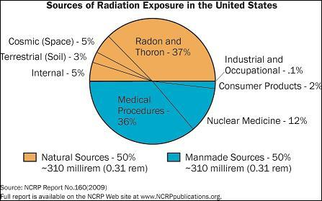
Figure 1. Sources of Ionizing Radiation Exposure in the United States
This figure shows average annual exposure for a citizen in the United States.
Half of the radiation exposures are from natural sources and manmade sources .

Recent trends have shown that cumulative exposure from medical imaging is increasing . While adverse effects to high and acute exposures can be predicted, adverse effects to lower cumulative doses such as DNA damage and cancer are more difficult to determine and can take years to manifest . The increase in cumulative radiation exposure from medical imaging in combination with high background levels creates an invisible environmental public health risk. Outside of the controlled medical setting, other unpredictable exposure risks can occur from potential radiological terrorism and nuclear disasters.
The purpose of this paper is to inform readers about the main environmental sources and dangers associated with cumulative radiation exposure and to suggest potential preventative measures to reduce the adverse effects. Evidence collected in laboratory and clinical trials have shown the potential for radioprotector and radiomitigator use in preventing and controlling biological damage from ionizing radiation exposures. The objective of this paper is to quantify the prophylactic potential of these agents in public health use against the effects of ionizing radiation exposures.
This paper is intended for general readers with emphasis on sensitive and vulnerable subgroups. These subgroups include children, workers in high risk occupations, and individuals who receive medical imaging and nuclear medicine.

Review
Radiation exists in two forms, either as non-ionizing or ionizing radiation. Non-ionizing radiation has enough energy to move atoms around in a molecule or cause vibrations. Some examples that contain non-ionizing radiation include infrared lamps that keep food warm in restaurants, visible light, and microwave ovens. Non-ionizing radiation does not have enough energy to remove electrons, but ionizing radiation does. Ionizing radiation can create ions by removing electrons from atoms. Advantages of this property include the ability to generate electric power and to kill cancer cells in nuclear medicine. However, because ionizing radiation indiscriminately targets both healthy and tumorous cells, its penetrating properties can also cause adverse health effects. Ultraviolet radiation that exists in higher frequencies can break chemical bonds and radiation that exists at the upper end of the spectrum, such as x-rays and gamma rays, can break up the nucleus of atoms. The general term "radiation" usually refers to this type of radiation. Ionizing radiation is divided into three main categories consisting of alpha particles, beta particles, and gamma rays .

alpha particles
Alpha particles are identical to a helium nucleus with two protons and two neutrons, making it a relatively heavy particle with high energy. These particles are usually emitted from atoms with high atomic numbers (> 82), such as lead or those of higher atomic number. During alpha emission, the nucleus of an atom is initially in an unstable energy state. A decay product remains when the alpha particle is ejected, causing the atom to lose two protons along with two neutrons. An example of an alpha emitter is polonium-210 where during radioactive decay, it loses two protons and becomes the stable (nonradioactive) atom, lead-206. The positively charged alpha particles are used in some man-made processes. For example, polonium-210 is used as a static eliminator in paper mills and radium-226 may be inserted in tiny amounts into a tumorous mass during cancer treatment. Alpha emitters occur naturally in the environment and human exposure increases greatly when soil and rock formations are disturbed for mineral extraction. During mining, especially of uranium, radioactive isotopes can become airborne or contaminate surface water as radioactive runoff when mining wastes are brought to the surface. Alpha particles cannot penetrate most material, and therefore the epidermis layer of human skin is sufficient to stop the particles, but internal exposure can produce adverse health effects. Alpha emitters can be inhaled, ingested, or absorbed into the blood stream where it can cause biological damage that increases cancer risk .

Radon gas exposure
The main exposure to alpha radiation for the average citizen is from inhalation of radon and its decay products in homes, schools, places of business, and low-lying areas such as basements . Radon gas is formed during the radioactive decay of uranium-238, a uranium isotope that is naturally found in rocks and soils in the environment. The gas enters homes through cracks and openings in the foundation and accumulates in the basement and lower living areas . Zakariya Hussein et al. analyzed eight government hospitals in three regions of Iraq for indoor radon concentration levels . They determined that the highest annual effective doses were found on the hospital ground floors and the lowest annual effective doses were found on the second level floors. Zakariya Hussein et al. concluded that the radon concentration and the annual effective dose decreased gradually as the floor level increased . Additionally, they determined that better ventilation, which was found in the upper floors, contributed to the lower exposure of radon. In addition to floor level, the study concluded that radon concentration is also dependent on geological formation and location along with the type of building material used . A study in Iowa determined similarly that cumulative ambient exposure to radon is a significant environmental health hazard . These conclusions show that radon exposure is a prevalent health hazard in different geographic locations regardless of the population demographics.
In the United States, lung cancer is the leading cause of cancer mortality. It was estimated that in 2009, there were a total of 219,440 new lung cancer cases and 159,390 deaths. With only a five-year survival ratio of 15%, lung cancer is a highly fatal disease. While the majority of lung cancer cases can be attributed to active cigarette smoking, residential radon and ambient air pollution can also contribute to lung cancer risks in the general population. Evidence collected in Europe suggest that radon may be responsible for 10% to 15% of lung cancer cases which makes radon the second leading cause of lung cancer after cigarette smoking. Turner et al. determined that there was a positive association between lung cancer risk and radon exposure . The association between residential radon concentrations and lung cancer mortality remained even after correcting for exposure to passive cigarette smoke or ambient sulfate concentrations, therefore cancer risks were increased solely from radon exposure . Similarly, a study in China observed a positive association between lung cancer and radon exposure . It was determined that in geographic locations with high radon levels, such as the rural Gansu Province in China, lung cancer risks associated with indoor radon exposures were equal to or even exceeded the extrapolations based on exposure data from studies of underground miners. The extrapolated data in the study suggests that residential radon exposure may be equal to or greater than levels observed in low-dose extrapolations from highly-exposed mining workers . Based on these conclusions, ionizing radiation from radon gas concentration and exposure poses a significant public health risk, especially as the time spent indoors increases in the general population.

beta particles
Beta particle emission occurs when the ratio of neutrons to protons in the nucleus is too high. The excess neutron transforms into a proton and an electron, whereby the electron is ejected during decay changing the radionuclide into a different element. Gamma ray emission, a highly penetrating photon, often accompanies the emission of a beta particle. Beta emitters are mostly used in the medical field setting, especially during diagnosis, imaging, and cancer treatment and can be administered orally due to their weak penetrating power. One use of beta emitters is iodine-131 which is used to treat thyroid disorders that include cancer and Grave's disease, a type of hyperthyroidism. In iodine-sufficient regions, Grave's disease is the most common cause of hyperthyroidism. Since the 1940s, oral administration of iodine-131 has been used to treat benign conditions of the thyroid gland, but recent evidence shows serious liver complications may result after treatment. Healthy Grave's disease patients were observed to develop jaundice and severe liver dysfunction which required hospitalization from one to several weeks after receiving iodine-131. Although rare, serious health implications could result from radioiodine treatment in individuals , especially in vulnerable subpopulations such as those with chronic liver disorders.

Radionuclides from nuclear disasters
While the main exposure sources of beta emitters stem from medical diagnostic and treatment procedures, radioactive iodine and cesium-137, which is another beta emitter, may enter the environment during a nuclear reactor accident and enter the food chain . The most recent disaster occurred at the Fukushima Daiichi Nuclear Power Plant on March 11, 2011 where a large earthquake in combination with a tsunami released a large deposition of radioactive material. The main concern was cesium-137 deposition and contamination of the soil. With a half life of 30.1 years and the difficulty of removing contaminated soils in certain areas, cesium-137 deposition drastically impacts agriculture and stock farming in contaminated areas. In addition, radioactive emissions can disperse and travel to different regions. Transport of contaminated air was observed due to wind patterns. Precipitation caused washouts of radionuclides contaminating soil and water far removed from the point source of release. Even in areas with low levels of contaminated topsoil, there may be contamination hotspots due to transportation from groundwater .
Because of the migratory abilities of radionuclides, there was great public concern over the safety of consuming fish from the Pacific Ocean in the United States after the Fukushima incident . Due to the lower per capita fish consumption levels in the United States compared to Japan, the radiation exposure from consuming Pacific bluefin tuna was comparable to the dose the average American citizen routinely obtained from naturally occurring radionuclides in other food sources because of radionuclide dilution into an ocean body. However, for subsistence fishermen (in both Japan or the United States) who consume more fish than the general public, the risk of Pacific bluefin tuna consumption alone was predicted to add two additional fatal cancer cases per 10,000,000 similarly exposed fishermen . Although these findings indicate that Pacific bluefin tuna may be permitted for the general public to consume in limited amounts, the findings do not necessarily indicate that all fish species have low contamination levels. Bottom dwelling-fish and numerous other fish species were observed to be contaminated at much higher levels than the Pacific bluefin tuna. A greenling that was caught inside the port of the Fukushima power plant nearly two years after the Fukushima incident had the highest reported contamination level. The observed radionuclide levels exceeded the Japanese market exclusion limit by a factor of 7,400 . While these highly-contaminated fish are excluded from the fish markets available to the general public, subsistence fishermen ignore these warnings and continue to consume highly-contaminated fish . Recreational fishermen as well as citizens in the population who overeat low-dose contaminated market fish from the Pacific Ocean are also exposed to cumulative radionuclide doses at higher levels than the general public. These estimations show that radionuclides have the potential to travel large distances from coasts such as Japan and that their persistence may affect not only fishermen, but also subgroups who consume more fish than the general population as far as the US west coast.
In the absence of dilution into an ocean body, radionuclides have high mobility and can be dispersed and impact large distances from the initial source. Kawauchi Village, located 30 km from the Fukushima plant, was affected by the disaster and residents were allowed to return to their homes nine months after the incident . Although radiation levels were observed to be low for the most part, radioactive persistence forced residents to adhere to some restrictions on the intake of contaminated foods to reduce unnecessary exposure. In particular, mushrooms that are primarily used in medical supplies had to be avoided because mushrooms were observed to selectively uptake and store cesium-137. From Chernobyl studies, it was determined that more than 4,000 new thyroid cancer cases were caused by a cumulative intake of dispersed iodine-131 found in contaminated food and cow's milk . Due to the increasing demand in energy, especially clean and sustainable energy, nuclear power is necessary to satisfy the demand. The increase in nuclear reactors may lead to future environmental public health risks, especially in the event of an unpredictable natural disaster such as the earthquake and tsunami observed in the Fukushima incident . Nevertheless, the main beta emission exposures stem from the medical diagnostics and treatment setting which poses a significant public health concern due to the increasing overuse of medical imaging and scanning technology .

GAMMA and x-ray particles
The last category of ionizing radiation consists of gamma and x-rays. Gamma ray emission occurs when a neutron transforms into a proton and a beta particle. The nucleus first ejects the beta particle and then ejects the gamma photon particle to stabilize itself. Gamma ray emissions are extremely penetrating and can pass through many kinds of materials, including human tissue. Because of the penetrating power, gamma emitters can be used for cancer treatment or for medical imaging such as x-rays. Very dense materials such as lead must be used to slow or stop these emissions. The primary source of gamma exposure occurs naturally through background levels such as in water, meats, and high-potassium foods like bananas. However, due to increasing use of nuclear medicine, there is an increasing proportion of exposure because of use in the medical setting .

Nuclear imaging procedures in medical and dental settings
Although extremely high and acute doses of radiation, such as lethal exposure levels observed in Fukushima workers after the incident, will lead to imminent death, there is increasing concern over the public health risks associated with low, cumulative doses from medical imaging. In a study comparing the use of imaging from five health care markets across the United States, Fazel et al. determined that the proportion of subjects undergoing at least one imaging procedure between the 18 to 34 age group was 49.5% . The proportion for individuals receiving at least one imaging procedure significantly increased to 85.9% for the 60 to 64 age group. The study only included those who remained alive throughout the duration of the study and excluded individuals that undergo multiple imaging procedures prior to death, a time period where health care services increase. When stratified according to gender, 78.7% of women were observed to undergo at least one imaging procedure compared to 57.9% of men. Additionally, it was determined that moderate doses were given at an annual rate of 193.8 per 1000 enrollees, whereas high doses were given at an annual rate of 18.6 per 1000 enrollees and very high doses were at the rate of 1.9 per 1000 enrollees . CT and nuclear imaging were observed to account for 21.0% of total procedures, but 75.4% of total effective dose. Despite the wide use of nuclear imaging, less than 50% of radiologists and only 9% of emergency department physicians reported being aware that CT was associated with increased cancer risk . According to the US Food and Drug Administration, an average CT scan increases the risk of fatal cancer by 0.05% . While the risks associated with a single CT scan may seem insignificant, the risks associated with multiple CT scans or other imaging procedures are dependent on the dose (imaging strength) used and are cumulative with other natural and man-made radiation exposures. According to the National Council on Radiation Protection, there is a six-fold increase in per capita radiation dose from medical imaging since the 1980s in the United States . These statistics raise significant public health concern, especially when patients trust a doctor's expert opinions and are recommended to accept these procedures. For diagnosis, individuals may undergo multiple imaging scans due to the difficulty of diagnosing certain diseases or be subjected to increased diagnostic tests because their doctors may fear malpractice lawsuits for negligence.
Children are considered to be a vulnerable subgroup and are more sensitive to the carcinogenic effects of ionizing radiation compared to adults. Numerous epidemiologic cohort studies of childhood exposure to radiation for treatment of benign diseases have shown increased risks of thyroid, breast, brain, and skin cancer as well as leukemia as a result of the exposures. As mentioned previously, the radiation exposures for single procedures are often classified as “low dose”, yet due to repeat examinations or procedures over an extended period of time, these doses accumulate to relatively high doses that can lead to radiation-induced cancers .
Despite the high prevalence of nuclear imaging in medicine, the most common artificial source of ionizing radiation occurs in the dental setting. Artificial ionizing radiation used in a controlled healthcare setting has been consistently identified as a modifiable risk factor for meningioma, the most frequently reported primary brain tumor in the United States. Since this risk factor is dose-dependent the level of risk can be modified by reducing the nuclear imaging strength/dosage used and also the number or frequency of imaging tests given. Claus et. al determined that there was a positive association between dental x-rays and intracranial meningioma risk, especially for individuals who receive exams at a young age or on a yearly basis . The results are consistent with Kleinerman's study ; children less than 10 years old who received panoramic dental imaging had a 4.9 -fold increased risk of developing meningioma compared to the other age groups who received the same dental exam. In addition to young age, the frequency of receiving dental exams also increased the risk of meningiomas . The overuse of x-ray and gamma rays in nuclear imaging along with the lack of awareness in practitioners about the associated risks contribute to significant public health concerns, especially when vulnerable subpopulations receive repeated/cumulative doses that start at an early age.
While the three categories of ionizing radiation have different mechanisms of damaging cells, they contribute to similar adverse health effects. Ionizing radiation exposure leads to either deterministic or stochastic effects . Deterministic effects occur after receiving a high, acute dose of radiation such as from nuclear accidents or during cancer treatment. These health effects are characterized by a non-linear dose-dependent response threshold where the severity of effects on the spectrum can range from skin burns and vomiting at lower doses to death after exposure from higher doses. Stochastic effects are less apparent and are considered the late health effects after low dose exposures. For most stochastic effects, there is no dose-response threshold and only the probability of occurrence, but not the severity of effect is dependent on the radiation dose. Stochastic effects are more difficult to assess due to uncertainties of estimates, especially when there is little epidemiological or biological evidence of thresholds for these effects . In addition to radiation-induced cancer risks, there are concerns of heritable genetic risks after low dose exposures . Somatic mutations may cause birth defects, eye maladies, and heritable mutations that may increase the risk of diseases among future generations. Several other confounding factors affect somatic mutations such as synergistic interaction of radiation with UV light, chemical and biological mutagens, the variation and ability of repair mechanisms, and the variation of adaptive responses that are dependent on the dose and levels of protective substances such as antioxidants. In addition to these confounding factors, there may be mutagenic effects on nearby non-targeted/non-irradiated cells due to the bystander effect . Non-irradiated cells were cultured with irradiated cells and due to the bystander effect, non-irradiated cells experienced chromosomal damage due to mutagenic factors produced by nearby irradiated cells . These results support public health concerns that targeted and non-targeted parent cell mutations caused by low dose exposures may be inherited by progeny and produce transgenerational effects that increase disease risks in future generations , especially if the mutation occurs in germline cells.
Because of the environmental prevalence of natural and man-made ionizing radiation sources, better preventative measures need to be adopted to reduce the implications on public health, especially in vulnerable subpopulations such as children and workers in certain occupations . The vulnerable subpopulation may include residents living near a nuclear facility during an accident. While these residents may not be directly affected by acute occupational doses such as nuclear facility workers during an accident, they may be affected by ingesting contaminated water or food. With the use of mathematical models, predictions of radioactive contamination of water bodies can be used to determine the migration of radionuclides such as after the Chernobyl accident or the migration of cesium-137 such as after the Fukushima disaster . In conjunction with these predictive models, the exposed affected population can be protected with radioprotectors or radiomitigators especially in a scenario where there may be delayed evacuation or underestimation of radioactive contamination. Regardless of the source of exposure, whether from radon gas, medical imaging or a nuclear disaster, radioprotectors and radiomitigators have the potential to reduce the damage of ionizing radiation and have considerable benefits in the public health field.

analytical section
Compounds that are designed to reduce damage in normal tissue during radiation exposure are classified as radioprotectors. These compounds are usually antioxidants and must be given before or at the time of radiation exposure for effectiveness. Radiomitigators may be used after radiation exposure to minimize toxicity . See Figure 2.

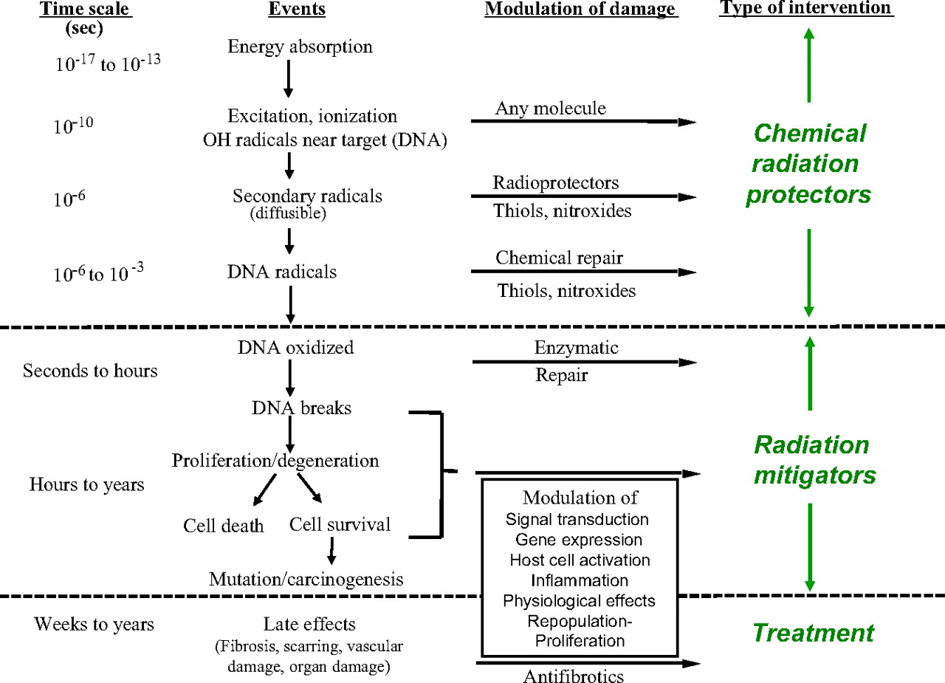

Figure 2. Sequence of Radioprotective and Radiomitigative Intervention Following Events
of Radiation Exposure

This figure shows the sequence of events involved in ionizing radiation exposure. Radioprotectors are used prior to exposure to reduce free radicals that may interact with DNA and other macromolecules within the cell. Radiomitigators are used after exposure to reduce damage to the cell and cellular DNA by augmentation of repair processes or preventing cell death. Treatment is used later to relieve and reduce further health complications that may occur as a result of injury to an organ or organ system .

For the radioprotector classification, the agent needs to be selective in protecting normal tissues, such as during radiotherapy, without protecting tumor tissue. The agent also needs the ability to be delivered with ease and minimal toxicity as well as protect normal tissues that are sensitive to acute or long-term/chronic damage which can significantly reduce the quality of life. According to Citrin et al, amifostine is the only radioprotector currently in use . Other agents have been tested but showed lower efficacy when given comparable doses in mice .

radioprotectors

Amifostine
Amifostine, administered via subcutaneous injection, scavenges damaging free radicals once it is inside the cell, protecting cellular membranes and DNA from damage . During radiotherapy, especially of the head and neck, xerostomia (acute or chronic salivary gland disorder) and mucositis (inflammation and ulceration of mucous membranes) are common side effects of treatment. The dry mouth caused by xerostomia can increase the risk for dental caries and oral infections in affected individuals. Numerous randomized controlled studies suggest that amifostine can protect against or reduce these radiation-induced toxicities . One study demonstrated that among patients who received radiation therapy, 86% developed severe mucositis in the control compared to none of patients that were treated with amifostine . At a twelve month follow-up, 17% of patients who received amifostine experienced grade 2 xerostomia compared to 55% of the patients who did not. Amifostine was observed to reduce acute and late stage xerostomia and its associated symptoms without affecting the disease-free and overall survival time of patients . In addition to reducing or protecting against adverse radiation effects, amifostine also had a protective effect on dental health . Fifteen percent of patients who received amifostine showed no deterioration of dental health compared to 7% of the patients who did not receive the treatment ; these findings support conclusions that amifostine protects against xerostomia which also protects dental health . For reducing mucositis symptoms, all patients who did not receive amifostine in the control group experienced grade 2 mucositis by week 3 compared to only 9% of the patients who received the amifostine treatment . After three months of follow-up, grade 2 xerostomia was reported in only 27% of treated patients compared to 74% of amifostine-untreated patients .
Mucositis of the gastrointestinal tract is another adverse effect that results from pelvic irradiation. Clinical trials have demonstrated that pretreatment of amifostine can reduce incidence of common gastrointestinal toxicities that follow radiation treatments . In patients treated for pelvic tumors, amifostine also offered protection against radiation-induced dermatitis. Seventy-seven percent of amifostine-treated patients had a lower risk of radiation-induced dermatitis compared to the control group. The severity of dermatitis was also significantly lower among amifostine-treated patients compared to the controls . For locally advanced cervical cancers, cisplatin combined with chemoradiotherapy is the standard of treatment. Although this combination improves survival rates, it also increases the already high frequencies of toxicity associated with traditional radiotherapy alone. Clinical trial data have shown that cervical cancer patients who receive amifostine pretreatment benefits from reduced treatment toxicity . When administered through a slow IV drip, amifostine use can also reduce the cumulative renal toxicity associated with repeated administration of cisplatin .

Barbados cherry
Because of toxicities that may arise from using synthetic compounds such as amifostine, plants and natural products have been also evaluated as radioprotectors . Natural plant derived protectors are promising sources of radioprotectors due to their low toxicities. These plant constituents, such the polyphenolic compounds found in berries, offer radioprotection of genetic material from radiation exposure through antioxidant and free radical-scavenging mechanisms . Foods, such as fruit, that are high in antioxidants reduce the level of oxidative damage to DNA caused by free radicals and ionizing radiation, which includes iodine-131 used in diagnosis and treatment of thyroid disorders. The Barbados cherry, which contains a mixture of potent antioxidants such as vitamin C, phenols, anthocyanins, and yellow flavonoids, was used in one study to determine its radioprotective benefits against mutagenic activity in bone marrow cells after therapeutic doses of radioiodine (iodine-131) for hyperthyroidism . In an acute dose of Barbados cherry via ingestion, it was observed that the fruit pulp decreased chromosomal abnormalities by 72% when given simultaneously with and after the single dose of radioiodine treatment and by 70% when given before the single radioiodine dose. For continuous, daily doses (subchronic) of Barbados cherry via ingestion, there was a 41% decrease in chromosomal abnormalities when the fruit was given to rats for five days prior to the single radioiodine exposure. A 45% decrease in chromosomal abnormalities was also observed when the cherry was given to rats for one day at the same time as the single radioiodine dose . Continuous, subchronic cherry doses given to rats prior to and after a single radioiodine dose for ten consecutive days produced the lowest percentage of chromosomal abnormalities compared to all the treatments in the study possibly due to the increased frequency of antioxidant consumption. Although the different doses (acute and subchronic) of cherry treatments may interfere with the radioprotective effects of the fruit, rats who ingested the Barbados cherries still received radical-scavenging benefits compared to the controls. These results suggest that Barbabos cherries have not only radioprotective properties, but also radiomitigative properties and that daily and continuous consumption of antioxidant-rich foods/mixtures can prevent and reduce mutations caused by ionizing radiation . These radioprotective results are consistent with results from previous studies , which showed that Barbados cherry juice reduced the average number of micronuclei by 50%, where the micronuclei induction results after exposure to a mutagen. Vitamin C, a major antioxidant component of the Barbados cherry, administered four hours prior to radioactive doses, also showed a radioprotective effect of mouse spermatocytes .
Other plant products that offer radioprotection include spices such as Curcumin, the yellow pigment found in the rhizomes of turmeric that give the yellow color and flavor in curries. Curcumin was observed to protect cells against radiation-induced deleterious effects while effectively killing tumor cells . While natural radioprotectors have low toxicity, they exhibit less efficacy compared to synthetic compounds . Nonetheless, these findings suggest that radioprotectors, when taken prior to exposure, can reduce the deterministic and stochastic toxicities associated with ionizing radiation exposure. According to Kuntić et. al, the ideal radioprotector has not been identified; synthetic radioprotectors of high efficacy may have high toxicities whereas natural radioprotectors of low toxicities may have low efficacies . Because of this complication, there needs to be a push for development or identification of efficacious agents to minimize adverse health effects from ionizing radiation use.

Radiomitigators
Radiation mitigators can be used when radioprotectors are not effective, such as after radiation-induced DNA damage has occurred. Radiation mitigators target DNA damage pathways, such as mitotic cell death, that prevent or reduce expressions of toxicity, such as vascular damage. In contrast to radioprotectors, mitigators would be useful after exposure and can be given after an unpredictable event such as radiologic terrorism or nuclear reactor accident . At high radiation dosage levels, the destruction of the bone marrow progenitor cells lead to a drop in blood cell counts which ultimately leads to death. The decline of blood cell counts also increases the risk of infections and hemorrhage in the affected individual. Currently, there is no approved drug to mitigate radiation toxicity in hematopoietic cells. However, recent studies have determined the potential of new drugs that may reduce hematopoietic toxicity after ionizing radiation exposure .

Ex-RAD
ON 01210.Na, or Ex-RAD, was developed as both a radioprotector and mitigator. In one study, the radiomitigator effects of Ex-RAD were determined after exposing mice to a sublethal dose of gamma irradiation, cesium-137 . When Ex-RAD was given subcutaneously 24 hours and 36 hours after radiation exposure, the Ex-RAD treated group showed significantly higher survival of bone marrow cells compared to the control group. Blood cell counts were also observed to be higher in the treated group compared to the control group. Ex-RAD-treated cells had higher white blood cell counts, neutrophil counts, monocyte counts, and platelet counts which suggest that Ex-RAD increased the recovery and regeneration of bone marrow cells. This recovery would not only reduce infection but also the risk of hemorrhages due to the recovery of leukocytes and platelets, respectively. DNA damage and cell death via apoptosis were also reduced in the Ex-RAD-treated bone marrow and spleen cells compared to the control; bone marrow and the spleen are responsible for maintaining the blood cell pool and proper immune system function . See Figure 3.

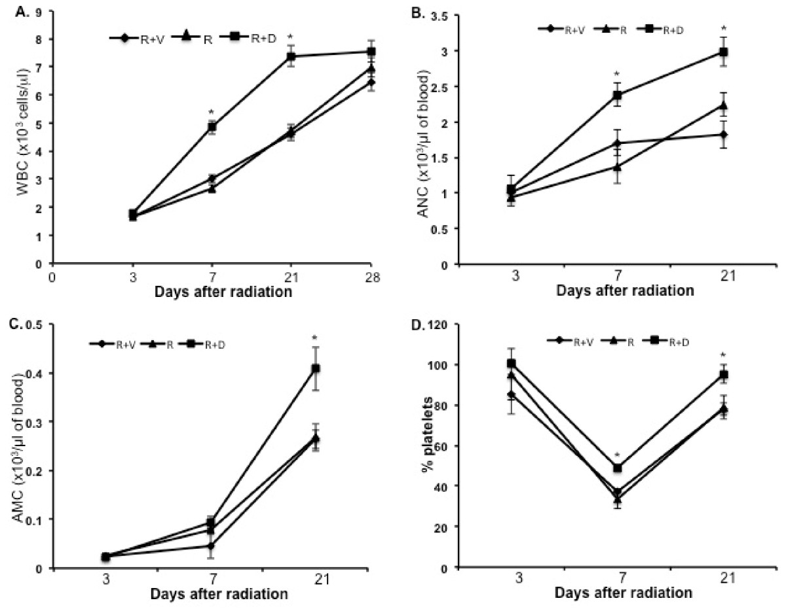
Figure 3. Results of Ex-RAD Treated and Control Cells after Irradiation for White Blood Cells (WBC), Absolute Neutrophil (ANC) , Absolute Monocyte (AMC), and Platelet (% platelet) Counts

These graphs show plotted results that consists of R, the irradiated control group, R+V, the negative control group to ensure no interaction of the Vehicle delivery mechanism, and R+D, the experimental group that received both radiation and Ex-RAD treatment. Graph A shows absolute white blood cell (WBC) counts. Graph B shows absolute neutrophil (ANC) counts. Graph C shows absolute monocyte (AMC) counts. Graph D shows platelet (% platelet) counts. Graph A, B, C, and D depict constituents found in the blood stream which includes constituents of the immune system. In all four graphs, R+D, the Ex-RAD treated group (top line), showed higher cell counts compared to the non-Ex-RAD treated groups. Ex-RAD treated groups showed faster recovery of blood cells and higher end cell counts compared to the non-treated groups .

HemaMax
HemaMax, a recombinant human interleukin-12, is also in development as a potential mitigator of ionizing radiation . After total body irradiation in mice and rhesus monkeys, HemaMax was observed to increase percent survival and survival without supportive care, including antibiotics, when administered 24 hours after a lethal ionizing radiation dose. The survival mechanisms were comparable to the mechanism observed with Suman et. al, where survival was due to the promotion of hematopoiesis and the recovery of the immune system; the majority of deaths from acute radiation exposure occurs from the combined effects of hematopoietic, immune, and gastrointestinal failures due to the radiosensitivity of these systems. Administered as fixed, single, low doses at 24 hours after total body irradiation exposures of 8.6 Gy (LD_{70/30}, the radiation dose that kills 70% of mice in 30 days), 8.8 Gy (LD_{90/30}), and 9.0 Gy (LD_{100/30}), mice who received HemaMax had a higher percentage of survival compared to the controls . The percentage of survival in the control groups was 20% for the 8.6 Gy dose (LD_{70/30},), 10% at 8.8 Gy (LD_{90/30}), and 0% at 9.0 Gy (LD_{100/30}), but the group who received HemaMax had a significantly higher percentage of survival at 80% for the 8.6 Gy dose (LD_{70/30}), 60% at 8.8 Gy (LD_{90/30}), and 70% at 9.0 Gy (LD_{100/30}). These results also demonstrate that at fixed HemaMax doses, an increase in radiation dose does not affect the efficacy of the drug. Additionally, for rats administered HemaMax at either 24 hours or 48 hours after exposure, it was observed that the percentage of survival was higher in those who received the drug at 24 hours compared to the 48 hour time point. This observation indicates that the effectiveness of these mitigators is dependent on treatment time after radiation exposure; however, even receiving mitigator treatment 72 hours after exposure might increase survival time compared to receiving no treatment at all. Similar effects were observed in the cells of the bone marrow and small intestine in mice where administration of HemaMax 24 hours after total body irradiation controlled injury in these radiosensitive organs .
After dose interspecies conversion from mice to non-human primates, rhesus monkeys were exposed to total body irradiation of 6.7 Gy (LD_{50/30}) and compared for survival between the control and HemaMax-treated group. Monkeys were treated with two different doses of HemaMax and had a significantly higher pooled percent survival of 75% versus the control group of 50%. There was no statistical difference between the two given doses of HemaMax which suggests that the minimal dose in the efficacious range is sufficient for optimal radiomitigative benefits . See Figure 4.

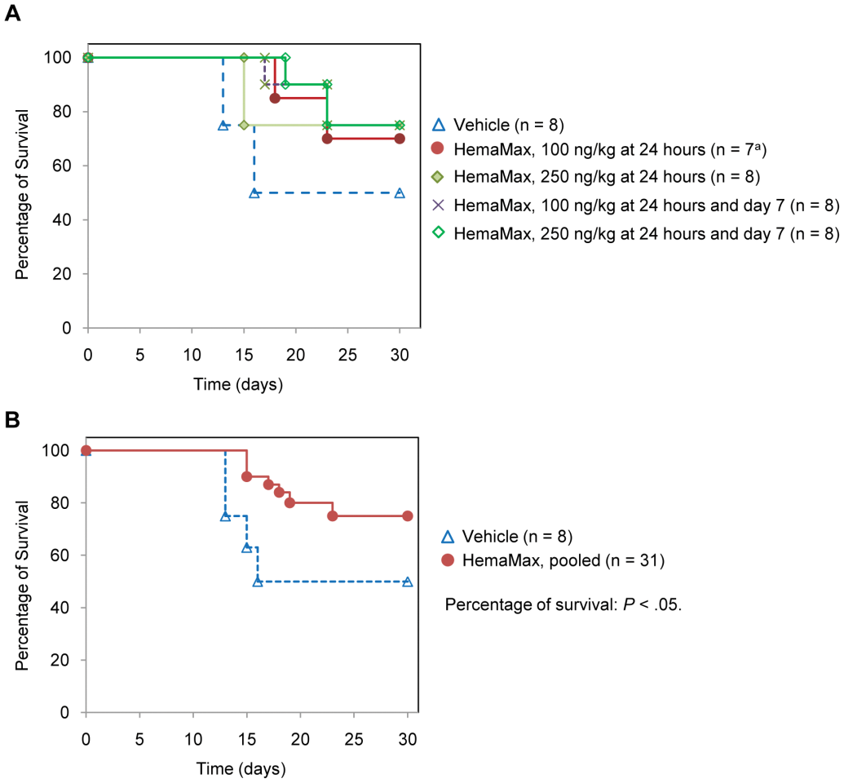
Figure 4. Survival Analysis of HemaMax-Treated and Control Rhesus Monkeys after Total Body Irradiation

This analysis shows that rhesus monkeys who were administered HemaMax had a higher survival percentage to 30 days compared to the control group (vehicle). The pooled HemaMax-treated group showed a 75% percent survival compared to 50% observed in the control .

HemaMax-treated monkeys were also observed to have higher blood cell counts, including leukocytes, thrombocytes, compared to the control group . For platelet counts, 25% of HemaMax-treated monkeys exhibited a drop of platelets below the threshold level, a level generally requiring platelet transfusion, compared to 80% of the monkeys in the control group. The monkeys that survived the radiation in the control group were observed to recover from the drop of blood cell counts which supports that radiation-induced death occurs from the destruction of blood cells and the hematopoietic system. These findings show that doses can be converted between species and show that radiomitigators increase survival time by promoting recovery of the blood cells and hematopoietic system, immune system, and also gastrointestinal function. As mentioned previously, there is currently no approved radiomitigator for the hematopoietic system, but the results of this study show potential agents that may be suitable for human use and possibly be used in clinical trials in the near future . The observed efficacy of radioprotectors and radiomitigators in acute doses of radiation suggests the efficacy and application of these agents in low-dose, cumulative radiation exposures by adjusting the amount and frequency/duration of administering the agent.

Conclusion
The beneficial potential for radioprotectors and mitigators can be used in many public health applications that can prevent or reduce injury caused by ionizing radiation exposure in the environment in both predicted and unpredicted exposure settings. When used with powerful predictive models, the application of these agents can improve emergency response preparations in events after the initial nuclear disaster. In this setting, the migratory/dispersion patterns of radioactive contamination can be extrapolated to predict radionuclide travel of surrounding and distant areas, and water bodies with the use of mathematical models. Trending of radionuclide migration can also be used to predict radiation uptake in plants and livestock via the ingestion route to avoid unnecessary/cumulative exposure from radionuclides that persist months to even years after the initial incident. As a part of the emergency response to events following the blast, predictive models can determine the radionuclide migratory patterns which would allow residents to take radioprotectors before radionuclides reach food and water sources . Similarly, tracking and trending of radon concentrations can allow for control from natural exposure sources with estimations based on a spatial-temporal distributions in regions and facilities such as in buildings . In combination with these models, the use of radioprotectors and radiomitigators offer the optimal primary and secondary prevention options. In a controlled medical/healthcare setting, radioprotectors and radiomitigators may be administered before or after nuclear imaging or radiotherapy to reduce adverse health effects due to overexposure from the increase (intentional or unintentional) in nuclear medicine use. For an unpredictable event such as radiological terrorism or the initial nuclear disaster, radiomitigators can reduce the extent of adverse effects from acute sublethal or lethal radiation doses, for which there is little effective therapy, when taken after the incident for those immediately within the vicinity such as nuclear occupational workers.
While there is hospital treatment for radiation exposures, in an unpredictable event such as terrorism or nuclear disaster, treatment would not be available immediately. Therefore, the self-administration of radiomitigators would significantly impact survival time compared to hospital care because medical teams may take at least 24 hours to prepare, mobilize and distribute treatment . For self-administration, it is imperative for agents to be accessed and administered with relative ease. The majority of the administration routes for compounds discussed above were through the subcutaneous route . However in a state of emergency, subcutaneous injection may be difficult to properly administer. Individuals, especially children, may not know how to correctly use syringes and Basile et al. observed that, in the case of HemaMax, the delivered radiomitigator dose was only 10% of the intended dose due to the interaction of the compound with the surfaces of the vials and syringes . Pills or tablets taken through the oral route are easier to administer, but due to slow absorption are better to use for administration of radioprotectors as opposed to radiomitigators where the mitigative effects are highly dependent on time taken after radiation exposure. Because of the slow absorption from the oral route, ingestion would be more suitable for residents living far from the initial accident or in nuclear medicine applications when the date and time of exposure is planned in advance [31]. Currently, potassium iodide is FDA-approved to take by mouth to help block the absorption of radioiodine during a nuclear accident. However, potassium iodide offers very limited protection because the thyroid gland will indiscriminately absorb both stable and radioactive iodine. The mechanism is to saturate the thyroid gland with enough stable iodine to prevent the uptake of radioactive iodine. Depending on an individual's absorption rate and the time of absorption, the distribution of stable iodine to the thyroid glands may be too slow to outcompete radioiodine uptake for individuals within the direct vicinity of exposure . In addition, it iodine does not protect against radiation from other isotopes. Inhalation offers the ease of administration and the effectiveness of rapid absorption but may also be difficult to administer in a state of emergency; individuals may have lung inflammation due to inhalation of radionuclides or may have impaired lung function from chronic diseases such as asthma. In addition to administration issues, the availability and accessibility of agents creates complications as well. In the occupational setting, agents may be available if there is a mandatory requirement of kits as a part of the occupational safety protocols. For residents, it would be difficult to enforce every household to purchase a home kit or ensure that supply can meet demand during an emergency. In controlled or predictable settings, there are potentials for administration of radioprotectors and radiomitigators from these three routes; however, in a state of emergency, administration and access of these agents becomes a challenge in the situation where public health application would have a significant impact on human health [31].
Another consideration is the potential adverse reactions from drug toxicities after administration of prophylaxis. Although well-tolerated, amifostine may have dose-related or allergic adverse events that include hypotension, nausea and vomiting, rash, fever, or anaphylactic shock . HemaMax was observed to mitigate jejunal (small intestine) injury, but high doses were observed to aggravate intestinal injuries in mice. The exacerbation was not observed in mice who did not receive radiation exposure . These implications may mean more harm than benefits, especially in individuals who may be allergic or hypersensitive to certain chemical compounds or fail to use the compound as directed. While 80% of adverse drug reactions are side-effects, 10% to 15% of individuals experience hypersensitivity type reactions in a population. Prophylactic doses taken by hypersensitive individuals may produce adverse drug reactions that would not be normally observed in majority of individuals . As with any drug, hypersensitive individuals create another complication in the development and the eventual adoption of radioprotectors and radiomitigators so it is imperative to determine the lowest optimal dose to potentially decrease adverse reactions. Studies for the effects of long-term synthetic radioprotector and radiomitigator use would also need to be taken into account, especially in areas of chronic radon or cesium-127 exposures where relocation or evacuation may not be possible. Prior to the use of synthetic drugs, a risk-benefit analysis needs to be conducted to determine if the individual or population risks outweigh the benefits. People who live in geographic regions with low radon levels and low radon-induced cancer risks may not benefit from taking these agents, especially if there are hypersensitive individuals in the group. In an emergency scenario such as a nuclear meltdown where death may be imminent without the agent, the benefits of the mitigative properties far outweigh adverse drug effects. Naturally-derived compounds such as from plants show potential in that they are less toxic compared to their synthetic counterparts, but natural compounds are less efficacious than synthetics. However, not all naturally occurring compounds have lower toxicities compared to synthetic compounds. Naturally occurring compounds such as arsenic may have higher toxicities than some synthetic compounds. Therefore, the ideal radioprotector and radiomitigator would maximize benefits while minimizing risks. The agent would be versatile enough to have both radioprotective and radiomitigative properties. This agent would also be easily administered, cost-effective, and can be quickly distributed or dispersed in emergency situations. Because there is currently no ideal agent, it is imperative to promote, educate, and encourage the research, development, and adoption of these prophylactics.
Currently, there is only one agent, amifostine, approved for radioprotective use and there are no approved radiomitigators for mitigating injury in hematopoietic cells . Potassium iodide offers limited protection from radioactive iodine, but it does not protect against other radionuclides and does not mitigate health effects after the thyroid gland is injured . Considerations such as agent administration routes and adverse drug reactions only add more obstacles and further hinder the development of these agents. Despite these challenges, it is important to recognize the versatility and protection power these agents can offer, especially by reducing health disparities. Radioprotectors and radiomitigators may prevent or reduce incidences of radiation-induced cancer which would cost significantly less than radiotherapy that would further aggravate adverse health effects and reduce the quality of life. Because of the prevalence and increasing environmental sources of exposure to cumulative ionizing radiation, radioprotectors and radiomitigators could be crucial tools that can be used in a variety of public health applications.

bibliography
1. United States Nuclear Regulatory Commission. Fact Sheet on Biological Effects of Radiation. 2011. Retrieved March 21, 2014 from http://www.nrc.gov/reading-rm/doc-collections/fact-sheets/bio-effects-radiation.html.
2. Basile, L.A., et al., HemaMax™, a Recombinant Human Interleukin-12, Is a Potent Mitigator of Acute Radiation Injury in Mice and Non-Human Primates. PLoS ONE, 2012. 7(2): p. e30434.
3. Suman, S., et al., Administration of ON 01210.Na after exposure to ionizing radiation protects bone marrow cells by attenuating DNA damage response. Radiation Oncology, 2012. 7(1): p. 6.
4. Citrin, D., et al., Radioprotectors and mitigators of radiation-induced normal tissue injury. Oncologist, 2010. 15: p. 360-71.
5. Smith-Bindman, R., et al., USe of diagnostic imaging studies and associated radiation exposure for patients enrolled in large integrated health care systems, 1996-2010. JAMA, 2012. 307(22): p. 2400-2409.
6. US EPA, Oria Radiation Protection Division., Ionizing & Non-Ionizing Radiation. 2006. Retrieved March 14, 2014, from http://www.epa.gov/radiation/understand/.
7. Turner, M.C., et al., Radon and lung cancer in the American Cancer Society cohort. Cancer Epidemiol Biomarkers Prev, 2011. 20(3): p. 438-48.
8. Zakariya A Hussein, M.S.J. and H.I. Asaad, Measurements of Indoor Radon-222 Concentration inside Iraqi Kurdistan: Case Study in the Summer Season. Journal of Nuclear Medicine & Radiation Therapy, 2013. 4(143).
9. Field, R.W., et al., Residential Radon Gas Exposure and Lung Cancer: The Iowa Radon Lung Cancer Study. American Journal of Epidemiology, 2000. 151(11): p. 1091-1102.
10. Wang, Z., et al., Residential Radon and Lung Cancer Risk in a High-exposure Area of Gansu Province, China. American Journal of Epidemiology, 2002. 155(6): p. 554-564.
11. Jhummon, N.P., B. Tohooloo, and S. Qu, Iodine-131 induced hepatotoxicity in previously healthy patients with Grave's disease. Thyroid Research, 2013. 6(1): p. 4.
12. Yasunari, T.J., et al., Cesium-137 deposition and contamination of Japanese soils due to the Fukushima nuclear accident. Proceedings of the National Academy of Sciences, 2011. 108(49): p. 19530-19534.
13. Fisher, N.S., et al., Evaluation of radiation doses and associated risk from the Fukushima nuclear accident to marine biota and human consumers of seafood. Proceedings of the National Academy of Sciences, 2013. 110(26): p. 10670-10675.
14. Taira Y, H.N.Y.H.Y.S.E.Y. and et al., Evaluation of Environmental Contamination and Estimated Radiation Doses for the Return to Residents’ Homes in Kawauchi Village, Fukushima Prefecture. PLoS ONE 7(9): e45816, 2012.
15. World Nuclear Association, World Energy Needs and Nuclear Power. 2014. Retrieved March 14, 2014, from http://www.world-nuclear.org/info/Current-and-Future-Generation/World-Energy-Needs-and-Nuclear-Power/.
16. Fazel, R., et al., Exposure to Low-Dose Ionizing Radiation from Medical Imaging Procedures. New England Journal of Medicine, 2009. 361(9): p. 849-857.
17. Storrs, C., How Much Do CT Scans Increase the Risk of Cancer? 2013. Retrieved March 30, 2014, from http://www.scientificamerican.com/article/how-much-ct-scans-increase-risk-cancer/.
18. Kleinerman, R.A., Cancer risks following diagnostic and therapeutic radiation exposure in children. Pediatr Radiol, 2006. 36 Suppl 2: p. 121-5.
19. Claus, E.B., et al., Dental x-rays and risk of meningioma. Cancer, 2012. 118: p. 4530-7.
20. Little, M., Risks associated with ionizing radiation: Environmental pollution and health. British Medical Bulletin, 2003. 68(1): p. 259-275.
21. Prasad, K.N., W.C. Cole, and G.M. Hasse, Health risks of low dose ionizing radiation in humans: a review. Exp Biol Med (Maywood), 2004. 229: p. 378-82.
22. Morgan, W.F., Non-targeted and Delayed Effects of Exposure to Ionizing Radiation: II. Radiation-Induced Genomic Instability and Bystander Effects In Vivo, Clastogenic Factors and Transgenerational Effects. Radiation Research, 2003. 159(5): p. 581-596.
23. Novitsky, M.A. and A.I. Nikitin, Prediction of Radioactive Contamination of Water Bodies After the Chernobyl Accident. Radiation Protection Dosimetry, 1996. 64(1-2): p. 29-32.
24. Kouvaris, J.R., V.E. Kouloulias, and L.J. Vlahos, Amifostine: The First Selective-Target and Broad-Spectrum Radioprotector. The Oncologist, 2007. 12(6): p. 738-747.
25. Rudat, V., et al., Protective effect of amifostine on dental health after radiotherapy of the head and neck. International Journal of Radiation Oncology*Biology*Physics, 2000. 48(5): p. 1339-1343.
26. Small, W., Jr., Potential for use of amifostine in cervical cancer. Semin Oncol, 2003. 29: p. 34-7.
27. Kuntić, V.S., et al., Radioprotectors – the Evergreen Topic. Chemistry & Biodiversity, 2013. 10(10): p. 1791-1803.
28. Dusman, E., et al., Radioprotective effect of the Barbados Cherry (Malpighia glabra L.) against radiopharmaceutical Iodine-131 in Wistar rats in vivo. BMC Complementary and Alternative Medicine, 2014. 14(1): p. 41.
29. Jagetia, G.C., Radioprotection and radiosensitization by curcumin. Adv Exp Med Biol, 2007. 595: p. 301-20.
30. Klein, D., et al., Developing measuring technique in radioprotection for tracking radon 222 “in situ”. International Journal of Radiation Applications and Instrumentation. Part D. Nuclear Tracks and Radiation Measurements, 1991. 19(1–4): p. 363-364.
31. Pros and cons of different routes of drug administration. Doctors.net.uk. Retrieved March 21, 2014, from http://www.doctors.net.uk/_datastore/ecme/mod1227/Drug_dosage_Table1.pdf.
32. Potassium Iodide (KI). 2013. Retrieved March 29, 2014, from http://www.bt.cdc.gov/radiation/ki.asp#sideEffects.
33. Thien, F.C.K., Drug hypersensitivity. Med J Aust, 2006. 185(6): p. 333-338.

