A REVIEW OF THE PATHOGENICITY OF THE HUMAN PAPILLOMA VIRUS AND BARRIERS TOWARDS VACCINATION AMONGST ADOLESCENT FEMALES IN THE UNITED STATES

by
ADEOLA OLUWAROTIMI IDOWU
MBBS, University of Ilorin, Nigeria, 2010

Submitted to the Graduate Faculty of
the Graduate School of Public Health in partial fulfillment
of the requirements for the degree of
Master of Public Health

University of Pittsburgh
2014

UNIVERSITY OF PITTSBURGH
GRADUATE SCHOOL OF PUBLIC HEALTH

This essay is submitted
by

Adeola Idowu

on
April 15, 2014
and approved by

Essay Advisor:
Luis A Ortiz MD _________________________________
Associate Professor
Department of Environmental and Occupational Health
Graduate School of Public Health
University of Pittsburgh

Essay Reader:
Candace M Kammerer Ph.D _________________________________
Associate Professor
Department of Human Genetics
Graduate School of Public Health
University of Pittsburgh

Luis A Ortiz, MD
Copyright © by Adeola O. Idowu
2014

A REVIEW OF THE PATHOGENICITY OF THE HUMAN PAPILLOMA VIRUS AND BARRIERS TOWARDS VACCINATION AMONGST ADOLESCENT FEMALES IN THE UNITED STATES
Adeola O. Idowu, MPH
University of Pittsburgh, 2014
ABSTRACT
The Human Papilloma Virus infection has been identified as the most common sexually transmitted disease in the United States, affecting over 20 million people in the country. In 2008, the World Health Organization (WHO) reported there were an estimated 529,000 new cases and 27,400 deaths due to cervical cancer. 75% of these are caused by the high risk type virus strains of Human Papilloma Virus, Type 16&18. Recent findings have also indicated a rapid rise in the incidence of Oropharyngeal cancer with an annual incidence of approximately 400,000 worldwide and with over 90% of positive cases being associated with infection with the virus. These results are of public health significance in addressing medical care costs that might be accrued as a result of providing care for chronic conditions and reducing mortality rates in the country.
In spite of these figures, there are still significant low rates of compliance amongst female adolescents with receiving vaccines. This essay attempts to provide a literature review of the recent trends associated with the pathogenicity of the virus, examine previous vaccination trends and formulate new intervention strategies to combat the low perception and relatively low rate of compliance with vaccination amongst young female adolescents.

TABLE OF CONTENTS
ACKNOWLEDGEMENTS viii
1.0 INTRODUCTION 1
1.1 PATHOGENIC REVIEW 1
1.1.1 INFECTIVITY AND ONCOGENIC CAPABILITIES OF HPV 3
1.1.2 CANCERS ASSOCIATED WITH THE HUMAN PAPILLOMA VIRUS 8
2.0 THE HUMAN PAPILLOMA VIRUS VACCINEs 10
2.1 HISTORY OF HPV VACCINATIONS 10
2.2 SAFETY AND SIDE EFFECTS OF THE VACCINE 13
2.3 VACCINATION 14
2.4 AWARENESS OF VACCINATION AND COMPLIANCE 15
2.4.1 HEALTH BELIEF THEORY 17
3.0 ANALYTICAL SECTION 20
4.0 SUMMARY, DISCUSSION AND CONCLUSIONS 23
BIBLIOGRAPHY 26

List of tables
Table 1 Analysis of efficacy of Gardasil in the per protocol efficacy (PPE) population of 16 through 26 year old women for vaccine HPV types 12
Table 2 Bivariate associations between HPV related risk perceptions and HPV vaccine uptake 19

LIST OF FIGURES
Figure 1 Genomic organization of the HPV genome 2
Figure 2 Cervical stratified squamous epithelial cell architecture and the expression of human papillomavirus (HPV) proteins after infection 5
Figure 3 Mechanism of infection of cervicovaginal epithelium by human papillomavirus, and infection inhibition by virus-like particle-induced antibodies. 6
Figure 4 Prevalence of high risk and low risk types among females aged 14-59 years. 21
Figure 5 Percent of adolescent girls who received 3 doses of HPV vaccine 22

ACKNOWLEDGEMENTS
Firstly, I would like to thank God for providing me this great opportunity and seeing me through the completion of this essay. I would also like to thank my essay advisor, Dr. Luis Ortiz for his guidance and support throughout the duration of this essay. I would also like to express my greatest appreciation to Dr. Candace Kammerer for her immense support and guidance while developing this paper. I am also extending my appreciation to my parents, Professor Adeyemi Idowu and Dr (Mrs.) Adetoun Idowu for their advice and support throughout the period of constructing this essay. My appreciation also goes to Dr. James Peterson for his support and advice throughout the period of writing this essay. I am particularly grateful to the members of Dr. Ortiz’s laboratory, for all their help since I joined the laboratory in summer of 2013: Michelangelo Di Giuseppe and Dr Joel Njah for their review and encouragement during my course of writing this essay and working as a researcher while learning the methodology and skills involved in an investigation.
Lastly, my sincerest gratitude to my fellow EOH 2014 graduate students who have been more than colleagues to me and have helped in various ways while developing this essay.

INTRODUCTION

PATHOGENIC REVIEW
Structure of the HPV
The human papilloma virus belongs to a DNA viral group of the papillomavirus family. The papillomaviruses are small icosahedral viruses with a genome consisting of double-stranded DNA, decorated and packed by histones of the host cell. It encodes two types of proteins, early (E) proteins and late (L) proteins. Early HPV proteins maintain regulatory functions and late proteins form the capsid of the virion. Members of the viral family have similar genomic organizations. The taxonomic status of papillomavirus types, subtypes, and variants is based on the sequence of their L1 genes which differ from each other by at least 10%, 2-10%, and maximally 2%, respectively (De Villiers, 2004). The early region of papillomavirus genomes occupies over 50% of the virus genome from its 5′ half and encodes six common open reading frames which are E1, E2, E4, E5, E6 and E7 (Danos O, 1982) The oncogenes E5, E6 and E7 modulate the transformation process, transcription and replication are regulated by E1 and E2 described as regulatory proteins, while the L1 and L2 make up the viral capsid (Munger & Howley, 2002). More than 200 types of HPV have been recognized on the basis of DNA sequence data showing genomic differences (Zur, 1999) while only over 170 have been completely sequenced (Chouhy et al., 2013).
The HPV capsid measures about 60nm in length, covering an 8,000 base pair DNA strand. The surface of the capsid in made up of 72 star shaped capsomeres. Each capsomere is made up of a pentamer of L1 proteins (Hagensee et al., 1994). The major and minor capsid protein L1 and L2 respectively differ from individual strains of the viral family forming surface loops. These surface loop differences make it difficult for the formation of a singular vaccine to cover all the strains of HPV. Also, disulfide bonds between neighboring L1 molecules help to stabilize the capsid. A study showed that papillomavirus capsids produced using this system, undergo a maturation process in which the formation of inter-L1 disulfide bonds drive condensation and stabilization of the capsid. Fully mature capsids exhibit improved regularity and resistance to proteolytic digestion (Buck et al., 2005).

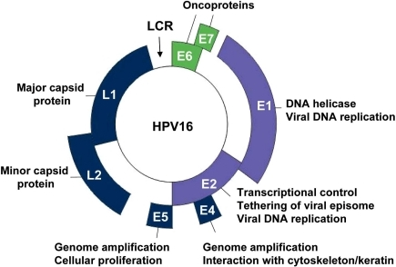
Figure 1 Genomic organization of the HPV genome
Source: D'Abramo CM, Archambault., Small Molecule Inhibitors of Human Papillomavirus Protein – Protein Interactions, J - Open Virol J (2011)

1.1.1 INFECTIVITY AND ONCOGENIC CAPABILITIES OF HPV
The Human papilloma virus infection is a very common and easily transmittable disease. One factor that makes transmission easy is its ability to remain undetectable after infection. According to the American Social Health Association, approximately 5.5 million new cases of sexually transmitted HPV infections are reported every year, though 6.2 million new infections are estimated to occur (Smith et al, 2010). In June 2013, the CDC estimated that 79 million Americans are infected with HPV, with 14 million new cases every year, of whom most do not know that they have the infection (CDC, 2013). The factors responsible for infection with HPV include multiple sexual partners, alteration and suppression of immune status as well as hormonal influences.
The HPV virus has numerous strains. They are classified into high risk, probable risk and low risk strains. The 15 subtypes for the high risk include 16, 18, 31, 33, 35, 39, 45, 51, 52, 56, 58, 59, 68, 73, and 82, probable high-risk include 26, 53, and 66, and low-risk which are 6, 11, 40, 42, 43, 44, 54, 61, 70, 72, 81, and CP6108 (Bosch et al., 2003). Studies have shown that about 40 strains of HPV’s are sexually transmitted and are in fact very easily passed from individual to individual. It is of great importance to note that contraceptive methods such as condoms, are not sufficient enough to prevent transmission as unprotected areas can still act as a route of transmission via skin contact.
Mechanism of Action
Recent studies have shown that the Human Papilloma Virus facilitates its infectivity by first binding via its L1 major capsid protein to heparan sulfate proteoglycans (HSPGs) on segments of the basement membrane (BM) exposed after epithelial trauma and undergo a conformational change that exposes the N-terminus of L2 minor capsid protein to furin cleavage. L2 proteolysis exposes a previously occluded surface of L1 that binds an as yet undetermined cell surface receptor on keratinocytes that have migrated over the BM to close the wound (Joyce et al, 1999). Papillomaviruses are also known to be the only viruses that initiate their infectious process at an extracellular site. However, some recent studies have detected the presence of HPV in the blood, which raised the possibility of blood transmission (Bodaghi et al., 2005; Chen et al., 2009; Keleher, 2009).
There are 3 types of infectious stages with human papilloma virus which are staged as Clinical, Subclinical and Latent phase. Clinical lesions include condyloma acuminatum, Bowenoid papulosis (vulvar intraepithelial neoplasia usual type) and Buschke-Loewenstein tumor. Subclinical lesions, which represent 60% of the cases of external anogenital HPV and 95% of cases of cervical HPV infection, have symptoms such as micro papillary, micropapular, spike, and keratotic lesions (Fedrizzi, 2012).

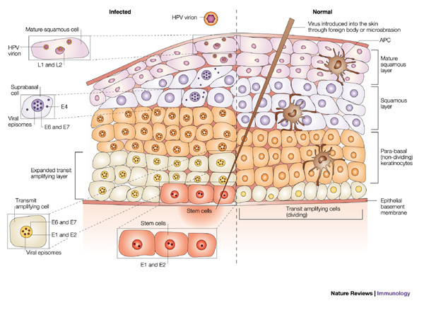
Figure 2 Cervical stratified squamous epithelial cell architecture and the expression of human papillomavirus (HPV) proteins after infection
Source: Ian H. Frazer, Prevention of cervical cancer through papilloma virus vaccinations
Nature Reviews, Immunology4, 46-55 (January 2004)

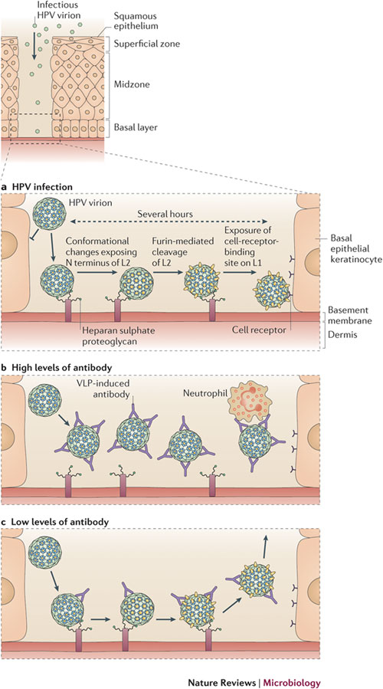
Figure 3 Mechanism of infection of cervicovaginal epithelium by human papillomavirus, and infection inhibition by virus-like particle-induced antibodies.
Source: John T. Schiller & Douglas R. Lowy, Understanding and learning from the success of prophylactic human papillomavirus vaccines, Nature Reviews, Microbiology 10, 681-692 (October 2012)

Oncogenic capability of the HPV
The initiation of cervical carcinogenesis has been linked to the expression of two oncogenes of high-risk HPVs, E6 and E7. Cell proliferation occurs following bonding of the E7 complexes and product of the Rb gene. Binding of E6 to the p53 gene's protein product degrades the latter, leading to loss of DNA repair function and prevents the cell from undergoing apoptosis (Francao et al., 2005). This leads to uncontrollable damage and further mutations.
Previous studies have associated environmental factors and specific aspects of lifestyle with cervical cancer. Studies have been reported on the relationship between these cofactors and cervical intraepithelial neoplasia (CIN 2-3) among women with a history of HPV infection with smoking being the most significant risk factor (Kjellberg et al., 2000). These investigations have shown that on examination of the cervix, nicotine derivatives like cotinine and tobacco speciﬁc nitrosamines can be detectable via tissue analysis (Szarewski & Cuzick, 1998; Simmons, 1995). Another study established that smoking affects local immune mechanisms in the cervix, with reductions in the number of Langerhans cells and other markers of immune function (Poppe et al., 1995).
Another study of 631 women in Brazil indicated a hereditary component for this neoplasia. Among genetic factors that could influence the susceptibility to this tumor and disease outcome, polymorphic genes of the major histocompatibility complex (MHC), as well as a particular polymorphism in the p53 gene have been intensely investigated. Analysis indicated that of 613 samples in Brazil, there was evidence indicating that different polymorphic human leukocyte antigen (HLA) genes are involved in the clearance and maintenance of HPV infection. In addition, the homozygous codon 72 p53-Arg gene allele is associated with susceptibility to HPV-associated cervical carcinogenesis (de Araujo Souza PS, Villa LL, 2003). This further supports previous studies that the persistence of human papillomavirus type 16 infection is associated with lack of cytotoxic T lymphocyte response to the E6 antigens (Nakagawa et al 2000). In addition, the CD8 T-cell epitopes demonstrate a striking HLA class I binding promiscuity.

1.1.2 CANCERS ASSOCIATED WITH THE HUMAN PAPILLOMA VIRUS
Oropharyngeal Cancer
Oropharyngeal cancer occurs as a result of malignant transformation of tissue within cells of the Oropharynx. Anatomically the oropharynx consists of the middle part of the throat, which includes the base of the tongue, the tonsils, the soft palate, and the walls of the pharynx.
A number of factors have been linked to the etiology of this malignancy which include, smoking, excessive alcohol intake, poor diet, asbestos exposure as well as infection with Ebstein Barr and human papilloma viruses. Studies have indicated that individuals who test positive for HPV16 oral infection have a 14 times increased risk of developing HPV+ OPC (Cleveland et al., 2011; Panders et al., 2010).
A pharmacological research study has however shed a glimmer of hope with combating head and neck tumors. The study involved a new recombinant strain of Listeria monocytogenes that was effective in treating HPV-positive tumors in a murine model. The results indicated that in C57BL/6 mice, the administration of Lm-ActA-E7 caused the complete regression of HPV-positive tumors in 6 of 8 mice tested (Sewell et al., 2004).
Cervical Cancer
Cervical cancer is a multi-etiology carcinoma that arises from precursor histological insult to the epithelial lining of the cervix. However, infection with the Human papilloma virus is a significant factor in the development of Cervical Cancer with smoking, multiple sexual partners and diet being other predisposing factors. Cervical Intraepithelial neoplasia (CIN) is one of two precursor lesions that eventually gives rise to Squamous-cell Carcinoma while Adenocarcinoma in situ gives rise to the second type of Cervical Cancer, Adenocarcinoma.
Cervical Intraepithelial Neoplasia, also called Cervical Dysplasia, is a precancerous condition stemming from abnormal cell growth on the internal lining of the Cervix. It is classified based on histological depth of infection into three (3) categories. CIN 1 is the mildest form of the neoplasia and corresponds with infection with the human papilloma virus with involvement of one-third of the Basal epithelium. More often than not, it clears depending on the body’s immune function. CIN 2 affects two-thirds of the basal epithelium and is otherwise called moderate dysplasia. CIN 3 represents the most severe form with involvement of greater than two thirds of the basal epithelium and this is otherwise known as Carcinoma In situ. The CIN 1 doesn’t usually require treatment, while the other two groups are usually treated using various surgical techniques as therapy.

THE HUMAN PAPILLOMA VIRUS VACCINEs

HISTORY OF HPV VACCINATIONS
The earliest concept relating to the development of vaccines can be traced to the year 1796 by a doctor living in Berkeley, England by the name Edward Jenner, who performed the world’s first vaccination using an inoculation derived from a cow’s lesion to confer immunity (Baxsby, 1994). This provided a fundamental knowledge of how current vaccines have been developed. The transmogrification and manipulation of animal antibodies have paved way for the development of wide varieties of vaccines in combating various diseases.
In the 1980’s, two Australian scientists at the University of Rochester, Georgetown successfully created virus like particles (VLP) that could initiate immunity to the recipient while being noninfectious. This spurred further investigations that eventually led to the creation of the HPV VL16 by the US National Cancer Institute.
Gardasil, which was manufactured by Merck&Co, is one of the two popular vaccines against HPV and was developed as a result of extensive research and development. Gardasil is a recombinant prophylactic vaccine that was approved by the FDA for prevention of anal cancer and associated precancerous lesions in December 2010. It was specific to preventing human papillomavirus of types 6, 11, 16, and 18.
The other vaccine, Cervarix, was developed by two Australian scientists from the Georgetown University medical center to prevent infections from HPV 16 and 18. It was approved by the Food and Drug administration for use in October 2009 (FDA, 2009). Cervarix, which is being manufactured by GlaxoSmithKline, was created as a direct competition to Gardasil. While both vaccines cannot cover all types of strains of the HPV, the latter which is a quadrivalent vaccine, covers more strains of HPV in comparison to the former, which is a bivalent vaccine. However, a study indicated that Gardasil was very effective against genital wart formation from human papilloma virus infection, as well as the development of Cancer, while Cervarix was more effective in preventing precancerous lesions and cancer. In addition, findings indicated that Cervarix was effective for up to 6.4 years while Gardasil was effective for only 5years (Harper, 2009). This suggests that both vaccines are beneficial with their own distinct advantages and disadvantages.
Mechanism of Action of the Vaccines
Fermentation of recombinant Saccharomyces cerevisiae, a specific species of yeast, yields the recombinant virus like particles, the active constituent of the Gardasil Vaccine. Gardasil is an adjuvanted non-infectious recombinant quadrivalent vaccine prepared from the highly purified virus-like particles (VLPs) of the major capsid L1 protein of HPV types 6, 11, 16 and 18. The VLPs contain no viral DNA, they cannot infect cells, reproduce or cause disease. HPV only infects humans, but animal studies with analogous papillomaviruses suggest that the efficacy of LI VLP vaccines is mediated by the development of a humoral immune response (Whelan, 2013).
Effectiveness of the Vaccine
Records from the Food and Drug Administration have indicated that the Gardasil vaccine sufficiently produces a high level of efficacy in regards to prevention. A number of Clinical trials were undertaken by Merck&Co prior to approval. The results (table 2) show only few cases related to genital diseases occurred after HPV vaccination. Prophylactic efficacy against overall cervical and genital disease related to HPV 6, 11, 16, and 18 in the clinical trials, was noted to be 100% (95% CI: 12.3%, 100.0%) among subject in the per-protocol population (PPE) naïve to the relevant HPV types. The conclusion was that the prophylactic vaccine was efficacious against HPV disease caused by HPV types 6, 11, 16, and 18 in women who were naïve for those specific HPV types at baseline.

Table 1Analysis of efficacy of Gardasil in the per protocol efficacy (PPE) population of 16 through 26 year old women for vaccine HPV types
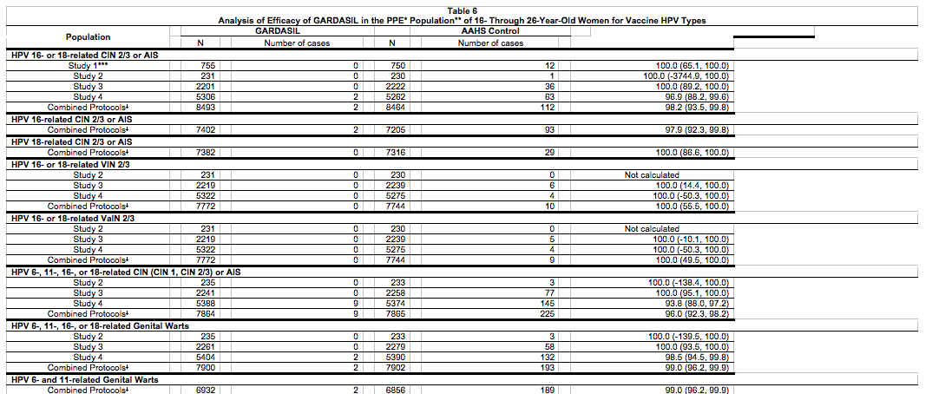
Source: Clinical trials of Gardasil, Merck Sharp & Dohme Corp 2006, 2009, 2010, 2011

The PPE population consisted of individuals who received all 3 vaccinations within 1 year of enrollment, did not have major deviations from the study protocol and were PCR negative and seronegative to HPV types 6,11,16 and 18 prior to dose 1 and through 1 month postdose 3 (month7)

SAFETY AND SIDE EFFECTS OF THE VACCINE
The Human papilloma vaccines are considered very safe because they do not contain live viruses that can replicate or pose a peril to immune compromised individuals. However, like with other vaccines, there are still a number of reported side effects such as generalized adverse effects, which involve the entire body system. Generalized adverse effects include vomiting, dizziness, headache, fever, fainting and rash development. The other type of adverse reactions is the localized adverse effects as a result of reaction at the site of injection. These include swelling, redness and pain arising from localized inflammatory reaction.
A number of database systems have been set up to monitor reports of adverse effects that might possibly arise as a result of vaccination. The most notable one is the Vaccine Adverse Event Reporting System (VAERS), a product of a collaboration between the Centers for Disease Control and the Food and Drug Administration that contains details surrounding the reported adverse effects of a particular vaccination event. Records from the system indicates 20 deaths in possible relation to the administration of the vaccine. However, the specifics of each case reveal no clear cut pattern to indicate that the deaths are directly attributable to the vaccines. The benefits of the vaccine far outweigh the risk and this is of importance in parent enlightenment regarding vaccination.

VACCINATION
Gardasil is indicated in males and females 9 through 26 years old for the prevention of cervical cancer, vaginal cancer, vulvar cancer, anal cancer, genital warts, precancerous and dysplastic lesions. It’s pertinent to note that it is not intended as a post-infection remedy or cure.
It comes in a sterile suspension and is administered intramuscularly with preferred site of administration being the deltoid region of the upper arm. In addition to some inactive agents, each dose of 0.5 ml contains 20 microgram of HPV 6 L1 protein, 40 microgram of HPV 11 L1 protein, 40microgram of HPV16 L1 protein and 20 microgram of HPV 18L1 protein indicating it quadrivalent capability. It is given in 3 separate doses over a 6month period. Once started, the second dose should be given two months after the first with a third dose given six months after the first dose. There have been some noted adverse effects in some cases following administration, which include swelling and pain at the inoculation site as well as erythema and pruritus around those areas.
Cervarix in contrast to Gardasil is a bivalent vaccine that protects against young women only as it isn’t licensed for use in Males. Cervarix is approved for females between the ages 10 through 25. It comes in a homogenous, white, suspension. Its dosage and administration is similar to that of Gardasil. It however doesn’t cover HPV 6 and 11.Reported side effects include pain, erythema and swelling of the injection site, menstrual pain, cough and runny nose.
Complying with this proposed schedule is a major challenge amongst adolescent females. A number of researchers have investigated whether a reduced number of doses confer the same immunity as taking all three. Researchers at the University of British Columbia were able to show that with two doses of the vaccine, antibody titer of serotypes 16 and 18 was significantly reduced (Dobson, 2013).

AWARENESS OF VACCINATION AND COMPLIANCE
Survey results suggest that in 2009, only 44% of US girls aged 13 to 17 years had received 1 or more HPV vaccines, and only 27% of US girls had received 3 HPV vaccines (Stokley S, Cohn A, Dorell C, et al., 2011). In comparison, developed countries such as England, through their annual data report, indicate that through 2012 to 2013, the hpv vaccination coverage rate was 86% in the target age group of 12 – 13 year old girls.
It is important to note that some of these countries have fixed programs and ‘catch up’ programs implemented specifically for the administration of the Human Papilloma Virus Vaccine.
In two countries, Bulgaria and Czech Republic, the recommendation has been produced, but the HPV vaccination has actually been integrated into the national immunization program. In 19 countries (Austria, Belgium, Denmark, France, Germany, Greece, Iceland, Ireland, Italy, Latvia, Luxembourg, the Netherlands, Norway, Portugal, Romania, Slovenia, Spain, Sweden, the United Kingdom) the program is currently active, and ten of them have also introduced catch-up programs for women (Dorleans et al., 2010) . A well-structured program to carry out the immunization process appears to be a key factor in achieving high coverage rate in a country.
A major factor affecting the compliance with Human Papilloma Virus vaccine in the United States appears to be the cost. In countries in the European Union, the vaccination programs are funded by the National Health Systems. As of 2010, thirteen countries (Denmark, France, Ireland, Italy, Latvia, Luxembourg, the Netherlands, Norway, Portugal, Romania, Slovenia, Sweden and the United Kingdom) had declared that there was a national HPV vaccination coverage monitoring system in place for routine immunization. Five of these countries (France, Italy, the Netherlands, Norway and Sweden) reported the existence of systems in place to follow up on adults/adolescents. For the countries not fully covered, a major portion of the vaccination fee is covered by the National Health System of the particular country involved. In 2010, out of seven countries for which data were available, only Portugal and the United Kingdom had vaccination coverage rates of ≥80%; Denmark and Italy ranged from 50–60%; France, Luxembourg and Norway had rates of ≤30%. The same applied to catch-up coverage, which ranged from 29–73%. Gardasil is not covered by all insurance providers in the United States and there is no mandatory vaccination requirement all over the country. On February 2, 2007, Texas became the first state to enact a mandate-by executive order from the governor-that all females entering the sixth grade receive the vaccine, with some exceptions. On March 2007, the Virginia legislature passed a school vaccine requirement and sent it to the governor for approval. This approach might be the solution to reducing future incidence of cervical cancer. A number of states have various legislation regarding vaccination against Human Papilloma Virus. These include including Colorado, District of Columbia, Illinois, Indiana, Iowa, Louisiana, Maine, Maryland, Michigan, Minnesota, Missouri, Nevada, New Mexico, New York, North Carolina, North Dakota, Oregon, Puerto Rico, Rhode Island, South Dakota, Texas, Utah, Virginia, Washington and Wisconsin. Most of the legislation involves offering screenings as part of the insurance or providing the option for vaccination as well as providing educational awareness in each state.
The Medicaid Vaccine for Children (VFC) is a program funded by the government that empowers CDC to purchase vaccines at discount prices for distribution to health facilities. However, an eligibility requirement restricts the children that can have access to this kind of offer. In addition, the Immunization Grant Program, a federal program through which the CDC awards grants to state and local territories to fund children that might not qualify for the VFC program.

HEALTH BELIEF THEORY
The Health belief Model helps one to understand an individual’s attitude or belief about seeking preventive measures or services such as vaccination for a better quality of life. The Health Belief Model proposes that people will respond best to messages about health promotion or disease prevention when he/she believes that a risk for developing a condition exists, the result is undesirable and that the risk is serious, a behavioral change would reduce the risk and that potential barrier to these changes can be overcome. The health belief theory has largely been used to study most sexually transmitted disease studies. It has six major components which are:
Perceived Susceptibility: This analyzes the belief about why an individual isn’t going to change a behavior unless they believe they are at risk. In the context of HPV infection, there might be the belief that condoms offer total protection against infection. However, the virus can still be deposited in areas not covered and deposition on skin can still transform into warts.
Perceived Severity/Seriousness: This analyzes the degree of seriousness a person feels to contracting a disease or illness which might include death and disability as well as psychosocial problems. With active infection with HPV, there is a high chance in females of development of Cervical Carcinoma later in life. 80% of sexually active people between ages 14-44 have had oral sex with an opposite partner which is a major factor for the development of Oropharyngeal cancer.
-Perceived Benefits: This emphasizes the individual’s belief that a given health intervention of treatment will cure or prevent an illness or negative health outcome. Based on the effectiveness of the vaccines, an individual should be enlightened as part of health education on how beneficial the vaccine is to health.
Perceived Barriers/Costs: This examines belief about the potential negative aspects of a particular health action that might hinder seeking positive health intervention. The major barrier associated with receiving the vaccination is the cost of the vaccines. The 3 course vaccine has been discovered to be the most expensive vaccination ever approved by the Food and Drug Administration (FDA). Another barrier that is noteworthy is the parental refusal to allow their children to get vaccinated as it might encourage promiscuity.
Cues to Action: This examines the impetus or motivation needed for seeking engagement in health promoting behavior. An individual clearly needs to see the benefit of taking a vaccine while considering the financial implication. Media campaigns similar to smoking cessation programs might be necessary to facilitate improved vaccination rate.
Self-Efficacy: Belief that one can achieve the behavior required to execute the outcome.

The Health Belief model is a perfect fit for analyzing the acquiescence regarding vaccination against the Human Papilloma Virus. The prevalence of HPV infection among US females to be over 25% (approximately 25 million women), with women ages 20–24 experiencing the highest prevalence at 45% (Dunne et al., 2007). Studies have been carried out to assess compliance with the HPV vaccine. One particular study used a Health belief model to assess barriers to HPV vaccination uptake and adherence, particularly among women of Appalachian Kentucky, a population with higher rates of cervical cancer, lower rates of HPV vaccination, and lower socioeconomic status compared with the rest of the nation (Vanderpool et al., 2011). The results (Table 2) indicated that the predictor variables “in general, vaccines are a good thing” (P=. 02) and “I believe that getting the vaccine will be painful” (P=. 03) were statistically significant. Predictor variables ‘worry about having HPV (P=. 07), HPV serious enough for vaccination [P=. 43], and not sure vaccine is safe (P=. 22) were not significant in the model.
The conclusion was that lower rate of HPV vaccination could be attributed to their misunderstanding the HPV virus and its vaccine. Other barriers that contributed to low compliance also included cost, limited transportation, geographic distance, and lack of insurance.
Socioeconomic disparity proves to be a very significant factor in the distribution of the disease in a country.

Table 2 Bivariate associations between HPV related risk perceptions and HPV vaccine uptake
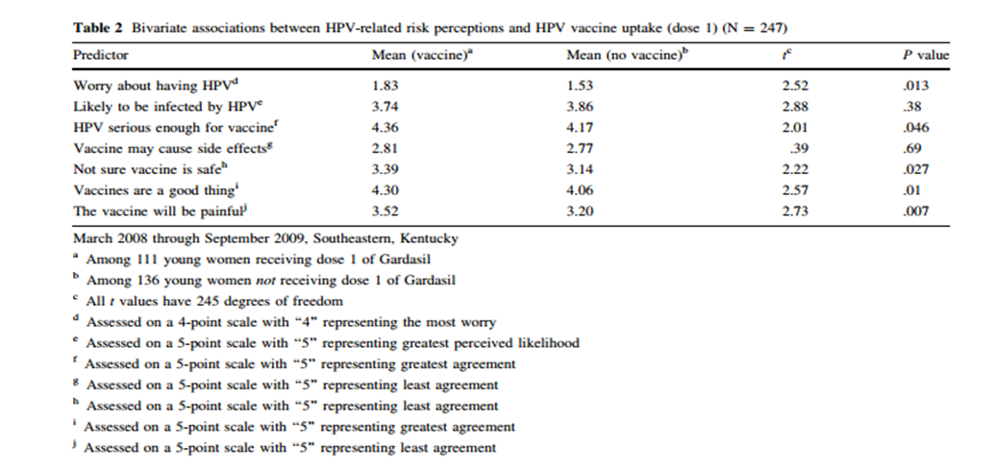
Source: Vanderpool RC1, Casey BR, Crosby RA. HPV-related risk perceptions and HPV vaccine uptake among a sample of young rural women. J Community Health. 2011 Dec; 36 (6): 903-9

ANALYTICAL SECTION
HPV causes a substantial disease burden, resulting in high and indirect costs. In 2006, it was estimated that approximately $1.4 billion is spent on cervical cancer treatment each year in the United States.
A recent report on oropharyngeal cancers titled “Annual Report to the Nation on the Status of Cancer, 1975-2009’’ gave the following statistics:
From 2005 to 2009, incidence rates of oropharyngeal Cancers were four times higher among men than women (8.2 versus 1.8 cases per 100,000 persons, respectively), with the highest incidence rates found in white and black men (8.5 and 7.9 cases per 100,000 persons).
Also, incidence rates of HPV-associated oropharyngeal cancer increased among white men (3.9%) and women (1.7%) over the same time period.
Of the 13,446 new HPV-associated cancer cases among men in 2009, 78.2% were HPV-associated cancers of the oropharynx.
Although cervical cancer remains the primary HPV-associated cancer among women, comprising 53.4% of U.S. cancer cases in 2009, 11.6% of HPV-associated oropharyngeal cancers also occurred in women (Chaturvedi AK, Engels EA, Pfeiffer RM, et al., 2011)
Exposure to human papillomavirus occurs commonly through sexual contact, and oncogenic HPV types have been increasingly shown to be associated with squamous cell cancers of the oropharynx. Over 90 percent of HPV-positive oropharyngeal cancers are associated with HPV-16 and HPV-18, the two oncogenic subtypes of HPV.
The plots below illustrate an evaluation of the distribution of HPV and genital warts prevalence in young females (CDC, 2012). The box plot below indicates a highest percentage of high risk HPV infection between the ages 20-24. A study conducted on 11- to 29-year-old enrollees of Northern California Kaise for 4 years before the arrival of the HPV vaccine, discovered that of the 1,682 cases identified, the incidence of genital warts was highest among persons aged 20 to 24 years This might indicate a need to target the young adult population as opposed to the young female teenagers. The incidence rate was highest among women (6.3/1000 person-years) and men (2.9/1000 person-years) aged 20 to 24 years old. (Camenga DR1 et al., 2013 )
Figure 4 Prevalence of high risk and low risk types among females aged 14-59 years.
Source: Hariri S, Unger ER, Sternberg M, Dunne EF, Swan D, Patel S et al., 2003-2006 Prevalence of genital human papillomavirus among females in the United States, the National Health And Nutrition Examination Survey, 2003-2006 J Infect Dis. 2011 Aug

In a report, co-authored by researchers from the American Cancer Society, the Centers for Disease Control and Prevention, the National Cancer Institute (NCI), and the North American Association of Central Cancer Registries, used data drawn from the National Program of Cancer Registries and/or the Surveillance, Epidemiology, and End Results (SEER) database. In 2010, 48.7% of girls of 13 to 17 years of age had received 1 or more doses of the vaccine; only 32.0% had received the 3 recommended doses (Jemal A et al., 2013) . In 2012, records show that only about one-third (33.4%) of adolescent girls aged 13-17 received all 3 doses of the vaccine in 2012 The Map (Figure 5) gives a geographic information display of the vaccination completion in the United States.

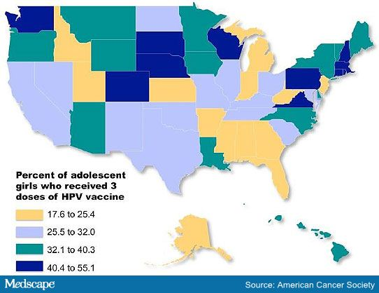
Figure 5 Percent of adolescent girls who received 3 doses of HPV vaccine
Source: American Cancer Society

A single dose wouldn’t confer immunity against the Human Papilloma Virus and those who miss the proposed vaccination schedule are required to start over again. With close to 50% of the target population without the completed vaccination, there is an urgent need to develop alternative strategies for getting the majority of these young females to be vaccinated.

SUMMARY, DISCUSSION AND CONCLUSIONS
The Human Papilloma virus infection still poses a threat to society based on the relative lack of awareness in the United States. It has been established as a necessary factor in the manifestation of cervical carcinoma. The findings of the infectivity pattern and pathogenic potential have been fairly consistent based on research. With the implementation of screening technology, more people are relying on the secondary preventive method rather than primary prevention. The efficacy of the HPV vaccines in curbing infections has yielded excellent results.
There are multiple factors influencing the low compliance of vaccination. The financial cost is one of the major barriers and can be tackled using a program similar to National Health programs in other developed countries, except this program would solely cater for high risk infections such as the Human Papilloma Virus and Hepatitis B infection. As parents still have to give consent to the administration of vaccines for the younger population, the fear of encouraging promiscuity arises, but it is important for Primary Care physicians and other health care providers to remove any doubts from the parent’s mind and encourage early vaccination. With health care costs being so high in the United States and a large proportion of the population still uninsured, it would be best to seek early intervention methods like vaccination rather than having to wait for the management of a chronic disease. There have been studies that have shown the possible benefit of the administration of two doses of the Gardasil Vaccine with substantial benefit and reduced risk of Cervical Cancer.This step and possible implementation would reduce the overall costs of the full course of vaccination.Another area worth looking into is investigating research supporting an increased timeline between succesive doses of vaccine administration.This might be beneficial towardincreasing compliance as many people find it hard to complete dose schedule after the initial dose and are forced to restart if its not completed within the recommended timeline.
Policies have an important role to play in decreasing the incidence of infection and prevalence of cervical cancer. Mandatory immunization for all states, as implemented in some states like Texas, Virginia and Washington, would definitely face opposition, but it is up the Public Health leaders to bring the silent threat of diseases to the lime light. A collaborative effort between hospitals, health departments, state and local governments would be ideal in achieving this goal. Hospital administrations should enact policies that would mandate primary health care givers to recommend early vaccination of young adolescents. Mothers are more likely to trust the opinion of a family doctor than a general health talk or campaign. Not receiving a health care recommendation has been shown to be one of the top 5 reasons for not vaccinating daughters according to the NIS 2012 data. A substantial group of the population still believe receiving the Influenza vaccine can cause them to come down with the flu. This fear could also be the case in receiving the HPV vaccine. Health education of vaccines and safety should be integrated into the educational curriculum to further enlighten the students that are the vulnerable population about the safety of the vaccine.
The health reform law, the Affordable Care Act, ACA, has increased preventive services as part of its benefits. Under the no-out-of-pocket expenses for essential preventive health care provision of ACA, women who are aged 30 and older can under HPV DNA testing without having to pay any extra out-of-pocket costs beyond the premiums they pay for their insurance. In addition, the ACA requires vaccination against quadrivalent human papillomavirus vaccine, diphtheria, tetanus, hepatitis A&B, inactivated polio virus amongst others. However, there arises the issue of the uninsured population. Approximately 40-50 million people are uninsured. This figure has dropped slightly after the introduction of the ACA, but the fact still remains that a large proportion of people are uninsured. Therefore, they can’t benefit from the preventive services offered to them.
In addition, one dose of Gardasil costs about $150 leading to a total of about $450 for the complete vaccination program. As this high cost can prove an impedement against compliance, discounted alternatives must be sought to create a more pocket friendly price. This would cut down the huge amount of money accrued from treatment of Cervical cancer.
In conclusion, the Public Health sector has a major role to play in alleviating the incidence of Human Papilloma Virus infection. As more people sign up for insurance, a major step is to enlighten and encourage individuals to seek vaccination.

BIBLIOGRAPHY
ADA Council on Scientific Affairs. Statement on Human Papillomavirus and Squamous Cell Cancers of the Oropharynx (adopted November 2012). Available at: “http://www.ada.org/1749.aspx”. Accessed January 14, 2013.
Bodaghi S, Wood LV, Roby G, Ryder C, Steinberg SM, Zheng ZM (November 2005). "Could human papillomaviruses be spread through blood?" J. Clin. Microbiol. 43 (11): 5428–34.
Camenga DR1, Dunne EF, Desai MM, Gee J, Markowitz LE, Desiliva A, Klein NP. Incidence of genital warts in adolescents and young adults in an integrated health care delivery system in the United States before human papillomavirus vaccine recommendations Sex Transm Dis. 2013 Jul; 40 (7): 534-8
Chaturvedi AK, Engels EA, Pfeiffer RM, et al. Human papillomavirus and rising oropharyngeal cancer incidence in the United States. J Clin Oncol 2011; 29: 4294–4230.
Chen AC, Keleher A, Kedda MA, Spurdle AB, McMillan NA, Antonsson A (October 2009)."Human papillomavirus DNA detected in peripheral blood samples from healthy Australian male blood donors". J. MED. Virol. 81 (10): 1792–6
Chouhy D, Bolatti EM, Perez GR, Giri AA (2013) Analysis of the genetic diversity and phylogenetic relationships of putative human papillomavirus types. J Gen Virology
Christopher B. Buck, Cynthia D. Thompson, Yuk-Ying S. Pang, Douglas R. Lowy, and John T. Schiller Maturation of Papillomavirus Capsids * Journal of virology Virol. (March 2005) vol. 79 no. 5 2839-2846
Cleveland JL, Junger ML, Saraiya M, et al. The connection between human papillomavirus and oropharyngeal squamous cell carcinomas. Implications for dentistry. J Am Dent Ass 2011;142 (8): 915-924.
Danos O, Katinka M, Yaniv M. Human papillomavirus 1a complete DNA sequence: a novel type of genome organization among papovaviridae. EMBO J. 1982;1:231–236
D. Baxby, Jenner’s Smallpox Vaccine: The Riddle of Vaccinia Virus and Its Origin (London: Heinemann Educational Books, 1981); D. Baxby, Smallpox Vaccine, Ahead of Its Time (Berkeley, U.K.: Jenner Museum, 2001) ; and D. Baxby, Vaccination: Jenner’s Legacy (Berkeley, U.K.: Jenner Educational Trust, 1994)
De Villiers EM, Fauquet C, Broker TR, Bernard HU, zur HH. Classification of papillomaviruses. Virology. 2004;324:17–27
Dobson S, et al "Immunogenicity of 2 doses of HPV vaccine in younger adolescents vs 3 doses in young women: A randomized clinical trial" JAMA 2013; 309: 1793-1802.
Dorleans F, Giambi C, Dematte L, Cotter S, Stefanoff P, Mereckiene J, et al. On behalf of the VENICE 2 project gatekeepers group. The current state of introduction of human papillomavirus vaccination into national immunization schedules in Europe: first results of the VENICE2 2010 survey. Eurosurveill. (2010)15(47):19730.
Dunne, E. F., Unger, E. R., Sternberg, M., Et al. (2007). Prevalence of HPV infection among females in the United States. JAMA, 297 (8), 813–819.
Edison Natal Fedrizzi (2012). Clinical Manifestations of Genital HPV Infection, Human Papillomavirus and Related Diseases - From Bench to Bedside - A Clinical Perspective, Dr. Davy Vanden Broeck (Ed.), ISBN: 978-953-307-860-1, InTech, DOI: 10.5772/27845
Eduardo L. Francoa, Diane M. Harper (2005) Vaccination against human papillomavirus infection: a new paradigm in cervical cancer control
FDA Licensure of Bivalent Human Papillomavirus Vaccine (HPV2, Cervarix) for Use in Females and Updated HPV Vaccination Recommendations from the Advisory Committee on Immunization Practices (ACIP) MMWR. Morbidity and mortality weekly report 59 (20): 626–629
FDA: Gardasil approved to prevent anal cancer (Press release). U.S. Food and Drug Administration (FDA). December 22, 2010. Retrieved 2011-01-04
Finalized report on the decision making process, modalities of implementation and current country status for the introduction of human papilloma virus and rotavirus vaccination into national immunization programs in Europe. VENICE 2. WP 3, Dec 2010.
‘Gardasil’ medicines.org.uk, 27 March 2014, Datapharm Communications Limited Web. March 27 2014 <http://www.medicines.org.uk/emc/medicine/19016/SPC/gardasil/>
Harper DM. (2009) Current prophylactic HPV vaccines and gynecologic premalignancies. Curr Opin Obstet Gynecol. 2009 Dec; 21 (6): 457-64
Hariri S, Unger ER, Sternberg M, Dunne EF, Swan D, Patel S et al., (2003-2006) Prevalence of genital human papillomavirus among females in the United States, the National Health And Nutrition Examination Survey, 2003-2006 J Infect Dis. 2011 Aug
‘Human Papillomavirus Vaccination Coverage among Adolescent Girls, 2007–2012, and Post licensure Vaccine Safety Monitoring, 2006–2013 — United States’. CDC.gov Centers for Disease Control and Prevention MMWR July 26, 2013
Jemal A, Simard EP, Dorell C, Noone AM, Markowitz LE, Kohler B, Eheman C, Saraiya M, Bandi P, Saslow D, Cronin KA, Watson M, Schiffman M, Henley SJ, Schymura MJ, Anderson RN, Yankey D, and Edwards BK. Annual Report to the Nation on the Status of Cancer, 1975–2009, Featuring the Burden and Trends in HPV-Associated Cancers and HPV Vaccination Coverage Levels. Journal of the National Cancer Institute; Published online Jan. 7, 2013.
Jennifer S. Smith, Stephen Moses, Michael G. Hudgens, Corette B. Parker, Kawango Agot, Ian Maclean, Jeckoniah O. Ndinya-Achola, Peter J. F. Snijders, Chris J. L. M. Meijer, and Robert C. Bailey. Increased Risk of HIV Acquisition among Kenyan Men with Human Papillomavirus Infection. Journal of Infectious Diseases, (2010). 201(11):1677–1685
Jindrich Pazderaa, Petr Michla, Martin Prochazkab, Richard Pinka, Tatana Stosova Human Papillomavirus in the etiology of head and neck carcinoma Biomed Pap MED Fac Univ Palacky Olomouc Czech Repub. 2010, 154(1):9-12
John T. Schiller & Douglas R. Lowy (2012). Understanding and learning from the success of prophylactic human papillomavirus vaccines. Nature Reviews Microbiology 10, 681-692
Joyce JG, Tung JS, Przysiecki CT, Cook JC, Lehman ED, Sands JA, et al. The L1 major capsid protein of human papillomavirus type 11 recombinant virus-like particles interacts with heparin and cell-surface glycosaminoglycans on human keratino-cytes. J Biol Chem. (1999);274:5810–22. [PubMed]
Kjellberg, L., Hallmans, G., Ahren, a M., Johansson, R., Bergman, F., Wadell, G., Dillner, J. (2000). Smoking, diet, pregnancy and oral contraceptive use as risk factors for cervical intra-epithelial neoplasia in relation to human papillomavirus infection. British Journal of Cancer, 82 (7), 1332–8. doi:10.1054/bjoc.1999.1100
M. E. Hagensee., N. H. Olson., T. S. Baker., D. A. Galloway (1994) Three-Dimensional Structure of Vaccinia Virus-Produced Human Papillomavirus Type 1 Capsids. J. Virol; 4503-4505.
Motoyama S., Ladines-Llave, C. A, Luis Villanueva, S., & Maruo, T. (2004). The role of human papilloma virus in the molecular biology of cervical carcinogenesis. The Kobe Journal of Medical Sciences, 50 (1-2), 9–19. Retrieved from http://www.ncbi.nlm.nih.gov/pubmed/15342967
Münger, K., & Howley, P. M. (2002). Human papillomavirus immortalization and transformation functions. In Virus Research (Vol. 89, pp. 213–228). Do: 10.1016/S0168-1702 (02)00190-9
Muñoz N, Bosch FX, de Sanjosé S, Herrero R, Castellsagué X, Shah KV, Snijders PJ, Meijer CJ (2003). "Epidemiologic classification of human papillomavirus types associated with cervical cancer". N. Engl. J. Med. 348 (6): 518–27
Nakagawa, M., D. P. Stites, S. Patel, S. Farhat, M. Scott, N. K. Hills, J. M. Palefsky, and A. B. Moscicki. (2000). Persistence of human papillomavirus type 16 infection is associated with lack of cytotoxic T lymphocyte response to the E6 antigens. J. Infect. Dis. 182:595-598.
Poppe WA, Ide PS, Drijkoningen MP, Lauweryns JM, Van Assche FA (1995) Tobacco smoking impairs the local immunosurveillance in the uterine cervix. An immunohistochemical study. Gynecol Obstet Invest 39: 34–38
Robin C. Vanderpool, Baretta R. Casey, Richard A. Crosby HPV-Related Risk Perceptions and HPV Vaccine Uptake among a Sample of Young Rural Women. J Community Health (2011) 36:903–909
Romanowski B1, Schwarz TF, Ferguson LM, Peters K, Dionne M, Schulze K, Ramjattan B, Hillemanns P, Catteau G, Dobbelaere K, Schuind A, Descamps D Immunogenicity and safety of the HPV-16/18 AS04-adjuvanted vaccine administered as a 2-dose schedule compared with the licensed 3-dose schedule: results from a randomized study Hum Vaccin. 2011 Dec; 7 (12): 1374-86. Do: 10.4161/hv. 7.12.18322.
Rosenstock, I. M. (1974). Historical origins of the health belief model. Health Education & Behavior, 2, 328–335. doi:10.1177/109019817400200403
Rossana de Araújo Catão Zampronha,I Ruffo Freitas-Junior,I Eddie Fernando Candido Murta,II Márcia Antoniazi Michelin,III Aline Almeida Barbaresco,IV Sheila Jorge Adad,V Amaurillo Monteiro de Oliveira,I Amanda B. Rassi, I and Glória Jabur Bittar OtonI (2013) Human papillomavirus types 16 and 18 and the prognosis of patients with stage I cervical cancer Clinics (Sao Paulo). Jun 2013; 68 (6): 809–814
Roxanne Nelson HPV Cancers Increase, Vaccination Rates Remain Low. Medscape. Jan 09, 2013
Sewell DA, Douven D, Pan Z, Rodriguez A, Paterson Y.(2004)Regression of HPV-Positive Tumors Treated With a New Listeria monocytogenes Vaccine. Arch Otolaryngol Head Neck Surg.;130(1):92-97. doi:10.1001/archotol.130.1.92
Simons AM, Mugica VH, Rodriguez JA, et al. (1995) Demonstration of smoking-related DNA damage in cervical epithelium and correlation with human papillomavirus type 16, using exfoliated cervical cells. Br J Cancer 71: 246–249.
Stokley S, Cohn A, Dorell C, et al. Adolescent vaccination-coverage levels in the United States (2006-2009) [published online ahead of print November 14, 2011]. Pediatrics. 2011 Dec; 128 (6): 1078-1086
Szarewski A, Cuzik J. (1998) Smoking and cervical neoplasia: a review of the evidence. J. Epidemiol Biostat.;3:229–256.
‘The Health Belief Model’. euromedinfo.edu, March 25 2014 <http://www.euromedinfo.eu/the-health-belief-model.html/> web. March 25 2014
Whelan M. (2013)WP 1 - Design of universal influenza VLPs based on tandem core technology Biosafety Report10-11
Zur Hausen, H. (1999) Papillomaviruses in human cancers. Proceedings, Association of American Physicians 111:581-587

