POLICY IMPACT ON CHINA’S RURAL HEALTH SYSTEM

by
Tina Phillips Johnson
PhD, University of Pittsburgh, 2006
MA, University of Pittsburgh, 1999
MLA, Johns Hopkins University, 1997
BA, Oklahoma State University, 1990

Submitted to the
Graduate School of Public Health in partial fulfillment
of the requirements for the degree of
Master of Public Health

University of Pittsburgh
2014

UNIVERSITY OF PITTSBURGH
GRADUATE SCHOOL OF PUBLIC HEALTH

This essay is submitted
by
Tina Phillips Johnson

on

November 20, 2014
and approved by

Essay Advisor:
David N. Finegold, MD ______________________________________
Director, Multidisciplinary MPH Program
Professor, Human Genetics
Graduate School of Public Health
University of Pittsburgh

Essay Reader:
Martha Ann Terry, PhD ______________________________________
Assistant Professor
Behavioral and Community Health Sciences
Graduate School of Public Health
University of Pittsburgh

Copyright © by Tina Phillips Johnson
2014
ABSTRACT

David N. Finegold, MD

POLICY IMPACT ON CHINA’S RURAL HEALTH SYSTEM

Tina Phillips Johnson, PhD
University of Pittsburgh, 2014

Village doctors in rural China are increasingly faced with fewer resources and limited knowledge when it comes to dealing with a wide array of communicable and chronic medical problems. The Chinese government has implemented wide-ranging policy changes to address problems of health care access and quality of care, namely the New Cooperative Medical Scheme and the National Essential Medicines Scheme that prevents providers from profiting from pharmaceutical sales. This paper explores the impacts of these 2009 policy reforms on rural clinics in two areas. First, through quantitative analysis, the impact of the 2009 reforms on clinic revenue is examined. Clinic revenue is an important indicator of whether village and township clinic doctors may seek other means of increasing income that may create skewed prescribing and treatment practices. Second, this paper provides a qualitative analysis of village and township health center doctors’ personal opinions of these health policy reforms.
This project is significant for public health because the role of village doctors in China is to provide the first level of health care for the more than 600 million rural inhabitants that comprise half of China’s population. The rural poor are overburdened with both non-communicable and communicable diseases throughout China, a disease pattern that is exacerbated by out-migration to cities of the working-age population, leaving behind the elderly and children in rural areas with little source of income. Furthermore, China’s aging population significantly contributes to the rise in non-communicable diseases. The confluence of a complex disease burden, considerable policy shifts, as well as growing patient demands all affect rural village doctors and their ability to provide quality care for their constituents. Ultimately, this research will provide health care workers, government officials, non-governmental organizations, as well as scholars and researchers, a better understanding of the impacts of major policy reforms on both providers and patients.

TABLE OF CONTENTS
acknowledgements ix
1.0 Introduction 1
2.0 china’s changing burden of disease 4
2.2 Public health priorities 10
2.3 CHINA’S HEALTH CARE SYSTEM 13
3.0 METHODS 15
3.1 data collection 15
3.2 data analysis 16
4.0 results 18
4.1 The setting: field notes from shangluo prefecture, shaanxi 18
4.2 zero-profit drug sales policy 22
4.3 new cooperative medical Scheme 24
5.0 discussion 28
5.1 zero-profit drug sales policy 28
5.2 new cooperative medical Scheme 30
6.0 conclusion and recommendations 31
6.1 limitations 33
APPENDIX: CODING DOCUMENT 34
bibliography 35
List of figures
Figure 1. Population pyramids for China: 1950, 2010, 2050 5
Figure 2. Tongchang village public health clinic, May 2013 19
Figure 3. Wanwan village gate, March 2014 20
Figure 4. Wanwan village public health center, March 2014 21
Figure 5. Impact on total village clinic revenue of zero-profit drug sales policy 23
Figure 6. Impact on total village clinic revenue of NCMS 25
Figure 7. Revenue impact of NCMS on township health centers 27
acknowledgements

I would like to thank the Northwest Socioeconomic Development Research Center (NSDRC) for its support. NSDRC director Dr. Yaojiang Shi provided the opportunity to work with his organization, utilize the survey data, and make site visits to rural villages. His graduate students, especially Yang Chu and Hao Xue, answered numerous questions and clarified survey responses. Dr. James Cook and Xia Yaqin, MD, were excellent companions on the site visits as we worked out project design and goals. The University of Pittsburgh Asian Studies Center provided partial funding. Dr. David Finegold and Dr. Martha Terry have been encouraging and sensitive mentors throughout the project.

Introduction
China has undergone extensive social, political, and economic change over the past several decades, and many of its people have seen tremendous improvements in standard of living, education, and life expectancy. However, since the economic reforms of the 1980s discrepancies in income and social service access have plagued society. The rural-urban transition, considered to be the largest human migration in recorded history, is creating a dearth of health facilities in the countryside and a rise in infectious disease in the cities.(1) This gap in living standards between rural and urban areas affects not only the poor Han Chinese, but also many of China’s 55 recognized minorities who live in these underdeveloped regions. In fact, a person’s place of birth in China has been shown to be an excellent determinant of overall health throughout one’s life cycle.(2) For instance, the difference in life expectancy at birth between a person in underdeveloped Guizhou, a poor province in central China, and the metropolis of Shanghai is 13.5 years; this gap is as great as that between people living in an undeveloped versus a developed country.(3)
China’s New Cooperative Medical Scheme aims to reduce these disparities and broaden access to quality medical care throughout the country. This plan grew out of the Rural Cooperative Medical Scheme of the 1950s that provided free or reduced cost primary and preventive care to rural residents. In the 1980s, however, the commune economy started to wane and the Rural Cooperative Medical Scheme nearly collapsed after losing almost all of its government funding. Economic reforms privatized much of the health care system, leaving poor rural areas with limited access and substandard quality of care. Demographic and epidemiological shifts placed further health care burdens on those who can least afford it. By the late 1980s, less than five percent of rural villages had any type of rural medical scheme.(4) In order to address problems in access and quality of care, the Rural Cooperative Medical Scheme was reformulated as the New Cooperative Medical Scheme (NCMS) in 2003. Additional reforms to the NCMS in 2009 aimed to expand insurance coverage, improve primary care, consolidate and reform hospitals and clinics, finance public health, and increase access to essential medicines.(5)
This paper explores the impacts of these 2009 policy reforms on rural clinics by examining two factors. First, through quantitative analysis, the impact of the 2009 reforms on clinic revenue is examined. Clinic revenue is an important indicator of whether village and township clinic doctors may seek other means of increasing income that may skew prescribing and treatment practices. Second, this paper provides a qualitative analysis of village and township health center doctors’ personal opinions of these health policy reforms.
The survey on which this project is based was conducted in 2012 of rural village clinic and township health center doctors nationwide. In addition, site visits by the author have taken place in several villages in rural Shaanxi province. Shaanxi province is a western inland province of 37.63 million people, with a high number of poor, rural counties. The per capita rural income and average life expectancy in Shaanxi are among the lowest in all of China, both well below the national average. In 2013, the rural population accounted for 49.98 percent of the total population in Shaanxi province. Nearly half (18.75 million) of Shaanxi’s residents live in rural areas, and the elderly (65 and over), who often need higher levels of health care, comprise 8.97 percent of the population (3.3 million).(6) The annual net income per capita of rural families in Shaanxi province is RMB 5,762 (US$911), as compared to the national average level of RMB 7916 (US$1252); the average GDP per capita in urban and rural areas of Shaanxi in 2013 was RMB 38,608 (US$6,240).(7) Together these quantitative and qualitative analyses show the impact of the 2009 NCMS reforms on revenue, as well as an understanding of rural health care providers’ perceptions of these reforms.

china’s changing burden of disease

Real improvements in life expectancy in China over the past century are tempered by demographic shifts and a changing burden of disease. Life expectancy at birth in China has increased from an estimated 30 years in 1900 to more than double that number in 2000 at 71 years, while under 5 mortality and total fertility rates have decreased.(8) However, because of the unique nature of Chinese politics this transition has salient features. China was in a period of political and civil unrest in the first half of the century, with the fall of the Qing dynasty (1644-1911), followed by a warlord period and weak central government, a Japanese invasion in 1937, World War II, and civil war 1945-49.(9) Thus, most of the rise in life expectancy and decrease in mortality took place in the first decades of the newly established People’s Republic of China between 1950 and 1980, as the government attempted to implement important public health reforms including clean water, sewage treatment, and sanitation efforts; infectious disease eradication initiatives; and development of a basic medical system that included immunization campaigns and improved prenatal care.(10) The People’s Republic of China made impressive gains in health care service provision in the 1960s and 1970s with its Barefoot Doctor campaign.(11)
Furthermore, demographics have shifted dramatically. Fertility has dropped over the past century due not only to the usual decrease that accompanies lower mortality and morbidity rates and a better standard of living, but also to the implementation of birth planning policies beginning in the 1970s that limited the number of children allowed for each family, greatly accelerating the demographic transition.(12) An unexpected result of these policies is that a cultural preference for boys has created a bulge in China’s current population and resulted in a shortage of girls (see Figure 1).(13) Migration from rural to urban areas over the past two decades has created a remarkable depopulation of the countryside and overcrowding in the cities. There have also been rapid drops in fertility and mortality overlaid with China’s expanding urban population.(10, 14) It is those left behind in rural areas, namely elderly and children, who must rely on the rural health system.

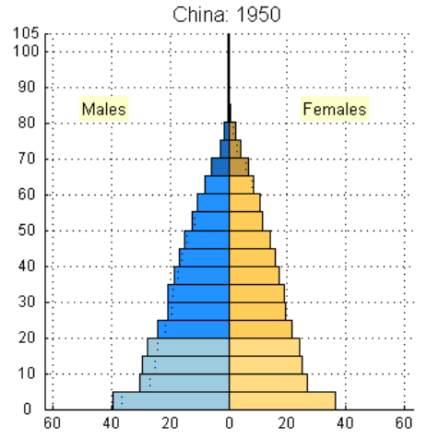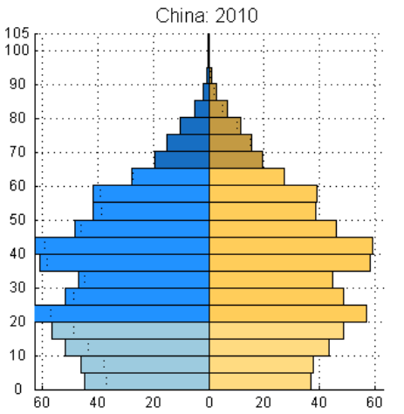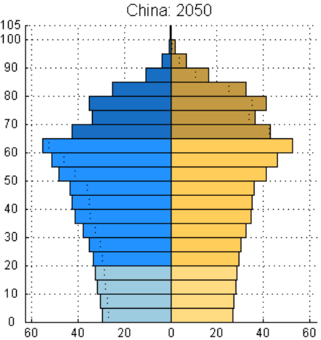
Figure 1. Population pyramids for China: 1950, 2010, 2050
Source: US Census Bureau. International Programs - International Data Base

The prevalence of communicable, maternal, and perinatal diseases remains significant in China, while chronic diseases resulting from higher standard of living like cardiovascular illnesses, cancer, alcohol and tobacco-related disease, and mental illness are also on the rise.(8) Increasing urbanization and socioeconomic disparities in China contribute to this double burden, as the rural and the poor are overburdened with both non-communicable and communicable diseases.(14) Furthermore, China’s aging population significantly contributes to the rise in non-communicable diseases (NCDs).(1)
Deaths from communicable diseases and maternal and neonatal causes have continued to fall throughout the past several decades, though they have not reached developed-country levels. Malaria, measles, pertussis, and dysentery rates have fallen precipitously; by 2006, only 1.2 percent of deaths in rural and urban areas were attributed to infectious disease.(15) China’s relatively stable government since the 1950s resulted in improved education, sanitation, and health care systems, whereas a growing economy and subsequent rising standard of living have all contributed to the decrease in communicable diseases. However, existing infectious diseases like HIV/AIDS and sexually transmitted diseases are making a comeback. While HIV/AIDS infects less than .1 percent of the population, there are an estimated 50,000 new cases per year.(15) Rates of gonorrhea and syphilis are also on the rise, attributed to factors like the shortage of women, migration to urban centers, and an increase in commercial sex. Emerging infectious diseases, including strains of swine and avian flu and severe acute respiratory syndrome (SARS) continue to pose problems, especially in dense urban areas. As a result of the potential for emerging infectious diseases to become epidemics in China’s huge population due to international travel and trade and improved transportation infrastructure, China’s Ministry of Health has expanded its methods of disease surveillance and reporting, and the government continues to struggle with environmental policies.(15)
China’s overall maternal and infant health situation has improved dramatically over the past several decades.(16) Ninety-four percent of pregnant women received at least one antenatal visit in 2010, and in 2009 over 96 percent were attended by a skilled health provider during childbirth.(17) China’s nationwide infant mortality rate (MR) has plummeted from 39 per 1000 live births in 1990 to 13 per 1000 live births in 2011.(18) The 2010 <5MR was 14 per 1000 live births, similar to rates in other emerging economies like Saudia Arabia, Columbia, and Peru.(18) Both China’s maternal mortality rate (MMR) and under 5 mortality rate (<5MR) are very close to meeting the Millennium Development Goals of 30 per 100K and 15 per 1000, respectively.(19) Measles immunization and Vitamin A supplementation are over 90 percent.(20, 21) Nonetheless, rural and urban neonatal and perinatal health disparities exist. In 2010 the neonatal mortality rate, infant mortality rate, and under 5 mortality rate were more than twice as high in rural areas than in urban ones.(22) The Chinese government has tried to address these issues by encouraging use of free or heavily subsidized maternal and child medical services including hospital delivery, folic acid supplementation, health literacy and awareness campaigns, and infant immunization programs.(23) However, uptake among low-income and minority populations in rural regions remains lower than the national average.(24) Reasons vary from lack of accessibility of these services to distrust of China’s public health apparatus.(24)
Infant and child nutrition is another problem in rural areas. Exclusive breastfeeding is not prevalent in China, with only 28 percent of infants exclusively breastfed to six months, and 37 percent at 12-15 months.(20) This is due to many factors, including cultural preferences, aggressive formula marketing campaigns, and job demands that prevent time for breastfeeding.(25) Despite the moderately low rates of severely underweight, wasting, and stunting in children under age 5, anemia and micronutrient deficiencies affect infants and children in impoverished rural regions, where their first foods are low-nutrient rice or millet porridge with little or no additional protein consumption.(26, 27) Out-migration, divestment, and a decrease in central government funding for education have created a situation in which rural children are housed in public rural boarding schools where many suffer from poor nutrition and mental health problems.(2) Undernutrition and anemia are common, affecting up to 50 percent of school age children, with even higher rates among preschoolers in poverty-stricken rural areas of the country.(2)
An alarming measurement is major depressive disorder as the highest cause of disability adjusted life years (DALYs) among children age 5-14 in 2010. This condition is significant among left-behind children who remain in the countryside after their parents have migrated elsewhere for work, to be cared for by others. (2, 28) Mental health issues are highly stigmatized in China so that insufficient research has been done into the causes and potential solutions to this problem.(29) Furthermore, inadequate prenatal care and worsening environmental pollution have been identified as factors contributing to a reported 70.9 percent increase in birth defects in China from 1996 to 2010.(16,30) The Chinese Ministry of Health has acknowledged this problem, but it is unclear how the ministry intends to address it.(16)
Gender discrepancies in health also exist, beginning even before birth. China’s birth planning policies make contraceptives easily available, with 85 percent prevalence in 2012; abortion is legal and accessible.(31) Sex-selective abortion, though not legal, is widespread utilizing ultrasound machines that are not uncommon even in rural clinics.(32) China’s sex ratio at birth (SRB) has thus become skewed because of cultural mores that value boys over girls, resulting in millions of missing girls through abortion and neglect, as there are additionally high rates of excessive female mortality in children aged 0-4.(33) The SRB has increased since 1982 from a normal 106 (106 boys for every 100 girls) to an estimated 120.5 in 2005, even higher in some regions.(33) This is most aggravated in traditional rural areas where women are not highly regarded.(34) Furthermore, SRB and rates of excess female infant mortality both increase sharply as birth order increases. This means that in areas where families are allowed more than one child, primarily among minorities and in non-urban settings, those whose first child is a girl actively take steps to ensure that subsequent children are male.(35, 36)
Non-communicable diseases are on the rise for the aging adult population. Stroke, COPD, ischemic heart disease, and lung cancer top the DALY causes among those over age 50.(28) Many of these NCDs are caused or aggravated by household and environmental pollution, smoking, and alcohol use.(3, 37) Environmental degradation affecting quality of air, water, and food supply is not limited to region or population, nor does it discriminate based on age. An eight-year-old Chinese girl was recently diagnosed with pollution-related lung cancer, a striking reminder of the gravity of the environmental problems facing China today.(38) Tobacco and alcohol use, markers of rising socioeconomic status in this developing nation, contribute significantly to NCD-related DALYs, and their use is not dependent on region or ethnicity.(3, 37) In 2010, an estimated 52.9 percent of men over age 15 smokes tobacco.(39, 40) It is still unacceptable for women to smoke in China, hence the very low 2.4 percent percentage of female smokers, though this number is rising slowly in urban areas.(40, 41) Smoking rates are highest among men 45-64 years of age at 63 percent and among rural dwellers at 56.1 percent compared with urbanites at 49.2 percent.(37) Smoking is the number three risk factor contributing to DALYs for people of all ages in China.(28) However, cigarettes are very much a part of cultural and business life in China, and tobacco companies are state-owned, so alleviating the public health burdens related to smoking and alcohol is very difficult.(41)
Obesity rates are much lower in China than in many developed countries (1.3 percent in China versus over 20 percent in the US), though they are rising steadily with the availability of nutrient-rich foods and processed oils.(42–44) Indeed, diabetes rates have increased since the 1980s, and spending on negative health effects of diabetes and other obesity-related diseases is expected to account for 8.73 percent of GDP in 2025, up from 3.58 percent in 2000.(43) High sodium consumption is related to high blood pressure and many other diseases. In fact, diet-related risks (dietary risks and high blood pressure) comprise the top two greatest DALY risks for all ages in China.(28)

2.2 Public health priorities
A huge health care gap exists between rural and urban areas in China. The life expectancy at birth in rural regions in 2007 was about 30 percent lower than in urban areas.(45) Likewise, the rural infant mortality rate in 2011 was 14.7 percent, as compared to only 5.8 percent in urban areas.(46) Rural inhabitants are more vulnerable to health disadvantages, and they often lack the financial resources to address their health care needs. Rural dwellers’ health expenditure is one-third of that of their urban counterparts: RMB 666.3 ($US98.4) versus RMB 2315.5 (US$342) in 2011. (2)
To address these issues, over the last decade China’s government has implemented numerous health system reforms that focus on improving access to health care, for example expanding insurance coverage and public health provisions in rural areas. By the end of 2012, around 98.3 percent of rural residents had some form of insurance coverage, though the details of reimbursements and subsidies vary by region.(7) China’s government has provided increasing levels of funding for rural health care providers to deliver a defined package of public health services to their constituents. In 2009 this funding was RMB 15 per capita, raised in 2011 to RMB 25 per capita, with expected continued increases in the future.(47) These policy reforms have in some cases dramatically increased the patient load of village doctors, and in other cases patient load has diminished as patients may bypass the rural village clinic in favor of the better-equipped township health center. These doctors are also required to provide new services with which they may not be familiar to them, such as treatment and care of patients with chronic diseases. Although China’s health care expenditure has risen over the past several decades, by 2010 it was still was lower than the average of all other middle income countries, at 5.1 percent of GDP compared with 6.6 percent of GDP.(48) Limited investment in health care aggravates disparities.
The main public health priorities in rural China are environmental pollution, socioeconomic inequalities, and management of chronic disease in an aging population. These fundamental problems are associated with much of the disease burden in China: air, water, and food quality; rising rates of NCDs; and health care policy and access. Environmental pollution affects supplies of water, food, and air, and those effects on health comprise a massive public health burden.(49) Diversion and degradation have caused considerable water shortages in China’s northwest. The Yellow River has been so polluted or diverted that many formerly fertile regions are left with virtually no water supply.(50) Food is contaminated not only with the polluted water but also with considerable heavy metals in the soil, not to mention overuse of pesticides and fertilizers.(49) The food supply cannot be trusted, as the China Food and Drug Administration seems to be unable to cope with regulating food production or distribution. One only needs to glance at news headlines to see the latest stories of dead pigs in a Shanghai drinking water reservoir or melamine-tainted infant milk powder.(51, 52) Air pollution is another headline-grabber, with reports of the Chinese government closing factories and rationing vehicle use when the air gets too bad to breathe.(53) The gravity of environmental pollution and degradation cannot be overstated as a public health issue.
Despite China’s rapid economic transformation and overall improvements in income and standard of living, socioeconomic inequalities highlight strains in the social fabric. In 2012, China’s estimated Gini coefficient was 0.61, and the top 10 percent of households earned 57 percent of total income.(54) The wealth gap is pronounced in the urban-rural divide, with richer urban coastal provinces earning up to 50 percent more in average per capita income and having much higher disposable income.(55) Some of this can be attributed to migration to cities for work, but this masks the larger problem of neglect of the countryside. As more people leave, fewer economic resources and services exist to aid those who remain. Migrants face even larger problems, as China’s hukou system of household registration ties a person to his birthplace and gives him access to local social services like education and health care. Migrants are essentially undocumented workers, often unable to access services outside their hukou.(56)
Finally, rising rates of chronic diseases in an aging population is a considerable public health problem. China’s restrictive birth policies, coupled with lack of social policies to care for the aged, have created an untenable burden. There are not enough children to care for their aging parents, as each couple has two sets of parents to worry about, and traditional culture disparages placing one’s elders under nursing or retirement care.(57) Out-migration leaves even fewer to care for the rural elderly population. Furthermore, the medical system in China lacks primary and preventive care to deal with chronic diseases of the aged, though the Chinese government has pledged to address the problems of pollution, income inequalities, and the health and care of the aging population.(58)

2.3 CHINA’S HEALTH CARE SYSTEM
China’s economic reforms of the 1980s dismantled the national health system in favor of market-based health services, exacerbating rural-urban disparities and leaving more than 90 percent of China’s rural inhabitants without any form of health insurance. China’s New Cooperative Medical Scheme (NCMS), piloted in 1998 and established nationwide in 2003, is an attempt to alleviate the rural medical impoverishment of the previous decades and provide care for the more than 600 million Chinese living in migrant communities and rural areas. Between 2000 and 2010, total health expenditure per capita in rural areas more than doubled, from RMB116 ($18.4) to RMB326 ($51.7), mainly due to increased government investment.(47) The reforms have sought to improve care provided by all three tiers of the rural health system: county hospitals, township health centers, and village doctors. The NCMS is voluntary, combining medical financial assistance, medical savings accounts, and catastrophic hospital insurance, though the majority of this investment has been aimed at expanding access to health care by increasing coverage under new public health insurance programs.(5, 59) By the end of 2011 around 96 percent of rural residents had insurance coverage.(60)
However, primary health care providers in China have strong incentives for unnecessary care and waste. Beginning in the 1950s, pharmaceutical sales were incorporated into village clinics and hospitals to improve allocation, efficiency, and oversight, and to meet the needs of local and national public health campaigns.(61) Later market reforms of the 1980s cut government monetary support of health care so that village doctors grew increasingly dependent on user fees. Heavy reliance on drug sales and user fees for income have diminished basic care and prevention and led to escalating patient costs and inappropriate treatment.(62, 63) Village doctors encourage parenteral administration of pharmaceuticals because these methods increase user fees. Studies have shown that antibiotics are widely overprescribed, and parenteral administration of drugs is unnecessarily overused.(64, 65)
To address problems of antibiotic abuse, reselling of medicines, and excessive parenteral drug administration, the Chinese government has modified its National Essential Medicines Scheme to substantially circumscribe the number of drugs that primary care institutions are allowed to carry.(66) In 2009 the government altered the system so that institutions can no longer increase the prices of drugs to augment revenue, though the policy is not applied uniformly and varies by clinic type and region. Likewise, the essential medicines list varies by province, and provinces are further able to approve additional supplemental drugs for use by their health care services.(66, 67)

METHODS
This paper utilizes qualitative methods and site visits with personal observation to determine the impact on rural village clinics and township health centers of the 2009 New Cooperative Medical Scheme reforms and the zero-profit drug policy of the National Essential Medicines Scheme. The dataset comes from an extensive nationwide survey of Chinese rural village and township doctors that took place in 2012 (see below). Statistical analysis was completed by the author using Stata 13, with all qualitative questions translated and coded by the author. See the appendix for a list of the analyzed qualitative questions and sample responses.

data collection

The Northwest Socioeconomic Development Research Center (NSDRC) at Shaanxi Normal University, in conjunction with Stanford University and the Center for Chinese Agricultural Policy of the Chinese Academy of Sciences in Beijing, led a nationwide longitudinal Public Goods Survey in 2005, 2008, and 2012 of 47 township health centers and 160 village clinics. The survey was conducted in 100 villages, 50 towns, and 25 rural counties in the five provinces of Hebei, Jiangsu, Jilin, Shaanxi, and Sichuan, and was intended to provide data on clinic services, finances, and village doctor qualifications (68). Results from the 2005 and 2008 versions of the survey have been published elsewhere regarding elderly care and rural primary health care services.(68,69) Data from all three surveys regarding diagnosis and treatment of common diseases have also been used to construct randomized controlled trials to improve village doctor training and patient health outcomes. Data for this paper come from the 2012 survey conducted in 160 village clinics and 47 township health centers (THCs). After cleaning by staff at the NSDRC, the data include information from 146 interviews of rural village doctors and 47 THCs, the remainder after accounting for attrition due to exiting the profession, relocation, retirement, clinic closing, or death. Not all respondents answered all questions.
In addition, the author made two visits to rural villages in this study with researchers from the NSDRC to observe data collection and interviews of participants, including patients, caregivers, and village doctors. Both visits took place in Shangluo prefecture (population approximately 400,000), Shaanxi province. Field notes and notes on conversations with villagers are included here to provide a deeper understanding of first-hand experience with the ways that government policy is impacting health care in rural areas.

data analysis
This paper utilizes qualitative and quantitative analysis to examine results from a nationwide village doctor survey conducted in China in 2012 in order to determine the impact of the New Cooperative Medical Scheme and the zero-profit drug sales policy on village clinic and township health center revenue. Two questions were analyzed, using STATA 13 to quantify impact (positive, no impact, or negative change in revenue), along with qualitative coding by the author to identify possible reasons for the impact. The township health center survey did not include any questions on revenue impact of the zero-profit drug policy, so only questions related to the NCMS are analyzed for the THCs. Survey questions are as follows:
1. How has the zero-profit drug policy impacted your total clinic revenue? (1 = increase; 2 = no impact; 3 = decrease.) A follow-up qualitative question asks the respondent to explain his or her answer.
2. How has the New Cooperative Medical Scheme affected your total clinic revenue? (1 = increase; 2 = no impact; 3 = decrease.) A follow-up question asks the respondent to explain his or her answer.
Coding was completed using Word and Excel with translations made by the author. For example, an answer to the question about NCMS on revenue, “看病的人增多，门诊收入增加,” translated as “the number of patients increased, outpatient revenue increased,” was given the codes “more patients” and “higher revenue.” The answer “有补贴但成本也变高,” translated as “I receive subsidies yet the costs are high,” was coded as “subsidy” and “higher costs.”

results

The setting: field notes from shangluo prefecture, shaanxi

In May 2013, the author accompanied NSDRC researchers to visit the local village doctor of Tongchang village in the town of Heishan, Shangluo, Shaanxi, in her home and at her clinic. Tongchang village is remote, requiring travel for three hours from the nearest city of Shangluo, often on dirt roads, and then for approximately 20 minutes on foot to reach the doctor’s home. The mountainous region was green and full of sounds of birds and chirping insects. A small stream ran adjacent to the narrow footpath. The village doctor’s home comprised a large main whitewashed house with long red strips of paper on which were written auspicious couplets hanging on either side of the wide front door. There were also several tamped earth outbuildings for farm animals and equipment. The village doctor’s family members, including her son and grandchild, served us tea while we sat outside on low stools and discussed the doctor’s daily duties. We learned that she had a middle school education and attended training sessions sponsored by the government. She was in her late forties or early fifties and had been a doctor for several decades. She does not deliver babies herself but instead refers mothers to the county level hospital. She brought out a box of milk powder that she distributes to new mothers, and she told us that most women nurse their babies for several months. She provides care for the approximately 30 families living in Tongchang. We later walked back to the main road where the clinic is located, and she gave us a tour.
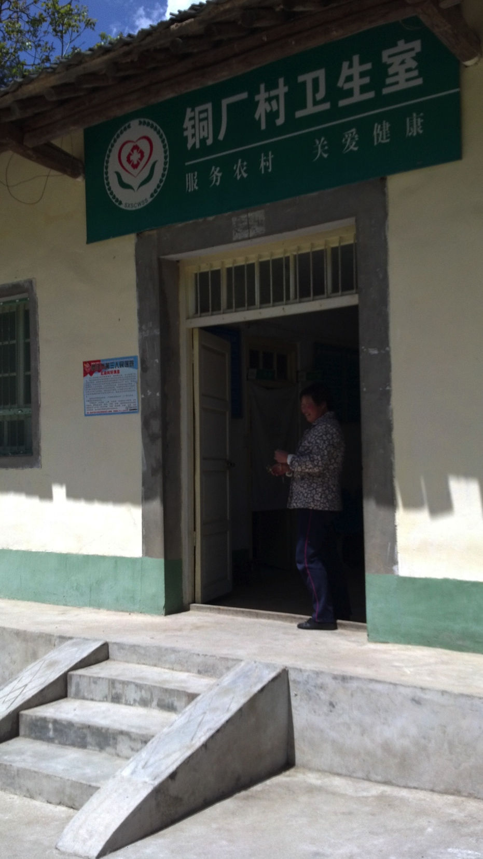
Photo: Tina Phillips Johnson
Figure 2. Tongchang village public health clinic, May 2013

Like most other buildings, the clinic was whitewashed, raised a few steps off the main road with a narrow porch extending its entire length (see Figure 2). Inside is a waiting room with several chairs and public health posters portraying national policies, mainly with regard to family planning, appreciating girl babies, and caring for the elderly. Directly opposite the door was a price list of clinic services. The two examination rooms off to the left each contained a bed with piles of flowery blankets and window curtains, which made the rooms look cozy, yet boxes and other supplies crowded the floor and metal shelves lining the walls. To the right of the waiting room was a storage room and the pharmacy. A large white printed metal list with red lettering hung above the pharmacy service window, displaying the very inexpensive prices of pharmaceuticals and related supplies.
By contrast, Wanwan village in Danfeng county is much more prosperous, with paved roads and a large, ornately carved and painted village gate (see Figure 3). The author and NSDRC researchers visited Danfeng’s village doctor in March 2014. This place is known as a wine and grape-producing region, and bare vineyards dotted the landscape as spring had yet to arrive. The name of the village means “ten thousand terraces,” which aptly describes the mountains surrounding this valley town. Also among the terraces are hundreds of ancient cave dwellings visible from the road. The village school was in session and the voices of children singing carried through the air.

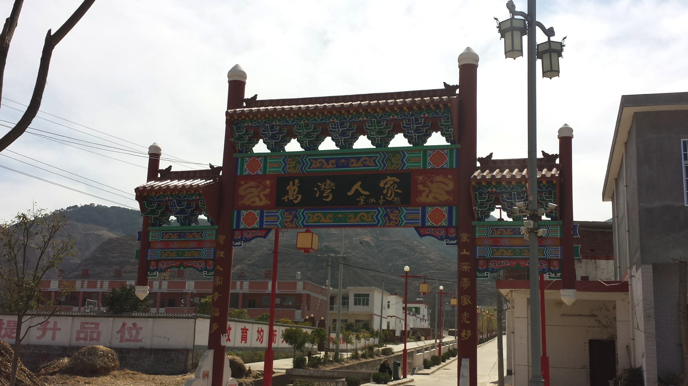
Photo: Tina Phillips Johnson
Figure 3. Wanwan village gate, March 2014

The village doctor had started practicing medicine in the mid-to late-1970s as part of the barefoot doctor program, a nationwide primary health care project started to provide primary and preventive care to the rural population. He was friendly and cooperative as we all sat around in his freezing building, with frequent breaks to warm up outside in the sunshine. He told us that he was chosen to become a barefoot doctor because he was very smart (officials routinely chose the best and brightest for the barefoot doctor program); he was even recommended to study at university but the entrance exam was held at a distant location, and it was too far for him to travel.
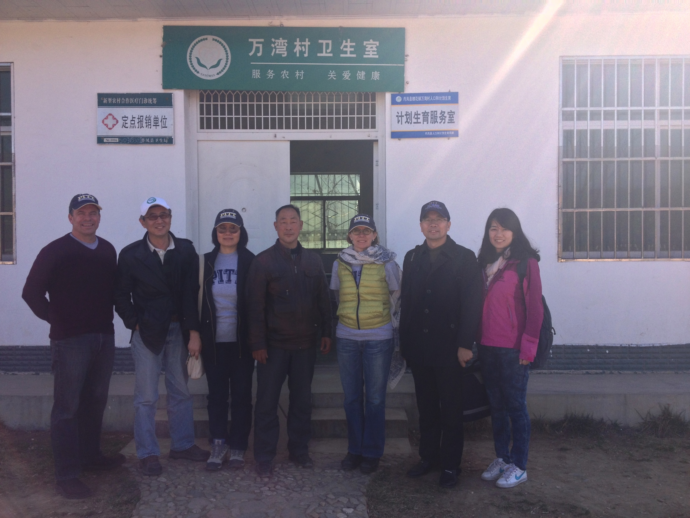
Photo: Hao Xue
Figure 4. Wanwan village public health center, March 2014

This clinic was similar in design to the one in Tongchang, with a main waiting room and two adjoining rooms jutting off on each side (see Figure 4). However, it was sparse and dingy, with no window coverings, the only decoration the family planning posters sent by the government. The doctor told us that he received no salary but was reimbursed with a supplement of RMB2000 per RMB10000 of pharmaceuticals ordered, with a RMB 45000 limit on annual pharmaceutical purchases. The IV poles made of rebar in the waiting room, sitting adjacent to the bucket of about 30 used syringes and IV lines betrayed how he really earned his money: RMB 5 for each injection or IV. Thirty syringes for three days for what he estimated to be 10 patients a day. Nearly all of his patients receive an injection or an IV. He provides no preventative education or treatment for his population of about 1800.

zero-profit drug sales policy
Two questions related to government policy and clinic revenue were analyzed to determine the impact of the zero-profit drug sales policy at the rural village clinic and township health center levels. The first question analyzed asks the village doctor respondents (n = 58) about the impact on clinic revenue after the zero profit drug policy was enacted, with three possible answers: 1 = revenue increased; 2 = revenue remained the same; and 3 = revenue decreased. The majority of village clinic respondents saw a decrease in total clinic revenue (see Figure 5). The frequency distribution results show that 42 (72.41 percent) respondents reported a decrease in total clinic revenue, while only one respondent (1.72 percent) out of 58 claimed a revenue increase. Fifteen respondents (25.86 percent) said there was no change in revenue after the policy was put in place.

Figure 5. Impact on total village clinic revenue of zero-profit drug sales policy

The single respondent who claimed a revenue increase said that the increase is due to receiving government wages: “The government gives me a little better wages.”
No change in revenue among the 15 respondents was explained as “subsidies” 11 times (73 percent), meaning that government subsidies offset the loss of revenue from drug sales. Two respondents claimed that an increased work load offset revenue loss, for example “decreased drug revenue, more patients, clinic revenue higher, subsidies, no change,” or “work more, lower income, no change.” One respondent said that since his pharmacy and clinic prices remained about the same, there was no change in his revenue.
Forty-two village clinic respondents claimed a decrease in clinic revenue after the implementation of the zero-profit drug sales policy. When asked to explain the negative effect, 36 out of 42 respondents claimed decreased drug sales or no drug sales by their clinics, for instance, “decreased drug revenue, clinic revenue same, total revenue lower.” Lower subsidies were also given as a primary reason for decreased revenue: “lower income, lower subsidies, clinic revenue same, lower total revenue.” Often decreased drug sales accompanied claims of lower subsidies: “decreased drug revenue, lower subsidies, total revenue lower.” Finally, three village clinic respondents claimed that the abbreviated essential drugs list, the drugs approved by the central and provincial governments for sale in pharmacies, clinics and hospitals, caused lower clinic revenue: “fewer essential drugs, can’t meet demand, no drug revenue.”
There were no survey questions for the township health center revenue impact resulting from the zero-profit drug sales policy. However, all but one of the 47 THCs responded that they had implemented the zero-profit policy in their health centers.

new cooperative medical Scheme
The second question analyzed for this paper asks about the impact on total clinic revenue of the New Cooperative Medical Scheme. The majority of village clinic respondents (n = 143) claimed no change or a decrease in total revenue since the NCMS was enacted, while several reported an increase in revenue (see Figure 6). A frequency distribution reveals 64 village clinic respondents each (44.76 percent) reported no change or a decrease. Just over 10 percent reported an increase in revenue.
Figure 6. Impact on total village clinic revenue of NCMS

The qualitative responses to this question are much more varied and complicated than those to the zero-profit drug policy query. Fifteen of the respondents (10 percent) claimed an increase in revenue after the implementation of the NCMS. They gave varied reasons, including government reimbursement or subsidy (four responses): “no effect, reimbursement”; or more patients or more work (six respondents): “more patients, higher revenue.” Many of these responses were complicated, providing several reasons that the NCMS had not impacted village clinic revenue. Some patients had been bypassing the village clinic (“fewer patients”) for the higher-reimbursing township health center (“higher level hospitals,” “higher hospital reimbursement”). Other clinics received a government subsidy to the clinic (“subsidy”), which offset the lower patient load and resulted in increased revenue.
Sixty-four respondents reported no change in clinic revenue as a result of the NCMS reforms for a variety of reasons. Twelve had a higher patient load and five received less revenue: “more patients, same fees, lower revenue, no effect.” Eight claimed patient reimbursement was nonexistent or so low as not to have a great impact: “no reimbursement, no effect.” Seven suggested that patient characteristics and preference contributed to no change, for example “patient habits, physician preference, no change.” Two of the clinics were not “designated agencies” of the NCMS and were therefore ineligible for NCMS benefits like reimbursements or subsidies.
Another sixty-four respondents reported a decrease in clinic revenue resulting from the NCMS reforms. Nineteen respondents claimed this was due at least in part to having fewer patients, while 17 reported lower or no reimbursements: (“fewer patients, no reimbursement”). Eight respondents claimed that patients bypassed the clinic for higher-level hospitals that offered better patient reimbursement rates: “hospitals higher reimbursement, better equipment, fewer patients.” Ten respondents discussed patient habits, preference, or benefits: “longer life, patient habits, physician preference.” Many claimed that their rural clinics were poor and had low revenue to begin with, but these also claimed a responsibility to their patients and community: “patient benefit, no effect, serve the people.” Three were not NCMS designated agencies.
The township health center data are much more straightforward (n = 47). All but seven township health center respondents (85 percent) claimed higher revenues resulting from the NCMS (see Figure 7). Of these, all claimed higher revenue from seeing more patients, including outpatients (38 respondents, or 95 percent), and/or from reimbursements (11 respondents, or 28 percent). Five surveyed claimed no revenue effect of NCMS reforms, for example: “no effect, revenue unrelated.” Two of these claimed more patients yet lower reimbursements. Finally, the two respondents who said their revenue decreased both pharmaceuticals as the reason: one claimed the essential medicines list restrictions decreased revenue, and the other the zero-profit drug sales policy.
Figure 7. Revenue impact of NCMS on township health centers

discussion

zero-profit drug sales policy

Only 58 out of 146 of the village clinics surveyed answered any questions about the zero-profit drug policy, either because the policy was in a pilot stage, or because the program may have been voluntary at the time the survey was conducted. However, nearly all of the township health centers had implemented the policy (46 out of 47). Health policies are often not uniformly implemented because decentralization since the 1980s has left much decision-making in the hands of provincial and local officials. This is one reason the survey was conducted: to discover how different regions are implementing these policies and how these differences may be affecting doctors, patients, and health outcomes. This policy was enacted at the higher levels, and sometimes it is the responsibility of THCs to oversee and manage the village clinics, so this may explain why the THCs were in compliance with the policy but that it had not yet gone down to the village clinic level.
Only one of these respondents reported an increase in revenue after this policy was put in place, due only to government subsidy that made up for the clinic’s loss in drug sales. Every other respondent saw either no change (15 respondents) or a decrease in revenue (42 respondents). A typical coding of this type of response is “decreased drug sales, government subsidies, no change.” Some village doctors saw more patients after the 2009 zero-profit drug policy was implemented, so the increased patient load offset the revenue loss from drug sales, resulting in a net zero revenue. Higher patient load is due partly to the increasing insurance coverage rates of rural inhabitants, as well as the consolidation or shuttering of numerous village clinics. Others reported that higher government subsidies made up for the difference in lost revenue. However, for many village doctors who do not receive government subsidies, or whose subsidies were not increased, clinic revenue dropped when the zero-profit policy was implemented. Furthermore, revisions to the National Essential Medicines Scheme have substantially decreased the number of drugs that primary care institutions like village clinics are allowed to carry, and recently have altered the system so that institutions can no longer increase the prices of drugs to supplement revenue.
During a site visit, a rural village doctor reported that he received no salary but was reimbursed with a supplement of RMB 2000 (US$320) per RMB 10,000 (US$1600) of pharmaceuticals ordered, with a RMB 45,000 (US$7230) limit on annual pharmaceutical purchases. His office, equipped with several IV poles made out of rebar and a bucket of about 30 used syringes, showed how he was able to make up the difference in lost profits after the zero-drug sales policy was implemented: RMB5 for each injection, amounting to 30 syringes for three days, totaling around 10 patients a day. Because the village doctor’s salary is so low, he is incentivized to prescribe the treatment that will make him the most extra income: parenteral delivery of antibiotics and fluids, regardless of illness. Even if the village doctor knows that this treatment is not useful or even harmful, he or she must make a living.

new cooperative medical Scheme
Of the 146 village clinic respondents, 143 answered the two questions directly related to the NCMS. The NCMS has been in place much longer than the 2009 zero-profit drug sales policy, and all village clinics are impacted by its wide-ranging reforms, either directly through subsidies or indirectly as access to care has increased with near-universal health insurance coverage.
A major result of the NCMS is that some village clinics are seeing many fewer patients. These patients, now at least partially insured, choose to bypass the clinic for the more prestigious (and higher-reimbursing) county hospital or township health center. The NCMS is clearly beneficial to the township health centers, as the overwhelming majority claimed an increase in revenue as a result. One of the major problems in the village clinics is staffing, as highly qualified staff are reluctant to live in remote rural areas. Township clinics and county hospitals have better trained physicians on staff, as well as more advanced technology to treat complex (and sometimes simple) diseases.
Furthermore, although China was a pioneer in the 1970s with its focus on primary and preventive care with its barefoot doctors campaign, after the economic reforms of the 1980s this focus fell by the wayside. Medical students aimed to go into lucrative specialties while hospitals encouraged high-cost advanced treatments. The NCMS has recently supported more primary and preventive care, with incentives to medical students to work in rural areas and better training for existing village doctors. On the other hand, some village clinic respondents claimed that their patients continue using village clinics for routine illnesses. They listed patient-doctor trust, a focus on traditional Chinese medicine for preventive and primary care, and the desire to serve their community as reasons for their stagnant clinic revenue.

conclusion and recommendations
China’s rural health reforms of the early twenty-first century have greatly expanded access to medical care for most of the population. Nearly all rural inhabitants have at least some form of health insurance, and consolidation and restructuring of the village and township health system have started to improve quality of care resulting from doctor incentive and training programs. The NCMS impact on township health centers is clearly beneficial in terms of clinic revenue; however, more research needs to be done on quality of care, especially with regard to appropriate diagnosis and treatment. The impact of these policies on rural village clinics is more complicated, and village doctor responses to the policies varied widely. However, it is obvious that the NCMS and the drug sales policy have not improved the revenue of these often ill-equipped clinics. It seems that many are losing patients to the more prestigious township health centers and county hospitals that may provide better reimbursement rates, and potentially better care.
Despite the innovations and improvement in China’s health care system, problems remain. Village doctors in China must navigate the rapidly shifting policy arena and keep up with medical technology like electronic medical records and new diagnostic and treatment tools. As the front line in primary and preventive care for millions of rural Chinese, they are moreover faced with a mountainous task of comprehending important shifts in the burden of disease of their constituents, as communicable diseases compete with ailments exacerbated by an improvement in the standard of living. China’s rapidly aging population requires particular expertise in chronic disease management and gerontology.
The experience of the Wanwan village doctor is particularly enlightening and illustrates this double burden: the most common ailments of the patients in his village are cough, diarrhea, and headache. An increase in non-communicable diseases is associated with smoking, for example, cardiopulmonary disease, asthma, emphysema, and certain cancers, all causes of chronic cough. Diarrhea, on the other hand, is caused by communicable dysentery or any other number of bacteria or virus present in an unsanitary water supply. Headache may result from stress, household or environmental pollution, cigarette smoke, alcohol, or viral or bacterial illnesses. The Wanwan village doctor is experiencing China’s real disease burden yet lacks the basic tools with which to prevent or treat it.
There were no anti-smoking campaign posters among the family planning images on the walls of the clinic, and the first thing our host did upon our arrival was offer all the men cigarettes. Although Wanwan village is relatively prosperous, the village latrines are of the open pit variety, a breeding ground for diarrheal illnesses. Yet there is no talk of providing clean wells or a sanitation system. Training village doctors -- and their patients -- about disease diagnosis and treatment, especially preventive and primary care; educating them on health policy and its implementation; and improving the payment structure to eliminate reliance on parenteral administration and antibiotic prescription may all aid in improving quality and access.
The survey data presented here from nearly 200 village clinic and township health centers point to effects of the New Rural Cooperative Medical Scheme and the zero-profit drug sales policy. Qualitative data and the words of those surveyed can illuminate some of these consequences presented in statistical analysis. This historian, in a turn to public health, has used not only the data but also historical knowledge to inform intervention, mitigation, or solution to help improve the health of China’s rural population.

limitations
This study is subject to several limitations. The data were collected from only 160 rural village clinics and 47 township health centers in 100 villages, 50 towns, and 25 rural counties in five provinces, out of a total population of China of 1.3 billion.
Because the author did not personally engage in the interviews or survey process, qualitative analysis must rely on the data already analyzed by others. The author is not privy to the context of the questions and cannot always know the tone of the responses.
Patient responses to the NCMS and the zero-profit drug policy should also be assessed, as the ultimate goal is to improve the health of the rural population.

APPENDIX: CODING DOCUMENT

Question F15: What impact has NCMS had on your clinic revenue?

More patients: higher patient load

Reimbursement: subsidies, reimbursement, grants

Revenue same: no change in clinic revenue

Rural villagers: patients

No effect: NCMS has had no impact on revenue

Low cost: costs of running clinic not high

Township clinic: lose patients to township

Higher revenue: more revenue from NCMS

More work: work load higher with NCMS

Same fee: Clinic fees remain the same

No drug sales: zero profit drug sales results in lower revenue

Higher costs: costs of running clinic higher

Less reimbursement: less $ from NCMS

Lower revenue: NCMS revenue lower

Patient trust: patients trust the medical system

Designated organizations: NCMS requires patients to utilize certain medical orgs?
bibliography
1. Yang G, Zeng Y, Gao GF, Liang X, Zhou M, Wan X, et al. Rapid health transition in China, 1990-2010: findings from the Global Burden of Disease Study 2010. The Lancet. 2013 Jun 8;381:1987–2015.

2. Luo R, Shi Y, Zhang L, Liu C, Rozelle S, Sharbono B. Malnutrition in China’s rural boarding schools: the case of primary schools in Shaanxi Province. Asia Pac J Educ. 2009;29:481–501.

3. Cochrane J, Chen H, Conigrave KM, Hao W. Alcohol Use in China. Alcohol Alcohol. 2003;38(6):537–42.

4. Xu K, Saksena P, Fu XZH, Lei H, Chen N, Carrin G. Health Care Financing in Rural China: New Rural Cooperative Medical Scheme. Geneva: World Health Organization Department of Health Systems Financing; 2009. Report No.: Number 3.

5. Fang Z. Chinese Health Care in Rural Areas: The New Rural Cooperative Medical Scheme is on the right track despite the challenges ahead. Br Med J. 2010 Oct 30;341(7779):899–900.

6. Shaanxi Provincial Bureau of Statistics. Shaanxi Statistical Yearbook (Shaanxi tongji nianjian). Beijing: China Statistics Press; 2013.

7. National Bureau of Statistics of China. China Statistical Yearbook for Regional Economy（Zhongguo quyu jingji tongji nianjian）. Beijing: China Statistics Press; 2013.

8. Chen L. China’s Exceptional Health Transitions: Overcoming the Four Horsemen of Apocalypse. China Medical Board centenary history project; 2011 Dec 10; MIT Endicott House, Boston, MA.

9. Spence JD. The Search for Modern China. New York and London: W.W. Norton; 1990.

10. Wang F. The Future of a Demographic Overachiever: Long-Term Implications of the Demographic Transition in China. Popul Dev Rev. 2011 Mar;37 (Supplement):173–90.

11. Gong Y-L, Chao L-M. The Role of Barefoot Doctors. Am J Public Health. 1982;72(Supplement):59–61.

12. White T. The Origins of China’s Birth Planning Policy. In: Gilmartin C, Hershatter G, Rofel L, White T, editors. Engendering China: Women, Culture, and the State. Cambridge: Harvard University Press; 1994. p. 250–78.

13. Greenhalgh S. Just One Child: Science and Policy in Deng’s China. University of California Press; 2008.

14. Ho CS, Gostin LO. The Social Face of Economic Growth: China’s Health System in Transition. JAMA. 2009 May 6;301(17):1809–11.

15. Wang L, Wang Y, Jin S, Wu Z, Chin DP, Koplan JP, et al. Emergence and Control of Infectious Diseases in China. The Lancet. 2008 Nov;372(9649):1598–605.

16. Ministry of Health of the People’s Republic of China. Report on Women and Children’s Health Development in China [Internet]. 2011. Available from: http://www.gov.cn/gzdt/att/att/site1/20110921/001e3741a4740fe3bdbf02.pdf

17. World Health Organization. Global Health Observatory Data Repository: Mortality and global health estimates: Adult mortality by country [Internet]. [cited 2013 Sep 25]. Available from: http://apps.who.int/gho/data/node.main.11?lang=en

18. UNICEF. UNICEF - China - Statistics [Internet]. [cited 2013 Sep 25]. Available from: http://www.unicef.org/infobycountry/china_statistics.html

19. Neff W, Yenokyan G, Friberg IK, Bryce J. Patterns in coverage of maternal, newborn, and child health interventions: projections of neonatal and under-5 mortality to 2035. The Lancet. 2013 Sep 21;382(9897):1029–38.

20. UNICEF. Childinfo: Monitoring the Situation of Children and Women: China [Internet]. [cited 2013 Dec 7]. Available from: http://www.childinfo.org/country_profiles.php?input=30

21. World Bank. World Development Indicators [Internet]. World DataBank. [cited 2013 Sep 6]. Available from: http://databank.worldbank.org/data/home.aspx

22. National Bureau of Statistics of China. China Statistical Yearbook (Zhongguo tongji nianjian). Beijing: China Statistics Press; 2011.

23. Ministry of Health, Ministry of Finance. Guidelines on Promoting Delivery in Hospital in Rural Areas (Guanyu jinyibu jiaqiang nongcun yunchanfu zhuyuan fenmian guongzuo de zhidao yijian) [Internet]. Report No.: 12. Available from: http://finance.sina.com.cn/roll/20090403/09062769966.shtml

24. Liu C, Zhang L, Yi H, Luo R, Shi Y, Zhou H, et al. Maternal Health Services in China’s Western Rural Areas: Uptake and Correlates [Internet]. Stanford University: Rural Education Action Project; 2013 Feb. Report No.: 256. Available from: reapchina.org/reap.stanford.edu

25. Gottschang SZ. The Consuming Mother: Infant Feeding and the Feminine Body in Urban China. In: Chen NN, Clark CD, Gottschang SZ, Jeffrey L, editors. China Urban: Ethnographies of Contemporary Culture. Duke University Press; 2001. p. 89–103.

26. Chang S, He W, Jia F, Chen C. Analysis on the changes of nutritional status in China anemia status of children under 5 in China. Wei Sheng Yan Jiu. 2007 Mar;36(2):210–2.

27. Cui Y, Yang L, Tan D, Wu Q, Du Q. Analysis on the status of anemia among children under 3 years old in 10 provinces in Western China. Zhonghua Liu Xing Bing Xue Za Zhi. 2007 Dec;28(12):1159–61.

28. Institute for Health Metrics and Evaluation. Global Burden of Disease Study 2010. China Global Burden of Disease Study 2010 Results 1990-2010 [Internet]. Seattle: Institute for Health Metrics and Evaluation; 2013 [cited 2013 Sep 25]. Available from: http://www.healthmetricsandevaluation.org/search-gbd-data?s=mortality%20by%20cause%20by%20country

29. Zhang Y. Transforming Emotions With Chinese Medicine: An Ethnographic Account from Contemporary China. 1st ed. SUNY Press; 2007.

30. Shan J. Birth defects an increasing concern for physicians. China Daily Online. Beijing; 2012 Feb 28;7.

31. United Nations. UNdata | Contraceptive prevalence rate (CPR) [Internet]. [cited 2013 Sep 25]. Available from: http://data.un.org/Data.aspx?d=SOWC&f=inID%3A34

32. Wu Z, Kirsi Viisainen, Xiaohong Li, Elina Hemminki. Maternal care in rural China: a case study from Anhui province. BMC Health Serv Res [Internet]. 2008 Mar 10;8(55). Available from: http://www.biomedcentral.com/1472-6963/8/55

33. Li S. Imbalanced Sex Ratio at Birth and Comprehensive Intervention in China. Fourth Asia Pacific Conference on Reproductive and Sexual Health and Rights; 2007 Oct 19; Hyderabad, India.

34. Evans H. The Subject of Gender: Daughters and Mothers in Urban China. Rowman and Littlefield Publishers, Inc.; 2007.

35. Chen J, Xie Z, Liu H. Son Preference, Use of Maternal Health Care, and Infant Mortality in Rural China, 1989-2000. Popul Stud. 2007;61(2):161–83.

36. Wu Z, Viisainen K, Wang Y, Hemminki E. Perinatal Mortality in Rural China: Retrospective Cohort Study. Br Med J. 2003 Dec;327:1–6.

37. Li Q, Hsia J, Yang G. Prevalence of Smoking in China in 2010. N Engl J Med. 2011 Jun 23;364(25):2469–70.

38. Brink S. A Chinese Child’s Lung Cancer Is Linked to Pollution: An expert tells what is known about the impact of air quality on health. National Geographic [Internet]. 2013 Nov 8 [cited 2013 Dec 7]; Available from: http://news.nationalgeographic.com/news/2013/11/131108-lung-cancer-childhood-china-pollution-eight-year-old-girl/

39. National Bureau of Statistics of China. Communiqué of the National Bureau of Statistics of People’s Republic of China on Major Figures of the 2010 Population Census[1] (No. 1) [Internet]. National Bureau of Statistics of China. 2011 [cited 2013 Sep 6]. Available from: http://www.stats.gov.cn/english/newsandcomingevents/t20110428_402722244.htm

40. World Health Organization. World Health Statistics 2013 [Internet]. Geneva, Switzerland: World Health Organization; 2013. Available from: http://www.who.int/gho/publications/world_health_statistics/EN_WHS2013_Full.pdf

41. Benedict C. Golden-Silk Smoke: A History of Tobacco in China, 1550-2010. University of California Press; 2011.

42. Sun X, Lei L. Obesity rate on the increase. China Daily Online [Internet]. 2013 Aug 6 [cited 2013 Nov 5]; Available from: http://usa.chinadaily.com.cn/china/2013-08/06/content_16872878.htm

43. Popkin BM. Will China’s Nutrition Transition Overwhelm Its Health Care System and Slow Economic Growth? Health Aff (Millwood). 2008;27(4):1064–76.

44. World Health Organization. WHO Global Infobase : International Comparisons: Estimated Obesity [Internet]. [cited 2013 Dec 7]. Available from: https://apps.who.int/infobase/Comparisons.aspx

45. Zimmer Z, Kaneda T, Spess L. An Examination of Urban Versus Rural Mortality in China Using Community and Individual Data. J Gerontol. 2007;62B(5):S349–57.

46. Li Y, Dorsten L. Regional and Urban/Rural Differences of Public Health in China. Glob J Health Sci. 2010;2(1):20.

47. Yip WC, Hsiao WC, Chen W, Hu S, Ma J, Maynard A. Early appraisal of China’s huge and complex health-care reforms. The Lancet. 2012 Mar 3;3(379):833–42.

48. World Health Organization Western Pacific Region. Health Sector Reform in China [Internet]. [cited 2014 Nov 7]. Available from: http://www.wpro.who.int/china/mediacentre/factsheets/health_sector_reform/en/

49. Wu F. China’s Pollution Timebomb. Int Econ. 2006 Fall;34–7.

50. China’s Coal Capital Begins Water Diversion from Yellow River. Xinhuanet [Internet]. 2002 Oct 20 [cited 2012 Jan 8]; Available from: http://news.xinhuanet.com/english/2002-10/20/content_602368.htm

51. Wang H. More dead pigs found floating in river. China Daily Online [Internet]. Shanghai; 2013 Mar 11 [cited 2013 Dec 8]; Available from: http://www.chinadaily.com.cn/cndy/2013-03/11/content_16296478.htm

52. Siegel M. Chinese Safety Concern Empties Distant Shelves. New York Times [Internet]. 2013 Jan 7 [cited 2013 Dec 8]; Available from: http://topics.nytimes.com/top/reference/timestopics/subjects/m/melamine/index.html

53. Schoolchildren ordered indoors as air pollution cloaks Shanghai. The Guardian [Internet]. 2013 Dec 6 [cited 2013 Dec 8]; Available from: http://www.theguardian.com/environment/2013/dec/06/schoolchildren-air-pollution-shanghai-eastern-china

54. To Each, Not According to His Needs: A New Survey Illuminates the Extent of Chinese Income Inequality. The Economist. Hong Kong; 2012 Dec 15;

55. Schiavenza M. Mapping China’s Income Inequality. The Atlantic [Internet]. 2013 Sep 13 [cited 2013 Dec 8]; Available from: http://www.theatlantic.com/china/archive/2013/09/mapping-chinas-income-inequality/279637/

56. Hornby L. Human cost of China’s hukou system. Financial Times [Internet]. 2013 Nov 8 [cited 2013 Dec 8]; Available from: http://www.ft.com/cms/s/0/5c38bbd0-46c7-11e3-9c1b-00144feabdc0.html#axzz2mu3CKW6I

57. Schiavenza M. China’s Big (and Growing) Problem With Its Elderly Population. The Guardian [Internet]. 2013 Jul 10 [cited 2013 Dec 8]; Available from: http://www.theatlantic.com/china/archive/2013/07/chinas-big-and-growing-problem-with-its-elderly-population/277656/

58. Wang J, Kushner K, Frey JJ, Du XP, Qian N. Primary Care Reform in the People’s Republic of China: Implications for Training Family Physicians for the World’s Largest Country. Fam Med. 2007;39(9):639–43.

59. Eggleston K. Healthcare for 1.3 billion: An overview of China’s health system. Stanford Asia Health Policy Program Working Paper; 2012. Report No.: 28.
60. Liang X, Guo H, Jin C, Peng X, Zhang X. The Effect of New Cooperative Medical Scheme on Health Outcomes and Alleviating Catastrophic Health Expenditure in China: A Systematic Review. PLoS ONE. 7(8):e40850.

61. Fang X. Barefoot Doctors and Western Medicine in China. Rochester, NY: University of Rochester Press; 2012.

62. Eggleston K, Ling L, Qingyue M, Lindelow M, Wagstaff A. Health service delivery in China: a literature review. Health Econ. 2008 Feb;17(2):149–65.

63. Yip W, Hsiao WC. Market Watch - The Chinese Health System at a Crossroads. Health Aff (Millwood). 2008 Apr;27(2):460–8.

64. Currie J, Lin W, Zhang W. Patient knowledge and antibiotic abuse: Evidence from an audit study in China. J Health Econ. 2011 Sep;30(5):933–49.

65. Reynolds L, McKee M. Factors Influencing Antibiotic Prescribing in China: An Exploratory Analysis. Health Policy. 2009 Apr;90(1):32–6.

66. Tian X, Song Y, Zhang X. National Essential Medicines List and policy practice: A case study of China’s health care reform. BMC Health Serv Res. 2012;12(401).

67. Chen M, Wang L, Chen W, Zhang L, Jiang H, Mao W. Does economic incentive matter for rational use of medicine: China’s experience from the essential medicines program. Pharmacoeconomics. 2014 Mar;32(3):45–55.

68. Babiarz KS, Yi H, Luo R. Meeting the Health-care Needs of the Rural Elderly: The Unique Role of Village Doctors. China World Econ. 2013;20(3):40–60.

69. Babiarz, Kimberly Singer, Miller G, Yi H, Zhang L, Rozelle S. New evidence on the impact of China’s New Rural Cooperative Medical Scheme and its implications for rural primary healthcare: multivariate difference-in-difference analysis. Br Med J. 2010 Oct 30;341(7779):929.

