Proximity to a major roadway, insufficient vitamin D, and severe asthma exacerbations in Puerto Rican children

by
Franziska Rosser
B.A., B.S., University of Alabama at Birmingham, 2003, 2003

M.D., University of South Alabama, 2009

Submitted to the Graduate Faculty of
Graduate School of Public Health in partial fulfillment
of the requirements for the degree of
Master of Public Health

University of Pittsburgh
2015

ABSTRACT
UNIVERSITY OF PITTSBURGH
GRADUATE SCHOOL OF PUBLIC HEALTH

This essay is submitted
by
Franziska Rosser

on

April 6th, 2015
and approved by

Essay Advisor:
David N. Finegold, MD ____________________________________
Director, Multidisciplinary MPH Program
Professor of Human Genetics
Graduate School of Public Health
University of Pittsburgh

Essay Reader:
Juan C. Celedón, M.D. Dr.P.H ____________________________________
Niels K. Jerne Professor of Pediatrics
Professor of Medicine, Epidemiology, and Human Genetics
Division Chief
Pulmonary Medicine, Allergy, and Immunology
Children’s Hospital of Pittsburgh of UPMC
University of Pittsburgh

Copyright © by Franziska Rosser
2015

Background: The environmental factors contributing to the rapid rise in childhood asthma prevalence over the last several decades are not well understood. Puerto Rican children have the highest asthma prevalence and morbidity of any racial or ethnic group in the United States. Proximity to a major roadway has been associated with increased asthma prevalence and morbidity.
David N. Finegold, MD
Proximity to a major roadway, insufficient vitamin D, and severe asthma exacerbations in Puerto Rican children
Franziska Rosser, MPH
University of Pittsburgh, 2015
Objective: To evaluate the association between asthma severity, proximity to a major roadway, and insufficient vitamin D in Puerto Rican children with asthma.
Methods: Three hundred and fifty one Puerto Rican children with asthma living in metropolitan San Juan, Puerto Rico were evaluated using near distance from each 2000 US Census Block centroid to a major roadway as a proxy for traffic related air pollution (TRAP). Serum 25-OH Vitamin D was measured and classified as insufficient if <30 ng/ml. Our outcome of interest was ≥ 1 severe asthma exacerbation in the last 12 months, as defined by the American Thoracic Society (ATS) guidelines.
Results: In multivariate analysis, asthmatics living near a major roadway had increased odds of ≥ 1 severe asthma exacerbation in the last year. By stratified analysis, living nearest a major roadway (≤ 441m) and having insufficient vitamin D conferred ~5 times the odds of a severe asthma exacerbation in the last year compared to those with sufficient vitamin D and living furthest from a major roadway.
Public Health Implications: Given that in some US cities 30-50% of the population lives close to major roads, further studies are urgently needed to assess the ameliorative properties of vitamin D supplementation on TRAP in asthmatic children.

TABLE OF CONTENTS
preface ix
1.0 Introduction 1
2.0 METHODS 3
2.1 Study Recruitment 3
2.2 Study Procedures 4
2.3 Statistical Analysis 5
3.0 Results 8
4.0 Discussion 13
Appendix: COPYRIGHT PERMISSION 17
bibliography 20

List of tables
Table 1: Characteristics of study participants, overall, and by residential distance to a major roadway 9
Table 2: Comparison of baseline characteristics between asthmatics with a severe asthma exacerbation in the last year and those without 10
Table 3: Multivariate analysis of distance from a major roadway (by quartiles [Model 1] and as a continuous variable [Model 2]) and severe asthma exacerbations in Puerto Rican children 11

List of figures
Figure 1: Categories of residential proximity to a major roadway (living > vs. ≤441 m away from a major road) and vitamin D insufficiency (plasma vitamin D level < 30 ng/dl) and severe asthma exacerbations. Multivariate analysis adjusted for age, sex, household income, and use of inhaled corticosteroids in the prior 6 months. 12

preface

This essay has been previously published, in a truncated and polished version, in the American Journal of Respiratory and Critical Care Medicine (AJRCCM). A complete citation is listed in the bibliography (1). This product represents a collaborative effort. For my part, I participated in hypothesis generation, creation of the proximity to a major roadway variable, and under the supervision of Dr.’s Celedón, Brehm, and Forno, I performed all analyses and wrote the first draft of the manuscript. This essay represents a version of that draft with some additional changes. My coauthors, John M. Brehm, M.D., M.P.H, Erick Forno, M.D., M.P.H., Kristen Kurland, B.A., Edna Acosta-Pérez, Ph.D., Glorisa Canino, Ph.D., and Juan C. Celedón, M.D., Dr.P.H., along with the AJRCCM have graciously granted me permission to use this manuscript for my MPH essay submission.
My coauthors and I thank all participating children and their families for their invaluable participation in this study. All analyses of the data were conducted at Children’s Hospital of Pittsburgh of UPMC under appropriate policies and human subject’s protections.
Additionally, I would like to acknowledge Dr. Ravi Sharma for his excellent instruction in ArcGIS.

Introduction
Asthma is one of the most common chronic diseases of children effecting an estimated 7 million children in the United States (2). Asthma is a multifactorial disease and the rapid rise in prevalence over the last several decades, particularly in developed countries, cannot be attributed to genetic factors alone and likely is a result of poorly understood and unidentified environmental and epigenetic factors. Residential proximity to a major roadway has been associated with increased asthma prevalence (3) and morbidity (4). Environmental effects on children with asthma have been estimated to cost 2.2 billion dollars annually (5), with a recent study estimating the effects of traffic related air pollution (TRAP) on asthmatic children to cost $18 million per year in just two California communities (6). The relationship of proximity to a major roadway and asthma is of particular concern in the United States as Hispanics (an ethnic group including Puerto Ricans) disproportionately live closer to a major roadway (7, 8).
Puerto Rican children have the highest prevalence and morbidity out of any racial or ethnic group in the United States (9). In contrast to other Hispanic subgroups, Puerto Rican children living on the island of Puerto Rico have been found to have increased asthma prevalence and hospitalizations compared to persons living in the mainland US (10). While the reasons for this are unclear, differences in environmental exposures, such as TRAP, may contribute.
The association of insufficient vitamin D and asthma morbidity has only recently been explored (11), with studies supporting increased asthma morbidity (12, 13). Hispanics are disproportionately represented among those with insufficient vitamin D compared to whites (14). Insufficient vitamin D, along with asthma, has been rising in prevalence over recent decades (15), and is alluring as a relatively easily correctable risk factor, compared to more recalcitrant factors such as obesity or stress. Vitamin D has also been described to have antioxidant effects (16, 17).
We hypothesized that proximity to a major roadway is associated with severe asthma exacerbations in Puerto Rican children with asthma and that vitamin D insufficiency modifies this effect. To test this hypothesis, we examined the relationship between residential proximity to a major roadway, vitamin D insufficiency, and severe asthma exacerbations in 351 Puerto Rican children with asthma.

METHODS

Study Recruitment
From March 2009 to June 2010 children from San Juan, Puerto Rico were enrolled in a NIH funded case-control study. As described previously (12), children were recruited via random selection from the Standard Metropolitan area of San Juan via a multistage probability sample design using neighborhood clusters based on 2000 US Census blocks; secondary sampling units were randomly selected households within primary sampling units. Household eligibility was determined if at least one resident was a child between 6 to 14 years old. A total of 7,073 households were selected with 6,401 (90.5%) being contacted. Questionnaires were the main recruitment tool and given to parents to obtain information about their children’s respiratory health and Puerto Rican ancestry. Of the contacted homes, 1,111 households had ≥1 child who met inclusion criteria other than age (four Puerto Rican grandparents and residence in the same household for ≥1 year). Of these 1,111 households, 438 (39.4%) had ≥1 eligible child with asthma (defined as having physician-diagnosed asthma and wheeze in the prior year). From these homes, one child was randomly selected (if there was more than one such child). Similarly, only one child without asthma was randomly selected from the remaining 673 households. In order to reach our target sample size of ~700 children, attempts were made to enroll 783 of the 1,111 households. Of the 783 households, 105 parents (13.4%) refused to participate or were unable to be reached, leaving 678 participants (351 cases and 327 controls). No significant differences in age, sex, or area of residence were observed between children enrolled and those whose parents did not agree to participate. As this analysis was focused on severe asthma exacerbations, we only included children with asthma (n=351).

Study Procedures
Study participants completed a protocol that included administration of questionnaires, spirometry, and collection of blood samples (for measurement of plasma vitamin D). The child’s parents completed a slightly modified questionnaire from that used in Collaborative Study of the Genetics of Asthma(18), which was used to obtain information about the child’s general and respiratory health, socio-demographic characteristics, family history, environmental tobacco smoke (ETS) exposure, and use of inhaled corticosteroids (ICS) in the previous 6 months.
Height and weight were measured to the nearest centimeter and pound, respectively. Spirometry was conducted with an EasyOne spirometer (NDD Medical Technologies, Andover, MA). Spirometry was performed in subjects free from respiratory illnesses for ≥4 weeks prior, and participants were instructed to avoid use of inhaled short- and long-acting bronchodilators for ≥4 and ≥12 hours before testing, respectively. Forced expiratory maneuvers were judged to be acceptable if they met or exceeded American Thoracic Society criteria modified for children (19). The best forced expiratory volume in 1 second (FEV₁) and forced vital capacity (FVC) were selected for data analysis.
Plasma 25-hydroxy-vitamin D levels (hereafter referred to as vitamin D) were measured using tandem mass spectrophotometry (Waters Corporation, Milford) as described previously (12). Skin test reactivity (STR) to aeroallergens, histamine and saline diluent, was assessed using a Multi Test device (Lincoln Diagnostics, Decatur, IL) on the skin of the forearm (in a site free of eczema). Aeroallergens tested included house dust mites (D. pteronyssinus and D. farinae), B. tropicalis, German cockroach (B. germanica), mouse pelt, dog dander, cat dander, mold mix, Alternaria tenuis, mixed tree pollen, mixed grass pollen, mugwort sage, and ragweed (Alk-Abello, Round Rock, TX). A skin test was considered positive if the maximum wheal diameter exceeded the diluent wheal diameter by ≥3 mm.
Both written parental consent and participant assent were obtained in addition to approval from Internal Review Boards at the University of Puerto Rico (San Juan, Puerto Rico) and the University of Pittsburgh (Pittsburgh, PA).

Statistical Analysis
Participant’s home addresses were geocoded to a 15 digit 2000 US Census Federal Information Processing Standards (FIPS) at the University of Puerto Rico. In ArcMAP10.1 (ArcGIS 10.1, ESRI, Redlands, CA), centroids were created by obtaining individual block X, Y coordinates based on a 2000 US Census block map (Tigerline, US Census) for Puerto Rico. Distance was then calculated using the ArcGIS proximity tool “near” which calculated the shortest distance from each block centroid to a major roadway (defined by ESRI 2012 Data and Maps major road layer: these include interstates, inter-metropolitan area and intra-state highways and major roads). One subject was excluded from analyses owing to an incomplete address that could not be validated.
Our primary outcome was severe asthma exacerbations, defined as at least one hospitalization or visit to an emergency department/ urgent care for asthma which resulted in treatment with systemic steroids (oral, intravenous, or intramuscular), or at least one course of systemic steroids for asthma (as described per recent consensus statement (20)) in the last 12 months.
Because of potential correlation with severe asthma exacerbations, bivariate analysis (paired Student T-test or Wilcoxon rank sum as indicated) was performed on the following covariates: percentage of African ancestry (21); household income equal or greater than $15,000 annually [near the median income for Puerto Rican households in 2008-09) (22)]; either private or employer health insurance; use of inhaled corticosteroids (ICS) in the previous 6 months; in utero or within the first 2 years of life exposure to environmental tobacco smoke (ETS) (23); current exposure to ETS (24, 25); body mass index (BMI) as a z score (26) (based on 2000 Centers for Disease Control and Prevention growth charts (27)); pre-bronchodilator forced vital capacity (FVC), forced expiratory volume in 1 second (FEV1), and FEV1/FVC ratio; and atopy as measured by at least one positive skin reaction to an allergen.
Bivariate analysis was also performed based on distance quartiles, by either Cochran Armitage trend test or unadjusted linear regression, based on prior studies suggesting threshold effects of roadway proximity (3, 4).
Logistic regression was used for multivariate analyses. The main predictor was distance to a major roadway, both as a continuous variable and by quartiles. All multivariate models included age, gender, household income, vitamin D insufficiency (defined as a plasma 25(OH)D level <30 ng/ml), and use of ICS in the previous six months. Additional covariates were included in the initial multivariate models if they were associated with the outcome at an alpha less than 0.25 in bivariate analysis. The full models were fitted and variables were removed in a step-wise fashion with the largest P value excluded. The procedure was stopped until all variables not forced into the model demonstrated p values less than 0.05. Although vitamin D was not initially included in the model, insufficient vitamin D and African ancestry were forced into the final model based on known association with the outcome. Only insufficient vitamin D was statistically significant in the final model and was included. Next, interactions between the predictor and covariates left in the final model were evaluated; no multiplicative interactions were present at an alpha 0.05.
Based on quartile univariate analysis, with quartiles 1-3 demonstrating similar rates of severe asthma exacerbations, a new categorical scoring variable was created to evaluate the effects of proximity to a major roadway by vitamin D status. Logistic multivariate analysis was performed with the new score predictor. Since nearly identical results for the two intermediate categories were obtained in a multivariate analysis, they were collapsed, and we thus analyzed three categories of exposure: vitamin D sufficiency and living furthest from a major road, either living close to a major road with sufficient vitamin D or living furthest from a road with insufficient vitamin D, and both living close to a major road and having vitamin D insufficiency.
All analyses were performed using SAS version 9.3 (SAS Institute, Cary, NC).

Results
Table one summarizes the baseline characteristics of the participants overall and by proximity to a major roadway, in quartiles. Participants overall demonstrated lower socioeconomic status with only 1/3rd reporting annual incomes greater than $15,000 or having private or employer based health insurance. Almost half of all subjects were exposed to ETS either early in life or currently and 44% were vitamin D insufficient despite living in an equatorial region. Overall, the majority of asthmatics were atopic (81%) and over half reported a severe asthma exacerbation in the last year.
By roadway quartiles, the percentage of households with annual incomes > $15,000 increased in quartiles farther away from a major road. Although both FVC and FEV1 increased in quartiles farther away from a major roadway this increase was not statistically significant. Severe asthma exacerbations were similar in the first three quartiles and demonstrated a statistically significant decrease in quartile 4 (p trend= 0.02). Use of an inhaled corticosteroid in the last 6 months was lowest in the first two quartiles compared to quartile 3 and 4. Insufficient vitamin D status, BMI, ETS exposure (either current or early life), private or employer health insurance, percent African ancestry, and atopy did not differ by roadway quartiles.
Table 1: Characteristics of study participants, overall, and by residential distance to a major roadway
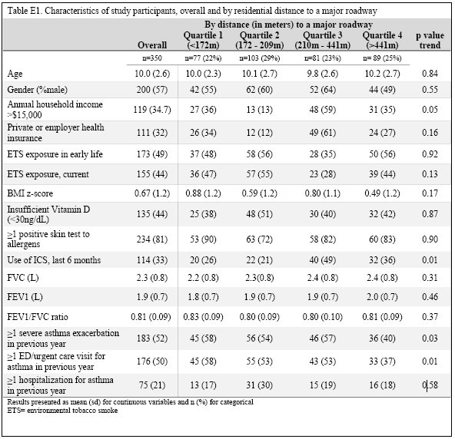
Reprinted with permission of the American Thoracic Society. Copyright © 2015 American Thoracic Society. Rosser F et. al./2014/ Proximity to a major road, vitamin D insufficiency, and severe asthma exacerbations in Puerto Rican children/Am J Respir Crit Care Med/190(10)/1190-3. The American Journal of Respiratory and Critical Care Medicine is an official journal of the American Thoracic Society.

Table 2 demonstrates the baseline characteristics of children with and without a severe asthma exacerbation in the last year. Children with severe asthma exacerbations lived on average 62 meters closer to a major roadway and were more likely to have insufficient vitamin D, early life ETS exposure, a lower FVC and FEV1, and increased use of an inhaled corticosteroid. Annual household income and percentage of private insurance did not differ between groups.
Table 2: Comparison of baseline characteristics between asthmatics with a severe asthma exacerbation in the last year and those without
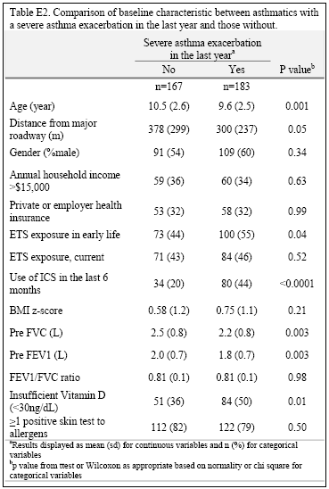
Reprinted with permission of the American Thoracic Society. Copyright © 2015 American Thoracic Society. Rosser F et. al./2014/ Proximity to a major road, vitamin D insufficiency, and severe asthma exacerbations in Puerto Rican children/Am J Respir Crit Care Med/190(10)/1190-3. The American Journal of Respiratory and Critical Care Medicine is an official journal of the American Thoracic Society.

Table 3 demonstrates the results of linear and logistic models. African ancestry, BMI, atopy, FEV1, and ETS exposure (early life or current) were not statistically significant contributors to severe asthma exacerbations as predicted by distance from a major roadway and were therefore excluded from the final models. After adjustment for age, gender, household income, and inhaled corticosteroid use, every 100 meters away from a major roadway was significantly associated with ~15% decrease in the odds of a severe asthma exacerbation in the last year. Children living closest to a major roadway demonstrated the highest odds of an asthma exacerbation inversely related to distance from a roadway. Insufficient vitamin D, as reported previously (12), conferred increased odds of a severe asthma exacerbation and was unchanged with adjustment for roadway distance.
Table 3: Multivariate analysis of distance from a major roadway (by quartiles [Model 1] and as a continuous variable [Model 2]) and severe asthma exacerbations in Puerto Rican children
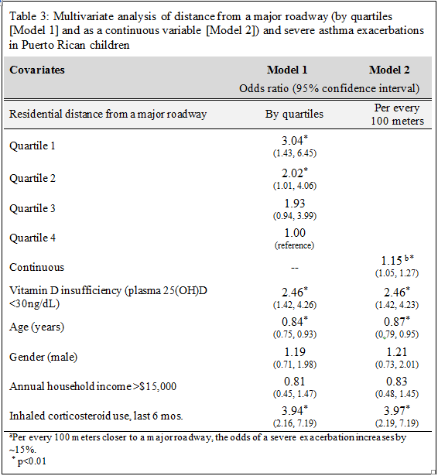
Reprinted with permission of the American Thoracic Society. Copyright © 2015 American Thoracic Society. Rosser F et. al./2014/ Proximity to a major road, vitamin D insufficiency, and severe asthma exacerbations in Puerto Rican children/Am J Respir Crit Care Med/190(10)/1190-3. The American Journal of Respiratory and Critical Care Medicine is an official journal of the American Thoracic Society.

No statistically significant multiplicative interactions were observed between roadway distance and any covariate in the final model. However, when creating a scoring system with quartile 4 (farthest away from a major roadway) and sufficient vitamin D as a reference category, insufficient vitamin D was found to augment the odds of a severe asthma exacerbation by roadway distance, with children living closest to a major roadway (< 441 meters) and having insufficient vitamin D having almost a five-fold increase in the odds of a severe asthma exacerbation in the last year (p value= 0.002). Sufficient vitamin D and living close to a major roadway had similar odds ratios to living farther away from a major roadway with insufficient vitamin D, although neither was statistically significant (Figure 1).
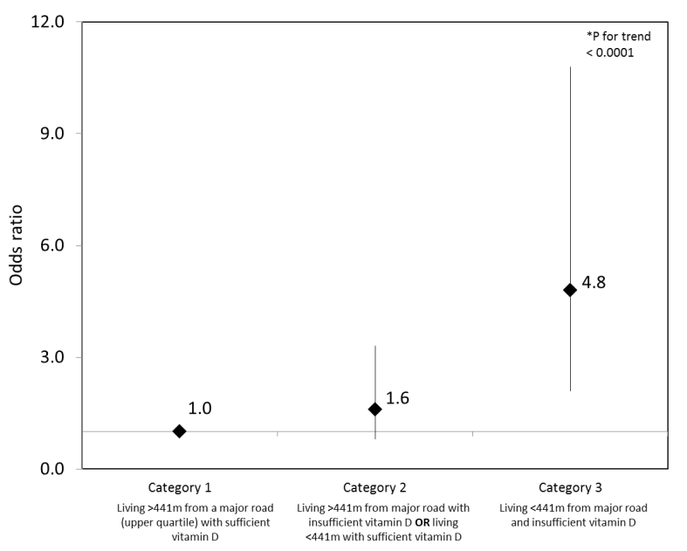
Reprinted with permission of the American Thoracic Society. Copyright © 2015 American Thoracic Society. Rosser F et. al./2014/ Proximity to a major road, vitamin D insufficiency, and severe asthma exacerbations in Puerto Rican children/Am J Respir Crit Care Med/190(10)/1190-3. The American Journal of Respiratory and Critical Care Medicine is an official journal of the American Thoracic Society.

Figure 1: Categories of residential proximity to a major roadway (living > vs. ≤441 m away from a major road) and vitamin D insufficiency (plasma vitamin D level < 30 ng/ml) and severe asthma exacerbations. Multivariate analysis adjusted for age, sex, household income, and use of inhaled corticosteroids in the prior 6 months.

Discussion
To our knowledge, this is the first study to report the joint detrimental effects of living near a major roadway and insufficient vitamin D on severe asthma exacerbations in children.
Consistent with studies over the last decade linking TRAP and asthma morbidity (4, 7, 28-31), our results demonstrate increased severe asthma exacerbations in association with roadway proximity. Brown et. al for example found that children in Atlanta, GA living closest to major roadways had increased hospitalizations including intensive care unit admissions, increased ED visits, and increased episodes of wheezing (4). Distance to freeway, as well as exposure to NO_{2,} has been associated with increased odds ratio of wheeze within the last 12 months, wheeze with exercise, and current asthma medication use (31). Interestingly, in our sample we found that children living with the first two quartiles demonstrated the lowest percentage prescription/use of an asthma medication and had increased odds of an exacerbation suggesting perhaps under-prescription/use of ICS in this at risk population. Despite this, adjustment of ICS did not alter our findings. In fact, use of ICS was associated with increased odds of an asthma exacerbation for reasons unclear but might represent children with more severe asthma.
Isolation of a specific agent or agents responsible for our findings is not possible given lack of robust air monitoring data. However, roadway pollution represents a heterogeneous mixture of gases and particulate matter that differs regionally and is affected by multiple factors including spatial location, meteorological conditions, seasons, traffic type and volume and contribution from point sources (30). While roadway proximity is a less precise estimate than direct concentration measurements, residential proximity has the advantage of integrating the complex milieu of exposures associated with roadways including multiple pollutants such as carbon monoxide, nitrogen oxides, ozone, particulate matter, poly-aromatic hydrocarbons, and other exposures such as heat, noise, water vapor and possible stress of living close to road (32).
Possible mechanisms for the association between increased asthma exacerbations and TRAP include airway inflammation mediated by oxidant stresses, enhancement of airway eosinophilia, activation of innate immune inflammatory pathways (33) and impaired lung development (34, 35) . In our study, although decreased lung function was associated with increased asthma exacerbations in bivariate analysis and both measures increased with distance away from a major roadway, neither FVC nor FEV1 significantly contributed in our multivariate models suggesting that decreased lung volumes do not explain our findings of increased asthma exacerbations in close proximity to a major roadway.
Prior studies evaluating decreased vitamin D and air pollution have used varying measures of air pollution, from UVB haze (36, 37), air quality index (38) to complex pollution modeling systems (39). Exposure to UVB light transforms 7-dehydrocholesterol (precursor for vitamin D₃) into cholecalciferol, the main source for vitamin D₃ in humans. Agarwal et. al. hypothesized that children living in communities with increased air pollution would have decreased UVB photon exposure (as a result of increased UVB absorption by pollution) and subsequently lower vitamin D levels compared to children living in communities with improved air quality. In their study of two communities in India, serum vitamin D significantly differed between communities (11.7ng/mL vs 27.1ng/mL, p value <0.001) with higher levels in the community with lower air pollution and thus higher ground level UVB penetration (37). A birth cohort study also found gestational exposure to nitrogen dioxide (NO₂) and particulate matter (PM) was a predictor of low vitamin D status in newborns (39). Air pollution has been hypothesized as a cause for the rise of vitamin D insufficiency and more research is needed to evaluate air pollution and vitamin D levels, especially in sunny equatorial regions where insufficient levels are prevalent.
In our study, insufficient vitamin D was not found to correlate significantly with a major roadway suggesting the vitamin D insufficiency is not a marker for increased air pollution exposure in our population. Given our use of proximity to roadway as a proxy for TRAP, we cannot exclude that specific pollutants, for example ozone, are relatively homogenous within this population and therefore UVB photon exposure would be similar among all participants. Prior studies have demonstrated that specific pollutants correlate differently with different distance measures, for example NO₂ best correlated with total roadway distance located within 50 meters suggesting that pollutant levels do vary by roadway proximity. It is therefore unlikely for air pollution to be homogenous throughout this large metropolitan area, thus explaining a lack of finding a correlation between insufficient vitamin d and roadway proximity.
Exposure to pollutants such as PM elicits airway oxidative stress (40). Thus, a possible explanation for our findings is that vitamin D insufficiency further exacerbates such oxidative stress. In support of this hypothesis, vitamin D has been shown to have antioxidant properties in experimental and murine models (16, 41). In a human clinical trial, vitamin D supplementation decreased serum malondialdehyde, a marker of reactive oxidant stress (42).
The strengths of our study include a well-characterized and large sample size of Puerto Rican children. We recognize some limitations of our study. First, the use of block centroids may under- or over-estimate the actual residential distance from a major roadway. However, the block areas are individually small and therefore unlikely to lead to large variations and these variations would be non-differential. Second, while we only have a single measurement of Vitamin D, Puerto Rico is located equatorially so wide variations between summer and winter are unlikely in this population. Additionally, correcting for month of collection in our models did not alter our findings.
In summary, our results suggest that residential proximity to a major roadway is associated with increased odds of an asthma exacerbation in Puerto Rican children with asthma living on the island of Puerto Rico. Furthermore, insufficient vitamin D was found to jointly increase the odds of a severe asthma exacerbation with roadway proximity. Future clinical trials should evaluate whether vitamin D supplementation ameliorates the negative effects of air pollution on asthma in heavily exposed children.
APPENDIX: COPYRIGHT PERMISSION
1. Letter Requesting permission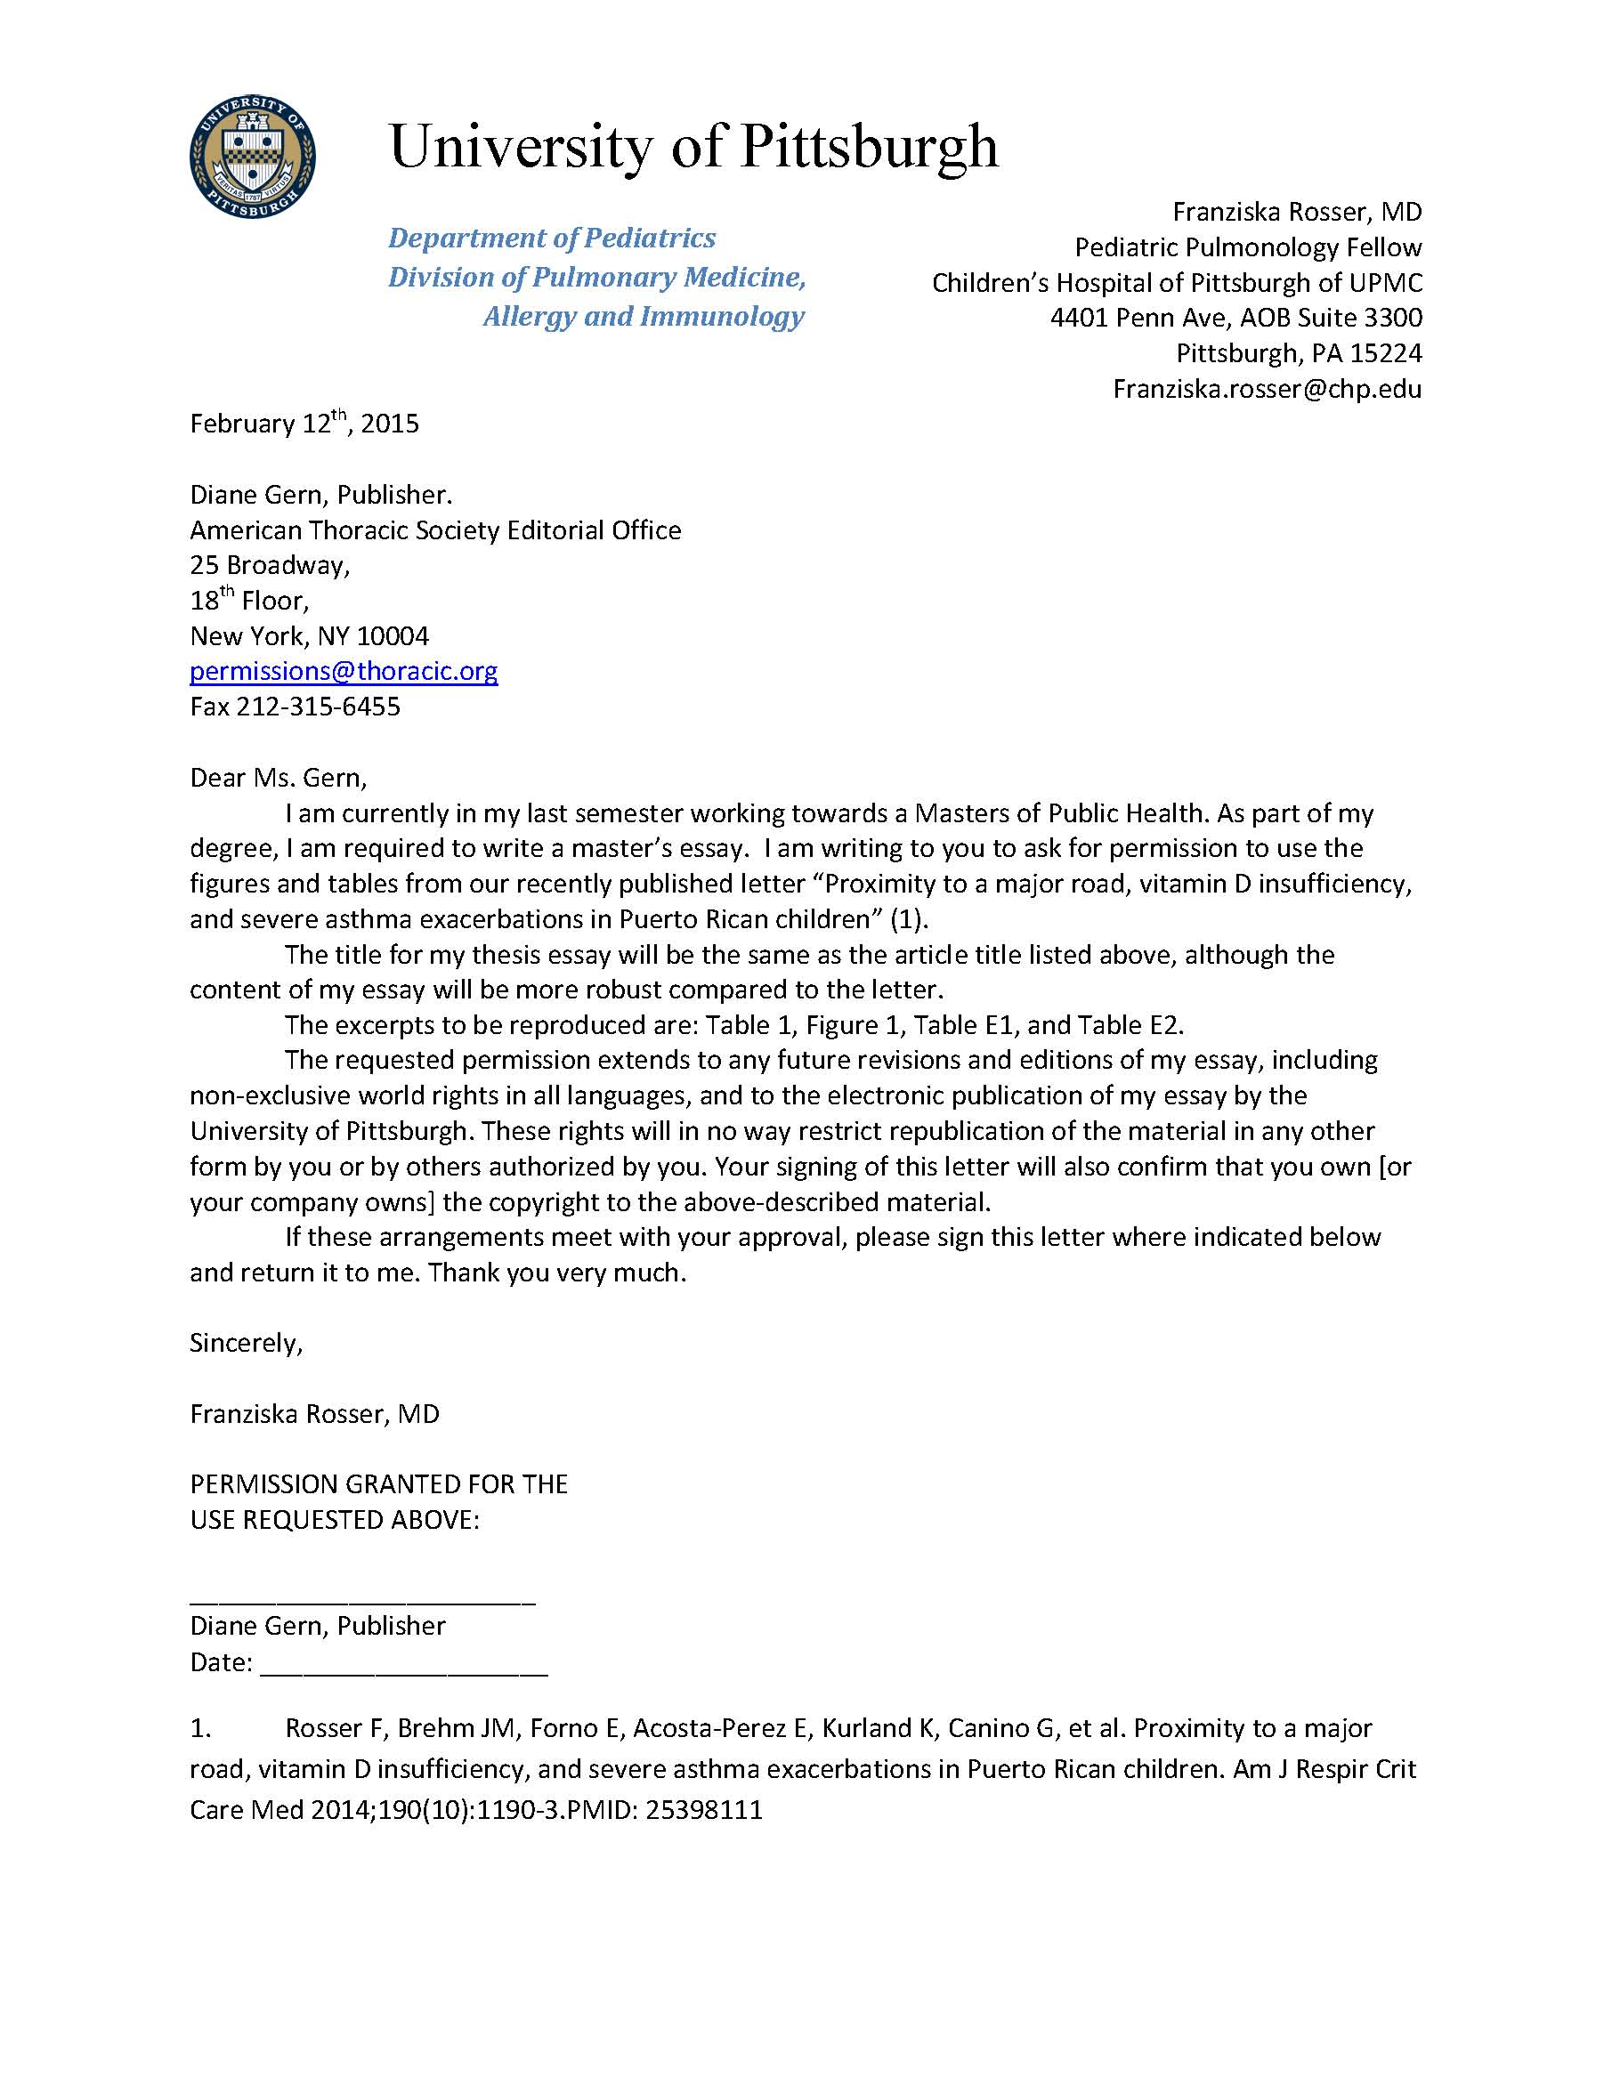
2. EMAIL GRANTING PERMISSION
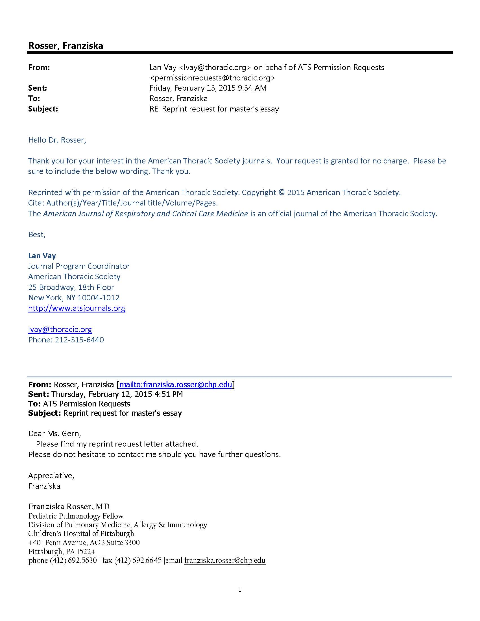

bibliography
1. Rosser F, Brehm JM, Forno E, Acosta-Perez E, Kurland K, Canino G, Celedon JC. Proximity to a major road, vitamin d insufficiency, and severe asthma exacerbations in puerto rican children. Am J Respir Crit Care Med 2014;190:1190-1193.
2. Bloom B, Jones L, Freeman G. Summary health statistics for u.S. Children: National health interview survey 2012. National Center for Health Statistics Vital Health Stat 2013;10.
3. McConnell R, Berhane K, Yao L, Jerrett M, Lurmann F, Gilliland F, Kunzli N, Gauderman J, Avol E, Thomas D, Peters J. Traffic, susceptibility, and childhood asthma. Environmental health perspectives 2006;114:766-772.
4. Brown MS, Sarnat SE, DeMuth KA, Brown LA, Whitlock DR, Brown SW, Tolbert PE, Fitzpatrick AM. Residential proximity to a major roadway is associated with features of asthma control in children. PloS one 2012;7:e37044.
5. Trasande L, Liu Y. Reducing the staggering costs of environmental disease in children, estimated at $76.6 billion in 2008. Health Aff (Millwood) 2011;30:863-870.
6. Brandt SJ, Perez L, Kunzli N, Lurmann F, McConnell R. Costs of childhood asthma due to traffic-related pollution in two california communities. The European respiratory journal 2012;40:363-370.
7. Meng YY, Rull RP, Wilhelm M, Ritz B, English P, Yu H, Nathan S, Kuruvilla M, Brown ER. Living near heavy traffic increases asthma severity. Policy Brief UCLA Cent Health Policy Res 2006:1-5.
8. Boehmer TK, Foster SL, Henry JR, Woghiren-Akinnifesi EL, Yip FY. Residential proximity to major highways - united states, 2010. MMWR Surveill Summ 2013;62 Suppl 3:46-50.
9. Lara M, Akinbami L, Flores G, Morgenstern H. Heterogeneity of childhood asthma among hispanic children: Puerto rican children bear a disproportionate burden. Pediatrics 2006;117:43-53.
10. Cohen RT, Canino GJ, Bird HR, Shen S, Rosner BA, Celedon JC. Area of residence, birthplace, and asthma in puerto rican children. Chest 2007;131:1331-1338.
11. Paul G, Brehm JM, Alcorn JF, Holguin F, Aujla SJ, Celedon JC. Vitamin d and asthma. Am J Respir Crit Care Med 2012;185:124-132.
12. Brehm JM, Acosta-Perez E, Klei L, Roeder K, Barmada M, Boutaoui N, Forno E, Kelly R, Paul K, Sylvia J, Litonjua AA, Cabana M, Alvarez M, Colon-Semidey A, Canino G, Celedon JC. Vitamin d insufficiency and severe asthma exacerbations in puerto rican children. Am J Respir Crit Care Med 2012;186:140-146.
13. Brehm JM, Celedon JC, Soto-Quiros ME, Avila L, Hunninghake GM, Forno E, Laskey D, Sylvia JS, Hollis BW, Weiss ST, Litonjua AA. Serum vitamin d levels and markers of severity of childhood asthma in costa rica. Am J Respir Crit Care Med 2009;179:765-771.
14. Ginde AA, Liu MC, Camargo CA, Jr. Demographic differences and trends of vitamin d insufficiency in the us population, 1988-2004. Arch Intern Med 2009;169:626-632.
15. Litonjua AA, Weiss ST. Is vitamin d deficiency to blame for the asthma epidemic? The Journal of allergy and clinical immunology 2007;120:1031-1035.
16. Wiseman H. Vitamin d is a membrane antioxidant. Ability to inhibit iron-dependent lipid peroxidation in liposomes compared to cholesterol, ergosterol and tamoxifen and relevance to anticancer action. FEBS letters 1993;326:285-288.
17. Uberti F, Lattuada D, Morsanuto V, Nava U, Bolis G, Vacca G, Squarzanti DF, Cisari C, Molinari C. Vitamin d protects human endothelial cells from oxidative stress through the autophagic and survival pathways. The Journal of clinical endocrinology and metabolism 2014;99:1367-1374.
18. Blumenthal MN, Banks-Schlegel S, Bleecker ER, Marsh DG, Ober C. Collaborative studies on the genetics of asthma--national heart, lung and blood institute. Clinical and experimental allergy : journal of the British Society for Allergy and Clinical Immunology 1995;25 Suppl 2:29-32.
19. Standardization of spirometry, 1994 update. American thoracic society. Am J Respir Crit Care Med 1995;152:1107-1136.
20. Reddel HK, Taylor DR, Bateman ED, Boulet LP, Boushey HA, Busse WW, Casale TB, Chanez P, Enright PL, Gibson PG, de Jongste JC, Kerstjens HA, Lazarus SC, Levy ML, O'Byrne PM, Partridge MR, Pavord ID, Sears MR, Sterk PJ, Stoloff SW, Sullivan SD, Szefler SJ, Thomas MD, Wenzel SE. An official american thoracic society/european respiratory society statement: Asthma control and exacerbations: Standardizing endpoints for clinical asthma trials and clinical practice. Am J Respir Crit Care Med 2009;180:59-99.
21. Brehm JM, Acosta-Perez E, Klei L, Roeder K, Barmada MM, Boutaoui N, Forno E, Cloutier MM, Datta S, Kelly R, Paul K, Sylvia J, Calvert D, Thornton-Thompson S, Wakefield D, Litonjua AA, Alvarez M, Colon-Semidey A, Canino G, Celedon JC. African ancestry and lung function in puerto rican children. The Journal of allergy and clinical immunology 2012;129:1484-1490 e1486.
22. Noss A. Household income for states: 2008 and 2009. September 2010.
23. Oh SS, Tcheurekdjian H, Roth LA, Nguyen EA, Sen S, Galanter JM, Davis A, Farber HJ, Gilliland FD, Kumar R, Avila PC, Brigino-Buenaventura E, Chapela R, Ford JG, LeNoir MA, Lurmann F, Meade K, Serebrisky D, Thyne S, Rodriguez-Cintron W, Rodriguez-Santana JR, Williams LK, Borrell LN, Burchard EG. Effect of secondhand smoke on asthma control among black and latino children. The Journal of allergy and clinical immunology 2012;129:1478-1483 e1477.
24. Lang JE, Dozor AJ, Holbrook JT, Mougey E, Krishnan S, Sweeten S, Wise RA, Teague WG, Wei CY, Shade D, Lima JJ. Biologic mechanisms of environmental tobacco smoke in children with poorly controlled asthma: Results from a multicenter clinical trial. The journal of allergy and clinical immunology In practice 2013;1:172-180.
25. Akinbami LJ, Kit BK, Simon AE. Impact of environmental tobacco smoke on children with asthma, united states, 2003-2010. Acad Pediatr 2013;13:508-516.
26. Forno E, Acosta-Perez E, Brehm JM, Han YY, Alvarez M, Colon-Semidey A, Canino G, Celedon JC. Obesity and adiposity indicators, asthma, and atopy in puerto rican children. The Journal of allergy and clinical immunology 2014;133:1308-1314, 1314 e1301-1305.
27. Kuczmarski RJ, Ogden CL, Grummer-Strawn LM, Flegal KM, Guo SS, Wei R, Mei Z, Curtin LR, Roche AF, Johnson CL. Cdc growth charts: United states. Advance data 2000:1-27.
28. Morgenstern V, Zutavern A, Cyrys J, Brockow I, Koletzko S, Kramer U, Behrendt H, Herbarth O, von Berg A, Bauer CP, Wichmann HE, Heinrich J. Atopic diseases, allergic sensitization, and exposure to traffic-related air pollution in children. Am J Respir Crit Care Med 2008;177:1331-1337.
29. Newman NC, Ryan PH, Huang B, Beck AF, Sauers HS, Kahn RS. Traffic-related air pollution and asthma hospital readmission in children: A longitudinal cohort study. The Journal of pediatrics 2014;164:1396-1402 e1391.
30. Salam MT, Islam T, Gilliland FD. Recent evidence for adverse effects of residential proximity to traffic sources on asthma. Current opinion in pulmonary medicine 2008;14:3-8.
31. Gauderman WJ, Avol E, Lurmann F, Kuenzli N, Gilliland F, Peters J, McConnell R. Childhood asthma and exposure to traffic and nitrogen dioxide. Epidemiology 2005;16:737-743.
32. Pratt GC, Parson K, Shinoda N, Lindgren P, Dunlap S, Yawn B, Wollan P, Johnson J. Quantifying traffic exposure. Journal of exposure science & environmental epidemiology 2014;24:290-296.
33. Auerbach A, Hernandez ML. The effect of environmental oxidative stress on airway inflammation. Current opinion in allergy and clinical immunology 2012;12:133-139.
34. Islam T, Urman R, Gauderman WJ, Milam J, Lurmann F, Shankardass K, Avol E, Gilliland F, McConnell R. Parental stress increases the detrimental effect of traffic exposure on children's lung function. Am J Respir Crit Care Med 2011;184:822-827.
35. Gauderman WJ, Avol E, Gilliland F, Vora H, Thomas D, Berhane K, McConnell R, Kuenzli N, Lurmann F, Rappaport E, Margolis H, Bates D, Peters J. The effect of air pollution on lung development from 10 to 18 years of age. The New England journal of medicine 2004;351:1057-1067.
36. Hosseinpanah F, Pour SH, Heibatollahi M, Moghbel N, Asefzade S, Azizi F. The effects of air pollution on vitamin d status in healthy women: A cross sectional study. BMC public health 2010;10:519.
37. Agarwal KS, Mughal MZ, Upadhyay P, Berry JL, Mawer EB, Puliyel JM. The impact of atmospheric pollution on vitamin d status of infants and toddlers in delhi, india. Archives of disease in childhood 2002;87:111-113.
38. Kelishadi R, Moeini R, Poursafa P, Farajian S, Yousefy H, Okhovat-Souraki AA. Independent association between air pollutants and vitamin d deficiency in young children in isfahan, iran. Paediatrics and international child health 2014;34:50-55.
39. Baiz N, Dargent-Molina P, Wark JD, Souberbielle JC, Slama R, Annesi-Maesano I. Gestational exposure to urban air pollution related to a decrease in cord blood vitamin d levels. The Journal of clinical endocrinology and metabolism 2012;97:4087-4095.
40. Li N, Hao M, Phalen RF, Hinds WC, Nel AE. Particulate air pollutants and asthma. A paradigm for the role of oxidative stress in pm-induced adverse health effects. Clin Immunol 2003;109:250-265.
41. Rafacho BP, Santos P, Assalin HB, Ardisson LP, Roscani MG, Polegato BF, Chiuso-Minicucci F, Fernandes AA, Azevedo PS, Minicucci MF, Zornoff LA, Paiva S. Role of vitamin d in the cardiac remodeling induced by tobacco smoke exposure. International journal of cardiology 2012;155:472-473.
42. Sharifi N, Amani R, Hajiani E, Cheraghian B. Does vitamin d improve liver enzymes, oxidative stress, and inflammatory biomarkers in adults with non-alcoholic fatty liver disease? A randomized clinical trial. Endocrine 2014;47:70-80.

