STRENGTHENING ROUTINE IMMUNIZATION USING INTERACTIVE VOICE RECORDING TECHNOLOGY IN NIGERIA

by

Ranjit Makam

MBBS, Dharwad University, India, 2000

Submitted to the Graduate Faculty of

Health Policy and Management

Graduate School of Public Health in partial fulfillment

of the requirements for the degree of

Master of Health Administration

University of Pittsburgh

2015

UNIVERSITY OF PITTSBURGH
Graduate School of Public Health

This essay is submitted
by
Ranjit K Makam
on
April 15, 2015
and approved by

Essay Advisor: ______________________________________
Wesley M Rohrer, PhD
Assistant Professor, Vice Chair of Education & Director MHA Program,
Health Policy and Management
Graduate School of Public Health
University of Pittsburgh

Essay Reader: ______________________________________
Jeremy J Martinson, PhD
Assistant Professor
Infectious Diseases and Microbiology
Graduate School of Public Health
University of Pittsburgh

Copyright © by Ranjit K. Makam
2015

Wesley M. Rohrer, PhD
STRENGTHENING ROUTINE IMMUNIZATION USING INTERACTIVE VOICE RECORDING TECHNOLOGY IN NIGERIA
Ranjit Makam, MHA
University of Pittsburgh, 2015
ABSTRACT
Immunization is one of the most effective essential public health interventions and cost effective strategies to reduce child morbidity and mortality. Reducing U5 child mortality is one among the eight Millennium Development Goals by the target date of 2015. However, there are three countries that are still reeling under the heavy burden of the poliovirus transmission. Nigeria, one among the three, has remained a reservoir for the re-introduction of polio into 25 previously polio-free countries. This calls for huge resources that have to be mobilized to mount a responsive immunization in these countries, primarily because poliovirus transmission could not be controlled in Nigeria, which is a source. This is because of the poor routine immunization coverage in the country coupled with low quality immunization campaigns - outcome influenced by religious opposition to OPV by Muslim groups, insurgency, militants, and poor health systems, hard to reach areas, poor commitment of voluntary workers hired for campaigns, official corruption, and other factors. In response to this disturbing trend, the Nigerian government initiated an emergency operations center to monitor the immunization campaigns and rolled out a nation-wide emergency action plan aimed at achieving full eradication of polio.
In order to strengthen routine immunization the government along with international partners developed the National Routine Immunization Strategic Plan 2012-15, which clearly lays out the key goals, challenges, objectives, and strategies to strengthen Nigeria’s Routine Immunization (RI) system along with a monitoring and evaluation plan. For this plan to be successful, there has to be a reliable and fast way to collect and transmit immunization data so that corrective actions can be initiated. Currently the paper based system of transmitting the routine immunization data to higher levels takes too long to initiate corrective actions that can make a meaningful impact. By collaborating with healthcare professionals currently working for RI in Nigeria and ongoing interviews with health care officers, the author has been able to understand better the real-time difficulties on the ground. This proposal presents a strategy that addresses this critical problem. The use of Interactive Voice Response (IVR) technology in gathering first hand information from the health workers at grass root level will provide sufficient and timely high quality data. The time lag will be reduced from the current 45 days to less than a week. Information on the proportion of planned immunization sessions conducted, number of immunization sessions cancelled, reasons for the cancellation of sessions, availability of vaccines and logistics, and provision of funding for transportation of health care workers to remote villages to conduct outreach sessions will be captured by the IVR system. Data will be collected through automated phone calls to the health care workers on the day of immunization soon after the session is completed. This data will be collected, collated, analyzed and trend graphs will be generated and shared with health care authorities at Local, State, and National levels, through the fastest possible channels - SMS, email, phone calls, etc. for corrective new actions. This exercise will require development and customization of the readily available software technology, crucial advocacy by the Ministry of Health in Nigeria for buy in, collection of critical information on immunization micro plans, collection of mobile numbers of health care workers, MOU's with the mobile service providers, training of health care workers, and supportive supervision. The project will also incorporate evaluation systems at regular intervals to ensure that the program is on track to achieve its objectives of capturing real-time data, reducing cancellation of scheduled sessions, and increasing immunization coverage. The successful interruption of polio transmission will undoubtedly rely on a sustained focus on the primary objective of achieving full eradication through effective and timely response to outbreaks, sustained surveillance measures, and increased routine immunization.
Keywords: Nigeria, immunization, surveillance, polio, eradication, healthcare, routine immunization, and IVR.

Table of Contents

Abbreviations x
Introduction 1
Public Health Relevance 3
Background of the Study 4
Demography 5
Healthcare System and Routine Immunization in Nigeria 7
Expanded Program on Immunization 8
The Challenges 11
Novel Solution 13
Budget Narrative and Assumptions 17
Program Goals and Objective 17
Operation/Design and Plans 18
Conclusion 21
Appendix A: Tables and Figures 23
Bibliography 37

List of Tables
Table 1. Numbers of FTEs.............................................................................................................32
Table 2. Budget..............................................................................................................................36

Table of Figures

Figure 1. Map of Nigeria...............................................................................................................24

Figure 2. Population Pyramid Nigeria...........................................................................................25

Figure 3. Barriers to RI in Nigeria.................................................................................................26

Figure 4. Current Data Gatherings Process in Nigeria..................................................................27

Figure 5. Outline of Project on IVR Collection of Routine Immunization Reports......................28

Figure 6. IVR Dialogue..................................................................................................................29

Figure 7. Reporting Format for Collection and Collaboration of Data..........................................30

Figure 8. Data for Action...............................................................................................................31

Figure 9. Training Implementation Levels in Nigeria...................................................................33

Figure 10. Map of Nigeria Showing the 20,000 Public Health Facilities Delivering Routine Immunization.................................................................................................................................34

Figure 11. Implementation Timeline of IVR Project in Nigeria....................................................35

Abbreviations

FMoH: Federal Ministry Of Health
GAVI: Global Alliance for Vaccination and Immunization
M&E: Monitoring and Evaluation
RI: Routine Immunization
VPD: Vaccine Preventable Diseases
WHO: World Health Organization
NPHCDA: National Primary Health Care Development Agency
FCT: Federal Capital Territory
LGA: Local Government Areas
RI: Routine Immunization
IVR: Interactive Voice Response

Introduction

In the past half century life expectancy at birth has increased by more than 20 years around the world due to the curbing of infant mortality. This achievement is greatly attributed to the robust immunization programs around the world and the reduction in infectious diseases with the invention of antibiotics (Organization, 2012). Children are among the most vulnerable group of every population, and are easily prone to severe lethal diseases, including vaccine preventable diseases (VPD). Immunization is a proven tool and a cost-effective public health intervention to reduce morbidity and mortality associated with infectious diseases (Gidado et al., 2014).
In 2014, World Health Organization (WHO) announced India to be polio free, which marked an important step towards global polio eradication. Polio eradication has been the largest public health initiative in the world since the smallpox eradication. The initiative consists of millions of volunteers who work round the clock to improve coverage and attempt to reach every child. Numerous success stories have been reported as a result of this achievement and many lessons have been learned vis-à-vis mobilization, surveillance, monitoring, and advocacy across governments and international aid organizations. The achievement would not have been realized without the collaborative efforts of the governments, non-governmental organizations, international partners, and the civil society. Such collaboration had earlier appeared to be very complex within a diverse society and in developing countries like India. However, now it has been learned that the accomplishment can be replicated in other developing countries and the need for collaboration is supplemented by gathering quality data in a timely fashion. The three countries currently most at risk for polio epidemics, which are struggling to stop the polio transmission are Pakistan, Nigeria, and Afghanistan.
Nigeria is one of these endemic countries with the highest number of polio cases and has continued to be under constant threat of spread of polio, and also other VPDs. The Federal Ministry of Health (FMoH) and the National Primary Health Care Development Agency (NPHCDA) collaborated with various international partners and developed a white paper for routine immunization: the National Routine Immunization Strategic Plan (NRISP). The objective of this document was to assess the current situation and develop a strategic plan to intensify reaching every ward through accountability (Agency, 2013). Though this document lays out the key goals, challenges, objectives, strategies for Nigeria’s Routine Immunization (RI) system along with monitoring and evaluation (M&E) plan, it fails to specifically address the challenges of surveillance and the advantages of timely data gathering. This document developed in 2013 by the Ministry has vaguely stated the need to improve data quality. Here we will be addressing these challenges of data gathering in depth and also provide insights to improving monitoring and surveillance by the use of simple and accessible technology.
With minimal training to healthcare workers engaged in RI programs we can improve data gathering, assist monitoring and surveillance, help make data driven decisions, assist contingency planning, and ease corrective actions. This solution has been structured based on understanding constraints in the local context and minimal resource availability. By collaborating with healthcare professionals currently working for RI in Nigeria and ongoing interviews with health care officers, the author has been able to understand better the real-time difficulties on the ground.

Public Health Relevance

The number of deaths in children under five years worldwide has declined from 12.7 million in 1990 to 6.3 million in 2013, which translates to around 17,000 fewer children dying everyday ("Reducing Child Mortality," 2013). Despite intensified efforts in reducing child mortality an increasing proportion of child deaths are in Sub-Saharan Africa and Southern Asia. Four out of every five deaths of children occur in this region. Children of educated mothers, even with mothers having only basic schooling or primary education, are more likely to survive than those mothers without any formal education (Gidado et al., 2014).
Further progress has been made by the introduction of vaccines, which prevent chronic diseases and reduce VPDs. Millennium Development Goal 4, is aimed to reduce child mortality in the world by two thirds by 2015 compared to the level in 1990. Immunization is one of the most effective essential public health interventions and a highly cost effective strategy to reduce child morbidity and mortality (Okafor, Dolapo, Onigbogi, & Iloabuchi, 2014).
As the proportion of cases with febrile rash who were immunized decreased from 81% in 2007 to 42% in 2011, the laboratory confirmed cases of measles increased from two in 2007 to 53 in 2011 (Umeh & Ahaneku, 2013). VPDs still account for one-quarter of deaths in children younger than 5 years of age. Vaccines against common causes of pneumonia and diarrheal diseases, the leading causes of death in children, are still not widely accessed by developing countries. Global goals including achieving certification of global polio eradication and measles/rubella elimination in at least five WHO regions by 2020, will be important measures of success for decades of vaccines ("Enhancing the Work of the Department of Health and Human Services National Vaccine Program in Global Immunization: Recommendations of the National Vaccine Advisory Committee: Approved by the National Vaccine Advisory Committee on September 12, 2013," 2014)
The Global Alliance for Vaccines and Immunization (GAVI) a public private partnership formed in 2000, has pledged to increase immunization coverage to underserved areas of poor and developing countries. Health officials from 194 countries endorsed the global Vaccine Action Plan (GVAP) and polio eradication was considered a programmatic emergency for global health.

Background of the Study

It is stipulated by IT News Africa that Nigeria is the most populous and the richest country in Africa (Africa, 2015). With a population of 170 million people and an addition of 6 million children every year, the population is growing steadily. Yet the country has one of the poorest rates of immunization coverage in the continent. It is one of the 3 endemic countries in the world that is still experiencing wild poliovirus circulation. The WHO and its various partners are working aggressively to ensure that Nigeria interrupts polio transmission this year by strengthening mass immunization programs by bundling polio into routine immunization. In the recent past, the number of unimmunized children has considerably increased from 2.5 million children in 2011 to 3.2 million children in 2012. About 17 states recorded less than 50% coverage in 2012 compared to only 8 states in 2011. The UNICEF-WHO, JRF reported 52% DPT3 coverage for the year 2012 and 65% for the year 2013 (UNICEF, 2013).
Only a few of the challenges from the NRISP draft document have been mentioned here considering the limitations to the scope of this project. Since most of the challenges for routine immunization and polio eradication are similar, the solutions suggested here would likely address both.

Demography

Nigeria is a federal republic comprising of 36 states and a Federal Capital Territory (FCT). Within these states are 774 local government areas (LGAs) and 9,556 wards, and The States are grouped into six geo-political zones; South East, South South, North East, South West, North Central and North West (Renne, 2010). Figure 1 is the Nigeria information map with the 36 states. English being the official language Nigeria also has over 500 additional indigenous languages. Of the 170 million people in Nigeria 50% of them are Muslims, 40% Christians, and 10% of them belong to 389 different ethnic beliefs. Thus the Nigerian population reflects a diverse mix culturally and ethnically. With an estimated birth cohort of 6.8 million the country’s population will raise to 183 million in 2015. The median age is 18.1 years for male and 18.3 for female with a death rate of 13.16 deaths per 1,000 (CIA, 2014). Figure 2 shows population pyramid illustrating the age and sex distribution of Nigeria (Prevention, 2015).
Nigeria’s urbanization is around 46.9% with a net migration of 0.22 migrants per 1,000 populations. Of the 193,200 km of roads, only 28,980 are paved and used for transportation. In terms of paved and unpaved portion Nigeria ranks 27th in world comparison. Such poor infrastructure is challenging for people to obtain basic amenities like education, clean water, and healthcare at primary health centers.
Oil has been a dominant source of revenue for the country and Nigeria has emerged as the richest African nation with a GDP of US $479 billion in 2014. Such growth in economy has not helped the declining poverty levels of the country and as of 2014 about 62% of Nigeria’s population live in extreme poverty (CIA, 2014). In 2011, the unemployment rate was estimated to be 23.9%. The total annual expenditure of the health sector is 5.6% of GDP and 4.4% of total government spending. Significant challenges for the public health services include inadequate quality of education, gender inequality, natural disasters and hard-to-reach populations. Nigeria presents numerous social and economic problems that are usually linked with developing economies. In Africa perhaps more than anywhere else in the world, ethnicity is a powerful force. The ethnic and conflicts hamper vaccination programs and also threaten the healthcare workers. In 2003 a well known Kano based muslim physician Datti Ahmed, who heads a promiment muslim group Supreme Council for Sharia in Nigeria (SCSN), is quoted as saying that polio vaccines were “corrupted and tainted by evildoers from America and their Western allies.” It was also propogated that these vaccines were responsible for infertility (Ghinai, Willott, Dadari, & Larson, 2013). Some articles spread the fear of HIV and AIDS through vaccinations. In 2013, nine polio workers were shot dead by unknown gunmen for participating in vaccination drives (Jr., 2013).
Boko Haram is a militancy group which is suspected to carry on such henious crimes in the northern part of Nigeria. Relegious beliefs surrounding OPV complicated the issue when relegious scholars raised queries over accepting healthcare from nonMuslim providers (Ghinai et al., 2013). Such boycotts proved a huge setback for vaccination programs. Significant other challenges hold back the delivery of public health services and the diversity in population and size makes it more challenging. Economic disparity, gender discrimination, natural disasters and hard to contact population like the nomadic riverine fishing communities all make it difficult for healthcare delivery mechanisms. “The problems are intertwined,” said Renne, author of The Politics of Polio in Northern Nigeria. “The solution to one is going to contribute to the solution of the other.” It is therefore essential that strategies must be engaged to particularly target these hard-to-reach populations and other communities that are still underserved (Agency, 2013).

Healthcare System and Routine Immunization in Nigeria

Nigeria’s healthcare system consists of both public and private sectors. The prominent huge presence of international agencies provides considerable resources and services to aid the population of the western part of Africa. There is considerable fiscal decentralization, and health is a concurrent responsibility of all three tiers of government – federal, state, and local. The federal Government of Nigeria is responsible for the tertiary care, the state governments for the secondary care, and the local governments (LGAs) for the primary care. The federal Government of Nigeria pays 100% for traditional vaccines (BCG, OPV, DPT, Measles, Yellow Fever) as well as Hepatitis B vaccine, and co-pays for newer Global Alliance for Vaccines and Immunizations (GAVI)-supported vaccines (Penta, IPV). GAVI, the vaccine alliance public private partnership has continued its support to Nigeria’s RI mission. The operational costs for vaccine campaigns and Immunization support systems are offered by this alliance and the pledge to reduce infant mortality in developing countries has been ongoing (Wonodi, 2012).
The NRISP is to make a significant contribution in the strategic direction of reducing infant and childhood mortality by half from the current level by 2015. Following on this the goal of NRISP is to reduce the total number of unimmunized children through attainment of at least 87% sustained national coverage in which not less than 90% of the LGAs reach at least 80% of infants with all scheduled routine antigens by the year 2015. The NRISP strategic framework lists out strategies to bolster the RI system in Nigeria.
In this regard, these strategic focal sectors have been determined to emphasize efforts for the purpose of improving the immunization system as it operates in practice. It is noteworthy that these strategies are already in action to various degrees and are identifiable by stakeholders at all ranks in Nigeria (Agency, 2013).
The priority purposes of NRISP are to refurbish sub-national level “cold chain” infrastructure to ensure that all vaccines are bundled, and to guarantee that all wards execute REW, reinforce Expanded program of Immunization (EPI), maintain the training of frontline employees, increase the quality of data, and to establish an accountability framework for RI. In addition to this, the NRISP is further taking action to improve the entire process of RI in Nigeria. It is making efforts to augment the funding for RI and assisting in collaborations to deliver immunization programs at the primary healthcare centers.

Expanded Program on Immunization

In current years, Nigeria’s coverage of DPT3, which is a chief indicator of a nation’s performance of routine immunization (RI), has decreased from 74% in 2010 to 52% in 2012. In addition, variations have also been noticed in the treatment of other antigens managed in the country.
The routine immunization services are delivered throughout the country through the 20,000 and more public primary health care facilities providing RI and private health care facilities with which the government has a public-private partnership. Even with this huge number of institutions involved in providing regular routine immunization, the coverage remains low in some states due to poor oversight and inadequate data which would be needed for steering corrective measures. Lack of accountability across all layers has greatly impacted the system and has pushed the institutions to work in silos. This method of immunization has resulted in limited feedback and minimum collaboration between the national, state and local agencies. The current data system is paper based and takes at least 45 days to reach the national agencies from the LGAs through their respective state agencies. The monitoring and planning are completely dependent on this information and when there is delay, there is no corrective action for any failed immunization session.
Weakness in the RI system is structural and logistical. A study performed by a selective group of states identified about thirty key barriers in six domains for RI system. All these barriers appeared to be more homogenous than was expected even with the geographic variations of the states (Wonodi, 2012). Figure 3. Illustrates the barriers to RI and the HMIS portion barriers will be addressed copiously in this document.
The author conducted an in-depth interview with Dr Jeevan Kumar, a Consultant with WHO. Dr Kumar is highly invested in the RI program in Nigeria and his collaborative efforts with the Federal Ministry of Health, Nigeria for successful implementation of RI is commendable. Dr Kumar identified various reasons for this poor RI coverage. He described that the activities which were conducted for managing any scheduled session were extensive and included coordinating with many officers and social workers to mobilize and educate the community prior to the immunization activity. Awareness and education within the community is a challenging task for healthcare workers. A recent study among 450 children between the ages of 12-23 months in Zamfara State of Northern Nigeria has described awareness and education as major determinants to improving immunization (Gidado et al., 2014). Often such scheduled sessions would get cancelled without notice for reasons some of which are avoidable such as untimely transported vaccines, stock outs of vaccines, shortage of vaccines, insufficient staffing, shortage of funds for mobility of health workers at the local site, and violence. Majority of the healthcare clinic or outreach site does not possess the infrastructure to store vaccines. These vaccines should be transported from the cold storages of state agencies for local storage points but they will have a short storage life. If they are not transported when the community has already been mobilized, the scheduled session might need to be cancelled. The vaccines have to be transported from the zonal stores to the state and LGA locations. Logistics has been complex and supply chain infrastructure has clearly been broken with 50% of the healthcare facilities not having refrigerators, vaccine storage becomes impossible at the local facility. Owing to the few cold storages found in the country, the success of a scheduled session is dependent on timely transport of resources to the local healthcare clinics.
The planning and preparation for a schedule of immunization involves many healthcare workers going door-to-door in the target community, educating them about the benefits of vaccination, and mobilizing mothers with infants on a particular day to the outreach site. Consequently, cancellation of scheduled sessions would adversely impact the providers’ future relation with the community. The irony is that such incidents are reported to the national level in the routine paper based system, which has a variable lag time. Such cancellations would weaken the morale of healthcare workers in the field. Mothers who visited the clinic and return home without vaccination tend not to return for a second rescheduled session resulting in increased dropouts and children ultimately not protected against VPDs. With around 80% of nationally scheduled sessions and 74% of outreach sessions being conducted successfully the 20% and 26% cancelled sessions respectively are missed opportunities which could have been used to improve coverage and save lives. Lack of quality data to analyze the reasons of cancellation and absence of corrective action has been identified as a challenge (Agency, 2013).

The Challenges

The root cause for these cancellations seems to be lack of communication and accountability. Often, corrective action can be taken immediately with respect to vaccine availability, resources like syringes, diluents and funding for conducting the outreach sessions to improve coverage, if information is collected in real time, consolidated, analyzed and acted upon promptly. This of course will have to be coupled with the very strong oversight of the program where taking corrective actions on the data gathered, which is of paramount importance.
In the document NRISP, NPHCDA has listed many challenges for implementing RI and the key inputs related to data gathering as follows:
- Poor health facility data management: Lack of data tools, data management protocols, and skilled data collectors at healthcare facilities have hindered data management. This is an issue that has potential to delay new vaccine introduction and its coverage.
- No real-time stock data management: Vaccine utilization data is currently captured using the stock management tool, which is not standardized. Across states and LGAs, reporting practices are varied and delayed. Lack of two way real-time data reporting system has led to insufficient supplies at all levels.
- Lack of monitoring adverse events: Lack of reporting adverse events in timely fashion and the reluctance in healthcare workers for the fear of being reprimanded. This has resulted in poor accountability and no supportive supervision.
- Data are not used for decision-making: Use of data to spur action, lack of evidence based decision making and need based adjustments in resources, targeting underserved areas, early identification of obstacles to prevent vaccine stock-outs. Poor acceptance by the community mainly due to lack of awareness and education. This has been contributed by the huge disparity between the rich and the poor.
- No data feedback mechanism: Results of analyses on data collected from states, LGAs and healthcare facilities are not being fed back to the institutions and stake holders responsible for RI. Unavailability of data in developing micro plans at LGAs results in poor outcomes. No feedback to the community has resulted in poor accountability.
- Inadequate training for data collection: Unclear protocols and insufficient training of staff for data collection. Use of paper based state registers to capture data and lack of standardization has made data unutilized.
- Poor forecasting: Time lag in the present data transfer has resulted in poor forecasting.
- Recent worsening national security system with the influx of militants and insurgents in the northeastern part of Nigeria has forced unwarranted migration. As a consequence of migration, the burden on the public health professionals increases due to lack of clear data to estimate the quantities of vaccines and other health interventions needed for the communities. Ultimately, Nigeria is experiencing too much in security in the form of militants in the south and rebellions in the north. In the year 2012 and 2013, attacks killed many health workers who were employed in vaccination in the north (Federal Republic of Nigeria, 2015).
Poor quality of data gathering techniques and monitoring has been very critical for the failure of obtaining optimum results in RI. The traditional paper based compilation methods and transportation of the collected data as filed documents through local government areas, states agencies, and finally to the regional office is usually a lengthy process. This process along with the corrective action can take approximately two months. This poor quality of data gathering has impeded the ability to make data-driven decisions. In the WHO Post-Introduction Evaluation (PIE) 2013, for example, only 36% of Health facilities (HFs) recorded prior doses of DPT in registers and only 56% reported updating information from the child’s immunization card. Furthermore, only 48% of local immunization officers (LIO) could explain anomalies in monitoring charts at their sites (Agency, 2013). Inadequate human resources in the field aggravate this lack of monitoring.
Figure 3 shows the current process of gathering data in the RI program of Nigeria. The health facilities that conduct the session collate the report for the whole month and at the end of the month send it to the LGA. The LGA collects data from all the facilities and consolidates it before sending forward to the state level, which takes 2 weeks. The state requires one more week for consolidating the reports of LGAs before sending it to the national level. The national level than takes 2 weeks to consolidate and analyze data. This whole exercise takes at least two months for the information to get transmitted from the HF level to the national level. This time lag causes so much delay that various levels are unable to mount corrective actions on a timely basis. This leads to low coverage and also emboldens the health workers to continue to skip or cancel sessions, as there is no oversight over the program.

Novel Solution

The penetration of mobile technology globally has improved tremendously over the past few years enabling easy communication between people. In Nigeria, telecommunication coverage is present in most parts of the states and local government areas. According to the Nigerian Communications Commission teledensity is 100% (Commission, 2015). Almost all health workers possess mobile phones and this technology has become a part of everyday life in Nigeria. Mobiles were used for texting, talking, taking pictures, and accessing for a range of consumer information. Recently, in the health sector mobile phone technology has obtained more attention, especially in extending the reach of health information and services to remote population and promoting health services. A recent study in Thailand showed that the use of mobile technology has been effective in improving the immunization program in stateless and hard to reach populations. Overall immunizations for OPV and DTP increased from 91.7% (483/527) to 94.4% (408/432) (Kaewkungwal et al., 2015). In Nigeria the downside to this technology is the challenge of keeping mobiles functional because of ongoing power shutdowns. Local indigenous systems have been developed to recharge the batteries of the phones at a small cost using generators at the local markets, it was also noticed that people have come up with innovative ways to recharge them using solar power in some areas of the country.
According to Airtel Nigeria (2015), country’s largest service provider, the costs of cellular phone communication in the country are affordable at $0.03 per day and calling charges of $0.01 per minute. The current proposal uses the mobile telephones to collect information through Interactive voice response (IVR) on the immunization sessions from the 20,000 health care workers (when fully implemented) on a regular basis (weekly or daily) by an automated call to their mobile phones. IVR has been used since 1970 in telecommunications and improved every day. Many commercial companies use IVR services to extend their business hours to 24/7 operations. This technology allows the end user to interact with the host via the telephone keypad on a variety of issues. The companies can service their own inquires by following the IVR dialogue. IVR systems can respond with prerecorded or dynamically generated audio to further guide the end user on how to proceed. Examples of typical use of IVR applications are in the banking industry, televoting, credit card services, marketing campaigns, and healthcare industries. Companies in developed countries have been using this technology in the healthcare industry to increase patient engagement and improve support mechanisms. IVR calls or automated phone calls have been used to remind patients about doctors appointments, refills of medications, reminders for investigations, and other health-related functions.
Figure 4 illustrates the outline of project on IVR collection of RI reports. The inputs by the end user, which has been keyed into the system, will then be captured at the host server. The host can predetermine the calls and it can automate them to schedule simultaneously to thousands of healthcare workers at same time. Figure 5 shows the IVR dialogue, the sequence of questions to be asked in every automated call.
The various antigens that are administered during a Routine Immunization Day in Nigeria include the following:
- BCG Vaccine
- Hepatitis B Vaccine
- Oral Polio Vaccine (OPV) 1, 2, 3
- Pentavalent Vaccine 1, 2, 3
- Pneumococcal Conjugate Vaccine (PCV-10) 1, 2, 3
- Inactivated Polio Vaccine
- Measles Vaccine
- Yellow Fever Vaccine
- Tetanus Toxoid – to pregnant women

Figure 6 Illustrates the reporting format of collection and compilation of data received from the IVR system. The (IVR) system can be implemented with minimal training to the social healthcare workers, as it requires no data entry on paper documents. Once the key inputs, numbers punched on the keyboard are received back at the server, the software tabulates it into appropriate tables, Simple statistical software like SPSS and Mapping software like health mapper or the like will be used to produce graphs, charts, maps, and trend analysis by LGA, State and National Levels. This immediate analysis of such data will now be disseminated to all concerned including sub-regional and national authorities for their information and corrective actions. This system also eliminates the tedious process of transporting the data to the regional office through unnecessary bureaucratic obstacles. It eliminates the need for the reports to be signed before they can be transmitted through the bureaucracy, a process that has been a major hurdle, which causes considerable delay.
This interactive voice activated data gathering system would address many key challenges mentioned in the NRISP document like the delay in data collection, non-availability of information for corrective action, real-time data reporting system, monitoring adverse events, reduction of time duration for transmitting data to all stake holders, supportive supervision, and use of data for evidence based decisions. It would ensure real time capturing of supplies and resources and prevent stock-outs. This instant feeding of data would promote feedback mechanism through all layers of implementation and motivate people for better performance.
Figure 4 demonstrates the process of disseminating the data after it has been analyzed through the new process. The data collected weekly through the IVR system is collated, checked for errors, charts and maps are prepared and shared with responsible persons – policy makers, program managers, logistics unit, and finance staff for corrective actions in their areas. This system once implemented can be scaled across the country in a short period of time simultaneously to many such healthcare initiatives and providers.

Budget Narrative and Assumptions

The project requires a strategic investment of $11.5 million from governments or philanthropic partners to move from planning to implementation. Table 2 illustrates the estimated expenses for the implementation of IVR system for RI in Nigeria. The strategic investment includes support for operations, plus first-year capital expenses such as build-out needs, equipment, and start-up costs. This will have long-term impact as we reach our outcomes increasing immunization coverage, capturing real-time data on a regular basis, and decrease in outbreaks of VPDs. Figure 7 illustrates the staffing budget for the entire implementation of the IVR, RI program. As detailed in the chart the staffing is projected to increase through the planning phase of six months to implementation time of one year.

Program Goals and Objective

Voice activated data gathering and monitoring system for routine immunization will constitute a 18-month program. The first six months will be in analyzing the current process, compilation of mobile numbers of healthcare workers, preparing training protocols, staffing, mapping the project, integrating the IVR system with the statistical software, training the master trainers, scripting of IVR dialogue, and test run. The implementation will include 12 months of data gathering, analyzing the data, transmitting the analyzed data to all concerned stakeholders, and providing data for microplanning at LGAs, state agencies, and regional level.

The objective of this project will be to
- Capture real-time data.
- Reduction in cancellation of scheduled sessions.
- Increase in RI coverage.

Operation/Design and Plans

The national level training will be conducted to recruit and train 75 “master trainers”. These master trainers will then be a part of the crack team that will train 5 participants from each the states, namely – State Immunization officer, State Cold Store Officer, State Logistics officer, State Social Mobilization Officer, and State Monitoring and Evaluation Officers. These personnel are the state level officers who regularly oversee the routine immunization program. Detailed training will be provided on the overall system, specific functions, hands on protocols, and reporting processes. Also a field visit will be arranged so that the trainers will be able to see first hand how the calls are received and data is captured and dissiminated. Sessions will be conducted on data analysis and the use of data for quick action and troubleshooting. The national level training will be followed by state and LGA level training for LGA officials and health workers. This cascading system has been used in the country for providing the training to the health care workers at grass root level for various health programs. This approach has proven to be very effective and can be achieved in a relatively short period of time, if well planned and executed. Figure 8. demonstrates the various training implementation levels for IVR, RI project.
Vaccinations for which real time data will be gathered at the national office will include BCG, Polio, DPT, Hepatitis, PCV, IPV, Measles and Yellow Fever. Once the training is completed, there will be mechanism to feedback to the LGAs, states, and the national level on its progress achieved on a weekly, monthly, and quarterly basis. These national trainers will be deployed to the states to brief state level officials on progress, review the project implementation, monitor the corrective actions and repeat/reconduct training for health workers who are either newly inducted or address the problems of those healthcare workers who have not been able to input the data, through the IVR system for any specific reason. There will be reference training modules which will be designed for the outreach workers who would like to make a quick reference or train other health workers. Telephone helplines will be set up to address questions and answers of those participating in this program. The IVR system will have built-in capability to verify if any figures are above the normal or acceptable range of numbers. The helpdesk will call back healthcare workers to reconfirm entries that appear to be incorrect and out-of-range to insure valid reporting. Regular feedback will be collected from the end users on the various components like language, clarity of speech, connectivity, options to choose responses and other parameters and adjust the program accordingly. This end user feedback will be a huge asset to the improvement of the project. Figure 8. shows the 20,000 health care facilities mapped in Nigeria.
The program will be controlled and monitored by a core team located in the Ministry of Health in Abuja, Nigeria. A program manager, consultants, training coordinators, data analysts, network administor, and an administrative assistant will support the program.
Program Manager: Will be responsible for overall program implementation; conduct advocacy with various officers at the national, state, and local governments. The position will be responsible for staffing, and management of financial resources. Provides feedback Staff Management of staff, hiring personnel for implementation, and financial resources. Provides feedback at the national level and conducts project assessments at set durations with internal and external assessors.
Data Analyst: Overall management of the software and its operationalization. Will place calls to healthcare workers using the IVR dialogue. Collect data sent by the IVR, clean data for errors, prepare standard set of analysis for dissemination. Will share the data timely with all the state supervisors and ministry of health officials.
Administrative Assistant: Scheduling and office management functions
Outcomes Analyst: Tracks and analyzes implementation, financial and other outcomes related to the program
Information Systems Technical Support: Responsible for providing technical installation and support services to the end users for information systems and interactive voice activated calls. Will place the calls and monitor them for its success. This support includes hardware and software set-ups, development of technical and network specifications, assistance with system installations, documentation, educational classes and analysis of end user information management needs from a technical perspective.
State Consultants: Provide training, visit health facilities, provide supportive supervision, meet health officials and discuss feedback. Participate in the monthly feedback meeting and provide feedback to all the LGA immunization officials. Provide feedback on the data collected, number of vaccine stock outs, number of HFs with vaccine shortfalls, reasons for cancellation of sessions, funding constraints etc. and encourage the responsible officers to take timely corrective actions. Provide monthly performance on the implementation of the project in their states
Training coordinators (Master Trainers): Assist in the training at various levels – National, State and LGA level. Monitoring the quality of the training at the LGA level and facilitate participation with social workers. Conducting catch up training sessions where ever needed.
Figure 9 illustrates the timeline of implementation of IVR project in Nigeria. The project will be implemented for a period of one year starting from June 2016. Quarterly assessment will follow a final project report at the end of project from external assessors. Figure 10. displays the estimated budget for the entire project.

Conclusion

Routine immunization is one of the key strategies through which children get immunized and protected against VPD. Overwhelming evidence demonstrates the benefits of immunization as one of the most cost effective and successful interventions. Over the past few decades’ immunization has the achieved eradication of smallpox, saving countless lives, and reducing morbidity. Routine immunization is increasingly being integrated with polio eradication activities as four doses of polio vaccine can be comfortably delivered to the child within the first four months of life.
Readily available affordable technology exists, which can be used for improving healthcare initiatives like immunization. The IVR system, which is being proposed by the author, has already proven to achieve results in commercial businesses and smaller health projects. This has been time tested and various companies have used it to bolster their strategies of reaching target population in their respective trades. Using such technology for RI provides great opportunity for accurate data, which is very critical in public health program implementation. This process has not been used previously in immunization as there is no literature available to provide evidence. The project aims at
- Increasing coverage
- Reducing outbreaks due to VPD
- Reducing the time lag of data gathering
- Improving the quality of data
- Monitoring and supportive supervision
- Interruption in polio transmission
- Motivation to healthcare workers with feedback
Thus, in light of the above-mentioned challenges and issues present in the country, it is apparent that readily available affordable technology can aid in strengthening data management in RI and polio eradication. Technology will aid in immunization by offering information on availability of vaccines, logistics, areas where sessions were planned and not implemented due to various reasons. The LGAs, states, and National level can use this readily available information to undertake corrective interventions either with regards to vaccine & logistics procurement, supply chain management, available funding, community mobilization and health workers motivation to conduct planned sessions.
An immunization system incorporating interactive voice response system and data capturing technology as presented in this study should be implemented within the Nigeria context. Whether this system can also be adapted to meet the needs and constraints of the other poliovirus endemic nations should be given serious policy attention.

Appendix A: Tables and Figures

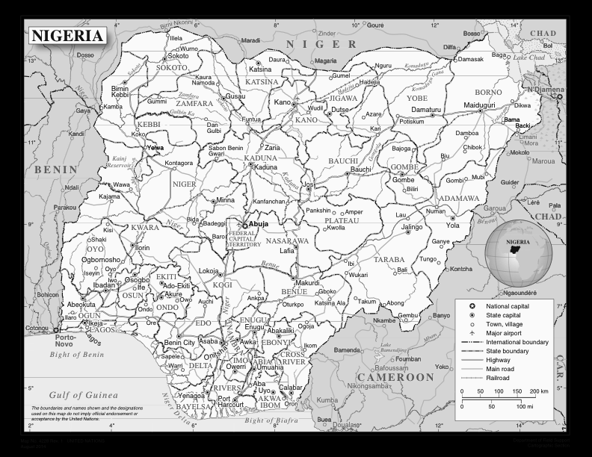
Figure 1. Map of Nigeria

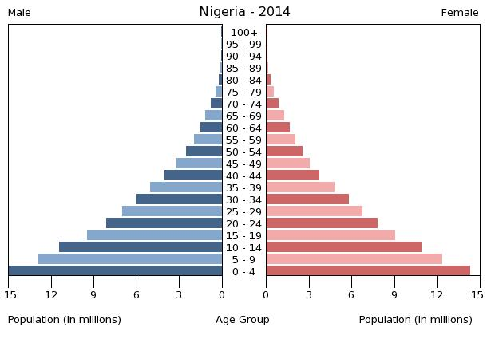
Figure 2. Population Pyramid Nigeria
Figure 2. Population Pyramid Nigeria

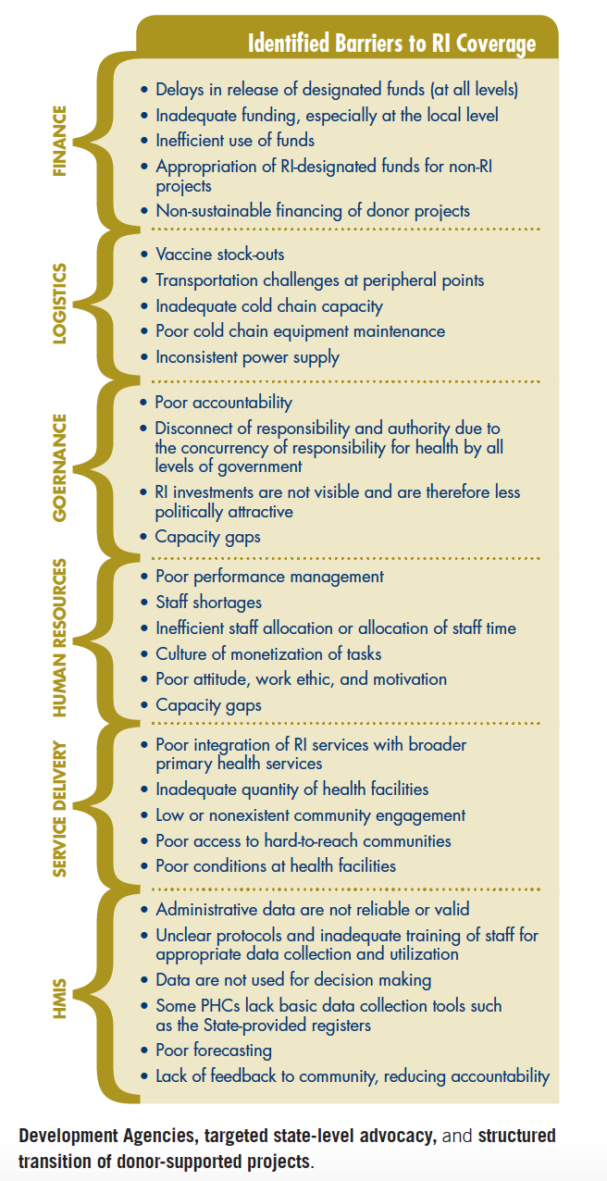
Figure 3. Barriers to RI in Nigeria

Figure 4: Current Data Gathering Process in Nigeria
Whole process is completed within a week, which usually takes 2-3 months at the present time
Figure 5. Outline of Project on IVR Collection of Routine Immunization Reports

The following questions should be asked in this sequence.
Good evening Mr / Mrs. _________________. This is the IVR system to collect the immunization report. If it is Mr / Mrs ___________________, please input your ID code number. If you want us to call later after 1 hr. time, please press “0”, For assistance press “9” to speak to the agent

If “0” is input, repeat call after 1 hr. time

Did you conduct the planned Immunization session today? For “YES”, press 1, For “NO” press 2

Option 1 Selected
Option 2 Selected

Sorry to hear that you were not able to conduct the planned session. Can you specify the reason by choosing one of the options:
Press 1 for No Vaccine Available
Press 2 for No Logistics Available
Press 3 for No Funds available
Press 4 for other competing Programs
Press 5 for problems with the community
Press 7 for any other reason and say the reason after the prompt

Thank you very much for the feedback. Have a nice evening

Thank you; now please enter the number of beneficiaries immunized after appropriate vaccine prompts.
How many children did you provide BCG Vaccine * ____*
How many children did you provide Hepatitis B Vaccine * ____*
How many children did you provide Pentavalent 1 Vaccine * ____*
How many children did you provide Pentavalent 2 Vaccine * ____*
How many children did you provide Pentavalent 3 Vaccine * ____*
How many children did you provide Measles Vaccine * ____*How many children did you provide Yellow Fever Vaccine * ____*
How many Women did you provide TT Vaccine * ____* etc
Thank you very much for your responses. Have a nice evening.

Figure 6. IVR Dialogue

Phone Number & Details of Health Worker | Date and Time of the call | Name of the Settlement (Number) – State, District etc | BCG Vaccine | Hepatitis B Vaccine | Oral Polio Vaccine 1 | Oral Polio Vaccine 2 | Oral Polio Vaccine 3 | Pentavalent Vaccine 1 | Pentavalent Vaccine 2 | Pentavalent Vaccine 3 | PCV 10 – 1 | PCV 10 – 2 | PCV 10 – 3 | Measles Vaccine | Yellow Fever vaccine | Tetanus Toxoid

Figure 7. Reporting Format for Collection and Complication of Data

Figure 8 demonstrates the process of disseminating the data after it has been analyzed

Figure 8. Data for Action

Table 1. Number of FTEs
Position | FTEs | Expense per FTE | Total Expenses
Program Manager | 1 | $78,000 | $78,000
Administrative Assistant | 1 | $15,000 | $15,000
Data Analyst | 2 | $36,000 | $72,000
Outcomes Analyst | 1 | $36,000 | $36,000
Technical support Information systems | 2 | $40,000 | $80,000
Consultants | 3 | $60,000 | $180,000
Training Coordinators | 75 | $30,000 | $2,250,000
Social care workers | 10 | $24,000 | $240,000
Total FTEs | 95 |  | $2,951,000

Figure 9. Training Implementation Levels in Nigeria

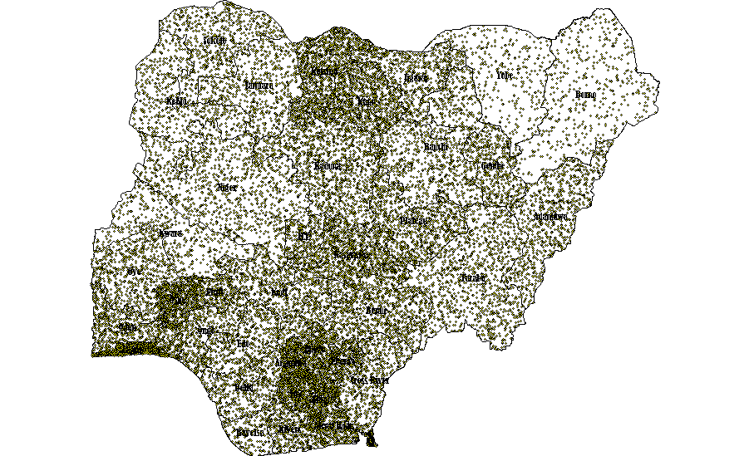

One public health facility providing routine immunization
Figure 10. Map of Nigeria Showing the 20,000 Public Health Facilities Delivering Routine Immunization

Program Timeline
Figure 11. Implementation Timeline of IVR Project in Nigeria

Table 2. Budget
Expense | Units | Rate/unit | Number of times | Yearly cost
One time Costs
Software to be procured | 1 | $50,000 |  | $50,000
Installation & operationalization | 1 | $15,000 |  | $15,000
Training of Health Care workers (1day) | 20,000 | $200 | 1 | $4,000,000
Blue tooth speakers or headphones | 20,000 | $2 | 2 | $80,000
SIM cards | 25,000 | $5 | 1 | $125,000
 |  | Subtotal One time costs |  | $4,270,000
Recurrent costs
Salaries of staff | 95 |  |  | $2,951,000
Telephone support | 25000 | $10 | 12 | $3,000,000
Consumables | 1 | $5,000 | 12 | $60,000
Staff travel to states | 37 | $1,000 | 12 | $444,000
Office Space Real Estate | 1 | $20,000 | 12 | $240,000
Office equipment lease Computers (10) Laptop (20), Tables (40), Phones (100), Printers (10), furniture, internet |  | $40,000 | 12 | $480,000
 |  | Subtotal |  | $7,175,000
 |  | Total |  | $11,445,000

Bibliography

Africa, I. N. (2015). Top 10 Richest Countries in Africa Rated. Retrieved April 15, 2015, from http://www.itnewsafrica.com/2015/02/top-10-richest-countries-in-africa-rated/
Agency, F. M. o. H. N. P. H. C. D. (2013). National Routine Immunization Strategic Plan 2013-2014. Retrieved April 15, 2015, from http://www.jhsph.edu/research/centers-and-institutes/ivac/resources/Nigeria-NRISP-Technical-Policy.pdf
CIA. (2014). The World Fact Book. Retrieved April 15, 2015, from https://http://www.cia.gov/library/publications/the-world-factbook/geos/ni.html
Commission, N. C. (2015, February, 2015). Retrieved April 15, 2015, from http://www.ncc.gov.ng/index.php?option=com_content&view=article&id=125:art-statistics-subscriber-data&catid=65:cat-web-statistics&Itemid=73
Enhancing the Work of the Department of Health and Human Services National Vaccine Program in Global Immunization: Recommendations of the National Vaccine Advisory Committee: Approved by the National Vaccine Advisory Committee on September 12, 2013. (2014). Public Health Reports, 129(Suppl 3), 12-85.
Etisalat Nigeria. (2015). Our Services. Retrieved on April 12th, 2015, from: http://www.etisalat.com.ng/
Ghinai, I., Willott, C., Dadari, I., & Larson, H. J. (2013). Listening to the rumours: What the northern Nigeria polio vaccine boycott can tell us ten years on. Glob Public Health, 8(10), 1138-1150. doi: 10.1080/17441692.2013.859720
Gidado, S., Nguku, P., Biya, O., Waziri, N. E., Mohammed, A., Nsubuga, P., . . . Sabitu, K. (2014). Determinants of routine immunization coverage in Bungudu, Zamfara State, Northern Nigeria, May 2010. Pan African Medical Journal, 18 Suppl 1, 9. doi: 10.11694/pamj.supp.2014.18.1.4149
Jr., D. G. M. (2013). Gunmen Kill Nigerian Polio Vaccine Workers in Echo of Pakistan Attacks. Retrieved April 15, 2015, from http://www.nytimes.com/2013/02/09/world/africa/in-nigeria-polio-vaccine-workers-are-killed-by-gunmen.html?_r=0
Kaewkungwal, J., Apidechkul, T., Jandee, K., Khamsiriwatchara, A., Lawpoolsri, S., Sawang, S., . . . Krongrungroj, S. (2015). Application of Mobile Technology for Improving Expanded Program on Immunization Among Highland Minority and Stateless Populations in Northern Thailand Border. JMIR mHealth uHealth, 3(1). doi: 10.2196/mhealth.3704
Mathews, M.P. (2002). Nigeria: Current Issues and Historical Background. Nova Publishers.
Williams, L. (2008). Nigeria: The Bradt Travel Guide. Bradt Travel Guides.

Mcdikkoh, D. M. N. (2010). The Nigerian Health System's Debacle and Failure!. Xlibris Corporation.

“Nigerian National Routine Immunization Strategic Plan”. (2013). Retrieved on April 12th, 2015, from http://www.nationalplanningcycles.org/sites/default/files/country_docs/Nigeria/ri_strategic_plan_combined_mahmud_draft_1.pdf
Okafor, I. P., Dolapo, D. C., Onigbogi, M. O., & Iloabuchi, I. G. (2014). Rural-urban disparities in maternal immunization knowledge and childhood health-seeking behavior in Nigeria: a mixed method study. African Health Sciences, 14(2), 339-347. doi: 10.4314/ahs.v14i2.8
Organization, W. H. (2012). Expectancy at Birth, Both Sexes. Retrieved April 15, 2015, from http://gamapserver.who.int/gho/interactive_charts/mbd/life_expectancy/atlas.html
Prevention, C. f. D. C. a. (2015). Population Pyramid. Centers for Disease Control and Prevention.
Renne, E.P. (2010). The Politics of Polio in Northern Nigeria. Indiana University Press.
Reducing Child Mortality. (2013). Global Health Observatory Data. Retrieved April 15, 2015, from http://www.who.int/gho/child_health/en/
Renne, E. P. (2010). The Politics of Polio in Northern Nigeria
Ihonvbere, J.O. (1994). Nigeria: The Politics of Adjustment and Democracy. Transaction Publishers.
Umeh, C. A., & Ahaneku, H. P. (2013). The impact of declining vaccination coverage on measles control: a case study of Abia state Nigeria. Pan African Medical Journal, 15. doi: 10.11604/pamj.2013.15.105.2515
UNICEF. (2013). WHO and UNICEF estimates of immunization coverage: 2013 revision. Retrieved March 21, 2015, from http://www.data.unicef.org/fckimages/uploads/1421191161_nigeria_rev_13_FINAL.pdf
UNICEF. (2013). Global Vaccine Action Plan. Retrieved on April 12th, 2015 from: http://www.unicef.org/immunization/files/GlobalVaccineActionPlan.pdf
Wonodi, C., Stokes-Prindle, C., Aina, M., Oni, G., Olukowi, T., Pate, M.A., Privor-Dumm, L., & Levine, O. (2012). Landscape Analysis of Routine Immunization in Nigeria. Retrieved April 15, 2015, from http://www.jhsph.edu/research/centers-and-institutes/ivac/projects/nigeria/IVAC-Landscape-Analysis-Routine-Immunization-Nigeria-Brief.pdf

