INITIATING SKIN-TO-SKIN IN THE OPERATING ROOM: PROGRAM DEVELOPMENT, IMPLEMENTATION, AND EVALUATION

by
Lauren Bealafeld
BS in Science of Nursing, University of Michigan, 2004

Submitted to the Graduate Faculty of
Behavioral and Community Health Sciences
the Graduate School of Public Health in partial fulfillment
of the requirements for the degree of
Masters of Public Health

University of Pittsburgh
2015

UNIVERSITY OF PITTSBURGH
GRADUATE SCHOOL OF PUBLIC HEALTH

This essay is submitted
by
Lauren Bealafeld

on

April 20, 2015
and approved by

Essay Advisor:
Elizabeth Felter, DrPH ______________________________________
Visiting Assistant Professor
Behavioral and Community Health Sciences
Graduate School of Public Health
University of Pittsburgh

Essay Reader:
Candace M. Kammerer, PhD ______________________________________
Associate Professor
Director of Graduate Studies in Human Genetics
Department of Human Genetics
Graduate School of Public Health
University of Pittsburgh

Copyright © by Lauren Bealafeld
2015
ABSTRACT
Elizabeth Felter, DrPH

INITIATING SKIN-TO-SKIN IN THE OPERATING ROOM: PROGRAM DEVELOPMENT, IMPLEMENTATION, AND EVALUATION

Lauren Bealafeld, MPH
University of Pittsburgh, 2015

Skin-to-skin contact between mother and child immediately following delivery is an important step in initiating successful breastfeeding episodes, in addition to many other physiologic benefits for mother and child. Breastfeeding remains a top national public health priority. Currently, at Magee Womens Hospital of UPMC (MWH), skin-to-skin contact is not being facilitated within the first hour of life when an infant is delivered via cesarean section. Through a literature review the technique for facilitating skin-to-skin in the operating room was developed. This technique was taught to the newborn assessment nurses (NANs) who are responsible for care of the infant after delivery in the operating room. This program was presented to obstetrical nursing leadership team who granted their approval. Additionally, this program was submitted for approval to the UPMC system wide quality improvement committee, from which approval was granted. When discussing this program with the NANs and birth center nurses the program was met with missed feelings. Many concerns have come up and they have been addressed to the best of the authors’ ability. The author has taught all NANs how to facilitate skin-to-skin while in the operating room. The program has been evaluated using a patient satisfaction survey and by querying infant temperatures and comparing the non-skin-to-skin group to the skin-to-skin group to assess if there is a difference between the mean temperatures of each group.

TABLE OF CONTENTS
Preface ix
1.0 Introduction 1
1.1 LITERATURE REVIEW 3
1.1.1 History of STS 3
1.1.2 Physiologic Rationale and Benefits to the Infant and Mother 3
1.1.3 Recommendations 7
1.1.4 Initiating Skin-to-Skin in the Operating Room 8
1.1.5 Theory 14
2.0 Methods 16
2.1 Stage 1- Define Problem (Awarness Stage) 17
2.1.1 Barriers 18
2.1.2 Outside Help 20
2.2 Stage 2-Initiate Action (Adapation Stage) 22
2.2.1 Presentations and Meetings-The Road to Implementation 23
2.3 Stage 3-Implement Change 25
2.4 Stage 4 Institutionalize Change 27
3.0 Findings/Evaluation 29
4.0 Discussion 34
5.0 Conclusion 37
5.1 Limitations 38
5.2 Public Health Impact 39
Appendix A-Patient Education Brochure 40
Appendix B-Nursing Workflow in the OR 43
Appendix C-CWISH Query 44
Appendix D-EBP Statement of Need 46
Appendix E-STS Inclusion Criteria & RAPP Assessment 50
Appendix F-Patient Satisfaction Questionnaire 53
bibliography 55
List of Figures
Figure 1. Skin-to-Skin being facilitated in the operating room 16
Figure 2. Normal newborn temperatures range from 36.5ºC to 37.5ºC 30
Figure 3. Temperatures at 1 Hour of Life 31
Figure 4. Makeup of the scheduled C-sections where STS was facilitated in the OR 32
Figure 5. Patient satisfaction results from patient satisfaction questionnaire 33
Preface
I would like to thank the people who helped me get here. Academically my advisor and essay chair Dr. Elizabeth Felter. Thank you for your support over the last three years and for giving me the idea for this program. Essay reader Dr. Candace Kammerer, thank you for reading this several times over and for your edits and suggestions. All of the help and guidance was greatly appreciated. Professionally, I would like to thank Linda Dudas, RNC, MSN, CNL and Karen Stein, MSED, RN for championing this project, helping guide me through the maze of hospital approval, and for making sure that the wheels were always greased. I honestly could not have successfully implemented this without you both. I truly appreciate everyone’s support and encouragement through this process.

Introduction
This essay will document the implementation of policy and procedural changes that occurred at Magee Womens Hospital (MWH), to facilitate the practice of providing skin-to-skin contact to babies born via cesarean section (C-section) during the closure of the procedure or as soon as the woman has returned to the post-anesthesia care unit (PACU). For the purpose of this project skin-to-skin (STS) is defined as “the placing of a newborn, wearing only a hat and diaper, prone on its mothers bare chest at birth or soon after[1].” The new procedure applies to straightforward elective C-sections for healthy women with uncomplicated singleton fetuses who are full term (37+ weeks of gestational age).
MWH has a twenty two-bed labor and delivery unit, six obstetrical intensive care beds, five operating rooms, and ten Post-Anesthesia Care Unit (PACU) bays in the birth center. MWH is located in the Oakland neighborhood of Pittsburgh, PA. MWH performed 10,200+ deliveries in 2013, with 3,189 of those deliveries being C-sections. This yields a C-section rate of about 30%. The national average C-section rate is 32% or 1.4 million C-section deliveries annually[2]. Despite MWH being below the national average, C-sections still comprise about one-third of MWH’s deliveries. The previous standard of care at MWH is immediate STS, if medically appropriate, following a vaginal birth. However, no STS was being facilitated between mothers and their infants born via C-section within the first hour after delivery. Thus, as many as one third of infants born at MWH are not receiving the benefits of immediate STS, with potential health consequences which will be discussed in the literature review section below.
To address this concern, the author created as part of her Masters in Public Health Practicum project, a program to facilitate STS in the OR for straightforward elective C-sections. The program includes the training of: 140 labor and delivery nurses, 10 newborn assessment nurses (NAN), 15 anesthesia attendings, 40 anesthesia residents, 39 obstetrical and gynecology (OBGYN) residents, and 170 OBGYN attendings, focusing on the benefits of STS and the necessary procedures to facilitate STS in the OR. Educational materials were also developed for the expectant mother and her support person explaining the option for STS. The Midwives of Magee were not included in this training because, whenever possible, the midwives from this group were already facilitating STS in the OR with their own patients.
It is the author’s intention that as a result of this initiative MWH will see, in the short term, normotensive infants at 30 minutes and 60 minutes of life and maternal satisfaction with the practice. In the long term MWH would like to experience an increased rate in infants that are exclusively breastfed at time of discharge, continued maternal satisfaction with the practice, and an increase in the rate of infants exclusively breastfed at time of hospital discharge reported for all of Allegheny County, PA.

LITERATURE REVIEW
An extensive literature review was conducted in the spring of 2014. Key words that were searched were: skin-to-skin, kangaroo care, kangaroo mother care, infant temperature, cesarean section, and combinations of these phrases.

History of STS
Skin-to-skin care (originally called Kangaroo Care) began in Bogota, Columbia in the 1970s - 1980s. Rey and Martinez were the first to document the effects of “Kangaroo Care” in 1983[3]. The mortality rate of preterm infants at that time was 70% due to infections, respiratory problems, and lack of bonding with the infant’s parents. Kangaroo Care evolved from the absence of medical care. Mothers of preterm infants held their babies 24 hours a day, including sleeping with the infant tucked into their clothes much like a kangaroo’s pouch and researchers noticed a drop in preterm infant mortality. Kangaroo care was introduced to hospitals in the United States in the early 1990s [4]. Up until recently most of the research and reporting of the benefits of STS has been focused on the preterm infant who are typically in the Neonatal Intensive Care Unit.

Physiologic Rationale and Benefits to the Infant and Mother
The usefulness of immediate STS contact between mother and infant has been well documented in animal studies. It is often habitat-dependent for the neonate to be carried by its mother for survival. This continuous maternal-child contact allows for protection from predators and for successful breastfeeding episodes[5]. The immediate post-delivery period is especially important because this is a period of programming for future behavior. This process allows for mother and baby to develop synchronous interaction patterns. Neuro-behaviors are triggered that ensure the fulfillment of basic biologic needs for the infant[6].
Ferber and Makhoul [6] discussed, in their 2004 article, the neurobehavioral responses of the term newborn. In this article the initial postnatal period was identified as being a time of stress for the newborn. This stress state was marked by increased levels of catecholamines, cortisol secretions, and labile neurobehavioral regulation. They identified that the five dimensions of neurobehavioral adaptations in the literature are: autonomic, motor, state, attention/interaction, and self-regulation. The idea of self-regulation was heavily discussed. Self-regulation was described as “the regulation of physiologic systems, information processes, and the formation of attachment bonds that ultimately determines how the infant responds cognitively and social-affectively to the environment.” Their study showed that STS between mother and child resulted in infants having better self-regulation in specific areas of motor system balance and sleep organization during transition to the extrauterine environment. These infants cried less and slept for longer time periods as compared to the control group.
Within the first two hours of life, considered the immediate transitional period, benefits of STS for the infant include: stabilization of the infant’s heart rate, stabilization of the infants breathing pattern, improved oxygen saturation levels, increased temperature, stabilization of blood sugar levels (even if not fed), and more successful breastfeeding episodes [6-8].
Several studies were reported by Goldson in his book, “Nurturing the Premature Infant: Developmental Intervention in the Neonatal Intensive Care Nursery”[3], discussing the effects of STS on an infant’s respiratory stability. In one study six infants were observed and two developed grunting respirations. Grunting is a sign of respiratory distress for infants and often results in the infant being admitted to the Neonatal Intensive Care Unit (NICU). When these two infants were placed into STS with an oxygen hood the grunting resolved. A second study was conducted which involved 14 infants in Columbia. All were grunting, they were all given early STS and had similar resolution of their grunting respiratory pattern.
For a newborn infant a normal temperature at birth is 36.5ºC to 37.5ºC. Horn et al [9] reported in an article that hypothermia in newborns has a prevalence rate of 85% in hospitals globally. Hypothermia contributes to neonatal morbidity and mortality. STS with the infant’s mother, as compared to an incubator or radiant warmer, is more effective in reducing neonatal hypothermia.
According to Gouchon et al. [10] there are five reasons why infants born via C-section are at a higher risk of hypothermia. First, the low temperature of the operating room (OR) air. At MWH the birth center ORs are kept around 70ºF. Second and third, the mothers skin temperature and exposure to locoregional anesthesia. Locoregional anesthesia can result in a decrease in maternal core temperature and ultimately a decrease in skin temperature. The cold air circulating in the OR will also cause a decrease in maternal skin temperature. Fourth, redistribution of body heat from the core to the periphery of the infant after he/she is born. This results in a decrease in core temperature of 0.5ºC-1ºC. Finally, infants born via C-section are exposed to drugs that cross the placental barrier that could effect thermoregulation and the sympathoadrenal system is not mobilized as extensively in infants born via C-section when compared to infants born vaginally.
If an infant experiences extended periods of cold stress possible complications include: increased oxygen consumption, which can lead to acidosis and hypoglycemia; a decrease in blood pressure; decreased plasma volume and subsequently decreased cardiac output; and increased peripheral resistance. It is possible that hypothermia can cause coagulation defects and delayed readjustment of the fetal circulation system. When an infant is born there is an increase in its temperature due to increased metabolic rate but that is quickly followed by a cooling phase which occurs in the first 10-20 minutes after birth[10].
Goldson [3] discussed a randomized control trial in which eight infants were randomly assigned to the STS group or standard care group at one hour of life. The STS group had a nurse researcher stay with the mother-baby dyad through the transition phase and supported each mother in breastfeeding, keeping her infant warm, and recognizing her infant’s cues and how to respond to them appropriately. All of the infants in the STS group showed appropriate thermoregulation, outstanding behavioral organization, and competence in breastfeeding by 24 hours of life. The mothers in turn developed a large milk supply, did not have engorgement, and did not complain of nipple or breast pain.
Benefit of STS for the infant in its first one to two days of life include: gain in sleep time and high-quality sleep that promotes brain development and maturation, quicker weight gain after birth, decreased crying, colonization with “safe germs” resulting in fewer infections, and earlier hospital discharge[1, 6-8, 11, 12].
STS may have a role in boosting development of infant’s nervous system and developmental measures at one year of age. These developmental measures include better social, linguistic, fine and gross motor skills [1, 6, 7, 11, 12].
Feldman et al [13] found that STS increased autonomic functioning and maternal attachment behaviors in the post-partum period. Children showed enhanced cognitive development and executive functions from 6 months to 10 years of age. At 10 years of age the child had a better stress response, organized sleep, and better cognitive control.
The benefits of STS for the parents include: improved bonding with their child, increased breast milk supply and decreased engorgement (for the mother), increased confidence in their ability to care for their infant, increased feeling that their infant is well cared for, decreased bleeding after delivery (for the mother), decreased maternal anxiety, and an increased sense of control [1, 8, 13]. It has been suggested that lack of STS could put mothers and infants at a disadvantage socially, developmentally, and nutritionally[14].

Recommendations
The World Health Organization (WHO) and United Nations International Children’s Emergency Fund (UNICEF) recommends that mothers and newborns have skin-to-skin contact immediately after vaginal birth, or as soon as the mother is alert and responsive after a C-section. Immediate is defined as within minutes and early skin-to-skin is defined as within one hour after birth. Skin-to-skin is recommended to for all women and their infant immediately after birth for at least one hour or until after their first breastfeeding episode is completed [12]. Step 4 of The Ten Steps to Successful Breastfeeding, developed by the Baby-Friendly USA hospital designation is “help mothers initiate breastfeeding within one hour of birth.” This step calls for placing infants skin-to-skin with their mother immediately following birth for at least one hour and as often as possible after that [15]. Given wide spread support by many health care organizations, as well as the significant amount of data that has been collected on the benefits of STS, this practice has been gaining in popularity over the past decades and has been adopted as standard practice for vaginal deliveries in most hospitals. The next wave of this is the facilitation of STS in the OR as standard of care for all C-section deliveries too.
While Healthy People 2020 makes no recommendation specifically about STS, as the literature has shown, STS supports the establishment of breastfeeding, which remains a top public health priority. Breastfeeding initiation and continuation until at least the end of the first year of life continues to be included in the Healthy People 2020 Goals. MICH 21 states “Increase the proportion of infants who are breastfed” as a goal [16]. Initiating Skin-to-Skin in the Operating Room is likely to help increase the number of women who are meeting Healthy People 2020 goals regarding breastfeeding.

Initiating Skin-to-Skin in the Operating Room
In order to understand how other hospitals had integrated STS in the OR, several articles were reviewed. At an inner-city hospital located in the Southwestern United States a Champion Team was assembled to implement the practice of facilitating STS in the OR [17]. The implementation team had three aims: “(1) develop a protocol for health care professionals’ roles in providing STS in the OR; (2) to implement the protocol and (3) to evaluated the process of implementation of the evidence-based intervention.” Their review of the literature showed that STS in the OR was safe for both mother and infant, that it increased maternal satisfaction and promoted breastfeeding. They found no adverse outcomes with STS in vaginal or C-section births. High levels of maternal satisfaction were documented when STS accompanied C-section births. Also in their literature review they found that C-sections negatively effected breastfeeding.
This group used the Iowa Model of Evidence-Based Practice and Lewin’s Change Theory in order to facilitate change and implementation of STS in the OR. The Iowa model promotes pilot testing before implementation. The Iowa Model uses knowledge and problem focused triggers to initiate a need for evidence based practice change. The Iowa Model has been used frequently in larger healthcare facilities to facilitate evidence based changes in practice. In order to move toward implementation the team did a literature review and performed a simulation of a birth where STS would be performed in the OR in order to identify and solve problems that arose. As a result of this simulation the following modifications were made: “(1) move the IV poles further away from a woman’s head toward the operating field by approximately 6 inches, (2) avoid tying a woman’s hand to the arm boards, (3) place the cardiac monitor leads on a woman’s side rather than her chest, and (4) place the warming blanket at a woman’s lower extremities instead of her upper body.” The team surveyed the staff that participated in piloting of STS in the OR. The staff felt that STS in the OR was easy to facilitate and did not interfere with their job. Minor modifications to the protocol were made following piloting: “(1) providing a chair specifically for the NAN to use at the woman’s head; (2) making sure that stethoscope, thermometer and glucometer necessary for newborn care are easily accessible for the NAN; (3) if patient census didn’t allow for the NAN to remain with the mother-baby dyad during the entire recovery period, the recovery room nurse would continue SSC (STS) in the recovery room; (4) to address communication issues, obstetricians and anesthesia personnel would understand that SSC (STS) would be expected in all scheduled or non-emergent cesarean births.” As a result of their surveys no major changes were made to their protocol. They strongly recommend the champion team model when facilitating evidence based practice change.
In a 2014 article by Brady, Bulpitt, and Chiarelli [18], they describe the process that their “Family Birthing Center” went through to begin facilitating STS in the OR. After implementing STS for all vaginal births they set out to implement STS in the OR for C-section deliveries as well. According to their data only 9% of infants born via C-section were exclusively breastfeeding at time of discharge. In order to address this problem two committees were created: Perinatal Safety and Patient Satisfaction Committee and the Baby-Friendly Committee. This facility utilize the plan, do, study, act (PDSA) method to facilitate practice change. Plan- an interprofessional team was assembled including nurses and scrub technicians, obstetricians, anesthesiologists and certified registered nurse anesthetists, neonatologists and pediatricians, lactation consultants, and patients themselves. A solid educational plan for staff was developed. Perinatal patent education on STS was seen as very important to the success of implementing STS in the OR and a patient education plan was developed as well. Do- Two “tests of change” were performed. In both of these “tests of change” the patients reported a high degrees of satisfaction and increased breastfeeding within the first hour of life. Study- Through chart review data was collected on initiating STS in the OR and breastfeeding exclusivity rates. Monthly meetings are held between the Perinatal Safety and Patient Satisfaction Committee and the Baby-Friendly Committee to share and review the collected data. Act- after six months of preparation STS in the OR was fully implement for all patients undergoing C-section. The committees went onto modify policies and procedures in order to fully adopt this new practice. In data collection after implementation of STS in the OR their rate of infants exclusively breastfeeding at time of discharge following C-section delivery increased to as high as 23%. They also noticed an increase in overall exclusive breastfeeding rates at time of hospital discharge from 30% to 63% over a 10 month period.
In an article by Moran-Peters et al. [4], they studied women who had previously delivered via C-section without STS being performed and asked them to compare the experience to their most recent C-section delivery where STS was performed immediately following delivery. The mothers were asked two questions in a qualitative interview: “1- What are your perceptions of the benefits of performing skin-to-skin contact with your newborn infant immediately following delivery? And 2- What difference do you note between your current cesarean birth experience, where immediate skin-to-skin contact was performed, and your previous elective cesarean birth experience when performing skin-to-skin contact was not the standard of care?” Two main themes arose from the analysis: 1- mothers’ relationships with their newborns, and 2- mothers’ experience with breastfeeding.
Women’s Relationships with Their Newborns: women reported an improved relationship with their infants after performing STS. They reported that their most recent C-section was improved by STS with their infant in the recovery room. The words reported as being used most to describe the experience were “peaceful, good, important, pleasant, positive, wonderful, nice, or great.” [4] The experience helped the women feel closer to their infants right from the start. The women also reported that STS was beneficial for their recovery and allowed for a connection in a “maternal” way.
Women’s Experiences with Breastfeeding: It was reported that most women struggled with breastfeeding their previous infants because of lack of contact after their earlier C-section. Their results indicated that mother-baby dyads that had STS following a C-section had better breastfeeding experiences. The women felt calmer and more relaxed which eased the process of breastfeeding. Participants reported that STS helped the baby latch better [4].
Memorial Hospital of Rhode Island developed a gentle cesarean program in 2009 [11]. This program was formed after a statewide advocacy group approached attending family and obstetrical physicians regarding strategies to improve family experiences during C-section and to promote early STS. As a result of this advocacy group the hospital redesigned its C-section delivery procedure. Initially they conducted “gentle” C-sections for scheduled cases and included the following elements: “1- minimal extraneous conversation among caregivers in the OR; 2- music of the parents’ choice playing, if desired; 3- delayed cord clamping for a minimum of 30 seconds after birth and stimulation of the infant (initial resuscitative measures) on the operating table before the cord is clamped and cut; 4- immediate placement of the infant skin-to-skin with the mother if both are clinically stable; 5- encouragement of early breastfeeding; and 6- avoidance of separation of mother and infant unless clinically indicated or desired by the mother.” Implementation involved input from relevant stakeholders and a simulated delivery scenario involving all team members. According to this article the only situation where STS in the OR is would be impossible is a C-section where the woman needs to be placed under general anesthesia.
On interesting trend in the literature was the juxtaposition of STS in the OR with the concept of “natural” or “gentle” Caesarean Sections. In their 2008 article “The natural caesarean: a woman-centered technique” Smith, Plaat, and Fisk [19] described an approach they are practicing at their hospital in London, during which a C-section delivery mimics a vaginal delivery. This approach allows for: “1- the parents to watch the birth of their child as active participants; 2- slow delivery with physiological auto resuscitation; and 3- the baby to be transferred directly onto the mother’s chest for early skin-to-skin.” In preparation for this style of delivery the woman and her partner are shown video clips demonstrating the natural C-section process. If possible they meet with a midwife and obstetrician and are given a tour of the operating room. This is believed to make the operating room less intimidating. On the day of delivery the woman’s intravenous line is placed in her non-dominant arm, her pulse oximeter is placed on her foot so her hands are free, and her electrocardiogram (EKG) leads are placed on the side of her chest.
The delivery is a slow process compared to what is typically performed in the United States. After the uterine incision is performed the surgical drape is lowered and the head of the operating table is raised. Both of these modifications allow for the mother to visualize the birth of her child. The fetus’ head is assisted though the abdominal incision. They describe the primary surgeon as “hands-off” after the head is assisted out. The fetus “auto resuscitates: breathing air through the exteriorized mouth and nose, while its trunk, still in utero, remains attached to the placental circulation.” The pressure exerted on the fetus by the uterus clears the lungs of amniotic fluid. When the fetus starts crying the shoulders are eased out by the surgeon. They report that after assisting the shoulders out the infant often delivers his/her own arms. The pressure exerted by the infant’s torso on the uterine and abdominal incision helps to minimize maternal bleeding. The remainder of the infant’s body is delivered through “passive expulsion” a combination of uterine contractions pushing the infant out and assistance from the obstetrician.
After delivery the infant is assessed for wellbeing, and the cord is clamped and cut in view of the parents. It is anesthesia’s responsibility to clear the womans gown from her chest so that the infant can be positioned appropriately. The woman’s midwife dons sterile gloves and receives the infant from the surgeon. The infant is placed prone between the mother breasts, is dried, and bubble wrapped (for warmth). The infant’s identification bracelet placement and vitamin K shot (to promote clotting) are performed while the infant is on the mother’s chest. The infant is weighed once surgery is completed and the mother is being transferred to her recovery bed. Once the woman is on her recovery bed STS is re-established with the infant in the same position.

Theory
As stated above the benefits of STS have been well researched and documented in the literature. This information has also been taught to the nurses and doctors working at MWH, however it was still the practice to not perform STS during a C-section. In order to change this practice “Organizational Change: Stage Theory” was utilized. This theory was originally developed by Kurt Lewin’s in 1951 as a stage model and modified by Beyer and Trice (1978) and later by Kaluzny and Hernandez (1988)[20].
According to Stage Theory of Organizational Change, adoption of change by an organization must occur through a series of stages. Each stage requires a specific set of strategies that are related to the stage of change the organization is in.
Lewin’s original model of organizational change consisted of three stages: “(1) unfreezing of past behavior and attitudes within the organization, (2) moving by exposure to new information, attitudes, and theories, and (3) refreezing through processes of reinforcement, confirmation, and support for the change.
In the most recent version of Organizational Change: Stage Theory Kaluzny and Hernandez have grouped change into four stages[20]:
- Define Problem (Awareness Stage)- Problems recognized and analyzed; solutions sought and evaluated
- Initiate Action (Adoption Stage)- Policy or directive formulated; resources for beginning change allocated
- Implement Change- Innovation implemented; reactions occur, and role changes occur
- Institutionalize Change- Policy or program becomes entrenched in organization; new goals and values internalized
It is known that different leaders and employees within the organization assume different roles during different stages of change. This was an ideal model for change within a large hospital because staff buy in was necessary at a variety of levels:
Stage 1 Define Problem- Involve management and personnel in awareness-raising activities.
Stage 2 Initiate Action- Consultations and discussion to inform decision makers and implementers regarding adoption of change.
Stage 3 Implement Change- Provide training, technical, and problem-solving support.
Stage 4 Institutionalize Change- Identify high-level champions, overcome obstacles to institutionalization, and create a structure for integration.
The most recent version of Organizational Change Stage Theory (Kaluzny and Hernandez) was used to develop and guide the implementation of this project, anticipate and resolve challenges, and allow for the institutionalization of STS in the OR beyond the timeframe of the Practicum project.

Methods
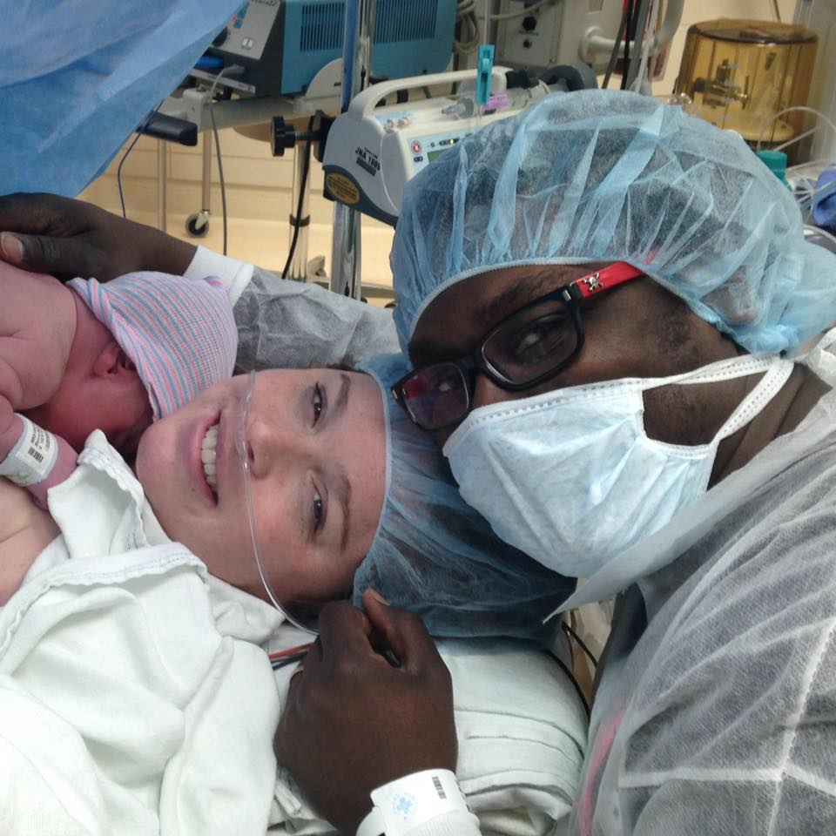

Figure 1. Skin-to-Skin being facilitated in the operating room

Stage 1- Define Problem (Awarness Stage)
After a meeting with the author’s academic advisor, Dr. Elizabeth Felter, at the end of the fall 2013 term, the decision was made to do a community-based practicum at MWH. The focus of the practicum would be implementing STS in the OR. The problem of absence of immediate STS for infants born via C-section was observed by the author and other employees of MWH birth center. Guided by the first stage in organizational change theory, the awareness stage, where the involvement of upper management is considered crucial, this issue was addressed with the OR manager, unit director, and ultimately the director of newborn and obstetrical services.
Throughout the spring of 2014 an extensive literature review was conducted. In the spring of 2014, management was approached about the idea of implementing STS in the OR. Birth center manager Linda Dudas was supportive and agreed to become an outside advisor for this project. At that time observation of C-sections began with specific attention paid to how STS in the OR could be safely facilitated and how STS would modify nursing workflow.
With guidance from our outside advisor the author was directed to a nurse practitioner and a certified nurse midwife at Midwives of Magee who had a particular interest in STS in the OR and who had facilitated STS in the OR in the past. A phone conference with these stakeholders was held during which they provided me with advice on facilitation STS in the OR and guidance regarding what the next steps should be. Additionally, they requested that a brochure be made that could be placed in waiting rooms around the hospital and outpatient areas. This brochure is to be used as a patient and family education tool (Appendix A). During that spring the author attend a conference on breastfeeding at which STS was extensively discussed, including benefits of STS.
Throughout the summer of 2014, the author started a dialog with nursing and medical staff. These discussions about STS in the OR were held in an attempt to discover staff opinion regarding the idea of implementing STS in the OR. For the most part the idea was well received. Nurses who were consistently assigned to the OR were specifically consulted in order to assess their ideas and any barriers they could foresee. This process was very beneficial. The nurses pointed out that anesthesia would be an issue, as would workflow for nursing staff. A concern regarding infant temperature (both too hot and too cold) was raised. Some of the challenges we would face in facilitating STS in the OR were discussed in four articles [4, 11, 17, 19] that were used as references to support successful implementation.

Barriers
At this stage in the process, barriers to STS in the OR were identified through discussions with key staff and the literature review. In the operating room there are many physical barriers to facilitating STS. First, there is a sterile drape and sterile field that is necessary for prevention of infection. Second, the mother has multiple monitors placed on her for the duration of the surgery. EKG electrodes are placed on her chest in the exact location in which an infant would be placed to facilitate proper STS. The woman must wear a blood pressure cuff that works best when her arm is held still and straight. Third, the woman’s arms are usually restrained for security and safety. Fourth, the medications that are administered to the mother to provide spinal analgesia often result in a decrease in the mother’s blood pressure. This drop in blood pressure can leave the woman feeling nauseous and lightheaded. Finally, there is limited space at the head of the operating table due to anesthesia equipment, personnel, and the woman’s support person.
Moran-Peters and colleagues [4] cited two concerns similar to the barriers to implementation that the author anticipated. First, they identified “Major surgery with sterile draping decreased ability to provide skin-to-skin contact.” The proposed solution for this barrier was to initiate skin-to-skin contact within two hours of birth. This would not be an acceptable solution for the purposes of MWH STS in the OR implementation, so this recommendation was not followed. The second similar barrier was that “pain and sedation medications used during cesarean alters a mother’s mental status, and, therefore, the ability to safely hold her newborn.” Their solution was that the anesthesia staff not automatically sedate mothers after surgery. A similar request was made to MWH anesthesia department that sedative medications, such as versed, not be automatically administered to the mother once the infant is delivered.
Patients’ feelings of modesty were identified as another potential barrier. Ferrarello and Hatfield [21] reported a study in which both nurses and new mothers were surveyed and participated in focus groups about the topic of barriers to STS. Both mothers and nurses reported that modesty or visitors in the room were barriers to STS. Because a woman’s breasts are exposed in order to facilitate STS, this is an understandable concern. In order to overcome this barrier the process of STS is thoroughly explained to the mother and her support person, including the inevitable exposure of her breast in order to assure that she is comfortable with the procedure.
Many nurses at MWH also identified anesthesia as a barrier. By facilitating STS in the OR the infant would be placed in anesthesia’s work area. Despite this concern, however, when this program was discussed briefly with the chief of obstetrical anesthesia, the initiative was quite well received. Through ongoing conversations with members of the anesthesia department the initiative was also well received and members of that staff were excited about the initiative. Ultimately a formal presentation was given to the Division of Obstetrical Anesthesia.
An overwhelming concern that was repeatedly noted in discussions with staff was the procedure for infant transport from the OR to the recovery area (PACU). Recently, infant transportation was changed from allowing the mother to hold her infant during transport to requiring that the infant be transported in a separate crib. This change has caused widespread dissatisfaction in both patients and staff. This practice is a barrier to the goal of uninterrupted STS between mother and child until the first feeding is complete. In an effort to change the practice to allow the patient to hold her infant on the transport to the PACU a CWISH query was conducted. CWISH is a group of hospitals that all specialize in the care of women and children. In the CWISH query (Appendix C) four questions were asked about the topic of transporting infants from the OR and about performing STS in the OR. The response on transport of the infant from the OR to PACU was mixed between allowing mothers to hold their infants and the infant being transported separately. It was determined that attempting to change infant transport practice was likely to substantially delay the implementation of STS in the OR, and the decision was made to revisit this issue at a later date and continue the STS program development regardless of the less-than-ideal transportation policy.

Outside Help
During this time, the author continued research to identify other hospitals that were performing STS in the OR. Two hospitals were identified and contacted. One was Little Company of Mary outside of Chicago, IL. Their manager was very receptive and shared their procedure for facilitating STS in the OR. Additionally, Brigham Womens in Boston, MA is doing STS in the OR. The author reached out to an anesthesiologist whom their website indicated had been a leader in implementing STS in the OR and also the manager of the birth center, but these calls were not returned.
As previously mentioned, a CWISH query was conducted that included questions regarding STS in the OR. The hospitals produced a range of answers regarding the facilitation of STS in the OR. The majority, 11 out of the 13 hospital in CWISH, did not have STS in the OR policies, however two hospitals have a full policy for performing STS in the OR.
Later in the fall of 2014 another attempt was made to get information and guidance from other facilities. The author reached out to hospitals that perform a similar number of deliveries as MWH, to inquire if they were doing STS in the OR and if so, how it was being performed. Prentice Women’s Hospital of Northwestern University and Johns Hopkins Hospital were approached via personal contacts. They reported that they were both in a similar situation to MWH- they will facilitate STS in the OR when requested, however it is not standard for them to offer and facilitate STS for every scheduled C-section. However, they were both also working on developing practice and policy to make this standard of care for all scheduled C-sections.
Through discussion with staff and from the literature review it was obvious that the lack of STS contact following a C-section delivery was a problem that was gaining awareness. As a result administration was made aware of the issue and they were receptive to moving forward with the process of changing the practice.

Stage 2-Initiate Action (Adapation Stage)
After moving through the awareness stage and gaining managerial attention of the problem the author moved into the adaptation stage of organizational change. A dialog was maintained with the nurses and NANs of the MWH birth center. The continued discussion was anticipated to make the implementation of this practice easier because the staff have been consulted on what is involved in adoption of STS in the OR. These discussions also allowed the idea of STS in the OR to be introduced with ample time for the staff to become accepting of this change in practice. Through consultation with the NANs a workflow plan was created for facilitation of STS in the OR (Appendix B). This plan was reviewed with the birth centers safety officer to ensure that no risks were being overlooked. The development of this plan proved to be challenging because each NAN wanted something different. Some wanted to be told very specifically what to do and how to do it, while others were more comfortable figuring it out on their own. In the end the work flow plan serves as a guideline for safe practice that all NANs reported being comfortable following.
In the fall of 2014 Magee was hosting its own maternal and child health conference. The author was asked by the staff educator of the birth center to help develop a presentation regarding STS for her to present at the conference. A secondary literature search was conducted and our information was complied into her presentation. Around this same time the author began development of a policy for performing STS in the OR. It was soon discovered that there was a hospital-wide committee working on a STS policy, which included STS in the OR. They were provided with the information the author had gathered and proceeded with their policy development efforts independently from the author.
The author conducted an additional literature review to see how other institutions were addressing the problem of delayed STS contact between mother and child as a result of C-section delivery. What strategies they used, as well as techniques used for implementation and facilitation of STS in the OR. From the literature an implementation plan, and steps for facilitation of STS in the OR were developed. The process of facilitation was discussed at length with the implementers (NANs) to develop a plan that they thought would work best.
A small number of C-sections were observed and timed, it was discovered that it was taking about 60-90 minutes from deliver of the infant to the beginning of breastfeeding or STS with his/her mother. Given the UNICEF, WHO, and Baby Friendly Initiative guidelines of STS within one hour of life MWH was not within the recommended time frame, and therefore doing C-section babies a disservice. Permission was also given to start doing a small pilot of STS in the OR to see if it would be feasible or if more research was needed.

Presentations and Meetings-The Road to Implementation
The nursing director of obstetrics requested that a presentation on STS in the OR be given to the obstetrical leadership team. This is a group that is composed of the clinicians, managers, unit directors, and staff educators from antepartum, the birth center, and postpartum. Their approval would be needed in order to be able to proceed and implement STS in the OR for every scheduled C-section. In preparation for this presentation a set of inclusion criteria that mothers would have to meet in order to be able to perform safe STS in the OR was developed. An easy to remember infant safety observation system, RAPP [22], was found that will be taught to mothers and their support person to ensure that when the infant is in STS that he/she is not in distress. Both the RAPP and the inclusion criteria have been placed as reference signs hanging in the birth center ORs (Appendix E). OB leadership approved the STS in the OR initiative.
A statement of need (Appendix D) and a quality improvement form were submitted to the system wide quality improvement committee. The quality improvement committee in turn approved this project to move forward to the implementation phase.
A meeting was held with the infection control department at MWH. Infection control was made aware of the start date of implementation for monitoring of C-section infection rates. If STS in the OR were found to have a negative impact on C-section infection rates the practice would have to be re-examined and possibly modified.
A presentation was given to Obstetrical Anesthesia. Since the NANs interaction while performing STS in the OR would primarily be with anesthesia staff their full support was needed. The initiative was challenged but ultimately supported. Out of this meeting suggestions were made regarding when the topic of STS should be brought up to the mother and her support person. Anesthesia requested that this be discussed before the day of surgery. As a result the pre-operative nurses have been asked to inquire about STS in their pre-operative instruction call the day before surgery.
Support from all groups was granted and required before moving onto Sstage 3- implement change, and would be needed for the final stage of organizational change, stage 4-institutionalize change, where high-level champions help overcome obstacles to institutionalization.

Stage 3-Implement Change
Implementation began on March 9th 2015, a week that the author was available to provide one-on-one training to the NANs. Prior to implementation the staff were made aware of the approval of STS in the OR through the birth centers weekly newsletter, 52 Fridays. The NANs were emailed directly. A PowerPoint was emailed out to the birth center nursing staff, as well as the NANs, to educate them on STS and how it is performed in the OR. This was done in order to prime them for when implementation started. This allowed staff to approach the author with questions, comments, ideas, and concerns prior to implementation.
As stage 3 of organizational change recommends author provided direct training to the NANs. During this time we were able to troubleshoot many issues form the basic mechanics of infant placement on mother’s chest, to communication with anesthetist, to documentation in the medical record. NANs who were not trained during this week were asked to arrange a day that training will occur.
In approaching staff training the motor skills theory was used. Fitts and Posner had developed a three-stage model for motor skills acquisition that was reviewed by Rogers, Elstein, and Bordage and applied to the healthcare setting [23]. The three stages are: cognitive, associative, and autonomous. In the cognitive stage an instructor explains and demonstrates and the person being trained gains understanding of the task. In the associative stage the person being trained practices the task, the instructor provides feedback, points out errors and explains modifications the trainee could make. Lastly, in the autonomous stage, the task is performed in an independent fashion. This model fit well because STS is not only a set of physiologic concepts that must be understood, but also a physical skill that a nurse must perform. When implementing STS in the OR the physiologic benefits were already known to the nursing staff and NANs as well as the basic mechanics of placing an infant into STS. This is because STS is performed with almost every vaginal delivery. The adaptation was placing the infant in STS in the OR with its challenges of extra monitors and sterile drapes. The process was explained to the NAN and demonstrated by the author on the first surgical case of the day. For the next mother desiring STS the infant was placed in STS by the NAN while the author supervised and gave feedback. The NAN performed any following cases independently unless assistance was requested. Due to prior experience with facilitating STS the NANs were able to move through the stages quickly, usually in one day.
Over the course of one week staff were able to move comfortably through the implementation stage. Continued training will be necessary with new NANs as they are hired and ultimately with birth center staff but implementation was considered a success.

Stage 4 Institutionalize Change
By the end of the implementation week stage four, institutionalization of change, had already begun. The PACU staff was observed discussing STS in the OR while prepping patients for their C-section. When the PACU staff calls the scheduled C-sections for the next day they are asking if the mother would like STS to be facilitated in the OR and staff is educating the mother when appropriate.
STS in the OR has been added to the weekly email that is sent out to all birth center nurses. This is to keep STS in the OR a topic of discussion and generate interest. Staff is encouraged to facilitate STS with all patients.
As mentioned a UPMC system wide policy is being developed for STS, which includes STS in the OR. At least one other hospital in the UPMC system has reached out to the author at this time in order to receive guidance in initiating STS in the OR at their facility.
As previously discussed a pamphlet for patient education on STS was developed (Appendix A) and it includes STS in the OR. This pamphlet will be placed in the check in area of the birth center, which is the point of entry for the majority of MWH obstetrical patients. As previously mentioned signs were developed that have been placed in the birth center ORs to provide a quick reference for “Safe skin-to-skin inclusion criteria” and an assessment tool for when the infant is in STS (Appendix E).
Follow up with the NANs takes place weekly via email and face to face whenever encountered at MWH. The follow ups allow for reporting on how STS in the OR is going and is a forum for the NANs to update the author on any issues that arise so that they can be addressed to the appropriate supervisor. Training of the remaining NANs is scheduled to occur and as new NANs are oriented to the OR they will also be trained in facilitating STS in the OR.
A team of birth center nurses have self identified as being interested in receiving training to facilitate STS in the OR. These birth center nurses will become “Skin-to-Skin Champions.” They will be trained to facilitate STS in the OR so that this benefit can be offered to scheduled C-sections on the weekends when a NAN is not available. Their training will be identical to the training methods that were used when training the NANs.
Managerial and administration level institutionalization had already begun before implementation through the required presentations and approvals. Once implementation occurred and birth center staff and the NANs witnessed the process of facilitation, institutionalization with that level of staff occurred quickly. The initiative is widely supported and is being encouraged with patients. The Institutionalization stage was anticipated to be the most difficult but ended up occurring naturally as a result of implementation.

Findings/Evaluation
Ultimately, the value of this program will be told by examining short and long term outcomes of the infants and mothers who participated. An ongoing monitoring and evaluation scheme has been developed to identify two outcomes: infant temperature and maternal satisfaction. This section will discuss the results of a short evaluation of those two factors and suggests further research that could be done to understand the longer-term benefits of such a program.
During the week of March 9th 2015 – March 13th 2015 there were seventeen scheduled C-sections at MWH. Of these 17 scheduled C-sections two were not eligible for STS in the OR due to one mother needing general anesthesia and another mother giving birth to triplets. Of the remaining 15 C-sections STS was performed with 10 mother-baby dyads. The five mother-baby dyads that did not participate in STS included: three mothers (20%) who declined to perform STS in the OR due to feeling nauseated. One infant (6%) experienced respiratory distress at delivery resulting in the need for an evaluation by a pediatrician. The length of this evaluation did not leave time for the infant to be placed in STS. Another infant (6%) required additional support at delivery and was transferred to the NICU. This resulted in a 66.6% success rate for facilitation of STS in the OR.

Temperature data was collected on the infants with whom STS in the OR was performed. This resulted in a mean temperature of 37.0ºC (98.6ºF) at thirty minutes of life for infants who performed STS in the OR. This is a normal temperature for infants.
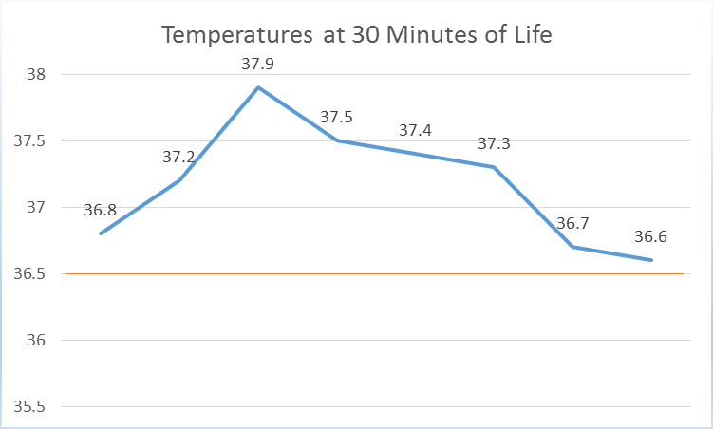
Figure 2. Normal newborn temperatures range from 36.5ºC to 37.5ºC

Infant Temperatures at one hour of life resulted in a mean temperature of 36.6ºC. Despite having overall lower temperatures at one hour of life, the mean temperature still fell within the normal range. This decrease in temperature at one hour of life is hypothesized to be due to the infants being removed from STS, swaddled, and transferred to the PACU around one hour of life. Figure 3 depicts the temperatures collected at one hour of life.

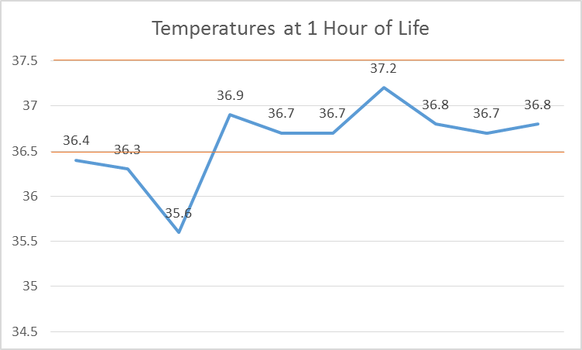
Figure 3. Temperatures at 1 Hour of Life

Figure 3. Normal newborn temperature rages is 36.5ºC to 37.5ºC
Future evaluation strategies should include a two sample T-test to compare the mean temperatures of STS in the OR babies to the mean temperatures of non-STS in the OR babies, however, this would require a much larger sample size of infants who have had access to the program than is currently available. However, data collection is ongoing and the analysis will be performed when a sufficient sample size is available.
A patient satisfaction questionnaire was developed (Appendix F) and distributed to the ten patients who received STS in the OR. The overall response from patients has been overwhelmingly positive. Of the ten women surveyed six (60%) of them were repeat C-sections and four (40%) were primary C-sections (Figure 4).

Figure 4. Makeup of the scheduled C-sections where STS was facilitated in the OR

Nine of the ten women, (90%), reported being “very satisfied” and one woman (10%) reported being “satisfied” when asked (Figure 5) “How satisfied were you with the skin-to-skin contact between you and your baby?” Of the six women who were repeat C-sections (Figure 6) five (83.3%) reported being “very satisfied” with their experience this time compared to their previous C-section experience. One woman (16.6%) reported being “satisfied” compared to her previous C-section experience. The questionnaire was developed as an evaluation tool to determine patient satisfaction with STS in the OR and to see if this is a practice that should be continued and encouraged. The feedback from the questionnaire has been distributed to the birth center nurses via 52 Fridays, a staff newsletter, and to the NANs via email. Additionally, NANs have begun to provide me with feedback directly via email.

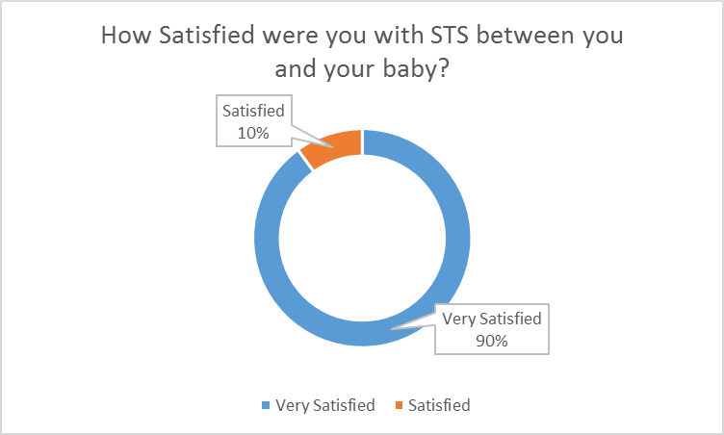
Figure 5. Patient satisfaction results from patient satisfaction questionnaire

Discussion
This project represents the implementation of a theory driven public health program in a clinical setting to address a major threat to optimal neonatal outcomes: the separation of mother and neonate post-cesarean delivery. The significance of using Organizational Change Theory[20] in this project is that it allowed the author to systematically identify, formulate, implement, and institutionalize the STS program so it is applied consistently throughout MWH and the UPMC system at large. This theory was especially helpful in seeking approval for this project from so many different personnel levels within the hospital system.
This program would not have been possible were it not for the authors enrollment in a program called the Evidence Based Nursing Fellowship (EBP). In this program nurses are mentored and allowed to go through the system wide process of implementing an evidence-based practice. Acceptance into this program proved to be necessary for success and allocation of resources (time) needed to implement STS in the OR. Up until enrollment in EBP the STS initiative had been moving slowly. The initiative had been discussed with many people but was not making progress within MWH. What the EBP Fellowship gave to this initiative was organization and connections. Though EBP mentor, Karen Stein, the author was pointed in the direction of many additional approvals that would be needed in order to be able to implement STS in the OR. While Linda Dudas had helped make connections with department leadership such as the head of anesthesia, obstetrics, and nursing; Karen Stein assisted in making contact with system wide groups such as infection control and the quality improvement committee. Through EBP a connection was made with another nurse who was also doing a project on STS. Collaboration took place in order to keep the messages and verbiage consistent between both projects.
Although the sample size is small, the results of implementing STS in the OR has been overwhelmingly positive. No adverse outcomes were reported, maternal satisfaction was excellent, and mothers were eager to participate. Although there was a concern that infants might become too hot or too cold, the 10 infants who performed STS in the OR remained normothermic upon their first temperature check at 30 minutes of life. This is consistent with Gouchon et al. [10], who noted “Cesarean-delivered newborns exposed to SSC (STS) within 1hr from delivery are not at risk for hypothermia.” It seems to support the notion that STS can be safely performed during a C-sections because there is no increased risk of hypothermia for the infant. Initially, the NANs thought that this practice would prevent them from completing their required assessments. However, they discovered that the workflow was not much different from the previous practice of having the support person holds the baby after delivery. The NANs also reported that the STS infants from the OR were able to breastfeed more successfully in the PACU. This is a finding that has been reported in the literature as well [11, 12, 24-26]. Obstetrician support has been positive with many of them expressing frustration that this had not been standard care practice until just now. The biggest surprise was that anesthesia staff, so far, seem to have no issues with this practice. In fact members of the anesthesia staff have been helping to move the mother’s gown for placement of the infant on her chest and independently started placing the EKG electrodes out of the way when they were informed that the mother wanted to perform STS, providing further evidence that institutionalization of the new STS protocol has occurred.
Many of the same challenges identified in literature review were faced by this author as well. There were challenges with staff and administration. Concerns for patient safely were similar but easily overcome with education and proper preparation.
Management has remained supportive and encouraging throughout this experience. Infection control will follow the rates of C-section site infections and report to the author if negatively impacted by facilitating STS in the OR.
Unfortunately at this time the MWH policy of transporting infants separately from their mother has not been modified and represent a substantial barrier in the full implementation of true STS. This is another initiative that should be pursued in the future. Moving forward the next step will be to implement STS in the OR with non-scheduled non-emergent C-sections. Breastfeeding rates at time of discharge should be tracked over a longer period in order to see if a correlation can be drawn between STS in the OR and breastfeeding rates at time of discharge. An appropriate sample should be gathered for a comparison of infant temperatures to run a two sample T-Test for statistical significance. Finally, NICU admission should be reviewed to see if there has been a decrease in the number of infants admitted to the NICU for hypothermia following a C-section delivery.

Conclusion
This project developed, implemented, and evaluated a theory-driven STS program in the OR for non-complicated, scheduled C-sections, for singleton gestations, who were full term (37+ weeks). Maternal child separation can contribute to a number of negative outcomes. By contrast, STS, provides many benefits: stabilization of the baby’s heart rate, breathing pattern, improved oxygen saturation levels, stabilization of blood sugar levels (even if not fed), increase in temperature- all of these will decrease NICU admissions of infants. These benefits may result in less maternal child separation and ultimately decrease in healthcare costs. Gain in infant sleep time resulting in higher quality sleep which aids in the development of the infant’s brain and neurologic functioning [1, 6-8, 11-13]. Quicker weight gain after birth, decreased crying, and more successful breastfeeding episodes may all lead to increased parental satisfaction and decreased parental fatigue, thus, enabling more positive and meaningful parent-infant interactions. Additionally, STS provides the best start to breastfeeding and may offer a way to help move the country forward on the Healthy People 202, MICH 21 goal of “Increase the proportion of infants who are breastfed.”
The implementation of STS in the OR has been a positive experience for all involved. Implementation itself was relatively easy, facilitated by the familiarity of the NANs with STS procedures already in place during vaginal deliveries. In the end the NANs simply needed a demonstration of how to facilitate STS in the surgical environment. The challenging aspect of this public health intervention was working through the healthcare system in order to gain approval from administration and various committees. In total, approval for implementation was needed from Obstetrical Nursing Leadership, Obstetrical Anesthesia, Infection Control, the UPMC system wide quality improvement committee, and finally the Obstetrical Physicians. Other birth centers within UPMC have already expressed interest in implementing this practice at their facilities. Continued education on the benefits of STS to the birth center nurses and NANs will be needed. Reminders of staff vigilance in patient and support person education regarding safe STS will also be needed on an ongoing basis. Ideally, a large study should be done to compare the difference in temperatures between infants who undergo STS in the OR, and infants who do not. In addition, a comparison of the two groups regarding breastfeeding rates at time of discharge from the hospital should be done.

Limitations
The sample size of this study was not statistically significant. As previously mentioned additional data should be gathered and analyzed for both patient satisfaction and temperature comparison.
The time prior to writing this was not long enough to analyze some of the anticipated intermediate and long term outcomes of this initiative. These include monitoring breastfeeding rates at time of hospital discharge and monitoring county wide breastfeeding rates. A review of NICU admission diagnoses codes should be performed and a comparison between before and after STS in the OR was implemented should be conducted.

Public Health Impact
In regards to the public health impact of STS, stemming from the physiologic benefits to the infant previously listed: stabilization of the baby’s heart rate, breathing pattern, improved oxygen saturation levels, stabilization of blood sugar levels (even if not fed), increase in temperature- all of these will decrease Neonatal Intensive Care Unit (NICU) admissions of infants. This will result in less maternal child separation, maternal child separation is a barrier to successful breastfeeding. Gain in sleep time- as discussed above longer sleep and higher quality sleep aid in the development of the infant’s brain and neurologic functioning [1, 6-8, 11-13]. Over the child’s lifetime this can only be a good thing. Quicker weight gain after birth, decreased crying, more successful breastfeeding episodes will all lead to increased parental satisfaction and decreased parental fatigue, thus, enabling more positive and meaningful parent-infant interactions. Maternal frustration, anxiety, and fatigue are barriers to successful breastfeeding.
To fully reap the benefits that STS has to offer, it needs to become the standard of care for all deliveries, vaginal or Cesarean, as desired by the mother and when medically appropriate. This project represents an effort to bring STS to a large maternity hospital where it can possibly be applied to as many as 3,000 deliveries a year. Additionally, it is hoped that the reporting of the development, implementation, and evaluation of the project can add to the literature and provide guidance and support as other health care delivery systems are looking to develop their own policies and procedures around providing STS in the OR. The lessons learned in this project can be of great use in other similar environments to help further the spread of STS.

Appendix A-Patient Education Brochure

What is skin-to-skin?  Skin-to-skin (also called kangaroo care) is the act of placing a new born baby, wearing only a hat and diaper, on their mother’s or support person’s bare chest. The infant is then covered with a warm blanket. The baby snuggles in the pouch that is created much like a kangaroo baby does within its mothers pouch.  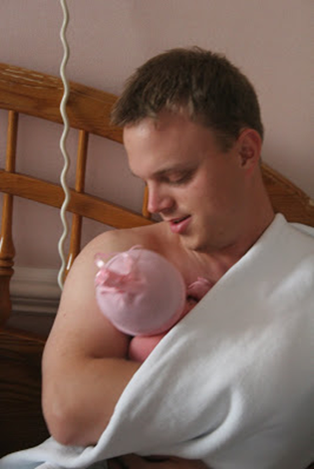 |  |  | If you have questions please talk with your health care provider.  Your midwife, nurse practitioner, or physician can answer all of your questions regarding skin-to-skin. Additionally, when you arrive to five birth please let your nurse know that you would like skin-to-skin to be performed if medically safe.
  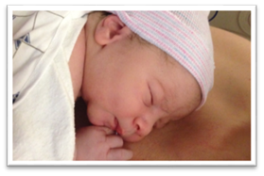
  Chest is Best
  Skin-to-skin contact between you and your baby
  Skin-to-skin contact between you and your baby
  What are the benefits of skin-to-skin for my baby?  - Regular heart rate  - Regular breathing pattern  - Improved oxygen saturation levels  - Normal blood sugar  - More sleep time  - More rapid weight gain  - Decreased crying  - Earlier more successful breastfeeding episodes |  |  | SKIN-TO-SKIN SHOULD BE PERFORMED WITH EVERY BABY, REGARDLESS OF FEEDING METHOD!  What are the benefits of skin-to-skin for the parents?  - Improved bonding and feelings of closeness with their baby  - Increased breast milk supply (mother)  - Increased confidence in ability to care for their baby  - Decreased pain (mother)  - Decreased anxiety |  |  | 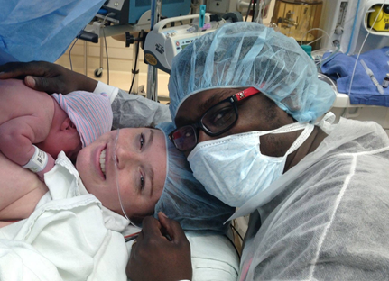  What if the mother has to have a C-section?  If a C-section is medically necessary skin-to-skin can still be done. After your baby is delivered and has been assessed by nursing or medical staff, if it is medically safe to do so, your baby will be brought over to you and positioned under your gown. If the mother does not feel comfortable, skin-to-skin can be performed with a support person. Your support person should wear a button down shirt or loose fitting top.  Nursing staff will assist in facilitating skin-to-skin.

Appendix B-Nursing Workflow in the OR
Nursing workflow for STS in the OR
- Prior to delivery nursing discusses with mother and support person if they would like skin to skin after the baby is delivered
- The baby is delivered
- Baby is handed to nurse or pediatricians
- Baby is stabilized (suctioned/dried)
- Baby weight obtained, footprints taken, ID bands placed on baby, APGARS assigned
- Hat and diaper placed on baby
- Nursing confirms again that the mother feels comfortable providing skin to skin on the operating table
- Nurse confirms that mother meets “Safe Skin-to-Skin Care Guidelines”
- Anesthesia frees one or both of the woman’s arms
- Baby lightly bundled
- Baby brought to mother and support person by nurse
- Baby is placed under mother gown and blanket onto mothers bare chest by nurse
- Nurse remains near the head of the bed to visually assess the infant and reassure the mother and her support person
- Mother and support person are educated on safe STS practice
- Nurse assesses babies vitals, color, and tone every 15min while in STS
- When it is time to escort the support person out of the OR the baby is removed from the mothers chest and placed under the warmer
- Mother and baby are transported to recovery via stretcher and walnut bed
- Upon arrival to the PACU the infant is immediately placed back into STS

Appendix C-CWISH Query

CWISH QUERY TEMPLATE FORM
Query Title: Use short, descriptive title. Do not exceed 60 character, including spaces. Conducting skin-to-skin (STS) in the OR: Safe facilitation and transportation of mother and baby |  |  |  |  |  |  |  |  |  | Date Originated: 1/10/2015
 |  |  |  |  |  |  |  |  |  | Date Final/Revised: Finalization or last revision date
Query Category: ü Check only ONE category
 |  | Maternal |  |  | Surgical/Anesthesia |  |  |  | Pathology/Lab |  |  |  | Other
 |  | Newborn |  |  | Physician Related |  |  |  | Administrative/Organizational
 | x | Women’s Health |  |  | Infection Control |  |  |  | Staffing/Budget
Name of CWISH hospital initiating Query:
Magee Womens Hospital of University of Pittsburgh Medical Center
Query Originator’s Name: Lauren Bealafeld BSN, RN |  |  |  |  |  |  |  | Query Originator’s e-mail: bealafeldlr@ph.upmc.edu
QUERY QUESTION(S): Limit on written queries is 4 questions. If more extensive, initiator should query the hospitals for the name and phone number of a contact based on topic and set up phone calls to gather information needed.
1. At your facility is skin-to-skin contact being performed between mother and infant in the operating room during a cesarean section?
2. If skin-to-skin is being performed in your operating room can you please describe the process of facilitation, including but not limited to personnel involvement, infant safety, supervision of STS, and infant care/assessment?
3. What criteria/protocol/policy is your facility using to determine maternal stability to safely perform skin-to-skin in the OR?
4. At your facility how are infants being transported from the operating room to the PACU/area of recovery? Such as: held by mother, separate crib, carried by staff, etc.

Appendix D-EBP Statement of Need
Through my quality improvement project our current practice of separating mother from baby immediately after a cesarean section will be changed to providing skin-to-skin contact to babies born via cesarean section (C-section) during the closure of the procedure. Patients, nursing staff, and medical staff will be educated on the benefits of skin-to-skin. Additionally, policy modification will be needed in order to facilitate skin-to-skin in the OR.
The current standard of care at Magee Womens Hospital of UPMC (MWH) is immediate skin-to-skin contact, if medically appropriate, following a vaginal birth. Currently no skin-to-skin contact is being given to babies born via C-section at MWH with in the first hour after delivery. I would like to decrease the amount of time that it takes staff to initiate skin-to-skin contact between mother and child after a C-section.
Skin-to-skin is defined as the placing of a naked newborn prone on its mothers bare chest at birth or soon after [1]. The history of skin-to-skin care (originally called Kangaroo Care) starts in Bogota, Columbia in the 1970s and 1980s. The mortality rate of preterm babies was 70% due to infections, respiratory problems, and lack of bonding with parents. Kangaroo Care evolved from the absence of medical care. Mothers of preterm infants held their babies 24 hours a day, including sleeping with the infant tucked into their clothes, much like a kangaroo pouch. Researchers noticed a precipitous drop in mortality. Kangaroo care was introduced to hospitals in the United States in the early 1990s [4]. The benefits of skin-to-skin for the infant include: stabilization of the baby’s heart rate, regular breathing pattern, improved oxygen saturation levels, gain in sleep time, quicker weight gain after birth, decreased crying, more successful breastfeeding episodes, colonization with “safe germs” resulting in fewer infections, high-quality sleep that promotes brain development and maturation, and earlier hospital discharge. STS may have a role in boosting development of infant’s nervous system and developmental measures at one year. Better social, linguistic, fine and gross motor skills [6, 8]. The benefits for the parents include: improved bonding with their child, increased breast milk supply (for the mother), increased confidence in their ability to care for the baby, increased feeling that their baby is well cared for, and an increased sense of control [8]. The World Health Organization (WHO) and United Nations International Children’s Emergency Fund (UNICEF) recommends that mothers and newborns have skin-to-skin contact immediately after vaginal birth, and as soon as the mother is alert and responsive after a C-section. Immediate is defined as within minutes and early skin-to-skin is defined as within one hour after birth. Skin-to-skin is recommended to for all women and their infant immediately after birth for at least one hour or until after their first breastfeeding is completed [12]. The Baby-Friendly USA hospital designation provides us with The Ten Steps to Successful Breastfeeding which lists step four as: help mothers initiate breastfeeding within one hour of birth. This step calls for placing infants skin-to-skin with their mother immediately following birth for at least one hour and as often as possible after that [15].
The technique for providing skin-to-skin in the operating room is as follows: Skin-to-skin will be offered in pre-op to straightforward elective C-sections for healthy women with non-complicated singleton fetuses who are full term. At a later date skin-to-skin will be offered to unscheduled C-sections as well. This would not be appropriate for preterm infants less than 35 weeks, which requires immediate transfer of the infant to the NICU. After the infant is born, handed off to nursing staff, dried, weighed, given a hat and diaper, footprints taken and banded, the infant will be brought over to the parents. The mother will again be asked if she would like to perform skin-to-skin. The mother must meet the following criteria in order to be eligible for safe STS in the OR: alert and oriented x3, the mother stating that she feels comfortable holding her infant, blood pressure above 100mmHg, not receiving versed 30-60min prior to transport, no nausea or vomiting, no shaking, no excessive itching, not lightheaded or dizzy, and estimated blood loss of <1000cc. After receiving maternal consent, her gown and bear hugger (forced air warming system) will be lifted off her chest and the infant will be laid prone between the mother’s breasts. The infant will be covered with warm blankets; the mother’s gown will be placed over top of the warm blankets as well, leaving the infants face visible to staff, mother, and support person. The ORs in the birth center are set to 70⁰F (21⁰C). The infant’s temperature will be assessed every 30 minutes as per protocol. The mothers and her support person are educated on safe skin-to-skin and how to support the infant on the mother’s chest. Nursing will remain near the head of the bed to monitor the baby and reassure the parents [19].
Many institutions are moving toward a more family centered approach to C-sections by facilitating skin-to-skin contact in the OR, including such hospitals as Brigham and Womens in Boston. There is much literature regarding this practice [1, 4, 11, 12, 15, 18, 19, 27, 28].
My EBP project will educate nursing staff and patients about the benefits of skin-to-skin contact and begin facilitating skin-to-skin contact in the OR. Current practice will have to be modified in order to allow infants to be placed in skin to skin while a C-section is ongoing or once the woman is placed on a stretcher for transport to PACU. A patient satisfaction survey will be conducted with patients who have received skin-to-skin in the OR. Temperature data will be collected on infants that have not received skin-to-skin in the OR and compared to temperature data collected on infants who did receive skin-to-skin in the OR to measure infant warmth between the two groups. C-section infection rates will be monitored to ensure that the practice of skin-to-skin in the OR does not negatively affect this quality matrix, this project has been discussed with the infection control department and they have voiced their support of this project. This project was presented to the Obstetrical Leadership team who has also voiced their approval and support for this project. It is my hope that through this EBP project I will be able to improve the quality and family centered experience of C-section deliveries.

Appendix E-STS Inclusion Criteria & RAPP Assessment

Inclusion Criteria for Safe STS
- A&Ox3
- Verbalizes comfort with holding infant
- BP above 100mmHg
- NO Versed 30-60min prior
- NO nausea or vomiting
- NO shaking
- NO excessive itching
- NO lightheadedness or dizziness
- EBL <1000cc

Safe STS instructions to mother and support person
- RAPP
  - Respiratory
    - Look for signs of breathing (chest rise and fall)
    - Face & nose visible not bearded in mom’s chest
  - Activity
    - Look for movement
  - Perfusion
    - Pink color in infants face, remind them that peripheral cyanosis is normal
  - Position/Tone
    - Head in sniffing position
    - No limp extremities

Appendix F-Patient Satisfaction Questionnaire

- Was this your first C-section?
Yes No
If no how many C-sections have you had (not including this one)?

- With this C-section was skin-to-skin contact between you and your baby initiated before you left the operating room?
Yes No
- How satisfied were you with the skin-to-skin contact between you and your baby? (Circle one)

Very Dissatisfied Dissatisfied Neutral Satisfied Very Satisfied

- If you have had a previous C-section how satisfied were you with your experience this time compared to your previous C-sections? (Circle one)

Very Dissatisfied Dissatisfied Neutral Satisfied Very Satisfied
- Please use the space below to tell us how we can make the experience of skin-to-skin during a C-section better for you or others in the future.

bibliography

