THE CHRONICLES OF GATEWAY: A CASE STUDY OF THE STRATEGIC MANAGEMENT OF GATEWAY HEALTH

by
Kushagra Banerjee
A.B. Anthropology & Biology, Washington University in St. Louis, 2012

Submitted to the Graduate Faculty of
the Department of Health Policy & Management
Graduate School of Public Health in partial fulfillment
of the requirements for the degree of
Master of Health Administration

University of Pittsburgh
2015

UNIVERSITY OF PITTSBURGH
GRADUATE SCHOOL OF PUBLIC HEALTH

This essay is submitted
by
Kushagra Banerjee

on

April 20, 2015

and approved by

Essay Advisor:
Samuel Friede, MBA, FACHE ______________________________________
Assistant Professor
Department of Health Policy & Management
Graduate School of Public Health
University of Pittsburgh

Essay Reader:
Louis Luangkesorn, PhD ______________________________________
Research Assistant Professor
Department of Industrial Engineering
Swanson School of Engineering
University of Pittsburgh

Essay Reader:
Dovile Usaite, MHA ______________________________________
Director, New Business Development
Gateway Health
Pittsburgh, Pennsylvania

Copyright © by Kushagra Banerjee
2015
ABSTRACT

Strategic management is a multi-step approach utilized by leadership to assess and execute the strategic thinking, strategic planning, and manage the strategic momentum of a health care organization. Health care organizations require comprehensive strategic management in order to successfully guide organizations through the dynamic and competitive environment of health care. The formalized rules of strategic management as applied to health care are still in its relative infancy, yet the industry’s most successful organizations consistently demonstrated strategic management competencies. In order for an organization in health care to think about, develop, and reach its long-term vision, leadership must recognize and utilize the principles of strategic management.
Samuel Friede MBA

THE CHRONICLES OF GATEWAY: A CASE STUDY OF THE STRATEGIC MANAGEMENT OF GATEWAY HEALTH
Kushagra Banerjee, MHA
University of Pittsburgh, 2015

This case study examines Gateway Health LP, a Pittsburgh-based managed care organization serving over 400,000 Medicare and Medicaid beneficiaries in six states. In the past three years, Gateway has made substantial strides and changes in order to proactively manage its strategic future. These steps involved significant forethought, planning and iterative management in uncertain and changing environments of federal and state health care programs. The goal of this case study analysis is to overlay the recent history of Gateway Health in the context of strategic management principles as outlined by Ginter’s Principles of Strategic Management and ultimately map the strategic course of the organization. Ultimately, the larger implication of executing effective strategic management for healthcare organizations is the ability to sustain the public health element of providing access to health services to their defined communities.

TABLE OF CONTENTS
preface x
1.0 Introduction to Strategic Management 1
1.1 Gateway Background 3
2.0 Strategic THinking 7
2.1 External Environment: What should we do? 8
2.2 Internal environment: What can we do? 13
3.0 Strategy Formulation 16
3.1 Directional Strategies: What we want to Do 16
3.1.1 Mission 17
3.1.2 Vision 18
3.2 Adaptive Strategies 18
3.2.1 Market Development 19
3.2.2 Product Development 20
3.2.3 Market Entry Strategies 21
3.2.3.1 Medicare Product Entry 22
3.2.3.2 Medicaid Product Entry 23
3.2.4 Competitive Strategies 24
3.2.4.1 Leveraging product line diversity to enter new markets 24
3.2.4.2 Developing a marketable network 25
4.0 Managing strategic momentum 28
4.1 Value-Added Service Delivery Strategies 29
4.2 Value-Added Support Strategies 30
5.0 Conclusion 33
bibliography 35
List of tables
Table 1. Medicare Star Ratings timeline- Number Plans by Star Ratings 9
Table 2. Gateway Market Development Efforts 20
Table 3. Gateway Marketable Network Strategies 27
List of figures
Figure 1. Strategic Management Model 2
Figure 2. . Gateway Health Organizational Timeline 5
Figure 3. States contracting with Medicaid Managed Care Organizations 12
Figure 4. Decision Logic of Strategy Formulation 16
Figure 5. Strategic Management Value Chain 28
preface

I would like to thank my readers- Sam, Louis, and Dovile- as well as Austin Ifedirah and all at Gateway Health who provided me with the opportunity to learn and grow with Gateway over the last 16 months.
A special thanks goes out to my MHA classmates, Pitt HPM faculty, my family, and Kaylyn Deming for all the love and support throughout the process.

Introduction to Strategic Management
Over the past twenty years, the United States health care environment has experienced particularly significant periods of transformation. Organizations operating in this environment face a number of critical issues (changes in the regulatory environment, the need to control costs, identify and seize market opportunities, and excel in quality measures), and they must be able to strategically anticipate, plan, and act on these issues in order to sustain themselves in the short-term and become successful in the long-term. Health care organizations have increasingly recognized the necessity for a more structured approach to guide their organizations through the dynamic and competitive environment of the industry. To gain best practice expertise, health care organizations looked to other industries and modified principles of strategic management to best fit the needs of their respective organizations (Arndt). Health care leaders are able to utilize principles in strategic management to best guide their organization in its environment, and maximize the value that they aim to provide to the organization’s stakeholders in the future. The results created from strategic management may not always be able to be quantified but it does lend itself as an empirically-based philosophy for managing an organization. Ginter et al. demonstrates some of the benefits organizations can achieve from effective strategic management:

- “Ties the organization together with a common sense of purpose and shared values
- Provides the organization with a clear self-concept, specific goals, and guidance as well as consistency in decision making
- Helps managers understand the present, think about the future, and recognize the signals that suggest change
- Improves financial performance in many cases
- Requires managers to communicate vertically and horizontally
- Improves overall coordination within the organization
- Encourages innovation and change within the organization to meet the needs of dynamic situations” (Ginter).
The process of Strategic Management is composed of three distinct elements: strategic thinking, strategic planning, and managing strategic momentum. The three components are interdependent activities in which each part is a means to the end for the other in the process. Figure 1 illustrates the iterative process of strategic management.

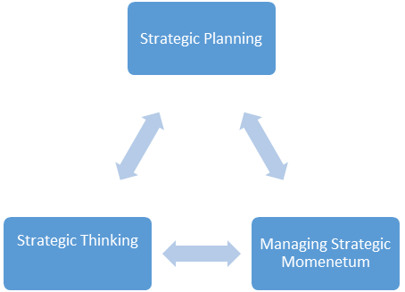
(Simplified from Ginter 1-1 (2013)

Figure 1. Strategic Management Model
The three subcomponents of strategic management are complex and require thorough examination of every sub-element within the scope of strategic management. In this review a strategic perspective of Gateway’s historical three year examination will demonstrate strategic management principles at work.

Gateway Background
Gateway Health LP (Gateway) is a managed care organization headquartered in Pittsburgh, Pennsylvania that has operated to serve members in both Medicare and Medicaid programs since 1992. As of 2015, Gateway contracts with both federal and state programs in six states to serve some of the most vulnerable populations requiring health care. Over the past twenty years, the organization has developed services such as disease management, health and wellness programs and preventive care to treat the indigent, aged, and disabled populations while steadily growing and expanding its reach to the community (“Gateway Health Plan”). Specialized populations served by Gateway include Dual Special Needs Plans (DSNPs) beneficiaries, who qualify for both Medicare and Medicaid and Chronic Special Needs (CSNPs), which are Medicare beneficiaries who also have a recognized chronic condition. To care for these high-risk populations, Gateway uses a trademarked care management approach called Prospective Care Management (PCM). Gateway Health PCM is a holistic method to design an individualized plan of care by using resources like disease-specific education, instruction in self-care, and aids members in locating referrals to community-based services. Gateway collaborates with physicians and community organizations to implement a care plan that addresses each member’s unique needs.
For the majority of Gateway’s history, the organization exclusively served select service counties in Managed Medicaid Pennsylvania HealthChoices program. In 2003, with the passage of the Medicare Prescription Drug, Improvement, and Modernization Act, recognized that segments of the population that qualified for Medicare and Medicaid were at a significant disadvantage in achieving health outcomes and were among the costliest patients to care for (Centers for Medicare & Medicaid Services). By more appropriately adjusting the risk scores to reflect the costs for the new defined DSNP members, managed care organizations could more realistically take on the risk of this re-categorized DSNP population. In 2006, Gateway officially entered the market to offer a new service segment and began enrollment of the DSNP Medicare product line for a population which was already covered by Gateway. Over time, Gateway would establish one of the largest single state DSNP plans in the country serving almost 50,000 DSNPs. From 2014-2015 Gateway entered multiple new markets and product segments including Medicare Advantage Prescription Drug Plans, Behavioral Health, Medicaid Long Term Services and Supports (MLTSS), and Administrative Services arrangements.
In the past three years, Gateway’s organization as a whole has committed to an ambitious development plan to expand the products and membership of the organization beyond what it has experienced in its history. To achieve these ends, organizational departments have restructured and introduced new leaders in the senior management team to facilitate the development of a strategic plan. Among the notable addition include a new President and CEO (2014), and a number of newly created positions such as CBDO (Chief Business Development Officer-2014), CIO (Chief Information Officer-2014), and CCO (Chief Clinical Officer-2014). The aim of this transition was to develop, implement and manage a strategic plan to transform the organization in a new era in the company’s history.
The overall strategic framework of the organization was to assess opportunities in the environment and to use competitive advantages of being able to care for the highest risk populations and to grow the business across the all government-sponsored managed care programs. In 2015, the organizational footprint expanded offerings from two to six states, and entered into joint venture partnerships in managed Medicaid. In developing and executing the strategic vision, the organization has overcome obstacles and taken iterative steps to assess and refine the development plan for the organization. Figure 1 demonstrates the historical timeline and service areas as of 2015.
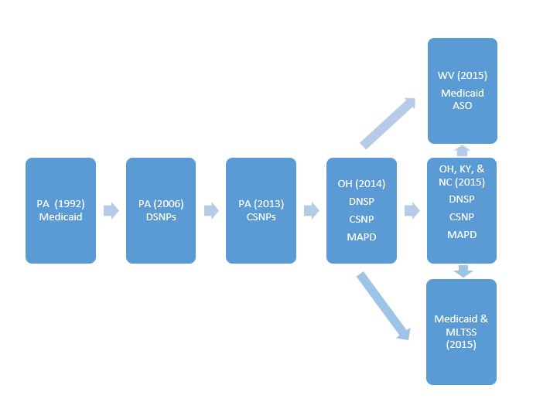
Figure 2. Gateway Health Organizational Timeline
By surveying the landscape and strategic thinking, planning, and implementation history of Gateway, this analysis aims to map the organization’s path to accomplish its strategic objectives and achieve its mission to become a nationally recognized, preferred managed care organization known for its innovative care models, quality clinical outcomes and excellent customer service (“Gateway Health Plan”). Through the lens of strategic management, Gateway’s orientation and action through the processes of strategic thinking, strategic planning and momentum management will be evaluated.

Strategic THinking
On the topic of strategic thinking, Peter Drucker, a leader in management education stated, “The most important task of an organization’s leader is to anticipate crisis. Perhaps not to avoid it. But to anticipate it. To wait until the crisis hits is already abdication. One has to make the organization capable of anticipating the storm, weathering, and it fact being ahead of it” (Drucker). The burden is on the organization to understand and anticipate changes in the external environment in which it exists as well as identify opportunities in market segments and service products that are yet untapped. In January 2014, Gateway Health introduced the first new President and CEO in the past 15 years: Patricia Darnley. Prior to entering Gateway, Ms. Darnley held the position of President and CEO of Centene Corporation, a multi-line healthcare enterprise that also provides services to government healthcare programs. In her first address to the employees she addressed the strategic direction of the organization and stated that there are many external and internal demands to which the organization will need to respond. She forecasted, “Organizations who are not growing, are dying, and if Gateway is going to survive and reach its potential, the present state [of quality and reach] is not a viable option five years from now. Instead Gateway must capture its most valuable features and translate that success and to move it to the future” (Darnley).
According to Ginter, et al., the development of a strategy consists of three separate strategic thinking activities, and the interaction of these activities form the development of strategy formulation:
- An external environment analysis suggests what the organization should do.
- An internal analysis suggests what the organization can do.
- A strategy which is driven by the organization mission, vision, organizational values and goals, which ultimately distill to formulate what the organization wants to do. (Ginter)
Navigating these three steps represent the broadest valuation of an organization, and allows for the recognition of the options available before drilling down into the various strategic opportunities in the planning and managing momentum stages.

External Environment: What should we do?
An external environment analysis considers Gateway’s interaction with the various entities that shape the environment in which the organization operates. There are numerous entities that impact a Medicare/Medicaid health plan and the most apparent is the role of the government in financing member care through these plans. The federal and respective state governments each have an interest in assuring that the beneficiaries are receiving quality care, access, and that plans are administering their benefits cost effectively.
For the Gateway Health Medicare Assured product line, one regulatory challenge is the Medicare Quality Star Ratings system, which was developed by the ACA and implemented in 2012. In this program, Medicare Advantage plans are rated on a 1-5 scale, where 1-star represents the worst performance, and 5 stars represents the best performance. According a 2015 Kaiser Family Foundation report, the quality scores for Medicare Advantage plans are based on 44 performance measures that are derived from plan and beneficiary information collected in three surveys – HEDIS® (Healthcare Effectiveness Data and Information Set , CAHPS® (Consumer Assessment of Healthcare Providers and Systems), and HOS (Health Outcomes Survey) – and administrative data (Kaiser Family Foundation). These performance measures include plan’s rates of administering screening tests, complaints submitted to CMS about the plan, and patient perception of communication skills of the providers in the plan’s network. As outlined in the ACA and a subsequent 3 year demonstration which followed, the high-rated plans (4-stars and above) were able to achieve up to 5% of revenue bonus from CMS. Proponents of the Stars program said the demonstration would encourage plans to improve or maintain their quality ratings and ultimately force “poor” quality plans out of the competitive marketplace. Table 1, via the Fact Sheet 2015 Star ratings illustrates the historical 4 year trend in the Stars ratings distribution.

Table 1. Medicare Star Ratings timeline- Number Plans by Star Ratings

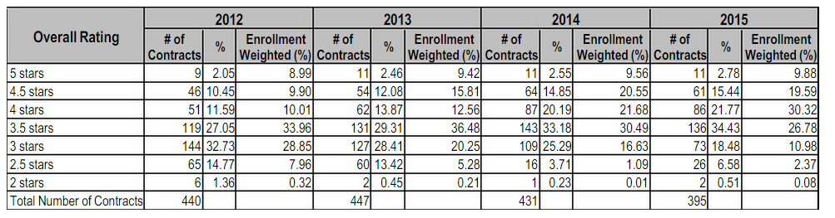
(Scribd)

As demonstrated in Table 1, the average star rating has increased every year since the program began: 3.56 in 2012, 3.71 in 2013, 3.86 in 2014, and up to 3.92 in 2015. In 2015, plans that rated overall for having 4-stars or higher accounted for 40 percent of MA-PD (Medicare Advantage Prescription Drug) plan market. In 2014, Gateway was rated as 3.5-star plan, and subsequently dropped to a 2.5 in 2015.
Since the inception through implementation of the Medicare Stars Program in 2010-2012, Gateway and other MCOs who operate Medicare SNP products voiced resistance to the program’s ratings methodology, which ultimately tied performance to revenue. Since Medicare SNP MCOs undertake among the highest risk patients, Gateway and other Medicare SNP MCOs challenged that rating system unfairly categorized all plans on the same scale and did not appropriately account the risk classification of the enrolled members. A 2011 MEDPAC report to Congress warned, “It is not possible to evaluate the quality of care furnished by most DSNPs as the star rating information for most SNPs includes non-SNP plans and does not include SNP-specific HEDIS and NCQA Structure and Process Measures” (National Health Policy Group). Despite the argument against the equity of the program, the program persists classifying Medicare SNPs on the same rating scale, which creates a disadvantage for the SNPs to remain competitive
Considering the forecasted revenue from Gateway’s market expansion, it is believed that missing the 4-star threshold in 2015 to achieve the 5% bonus lost the company potentially $30 million in revenue for 2015, and missing the threshold could lead to a $40 million loss in 2016 (Ifedirah). This opportunity cost continues the trend in which Gateway’s 3.5 star rating in 2014 led to approximately $24 million loss of payment. Understanding and navigating the value-based environment is essential for health plans, and to achieve proficiency, health plans should become successful by Medicare Stars system standards.
Another prominent feature of the Medicare market is the increasing pressure to reduce the costs of the Medicare program. According to Modern Healthcare, the ACA is anticipated to reduce government spending on Medicare Advantage plans by more than $200 billion through 2019. Although projections for enrollment were expected to significantly decrease in the coming years, the percentage of Medicare beneficiaries signing up for MA plans now approach 30% of those eligible (Demko). Per the same report, MA-SNPs health plans were pacing to achieve profit levels nearly double that of other Advantage plans, accounting for 8.6% of revenue (Demko). By this estimate, MA-SNP turned a profit of $1,115 per special needs enrollee. Due to the overall pressures of sequestration, health plans must learn how to operate and execute their strategic objectives under increasingly smaller PMPM rates. At the same time Medicare and Medicaid programs are testing these new models of reimbursement to reward only the health plans that are achieving the best measures of quality outcomes.
The external environment of the national Medicaid Managed Care market is another relevant market that has been carefully monitored by Gateway given their longtime experience in Pennsylvania’s Medicaid program. According to a Kaiser Family Foundation Report, and illustrated in Figure 2, there are 39 states who administer programs with MCOs to serve segments of states’ Medicaid populations (Kaiser Family Foundation). Of the nation’s Medicaid beneficiaries, over half of all Medicaid beneficiaries – mostly children and parents – get their care through MCO’s contracted by their state (Kaiser Family Foundation).
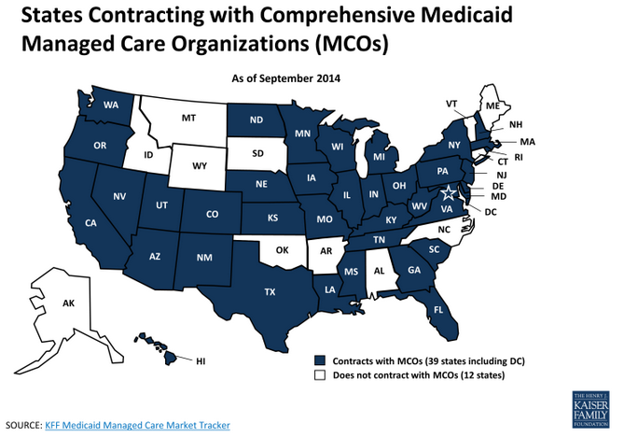
Figure 3. States contracting with Medicaid Managed Care Organizations

Since ACA Medicaid expansion began, 29 states and Washington DC have implemented some form of Medicaid expansion, which has led to an increase of nearly 7 million people who were not qualified for the programs as previously constructed (Haislmaier). This influx of volume into state Medicaid programs has caused states to reassess their Medicaid programs, and increasingly, states are relying on MCOs to manage and spread the risk of financing the parts of the highest risk population’s health (Kaiser Family Foundation). Opportunities to enter various states Medicaid programs vary by the state and may be limited by the following factors: population services offered or “carved-in” services, the number of MCOs contracts awarded, timelines in which opportunities become available, and other state-specified requirements. In January 2015, Pennsylvania’s governor-elect began efforts to withdraw the 1115 waiver for Medicaid expansion, in favor of implementing traditional Medicaid expansion. This move will have an impact the PA Medicaid MCOs who have contracts to undertake the newly eligible population, and may potentially add as many as 100,000 beneficiaries to Gateway’s membership.
Many other environmental factors including the increased burden of prescription drugs, aging populations that are living longer, meeting NCQA (National Committee for Quality Assurance) Accreditation standards, and emerging payment demonstration models shape the industry in which Gateway exists. Anticipating, influencing, and navigating the environment is a crucial first step in the strategic thinking process.

Internal environment: What can we do?
Internal assessment of an organization answers the question: What can we do? Gateway’s overarching strategy is driven from the top-down from the senior-management team and shaped by the board of directors. Gateway’s board is represented by 50% parent owner Highmark Inc., a Pittsburgh-based health insurer and 50% owner Trinity Health, a Michigan-based Catholic health system operating in 21 states. For the first 20 years, Gateway operated in a niche Medicare and Medicaid market segments in Western Pennsylvania, and they built a reputation in developing programs and benefits for patients requiring more intensive care management relative to the general population. The risk score of Gateway in 2014 was around 1.23, which denotes that the average patient is approximately a 23% than that of an average person with risk score of 1.0 (Ifedirah). Gateway resolved that their developed reputation and care model could be leveraged to manage populations of varying sensitivity to the risk score of Gateway. The tools to make a transition to reach a new market involved translating PCM and other effective health management programs to fit new populations and geographic service areas.
Over the years, Gateway has built up considerable financial flexibility in that Gateway has had a positive net income before taxes every year since the organization’s inception. In 2010, the Gateway’s reserves nearly doubled Pennsylvania’s risk-based capital requirement for health plans. Risk-based capital is a method of measuring the minimum amount of capital necessary for a health plan to support its overall business operations with consideration to its size and risk profile (National Association of Insurance Commissioners). This long-term financial success created flexibility entering the 2012 movement to explore the diversity of opportunities in the government-sponsored managed care space.
With financial flexibility and expertise in high risk populations, opportunities for growth were explored via relationships that could align with the corporate parents and their strategies. The presence of the two corporate parents has had a beneficial effect for Gateway to penetrate into existing regions as well as facilitate expansion efforts. In 2013-2014, a major effort was realized in the Eastern PA market as Gateway entered a new service area and gained considerable DSNP and CSNP membership. This growth was driven by divestment by competitors in the region and in part from an established market presence of Catholic Health East, the corporate parent of Gateway before the acquisition by Trinity Health in 2014. Similarly, new opportunities have emerged in service areas where the corporate parents are not present. For example, before 2014, Gateway only operated the Gateway Medicare Assured SNP product line in PA, which does not include a MA-PD product because the corporate parent Highmark is established in the PA MA-PD market. In 2014, Gateway expanded its footprint into Ohio, and expanded its product line to include two MA-PD products. Since Highmark itself had minimal presence in Ohio, the two organizations avoided overlapping services while spreading each of their presence across different service areas. In 2015, a 7-product Medicare MA-PD, DSNP, and CSNP plans were extended across the three state Gateway Medicare expansion area and available to members in 170 counties.
Overall, the internal environment assessment begins to formalize recognizable opportunities and cautionary features that must be monitored or avoided during the strategy formulation. Each component may ultimately affect the downstream strategy formulation of the organization’s vision or may alter how to best execute a specific action plan.

Strategy Formulation
The strategy formulation phase of strategic management begins when the board and senior leaders of an organization start to leverage the information from the internal and external assessment and hypothesize what they can do with it. The ultimate hypothesis is the vision of the organization and is housed under the “directional strategy” of strategy formulation. Each subsequent step in the Decision Logic of Strategy Formulation model as illustrated in Figure 4 demonstrates the “means” to which the “end” are achieved.

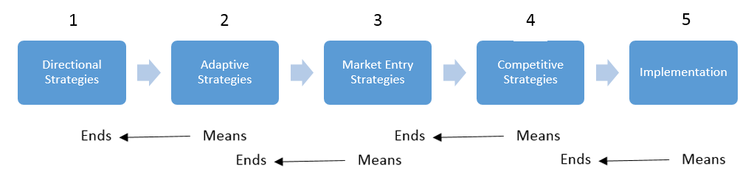
(Modified from Ginter et. al. (2013): Exhibit 6.2)

Figure 4. Decision Logic of Strategy Formulation

Directional Strategies: What we want to Do
The end of the “strategic thinking” phase marks the commencement of the strategy formulation stage through the development of the directional strategies. Using the information from the internal and external analysis, an organization’s leaders can review these factors to answer the question: what do we want to do? This question is a big-picture thought project for leaders which culminates into composing the organization’s mission and vision statements. The mission and vision comprise the broadest level plan describing actions and aimed accomplishments the organization will achieve.

Mission
According to Ginter, et al., organizations with an effective mission statement have target customer markets, state how the organization seeks the customer, demonstrates its values and where it intends to compete (Ginter). Moreover, the mission should be constructed to be relevant not only in the present but also in the future to serve as a constant compass for the organization and its employees. The senior management and board were instrumental in constructing the following Gateway mission statement in 2014:
Gateway Health Mission Statement:
Gateway Health positively impacts the health of its membership through a health care delivery system that provides access to high-quality medical services in a cost-effective manner.
The mission statement comments on the principle focus of Gateway’s practice: to “positively impact health” and “provide access to high-quality medical services in a cost-effective manner.” The mission also states the method through which Gateway will achieve the mission through a “health care delivery system”, which fits with the reality of the organizations practices. In the context of the external and internal environment, it can be concluded that the mission statement is timeless and aligns with the strategic thinking phase idea, yet it remains vague on the target customer or identify where it intends to compete.

Vision
An organization’s vision is the form an organization and its leaders aim to achieve in the long term. The vision, like a mission statement, is developed from considering the needs of the organization’s stakeholder, however, vision, is a description of where the mission will lead the organization to achieve. The following is the Gateway Vision Statement created in 2014:
Gateway Vision Statement: Gateway Health’s vision is to become a nationally recognized, preferred managed care organization known for its innovative care models, quality clinical outcomes and excellent customer service.
The Gateway vision statement, although broad, mentions the measures by which the organization would like to be measured moving forward. Through the mission, Gateway aims to become “nationally recognized”, and references the achievement measures they would like to accomplish. Strategic objectives (i.e. Achieve a 4-star rating or Medicaid NCQA Excellent rating) are can be inferred as being encompassed in this statement, but require further iterations could be made to define a clear image of where the organization aims to be in the long-term.

Adaptive Strategies
Adaptive strategies are more specific than the directional strategies and provide the methods for achieving the mission and vision through identifying an optimum response to a given environment. Gateway’s method toward becoming the “nationally recognized health plan” required the organization to expand its scope of operations from the Pennsylvania Medicaid and Medicare SNP market segments. Expansion of scope involves related diversification, which occurs when markets outside the organization’s business offer substantial growth. The competitive advantage of managing the high risk patients generated opportunities in the population segments outside Gateway’s typical risk profile. The core operations of Gateway could take on expansion of scope opportunities new market segments such as Behavioral Health, children’s health programs, and MLTSS due to the similarity in operational processes that exist in supporting the various populations. The core care model of care, provider networks, and claims processing allow for economies of scale and flexibility in weighing potential avenues of pursuit.

Market Development
Market development is an adaptive strategy used to expand scope and enter new markets with present products or services. The aim in market development is to achieve greater volume through service area expansion or by targeting new market segments within present geographic service area. Gateway has exhibited market development strategies in several varieties including those highlighted in Table 2.

Table 2. Gateway Market Development Efforts
Year | Market Development
2013-2014 | Expansion into Southeastern PA Medicare Assured and growth in existing membership.
2012-2015 | Development of provider networks, to introduce more marketable provider options to members and improve penetration into existing service areas through take-up of membership.
2014-2015 | Expansion of Gateway Medicare Assured product line into new service area Ohio, North Carolina, and Kentucky.
2014-2015 | Exhibiting horizontal integration, by obtaining growth across all Medicare Assured products by packaging all plans together in marketing participation agreements to providers. By doing so, providers must agree to accept the riskier Gateway SNP members if they are willing to accept the generally healthier MA-PD members.

Market development offers several advantages such as increased access to capital, reduction in duplication of services, economies of scale, improved productivity, operating efficiencies, improved patient access, and improvement in quality (Blair).

Product Development
Product development is the introduction of new products or services in an existing service area. Government contracted health plans are compliant to the regulations which govern how the MCOs may design or market their product in their respective markets. Product development can be limited by the regulation of carved-in/carved out services or enact restrictions of financial burden which can be placed on members in the plan’s benefit design. For instance, CMS annually issues a schedule designating the extent Medicare Advantage plans in any given market can change the benefits. Therefore, if CMS rules a member’s OOP (out-of-pocket) cost cannot exceed $20 for the given year, then any increase in cost sharing past the limit would require a decrease in cost sharing elsewhere in the member benefit structure. Limitations on product development are to ensure fair competition as well as protect beneficiaries from exorbitant changes in benefits.
In 2015, Gateway introduced a $0 deductible plan to the Gateway Health Medicare Assured product line. It became the most popular MA-PD plan selected by members in the Annual Election Period (AEP) effort to enroll new members during the entry into the new service regions and market segments. Because all Medicare beneficiaries have the choice to switch plans during AEP, a prospective MA-PD beneficiary who is conscious about their first dollar in spending health care, may consider replacing their existing plan or switch from traditional Medicare. In most of the counties in which Gateway contended for membership, it was the only $0 deductible option, and established a cost leadership advantage in positioning themselves as a low cost option.

Market Entry Strategies
Market Entry Strategies are strategies that enable an organization to establish how it will enter and develop in the market. Market entry is ultimately the mechanism to carry out the adaptive strategies, and it is achieved through three approaches: purchase, cooperation or internal development (Ginter 230).

Medicare Product Entry
For Medicare Advantage products, market entry into the federal government program is achieved through the CMS and/or the state various state licensing entities. Health plans require the appropriate licensing requirement or Certificate of Authority (COA) to sell health insurance products to beneficiaries in that state. Gateway Health Plan of Ohio was established as a subsidiary of Gateway Health LP in order to consolidate expansion efforts of the Medicare Assured product line. To gain entry into three states in 2015, Gateway Health Plan of Ohio had to obtain the licensing in each of the expansion states.
After the state licensing requirements are met, many subsequent benchmarks need to be met on a county-by-county basis within the state to gain CMS approval to sell in any given county. These requirements ensure health plans can only market plans that meet floor pre-empted standards of adequacy before beneficiaries can choose to enroll in those plans. Some of these requirements include a minimum time and distance requirement between members and providers in the health plans network. For each county where a Medicare Advantage plan requests access, the MCO must prove 90% members meet the CMS adequacy standards to pass approval by CMS; missing this target would disqualify other participating provider agreements in that county and the plan cannot enroll the county’s beneficiaries in that calendar year. Health plans necessarily require methods of building a “CMS adequate” and marketable networks and systems in place to assure fulfillment of all the necessary requirements for entry. From 2014-2015 Gateway Health Plan of Ohio completed such requirements and gained CMS and state approval to enroll members for 7 Gateway Medicare Assured SNPs and MA-PD products in 170 additional counties across Ohio, Kentucky, and North Carolina.

Medicaid Product Entry
Each state has its own discretion in the design of its Medicaid managed care program and the method by with prospective MCOs can procure entry to serve the state’s beneficiaries. Generally a state issues a Request for Proposal (RFP) or submits an application with a state to procure a contract to care for a defined population. Like Medicare Advantage, Medicaid programs maintain specific requirements that health plans must follow in order gain entry to serve a state’s Medicaid beneficiaries. Delaware, in 2014, experienced ballooning costs in their Medicaid program and specifically high cost among population requiring long term care services. Other state programs may elect to carve-out populations like MLTSS or issue an RFP for more specific population segments such as dual eligible or limiting the RFP to certain regions of the state. After applying and competing for the Delaware MLTSS RFP in 2014, Gateway and its joint venture partners were rewarded with entry into Delaware Medicaid Managed Care program reaching a new population segment.
Joint ventures represent a fast and efficient method to quickly gain entry into a new market. When projects get too large, technology gets too expensive, internal resources, competencies or capabilities too scarce, or the costs of failure too high for a single organization, joint ventures are often used (Roberts & Berry 1984). Delaware and West Virginia Medicaid market expansion mark examples of utilizing the relationship with the parent organization Highmark and other experienced MCOs with familiarity in those states to leverage its value to gain market entry. Specifically, Gateway utilized its highly efficient PCM approach and claims processing capacity to partner with its parent and other Managed Care enterprise with presence in the states, to bid and gain presence in these states within one year of identifying the opportunity. Meanwhile the JV (joint venture) partners developed other aspects of the developmental plan such as building the provider network. The joint venture approach proved to be a highly effective and efficient approach to entry as meeting the state-specific Medicaid criteria would have been more difficult independently, especially considering the limited time frame to establish presence in the state.

Competitive Strategies
For an organization entering a new market, competitive strategies create opportunity to differentiate its product and establish its presence to the providers and consumer base in the market. Large, established providers in a new service area are often more difficult to contract as they understand the value of the patient-drawing power they hold in their service area. As a result, a new MCO entrant can compromise terms of agreement (i.e. higher reimbursement rates) to the high-profile provider in order to establish a marketable presence in the service area. Health plan members value options in provider choice, diverse benefits, and lower OOP cost, so MCOs consider each of these elements in navigating and weighing their competitive strategies with each stakeholder.

Leveraging product line diversity to enter new markets
Having successfully established a presence and approach in Pennsylvania in Medicaid and Medicare SNPs for over 20 years, a strategic plan must establish the competitive strategy to uniquely position Gateway to 1) gain entrance into a market and 2) make the transition effectively to become competitive and stay profitable within the first few years of entry. As described in market entry, entrance into the Medicare Advantage is considerably more standardized than entry into any individual states Medicaid managed care program, so with its market entry Gateway had to build its membership base de novo. Alternatively, in most states’ Medicaid programs, after MCOs gain entry to administer Medicaid benefits, there are often mechanisms designed in the state program to ensure substantial volume of membership upon launch of the health plan in the new state. By gaining entry into a service area with a guaranteed volume of members, health plans can operationalize a more profitable and sustainable presence in the market immediately. This is opposed to Medicare where new participants may struggle to gain market share from well-established and existing competitors in the region. By entering a new market with Medicaid, the transition toward adding a Medicare offering thereafter creates a more manageable entry due to a sustainable and competitive Medicaid line creating presence in the state. Meanwhile, the Medicare program can slowly build a reputable brand with beneficiaries in the state. Using the existing provider networks established from either the Medicare or Medicaid line of business, transitioning these network toward accepting all potential product lines available becomes a less demanding effort. For example, given that Gateway has established a Medicare presence in Kentucky in 2014, the organization could potentially leverage the existing provider network established in the state and make and the necessary modifications to enter a Medicaid Managed Care program if the state were to announce such plans. These modifications would include completing state-specified requirements per the Medicaid program and upholding the CMS Medicare requirements while maintaining provider network capable of supporting both product lines.

Developing a marketable network
The value proposition that managed care organizations offer the consumer often is lower overall health care out-of-pocket expenses in addition to “extra benefits” that may not be present in other Medicare Advantage plans or traditional Medicare. Extra benefits such as dental coverage, gym membership, or transportation to participating providers are some examples of added benefits, which consumers can compare in choosing their health insurance carrier. There is a growing movement of consumerism in health care where beneficiaries have more choice in their health care options. Due to the mandatory and essential health benefits established by state and federal programs, consumers receive more protection that a baseline “fair” choice is established. Beneficiaries are encouraged to use factors such as cost, convenience, and valued benefits to make the distinction between the choices available in their respective markets. Because members of the MA-PD plans can only select a plan during the Annual Election Period (AEP) from October to December, there is necessary member outreach by health plans to ensure the plan can take advantage of the opportunity to attract new members as well as retain the existing members who have the option to select a different plan.
MA-SNP beneficiaries, unlike MA-PD plan recipients, have more flexibility in the time allowed to select a new plan, and therefore health plans are subject to market competition with its membership year-round. To stay competitive in all product lines, health plans need to communicate the value it presents to its members, and how it exceeds the other options in the market. In fact, demonstrating value to the members at all points of service is essential due to the consumer satisfaction measures (i.e. CAHPS), which are increasingly tied to performance based reimbursement. To engage members at these time points Gateway presents the following activities listed in Table 3 to attract and retain members.

Table 3. Gateway Marketable Network Strategies
Gateway Marketable Network Strategies
Narrowed yet comprehensive provider network comprising quality care providers at discounted rates in comparison to competitors.

Gateway “Take Charge of Your Health” program: By participating in valued-added benefits such as completing preventive screenings, members can earn $15 gift cards to retail stores such as Target or CVS.

Member engagement events- Designed to welcome new members and inform the members of benefits of membership to Gateway.

These activities create the value necessary at the service delivery and support levels of the value chain to enable Gateway to sustain itself in an environment where it is subject to the perception of the consumer. Therefore, in the management of the strategic momentum, decisions to change the strategic direction must align with the value to the target market segments of Medicare and Medicaid beneficiaries.

Managing strategic momentum
The implementation component in the strategic formulation model (Figure 4), is embedded in the strategic momentum management portion of the strategic management model. The strategic momentum is characterized as the day-to-day activities of managing the strategic formulation and the goals to which they aim to achieve (Ginter). The implementation strategies involved in realizing the strategic momentum involve two general components: value-added service delivery and value-added support activities. The details of the component are detailed in Figure 5, and each element requires the context of the strategic thinking and formulation which precede it on the strategic momentum value chain map as described by Ginter.

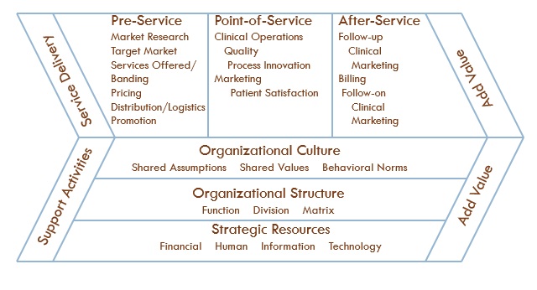
Modified from Ginter, et al., Exhibit 8.1

Figure 5. Strategic Management Value Chain

Value-Added Service Delivery Strategies
The components of an organizations’ value chain’s Service Delivery strategy consists of pre-service, point-of service, and after service activities. The product of the value chain creates a strategic advantage for an organization. The competitive advantage is created by the organization’s ability to design, produce, and market products and services of greater perceived value to the customer. In Gateway’s environment, quality of care, low costs, and added benefits are drivers to gain competitive advantage.
In the pre-service delivery, the aim is to convey the value of the competitive advantage to the customer in the market. The methods to influence the target market segments require market research, which lead to strategies involving branding, pricing, promotion and distribution. Gateway leveraged market research and historical success to create pre-service value to providers and members they engage. Examples of these services include targeted direct mail campaigns to senior citizens advertising unique Gateway benefits. Another pre-service value identified by Gateway involved rebranding the organization name from “Gateway Health Plan” to Gateway Health. The rebranding effort occurred in 2013 for the purpose that Gateway Health conveyed a more consumer-friendly company (Toland).
Point of service is a transformational process that integrates an organizations assets, including- resources and capabilities- into its service delivery (Ginter). Various environmental changes create the need for health care that is more responsive to wants, needs, expectations, and requirements of patients for information, convenience, and personal control (Bobel). Environmental change has had such a dramatic impact to the Medicare Advantage line of Gateway. Consumers have an ever increasing role in choosing their health care, and the Medicare Stars Program is aimed to enable Medicare beneficiaries to make informed decision in the value they receive from their health care spending. Since the Medicare product perception is shaped by this system, an organization-wide effort has been instituted assure employees that they all play a part in affecting the quality provided to members. Ultimately, the aim is to impact the quality measures that create the Medicare and Medicaid rating scores.
Implementing post-service strategies to advance tracking of provider clinical data metrics allows more effective utilization management, which can return feedback on key metrics to improve quality care measures. These self-assessment measures allow Gateway to respond more proactively to the measures regarding member quality care. CMS and state agencies often delay feedback, so tracking the measures internally created greater opportunity to identify and address issues sooner. To be more proactive, an organization-wide task force was assembled by Gateway to target individual HEDIS and CAHPS measures to improve the quality metrics for future ratings.

Value-Added Support Strategies
A company’s organizational structure, culture, and strategic resource considerations are value added strategies that support the service delivery methods outlined in the previous section.
The Business Development department at Gateway was tasked to facilitate and document various departments’ execution the strategic formulations. The responsibility of carrying out each individual component of the strategies are spread throughout internal departments, but Business Development has stood as the accountable party to coordinate interactions and track progress of the implementation strategies. Leading into the 2013 and 2014 AEP seasons, marketing efforts, regulatory affairs, compliance, and network development were coordinated to prepare for the expansion of the Medicare Assured product line. Soon thereafter, a development plan to implement the Go-Live (inaugural enrollment date) in the new markets followed the commencement of AEP. A project management tool to track planning and implementation was adopted in summer of 2014 in order to assure communication and transparency of plan execution from top level executives down to the day-to-day managers of 15 departments at Gateway. With a consolidated location to monitor and maintain record of strategic execution, the strategic momentum can persist to support the value-added service delivery components it supports.
The human resources and the technology infrastructure are additional value added support structures required to facilitate the implementation of market and product development. In 2012, Gateway was an organization with under 500 employees and grew to over 850 employees by 2015. The influx of human resources of the organization was needed to meet the demand which outpaced the capacity to which existing employees could function. From 2014-2015 Gateway gained approximately 100,000 members; therefore, the organization had to make a prediction prior to entering the new markets whether the processes and staff were equipped to handle the increased volume of members and processing their needs. Proactive response to department’s needs for interacting with stakeholders and maintaining operations is a critical support factor for service delivery.
Improving information technology infrastructure to more effectively recognize members’ needs and market to members serves as major supports to Gateway’s plan to achieve recognition for its excellence. To effectively position develop the infrastructure to meet the strategic growth objectives, in 2014 Gateway hired Mark Lantzy, the former CIO at WellCare, a for-profit Medicare and Medicaid MCO serving nearly 2.2 million beneficiaries. The new CIO brought his expertise of how to guide vision and implement the resources required to achieve similar ambitions. Developing the infrastructure for each service delivery unit at Gateway to gain access to data that can help better identify and treat the patients that can “bend the cost curve” are opportunities that are supported by IT. The growth of product and market, itself, ultimately creates an opportunity to gain large membership in new markets; still, with growth, management must be cognizant to the threshold to which human resources and operational systems function and adjust the structures to support the overarching support services. Based on executive assessment, the organization can decide whether these structures can be maintained, how they can be sustained, or be changed.

Conclusion
Each part of strategic management model, from strategic thinking, to strategic planning, to strategic momentum, represents a framework for assessing, creating, and executing a strategic plan. Every organization and their leadership is working toward a unique vision and face varying circumstances in their markets, so although a structured strategic management process is outlined in theory, it is apparent that not one organization can follow the strategic management model entirely.
Through the lens of the principles of strategic management, Gateway Health’s strategic thinking, strategy formulation, and strategic management demonstrate a roadmap in meeting the challenges the organization has faced. In order to remain on a path toward achieving the organization’s mission, vision and strategic objectives, Gateway’s board and senior management must continue to examine the rationale of each step in the strategic management process. According to Mintzberg, organizations allow for an environment where strategy is constantly discussed, developed, and substantiated with relevant data (Mintzberg 1994). Further, successful organizations have the leadership to recognize, sustain and execute the direction and vision (Mintzberg 1994). The process of strategic management is a highly subjective process; however, it requires understanding of such principles paired with leadership and a degree of experience-driven intuition. Ultimately, every phase in the strategic management process is significant and relate to the components which precede it; therefore, it is incumbent on an organization’s leadership to understand the value the process lends in guiding the organization to its strategic goals. With appreciation for the process, the optimum path will reveal itself. Then, it is the responsibility of leadership to recognize the value of each alternative and determine how it may align with the strategic orientation of the organization.
bibliography
Arndt, M. A. "339." The Transfer of Business Practices into Hospitals: History and Implications.
2000. 339. Print.

Blair J, Fottler M, and Savage G. “Advances in Health Care Management”. Stamford, CT: JAI
Press; 2001. pp. 11–36.

Bobel, Ingo and Martis, Amirita. “Value Creation in Health Care: The Case of Centre Hospitalier
Princess Grace (CHPG) in Monaco”. 2010. Journal of Strategic Management Education 6. No 2. Pp 1-36.

Centers for Medicare & Medicaid Services. "Special Needs Plans." Web. 14 Jan. 2015.
<https://www.cms.gov/Medicare/Health-Plans/SpecialNeedsPlans/index.html?redirect=/specialneedsplans/>.

Darnley, Patricia. Personal Interview. October 16, 2014.

Demko, Paul. "Most Medicare Advantage Plans Will Meet ACA Medical-loss Ratio
Requirements, Report Finds." Modern Healthcare. Modern Healthcare, 23 Jan. 2014. Web. 6 Apr. 2015. <http://www.modernhealthcare.com/article/20140123/NEWS/301239953/ {{link}}>.

Drucker, Peter F. Managing the Non-profit Organization: Practices and Principles. New York,
N.Y.: HarperCollins, 1990. Print.

Gateway Health. "Gateway Health Plan." Web. 6 Jan. 2015.
<http://gatewayhealthplan.com/about-us>.

Gateway Health. "Gateway Health Plan News Release." 7 Nov. 2010. Web. 6 Jan. 2015.
<https://www.gatewayhealthplan.com/node/330>.

Ginter, Peter M., W. Jack Duncan, and Linda E... Strategic Management of Health Care
Organizations. 7th ed. San Francisco, CA: Jossey-Bass, Wiley, 2013. Print.

Haislmaier, Edmund F., and Drew Gonshorowski. "Obamacare's Enrollment Increase: Mainly
Due to Medicaid Expansion." The Heritage Foundation. 22 Oct. 2014. Web. 16 Feb. 2015. <http://www.heritage.org/research/reports/2014/10/obamacares-enrollment-increase-mainly-due-to-medicaid-expansion>.

Ifedirah, Austin. Personal Interview. January 23, 2015

Kaiser Family Foundation. "Key Findings on Medicaid Managed Care: Highlights from the
Medicaid Managed Care Market Tracker." Web. 30 Jan. 2015. <http://kff.org/medicaid/report/key-findings-on-medicaid-managed-care-highlights-from-the-medicaid-managed-care-market-tracker/>.

Kaiser Family Foundation. "Medicare Advantage 2015 Data Spotlight: Overview of
Plan Changes." Web. 16 Jan. 2015. <http://kff.org/medicare/issue-brief/medicare-advantage-2015-data-spotlight-overview-of-plan-changes/>.

Mintzberg, H. (1994, January-February). The fall and rise of strategic planning. Harvard
Business Review. 107-114.

National Association of Insurance Commissioners. "Risk-Based Capital." 27 Feb. 2015. Web. 3
Mar. 2015. <http://www.naic.org/cipr_topics/topic_risk_based_capital.htm>.

National Health Policy Group. 1 July 2012. "How MA-SNPs Are Different from Standard MA
Plans." Web. 6 Feb. 2015. <http://www.nhpg.org/media/14844/snp alliance fact sheet on snps 7-20-12.pdf>.

Roberts, Edward and Berry, Charles. “Entering new businesses: selecting strategies for success”.
1984. A Sloan School of Management. P6.

Scribd. "Medicare Advantage Rankings Fact Sheet." Web. 6 Feb. 2015.
<http://www.scribd.com/doc/242943563/Medicare-Advantage-Rankings-Fact-Sheet>.

Toland, Bill. "Gateway Health Plan Rebrands, Plans Some Expansion." Pittsburgh Post-Gazette.
9 Apr. 2013. Web. 19 Feb. 2015. <http://www.post-gazette.com/businessnews/2013/04/09/Gateway-Health-Plan-rebrands-plans-some-expansion/stories/201304090143>.

