Using deciduous tree leaves as biomonitors for particulate air pollution: a literature review and pilot study

by
Sara Ellen Gillooly
B.A. Physical Anthropology, University of Pittsburgh, 2007

Submitted to the Graduate Faculty of
the Department of Environmental and Occupational Health
Graduate School of Public Health in partial fulfillment
of the requirements for the degree of
Master of Public Health

University of Pittsburgh
2015

UNIVERSITY OF PITTSBURGH
GRADUATE SCHOOL OF PUBLIC HEALTH

This essay is submitted
by
Sara Ellen Gillooly

on

April 24, 2015
and approved by
Essay Advisor:
Jane E. Clougherty, MSc, ScD ___________________________________________
Assistant Professor
Environmental and Occupational Health
Graduate School of Public Health
University of Pittsburgh

Essay Readers:

James P. Fabisiak, PhD ___________________________________________
Associate Professor
Environmental and Occupational Health
Graduate School of Public Health
University of Pittsburgh

James Peterson, PhD ___________________________________________
Associate Professor
Environmental and Occupational Health
Graduate School of Public Health
University of Pittsburgh

Daniel J. Bain, PhD ___________________________________________
Assistant Professor
Geology and Planetary Sciences
The Kenneth P. Dietrich School of Arts and Sciences
University of Pittsburgh

Copyright © by Sara Ellen Gillooly
2015
ABSTRACT
Jane E. Clougherty, MSc, ScD
Using deciduous tree leaves as biomonitors for particulate air pollution: a literature review and pilot study
Sara Ellen Gillooly, MPH
University of Pittsburgh, 2015

Particulate matter (PM) air pollution varies in concentration and composition across both space and time, and has been shown to cause or exacerbate adverse effects on human and ecological health. The concept of biomonitoring - using tree leaves as a proxy for PM pollution - has been explored using a variety of study designs, tree species, sampling strategies, and analytical methods across multiple geographies. Development and refinement of methods for utilizing tree leaves as biomonitors is relevant to public health in that it may improve spatially-resolved PM exposure assessments for epidemiological studies, ultimately contributing to PM exposure reduction and improved urban planning. A pilot study investigating this method is discussed, with results suggesting a somewhat limited utility of magnetic methods that is relatively understated in the literature.

TABLE OF CONTENTS
preface ix
1.0 LITERATURE REVIEW 1
1.1 INTRODUCTION 1
1.2 methods 2
1.3 Search results review 3
1.3.1 Analytic methods 3
1.3.2 Tree species selection 10
1.3.3 Site selection 12
1.3.4 Sampling height and leaf position 12
1.3.5 Sampling season and interval 14
1.3.6 Physio-chemical properties affecting interpretation of PM contribution to leaves 14
1.3.7 Effects of weather, precipitation, and moisture 15
1.3.8 Analytic controls 16
1.3.9 Validation: PM measures from sampling and/or modeling 17
1.3.10 Observed associations between sources and PM concentration or composition 18
1.4 Review Conclusions 19
2.0 pilot study 21
2.1 methods 21
2.1.1 Study design 21
2.1.2 Sample collection 23
2.1.3 Sample analysis 24
2.1.3.1 Magnetic analyses 25
2.1.3.2 Chemical analysis 27
2.2 results 28
2.2.1 Magnetic measurements 28
2.2.2 Chemical measurements 31
2.2.3 Correlations 32
2.2.4 Factor analysis 34
2.3 Discussion 37
bibliography 40
List of tables
Table 1. Analytic techniques in deciduous tree leaf biomonitoring studies modified after Rai (2013). 5
Table 2. Five major classes of magnetic materials. 7
Table 3. Distribution of candidate Norway maple trees by class. 22
Table 4. MDF_{ARM}, MDF_{IRM}, H_{c}, SIRM, and M_{r}/M_{s} values for leaf samples. 30
Table 5. Mean and standard deviation of leaf constituents analyzed via ICP-MS. 32
Table 6. Mean and standard deviation of filter constituents analyzed via ICP-MS. 32
Table 7. Correlations between filter constituents & leaf SIRM, and leaf constituents & leaf SIRM. 33
Table 8. Factor analysis of leaf and filter constituents. 35
Table 9. Factor analysis of leaf and filter constituents and leaf SIRM. 36
List of figures
Figure 1. Scanning electron micrograph of clustered, spherical leaf particulates. Pb occurs only within spherules <1µm in diameter [37]. 9
Figure 2. Abaxial surface of a leaf [1]. 10
Figure 3. Adaxial surface of a leaf [1]. 10
Figure 4. Candidate Norway maple trees by class in study domain of Pittsburgh, PA (n = 4,376). 22
Figure 5. Process of leaf and filter sample analysis. 25
Figure 6. Conceptual model of biomonitoring using tree leaves via magnetic analysis. 26
preface
I am grateful to have had the opportunity to collaboratively design a research study utilizing a part of nature that I love - trees - while simultaneously working toward a Master’s degree in Public Health. It is my hope that this somewhat novel approach to particulate air pollution sampling using tree leaves becomes refined enough for datasets that are useful for epidemiological investigations and/or urban planning strategies (i.e. urban forestry) in the United States and abroad.
I would like to acknowledge my advisor, Dr. Jane E. Clougherty, as well as members of the Clougherty Lab - Drew Michanowicz, Sheila Tripathy, Jessie LC Shmool, Brett Tunno, and Ellen Kinnee - for without their collaboration and support, I would not be at this point in my academic endeavors. I would also like to acknowledge Drs. Joshua Feinberg, Mike Jackson, and Bruce Moskowitz from the University of Minnesota Institute for Rock Magnetism for granting the visiting fellowship that allowed for magnetic analyses and providing me with relevant knowledge and understanding of magnetism. I am thankful to Drs. Daniel J. Bain and Jim Peterson for providing resources and guidance for chemical analysis of leaf samples. Additionally, I would like to acknowledge Kyra Naumoff Shields and Leah Cambal for collaborative work on the pilot project, as well as Jeffrey Howell and Leah Cambal for their contribution to a class project study design that later evolved into an idea for the pilot study discussed in this essay.

LITERATURE REVIEW

INTRODUCTION
Particulate matter (PM) has been linked to cardiovascular and respiratory health , with varying effects by chemical composition . Although PM concentration and composition varies across urban areas , monitoring costs have limited most “saturation” monitoring campaigns to relatively short time periods of a few weeks or less. Thus, there is a growing need for low-cost monitoring methods to capture longer-term (e.g., seasonal), spatially-resolved ambient PM measures (including constituents) across urban space.
With the beginning of the industrial era, effects of increased anthropogenic air pollution on certain organisms were evident . In the 19th century, qualitative environmental information provided by vegetation was observed in lichens by Scandinavian lichenologist William Nylander . Since then, biomonitoring of air pollution based on quantitative analysis of plants, lichens, or tree leaves has been explored , but has not been formally applied to exposure estimations. Specifically, tree leaves may serve as low-cost, widespread biomonitors, due to their quantity, distribution across metropolitan areas, availability of leaves at heights approximating the human breathing zone and minimal training required for collection . There are, however, technical, analytical, and practical challenges associated with effectively using leaves as biomonitors. In recent years, several European studies have demonstrated utility of leaves as biomonitors in urban areas , and a limited number of U.S. studies have considered tree density or cover as a predictor of spatial variation in pollution , though the U.S. Department of Agriculture (USDA) has investigated pollutant [ozone (O₃), particulate matter less than 10µm in diameter (PM₁₀), nitrogen dioxide (NO₂), sulfur dioxide (SO₂), and carbon monoxide (CO)] removal resulting in improved air quality in various U.S. locations . To our knowledge, no U.S. studies have effectively used tree leaves as biomonitors across an urban area. Given our interest in characterizing spatially-resolved variation in PM, we review techniques drawn from the existing literature on deciduous tree leaves as biomonitors of PM, and consider issues including species selection, study design, and methods for compositional analysis, to assess utility of tree leaves in intra-urban air pollution exposure assessment and source apportionment.

methods
A search was performed in April 2014 using PubMed (U.S. National Library of Medicine, Bethesda, MD, USA) and Google Scholar for articles identifiable using the keywords “biomonitoring,” “trees,” “leaves,” “pollution,” and/or “magnetic.” Twenty-eight studies met this criterion, and methods and results from these studies were reviewed. From the total number of papers (n = 28), we selected to review data, which included: analytic methods, tree species selection, site selection, sampling height and leaf position, season and sampling interval, analytic controls, and validation with PM sampling and/or modeling.

Search results review

Analytic methods
Various chemical and magnetic analytic methods have been used for compositional analysis of PM on tree leaves, detailed in Table 1, and summarized below.
Chemical measurements
Chemical methods - including inductively-coupled plasma mass spectrometry (ICP-MS) , optical emission spectrometry (ICP-OES) or atomic emission spectrometry (ICP-AES) , and atomic absorption (AA) spectroscopy - have been used to quantify trace elemental composition of multiple media with the best detection limits available for most elements and easily interpreted spectra . While sensitive to chemical concentrations at relatively low limits of detection (LOD) and providing information for a larger suite of elements with more specificity compared to magnetic measures (described below), these methods are costly, require technical expertise, irreversibly destroy samples, and require digestion of leaf samples using corrosive materials such as nitric acid (HNO₃) , a combination of HNO₃ and hydrogen peroxide (H₂O₂) , or “aqua regia” [HNO₃+hydrochloric acid (HCl)] prior to microwave digestion, open-vessel heating, or ashing. One study used differential pulse anodic stripping voltammetry (DPASV) with a hanging mercury drop electrode to determine lead (Pb), cadmium (Cd), copper (Cu), and zinc (Zn) post-ashing .

Magnetic measurements
All matter responds in various ways to applied magnetic fields . Magnetic measurements can be derived from urban dust on leaf surfaces, and mainly reflect the characteristics of trace or moderate amounts of iron oxides from industrial, domestic, and vehicular emissions . Because leaves themselves are insignificantly magnetic, they create minimal interference with magnetic analysis . Accordingly, magnetic analyses may offer rapid, low-cost, non-destructive methods to determine particle properties including magnetic grain size and magnetic mineralogy. Magnetic materials are classified into five major magnetic groups, as detailed in Table 2.
Magnetic techniques can distinguish particles produced at different temperatures and oxidation-reduction (redox) conditions, providing PM composition and source information (Table 1) . Magnetite-like materials (Fe₃O₄; more strongly magnetic iron oxides) derive predominately from vehicle-related emissions, while hematite (Fe₂O₃; weaker magnetic iron oxides) forms at higher combustion temperatures from industrial sources in different areas of the world (e.g. steel production in European countries) . Hansard et al. (2011) found hematite concentrations on leaves from industrial areas 100 times greater than roadside leaves . A similar study found that leaves from port areas had higher saturation isothermal remanent magnetization (SIRM), indicating iron spherules of 5 to 10µm in diameter, associated with industrial combustion .
Magnetic materials in areas of predominantly traffic-derived pollution are typically iron oxides (e.g. magnetite ) and hydroxides, which can constitute between 10 to 70% of the approximately 5 to 15% iron content of traffic-derived urban PM . Observed relationships between tree position and roadway suggest associations with engine wear or combustion emissions; Maher et al. (2008) found higher SIRM for leaves from roadside, uphill-adjacent tree leaves, lower for tree leaves from roadside, downhill-adjacent trees, and lowest for leaves from the distal side of roadside, downhill-adjacent trees . Additional factors influencing leaves’ magnetic measures include tree distance from roadway and traffic intensity, sampling height , fleet composition , and street canyonization . Because magnetic grain size is sometimes inconsistently correlated with ambient particle size [i.e. PM as defined by a regulatory agency such as the United States Environmental Protection Agency (US EPA)], this determination warrants supplementary analytic methods.
Table 1. Analytic techniques in deciduous tree leaf biomonitoring studies modified after Rai (2013).
Chemical
Parameters | Instrumentation | Studies Used | Units | Description
Trace element determination | Mass spectrometer [inductively-coupled plasma mass spectrometry (ICP-MS) , optical emission spectrometry (ICP-OES) or atomic emission spectrometry (ICP-AES)]  Atomic absorption (AA) spectroscopy  Differential pulse anodic stripping voltammetry (DPASV) with hanging mercury drop electrode | Šućur et al. (2010)  Simon et al. (2011)  Piczak et al. (2003)  Ataabadi (2012)  Aničić et al. (2011)  Rodríguez-Germade et al. (2014)  Davila et al. (2006)  Sawidis et al. (2011)  Sawidis et al. (1995)  Aboal et al. (2004)  Sant’Ovaia et al. (2012)  Baycu et al. (2006)  Tiwari and Dhakarey (2012)  Yildiz et al. (2010)  Tomašević et al. (2008) | µg g^{–1}  mg kg⁻¹  µg g^{–1}  µg g^{–1}  µg g^{–1}  µg g^{–1}  ppb/m²  µg g^{–1}  mg kg⁻¹  µg g^{–1}  n/a  mg kg⁻¹  ppm  µg g^{–1}  µg g^{–1} | Analysis for elements comprising leaf sample
Magnetic
MEASURED*
Parameters  Table 1 continued | Instrumentation | Studies Used | Units | Description
Magnetic susceptibility (mass χ or volume κ) | Bartington MS2B dual-frequency susceptibility sensor connected to MS2 susceptibility meter  Bartington susceptibility meter  Geofyzika KLY 2 Kappabridge  AGICO Kappabridge KLY-4S model  AGICO Kappabridge KLY-2 instrument | Power et al. (2009)  Mitchell and Maher (2009)  Mitchell et al. (2010)  Hanesch et al. (2003)  Sant’Ovaia et al. (2012)  Moreno et al. (2003) | m³ kg⁻¹  A  A  m  m³ kg⁻¹  m³ kg⁻¹ | Defined as the ratio of magnetization induced to intensity of magnetic field that is measured on volume (κ) or mass (χ) specific basis  Studies have explored range of susceptibility measurements: 1) room temperature, 2) frequency-dependent, and 3) low and high temperature, as properties of different classes of magnetic materials behave differently under different conditions.
Frequency-dependent susceptibility (χ_{FD}) | MS2 Bartington magnetic susceptibility sensor | Rodríguez-Germade et al. (2014) | m³/kg | Measured in terms of frequency variations (calculated as: χ_{FD =} χ_{LF} – χ_{HF}) that is used to constrain grain size and domain state of magnetic materials
Anhysteretic remanent magnetization (ARM) | Molspin (Newcastleupon-Tyne, England) A. F. Demagnetizer | Power et al. (2009) | Am² kg⁻¹ | Magnetization acquired by effects of large alternating (AC) current and small direct current (DC) field
Isothermal remanent magnetization (IRM) | Cryogenic magnetometer (CCL Ltd.)  Digico spinner magnetometer (Molyneux-Newcastle)  High sensitivity Molspin Minispin magnetometer  Molspin Minispin spinner magnetometer | Maher et al. (2008)  Matzka and Maher (1999)  Hanesch et al. (2003)  Sant’Ovaia et al. (2012)  Rodríguez-Germade et al. (2014) | A  A  A  Am² kg⁻¹  n/a | Magnetization left after steady field (1-1000mT) applied for short time (~100sec) then removed
Saturation isothermal remanent magnetization (SIRM) | Molspin Minispin magnetometer  AGICO JR5A magnetometer  Molspin1A magnetometer  2G Enterprises 755R cryogenic  Magnetometer | Kardel et al. (2011, 2012, 2013)  Mitchell et al. (2010)  Hansard et al. (2012)  Hofman et al. (2013)  Maher et al. (2013)  Sant’Ovaia et al. (2012)  Davila et al. (2006)  Power et al. (2009)  Moreno et al. (2003) | A  A  Am²  A  A  Am² kg⁻¹  Am² kg⁻¹  Am² kg⁻¹  m³/kg | Magnetization when external field is reduced to zero and reflective of all concentrations of all remanence-carrying minerals in the sample, dependent on grain size, domain, and temperature
CALCULATED**
Parameters | Studies Used | Units | Description
High field isothermal remanent magnetization (HIRM) | Hansard et al. (2011, 2012)  Mitchell and Maher (2009)  Sant’Ovaia et al. (2012) | %  %  Am² kg⁻¹ | Magnetization acquired between 300mT and 1T which indicates high-coercivity antiferromagnetic minerals
SIRM/ χ | Sant’Ovaia et al. (2012)  Moreno et al. (2003) | k Am⁻¹  kA/m | Ratio of SIRM to susceptibility that provides information on magnetic particle size and composition
IRM/ κ | Hanesch et al. (2003) | A/m | Ratio of IRM to susceptibility that gives insight to the class and grain size of the sample
S ratio | Moreno et al. (2003)  Hanesch et al. (2003) | Dimensionless  Dimensionless | Determined from IRM acquisition and backfield magnetization curves that discriminates between high and low coercivity material
Median destructive field (MDF_{ARM}) | Hansard et al. (2011)  Mitchell and Maher (2009) | mT  mT | Alternating field required to reduce remanence values to one half of initial value , indicative of magnetic grain size of ferromagnetic grains
χ_{ARM}/SIRM | Hansard et al. (2011, 2012)  Mitchell and Maher (2009) | A  A | Ratio indicative of “soft” magnetic grain size of magnetite-like particles affected by presence of “harder” magnetic minerals
Additional
Parameters | Instrumentation | Studies Used | Units |  | Description
Particle characteristics | Scanning electron microscopy (SEM) with energy dispersive x-ray analyzer (EDXA) | Maher et al. (2013)  Hanesch et al. (2003)  Sawidis et al. (2011)  Mitchell and Maher (2009) | nm, µm  µm  µm  nm, µm |  | Determination of particle sizes and morphologies
Enrichment ratio or pollution factor level | None (but need elemental concentrations or magnetic parameters to calculate) | Maher et al. (2008)  Mitchell and Maher (2009) | Dimensionless  Dimensionless |  | Used for certain magnetic parameters [e.g. mean enrichment ratio of SIRM (roadside: background)]
*values from direct measurements of samples
**calculated values from measurements taken [e.g. HIRM = 0.5 * (SIRM + IRM_300mT)]
Table 1 Continued
Table 2. Five major classes of magnetic materials.
Class | Example(s) | Definition
Diamagnetic | Cd, Cl, Cu | A usually weak fundamental property of all matter, due to non-cooperative behavior of orbiting electrons when exposed to an applied magnetic field. Diamagnetic materials are composed of atoms with no net magnetic moments, therefore producing a negative magnetization when exposed to a magnetic field.
Paramagnetic | Al, Mg, Na | These materials have a net magnetic moment due to unpaired electrons in partially-filled orbitals, but individual magnetic moments do not interact magnetically, so magnetization is zero when magnetic field removed, but in the presence of a magnetic field, there is partial alignment of atomic magnetic moments in the direction of the field, resulting in a net positive magnetization.
Ferromagnetic | Fe, Co, Ni | These materials are generally highly magnetic because their atomic moments exhibit very strong interactions, produced by electronic exchange forces which results in parallel or antiparallel alignment of atomic moments. There is parallel alignment of magnetic moments resulting in large net magnetization even in absence of magnetic field, therefore enabling maintenance of magnetization in absence of a magnetic field.
Ferrimagnetic | Fe₃O₄ | These materials exhibit a type of magnetic ordering, with a structure composed of two magnetic sublattices separated by oxygens. The magnetic moments of the sublattices not equal, resulting in a net magnetic moment, similar to ferromagnetism aside from the magnetic ordering. Ferrimagnetic materials are also able to remain magnetized in the absence of a magnetic field.
Antiferromagnetic | Cr, Fe₂O₃ | These materials have well-aligned but opposing magnetic moments, with magnetic forces virtually canceling each other out. They have a net magnetic moment of zero, and are able to remain magnetized in the absence of a magnetic field.
Adapted from Moskowitz (1991) .
Table 2 Continued

Other measurements: scanning electron microscopy (SEM)
SEM coupled with energy dispersive x-ray analysis (SEM-EDXA) provides highly-resolved leaf surface images for quantification of particle size and elemental composition. This method, however, requires exhaustive examination by an analyst across leaf surfaces due to heterogeneity in PM deposition, size distribution, and composition, and thus is time-consuming and costly.
Maher et al. (2008) used SEM-EDXA to observe PM morphology in a subset of leaves, finding spherical clusters ranging from less than 0.5 to 20µm, comprised mostly of iron (Fe), silicon (Si), and aluminum (Al), and some angular particles 1 to 10µm diameter, comprised mostly of Fe, sulfur (S), Al, potassium (K), and calcium (Ca) . Pb was present as a minor element on leaf surfaces, only within spherules less than one µm in diameter (Figure 1).
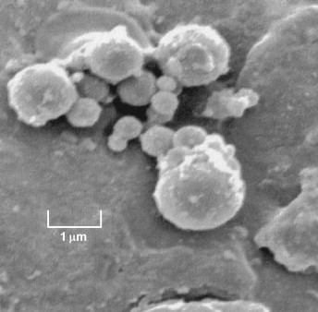
Figure 1. Scanning electron micrograph of clustered, spherical leaf particulates. Pb occurs only within spherules <1µm in diameter .
Reprinted from: Maher BA, Moore C, and Matzka J: Spatial variation in vehicle-derived metal pollution identified by magnetic and elemental analysis of roadside tree leaves. Atmospheric environment 42.2 (2008): 364-373, with permission from Elsevier.

Sawidis et al. (2011) found that leaf surface analysis revealed particles with variable morphology, structure, and chemical composition and relative trapping efficiency for larger particles (20 to 40µm) on the abaxial (bottom) surface, and for small particles (1 to 20µm) on the adaxial (top) surface . Figures 2 and 3 show this variation.
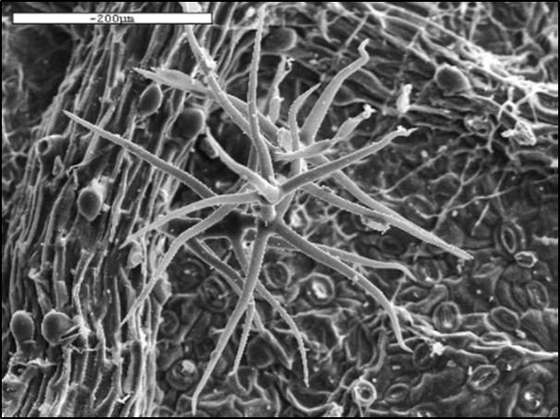
Figure 2. Abaxial surface of a leaf .
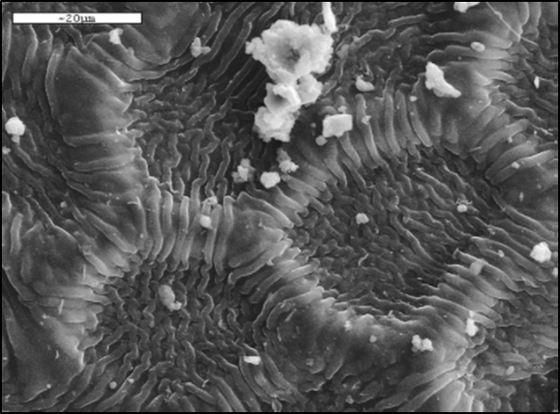
Figure 3. Adaxial surface of a leaf .
Figures 2 and 3 reprinted from: Sawidis T, Breuste J, Mitrovic, Pavlovic P, Tsigaridas K: Trees as bioindicator of heavy metal pollution in three European cities. Environmental Pollution 159.12 (2011): 3560-3570, with permission from Elsevier.

Tree species selection
Selection of deciduous or evergreen trees may depend on characteristics relevant to the exposure interval(s) of interest and goals of study, such as textural component of leaves, abundance within study area, etc. Deciduous trees lose their leaves each fall (abscission), go dormant for the winter, and leaf out again in spring; dormancy occurs to conserve water and reduce water loss, enabling it to survive. Evergreen trees, including various conifers, retain leaves year-round and can have needle-, scale-like, or broad-leafed foliage, adapted so that they do not need to drop leaves to conserve water during certain times of the year. Therefore, deciduous tree leaves may be appropriate for measures capturing the growing season or a portion of it. For year-round or longer-term measures, evergreens may be appropriate, as their leaves or needles grow for a longer period, slowly incorporating particles into the epicuticular wax layer .
Particle deposition varies with leaf characteristics (e.g. complex leaf shape), and large surface area increases surface adsorption . Many studies reviewed selected species by: (a) abundance within, or spatial coverage across, the sampling domain or (b) leaf surface characteristics (e.g., broad shape, ridged or “hairy” surface) to maximize surface deposition .
Easily identifiable tree species may facilitate collection and improve consistency across sampling personnel. The ability to grow in urban environments is required for sampling in highly-polluted areas, and to ensure non-differential variance in species availability and survival across an urban domain. Trees capable of thriving in multiple environments (”generalists”) may improve generalizability across studies and locations, as would the capacity to grow at different elevations, and ability to transplant well . In addition, the role of genotypic variability between trees may be less influential on elemental concentrations in leaves than the role of the environment .

Site selection
Geographic range of selected tree species can be a limiting factor for sampling allocation; hence most studies prioritize spatial coverage across study areas in species selection. Site allocation approaches have ranged from systematic coverage (i.e., representation across land-use types) to source-specific sampling (i.e., high traffic areas) .
To compare leaf samples by land-use type, Kardel et al. (2011,2012,2013) sampled sites across: 1) green spaces, 2) suburban areas, 3) urban areas, and 4) harbor/industrial areas . Other studies used systematic grid-based approaches; Hanesch et al. (2003) used the urban administration grid to achieve uniform coverage, allocating at least one sampling point to each cell . To systematically sample leaves across different urbanization levels, Davila et al. (2006) divided their urban and suburban zones into 1km² cells, and the city center (expecting greater spatial variability) into 0.25km² cells . Power et al. (2009) focused sampling along high traffic roadways, to compare roadside pollution along four differently-characterized roadways .

Sampling height and leaf position
Though most studies aim to examine leaves from heights approximating the human breathing zone, sampling height may depend on study goals, characteristics of emissions sources relative to leaf position, or general availability of tree leaves at a particular height. Because PM concentration and composition can vary with height or source proximity, it is important to keep this variable constant to accurately compare between sites. Reviewed studies sampled at heights ranging from less than 1 to more than 5m above ground, depending on tree height and crown properties , leaf age or availability , position of leaves (e.g. facing roadside) , or hypothesized associations between concentrations and near-roadway pollution gradients . One study did not specify sampling height . Hofman et al. (2013) found SIRM to be 66% weaker, on average, for leaves collected at 12 vs. 5m in height within an urban street canyon . Mitchell and Maher (2009) found 50% reduction in SIRM from leaves collected at 2 vs. 0.3m in height . A separate study observed height effects by PM components: SIRM, Pb, and Fe concentrations all peaked at 0.3m, and decreased with height, while Zn, barium (Ba), and manganese (Mn) were lowest at 0.3m, and increased with height . Another study found no significant effect of sampling height on leaf SIRM .
Beyond sampling height, appropriate study designs for leaf sampling likely require attention to the position of selected leaves on the tree, as leaves adjacent to a busy road, for example, may differ in PM deposition from leaves on the opposite side. Further variation may arise from position on a branch, leaf size, age, light, and shade conditions, though this variation may be assessed by sampling multiple leaves per branch, and selecting leaves of uniform size or of similar age (i.e. oldest leaves on newest twig growth) .

Sampling season and interval
For ambient air pollution monitoring, seasonal characteristics (e.g., meteorology, regional source emissions intensity) are important drivers of temporal variance in PM concentrations . For leaf sampling, the seasonal growth cycle is of concern. Single-season sampling (i.e., spring or summer ) may be useful for capturing specific meteorological or regional source emissions regimes. Autumn sampling , assuming leaf persistence, is useful for capturing PM accumulated throughout the growing season. Alternatively, multi-season approaches have been used to compare pollutant concentration and composition across seasons, and biomonitoring capability of trees at different points in the growing season .
While longer sampling intervals may be useful to compare accumulated seasonal concentration gradients across an urban area, shorter intervals may be useful for examining short-term weather or source effects on PM deposition on leaves. Matzka and Maher (1999) used consecutive-day sampling to examine spatial and temporal patterns of urban dust on roadside tree leaves (n = 600) . Others used consecutive-day sampling to elucidate patterns of PM magnetism from varying vehicular emissions .

Physio-chemical properties affecting interpretation of PM contribution to leaves
In order to utilize leaves as biomonitors for air pollution, it is necessary to determine what proportion of PM is on the leaf surface or within leaf tissue and whether or not it results from airborne deposition vs. translocation from roots, bark, or soil. Rodríguez-Germade et al. (2014) suggested that biogenic magnetic materials in leaves are not significantly related to those in soil, indicating a predominant contribution from airborne deposition . Some elements are relatively immobile from soil, but translocation of inorganic elements within plants is not clear . Physio-chemical soil characteristics may affect element uptake and bioavailability of elements, and thus are preferably sampled in conjunction with leaves. Tomašević et al. (2008) stated that soils with lesser organic matter tend to accumulate more Pb, Cd, Cu, and Zn than do soils with more organic matter . Likewise, lower pH may increase bioavailability of metals for uptake .

Effects of weather, precipitation, and moisture
Leaves are not sheltered from weather, which may result in sample loss or reduced collection efficiency, and may vary with leaf position on the tree or irregular surface structure . The net effect of precipitation on leaf surface PM integrity is unclear , and study designs require attention to variation in moisture conditions. Collecting leaves before and after rainfall may reveal precipitation-driven changes in concentrations. Kardel et al. (2011) observed limited rain-induced wash-off, and increased SIRM of PM concentrations over the growing season in two species, possibly from PM accumulation in the leaf tissue . Others reported decreased magnetic measures of 5-30% , 12-64% , and 28% after a rainstorm, and Moreno et al. (2003) observed no significant change in magnetic measures - specifically magnetic susceptibility - after rainfall .
Other studies examined precipitation effects using leaf washing or leaching procedures , though the process may imperfectly represent precipitation effects . Davila et al. (2006) reported leaf samples with high magnetic measures retaining up to 20% of initial measures post-leaching; those with low initial measures had post-leaching measures close to instrument LOD . Rodríguez-Germade et al.’s (2014) procedure removed 69 to 97% of Al, Cu, Fe, Mn, and Zn , and Maher et al. (2008)’s removed approximately 75% of initial SIRM .
Leaf moisture content can vary across the growing cycle and with soil moisture status, therefore, several leaf drying procedures have been developed to standardize the analysis of dry mass . Accordingly, studies which did not dry leaves, but instead stored samples in a refrigerator or freezer until analysis, may not be directly comparable to dry leaves.

Analytic controls
Identifying and obtaining control leaves for analytic calibration (or blank control) can be a challenge, thus few studies have used a “clean” control of the same species. Mitchell et al. (2010) grew glasshouse-grown, “magnetically-clean” leaves to adjust for environmental background, then deployed them at background and high traffic sites for reanalysis . Some studies have employed washing, or reference, procedures using distilled or deionized water , detergents, and/or ultrasonic agitation to clean “control” leaves for magnetic analysis. Matzka and Maher (1999) reported that cleaning with water, detergent, and ultrasonic agitation removed 65 to 80% of magnetization from leaf samples, with residual magnetization attributed to incorporation of dust particles into leaf tissue, imperfect cleaning, or biogenic magnetic contributions .
Nutrient uptake varies with species and nutrient availability, and trees can survive only within distinct ranges of nutrient concentrations , which vary over the vegetative cycle . Thus, determining the leaf’s “chemical fingerprint” may help disentangle inherent elemental concentrations from anthropogenic contributions , if this “fingerprint” is not unreasonably variable.

Validation: PM measures from sampling and/or modeling
Validating leaf magnetic and elemental measures against traditional air monitoring data, or additional active sampling, is critical for understanding the utility of tree leaves as sampling media for environmental exposure studies. Multiple studies reported positive correlations between leaf-based magnetic measures and atmospheric PM measurements . Power et al. (2009) used a hand-held P-Trak Ultrafine Particle Counter to measure ultrafine PM_{1.0} concentrations at each leaf sampling site during peak traffic hours, reporting positive correlations between PM_{1.0} and χ_{LF} (R² = 0.60, p > 0.05), ARM (R² = 0.75,p > 0.05), and SIRM (R² = 0.78, p < 0.05) of roadside Tilia europaea leaves, and between PM_{1.0} and χ_{LF} (R² = 0.79, p < 0.05), ARM (R² = 0.94, p < 0.01), and SIRM (R² = 0.96, p < 0.01) of roadside Acer pseudoplatanus leaves, with higher PM_{1.0} concentrations near roadways with more idling vehicles . Hansard et al. (2011) co-located SidePak AM510 personal aerosol monitors for coarse PM₁₀ with sampled trees, reporting positive associations with leaf SIRM (R² = 0.71, p = 0.01) . In the same study, comparisons were made between leaf-derived PM₁₀ estimates and Gaussian plume dispersion model results near an industrial site. Model results underestimated ambient PM₁₀ (expected for single-source models), but spatial patterns of leaf SIRM corresponded with monthly-averaged prevailing wind direction from the industrial site . Mitchell and Maher (2009) collected one-hour PM₁₀ samples at leaf sampling sites using SKC Leyland Legacy personal monitors with magnetically-clean Teflon® filters. Despite different sampling intervals, filter samples correlated strongly with mean leaf SIRM (R² = 0.80, p = 0.01). Leaf magnetic measures and filters revealed similar ranges of particle sizes, morphologies, and compositions, with most particles in the 0.1 to 1µm diameter range. Elemental analysis revealed high Fe concentrations in sub-micron particles, and higher concentrations of Al and Si in larger (≤ 5µm) angular particles. Mitchell and Maher further compared mean PM₁₀ leaf measures with dispersion model predictions, reporting a correlation of rho = 0.60 (p = 0.01) .

Observed associations between sources and PM concentration or composition
Despite challenges in using tree leaves as biomonitors of PM pollution, meaningful associations between leaf-derived measures and local emissions sources have been observed. Davila et al. (2006) identified higher magnetic SIRM for leaf samples from urban areas with higher traffic density and spherical iron particles (5 to 10µm in diameter) from combustion sources using magnetic methods . Kardel et al. (2012) found that leaf SIRM decreased with increasing distance from nearest road, and increased with higher traffic intensity and tram/rail transport frequency .
Using chemical analysis, Baycu et al. (2006) found higher Pb concentrations in leaves from roadside sites . Similarly, Tomašević et al. (2008) hypothesized the source of Pb concentrations from leaf samples to be from traffic emissions, as leaded gasoline was the predominant fuel used in their sampling domain , and Sawidis et al. (2011) found that leaves from city centers had higher concentrations of metals associated with vehicular and industrial activities (Cr, Cu, Fe, Pb) . Simon et al. (2011) found that leaf wash (solution derived from leaf-washing procedures) from urban areas had higher concentrations of sodium (Na), Ba, strontium (Sr), Pb, Fe, selenium (Se), Al, Cu, cobalt (Co), magnesium (Mg), arsenic (As), and Ca, and that (washed) leaf tissue from urban areas higher concentrations of Zn, Mn, Mg, Cu, Ca, phosphorus (P), K, Cd, Ba, and lithium (Li), both associated with vehicular and industrial activities . As hypothesized, differences in various constituents from leaf samples (or leaf wash) from high traffic, roadside, or urban areas have been found when compared to low traffic or rural areas.

Review Conclusions
Cost-effective methods to capture and identify sources of intra-urban variability in PM pollution are needed for use in human exposure assessment. Deciduous tree leaves - exposed throughout the leaf-growing season - offer a cost-effective means of collecting seasonal PM samples across urban areas, and statistically significant positive associations have been found between magnetic and chemical leaf and atmospheric PM measurements. However, magnetic and chemical leaf-based analyses require robust validation against actively-sampled or modeled PM concentrations to derive location or source-specific associations. For instance, in the US, co-locating tree leaves with EPA PM_{2.5} Federal Reference Method filter-based measurements after sampling for approximately six rain-free days will increase the interpretability of results. A multiple-technique approach, such as coupled magnetic and microscopy analyses , may also be employed for better characterization of pollutants - depending on hypothesis - and understanding of sources . Additionally, a standard “control” leaf sample for tree species that have been utilized is lacking in some investigations, and standard reference material such as lichen-336 may not sufficient for use as a “control” due to inter-species differences in trace element concentrations. Thus, there are some clear benefits and utility for deciduous tree leaves as biomonitors for characterizing spatially-resolved variation in PM in areas of stark contrast, such as high traffic urban roadways or industry-dominated (e.g. steel-making) areas vs rural areas. However, technique refinement is needed to reduce uncertainties for general application and potential use in exposure and epidemiological studies. These and other issues were taken into consideration for a pilot study designed, implemented, and conducted in 2012 and discussed below.

pilot study

methods

Study design
Using Geographic Information Systems (GIS)-based methods, we designed a study to systematically sample Norway maple tree leaves across our Pittsburgh domain. Built upon the design for Shmool et al. (2014), we aimed to capture pollutant source variability across the region. This was done by parsing our study domain into 100m² grid cells (n = 159,031) using ArcGIS and removing rivers, streams, and river-edges to 20m using the USGS National Hydrography Dataset to ensure accessibility to all sampling locations. Data on traffic density, local industrial facilities, and topography were collected from publicly-available resources at the Pennsylvania Department of Transportation (PennDOT), the Allegheny County Health Department criteria pollutant emissions inventory, and the USGS National Elevation Dataset (30m² resolution raster dataset). These data were used as pollutant “source indicators” across the study domain. We dichotomized each source indicator at the 70th percentile, and cross-stratified each grid cell across eight classifications, representing combinations of ‘high’ and ‘low’ local pollution source profiles , and conducted sampling so as to represent each of these classes. A high traffic/non-valley/near industry area was excluded due to lack of candidate trees in accessible locations. The distribution of candidate Norway maple trees across the study domain by class is quantified in Table 3 and visualized in Figure 4 from data obtained from TreePittsburgh.
Table 3. Distribution of candidate Norway maple trees by class.
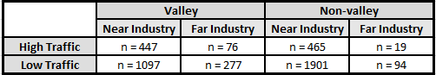

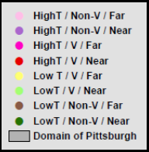
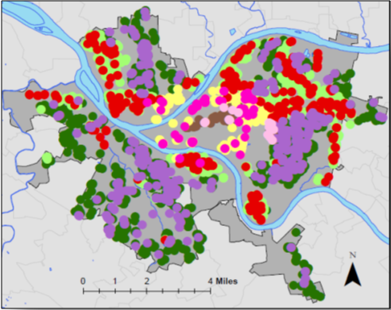
Figure 4. Candidate Norway maple trees by class in study domain of Pittsburgh, PA (n = 4,376).

Sample collection
Leaf samples
To avoid the possibility of species-dependent differences in accumulation, all samples were collected from a single tree species - the Norway maple - which is the most abundant (street) tree species in Pittsburgh at 15.7% . Six of the oldest leaves of the newest twig growth (i.e. larger leaves on the lower outer canopy) facing the roadside were collected to ensure leaves of similar age and exposure time. This was done at all sites (n = 25) for a 5-day sampling period each month from August through October. We sampled at heights approximating the human breathing zone; sampling height across all sites averaged approximately 2m above the ground. Because leaves lack shelter from the elements (e.g. precipitation, wind), we attempted to minimize any local meteorological effects by sampling after six consecutive, rain-free days when possible . Leaf samples were stored in plastic bags at 4°C to avoid contamination until subsequent magnetic and chemical analyses. Prior to analyses, the surface area of each leaf was measured by pixel counting scanned images using ImageJ software and adapted from protocols by Luke Miller (Stanford University) and Kitren Glozer (University of California Davis).
Filter samples
Air pollution monitors equipped with Harvard Impactors (Air Diagnostics and Engineering Inc.), 37mm Teflon filters and a HOBO H21-002 data logger (Onset Computer Corporation), contained in waterproof Pelican cases and co-located within 3-4m of sampled trees were used to measure PM_{2.5} concentrations. Using a temperature (20°C) and relative humidity (35%) controlled glove box (PlasLabs Model 890 THC), 37mm Teflon filters (Pall Life Sciences) were equilibrated for 48 hours and then pre-and post-weighed using an ultramicrobalance (Mettler Toledo Model XP2U). Sampling units were custom-designed to capture integrated street-level samples of PM_{2.5}. Instruments were programmed to run for a 5-day, 24-hour sampling period using a chrontroller (ChronTrol Corporation). A tetraCal® volumetric air flow calibrator (BGI Instruments) was used to calibrate the flow of air to 4.0 liters per minute (LPM), and HOBO data logger recorded temperature and relative humidity at fifteen-minute intervals for the duration of each sampling period. All samplers were deployed on utility poles near selected trees at a height of approximately 3m. For quality assurance and control purposes, filter field blanks were deployed for each sampling session, and all concentrations were blank-corrected . Co-located PM_{2.5} samples (n = 4) were highly correlated at r = 0.95, suggesting reproducibility of the sampling method.

Sample analysis
The magnetic and chemical analysis of leaf and filter samples is shown below in Figure 5:
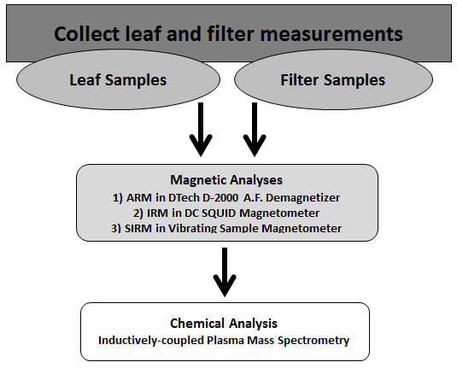
Magnetic Analyses
a) ARM in DTech D-2000 A.F. Demagnetizer
b) IRM in DC SQUID Magnetometer
c) SIRM in Vibrating Sample Magnetometer
Figure 5. Process of leaf and filter sample analysis.

Magnetic analyses
Leaf samples
Leaf and filter samples underwent magnetic analysis at the University of Minnesota Institute for Rock Magnetism. Each leaf sample consisted of 3 leaves which were packed into 5.3cm³ plastic boxes with lids then weighed using a microbalance. Next, in a zero field laboratory (i.e. protected from the Earth’s magnetic field) at room temperature, samples were given anhysteretic remanent magnetization (ARM) on a DTech D-2000 AF Demagnetizer (Precision Instruments). The ARMs were measured and subjected to stepwise alternating field (AF) cleaning in a 2G Long-core Magnetometer (2G Enterprises) with an in-line automated AF demagnetizer to characterize their magnetic stability, including median destructive field (MDF_{ARM}) values. The samples were then magnetized at 1 Tesla (T) using an IRM Controller (2G Enterprises) to produce saturation isothermal magnetizations (SIRM), which were also measured and subjected to stepwise AF cleaning in the 2G Long-core instrument, and resulting data were used to compute MDF_{SIRM}. Finally, hysteresis loops were measured on the Vibrating Sample Magnetometer (Princeton Measurements, sensitivity 5 x 10⁻⁹ A m²) in order to obtain saturation magnetization (M_{s}), saturation isothermal remanent magnetization (SIRM), and coercivity (H_{c}) values. Figure 6 shows a conceptual model depicting the process of sample collection to magnetic analysis.
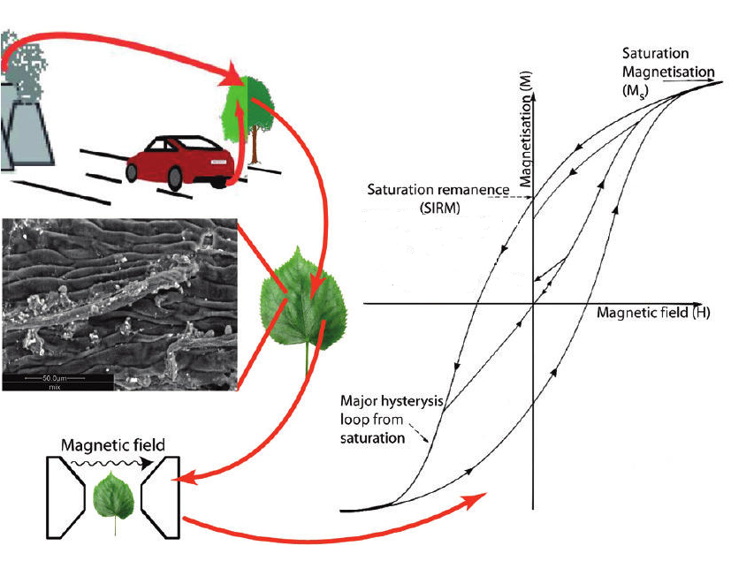
Figure 6. Conceptual model of biomonitoring using tree leaves via magnetic analysis.
Reprinted (adapted) with permission from: Hansard R, Maher BA, Kinnersley RP: Rapid magnetic biomonitoring and differentiation of atmospheric particulate pollutants at the roadside and around two major industrial sites in the U.K. Environ Sci Technol 2012, 46(8):4403-4410. Copyright (2012) American Chemical Society.

Adapted from Hansard et al. (2012) .

Filter samples
Magnetic values from filter samples could not be obtained due to resource constraints, which does not allow for appropriate comparison between leaf and filter magnetic values.

Chemical analysis
Leaf analysis
Each leaf sample consisted of a 0.5g mass, obtained by cutting leaf samples with sterile scissors, then weighed on a Mettler Toledo AE240 analytical balance. Each sample was digested using HNO₃, and Xpress vessels in a CEM Corporation MARS Xpress microwave digester using a CEM Corporation protocol for plant sample digestion.
Post-digestion, a diluted 0.5mL digested leaf solution (with HNO₃ and internal standard - Be, Ge, Tl) underwent ICP-MS analysis (Perkin Elmer ICP-Mass Spectrometer NexION 300X). For quality assurance and control purposes, blanks were run every 10th sample, and the first sample from each 10 runs was repeated. Elemental concentrations were obtained for Li, Mg, Al, K, Ca, Cr, Mn, Fe, Cu, Ba, Pb, Mo, Ni, Sb, V, Zn, Cs, and Sr in units of µg of element per g of leaf sample. The unit of µg/g was used to compare to filter values (ng/m³) based on the assumption that atmospheric deposition was the primary source of constituent accumulation.
Filter analysis
PM_{2.5} concentrations were calculated using pre- and post-sampling Teflon net filter weights and sampling volume . All filter samples were sent to Wisconsin State Laboratory of Hygiene (Madison, WI) and analyzed for the same constituents as leaf samples (above).

results

Magnetic measurements
Leaf samples
Table 4 shows a summary of magnetic measures from the leaf samples used to characterize PM present, including: SIRM, M_{r}/M_{s}, MDF_{ARM} and MDF_{IRM}, and H_{c} values.
Saturation isothermal remanent magnetization (SIRM): SIRM values were obtained from hysteresis loops, which characterize the magnetic mineralogy, grain size, and concentration. SIRM was then converted to an average magnetization, or total magnetic moment (Am²) per leaf sample by surface area (m²), hence, Amperes (A). Hysteresis data showed that all samples reached magnetic saturation between 300 and 500mT, indicating predominately ferrimagnetic (magnetite-like) particles. Hysteresis data were corrected to remove any diamagnetic contribution from the sample box or from leaf water content (i.e. non-metal constituents). The highest SIRM values were from samples taken from a heavily polluted industrial area.
Remanence ratios: Ratios of saturation remanence to saturation magnetization (M_{r}/M_{s}), reflective of grain size, are shown in Table 4 and indicate a narrow range from 0.07 to 0.13. This value represents the proportion of magnetization remaining in the sample when the magnetic field is removed after saturation, and is a good indicator of magnetic domain state, which is strongly related to magnetic grain or particle size . The measured values correspond to grain sizes in the pseudo-single domain (PSD) and multi-domain (MD) range. [A magnetic domain is a collection of magnetic fields in the same direction, and the number of domains is indicative of magnetic grain size. For instance, a SD is a uniform magnetization in the same direction, and exhibits high coercivity and remanence values due to difficulty in rotating the magnetization. A division into multiple domains (MD) occurs with increasing grain size and surface area to better distribute magnetostatic, or surface, energy of the grain. PSD grains exhibit a combination of SD and MD properties .] The highest M_{r}/M_{s} value was from a site with high traffic density in a low-lying area along a river. M_{r}/M_{s} values for approximately 8% of total samples (n = 2) were missing due to error.
Median destructive field: MDF values were obtained by subjecting leaf samples to stepwise alternating magnetic field demagnetization. At each step, the AF is smoothly reduced to zero from some peak value, and the demagnetization curve is constructed by exposing the sample to a series of increasing AF peak values, measuring the remaining remanence after each step. The MDF is the peak AF value needed to reduce the initial remanence by one half of its initial value . MDF_{ARM} values greater than MDF_{IRM} values indicate samples consisting of single domain (SD) and/or PSD particles (the “Lowrie-Fuller test”) . For alternating field demagnetization characteristics of MD thermoremanent magnetization in magnetite, refer to Dunlop and Özdemir (1997) . Table 4 shows MDF values; value from one site was removed due to equipment error.
Coercivity: H_{c} values - ranging from 9.76 to 14.53mT - indicate predominately PSD particles , consistent with the MDF_{ARM}/MDF_{IRM} data. In addition, these lower H_{c} values suggest magnetically “soft” ferrimagnetic materials (i.e. magnetite). However, the PSD state is not as clearly defined as SD and MD: samples may contain mixtures or broad distributions of grain size, or may be dominated by “true PSD” material (i.e. small MD grains exhibiting a mixture of SD-like (high remanence) and MD-like (low H_{c}) behavior, and ranging from 0.1-20µm in diameter) . Table 4 shows H_{c} values; one value was removed due to equipment error.
Table 4. MDF_{ARM}, MDF_{IRM}, H_{c}, SIRM, and M_{r}/M_{s} values for leaf samples.
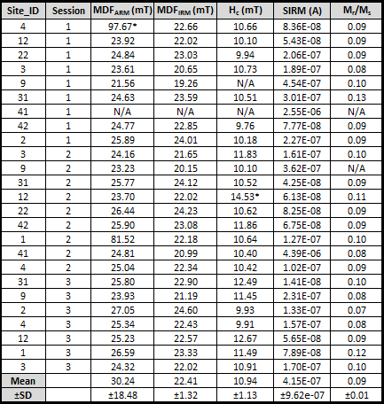
*Indicates outlying values.

Filter samples
Magnetic values from filter samples could not be obtained due to resource constraints.

Chemical measurements
Leaf samples
Leaf samples were analyzed for the following constituents: Li, Mg, Al, K, Ca, Cr, Mn, Fe, Cu, Ba, Pb, Mo, Ni, Sb, V, Zn, Cs, and Sr. Summary statistics for leaf sample constituent analysis were performed in STATA version 13 (StataCorp, College Station, TX), and are shown in Table 5. Significant variation in concentration between constituents was observed, as indicated by certain large standard deviations (e.g. Mn and Fe). However, relatively higher concentrations were expected for certain macro- and/or micronutrients essential to plant or tree processes such as Ca, K, Fe, and Mn, which are important in protein synthesis and operation of stomata (K), maintenance of membrane structure (Ca), chlorophyll synthesis (Fe), and enzyme activation (Mn) . In addition, the pollutant-tolerant nature of the Norway maple, along with its ability to withstand other urban impacts (e.g., dusts, dry soils, and pavement) may also result in relatively higher concentrations of various constituents. Leaf samples were not blank-corrected due to difficulty in obtaining and interpreting a “control” leaf. Outliers were kept in the data due to small sample size, and hypothesized high concentrations for certain constituents at purposeful sites (i.e. those in close proximity to a heavy industry-polluted area).
Table 5. Mean and standard deviation of leaf constituents analyzed via ICP-MS.
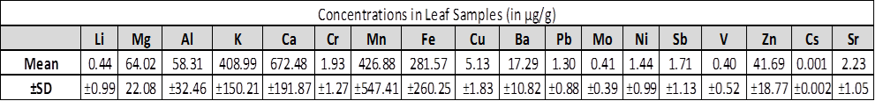
Note units in µg/g.

Filter samples
Filter samples were analzyed for the same constituents as leaf samples, listed in the paragraph above. Summary statistics for filter constituent analysis were performed using STATA (College Station, TX) (Table 6). Blank corrections using field blanks were performed using SAS (Cary, NC). Consistent with leaf data, outliers were kept due to small sample size, and because purposeful sites were hypothesized to be much higher in concentration for certain constituents.
Table 6. Mean and standard deviation of filter constituents analyzed via ICP-MS.
Note units in ng/m³.

Correlations
Leaf chemical, filter chemical & leaf SIRM
Table 7 shows correlations between leaf and filter constituents, and leaf SIRM (n = 25). Highest correlations of statistical significance between leaf constituents and leaf SIRM were reported between leaf V, Cs, Al, Mo, and Fe and SIRM, respectively. Because filter SIRM values were not able to be successfully measured, filter constituents were compared to leaf SIRM, also shown in Table 7. However, depending on the source of PM, it has been shown that certain constituents positively correlate with SIRM values (e.g. Fe and/or Pb and SIRM), so we hypothesized a positive correlation among co-located leaf SIRM values and certain filter constituents . Highest correlations of statistical significance (Spearman rho) between filter constituents and leaf SIRM were reported here between filter Mn, K, Cs, Li, and Fe and leaf SIRM, respectively. Correlation between PM_{2.5} mass concentrations and leaf SIRM was rho = 0.45 (p = 0.024).
Table 7. Correlations between filter constituents & leaf SIRM, and leaf constituents & leaf SIRM.
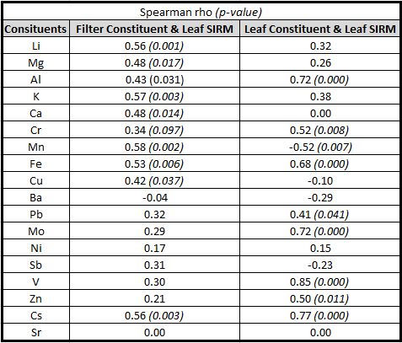

Factor analysis
We explored the utility of exploratory factor analysis (EFA) to better summarize our data and determine source contributions, such as traffic or local industry, from leaf and filter constituents, as well as leaf SIRM. Accordingly, we performed a factor analysis with varimax rotation (resulting in orthogonal components) using the methods outlined in Clougherty et al. (2011), which ensures no correlation between factors. Criteria considered included the eigenvalue-one criterion and scree test, and components accounting for at least 5% of the total variance were retained . Factor loadings, which are the correlations between each variable and the factor (e.g. filter Al and leaf Al in Factor 1 of Table 8b), that were greater than or equal to 0.60 were chosen in order to make the factor patterns more interpretable. Constituents loading greater than or equal to 0.60 are shown in Table 8a and 8b; Table 8a shows leaf and filter constituents run separately, and 8b run together. When run separately and together, there are a number of leaf and filter constituents that retain a positive factor loading of 0.60 - Al, Fe, Pb, and Zn. This demonstrates the consistency between media for various constituents across all sites. Filter and leaf Li both have a positive factor loading of 0.60 or greater when run separately, but when run together leaf Li drops just below the 0.60 cutoff (0.53).
Table 8. Factor analysis of leaf and filter constituents.
a
b
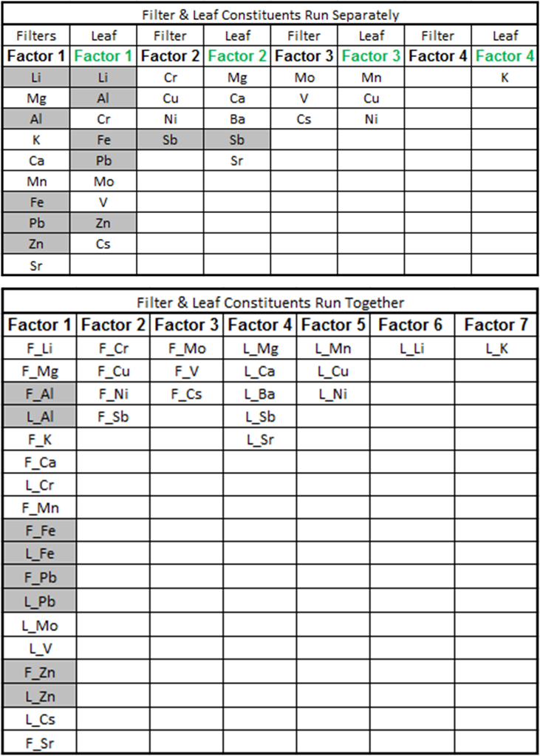
Shaded values indicate constituents appearing in separate and combined FA. Note: “F_” indicates filter; “L_” indicates leaf.

Further, Table 9a and 9b show filter constituents and leaf SIRM and leaf constituents and leaf SIRM run together, respectively and 9c shows filter and leaf constituents and leaf SIRM run together. Measures from different methods (i.e. magnetic and chemical) were combined into the same FA due to the relationship between SIRM and various constituents found in the literature.
Table 9. Factor analysis of leaf and filter constituents and leaf SIRM.
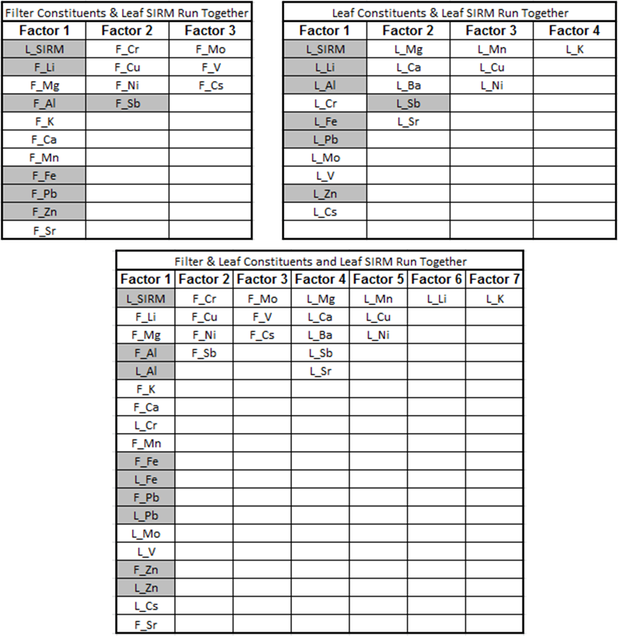
b
Shaded values indicate constituents appearing in separate and combined FA. Note: “F_” indicates filter; “L_” indicates leaf.
a
c

There are a number of leaf and filter constituents - along with leaf SIRM - that retain a positive factor loading of 0.60 - Al, Fe, Pb, and Zn. Filter and leaf Li both have a positive factor loading of 0.60 or greater when run separately with leaf SIRM, but run together leaf Li drops below the 0.60 cutoff, at 0.57. These metals that showed up for leaf and filter samples as the strongest factor (Al, Fe, Pb, Zn) can be interpreted as, across all sites sampled, Al, Fe, Pb, and Zn consistently showed up together in both leaf and filter samples.

Discussion
Characterization of particles
As stated previously, filter sampling methods using Harvard Impactors allowed for collection and definition of PM_{2.5} without further analysis, and magnetic properties were used to attempt to characterize PM on leaf samples. These magnetic properties, such as SIRM, a general M_{r}/M_{s} in the 0.1-0.5 range, and lower H_{c} values (approximately 10mT averaged across all sites), indicated iron-rich, magnetite-like particles which were relatively homogenous in composition, but varying by grain size distribution. However, caution should be taken when interchangeably using particle and grain size, due to the inconsistency between particle size as defined by the EPA, and grain size defined in terms of magnetism. If a sample is mono-grain - as opposed to an agglomerate of different grains - grain size and particle size may be interchangeably used . Determining this may require additional analysis via SEM-EDXA, which is tedious and a potential issue in terms of cost and resources. Since we did not have access to SEM-EDXA, we have to rely on the statistical analyses of magnetic and chemical parameters of samples.

Source of particles
Factor analysis performed on filter and leaf chemical constituents and leaf SIRM indicated that leaf SIRM, Al, Fe, Pb, and Zn showed up as the strongest factor across all sites. A heavy traffic-related contribution to samples was evident from the constituents or magnetic measurements such as SIRM, Al, Fe, Pb, and Zn attributed to soil and road dust, motor vehicle emissions, diesel, and brake and tire wear. However, this was expected since leaves were sampled from street trees at an average height of approximately 7 feet above the ground, and is consistent with findings in previous studies that magnetic PM decreases significantly within a few tens of meters from the source (i.e. high-traffic roads) . A weaker industrial component was present in the strongest factor as steel-making (Pb and Zn) and coal or secondary transport (Pb). In addition, the anthropogenic mechanisms hypothesized here - combustion, brake pad wear, steel-making - produce magnetite-like materials with certain metals (Pb and Zn) incorporated into the crystal lattice structure of the magnetite, as opposed to adhering to the surface of the magnetite, as Al from soil and road dust may do. However, different geographic regions may have a different source mix or composition of pollutants (e.g. leaded gasoline in Europe but not United States) so contribution from sources in the local or regional area should be investigated via review of relevant literature, as was done for our pilot study with a literature review of source apportionment for outdoor air .
Evaluation and limitations of biomonitoring method
Despite our study’s small sample size, the statistically significant positive correlation between PM_{2.5} concentration and leaf SIRM [rho = 0.45 (p = 0.024)] indicates the potential for SIRM to serve as a proxy for PM_{2.5} pollution in urban areas with additional research. For instance, a deposition velocity calculation for PM onto leaf surfaces in order to obtain a concentration for better comparison to filter-based PM concentrations could be explored. However, this was not completed for the pilot study due to lacking SIRM values from filters. To effectively do this, truly co-located leaf and filter samples (i.e. from beginning to end of sampling period) may be more interpretable due to a matching temporal component, despite the possibility of the pollution source mix not significantly changing from beginning to end of our sampling campaign (August through October). Our leaf samples were collected solely at the end of the 5-day sampling period, which may be more representative of PM accumulated over a period of time longer than our 5-day sampling period. In addition, a proper “control” tree leaf to blank-correct tree leaves from distributed sites would ensure more accurate concentrations for comparison to filter-based results. Regarding chemical and magnetic parameters, an understanding of the origin or source of particles or constituents with respect to urban PM pollution and definition of particle size as it relates to regulatory agencies like the EPA is important in interpretation of results and usefulness of data for further studies (e.g. epidemiological investigations).

bibliography
1. Sawidis T, Breuste J, Mitrovic M, Pavlovic P, Tsigaridas K: Trees as bioindicator of heavy metal pollution in three European cities. Environmental pollution 2011, 159(12):3560-3570.
2. Dockery DW: Epidemiologic evidence of cardiovascular effects of particulate air pollution. Environmental health perspectives 2001, 109(Suppl 4):483.
3. Pope III CA, Burnett RT, Thun MJ, Calle EE, Krewski D, Ito K, Thurston GD: Lung cancer, cardiopulmonary mortality, and long-term exposure to fine particulate air pollution. Jama 2002, 287(9):1132-1141.
4. Dominici F, Peng RD, Bell ML, Pham L, McDermott A, Zeger SL, Samet JM: Fine particulate air pollution and hospital admission for cardiovascular and respiratory diseases. JAMA 2006, 295(10):1127-1134.
5. Laden F, Neas LM, Dockery DW, Schwartz J: Association of fine particulate matter from different sources with daily mortality in six US cities. Environmental health perspectives 2000, 108(10):941.
6. Bell ML: Assessment of the health impacts of particulate matter characteristics. Research Report (Health Effects Institute) 2012(161):5-38.
7. Ito K, Mathes R, Ross Z, Nádas A, Thurston G, Matte T: Fine particulate matter constituents associated with cardiovascular hospitalizations and mortality in New York City. Environmental health perspectives 2011, 119(4):467-473.
8. Valavanidis A, Fiotakis K, Vlachogianni T: Airborne particulate matter and human health: toxicological assessment and importance of size and composition of particles for oxidative damage and carcinogenic mechanisms. Journal of Environmental Science and Health, Part C 2008, 26(4):339-362.
9. Bell ML, Ebisu K, Peng RD, Samet JM, Dominici F: Hospital admissions and chemical composition of fine particle air pollution. American journal of respiratory and critical care medicine 2009, 179(12):1115-1120.
10. Peng RD, Bell ML, Geyh AS, McDermott A, Zeger SL, Samet JM, Dominici F: Emergency admissions for cardiovascular and respiratory diseases and the chemical composition of fine particle air pollution. Environ Health Perspect 2009, 117(6):957-963.
11. Mostofsky E, Schwartz J, Coull BA, Koutrakis P, Wellenius GA, Suh HH, Gold DR, Mittleman MA: Modeling the association between particle constituents of air pollution and health outcomes. American journal of epidemiology 2012, 176(4):317-326.
12. Bell ML, Ebisu K, Peng RD: Community-level spatial heterogeneity of chemical constituent levels of fine particulates and implications for epidemiological research. J Expo Sci Environ Epidemiol 2011, 21(4):372-384.
13. Clougherty JE, Kheirbek I, Eisl HM, Ross Z, Pezeshki G, Gorczynski JE, Johnson S, Markowitz S, Kass D, Matte T: Intra-urban spatial variability in wintertime street-level concentrations of multiple combustion-related air pollutants: The New York City Community Air Survey (NYCCAS). J Expos Sci Environ Epidemiol 2013, 23(3):232-240.
14. Eeftens M, Tsai M-Y, Ampe C, Anwander B, Beelen R, Bellander T, Cesaroni G, Cirach M, Cyrys J, de Hoogh K: Spatial variation of PM2. 5, PM10, PM2. 5 absorbance and PMcoarse concentrations between and within 20 European study areas and the relationship with NO2-Results of the ESCAPE project. Atmospheric Environment 2012, 62:303-317.
15. Markert B, Oehlmann J, Roth M: General aspects of heavy metal monitoring by plants and animals. 1997.
16. Ågren GI, Weih M: Plant stoichiometry at different scales: element concentration patterns reflect environment more than genotype. New Phytologist 2012, 194(4):944-952.
17. Moreno E, Sagnotti L, Dinarès-Turell J, Winkler A, Cascella A: Biomonitoring of traffic air pollution in Rome using magnetic properties of tree leaves. Atmospheric Environment 2003, 37(21):2967-2977.
18. Maatoug M, Taïbi K, Akermi A, Achir M, Mestrari M: Bio-Monitoring of Air Quality Using Leaves of Tree and Lichens in Urban Environments.
19. Simon E, Braun M, Vidic A, Bogyo D, Fabian I, Tothmeresz B: Air pollution assessment based on elemental concentration of leaves tissue and foliage dust along an urbanization gradient in Vienna. Environmental pollution 2011, 159(5):1229-1233.
20. Aksoy A, Osma, E. and Z. Leblebici: Spreading Pellitory (Parietaria Judaica L.): A Possible Biomonitor of Heavy Metal Pollution. Pak J Bot March 2012, 44:123-127.
21. Baycu G, Tolunay D, Özden H, Günebakan S: Ecophysiological and seasonal variations in Cd, Pb, Zn, and Ni concentrations in the leaves of urban deciduous trees in Istanbul. Environmental pollution 2006, 143(3):545-554.
22. Nowak DJ, Crane DE, Stevens JC: Air pollution removal by urban trees and shrubs in the United States. Urban forestry & urban greening 2006, 4(3):115-123.
23. Šućur KM, Aničić, M.P., Tomašević, M.N., Antanasijević, D.Z., Perić-Grujić, A.A. and M.DJ. Ristić: Urban deciduous tree leaves as biomonitors of trace element (As, V and Cd) atmospheric pollution in Belgrade, Serbia. J Serb Chem Soc 2010, 75(10):1453-1461.
24. Piczak K, Leśniewicz, and Wiesiaw Żyrnicki: Metal Concentrations in Deciduous Tree Leaves from Urban Areas in Poland. Environmental monitoring and assessment 2003, 86:273-287.
25. Ataabadi M: Assessment of washing procedure for determination some of airborne metal concentrations. African Journal of Biotechnology 2012, 11(19).
26. Aničić M, Spasić T, Tomašević M, Rajšić S, Tasić M: Trace elements accumulation and temporal trends in leaves of urban deciduous trees (Aesculus hippocastanum and Tilia spp.). Ecological Indicators 2011, 11(3):824-830.
27. Rodriguez-Germade I, Mohamed KJ, Rey D, Rubio B, Garcia A: The influence of weather and climate on the reliability of magnetic properties of tree leaves as proxies for air pollution monitoring. Sci Total Environ 2014, 468-469:892-902.
28. Davila AF, Rey D, Mohamed K, Rubio B, Guerra AP: Mapping the sources of urban dust in a coastal environment by measuring magnetic parameters of Platanus hispanica leaves. Environmental science & technology 2006, 40(12):3922-3928.
29. Sawidis T, Marnasidis, A., Zachariadis, G. and J. Stratis: A Study of Air Pollution with Heavy Metals in Thessaloniki City (Greece) Using Trees as Biological Indicators. Arch Environ Contam Toxicol 1995, 28:118-124.
30. Aboal JR, Fernández JA, Carballeira A: Oak leaves and pine needles as biomonitors of airborne trace elements pollution. Environmental and Experimental Botany 2004, 51(3):215-225.
31. Sant'Ovaia H, Lacerda, M.J. and C. Gomes: Particle pollution – An environmental magnetism study using biocollectors located in northern Portugal. Atmospheric Enviroment 2012, 61:340-349.
32. ThermoElemental: AAS, GFAAS, ICP or ICP-MS? Which technique should I use? An elementary overview of elemental analysis. In.; 2001: 12.
33. Tomasevic M, Vukmirovic Z, Rajsic S, Tasic M, Stevanovic B: Contribution to biomonitoring of some trace metals by deciduous tree leaves in urban areas. Environmental monitoring and assessment 2008, 137(1-3):393-401.
34. Tiwari S, Dhakarey R: Accumulation of Heavy Metals in Soil and Tree Leaves in Heavy Traffic Affected Area of Agra city.
35. Moskowitz BM: Hitchhiker's guide to magnetism. In: Environmental Magnetism Workshop (IRM): 1991; 1991: 48.
36. Kardel F, Wuyts K, Khavaninzhadeh AR, Wuytack T, Babanezhad M, Samson R: Comparison of leaf saturation isothermal remanent magnetisation (SIRM) with anatomical, morphological and physiological tree leaf characteristics for assessing urban habitat quality. Environmental pollution 2013, 183:96-103.
37. Maher BA, Moore, C. and J. Matzka: Spatial variation in vehicle-derived metal pollution identified by magnetic and elemental analysis of roadside tree leaves. Atmospheric Environment 2008, 42(2):364-373.
38. Hansard R, Maher BA, Kinnersley RP: Rapid magnetic biomonitoring and differentiation of atmospheric particulate pollutants at the roadside and around two major industrial sites in the U.K. Environ Sci Technol 2012, 46(8):4403-4410.
39. Mitchell R and Maher BA: Evaluation and application of biomagnetic monitoring of traffic-derived particulate pollution. Atmospheric Enviroment 2009, 43:2095-2103.
40. Hofman J, Stokkaer I, Snauwaert L, Samson R: Spatial distribution assessment of particulate matter in an urban street canyon using biomagnetic leaf monitoring of tree crown deposited particles. Environmental pollution 2013, 183:123-132.
41. Hansard R, Maher, B.A. and R. Kinnersley: Biomagnetic monitoring of industry-derived particulate pollution. Environmental pollution 2011, 159:1673-1681.
42. Muxworthy AR, Matzka J, Petersen N: Comparison of magnetic parameters of urban atmospheric particulate matter with pollution and meteorological data. Atmospheric Environment 2001, 35(26):4379-4386.
43. Dedik A, Hoffmann P, Ensling J: Chemical characterization of iron in atmospheric aerosols. Atmospheric Environment Part A General Topics 1992, 26(14):2545-2548.
44. Weber S, Hoffmann P, Ensling J, Dedik A, Weinbruch S, Miehe G, Gütlich P, Ortner H: Characterization of iron compounds from urban and rural aerosol sources. Journal of Aerosol Science 2000, 31(8):987-997.
45. Power AL, Worsley AT, Booth C: Magneto-biomonitoring of intra-urban spatial variations of particulate matter using tree leaves. Environ Geochem Health 2009, 31(2):315-325.
46. Kardel F, Wuyts K, Maher B, Samson R: Intra-urban spatial variation of magnetic particles: monitoring via leaf saturation isothermal remanent magnetisation (SIRM). Atmospheric Environment 2012, 55:111-120.
47. Mitchell R, Maher, B.A. and R. Kinnersley: Rates of particulate pollution deposition onto leaf surfaces: Temporal and inter-species magnetic analyses. Environmental pollution 2010, 158(5):1472-1478.
48. Hanesch M, Scholger, R. and D. Rey: Mapping dust distribution around an industrial site by measuring magnetic parameters of tree leaves. Atmospheric Enviroment 2003, 37(36):5125-5133.
49. Rai PK: Environmental magnetic studies of particulates with special reference to biomagnetic monitoring using roadside plant leaves. Atmospheric Environment 2013, 72:113-129.
50. Dearing J: Environmental magnetic susceptibility. Using the Bartington MS2 system Kenilworth, Chi Publ 1994.
51. Matzka J and Maher BA: Magnetic biomonitoring of roadside tree leaves: identification of spatial and temporal variations in vehicle-derived particulates. Atmospheric Enviroment 1999, 33(28):4565-4569.
52. Kardel F, Wuyts, K., Maher, B.A., Hansard, R. and R. Samson: Leaf saturation isothermal remanent magnetization (SIRM) as a proxy for particulate matter monitoring: Inter-species differences and in-season variation. Atmospheric Enviroment 2011, 45:5164-5171.
53. Gubbins D, Herrero-Bervera E: Encyclopedia of geomagnetism and paleomagnetism: Springer; 2007.
54. Maher BA, Ahmed IA, Davison B, Karloukovski V, Clarke R: Impact of roadside tree lines on indoor concentrations of traffic-derived particulate matter. Environ Sci Technol 2013, 47(23):13737-13744.
55. Liu Q, Roberts AP, Torrent J, Horng C-S, Larrasoaña JC: What do the HIRM andS-ratio really measure in environmental magnetism? Geochemistry, Geophysics, Geosystems 2007, 8(9):n/a-n/a.
56. Chakre OJ: Choice of eco-friendly trees in urban environment to mitigate airborne particulate pollution. Journal of Human Ecology 2006, 20(2):135-138.
57. Nowak DJ, McBride JR, Beatty RA: Newly planted street tree growth and mortality. Journal of Arboriculture 1990, 16(5):124-129.
58. Guha M, Mitchell R: The trace and major element composition of the leaves of some deciduous trees. Plant and Soil 1965, 23(3):323-338.
59. Bereznicki SD, Sobus JR, Vette AF, Stiegel MA, Williams RW: Assessing spatial and temporal variability of VOCs and PM-components in outdoor air during the Detroit Exposure and Aerosol Research Study (DEARS). Atmospheric Environment 2012, 61:159-168.
60. Yildiz D, Kula I, Ay G, Baslar S, Dogan Y: Determination of trace elements in the plants of Mt. Bozdag, Izmir, Turkey. Archives of Biological Sciences 2010, 62(3):731-738.
61. Guha MM, Mitchell R: The trace and major element composition of the leaves of some deciduous trees. Plant and Soil 1966, 24(1):90-112.
62. Djingova R, Kuleff I, Markert B: Chemical fingerprinting of plants. Ecological Research 2004, 19(1):3-11.
63. Sagnotti L, Taddeucci J, Winkler A, Cavallo A: Compositional, morphological, and hysteresis characterization of magnetic airborne particulate matter in Rome, Italy. Geochemistry, Geophysics, Geosystems 2009, 10(8):n/a-n/a.
64. Shmool JL, Michanowicz DR, Cambal L, Tunno B, Howell J, Gillooly S, Roper C, Tripathy S, Chubb LG, Eisl HM: Saturation sampling for spatial variation in multiple air pollutants across an inversion-prone metropolitan area of complex terrain. Environmental Health 2014, 13(1):28.
65. Group DR: City of Pittsburgh, Pennsylvania Municipal Forest Resource Analysis In.; 2008.
66. Lowrie W, Fuller M: On the alternating field demagnetization characteristics of multidomain thermoremanent magnetization in magnetite. Journal of Geophysical Research 1971, 76(26):6339-6349.
67. Dunlop DJ and Özdemir Ö: Rock Magnetism Fundamentals and Frontiers, vol. No. 3, 1st edn. Cambridge Books Online: Cambridge University Press; 1997.
68. Raven PHJ, George B.: Biology, 6th Edition. Boston, MA: McGraw-Hill; 2002.
69. Nowak DJ, Rowntree RA: History and range of Norway maple. Journal of Arboriculture 1990, 16(11):291-296.
70. Clougherty J, Houseman E, Levy J: Source apportionment of indoor residential fine particulate matter using land use regression and constrained factor analysis. Indoor air 2011, 21(1):53-66.
71. Maher B: Personal Communication. In. Edited by Gillooly S; 2014: 1.
72. Tunno B, Dalton, R, Michanowicz, D, Shmool, JL, Kinnee, E, Tripathy, S, Cambal, L, Clougherty JE: Spatial Patterning in PM2.5 Constituents under an Inversion-Focused Sampling Scheme across an Urban Area of Complex Terrain. Environmental Health (in preparation) 2015.

