EFFECTIVENESS OF TRAP-SPAY/NEUTER-RETURN PROGRAMS ON FREE-ROAMING CATS AS A FORM OF RABIES PREVENTION

by
Scott McGonagle
BS, Grove City College, 2012

Submitted to the Graduate Faculty of
Graduate School of Public Health in partial fulfillment
of the requirements for the degree of
Master of Public Health

University of Pittsburgh
2015

UNIVERSITY OF PITTSBURGH
GRADUATE SCHOOL OF PUBLIC HEALTH

This essay is submitted
by
Scott McGonagle

on

May 11, 2015
and approved by

Essay Advisor:
Willem G. Van Panhuis, MD PhD ______________________________________
Assistant Professor
Department of Epidemiology
Graduate School of Public Health
University of Pittsburgh

Essay Reader:
Candace Kammerer, PhD ______________________________________
Associate Professor
Department of Human Genetics
Graduate School of Public Health
University of Pittsburgh

Copyright © by Scott McGonagle
2015
ABSTRACT

Introduction
Willem G. Van Panhuis, MD PhD

EFFECTIVENESS OF TRAP-SPAY/NEUTER-RETURN PROGRAMS ON FREE-ROAMING CATS AS A FORM OF RABIES PREVENTION

Scott McGonagle, MPH
University of Pittsburgh, 2015

Cats are the second most tested animal for rabies each year in Massachusetts. In order to reduce the cost of rabies prevention, trap-spay/neuter-return (TNR) programs for feral cats can be used to reduce the population of cats, thus reducing potential rabies exposure. This is significant to public health because reducing the free-roaming cat population may not only reduce exposure to rabies, but reduce rabies prevention costs, freeing resources which can be used on other interventions.
Methods
The effectiveness of TNR programs in Massachusetts was assessed using analysis of variance and analysis of covariance tests which compared the number of animals submitted for rabies testing per year by county. Spearman’s rank order correlation test was used to determine whether or not differences in the number of animals submitted for rabies testing were associated with the number of free-roaming cat population reduction interventions present in each county. The costs of TNR programs were assessed and compared to normal rabies prevention costs.
Results
There were statistically significant differences (p<0.0001) between the number of animals tested in each county, and the differences appeared to be associated with the presence of TNR programs or low cost spay/neuter programs, but only slightly (correlation coefficient of -0.20).
Discussion
TNR programs may be effective as a targeted approach with a small, known population, but it is not viable as a means of rabies prevention at the county level based on the small magnitude of correlation between interventions and reduction of animals submitted for rabies testing. Adopting TNR programs as prevention measures would likely increase spending on rabies prevention.
Conclusion
Free-roaming cat population control interventions are inversely associated with the number of animals submitted for rabies testing in Massachusetts counties. This indicates that TNR programs are effective for reducing free-roaming cat populations, but the magnitude of the testing reduction, while statistically significant, is still small.

TABLE OF CONTENTS
1.0 IntroductiOn 1
1.1 RABIES BACKGROUND 1
1.2 RABIES AND FREE-ROAMING CATS 4
1.3 TNR LITERATURE 8
2.0 METHODS 13
2.1 Relation between interventions and number of cats 13
2.2 TNR COSTS 16
3.0 RESULTS 18
4.0 DISCUSSION 24
5.0 Conclusion 28
bibliography 29
List of tables

Table 1. Rabies Testing Across States 3Table 2. Rabies Testing in Massachusetts: 2005-2014 5Table 3. Mean Rates of Rabies Testing per County .....................................................................19
Table 4. ANCOVA Multiple Comaprisons: p-values 21
Table 5. Spearman Correlation Statistics 22Table 6. Spearman Correlation Statistics Without Barnstable County 22
Table 7. Distribution of TNR and Low Cost Spay/Neuter across Massachusetts 22
List of figures

Figure 1. Human Rabies Cases: 1995-2011 2
Figure 2. Rabid Cats and Dogs Reported in the United States during 2010 7
Figure 3. Animals Submitted for Rabies Testing by County 20
Figure 4. Correlation Between Interventions and Number of Animal Tested 23

Introduction

Rabies bacKground
Rabies is a vaccine preventable zoonotic viral disease. In humans, as many as 40,000 individuals are exposed each year [1] and the cost of prevention is over $300 million per year. [1] Rabies can be transmitted to humans by both domestic and wild animals, [2] although in the United States, more than 90% of animal cases are reported in wildlife. [3] The virus is spread through the saliva of an affected animal via bites and scratches. [2] The incubation period is generally one to three months, but can be as little as one week or as long as one year, depending on the animal and the exposure site. [2] There are two forms of the disease, furious rabies and paralytic rabies, but both are nearly 100% fatal if left untreated. There are no diagnostic tests currently available for humans or animals for use before the onset of clinical disease. [2]
Treatment of rabies is through the use of post exposure prophylaxis (PEP). [2] PEP consists of local treatment of the wound immediately after exposure, a course of rabies vaccinations, and administration of rabies immunoglobulin. [2] Treatment soon after exposure can prevent onset of clinical disease and death; modern day PEP has been shown to be nearly 100% effective. [3] Human fatalities in the United States occur in those who do not seek treatment, generally because they are unaware of the exposure. [3] As a result, in the United States, there are only two or three deaths nationwide per year. [4] Pre-exposure vaccination is available, but is typically only recommended for individuals at high risk, due to the high cost associated with vaccinations. [2] Rabies PEP costs over $1,000 for a five dose vaccination series over the course of four weeks. [1] The Centers for Disease Control and Prevention (CDC) estimates that as many as 40,000 PEP treatments are given per year. [1]
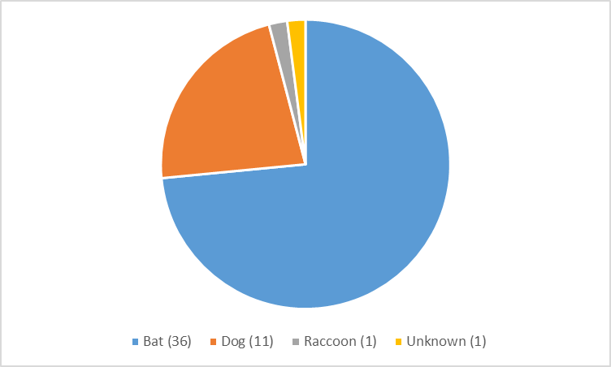
Figure 1. Human Rabies Cases: 1995-2011[5].
Number of cases of human rabies categorized by the animal responsible for transmission.

Human death from rabies in the United States is rare. Figure 1 shows all of the cases in the United States between 1995 and 2011. In a 16 year period, there was a total of 49 human cases spread across the country. [5] Because of how rare human cases are, the major impact of rabies is currently the large costs associated with prevention.
During the summer of 2014, I participated in an internship in Plymouth County, Massachusetts, which involved establishing a trap-spay/neuter-release (TNR) program in the town of Middleborough. This internship is the basis for the essay, so the focus will be on the state of Massachusetts. Table 1 compares the number of animals submitted and tested in Massachusetts from 2009 to 2013 with two bordering states. This time frame was selected based on the availability of data from the New York and New Hampshire Departments of Public Health.
Table 1. Rabies Testing Across States [6-25].
 | Massachusetts |  | New York |  | New Hampshire
Year | Submitted | Positive | Submitted | Positive | Submitted | Positive
2013 | 2689 | 97 | 5689 | 336 | 502 | 34
2012 | 2790 | 111 | 6654 | 425 | 465 | 28
2011 | 2453 | 110 | 6430 | 370 | 437 | 25
2010 | 2418 | 131 | 6642 | 499 | 433 | 17
2009 | 2468 | 128 | 7275 | 440 | 543 | 33

Number of animals submitted for rabies testing and number of animal that tested positive for rabies between 2009 and 2013 organized by state.

Rabies prevention is extremely expensive, with the United States spending over $300 million per year on prevention measures. [1] The cost per human life saved is estimated between $10,000 and $100 million. [1] The prevention costs include vaccination of companion animals, animal control programs including bait vaccination programs, maintenance of rabies laboratories, medical costs, and time. [1] The oral rabies vaccine used in bait vaccination programs is licensed for use in raccoons, gray foxes, and coyotes only, so is not a feasible vaccination method for all wildlife. [26]
With so much money spent on rabies prevention, reducing the cost would allow for allocation of resources to other public health interventions. Because rabies had such a high mortality rate in the untreated, it would be unethical to cut prevention measures. In order to reduce costs, alternative methods need to be considered beyond reducing rabies surveillance and treatment.

rabies and free-roaming cats
In Massachusetts, from 2012 to 2014, cats were the second most tested animal for rabies, second only to bats [6-15] which are the primary mode of transmission in the United States. [2] Prior to this, cats have been the most tested animal for rabies in Massachusetts. Table 2 summarizes the numbers of cats submitted for testing and cats testing positive in Massachusetts from 2005 to 2014 as compared with the other animals associated with a high amount of rabies exposure. Dogs and raccoons have relatively low numbers of testing submissions, with cats and bats accounting for the majority of submissions. Figure 2, taken from the CDC, shows the frequency of rabies testing for cats and dogs across the US in 2010. [27] There is a large cluster of cats in the northeast United States, [27] suggesting that cats present a major concern regarding rabies testing and exposure in this region. Public health concerns regarding this large amount of testing include cost associated with each exposure and subsequent capture and testing of the animal, as well as the large amount of time required for assessing each case of exposure, described in more detail below.
Table 2. Rabies Testing in Massachusetts: 2005-2014 [6-15].
Animal | Cat |  | Bat |  | Dog |  | Raccoon
Year | Submitted | Positive | Submitted | Positive | Submitted | Positive | Submitted | Positive
2014 | 730 | 4 | 1175 | 40 | 472 | 0 | 112 | 48
2013 | 781 | 2 | 1045 | 18 | 473 | 0 | 103 | 34
2012 | 782 | 2 | 1196 | 38 | 423 | 0 | 98 | 45
2011 | 855 | 2 | 753 | 20 | 445 | 0 | 110 | 53
2010 | 833 | 9 | 678 | 14 | 443 | 0 | 137 | 61
2009 | 863 | 9 | 698 | 21 | 453 | 0 | 128 | 58
2008 | 1028 | 15 | 750 | 19 | 396 | 1 | 359 | 62
2007 | 901 | 6 | 791 | 29 | 403 | 1 | 272 | 71
2006 | 952 | 12 | 756 | 34 | 400 | 0 | 300 | 135
2005 | 999 | 4 | 709 | 33 | 443 | 0 | 552 | 207

Number of animals submitted for rabies testing and that tested positive for rabies between 2005 and 2014 categorized by animal type.
While the number of bats tested has increased over the past ten years, the number of cats tested for rabies has decreased. As there are currently no interventions for cats besides trap-spay/neuter-return and reduced cost spay/neuter services, the decline in cats being tested for rabies may be attributable to these interventions.
There are several different categories of cats that can result in potential exposure: owned cats, stray cats, and feral cats. Definitions of these terms varies between sources, but this essay will define them as follows. Owned cats consist of both indoor cats and cats that spend time outside, but are associated with a household and live indoors (outdoor cats). [28] Stray cats are cats that do not have an owner, but are still considered to be domesticated. [28] Feral cats are cats with no owner who live in the wild; they were either born in the wild or were abandoned early enough so as to not be domesticated and are unable to be domesticated. [28] All cats that spend time outdoors (owned cats, stray cats, and feral cats) are considered to be free-roaming cats. Free-roaming cats are the major source of rabies testing in cats.
Testing of a cat primarily results from one of two exposure pathways: a person being bitten by a cat or a household pet being bitten by a cat. If a human is bitten, there are several different procedures that can be followed, depending on whether they were bitten by an owned or free-roaming cat. [29] If a human is bitten by an owned cat, the cat can be quarantined for 10 days. [29] If the cat has not died within the 10 day period, there was no rabies exposure. [29] If the cat does die within the 10 day period, there was likely rabies exposure, and PEP treatment should be sought immediately. [29] If a person was bitten by a free-roaming cat, the cat can be submitted for testing to determine rabies exposure. Testing can only be performed via necropsy, and involves decapitating the animal for specimen submission. If the cat cannot be captured, rabies exposure can be assessed based on the cat’s behavior and whether or not the attack was provoked. [29] Cat behavior which may indicate rabies exposure includes aggression, restlessness, lethargy, increased vocalization, loss of appetite, weakness, disorientation, paralysis, or seizures. [30] An attack may be provoked if the cat is attacked first or is being harassed by a human.
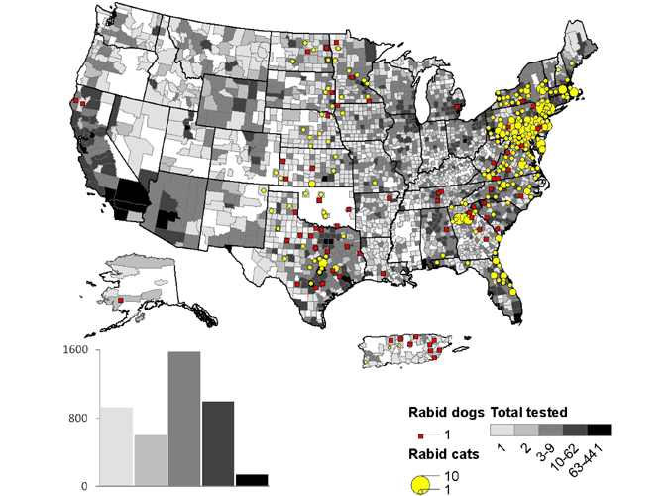
Figure 2. Rabid Cats and Dogs Reported in the United States during 2010. [27]
Histogram represents numbers of counties in each category for total number of cats and dogs submitted for testing. [27]

If a household pet is bitten, the procedure is different. If the animal can be captured, testing will be performed to determine rabies exposure. [31] If the animal cannot be captured, the pet should be considered to be exposed to rabies. [31] At this point, how to proceed is determined by the pet’s vaccination status. [31] If the pet is unvaccinated, it should be euthanized, but many owners are unwilling to do this, so the animal should be quarantined for 6 months for monitoring and should be vaccinated one month before release. [31] If the pet is vaccinated, it only needs to be kept under observation for 45 days. [31]
There are several potential interventions to reduce exposure to free-roaming cats, and thus reduce spending on rabies prevention. One intervention is to reduce the free-roaming cat population, and thus reduce exposure because there are fewer cats to be exposed to and fewer cats that have rabies. One proposed method to reduce the free-roaming cat population are Trap-spay/neuter-return (TNR) programs. TNR programs involve capturing cats, vaccinating and sterilizing the cats, and then returning the cats to their original colony in order to reduce the free-roaming cat population. Euthanasia is another method of reducing the population, but is considered less humane than TNR programs. [32] Alternatively, exposure can be reduced through educational programs targeted at the most exposed populations to avoid petting and feeding free-roaming cats. [33] Many feral cat colonies are cared for by humans [34]; education may prevent the formation of these colonies as well as reduce exposure by having people avoid the colonies.

TNR literature
A difficulty with examining the effectiveness of TNR is that there is only a small amount of scientific literature concerning free-roaming cats and relevant population control measures. There are less than 100 peer reviewed sources available from the University of Pittsburgh library network concerning feral cats and TNR programs (the search was conducted using PittCat for peer reviewed sources containing the key words “feral cat,” “trap”, “neuter and/or sterilize”, “return and/or release”, “population,” and “control”). The existing literature reports conflicting conclusions about the effectiveness of TNR programs, both in terms of success in reducing populations as well as the time frame required for population reduction. The main findings are that TNR programs successfully reduce cat populations [35] with both fast [36] and lasting results, [37] but there is evidence to suggest the TNR programs must be run continually and need to impact a large portion of the cat population. [38]
A study which supports the effectiveness of TNR studies was conducted in Orange County, Florida. [35] A TNR program was implemented at the county level to reduce money and time spent on catching and euthanizing cats. [35] The study found that, compared with impounding and euthanizing cats, TNR programs reduced costs by $655,949 across Orange County over a six year period. [35] Although the number of cats impounded did not change, fewer cats were euthanized, accounting for the reduced costs. [35] The TNR program also resulted in a decrease in complaint calls to the animal control department. Indirect effects of the program were greater support and participation by residents. [35] The reduction of the free-roaming cat population is demonstrated by the reduced number of complaint calls to animal control, but there was no apparent reduction in the amount of work that needed to be done by animal control as they number of cats impounded did not decrease. [35] In Massachusetts, there are no leash laws that require cats to be kept indoors or within the owner’s property, so municipal animal control does not have authority to remove cats. [39] As such, Massachusetts animal control does not typically impound cats, so there would not be any anticipated cost reduction, rather cost would increase for now having to capture and care for the cats for them to be sterilized.
Another study, performed at Texas A&M University, examined the effect of a TNR program on the campus over the course of two years. [36] Cats were trapped and tested for disease. If they tested positive, the cats were euthanized; if they tested negative, the cats were sterilized, vaccinated, and returned to the colony. [36] After the second year, no litters or nursing mothers were found on the campus, suggesting full sterilization of the colony. [36] This study provides an example of TNR programs working to reduce the reproductive capabilities of a cat colony, but it does so also with the help of euthanasia. The short time frame of the study does nothing to show the long term effects of the intervention, and it is likely that if the TNR program is not run consistently, other free-roaming cats will roam into the colony and replenish its reproductive capabilities.
A study conducted at the University of Central Florida provides evidence supporting the effectiveness of TNR programs, but only at a small, targeted level. [37] There were 155 free-roaming cats on the college campus. [37] Cats were trapped, neutered, and then either adopted or returned to the colony. [37] The study found that this methodology reduced the cat population by 66% over 11 years. [37] While this study provides evidence that TNR programs can reduce colony size, it does so in an area where the size and location of the colony are completely known, allowing a specifically targeted intervention, something that is not always plausible. The success of the intervention is limited. It took 11 years to see these results, and only reduced the population by about 100 cats. [37] Part of the difficulty of establishing TNR programs stems from an uncertainty over the number of cats in an area, and while 100 cats may make a difference in a small area, the cost for widespread use of this method may not be justifiable as the number of cats present may be too large for a population reduction of 100 cats to have an impact.
Further evidence for the shortcoming of large scale TNR programs is found in a study which used population modeling techniques in order to statistically assess TNR programs in two Florida counties. [38] The study found that TNR programs would not result in consistent reduction in population growth or the proportion of female cats that were pregnant. [38] The analysis also predicted that TNR programs must sterilize between 71% and 94% of the cat population to stop population growth. [38] In order for this type of intervention to work, TNR programs must be focused on well-defined populations for a targeted approach. This study provides evidence that while TNR can work on defined populations, at the county level it would not produce noticeable results.
In comparison to TNR programs, euthanasia may be a viable alternative. One study used data from the literature to estimate free-roaming cat populations in urban environments. [32] A matrix model was used with varying combinations of survival and fecundity values. [32] All combinations yielded estimates of rapid population growth. [32] Effective population control was seen by euthanizing either 50% of the population or sterilizing 75% of the population. [32] This study suggests that euthanasia is more effective in reducing free-roaming cat populations, and should be considered in place of TNR programs. Fewer cats would need to be captured, which would result in lower costs. The downside to this type of intervention is that mass euthanasia is seen as inhumane and wasteful as it continually produces and kills cats, treating the symptom of cat overpopulation rather than the cause. Such an intervention is not supported by animal rights activists, unlike TNR programs.
Beyond the numbers of cats sterilized and reductions in populations, part of the appeal of TNR programs is the humane benefits for animals. Not only is euthanasia prevented, but reducing the cat population will prevent the suffering of animals from disease as well as inability of the environment to sustain large colony sizes. [40]
The evidence presented above illustrates the mixed views concerning TNR as a means of population control, but there are no studies reporting on the effects of TNR as a means of rabies prevention. Reduction of the free-roaming cat population may reduce rabies exposure, and thus reduce the number of cats tested for rabies.
This essay examines the effectiveness of TNR programs on the county level. It hypothesizes that Massachusetts counties which had free-roaming cat population control interventions between 2005 and 2014 had fewer cats tested for rabies during those years compared to counties which did not have these interventions; reduction of the free-roaming cat population also results in reduced rabies prevention costs during the specified time period.

methods

relation between interventions and number of cats
This essay hypothesizes that Massachusetts counties which had free-roaming cat population control interventions between 2005 and 2014 had fewer cats tested for rabies during those years compared to counties which did not have these interventions or had fewer interventions, suggesting that there are fewer free-roaming cats in these counties. This reduction of the free-roaming cat population and associated costs also results in reduced rabies prevention costs for the respective county and the state during the specified time period.
This hypothesis will be tested by comparing the mean number of cats submitted for rabies testing per year between counties over the ten year time period using an analysis of variance (ANOVA) test. Because each county has at least one type of intervention, a comparison cannot be made between counties with interventions versus counties without any interventions. Instead, the comparison needs to be made based on the number or interventions present, assuming that more interventions will result in smaller free-roaming cat populations and thus fewer animals submitted for rabies testing. The data will be checked to see if they follow a normal distribution; if they do not follow a normal distribution, the results from the ANOVA will be verified using a Kruskal-Wallis test. If the ANOVA test finds that there is a difference between the mean numbers of cats submitted for rabies testing, an analysis of covariance (ANCOVA) test will be used to identify which county or counties differ from the other counties with regards to the numbers of cats submitted for rabies testing per year. The ANOVA and ANCOVA tests are appropriate for this hypothesis because they test are designed to test the differences in mean values between a given number of populations, which is the question the hypothesis addresses; the mean of each county is compared to the mean of the other counties. Type I error is controlled by using an alpha value of 0.05. The ANOVA uses 13 and 126 degrees of freedom. The second stage of the analysis involves determining whether or not there is an association between the numbers of cats submitted for rabies testing per county and the total number of free-roaming cat population interventions present in each county, these two variables will be compared using a Spearman’s correlation test.
The data for the numbers of animals submitted for rabies testing each year was gathered from surveillance data published by the Massachusetts Department of Public Health (MDPH). MDPH releases quarterly and yearly reports on how many animals were submitted for testing, by county, to the state laboratory and how many tested positive for rabies. MDPH collects this data by receiving reports from veterinarians as cases present. Rabies found in animals is a reportable disease in MA, and the reports are required to be sent to the MDPH state laboratory. These reports include all of the reported cases of rabies for each year. For this study, data was taken from a ten year period (2005 to 2014). This period was chosen as it should provide a sufficient amount of time, based on TNR literature, for each free-roaming cat population reduction intervention to produce results. [38]
Two different sources were used to collect data on the number of free-roaming cat population reduction interventions. The Massachusetts Animal Coalition (MAC) has compiled a list of major low cost spay/neuter clinics in Massachusetts. [41] MAC is a statewide nonprofit organization which promotes collaboration between individuals and organizations interested in animal welfare. [42] Many TNR programs are not run through an organization, rather they are run by a group of individuals in a neighborhood or community and make use of resources provided by low cost spay/neuter programs. Because of this, low cost spay/neuter programs can function as a proxy measure of the existence of TNR programs as part of their function is to provide aid to minor TNR programs. Information on the low cost spay/neuter programs was gathered from the respective websites of the veterinary clinics that offer the programs; the websites were examined to see which counties they served and whether or not they had been operational for the ten year period being investigated.
The second source is the Alley Cat Allies Feral Friends Network, which maintains a list of major TNR programs in Massachusetts. Alley Cat Allies is a national organization which advocates for the humane treatment of feral cat and is a strong supporter of TNR programs. [43] Information from these programs’ respective websites were examined to see which counties they served and that they have been active for the ten year time frame being examined. [44]
This data was compiled and examined using SAS 9.3. For the ANOVA and ANCOVA tests, the variable being compared was the mean number of animals submitted for rabies testing per year per 100,000 human population. The mean value for each county was compared to the mean value of each other county. The null hypothesis of the test was that all counties had the same mean number of animals submitted for rabies testing per 100,000 human population. The number of animals submitted for rabies testing per year was converted into a rate in order to account for the effect of county population size on the number of animals submitted for rabies testing. The assumptions for the ANOVA and ANCOVA tests were that each county had a normal population with common variance, each sample was a simple random sample, and the observations are independent of one another. An alpha value of 0.05 was used to assess statistical significance. The ANCOVA test utilized a Bonferroni adjustment to correct p-values for multiple testing.
For the correlation test, the variables being compared were the mean number of animals submitted for rabies testing per year per 100,000 human population per county and the total number of free-roaming cat population reduction interventions present in a county. The normality of the two-variables were assessed and they were both discovered to be non-normal, so a Spearman rank-order correlation test was used. The test was performed using Fisher’s z-transformation (Fisher’s Z of -0.20). The assumptions for the Spearman test were that each sample was a simple random sample, each pair of values was independent, and there is a monotonic relationship between the two variables.

TNR Costs
In order to estimate the costs of TNR programs implemented on a county wide level, the price of a TNR program per colony targeted was determined, as well as the number of colonies to be targeted per county. The costs for implementing a TNR program were estimated using funding estimates from the The Merrimack River Feline Rescue Society (MRFRS). MRFRS provides grants to fund targeted TNR programs throughout Massachusetts. The TNR programs which it funds are targeted at a specific area, likely a single colony, and cost from 5,000 to 8,000 dollars to sterilize 200 cats over a four month period, [45] which totals 15,000 to 24,000 dollars per year. The funding that MRFRS provides includes startup costs for establishing a TNR program, but is mostly aimed at covering surgical expenses; [45] it is reasonable to expect that costs would go down once a large number of cats have been sterilized, as the colonies will have fewer fertile cats to capture, but this would not likely occur for several years, [37, 38] and funding needs to be provided each year or else the cat population will grow, although the required amount of funding may be reduced as the population declines.
Potential costs were calculated by multiplying the cost of the intervention by the number of interventions required to yield results. Based on the relevant literature, for TNR to be effective, 71% to 94% of the free-roaming cat population need to be sterilized [39], so most, if not all, colonies that have human contact in the county would need to be targeted with an intervention. In order to determine the cost-benefit of TNR programs, the cost of the TNR program would be added to the cost of normal rabies prevention programs. Normal costs for TNR programs include traps, bait, vaccines, sterilization surgery, and wages for those conducting the programs. If the TNR programs help lower the number of cats being tested, there should be some reduction in the normal prevention costs. TNR program costs were estimated by finding the amount of money allotted by various grants, such as the MRFRS grant, to implement a TNR program. These TNR program costs were compared to potential savings provided by reduction of the free-roaming cat population; free-roaming cats can induce costs through capture, testing for rabies, and use of PEP. As no data was directly analyzed to obtain results, costs for interventions will be discussed in the discussion section.

Results
The mean rates of animals tested per county are shown in table 3. The rate ranges from 21 animals submitted per 100,000 population to 103 animals submitted per 100,000 population, with the majority falling in the 30-40 range. Figure 3 compares the number of animals submitted for rabies testing per county over time; the majority of counties have similar levels of animals being submitted for testing, between 30 and 60 animals per year, with the exception of Barnstable County, which has a much larger amount of animals submitted (over 100 submitted before 2009 when it begins to match the other counties). These rates were then used in the ANOVA analysis. There was a significant difference in the mean number of cats submitted for rabies testing among counties (p<0.0001), providing the evidence to reject the null hypothesis of each county having the same number of animals submitted for rabies testing. The number of animals submitted for rabies testing does not follow a normal distribution. The Kruskal-Wallis test matches the results obtained from the ANOVA test (p<0.0001). To determine which counties differed from other counties with regards to the mean number of animals submitted for rabies testing, ANCOVA multiple comparisons tests were performed, the results of which are shown in table 4 with the relevant p-values. The number of animals submitted were similar for the majority of counties (p>0.05). The biggest distinction is with Barnstable County, only having a similar number of animals submitted as Franklin County (p=0.9734). Franklin County differed from all counties (p<0.05) besides Barnstable (p=0.9734), Essex (p=0.0846), Norfolk (p=1.0000), Plymouth (p=0.3220), and Worcester (p=0.2093). All other counties were considered as having the same number of animals submitted for rabies testing (p>0.05).
Table 3. Mean Rates of Rabies Testing per County.
County | Animals Submitted per 100,000 population | Lower Confidence Interval | Upper Confidence Interval
Barnstable | 103 | 44 | 162
Berkshire | 50 | 45 | 56
Bristol | 36 | 32 | 41
Dukes | 39 | 27 | 50
Essex | 41 | 38 | 43
Franklin | 76 | 68 | 85
Hampden | 30 | 26 | 34
Hampshire | 39 | 35 | 42
Middlesex | 36 | 33 | 38
Nantucket | 21 | 10 | 31
Norfolk | 51 | 49 | 54
Plymouth | 45 | 43 | 48
Suffolk | 36 | 34 | 39
Worcester | 44 | 41 | 46
Total | 46 | 41 | 51

Rate is the number of animals submitted for rabies testing per 100,000 human population. The mean is taken from the data from 2005 to 2014 and the upper and lower confidence intervals are shown.
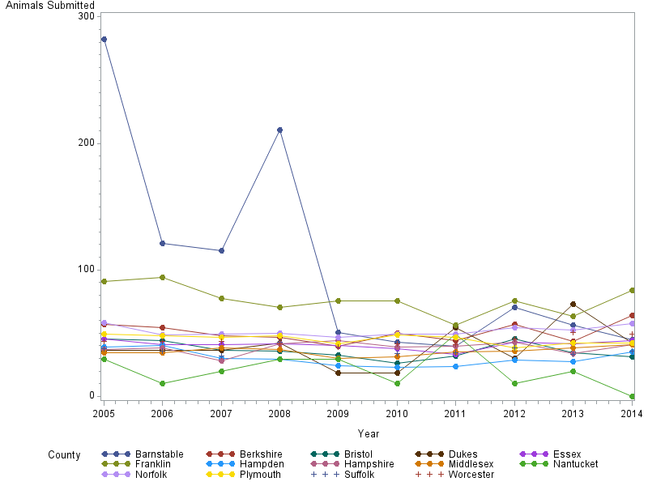

Figure 3. Animals Submitted for Rabies Testing by County.
The number of animals submitted for rabies testing from 2005 to 2014, categorized by county.

Table 4. ANCOVA Multiple Comaprisons: p-values.
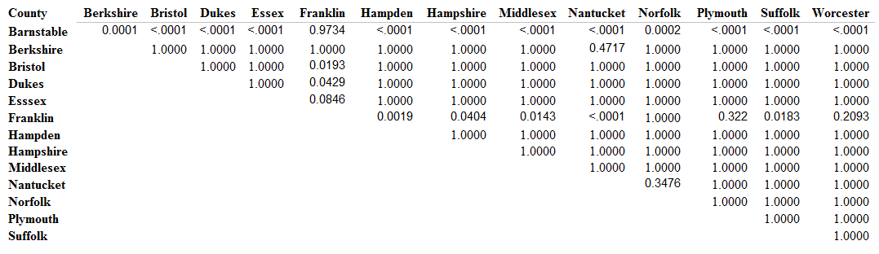
Comparison of mean number of animals submitted for rabies testing for each county with every other county; p-value to determine statistical significance is shown.

Using Spearman’s rank-order correlation, there does appear to be a statistically significant inverse association between the number of interventions in a county and the number of animals submitted for rabies testing. The correlation coefficient is -0.20 with a 95% confidence interval of (-0.36, -0.04). The results of the correlation test are shown in Table 5. This indicates that counties with more free-roaming cat population reduction interventions have fewer animals submitted for rabies testing. Barnstable County appears to have a major impact on the correlation, so the correlation test was conducted a second time without Barnstable County present. The results are listed in table 6. Without Barnstable County present the magnitude of the correlation decreased to -0.19 with a p5% confidence interval of (-0.35, -0.01). The correlation maintained its statistical significance (p=0.03). The numbers of interventions per county are listed in table 7. Each intervention was present for the duration of the period being examined. Suffolk County has the greatest number of interventions, with a total of 16, followed closely by Middlesex County with 15 interventions. Most counties fall in the range of 8 to 12 interventions. Berkshire County has the fewest number of interventions with only 3 being present.
Table 5. Spearman Correlation Statistics (Fisher’s z Transformation).
Variable | With Variable | N | Sample Correlation | Fisher's z | Bias Adjustment | Correlation Estimate | 95% Confidence Limits |  | p Value for  H0:Rho=0
adjsub | interv | 140 | -0.20273 | -0.20558 | -0.0007292 | -0.20203 | -0.356002 | -0.037381 | 0.0161

Correlation between number of animals submitted for rabies testing and number of free-roaming cat population control interventions.

Table 6. Spearman Correlation Statistics (Fisher’s z Transformation) without Barnstable County.
Spearman Correlation Statistics (Fisher's z Transformation)
Variable | With Variable | N | Sample Correlation | Fisher's z | Bias Adjustment | Correlation Estimate | 95% Confidence Limits |  | p Value for  H0:Rho=0
adjsub | interv | 130 | -0.18675 | -0.18897 | -0.0007238 | -0.18605 | -0.347119 | -0.014326 | 0.0332

Correlation between number of animals submitted for rabies testing and number of free-roaming cat population control interventions excluding the data for Barnstable County.

Table 7. Distribution of TNR and Low Cost Spay/Neuter across Massachusetts.
County | TNR Programs | Low Cost Spay/Neuter
Barnstable | 0 | 8
Berkshire | 1 | 2
Bristol | 1 | 8
Dukes | 0 | 8
Essex | 1 | 11
Franklin | 0 | 6
Hampden | 1 | 6
Hampshire | 1 | 6
Middlesex | 4 | 11
Nantucket | 0 | 8
Norfolk | 2 | 8
Plymouth | 0 | 12
Suffolk | 4 | 12
Worcester | 1 | 9
Table 7 Continued
Number of free-roaming cat population control interventions, organized by type and county.
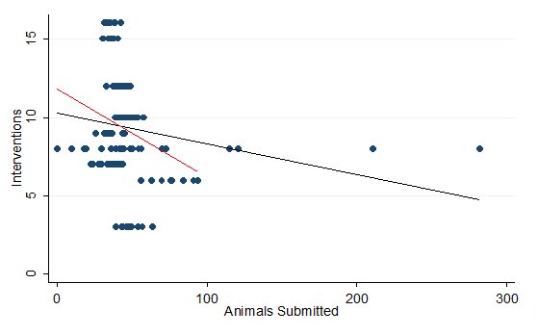
Figure 4. Correlation Between Interventions and Number of Animals Tested.
Best fit lines between free-roaming cat population control interventions and number of animals submitted for rabies testing, with the correlation coefficient -0.20 corresponding with the black line. We also determined the correlation coefficient without Barnstable County included, -0.19, corresponding with the red line.

discussion
Based on this analysis and a review of literature concerning TNR programs, free-roaming cat population reduction interventions do not appear to be effective on the necessary scale to make adoption of them as a rabies prevention method viable. While rabies prevention is expensive, government adoption of interventions would only increase spending. TNR programs are popular among animal advocates because of their humane nature, and they can be effective as a small scale, targeted intervention. Privately funded or volunteer interventions should be encouraged because of benefits not associated with rabies prevention, such as reduction in the suffering of cats and the disruption that a large free-roaming cat colony can cause in the community and environment, but these interventions are not suitable as a rabies prevention measure.
The county of Plymouth, where my internship took place, has a relatively large number of free-roaming cat population reduction interventions (12 interventions) compared with the other counties, but still falls in the upper range of animals submitted for rabies testing (45 animals per 100,000 population). The number of cats being tested for rabies in Massachusetts has been decreasing over the past ten years, which is consistent with the timeline of population reduction presented in TNR literature. [38] This suggests, along with the analysis performed, that the free-roaming cat population reduction interventions are in fact reducing the number of animals being submitted for rabies testing.
There are several limitations of the above analysis, namely that the analysis was unable to take into account the size of the low cost spay/neuter programs or TNR programs. This is due to a lack of data available about the programs. Smaller programs may not have a noticeable impact on the number of animals reported for rabies testing, but still influence the analysis by appearing as a data point. As a result, the correlation between animals submitted for testing and number of interventions may appear less significant.
The means compared in the ANOVA and ANCOVA tests may not be indicative of the trends present over time regarding animals submitted for rabies testing. This was accounted for by using a correlation analysis to assess whether or not number of interventions was related to the number of animals submitted for rabies testing, as this analysis takes into account all data points, not just the means.
County population density may also have functioned as a confounder. Counties with smaller populations will naturally have less exposure to free-roaming cats because there are fewer people to be exposed. While rates allow for comparison across counties with greatly differing population sizes, population size and density (of both humans and cats) may still have affected the number of animals submitted for rabies testing. Barnstable County had the highest number of animals submitted for rabies testing, but is on the lower end of population density (165.4 people per square mile). [46] This suggests that human population density do not have much of an effect, but there is no data available on cat population density.
The number of animals that were submitted for rabies testing could have been affected by an unusually large amount of a different type of animal other than cat in a particular county. This would limit the effect that cat targeted interventions would have on the number of animals submitted for rabies testing, but ultimately is not a major concern to the study, as it would still contribute to determining whether or not free-roaming cat population reduction interventions are suitable for reducing the number of animals submitted for rabies testing.
The true cost of TNR programs is difficult to estimate as it is difficult to determine how many free-roaming cats are in a colony, which is an indicator of how much money will need to be invested into a TNR program. There may be significantly more cats than expected, which would require further spending on population control than anticipated, making prediction of costs imprecise. The estimates used in this essay were intended to reflect a lower cost, but the true cost may be higher or lower depending on how many cats are in a given county, which there is no reliable data on.
In order to establish enough TNR programs to make a difference in the county, all major free-roaming cat colonies would need to be targeted. Massachusetts counties have a median of 24 cities/towns. Assuming just one major colony per city, and using the lower estimate of TNR costs, it would cost $360,000 per county for one year of running a TNR program. There is evidence to suggest that presence of free-roaming cat population reduction interventions lower the number of animals tested for rabies, but, while statistically significant, the decrease in animals tested is small in magnitude and does not appear to occur for all counties. In counties where there is no reduction in the number of animals tested, no cost savings can be expected, so the presence of free-roaming cat population reduction interventions would only increase costs.
Another limitation of the study is that the costs were unable to account for the value people place on the humane treatment of animals. While TNR programs may not be beneficial for rabies prevention, they do still serve as a humane method of reducing the free-roaming cat population. The value of humane treatment could potentially be assessed through a survey asking about the importance of cost savings compared with humane treatment of animals.
Next steps for assessing the impact of free-roaming cats on rabies prevention would be to examine the costs and effectiveness associated with euthanasia of free-roaming cats or implementation of an educational program. TNR programs may be a humane alternative, but there is evidence to suggest that euthanasia may be more cost effective; however, euthanasia is not a preferred public health method as it does not target the cause of the cat populations (fertile cats), but rather focuses on the symptoms of the problem. It is difficult to find data on euthanasia as a prevention method, because it is often considered to not be humane. Many of the animal shelters in Massachusetts are operated as “no kill” shelters, and seek to adopt cats rather than have them euthanized. An education campaign could be used to teach the public to avoid free-roaming cats, spay and neuter their pets to decrease the free-roaming population, and even participate in a TNR program. Free-roaming cat colonies frequently form where there is a colony caretaker; educating caretakers about risks associated with free-roaming cats may prevent establishment of colonies near places of human activity, potentially reducing rabies exposure.
Rabies is a major threat to public health because of the severity of the disease and the high costs associated with prevention. Assessing the potential contribution of free-roaming cat population reduction interventions on rabies testing and costs is beneficial for public health because it examines potential ways to reduce exposure to a lethal disease and possibly reduce money spent on prevention measures, which could make resources available for other public health needs.

Conclusion
Free-roaming cat population control interventions are inversely associated with the number of animals submitted for rabies testing in Massachusetts counties. This indicates that TNR programs are effective for reducing free-roaming cat populations, but the magnitude of the testing reduction, while statistically significant, is still small.
BIBLIOGRAPHY

1) "Cost of Rabies Prevention." Centers for Disease Control and Prevention. April 22, 2011. Accessed November 25, 2014. http://www.cdc.gov/rabies/location/usa/cost.html.

2) "Rabies." WHO. September 1, 2014. Accessed November 25, 2014. http://www.who.int/mediacentre/factsheets/fs099/en/.

3) "Rabies in the U.S." Centers for Disease Control and Prevention. April 22, 2011. Accessed November 25, 2014. http://www.cdc.gov/rabies/location/usa/index.html.

4) "Human Rabies." Centers for Disease Control and Prevention. May 3, 2012. Accessed November 25, 2014. http://www.cdc.gov/rabies/location/usa/surveillance/human_rabies.html.

5) “Human Rabies Surveillance.” Centers for Disease Control and Prevention. May 3, 2012. Accessed 30 March, 2015. http://www.cdc.gov/rabies/location/usa/surveillance/human_rabies.html.

6) “2005 Rabies Summary.” Massachusetts Department of Public Health. 2006. Accessed 19 April, 2015. http://www.mass.gov/eohhs/gov/departments/dph/programs/id/epidemiology/researchers/
public-health-cdc-rabies-surveillance.html.

7) “2006 Rabies Summary.” Massachusetts Department of Public Health. 2007. Accessed 19 April, 2015. http://www.mass.gov/eohhs/gov/departments/dph/programs/id/epidemiology/researchers/
public-health-cdc-rabies-surveillance.html.

8) “2007 Rabies Summary.” Massachusetts Department of Public Health. 2008. Accessed 19 April, 2015. http://www.mass.gov/eohhs/gov/departments/dph/programs/id/epidemiology/researchers/
public-health-cdc-rabies-surveillance.html.

9) “2008 Rabies Summary.” Massachusetts Department of Public Health. 2009. Accessed 19 April, 2015. http://www.mass.gov/eohhs/gov/departments/dph/programs/id/epidemiology/researchers/
public-health-cdc-rabies-surveillance.html.

10) “2009 Rabies Summary.” Massachusetts Department of Public Health. 2010. Accessed 19 April, 2015. http://www.mass.gov/eohhs/gov/departments/dph/programs/id/epidemiology/researchers/
public-health-cdc-rabies-surveillance.html.

11) “2010 Rabies Summary.” Massachusetts Department of Public Health. 2011. Accessed 19 April, 2015. http://www.mass.gov/eohhs/gov/departments/dph/programs/id/epidemiology/researchers/
public-health-cdc-rabies-surveillance.html.

12) “2011 Rabies Summary.” Massachusetts Department of Public Health. 2012. Accessed 19 April, 2015. http://www.mass.gov/eohhs/gov/departments/dph/programs/id/epidemiology/researchers/
public-health-cdc-rabies-surveillance.html.

13) “2012 Rabies Summary.” Massachusetts Department of Public Health. 2013. Accessed 19 April, 2015. http://www.mass.gov/eohhs/gov/departments/dph/programs/id/epidemiology/researchers/
public-health-cdc-rabies-surveillance.html.

14) “2013 Rabies Summary.” Massachusetts Department of Public Health. 2014. Accessed 19 April, 2015. http://www.mass.gov/eohhs/gov/departments/dph/programs/id/epidemiology/researchers/
public-health-cdc-rabies-surveillance.html.

15) “2014 Rabies Summary.” Massachusetts Department of Public Health. 2015. Accessed 19 April, 2015. http://www.mass.gov/eohhs/gov/departments/dph/programs/id/epidemiology/researchers/
public-health-cdc-rabies-surveillance.html.

16) “December 2009 Rabies Monthly Report.” New Hampshire Division of Public Health Services. 2010. Accessed 19 April 2015. http://www.dhhs.nh.gov/dphs/cdcs/rabies/publications.htm.

17) “December 2010 Rabies Monthly Report.” New Hampshire Division of Public Health Services. 2011. Accessed 19 April 2015. http://www.dhhs.nh.gov/dphs/cdcs/rabies/publications.htm.

18) “December 2011 Rabies Monthly Report.” New Hampshire Division of Public Health Services. 2012. Accessed 19 April 2015. http://www.dhhs.nh.gov/dphs/cdcs/rabies/publications.htm.

19) “December 2012 Rabies Monthly Report.” New Hampshire Division of Public Health Services. 2013. Accessed 19 April 2015. http://www.dhhs.nh.gov/dphs/cdcs/rabies/publications.htm.

20) “December 2013 Rabies Monthly Report.” New Hampshire Division of Public Health Services. 2014. Accessed 19 April 2015. http://www.dhhs.nh.gov/dphs/cdcs/rabies/publications.htm.

21) “2009 Rabies Annual Report.” New York Department of Health. 2010. Accessed 19 April 2015. http://www.wadsworth.org/rabies/annualsum.htm.

22) “2010 Rabies Annual Report.” New York Department of Health. 2011. Accessed 19 April 2015. http://www.wadsworth.org/rabies/annualsum.htm.

23) “2011 Rabies Annual Report.” New York Department of Health. 2012. Accessed 19 April 2015. http://www.wadsworth.org/rabies/annualsum.htm.

24) “2012 Rabies Annual Report.” New York Department of Health. 2013. Accessed 19 April 2015. http://www.wadsworth.org/rabies/annualsum.htm.

25) “2013 Rabies Annual Report.” New York Department of Health. 2014. Accessed 19 April 2015. http://www.wadsworth.org/rabies/annualsum.htm.

26) “Wildlife and Rabies.” Alley Cat Allies. 2015. Accessed 30 March 2015. http://www.alleycat.org/page.aspx?pid=691.

27) "Rabid Cats and Dogs Reported in the United States during 2010." Centers for Disease Control and Prevention. November 10, 2011. Accessed November 25, 2014. http://www.cdc.gov/rabies/resources/publications/2010-surveillance/cats-and-dogs.html.

28) “Feral and Stray Cats—An Important Difference.” Alley Cat Allies. 2015. Accessed May 5, 2015. http://www.alleycat.org/StrayorFeral.

29) "Domestic Animals." Centers for Disease Control and Prevention. November 15, 2011. Accessed November 25, 2014. http://www.cdc.gov/rabies/exposure/animals/domestic.html.

- “Pet Care: Rabies.” American Society for the Protection and Care of Animals. 2015. Accessed 30 March, 2015. https://www.aspca.org/pet-care/cat-care/rabies.

31) "What Is the Risk for My Pet?" Centers for Disease Control and Prevention. April 22, 2011. Accessed November 25, 2014. http://www.cdc.gov/rabies/pets/.

32) Andersen, Mark C., Brent J. Martin, and Gary W. Roemer. "Use Of Matrix Population Models To Estimate The Efficacy Of Euthanasia Versus Trap-neuter-return For Management Of Free-roaming Cats." Journal of the American Veterinary Medical Association 225, no. 12 (2004): 1871-876.

33) "Campaign for Cats: Reducing the Number of Homeless Casts in Massacchusetts." MSPCA-Angell. Accessed November 25, 2014. http://www.mspca.org/programs/cat-campaign/.

34) Centonze, Lisa A., and Julie K. Levy. "Characteristics of Free-roaming Cats and Their Caretakers." Journal of the American Veterinary Medical Association 220, no. 11 (2002): 1627-633.

35) Hughes, Kathy L., Margaret R. Slater, and Linda Haller. "The Effects Of Implementing A Feral Cat Spay/Neuter Program In A Florida County Animal Control Service." Journal of Applied Animal Welfare Science 5, no. 4 (2002): 285-98.

36) Hughes, Kathy L., and Margaret R. Slater. "Implementation of a Feral Cat Management Program on a University Campus." Journal of Applied Animal Welfare Science 5, no. 1 (2002): 15-28.

37) Levy, Julie K., David W. Gale, and Leslie A. Gale. "Evaluation of the Effect of a Long-term Trap-neuter-return and Adoption Program on a Free-roaming Cat Population." Journal of the American Veterinary Medical Association 222, no. 1 (2003): 42-46.

38) Foley, Patrick, Janet E. Foley, Julie K. Levy, and Terry Paik. "Analysis of the Impact of Trap-neuter-return Programs on Populations of Feral Cats." Journal of the American Veterinary Medical Association 227, no. 11 (2005): 1775-781.

39) "Cat Campaign: Feral Cats." MSPCA-Angell. Accessed November 25, 2014. http://www.mspca.org/programs/cat-campaign/feral-cats.html.

40) Nutter, Felicia B., Jay F. Levine, and Michael K. Stoskopf. "Reproductive Capacity Of Free-roaming Domestic Cats And Kitten Survival Rate." Journal of the American Veterinary Medical Association 225, no. 9 (2004): 1399-402.

41) "Low Cost Spay/Neuter Services." Massachusetts Animal Coalition. 2015. Accessed November 25, 2014. http://massanimalcoalition.com/resources/spay-neuter/.

42) “About Us.” Massachusetts Animal Coalition. 2015. Accessed 19 April, 2015. http://massanimalcoalition.com/about/.

43) “About Us.” Alley Cat Allies. 2015. Accessed 19 April 2015. http://www.alleycat.org/page.aspx?pid=616.

44) "Alley Cat Allies' Feral Friends Network." Alley Cat Allies. 2015. Accessed November 25, 2014. http://www.alleycat.org/feralfriends.

45) "MRFRS Mentoring Program." Merrimack River Feline Rescue Society. Accessed November 25, 2014. http://mrfrs.org/mrfrs-mentoring-program-for-free-roaming-cats/.

46) “Massachusetts Population Density County Rank.” World Media Group, LLC. 2015. Accessed May 4, 2015. http://www.usa.com/rank/massachusetts-state--population-density--county-rank.htm.

