TELEMEDICINE IN THE ICU: REDUCTION IN MORTALITY, COST, AND AVERAGE
LENGTH OF STAY

by
Marques Bernard Moore
BS in Health Information Management, University of Pittsburgh, 2011

Submitted to the Graduate Faculty of
Health Policy and Management
Graduate School of Public Health in partial fulfillment
of the requirements for the degree of
Master of Health Administration

University of Pittsburgh
2015

UNIVERSITY OF PITTSBURGH
GRADUATE SCHOOL OF PUBLIC HEALTH

This essay is submitted
by
Marques B. Moore

on

April 20th, 2015
and approved by

Essay Advisor:
Nicholas Castle, PhD, MHA ______________________________________
Professor
Department of Health Policy and Management
Graduate School of Public Health
University of Pittsburgh

Essay Reader:
Valerie J. Watzlaf, PhD, MS ______________________________________
Associate Professor
Health Information Management
School of Health and Rehabilitative Sciences
University of Pittsburgh

Copyright © by Marques B. Moore
2015
ABSTRACT
Nicholas Castle, PhD, MHA
TELEMEDICINE IN THE ICU: REDUCTION IN MORTALITY, COST, AND AVERAGE LENGTH OF STAY
Marques B. Moore, MHA
University of Pittsburgh, 2015

Legislation such as the Affordable Care Act has changed the national perspective on the healthcare industry. In today’s society we see a heavier emphasis on the use and need for the integration of technology in business practices. Efficiency is driven by technology. Technology has driven the streamlining of processes and encouraged organizations to apply innovative solutions in order to improve the organizations operations. In healthcare we have seen the implementation of surgical robots, electronic medical record systems, pharmaceutical solutions that alert physicians of medication interactions and track dispenses and a host of other technology solutions. A new developing solution that is continuing to gain traction and acceptance throughout the industry is telemedicine and telehealth.
Telemedicine and telehealth are crucial new services that are needed. They are significant to the field of public health because the use of these remote clinical services increases the access to and quality of care for all people. Also, it is extremely relevant as the use of the tele-services, improve health outcomes which will lead to a positive qualitative and economic positioning for the country.

TABLE OF CONTENTS
preface viii
1.0 Introduction 1
1.1 What is telemedicine/telehealth 2
1.2 history of telemedicine 3
1.3 Quality and Cost 5
1.4 Telemedicine Infrastructure 7
1.4.1 Infrastructure Needs 7
1.4.2 Types of Services Available 8
1.5 the need for healthcare technology innovation 9
2.0 Why the ICU 11
2.1 Case Study 1 13
2.2 Case Study 2 14
2.3 Case Study 3 16
2.4 Future of telemedicine 17
2.5 Conclusion 17
APPENDIX: Tables 19
bibliography 21
List of tables

Table 1. Infrastructure Component 20
Table 2. Types of Telemedicine Services 21
List of figures

Figure 1. Overall Ranking 6
preface

I would like to acknowledge the University Of Pittsburgh Graduate School Of Public Health and the Department of Health Policy and Management and all who helped make this accomplishment possible.

Introduction
In a world where change is the only constant, it is imperative that healthcare organizations and leadership strategically position themselves at the forefront of this change. Over the past 5 years we have seen a drastic change in the landscape of the healthcare industry. A world that was once fee-for service, is transforming to a world based on the quality and value of care. Health insurance was previously not guaranteed for all citizens, and currently it is available for all Americans. Legislation such as the Affordable Care Act has changed the national perspective on the healthcare industry. In today’s society we see a heavier emphasis on the use and need for the integration of technology in business practices. We are accustomed to having information at our finger tips and access to that information within a few clicks of a button. Efficiency is now heavily driven by technology. Technology has motivated the streamlining of processes and encouraged organizations to apply innovative solutions in order to improve the organizations operations.
Organizations in all industries have employed consultants and technology companies to overhaul their business processes. In healthcare we have seen the implementation of surgical robots, electronic medical record systems, pharmaceutical solutions that alert physicians of medication interactions and track dispenses and a host of other technology solutions. (Yoo, Dudley) A new developing solution that is continuing to gain traction and acceptance throughout the industry is telemedicine and telehealth. Throughout this paper I will discuss the impacts, cost and benefits and future state of this technology solution.

What is telemedicine/telehealth
“Defined broadly, telemedicine is the use of electronic information and communications technologies to provide and support health care when distance separates the participants. The term is also applied more narrowly to medical applications that use interactive video, typically for specialty or subspecialty physician consultations. Sometimes the term telehealth is used to encompass educational, research, and administrative uses as well as clinical applications that involve nurses, psychologists, administrators, and other non-physicians.” (Marilyn J. Field, PhD Jim Grigsby, PhD, “Telemedicine and Remote Patient Monitoring”) This broad definition shows that there is a large service area that can be affected by the implementation of telemedicine or telehealth services and service lines. Looking more granularly, HRSA defines telehealth as, “the use of electronic information and telecommunications technologies to support long-distance clinical health care, patient and professional health-related education, public health and health administration.” (HRSA) This description more clearly defines what telemedicine is and describes its application, as well as, interaction in the sphere of health care.
This new form of medical medium showcases the innovative ability of new health technology to fill a need or void in the continuum of care. Previously, geographic barriers may have made it difficult for individuals in remote or underserved areas to receive specialized care. The development of telemedicine applications has led to the development of a new frontier in healthcare access or accessibility for the modern day healthcare consumer. (Teresa Welsh "Telemedicine") For example, “One of the most common applications is in the intensive care unit (ICU), where ICU telemedicine (tele-ICU) can be used to increase access to intensivist physicians. In this care model, intensivist physicians and nurses, located in a central monitoring facility, are able to visually monitor patients across multiple ICUs in many hospitals using bedside cameras while also electronically tracking relevant clinical information, such as vital signs or laboratory data. The remote care team is then able to communicate orally with bedside caregivers to provide real-time, around-the-clock patient care.” (Erika Yoo, R.A. Dudley "Evaluating Telemedicine in the ICU") These possibilities, created by new technological outlets, allow for better monitoring of health conditions and the opportunity for individuals and healthcare constituents to benefit from advanced care methodologies.

history of telemedicine
“The practice of medicine through telecommunications, or telemedicine, began in the early 1960’s when the National Aeronautics and Space Administration (NASA) first put men in space. Physiological measurements of the astronauts were telemetered from both the spacecraft and the space suits during NASA space flights. These early efforts were enhanced by the development of satellite technology which fostered the development of telemedicine.” (Teresa Welsh "Telemedicine") Thus, by utilizing some of the brightest minds in the space program, NASA was one of the pioneering organizations in the development of telemedicine. In order to effectively measure the medical and physiological states of the astronauts on the missions, a primitive form of telemedicine was developed. (Cipolat Geiges, “1.2 The History of Telemedicine") Although this was a more simplistic version of telemedicine than is used today, it was effective in monitoring the health status of astronauts. It has been reported that NASA had approximately fifteen active telemedicine projects throughout the 1960s and 1970s. (Teresa Welsh "Telemedicine")
The improved functionality of television and radio allowed for innovative application of these devices. Organizations began to utilize this to conduct evaluation and consults. The use of closed circuit televisions and two-way audio allowed for remote consultation. (Teresa Welsh "Telemedicine")
Telemedicine will effectively be able to serve rural communities who may lack the adequate access needed to receive top quality care. (K M Zundel) According to an article by Broadband Expanded from January 2013, “20% of the U.S. population resides in rural locations, chronic illnesses and poor overall health rates are higher in rural areas than in urban locations. In general, relative to the overall population, rural residents are older, have lower incomes, have fewer physicians available to care for them, and have fewer employer-provided health insurance options.” (“Broadband & Telemedicine”, 1) Increasing the access for these individuals is crucial to improving the overall national perspective on quality of care. Furthermore, “As of 2011, about a third of rural patient hospitalizations take place in urban hospitals. Moreover, patients from rural areas reported that that they are forced to travel, on average, 60 miles to visit a specialty care physician.” (“Broadband & Telemedicine”, 4) With glaring reports and statistics such as these, the need is clearly evident and blatantly present for the implementation of telemedicine services. Through telemedicine, rural residents will be able to receive care that otherwise would be deprived to them, or would require lengthy travel which may not be possible to severity of illness, or socioeconomic factors. (“Broadband & Telemedicine”) Rural healthcare organizations will not be the only areas to benefit from the implementation of telemedicine. ICU’s, specialty clinics, academic medical facilities and other types of healthcare delivery facilities will also gain benefits through opportunities to have patients remotely monitored, or the ability to conduct remote examinations and consultations with top specialists in their field of practice.

Quality and Cost
In an era where healthcare spending is consuming 18% of the Gross Domestic Product, the need to decrease spending is becoming ever more prevalent. One way to decrease spending is through quality improvement. Quality in healthcare is defined as providing the “right care to the right patient at the right time – every time.” (Carolyn Clancy "What Is Health Care Quality and Who Decides?") To accomplish this endeavor, healthcare organizations have placed a large focus on continuous quality improvement and total quality management. Through these avenues, organizations are able to ensure that the most appropriate level of care is provided to all of its patients. In order to consistently and adequately capture quality status for organizations, certain metrics or quality measures are utilized by accrediting or reviewing bodies. Organizations such as CMS analyze health outcomes, clinical processes, patient safety efficient use of resources (costs), population or public health, and other metrics to determine level of quality efficiency. (Carolyn Clancy "What Is Health Care Quality and Who Decides?")
When looking at telemedicine in the ICU, some of the important metrics that are being analyzed to determine the effectiveness of the service line are Average Length of Stay (ALOS), Mortality and Cost Effectiveness. Healthcare organizations that implement telemedicine into their ICUs are utilizing these outcomes to determine the success and effectiveness in the facilities. (Advanced ICU Care) By decreasing these outcomes, it stands to reason that healthcare organizations will be able to do their part in decreasing the healthcare spending crisis. The figure below published by the OECD depicts how the United States ranks globally in healthcare quality and cost. (Gerard Anderson, Bianca Frogner "Health Spending in OECD Countries")

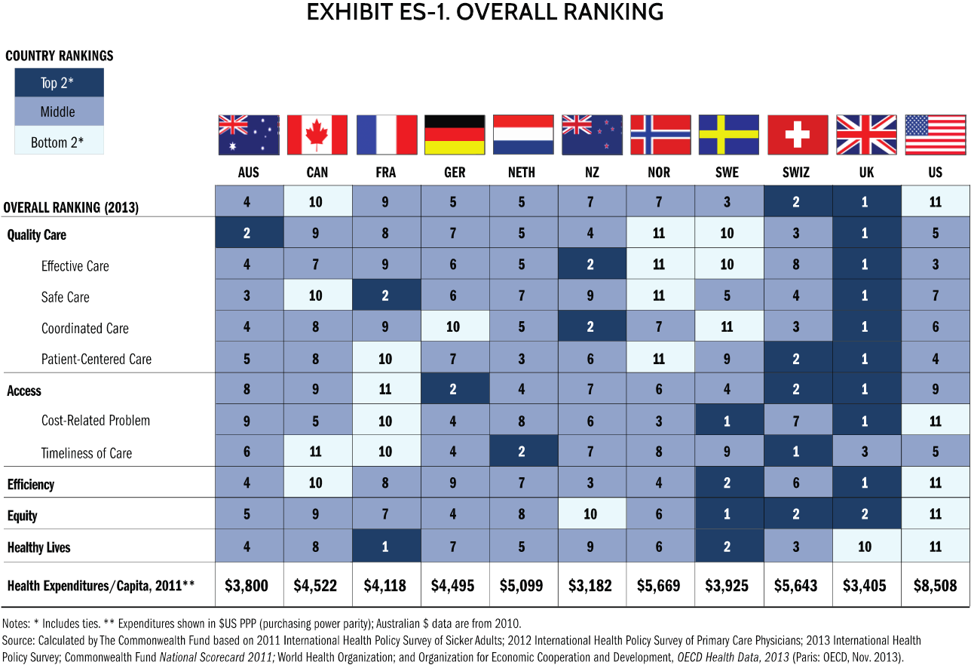
(Commonwealthfund, “Mirror Mirror”)
Figure 1. Overall Ranking

From the figure above, we see that it imperative that innovative solutions are utilized to change our global position. To be one of the most powerful nations if not the most powerful and innovative nations, and yet one of the worst in quality and spending is not acceptable. Innovative solutions such as telemedicine boast a host of benefits that could assist in the overall goal of improving our global footprint.

Telemedicine Infrastructure

Infrastructure Needs
In order to ensure high quality of care and accessibility for clinicians, it is imperative that a certain level of technical infrastructure is implemented. The requirements themselves will vary
depending on the needs of the organizations and health facilities, as well as the type of services that will be offered. Basic requirements consist of technical components such as type of internet access, imaging technology and peripherals, access to tech support and training. A table of infrastructure components can be found in the Appendix.
It is important to understand that to ensure the technical success of the telemedicine service, that the technical aspects of the system fit the technical needs of your organization. For example, the higher the bandwidth utilized, the higher the amount of data that can be transmitted resulting in a higher quality image, or clearer communication. (KUCTT) The Kansas University Center for Telemedicine and Telehealth uses a H.323 Internet protocol with a minimum 1Mbps of bandwidth to ensure HD videoconferencing. (KUCTT) It is necessary to work closely with your telemedicine or telehealth vendor or IT department to accurately establish and operate the technical side of the service. (KUCTT) The size of the organization will determine bandwidth, types of monitors, peripherals and amount of support needed to successfully maintain the service.

Types of Services Available
Types of equipment will also vary based upon the type of service line being implemented. A comprehensive list of tele-service lines that can be implemented can be found in Appendix A. Each service line will vary with the implementation procedure, reimbursement and technical configuration.

the need for healthcare technology innovation
As it has been noted, the usefulness and benefits of Telemedicine were evident years before legislation such as the HITECH Act was implemented. The HITECH Act, which stands for the Health Information Technology for Economic and Clinical Health, was enacted in 2009 with the purpose of improving quality of care, safety, and efficiency, by the utilization and promotion of health information technology. (Health IT.gov, “Infrastructure”) The passage of this legislation, however, has reinforced the need for the implementation of innovative healthcare IT solutions that can and will improve access to care, quality and efficiency. Improving these three areas of care will benefit all healthcare consumers. Looking specifically at telemedicine we see that these three areas of healthcare are directly affected. Telemedicine creates access for rural healthcare consumers. (K M Zundel) Patients are able to receive specialized care remotely instead of traveling long distances to obtain that care which can ultimately lead to an improvement in quality of life. The specialized care in itself leads to improvement of quality. Looking at efficiency, we see patients that are able to be quickly evaluated by physicians with more experience in complex cases. For example, stroke patients may be diagnosed and treated more quickly due to clinical staff being able to reach out to specialists hundreds or thousands of miles away. (Health IT.gov, “Infrastructure”)
The HITECH Act has created the Rural Health Information Technology Task Force which was initiated by the Department of Health and Human Services and specifically the ONC or Office of the National Coordinator and HRSA or the Health Resources and Services Administration. (Health IT.gov, “Rural”) These governmental agencies worked together in conjunction with the U.S. Department of Agriculture to guarantee that rural healthcare organizations and providers would be able to acquire the appropriate technological infrastructure to handle the implementation of Telemedicine, EMR Platforms and other technology needs to facilitate clinical innovation through technology. (Health IT.gov, “Rural”) To ensure the success of these initiatives, the government created financial opportunities so that rural facilities would have access to capital to fund the development of these programs. For telemedicine, governmental agencies developed a “Distance Learning and Telemedicine Grant Program,” which provides grants to deliver telemedicine services and infrastructure to rural communities. (Health IT.gov, “Rural”)
The grant funds require that all eligible entities must contribute a 15% match minimum to the funds in which they receive. Eligible entities include; Non-profit organizations, For-profit businesses, Consortia of eligible entities, state and local government entities as well as federally recognized tribes. The funds that these entities receive must be delegated to the purchase of capital assets. (USDA "Distance Learning and Telemedicine Grants") Qualifying capital assets are as follows: A/V and interactive video equipment, terminal and data terminal equipment, computer hardware, software and network components such as servers, and lastly, wiring and similar infrastructure needs to facilitate the goal of increased connectivity. It is important to note that programming and technical assistance also fall under the umbrella of assets that can be acquired with grant funding. (USDA "Distance Learning and Telemedicine Grants")

Why the ICU
With all of the available uses for telemedicine applications, and the need for continuous quality improvement in different healthcare avenues, we will focus on the use of telemedicine in the ICU. The ICU in hospitals is a major focal point; as this is where the patients in the most severe condition go in order to receive the most intense monitoring and clinical attention. (Sutter Health "What Is the ICU") It is imperative to understand that the care received in the ICU is drastically different than care that is given in other hospital units. The ICU requires more attention to detail by physician and clinical staff as well as around the clock monitoring. (Sutter Health "What Is the ICU") To accomplish this expert and intense level of treatment, specialized equipment is stationed in the clinical rooms, or patient bays. With the emphasis on efficiency, access, and quality in relation to care given, it important that innovative solutions are implemented in the ICU to carry out the mission and vision of the legislation passed.
According to icumedicine.com, “Five million patients are admitted to ICUs each year and, of those patients, an estimated 10 percent die while in the ICU.” (Advanced ICU Care) With an estimated 500,000 to 540,000 patients a year dying in the ICU, it stands to reason that a solution should be implemented in order to ensure that healthcare organizations see a decrease in the mortality rate of the ICU. (Advanced ICU Care) Critical Care Medicine recommended in a 2006 article that a full staff of intensivists could save approximately 162,000 lives per year of the projected 500,000 to 540,000 loss. (Critical Care Medicine "Intensive Care Unit Telemedicine") Economically however, in the current healthcare climate, it is difficult to accomplish this due to financial and availability limits. (Advanced ICU Care) With the current healthcare landscape in fluctuation due to the implementation of the Affordable Care Act and the transition from to Fee-For Service to a model focused on value based care, it becomes more important to find innovative solutions to solve today’s healthcare problems. We know that physician and clinical staff shortages plague different areas of healthcare, icumedicine.com specifically references the shortage for intensivists and nurses. "People are turning to remote ICU monitoring programs because of the national shortage of critical care physicians," explained Sandi Aubuchon, BSN, RN, associate director of operations at Advanced ICU Care, a St. Louis company that provides such telemedicine. (Advanced ICU Care) These are crucial staff members in the ICU and with a majority of hospitals facing these challenges, innovative solutions like telemedicine become more desirable and even more necessary.
Once again, we are back to looking at the opportunity to improve the quality, access and efficiency of care. In the ICU this is even more crucial which has led to the adoption of Telemedicine and remote monitoring systems in the ICU. (Critical Care Medicine "Intensive Care Unit Telemedicine") Several articles and case studies report findings that showcase a 27%-33% decrease in ICU mortality due to the continuous on-site and remote monitoring capabilities. There are also reports of a decrease in overall ICU length of stay. Reports also stated that fewer complications arose due to the continuous monitoring of patients. (Critical Care Medicine "Intensive Care Unit Telemedicine")
As we will see from these case studies, innovative technology practices are improving access, both for the patient and the physician. This access has several economic benefits as well. “The market for telemedicine devices and services will generate nearly $3.6 billion in annual revenue within the next five years.” (“Broadband & Telemedicine” 6)
Remote monitoring in particular could significantly reduce healthcare expenditures. A major study from 2008 estimated that “a full embrace of remote monitoring alone could reduce healthcare expenditures by a net of $197 billion (in constant 2008 dollars) over the next 25 years with the adoption of policies that reduce barriers and accelerate the use of remote monitoring technologies.” (“Broadband & Telemedicine” 7) If employed on a daily basis to address chronic illness, remote online monitoring may save hospital, drug, and outpatient costs by 30 percent and also improve the quality of care and quality of patients’ lives.” (“Broadband & Telemedicine” 7-8)

Case Study 1
The series of case studies that will be examined will analyze factors such as length of stay, mortality rates as well as cost effectiveness of Tele-ICU Services.
The first case study that will be examined is from the University of Massachusetts Memorial Medical Center. University of Massachusetts Memorial Medical Center is a 781 bed academic medical center affiliated with the Medical School at the University of Massachusetts that maintains Level 1 trauma center and holds a non-profit status. It is important to note that UMMMC is the only level 1 trauma center verified by the American College of Surgeons in the region. (Coustasse et al) This distinction is reflective of the clinical prowess of the organization, but also tells us that we can expect to see higher volumes as well as the more complex trauma cases that present to the ER and eventually to the ICU.
The UMMMC implemented its pilot Tele-ICU service in 2005. This project consisted of implementing a command center restricted to the Tele-ICU service; from there, they expanded coverage to 2 Massachusetts area community hospital facilities. This expansion occurred from 2007 through 2008. (Coustasse et al) In conjunction with the initial expansion to the two community facilities, UMMMC also leveraged its 1-Tele-ICU command center and over the course of 3 years expanded to 9 adult ICU’s providing coverage to a total of 116 ICU beds in the greater central Massachusetts area. (NEHI) The goal of the program was to analyze efficiencies as well as focus on the cost effectiveness of implementing Tele-ICU services.
UMMMC recognized a total operating cost of $7.12 million dollars. As we know maintaining technology is not a one-time fee nor is it a cheap expense. UMMMC saw that 34% of expenses were related to implementation and licensing costs. (Coustasse et al) Licensing designates a certain amount of devices and users that are eligible to utilize the software and support services. The Implementation costs cover proper installation and setup, training as well as support. The equipment that UMMMC purchased, which included Tele-ICU equipment, support center needs, and servers, totaled $2.29 million dollars. (Coustasse et al) Overall UMMMC saw a significantly favorable return. In their report, it exhibited that their implementation costs were recovered within the first year of operation.

Case Study 2
The second case study that we will focus on looks at St. Mary’s Health Center which is located in Jefferson City, MO. St. Mary’s Health Center is an organization that recognized the severe impact of the intensivist and nursing shortage. In 2006, in order to combat this problem in their facility, they decided to implement Tele-ICU technology on 10 out of its 13 designated ICU beds. (Advanced ICU Care) The technology that was implemented allowed a total of 31 nurses (25 Full-Time and 6 Per Required Need(PRN)) to utilize an additional level of care assistance by using intensivists and critical care nurses expertise through remote monitoring of the ICU patients occupying the designated 10 beds. (Advanced ICU Care) The director of the ICU, Jane Dozier,MBA-HM,BSN,RN, said, “The nurses really appreciate the added resource, particularly the night and weekend staff…They’re more attached because they don’t have to wake someone up in the middle of the night or deal with the time delay waiting for somebody to respond to a phone call. You have instant support.” (Advanced ICU Care)
In this case, St. Mary’s is a smaller facility that was leveraging the tele-ICU services of Advanced ICU Care telemedicine hub located in the metropolitan area of St. Louis Missouri. By utilizing their equipment and services, they were able to connect with specialist around the clock. This affiliation gave them access to remote care tools, beside cameras, microphones and clinical expertise. (Advanced ICU Care)
Over the course of the 1 year evaluation period, St. Mary’s saw their ICU mortality drop 24%. They also saw improvement in other areas. Cardiac arrests dropped by 69%, Total Length of Stay for ICU patients also fell by 14%. (Advanced ICU Care) Through 24/7 care management, patients produced better outcomes improved in health status and were able to move out of the ICU in a more efficient time. Significant gains were recognized in quality. At the time this was conducted, St. Mary’s moved into the top 1% for CMS core measures. (Advanced ICU Care)

Case Study 3
For the third case study, the ICU at Resurrection Health Care is examined. Resurrection Health Care is now part of the Presence Health system in Des Plaines, Illinois. At the time of the study, Resurrection Health Care was comprised of seven acute care hospitals, as well as one long-term care facility. (Coustasse et al) In 2007 Resurrection Health Care rolled out its Tele-ICU solution to 14 ICUs located throughout its facilities. As in previous case studies, they set up a central Tele-ICU command center. This command center promoted proactive intervention and tracked alerts, and monitored critical factors such as blood pressure, O2 levels, and other vitals. (Coustasse et al)
Six months after the Tele-ICU rollout, administration was able to report a cost savings of $3 Million. According to the financial reports, of the initial $3 Million in cost savings, approximately $11,000 of those savings were related to improved efficiency in the ICU. A 7% reduction in blood transfusions was responsible for this savings. Over that six month period, there was also a 38% reduction in ICU average length of stay which led to another $3 Million in costs savings. (Coustasse et al) There was a total reported cost savings of approximately $11.5 Million which significantly outweighed the $7 Million dollars it cost to implement the Tele-ICU service in all 14 of the designated ICUs. Within the first year of implementation, the Tele-ICU turned a profit of $4.5 Million due to cost savings. (Coustasse et al)
RHC was able to continue its success with the Tele-ICU service line. In 2011 they were able to report another financial benefit of $11.5 Million which was a result of saving 9000 ICU patient days. (Coustasse et al) Through continued innovation and reengineering they were able to expand their Tele-ICU infrastructure and implemented tele-psychiatry, tele-stroke and telemedicine in their skilled nursing facilities.

Future of telemedicine
The positive effects of implementing telemedicine are evident from the decades of research and previous case studies that have shown positive outcomes related to the decrease in cost, mortality and average length of stay. The next question we must ask is where does telemedicine go from here? How do we improve on these advances in healthcare technology? How do we continue to increase access to top quality care? In a perfect world, healthcare organizations would be able to utilize telemedicine to consult with some of the brightest clinical minds throughout the country. However, therein lays the problem. Physician credentialing and licensure are only applicable for areas they are licensed to practice. Also reimbursements differ based on location and type of facility. According to an article by Modern Healthcare, Telehealth firms would have to purchase “multiple licenses costing thousands of dollars for every physician they employ. This is due to the fact that “a physician needs a license in the state where the patient resides.” (Merrill Goozner, Modern Healthcare) The current legislation in place thus significantly limits the potential of telemedicine. Lobbying for improved reciprocity regarding telemedicine is crucial in the future expansion of the telemedicine service. By working out a plan at the state and federal level, telemedicine and telehealth could leverage technology and move from just improving rural health to improving health care on a global scale.

Conclusion
Through the case studies examined in this paper, we see that technology, specifically telemedicine and telehealth, can be effectively utilized to improve quality and health outcomes. We saw in every case study a significant decrease in cost, average length of stay and mortality in ICU’s that implemented telemedicine services. By applying innovative technological solutions such as the Tele-ICU, we can chip away at the healthcare spending crises that is currently plaguing the nation. Telemedicine is also increasing the amount of access patients have nationally, and who knows in the future may lead to an improvement in overall global health.
We have seen companies such as Google, IBM and others, leverage innovative technology solutions in order to improve the way business is done on a global scale. Healthcare organizations should investigate opportunities to follow the examples and trends of private sector corporations and utilize new technology to achieve improved quality outcomes and financial impact.

APPENDIX: Tables

Table 1. Infrastructure Component
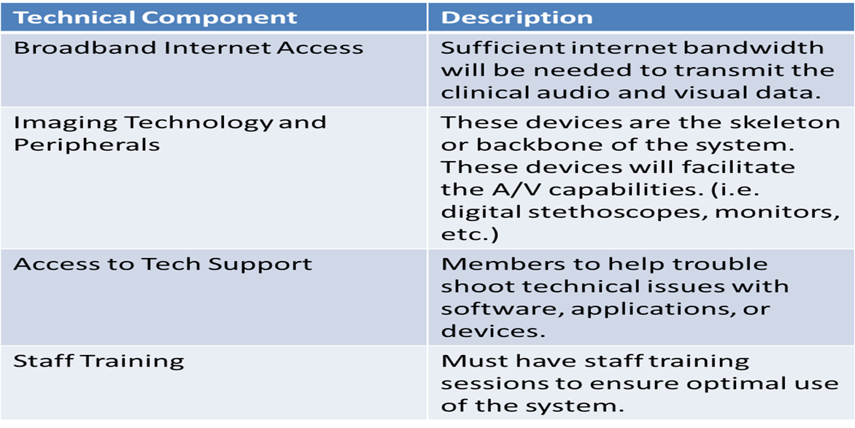(HealthIT.gov)

Table 2. Types of Telemedicine Services
Specialty/Subspecialty
Allergy/Immunology | Maternal/Fetal Medicine
Anesthesia | Mental/Behavioral Health
Cardiology | Neurology
Critical Care | Oncology/Hematology
Dentistry | Ophthalmology/Optometry
Dermatology | Orthopedics
Otolaryngology (ENT) | Pathology
Emergency Medicine | Pediatrics
Endocrinology | Psychiatry
Family/General Practice | Pulmonology
Gastroenterology | Rehabilitative Medicine
Infectious Diseases | Rheumatology
Internal Medicine | Surgery
Intensive Care Unit | Urology
(TRC, Telehealth Resource Center)

bibliography
Advanced ICU Care. "Virtual Reality With E-ICUs." Advanced ICU Care. Advanced ICU Care, 2012. Web. 5 Feb. 2015.
Anderson, Gerard F., and Bianca K. Frogner. "Health Spending In OECD Countries: Obtaining Value Per Dollar."Health Affairs. Health Affairs, 2008. Web. 23 Mar. 2015.
"Broadband & Telemedicine Stats, Data, and Observations." Broadband Expanded. Broadband Expanded, Jan. 2013. Web. 29 Jan. 2015. <http://www.broadbandexpanded.com/policymakerfiles/telemedicine/Telemedicine_Stats&Data.pdf>.
Cipolat, Claudio, and Michael Geiges. "1.2 The History of Telemedicine." Telemedicine and Teledermatology. Ed. Gunter Burg. Vol. 32. N.p.: Karger Medical and Scientific, 2003. 4+. Current Problems in Dermatology. Google Books. Karger/Google. Web. 12 Jan. 2015.
Commonwealthfund. "Mirror, Mirror on the Wall, 2014 Update: How the U.S. Health Care System Compares Internationally." - The Commonwealth Fund. The Commonwealth Fund, 2015. Web. 24 Mar. 2015.
Coustasse, Alberto, DrPH, MD, MBA, MPH, Stacie Deslich, MA, MS, Deanna Bailey, MS, Alesia Hairston, MS, and David Paul, DDS, PhD. "A Business Case for Tele-Intensive Care Units." The Permanente Journal. The Permanente Journal, 2014. Web. 10 Apr. 2015.
"Distance Learning & Telemedicine Grants." Distance Learning & Telemedicine Grants. United States Department of Agriculture, 2014. Web. 17 Feb. 2015.
Field, Marilyn J., PhD, and Jim Grigsby, PhD. "Telemedicine and Remote Patient Monitoring." The Journal of the American Medical Association 288.4 (2002): n. pag. JAMA Network. The Journal of the American Medical Association, 24 July 2002. Web. 5 Dec. 2014.
Goozner, Merrill. "National Action Needed to Advance Telemedicine." Modern Healthcare. Modern Healthcare, Jan. 2015. Web. 20 Jan. 2015.
"HealthIT.gov." Rural Health Care Initiative. United States Government, 13 Jan. 2013. Web. 17 Feb. 2015.
"HealthIT.gov." What Are the Technical Infrastructure Requirements of Telehealth? United States Government, 11 Sept. 2014. Web. 10 Feb. 2015.
HRSA. "Telehealth." Telehealth. Health Resources and Services Administration, 2012. Web. 27 Mar. 2015.
"Intensive Care Unit Telemedicine: Alternate Paradigm for Pro... : Critical Care Medicine." Critical Care Medicine28.12 (2000): 3925-931. Critical Care Medicine. Lippincott Williams & Wilkins, Dec. 2000. Web. 17 Dec. 2015.Rosenfeld, Brian, MD, FFCM, FCCP, Dorman Todd, MD, FCCM, Michael Breslow, MD, FCCM, Peter Pronovost, MD, PhD, Mollie Jenckes, MSc, Nancy Zhang, PhD, Gerard Anderson, PhD, and Haya Rubin, MD, PhD. "Intensive Care Unit Telemedicine: Alternate Paradigm for Pro... : Critical Care Medicine." Critical Care Medicine 28.12 (2000): 3925-931. Critical Care Medicine. Lippincott Williams & Wilkins, Dec. 2000. Web. 5 Dec. 2014.
"KU Center for Telemedicine & Telehealth." (KUCTT). KUCTT, 2015. Web. 20 Mar. 2015.
New England Healthcare Institute, Massachusetts Technology Collaborative. “Critical care, critical choices: the case for tele-ICUs in intensive care.” Web. Westborough, MA: Massachusetts Technology Park Corporation; 2010. 25 Jan 2015.
Sutter Health. "Learning About Your Health." What Is the ICU (Intensive Care Unit)? Sutter Health CPMC, 2014. Web. 17 Jan. 2015.
TRC. "Telehealth Resource Center." Types of Telemedicine Specialty Consultation Services -. Telehealth Resource Centers, n.d. Web. 5 Feb. 2015.
United States. Cong. Senate. Committee on Finance Subcommittee on Health Care United States Senate. What Is Health Care Quality and Who Decides? By Carolyn M. Clancy. S. Rept. Agency for Health Care Research and Quality Department of Health and Human Services, 18 Mar. 2009. Web. 17 Feb. 2015.
Ward, MM, F. Ullrich, AJ Potter, AC Mackinney, S. Kappel, and KJ Mueller. "Factors Affecting Staff Perceptions of Tele-ICU Service in Rural Hospitals." National Center for Biotechnology Information. U.S. National Library of Medicine, 3 Mar. 2015. Web. 11 Mar. 2015.
Welsh, Teresa. "Telemedicine." Telemedicine. University of Tennessee Telemedicine Network, 20 June 1999. Web. 1 Feb. 2015.
Yoo, Erika J., MD, and R. A. Dudley, MD, MBA. "Evaluating Telemedicine in the ICU." JAMA The Journal of the American Medical Association 302.24 (2009): 2705-706. JAMA Network. The Journal of the American Medical Association, 23 Dec. 2009. Web. 5 Dec. 2014.
Zundel, K. M. "Telemedicine: History, Applications, and Impact on Librarianship." Bulletin of the Medical Library Association. U.S. National Library of Medicine, 2014. Web. 10 Apr. 2015.

