r
POTENTIALLY DANGEROUS INGREDIENTS IN PERSONAL CARE AND COSMETIC PRODUCTS: AN ANALYSIS AND COMPARISON OF UNITED STATES AND EUROPEAN POLICY

by
Elizabeth Pferdehirt
B.S. Health Information Management, Saint Louis University, 2011

Submitted to the Graduate Faculty of
Graduate School of Public Health in partial fulfillment
of the requirements for the degree of
Master of Public Health

University of Pittsburgh
2015

UNIVERSITY OF PITTSBURGH
GRADUATE SCHOOL OF PUBLIC HEALTH

This essay is submitted
by
Elizabeth Pferdehirt

on

May 29, 2015
and approved by

Essay Advisor:
Julie Donohue, PhD ______________________________________
Associate Professor
Department of Health Policy and Management
Graduate School of Public Health
University of Pittsburgh

Essay Reader:
Supriya Kumar, PhD, MPH ______________________________________
Visiting Research Assistant Professor
Department of Behavioral and Community Health Sciences
Graduate School of Public Health
University of Pittsburgh

Copyright © by Elizabeth Pferdehirt
2015

ABSTRACT
Julie Donohue, PhD
POTENTIALLY DANGEROUS INGREDIENTS IN PERSONAL CARE AND COSMETIC PRODUCTS: AN ANALYSIS AND COMPARISON OF UNITED STATES AND EUROPEAN POLICY

Elizabeth Pferdehirt, MPH
University of Pittsburgh, 2015

In the United States, only 11 ingredients are prohibited or restricted from inclusion in cosmetics, compared to over 1,300 ingredients banned from inclusion in cosmetics sold in Europe. Some legislators have expressed concern that these chemicals can increase the risk of cancer, endocrine and reproductive disorders, and more, but policy action has been minimal. The presence of dangerous chemicals in cosmetics should be a focus of public health leaders and policy makers in the United States, because without further action, rates of disease associated with these ingredients may increase.
This paper will define the problem of chemicals in cosmetic products and propose changes to policy to correct the problem. This will be done through a review of existing policies and a discussion of the significance of the problem including the types of diseases that result.
This paper proposes that harmful chemicals are present in products that many consumers believe are safe, and makes recommendations for additional regulation of the cosmetics industry. Along with legislative changes, this paper recommends that educational programs must also be developed to bring awareness to this issue, and a systematic review of all potentially risky substances should also be conducted with alternative options proposed, as well as additional policies to expand regulation in order to emphasize public health.
TABLE OF CONTENTS
1.0 INTRODUCTION 1
1.1 PROBLEM DEFINITION 2
1.2 DOMAINS OF REGULATION 6
2.0 REGULATORY ENVIRONMENT – UNITED STATES 9
2.1 resistance to change 13
3.0 REGULATORY ENVIRONMENT – EUROPE 15
4.0 FUTURE AND PENDING UNITED STATES LEGISLATION 18
4.1 OPPORTUNITIES FOR POLICY EXPANSION 20
4.2 POTENTIAL WEAKNESSES OF NEW POLICY 21
5.0 CONCLUSION 22
bibliography 23
List of tables
Table 1. Common chemicals, derivation, uses, and examples 4
Table 2. Common chemicals and potential Common chemicals, derivation, uses, and examples health effects 5
Table 3. Defining misbranded and adulterated cosmetics 11

INTRODUCTION
Various chemicals exist in the cosmetic products used by the majority of Americans on a daily basis. Cosmetic items include everything used for personal care purposes and intended to cleanse, perfume, or improve an individual’s appearance such as facial creams and moisturizers, shampoos, conditioners, bath oils and gels, deodorants, lotions, hair dye, foundations, lip products, eye makeup, sunless tanning products, anti-wrinkle products, makeup removal products, and more.
In the United States, only 11 ingredients are prohibited or restricted from inclusion in cosmetics (Prohibited & Restricted Ingredients, 2015). In comparison, over 1,300 ingredients are banned from inclusion in cosmetics sold in Europe, and many other countries have significantly more chemical bans than the United States as well. For example, the European Union has banned petroleum distillates, hydroquinone, and formaldehyde or formaldehyde releasers, but all of these chemicals are permissible in the United States, and are found in products that are commonly used (Naveed, 2014). Petroleum distillates are often found in mascaras in the United States, and largest ingredient in Cover Girl Fantastic Lash Waterproof Mascara (Material Safety Data Sheet, 2011). Hydroquinone is used to lighten skin tone or reduce age spots, and is classified as a carcinogenic by the European Union (Cosmetics – CosIng, 2009), but is common in several antiaging products including AMBI Skincare Fade Cream. Many people are familiar with the risks of lead exposure, yet lead is commonly used in lipsticks, although typically within the expected range when formulated with color additives (Hepp, Mindak, & Cheng, 2009). Consumers have questioned the FDA about the presence of lead in cosmetics, and the FDA placed the following answer on its website: “[The] FDA has not set limits for lead in cosmetics” (Lipstick & Lead, Questions and Answers 2015).
Representative Jan Schakowsky of Illinois, who introduced legislation in 2012 to increase regulation of the cosmetics industry, said in an interview in 2012, “The…cosmetics industry is one of the least regulated that we have in the country. We don't even know how many companies there are right now that are producing their products. We certainly don't know what's in them,” (Avila, 2012).
Through a review of existing domestic and foreign policies and an examination of some scientific evidence illustrating improvements in health through enacted legislation, this essay will identify directions for future policy intervention in the United States to better protect Americans from these dangerous chemicals. This essay explores the evidence of risks of selected widely used chemicals. It goes on to compare the level of regulation of cosmetics in the United States to other industries such as pharmaceuticals, and to regulation of cosmetics in other countries.

PROBLEM DEFINITION
According to The Campaign for Safe Cosmetics, an advocacy organization that aims to implement additional regulation of the cosmetics industry, the average American uses 10 cosmetic or personal care products per day, which can expose the individual to 100 or more chemicals.
There is an infinite amount of natural and lab-created chemical compounds found in cosmetic items because new substances are frequently included as new products are released to the marketplace. As a result, it is difficult to compile an exhaustive list of all substances used in the marketplace. Numerous individuals and organizations including Environmental Working Group (EWG) and Skin Deep, The Campaign for Safe Cosmetics, The David Suzuki Foundation, and articles that have appeared in Environmental Health Perspectives, the monthly peer-reviewed journal published with the support of the NIH have identified some of the most frequently used chemicals that should be of concern to consumers. There is substantial overlap in the chemicals identified by these organizations as carrying risk. These substances include: butylated compounds, ethanolamine compounds (MEA, DEA, TEA), formaldehyde, hydroquinone, lead, phthalates, polytetrafluoroethylene, and triclosan.
Nearly all of these chemicals have been shown to cause organ-system or reproductive toxicity, ecotoxicity, endocrine disruption, skin irritation, immunotoxicity, bioaccumulation, and/or cancer. In fact, some of these chemicals are banned substances in other countries. Table 1 describes common chemicals, how they are derived, their uses, and examples of products that contain these chemicals. Table 2 describes the known potential health effects of these common but dangerous substances.

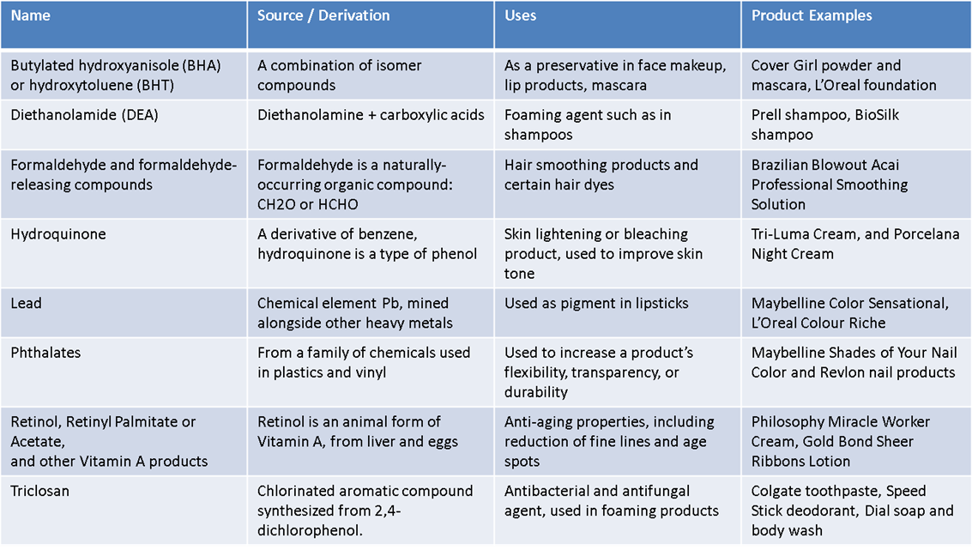
Table 1. Common chemicals, derivation, uses, and examples

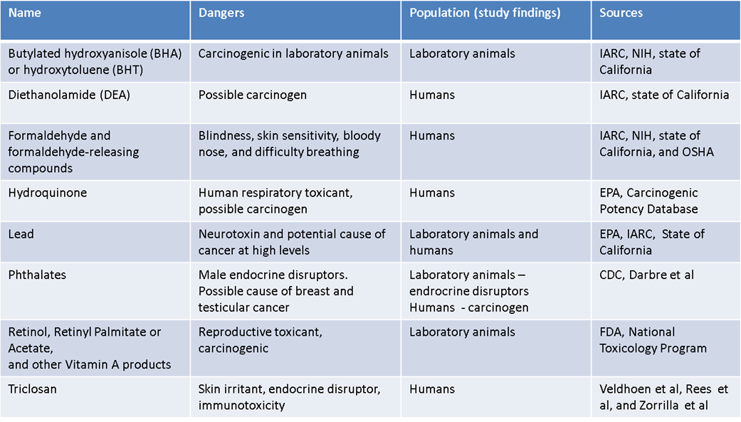
Table 2. Common chemicals and potential Common chemicals, derivation, uses, and examples health effects
In 2012, American women had the second highest rate of identified cancer, compared to all other countries (Ferlay, Soerjomataram, Ervik, Dikshit, Eser, Mathers, Rebelo, Parkin, Forman, & Bray, 2012). The highest rate of cancer in women goes to Denmark, where smoking and high alcohol consumption are more prevalent. Although it is difficult to distinguish all factors that contribute to cancer to determine why American women rank so high on the list, one distinction is the chemical ban. Most women use numerous cosmetics on a daily basis, so this may be a contributing factor. Although the numerous contributing factors that cause disease and the thousands of chemicals a person can encounter make it difficult to directly link any one chemical to any one particular disease, it is important to regulate these chemicals. The precautionary principle is relevant in this scenario, which is described as: “When an activity raises threats of harm to the environment or human health, precautionary measures should be taken even if some cause and effect relationships are not fully established scientifically” (Johnson Foundation, 1998). Because these chemicals have been shown to be harmful, although there is not worldwide scientific consensus, a conservative approach should be taken to ensure harmful chemicals do not make it into cosmetics. Unfortunately, the limited regulation of the cosmetic industry in the United States has not invoked this approach.

DOMAINS OF REGULATION
There are several aspects of the regulation of any consumer good that a government should consider. These domains include product approval, chemical bans, a database of potentially risky products and a mechanism for warning the public, general consumer education, labeling and promotional claims, monitoring of companies producing cosmetics, and enforcement of established regulations. Currently the only domains the United States participates in for the cosmetic industry are regulations around labeling and marketing and a banned chemical list consisting of 11 substances (Engasser et al., 2007, p. 28).
Cosmetics manufacturers bring products to market in the United States and are not required to seek approval before marketing products to the public, with the exception of certain color additives (FDA Authority Over Cosmetics, 2013). The regulation of prescription drugs, although a much larger industry, and arguably with much more significant and immediate consequences (i.e. death from a potent drug), could provide some foundation for regulation of cosmetics, and in particular, bringing products to market. Drug regulation is structured such that manufacturers must perform vigorous laboratory testing to prove effectiveness, and then review by the FDA, before going on to approval for human trials. Following the FDA review, human trials occur in multiple phases with continuous monitoring by the FDA. A team of various professionals review the data from the trials and identify whether the benefits of the drug outweighs the risks, making it allowable for sale, and the team also determines what information, including negative information about the drug, should be listed on the label. The FDA continues to monitor reported side effects and sometimes pulls drugs from the market if serious issues arise.
The regulation of the pharmaceutical industry provides an excellent framework for the cosmetic industry. Cosmetics could be brought to market following a comprehensive review of study data, although specific human trials and other such aspects of the structure are likely not necessary. The primary focus of regulation should be the safety of ingredients, whereas with drugs, the FDA is also concerned with effectiveness. For cosmetics, it is up to consumers to decide what products they choose to purchase and whether or not the desired affect is achieved (i.e. if softer hair results from shampoo use), although marketers cannot make exorbitant claims.
Although there are 11 chemicals currently banned from inclusion in cosmetics, the list is a ban on chemicals that are widely believed to be dangerous in all capacities, and therefore are banned beyond just for use in cosmetics: Bithionol, chlorofluorocarbon propellants, chloroform, halogenated salicylanilides, hexachlorophene, mercury compounds, methylene chloride, prohibited cattle materials, sunscreens in cosmetics (within certain scenarios), vinyl chloride, and zirconium-containing complexes (Prohibited & Restricted Ingredients, 2015). A true comprehensive chemical list that compares available evidence and also emphasizes readily available alternatives would be ideal in the United States, similar to CosIng in Europe, which will be described later.
Along with a comprehensive banned chemicals list is the need for a tracking and reporting mechanism of risky chemicals. The EWG, a non-profit and non-partisan environmental group, maintains a database called Skin Deep which lists ingredients in more than 68,000 products, and describes the potential risks associated with various chemicals. Such a database might be more useful if it was connected with or run by the FDA or another regulatory body so as to more clearly develop inclusion strategies, methodologies, and have more exposure to the public. The FDA currently responds to public comments about specific chemicals of concern, but by housing its own easily accessible database explaining the available research on these ingredients could resolve some of these issues, and also bring about greater public education.
Beyond a database of risky chemicals, overall general education is needed about the dangers of various chemicals. Because of the limited existing bans and the numerous cosmetics used by the public, the FDA could expand its consumer information role and provide additional information to the public on its website and through other means.
The final domain is the enforcement of previously established domains, as well as the monitoring and maintenance of the program. Under current law, the primary authority the FDA has is to take action through the Department of Justice to eradicate adulterated and misbranded cosmetics after they have been brought to market. The FDA cannot order recalls of cosmetics, does not require manufacturers to register products, and has minimal authority to provide oversight or enforce policies related to cosmetics.

REGULATORY ENVIRONMENT – UNITED STATES
Many consumers assume that if a product is available for purchase, it must be safe. In fact, one survey found that safety is the number one concern of more than half of the population when selecting a cosmetic or personal care product (Deloitte, 2011). The FDA regulates the pharmaceutical industry so closely, and many consumers believe such regulations apply to cosmetic items as well, but in actuality, the FDA does not have authority to regulate the chemicals in cosmetics.
Cosmetic manufacturers are not required to seek approval from the FDA before taking a cosmetic to market. According to the FDA, “a manufacturer may use any ingredient in the formulation of a cosmetic, provided that the ingredient and the finished cosmetic are safe under labeled or customary conditions of use, the product is properly labeled, and the use of the ingredient does not otherwise cause the cosmetic to be adulterated or misbranded under the laws that FDA enforces” (FDA Authority Over Cosmetics, 2013). While this statement might be interpreted to mean the FDA requires proof of safety before it approves a cosmetic product, no such proof is required and FDA does not have the authority to approve cosmetic products in the same way it does medicines. The FDA website makes it clear that the cosmetic industry holds the responsibility for ensuring the safety of its products: “Companies and individuals who manufacture or market cosmetics have a legal responsibility to ensure the safety of their products. Neither the law nor FDA regulations require specific tests to demonstrate the safety of individual products or ingredients. The law also does not require cosmetic companies to share their safety information with FDA” (FDA Authority Over Cosmetics, 2013). The origins of a manufacturer’s legal responsibility regarding the safety of their products stems from general consumer protection requirements, and not from FDA authority. The FDA may only take legal action if it has evidence to suggest a cosmetic is adulterated or misbranded, and the legal action is limited to the seeking of a restraining order to seize a product from the marketplace.
The laws that regulate the cosmetic industry in the United States that the FDA is responsible for enforcing are the Federal Food, Drug, and Cosmetic Act (FDCA) and the Fair Packaging and Labeling Act (FPLA).
The FDCA was originally passed in 1938 to establish the authority within the FDA to oversee food, drug, and cosmetic safety. The primary motivation behind the act was the death of more than 100 patients in 15 states after toxic diethylene glycol was used to liquefy a commonly prescribed strep infection medication called sulfanilamide (Ballentine, 1981). The inclusion of cosmetics in the FDCA was aimed at helping to better distinguish between drugs and cosmetics so as to prevent manufacturers from circumventing drug regulations by calling a drug a cosmetic. While the FDCA has been amended several times to expand the FDA’s authority to regulate the food and drug industry there have been no significant amendments to that act that are related to cosmetics. Chapter 6 of the FD&C deals with cosmetics, and it consists of three sections: Section 361: Adulterated Cosmetics which is approximately one half page in length, Section 362: Misbranded Cosmetics which is approximately one page in length, and Section 363: Regulations Making Exemptions, which is two paragraphs in length (Food, Drug, and Cosmetic Act, 2013, Chapter VI). The entire original FDCA was over 450 pages, with approximately 1.5 pages dedicated to cosmetics. Table 3 explains the meaning of adulterated and misbranded cosmetics.
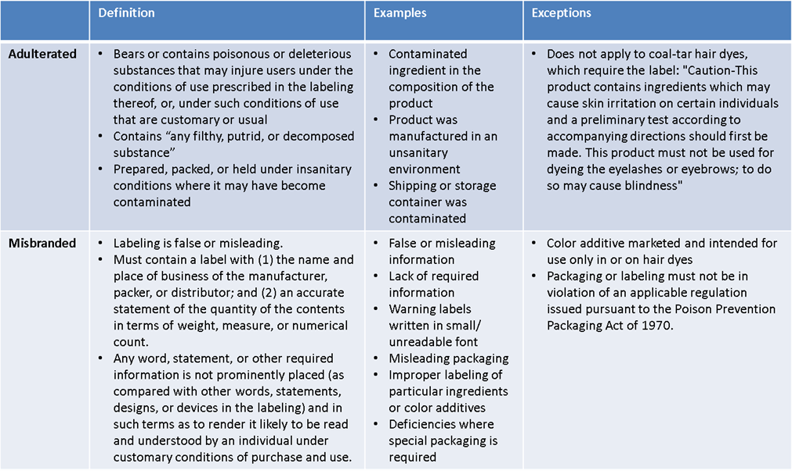
Table 3. Defining misbranded and adulterated cosmetics

The primary purpose of these sections is to ensure that a product that is being sold is as described. The misbranding section relates to being sold in correct quantities (i.e. numerical count and weight) for general consumer protection and to meet established trade laws, and to ensure that a product’s label uses clear and appropriate wording. The adulteration section was designed to ensure that a product does not contain poisonous substances, and to prevent a manufacturer from labeling a drug as a cosmetic.
The FPLA was originally passed in 1966 and focuses on the labeling or mislabeling of cosmetics. The requirements for cosmetic labeling as set out by the act are that the label must not be false or misleading, must state the name and location of the manufacturer or distributor, and must list ingredients accurately. The FPLA was established to better enable value and quantity comparisons and to prevent deceptive packaging and labeling, and not for safety reasons (Fair Packaging and Labeling Act, 2015). The sections of the FPLA relate to measure of weight or mass, measurement of length and width, units of count, and other terminology manufacturers include on packaging. Accuracy of ingredients is included as a means to ensure there is no confusion about a product’s identity or purpose.
The FDA’s ability to censure a manufacturer occurs through the use of warning letters. The majority of the FDA’s warning letters have been issued when a drug or medical devise was marketed as a cosmetic, of which they include 28 on their website since 2005 (Warning Letters Related to Cosmetics, 2014). Since 2005 there were three warning letters issued for adulterated cosmetics due to microbial contamination, one issued for adulterated, mislabeled, and safety violations, one issued for adulterated due to use of canthaxanthin, and one issued for adulterated due to use of an unsafe color additive, for a total of six warning letter for adulterated or mislabeled cosmetics in the past ten years.
The FDA and other regulatory bodies in the United States do not actively seek to limit, regulate or ban chemicals in cosmetics. The United States has set a high burden of proof before regulatory action can be taken, whereas Europe has taken the stance that when there is substantial evidence of danger, preventive and protective action is taken even when there is debate over the level of evidence or disagreement among scientists.
The vast differences between the regulation of cosmetics in the United States and many other countries are evident even through the definition of cosmetics and the number of regulations associated with them.

resistance to change
It could be challenging to fight for policy intervention that incorporates all of these above substances and compounds, and the numerous other potentially dangerous substances, because there are multiple interests at stake. The labs who create these substances would likely fight to protect their compounds, as well as cosmetic manufacturers who would not be enthused to search for new substances that achieve the same purpose, but with a potential increase in cost. It is important that both policymakers and consumers understand the risks associated with these ingredients though, to better make personal purchasing decisions for their families, as well as to create and implement the level of policy necessary for protecting the public’s best interest.
The United States cosmetic industry represented approximately $54.89 billion in revenue in 2012 (Cosmetic Chemicals Market, 2014), and the numerous interests at play may have an impact on the regulation of the market. There are opportunities to improve the ingredients used in cosmetics, but without restrictions or requirements placed upon manufacturers, and without more public outcry, there is minimal incentive to make these changes. One opportunity for a potential ban with safer replacement would be butylated hydroxyanisole (BHA) and butylated hydroxytoluene (BHT), which are common additives used to preserve lipsticks, lotions, and face creams. BHA and BHT require warning labels in the state of California, but they are permitted without warning in all other states. BHA and BHT have been identified by the European Union as endocrine disruptors, carcinogenic by California, and potentially hazardous to the environment, and a common and readily available alternative preservative exists – Vitamin E (Kahl & Kappus, 1993). Vitamin E is frequently used in many personal care and cosmetic products, and would not cause a significant financial burden to manufacturers and consumers.
Another example of a substance that is unregulated is formaldehyde or formaldehyde-releasers used in many cosmetics products. According to a study that reviewed 496 products and compared its findings to FDA data, nearly one in four cosmetics contains a formaldehyde-releaser (De Groot & Veenstra, 2010). As Table 1 above illustrates, formaldehyde has been shown to cause various health issues by numerous entities.
Several of the largest consumer packaged goods companies also represent a large share of the cosmetics market including Proctor and Gamble, L’Oreal, Johnson & Johnson, and Unilever. Proctor and Gamble, L’Oreal, and Revlon make up nearly 40% of the cosmetic market (Kumar, 2004). Several of Proctor and Gamble’s largest brands that have net sales over $1 billion include cosmetics, such as Crest, Olay, and Pantene (2011 Annual Report, Procter and Gamble). Although the cosmetics industry represents only a small percentage of a larger product base, cosmetic and personal care products represent some of the highest markups, with profit margins as high as 38% (BERA, 2010). Although it is difficult to ascertain exactly how much of a percentage of lobbying expenditures are devoted to cosmetics, these multinational companies do draw high lobbying tolls. For example, in 2014, Proctor and Gamble spent $5.4 million on lobbying (Open Secrets, 2015). Some estimates suggest lobbying expenditures in 2012 by cosmetics companies against specific legislation related to cosmetics were as high as $3.5 million (Avila, 2012).

REGULATORY ENVIRONMENT – EUROPE
The European Union has taken numerous steps to protect its population from possible hazardous materials in cosmetics and personal care products. Of note, the Cosmetics Directive, the Cosmetics Regulation from the European Parliament, and the Scientific Committees’ Opinions on Cosmetic Substances are major legislation that define and maintain safe practices for manufacturers and sellers of cosmetics.
The Cosmetics Directive (Council Directive 76/768/EEC of 1976-07-27) was created in 1976 created to provide background and definition for cosmetics. The Cosmetics Directive defined cosmetic products, noting they are “any substance or preparation intended for placing in contact with the various external parts of the human body (epidermis, hair system, nails, lips and external genital organs) or with the teeth and mucous membranes of the oral cavity with a view exclusively or principally to cleaning them, perfuming them or protecting them in order to keep them in good condition, change the appearance or correct body odours,” (Council Directive 76/768/EEC, 1976, Article 1.1). The Cosmetics Directive focuses on identifying substances that are banned or have restricted uses and substances that are permitted for specific uses. It has been amended numerous times since its creation to alter the lists as necessary.
The Cosmetics Regulation (Regulation EC No 1223/2009) was a regulation passed in 2009 with specific regulatory changes that came about in 2013. The legislation is complex and over 150 pages, but its objectives were described as, “simplifying procedures and streamlining terminology, thereby reducing the administrative burden and ambiguities, [and] strengthen[ing] certain elements of the regulatory framework for cosmetics, such as in-market control, with a view to ensuring a high level of protection of human health,” (Regulation EC No 1223/2009, p. 342/59). The primary purposes of this regulation were to redefine the roles and responsibilities of cosmetic and personal care product manufacturers and sellers, the inclusion of all approved and unapproved products on the Cosmetic Product Notification Portal, and the enhancement and expansion of safety assessments for cosmetics to a new process called the Cosmetic Product Safety Report.
Safety assessments are performed according to the regulation for all cosmetics, with enhanced requirements for certain types of products such as sunscreen. Categories tested include dermal absorption and irritation, mucous membrane irritation, skin sensitization, toxicity, mutagenicity, and phototoxicity for certain substances, and tests must be performed by qualified individuals who were trained in accordance with the requirements of the regulation (Council Directive 76/768/EEC). CosIng is the database that houses information about all substances contained in cosmetics. It details restrictions and allowable limits, and banned ingredients, based on these safety assessments, and CosIng also includes links to opinions and the research used to help shape the opinion of the committee.
Other provisions of the Cosmetics Regulation include the prohibition of chemicals labeled carcinogenic, mutagenic, or toxic for reproduction in personal care products as well as new “Good Manufacturing Practice” standards for manufacturers. The legislation consists of 10 chapters: scope and definitions; safety, responsibility, and free movement of goods; safety assessment, product information notification; restrictions for specific substances; animal testing; consumer information; in-market control; non-compliance and safeguards; cooperation between authorities; and implementation of measures (Mildau & Huber, 2010, p. 41).
The Scientific Committees’ Opinions on Cosmetic Substances, which has since been replaced by the Scientific Committee on Consumer Safety (SCCS), provides details and descriptions of accepted research regarding specific substances and their uses. These opinions serve as guidelines for manufacturers and contribute to the development and maintenance of the Cosmetics Directive lists of substances. Membership on the SCCS comes through appointment by the European Commission, with members being leading scientists and health professionals from different countries in the European Union from various backgrounds. One recent example is methylchloroisothiazolinone and methylisothiazolinone (MI), which will no longer be permitted in cosmetics after July 16, 2015 (Hudson & Stankova, 2014). After reviewing new safety data it was determined that the substance was not safe for inclusion in leave-on products such as lotions, where it is commonly used as a preservative.

FUTURE AND PENDING UNITED STATES LEGISLATION
The lack of regulation in spite of readily available research on the dangers of these ingredients illustrates that additional policy intervention is necessary in the United States. Thousands of different products are available to consumers for purchase, and many contain substances that are potentially hazardous to health. Unless consumers are spending time researching the regulation of cosmetics, it is unlikely they will ever have firsthand knowledge of the current state of affairs. The legislature must work to enact policy that protects these vulnerable consumers.
Why has Europe banned over 100 times the number of ingredients as the United States? The limited, compared to Europe, legislation in the United States described above is a likely culprit. The FDCA was passed in 1938. Since its inception, other than the FPLA there have been no major amendments that directly impact the safety or regulation of cosmetics. Most major amendments (including the FPLA) have been aimed at enhancing regulation of the pharmaceutical and device manufacturing industries, along with some focus on nutritional labeling and marketing claims of foods and pharmaceuticals.
Without enhanced legislation designed specifically with cosmetics in line, it is unlikely that the cosmetics industry will justify any reasoning to eliminate existing harmful ingredients from their products. Part of the reason for this is that the cosmetics industry in the United States is quite lucrative, generating high profit margins. The primary source of information for consumers about cosmetics, their proposed benefits, and their contents is marketing materials. Without a requirement to detail and publish specific safety information, adverse effects, and the known negative effects of specific ingredients, the cosmetics industry is left unchecked to continue to put these products to market. Typically the only time a manufacturer changes a product or removes a product from the market is when consumers provide enough public negative feedback or complaints and/or sales decline to such a point that they no longer find the product financially beneficial.
As evidenced through the lack of existing policy in the United States, some advocacy organizations, such as the Campaign for Safe Cosmetics, have been pushing Congress to pass new legislation that is designed with the safety of the consumer in mind. The Safe Cosmetics and Personal Care Products Act of 2013 was introduced in the House on March 21, 2013. The proposed legislation amends the FD&C Act with several aims including:
• Allow the Secretary of Health and Human Services (HHS) to regulate cosmetics
• Require cosmetic manufacturers to register and pay a fee that funds this regulation
• Establish: labeling requirements and “a safety standard that provides a reasonable certainty of no harm from exposure to a cosmetic or an ingredient in a cosmetic and that protects the public from any known or anticipated adverse health effects associated with the cosmetic or ingredient” (H.R. 1385, 2013)
• Creates a database to track and monitor cosmetics and ingredients
• Establish lists maintained by the HHS of prohibited or restricted ingredients and safe ingredients
• Establish a recall process for cosmetics in violation of the Act
To date, the following action has occurred with the Safe Cosmetics and Personal Care Products Act of 2013: it was introduced in the house and referred to the Committee on Energy and Commerce, the Committee of Education and the Workforce, the Subcommittee on Health, and the Subcommittee on Workforce Protections. No other action, published revisions, or votes have occurred.

OPPORTUNITIES FOR POLICY EXPANSION
Although Europe’s level of regulation can serve as a guide to the United States for expanded legislation, further opportunities exist where additional legislation around the world could be beneficial. Products that have been studied and show significant potential health risks should be carefully considered by a health and science committee and ultimately banned where deemed appropriate. Where healthier alternatives exist, these substances should be required replacements for less healthy substances. This health and science committee could be structured similar to the committee that makes recommendations for cosmetics and the safety of ingredients of Europe, and it could be overseen by the HHS.
Along with a complete review of existing chemicals in use in cosmetic products in the United States, and widespread educational campaign is necessary to promote awareness of the substances commonly found in cosmetic products, the risks of various common substances, alternative options, and a greater understanding of the availability of research internationally that has led to this discussion.

POTENTIAL WEAKNESSES OF NEW POLICY
Although regulation of dangerous chemicals in cosmetics would likely benefit the population as a whole, certain disadvantages do exist. In some cases, the alternative but healthier substance will be more expensive than a banned substance, causing manufacturing costs to increase, and therefore consumer prices to increase. A cost benefit analysis in these cases would be helpful to illustrate the short and long term financial gains associated with any reduced side effects and diagnoses resulting from the substance (including any moderate, acute, or chronic conditions that can be linked).
Regulation of various commonly used but potentially dangerous chemicals will also be difficult because of the numerous interests at play. It may be difficult to distinguish between the opposing or varying findings from research of specific chemicals, although any ties or conflicts of interest based on the researchers or funding of the research may help alleviate some of those challenges. Establishing a review panel to determine which studies are accepted as support for a ban or inclusion and which studies are not accepted will also be difficult, but such panels are important from the public’s perspective in the long term, as decision-maker panels will help reduce healthcare expenditures related to harmful chemicals, with the potential to significantly reduce costs for the entire population.

CONCLUSION
Various studies have looked at the presence of specific chemicals in the body as well as a comparison of exposure levels (i.e. some individuals use products more often than other individuals, or use products with higher concentrations of potentially dangerous chemicals). The various health effects that result from use of these chemicals indicate the importance and need for regulation.
The American public should also be exposed to an educational program aimed at increasing awareness for common cosmetic and personal care product ingredients. The increase in awareness will play a major role in consumer spending and decision-making that may ultimately lead to a shift in cosmetic manufacturer practices that self-limit dangerous substance usage.
The legislative process must continue for the Safe Cosmetics and Personal Care Products Act of 2013. The United States needs to begin the process of determining which substances should be banned in the immediate future, and also develop a process for review of all potentially risky substances along with alternative solution options. Additional policies must be developed that expand the role of regulation in cosmetic and personal care products while placing more emphasis on public health.

bibliography
2011 Annual Report, Procter & Gamble. (2011). Retrieved from http://www.pginvestor.com/interactive/lookandfeel/4004124/PG_2011_AnnualReport.pdf
Avila, J. (2012, April 30). FDA Regulation of Cosmetics Nears Despite Industry Objections. ABC News World News. Retrieved from http://abcnews.go.com/blogs/lifestyle/2012/04/fdas-regulation-over-cosmetics-nears-despite-industry-backlash/
Ballentine, C. (1981, June). Taste of Raspberries, Taste of Death: The 1937 Elixir Sulfanilamide Incident. FDA Consumer Magazine.
BERA: Business & Economics Research Advisor. (2010, January). The Cosmetics Industry Today. Business Reference Services.
CA: "Chemicals listed effective June 22, 2012 as known to the state of California to cause cancer: benzophenone (CAS No. 119-61-9), coconut oil diethanolamine condensate (cocamide diethanolamine) (CAS No. 68603-42-9), diethanolamine (CAS No. 111-42-2), and 2-methylimidazole (CAS No. 693-98-1)". Retrieved 2015-01-22.
Council Directive 76/768/EEC of 27 July 1976 on the approximation of the laws of the Member States relating to cosmetic products http://eur-lex.europa.eu/LexUriServ/LexUriServ.do?uri=CONSLEG:1976L0768:20100301:en:PDF
De Groot, A., & Veenstra, M. (2010). Formaldehyde-releasers in cosmetics in the USA and in Europe. Contact Dermatitis, 62(4), 221-224.
Deloitte. (2011, April 15). Food Safety Survey. Retrieved from http://www2.deloitte.com/content/dam/Deloitte/us/Documents/Consumer Business.html/us_cp_2011foodsafetysurvey_041511.pdf
Engasser, P., Long, T., McNamee, P., Schlatter, H., & Gray, J. (2007). Safety of cosmetic products. Journal of Cosmetic Dermatology, 6(s1), 23-31

Fair Packaging and Labeling Act. (2015, February 2). Retrieved from https://www.ftc.gov/enforcement/rules/rulemaking-regulatory-reform-proceedings/fair-packaging-labeling-act
Ferlay J, Soerjomataram I, Ervik M, Dikshit R, Eser S, Mathers C, Rebelo M, Parkin DM, Forman D, Bray, F. GLOBOCAN 2012 v1.1, Cancer Incidence and Mortality Worldwide: IARC CancerBase No. 11. Lyon, France: International Agency for Research on Cancer; 2014. Available from: http://globocan.iarc.fr.
Food, Drug, and Cosmetic Act (FD&C Act) (2013). Chapter VI: Cosmetic Sec, 601, 21.
FDA Authority Over Cosmetics. (2013, August 3). U.S. Food and Drug Administration. Retrieved from http://www.fda.gov/Cosmetics/GuidanceRegulation/LawsRegulations/ucm074162.htm
Future Market Insights. (2014). Cosmetic Chemicals Market - ASEAN Industry Analysis and Opportunity Assessment 2014 - 2020. Retrieved from http://www.futuremarketinsights.com/reports/details/asean-cosmetic-chemicals-market
H.R.1385. (2013). Safe Cosmetics and Personal Care Products Act. Retrieved from https://www.congress.gov/bill/113th-congress/house-bill/1385
Hepp, N., Mindak, W., and Cheng, J., "Determination of Total Lead in Lipstick: Development and Single Lab Validation of a Microwave-Assisted Digestion, Inductively Coupled Plasma–Mass Spectrometric Method," Journal of Cosmetic Science, Vol. 60, No. 4, July/August, 2009.
Hudson, D., & Stankova, A. (2014, September 26). Consumers: Commission improves safety of cosmetics. Retrieved from http://europa.eu/rapid/press-release_IP-14-1051_en.htm
International Agency for Research on Cancer: Agents Classified by the IARC Monographs, Volumes 1–105.
Kahl, R., & Kappus, H. (1996). Toxicology of the synthetic antioxidants BHA and BHT in comparison with the natural antioxidant vitamin E. European Journal of Nutrition, 196(4), 329-38.
Kumar, S. (2004). Exploratory analysis of global cosmetic industry: Major players, technology and market trends. Technovation, 25. doi:doi:10.1016/j.technovation.2004.07.003
Lipstick & Lead: Questions & Answers. (2015, March 17). U.S. Food and Drug Administration. Retrieved from http://www.fda.gov/Cosmetics/ProductsIngredients/Products/ucm137224.htm
Johnson Foundation, Science and Environmental Health Network. January 26, 1998 Wingspread Conference on the Precautionary Principle
Material Safety Data Sheet, Finished Product. (2011, June). Retrieved from http://www.pg.com/productsafety/msds/beauty_care/color_cosmetics/Cover_Girl_Fantastic_Lash_Waterproof_Mascara_(95346440).pdf
Mildau, G., & Huber, B. (2010, March). The New EC Cosmetics Regulation 1223/2009 – Contents and First Explanations. SOFW Journal. Retrieved from http://ikw.org/fileadmin/content/downloads/Schönheitspflege/SP_Kosmetikrichtlinie-en.pdf
National Institutes of Health, Butylated Hydroxyanisole (BHA), CAS No. 25013-16-5, Report on Carcinogens, Eleventh Edition.
Naveed, N. (2014). The Perils of Cosmetics. Journal of Pharmaceutical Sciences & Research, 6(10)
Open Secrets. (2015, February 11). Lobbying - Procter & Gamble: Summary. Retrieved from https://www.opensecrets.org/lobby/clientsum.php?id=D000000485
Prohibited & Restricted Ingredients. (2015, January 26). U.S. Food and Drug Administration. Retrieved from http://www.fda.gov/cosmetics/guidanceregulation/lawsregulations/ucm127406.htm
Regulation EC No 1223/2009 of the European Parliament and of the Council of 30 November 2009 on cosmetic products. (2009, December 22). Official Journal of the European Union.
Warning Letters Related to Cosmetics. (2014, December 11). U.S. Food and Drug Administration. Retrieved from http://www.fda.gov/Cosmetics/ComplianceEnforcement/WarningLetters/ucm2005169.htm

