CHARACTERISTICS OF REPORTED LYME DISEASES CASES
IN ALLEGHENY COUNTY, 2014

by
Kristin Komazec
B.S., Biological Sciences, University of Pittsburgh, 2003

Submitted to the Graduate Faculty of
the Department of Epidemiology of the
Graduate School of Public Health in partial fulfillment
of the requirements for the degree of
Master of Public Health

University of Pittsburgh
2015

UNIVERSITY OF PITTSBURGH
GRADUATE SCHOOL OF PUBLIC HEALTH

This essay is submitted
by
Kristin Komazec

on

August 20, 2015
and approved by

Essay Advisor:
Faina Linkov, PhD, MPH ______________________________________
Associate Professor
School of Medicine
Department of Obstetrics, Gynecology & Reproductive Sciences
Magee-Womens Research Institute
University of Pittsburgh

Essay Reader:
Jeremy J. Martinson, DPhil ______________________________________
Assistant Professor
Infectious Diseases and Microbiology
Graduate School of Public Health
University of Pittsburgh

Copyright © by Kristin Komazec
2015
ABSTRACT

Background: Lyme disease is a bacterial disease transmitted by infected ticks that, if left untreated, can lead to serious health complications. Pennsylvania leads the nation in annual cases, but knowledge of its incidence and distribution throughout Allegheny County has been lacking. The objectives of this essay are to describe characteristics of 1) county Lyme disease cases that occurred in 2014 and 2) case investigations submitted to the Allegheny County Health Department for the same year.
Faina Linkov, PhD, MPH

CHARACTERISTICS OF REPORTED LYME DISEASE CASES
IN ALLEGHENY COUNTY, 2014
Kristin Komazec, MPH
University of Pittsburgh, 2015

Methods: Data for analysis were obtained from surveillance data originally collected by the ACHD for public health purposes. Statistical software was used to perform descriptive statistics, including counts, percentages, and incidence, on confirmed and probable year 2014 cases by age, sex, symptom onset, geography, and clinical characteristics. Descriptive statistics were also performed on case investigations to describe details and follow-up of year 2014 reports received and investigated by the ACHD.
Results: Of the 1445 case investigations analyzed, 745 (51.6%) were classified as confirmed and 65 (4.5%) as probable per CDC case definition. Overall incidence in males was greater than females (77.69 versus 52.83 per 100,000), and highest incidence was in males ages 5-9 years (19.22 per 1,000). Clinical onset peaked in June (36.38%). Erythema migrans was the most common symptom in confirmed cases (70.07%), followed by arthritis (45.91%). Cases were reported in 86 residential zip codes, with incidence generally higher in northern regions. Most initial reports were submitted electronically (90.0%), included a laboratory test result (97.8%), and lacked clinical information necessitating follow-up investigation by the ACHD (97.4%). Follow-up information was obtained through investigation for 1313 cases (90.9%), most frequently from healthcare provider (67.38%).
Conclusions: Knowledge gained from this descriptive study has public health relevance for Allegheny County, where Lyme disease is endemic and a growing problem. Characteristics of county cases show demographics most affected and reflect national patterns with some deviations. Follow-up investigation, while labor-intensive, produces useful information that can inform case classification and education, prevention, and treatment efforts. Future research should focus on improving provider reporting and identifying alternative surveillance methods so that this useful public health data may continue to be captured.
TABLE OF CONTENTS
preface xii
1.0 INTRODUCTION 1
1.1 Objective 5
2.0 METHODS 6
2.1 Source Data 6
2.1.1 Allegheny County Health Department Lyme Disease Surveillance Project Data 6
2.1.2 Research Data 7
2.2 Data Analysis 8
3.0 RESULTS 11
3.1 Confirmed and Probable Lyme Disease Cases in Allegheny County, 2014 11
3.2 Lyme Disease Case Investigations in Allegheny County, 2014 15
4.0 DISCUSSION 18
4.1 Confirmed and Probable Lyme Disease Cases in Allegheny County, 2014 18
4.2 Lyme Disease Case Investigations in Allegheny County, 2014 25
4.3 Future Directions 28
APPENDIX A: LYME DISEASE CASE DEFINITION 31
APPENDIX B: 2014 ALLEGHENY COUNTY HEALTH DEPARTMENT LYME DISEASE CASE INVESTIGATION PROTOCOL 32
APPENDIX C: RESULTS 33
APPENDIX D: ADDITIONAL DATA 53
BIBLIOGRAPHY 58

List of tables
Table 1. Lyme Disease (Borrelia burgdorferi), 2011 Case Definition, CDC 31
Table 2. Classification Status, All Reported Lyme Disease Cases, Allegheny County, 2014 33
Table 3. Classification and Incidence of Confirmed and Probable Lyme Disease Cases, Allegheny County, 2014 34
Table 4. Confirmed and Probable Lyme Disease Cases by Age Group, Allegheny County, 2014 34
Table 5. Confirmed and Probable Lyme Disease Cases by Sex, Allegheny County, 2014 35
Table 6. Confirmed and Probable Lyme Disease Cases by Sex and Age Group, Allegheny County, 2014 37
Table 7. Confirmed and Probable Lyme Disease Cases by Month of Clinical Onset, Allegheny County, 2014 39
Table 8. Clinical Manifestations of Confirmed Lyme Disease Cases by Symptom, Allegheny County, 2014 40
Table 9. Hospitalization in Confirmed and Probable Lyme Disease Cases, Allegheny County, 2014 41
Table 10. Reported Known Tick Bite in Confirmed and Probable Lyme Disease Cases, Allegheny County, 2014 42
Table 11. Lyme Disease Reports by Month of Investigation Initiation, Allegheny County, 2014 45
Table 12. Lyme Disease Investigation Initial Report Type, Allegheny County, 2014 46
Table 13. Acquisition of Follow-up Data through Lyme Disease Case Investigation, Allegheny County, 2014 47
Table 14. Lyme Disease Investigation Follow-up Data Source, Allegheny County, 2014 48
Table 15. Lyme Disease Lab Result Included in Initial Report, Allegheny County, 2014 49
Table 16. Lyme Disease Lab Test Results in Initial Report by Specific Test, Allegheny County, 2014 50
Table 17. Positive IgM and IgG Immunoblot Test Results at Initial Report by Classification Status, Allegheny County, 2014 51
Table 18. Positive IgM and IgG Immunoblot Test Results at Time of Case Classification by Classification Status, Allegheny County, 2014 52
List of figures

Figure 1. Flowchart of Lyme Disease Case Investigation Protocol, Allegheny County Health Department, 2014 32
Figure 2. Classification Status, All Reported Lyme Disease Cases, Allegheny County, 2014 33
Figure 3. Confirmed and Probable Lyme Disease Cases by Age Group, Allegheny County, 2014 35
Figure 4. Confirmed and Probable Lyme Disease Cases by Sex, Allegheny County, 2014 36
Figure 5. Incidence of Confirmed and Probable Lyme Disease Cases by Sex, Allegheny County, 2014 36
Figure 6. Confirmed and Probable Lyme Disease Cases by Sex and Age Group, Allegheny County, 2014 38
Figure 7. Incidence of Confirmed and Probable Lyme Disease Cases by Sex and Age Group, Allegheny County, 2014 38
Figure 8. Confirmed and Probable Lyme Disease Cases by Month of Clinical Onset, Allegheny County, 2014 39
Figure 9. Clinical Manifestations of Confirmed Lyme Disease Cases by Symptom, Allegheny County, 2014 40
Figure 10. Hospitalization in Confirmed and Probable Lyme Disease Cases, Allegheny County, 2014 41
Figure 11. Reported Tick Bite in Confirmed and Probable Lyme Disease Cases, Allegheny County, 2014 42
Figure 12. Number of Confirmed and Probable Lyme Disease Cases by Residential Zip Code, Allegheny County, 2014 43
Figure 13. Incidence of Confirmed and Probable Lyme Disease Cases by Residential Zip Code, Allegheny County, 2014 44
Figure 14. Reports of Lyme Disease by Month of Investigation Initiation, Allegheny County, 2014 45
Figure 15. Lyme Disease Investigation Initial Report Type, Allegheny County, 2014 46
Figure 16. Lyme Disease Investigation Initial Report Type, Allegheny County, 2014 47
Figure 17. Lyme Disease Investigation Follow-up Data Source, Allegheny County, 2014 48
Figure 18. Lyme Disease Lab Result Included in Initial Report, Allegheny County, 2014 49
Figure 19. Lyme Disease Lab Test Results in Initial Report by Specific Test, Allegheny County, 2014 50
Figure 20. Case Classification Status by Positive IgM and IgG Immunoblot Test Results at Time of Initial Report, Allegheny County, 2014 51
Figure 21. Case Classification Status by Positive IgM and IgG Immunoblot Test Results at Time of Case Classification, Allegheny County, 2014 52
Figure 22. Confirmed Lyme Disease Cases by Age and Sex, United States, 2001-2010 53
Figure 23. Confirmed Lyme Disease Cases by Month of Disease Onset, United States, 2001-2010 54
Figure 24. Clinical Manifestations of Confirmed Lyme Disease Cases, United States, 2001-2010 54
Figure 25. Urban and Rural Areas per Zip Code in Allegheny County, 2010 55
Figure 26. Urban and Rural Areas per County, Southwestern Pennsylvania, 2010 56
Figure 27. Percentage Urban and Rural Population per Southwestern Pennsylvania Counties, 2010 57
Figure 28. Lyme Disease Incidence of Select Southwestern Pennsylvania Counties, 2014 57
preface
I would like to thank my essay and faculty advisor, Faina Linkov, PhD, MPH, and essay reader, Jeremy Martinson, DPhil, for their time and constructive reviews of this essay. I would also like to thank Dr. Linkov for her helpful guidance provided throughout my academic pursuits at the Graduate School of Public Health, including my internship with the Allegheny County Health Department and participation in the 2015 GSPH Dean’s Day competition.
I give much appreciation to Medical Epidemiologist, Kristen Mertz, MD, MPH, and Epidemiology Research Associate, Jennifer Fiddner, MPH, of the Allegheny County Health Department for the opportunity to take part in the Lyme disease surveillance activities as an intern, and for guidance provided throughout my time there. Special acknowledgement is owed to the students, volunteers and workers involved in gathering follow-up data for the Allegheny County Lyme disease surveillance project, whose efforts ultimately resulted in the data for this essay: Vivian Lang of AmeriCorps/National Health Corps; Lynda Jones, Katie Krancevich and Jennifer Bowling of the University of Pittsburgh Graduate School of Public Health; Carol Szeg of the Allegheny County Health Department; and Mark Harding of the University of Pittsburgh School of Medicine. I am also very grateful to the Allegheny County Health Department for the space and resources provided to me to conduct my analysis for this paper at their site.

INTRODUCTION
Lyme disease is a bacterial disease of great public health significance. It is caused by the spirochete Borrelia burgdorferi, transmitted to humans through the bite of a blacklegged tick previously infected through feeding on the blood of an infected host.^{1,2}

It is spread by Ixodes scapularis (blacklegged, or deer, tick) in the northeastern, mid-Atlantic, and north-central regions of the United States, and by Ixodes pacificus (western blacklegged tick) in the Pacific coastal region.¹
Clinical manifestations of Lyme disease can range from minor to severe, and symptoms are dependent on stage of infection.³ Early localized stage Lyme disease, occurring three to thirty days after tick bite, typically manifests as various non-specific flu-like symptoms such as fatigue, headache, muscle aches, joint pain, chills and fever, and in many cases may include the characteristic red, expanding “bull’s eye” rash at the site of tick bite, known as erythema migrans (EM).³ Early stage Lyme disease can be treated successfully with antibiotics. Left untreated, it can lead to more serious and debilitating complications as the infection spreads throughout the body.³ In early disseminated stage, occurring days to weeks after infection, additional EM rashes may appear away from the site of tick bite. Symptoms may involve the nervous system, presenting as facial or Bell’s palsy, severe shooting pains throughout the body, or meningitis due to inflammation of the spinal cord.³ The musculoskeletal system may be affected by arthritis with swelling in the large joints.³ Although rare, a cardiovascular complication called Lyme carditis may develop, in which changes in heartbeat result from bacteria entering the heart tissue and interfering with its electrical signals.⁴ While symptoms may resolve, some individuals with untreated Lyme disease experience debilitating problems that persist for months to years post-infection. Lyme-associated arthritis and neurologic ailments occur in about 60% and 5% of untreated patients, respectively, in this late disseminated stage of the disease.³
Lyme disease is diagnosed based on symptoms and potential exposure to ticks infected with the bacterium.⁵ Laboratory testing is often employed to assist or confirm diagnosis. The current Center for Disease Control and Prevention (CDC) recommendation is two-tiered testing of the blood for antibody response to Borrelia burgdorferi, with enzyme immunoassay (EIA) or immunofluorescence assay (FIA) as the first test.⁶ A positive or equivocal EIA or FIA result is followed by the second test, consisting of immunoglobulin M (IgM) and immunoglobulin G (IgG) immunoblot (or Western blot) in patients with symptoms for 30 or fewer days, and IgG immunoblot only in patients with symptoms lasting greater than 30 days.⁶ These laboratory tests alone cannot be used to determine whether or not Lyme disease is truly present. To make a complete and accurate assessment, both laboratory results and clinical information must be collected for each reported case.
Lyme disease is on the list of national notifiable diseases.⁷ It is recognized by the Council of State and Territorial Epidemiologists (CSTE) as a disease that warrants routine data collection on cases at the local, territorial and state levels, followed by subsequent reporting of this information to the CDC through the National Notifiable Diseases Surveillance System (NNDSS).⁷ Through passive reporting, healthcare providers and clinical laboratories are supposed to report potential cases of Lyme disease to local, territorial or state health departments per applicable laws and regulations.⁷ These data are then used to classify cases as confirmed, probable, suspected, or not a case per CDC case definition criteria. At the end of the annual reporting period, counties, territories and states voluntarily report de-identified results to the CDC for national results to be compiled and disseminated.
The CDC classifies Lyme disease according to the case definition criteria, originally established in 1995 and most recently revised in 2011 [Table 1].⁸ The criteria for a confirmed case are: having erythema migrans (EM) with recent (within ≤30 days) known exposure to a potential tick habitat in an area where Lyme disease is endemic; or having EM without known exposure and with laboratory test results showing evidence of infection per CDC criteria; or having one or more late manifestation symptoms with laboratory evidence of infection per CDC criteria.⁸ A case is classified as probable if Lyme disease was diagnosed by a physician and has laboratory test results showing evidence of infection.⁸ A case meets the criteria for suspected when: EM is present without known exposure and without laboratory evidence of infection; or laboratory evidence of infection is present but clinical information is unavailable.⁸ Cases failing to meet any of the above criteria are classified as not cases.
In the United States, Lyme disease is reported nationwide but mostly found in the northeastern and upper Midwest regions of the country, with 95% of year 2013 cases occurring in just 14 states.⁹ Approximately 30,000 Lyme disease cases are reported to the CDC each year, with 36,307 confirmed and probable cases reported in 2013.^{9,10} This is likely a gross underestimate of actual nationwide incidence. Recent research suggests that approximately 300,000 people may be diagnosed annually.¹⁰
Pennsylvania currently leads the country as the state with the highest number of cases reported to the CDC, with a total of 5,758 confirmed and probable cases of Lyme disease in 2013.⁹ This is not surprising given Pennsylvania’s terrain, which is characteristic of areas in which Lyme disease is spread. The risk of Lyme disease is greatest in areas that are wooded, or with tall grasses or shrubs, where humans may come into contact with blacklegged ticks in search of a blood meal between life stages.¹ Recent statewide tick surveillance research found the presence of Ixodes scapularis and Ixodes scapularis infected with Borrelia burgdorferi in all 67 Pennsylvania counties.¹¹ In the same study, a sampling of ticks collected in the fall of 2013 revealed an average statewide tick infection rate of 47.4%.¹¹
In 2014, the Allegheny County Health Department (ACHD) conducted an extensive investigation of Lyme disease in Allegheny County. While it was known that the disease is endemic in the county, follow-up on each reported case had not been done in recent years, resulting in a lack of true county incidence rates. This is primarily due to the labor-intensive process that follow-up of Lyme disease reports necessitates. Clinical laboratories and healthcare providers in Allegheny County submit reports to the ACHD by electronic report through the Pennsylvania National Electronic Disease Surveillance System (PA-NEDSS), or by mailed and/or faxed paper report. Most commonly, these reports are in the form of a laboratory report with a test result indicating possible Lyme disease. This could include a positive or equivocal unspecified antibody screen or EIA/FIA, a positive IgM immunoblot or positive IgG immunoblot, or any combination of these laboratory tests. Clinical information is typically not reported or only partially reported in this initial report, thereby requiring follow-up contact with the healthcare provider or patient to obtain it. With an average of hundreds of reports received monthly, this necessitates considerable effort and resources that are not always available.

Objective
Using data collected through the 2014 ACHD Lyme disease surveillance project, this descriptive research study will describe the characteristics of Lyme disease in Allegheny County for the year 2014. This project will also outline characteristics of Lyme disease case investigations received and investigated by the ACHD. It is crucial to understand the current state of Lyme disease in the county, knowledge that was lacking prior to the ACHD surveillance project. It is also essential to know current county reporting practices. Through analysis of surveillance data, current incidence rates of Lyme disease in the county can be determined, along with patterns of distribution and reporting that may be useful in guiding future intervention campaigns, research projects, and surveillance efforts.

METHODS

Source Data

Allegheny County Health Department Lyme Disease Surveillance Project Data
Data used for this descriptive research study were originally collected by the Allegheny County Health Department for the purpose of public health surveillance. The 2014 ACHD surveillance project dedicated time and resources towards the intensive follow-up process needed to investigate reports of Lyme disease. Under the guidance of ACHD epidemiologists, University of Pittsburgh Graduate School of Public Health interns and volunteers, along with a full-time HealthCorp employee stationed with the ACHD, conducted follow-up investigation on every report of Lyme disease received by the county health department during the calendar year 2014. An investigation protocol was established by the ACHD and followed for this purpose [Figure 1].
Data gathered on each case and overall progress of follow-up efforts were tracked in a spreadsheet at the ACHD by surveillance project workers. Upon successfully obtaining follow-up information for a case, project workers entered this information into the Pennsylvania National Electronic Disease Surveillance System (PA-NEDSS). At the end of the reporting period, in May 2015, the Pennsylvania Department of Health (PA DOH) ran an algorithm on all case investigation data present in PA-NEDSS. This algorithm was used to classify Allegheny County cases as confirmed, probable, suspected, or not a case, according to the CDC case definition.

Research Data
The data set for analysis for this research project consisted of de-identified data, previously collected through the aforementioned ACHD Lyme disease surveillance project efforts. Data were stored on an ACHD password protected server, and access to this server was provided to the researcher.
To be included in the data set, a Lyme disease case had to meet the following criteria:
- Inclusion criteria:
  - Exists as a Lyme disease investigation in PA-NEDSS;
  - Has an investigation status recorded as “Closed” in PA-NEDSS, indicating that classification was complete;
  - Has a classification status of confirmed, probable, suspect, or not a case as determined by the algorithm run by the PA DOH; and
  - Has an investigation initiation date:
    - Occurring in the year 2014, or
    - Occurring in the year 2015 with a laboratory test result initially reported in year 2014, but not entered into PA-NEDSS until 2015.
- Exclusion criteria:
  - Has an investigation status of “Under investigation” or “Open” in PA-NEDSS;
  - Has a classification status of “Duplicate” in PA-NEDSS;
  - Possesses a residential zip code not belonging to Allegheny County.

Data Analysis
Data analysis was conducted at the ACHD administrative office. Statistical software (i.e., SAS version 9.4) was downloaded onto an ACHD-owned, password-protected laptop and used to perform descriptive statistics on Allegheny County Lyme disease cases occurring in calendar year 2014.
Descriptive statistics were used to describe overall classification status of all Lyme disease cases reported to the ACHD. Following current CDC reporting practices, descriptive statistics were also used to examine demographics and characteristics of confirmed and probable cases. Counts, percentages, and incidence rates were calculated for confirmed and probable cases in total and also by sex and age group. Incidence rates for total confirmed and probable cases were calculated by dividing the number of cases by the Allegheny County 2014 population estimate, and then multiplying by 100,000.¹² Incidence rates for sex and age group were calculated similarly, using county population estimates for the appropriate demographic category and multiplying by 100,000 for sex and by 10,000 for sex and age group.¹²
To analyze distribution of county Lyme disease cases over time, counts and percentages of cases by month of clinical onset were calculated. To examine symptomology of county cases, numbers and percentages of specific symptoms were calculated for confirmed cases, and hospitalization status was calculated for confirmed and probable cases. Finally, to analyze exposure among confirmed and probable cases, history of known tick bite was described through counts and percentages by bite status.
To analyze geographic distribution of Lyme disease throughout Allegheny County, numbers and incidence of confirmed and probable cases per residential zip code were calculated and mapped. Incidence rate was calculated by dividing number of cases per county zip code by the Census 2010 respective zip code population estimate, and then multiplying by 1,000.¹³ Statistical analysis was performed to explore the association between urban or rural geographic status and Lyme disease incidence. Each Allegheny County zip code was first assigned “urban” or “partial rural” status according to geographic distribution listed in Census 2010 zip code population data.¹⁴ Zip code incidence rates (cases per 1,000) were then log transformed to meet the normality assumption. Using STATA® version 13.1, a two-sample t-test was used to test the null hypothesis that the mean log incidence rate of the “urban” zip codes was no different than that of the “partial rural” zip codes.
Descriptive statistics were also used to describe general characteristics, reporting patterns, and investigation details of Lyme disease case reports received and investigated by the ACHD during the 2014 surveillance project. Report burden was examined by calculating number and percentage of Lyme disease reports received by the ACHD per month, based on case investigation initiation date in PA-NEDSS. Initial report type was described by calculating percentage of electronic versus paper reports. ACHD follow-up efforts were examined by quantifying success or failure in obtaining follow-up information during a case investigation. The source of follow-up information, when successfully obtained, was described by calculating percentage of healthcare provider versus patient as information source. Details regarding Lyme disease laboratory results were also described. Presence and type of Lyme disease laboratory result(s) included in the initial report to the ACHD were described through counts and percentages. Because IgM and IgG immunoblot tests are the most frequently depended upon tests for laboratory confirmation of Lyme disease, case classification status was compared against positive IgM and IgG results at time of initial report and at time of classification status.

RESULTS
A total of 1445 Lyme disease cases reported to the Allegheny County Health Department for the year 2014 met the criteria for inclusion in the data set for analysis. Of these, 745 (51.6%) were classified as confirmed, 65 (4.5%) as probable, and 77 (5.3%) as suspected, with a total of 558 reported cases (38.62%) determined to not meet the criteria for classification as a case [Table 2, Figure 2].

Confirmed and Probable Lyme Disease Cases in Allegheny County, 2014
Based on investigations reported to the health department, Allegheny County 2014 incidence rates for confirmed, probable, and total cases of Lyme disease were 60.51, 5.28, and 65.70 cases per 100,000 persons, respectively [Table 3]. Of the 810 total confirmed and probable cases, 92.0% were classified as confirmed and 8.0% as probable.
Median age of confirmed and probable Lyme disease cases was 47 years. The highest numbers of reported confirmed and probable cases of Lyme disease were found in children 5-9 years of age, with 96 total cases (11.85%), followed by those in age groups 55-59 and 60-64 years, with 90 (11.11%) and 83 (10.25%) cases, respectively [Table 4, Figure 3]. With eight total cases (0.99%), the age group with lowest number of total Lyme disease cases was adults ages 85 years and older.
Sex was known for 798 out of 810 confirmed and probable cases of Lyme disease (98.52%). Of cases with known sex, 461 (57.77%) were in males and 337 (42.23%) were in females [Table 5, Figure 4]. Calculated incidence rates of cases by sex highlight the difference in distribution between the groups, with an incidence rate for males of 77.69 cases per 100,000 and that for females of 52.83 per 100,000 [Figure 5].
Of the 798 confirmed and probable cases with known age and sex, the highest number of cases was found in males 5-9 years of age with 62 cases (7.77%), followed by females 55-59 years of age with 46 cases (5.76%) [Table 6, Figure 6]. The age groups with next highest numbers of cases for each sex were ages 55-59 and 60-64 years for males, with 41 cases each (5.14%), and ages 60-64 years for females, with 42 cases (5.26%). Incidence rates for females ranged from 1.58 per 1,000 in those aged 85 years or older to 9.72 per 1,000 in those ages 5 through 9 [Figure 7]. Among males, incidence rates ranged from 3.34 per 1,000 in those aged 85 years or older to 19.22 per 1,000 in those ages 5 through 9.
Date of clinical onset was reported for 657 out of 810 confirmed and probable cases (81.11%). Onset of symptoms occurred in every month of 2014, peaking in June with 239 cases (36.38%) [Table 7, Figure 8]. Cases by clinical onset declined slightly in the following month, with 201 cases in July (30.59%), and continued to decrease through December. The lowest numbers of cases by month of clinical onset were found in the early months of 2014, from January through April.
Among the 745 confirmed cases of Lyme disease, physician-diagnosed erythema migrans (≥5 cm in diameter) was the most frequently reported symptom, with 522 total reports (70.07%) [Table 8, Figure 9]. Lyme-associated arthritis, characterized by arthritis with brief attacks of joint swelling, was the second most frequently reported symptom with 342 confirmed cases exhibiting this manifestation (45.91%). Neurologic and cardiovascular manifestations were reported far less frequently. The most common neurologic symptom, Bell’s/facial palsy or cranial neuritis, was reported in less than 10% of confirmed cases (8.19%, or 61 cases). Radiculoneuropathy and lymphocytic meningitis were both reported in less than 5%, while encephalitis/encephalomyelitis and the cardiac manifestation of 2nd or 3rd degree atrioventricular block were both reported in less than 1% of confirmed cases.
Hospitalization status was reported in 731 of the 810 confirmed and probable cases (90.25%). Of these cases, 103 had a hospitalization that was reported to be associated with Lyme disease (14.09%) [Table 9, Figure 10]. Known tick bite status was captured for only 361 confirmed and probable Lyme disease cases (44.57%). Of these, 114 cases reported having a tick bite (31.58%) [Table 10, Figure 11].
Residential zip code was reported for all confirmed and probable Lyme disease cases (810 in total) and showed that cases were reported in a total of 86 zip codes throughout Allegheny County. The greatest number of reported cases was found in area zip code 15237, with 112 cases (13.83%), followed by 40 reported cases in zip code 15044 (4.94%) and 31 reported cases in zip code 15214 (3.83%) [Figure 12].¹⁵ The median number of cases by reporting zip codes was 3.5, with 10 area zip codes reporting between 21 and 30 cases, eleven between 11 and 20 cases, ten between 6 and 10 cases, and 52 zip codes had 5 or fewer reported cases. Sixteen zip codes reported zero confirmed or probable cases.
Zip code incidence rates could not be calculated for three of the 86 area zip codes due to missing Census 2010 population estimates for zip codes 15091, 15231, and 15240.¹³ Of the remaining 83 zip codes reporting confirmed or probable cases of Lyme disease, zip code incidence rates ranged from 0.034 cases per 1,000 persons (zip code 15102) to 7.813 cases per 1,000 (zip code 15075) [Figure 13].¹⁵ The next highest zip code incidence rates were found in area zip codes 15076, 15020, and 15007, with respective rates of 5.889, 4.329, and 3.096 cases per 1,000 persons. Six zip codes had incidence rates between 2 and 2.999 cases per 1,000, and 19 had incidence rates between 1 and 1.999 cases per 1,000. The majority of area zip codes (54 in total) had incidence rates falling between 0.001 and 0.999 cases per 1,000 persons.
Eighty of the 83 zip codes with calculated incidence rates were included in the analysis to test an association between urban/rural zip code status and incidence of Lyme disease. Three zip codes (15026, 15057, and 15068) were omitted from analysis due to having a large portion of their respective landmasses lying outside of Allegheny County. Of the 80 remaining area zip codes, 58 (72.5%) were assigned an “urban” status and 22 (27.5%) a “partial rural” status. No zip code was designated entirely “rural.” All zip codes included in this analysis had an urban component, either in full (“urban”), or consisting of partly urban and partly rural areas (“partial rural”). A two-sample t-test resulted in a difference between the mean log incidence rate of “urban” and “partial rural” zip codes of -0.4709, with a test statistic of -1.6167, 78 degrees of freedom, and an associated p-value of 0.1100. With a significance level of α=0.05, the null hypothesis that mean log incidence rate of “urban” zip codes was no different than that of “partial rural” zip codes could not be rejected. No significant association between urban and mixed urban/rural Allegheny County zip codes and Lyme disease incidence rate was found.

Lyme Disease Case Investigations in Allegheny County, 2014
A total of 1445 reports of Lyme disease that were submitted to the ACHD for the year 2014 were analyzed for general case investigation characteristics. Based on investigation initiation dates recorded in PA-NEDSS, Lyme disease case investigations for the year 2014 started in January of 2014 and continued through February of 2015, indicating that Lyme disease reports were received by the ACHD year round and into early 2015 [Table 11, Figure 14]. Case investigations peaked in July, with 473 investigations initiated in PA-NEDSS that month alone (32.73%). The month of September saw the second highest number of investigation initiations with 334 (23.11%), followed by August with 160 investigations (11.07%). The fewest case investigation reports were initiated in the early months of the surveillance year, January through April.
Type of report was known for 1350 of the 1445 case investigations for year 2014 (93.43%). Of the 1350 investigations with known type, the majority (1215, or 90.00%) were submitted electronically through PA-NEDSS [Table 12, Figure 15]. The remaining 135 investigations (10.00%) were paper reports faxed or mailed to the health department.
Of the 1445 total potential reports of Lyme disease received for 2014, follow-up data was obtained for 1313 investigations (90.87%) through health department follow-up efforts [Table 13, Figure 16] following the ACHD case investigation protocol [Figure 1]. Follow-up information was not obtained for 95 investigations (6.57%), leaving these potential cases to be classified with information only initially reported. Information was obtained by means other than health department follow-up for 37 investigations (2.56%), potentially reported by a healthcare provider during submission of initial report, thereby eliminating the need for follow-up by the ACHD.
Source of follow-up information was known for 1266 out of 1445 investigations (87.61%). The majority of follow-up information was obtained from healthcare providers, for 853 investigations (67.38%) [Table 14, Figure 17]. Patients (or parents of patients under 18 years of age) provided follow-up information for 375 investigations (29.62%). A follow-up data source was not necessary for 38 investigations (3.00%), in which all needed follow-up information had already been provided with initial report.
The presence or absence of at least one laboratory test result was reported for 1407 out of 1445 investigations (97.37%). Of the 1407 investigations with these data, 1376 (97.80%) included a laboratory test result with the initial report, and 31 (2.20%) included none [Table 15, Figure 18]. Of the 1376 investigations with a laboratory report included with initial report, a total of 1978 laboratory test results were reported, with some investigations reporting multiple test results per case. The most frequently reported test result was IgM immunoblot with 1153 reported (79.79%), followed by IgG immunoblot with 523 reported (36.19%) [Table 16, Figure 19].
A total of 1226 out of 1445 investigations (84.84%) had a reported positive IgM test result, positive IgG test result, or positive IgM and IgG test results at the time of initial report to the ACHD. Of these 1226 investigations, 800 (65.25%) reported initial positive IgM test alone, 104 (8.48%) had positive IgG test alone, and 322 (26.26%) reported both positive IgM and IgG tests [Table 17, Figure 20]. An initially reported positive IgM result alone was most frequently characteristic of cases classified as not a case (32.38%), followed closely by those classified as confirmed (31.08%), and with low frequency in probable (1.39%) and suspected (0.41%) cases. An initially reported positive IgG test result alone was found most frequently in confirmed cases (4.24%), but was comparatively low in all other classification types (2.12% in suspected, 1.39% in not a case, and 0.73% in probable cases). An initial report containing both positive IgM and positive IgG test results was most frequently observed in confirmed cases (18.27%), and less frequently in probable (3.18%), suspected (2.45%), and not a case (2.37%).
A total of 1203 of 1445 investigations (83.25%) had a positive IgM test result and/or positive IgG test result at the end of the follow-up investigation efforts, at the time of case classification by the PA DOH. Of these 1203 investigations, 781 (64.92%) had a positive IgM test result alone, 104 (8.65%) had a positive IgG test result alone, and 318 (26.43%) had both positive IgM and IgG test results [Table 18, Figure 21]. Distribution of positive lab results among the different case classifications was similar to the distribution of lab results initially reported. A positive IgM result only was found most frequently in cases classified as not a case (32.92%), followed closely by those confirmed (30.34%), and less frequently in probable (1.33%) and suspected cases (0.33%). A positive IgG result at time of classification was observed in 4.74% of confirmed cases, 2.66% of suspected, 0.75% of probable, and 0.50% of not a case. A report of both positive IgM and positive IgG results at time of classification was most frequently characteristic of confirmed cases (18.45%), and less frequently in probable (3.24%), suspected (3.08%), and not cases (1.66%).

DISCUSSION

Confirmed and Probable Lyme Disease Cases in Allegheny County, 2014
When compared to characteristics of national Lyme disease cases, characteristics of Allegheny County cases follow mostly similar patterns of distribution with respect to sex, age, month of onset and symptoms, with some deviations from national trends.
In Allegheny County, the number of confirmed and probable cases was highest in male children ages 5 through 9 years [Figure 6]. This is consistent with the CDC’s latest reported national figures, in which confirmed cases were the highest for this same group for years 2001 through 2010 [Figure 22].¹⁶ Lowest numbers of county cases also followed national patterns, with the fewest number reported in those ages 85 years and older. Also consistent with national trends is the greater number of county male cases over female cases across most age groups, particularly in ages 5 through 54 years. Yet, a noticeable departure from the national pattern can be found in the age group with the second greatest number of cases. National data from 2001-2010 showed the next highest peak in adults 45 through 54 years of age, while Allegheny County 2014 cases peaked in a group older by a decade, in those ages 55 through 64 years. This difference could be indicative of an actual difference between county and national trends in age distribution of Lyme disease cases. One explanation is that Allegheny County adults 55-64 years of age may participate in outdoor activities that bring them into close contact with tick-infested habitats, more so than this age group nationally. This difference could also be due to other reasons, such as errors in surveillance and reporting, or the fact that the data come from different time frames, with national data spanning 2001-2010 compared to 2014 county data.
Clinical onset of confirmed and probable county cases occurred most frequently during the months of June and July, with the least number of cases occurring from January through April [Figure 8]. This mirrors national patterns for years 2001 through 2010, during which clinical onset peaked in June and July and was lowest during the winter and early spring months [Figure 23].¹⁷ This time trend corresponds with risk of exposure. Humans are most likely to be exposed to infected ticks during late spring and summer, when the weather becomes suitable for engaging in outdoor activities, oftentimes in the wooded and grassy habitats of the blacklegged tick. It is also during the late spring and early summer months that ticks are in the nymph stage of their lifecycle, when they are very small and difficult to detect on the skin.¹
The most frequently reported symptom of confirmed Allegheny County Lyme disease cases was erythema migrans (EM) in 70.07% of confirmed cases, followed by Lyme-related arthritis in 45.91%, Bell’s or facial palsy in 8.19%, radiculoneuropathy in 4.45%, lymphocytic meningitis in 1.88%, and encephalitis and cardiovascular manifestations in less than 1% [Table 8, Figure 9]. This symptomatic distribution is similar to national distributions of confirmed cases from years 2001 to 2010, with one exception [Figure 24].¹⁸ Lyme-related arthritis was reported in 31% of national confirmed cases compared to the ~46% of confirmed cases in Allegheny County. This difference between national and county level trends may be due to an actual increased manifestation of this symptom in Allegheny County Lyme disease cases. It may also be due to erroneous data capture during the health department’s follow-up investigation with the healthcare provider or patient. Arthritis is an ailment not specific to Lyme disease, although arthritis related to Lyme disease has particular characteristics, such as swelling of the large joints.² Healthcare providers may diagnose a patient with Lyme-related arthritis, when in reality the patient’s arthritis is due to another cause. Similarly, a patient being interviewed during follow-up may misconstrue the symptoms of arthritis as Lyme-related arthritis, and incorrectly report experiencing the latter.
National data on hospitalization rates for Lyme disease are not available for comparison to Allegheny County rates, nor are national data on known tick bite status available for comparison to county data. Nevertheless, county data alone for these categories may provide some useful information. Of the 731 cases with known hospitalization status, hospitalization was shown to occur in 103, or about 14%, of cases [Table 9, Figure 10]. This highlights the clinical severity experienced by some patients, and at what rate hospitalization is likely for Lyme disease in Allegheny County. Reports of known tick bite status provide insight into the public’s awareness of Lyme disease and prevention methods, even with the majority of cases missing information on tick bite status (55.43% of confirmed and probable cases had unknown status). Of those with known status, about 32% of cases were reported to have a known tick bite, with the remaining 68% reporting no known tick bite [Table 10, Figure 11]. It can be inferred that the latter group did not notice having a tick attached to their skin for over 36 hours, the least amount of time it takes for an infected tick to transmit the bacterium to a human.¹ This may reveal a lack of knowledge to do a thorough body check for ticks after spending time outdoors, particularly in tick-infested habitats, and especially in the spring and summer, when ticks are in the small nymph stage of their life cycle.¹
Geographical data show that Lyme disease is present throughout Allegheny County, according to residential zip code of confirmed and probable cases [Figure 12, Figure 13].¹⁵ In general, the northern areas of the county show higher case counts and greater incidence than the southern regions. There are some limitations to these geographical data. Zip code captured in PA-NEDSS reflects the case’s county of residence, which is not necessarily the same geographical region in which the person was exposed to an infected tick. Geographical exposure data would be valuable to have, but this information is not routinely collected as part of the case investigation protocol.
Another limitation to residential zip code data is that some zip codes recorded in PA-NEDSS may not be accurate. At the time a clinical laboratory submits an electronic report of a potential positive Lyme disease test result in PA-NEDSS, the submitter may not have the residential zip code of the patient on record. Because zip code is a required field for submitting an electronic report, the submitter will enter the zip code of the healthcare facility at which the patient was treated or the site of the testing laboratory, rather than the zip code of the patient’s residence. While address, including residential zip code, is verified during the health department’s case investigation follow-up with providers and patients, not all follow-up investigations yield responses. This could result in some inaccuracy in case counts and incidence rates per zip code across the county. It may also explain the extraordinarily high number of cases seen in just one zip code (15237, which reported 112 confirmed and probable cases) compared to the numbers reported by all other reporting zip codes in the county (ranging from 1 to 40 cases).
Incidence rates for select zip codes may not be accurate due to the fact that they overlap with counties outside of Allegheny County (15026, 15057, and 15068). In this analysis, total population estimate per zip code was used to calculate the incidence rates of overlapping zip codes. Yet, their respective total populations do not reside entirely within Allegheny County. It would be more accurate to use a population estimate that reflects the portion of the zip code falling within Allegheny County only.
Despite these limitations, residential zip code data provides useful information about distribution of Lyme disease cases across the county. Several reasons could explain geographical differences in distribution. Zip codes with higher Lyme disease incidence rates may in fact be home to areas that are richer in infected tick habitats than areas with lower incidence rates. It could also be that residents of zip codes with higher incidence rates may partake more frequently in outdoor activities that heightens their risk of contact with infected ticks. The differences in distribution by zip code may reflect the likelihood of healthcare providers in any given area to report potential cases of Lyme disease to the ACHD in accordance with reporting guidelines. The data may suggest that providers in the northern parts of the county may adhere more closely to county reporting guidelines than providers in the southern areas of the county.
Whether a given zip code was classified as “urban” or “partial rural” did not appear to have any bearing on Lyme disease incidence rate. A two-sample t-test revealed no significant association between log incidence rate and urban or mixed rural/urban status. At first glance, this was somewhat surprising. A natural assumption is that rural areas would be comprised of more wooded and grassy tick-friendly terrain compared to urban areas, and a more expansive tick habitat would increase risk of exposure to ticks, and thereby Lyme disease in that region. However, within Allegheny County, the majority of zip codes are entirely urban according to 2010 Census data, and most zip codes with rural areas are not entirely rural [Figure 25].¹⁵ The total population of Allegheny County living in rural areas is 2.5%.¹⁴
Given this, it may be more useful to compare case counts and incidence rates of the mostly urban Allegheny County to its neighboring counties, which are more rural in comparison [Figure 26, Figure 27].^{15,14} A brief comparison of Pennsylvania Department of Health 2014 Lyme disease incidence rates for select southwestern PA counties shows great variability across the region that does not appear to correspond with urban or rural status [Figure 28].¹⁹ Yet, some geographic patterns do appear to be present. Butler County to the north and Armstrong and Indiana counties to the northeast have considerably higher Lyme disease incidence rates than Allegheny County; Westmoreland County to the east has a nearly equal incidence rate; and the remaining counties – Lawrence and Beaver to the northwest, Washington and Greene to the southwest, and Fayette to the south – have considerably lower incidence rates. Lyme disease is transmitted by a vector, and this general geographical pattern may reflect the current distribution of infected ticks in southwestern Pennsylvania. The geographical distribution of Lyme disease in Allegheny County previously described – generally greater incidence in the northern parts of the county versus the southern areas [Figure 12, Figure 13] – fits well within this regional pattern across the southwestern part of the state.
Differences in incidence rates between counties may be due to other reasons, such as regional differences in healthcare provider adherence to reporting requirements. It may also be due to regional differences in the amount of efforts and resources dedicated to follow-up investigations of potential Lyme disease reports submitted to the health department. This is best illustrated by comparing the PA Department of Health’s 2014 incidence rates of Allegheny County Lyme disease cases, for which intensive follow-up of investigations was conducted, to the incidence rates of previous years in which it was not.^{19,20} Without intensive investigation efforts applied to years 2010 through 2013, incidence rate was reported to be relatively low compared to 2014.^{19,20} With the focused efforts of the 2014 ACHD Lyme disease surveillance project, the incidence of confirmed and probable Lyme disease cases for 2014 yielded a rate of 66.75 per 100,000. An actual increase in county incidence could account for a proportion of this increased incidence rate, as local health providers and public health officials have suspected that county rates have been rising.²⁰ Yet, this cannot explain the entirety of the increase. Having clinical information is essential for classifying cases per CDC criteria.⁸ The 2014 ACHD Lyme disease surveillance project, which obtained this clinical information through follow-up investigations, can be attributed with a significant proportion of the increased 2014 incidence rate.
Comparison of Allegheny County data reported in the PA DOH 2014 Lyme disease report to data in this research paper uncovered some discrepancies. Total number of Lyme disease reports and cases presented in the results of this research paper (1445 reports; 745 confirmed and 65 probable cases) differed slightly from those reported by the state (1455 reports, 756 confirmed and 66 probable cases).¹⁹ The research data set used in this analysis contained data from multiple sources, including data sets verified by the PA Department of Health and a spreadsheet into which ACHD surveillance project workers entered data manually during the follow-up investigation process. It is possible that errors occurred during the merging of these data sets, therefore resulting in this inconsistency between state and research counts.

Lyme Disease Case Investigations in Allegheny County, 2014
Analyzing the characteristics of the 2014 Lyme disease case reports received and investigated by the Allegheny County Health Department illuminated current trends in disease reporting by county providers and laboratories, as well as the burden of Lyme disease investigations on the health department.
By examining Lyme disease case investigations conducted by the ACHD for the year 2014, it became clear why intensive follow-up of Lyme disease reports had been lacking in the years immediately preceding it. The magnitude of this undertaking was brought to light by the number of reports received throughout the calendar year. Reports were received year-round, began to increase in May, peaked in July, and continued, while at a lesser frequency of reporting, into the early months of 2015 [Table 11, Figure 14]. By July of 2014, when monthly receipt of investigations reached their maximum, a cumulative total of 686 potential Lyme disease reports had been received by the ACHD. By November, this was nearly doubled with 1341 total received reports.
The Maryland Department of Health and Mental Hygiene has estimated that the median time the state’s local health departments spend following up on a report of Lyme disease is 2.6 hours, with a range of 0.5 to 52 hours per report.²¹ Applying these estimates to the 1445 reports received by the ACHD for year 2014, this would require a median 3,757 hours, or 470 eight-hour workdays (range of 90 to 9,393 eight-hour workdays), to investigate all reports received.
Despite the scope of the task, the ACHD Lyme disease investigation efforts were successful in obtaining follow-up information for 1313, or approximately 91%, of the 1445 potential cases of Lyme disease [Table 13, Figure 16]. Efforts were not successful for 6.57%, or 95 cases. Altogether, a total of 1408 or 97.44% of reports received by the ACHD required follow-up. This shows the dearth of clinical and follow-up information being reported to the ACHD through the passive surveillance system currently in place.
The majority of initial reports to the ACHD were submitted electronically through PA-NEDSS (90% of reports with known status) [Table 12, Figure 15], adhering to the mandatory mechanism for disease reporting in Pennsylvania.²¹ Yet, the 10% of reports that were either faxed or mailed to the health department show that not all reporting providers and laboratories are following mandatory electronic reporting requirements. Not only does this breed inconsistency in reporting, it adds an additional burden on the health department conducting follow-up investigations. When paper reports are received, health department workers must create the electronic investigation record (and sometimes also the patient record) in PA-NEDSS, which increases time spent on each investigation received in paper form.
The ideal source for obtaining follow-up clinical information about a potential case of Lyme disease is the reporting or treating healthcare provider of the patient. Even if follow-up contact with the provider is not achieved until months after the initial report is submitted to the health department, the provider can access detailed medical records to retrieve clinical information about the patient’s past symptoms. Relying on a patient for follow-up information introduces recall bias into data collected. Patients are not as likely as providers to keep meticulous records of dates of symptom onset and details of symptoms experienced, and must instead rely on memory. Inaccurate self-reporting of onset dates and symptoms may lead to a case being classified incorrectly. This is why the provider is first contacted when attempting to obtain follow-up information about a potential case per the ACHD Lyme disease investigation protocol [Figure 1]. Follow-up with healthcare providers is not always successful. Provider identity is sometimes omitted from the initial report, making contact with the provider impossible. In many cases, provider identity is known, but current and accurate contact information is difficult to locate, or a provider may simply not respond to contact attempts. In this surveillance project, of reports with known follow-up data source, approximately 67% of follow-up information was obtained from healthcare providers and 30% from patients (or parents of patients under 18 years of age) [Table 14, Figure 17], which may be at risk of recall bias.
The great majority of initial reports to the ACHD included at least one laboratory test result indicating a potential case of Lyme disease, revealing that providers are likely to rely on laboratory tests to assist in diagnosis [Table 15, Figure 18]. Of the different types of laboratory test results reported, the most frequently included was the IgM immunoblot, in about 80% of reports [Table 16, Figure 19]. The next most frequently submitted laboratory test result was the IgG immunoblot, in about 36% of initial reports. A positive IgM and/or IgG immunoblot, if done within the appropriate time frame within date of clinical onset, and if considered with other information about the potential case, can greatly assist with classification per the current CDC case definition and recommendations for two-tiered laboratory testing.⁶
Because of the value that IgM and IgG immunoblot test results provide in classification, and because they were the most frequently reported laboratory tests in this project, positive results were graphed against classification status to ascertain any potential patterns between the two. This revealed a discrepancy in total number of IgM and IgG immunoblot test results at time of initial report compared to total number of results at time of classification, with 1226 total IgM and IgG test results with initial report and 1203 total test results at classification. This is likely due to data entry errors made during the follow-up investigation process. Data were to be entered into a spreadsheet and into PA-NEDSS. Facing time and resource constraints, surveillance project workers may have overlooked some data entry steps, which would account for this discrepancy. For both initial laboratory reports submitted to the ACHD and for all laboratory reports known at time of classification, the same general patterns were observed [Table 17 and Figure 20, Table 18 and Figure 21, respectively]. Positive IgM test results were most frequently seen in confirmed cases and those classified as not a case (~30-34%). Having both positive IgM and positive IgG test results were most frequently observed in confirmed cases (~18%). While an in-depth analysis of these potential associations was not performed for the purposes of this project, this information may inform future investigation into associations between positive immunoblot results and classification status.

Future Directions
Local public health officials and healthcare providers have recently reported that Lyme disease is a continued and growing public health concern in Allegheny County.^{23,24} Analysis of data obtained through the 2014 ACHD Lyme disease surveillance project agreed with these assertions. These data, despite their limitations, defined the current state of reported Lyme disease cases in Allegheny County and confirmed its endemicity in the region. This analysis also revealed many challenges with the current passive surveillance system for tracking Lyme disease, along with opportunities for guiding education, prevention efforts, and future research.
Lyme disease surveillance presents a unique challenge. Because both clinical and laboratory information need to be known to accurately classify cases, a system in which only one component is typically reported is not optimal. With 97.44% of reports requiring follow-up investigation, analysis showed that Allegheny County healthcare providers do not regularly report symptoms of potential Lyme disease cases to the ACHD. What is most often submitted is a lone laboratory test result. While focused follow-up investigations were successful in the 2014 ACHD Lyme disease surveillance project, this was achieved with the work of two part-time interns, multiple volunteers, and a full-time HealthCorp worker stationed at the ACHD for this purpose. Similar resources may not be available in future years, making this model unsustainable. Exploring improvements and alternatives to the current surveillance system is critical.
Lyme disease surveillance challenges are not unique to Allegheny County. The CDC estimates that around 300,000 cases may be diagnosed annually, a roughly 10-fold increase in the approximately 30,000 annual cases reported by states.¹⁰ This reflects widespread under-reporting. Research has been done to assess current Lyme disease surveillance systems and investigate potential alternatives for capturing cases. Jones et al. compared administrative medical claims data against data collected by the Tennessee Department of Health through its passive surveillance system for various vector-borne diseases, one of which was Lyme disease, across the state for years 2000-2009.²⁵ Their comparison revealed an incidence of Lyme disease that appeared to be 7.7 times higher in medical claims data than that reported through the state health department’s passive surveillance, over the course of the entire study period.²⁵ In a comparison of Maine’s Center for Disease Control and Prevention (CDC) Lyme disease surveillance data from 2008-2011, captured through passive surveillance in NEDSS, against Maine Health Data Organization (MHDO) inpatient and outpatient visits for Lyme disease during the same time span, Robinson found a similar discrepancy of fewer cases reported through the passive surveillance system.²⁶ Both alternatives were met with challenges in comparisons to surveillance data. Nevertheless, utilizing alternative electronic data systems such as these to track Lyme disease cases is a promising mechanism that should be further researched.
Knowing the state of a disease in any given region is the first step in determining how to best facilitate treatment, prevention, and education to combat its spread. This is why it is crucial for county healthcare providers to adhere to mandatory reporting requirements for Lyme disease, and for alternative surveillance methods to be explored. Knowing approximate number of persons affected can raise awareness in the general public about the presence and potential risk of disease. After the ACHD surveillance project was completed, the county and state health departments issued a press release to inform the public about the increased cases of Lyme disease in the county, with tips on prevention and seeking treatment.²³ Being aware of patterns in distribution by age, sex and month of onset can reveal the most vulnerable populations and times at which people are most at risk. This can help public health officials shape targeted prevention efforts that are administered to the right people at the right time. Geographical distributions may uncover not only patterns of incidence across a region, but also trends in tick density and healthcare provider reporting practices, areas that warrant further research and investigation. Complete surveillance data can also reveal deviations from national trends, such as the differences observed in adult age distribution and Lyme-related arthritis in Allegheny County. Being aware of these nuances in distribution and symptomology equips healthcare providers with the knowledge to better recognize, and therefore better treat, the disease in their patients.
When followed, Lyme disease surveillance results in descriptive data that is useful to public health professionals, healthcare providers, and the general public. Armed with this information, actions can be taken in to improve education, treatment, and prevention, all with the goal of decreasing incidence in the region.

APPENDIX A: LYME DISEASE CASE DEFINITION
Table 1. Lyme Disease (Borrelia burgdorferi), 2011 Case Definition, CDC
Case classification | Erythema migrans (EM)ª | Late manifestation symptom(s)^{b} | Physician diagnosis | Known exposure^{c} | Laboratory evidence of infection per CDC^{d}
Confirmed | Yes | - | - | Yes | -
Confirmed | Yes | - | - | No | Yes
Confirmed | - | Yes | - | - | Yes
Probable | - | - | Yes | - | Yes
Suspected | Yes | - | - | No | No
Suspected | Not avail | Not avail | Not avail | - | Yes
a. Physician-diagnosed; must be ≥5 cm in diameter.⁸
b. At least one of the following must be included: Recurring, brief attacks of joint swelling, often accompanied by arthritis (musculoskeletal); cranial neuritis such as facial palsy, radiculoneuropathy, lymphocytic meningitis, or encephalomyelitis (neurological); 2nd or 3rd degree atrioventricular block (cardiovascular).⁸
c. Because Lyme disease is endemic in Allegheny County, all county residents are considered to have been exposed.
d. Qualified laboratory assays: positive culture for Borrelia burgdorferi, or CDC recommended two-tier testing of IgM and/or IgG⁶; single-tier testing of IgG immunoblot; CSF antibody positive for B. burgdorferi by EIA or IFA, with CSF titer>serum.⁸

APPENDIX B: 2014 ALLEGHENY COUNTY HEALTH DEPARTMENT LYME DISEASE CASE INVESTIGATION PROTOCOL
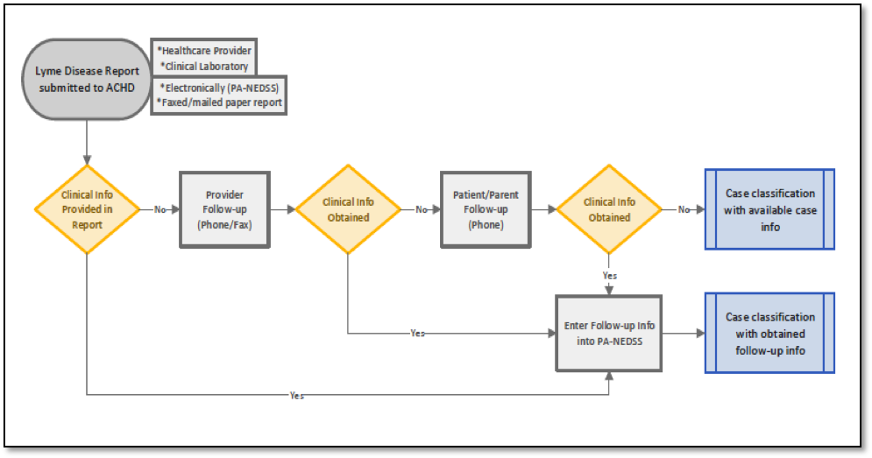
Potential Lyme disease cases are received by the Allegheny County Health Department when a healthcare provider and/or clinical laboratory faxes or mails a paper report to the ACHD or submits an electronic report in PA-NEDSS. If sufficient information about the patient’s symptoms is included in the initial report, no further follow-up is required. If clinical information is not present in the initial report, ACHD staff contacts the healthcare provider by phone or fax with a request for the missing information. If the healthcare provider is unknown or cannot be reached, ACHD staff calls the patient or the patient’s parent if under 18 years of age. A Lyme disease follow-up questionnaire, tailored to interview with either provider or patient, is used to ensure that all necessary clinical information is collected during the interview with the follow-up source. All information obtained through follow-up is entered into PA-NEDSS, and the case is then classified when the Pennsylvania Department of Health runs an algorithm on all collected data.
Figure 1. Flowchart of Lyme Disease Case Investigation Protocol, Allegheny County Health Department, 2014
APPENDIX C: RESULTS
Table 2. Classification Status, All Reported Lyme Disease Cases, Allegheny County, 2014
 | Confirmed |  | Probable |  | Suspected |  | Not a case |  | Total
 | No. | % | No. | % | No. | % | No. | % | No.
Cases | 745 | 51.6 | 65 | 4.5 | 77 | 5.3 | 558 | 38.62 | 1445

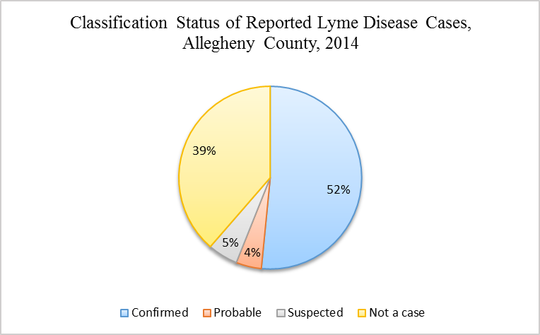
Figure 2. Classification Status, All Reported Lyme Disease Cases, Allegheny County, 2014

Table 3. Classification and Incidence of Confirmed and Probable Lyme Disease Cases, Allegheny County, 2014
 | Confirmed |  | Probable |  | Total
 | No. | % | No. | % | No.
Cases | 745 | 92.0 | 65 | 8.0 | 810
Incidence* | 60.51 |  | 5.28 |  | 65.79
*Cases per 100,000 persons. Calculated with Allegheny County 2014 population estimate: 1,231,255.¹²

Table 4. Confirmed and Probable Lyme Disease Cases by Age Group, Allegheny County, 2014
 | Confirmed |  | Probable |  | Total
Age Group (Years) | No. | % | No. | % | No. | %
0-4 | 29 | 3.58 | 2 | 0.25 | 31 | 3.83
5-9 | 89 | 10.99 | 7 | 0.86 | 96 | 11.85
10-14 | 54 | 6.67 | 2 | 0.25 | 56 | 6.91
15-19 | 32 | 3.95 | 0 | 0.00 | 32 | 3.95
20-24 | 27 | 3.33 | 1 | 0.12 | 28 | 3.46
25-29 | 29 | 3.58 | 1 | 0.12 | 30 | 3.70
30-34 | 28 | 3.46 | 2 | 0.25 | 30 | 3.70
35-39 | 41 | 5.06 | 1 | 0.12 | 42 | 5.19
40-44 | 41 | 5.06 | 1 | 0.12 | 42 | 5.19
45-49 | 42 | 5.19 | 2 | 0.25 | 44 | 5.43
50-54 | 55 | 6.79 | 3 | 0.37 | 58 | 7.16
55-59 | 81 | 10.00 | 9 | 1.11 | 90 | 11.11
60-64 | 71 | 8.77 | 12 | 1.48 | 83 | 10.25
65-69 | 38 | 4.69 | 6 | 0.74 | 44 | 5.43
70-74 | 40 | 4.94 | 6 | 0.74 | 46 | 5.68
75-79 | 27 | 3.33 | 7 | 0.86 | 34 | 4.20
80-84 | 16 | 1.98 | 0 | 0.00 | 16 | 1.98
≥85 | 5 | 0.62 | 3 | 0.37 | 8 | 0.99
Total | 745 | 91.98 | 65 | 8.02 | 810 | 100.00

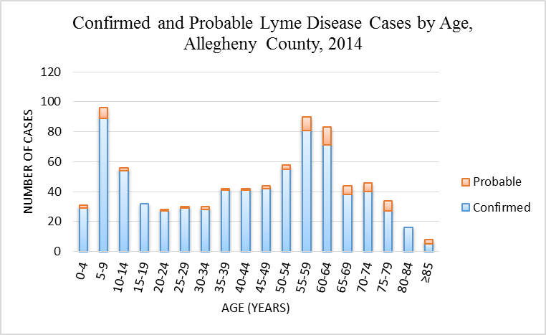
Figure 3. Confirmed and Probable Lyme Disease Cases by Age Group, Allegheny County, 2014

Table 5. Confirmed and Probable Lyme Disease Cases by Sex, Allegheny County, 2014
 | Confirmed |  | Probable |  | Total
Sex | No. | % | No. | % | No. | %
Female | 319 | 39.97 | 18 | 2.26 | 337 | 42.23
Male | 415 | 52.01 | 46 | 5.76 | 461 | 57.77
Total | 745 | 91.98 | 65 | 8.02 | 798* | 100.00
* Data on sex missing for 12 observations.

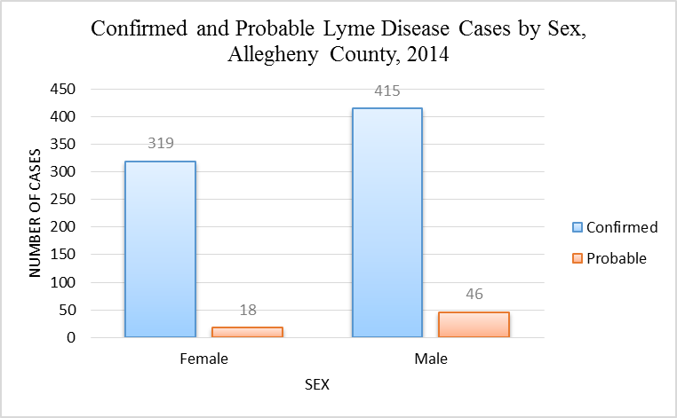
Figure 4. Confirmed and Probable Lyme Disease Cases by Sex, Allegheny County, 2014

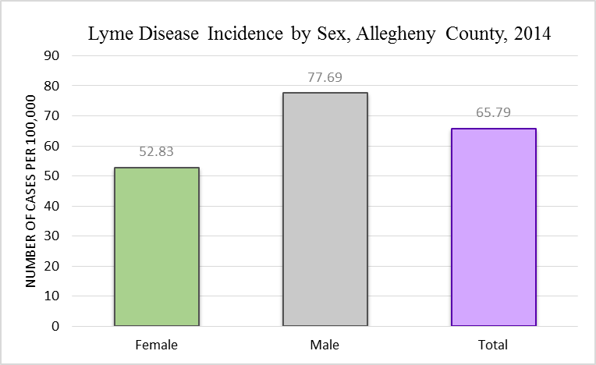
Cases per 100,000 persons. Calculated with Allegheny County 2014 population estimates for total females and males.¹²
Figure 5. Incidence of Confirmed and Probable Lyme Disease Cases by Sex, Allegheny County, 2014

Table 6. Confirmed and Probable Lyme Disease Cases by Sex and Age Group, Allegheny County, 2014
 | Female |  | Male |  | Total
Age Group | No. | % | No. | % | No. | %
0-4 | 20 | 2.51 | 11 | 1.38 | 31 | 3.88
5-9 | 30 | 3.76 | 62 | 7.77 | 92 | 11.53
10-14 | 26 | 3.26 | 30 | 3.76 | 56 | 7.02
15-19 | 6 | 0.75 | 26 | 3.26 | 32 | 4.01
20-24 | 8 | 1.00 | 20 | 2.51 | 28 | 3.51
25-29 | 9 | 1.13 | 21 | 2.63 | 30 | 3.76
30-34 | 9 | 1.13 | 19 | 2.38 | 28 | 3.51
35-39 | 16 | 2.01 | 26 | 3.26 | 42 | 5.26
40-44 | 11 | 1.38 | 29 | 3.63 | 40 | 5.01
45-49 | 20 | 2.51 | 24 | 3.01 | 44 | 5.51
50-54 | 26 | 3.26 | 32 | 4.01 | 58 | 7.27
55-59 | 46 | 5.76 | 41 | 5.14 | 87 | 10.90
60-64 | 42 | 5.26 | 41 | 5.14 | 83 | 10.40
65-69 | 20 | 2.51 | 24 | 3.01 | 44 | 5.51
70-74 | 18 | 2.26 | 27 | 3.38 | 45 | 5.64
75-79 | 14 | 1.75 | 20 | 2.51 | 34 | 4.26
80-84 | 12 | 1.50 | 4 | 0.50 | 16 | 2.01
≥85 | 4 | 0.50 | 4 | 0.50 | 8 | 1.00
Total | 337 | 42.23 | 461 | 57.77 | 798* | 100.00
* Data on sex missing for 12 observations.

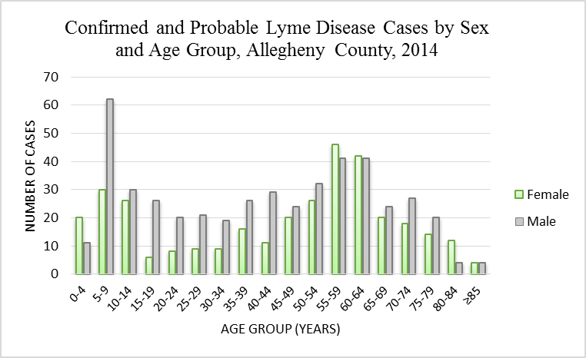
Figure 6. Confirmed and Probable Lyme Disease Cases by Sex and Age Group, Allegheny County, 2014

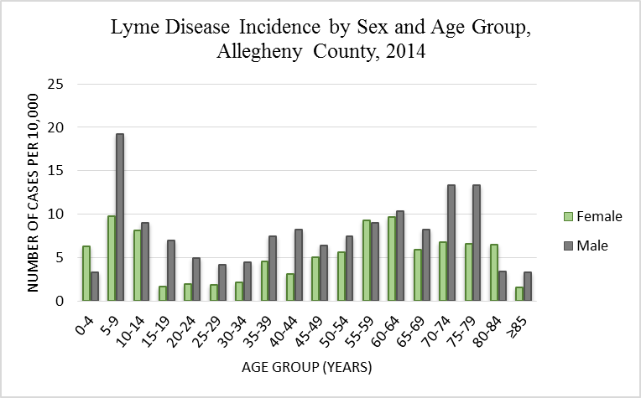
Cases per 10,000 persons. Calculated with Allegheny County 2014 population estimates for females and males per age group.¹²
Figure 7. Incidence of Confirmed and Probable Lyme Disease Cases by Sex and Age Group, Allegheny County, 2014
Table 7. Confirmed and Probable Lyme Disease Cases by Month of Clinical Onset, Allegheny County, 2014
 | Confirmed |  | Probable |  | Total
Month of Onset | No. | % | No. | % | No. | %
January | 5 | 0.76 | 0 | 0.00 | 5 | 0.76
February | 4 | 0.61 | 0 | 0.00 | 4 | 0.61
March | 2 | 0.30 | 0 | 0.00 | 2 | 0.30
April | 6 | 0.91 | 0 | 0.00 | 6 | 0.91
May | 36 | 5.48 | 3 | 0.46 | 39 | 5.94
June | 220 | 33.49 | 19 | 2.89 | 239 | 36.38
July | 190 | 28.92 | 11 | 1.67 | 201 | 30.59
August | 57 | 8.68 | 3 | 0.46 | 60 | 9.13
September | 32 | 4.87 | 1 | 0.15 | 33 | 5.02
October | 32 | 4.87 | 6 | 0.91 | 38 | 5.78
November | 18 | 2.74 | 1 | 0.15 | 19 | 2.89
December | 10 | 1.52 | 1 | 0.15 | 11 | 1.67
Total | 612 | 93.15 | 45 | 6.85 | 657* | 100.00
* Data on month of clinical onset missing for 153 observations.
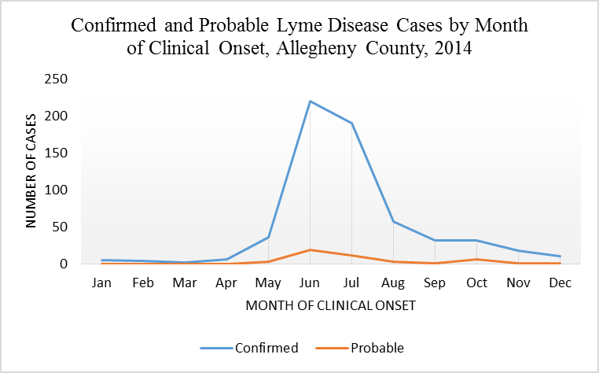
Figure 8. Confirmed and Probable Lyme Disease Cases by Month of Clinical Onset, Allegheny County, 2014
Table 8. Clinical Manifestations of Confirmed Lyme Disease Cases by Symptom, Allegheny County, 2014
Symptom Type | Symptom | No. | %*
Dermatologic | Erythema migrans (≥5 cm diameter) | 522 | 70.07
Musculoskeletal | Arthritis w/brief attacks of joint swelling | 342 | 45.91
Neurologic | Bell’s or facial palsy/cranial neuritis | 61 | 8.19
Neurologic | Radiculoneuropathy | 33 | 4.45
Neurologic | Lymphocytic meningitis | 14 | 1.88
Neurologic | Encephalitis/encephalomyelitis | 5 | 0.67
Cardiovascular | 2nd or 3rd degree atrioventricular block | 6 | 0.81
* Calculated using n=745 total confirmed cases.

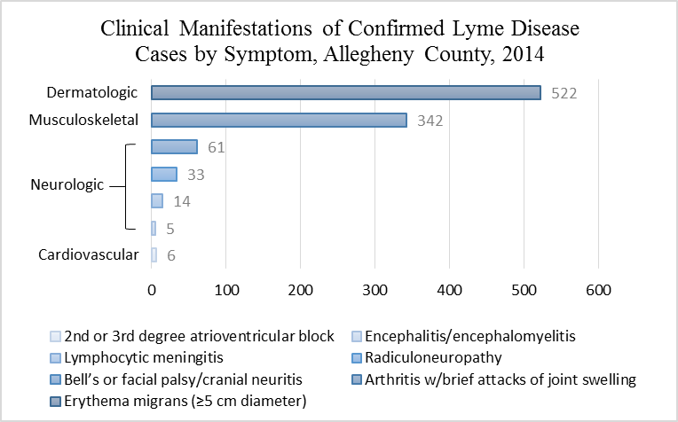
Figure 9. Clinical Manifestations of Confirmed Lyme Disease Cases by Symptom, Allegheny County, 2014

Table 9. Hospitalization in Confirmed and Probable Lyme Disease Cases, Allegheny County, 2014
 | Confirmed |  | Probable |  | Total
 | No. | % | No. | % | No. | %
Hospitalization | 96 | 13.13 | 7 | 0.96 | 103 | 14.09
No Hospitalization | 583 | 79.75 | 45 | 6.16 | 628 | 85.91
Total | 679 | 92.89 | 52 | 7.11 | 731* | 100.00
* Data on hospitalization missing for 79 observations.

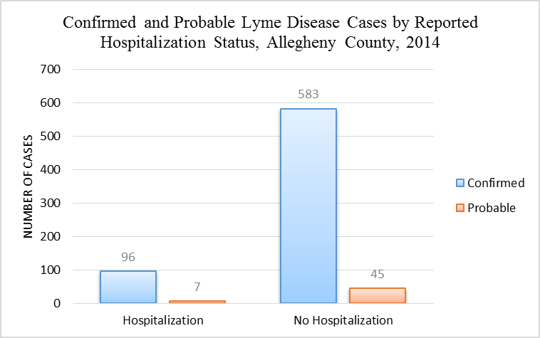
Figure 10. Hospitalization in Confirmed and Probable Lyme Disease Cases, Allegheny County, 2014

Table 10. Reported Known Tick Bite in Confirmed and Probable Lyme Disease Cases, Allegheny County, 2014
 | Confirmed |  | Probable |  | Total
 | No. | % | No. | % | No. | %
Known Tick Bite | 104 | 28.81 | 10 | 2.77 | 114 | 31.58
No Known Tick Bite | 225 | 62.33 | 22 | 6.09 | 247 | 68.42
Total | 329 | 91.14 | 32 | 8.86 | 361* | 100.00
* Data on hospitalization missing for 449 observations.

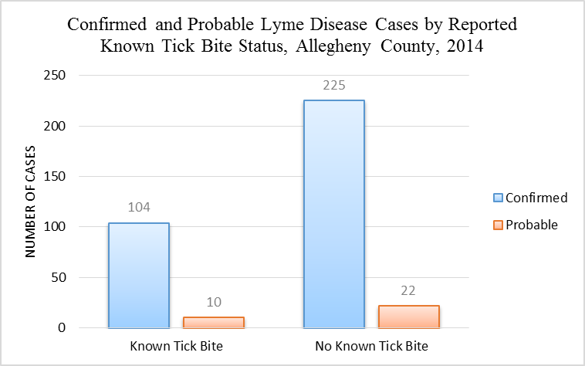
Figure 11. Reported Tick Bite in Confirmed and Probable Lyme Disease Cases, Allegheny County, 2014

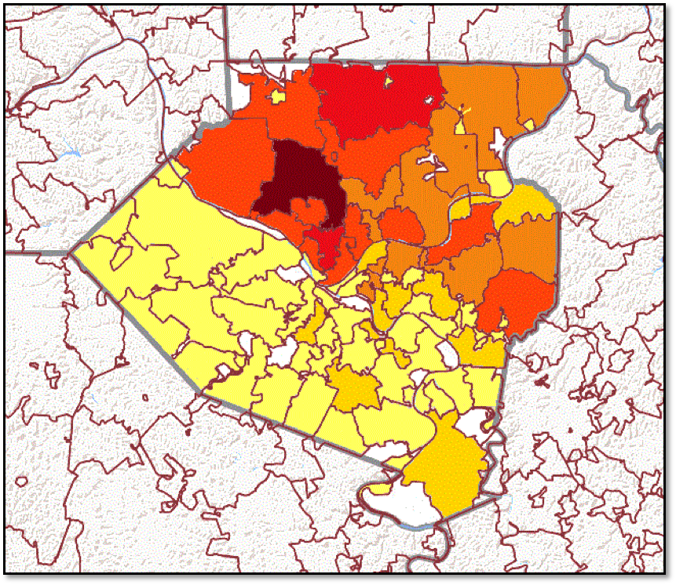
Map adapted from: http://tigerweb.geo.census.gov/tigerweb/ ¹⁵
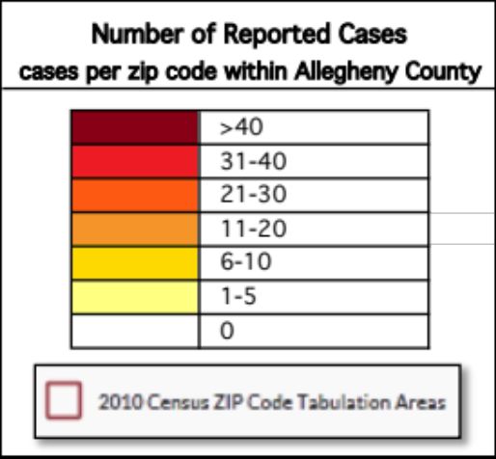
Figure 12. Number of Confirmed and Probable Lyme Disease Cases by Residential Zip Code, Allegheny County, 2014

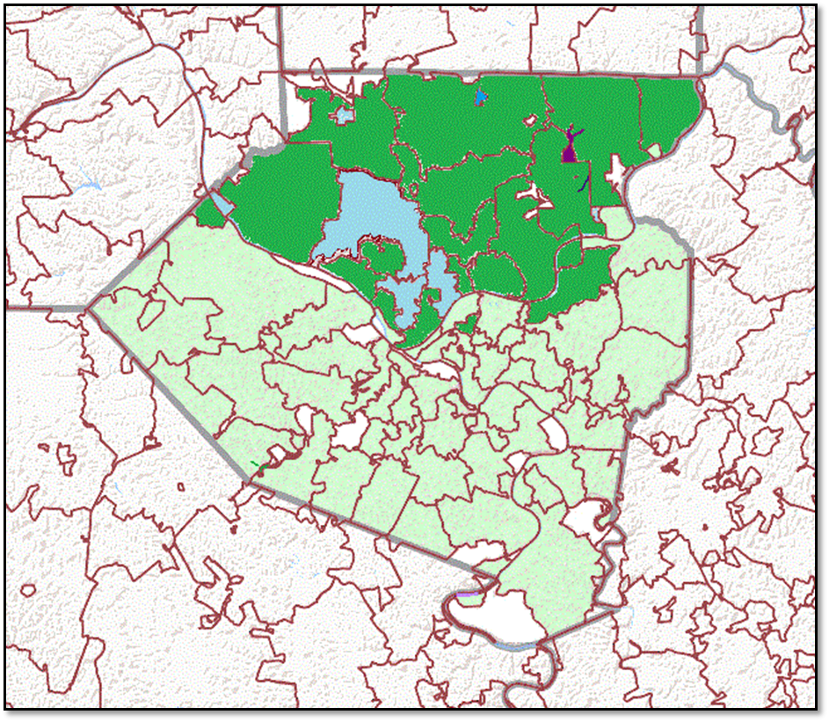
Map adapted from: http://tigerweb.geo.census.gov/tigerweb/ ¹⁵
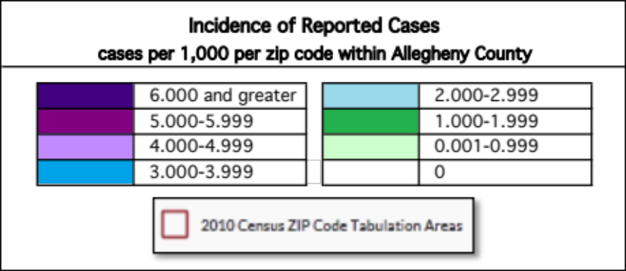
Figure 13. Incidence of Confirmed and Probable Lyme Disease Cases by Residential Zip Code, Allegheny County, 2014

Table 11. Lyme Disease Reports by Month of Investigation Initiation, Allegheny County, 2014
Year | Month | No. | % | Cumulative Frequency | Cumulative %
2014 | January | 16 | 1.11 | 16 | 1.11
2014 | February | 29 | 2.01 | 45 | 3.11
2014 | March | 19 | 1.31 | 64 | 4.43
2014 | April | 21 | 1.45 | 85 | 5.88
2014 | May | 47 | 3.25 | 132 | 9.13
2014 | June | 81 | 5.61 | 213 | 14.74
2014 | July | 473 | 32.73 | 686 | 47.47
2014 | August | 160 | 11.07 | 846 | 58.55
2014 | September | 334 | 23.11 | 1180 | 81.66
2014 | October | 94 | 6.51 | 1274 | 88.17
2014 | November | 67 | 4.64 | 1341 | 92.8
2014 | December | 61 | 4.22 | 1402 | 97.02
2015 | January | 33 | 2.28 | 1435 | 99.31
2015 | February | 10 | 0.69 | 1445 | 100

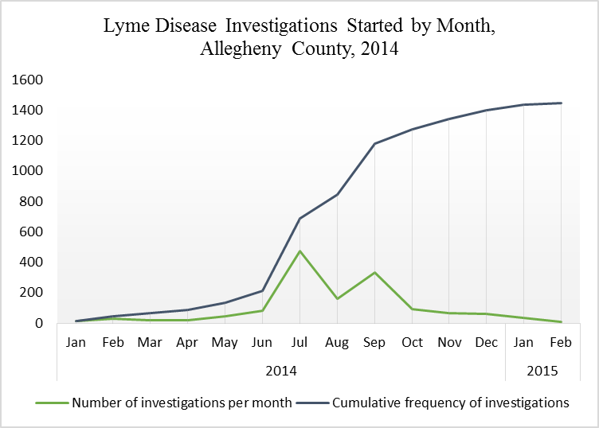
Figure 14. Reports of Lyme Disease by Month of Investigation Initiation, Allegheny County, 2014
Table 12. Lyme Disease Investigation Initial Report Type, Allegheny County, 2014
Report Type | No. | %
Paper (faxed or mailed to ACHD) | 135 | 10.00
Electronic (submitted in PA-NEDSS) | 1215 | 90.00
Total | 1350* | 100.00
* Data on report type missing for 95 observations.

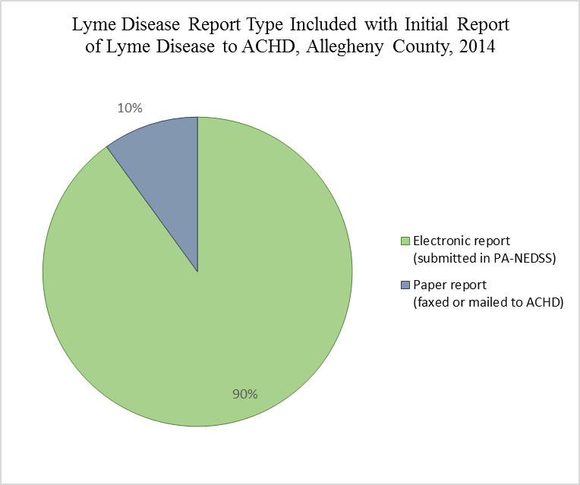
Figure 15. Lyme Disease Investigation Initial Report Type, Allegheny County, 2014

Table 13. Acquisition of Follow-up Data through Lyme Disease Case Investigation, Allegheny County, 2014
Acquisition of Follow-up Data | No. | %
Obtained by health department | 1313 | 90.87
Obtained by other | 37 | 2.56
Not obtained | 95 | 6.57
Total | 1445 | 100.00

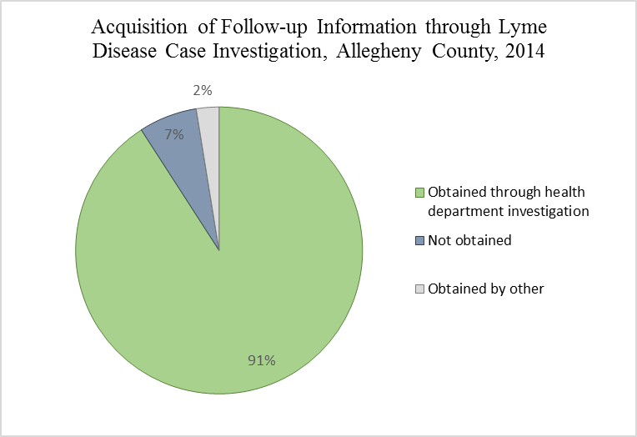
Figure 16. Lyme Disease Investigation Initial Report Type, Allegheny County, 2014

Table 14. Lyme Disease Investigation Follow-up Data Source, Allegheny County, 2014
Follow-up Data Source | No. | %
Provider | 853 | 67.38
Patient or parent of patient | 375 | 29.62
Not applicable | 38 | 3.00
Total | 1266* | 100.00
* Data on follow-up data source missing for 179 observations.

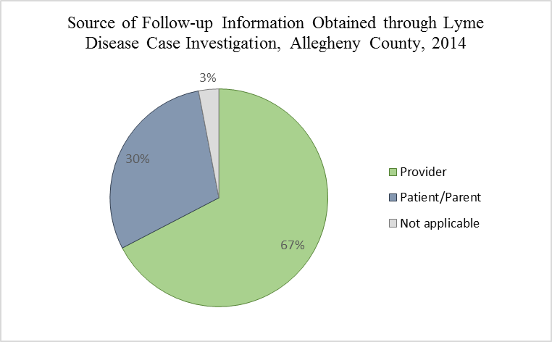
Figure 17. Lyme Disease Investigation Follow-up Data Source, Allegheny County, 2014

Table 15. Lyme Disease Lab Result Included in Initial Report, Allegheny County, 2014
Laboratory Test Result in Initial Report | No. | %
Included | 1376 | 97.8
Not included | 31 | 2.20
Total | 1407* | 100.00
* Data on initial report laboratory test missing for 38 observations.

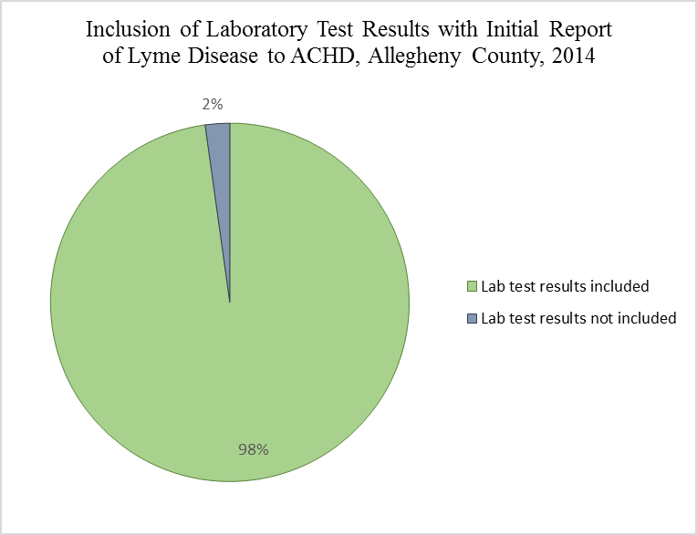
Figure 18. Lyme Disease Lab Result Included in Initial Report, Allegheny County, 2014

Table 16. Lyme Disease Lab Test Results in Initial Report by Specific Test, Allegheny County, 2014
 | EIA/FIA |  | Unspecified Antibody |  | IgM Immunoblot |  | IgG Immunoblot |  | DNA
Lab Result | No. | % | No. | % | No. | % | No. | % | No. | %
Positive | 45 | 3.11 | 219 | 15.16 | 1122 | 77.65 | 426 | 29.48 | 25 | 1.73
Negative | 2 | 0.14 | 4 | 0.28 | 31 | 2.15 | 97 | 6.71 | 2 | 0.14
Equivocal | 2 | 0.14 | 3 | 0.21 | 0 | 0 | 0 | 0 | 0 | 0
Total | 49 | 3.39 | 226 | 15.64 | 1153 | 79.79 | 523 | 36.19 | 27 | 1.87

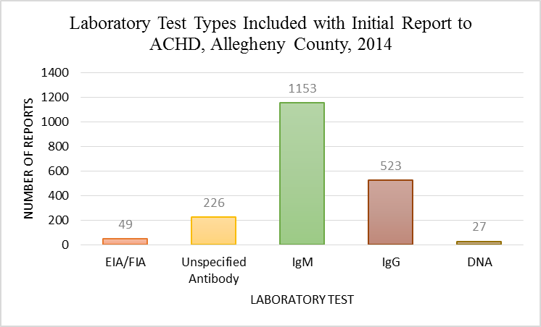
Figure 19. Lyme Disease Lab Test Results in Initial Report by Specific Test, Allegheny County, 2014

Table 17. Positive IgM and IgG Immunoblot Test Results at Initial Report by Classification Status, Allegheny County, 2014
 | Confirmed |  | Probable |  | Suspected |  | Not a case |  | Total
Lab Test Result | No. | % | No. | % | No. | % | No. | % | No. | %
Pos IgM only | 381 | 31.08 | 17 | 1.39 | 5 | 0.41 | 397 | 32.38 | 800 | 65.25
Pos IgG only | 52 | 4.24 | 9 | 0.73 | 26 | 2.12 | 17 | 1.39 | 104 | 8.48
Pos IgM & IgG | 224 | 18.27 | 39 | 3.18 | 30 | 2.45 | 29 | 3.18 | 322 | 26.26
Total | 657 | 53.59 | 65 | 5.30 | 61 | 4.98 | 443 | 36.13 | 1226 | 100.00

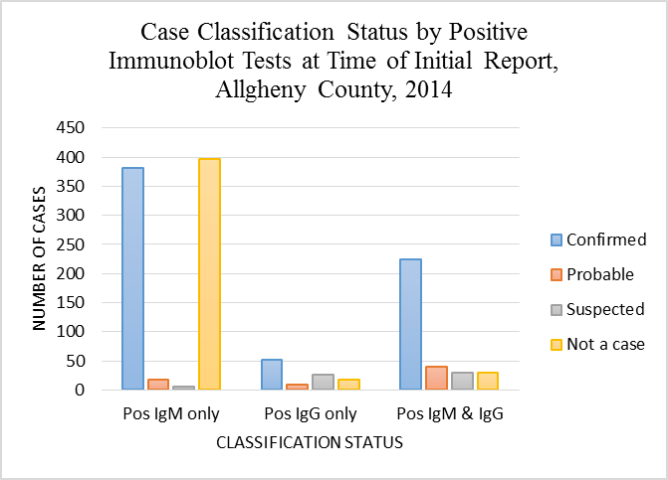
Figure 20. Case Classification Status by Positive IgM and IgG Immunoblot Test Results at Time of Initial Report, Allegheny County, 2014

Table 18. Positive IgM and IgG Immunoblot Test Results at Time of Case Classification by Classification Status, Allegheny County, 2014
 | Confirmed |  | Probable |  | Suspected |  | Not a case |  | Total
Lab Test Result | No. | % | No. | % | No. | % | No. | % | No. | %
Pos IgM only | 365 | 30.34 | 16 | 1.33 | 4 | 0.33 | 396 | 32.92 | 781 | 64.92
Pos IgG only | 57 | 4.74 | 9 | 0.75 | 32 | 2.66 | 6 | 0.50 | 104 | 8.65
Pos IgM & IgG | 222 | 18.45 | 39 | 3.24 | 37 | 3.08 | 20 | 1.66 | 318 | 26.43
Total | 644 | 53.53 | 64 | 5.32 | 73 | 6.07 | 422 | 35.08 | 1203 | 100.00

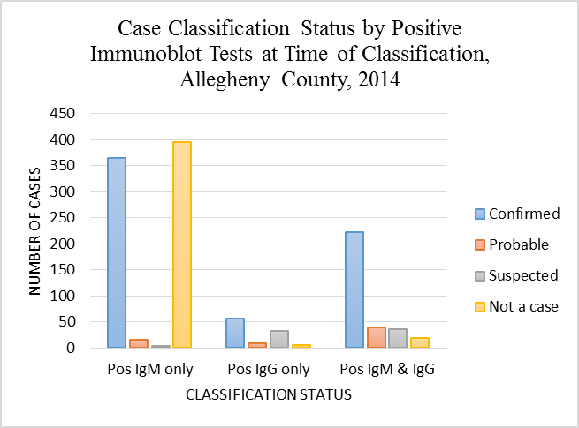
Figure 21. Case Classification Status by Positive IgM and IgG Immunoblot Test Results at Time of Case Classification, Allegheny County, 2014

APPENDIX D: ADDITIONAL DATA

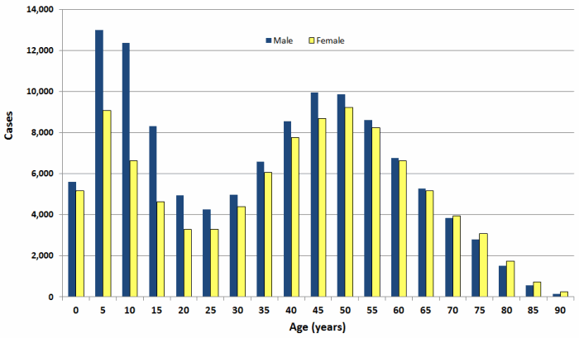
Graphic courtesy of CDC: http://www.cdc.gov/lyme/stats/chartstables/incidencebyagesex.html ¹⁶
Figure 22. Confirmed Lyme Disease Cases by Age and Sex, United States, 2001-2010

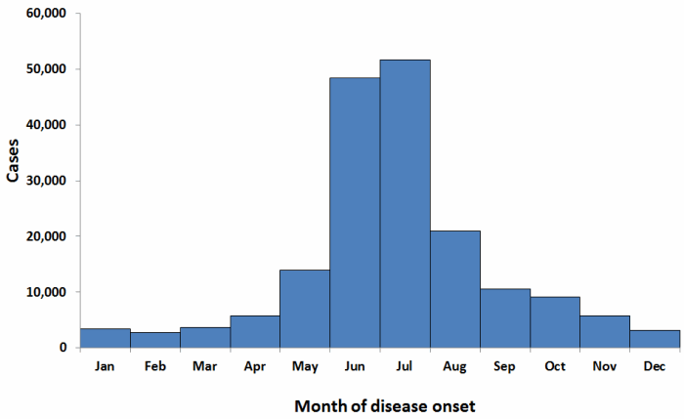
Graphic courtesy of CDC: http://www.cdc.gov/lyme/stats/chartstables/casesbymonth.html ¹⁷
Figure 23. Confirmed Lyme Disease Cases by Month of Disease Onset, United States, 2001-2010

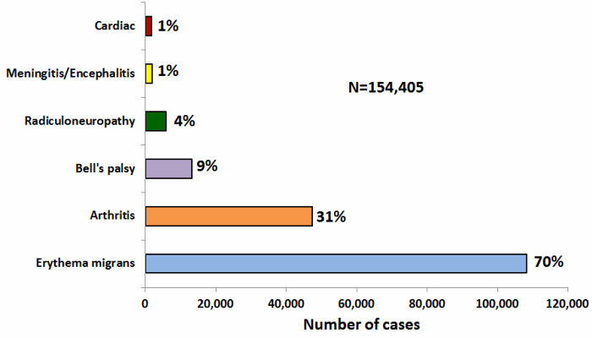
Graphic courtesy of CDC: http://www.cdc.gov/lyme/stats/chartstables/casesbysymptom.html ¹⁸
Figure 24. Clinical Manifestations of Confirmed Lyme Disease Cases, United States, 2001-2010

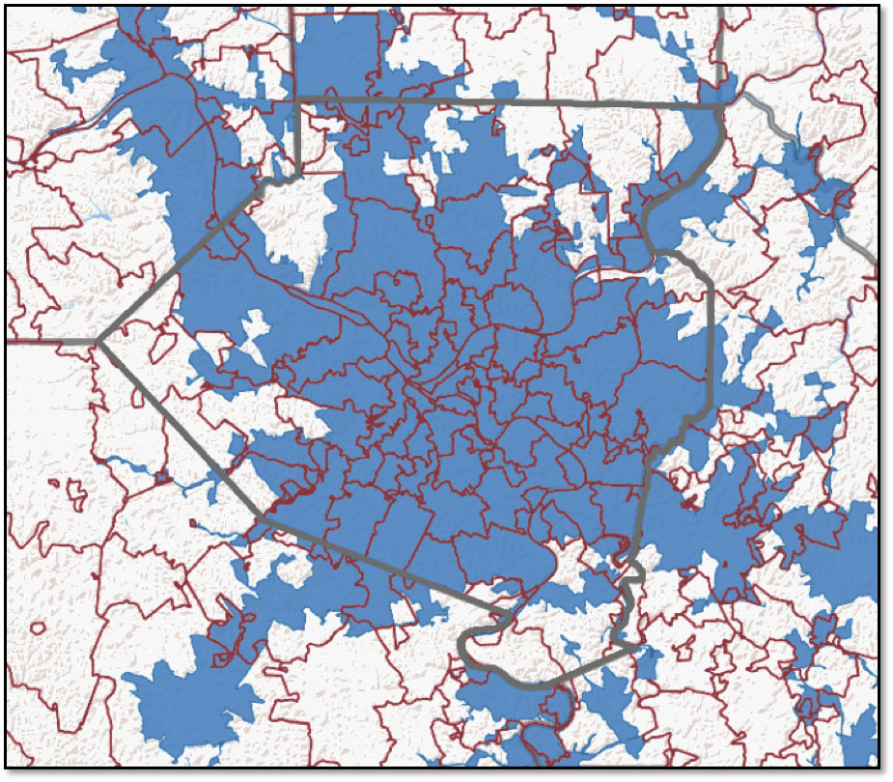
Map adapted from: http://tigerweb.geo.census.gov/tigerweb/ ¹⁵
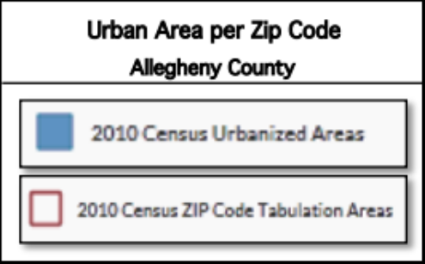
Figure 25. Urban and Rural Areas per Zip Code in Allegheny County, 2010

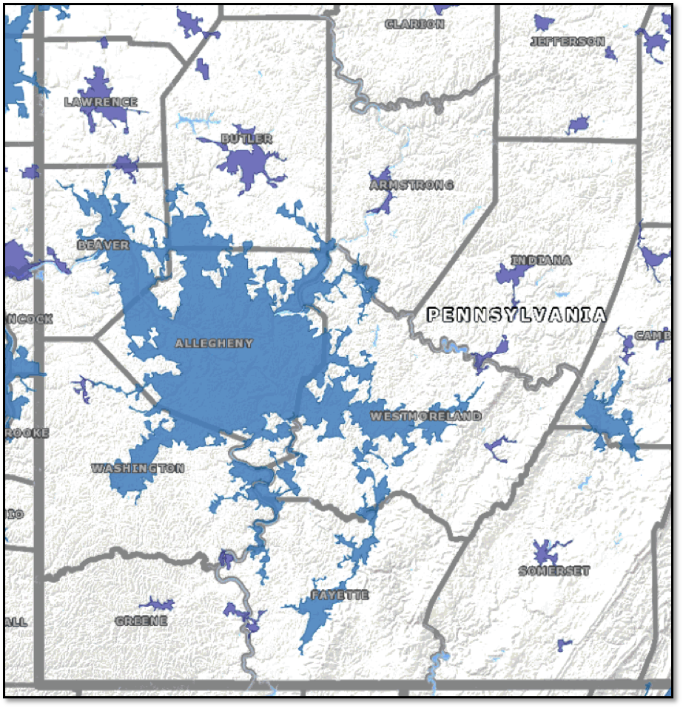
Map adapted from: http://tigerweb.geo.census.gov/tigerweb/ ¹⁵
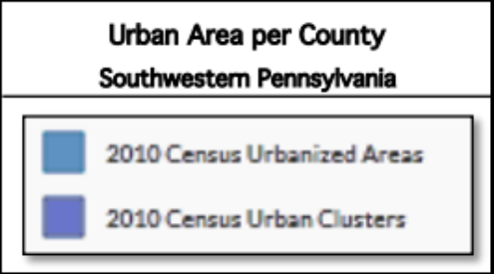
Figure 26. Urban and Rural Areas per County, Southwestern Pennsylvania, 2010

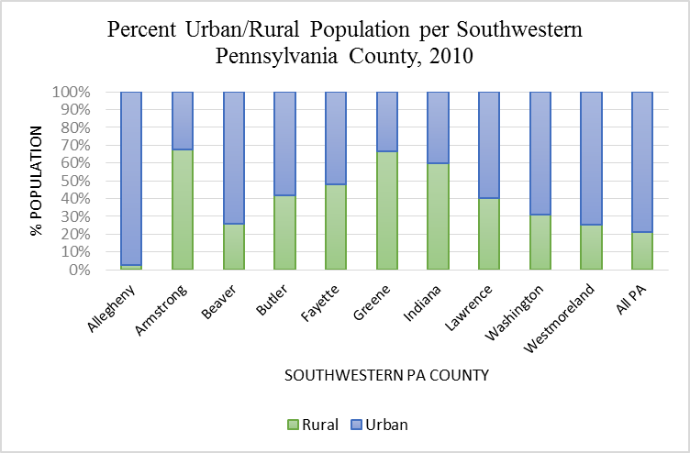
Data obtained from U.S. Census Bureau, 2010 Census, using American FactFinder ¹⁴
Figure 27. Percentage Urban and Rural Population per Southwestern Pennsylvania Counties, 2010

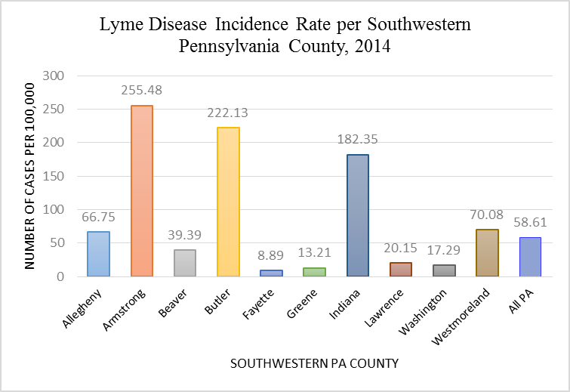
Data obtained from Pennsylvania Department of Health, 2014 Lyme disease report ¹⁹
Figure 28. Lyme Disease Incidence of Select Southwestern Pennsylvania Counties, 2014
BIBLIOGRAPHY
1. Centers for Disease Control and Prevention. (n.d.). Lyme disease. Transmission [Web page]. Retrieved on July 10, 2015, from http://www.cdc.gov/lyme/transmission/index.html
2. National Institute of Allergy and Infectious Diseases. (n.d.). A history of Lyme disease, symptoms, diagnosis, treatment, and prevention [Web page]. Retrieved on July 10, 2015, from http://www.niaid.nih.gov/topics/lymeDisease/Pages/history.aspx
3. Centers for Disease Control and Prevention. (n.d.). Lyme disease. Signs and symptoms [Web page]. Retrieved on July 10, 2015, from http://www.cdc.gov/lyme/signs_symptoms/index.html
4. Centers for Disease Control and Prevention. (n.d.). Lyme disease. What you need to know about Lyme carditis [Web page]. Retrieved on July 10, 2015, from http://www.cdc.gov/lyme/signs_symptoms/lymecarditis.html
5. Centers for Disease Control and Prevention. (n.d.). Lyme disease. Diagnosis and testing [Web page]. Retrieved on July 10, 2015, from http://www.cdc.gov/lyme/diagnosistesting/index.html
6. Centers for Disease Control and Prevention. (n.d.). Lyme disease. Two-step laboratory testing process [Web page]. Retrieved on July 10, 2015, from http://www.cdc.gov/lyme/diagnosistesting/labtest/twostep/index.html
7. Centers for Disease Control and Prevention. (n.d.). Lyme disease. Lyme disease surveillance and available data [Web page]. Retrieved on July 10, 2015, from http://www.cdc.gov/lyme/stats/survfaq.html
8. Centers for Disease Control and Prevention. (n.d.). National Notifiable Diseases Surveillance System (NNDSS). Lyme disease (Borrelia burgdorferi). 2011 case definition [Web page]. Retrieved on July 10, 2015, from http://wwwn.cdc.gov/nndss/conditions/lyme-disease/case-definition/2011/
9. Centers for Disease Control and Prevention. (n.d.). Lyme disease. Data and statistics [Web page]. Retrieved on July 10, 2015, from http://www.cdc.gov/lyme/stats/index.html
10. Centers for Disease Control and Prevention. (n.d.). Lyme disease. How many people get Lyme disease? [Web page]. Retrieved on July 10, 2015, from http://www.cdc.gov/lyme/stats/humancases.html
11. Hutchinson, M. L., Strohecker, M. D., Simmons, T. W., Kyle, A. D., Helwig, M. W. (2015). Prevalence rates of Borrelia burgdorferi (Spirochaetales: Spirochaetaceae), Anaplasma phagocytophilum (Rickettsiales: Anaplasmataceae), and Babesia microti (Piroplasmida: Babesiidae) in host-seeking Ixodes scapularis (Acari: Ixodidae) from Pennsylvania. Journal of Medical Entomology, 52(4), 693-698. doi: http://dx.doi.org.pitt.idm.oclc.org/10.1093/jme/tjv037.
12. U.S. Census Bureau; Annual Estimates of the Resident Population for Selected Age Groups by Sex for the United States, States, Counties, and Puerto Rico Commonwealth and Municipios: April 1, 2010 to July 1, 2014, 2014 Population Estimates; generated by Kristin Komazec; using American FactFinder; <http://factfinder2.census.gov>; (20 July 2015).
13. U.S. Census Bureau; Profile of General Population and Housing Characteristics: 2010, 2010 Demographic Profile Data; generated by Kristin Komazec; using American FactFinder; <http://factfinder2.census.gov>; (20 July 2015).
14. U.S. Census Bureau; URBAN AND RURAL. Universe: Total population, 2010 Census Summary File 1; generated by Kristin Komazec; using American FactFinder; <http://factfinder2.census.gov>; (20 July 2015).
15. U.S. Census Bureau; Geography Division; generated by Kristin Komazec; using TIGERweb; <http://tigerweb.geo.census.gov/tigerweb/>; (20 July 2015).
16. Centers for Disease Control and Prevention. (n.d.). Lyme disease. Cases by age and sex [Web page]. Confirmed Lyme disease cases by age and sex—United States, 2001-2010 [Bar graph]. Retrieved on July 29, 2015, from http://www.cdc.gov/lyme/stats/chartstables/incidencebyagesex.html
17. Centers for Disease Control and Prevention. (n.d.). Lyme disease. Cases by month [Web page]. Confirmed Lyme disease cases by month of disease onset—United States, 2001-2010 [Bar graph]. Retrieved on July 29, 2015, from http://www.cdc.gov/lyme/stats/chartstables/casesbymonth.html
18. Centers for Disease Control and Prevention. (n.d.). Lyme disease. Cases by symptoms [Web page]. Clinical manifestations of confirmed Lyme disease cases—United States, 2001-2010 [Bar graph]. Retrieved on July 29, 2015, from http://www.cdc.gov/lyme/stats/chartstables/casesbysymptom.html
19. Pennsylvania Department of Health. (2015). 2014 Lyme disease report. Retrieved on August 1, 2015, from http://www.health.pa.gov/My%20Health/Diseases%20and%20Conditions/I-L/Pages/Lyme-Disease-.aspx
20. Reily, K. (2014, Aug 2). Cases of Lyme disease on the uptick in the Pittsburgh region. Pittsburgh Post-Gazette. Retrieved on May 15, 2015, from http://www.post-gazette.com/local/region/2014/08/02/Cases-of-Lyme-disease-on-the-uptick-in-the-region/stories/201408010011
21. Feldman, K. (2013). Maryland Department of Health and Mental Hygiene. Lyme disease in 2013: Lessons learned in surveillance [PDF document]. Retrieved on August 14, 2015, from http://www.jhsph.edu/research/centers-and-institutes/mid-atlantic-public-health-training-center/_documents/051513_Lyme_Disease_Feldman.pdf.
22. Pennsylvania Department of Health. (n.d.). What is NEDSS? [Web page]. Retrieved on August 15, 2015, from http://www.portal.state.pa.us/portal/server.pt/community/pa_national_electronic_disease_surveillance_system_(pa-nedss)/14215
23. Templeton, D. (2015, June 10). Lyme disease on the rise, Allegheny County health department records show. Pittsburgh Post-Gazette. Retrieved on July 29, 2015, from http://www.post-gazette.com/local/region/2015/06/10/Lyme-disease-on-the-rise-Allegheny-County-health-department-records-show/stories/201506100195
24. Daly, J. (2015, July 16). Lyme disease a growing threat in Pittsburgh region. Pittsburgh Post-Gazette. Retrieved on July 29, 2015, from http://www.post-gazette.com/news/health/2015/07/16/CDC-Pennsylvania-other-high-risk-areas-for-Lyme-disease-growing-study/stories/201507160155
25. Jones, S. G., Coulter, S., Conner, W. (2013). Using administrative medical claims data to supplement state disease registry systems for reporting zoonotic infections. Journal of the American Medical Informatics Association, 20(1), 193-198. doi: 10.1136/amiajnl-2012-000948
26. Robinson, S. (2014). Lyme disease in Maine: a comparison of NEDSS surveillance data and Maine Health Data Organization Hospital discharge data. Online Journal of Public Health Informatics, 5(3), 231. doi: 10.5210/ojphi.v5i3.4990

