TRENDS IN CARDIOVASCULAR RISK FACTOR MANAGEMENT IN TYPE 1 DIABETES BY SEX: THE PITTSBURGH EDC STUDY

by
Krystal Kapi’olani Swasey
BS, Albright College, 2014

Submitted to the Graduate Faculty of
Epidemiology
Graduate School of Public Health in partial fulfillment
of the requirements for the degree of
Master of Public Health

University of Pittsburgh
2015

UNIVERSITY OF PITTSBURGH
GRADUATE SCHOOL OF PUBLIC HEALTH

This essay is submitted
by
Krystal Kapi’olani Swasey

on

December 11, 2015
and approved by

Essay Advisor:
Tina Costacou, PhD ______________________________________
Assistant Professor
Department of Epidemiology
Graduate School of Public Health
University of Pittsburgh

Essay Reader:
Vincent C. Arena, PhD ______________________________________
Associate Professor
Department of Biostatistics
Graduate School of Public Health
University of Pittsburgh

Copyright © by Krystal Kapi’olani Swasey
2015
ABSTRACT

Background: The Diabetes Control and Complications Trial demonstrated a reduced incidence of microvascular and macrovascular disease with intensive diabetes management among those with type 1 diabetes (T1D). However, to what extent the general T1D population practices intensive management has not been well studied. Our aim was therefore to assess trends in cardiovascular disease risk factors among men and women with T1D. We further evaluated the proportion adhering to the American Diabetes Association’s (ADA) guidelines and recommendations for the prevention of acute and long-term complications of diabetes.
Tina Costacou, PhD

TRENDS IN CARDIOVASCULAR RISK FACTOR MANAGEMENT IN TYPE 1 DIABETES BY SEX: THE PITTSBURGH EDC STUDY
Krystal Kapi’olani Swasey, MPH
University of Pittsburgh, 2015

Methods: We based our investigation on the Pittsburgh Epidemiology of Diabetes Complications (EDC) study of individuals with childhood-onset T1D (n=658; 325 women, 333 men). At baseline, the mean age was 28 years and the mean diabetes duration was 19 years. Following a clinical exam at study entry, participants have been followed biennially for up to 20 years. We assessed the proportion of EDC participants at each clinical examination adhering to the ADA Recommendations. Participant adherence to intensive insulin therapy and statin use was also assessed.
Results: During 20 years of follow-up, adherence to ADA recommendations increased for HbA_{1c} (from 9.6 to 35.2%, p<0.0001) but decreased for blood pressure (from 89.7 to 74.8%, p<0.0001) and LDL cholesterol (from 62.7 to 40.7%, p<0.0001). Adoption of intensive insulin therapy (from 5.9 to 46.8%, p<0.0001) and statin use (from 0.16 to 39.7%, p<0.0001) increased throughout the follow-up period as well. Women were significantly more likely to be on intensive insulin therapy and to meet guidelines for blood pressure than men. Overall, the proportion of the cohort meeting all four ADA recommendations increased by 4.5% (from 6.8 to 11.3%, p=0.02).
Conclusion: These results suggest that, although the adoption of intensive insulin therapy, statin use, and HbA_{1c} recommendation compliance are increasing, recommendation compliance is still low. Greater emphasis should be placed on blood pressure and lipid control among individuals with T1D. The relevance of these findings to public health is substantial in that it reveals the small proportion adhering to all four ADA guidelines, and demonstrates a serious need for the majority of this population to improve intensive diabetes management practices.

TABLE OF CONTENTS
1.0 Introduction 1
2.0 RESEARCH DESIGN AND METHODS 3
2.1 CARDIOVASCULAR DISEASE RISK FACTORS 3
2.2 AMERICAN DIABETES ASSOCIATION (ADA) CLINICAL PRACTICE RECOMMENDATIONS 5
2.3 ANALYTICAL STRATEGY 5
3.0 RESULTS 7
3.1 BASELINE CHARACTERISTICS 7
3.2 TRENDS IN GLYCEMIC CONTROL 8
3.3 TRENDS IN LIPID AND BLOOD PRESSURE CONTROL 9
3.4 TRENDS IN OVERWEIGHT/OBESITY 10
3.5 AGE 11
4.0 DISCUSSION 12
appendix a: TABLES 19
APPENDIX b: FIGURES 27
bibliography 34
List of tables
Table 1. Participant Characteristics at Study Entry 19
Table 2. ADA Recommendation Goals by Year 20
Table 3. Proportion of Total Cohort Meeting Recommended Goals 21
Table 4. Proportion of Total Cohort who are Overweight, Obese, using Intensive Insulin Therapy, or using Statins 22
Table 5. Proportion of Men and Women Meeting Recommended Goals 23
Table 6. Proportion of Men and Women who are Overweight, Obese, use Intensive Insulin Therapy, or use Statins 24
Table 7. Proportion of Patients Aged 35-45 Years Old Meeting ADA Recommendations 25
Table 8. Proportion of Patients Age 35-45 Years Old who are Overweight, Obese, use Intensive Insulin Therapy, or use Statins 26
LIST OF FIGURES
Figure 1. Trends in Intensive Therapy and Mean HbA1c 27
Figure 2. Trends in Statin Use and LDL Cholesterol Recommendations Met 28
Figure 3. Trends in Blood Pressure Recommendations Met 29
Figure 4. Trends in Triglyceride Recommendations Met 30
Figure 5. Proportion that Meets All ADA Recommendations 31
Figure 6. Proportion Meeting Zero, One, Two, Three, and Four Recommendations at Study Entry (1986-1988) 32
Figure 7. Proportion Meeting Zero, One, Two, Three, and Four Recommendations at Last Cycle (2004-2006) 33
preface

Type 1 diabetes is a topic that near and dear to my heart. When presented with the opportunity to participate in research involving this population, I immediately agreed without question. The internship that allowed me to create this paper helped to fulfil my long-standing goal of participating in type 1 diabetes research. I am immensely grateful that I was able to contribute to this growing field of knowledge. Not only did it afford me the chance to learn more about this cohort of individuals, but I also learned about myself in the process. This opportunity has further solidified that I want to focus on type 1 diabetes research in my future career.
I would first like to thank Dr. Trevor Orchard for giving me the opportunity to conduct analyses on this impressively long-running prospective cohort of individuals with childhood-onset type 1 diabetes. Thank you also to the staff of the Pittsburgh EDC Study who assisted me during the summer of my internship. Last, but certainly not least, I would like to give many thanks to my advisor Dr. Tina Costacou, who has been a positive, endearing, and supportive presence throughout my entire time here at Pitt Public Health. I am extremely grateful for your outstanding mentorship and your sincere interest in my success.

Introduction
The incidence of type 1 diabetes continues to increase annually (1), and with that comes a growing concern for the burden posed by diabetes-associated microvascular and macrovascular complications (2, 3). Increased risk of cardiovascular disease (CVD) has been repeatedly recognized as a complication of type 1 diabetes, with up to 10-fold higher event rates than in the general population (4). There are multiple modifiable risk factors, such as HbA_{1c}, blood pressure, lipids, smoking, and obesity status, which could be intervened upon to reduce CVD risk in type 1 diabetes (5). Indeed, results from the Diabetes Control and Complications Trial (DCCT) demonstrated that intensive diabetes management greatly reduces the development and progression of micro- (6) and macro-vascular (7) disease in type 1 diabetes, revolutionizing care for these individuals. Unfortunately, years after the advent of intensive insulin therapy, the rates of CVD are still higher in type 1 diabetes compared to the general population, leading to the conclusions that tighter control of non-glycemic factors would be most beneficial. However, to what extent improvements in cardiovascular risk factor control have occurred in the general type 1 diabetes population and whether they may differ between men and women, is not clear. As a result, in the present study, we aimed to assess trends in CVD risk factors among men and women over the 25-year follow-up of a cohort study of individuals with childhood-onset type 1 diabetes.
For more than 20 years, the American Diabetes Association (ADA) has disseminated their key recommendations for diabetes care standards and guidelines in an attempt to increase self-management education (8). Their therapeutic recommendations for glycemic goals, blood pressure control, and lipid management help support patients in the prevention of acute complications and the reduction of the risks associated with long-term complications (8). Understanding what these guidelines entail and the proportion of individuals who adhere to them may give insight into what areas of care need to be more emphasized within the type 1 diabetic population. We therefore also aimed to determine the proportion of individuals within this type 1 diabetes cohort adhering to guidelines set by the ADA for the prevention and management of diabetes complications.

RESEARCH DESIGN AND METHODS
The Pittsburgh Epidemiology of Diabetes Complications (EDC) study is a historical prospective cohort study of risk factors for complications resulting from childhood-onset (<17 years old) type 1 diabetes. Participants were either diagnosed or seen within 1 year of diagnosis at Children’s Hospital of Pittsburgh between 1950 and 1980. The cohort, which has been shown to be representative of the Allegheny County, Pennsylvania, type 1 diabetes population (9), has been described in detail elsewhere (10). Briefly, participants have been followed by survey since initial examination in 1986-1988, with biennial surveys throughout the follow-up period and study examinations occurring biennially for the first 10 years and again at 18 and 25 years of follow-up. The study protocol was approved by the University of Pittsburgh Institutional Review Board, and all participants provided written informed consent.

CARDIOVASCULAR DISEASE RISK FACTORS
At each biennial follow-up, information was collected by questionnaire concerning demographic characteristics, health care, self-care, medical history, the Beck Depression Inventory (BDI) for those >18 years old (11), and the Harvard Alumni Study physical activity questionnaire (12).
At each exam, sitting blood pressures were measured using a random-zero sphygmomanometer, according to the Hypertension Detection and Follow-up Program protocol (13). The mean of the second and third blood pressures was determined and hypertension was defined as blood pressure >140/90 mmHg or use of antihypertensive medication in Table 1 and as defined by the ADA in other analyses. Fasting blood samples were taken for measurement of lipids. HDL-cholesterol was determined by a precipitation technique (heparin and manganese chloride) with a modification (14) of the Lipid Research Clinics method (15). Total cholesterol and triglycerides were measured enzymatically (16, 17). Fasting blood samples were analyzed for HbA₁ (microcolumn cation-exchange; Isolab, Akron, OH) for the first 18 months, after which automated high-performance liquid chromatography (Diamat; Bio-Rad, Hercules, CA; correlation r=0.95) was performed for 10 years. For follow-up beyond the 10 years, HbA_{1c} was measured with the DCA 2000 analyzer (Bayer, Tarrytown, NY, USA). The DCA and Diamat assays were highly correlated (r=0.95). Original HbA₁ (1986-1998) and HbA_{1c} values (1998-2004) were converted to DCCT aligned standard HbA_{1c} values using regression formulae derived from duplicate assays (DCCT HbA_{1c} = (0.83 × DIAMAT HbA₁) + 0.14 and DCCT HbA_{1c} = (DCA HbA_{1c} – 1.13) / 0.81). Heights and weights were measured during clinic visits and BMI was calculated as weight (kg) / height (m)². Intensive insulin therapy was defined as the participant’s use of multiple daily insulin, which included more than three shots daily or the use of an insulin pump, as well as checking glucose greater than 28 times weekly. Amputation was determined by patient self-report, and claudication was determined by the Rose questionnaire (18). Incidence stroke was assessed biennially via survey, and medical records were obtained to verify stroke occurrence and type. Stroke was therefore defined as a neurological deficit of acute onset lasting 24 hours or more, without other evident cause.

AMERICAN DIABETES ASSOCIATION (ADA) CLINICAL PRACTICE RECOMMENDATIONS
The ADA recommendations for appropriate HbA1c, blood pressure, LDL cholesterol, and triglyceride levels for people with diabetes were compiled (19-32). Although the guidelines are not always specific to type 1 diabetes, they are still appropriate for any adult with a diabetes diagnosis. EDC participants were subsequently classified as adhering, or not, to recommendations at each clinical assessment during the study follow-up, using those recommendations that more closely corresponded to the specific study period. However, the 1995 recommendations (22) were also used as guidelines for EDC assessments from study entry to the 1994-1996 examination period for all risk factors of the previous years, excluding blood pressure, as it was the first year complete guideline information was made available. Blood pressure guidelines were retrieved from the Joint National Committee on Prevention, Detection, Evaluation, and Treatment of High Blood Pressure (33-35).

ANALYTICAL STRATEGY
Descriptive statistics, including means and frequencies, were conducted to examine the distribution and counts of the data. Differences in demographic and clinical characteristics between men and women were evaluated using the Wilcoxon two-sample test for continuous variables and the χ² test for categorical variables. A χ² test was also used for the analysis of trends from 1986-2006. Differences were considered statistically significant at the p<0.05 level. SAS version 9.4 (SAS Institute, Cary, NC) was used for all analyses.

RESULTS

BASELINE CHARACTERISTICS
A total of 658 individuals (333 males and 325 females) with type 1 diabetes were assessed at baseline. The baseline characteristics for the total cohort, as well as the characteristics stratified by gender, are presented in Table 1. Overall, the median (interquartile range) age and duration of diabetes were 27 (21.9, 33.3) years and 18.5 (5.1, 11.5) years, respectively. HbA_{1c} was high for both men and women, with an overall median of 8.6% (7.7%, 9.7%). The cohort had a median body mass index (BMI) of 23.3 (21.4, 25.4) kg/m². A greater proportion of women compared to men were obese (4.3 vs. 1.8%, respectively, p = 0.06), but the waist to hip ratio (WHR) was significantly higher, as expected, in men (0.87 (0.84, 0.90)) than in women (0.77 (0.74, 0.81), p < 0.0001). Men also had significantly higher systolic and diastolic blood pressure than women (p < 0.0001), and as a result, the proportion of men who had hypertension was greater as well (36.6 vs. 20.3%, respectively, p < 0.0001). Non-HDL cholesterol was higher in men (132.5 (109.3, 164.4)) mg/dl compared to women (125.6 (105.2, 157.2) mg/dl, whereas women, as in the general population, had significantly higher HDL cholesterol than men (p < 0.0001).
The guidelines set by the American Diabetes Association (ADA) for the prevention and management of diabetes complications are presented in Table 2. The ADA recommendations for HbA_{1c}, blood pressure, LDL cholesterol with and without overt CVD, and triglycerides are listed from 1995 to 2014. Overt CVD was defined as a participant having a history of or experiencing incident claudication, amputation due to vascular causes, and/or stroke during follow up.
The proportion of the total cohort, as well as for men and women separately, meeting recommendations is shown in Table 3, Table 4, Table 5, and Table 6. Since there was not complete recommendation information available during the initiation of the EDC study and for a few years afterward, the 1995 guidelines were used for all recommendations prior to and including that year. As a result of limited available data, the 1998-2000 and the 2006-2008 cycles were excluded from analysis.

TRENDS IN GLYCEMIC CONTROL
From baseline to the 2004-2006 cycle, Table 3 illustrates that the proportion of individuals meeting the HbA_{1c} recommendation has increased from 9.6% to 35.2% (p<0.0001), following the increased proportion of individuals using intensive insulin therapy (5.9% to 46.8%, p<0.0001) seen in Table 4. Table 6 shows that women are significantly more likely to be on insulin therapy, compared to men, with differences generally observed throughout the follow-up period. Table 3 also shows that HbA_{1c} adherence has increased from 10.3% to 36.2% (p<0.0001) and from 9.0% to 34.2% (p<0.0001), respectively.
Figure 1 graphically illustrates the trend in intensive therapy and mean HbA_{1c} for the cohort from baseline to the 2004-2006 cycle. Over time, the proportion of the cohort who is on intensive insulin therapy has increased by 693% (p<0.0001), coinciding with a significant decrease in mean HbA_{1c} of 11.5% (p<0.0001).

TRENDS IN LIPID AND BLOOD PRESSURE CONTROL
Figure 2 shows that statin use increased throughout follow up, improving from 0.16% to 39.7% (p<0.0001). However, this increase was accompanied by a decrease in LDL cholesterol guidelines met, with adherence dropping from 62.7% to 40.7% (p<0.0001). Table 3 shows that adherence to blood pressure guidelines has also declined, decreasing from 89.7% to 74.8% (p<0.0001) from baseline to the 2004-2006 cycle. There was no significant change in the proportion of individuals following triglyceride guidelines over time.
Although the use of statins improved for both genders during follow up (p<0.0001), men consistently used statin therapy more often than women, with a significant difference between genders during the 2000-2004 cycle (p=0.001). Both men and women experienced decreases in the proportion of those who met blood pressure guidelines, but Figure 3 shows that women are meeting these recommendations more than men, with significant differences by gender generally observed throughout the follow-up period. Over the 25 year follow up, adherence to LDL cholesterol guidelines has decreased from 60.1% to 34.7% (p<0.0001) in men and from 65.4% to 46.5% (p<0.0001) in women. Shown in Figure 2, women met LDL guidelines more than men, but given that most of the comparisons in each cycle are not significant, in general, no gender differences were observed. Figure 4 depicts the differences between men and women in the triglyceride recommendations met. The proportion of individuals meeting triglyceride guidelines has remained consistently high from baseline to the 2004-2006 cycle, with a non-significant trend in both genders. However, women were significantly more likely to meet triglyceride guidelines than men during the 1986-1988 (p=0.01) and the 2004-2006 (p=0.04) cycles.

TRENDS IN OVERWEIGHT/OBESITY
In the total cohort (Table 4) both overweight status (p<0.0001) and obesity status (p<0.0001) increased throughout the follow up period. The men in this cohort are more likely to be overweight than the women, with a significant difference at the 1990-1992 cycle (p=0.02), seen in Table 6. However, a greater proportion of women are more obese than the men, with a significant difference between the genders seen in the 1988-1990 cycle (p=0.01). The proportion of men who are overweight increased from 30.9% to 66.7% (p<0.0001), and the proportion of women who are overweight increased from 28.7% to 62.2% (p<0.0001). Likewise, the proportion of men who are obese increased from 1.8% to 22.4% (p<0.0001), compared to the proportion of women, which increased from 4.3% to 22.5% (p<0.0001).
Overall, the proportion of individuals in this cohort who were able to meet all four ADA recommendations increased from 6.8% at baseline to 11.3% by the end of the follow-up period (p=0.02). Figure 5 shows that, although not statistically significant, women were more likely to meet all recommendations than men. Figures 6 and 7 depict the proportion meeting zero, one, two, three, or all four ADA guidelines at baseline and at the last cycle. At baseline, most participants meet three out of the four recommendations at 52%, while only 7% meet all four, and 4% fail to meet any recommendations. During the last cycle, about a third of the participants meet two or three recommendations. The proportion meeting all four increased to 11%, but 5% still fail to follow any of the guidelines.

AGE
To account for the aging of the cohort, and thus, the increasing or decreasing trends of particular modifiable factors as part of normal aging, we repeated analyses restricting the cohort to those aged 35-45 years old at each cycle. Our findings suggest that, as in the entire cohort, the proportion of 35-45 year olds meeting HbA_{1c} recommendations increase over time, as did the proportion on IIT, statins, and of overweight or obesity, seen in Table 7 and Table 8 (all p<0.0001). Also similar to the total cohort, there was a significant decreasing trend in the proportion meeting blood pressure recommendations (p=0.03) among the 35-45 age group. No significant trends were observed over time in the proportion meeting guidelines for LDL cholesterol and triglycerides.

DISCUSSION
In this cohort of individuals with childhood-onset type 1 diabetes, we observed that the proportion adhering to the ADA recommendations for HbA_{1c} increased, whereas the proportion following the ADA recommendations met for blood pressure, LDL cholesterol, and triglycerides gradually decreased over the 25-year follow up period, suggestive perhaps of the aging of the population. When analyses were restricted to individuals age 35-45 years at each time point, however, a significant decrease was only for the proportion adhering to blood pressure recommendations. Overall adoption of IIT and use of statins increased over time, as did the percentage classified as overweight or obese, whereas no significant trends were observed for adherence to lipid recommendations.
At the latest follow-up examination cycle (2004-2006), the highest proportion of ADA recommendations met for the cohort was for triglycerides at 89.9%, and the lowest proportion of recommendations met was for HbA_{1c} at 35.2%. Less than one-fifth of the cohort met all four recommendations, with most individuals meeting either two or three recommendations. Thus, our findings suggest that a very small proportion of EDC study participants currently adhere to recommendations for all risk factors evaluated, suggesting that more needs to be done in terms of improving control of individual factors.
Indeed, although glycemic control is getting better, it is still suboptimal. This is concerning given the findings from DCCT/EDIC that intensive diabetes control is associated with decreases in the incidence of both microvascular complications and CVD complications (7,44). The reduction in the incidence of macrovascular events in this study was 58% with intensive compared to conventional therapy (36).
Despite the encouraging clinical trial results, the incidence of cardiovascular disease in the general type 1 diabetes population has not declined as sharply as the incidence of microvascular complications. As shown in the EDC study, notwithstanding a major decline in total mortality and renal failure rates in individuals born after the mid-1960s, and in neuropathy for those diagnosed in the 1970s, rates of decline for cardiovascular disease were low (37). Since there was no improvement in either blood pressure or lipid levels in this study, regardless of a significant decrease in HbA1c (37), results would suggest that management of other cardiovascular risk factors, in addition to glycemic control, may be required to observe a greater decline in CVD rates.
Generally, hyperlipidemia is not a feature of type 1 diabetes. This is reflected in our study results, suggesting that the proportion with triglyceride concentrations within the recommended levels was high and not altered over the follow-up period, although LDL cholesterol management appeared to worsen over time. Restricting the analysis to individuals between the ages of 35 and 45 at each time point, however, showed no downward trends, suggesting that the observed decline in the proportion meeting guidelines in the total cohort was related to aging. The general drop in LDL cholesterol recommendations met over time experienced by the total cohort paralleled a slower, yet statistically significant, increasing trend toward adoption of lipid lowering therapy, i.e. statin use. Although no significant differences were observed by gender in the proportion meeting LDL-C guidelines, men were slightly more likely to be on statin therapy compared to women. Unfortunately, the data presented in this manuscript do not allow us to make conclusions on whether a greater proportion of men exhibited higher LDL concentrations, mandating the prescription of statins, or whether a similar proportion of men and women had elevated LDL-C concentrations but that men were more frequently seen and/or prescribed medications by physicians. The DCCT/EDIC study, however, has previously shown that CVD reducing interventions are underused in women compared to men with type 1 diabetes, even when women present with a more adverse risk factor profile (38). Conversely, Kautzky-Willer et al. found that women had a lower adherence to pharmacological intervention than men, including the prescription of statins and the achievement of lipid goals, among individuals younger than 50 years at increased cardiovascular risk (39). The reasons for this discrepancy are not clear, though differences in the populations (USA vs. Europe), socioeconomic status (including health insurance status) and the nature of assessment (self-report) could have contributed.
Blood pressure control also appeared to worsen over time overall, as well as among 35-45 year olds at each time point. It was the only ADA recommended modifiable factor that showed significant gender differences, with women meeting recommendations more often than men. DCCT/EDIC investigators have previously suggested that male sex is associated with increased hypertension risk (40), a finding we were able to replicate in the EDC cohort.
Of great concern is the increasing prevalence of overweight and obesity in the type 1 diabetes population, since excess weight gain plays a major role in CVD risk. It is possible that these increasing trends in overweight and obesity are the result of increased adoption of intensive insulin therapy. Indeed, according to DCCT study findings, intensive insulin therapy is associated with weight gain (41), which when excessive, promotes adverse changes in lipid levels and blood pressure despite the concurrent improvement in glycemic levels (42). More recently, DCCT/EDIC investigators further observed a significant association between excessive weight with the use of intensive insulin therapy and increased risk of macrovascular disease, potentially mediated by lipid and metabolic changes (41).
Though we have not evaluated its association with complication incidence in this study, our results also suggest that significant increases in IIT use are accompanied by increases in the prevalence of overweight and obesity. Insulin is known to promote weight gain by stimulating lipogenesis, inhibiting protein catabolism, and slowing basal metabolism (43). However, IIT cannot be solely responsible for the dramatic weight gain in the type 1 diabetes population. Obesity may in fact be increasing regardless of intensive insulin therapy as suggested by a study comparing the prevalence of overweight among children with newly onset type 1 diabetes at two time points approximately 10 years apart. Investigators observed that the prevalence of overweight increased 5-fold, now similar to the prevalence of overweight in the general population at the most recent follow-up (44). Moreover, optimizing therapy can still be achieved without inducing weight gain, but doing so requires control of both insulin dosage and carbohydrate counting. By reducing basal rate insulin, improving methods for carbohydrate counting, and increasing meal-time bolus delivery, participants of one study experienced little to no weight gain, along with a decrease in rates of hypoglycemia (45). Working with physicians to optimize basal rates and adjust insulin-to-carbohydrate ratios, as well as revisiting carbohydrate counting with a diabetes educator may result in a decline of the prevalence of overweight and obesity in this population.
It should be mentioned, however, that increasing body weight in individuals with type 1 diabetes may not be as damaging as it is in the general population. The amount of adiposity may be more important than being overweight. Experiencing moderate weight gain with concurrent improvements in glycemic control positively affected the cardiovascular risk profile of participants in a previous study (46). Likewise, even though adiposity is positively associated with the presence of coronary artery calcification (CAC), we have previously shown that among those with measurable CAC, a relationship between adiposity and the extent of CAC is either lacking or inverse (47).
In general, no gender differences were observed in cardiovascular disease risk factors although women were significantly more likely to be using IIT and to meet guidelines for blood pressure than men. In the general population, cardiovascular disease unevenly affects men more than women (48), but this gender difference is not present among individuals with type 1 diabetes. The protective effect experienced by women in the general population has greatly diminished for women with type 1 diabetes (49). It has been suggested that increased adiposity, and subsequent dyslipidemia, hyperglycemia, and hypertension may lead to this increased risk, but the mechanisms behind this change are not yet fully established (39,49,50).
Previously published data from CACTI suggest that those with type 1 diabetes actually have a better risk factor profile when compared to the general population. Indeed, both men and women with type 1 diabetes had significantly lower total and LDL cholesterol and triglyceride levels, as well as higher HDL levels when compared to controls without diabetes (51). Nevertheless, despite this apparent similar, or better, risk factor profile, there is still a greater incidence of CVD among those with type 1 diabetes. These data suggest that, given the stress posed by the increased glycemic levels in type 1 diabetes, tighter control of CVD risk factors, with potentially stricter cut-off points, may be required to reduce cardiovascular disease risk among these individuals.
There are a few other studies that have assessed adherence to guidelines, but they are mainly focused on children, adolescents, and young adults. Also, said studies mainly monitored compliance of clinical guidelines regarding the number of examinations, measurements, and medical practitioner visitation for individuals with type 1 diabetes. The SEARCH for Diabetes in Youth study observed that children and youth with diabetes are lacking in glycemic control and often do not receive treatment for dyslipidemia. They found that children are less likely to have recommended eye exams and tests for HbA_{1c}, which increases their risk for complications (52). In a prospective cohort study assessing ADA compliance in youth and young adults, only about one-third of participants met the criteria for optimal compliance to guidelines, whereas more than half had poor compliance to set guidelines. Also, as the duration of diabetes increased, the proportion meeting recommendation goals significantly decreased each year (53). In assessing compliance of A1c goals in adolescents, Clements et al. observed that less than 20% of their cohort achieved an A1c goal of less than 7.5%. Interestingly, a greater proportion of adolescents who thought that the Institutional Society for Pediatric and Adolescent Diabetes (ISPAD) goal was lower than 7.5% met this target (54), suggesting that awareness and/or perception of set recommendations are important factors in achieving adherence to guidelines.
The limitations of these analyses are that participants analyzed throughout the follow-up period are not necessarily the same individuals from cycle to cycle. This may have led to observations being due to survival bias and/or the aging of the population rather than true trends in the type 1 diabetes population. However, when analyses were restricted to individuals aging 35-45 years at each time point, similar results were observed. In addition, the ADA recommendations used were not specific to those with type 1 diabetes. Guidelines given were for the general standards of medical care in diabetes, but did not specify which diabetes type they were referring to. Moreover, due to the absence of available recommendations prior to 1989, we used the guidelines from 1995 for that year and all previous years.
In conclusion, our cohort showed an increase in the proportion of HbA_{1c} recommendations met, IIT use, statin use, overweight status, and obesity status, but a decrease in the proportion of blood pressure, LDL cholesterol, and triglyceride recommendations met. Women used IIT and met blood pressure recommendations more often than men. These results illustrate the importance of making patients aware of their blood pressure and lipid profiles, as well as the need for stricter treatment regimen for patients whose measurements exceed goals back down to the recommended targets. Our cohort has been shown to receive limited diabetes education and limited specialist care, which has translated into inadequate self-monitoring of blood glucose and higher HbA_{1c} (55). Seeking specialist care, instead of simply care from a general physician, reaps benefits like lower HbA_{1c} as a result of increased self-management practices (56) and delayed development of particular diabetes complications (57). These and the present study results point to the need for a greater use of specialist care and more aggressive treatment regimen among individuals with type 1 diabetes.

appendix a: TABLES
Table 1. Participant Characteristics at Study Entry
Characteristics | Total cohort (n=658) | Men (n=333) | Women (n=325) | p-value
Age (years)* | 27 (21.9, 33.3) | 27.3 (21.9, 33.1) | 26.9 (21.9, 33.4) | 0.91
Age at onset (years)* | 8.4 (5.1, 11.5) | 8.2 (4.6, 11.5) | 8.6 (5.7, 11.5) | 0.10
Diabetes duration (years)* | 18.5 (13.2, 25.5) | 19.0 (13.9, 25.4) | 18.2 (12.5, 25.6) | 0.48
Percent female (n) | 49.4% | -- | --
BMI (kg/m²)* | 23.3 (21.4, 25.4) | 23.6 (21.6, 25.6) | 22.8 (21.2, 25.3) | 0.16
Percent overweight (n) | 29.8% | 30.9% | 28.7% | 0.53
Percent obese (n) | 3.0% | 1.8% | 4.3% | 0.06
Waist to hip ratio* | 0.83 (0.77, 0.87) | 0.870 (0.840, 0.900) | 0.770 (0.740, 0.810) | <0.0001
HbA_{1c} (%)* | 8.6 (7.7, 9.7) | 8.6 (7.8, 9.7) | 8.5 (7.7, 9.7) | 0.60
Systolic blood pressure (mmHg)* | 111 (104, 121) | 114 (107, 123) | 108 (100, 115) | <0.0001
Diastolic blood pressure (mmHg)* | 72 (66, 79) | 76 (69, 82) | 69 (64, 75) | <0.0001
Percent hypertension (n) | 28.6% | 36.6% | 20.3% | <0.0001
Percent blood pressure medication use (n) | 10.8% | 14% | 7.6% | 0.010
HDL cholesterol (mg/dl)* | 52.2 (45.1, 60.8) | 48.1 (42.6, 55.6) | 57.2 (49.2, 65.8) | <0.0001
Non-HDL cholesterol (mg/dl)* | 130 (107.3, 160.3) | 132.5 (109.3, 164.4) | 125.6 (105.2, 157.2) | 0.072
ACE/ARB use (%, n) | 3.5% | 3.5% | 3.5% | 1.0
Data are median (interquartile range) or percent (n) unless otherwise indicated.
* The Wilcoxon two-sample test was used for non-normally distributed variables.

Table 2. ADA Recommendation Goals by Year

Year | HbA1c (%) | Blood Pressure (mmHg) | LDL-C (mg/dl) (without overt CVD) | LDL-C (mg/dl) (with overt CVD) | Triglycerides (mg/dl)
1986-2001 | <7 | <130/85 | <130 | ≤100 | <200
2002-2004 | <7 | <130/80 | <100 | <100 | <150
2005-2012 | <7 | <130/80 | <100 | <70 | <150
2013-2014 | <7 | <140/80 | <100 | <70 | <150

Table 3. Proportion of Total Cohort Meeting Recommended Goals *
Cycle | HbA1c | Blood Pressure (SBP/DBP) (mmHg) | LDL-C (mg/dl) | Triglycerides (mg/dl)
1986-1988  (n=620-658) | 9.6% | 89.7% | 62.7% | 90.2%
1988-1990  (n=494-521) | 6.7% | 86.9% | 62.1% | 89.5%
1990-1992  (n=383-498) | 5.8% | 90.1% | 69.7% | 94.6%
1992-1994  (n=337-456) | 5.6% | 87.6% | 63.2% | 90.9%
1994-1996  (n=309-502) | 9.1% | 78.3% | 66.3% | 95.5%
1996-1998  (n=561-346) | 14.0% | 75.1% | 59.8% | 92.0%
2000-2004  (n=149-416) | 25.1% | 67.4% | 33.6% | 93.0%
2004-2006  (n=248-383) | 35.2% | 74.8% | 40.7% | 89.9%
*The same individuals were not assessed in each cycle

Table 4. Proportion of Total Cohort who are Overweight, Obese, using Intensive Insulin Therapy, or using Statins*
Cycle | Intensive Insulin Therapy | Overweight | Obese | Statin Use
1986-1988  (n=620-658) | 5.9% | 29.8% | 3.0% | 0.16%
1988-1990  (n=494-521) | 12.7% | 36.0% | 4.5% | 0.39%
1990-1992  (n=383-498) | 4.8% | 36.1% | 5.2% | 1.2%
1992-1994  (n=337-456) | 8.4% | 42.7% | 8.5% | 2.6%
1994-1996  (n=309-502) | 8.5% | 44.3% | 9.5% | 3.6%
1996-1998  (n=561-346) | 13.0% | 45.6% | 10.9% | 6.6%
2000-2004  (n=149-416) | 42.4% | 56.7% | 20.1% | 24.5%
2004-2006  (n=248-383) | 46.8% | 64.4% | 22.4% | 39.7%
*The same individuals were not assessed in each cycle

Table 5. Proportion of Men and Women Meeting Recommended Goals *

Cycle | HbA1c |  | Blood Pressure (SBP/DBP) (mmHg) |  | LDL-C (mg/dl) |  | Triglycerides (mg/dl)
 | Men | Women | Men | Women | Men | Women | Men | Women
1986-1988  (n=308-333) | 10.3% | 9.0% | 86.5% ‡ | 92.9% | 60.1% | 65.4% | 87.2% ‡ | 93.2%
1988-1990  (n=218-271) | 7.2% | 6.0% | 83.3% ‡ | 91.0% | 57.7% † | 67.0% | 87.1% | 92.0%
1990-1992  (n=188-253) | 6.2% | 5.5% | 85.7% ‡ | 94.6% | 67.5% | 72.0% | 94.7% | 94.5%
1992-1994  (n=153-235) | 6.2% | 5.0% | 85.2% | 90.2% | 62.2% | 64.4% | 91.7% | 90.0%
1994-1996  (n=140-254) | 10.2% | 8.0% | 75.7% | 81.1% | 62.3% | 70.7% | 94.4% | 96.6%
1996-1998  (n=166-281) | 14.7% | 13.2% | 69.9% ‡ | 80.5% | 59.4% | 60.2% | 90.0% | 94.3%
2000-2004  (n=74-221) | 24.1% | 26.1% | 55.8% ‡ | 78.1% | 27.0% | 40.0% | 90.9% | 94.9%
2004-2006  (n=127-199) | 36.2% | 34.2% | 68.7% † | 80.4% | 34.7% | 46.5% | 85.9% † | 93.5%
*The same individuals were not assessed in each cycle
†Significant difference between men and women at the p<0.05 level
‡Significant difference between men and women at the p<0.01 level

Table 6. Proportion of Men and Women who are Overweight, Obese, use Intensive Insulin Therapy, or use Statins*

Cycle | Intensive Insulin Therapy |  | Overweight |  | Obese |  | Statin Use
 | Men | Women | Men | Women | Men | Women | Men | Women
1986-1988  (n=308-333) | 3.2% † | 8.6% | 30.9% | 28.7% | 1.8% | 4.3% | 0% | 0.31%
1988-1990  (n=218-271) | 8.5% † | 17.2% | 37.4% | 34.5% | 2.3%† | 6.9% | 0.75% | 0%
1990-1992  (n=188-253) | 4.2% | 5.3% | 41.5%† | 30.6% | 4.5% | 5.9% | 2.0% | 0.40%
1992-1994  (n=153-235) | 5.7% † | 11.0% | 45.7% | 39.6% | 8.2% | 8.9% | 3.2% | 2.1%
1994-1996  (n=140-254) | 5.8% † | 11.2% | 47.8% | 40.9% | 8.6% | 10.5% | 4.4% | 2.8%
1996-1998  (n=166-281) | 11.2% | 14.8% | 49.1% | 41.9% | 8.9% | 13.0% | 8.2% | 5.0%
2000-2004  (n=74-221) | 36.2% † | 48.0% | 61.9% | 52.1% | 17.9% | 22.1% | 31.8% † | 18.1%
2004-2006  (n=127-199) | 43.3% | 50.0% | 66.7% | 62.2% | 22.4% | 22.5% | 44.6% | 35.2%
*The same individuals were not assessed in each cycle
†Significant difference between men and women at the p<0.05 level
‡Significant difference between men and women at the p<0.01 level

Table 7. Proportion of Patients Aged 35-45 Years Old Meeting ADA Recommendations*
Cycle | HbA1c | Blood Pressure (SBP/DBP) (mmHg) | LDL-C (mg/dl) | Triglycerides (mg/dl)
1986-1988  (n=106-123) | 9.9% | 86.2% | 44.1% | 86.7%
1988-1990  (n=108-132) | 5.6% | 75.6% | 50.0% | 87.6%
1990-1992  (n=115-150) | 5.8% | 84.2% | 61.7% | 93.6%
1992-1994  (n=108-151) | 6.7% | 82.2% | 52.8% | 94.1%
1994-1996  (n=104-183) | 6.3% | 71.3% | 57.7% | 93.8%
1996-1998  (n=135-230) | 17.9% | 74.7% | 60.7% | 92.4%
2000-2004  (n=81-195) | 22.2% | 68.8% | 28.4% | 92.9%
2004-2006  (n=111-169) | 33.6% | 75.7% | 38.7% | 88.2%
*The same individuals were not assessed in each cycle

Table 8. Proportion of Patients Age 35-45 Years Old who are Overweight, Obese, use Intensive Insulin Therapy, or use Statins*
Cycle | Intensive Insulin Therapy | Overweight | Obese | Statin Use
1986-1988  (n=106-123) | 6.7% | 29.3% | 2.4% | 0.83%
1988-1990  (n=108-132) | 13.1% | 36.5% | 5.6% | 0%
1990-1992  (n=115-150) | 5.4% | 36.0% | 5.9% | 2.0%
1992-1994  (n=108-151) | 8.2% | 47.4% | 10.4% | 2.0%
1994-1996  (n=104-183) | 7.7% | 42.8% | 10.8% | 4.9%
1996-1998  (n=135-230) | 12.8% | 44.3% | 8.0% | 7.8%
2000-2004  (n=81-195) | 34.1% | 61.3% | 20.8% | 22.1%
2004-2006  (n=111-169) | 39.7% | 65.3% | 24.0% | 34.3%
*The same individuals were not assessed in each cycle

APPENDIX b: FIGURES
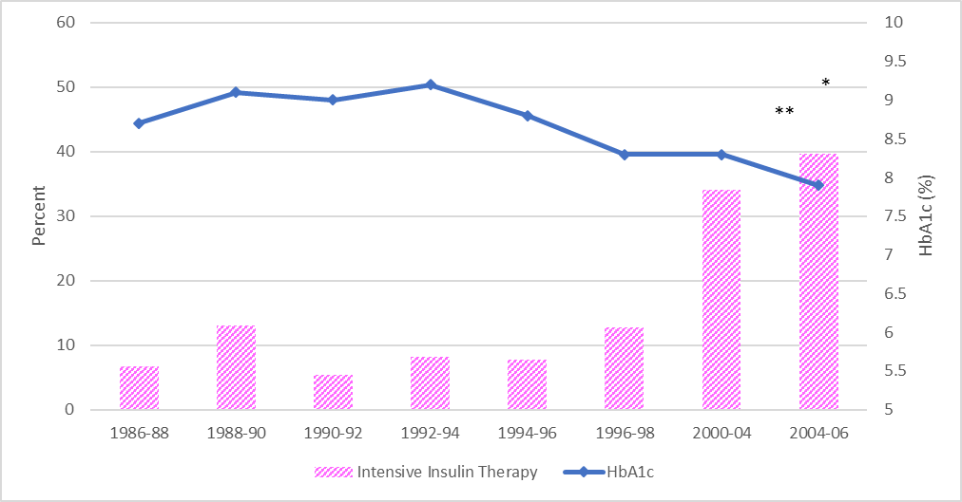
Figure 1. Trends in Intensive Therapy and Mean HbA1c
*Intensive insulin therapy: p_{1986-88 vs. 2004-06} <0.0001
** HbA1c: p-trend <0.0001
^{α}As a result of limited available data, the 1998-2000 and the 2006-2008 cycles were excluded from analysis.

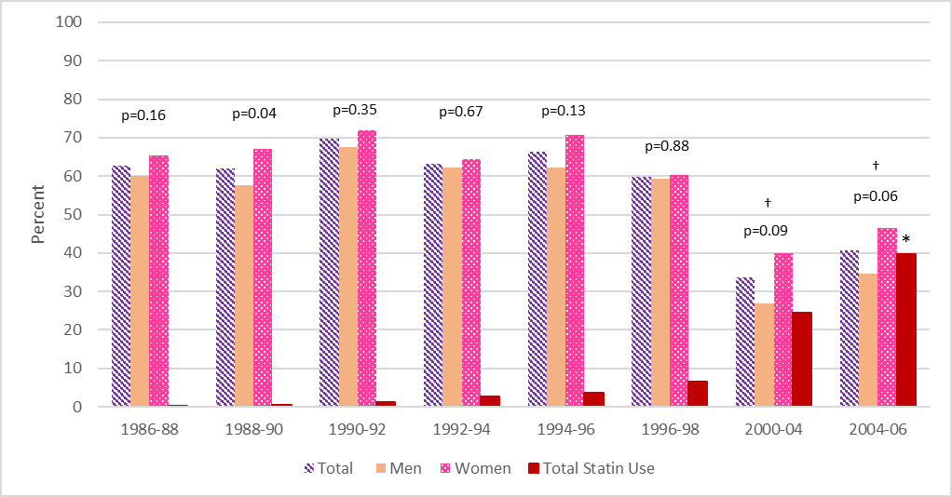

Figure 2. Trends in Statin Use and LDL Cholesterol Recommendations Met
*Statin Use: p_{1986-88 vs. 2004-06} <0.0001
†Change in Recommendation
^{α}As a result of limited available data, the 1998-2000 and the 2006-2008 cycles were excluded from analysis.

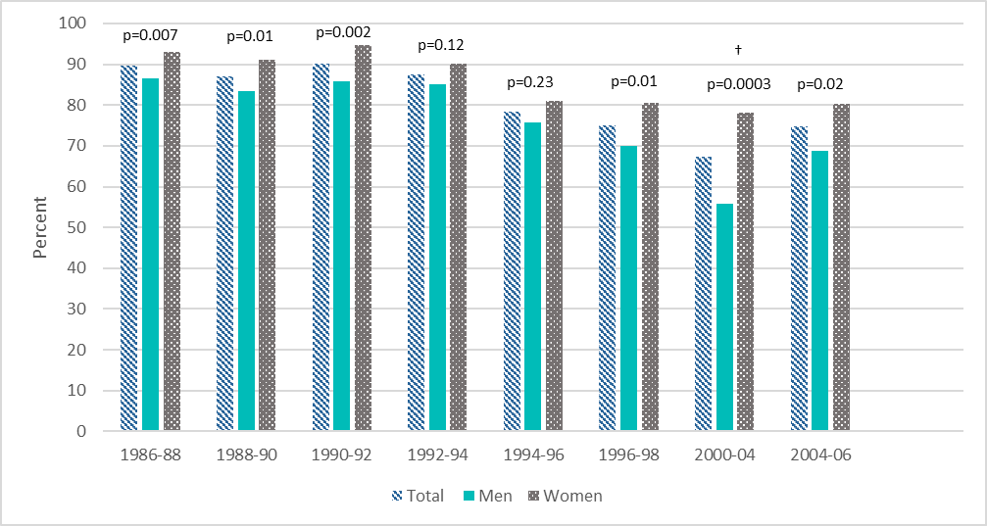

Figure 3. Trends in Blood Pressure Recommendations Met
†Change in Recommendation
^{α}As a result of limited available data, the 1998-2000 and the 2006-2008 cycles were excluded from analysis.

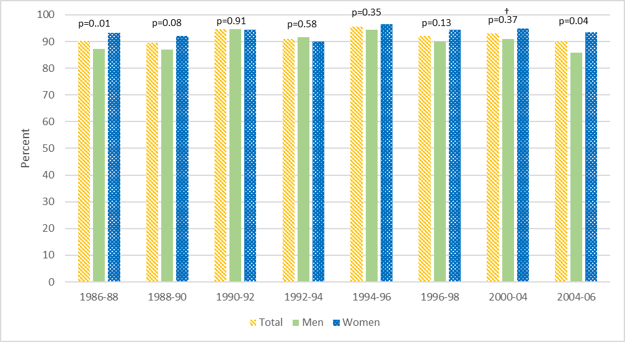

Figure 4. Trends in Triglyceride Recommendations Met
†Change in Recommendation
^{α}As a result of limited available data, the 1998-2000 and the 2006-2008 cycles were excluded from analysis.

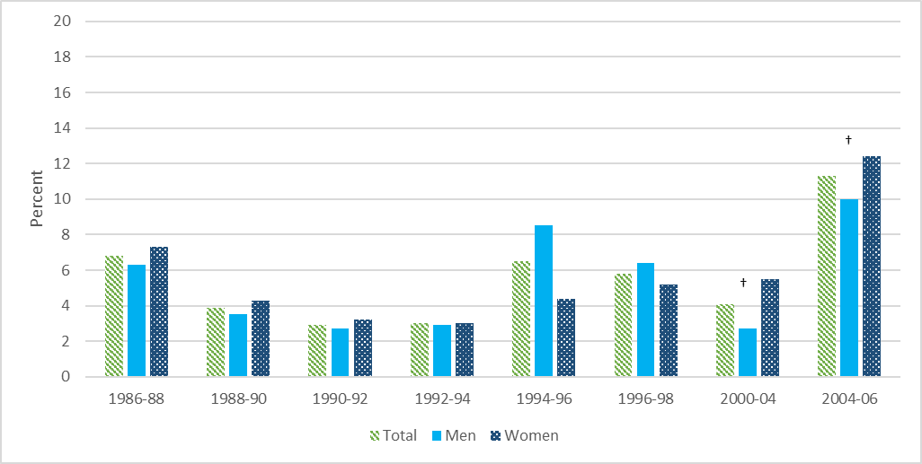

Figure 5. Proportion that Meets All ADA Recommendations
†Change in Recommendation
^{α}As a result of limited available data, the 1998-2000 and the 2006-2008 cycles were excluded from analysis.

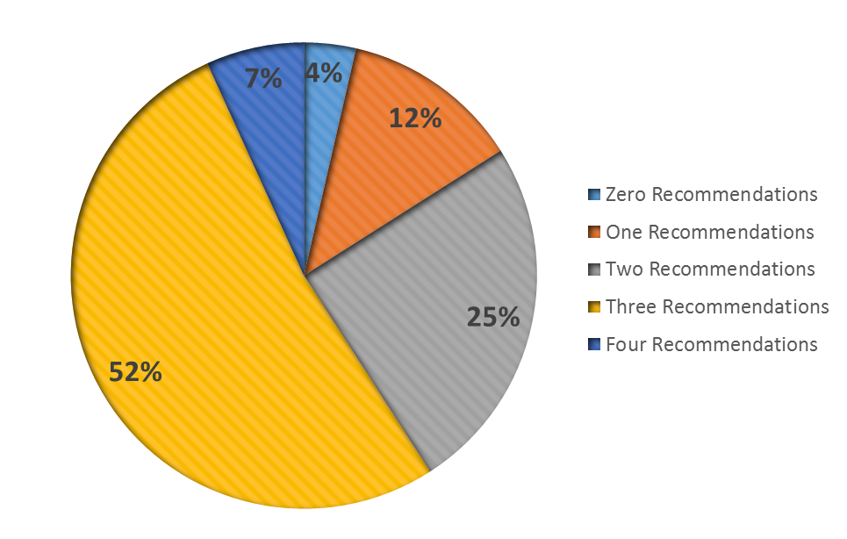
Figure 6. Proportion Meeting Zero, One, Two, Three, and Four Recommendations at Study Entry (1986-1988)

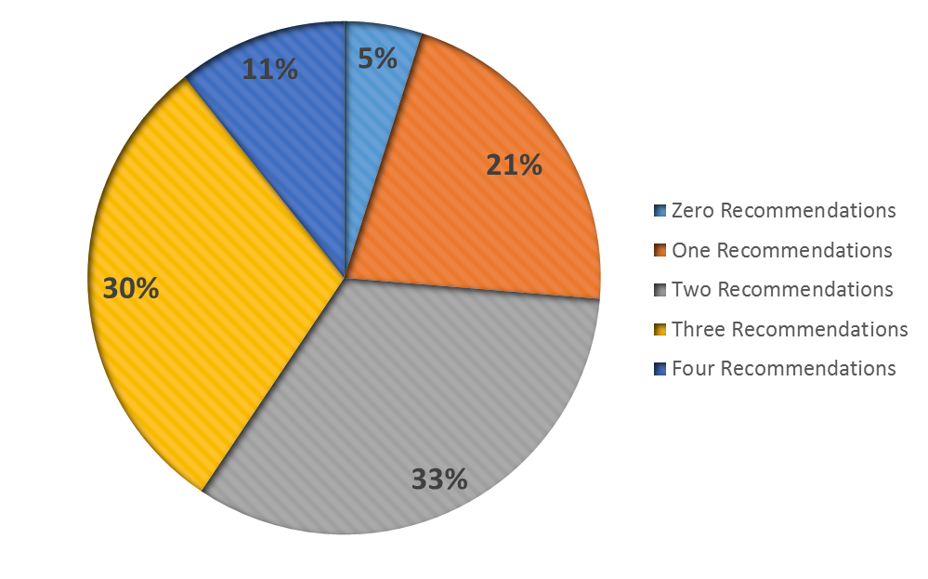
Figure 7. Proportion Meeting Zero, One, Two, Three, and Four Recommendations at Last Cycle (2004-2006)

bibliography
- International Diabetes Federation. IDF Diabetes Atlas, 6th edn. Brussels, Belgium:
International Diabetes Federation, 2013.

- Diabetes Control and Complications Trial/Epidemiology of Diabetes Interventions and
Complications (DCCT/EDIC) Research Group*. Modern-Day Clinical Course of Type 1 Diabetes Mellitus After 30 Years’ Duration: The Diabetes Control and Complications Trial/Epidemiology of Diabetes Interventions and Complications and Pittsburgh Epidemiology of Diabetes Complications Experience (1983-2005). Arch Intern Med. 2009;169(14):1307-1316.

- Melendez-Ramirez LY, Richards RJ, Cefalu WT. Complications of Type 1 Diabetes.
Endocrinol Metab Clin North Am. 2010;39:625-640.

- Zgibor JC, Piatt GA, Ruppert K, Orchard TJ: Deficiencies of cardiovascular risk
prediction models for type 1 diabetes. Diabetes Care 2006;29:1860-1865.

- Maahs DM, Eckel RH. Type 1 Diabetes and Associated Cardiovascular Risk and
Disease. In: McGuire DK, Marx N Diabetes in Cardiovascular Disease: a Companion to Braunwald’s Heart Disease. Elsevier Health Sciences;2014:127-135.

- Reichard P, Nilsson B-Y, Rosenqvist U. The Effect of Long-Term Intensified Insulin
Treatment on the Development of Microvascular Complications of Diabetes Mellitus. N Engl J Med. 1993;329(5):304-309.

- The Diabetes Control and Complications Trial/Epidemiology of Diabetes Interventions
and Complications (DCCT/EDIC) Study Research Group. Intensive Diabetes Treatment and Cardiovascular Disease in Patients with Type 1 Diabetes. N Engl J Med. 2005;353(25):2643-2653.

- American Diabetes Association. Standards of Medical Care for Patients with Diabetes
Mellitus: Position Statement. Diabetes Care. 1995;18(1):8-15.

- Wagener DK, Sacks JM, LaPorte RE, MacGregor JM: The Pittsburgh Study of Insulin-
dependent Diabetes Mellitus: Risk for Diabetes Among Relatives of IDDM. Diabetes 1982;31(2):136-144.

- Pambianco G, Costacou T, Ellis D, Becker DJ, Klein R, Orchard TJ. The 30-year natural
history of type 1 diabetes complications: the Pittsburgh Epidemiology of Diabetes Complications Study experience. Diabetes 2006;55:1463-1469pmid:16644706.

- Beck AT, Garbin MG: Psychometric properties of the Beck Depression Inventory: 25
years of evaluation. Clin Psychol Rev. 1988;8:77-100.

- Lee I-M, Paffenbarger RS, Hsieh C-C: Time trends in physical activity among college
alumni. Am J Epidemiol. 1992;135:915-925.

- Borhani NO, Kass EH, Langford HG, Payne GH, Reminton RD, Stamler J. The
hypetension detection and follow-up program. Prev Med. 1976;5:207-215.

- Warnick GR, Albers JJ. Heparin-Mn2+ quantitation of high-density lipoprotein
cholesterol: an ultrafiltration procedure for lipemic samples. Clin Chem. 1978; 24:900-904.

- National Institutes of Health, Department of Health (1975) Lipid research clinics
program. US Government Printing Office, Washington, DC, pp 75-628

- Allain CC, Poon LS, Chan CSG, Richmond W, Fu PC: Enzymatic determination of total
serum cholesterol. Clin Chem. 1974;20:470-475.

- Bucolo G, David H: Quantitative determination of serum triglycerides by the use of
enzymes. Clin Chem. 1973;19:476-482.

- Rose G, Blackburn H. Cardiovascular survey methods. Monograph Series/World Health
Organization 1968;56:1-188.

- American Diabetes Association. Role of Cardiovascular Risk Factors in Prevention and
Treatment of Macrovascular Disease in Diabetes: Consensus Statement. Diabetes Care. 1990;13(1):53-59.

- American Diabetes Association. Role of Cardiovascular Risk Factors in Prevention and
Treatment of Macrovascular Disease in Diabetes: Consensus statement. Diabetes Care. 1991;14(2):69-75.

- American Diabetes Association. Role of Cardiovascular Risk Factors in Prevention and
Treatment of Macrovascular Disease in Diabetes: Consensus Statement. Diabetes Care. 1992;15(2):68-74.

- American Diabetes Association. Standards of Medical Care for Patients with Diabetes
Mellitus: Position Statement. Diabetes Care. 1995;18(1):8-15.

- American Diabetes Association. Standards of Medical Care for Patients with Diabetes
Mellitus: Position Statement. Diabetes Care. 1997;20(1):S5-S13.

- American Diabetes Association. Standards of Medical Care for Patients with Diabetes
Mellitus: Position Statement. Diabetes Care. 1998;21(1):S23-S31.

- American Diabetes Association. Standards of Medical Care for Patients with Diabetes
Mellitus: Position Statement. Diabetes Care. 1999;22(1):S32-S41.

- American Diabetes Association. Standards of Medical Care for Patients with Diabetes
Mellitus: Position Statement. Diabetes Care. 2002;25(1):S33-S49.

- American Diabetes Association. Standards of Medical Care in Diabetes: Position
Statement. Diabetes Care. 2003;26(1):S33-S50.

- American Diabetes Association. Standards of Medical Care for Patients with Diabetes
Mellitus: Position Statement. Diabetes Care. 2004;27(1):S15-S35.

- American Diabetes Association. Standards of Medical Care in Diabetes: Position
Statement. Diabetes Care. 2005;28(1):S4-S36.

- American Diabetes Association. Standards of Medical Care in Diabetes-2006: Position
Statement. Diabetes Care. 2006;29(1):S4-S42.

- American Diabetes Association. Standards of Medical Care in Diabetes-2007: Position
Statement. Diabetes Care. 2007;30(1):S4-S41.

- American Diabetes Association. Standards of Medical Care in Diabetes-2008: Position
Statement. Diabetes Care. 2008;31(1):S12-S54.

- The 1984 Report of the Joint National Committee on Detection, Evaluation, and
Treatment of High Blood Pressure. The Joint National Committee on Detection, Evaluation, and Treatment of High Blood Pressure. Arch Intern Med 1984;144:1045-1057.

- The 1988 Report of the Joint National Committee on Detection, Evaluation, and
Treatment of High Blood Pressure. 1988 Joint National Committee. Arch Intern Med 1988;148:1023-1038.

- The Fifth Report of the Joint National Committee on Detection, Evaluation, and
Treatment of High Blood Pressure (JNC V). The Joint National Committee on Detection, Evluation, and Treatment of High Blood Pressure. Arch Intern Med 1993;153:154-183.

- Diabetes Control and Complications Trial/Epidemiology of Diabetes Interventions and
Complications (DCCT/EDIC) Research Group*. Effect of intensive diabetes management on macrosvascular events and risk factors in the diabetes control and complications trial. Am J Cardiol 1995;75(14):894-903.

- Pambianco G, Costacou T, Ellis D, Becker DJ, Orchard TJ. The 30-Year Natural History
of Type 1 Diabetes Complications: The Pittsburgh Epidemiology of Diabetes Complications Study Experience. Diabetes. 2006;55(5):1463-1469.

- Larkin ME, Backlund JY, Cleary P, Bayless M, Schaefer B, Canady J, Nathan DM.
Disparity in management of diabetes and coronary heart disease risk factors by sex in DCCT/EDIC. Diabet Med 2010;27(4):451-458.
- Kautzky-Willer A, Stich K, Hintersteiner J, et al. Sex-specific-differences in
cardiometabolic risk in type 1 diabetes: a cross-sectional study. Cardiovasc Diabetol 2013;12:78.

- De Boer IH, Kestenbaum B, Rue TC, et al. Insulin Therapy, Hyperglycemia, and
Hypertension in Type 1 Diabetes Mellitus. Arch Intern Med. 2008;168(17):1867-1873.

- Purnell JQ, Hokanson JE, Marcovina SM, Steffes MW, Cleary PA, Brunzell JD.
Effect of Excessive Weight Gain with Intensive Therapy of Type 1 diabetes on Lipid Levels and Blood Pressure: Results from the DCCT. JAMA 1998;280(2):140-146.

- Purnell JQ, Hokanson JE, Cleary PA, et al. The Effect of Excess Weight Gain with
Intensive Diabetes Treatment on Cardiovascular Disease Risk Factors and Atherosclerosis in Type 1 Diabetes: Results from the Diabetes Control and Complications Trial/Epidemiology of Diabetes Interventions and Complications Study (DCCT/EDIC) Study. Circulation 2012; doi: 10.1161/CIRCULATIONAHA.111.077487.

- Conway B, Miller RG, Costacou T, Fried L, Kelsey S, Evans RW, and Orchard TJ.
Temporal patterns in overweight and obesity in Type 1 diabetes. Diabet Med 2010;27:398-404.

- Libman IM, Pietropaolo M, Arslanian SA, LaPorte RE, Becker DJ. Changing Prevalence
of Overweight Children and Adolescents at Onset of Insulin-Treated Diabetes. Diabetes. 2003;26(10):2871-2875.

- Brown RJ, Wijewickrama RC, Harlan DM, Rother KI. Uncoupling intensive insulin
therapy from weight gain and hypoglycemia in type 1 diabetes. Diabetes Technol Ther. 2011;13(4):457.

- Williams KV, Erbey JR, Becker D, Orchard TJ. Improved glycemic control reduces
impact of weight gain on cardiovascular risk factors in type 1 diabetes: The Epidemiology of Diabetes Complications Study. Diabetes Care. 1999;22(7):1084-1091.

- Conway B, Miller RG, Costacou T, et al. Double-edged relationship between adiposity
and coronary artery calcification in type 1 diabetes. Diab Vasc Dis Res. 2007;4(4):332-339.

- Regnault V, Thomas F, Safar M E. Sex Difference in Cardiovascular risk: Role of Pulse
Pressure Amplification. J Am Coll Cardiol. 2012;59(20):1771-1777.

- Sattar N. Revisiting the links between glycaemia, diabetes and cardiovascular disease.
Diabetologia 2013;56:686-695.

- Costacou T, Evans RW, Orchard TJ. High-density lipoprotein cholesterol: is higher
always better? J Clin Lipidol. 2011;5(5):387-394.

- Dabelea D, Kinney G, Snell-Bergeon JK, et al. Effect of Type 1 Diabetes on the Gender
Difference in Coronary Artery Calcification: a Role for Insulin Resistance? The Coronary Artery Calcification in Type 1 Diabetes (CACTI) Study. Diabetes. 2003;52(11):2833-2839.

- Waitzfelder B, Pihoker C, Klingensmith G, et al. Adherence to Guidelines for Youths
with Diabetes Mellitus. Pediatrics. 2011;128(3):531-538.

- Amed S, Nuemberger K, McCrea P, et al. Adherence to Clinical Practice Guidelines in
the Management of Children, Youth, and Young Adults with Type 1 Diabetes – A Prospective Population Cohort Study. J Pediatr. 2013;163(2):543-548.

- Clements SA, Anger MD, Bishop FK, et al. Lower A1c among adolescents with lower
perceived A1c goal: a cross-sectional survey. Int J Pediatr Endocrinol. 2013;17:1-6.

- Tabak AG, Tamas G, Zgibor J, et al. Targets and Reality: A Comparison of Health Care
Indicators in the U.S. (Pittsburgh Epidemiology of Diabetes Complications Study) and Hungary (DiabCare Hungary). Diabetes Care. 2000;23(9):1284-1289.

- Zgibor JC, Songer TJ, Kelsey SF, et al. The Association of Diabetes Specialist Care with
Health Care Practices and Glycemic Control in Patients with Type 1 Diabetes. Diabetes Care. 2000;23(4):472-476.

- Zgibor JC, Songer TJ, Kelsey SF, Drash AL, Orchard TJ. Influence of Health Care
Providers on the Development of Diabetes Complications: Long-term follow-up from the Pittsburgh Epidemiology of Diabetes Complications Study. 2002;25(9):1584-1590.

