DEVELOPING A COLLABORATIVE, PATIENT-CENTRIC APPROACH FOR ADOLESCENT TRANSITION FROM PEDIATRIC TO ADULT HEALTH CARE

by
C. Ashley Oates
BA, Texas Tech University, 2008

Submitted to the Graduate Faculty of
Department of Health Policy & Management
Graduate School of Public Health in partial fulfillment
of the requirements for the degree of
Master of Health Administration

University of Pittsburgh
2016

ABSTRACT
UNIVERSITY OF PITTSBURGH
GRADUATE SCHOOL OF PUBLIC HEALTH

This essay is submitted
by
C. Ashley Oates

on

February 4, 2016
and approved by

Essay Advisor:
Samuel Friede, MBA ______________________________________
Assistant Professor
Department of Health Policy & Management
Graduate School of Public Health
University of Pittsburgh

Essay Reader:
Elizabeth Miller, M.D., Ph.D. ______________________________________
Professor and Division Chief
Department of Pediatrics, Adolescent and Young Adult Medicine
School of Medicine
Behavioral and Community Health Sciences
Graduate School of Public Health
University of Pittsburgh

Copyright © by C. Ashley Oates
2016

Pediatric hospitals are primed to be the main driver of creating successful transition programs for adolescents with special health care needs. With more than 11 million children in the United States affected by special health care needs, a seamless process for preparing, assessing and completing a transition from pediatric care to adult care is paramount. This essay aims to identify a transition structure that addresses the needs of many types of patients who are transitioning from pediatric to adult hospitals, but specifically focuses on the high population of adolescents with special health care needs. The Children’s Hospital of Pittsburgh of UPMC (CHP) will serve as a data model and case study for supporting the author’s recommended transition structure, as CHP serves more than 9,500 adolescents each year. Core components of transition should be addressed in a pediatric hospital-led transition program will focus on the patient. A patient-centric transition program should transcend condition, socioeconomic status, number of specialists involved, and most importantly, physical hospital walls. The author recommends a set of immediate and future goals for CHP based on literature findings and current processes. These recommendations address the areas of patient-centric and transition-focused programming, team composition, clear programmatic direction, and the appropriate use of technology. In terms of public health, this topic addresses a potential barrier in the continuum of care and desired health outcomes for the foundation of our society: children and their families.
Samuel Friede, MBA

DEVELOPING A COLLABORATIVE, PATIENT-CENTRIC APPROACH FOR ADOLESCENT TRANSITION FROM PEDIATRIC TO ADULT HEALTH CARE
C. Ashley Oates, MHA
University of Pittsburgh, 2016

TABLE OF CONTENTS
Introduction 1
1.1 Literature Review: Overview 3
1.2 Programmatic Barriers and Successes 5
1.2.1 Patient-Centric Care 7
1.2.2 Team Composition 9
1.2.3 Programmatic Direction 10
1.2.4 Use of Technology 14
2.0 Second chapter: Data analysis 16
2.1 Data Review 16
3.0 Third chapter: Recommendations 20
3.1 Program Structure 20
3.2 Incorporating the Six core elements 23
3.3 Instratructure, Human Resources, and Operations 29
3.4 Collaborative Opportunities 32
3.5 Future Directions 33
4.0 Conclusion 35
APPENDIX A: CORE ELEMENTS 37
APPENDIX B: SAMPLE INDIVIDUAL TRANSITION FLOW SHEET 38
APPENDIX C: JOB DESCRIPTION FOR TRANSITION CARE COORDINATOR 39
bibliography 41

List of tables

Table 1. Programmatic Barriers and Themes of Success by Topic or Area 6
Table 2. Adolescent Cases by Specialty or Area 17
Table 3. Assigning Roles for Implementing the Six Core Elements 24
Table 4. Proposed Staffing Model, Years 1-3 30
Table 5. Summary of Recommendations: Immediate and Reach Goals 36

List of figures

Figure 1. Six Core Elements of Health Care Transition 2.0 12
Figure 2. Top 5 Specialties, by Case Volume 18
Figure 3. Model of CHP’s Transition Program Flow 21

Introduction
Pediatric hospitals are primed to be the main driver of creating successful transition programs for adolescents with special health care needs. With more than 11 million children in the United States affected by special health care needs, a seamless process for preparing, assessing and completing a transition from pediatric care to adult care is paramount. Almost half of adolescents with special health care needs have moderate to severe chronic illness, physical and/or emotional disabilities (Newacheck PA, 1992), and within that population many are diagnosed with multiple health care needs (Data Resource Center for Child & Adolescent Health, 2013). This population of adolescents with special health care needs totals of more than 500,000 turning 18 each year. Furthermore, 90% of pediatric patients with childhood-onset conditions are now surviving into adulthood (American Academy of Pediatrics, 2011). This substantial number of adolescents will have to navigate the challenges of adolescence all while enduring intermittent hospitalizations, visits with many health professionals, side effects of new medications, and the negative effects their condition has on their social, emotional and physical development. These adolescents are often dependent to varying degrees on pediatric hospitals, and research confirms little is understood about how adolescents should be prepared for navigating the adult-focused health care system prior to their transfer of care.
This essay aims to identify a transition structure that addresses the needs of many types of patients who are transitioning from pediatric to adult hospitals, but specifically focuses on the high population of adolescents with special health care needs. The Children’s Hospital of Pittsburgh of UPMC (CHP) will serve as a data model and case study for supporting the author’s recommended transition structure, as CHP serves more than 9,500 adolescents each year in the southwestern Pennsylvania area who are on the cusp of transitions to adult care as well as to adulthood. Other core components of transition that should be addressed in a pediatric hospital-led transition program will focus again on the patient themselves. A patient-centric transition program should transcend condition, socioeconomic status, number of different specialists involved in typical care, and most importantly, physical hospital walls.
Health care delivery in pediatric settings varies in its approach compared to adult settings, which poses challenges to adolescents’ transition from pediatric to adult health (Pediatrics., 2002; Peters A, 2011). Pediatric providers are typically family-centered, with a focus on social issues in a relaxed setting, and are more likely to discuss implications of their illness (e.g. school progress). Adult providers often focus solely on the individual, rather than the family unit, and can be more formal, focusing more on the physiological aspects of disease and less on the social impact of the illness (Fleming E, 2002). Additionally, pediatric providers often deliver care via integrated services and supports, whereas adult services more often rely on patient initiative to follow through on medical advice (Peters A, 2011). Due to the dichotomous nature of pediatric and adult service providers, coupled with the logistical finesse required in making the shift to new providers for those with multiple conditions requiring different subspecialties, adolescents with special needs face extraordinary challenges in making the transition from pediatric to adult health care.

Literature Review: Overview
Utilizing a systematic approach to complete a literature review with Pub Med primarily, the following Medical Subject Headings (MeSH) were included in the search terminology to capture 23 applicable publications: adolescent, adult, care, child, pediatric, transition, and young adult. Date parameters were limited to within the last two years to capture new research. Though somewhat general in terminology, this search yielded surprisingly few applicable research publications, especially those that featured implementation and evaluation of transition programs. Of the 23 applicable publications, five groups emerged: condition-specific (10), evaluation or results of an implemented transition program (5), use of a qualitative interview or survey on patients or providers (5), a systematic review of transition literature (2), or the development of an assessment tool (1).
Despite this lack of comprehensive transition programs and the resulting peer-reviewed research publications, previous studies have identified several criteria which influence successful transition (Bloom, 2012), including poor pre-transition planning, lack of training for adult providers, and gaps in insurance coverage all undermine successful transitions (Stabile L, 2005). However, these studies do not address many other critical factors such as preparation and skill-building, training and education regarding differences between adult and pediatric systems, and opportunities to build relationships with adult providers (Bloom, 2012). Furthermore, few studies discuss the factors what matter most to the adolescents, which is perhaps the crux of the gap in transition literature.
Additionally, there were varied outcome measurements, often not well defined, and very few were evidence-based (Davis, Brown, Taylor, Epstein, & McPheeters, 2014). Overall, there is a lack of studies with an adequate sample size which assess the impact of transition on health outcomes (Peters A, 2011), and it’s extremely rare that a study addresses the adolescent’s defined outcomes. These outcomes could include medical outcomes, but could also include criteria critical for a successful transition of care, for example a sense of being ‘listened to’ during visits, collaborating with providers on medical decision making, cultivating a sense of responsibility, or developing new relationships with providers. While these items are typically indicators of personal wellbeing, they’re also signs of engagement with the providers, program and health care system, as well as their own behaviors and physical health.
There is a paucity in transition literature, and it’s no surprise that comprehensive transition programs are still rare. For example, the US government and other organizations have published recommendations to improve both process and outcomes, yet functioning delivery models for transition services are not available (Ciccarelli, Brown, Gladstone, Woodward, & Swigonski, 2014). Of those adolescents in transition programs that exist, they report feeling unprepared and unsupported during this transition (Busse FP, 2007; Tuchman, 2008).
In the last twenty years, research literature has placed a spotlight on the increasing population of adolescents with special health care needs, and their approaching transition to adulthood. Sixty percent of adolescents (ages 12-17) with special health care needs in Pennsylvania have unmet transition needs, and nationwide the average hovers around fifty-eight percent (National Survey of Children with Special Health Care Needs, 2012). Adolescents with more complex health conditions account for a greater share of healthcare costs and have complex coordination needs, often exceeding the time constraints and skill sets of primary care providers (Ciccarelli et al., 2014), which cyclically contributes to the factors responsible for these unmet needs of the adolescents.
This essay proposes that recent literature, however limited or absent, supports the need for a multidisciplinary, patient-focused transition program in order to successfully transition a adolescent into adult care. Outcomes should be measured by patient-specific criteria, including self-efficacy, autonomy, and decision making skills. Specific disadvantages and advantages of each transition program approach will be discussed later, culminating in a set of criteria for a transition program at CHP.

Programmatic Barriers and Successes
The literature review yielded several themes for planning and implementing programs for an adolescent’s transition from pediatric to adult care. Studies called for more patient-centric care, a focus on both team composition and strategic programmatic direction, and an electronic medical record (EMR) or technology component (Table 1), among others. Thematic correlations occurred with both negative and positive examples, but centered on overcoming barriers to the patient and family, provider, and health care system.
Table 1. Programmatic Barriers and Themes of Success by Topic or Area
Topic/Area | Programmatic Barriers | Themes of Success
Patient-Centric Program | Condition-Specific (Davis, Hopper); Concern with Reimbursement Challenges (Ciccarelli, Fishman, Mackie, McManus) | Patient-Centric approaches and outcomes (Ciccarelli, Davis, Fishman, Hopper, Huang, Kovacs, McManus, Prior, Sawicki, O’Sullivan-Oliviara, Williams); Insurance Continuity (Ciccarelli, Hopper, Williams)
Team Composition | Concern with Funding for Staffing (Ciccarelli, Fishman, Mackie, McManus) | Multidisciplinary Teams (Ciccarelli, McManus, Sanabria, O’Sullivan-Olivaria, Williams)
Programmatic Direction | Varied Outcome Measures (Davis, Prior, van Staa) | 6 Core Elements Implementation (Ciccarelli, Hopper, Klassen, Kovacs, Mackie, McManus, Prior); Quality Improvement (McManus); Pediatric-Led Initiatives (Ciccarelli)
Use of Technology | Lack of Interoperability (Huang, McManus); Gap in literature | EMR or Technology Focus (Davis, Hopper, Huang, Sanabria)  Tracking Transition and Transfer Outcomes (Kovacs)

Furthermore, many studies utilized public resources including The Center for Health Care Transition Improvement’s Six Core Elements for Health Care Transition (discussed in section 1.2.3) and the corresponding 2011 Clinical Report issued by American Academy of Pediatrics; the latter of the two outlines a structure and detailed processes for training and continuing education to further understand the nature of adolescent transition and how best to support it.

Patient-Centric Care
The primary theme emerging from the literature review was the necessity of patient-centric care for the transition program. Successful programs recommended a “whole-life” rather than a pure medical approach (Ciccarelli et al., 2014). Oftentimes negative outcomes (i.e. a decline in health status) are the result of preventable lapses in adherence, follow-up, and insurance coverage (Prior, McManus, White, & Davidson, 2014), all issues potentially within the adolescent and family’s purview, but spanning over several years. In the short term, however, many barriers can prevent an adolescent from successfully transitioning as well. Specific barriers to successful transition to adult care include lack of preparation, psychosocial issues, loss of relationships, stigma associated with special health care needs, and other system-related issues concerning communication, finances, transportation, among others (Newman, Persson, Miller, & Cama, 2014), which can be addressed by providers, program administrators and family focusing on the patient’s individual needs at each step of the transition.
Establishing an appropriate timeline for transition can be difficult. According to an American Academy of Pediatrics (AAP) Fellows Survey, most pediatricians did not yet offer recommended transitions services and the majority still believed transition planning should begin at ages 17-18, despite AAP recommendations for earlier initiation (Ciccarelli et al., 2014). In the AAP’s 2011 Clinical Report, a planned transitions process should begin early in adolescence (ages 12-14 years) for all youth, including those with special health care needs (McManus et al., 2015; O'Sullivan-Oliveira, Fernandes, Borges, & Fishman, 2014). The targeted age group for CHP’s transition program is 12-26, encompassing the entire adolescent to adult spectrum. Oftentimes patients and their families arrive during a crisis, and a transition becomes a quick transfer, as there was not a plan in place originating from interaction with their primary care or specialty provider. However, primary care providers do not yet have high familiarity with transition knowledge and recommendations to provide this service to patients without other education or support (Ciccarelli et al., 2014). Furthermore, adolescent health literacy statuses alter the effects of a transition intervention on disease management outcomes (Huang et al., 2014). Individualized transition planning should occur early, if possible, and transfer itself should not occur during a period of crisis.
As a patient’s time in the transition program draws to a close after the transfer and she has become established with the adult provider, the program should consider the adolescent’s perceptions on her own development and growth throughout the experience. A self-assessed ‘graduation’ via a simple follow-up phone call can be used to ensure the adolescent is ready to complete the program (Ciccarelli et al., 2014). The private phone call would query their self-assessment of readiness to graduate from the transition program, rather than a set of written guidelines, which may not align with the patient’s needs. Program outcomes should also be tailored to the individual. Possible metrics to evaluate meaningful success could include provider, adolescent, and parent’s perception of successes and satisfaction with the transition process, improved medical outcomes, decreased or stable cost of health care, or educational milestones in patient’s ability to care for themselves or navigate the health care setting (Davis et al., 2014).

Team Composition
Next, a spotlight should be placed on the transition program’s team composition. A variety of interventions have been used to improve health care transition support staff, but the evaluation of these interventions is limited (Prior et al., 2014). Of the interventions that have been evaluated, a multidisciplinary team is necessary, especially considering the multifaceted nature of transitions from pediatric to adult care. Both complex and decentralized structures were formed. In one statewide study in Indiana, a complex transition team was comprised of pediatric physicians, a pediatric rehabilitation physician, nurses, a social worker, a community disability advocate, parent advocates, and an administrative assistant. The administrative assistant was hired by specifically seeking individuals who were also experienced as health care providers or family members of consumers with chronic conditions or disabilities (Ciccarelli et al., 2014). Two team members were shared employees, one with the local center for independent living and another with one of the state parent-to-parent networks. In another successful program, each separate practice involved in the transition study formed a team consisting of a lead physician, a care coordinator who focused on transition (nurse, social worker, or family navigator), and a consumer (parent/caregiver or young adult) (McManus et al., 2015), creating a more decentralized structure. While both programs had measures of success, the transcending factor was the multidisciplinary nature of the composition.
There are other methods to creating a multidisciplinary program. Approaching transition as a team-based activity, not as a physician-only process, is essential to go beyond buy-in into program ownership by all involved (McManus et al., 2015). Identifying a highly visible champion can be useful as well. A successful transition program highlighted the significance of senior leadership support not only from medicine but also from specific areas involved, such as nursing and social work (McManus et al., 2015). Though actual efforts are likely to be completed by front-line staff, the program needs the anchor of being led by a practitioner, clinician, and/or dedicated staff member in a highly visible role in the organization.
Not all barriers can be eliminated by a multidisciplinary team; in fact, this type of team structure can foster unique challenges, including a lack of a care coordination infrastructure, particularly at the adult sites (McManus et al., 2015). A strong plan for connectivity and coordination should be incorporated into the program. Components of this plan could include educational materials, perhaps using computer-based programming, and the use of a transition coordinator (Davis et al., 2014), utilized by both the pediatric and adult providers.
Furthermore, the need for additional training appears frequently (Sanabria, Ruch-Ross, Bargeron, Contri, & Kalichman, 2015). In one study, faculty with expertise in transition, medical homes, and consumer engagement provided training support using the Six Core Elements (discussed in section 1.2.3) as a guide and toolset with sample tools for each core element (McManus et al., 2015). Adult-oriented providers report obstacles such as lack of training in childhood-onset or –acquired conditions, lack of familiarity with social services and benefit options (Sanabria et al., 2015). Two separate training curricula could be developed for pediatric and for adult providers, covering age- and condition-specific issues.

Programmatic Direction
For those studies of programs completed through implementation, the approaches are often tailored to condition; however, studies exist which suggest a generic approach might be both effective and cost-saving (Huang et al., 2014). Researchers found that a more resource-intensive disease-specific approach may not be necessary now that generic approaches have been shown to be efficacious. For example, a study focusing on preparing adolescents with chronic disease for transition utilized a technology-based program. The use of technology (i.e. cell phone- and computer-based education and communication program) in this particular program offered a low-cost alternative for intervention in their at-risk population, which can be distributed across time and geography and independent of the clinic setting. This study was just one example of how critical programmatic direction can be when considering cost, access, and preferred outcomes.
Many studies employ the use of the Center for Health Care Transition Improvement’s Six Core Elements of Health Care Transition 2.0 (Ciccarelli et al., 2014; Hopper, Dokken, & Ahmann, 2014; Klassen et al., 2014; Kovacs & McCrindle, 2014; Mackie et al., 2014; McManus et al., 2015; Prior et al., 2014), all of which recommend a generic approach, as none of the elements are condition- or age-specific. The Six Core Elements of Health Care Transition 2.0 (hereafter referred to as the ‘Six Core Elements’) were created to align with the transition algorithm in the 2011 Clinical Report, and they define a sequential clinical process with a sample set of tools to be used by pediatric and adult providers. Although the Six Core Elements have specific elements for both pediatric providers and adult providers, this essay will focus on the pediatric column of elements, as the author’s recommended transition program model is pediatric-led. The entire list of Core Elements can be found in Appendix A.
The first Core Element (Figure 1) is regarding the statement or policy that must be adopted by the partnering clinics, specialty providers and others involved, placing emphasis on the roles of the patient, family, pediatric and adult providers.
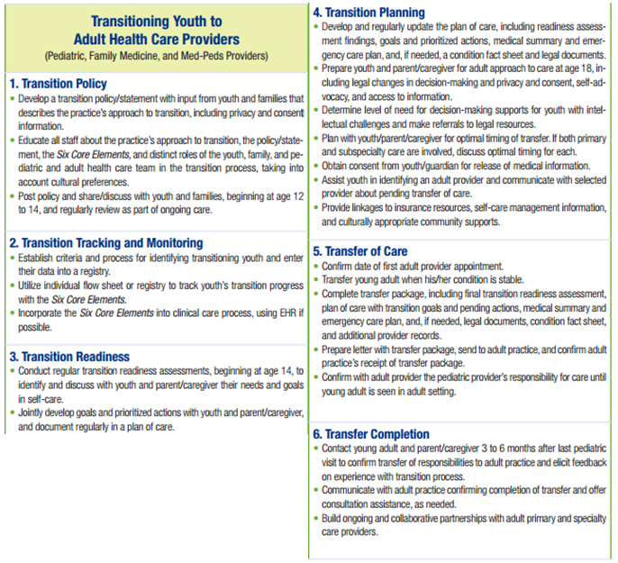
Figure 1. Six Core Elements of Health Care Transition 2.0

The second element ensures that each adolescent is monitored and tracked throughout the process and ultimately in a registry for long-term follow-up. The third element addresses the adolescent’s readiness for transition and the transfer to adult care, which is followed by the fourth and fifth elements addressing planning, integration and the actual transfer and initial visit itself. In the fifth element, the adolescent completes the self-care assessment. Featured in many of the studies for the self-care assessment, the TRANSITION-Q is a short, clinically meaningful and psychometrically sound scale (Klassen et al., 2014). It employs a generic scale, which can be used in research and in pediatric and adolescent clinics to help evaluate readiness for transition. Most importantly, it is driven by the adolescent themselves. Finally, the sixth element creates the feedback loop between pediatric and adult providers and the adolescent and family, discussing the continual needs of the adolescent and ongoing care management. Oftentimes transition programs face hurdles on how to bridge the gap between pediatric and adult providers, especially in terms of communication and building relationships. Formal transition events (transition evenings, for example) that are attended by adult-care providers and include a tour of the adult clinic could be offered (Kovacs & McCrindle, 2014). Maintaining a communicative relationship between all providers will benefit the patient by ensuring any medical and mental health gaps are filled.
Once properly adopted, the Six Core Elements can also be successfully implemented in a quality improvement capacity (McManus et al., 2015), the Plan-Do-Study-Act cycle, or through continuous process improvement. One study coupled the evidence from transition research, inclusive of the Six Core Elements implementation, into everyday processes, via the use of an implementation science approach (Ciccarelli et al., 2014). However, there are so few implementation science approaches to transitions, as the process usually takes two to four years to achieve.
As previously mentioned, transitions literature points to a lack of well-defined outcome measures, which ultimately is a major barrier (Davis et al., 2014). Beyond the Six Core Elements, a focus for the CHP transition program should be on outcomes for measuring success, i.e. the adolescent’s ability to care for themselves, lower or stabilize the cost of care, and long-term follow up.

Use of Technology
The last major theme emerging from the literature review considered the use of the hospital system’s Electronic Medical Record (EMR) or another technology component. With recent legislative action and Meaningful Use requirements, it’s imperative to discuss the need for EMR components and interoperability challenges with merging, newer health care systems, or even within a stand-alone facility. Simply the lack of functionality of the EMR could be a significant barrier for the transition program’s implementation of the Six Core Elements (McManus et al., 2015). Integration between varying systems will be a challenge for CHP: for example, Cerner and Epic systems are both used, depending on practice location.
Some of the disparities in access to care as adolescents transition may be minimized by expansion and evaluation of uses of technology such as telemedicine, short message service (SMS) or text messaging, or social media (Huang et al., 2014). The computing power and portability of mobile phones make possible new application for automatic, timely and tailored presentation of health messages, and because mobile phones are generally accessed by a single individual, outreach can be improved for sensitive medical issues. The use of technology in transition has particular promise for adolescents, who may be more comfortable users of technology than some adults (Davis et al., 2014). Innovative uses of technology to improve adherence to medications, to provide education regarding their medical disease, to identify medical deterioration earlier, and to communicate with their health care providers should be considered for transition programs and in the resulting future studies.
The technology-based approach offers the possibility of efficient implementation in a clinic setting with modest personnel time and effort (Huang et al., 2014). Use of personal technology, i.e. portable health records, texts, connections through telemedicine, and social media are all successful tactics (Davis et al., 2014).
Finally, the tracking of completed transition and program outcomes can be transformed by the use of technology. Maintaining an electronic registry that actively tracks transitioning youths (in the pediatric setting) and young adults (in the adult-care setting) is encouraged in order to recognize lapses in care as soon as they occur (Kovacs & McCrindle, 2014). However, in one study, none of the practices were able to integrate an electronic registry to systematically track implementation of all transition steps (McManus et al., 2015) or other important outcomes.
It is critical to meet the adolescents in their world, crafting a transition program that will speak to them and serve their needs in an efficient manner: electronically. This can be accomplished by disseminating crucial information through channels such as mobile phones, tablets, and other electronic devices that the adolescent is comfortable with operating.

Second chapter: Data analysis
More than ever, healthcare is an industry that is driven by data. Data analytics is often the driving force behind many of senior leaderships’ decision-making processes, leading to secure pathways to achieve measurable goals. In this section a slice of data from CY14 is reviewed to begin drilling down on the exact population Children’s Hospital of Pittsburgh of UPMC (CHP) will be serving with the transition program. A more in-depth look at the population’s demographics, payor information, type of condition, current physician, and other important determinants of health should be reviewed, based on new data from CY15, before moving forward with the recommendations discussed in the next chapter.

Data Review
Based on the data reviewed, there is an opportunity for implementation of a transitions program at CHP. Currently, there is nothing formal in place in terms of transition programming which touches all types of patients served at CHP. In existing siloed programs that minimally address transitions, only very specific conditions are served, and those programs are more about processes for referrals, not formal, hospital- or system-wide programs with established measures, goals, and outcomes. Furthermore, there are satellite programs that could be brought together into a collective group to serve this varied population with a transition program suited for all adolescents and those with special needs. Of the 986 adolescents (18-26) served in an inpatient, inpatient rehabilitation, or outpatient capacity at CHP in CY14, each case had a primary area or specialty through which they were admitted. These 29 areas (Table 2) pinpoint opportunities for collaboration, and should be aware of their ability to facilitate a transition program, supplied with the specific number of adolescents within their panel.
Table 2. Adolescent Cases by Specialty or Area
Specialty or Area | Outpatient | Inpatient | Inpatient Rehab | Grand Total
Anesthesia | 0 | 12 | 0 | 12
Cardiology | 1 | 23 | 0 | 24
Critical Care Medicine | 0 | 52 | 0 | 52
Ear, Nose, Throat | 5 | 1 | 0 | 6
Emergency Care | 0 | 15 | 0 | 15
Endocrinology | 3 | 31 | 0 | 34
Family Medicine | 1 | 0 | 0 | 1
Gastroenterology | 8 | 66 | 0 | 74
General Medicine | 1 | 66 | 0 | 67
General Pediatrics | 1 | 100 | 0 | 101
General Surgery | 0 | 17 | 0 | 17
Genetics | 0 | 1 | 0 | 1
Hematology/Oncology/BMT | 18 | 149 | 0 | 167
Infectious Disease | 0 | 4 | 0 | 4
Nephrology | 8 | 36 | 0 | 44
Neurology | 57 | 20 | 0 | 77
Neurosurgery | 0 | 26 | 0 | 26
Oral and Maxillofacial Surgery | 0 | 19 | 0 | 19
Orthopedic | 0 | 39 | 0 | 39
Pediatric Rehab Medicine | 0 | 0 | 18 | 18
Pediatric Surgery | 0 | 17 | 0 | 17
Plastic Surgery | 3 | 6 | 0 | 9
Pulmonology | 13 | 27 | 0 | 40
Radiology | 1 | 1 | 0 | 2
Renal Electrolyte | 3 | 8 | 0 | 11
Rheumatology | 28 | 8 | 0 | 36
Thoracic Surgery | 0 | 27 | 0 | 27
Transplant | 2 | 38 | 0 | 40
Urology | 0 | 6 | 0 | 6
Grand Total | 153 | 815 | 18 | 986
The top 5 specialty areas which dominate this set of 29 are Hematology/Oncology/Bone Marrow Transplantation (BMT) with 17% of the cases, General Pediatrics with 10% of the cases, Neurology with 8% of the cases, Gastroenterology with 8% of the cases, and General Medicine with 7% of the cases (Figure 2). Combined, these five ‘heavy hitters’ comprise nearly 50% of the case volume of patients at CHP preparing to transition to adult care.

Figure 2. Top 5 Specialties, by Case Volume

This breakdown yields unsurprising results; there are many reasons as to why these areas receive a particular volume of adolescents. The volume each of these areas receives may be due to the common profile of their patients, i.e. age-specific qualifications for treatment or surgery. Additionally, the general nature of two of these areas (General Pediatrics and General Medicine) will capture a greater share of patient volume than a more condition-specific area such as urology (>1%), likely due to their primary care orientation. These five areas should be incorporated into the recommended program structure as key stakeholders in the new transition program, operating as gatekeepers for reaching goals along the transition timeline. This incorporation is discussed in section 3.1.

Third chapter: Recommendations
As the sole pediatric hospital in Southwestern Pennsylvania, the Children’s Hospital of Pittsburgh of UPMC (CHP) is positioned to be the leader in this collaborative, patient-centered, multidisciplinary approach to transitioning adolescents from their care to adult care in the region. A successful program could further impart a sense of trust and community approval for CHP and UPMC as a whole. In the sections below, a set of recommendations for a CHP-lead transitions program is discussed. Always aiming to be focused on the patient, the transition program addresses team composition, programmatic direction, and incorporating information technology to reach those being served.

Program Structure
The author recommends that initially a project management style approach be implemented, along with tailoring key literary findings and the Six Core Elements for Health Care Transitions 2.0 for a large pediatric hospital.
The first step in preparing the transitions program for CHP is to gather the appropriate people together for a meeting to agree upon the reasons for creating the program, and to establish a number of other items crucial to the inception of an extensive program. The team should be comprised of pediatric and adult provider leadership, clinical staff from each provider segment, representation from referral sources (i.e. mental health, specialty, and emergency care providers), patient navigators, and any administrative support staff to be involved after operations begin. Adolescents and families or their advocates could be present at this meeting if there is enough consensus among hospital employees, however, this may not be wise at the program’s inception. The CHP transition program flow (Figure 3) connects pediatric providers by interaction with the patient and family, who are central to the program. The flow of information about the adolescent should originate from the adolescent’s primary provider, whether that is a pediatrician or a specialty care provider, a mental health provider, or via an emergency care setting.

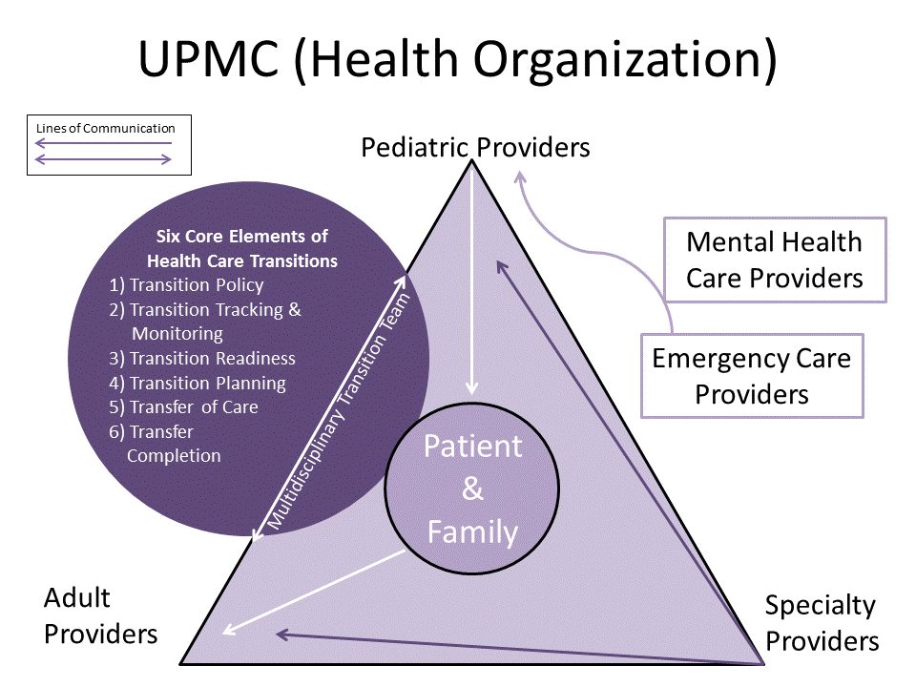
Figure 3. Model of CHP’s Transition Program Flow
The providers will collaborate through the multidisciplinary transition team, utilizing current evidence-based tactics coupled with the Six Core Elements of Health Care Transition 2.0 (hereafter referred to as the Six Core Elements). The program will be staffed with effort from a Medical Director, Administrator, and newly created Transition Care Coordinator positions to entrench the program into routine care. With input from specialty, mental health, and emergency care providers, a holistic approach will ground the program.
As discussed in the data review, the five key specialty areas in the Department of Pediatrics at CHP will play a gatekeeper role. Oftentimes the transitioning adolescent will be queued from the pediatric standpoint, which makes CHP the natural lead for this program, especially via the Gatekeeper Five, or the divisions of Hematology/Oncology/Bone Marrow Transplantation (BMT), General Pediatrics, Neurology, Gastroenterology, and General Medicine. The Gatekeeper Five are critical to the tracking and monitoring of a large group of adolescents primed for transitioning into adult care, and should be a pivotal part of the multidisciplinary transitions team.
Led by the health care providers, the multidisciplinary transition team should establish the following: 1) a detailed description of the intended results (i.e. roadmap the successful transition process at CHP); 2) a list of all constraints and barriers the program must address; and 3) a list of all assumptions related to the program. By drafting and approving these initial items, the group will build consensus and buy in from all those present. At subsequent meetings, a patient flow model should be introduced, to be developed jointly by the pediatric medical director, administrator and corresponding lead adult provider, and a list of all required work directly tied to the adolescent’s transition. This comprehensive list will help create a detailed and patient-specific schedule for when a patient reaches their self-assessed transfer point in their transition timeline.
Additional input from youth representatives from the Children’s Hospital Advisory Network for Guidance and Empowerment (CHANGE) will help address challenges to successful health care transition. The CHANGE network should be utilized to the fullest, inclusive of the peer-to-peer contact perspective during transition. CHANGE was created to engage youth ages 16-26 who may experience challenges to successful health care transition, and typically has an active board of 10 to 20 young adult advocates. These advocates are responsible for maintaining contact with 40 additional adolescents through monthly networking events. The majority of youth involved have recently complete or are in the process of completing their own transition from pediatric to adult care. A tangential direction from this central CHANGE program would be to create and monitor transitioning adolescent and family-led support groups, held at neutral meeting locations. The same type of methodology for the CHANGE group could be applied, but with a focus on confidentiality and camaraderie.

Incorporating the Six core elements
While creating the comprehensive transition ‘task’ list, the multidisciplinary transition team should review and incorporate the Six Core Elements of Health Care Transition 2.0, specifically the Transitioning Youth to Adult Health Care Providers section. In addition to the list of specific tasks of the transition, the team should consider making a chart of who specifically is the lead on each of the Six Core Elements. An example of role assignments is shown below (Table 3), but contemporary partnerships and staff availability will determine the final role for each team member involved.
Table 3. Assigning Roles for Implementing the Six Core Elements
Core Element | Pediatric Providers | Adult Providers | Other (Specialty Providers and CHANGE)
1) Transition Policy | Senior Leadership Champion, Medical Director, Physicians, Nursing Staff, Administrator, Transition Care Coordinators | Physicians,  Nursing Staff | Adolescent, Families, Patient Advocates, Specialty Providers, CHANGE Youth Advisors
2) Transition Tracking and Monitoring | Gatekeeper Five,  Nursing Staff, Administrator,  Transition Care Coordinators | Nursing Staff | Specialty Providers
3) Transition  Readiness | Adolescent, Physicians, Nursing Staff, Transition Care Coordinators | Physicians,  Nursing Staff | CHANGE Youth Advisors, Mental  Health and Specialty Providers
4) Transition Planning | Adolescent, Physicians, Nursing Staff, Administrator, Transition Care Coordinators | Physicians,  Nursing Staff | CHANGE Youth Advisors
5) Transfer  of Care | Adolescent, Physicians, Nursing Staff,  Transition Care Coordinators | Physicians,  Nursing Staff | CHANGE Youth Advisors
6) Transfer Completion | Adolescent, Physicians, Nursing Staff,  Transition Care Coordinators | Physicians,  Nursing Staff | CHANGE Youth Advisors, Specialty Care, Mental Health,  and Emergency Care Providers
In practice, the Six Core Elements will ultimately tie in the four successful themes from literature: patient-centric care, team composition, programmatic direction, and the use of technology. Each Core Element is addressed in the recommendations below.

Core Element 1: Transition Policy
The CHP policy regarding adolescent transitions to adult care is perhaps more general than necessary. CHP Policy #100.05A states, “Attending physicians and clinical staff are committed to proactively and safely transitioning children who have been followed over time at Children’s to adult providers in a timely fashion based on their diagnoses and other clinical needs. Such a transition plan should be in active development well before the patient’s care is transitioned.” The transitions team should consider amending or updating practice policy to include the new patient-centric approach, focusing on privacy, consent, and the distinct role of the adolescent and family. Adding in the multiple stakeholders in the transition program will help establish a system-wide knowledge of the reach of the transitions team. After the policy has been agreed upon by the multidisciplinary transition group, adequate time needs to be given to system approvals. Obtaining instructional approval for a transition policy can be time consuming and required senior leadership and legal reviews (McManus et al., 2015). Publicly posting the policy and consistently sharing it with youth, young adults, and families can be an unanticipated hurdle (McManus et al., 2015). The Center for Health Care Transition Improvement also suggests that clinicians should begin sharing and discussing the policy with adolescents and families beginning at age 12 to 14, with a regular review of the policy as a part of ongoing care.

Core Element 2: Transition Tracking and Monitoring
While the Six Core Elements offer a general description for the tracking and monitoring of each transition, the author recommends the transitions tracking process be incorporated into the EMR. By adding the tracking and monitoring of each adolescent case to the clinical care process, both pediatric and adult clinicians are incentivized to make transition a priority during each visit. This will be a challenge for CHP, as there are current issues with interoperability for Cerner and Epic systems. Additionally, the Six Core Elements suggest utilizing their flow sheet (see Appendix B) to track the adolescent’s progress with the Six Core Elements through transition. It’s recommended that the flow sheet, among other checklists created for tracking purposes, be integrated electronically for ease of use during patient visits and portability after transition. As conduits for patient flow, the Gatekeeper Five divisions will also be critical for identifying and tracking adolescents for the transitions program.

Core Element 3: Transition Readiness
The Six Core Elements address the frequency by which readiness assessments are issued; the Center for Health Care Transition Improvement recommends beginning at age 14 to identify and discuss with adolescents and their parents any specific needs and goals for self-care. The final portion of this statement is unequivocally important, as the adolescent’s voice should drive the discussion on readiness. Additionally, the TRANSITION-Q (TRAQ) and other assessments can be utilized to complete self-assessments to supplement any joint-developed goals between the clinicians and the patient. Though self-assessment is key, it cannot be the only resource in assessing readiness.
In addition to issues related to the type of provider, the transition from pediatric to adult care coincides with other life transitions for adolescents, which may interfere with their engagement in the health care system (Blum, 1997). Specifically, these life transitions include seeking employment and educational opportunities, living on their own, and negotiating changes in relationships with family and friends. All of these life transitions require adolescents and emerging adults to develop autonomy in decision-making skills, self-advocacy, communication skills, and medication knowledge (Fishman, Ziniel, Adrichem, Fernandes, & Arnold, 2014). The act of realizing and addressing these developmental milestones may cause inefficiencies in health care transitions. To illustrate, irregular employment status could affect insurance coverage, making it more difficult for adolescents to maintain their engagement with the provider. In fact, adolescence is often a period when many disconnect with their provider network. Disparities emerge when comparing adolescents and other age groups in terms of access to primary care, health insurance coverage, and emergency department utilization (Lotstein Ds, 2007). These disparities are amplified within the adolescent age group when comparing those with and without special health care needs (Bloom, 2012).

Core Element 4: Transition Planning
The crux of this Core Element is the continual updating of the plan for transition. The readiness assessment findings, goals, medical summary and emergency care plan can be seen as fluid documents, changing at any time due to the patient’s needs. Again, planning should begin in what was previously thought to be too early; adolescents aged 14-16 years should be queued into the transition program, and distinct age-appropriate adult focus placed on the 18-26 group. This older group can review more adult matters such as legal changes, changes in decision-making, privacy, consent, self-advocacy, and access to information. Considerations for incorporating sexual and reproductive health education (Stephany et al., 2015) into this portion of transition planning could be timely and well-received. The targeted age group for CHP’s transition program is 12-26, encompassing the entire adolescent to adult spectrum. The timing of the transfer should be discussed as well. As mentioned previously, transferring during times of crises should be avoided. The adolescent and family should be heavily involved in selecting the adult provider, if possible. Selection based on insurance continuity, location, and other benefits should be considered.

Core Element 5: Transfer of Care
The actual event of transferring the adolescent to their new adult provider can be a smooth process, if several factors are considered. Confirming the date of the first appointment is key, as well as transferring when the adolescent is well or deemed to be healthy. If possible, CHP should practice warm hand-offs via dual-certified physicians or joint clinics, which would eliminate many feelings of disconnect or neglect; however, facility concerns may be a roadblock to creating a joint clinic space for the transition program. Other items should accompany the transfer to ensure a smooth experience: a portable (preferably protected electronic version) transfer package, including any up-to-date checklists, medical histories, and capped off with a detailed letter from the pediatric physician to the new physician with the adult provider (unless there was a warm hand-off during transfer). Though there are security issues created with an electronic transfer package, portability is also important for mobility and ease of access. Furthermore, any additional instructions should be given on ensuring insurance continuity throughout the transfer process is paramount for maintaining important outcomes such as medication adherence and continued stable mental health.

Core Element 6: Transfer Completion
After the transfer is complete, the transition program is not yet finished. Once outcomes are agreed upon in the multidisciplinary transitions team meetings, an electronic tracking system, such as a screen within the EMR or system-wide repository, should be implemented to monitor any gaps in care or opportunities to get an adolescent back on track towards achieving their goals within the adult care world. Plans for employment and education are critical for the transition program to continually address even after the program is officially complete. Adolescents who receive coordinated services have the strongest outcomes related to employment, self-sufficiency, and health (ODEP, 2013).
Again, consideration should be made for Six Core Element implementation through quality improvement projects, the Plan-Do-Study-Act (PDSA) cycle, and continual process improvement initiatives.

Instratructure, Human Resources, and Operations
In terms of infrastructure and making the transition program operational, several factors should be considered. The program will require dedicated staffing to manage both oversight and daily operations. The proposed staffing model (Table 4) includes pediatric-based personnel for years 1 through 3 of the program, or the ideal amount of time to establish the program at CHP and address any initial operating and programmatic issues. This three–year timeframe will likely be necessary to ramp-up operations and ensure a smooth process for all types of adolescents preparing to transition to adult care. This time period can focus on securing pathways, establishing processes, and sustained funding for the program’s expenses. Program funding should be sought through foundation sponsorship until government reimbursement structures shift towards performance and outcomes-based payments. If possible, the staff can be shared with the gatekeeper five divisions.
Table 4. Proposed Staffing Model, Years 1-3
Position | Year One | Expenses | Year Two | Expenses | Year Three | Expenses
Medical  Director | 20%  of 1.0 FTE | $30,000 | 15%  of 1.0 FTE | $23,175 | 15%  of 1.0 FTE | $23,870
Administrator | 85%  of 1.0 FTE | $55,250 | 85%  of 1.0 FTE | $56,908 | 85%  of 1.0 FTE | $58,615
Transition Care Coordinator(s) | 1.0 FTE | $35,000 | 2.0 FTE | $71,050 | 2.0 FTE | $73,182
CHANGE  Youth Advisors (5 to 25/year) | 10 hours per month (stipend) | $750 | 15 hours per month  (Stipend) | $3,375 | 20 hours per month  (Stipend) | $7,500
 | Total (Y1) | $121,000 | Total (Y2) | $154,508 | Total (Y3) | $163,167
Positions include a medical director initially committing 20% of her time to provide high-level oversight of the program; an administrator dedicated 85% to manage the staff, program goals, and financial oversight; one full-time Transition Care Coordinator (TCC) to perform daily transition tasks; and youth advisors utilized in various hourly amounts during transitions. These last two positions are critical for the program’s success. The Transition Care Coordinator’s job description can be found in Appendix C, and combined with the Youth Advisors, these positions are responsible for coordination of interdisciplinary assessment, counseling, referral, and advocacy based on the needs of adolescents and young adults with special health care needs as they transition from childhood to adulthood. Furthermore, the CHANGE Youth Advisors will become the ‘glue’ for keeping the adolescents engaged in the transition process, based on timely peer-to-peer interactions, and offered stipends based on performance and time commitment.
Prior to this three-year ramp-up period, it is critical that the paid staff, collaborating providers, and other team members be provided with training on patient flow, specific tasks which involve communication between providers, and instruction on how to address condition-specific issues that may arise before, during, and after the transfer. Moreover, the multidisciplinary transition team should describe how they would manage significant risks and uncertainties through a contingency plan, should any unforeseen financial or administrative issues become barriers to the program’s success. These barriers could be human resource-related (i.e. attrition rates) and non-personnel related (i.e. needed equipment or facility rental).
Communication between providers, adolescents and families, and staff should have an established mode of transmission as well. CHP providers will often not have the ability to share visit notes in real time, and therefore must establish methods for keeping critical information flowing through appropriate confidential channels. Program leadership should also communicate to the multidisciplinary transitions team on program progress and assemble the team to address any roadblocks.
Finally, plans for ensuring program quality should be established based on adolescent and family experience (primarily focusing on self-development and efficacy measures), implemented via survey, and continually monitored by the multidisciplinary team. As mentioned previously, studies have been published recommending short-and long-term outcomes for successful programs; however, the administrator and medical director should periodically update the program’s definition of quality through gained knowledge through operations and current findings from publications.

Collaborative Opportunities
Fragmented efforts currently exist within the Children’s Hospital of Pittsburgh of UPMC’s (CHP) purview, and this transitions program has the potential to bring the strengths and knowledge of these efforts into a collective group, focusing on a general approach to transitioning adolescents from pediatric to adult care.
CHP is the dominant pediatric provider in Southwestern Pennsylvania, and serves more than 9,500 adolescents annually. Leveraging existing partnerships with clinics and specialty providers in the area, connection through primary care and initial contact can capture more adolescents in need of transitions services. For example, the University of Pittsburgh Physicians (UPP) General Internal Medicine Clinic operates a hospital-based clinic within UPMC Montefiore called the Progressive Evaluation and Referral Center (PERC), which can be a conduit for identifying adolescents in need of transition services. PERC is a niche practice through which adolescents can receive preventative care and engage in care coordination, a perfect combination for partnering with the multidisciplinary transitions team lead by CHP. Frequently, adolescents under the PERC umbrella are completing their transition from pediatric to adult care, but will likely need further attention given to their transfer. The multidisciplinary transitions team should reach out to PERC to establish a partnership for recruitment of adolescents and affiliated specialists for both transfers and completing the transition continuum.
Furthermore, Allegheny County Health Department (ACHD) is a source for identifying adolescents ready for transition. Within ACHD, several of their programs and clinics are targeted toward the age group identified for the CHP transitions program, and should be considered for partnership opportunities.

Future Directions
As the national discussion continues regarding the movement from reimbursing providers for their volume of services rendered to value-based payment models, the topic of funding for transitions work will become more relevant. With value-based reimbursement models, the transitioned patients should have better outcomes. These performance-driven metrics will create cost savings for the hospital through achieving the long-term outcomes of the transitions program by having fewer Emergency Department visits and fewer hospitalizations.
Although this essay outlines a basic, initial transition program for Children’s Hospital of Pittsburgh (CHP), authorities such as the AAP support a Patient-Centered Medical Home (PCMH) model for transition program (Pediatrics, 2011). The PCMH model would include a more robust infrastructure, including established care plans, care coordination, co-management, and plans for payment for the medical home. Eventually, this methodology should be considered once relationships between providers are well established, potentially in year 3 of the recommended program.
In terms of technology, many factors should be considered in the continual revision of the transition program over time. Considerations for electronic medical record (EMR) interoperability, creating a personal health record (PHR) with portability, and direct contact with adolescents’ through SMS and text messaging can be made within the first 3 years of the transition program. The EMR should feature a checklist based on transition continuum milestones as a tab within the provider interface, and have capability to be shared between providers in real-time, rather than just a the time of transfer. Additionally, a portable PHR should be considered for adolescents to improve their health literacy, disease progression, and ultimately their self-development regarding personal diseases management. Finally, direct electronic communication is woefully underutilized. The multidisciplinary transition team should consider writing a script flow-through of SMS and text messaging regarding medication and appointment reminders.
An additional future direction could be the evaluation of the transitions program after several years of operation, based on outcomes related to the Triple Aim. Developed by the Institute of Health Care Improvement (IHI), the Triple Aim is organized around 3 interdependent goals: improving the individual’s health care experience, improving the health of populations, and reducing the per capita costs of health care. The ‘Triple Aim’ framework is a conceptual model that has been used to determine the impact of the medical home and to guide the redesign of pediatric practice (Prior et al., 2014), and therefore could be considered if the PCMH model is utilized in the future of transitions care.

Conclusion
It is vital that a multidisciplinary approach with collaborative, patient-centric elements be utilized for CHP to establish their program for an adolescent’s transition from pediatric to adult care. CHP serves almost 10,000 adolescents each year, many of whom will be preparing to make this transition with limited resources. This transition program has enormous potential to serve Pittsburgh and the rest of Southwestern Pennsylvania from a public health perspective; it’s relevance lies with the special health care needs population, beset with unique challenges which can last far into adulthood.
The author’s recommendations are summarized in Table 5, which primarily focus on the four trends from transition literature (patient-centric and transition-focused programs, transition team composition, clear programmatic direction and the appropriate use of technology), what CHP is contributing towards these areas, and the author’s direct recommendations. These recommendations are divided into two goal categories: ‘immediate’ achievable goals to be met in the initial two years of the program, and aspirational ‘stretch’ goals to be addressed in years 3 through 5 of implementation.

Table 5. Summary of Recommendations: Immediate and Reach Goals
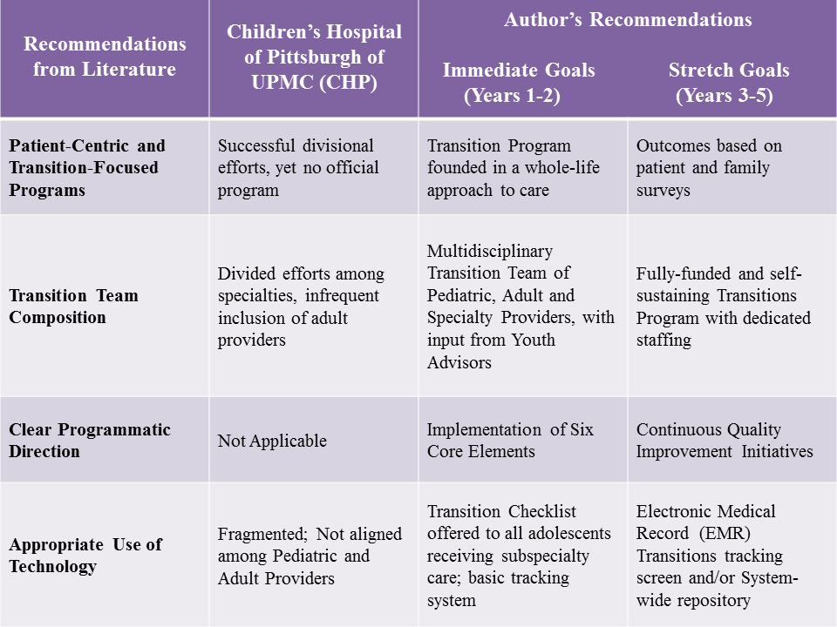
Furthermore, it is critical that the overall program and the multidisciplinary transitions team identify meaningful outcomes. The literature review yielded several accounts suggesting that future methodological research should focus more on identifying or developing objective measures of successful transition as well as transition tools (Davis et al., 2014). In addition, studies should track data points on long-term follow-up, which could be important for considering the ultimate success of transitioning.
It is paramount that transitioning from pediatric to adult care be addressed by the Children’s Hospital of Pittsburgh, the leading children’s hospital in the region, within the next year to best serve the growing population of adolescents with special needs.
APPENDIX A: CORE ELEMENTS

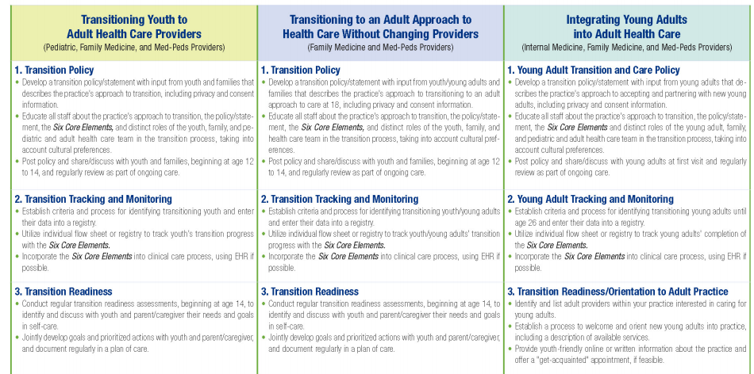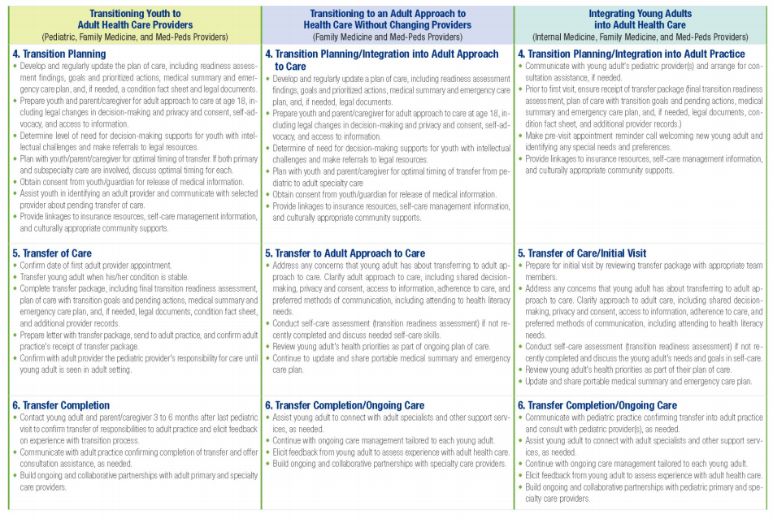
APPENDIX B: SAMPLE INDIVIDUAL TRANSITION FLOW SHEET

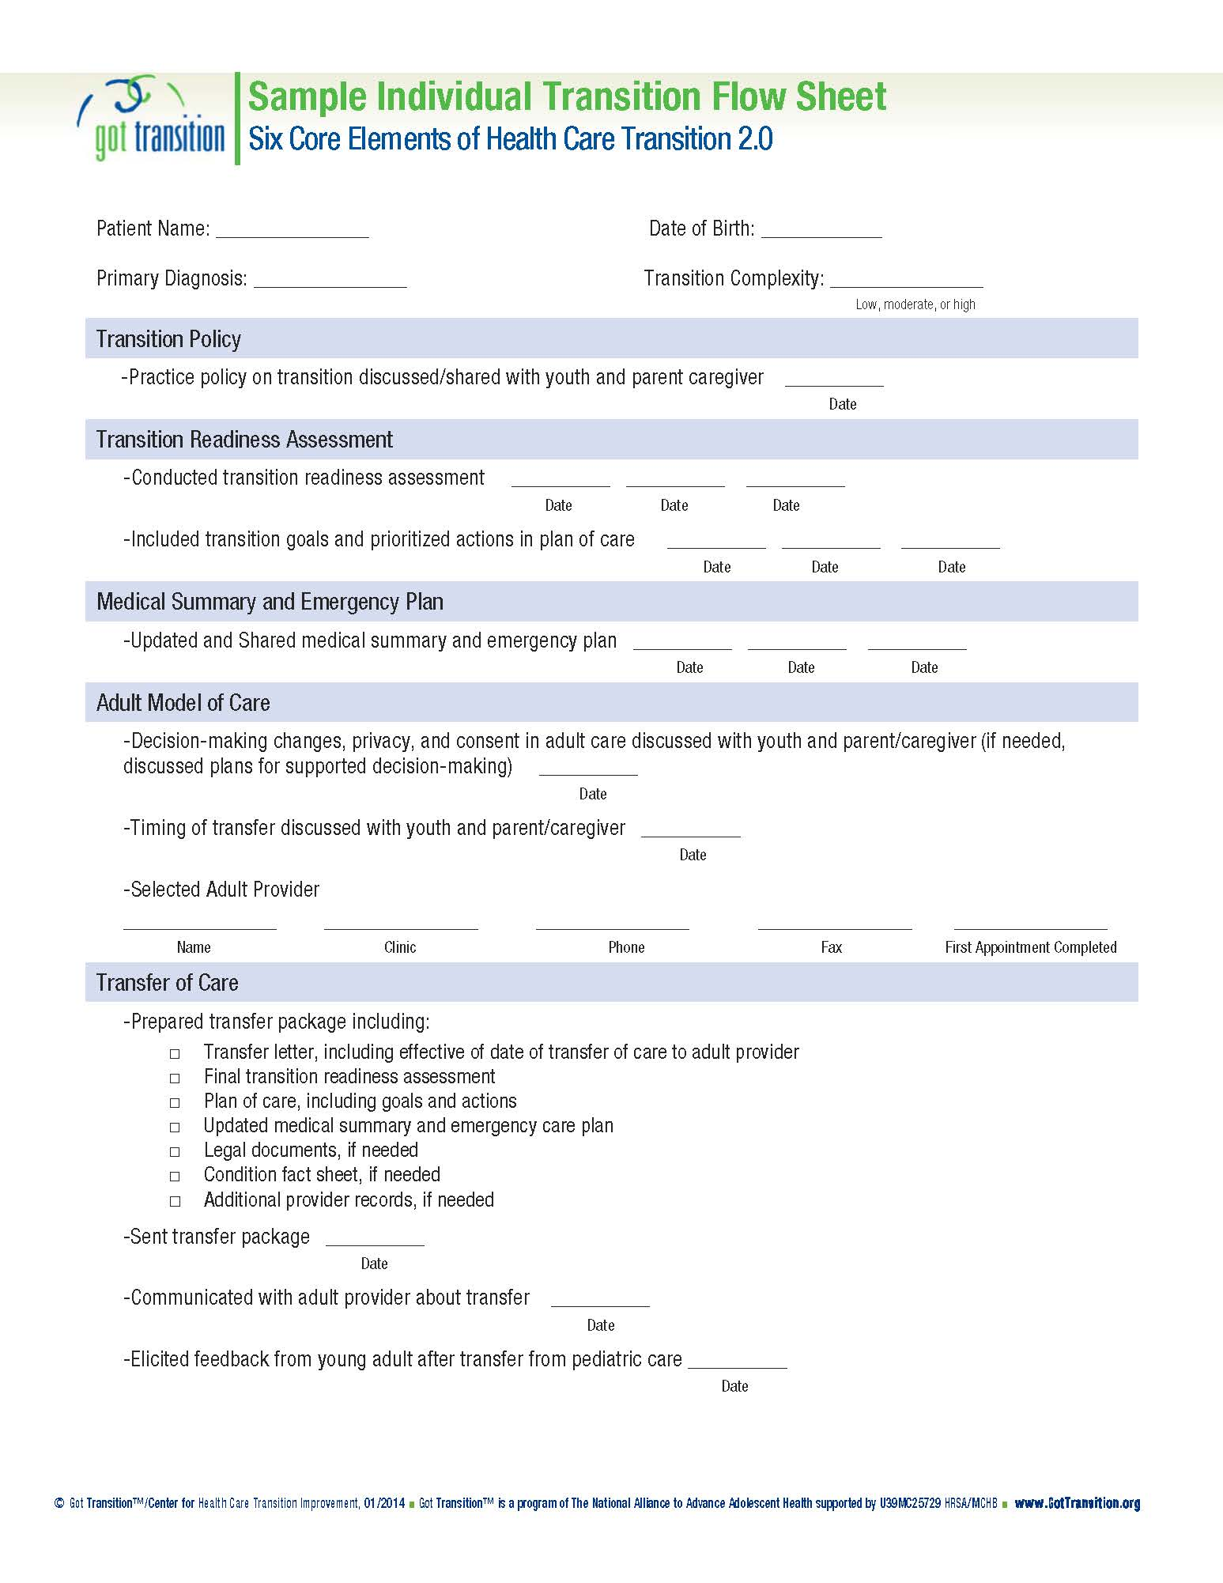
APPENDIX C: JOB DESCRIPTION FOR TRANSITION CARE COORDINATOR
Description of Transition Care Coordinator:
The Transition Care Coordinator (TCC) is responsible for coordination of interdisciplinary assessment, counseling, referral, and advocacy based on the needs of adolescents and young adults with complex health needs (AYA) as they transition from childhood to adulthood.
- Orient and educate staff, patients and families to the role of the TCC.
- Effectively coordinate the identification, assessment, and counseling of individuals who have medical and psychosocial complex needs.
  - A complete assessment includes social, economic, cultural, age/development related behavioral factors, history of child, elder or domestic abuse, prior psychiatric or substance abuse treatment, family and social support systems, and all other available resources.
  - Coordination of counseling includes communication with collocated, intra-system, and community-based therapists and professionals.
- Participate in crisis assessment and utilize the modalities of crisis intervention, including brief goal-directed therapy or other therapeutic counseling methods.
- Initiate and collaborate with the healthcare providers, patients and families, and relevant community resources to develop and implement an individualized interdisciplinary care plan.
- Foster peer support and community engagement for adolescents and young adults (AYA).
- Provide education to AYA regarding the case management process as indicated.
- Monitor and evaluate the plan, options, and available services to effectively meet the patient’s needs. Reassess the plan of care as status changes.
- Maintain extensive knowledge of federal, state and local assistance programs and community resources that affect patient needs; demonstrate expertise in accessing social systems by providing resource-specific information to patients/families, initiating contact with resources and facilitating the patient’s / family’s ability to accept referrals.
- Educate and advocate for patient and families to enhance their ability to make informed decisions regarding medical care.
- Demonstrate knowledge of reimbursement systems, the ability to train patient and families regarding payer requirements/coverage for outpatient services and individual’s responsibilities regarding maintenance of health care coverage.
- Practice effective advocacy on behalf of patients to obtain authorization for services, while promoting the development of self-advocacy skills.
- Provide follow-up and assess effectiveness of services after individuals have transferred from our clinical services.
- Participate in Interdisciplinary Quality Improvement projects and Case Conferences.
  - As skills develop, expectations will include leadership roles in QI projects
- Provide accurate, timely and appropriate documentation of all social work care coordinated services in the medical record per regulatory policies and procedures.
- Perform duties and responsibilities in accordance with the philosophy and standards of UPMC, including conveying courtesy, respect, enthusiasm, and a positive attitude through contacts with staff, health plan members, peers and external contacts.
- Perform in accordance with system-wide competencies/behaviors.
- Perform other duties as requested.

bibliography
Bloom, S. R., Kuhlthau, K., Van Cleave, J., Knapp, A. A., Newacheck, P., & Perrin, J. M. (2012). Health care transition for youth with special health care needs. Journal Of Adolescent Health, 51(3), 213-219.
Blum, R. (1997). Sexual health contraceptive needs of adolescents with chronic conditions. Arch Pediatr. Adolesc. Med., 151, 290-296.
Busse FP, H. P., Galler A, Stumvoll M, Wiessner T, Kiess W, et al. (2007). Evaluation of patients' opinion and metabolic control after transfer of young adults with type 1 diabetes from a pediatric diabetes clinic to adult care. Hormone Research., 67, 132-138.
Ciccarelli, M. R., Brown, M. W., Gladstone, E. B., Woodward, J. F., & Swigonski, N. L. (2014). Implementation and sustainability of statewide transition support services for youth with intellectual and physical disabilities (Vol. 7): IOS Press.
Data Resource Center for Child & Adolescent Health, D. (2013). from http://www.childhealthdata.org/learn/NS-CSHCN
Davis, A. M., Brown, R. F., Taylor, J. L., Epstein, R. A., & McPheeters, M. L. (2014). Transition Care for Children With Special Health Care Needs. Pediatrics, 134(5), 900-908. doi: 10.1542/peds.2014-1909
Fishman, L. N., Ziniel, S. I., Adrichem, M. E., Fernandes, S. M., & Arnold, J. (2014). Provider Awareness Alone Does Not Improve Transition Readiness Skills in Adolescent Patients With Inflammatory Bowel Disease. Journal of Pediatric Gastroenterology and Nutrition, 59(2), 221-224. doi: 10.1097/MPG.0000000000000405
Fleming E, C. B., Gillibrand W. (2002). The transition of adolescents with diabetes from the children's health care service into the adult health care service: A review of the literature. Journal of Clinical Nursing., 11, 560-567.
Hopper, A., Dokken, D., & Ahmann, E. (2014, 2014 September-October). Transitioning from pediatric to adult health care: the experience of patients and families. Pediatric Nursing, 40, 249+.
Huang, J. S., Terrones, L., Tompane, T., Dillon, L., Pian, M., Gottschalk, M., . . . Bartholomew, L. K. (2014). Preparing Adolescents With Chronic Disease for Transition to Adult Care: A Technology Program. Pediatrics, 133(6), e1639-e1646. doi: 10.1542/peds.2013-2830
Klassen, A. F., Grant, C., Barr, R., Brill, H., Kraus de Camargo, O., Ronen, G. M., . . . Gorter, J. W. (2014). Development and validation of a generic scale for use in transition programmes to measure self-management skills in adolescents with chronic health conditions: the TRANSITION-Q. Child: Care, Health and Development, n/a-n/a. doi: 10.1111/cch.12207
Kovacs, A. H., & McCrindle, B. W. (2014). So hard to say goodbye: transition from paediatric to adult cardiology care. Nat Rev Cardiol, 11(1), 51-62. doi: 10.1038/nrcardio.2013.172
Lotstein Ds, I. M., Hays RD, Halfon N, Brook R. (2007). Access to care for youth with special health care needs in the transition to adulthood. JAH, 43, 23-29.
Mackie, A. S., Islam, S., Magill-Evans, J., Rankin, K. N., Robert, C., Schuh, M., . . . Rempel, G. R. (2014). Healthcare transition for youth with heart disease: a clinical trial. Heart, 100(14), 1113-1118. doi: 10.1136/heartjnl-2014-305748
McManus, M., White, P., Barbour, A., Downing, B., Hawkins, K., Quion, N., . . . McAllister, J. W. (2015). Pediatric to Adult Transition: A Quality Improvement Model for Primary Care. Journal of Adolescent Health, 56(1), 73-78. doi: http://dx.doi.org/10.1016/j.jadohealth.2014.08.006
National Survey of Children with Special Health Care Needs. (2012).
Newacheck PA, T. W. (1992). Childhood chronic illness: prevalence, severity, and impact. . Amer Jl Pub Health, 82, 364-371.
Newman, C., Persson, A., Miller, A., & Cama, E. (2014). Bridging Worlds, Breaking Rules: Clinician Perspectives on Transitioning Young People with Perinatally Acquired HIV Into Adult Care in a Low Prevalence Setting. AIDS Patient Care and STDs, 28(7), 381-393. doi: 10.1089/apc.2013.0346
O'Sullivan-Oliveira, J., Fernandes, S. M., Borges, L. F., & Fishman, L. N. (2014, 2014 May-June). Transition of pediatric patients to adult care: an analysis of provider perceptions across discipline and role. Pediatric Nursing, 40, 113+.
Office of Disability Employment Policy. (2013). Healthy Transitions: A Pathway to Employment for Youth with Chronic Health Conditions and Other Disabilities. Department of Labor.
Pediatrics, American Academy of (2011). Supporting the Health Care Transition From Adolescence to Adulthood in the Medical Home. Pediatrics, 128(1), 182-200. doi: 10.1542/peds.2011-0969
Pediatrics, American Academy of (2002). A consensus statement on health care transitions for young adults with special health care needs. Pediatrics., 110, 1304-1306.
Peters A, L. L. (2011). Diabetes care for emerging adults: Recommendations for transition from pediatric to adult diabetes care systems. Diabetes Care. , 34, 2477-2485.
Prior, M., McManus, M., White, P., & Davidson, L. (2014). Measuring the “Triple Aim” in Transition Care: A Systematic Review. Pediatrics.
Sanabria, K. E., Ruch-Ross, H. S., Bargeron, J. L., Contri, D. A., & Kalichman, M. A. (2015). Transitioning youth to adult healthcare: New tools from The Illinois Transition Care Project (Vol. 8): IOS Press.
Stabile L, R., L, Perterfield, MCauley S, Levenson C, Haglund J, Christman K. (2005). Transfer versus transition: success in pediatric transplant brings the welcome challenge of transition. Progess in Transplantation, 15(4).
Stephany, H. A., Ching, C. B., Kaufman, M. R., Squiers, A., Trusler, L., Clayton, D. B., . . . Tanaka, S. T. (2015). Transition of Urologic Patients From Pediatric to Adult Care: A Preliminary Assessment of Readiness in Spina Bifida Patients. Urology, 85(4), 959-963. doi: http://dx.doi.org/10.1016/j.urology.2014.12.019
Tuchman, L. K., Slap, G. B., & Britto, M. T. (2008). Transition to adult care: Experiences and expectations of adolescents with a chronic illness. Child: Care, Health and Development, 34(5), 557-563.

These needs range in severity, and include challenges with health and development such as asthma, developmental delays, and mental health problems such as depression, chronic headaches, and allergies, among others (Data Resource Center for Child and Adolescent Health, 2013).
It’s important to make the distinction between transition and transfer. A transition is an extended and comprehensive process, whereas transfer is only one component of that process (Kovacs & McCrindle, 2014). The transition process should be a thorough practice, taking into account the viewpoint of the patient, family, pediatric and adult providers, and the organization as a whole.

