AGE-ADJUSTED MORTALITY RATES OF TOBACCO-RELATED MALIGNANT NEOPLASMS IN ALLEGHENY COUNTY, STATE OF PENNSYLVANIA AND THE UNITED STATES, 2012-2013

by
Chun Zou
BS, Beijing Institute of Technology, China, 2014

Submitted to the Graduate Faculty of
Department of Epidemiology
Graduate School of Public Health in partial fulfillment
of the requirements for the degree of
Master of Public Health

University of Pittsburgh
2016

UNIVERSITY OF PITTSBURGH
GRADUATE SCHOOL OF PUBLIC HEALTH

This essay is submitted
by
Chun Zou

on

April 24,2016
and approved by

Essay Advisor:
Nancy W. Glynn, PhD ______________________________________
Assistant Professor of Epidemiology
Department of Epidemiology
Graduate School of Public Health
University of Pittsburgh

Essay Readers:

Evelyn O. Talbott, Dr P.H, MPH ______________________________________
Professor of Epidemiology
Department of Epidemiology
Graduate School of Public Health
University of Pittsburgh

Jeremy J. Martinson, DPhil ______________________________________
Assistant Professor of Infectious Diseases and Microbiology
Department of Infectious Diseases and Microbiology
Graduate School of Public Health
University of Pittsburgh

John M. Kokenda, BA ______________________________________
Statistical Analyst
Bureau of Assessment, Statistics & Epidemiology
Allegheny County Health Department
Copyright © by Chun Zou
2016

Nancy W. Glynn, PhD
AGE-ADJUSTED MORTALITY RATES OF TOBACCO-RELATED MALIGNANT NEOPLASMS IN ALLEGHENY COUNTY, STATE OF PENNSYLVANIA AND THE UNITED STATES, 2012-2013
Chun Zou, MPH
University of Pittsburgh, 2016
ABSTRACT

Tobacco use and tobacco-related malignant neoplasms are a large problem and cause of death in the United States. Tobacco-related malignant neoplasms status varies between sex, race, age group and type of cancer. This essay aims to conduct an analysis of resident deaths due to tobacco-related malignant neoplasms in Allegheny County for the year 2012, and to compare them with those for the United States and Pennsylvania. This essay will also include spatial analysis for 2012 and 2013 to show the geographic distribution of eight tobacco-related malignant neoplasms in Allegheny County in 2012 and 2013. Age-adjusted mortality rates of eight malignant neoplasms for Allegheny County residents age 25 or older in 2012 were calculated, adjusted for sex and race. These rates were compared with those of the State of Pennsylvania and the United States. Age-adjusted mortality rates of eight malignant neoplasms of all sexes and races in Allegheny County in 2012 and 2013 were calculated, by municipality, to show geographic patterns of tobacco-related malignant neoplasms. The age-adjusted mortality rates of tobacco-related malignant neoplasms were similar among Allegheny County, State of Pennsylvania and the United States. The age-adjusted mortality rate of malignant neoplasms of trachea, bronchus and lung is the highest in each race and sex groups. In general, males have higher age-adjusted mortality rates of tobacco-related cancers than females, and age-adjusted mortality rates of tobacco-related cancers in blacks are higher than those of whites. Based on spatial analysis, higher mortality rates seem to be concentrated in Pitcairn Borough, Millvale Borough, Etna Borough, Tarentum Borough, which present visible geographic patterns within Allegheny County in 2012 and 2013. These results indicate a need to address and develop tobacco cessation programs to improve policies and public health awareness of tobacco cessation and tobacco-related malignant neoplasms prevention, and assist with reducing tobacco use and eliminating tobacco-related disease disparities in the population.

TABLE OF CONTENTS
PREFACE X
1.0 INTRODUCTION 1
1.1 TOBACCO USE IN THE UNITED STATES 1
1.2 ASSOCIATION BETWEEN TOBACCO USE AND MALIGNANT NEOPLASMS 3
1.2.1 TOBACCO-RELATED MALIGNANT NEOPLASMS OF THE LIP, ORAL CAVITY AND PHARYNX (C00-C14) 3
1.2.2 TOBACCO-RELATED MALIGNANT NEOPLASMS OF THE ESOPHAGUS (C15) 4
1.2.3 TOBACCO-RELATED MALIGNANT NEOPLASMS OF STOMACH (C16) 5
1.2.4 TOBACCO-RELATED MALIGNANT NEOPLASMS OF THE PANCREAS (C25) 5
1.2.5 TOBACCO-RELATED MALIGNANT NEOPLASMS OF THE LARYNX (C32) 6
1.2.6 TOBACCO-RELATED MALIGNANT NEOPLASMS OF THE TRACHEA, BRONCHUS AND LUNG (C33-C34) 7
1.2.7 TOBACCO-RELATED MALIGNANT NEOPLASMS OF THE KIDNEY AND RENAL PELVIS (C64-C65) 7
1.2.8 TOBACCO-RELATED MALIGNANT NEOPLASMS OF THE BLADDER (C67) 8
1.3 SEX AND RACE VARIATIONS OF TOBACCO-RELATED MALIGNANT NEOPLASMS 9
1.4 TOBACCO USE AND MALIGNANT NEOPLASMS IN ALLEGHENY COUNTY, PA 10
1.5 GEOGRAPHIC DISTRIBUTION OF MALIGNANT NEOPLASMS IN ALLEGHENY COUNTY, PA 11
1.6 PUBLIC HEALTH SIGNIFICANCE 12
1.7 OBJECTIVE 13
2.0 METHODS 14
2.1 STUDY POPULATION 14
2.2 ALLEGHENY COUNTY RESIDENT DEATH RECORD 15
2.3 DISCLAIMER 15
2.4 CDC WONDER SYSTEM: CANCER STATISTICS 16
2.5 AGE-ADJUSTMENT OF MORTALITY RATES 16
2.6 DATA ANALYSES 17
3.0 RESULTS 19
3.1 AGE-ADJUSTED MORTALITY RATES OF TOBACCO-RELATED MALIGNANT NEOPLASMS IN ALLEGHENY COUNTY, THE STATE OF PENNSYLVANIA AND THE UNITED STATES 19
3.2 AGE-SPECIFIC MORTALITY RATES OF TOBACCO-RELATED MALIGNANT NEOPLASMS BY AGE GROUPS IN ALLEGHENY COUNTY, PENNSYLVANIA, AND THE UNITED STATES 26
3.3 SPATIAL ANALYSIS OF AGE-ADJUSTED MORTALITY RATES BY MUNICIPALITY IN ALLEGHENY COUNTY 29
4.0 DISCUSSION 33
APPENDIX A: SUPPLEMENTARY TABLES 39
APPENDIX B: SUPPLEMENTARY FIGURES 42
BIBLIOGRAPHY 45

List of tables
Table 1. Age-adjusted mortality rates of tobacco-related malignant neoplasms in Allegheny County, PA in 2012 by sex and race. 21
Table 2. Age-adjusted mortality rates of tobacco-related malignant neoplasms in Pennsylvania in 2012 by sex and race. 23
Table 3. Age-adjusted mortality rates of tobacco-related malignant neoplasms in the US in 2012 by sex and race. 25
Table 4. Age-adjusted mortality rates of tobacco-related malignant neoplasms by municipality in Allegheny County in 2012 and 2013 (all sexes and races) (per 100,000 people) 39
Table 5. Poverty rates by municipality in Allegheny County in 2013 (all sexes and races) (per 100 people)……………………………………………………………………………………….39

List of figures
Figure 1. Age-specific mortality rates of Tobacco-related Malignant Neoplasms by Age Groups in Allegheny County in 2012 27
Figure 2. Age-specific mortality rates of Tobacco-related Malignant Neoplasms by Age Groups in Pennsylvania in 2012 28
Figure 3. Age-specific mortality rates of Tobacco-related Malignant Neoplasms by Age Groups in the United States in 2012 29
Figure 4. Distribution of age-adjusted mortality rates of eight tobacco-related malignant neoplasms by municipality in Allegheny County in 2012 and 2013 (all sexes and races) (per 100,000 people) 31
Figure 5. Distribution of poverty rate by municipality in Allegheny County in 2013 (all sexes and races)(per 100 people) 32
Figure 6. Age-adjusted mortality rates of tobacco-related malignant neoplasms in Allegheny County, PA in 2012 by sex and race. 42
Figure 7. Age-adjusted mortality rates of tobacco-related malignant neoplasms in Pennsylvania in 2012 by sex and race. 43
Figure 8. Age-adjusted mortality rates of tobacco-related malignant neoplasms in the United States in 2012 by sex and race. 44

PREFACE
I’d like to express my sincere appreciation to Professor Nancy W. Glynn, my academic advisor, who has always been encouraging and illuminating me through my whole study. Without her insights and guidance, it would be impossible to finish this essay.
My gratitude would also go to Professor Evelyn O. Talbott and Professor Jeremy J. Martinson not only for sitting on my essay committee but most importantly for sharing their valuable insights and inspiring comments on this essay.
I would also like to thank my supervisor, John Kokenda, Statistical Analyst, Allegheny County Health Department, for his guidance, comments, suggestions and other assistance during the research.

Introduction

TOBACCO USE IN THE UNITED STATES
Tobacco use has been a large problem and cause of disease and death in the United States. Since 1965, the prevalence of tobacco use in U.S. has declined by almost 50%, which shows positive trends in prevention and cessation processes[1]. Based on the data from the CDC and NHIS, in 1965, the prevalence of tobacco use among adults in the U.S. was 42.4%, and declined to 23.3% in 2000, which is approximately 47 million adults[2].In 2014, it was estimated that 16.8% (40 million) of U.S. adults currently use tobacco products, and 76.8% of them were heavy smokers[3]. The prevalence of prevention and cessation has also increased. In 1965, the prevalence of cessation was 24.3%, increasing to 48.8% in 2000. The highest prevalence of cessation was 49.6% in 1993. In 1974, the percentage of heavy smokers was 25.3 and decreased to 15.3% in 2000, with positive trends in frequency control of tobacco use [4]. As the prevalence of tobacco use declined, U.S. cigarette consumption also decreased by over 100 billion cigarettes during the past 20 years, with the comparison of 640 billion cigarettes were smoked in 1981 and 360 billion in 2007[5].
Adults (age 18+) are the largest tobacco user group, which accounted for 63.2% of all smokers in U.S.[3]. In 2014, almost 17 of every 100 U.S. adults used tobacco products. Although obvious declines have been shown in tobacco use among U.S. adults over the past decade, the rate of decline has slowed down in recent years[6]. Based on the data from the 2012-2013 National Adult Tobacco Survey (NATS), the use rate of emerging products, such as e-cigarettes, has increased rapidly. Among adult smokers in 2014, males were more likely to smoke than females, with a prevalence rate of 18.8% of males compared to 14.8% of females[7]. Current tobacco use was higher among adults aged 25-44 years with a prevalence of 20.0% and adults aged 45-64 with a prevalence of 18.0%, and lowest among those aged 65+, with a prevalence of 8.5%. Of all racial and ethnic groups, tobacco use was highest among non-Hispanic American Indians/Alaska Natives (29.2%), and lowest among Asians (9.5%). Adults with a GED certificates and lower educational attainment had the highest prevalence of tobacco use (65.9%), and adults with a graduate degree had the lowest prevalence of tobacco use (5.4%)[3].
Tobacco use poses a serious health threat to youths in the U.S., which can cause significant health problems, including asthma and respiratory diseases.[8] Nearly 9 out of 10 cigarette smokers report that they started smoking by age 18, and 10% of adolescents are current smokers by the time they leave high school[9]. According to data from the U.S. Department of Health & Human Services, over 450,000 adolescents aged 12-13 years and approximately 4.4 million adolescents aged 14-17 years have smoked. Racial/ethnic and regional differences are significant among young smokers. White teens are more likely to smoke than black or Hispanic teens among high school students, and prevalence of tobacco use in youths in nonmetropolitan, Southern and Midwestern areas is higher than other regions in the U.S.[10].
The United States has been aware of the importance of tobacco cessation and has made historic progress in combatting the prevalence of tobacco use and the epidemic of tobacco-caused diseases, towards the Health People 2010 goal “To reduce illness, disability, and death related to tobacco use and exposure to secondhand smoke”.

Association between tobacco use and malignant neoplasms
Tobacco use is responsible for nearly 20% of all deaths in the U.S., and accounts for at least 30% of all malignant neoplasm-specific deaths and over $190 billion in economic losses annually.[11] Most tobacco-caused deaths are due to lung cancer, obstructive pulmonary disease, coronary heart disease and other airway obstruction.[12] According to the 2014 Surgeon General’s Report, tobacco smoking is the main cause of human malignant neoplasms in the world[13]. It is not only related to malignant neoplasm-specific mortality but also all-cause mortality in people with malignant neoplasms. The International Agency for Research on Cancer (IARC) indicates that there is sufficient evidence to consider that tobacco smoking can cause up to one third of all cancers, including lung, larynx, paranasal sinuses, oral cavity and pharynx, stomach, esophagus, liver, ureter, pancreas, kidney and bone marrow.[14]
The CDC Tobacco-Related Mortality Report suggested that, from 2005 to 2009, annual cigarette tobacco-related mortality in the U.S. of all cancers was 163,700, including 100,300 male and 63,400 females. The cancer with the highest annual tobacco-related mortality was lung cancer, 127,700, accounting for 78% of all cancer-specific deaths[15].

TOBACCO-RELATED MALIGNANT NEOPLASMS OF THE LIP, ORAL CAVITY AND PHARYNX (C00-C14)
Oral cancer is an uncontrolled growth of abnormal cells that starts in the mouth cavity, which leads to the development of a tumor. It is estimated that, close to 48,000 people will be diagnosed with lip, oral cavity and pharynx cancer every year, which causes over 9,575 deaths and kills about 1 person per hour each day.[16] The International Agency for Research on Cancer (IARC) shows that tobacco use is considered to be a major cause of lip, oral cavity and pharynx cancers, with an estimate of 65% of lip, oral cavity and pharynx cancers being linked to tobacco use. A meta-analysis shows that the risk of oral cavity cancer is 3 times higher in tobacco users than that of non-tobacco users, and pharynx cancer risk is about 7 times higher in tobacco users compared to non-tobacco users.[17] Chemicals in tobacco smoke can cause genetic changes in mouth cells that can initiate or promote lip, oral cavity and pharynx cancers. Exposing the mouth to the carcinogenic chemicals in tobacco will increase the risk of lip, oral cavity and pharynx cancers, either through direct contact such as chewing tobacco products or inhalation. Malignant neoplasms of lip, oral cavity and pharynx are defined as ICD-10 codes C00-C14.

TOBACCO-RELATED MALIGNANT NEOPLASMS OF THE ESOPHAGUS (C15)
Esophageal cancer is a disease where malignant cells form in the lining of esophagus tissues. Based on the data from the American Cancer Society, about 16,910 new esophageal cancer cases (13,460 in men and 3,450 in women) will be diagnosed in the United States in 2016, which makes up approximately 1% of all cancers diagnosed in the United States. About 15,690 deaths were due to esophageal cancer.[18] In the United States, tobacco use is classified as one of the major factors for esophageal cancer, particularly squamous cell carcinoma. It is estimated that about 66% of esophageal cancer cases are linked to tobacco use, including several tobacco products such as cigarettes, pipes, cigars and chewing tobacco.[19]The risk of esophageal cancer is about 2 times higher in tobacco users than non-tobacco users, and the risk increases the more a person uses tobacco products and the longer a person smokes.[20] Malignant neoplasms of the esophagus is defined as ICD-10 code C15.

TOBACCO-RELATED MALIGNANT NEOPLASMS OF STOMACH (C16)
Stomach cancer, also known as gastric cancer, begins when malignant neoplasms form in the inner lining of stomach, which grows slowly and usually affects older people. Based on the statistics from the American Cancer Society’s estimation, about 26,370 stomach cancer cases will be diagnosed in the United States in 2016, which involves 16,480 men and 9,890 women, and about 10,730 deaths will occur.[21] Tobacco use is considered to be one of the major causes of stomach cancer. According to a large cohort study of United States veterans, a statistically significant 40% increased risk of stomach cancer exists in tobacco users compared to non-tobacco users, and an 82% increased risk among heavier tobacco users.[22] Tobacco use could promote stomach cancer development in several ways, such as promoting the reflux of the duodenal contents back into stomach and increasing the acidity of the duodenum. Tobacco use will also reduce the production of natural substances and reduce blood flow, which leads to damage of stomach tissues.[23] Malignant neoplasms of the stomach are defined as ICD-10 code C16.

TOBACCO-RELATED MALIGNANT NEOPLASMS OF THE PANCREAS (C25)
As the fifth leading cause of cancer related mortality in the United States, cancer of the pancreas caused about 40,560 deaths (20,710 men and 19,850 women) in the United States in 2015. Tobacco use is one of the most important risk factors for cancer of the pancreas, with the risk of getting cancer of the pancreas twice as high among tobacco users as non-tobacco users.[24] Based on a prospective study of cigarette smoking and the risk of pancreatic cancer, the data shows that the relative risk of pancreatic cancer for tobacco users was 2.5 times greater than non-tobacco users (95% confidence interval 1.7-3.6), and as the years of tobacco use increase, there is a significant and positive trend of pancreatic cancer risk.[25] According to a study in 2011, at least 69 out of 250 known harmful chemicals in tobacco smoke can cause pancreatic cancer, by damaging the DNA or changing genes that lead to cells multiplying out of control.[26] Malignant neoplasms of the pancreas is defined as ICD-10 code C25.

TOBACCO-RELATED MALIGNANT NEOPLASMS OF THE LARYNX (C32)
Laryngeal cancer is not well known. It is considered a rare disease. In 2012, according to the statistics of the American Cancer Society, about 12,000 laryngeal cancer cases were diagnosed in the United States with about 3,600 deaths. Most laryngeal cancer develops in people over the age of 50, and men are 10 times more likely to get laryngeal cancer compared to women.[27] Laryngeal cancer is considered a preventable disease, but for those survivors, the consequences still can be severe with influences on voice, breathing and swallowing.[28] Based on a report from the American Academy of Otolaryngology, laryngeal cancer development involves several factors, and chief among them is tobacco use. Over 90% of laryngeal cancers are squamous cell carcinomas, and over 95% of squamous cell carcinoma patients are tobacco users. People with more than 40 years of smoking history and people who smoke over 20 cigarettes a day have about 40 times higher risk of getting laryngeal cancers compared to non-tobacco users. One research study shows that about 80% of laryngeal cancers could have been prevented if people lived a healthier lifestyle. Malignant neoplasms of the larynx are defined as ICD-10 code C32.[29]

TOBACCO-RELATED MALIGNANT NEOPLASMS OF THE TRACHEA, BRONCHUS AND LUNG (C33-C34)
Lung cancer is the leading cancer killer for both men and women in the United States. In 2015, it’s estimated that about 158,000 deaths were due to lung cancer, which account for nearly 27% of all cancer deaths in the United States. Lung cancer is also one of the most common cancers worldwide. In 2012, 1.8 million cases of lung cancer were diagnosed and 1.6 million deaths were due to lung cancer.[30] The incidence of lung cancer is significantly correlated with tobacco use, with close to 90% of lung cancer cases resulting from tobacco use. Compared to non-tobacco users, male tobacco users have a 23 times higher risk of getting lung cancer, and females are 13 times more likely to develop lung cancer.[31] Tobacco use causes the majority of lung cancers not only in tobacco users, but also in people exposed to secondhand smoke. According to the Surgeon General’s Report, non-tobacco users who are exposed to secondhand smoke have an increased risk of developing lung cancer by 20 to 30 percent.[32] Malignant neoplasms of trachea, bronchus and lung are defined as ICD-10 codes C33-C34.

TOBACCO-RELATED MALIGNANT NEOPLASMS OF THE KIDNEY AND RENAL PELVIS (C64-C65)
After about two decades of increasing rates, kidney and renal pelvis cancers have shown a downward trend in recent years in the United States. According to the American Cancer Society’s estimates for kidney and renal pelvis cancers in the United States in 2016: approximately over 62,000 new cases of kidney and renal pelvis cancer will be diagnosed, and over 14,000 people will die from them.[33] Kidney cancer includes malignant tumors in renal parenchyma and renal pelvis. Renal parenchyma cancer in adenocarcinoma cell type is the major kidney cancer. Among all cell types, renal pelvis cancers are the most transitional. The International Agency for Research and Cancer and the U.S. Surgeon General states that tobacco use is a causal risk factor for kidney and renal pelvis cancers. Tobacco use is considered to increase kidney and renal pelvis cancers through chronic tissue hypoxia, due to exposure to carbon monoxide and chronic obstructive pulmonary disease.[34] The risk of developing kidney and renal pelvis cancers increases about 50% in men and 20% in women compared to non-tobacco users, with a significant dose-response pattern of the risk.[34] Malignant neoplasms of the kidney and renal pelvis are defined as ICD-10 codes C64-C65.

TOBACCO-RELATED MALIGNANT NEOPLASMS OF THE BLADDER (C67)
Bladder cancer develops when cells start to grow uncontrollably in the urinary bladder. Based on the key statistics for bladder cancer from the American Cancer Society, over 76,000 new cases of bladder cancer will be diagnosed in the United States, and over 16,000 deaths will occur due to bladder cancer.[35] Among several risk factors of bladder cancer, the National Institutes for Health states that tobacco use is the single most important known risk factor for bladder cancer. Based on a new study by Dr. Neal Freedman and colleagues at NIH’s National Cancer Institute, tobacco use is responsible for nearly 50% of men and women’s bladder cancer, and tobacco users are 4 times as likely to develop bladder cancer than those who are non-tobacco users.[36] People with the highest risk are heavy tobacco users or who have used tobacco products for a long time. Malignant neoplasms of the bladder are defined as ICD-10 code C67.

sex and race variations of Tobacco-related malignant neoplasms
Malignant neoplasms status varies largely by sex and race. Based on data from the Centers for Disease Control and Prevention, in 2011, incidence rates and mortality rates of cancers among men were higher than those of women. For males, incidence rates of all cancers combined among black men was 538.2 per 100,000, which was the highest of all races, followed by white, Hispanic, Asian/Pacific Islander, and American Indian/Alaska Native. Death rates for all cancers among black men was 247.8 per 100,000, which was higher than all the other races, followed by white, Asian/Pacific Islander, and American Indian/Alaska Native. For females, the incidence rate for all cancers combined among white women was 416.7 per 100,000, which was the highest of all races, followed by black, Hispanic, Asian/Pacific Islander, and American Indian/Alaska Native. Death rates of all cancers combined was highest among black women (161.9 per 100,000 people), and followed by white, American Indian/Alaska Native, Hispanic and Asian/Pacific Islander.[37]

tobacco use and malignant neoplasms in allegheny county, pa
For tobacco smoking in Allegheny County, in the US state of Pennsylvania, the Allegheny Community Indicators (ACI) report shows that 23% of adults in Allegheny County currently smoke. That is almost 230,000 people, which is 5% higher than the mean value of all counties in the state and leads to over $635 million health care costs every year.[7] In the Healthier Allegheny Plan, Allegheny County Health Department (ACHD) committed to curtailing the adult smoking rate by 10% by 2020[8]. To achieve these goals, some of the state-level initiatives include Free Quitline, restriction of minors’ access to tobacco products, efforts to counter tobacco-marketing, and improvement of clinical-practice guidelines for tobacco addiction assessment and treatment.[32] Significant progress has been made, but there is still much work to be done.
For malignant neoplasms in Allegheny County, 2012, the Allegheny County Mortality Report shows that malignant neoplasms were responsible for 3,095 deaths of residents of Allegheny County, and accounted for 23% of all deaths for county residents, which were the second leading cause of death. After age-adjustment, the malignant neoplasm mortality rate was 184.2 per 100,000 standardized population, which is higher than that of heart disease.[7]

geographic distribution of MALIGNANT NEOPLASMS in Allegheny County, PA
Malignant neoplasms rank as the second leading cause of death in Allegheny County, which was responsible for over 3,000 deaths and accounted for over 20% of all deaths in 2012, according to the 2012 Allegheny County Mortality Report. Tobacco-related cancers introduced above accounted for over 50% of all cancer deaths in Allegheny County in 2012, with trachea, bronchus and lung cancer accounting for 28%, and pancreas cancer accounting for 7%. Tobacco-related cancer deaths vary by age group, sex, race, and geographic area.[38]
Allegheny County consists of 130 municipalities and is bordered by Pine Township, Richland Township and other 4 municipalities to the north, Forward Township to the south, Findlay Township to the west and Plum borough to the east. Since there are geographic differences among all municipalities in Allegheny County, demographic variability across Allegheny County will be one of several factors when assessing cancer status and risks, as well as cancer detection, prevention and control.[39]
Based on the number of deaths due to cancers in each municipality in 2012 and 2013, it is clear that the major cancer prevention effort and health care may be concentrated and provided in the city of Pittsburgh. However, since the population of each municipality in Allegheny County varies from each other, and age distribution of each municipality population differs, to better control for demographic differences among all municipality populations and show tobacco-related cancers distribution in 2012 and 2013, this essay will focus on the age-adjusted rates of each municipality in Allegheny County.

Public health significance
Malignant neoplasms pose a huge threat to the United States, Pennsylvania and Allegheny County, and according to 2014 Surgeon General’s Report, tobacco smoking is a main cause of human malignant neoplasms in the world[7]. Among all the cancers, lung cancer is the leading cause of cancer death in the United States for both males and females. Based on the 2014 US Surgeon General Report, men who are tobacco users have a 25 times higher risk of developing lung cancer compared to those who never smoked, and women smokers are 25 times more likely to get lung cancer, compared to those who never used tobacco products. [40] Besides lung cancer, tobacco use may also increase the risk for getting other cancers, such as lip, oral cavity and pharyngeal cancers, esophageal cancer, stomach cancer, pancreatic cancer, laryngeal cancer, kidney and renal pelvis cancers, bladder cancer, etc. The financial costs of cancer are extremely high for not only the people with tobacco-related cancers but also for society as a whole. According to the Agency for Healthcare research and Quality, it is estimated that in 2011 in the United States, the direct medical costs for all cancers were over $88 billion[41], and a large number of all cancers are tobacco-related cancers. With the huge amount of life lost and financial cost due to tobacco-related cancers, it is crucial that public health leaders and policy makers promote tobacco cessation programs to raise public awareness and to fight for eliminating suffering and potential deaths due to tobacco-related cancers.

objective
The objective of this essay is to conduct an analysis and assessment of resident deaths due to tobacco-related malignant neoplasms in Allegheny County, Pennsylvania in 2012 and 2013, using 2012 and 2013 Allegheny County Resident Death Records. Likewise, this essay will compare the age-adjusted mortality rates of tobacco-related malignant neoplasms with those of the Pennsylvania and the United States. This essay will also conduct spatial analysis of the geographic distribution of tobacco-related malignant neoplasms decedents in Allegheny County in 2012 and 2013.
The results of this analysis and interpretation will help to improve public awareness of tobacco cessation and health practice and health policy influence regarding tobacco-related malignant neoplasms elimination in Allegheny County, in Pennsylvania and in the United States, and address tobacco-related malignant neoplasm disparities in sex and race. The results of this spatial analysis will also help to explore the possible existence of geographical patterns of tobacco-related malignant neoplasms in Allegheny County and assist in exposing health disparities and deciding where to focus tobacco-related malignant neoplasm control interventions.

methods

study population
The data I used in this research are from 2012 and 2013 Allegheny County Resident Death Records, which were provided by the Allegheny County Health Department, Bureau of Assessment, Statistics & Epidemiology. The study population are decedents aged 25 years and older who were residents of Allegheny County and died in 2012 or 2013. The subset of the population that I used for this research are all individuals who died due to: Malignant neoplasms of the lip, oral cavity and pharynx (C00-C14), malignant neoplasms of the esophagus (C15), malignant neoplasms of the stomach (C16), malignant neoplasms of the pancreas (C25), malignant neoplasms of the larynx (C32), malignant neoplasms of the trachea, bronchus and lung (C33-C34), malignant neoplasms of the kidney and renal pelvis (C64-C65), and malignant neoplasms of the bladder (C67), which are classified by the International Statistical Classification of Diseases and Related Health Problems, 10th edition.
Based on vital statistics from Enterprise Data Dissemination Informatics Exchange System of the Pennsylvania Health Department, for Allegheny County in 2012, the municipalities of Ben Avon Heights Borough, Chalfant Borough, Edgeworth Borough, Haysville Borough, Rosslyn Farms Borough, South Versailles Township, Trafford Borough and West Elizabeth Borough had no deaths due to cancers, while the city of Pittsburgh had the highest deaths due to cancers, that was 664 people. For Allegheny County in 2013, the municipalities of Glenfield Borough, Haysville Borough, Kilbuck Township, Pennsbury Village Borough, Rosslyn Farms Borough, South Versailles Township and Trafford Borough had no deaths due to cancers, while the city of Pittsburgh had the highest number of deaths due to cancers, 695 people.[42]

Allegheny county resident death record
Allegheny County Resident Death Records are collected by medical professionals and completed at the time of death. They are then sent to the Pennsylvania Health Department in Harrisburg, PA, to be filed. The Pennsylvania Department of Health then sends an annual electronic file to the Allegheny County Health Department, Pittsburgh, PA.
The Bureau of Assessment, Statistics, & Epidemiology then reviews each death record to verify residency and census tract. Once all records are verified for accuracy, municipality and City of Pittsburgh neighborhood are added to each record.

disclaimer
These data are provided by the Allegheny County Health Department, Bureau of Assessment, Statistics & Epidemiology through a cooperative agreement with the Pennsylvania Department of Health which requires the following disclaimer: "These data were supplied by the State Health Data Center, Pennsylvania Department of Health, Harrisburg, Pennsylvania. The Pennsylvania Department of Health specifically disclaims responsibility for any analyses, interpretations or conclusions."

cdc wonder system: cancer statistics
CDC WONDER is an online public health information system of the Centers for Disease Control and Prevention (CDC). It is used to provide timely and action-oriented information. The system is created and maintained by public health professionals. The United States Cancer Statistic (USCS) is one of the online databases of CDC WONDER. It provides cancer incidence and mortality information for the public starting in 1999, by year, state and metropolitan statistical areas (MSA), age group, race, sex, ethnicity, cancer classifications and cancer site. The mortality data is provided by the Center for Disease Control and Prevention (CDC), in collaboration with the National Center for Health Statistics (NCHS) and the National Vital Statistics System (NVSS). The USCS automatically creates reports with the variables and information needed. The report can include the case counts, deaths, crude mortality rate, age-adjusted incidence and mortality rates with 95% confidence intervals.

Age-Adjustment of mortality rates
Crude numbers of people in each age group were inputted into an Excel program to calculate age-adjusted mortality rates. Age-adjusted mortality rates in this essay are adjusted using the U.S. 2000 Standard Million Population. The age groups are: 25-29 years, 30-34 years, 35-39 years, 40-44 years, 45-49 years, 50-54 years, 55-59 years, 60-64 years, 65-69 years, 70-74 years, 75-79 years, 80-84 years, 85+ years.

data analyses
Data analyses were conducted using the data for 2012, except for spatial analyses which aggregated 2012 and 2013 data to make the numbers more stable.
Age-adjusted mortality rates of malignant neoplasms of the lip, oral cavity and pharynx, malignant neoplasms of the esophagus, malignant neoplasms of the stomach, malignant neoplasms of the pancreas, malignant neoplasms of larynx, malignant neoplasms of the trachea, bronchus and lung, malignant neoplasms of the kidney and renal pelvis, and malignant neoplasms of the bladder by residence for those aged 25 years and over in Allegheny County in 2012 were analyzed, adjusted by sex and race, to illustrate the tobacco-related malignant neoplasms status in Allegheny County in 2012. Those age-adjusted mortality rates of eight malignant neoplasms of Allegheny County in 2012 were compared with those of Pennsylvania and the United States. Age-adjusted mortality rates of the Pennsylvania and the United States were collected from the United States Cancer Statistic (USCS) databases of CDC WONDER. Each mortality rate was adjusted by age (age group: 25-34, 35-44, 45-54, 55-64, 65-74, 75-84, 85+), sex (male, female) and race (white, black).
Age-adjusted mortality rates for all eight tobacco-related malignant neoplasms combined by residence for those aged 25 years and over in Allegheny County in 2012 and 2013 were analyzed, adjusted by municipality, to conduct spatial analysis of geographical patterns of tobacco-related malignant neoplasms in Allegheny County in 2012 and 2013.
All data were analyzed using SAS (version 9.3, SAS Institute Inc) and Excel. Spatial analysis was run by ArcGIS 10.1.

results

Age-adjusted Mortality rates of tobacco-related malignant neoplasms in allegheny County, the state of pennsylvania and the united states
Table 1 illustrates the age-adjusted mortality rates of eight tobacco-related malignant neoplasms in Allegheny County in 2012 by sex and race. Bar graph of Table 1 can be found in the appendix. Within all eight tobacco-related malignant neoplasms types, the age-adjusted mortality rate of malignant neoplasms of the trachea, bronchus and lung is the highest in each race and sex group. The highest one is malignant neoplasms of the trachea, bronchus and lung in black males (139.0 per 100,000 people), followed by white males (99.1 per 100,000 people) and black females (77.8 per 100,000 people).
Among whites, the age-adjusted mortality rates of all eight tobacco-related malignant neoplasms of males are higher than those of females, and the highest is the age-adjusted mortality rate of malignant neoplasms of the trachea, bronchus and lung (99.1 per 100,000 people) and followed by malignant neoplasms of pancreas (19.2 per 100,000 people) and bladder (15.4 per 100,000 people). In the black group, the age-adjusted mortality rates of all eight tobacco-related malignant neoplasms of males are higher than those of females except malignant neoplasms of the pancreas, and the highest is the age-adjusted mortality rate of malignant neoplasms of the trachea, bronchus and lung (139.0 per 100,000 people).

Table 1. Age-adjusted mortality rates of tobacco-related malignant neoplasms in Allegheny County, PA in 2012 by sex and race.
Name of malignant neoplasms  (Based on ICD-10)  (Per 100,000 people) | White |  |  |  | Black
 | Male |  | Female |  | Male |  | Female
 | Age-adjusted rate | 95% CI  (low, hi) | Age-adjusted rate | 95% CI  (low, hi) | Age-adjusted rate | 95% CI  (low, hi) | Age-adjusted rate | 95% CI  (low, hi)
Bladder | 15.4 | (11.6, 19.3) | 4.5 | (2.8, 6.2) | 22.8 | (7.0, 38.6) | 11.5 | (3.0, 20.1)
Esophagus | 12.3 | (8.9, 15.6) | 2.4 | (1.2, 3.6) | 4.6 | (-1.8, 11.1) | 1.3 | (-1.2, 3.7)
Larynx | 2.0 | (0.6, 3.3) | 0.1 | (-0.1, 0.3) | 6.7 | (-2.6, 16.1) | 1.8 | (-1.7, 5.2)
Pancreas | 19.2 | (15.0, 23.4) | 14.9 | (11.8, 18.0) | 32.2 | (14.7, 49.6) | 36.3 | (21.1, 51.5)
Stomach | 4.7 | (2.6, 6.8) | 3.8 | (2.3, 5.3) | 23.7 | (8.2, 39.1) | 1.7 | (-1.6, 5.1)
Kidney and renal pelvis | 9.5 | (6.5, 12.5) | 5.5 | (3.6, 7.5) | 8.6 | (0.2, 16.9) | 4.8 | (-0.6, 10.3)
Lip, oral cavity and pharynx | 2.7 | (1.0, 4.3) | 2.2 | (1.0, 3.4) | 3.2 | (-3.1, 9.6) | 3.5 | (-1.3, 8.3)
Trachea, bronchus and lung | 99.1 | (89.4, 108.7) | 65.1 | (58.3, 71.8) | 139 | (103.2, 174.8) | 77.8 | (55.8, 99.8)
Total | 164.8 | (152.3,177.2) | 98.5 | (90.3,106.6) | 240.8 | (192.9,288.7) | 136.9 | (107.6,166.2)
Age Group: 25-29 years, 30-34 years, 35-39 years, 40-44 years, 45-49 years, 50-54 years, 55-59 years,
60-64 years, 65-69 years, 70-74 years, 75-79 years, 80-84 years, 85+ years.
Standard Population: 2000 U.S. Std. Million

Table 2 shows the age-adjusted mortality rates of eight tobacco-related malignant neoplasms in the State of Pennsylvania in 2012 by sex and race. Bar graph of Table 2 can be found in the appendix. Among all age-adjusted mortality rates of eight tobacco-related malignant neoplasms in each sex and race group, the rate for black males with malignant neoplasms of the trachea, bronchus and lung is the highest (113.7 per 100,000 people), followed by white males with malignant neoplasms of the trachea, bronchus and lung (92.1 per 100,000 people). When comparing the eight tobacco-related cancer types, age-adjusted mortality rates of the larynx in each sex and age group are the lowest than those of other cancers. In two race groups, age-adjusted mortality rates of all cancers in males are higher than that of females. For males, age-adjusted mortality rates of malignant neoplasms of the bladder, esophagus and larynx in whites are higher than that of blacks, and age-adjusted mortality rates of other cancers in whites are lower than those of blacks. For females, age-adjusted mortality rates of malignant neoplasms of the larynx, kidney and renal pelvis and the lip, oral cavity and pharynx in whites are higher than those of blacks, and age-adjusted mortality rates of other cancers in whites are lower than that of blacks.

Table 2. Age-adjusted mortality rates of tobacco-related malignant neoplasms in Pennsylvania in 2012 by sex and race.
Name of malignant neoplasms  (Based on ICD-10)  (Per 100,000 people) | White |  |  |  | Black
 | Male |  | Female |  | Male |  | Female
 | Age-adjusted rate | 95% CI  (low, hi) | Age-adjusted rate | 95% CI  (low, hi) | Age-adjusted rate | 95% CI  (low, hi) | Age-adjusted rate | 95% CI  (low, hi)
Bladder | 13.5 | (12.4,14.7) | 3.2 | (2.8,3.8) | 10.3 | (6.8,14.9) | 7.7 | (5.4,10.7)
Esophagus | 14.2 | (13.1,15.4) | 2.1 | (1.8,2.6) | 6.6 | (4.0,10.1) | 3.17 | (1.8,5.2)
Larynx | 3.0 | (2.5,3.6) | 0.6 | (0.4,0.9) | Suppressed | Suppressed | Suppressed | Suppressed
Pancreas | 20.8 | (19.4,22.3) | 15.1 | (14.1,16.2) | 23.3 | (18.3,29.3) | 22.23 | (18.2,26.90)
Stomach | 5.7 | (4.9,6.4) | 2.8 | (2.4,3.3) | 13.5 | (9.7,18.2) | 6.42 | (4.4,9.1)
Kidney and renal pelvis | 8.8 | (7.9,9.8) | 4.1 | (3.6,4.7) | 11.0 | (7.4,15.6) | 3.72 | (2.2,5.9)
Lip, oral cavity and pharynx | 4.7 | (4.0,5.4) | 2.0 | (1.6,2.4) | 6.2 | (3.7,9.6) | Suppressed | Suppressed
Trachea, bronchus and lung | 92.1 | (89.1,95.0) | 56.5 | (54.4,58.6) | 113.7 | (101.8,126.6) | 75.6 | (68.0,83.9)
Total | 162.7 | (158.8,166.6) | 86.4 | (83.9,89.0) | 188.5 | (173.1,204.9) | 122.1 | (112.3,132.4)
Age Group: 25-29 years, 30-34 years, 35-39 years, 40-44 years, 45-49 years, 50-54 years, 55-59 years,
60-64 years, 65-69 years, 70-74 years, 75-79 years, 80-84 years, 85+ years.
Standard Population: 2000 U.S. Std. Million
The label "Suppressed" is displayed when counts fall below the determined "cut-off" value and the conditions for suppression are met.

Table 3 presents the age-adjusted mortality rates of eight tobacco-related malignant neoplasms in the United States in 2012 by sex and race. Bar graph of Table 3 can be found in the appendix. Compared to all eight tobacco-related malignant neoplasm types, the age-adjusted mortality rate of malignant neoplasms of the trachea, bronchus and lung is the highest in each race and sex groups, while the age-adjusted mortality rate of malignant neoplasms of the larynx is the lowest in each race and sex group. The age-adjusted mortality rate of malignant neoplasms of the trachea, bronchus and lung in black males is the highest (106.9 per 100,000 people), compared to all eight cancer types, sex groups and race groups, followed by white males with malignant neoplasms of the trachea, bronchus and lung (86.9 per 100,000 people) and white females with malignant neoplasms of the trachea, bronchus and lung (58.3 per 100,000 people). For whites, the age-adjusted mortality rates of all eight tobacco-related malignant neoplasms of males are higher than those of females, and the highest is the age-adjusted mortality rate of malignant neoplasms of the trachea, bronchus and lung (86.9 per 100,000 people) followed by malignant neoplasms of the pancreas (19.6 per 100,000 people) and bladder (12.5 per 100,000 people). For blacks, the age-adjusted mortality rates of all eight tobacco-related malignant neoplasms in males are higher than females, and the highest is the age-adjusted mortality rate of malignant neoplasms of the trachea, bronchus and lung (106.9 per 100,000 people), followed by malignant neoplasms of the pancreas (22.5 per 100,000 people) and stomach (13.0 per 100,000 people).

Table 3. Age-adjusted mortality rates of tobacco-related malignant neoplasms in the United States in 2012 by sex and race.
Name of malignant neoplasms  (Based on ICD-10)  (Per 100,000 people) | White |  |  |  | Black
 | Male |  | Female |  | Male |  | Female
 | Age-adjusted rate | 95% CI  (low, hi) | Age-adjusted rate | 95% CI  (low, hi) | Age-adjusted rate | 95% CI  (low, hi) | Age-adjusted rate | 95% CI  (low, hi)
Bladder | 12.5 | (12.2,12.7) | 3.4 | (3.3, 3.5) | 8.2 | (7.5,8.9) | 3.7 | (3.3,4.0)
Esophagus | 11.9 | (11.6,12.1) | 2.3 | (2.2, 2.4) | 9.6 | (9.0,10.3) | 3.0 | (2.7,3.3)
Larynx | 2.7 | (2.6,2.8) | 0.6 | (0.5,0.6) | 5.2 | (4.8,5.8) | 0.9 | (0.7,1.1)
Pancreas | 19.7 | (19.3,20.0) | 14.6 | (14.4,14.8) | 22.45 | (21.4,23.5) | 19.3 | (18.5,20.1)
Stomach | 5.8 | (5.6, 6.0) | 3.1 | (3.0,3.2) | 13.0 | (12.3,13.9) | 6.5 | (6.1,7.0)
Kidney and renal pelvis | 8.9 | (8.7,9.1) | 3.8 | (3.7,3.9) | 8.6 | (7.9,9.2) | 3.4 | (3.1,3.8)
Lip, oral cavity and pharynx | 5.8 | (5.7, 6.0) | 2.1 | (2.0,2.2) | 7.8 | (7.2,8.4) | 2.0 | (1.8,2.3)
Trachea, bronchus and lung | 86.9 | (86.3, 87.5) | 58.3 | (57.8,58.8) | 106.9 | (104.6,109.2) | 53.9 | (52.6,55.2)
Total | 154.1 | (153.2,154.9) | 88.0 | (87.5, 88.6) | 181.7 | (178.8,184.7) | 92.7 | (91.1, 94.5)
Age Group: 25-29 years, 30-34 years, 35-39 years, 40-44 years, 45-49 years, 50-54 years, 55-59 years,
60-64 years, 65-69 years, 70-74 years, 75-79 years, 80-84 years, 85+ years.
Standard Population: 2000 U.S. Std. Million

Age-specific mortality rates of tobacco-related malignant neoplasms by age groups in allegheny County, pennsylvania, and the united states
Figures 1-3 show the trends of age-specific mortality rates of tobacco-related malignant neoplasms by age groups in Allegheny County, the State of Pennsylvania and the United States in 2012. After comparison of age-specific mortality rates of eight tobacco-related malignant neoplasms between Allegheny County, the State of Pennsylvania and the United States, I found that they share similar trends by age groups for each malignant neoplasm type. The age-specific mortality rate of malignant neoplasms of the trachea, bronchus and lung is higher than other cancers in each age group, followed by malignant neoplasms of the pancreas and malignant neoplasms of the bladder. The age-specific mortality rate of malignant neoplasms of the larynx in each age group is the lowest among all eight malignant neoplasms types in Allegheny County, the State of Pennsylvania and the United States.
In Allegheny County, the State of Pennsylvania and the United States, the age-specific mortality rates of eight tobacco-related malignant neoplasms are very low before age 40 (less than 1.0) and there are no significant differences among cancer types for males, females or by race among cancer types between Allegheny County, PA, and US. When considering those aged over 40, the age-specific mortality rates increase and show differences of trends among cancer types. For malignant neoplasms of the trachea, bronchus and lung in the United States and Pennsylvania in 2012, the age-specific mortality rates increase steadily between age 40 and 64, and reach approximately 100/100,000 for those aged 60-64. Between age 64 and 84, the age-specific mortality rates rise sharply and peak for those in the age group 80-84, with an age-specific mortality rate over 350 per 100,000 people. The trend decreases after age 84. The trend of the other seven tobacco related cancers shows a gradual rise after age 40 and reach their peak for the age group 80-84. Malignant neoplasm of the stomach had a sharp increase after age 84. For malignant neoplasms of the trachea, bronchus and lung in Allegheny County in 2012, the trends are similar to those for Pennsylvania and the United States. The age-specific mortality rates of eight tobacco-related malignant neoplasms are low before age 40 (less than 1.0) and do not show significant difference among cancer types.

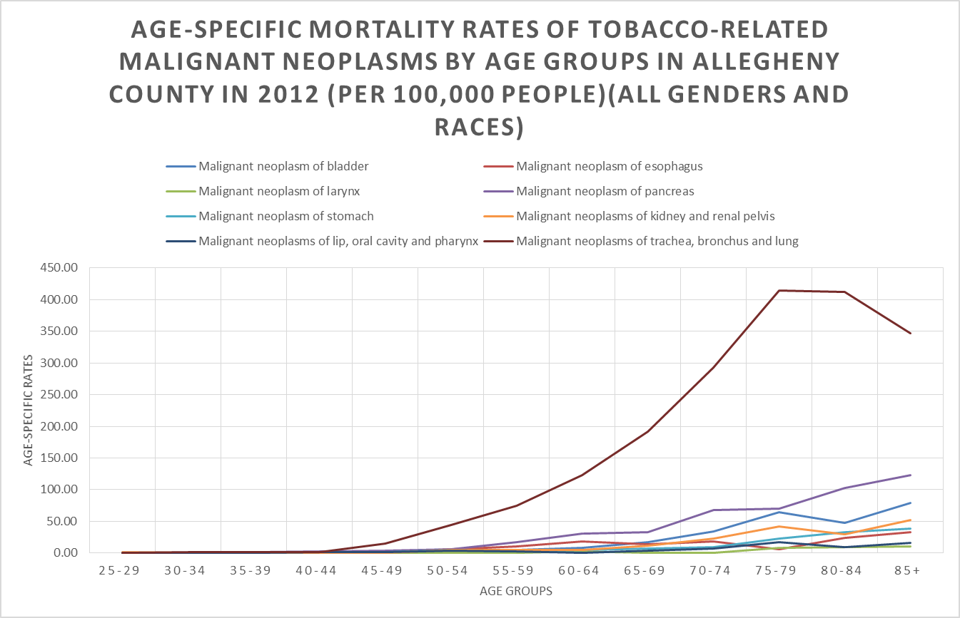
Figure 1. Age-specific mortality rates of Tobacco-related Malignant Neoplasms by Age Groups in Allegheny County in 2012

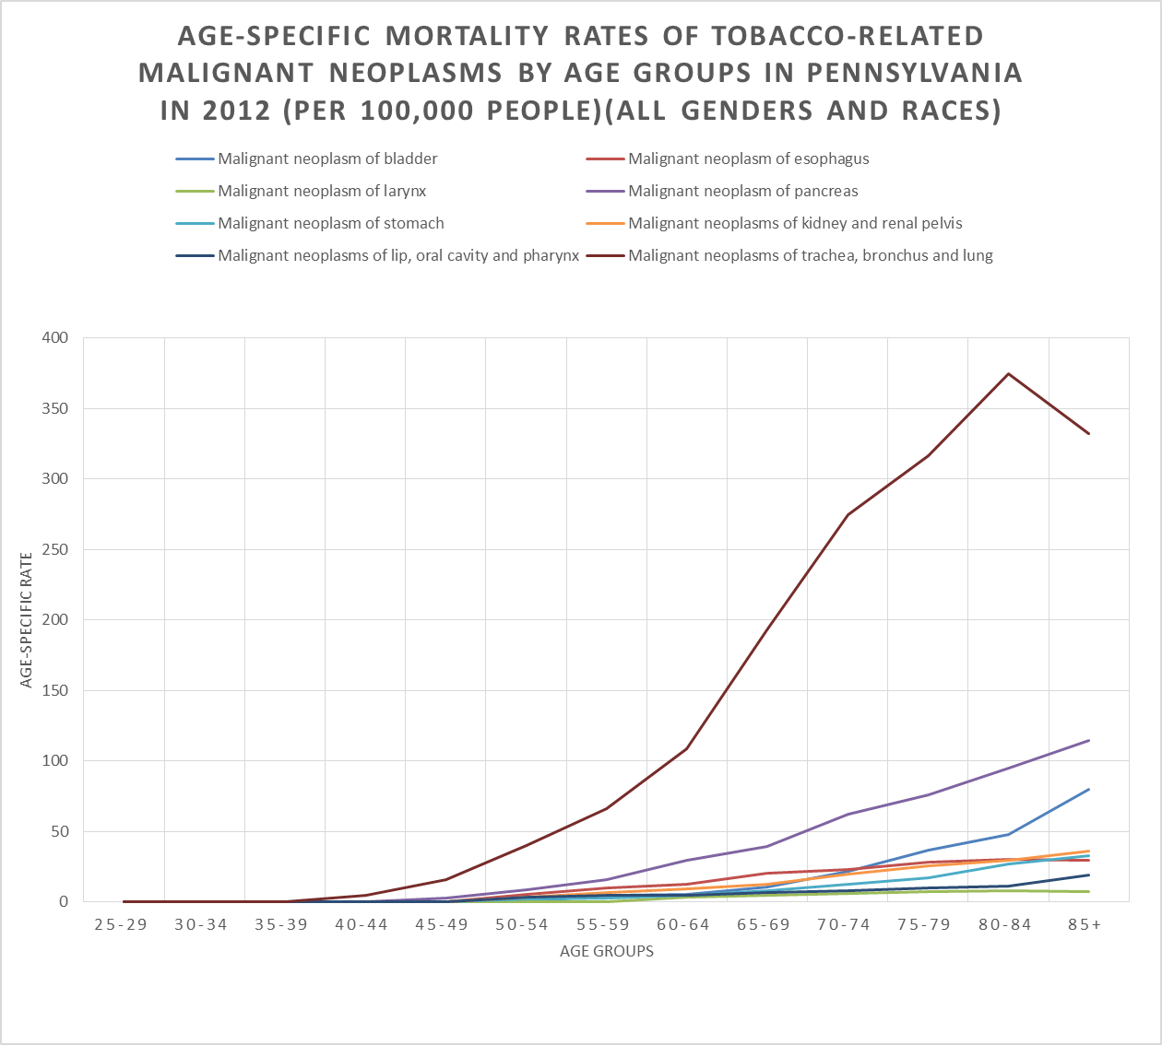
Figure 2. Age-specific mortality rates of Tobacco-related Malignant Neoplasms by Age Groups in Pennsylvania in 2012

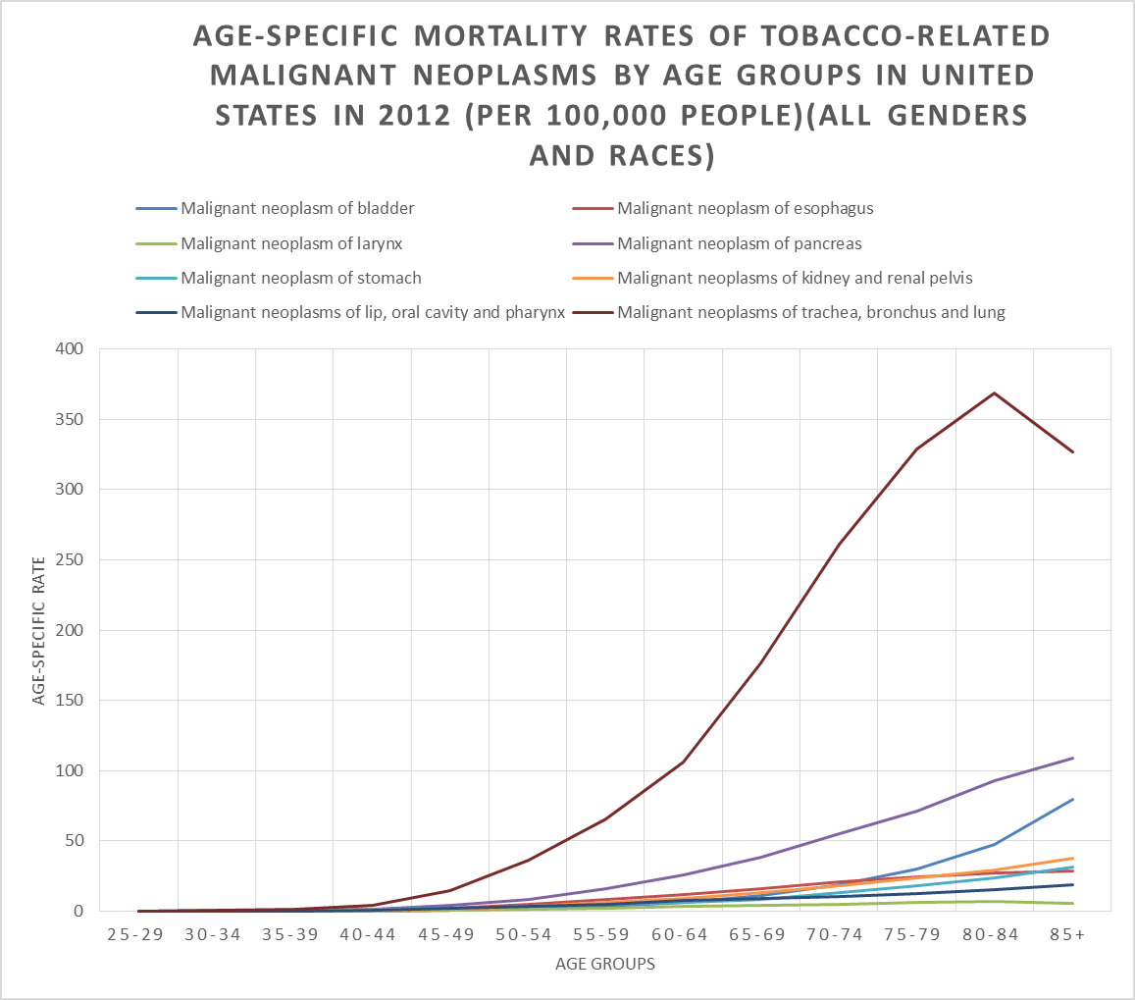
Figure 3. Age-specific mortality rates of Tobacco-related Malignant Neoplasms by Age Groups in the United States in 2012

Spatial analysis of Age-adjusted mortality rates by municipality in allegheny county
Figure 4 presents the geographic spatial analysis of the distribution of age-adjusted mortality rates of eight tobacco-related malignant neoplasms by municipality in Allegheny County in 2012 and 2013. Data needed to create the map can be found in the Appendix. From the map, the age-adjusted mortality rates seem to exhibit a visible geographic pattern within Allegheny County, as higher mortality rates seem to be concentrated in the northeast, west and middle of the county, such as the municipalities of Pitcairn Borough, Millvale Borough, Etna Borough, Tarentum Borough, Braddock Borough, and Kilbuck Township. Eleven municipalities are considered to have high age-adjusted mortality rates of tobacco-related cancers that exceeds 135.9 per 100,000 people (see figure 4). Over 20 municipalities in south and southeast Allegheny County have low age-adjusted mortality rates, with the rates below 41.7 per 100,000 people, such as Churchill Borough, Ohio Township, Elizabeth Borough, Harmar Township, Edgewood Borough, and Emsworth Borough.
As the most financially distressed municipality and with the largest area (58.3 square miles). and population (306,211 people in 2012) of all municipalities in Allegheny County, the city of Pittsburgh has a middle level of age-adjusted mortality rates between 75.5 and 99.6 per 100,000 people in 2012 and 2013. Pennsbury Village has the highest population density of all municipalities in Allegheny County, and the age-adjusted mortality rate of Pennsbury Village falls between 41.7 and 75.5 per 100,000 people in 2012 and 2013, which presents a relatively low level.
Figure 5 presents the distribution of poverty rate by municipality in Allegheny County in 2013. Data needed to create the map can be found in the appendix. As we can see in the map, the poverty rates show a geographic pattern within Allegheny County, as higher poverty rates are concentrated in the southeast and middle of the county, such as the municipalities of Rankin Borough, Braddock Borough and Duquesne City. Ten municipalities are considered to have a high poverty rate, in excess of 26 per 100 people (see the figure 5). About 37 municipalities in Allegheny County have low poverty rates, with the rates below 5.5 per 100 people, such as Sewickley Heights Borough, Mairshall Township, Franklin Park Borough, and others.

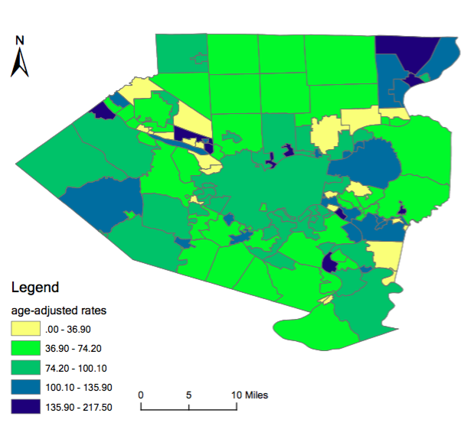
Figure 4. Distribution of age-adjusted mortality rates of eight tobacco-related malignant neoplasms by municipality in Allegheny County in 2012 and 2013 (all sexes and races) (per 100,000 people)

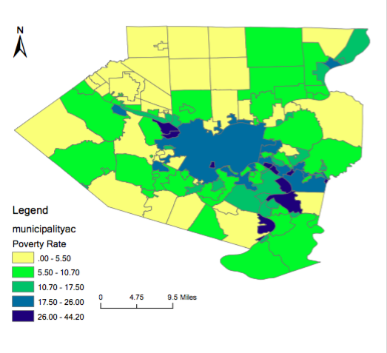
Figure 5. Distribution of poverty rate by municipality in Allegheny County in 2013 (all sexes and races)(per 100 people)

discussion
Overall, in 2012, for Allegheny County, the age-adjusted mortality rates of all eight tobacco-related cancers in black males is the highest among all age and sex groups, which is 240.8 (per 100,000 people), followed by white males (164.8 per 100,000 people), black females (136.9 per 100,000 people), and white females (98.5 per 100,000 people). For the State of Pennsylvania, in all age and sex groups, the age-adjusted mortality rates of all eight tobacco-related cancers in black males (188.5 per 100,000 people) is the highest, followed by white males (162.7 per 100,000 people), black females (122.1 per 100,000 people), and white females (86.4 per 100,000 people). For the United States, of all age and sex groups, the age-adjusted mortality rates of all eight cancers on black males is still the highest, which is 181.7 per 100,000 people, followed by white males (154.1 per 100,000 people), black females (92.7 per 100,000 people), and white females (88.0 per 100,000 people). In Allegheny County, the State of Pennsylvania and the United States, the age-adjusted mortality rate of malignant neoplasms of trachea, bronchus and lung is the highest in each race and sex groups, compared to other seven tobacco related cancers. With the results and comparison, there are various approaches that could be addressed and improved focusing on tobacco use cessation. This may include current tobacco laws and policies, tobacco cessation programs, examining reasons for differences among sex and race groups and cancer types, prevention efforts focusing on populations that are considered at high risk, and consideration of future tobacco-related cancers intervention programs.
Nationwide, tobacco use is responsible for almost 20% of all deaths in the United States[43]. Based on 2011 National Health Interview Survey and the Cancer Prevention Study, among 345,000 malignant-specific deaths, over 167,000 were attributed to tobacco use, which accounted for over 30% of all cancer-related deaths. The majority of them are due to malignant neoplasms of trachea, bronchus and lung, which accounted over 125,000 deaths.[44] Tobacco use has been a huge problem in the United States for a long time throughout its history by 1600, tobacco use had spread across Europe and become more widespread by the 1700s as the tobacco industry developed. After the first U.S. Surgeon General’s Report on smoking and health in 1964, the prevalence of tobacco use in the United State has declined by about 50%. The prevalence decreased to 23.3% in 2000 compared to 42.4% in 1965. Since 1999, to prevent tobacco-related cancers and diseases, CDC’s Office on Smoking and Health (OSH) developed a National Tobacco Program to concentrate on tobacco-related diseases and deaths intervention, exposure to secondhand smoking elimination, adults and youth smoking quitting and try to eliminate disparities among population groups.[45] Pennsylvania has also created several tobacco cessation programs and strategic plans, which included a telephone Quitline, surveillance of tobacco sales to minors’ surveillance, and clinical-practice guidelines for treatment of tobacco addiction promotion, etc. In 2014, the prevalence of tobacco-use decreased to 17% in the United States, which presented obvious declines.[46] Based on Healthy People 2020, the CDC recommends several statewide programs and community-based interventions to prevent initiation of tobacco use and quitting smoking among youth and adults, which helps to prevent tobacco-related cancers and diseases.[47] In the Healthier Allegheny Plan, Pennsylvania and Allegheny County Health Department committed to curtailing the smoking rate by 10% by 2020.[48] By 2015, Pennsylvania and Allegheny County had various tobacco cessation programs and had victories in tobacco prevention, such as there are over 690 smoke-free units in 10 buildings designated by The Allegheny County Housing Authority, all Pennsylvania secondary schools and 10 colleges and universities in Pennsylvania have smoke-free policies.[49]
The data and results show differences in age-adjusted mortality rates within sex and race groups, age groups and eight tobacco-related cancers. One reason for this difference could be that tobacco use varies across groups defined by sex, race, age, educational level and socioeconomic status in the United States. Based on the 2008 CDC report, the overall prevalence of tobacco use for blacks and whites was the same, about 20%. For young people under age 18, blacks had significant lower smoking rates than whites, but for the adults, the prevalence of tobacco use among white adults exceeds that of blacks. In addition, over 70% of black smokers use menthol cigarette brands, which may confer greater mental health risks and inhibit smoking cessation, compared to less than 30% of white smokers.[50] Current tobacco use is higher among persons aged between 18-64, which accounts for over 64% of all tobacco users.[51] In terms of education level and socioeconomic status, the prevalence of tobacco use is highest among people with a GED than those with a graduate degree, and higher among people below the poverty level than at or above the poverty level.[52] To address the gaps and reduce such disparities, the National Conference on Tobacco and Health Disparities (NCTHD) 2012 has developed several effective cessation interventions aimed at eliminating tobacco-use and tobacco-related disease disparities in various scientific areas. For example, in the case of surveillance, plans to enhance monitoring and evaluation of tobacco use and tobacco-related risk factors among blacks have been developed. In the case of marketing, plans to examine brand use, distribution patterns and advertisements of tobacco products to minority population groups have been developed. For the treatment of nicotine addiction, plans have been developed to identify and test interventions to treat tobacco users addicted to nicotine.[53]
Considering the geographic spatial analysis results of distribution of age-adjusted mortality rates by municipality in Allegheny County for 2012-2013, the age-adjusted mortality rates exhibit visible geographic pattern within Allegheny County, as higher mortality rates seem to be concentrated in northeast, west and middle, such as the municipalities of Pitcairn Borough, Millvale Borough, Etna Borough, Tarentum Borough, Braddock Borough, and Kilbuck Township. Over 20 municipalities in south and southeast have low age-adjusted mortality rates. One reason for the mortality geographic patterns in mortality may due to social economic status differences within Allegheny County. Tobacco use is more concentrated among populations with lower incomes and lower social economic status[54] As figure 5 shows the distribution of poverty rate by municipality in Allegheny County in 2013, higher poverty rates seem to be concentrated in the southeast and middle of the county, such as the municipalities of Rankin Borough, Braddock Borough and Duquesne City. Although poverty status has been related to tobacco-related cancer mortality rates, lack of physical activity, poor environment and other factors may also affect tobacco-related cancer status. The correlation of poverty rates at the municipality level in Allegheny County and tobacco-related cancer mortality rates is low based on the data of this essay (R²=0.05). Another reason may be due to differences of sex and race distribution among 130 municipalities. The spatial analysis in this essay is based on all sexes and races, and only adjusted by age groups, so any tobacco use disparities in sex, race, age, educational level and socioeconomic status that could affect the tobacco use and tobacco-related cancer status among people in each municipality will not be detected. In addition, another reason may be that Allegheny County has several tobacco-cessation programs aiming to reduce tobacco product use, but their implementation status and effects may vary for each municipality. In this case, by monitoring and understanding geographic patterns of mortality rates of tobacco-related cancers within municipalities in Allegheny County, it is important that prevention efforts shift to focus on the municipalities with higher tobacco-related cancer mortality rates and those considered at high risk. Moreover, another important reason could be other risk factors may attribute to tobacco-related cancers. Tobacco use is a major risk factor for tobacco-related cancers, however, some other risk factors such as alcohol use, cancer-causing substances, family history, chronic inflammation, obesity, diet, sunlight, etc. will also largely affect tobacco-related cancers status. People in each municipality differentiate from each other for these factors, which may affect the geographic patterns of mortality rates of tobacco-related cancers by municipality in Allegheny County.
This essay utilized standardized data programs and data collection, which conferred strengths and limitations. One of the strengths is that each decedent of Allegheny County has a death certificate record, which is submitted to the Allegheny County Health Department. The records are detailed and make the sample nearly perfect. Another strength is that, since the deaths were due to malignant neoplasms based on ICD-10 codes, and examined and confirmed by physicians, this makes the death certificate more accurate, compared to other typical death certificates. For the analysis method strengths, since age-adjustment relies on rates, and also was adjusted by sex and race, it provides accurate evaluation of the different age, sex, and race structures. The limitations of this essay include errors and unknown information in the death record. There are almost 40% unknown values of the tobacco variable for eight tobacco-related cancers. During the analysis, I tried to compare age-adjusted mortality rates of deaths due to malignant neoplasms and tobacco use, with those of non-tobacco use. But due to a large proportion of unknown values for the tobacco use variable, the results show that age-adjusted mortality rates of tobacco users with cancers of the pancreas, stomach, and kidney are significantly lower than those of non-tobacco users, which are contradictory to previous research and our expectation.
In conclusion, there were not many differences in the age-adjusted mortality rates of tobacco-related malignant neoplasms between Allegheny County, the State of Pennsylvania, and the United States. The age-adjusted mortality rate of malignant neoplasms of trachea, bronchus and lung was highest in each race and sex groups. In general, males have higher age-adjusted mortality rates of tobacco-related cancers than females, and age-adjusted mortality rates of tobacco-related cancers in blacks are higher than those of whites. After conducting spatial analysis of the distribution of age-adjusted mortality rates by municipality in Allegheny County, higher mortality rates seem to be concentrated in the northeast, west and middle, which presents a visible geographic pattern within Allegheny County. The results of this essay address the importance of tobacco cessation programs and strategic plans aiming at improving public health awareness of tobacco cessation, and will assist with reducing tobacco use in the United States and eliminating tobacco-related diseases disparities in the population.
APPENDIX A: SUPPLEMENTARY TABLES
Table 4. Age-adjusted mortality rates of tobacco-related malignant neoplasms by municipality in Allegheny County in 2012 and 2013 (all sexes and races) (per 100,000 people)
Municipality names | Age-adjusted mortality rates  (per 100,000 people) | Municipality names | Age-adjusted mortality rates  (per 100,000 people) | Municipality names | Age-adjusted mortality rates  (per 100,000 people) | Municipality names | Age-adjusted mortality rates  (per 100,000 people)
Aleppo township | 52 | Edgeworth borough | 63.1 | Monroeville municipality | 66.1 | Shaler township | 75.5
Aspinwall borough | 108.6 | Elizabeth borough | 27.3 | Moon township | 83.9 | Sharpsburg borough | 83.6
Avalon borough | 152.6 | Elizabeth township | 91.5 | Mount Lebanon township | 51.9 | South Fayette township | 95.5
Baldwin borough | 76.2 | Emsworth borough | 20.4 | Mount Oliver borough | 59.7 | South Park township | 69.4
Baldwin township | 63.7 | Etna borough | 172.6 | Munhall borough | 92.6 | South Versailles township | 0
Bell Acres borough | 31.6 | Fawn township | 149.1 | Mckeesport city | 98 | Springdale borough | 59.1
Bellevue borough | 72.2 | Findlay township | 94.7 | McCandless twp | 67.9 | Springdale township | 35.1
Ben Avon borough | 18.6 | Forest Hills borough | 57.6 | Neville township | 130.3 | Stowe township | 12.7
Ben Avon Heights borough | 113.9 | Forward township | 69.8 | North Braddock borough | 133.2 | Swissvale borough | 113.4
Bethel Park municipality | 63.7 | Fox Chapel borough | 36.7 | North Fayette township | 111.6 | Tarentum borough | 168.6
Blawnox borough | 104.4 | Franklin Park borough | 62.5 | North Versailles township | 117.5 | Thornburg borough | 86.2
Brackenridge borough | 78 | Frazer township | 117.5 | O'Hara township | 79.9 | Turtle Creek borough | 61.3
Braddock borough | 160.6 | Glassport borough | 157.5 | Oakdale borough | 39.1 | Upper St. Clair township | 56.2
Braddock Hills borough | 66.6 | Green Tree borough | 93.8 | Oakmont borough | 88.9 | Verona borough | 110.5
Bradford Woods borough | 79.6 | Hampton township | 41.7 | Ohio township | 29.4 | Versailles borough | 127.4
Brentwood borough | 77.7 | Harmar township | 26 | Osborne borough | 0 | West Deer township | 70.9
Bridgeville borough | 128.9 | Harrison township | 126.8 | Penn Hills township | 103.6 | West Homestead borough | 95
Carnegie borough | 90.2 | Heidelberg borough | 86.9 | Pennsbury Village borough | 42.4 | West Mifflin borough | 72.8
Castle Shannon borough | 111.5 | Homestead borough | 88.1 | Pine township | 54.3 | West View borough | 81.7
Chalfant borough | 52.4 | Indiana township | 74.2 | Pitcairn borough | 217.5 | Whitaker borough | 97.9
Cheswick borough  Table 4 Continued | 70.3 | Ingram borough | 83.5 | Pleasant Hills borough | 93.2 | White Oak borough | 11.1
Churchill borough | 30.7 | Jefferson Hills borough | 73.5 | Plum borough | 67.6 | Whitehall borough | 58.1
Clairton city | 60.6 | Kennedy township | 62.5 | Port Vue borough | 56.6 | Wilkins township | 64.2
Collier township | 77.2 | Kilbuck township | 159.1 | Penn Hills twp | 0 | Wilkinsburg borough | 88.6
Coraopolis borough | 70.2 | Leet township | 105.1 | Pittsburgh city | 96 | Wilmerding borough | 131
Crafton borough | 99.6 | Leetsdale borough | 67.7 | Rankin borough | 36.9 | West Elizabeth borough | 0
Crescent township | 147.1 | Liberty borough | 59.9 | Reserve township | 85.1 | Wall borough | 0
Dormont borough | 103.8 | Lincoln borough | 83.9 | Richland township | 65.2 | Trafford borough | 0
Dravosburg borough | 88.4 | Marshall township | 96.3 | Robinson township | 68.1 | Rosslyn Farms borough | 0
Duquesne city | 135.9 | McCandless township | 67.9 | Ross township | 62.6 | Glen Osborne borough | 0
East Deer township | 124.9 | McDonald borough | 89 | Scott township | 66.5 | Haysville borough | 0
East McKeesport borough | 121.2 | McKees Rocks borough | 0 | Sewickley borough | 53.2 | Glenfield borough | 0
East Pittsburgh borough | 71.2 | McKeesport city | 98 | Sewickley Heights borough | 42.9
Edgewood borough | 25.8 | Millvale borough | 197.9 | Sewickley Hills borough | 100.1

Table 5. Poverty rates by municipality in Allegheny County in 2013 (all sexes and races) (per 100 people)
Municipality names | Poverty rates (per 100 people) | Municipality names | Poverty rates (per 100 people) | Municipality names | Poverty rates (per 100 people) | Municipality names | Poverty rates (per 100 people)
Aleppo township | 3.2 | Edgeworth borough | 2.8 | McKees Rocks borough | 33.2 | Shaler township | 4.7
Aspinwall borough | 5.8 | Elizabeth borough | 15.8 | Marshall township | 1.4 | Sharpsburg borough | 22.2
Avalon borough | 12.8 | Elizabeth township | 5.8 | Millvale borough | 19.9 | South Fayette township | 5.5
Baldwin borough | 10.2 | Emsworth borough | 6 | Monroeville municipality | 7.7 | South Park township | 8
Baldwin township | 4.6 | Etna borough | 19.5 | Moon township | 9.6 | South Versailles township | 7.9
Bell Acres borough | 3.9 | Fawn township | 4.4 | Mount Lebanon township | 5.8 | Springdale borough | 10.6
Bellevue borough | 14.5 | Findlay township | 4.3 | Mount Oliver borough | 37.3 | Springdale township | 10.7
Ben Avon borough | 2.5 | Forest Hills borough | 7.7 | Munhall borough | 9.6 | Stowe township | 30.1
Ben Avon Heights borough | 1.8 | Forward township | 6.9 | Neville township | 16.4 | Swissvale borough | 19.3
Bethel Park municipality | 3.5 | Fox Chapel borough | 7.4 | North Braddock borough | 21.4 | Tarentum borough | 19.8
Blawnox borough | 13.1 | Franklin Park borough | 1.7 | North Fayette township | 8.5 | Thornburg borough | 0
Brackenridge borough | 16.6 | Frazer township | 5.7 | North Versailles township | 18.4 | Trafford borough | 30.2
Braddock borough | 39.5 | Glassport borough | 12.7 | Oakdale borough | 6.8 | Turtle Creek borough | 21.4
Braddock Hills borough | 17.2 | Glenfield borough | 7.1 | Oakmont borough | 4.9 | Upper St. Clair township | 2.6
Table 5 Continued
Bradford Woods borough | 3.2 | Glen Osborne borough | 7.7 | O'Hara township | 2.8 | Verona borough | 17.5
Brentwood borough | 15 | Green Tree borough | 2.6 | Ohio township | 3 | Versailles borough | 16.8
Bridgeville borough | 8.3 | Hampton township | 4 | Penn Hills township | 10.6 | Wall borough | 12.9
Carnegie borough | 25.6 | Harmar township | 7.9 | Pennsbury Village borough | 6.4 | West Deer township | 5.8
Castle Shannon borough | 12.4 | Harrison township | 13.5 | Pine township | 1.9 | West Elizabeth borough | 29.6
Chalfant borough | 6.4 | Haysville borough | 14.9 | Pitcairn borough | 12.2 | West Homestead borough | 9
Cheswick borough | 5.9 | Heidelberg borough | 6.8 | Pittsburgh city | 22.6 | West Mifflin borough | 12.7
Churchill borough | 3.1 | Homestead borough | 23.6 | Pleasant Hills borough | 5.5 | West View borough | 6
Clairton city | 28.8 | Indiana township | 9 | Plum borough | 4.7 | Whitaker borough | 15.4
Collier township | 6.8 | Ingram borough | 11.2 | Port Vue borough | 11.5 | Whitehall borough | 8.9
Coraopolis borough | 20.8 | Jefferson Hills borough | 4 | Rankin borough | 44.2 | White Oak borough | 3.9
Crafton borough | 4.8 | Kennedy township | 8.6 | Reserve township | 4.7 | Wilkins township | 12.3
Crescent township | 8.7 | Kilbuck township | 4.5 | Richland township | 5.1 | Wilkinsburg borough | 23.1
Dormont borough | 6.9 | Leet township | 3 | Robinson township | 4.9 | Wilmerding borough | 26
Dravosburg borough | 11.1 | Leetsdale borough | 4 | Ross township | 7
Duquesne city | 37.7 | Liberty borough | 7.8 | Rosslyn Farms borough | 2.8
East Deer township | 12.4 | Lincoln borough | 8.6 | Scott township | 7.7
East McKeesport borough | 9.9 | McCandless township | 4.5 | Sewickley borough | 6.7
East Pittsburgh borough | 29.2 | McDonald borough | 13.1 | Sewickley Heights borough | 0.8
Edgewood borough | 9.8 | McKeesport city | 29.6 | Sewickley Hills borough | 3.5

APPENDIX B: SUPPLEMENTARY FIGURES
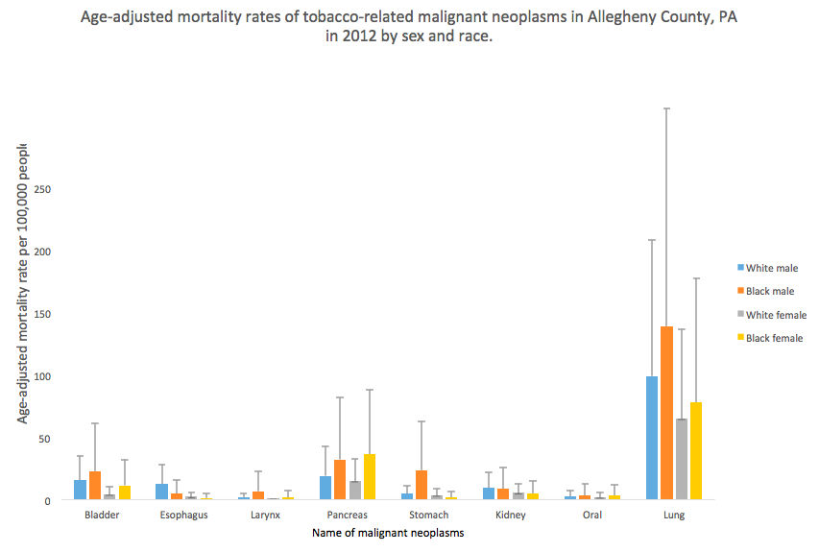
Figure 6. Age-adjusted mortality rates of tobacco-related malignant neoplasms in Allegheny County, PA in 2012 by sex and race.
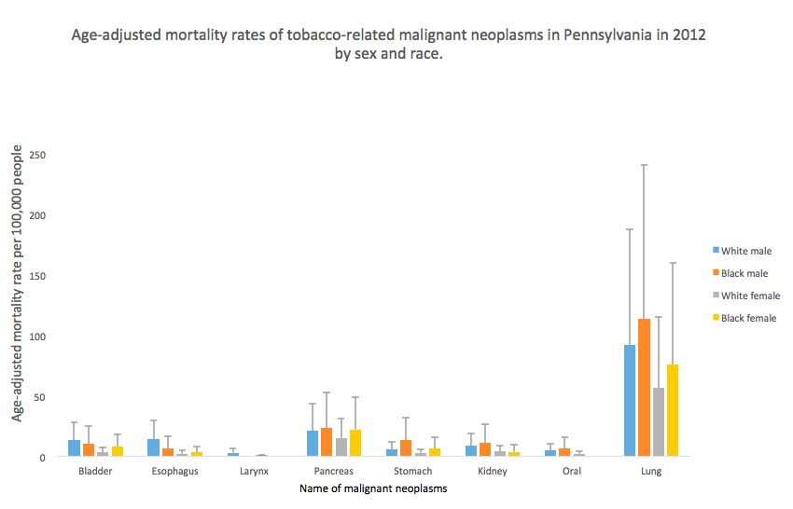
Figure 7. Age-adjusted mortality rates of tobacco-related malignant neoplasms in Pennsylvania in 2012 by sex and race.

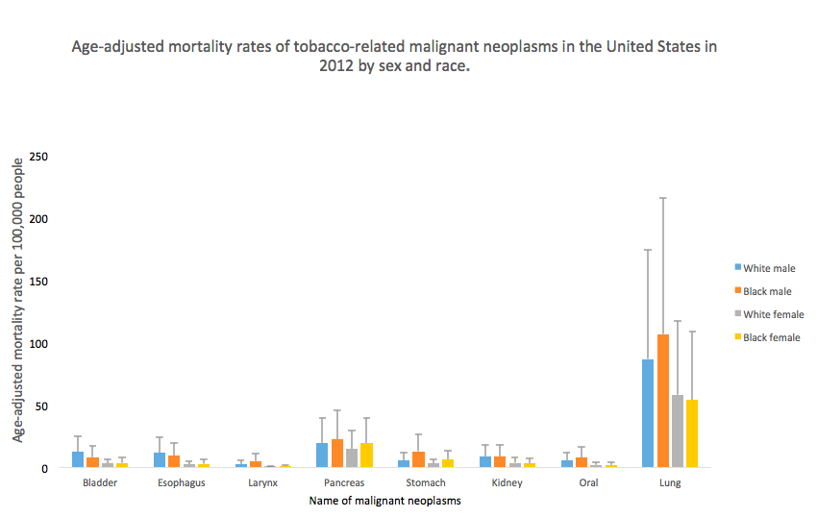
Figure 8. Age-adjusted mortality rates of tobacco-related malignant neoplasms in the United States in 2012 by sex and race.

bibliography
1. CDC, Smoking-attributable mortality, years of potential life lost, and productivity losses. MMWR 2008, 2000-2004. 57:1221-6.
2. CDC, Cigarette smoking among adults. 2007. 57:1221–6.
3. CDC. Cigarette Smoking in the United States. Tips From Former Smokers 2015; Available from: http://www.cdc.gov/tobacco/campaign/tips/resources/data/cigarette-smoking-in-united-states.html.
4. Giovino, G.A., Epidemiology of tobacco use in the United States. 2002. 21:7326-7348.
5. Trends in Tobacco Use, R.a.P. Services, Editor. 2011, Epidemiology and Statistics Unit.
6. Why Cigarette Usage Is At Record Lows And Dropping. All Sections 2015; Available from: http://www.huffingtonpost.com/2015/03/26/cigarette-smoking-decline_n_6855468.html.
7. CDC, National Adult Tobacco Survey, in 2012-2013 National Adult Tobacco Survey Sample Design and Methodology Summary. 2015: US.
8. CDC. Health Effects of Secondhand Smoke. Fact Sheets 2016; Available from: http://www.cdc.gov/tobacco/data_statistics/fact_sheets/secondhand_smoke/health_effects/.
9. CDC. Youth and Tobacco Use. Fact Sheet 2016; Available from: http://www.cdc.gov/tobacco/data_statistics/fact_sheets/youth_data/tobacco_use/.
10. Wang, B., et al., Awareness and Use of Non-conventional Tobacco Products Among U.S. Students, 2012. American Journal of Preventive Medicine. 47(2): p. S36-S52.
11. CDC. Statistics Fast Facts. 2016; Available from: http://www.cdc.gov/tobacco/data_statistics/fact_sheets/fast_facts/.
12. CDC, Smoking and COPD. 2016.
13. The Health Consequences of Smoking—50 Years of Progress. A Report of the Surgeon General 2014; Available from: http://www.surgeongeneral.gov/library/reports/50-years-of-progress/exec-summary.pdf.
14. IARC Monographs on the Evaluation f Carcinogenic Risks to Humans. 2006; Available from: http://monographs.iarc.fr/ENG/Preamble/currentb6evalrationale0706.php.
15. CDC. Tobacco-Related Mortality. Smoking and Tobacco Use 2016; Available from: http://www.cdc.gov/tobacco/data_statistics/fact_sheets/health_effects/tobacco_related_mortality/.
16. Oral Cancer Facts. Rates of occurrence in the United States 2016; Available from: http://www.oralcancerfoundation.org/facts/.
17. Oral Cancer Risk Factors. Oral Cancer Statistics 2015; Available from: http://www.cancerresearchuk.org/health-professional/cancer-statistics/statistics-by-cancer-type/oral-cancer/risk-factors.
18. What are the key statistics about cancer of the esophagus? Esophagus Cancer 2014; Available from: http://www.cancer.org/cancer/esophaguscancer/detailedguide/esophagus-cancer-key-statistics.
19. Jean A. Shapiro, E.J.J.a.M.J.T., Cigar Smoking in Men and Risk of Death From Tobacco-Related Cancers. JNCI, 1999. 92(4): p. 333-337.
20. Tobacco forms and types. 2014; Available from: http://www.oralcancerfoundation.org/tobacco/tobacco-forms-types.php.
21. What are the key statistics about stomach cancer? Stomach Cancer 2016; Available from: http://www.cancer.org/cancer/stomachcancer/detailedguide/stomach-cancer-key-statistics.
22. Lopez, M.E.a.A.D., Smoking and oral tobacco use. 2014. 11(3): p. 884-890.
23. Quit. How does smoking affect my stomach and bowel? 2016; Available from: http://www.quit.org.au/about/frequently-asked-questions/how-does-smoking-affect-my-body/stomach-and-bowel.html.
24. Smoking and cancer. 2014; Available from: http://www.kingcounty.gov/healthservices/health/tobacco/tobacco-vapor/cancer.aspx.
25. Genetics of Prostate Cancer (PDQ): Genetics - Health Professional Information [NCI]. 2014; Available from: http://cancer.dartmouth.edu/pf/health_encyclopedia/ncicdr0000299612.
26. Parkin, The fraction of cancer attributable to lifestyle and environmental factors British Journal of Cancer, 2011. 105: p. 77-81.
27. Cancer Facts and Figures 2015. 2016; Available from: http://www.cancer.org/acs/groups/content/@editorial/documents/document/acspc-044552.pdf.
28. Voice Box (Laryngeal) Cancer. 2012; Available from: http://www.entnet.org/content/voice-box-laryngeal-cancer.
29. Ahmedin Jemal DVM, F.B., Melissa M. Center, Jacques Ferlay, Elizabeth Ward and David Forman, CA: A Cancer Journal for Cllinicians. Oncology and Radiotherapy, 2011. 61(2): p. 69-90.
30. Lung Cancer Fact Sheet. Lung Health and Diseases 2015; Available from: http://www.lung.org/lung-health-and-diseases/lung-disease-lookup/lung-cancer/learn-about-lung-cancer/lung-cancer-fact-sheet.html.
31. Rebecca E. Schane, M., Pamela M. Ling, MD, MPH, and Stanton A. Glantz, PhD, Health Effects of Light and Intermittent Smoking: A Review. Circulation, 2010. 121(13): p. 1518-1522.
32. CDC. Secondhand Smoke (SHS) Facts. 2016; Available from: http://www.cdc.gov/tobacco/data_statistics/fact_sheets/secondhand_smoke/general_facts/.
33. What are the key statistics about kidney cancer?
. 2016; Available from: http://www.cancer.org/cancer/kidneycancer/detailedguide/kidney-cancer-adult-key-statistics.
34. Wong-Ho Chow, S.I., Linda M. Dong, postdoctoral fellow, and Susan S. Devesa, contractor and former Senior Investigator, Epidemiology and risk factors for kidney cancer. Nat Rev Urol, 2010. 7(5): p. 245-257.
35. NIH. SEER Stat Fact Sheets: Bladder Cancer. 2015; Available from: http://seer.cancer.gov/statfacts/html/urinb.html.
36. NIH. Smoking and Bladder Cancer. NIH Research Matters 2011; Available from: http://www.nih.gov/news-events/nih-research-matters/smoking-bladder-cancer.
37. CDC, Preliminary Data for 2010, in National Vital Statistics Reports. 2012.
38. Kokenda, J.M., 2012 Allegheny County Mortality Report. 2015: Pittsburgh.
39. Allegheny County Municipality Map. 2015; Available from: http://apps.alleghenycounty.us/website/munimap.asp.
40. CDC. Health Effects of Cigarette Smoking. 2016; Available from: http://www.cdc.gov/tobacco/data_statistics/fact_sheets/health_effects/effects_cig_smoking/.
41. Economic Impact of Cancer. 2015; Available from: http://www.cancer.org/cancer/cancerbasics/economic-impact-of-cancer.
42. Michelle Kurta, L.T. 2015 COMMUNITY HEALTH ASSESSMENT. 2015; Available from: http://www.achd.net/cha/CHA_Report-Final_42815.pdf.
43. NIH. Tobacco-Related Cancers Fact Sheet. 2014; Available from: http://www.cancer.org/cancer/cancercauses/tobaccocancer/tobacco-related-cancer-fact-sheet.
44. CDC, Summary Health Statistics for the U.S. Population: National Health Interview Survey, 2011. 2012.
45. CDC, Preventing Initiation of Tobacco Use: Outcome Indicators for Comprehensive Tobacco Control Programs–2014. 2014, National Center for Chronic Disease Prevention and Health Promotion: Atlanta, Georgia.
46. NTCC Develops National Priorities, Strategic Plan. 2011; Available from: http://tobacco-cessation.org/news/news_apr09.htm.
47. CDC, Best Practices for Comprehensive Tobacco Control Programs. 2014.
48. Plan for a Healthier Allegheny. 2015, Health Resources in Action.
49. PA.GOV. Allegheny Quit for Life. 2015; Available from: http://www.achd.net/chrond/pubs/pdf/111315_Tobacco_in_AlleCounty_2pg.pdf.
50. CDC. Health. United States. 2008. 2009; Available from: http://www.cdc.gov/nchs/data/hus/hus08.pdf.
51. CDC, Morbidity and Mortality Weekly Report. 2014.
52. CDC. Current Cigarette Smoking Among Adults in the United States. 2016; Available from: http://www.cdc.gov/tobacco/data_statistics/fact_sheets/adult_data/cig_smoking/.
53. Pebbles Fagan, G.K., Eliminating Tobacco-Related Health Disparities: Directions for Future Research. Tobacco Cessation, 2004. 94(2): p. 211-217.
54. Bach, L., Tobacco and Socioeconomic Status, in Campaign for Tobacco-Free Kids. 2015: US.

