IMPROVING PATIENT SATISFACTION THROUGH PAIN MANAGEMENT WITH QUALITY INITIATIVES

by
Jingyi Huang
BS, University of Pittsburgh, 2013

Submitted to the Graduate Faculty of
Health Policy and Management
Graduate School of Public Health in partial fulfillment
of the requirements for the degree of
Master of Public Health

University of Pittsburgh
2016

UNIVERSITY OF PITTSBURGH
GRADUATE SCHOOL OF PUBLIC HEALTH

This essay is submitted
by
Jingyi Huang

on

March 29th, 2016
and approved by

Essay Advisor:
Gerald Barron, MPH ______________________________________
Associate Professor
Health Policy and Management
Graduate School of Public Health
University of Pittsburgh

Essay Reader:
Jermy Martinson, DPhil ______________________________________
Assistant Professor
Infectious Diseases and Microbiology/Human Genetics
Graduate School of Public Health
University of Pittsburgh

Copyright © by Jingyi Huang
2016
ABSTRACT
Gerald Barron, MPH

IMPROVING PATIENT SATISFACTION THROUGH PAIN MANAGEMENT WITH QUALITY INITIATIVES
Jingyi Huang, MPH
University of Pittsburgh, 2016

Effective pain management is a compelling and universal necessity in health care today. Untreated pain can greatly impact one’s quality of life and leave undesirable clinical and psychological outcomes. Pain also has significant public health relevance. It effects millions of Americans, impacts vulnerable population groups like children and racial minorities, creates demands on the health care system, and brings severe economic burdens. With the value-based system linking Medicare payment to HCAHPS (Hospital Consumer Assessment of Healthcare Providers and Systems) scores, it has become even more important for hospitals to consider pain management as a critical component of patient satisfaction. The successful patient-partnered pilot project at UPMC-Passavant demonstrated the effectiveness of a series of quality initiatives. The changes made on patient communication, patient expectation, hospital culture and medication delivery resulted in Unit 3 Main’s HCAHPS Pain Domain scores to increase by 32% since the project began. Therefore, quality initiatives are vital to the success of adequate pain management, because they can improve patients’ attitudes to and perceptions of pain. More research must be devoted into developing multidisciplinary approaches to pain management rather than solely relying on clinical treatments.
TABLE OF CONTENTS
1.0 Introduction 1
1.1 Public health relevance 2
1.2 Overview of HCAHPS 3
1.3 Understanding Pain Managemet 5
1.3.1 Pain Assessment 5
1.3.2 Cost Analysis 7
2.0 Patient-Partnered Quality initiative at UPMC-Passavant 10
2.1 Root Cause Analysis 10
2.2 Quality Initiatives 16
2.3 Result 20
2.3.1 Interpretation 21
2.3.2 Sustainability 21
2.4 Discussion 22
2.4.1 Challenges 23
2.4.2 Program Evaluation 24
2.4.3 Recommendations 25
3.0 Quality Improvement initiatives 27
3.1 Triage Effectiveness 27
3.2 Educational Approach 28
3.3 Multidisciplinary Approach 30
4.0 Summary 32
Bibliography 34
List of tables
Table 1. HCAHPS pain scores for each of the three subsequent quarters after baseline 20
Table 2. Dilaudid data for all UPMC hospitals, June 2014 20
List of figures
Figure 1. Wong-Baker FACES 6
Figure 2. Memorial Pain Assessment 6
Figure 3. Root cause analysis 11
Figure 4. Value-based purchasing 12
Figure 5. UPMC among other academic medical centers on answering "Always" for Pain Question #1 13
Figure 6. UPMC among other community hospitals on answering "Always" for Pain Question #1 13
Figure 7. Leadership rounding on requests to improve 14
Figure 8. Condition H (help) calls at UPMC Presbyterian between October 1st, 2012 and September 30th, 2013 15
Figure 9. The Pain Hotline 17
Figure 10. Pain Card 17
Figure 11. Improved pain board with pain information in red 18
Figure 12. Pink for pain 18
Figure 13. Communication and expectation 19
Figure 14. Result after reinforcing patient-staff communication. 21
Figure 15. HCAHPS pain domain composite scores 22

Introduction
“The greatest evil is physical pain” – Saint Augustine.
Virtually everyone has experienced some type of pain in life, it is an unpleasant feeling and emotional experience, and those of us who have experienced true pain know how debilitating it is. From post-surgery pain to back pain to arthritis to migraines, pain is becoming the most common reason patients visit doctors and hospitals today. Over the years, physical pain has begun to define the American health care system. Whether the pain is sporadic or chronic, patients continue to move from hospital to hospital, seeking various treatment and diagnosis for relief.⁵ Therefore, pain has represented a booming patient market for our health system. Pain management is a huge concern for patients, and a flourishing service line for healthcare.
According to a 2011 report brief by the Institute of Medicine of the National Academies, chronic pain affects about 100 million American adults—more than the total affected by heart disease, cancer, and diabetes combined. Pain also costs the nation up to $635 billion each year in medical treatment and lost productivity.¹ Hospitals are responding to the thriving statistics with pain management centers, interventional and multidisciplinary procedures, and focusing on various aspects of care such as psychological evaluation. In addition, the Hospital Consumer Assessment of Healthcare Providers and Systems survey (HCAHPS) is linked to CMS payments, and one criterion of patient satisfaction is pain management. Therefore, managing a patient's pain level is crucial not only for the patient's comfort but also vital for compliance, clinical outcomes, and patient satisfaction.
This paper will analyze a patient-partnered quality improvement intervention I was involved in for pain management at the University of Pittsburgh Medical Center-Passavant Campus. The quality initiative demonstrated a use of effective processes for change with emphasis on patient satisfaction.

Public health relevance
Pain is also a significant public health issue, and it effects millions of Americans. Unmanaged pain can reduce quality of life, impact specific population groups disparately including the elderly, children and racial minorities, create demands on the health care system, and bring economic burdens for the nation. The healthcare system is continuously spending large amount of money in pain management due to the increasing demand. Given the prevalence of major health and social consequences, pain management must be taken seriously by the public health community. The ability to reduce pain can be a collaborative effort among all health sectors, and public health can provide the resources for developing strategies to prevent and address pain. Federal agencies like the Centers for Disease Control and Prevention (CDC) and Agency for Healthcare Research and Quality (AHRQ) are constantly working together with state and local public health agencies to develop and implement intervention programs. In addition, quality initiative in pain management will hopefully shift the emphasis away from pain medications like opioids being the primary policy strategy.

Overview of HCAHPS
Patients are central to health care. The hospital consumer assessment of health care providers and systems survey scores have pushed quality metrics to focus more on patient perspective rather than doctors or nurses. According to the Centers for Medicare and Medicaid Services, “the Hospital Consumer Assessment of Healthcare Providers and Systems (HCAHPS) is the first national standardized publicly reported survey of patients’ perspectives of hospital care”. Before HCAHPS, there has been no national standard for collecting and publicly reporting the results on patient experience of care and comparing hospital experiences across hospitals nationally.¹⁰
HCAHPS survey began its development and testing process in 2002 with the partnership of Centers for Medicare & Medicaid (CMS) and Agency for Healthcare Research and Quality (AHRQ), in order to assure a credible, useful, and practical survey.⁸ In December 2005, the survey was given the green light for national implementation by the federal Office of Management and Budget. HCAHPS survey was finally implemented by CMS in October 2006, and the first public reporting of HCAHPS results occurred in March 2008. The survey, along with its methodology and its results are in the public domain. For public reporting purposes, CMS publishes HCAHPS results on Hospital Compare website quarterly. Anyone can easily access these results and data on the quality of hospital care, therefore promoting transparency and importance of accountability in health care.¹¹
In HCAHPS there are 27 categories, ranging from communication with the care staff to facility cleanliness and quietness to nurses to pain management. The current HCAHPS survey has two questions on pain:

How often was your pain well controlled?
How often did the hospital staff do everything they could to help you with your pain?
The first question discusses whether a patient thought his or her pain level was well managed. The second question— much more subjective — is whether that same patient felt that everything possible was done to help relieve the pain. “Everything possible” can mean various things, in addition to the necessary pain medication. It implies in order to reduce patient’s suffering and pain, extra steps were taken to achieve that goal. This may be demonstrated in the hospital environment, staff atmosphere, and timing of medication… among other numerous aspects. The two questions suggest that hospital or facilities must refer to both suffering and pain and taking other measures beyond solely medication in order to provide a healing environment.¹⁵
Aside from the ever growing need for pain control to the sheer volume of medical conditions and illness, what further engaged hospital executives to respond to the quality and effectiveness of pain management in their facilities is tying patient satisfaction to reimbursement. Medicare values patients’ voices and experiences, and takes that in consideration in the reimbursement process with the participating hospital. Beginning in October 2012, HCAHPS survey scores, including pain management, is used as one of the measures federal government use to calculate value-based incentive payments under the Medicare Hospital Value-Based Purchasing program. In fiscal year of 2015, hospitals can either lose or gain up to 1.5% of their Medicare payments based on the survey scores.¹² Higher scores in HCAHPS scores will help protect hospital revenue, therefore hospital executives are always looking for strategies to boost HCAHPS scores by improving the patient experience. This not only rewards hospitals for high quality of care provided but also encourages ideas to improve quality care and clinical outcomes.

Understanding Pain Managemet
Pain is ubiquitous, personal and very biased, yet managing pain is one of the many duties and responsibilities of healthcare providers, regardless of training and specialty. Patients will seek pain control for different reasons and varying degrees of severity. Often, patient demand can put providers at a difficult position in choosing the appropriate treatment to alleviate pain. There are societal factors in pain management to consider as well, such as concerns for the cost and risk involved.⁶ In a 2016 press release, the CDC announced that deaths caused by prescription pain killers have exceeded all other causes of accidental death, and the number of prescriptions continues to ascend.

Pain Assessment
Before pain management takes place, precise and systematic diagnosis of pain level must be determined in order to develop the most efficacious treatment plan for the patient. Appropriate pain assessment is a key step to providing good pain management.²
Due to the nature of pain, many factors must be taken into consideration when evaluating pain level, such as age, pain history, mechanism of injury, and location of pain. Pain measure tools are typically divided into two categories, single-dimensional scale and multidimensional scale. Single dimensional scales, such as the commonly utilized Wong-Baker FACES Pain Rating Scale (Figure 1), measure only pain intensity. These type of scales are very useful in the occurrence of acute pain or when verbalization is limited, like in the cases of child injury.
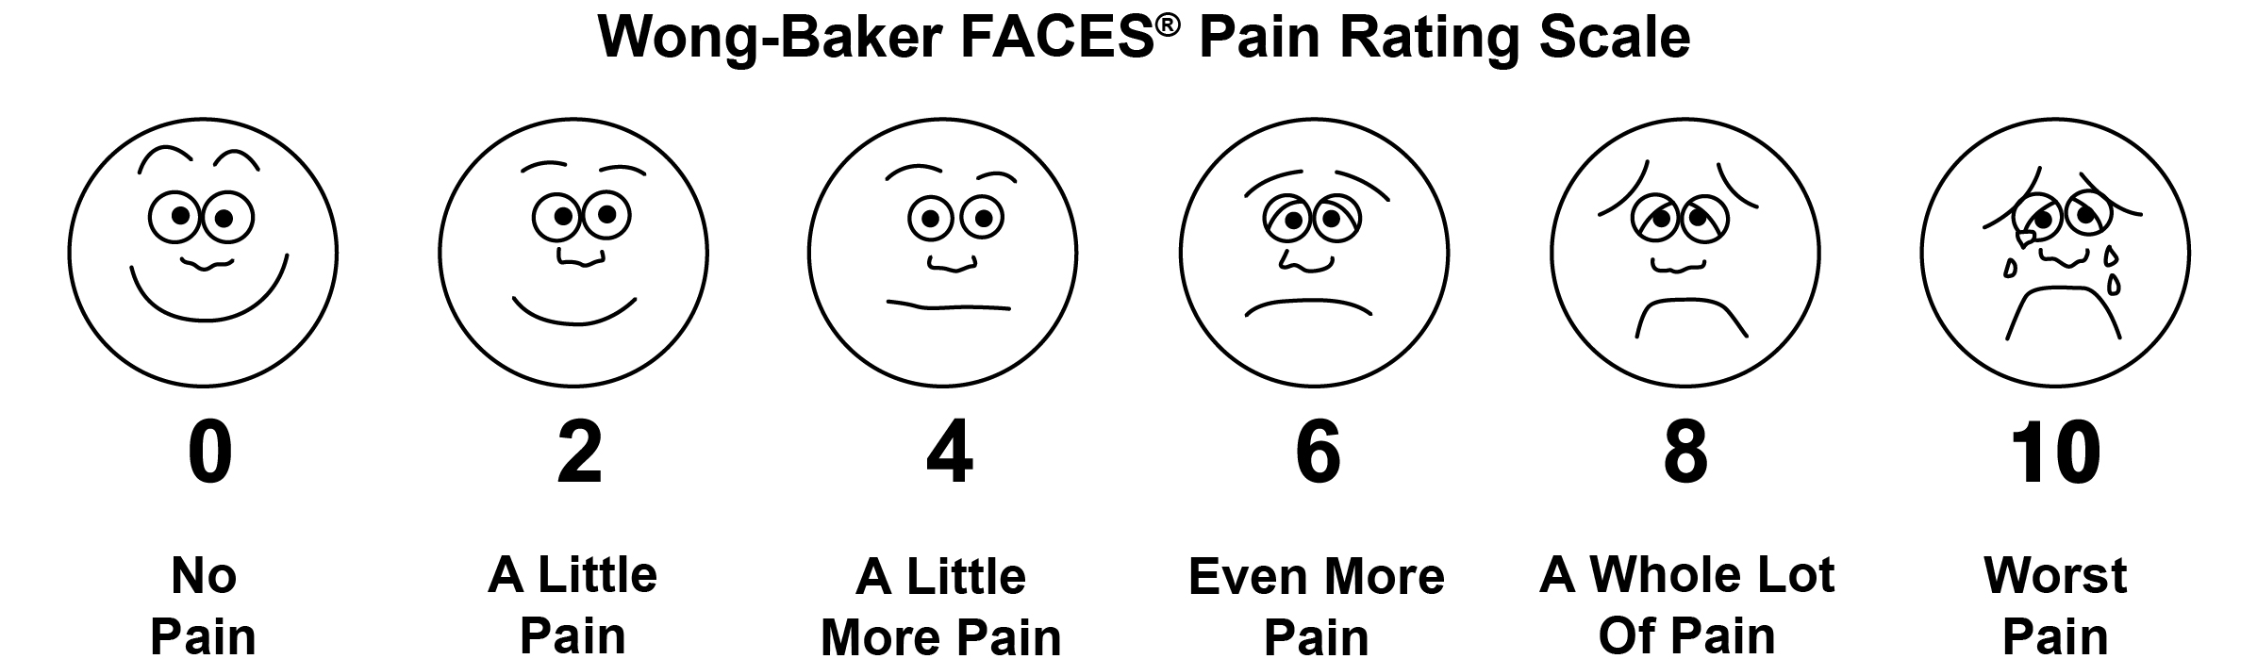
Figure 1. Wong-Baker FACES

Wong-Baker FACES Pain Rating Scale. Retrieved from http://wongbakerfaces.org/wp-content/uploads/FACES_English_Black_Adult-Words.jpg

When there is chronic or persistent acute pain, multidimensional scales are more helpful to measure not only the intensity but also the nature and location of the pain. For example, the Memorial Pain Assessment (Figure 2) for cancer patient measures the pain, relief and mood in three different visual analog scales for a rapid assessment.
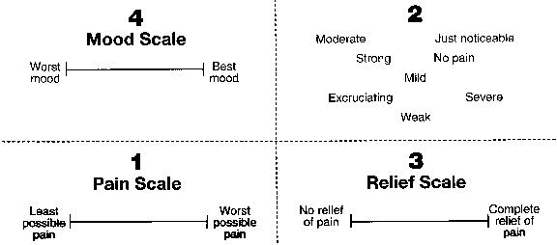
Figure 2. Memorial Pain Assessment

Retrieved from http://www.hospicepatients.org/clinicalpracticeguidelines1994.html.

Cost Analysis
Millions of American are currently living with pain or going through pain management treatments. The economic impact of pain on the health care system is significant. When pain is left untreated, it can cost hospitals millions of dollars in the long run. For the patient, it can mean the loss of quality of life, work abilities, working-days, happiness… The costs can be both direct and indirect. Direct costs may include patient’s health care incremental costs, both inpatient and outpatient care due to pain. Indirect cost are derived from one’s loss of productivity and leisure time associated with decreased days and hours of work and lower wages.¹⁷ Pain management is so expensive because it is difficult to treat, and often requires multiple and complicated medical treatment. Chronic pain, in particular, will require lengthy process of trial of error before patient finds the right treatment. Some examples of pain treatment costs are listed below.
Drugs. Acetaminophen and nonsteroidal anti-inflammatory drugs (NSAIDS) are typically the over-the-counter drugs recommended by doctor for mild, temporary pain. Examples include ibuprofen and aspirin.¹⁸ These drugs cost about $5-$25, depending the location of purchase, insurance coverage and whether it is a name brand or if it’s a generic equivalent. Prescription medications for chronic, and more severe pain can include anticonvulsants, such as carbamazepine (Tegretol). According to Goodrx.com, these drugs cost about $50 for thirty 100 mg capsules at drugstore.com; Amitriptyline, an antidepressant, $15 for thirty 10 mg tablets; and opiate pain relievers like hydrocodone (i.e. Norco, Vicodin), $17 for thirty 325 mg tablets.
Pain Center. A physician may refer a chronic pain patient to a pain center. A pain center is a health care facility where a team of health professionals focuses on the diagnosis and management of chronic pain by creating a treatment plan with a multidisciplinary approach. The goal is to not only treat the pain but the total person. According to data from Marketdata Enterprises, a market-research firm, the typical cost of a pain management program is about $5,000. Fees will vary depending on the procedures involved and complexity of the problem. Florida Medical Pain Relief Center, for example, has an initial consultation fee of $225, a requirement of a monthly office visit fee of $195 per patient, and additional treatments may be needed. Most health insurance plan may cover a partial cost of treatments at the pain center, but only if other conventional methods like drug treatment have failed. Many other restrictions will apply as well when it comes to coverage terms.
Surgery. If medication does not provide the ideal outcome for pain, surgery is typically the most common choice for chronic pain. According to the book Chronic Pain Management, every year, over 30,000 lumbar surgeries are performed each year to alleviate pain, at an estimated cost of $27,577 per patient. For insured patients, out-of-pocket costs for surgery typically consist of a specialist copay, possibly a hospital copay of $100 or more, and coinsurance of 10% to 50%.
Medical Devices. Devices are also used in conjunction with other treatments for chronic pain management, and the costs vary. Transcutaneous Electrical Nerve Stimulators, is a small battery-operated machine that uses low-voltage electrical current for pain relief, and they typically cost at least $100.¹³ When other methods fail, surgically implanted devices can be used to deliver the medication, and they can cost anywhere from $27,000 to $56,000. Many health plans have strict criteria when determining area of coverage.
Physical Therapy. Physical therapists play an important role in helping patients coping with pain symptoms, and these physical therapy or cognitive behavioral therapies aren’t cheap. For uninsured patients, a session of physical therapy typically costs $50 -$350 or more, while a one-hour of cognitive behavioral therapy session is usually around $100-$250. For insured patients, out-of-pocket costs for these therapies typically include a co-pay of $10 -$75 per session or coinsurance of 10%-50% or more.¹⁴
Therefore, when implementing quality initiatives in pain management, it is important to consider both cost and effectiveness, and find an affordable method that also provides the best results. Aside from clinical developments for pain management, it is also valuable to examine systems approaches with quality change efforts. Many of the interventions in pain management mainly target improvement in clinical area with usage of invasive treatments and costly drugs.

Patient-Partnered Quality initiative at UPMC-Passavant
At UPMC, Pain was identified as one of the five HCAHPS drivers that impacted the overall hospital ratings. Going above and beyond to help reduce patients’ suffering and strive for an acceptable level of pain are simply part of UPMC’s responsibilities, in addition to the financial incentives of the value-based payments. To successfully implement the interventions, we needed to acknowledge that the first requirement for a positive experience was to identify our customer’s expectations. Feedback from the integrated surveys and comments was invaluable in establishing our current state. In addition, former UPMC patients, who responded unfavorably about pain management on the HCAHPS survey, were invited to participate in one-on-one video-taped interviews. Common themes across the interviews were “delays in receiving pain medication” and “unsympathetic staff”, thus these areas became the focus for the work.
The pilot unit for the project was chosen at UPMC-Passavant Unit 3 Main, a 62-bed medical-surgical unit with a 40% observation patient population. The aim of the quality initiative at Passavant is to increase the current HCAHPS Pain Domain percentile by 3 percentage points of fiscal year of 2015.

Root Cause Analysis
Through root cause analysis, some major causes were revealed as to why pain was not well controlled, thus leading to the low pain domain scores in HCAHPS. Here we looked at human causes and organization causes in order to trace back the action and investigate where the problem started and how one action triggered another. Finally we can recommend and implement solutions to solve the problem.

WHY ARE PAIN SCORES LOW?
Human causes
Organizational causes
Unsympathetic staff
Frequent Condition Help regarding Pain
Medication
Nursing
Partial doses of Dilaudid
Multiple patients on frequent pain medications
Too many call bells
Unable to distinguish between immediate pain needs and other requests
Delay in giving pain medications
Miscommunication
Engaging all staff in pain management
Pain Button, visual cue for all staff
Pain cards
Pain communication on white boards
Witness for the wasted drug
Produce lower dose
Pain Hotline
Rebalance nursing assignments
Figure 3. Root cause analysis
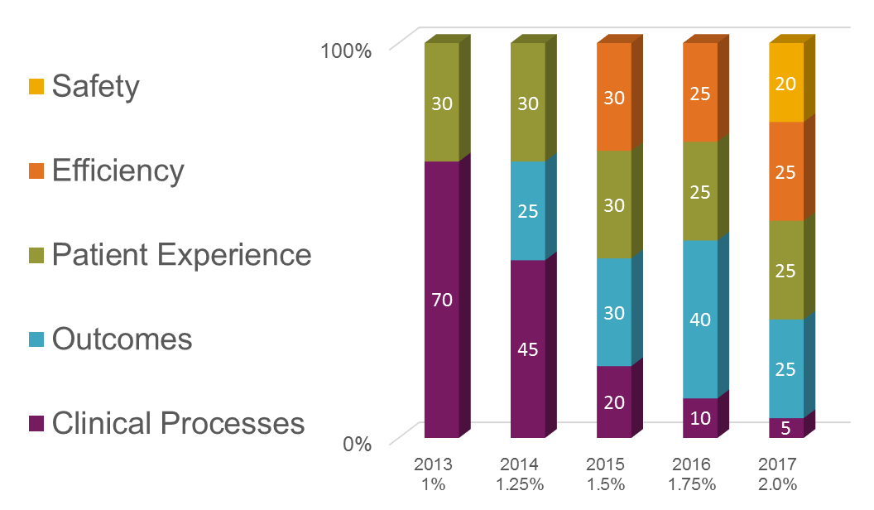
Identify the problem. Through the patient’s voice it was discovered that there was a disconnection between the delivered experience and patients’ perception of the experience and their feedback was a significant driver for the resulting actions. Patient suffering was at the forefront of the motivation to improve. Other rationales in the business case included the fact that HCAHPS measures were driving 30% of UPMC’s performance scores for incentive payments under value-based purchasing. The graph below depicts the literal cost of poor quality. From 2013 to 2017, as quality (safety, efficiency, and patient experience) are considered more and more valuable in Medicare repayment from the federal government, the possible gains and losses increased as well, from 1.0% to 2.0%.
Figure 4. Value-based purchasing

There was truly a “cost of poor quality” with actual “hold back” dollars with HCAHPS pain scores in all 14 UPMC’s acute care hospitals. With the scores publically reported on the CMS Hospital Compare website, market share and customer loyalty were real factors for consideration. UPMC was below the state and national averages and below several of the other academic medical center and community hospitals in the area. The data below compares UPMC PUH/SHY (Presbyterian and Shadyside) and PAS (Passavant) against other hospitals on percentage of patients reporting pain was “ALWAYS” well controlled. (Pain question #1 on HCAHPS survey).
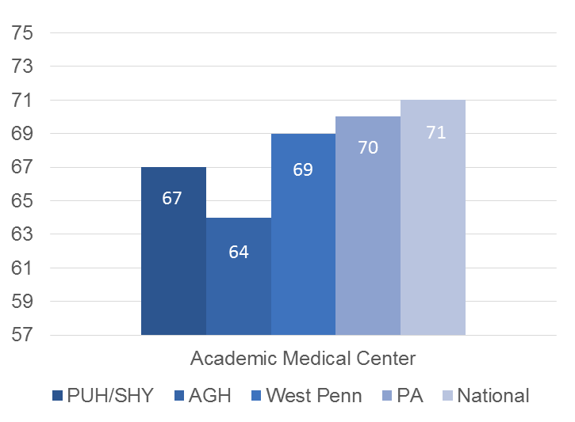
Figure 4. UPMC among other academic medical centers on answering "Always" for Pain Question #1
Data retrieved from http://www.medicare.gov/hospitalcompare/results. (2014)
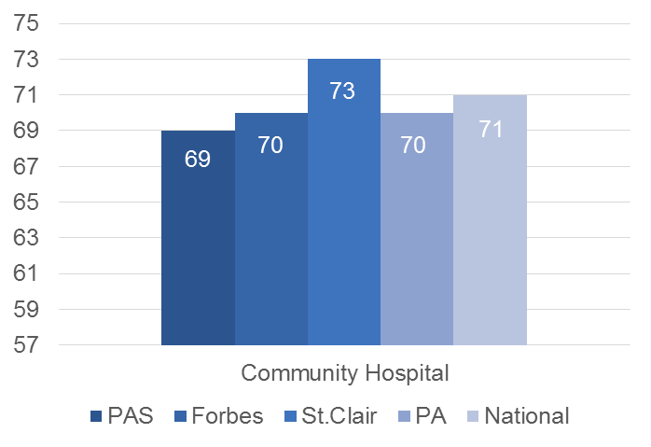
Figure 5. UPMC among other community hospitals on answering "Always" for Pain Question #1
Data retrieved from http://www.medicare.gov/hospitalcompare/results. (2014)
Collect data. To analyze and understand pain management at Passavant fully, “proof” was needed to illustrate that a problem exists. To achieve this, we not only partnered with patients but worked WITH them to explore why they were not satisfied with our current pain management system. Using a piloting mobile round application, eRound, the executive team members rounded on patients and asked them “What types of requests can we improve upon?”, and the top answer we received was Pain.⁷
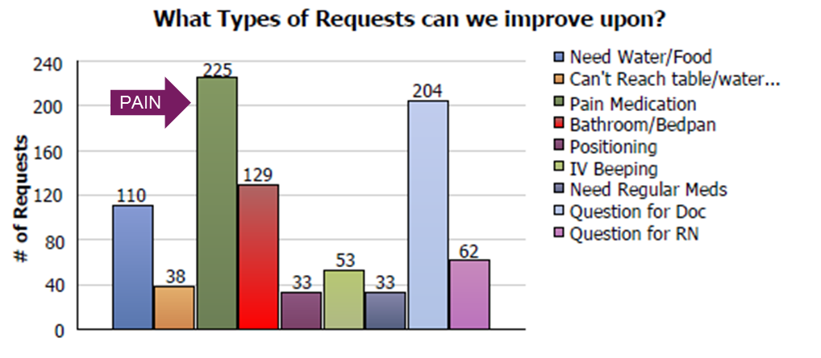
Figure 6. Leadership rounding on requests to improve

Former UPMC patients, who responded unfavorably about pain management on the HCAHPS survey, were invited to participate in one-on-one video-taped interviews, and they clearly “defined the problem”. Common themes across the interviews were “delays in receiving pain medication” and “unsympathetic staff” and these became areas of intense focus for the work.
The design of tests of change and data collection continued to involve the voice of the customer. In-patients on the 62-bed medical surgical pilot unit were asked “what was a reasonable time from when they asked for pain medication until the nurse administered the medication”. Response mean time was 15 minutes and set our target goal. To measure the times from the “ask” to the “give”, patients were engaged as data collectors in a very unique and transparent process, and with each test of change we continued to solicit feedback.
Identify root causes. With the problems identified, next the causes. The Press Ganey Improvement Portal is an online resource with access to actual surveys. In the Portal’s Community Forum, we reviewed the suggestions under the Solutions and Discussions. In-patients supported the current state assessment with actual data collection (how long does it take now?), established process measures (to reduce the times) and set expectation goals (patient interviews found 15 minutes a reasonable target).
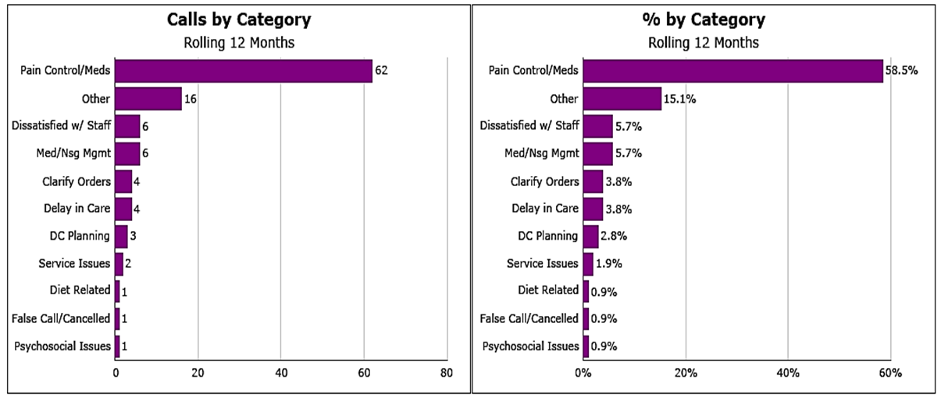
At UPMC Presbyterian, a 900+ bed flag ship hospital, nearly 60% of patient/family initiated “codes” or Condition H (Help) calls were related to pain or pain medication. Modeled after hospital’s Rapid Response Team, Condition H is a program that allows patients and family member to call for immediate help when they feel the patient is not receiving adequate medical care. The data illustrates that patients were speaking out in real time that pain management was a problem.
Figure 8. Condition H (help) calls at UPMC Presbyterian between October 1st, 2012 and September 30th, 2013

The nurse call bell. Arguably the most hated piece of medical equipment in the unit. The rolling 12 months prior to our pilot unit kick off, 3 Main averaged 44.7% for Call Button Assistance. A huge problem given that most patients report pain or request pain medication by pressing the call bell. We needed to isolate this specific need from other requests and direct it to the nurse.
Another issue identified was high volume of partial doses of IV Dilaudid. Dilaudids were only available in 1mg or 2mg format, but the most often administered dosage is 0.5mg. Due to the nature of the drug and hospital policy, it is required to have a witness (another nurse) to witness the disposal of the remaining dosages. This policy, though logical and responsible, required additional time to locate a nurse to witness the wasted drug. Therefore the time spent on waiting on a witness and the time spent on being someone else’s witness is further added onto the time a patient is waiting for his or her pain medication. These interruptions and inefficiencies were clearly examples of staff inefficiency.

Quality Initiatives
Pain Communication: Pain hotlines, cards, and whiteboards. With large volume of patient calls to nurses’ phones for various need, it is useful to isolate pain need from other requests and direct it to the nurse. With current patients, the first test of change was the Pain Hotline (call PAIN or 7246) (Figure 9). The clinical secretary on day shifts and charge RN on night shifts carried the mobile phone and routed calls to patient’s nurse. Feedback found the Pain Hotlines too impersonal and the poster too hard to read. The notification process was then re-designed with Pain “business cards” (Figure 10) nurses provided to patients with their name and direct phone number. However, cards often got lost in sheets or stuck to dietary trays. Patients then suggested “put the number on the (white) board with other pain stuff…but write it in red so it stands out” (Figure 11). Patient and nurse satisfaction with this strategy has been preliminarily good.
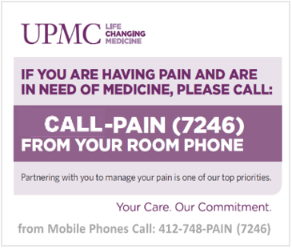
Figure 7. The Pain Hotline

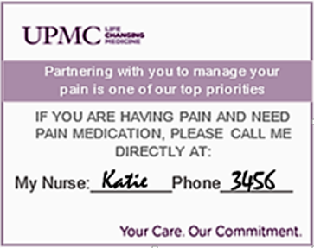
Figure 8. Pain Card

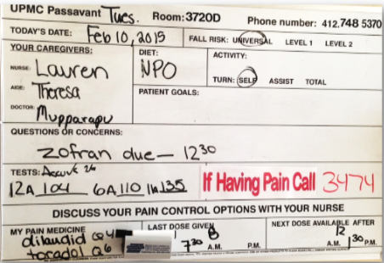

Figure 9. Improved pain board with pain information in red

Pain Button. Patients supported the design and re-design for the direct communication pathway between themselves and their nurse. The spread unit has the Responder 5 Nurse Call System with a designated Pain Button on the pillow speaker automatically rings the nurse’s mobile phone. The last color in the corridor light panel is the “pink for pain” light. When the patient presses the Pain Button, this solid pink hallway light provides a visual cue for all staff. At 5 minutes the light flashes as an overtime indicator.
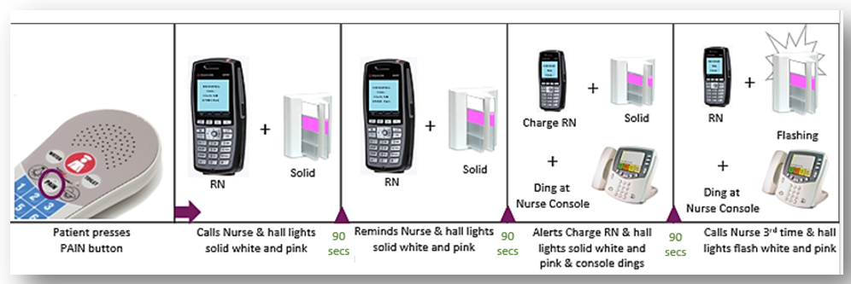
Figure 10. Pink for pain
IV Dilaudid. The interruptions and inefficiencies from waiting for a witness for the extra dosage disposal were clearly examples of patient and staff distress. Since IV Dilaudid is only commercially available in 1mg/2mg, an external compounding pharmacy was contacted to produce 0.5mg doses to reduce the waste, thus delivering the pain meds to our patients more quickly. This initiative was very satisfying to the nursing staff and has begun to spread across 4 other hospitals.
Culture of Service Excellence. The definition of “staff” in “staff do everything to help with pain” is expanded by engaging ancillary staff such as having the Environmental Services and Transporters ask patients if they are “comfortable” with actionable responses. Patient expectations are better managed by changing whiteboard language to “available after” for next pain medication.
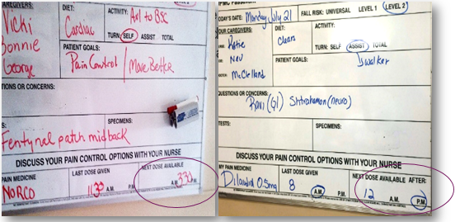
Figure 11. Communication and expectation
Upon admission to the floor, patients will receive a letter from the Unit Director in the patient admission packet describing how the staff will work together to improve the pain management experience. In addition, nursing assignments are continually rebalanced to avoid multiple patients on frequent pain medication. Pain is also included in huddles, bedside report, care coordination rounds, and staff meetings.
From Pain Hotlines, to Pain Business Cards, to the strategic use of space and color with Pain Communication on the whiteboards, achieving upward trends was not just accomplished FOR patients but WITH patients.

Result
Table 1. HCAHPS pain scores for each of the three subsequent quarters after baseline
Timeline | HCAHPS Pain Scores
Baseline | 54.00%
Quarter 1 | 66.30%
Quarter 2 | 77.60%
Quarter 3 | 79.10%

Table 2. Dilaudid data for all UPMC hospitals, June 2014
Dilaudid | Total Dilaudid Given (Doses) | Dilaudid Wasted (Doses) | Nursing Times (Shifts) | Nursing Times (Dollars)
1mg/2mg | 44,000 | 32,000 | 4,020 | 877,520

Interpretation
The overarching outcome measure was the increase in HCAHPS pain scores. The pilot unit scores were reported quarterly due to the small “n” of only 25-35 responses per month. HCAHPS Pain scores were 54% at baseline for our first quarter and 66.3%, 77.6% and 79.1% for each of the three subsequent quarters. Process measures were developed to monitor the effectiveness of the implemented changes: measuring time from when the patient asked for pain medication until they received it, auditing the whiteboards for compliance with documenting the nurse’s direct phone number and capturing the decrease in indirect salary costs with reducing the time nurses spent wasting IV Dilaudid. The strategies are currently spread from the pilot unit to the rest of the hospital units (at UPMC Passavant) with planned enterprise deployment to all 14 UPMC acute care hospitals.
For all UPMC hospitals in June 2014, over 44,000 doses of IV Dilaudid were given and 32,000 required a witnessed waste. Annualized, this represents 4,020 shifts of nursing time wasted. At an average salary of $27.63/hour, this lost nursing time translates to $877,520. Transforming to the lowered dose of Dilaudid has not only allowed us to deliver the pain medication to patient more quickly in a ready-to-use delivery system but also helped to reduce waste in time and money.

Sustainability
HCAHPS Pain scores drifted down from the ideal goal and then plummeted by the end of 3rd QTR FY15. Re-evaluation of processes found that the only change was in how the nurse’s contact information was delivered. Overtime, the “conversation” between nurses and patients about pain managements (educating patients on a direct line of communication to report pain or request pain medication) was dropped. Resuming this critical step reversed the trend and validated the importance of showing we care by simply talking to the patients.
Figure 12. Result after reinforcing patient-staff communication.
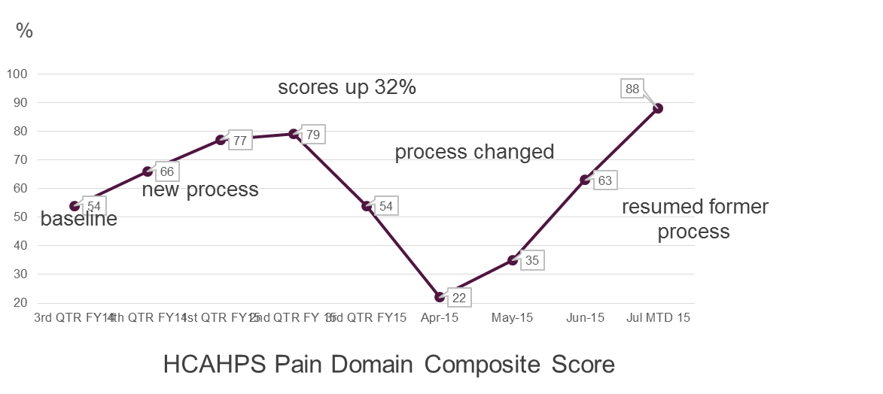
Figure 13. HCAHPS pain domain composite scores

Discussion

Challenges
Pain is subjective. How one perceives his or her pain management experience is not entirely based on the pain level. Perceptions of the experience can be affected by various factors, such effective communication with the providers, responsiveness, clinical outcome, and attentiveness… and the list goes on.³ Therefore attaching numeric values to an immeasurable event can be a challenge to develop a proper treatment.
Redesign treatment programs. Several variables play in role in the development and impact of pain. Therefore it is important to develop a program that tackled not only the physical pain but mental health and quality of life as well. This is particularly evidenced in chronic pain patient, when they are living with biological, psychological and social encumbrance.
Patient population on the rise. With our aging population, a lifetime on minor injuries can add up to some serious pain. Diseases play a critical hand too, and with almost any medical condition, the incidences of pain will increase. More and more Americans every year will require pain management through drugs, therapy or surgery. Therefore it is necessary to develop formal protocols for hospitals or clinics to improve care and boost patient satisfaction in order to minimize the quality of life lost through inadequate treatments.
Opioid abusers. As the percentage of pain patients grows, more and more management methods are relying heavily on opioid analgesics. At the same time, abuse and misuse of opioid overdoses are transforming into the new “epidemic”. It is important to recognize the seriousness of the issue, and work towards a solution that minimize the risk of opioid addiction. According to the National Conference of State Legislature data, in the 2011/2011 legislative season, at least 13 states are either considering or have passed narcotic prescribing laws.¹⁹ Tougher guidelines and protocols will be need in order to transform prescribing policies and identify abusers.

Program Evaluation
Keys to the success of the program included but not limited to the participation of patients, closely monitoring of the progress, ongoing training (of staff), measurement of key variables, and multidisciplinary approaches.
Overall the pilot program was very successful at Passavant, and the hospital is very excited to expand the initiative to other locations. Not only were the HCAHPS pain scores raised, there were several innovative aspects discovered along the way. The newly designed 0.5mg of IV Dilaudid not only helped to achieve the goal of reducing patient wait time for pain medication, it has also saved a significant amount of money from product and nursing time waste. Through close monitoring and follow-up of the project, the sudden drop of HCAHPS scores after an initial increase was analyzed. Inspection of key variables of the project and analyzation of cause-and-effect relationships revealed the root of the problem (the drop in scores) at patient-nurse communication. Fortunately, the issue was discovered early on and the team was able to reinforce the importance of communication with patients to all staff, and finally raise the scores once again. This additional improvement illustrated that despite physical pain levels, nursing communication, attention, and patient education of pain were perceived by patients to be stronger deciding factors in how well their pain management was.
To not only work with the customers (patients), but also partnering with them, the project was able to make adjustments over and over again to meet the demand. After all, HCAHPS survey is all about patient perception. Feedback of both patient and staff was the vital to the implementation of the project. Patients were engaged in conversations about their pain management during leader rounding and care coordination rounds to better understand their individual expectations about their pain management. In addition, the nursing staff were survey about the barriers and challenges to pain management on the unit to effectively target interventions to mitigate them.

Recommendations
The quality initiative at Passavant was a perfect example of the Plan-Do-Check-Act cycle. The model presented the basic structure of the district's overall strategic planning, goal-setting and evaluation, needs analysis, and implementing changes.
The drop in the HCAHPS pain scores after the initial improvement is a good lesson to remember that the Plan-Do-Check-Act cycle has no end, it must be repeated again and again for continuous improvement. After evaluating the process and analyzing the data (the "Check" step), we learned that the initial communication about pain was dropped between the nursing staff and the patient. Therefore we met with the nursing staff on Passavant Unit 3 Main and discussed the importance of talking to the patients when they are admitted. The "pain conversation" was then picked up again and reinforced by the Unit Director during each staff meeting. This is "Act" step, where we incorporated what we learned into implementing new improvement for more changes.

This is a useful quality improvement and effective project management tool to be continuously used throughout the project at Passavant and many other quality initiatives in health care. This model will provide a simple and effective approach for problem solving and implementing changes. One can change and improve processes continually, and see clearly which stage the project is at. The result will be high efficiency work in a logical and systematical process.

Quality Improvement initiatives
Pain management is a growing topic among health care professionals and the public. The heightened awareness from press coverage and increased clinical information has urged for more effective treatments of pain. Despite current advances in medical options, pain is still poorly managed and undertreated. Over the years, quality improvement initiatives have proven to be a comprehensive method of addressed pain. This section highlights some current best studies in improving pain care practices.

Triage Effectiveness
LDS hospital is a 547-bed general urban hospital and surgical center located in Utah. The current statistics include LDS serving 36,000 patients, a 19 percent admission rate and a walkaway rate of under 1 percent. Through a series of continuous quality improvement programs focused on pain management, the hospital saw a higher patient satisfaction scores, lowered walkaway rates, and shorter turnaround times.
Alerted by complaints from patients, the Emergency Department staff began pain management initiatives in 2002 to combat the rapid treatment of painful conditions. A version of the visual analog scale (VAS) was used routinely in the emergency department to measure patient’s perception of pain. The higher the VAS number, the more severe the pain. The audit findings, including the chief complains, the scale, and the treatment given for pain relief were made aware to the medical care staff, and kept as a priority during monthly staff meetings. Based on the findings, physicians worked on developing chief complaint-based patient care protocols, and nurses worked on an educational module. The goal was to improve the rate of administering pain management to patients. A new updated triage protocol allowed the staff to start pain management using adjunctive treatments like warm blankets, ice, local anesthetics. Previously, “treatment” process only begin after patient registration, nurse evaluation, and physician order.
The strategy in the project was using a DMADV (Define, Measure, Analyze, Devise, Verify) roadmap to resolve the pain issue. The project goals and deliverables are defined first. A screening tool was devised to measure and determine the patient needs and specifications. Team was formed to analyze the options to meet the deliverable. The education initiative regarding pain management was designed by the team to meet the needs. Lastly, repeated audit pain management in the ED are carried out to verify the design performance and ability to success.
The program was successful, and LDS was able to increase the rate of administering pain therapies and decreasing the time to pain manage. In return, there was a positive effect on patient satisfaction. The survey score of patient satisfaction (five being excellent and 3 being good) rose from 3.93 to 4.37 from January to October. In addition, patients who reported their pain control as “excellent” rose from 29.8 to 39.1 percent.

Educational Approach
An educational initiative was implemented at a 74-bed general internal medical unit at a large hospital. The initiative started began from the many healthcare workers’ lack of ability to efficiently and correctly assess pain. It is essential that professionals must possess sufficient knowledge with respect to pain assessment and analgesics knowledges. Among clinicians and health practices, there are still many myth and misconceptions around pain tolerance and addiction. Although the pain scores did not show improvement, the study did see improvements made to patient assessment, patient satisfaction, and nursing knowledge.
The interventions were studied through 3 mechanisms: Patient surveys, to measure patients' satisfaction with their pain management; Nurse surveys, to measure nurses' knowledge and attitudes with respect to pain and pain management; and Chart audits, to measure documentation of pain assessments by nurses.⁹ Pain education for the nurses included a one-hour inservice on pain assessment and management, and usage of cards that provided a numerical pain scale in 19 different languages for patients. Nurses were asked to complete pain assessment on every shift, and ask their patients to use the scale to rate their pain. Informational posters on pain assessment and management were posted on the unit to remind the nurse. Nursing stations also had new equianalgesia charts that compared different opioids. Pocket sized cards with pain management references were given to all nurses, physicians, and pharmacists, and other interested healthcare providers. The cards are useful to refresh knowledge and prepare for the weekly pain consult team rounding to insure effective pain management is carried out.
As a result of the interventions, patient satisfaction ratings increased by 20% and nursing scores on the knowledge and attitude survey increased by 12%. Nursing documentation of patient’s patient scores were also increased by 48%. The project successfully increased overall patient satisfaction with how their pain was managed, nurse’s knowledge of pain assessment and management, and continuous documentation.

Multidisciplinary Approach
At a 30-bed, trauma surgical unit in an academic medical center, a best practice group was developed to work on improving patients’ pain experience and practicing effective pain management. The medical center’s trauma surgical unit’s HCAHPS scores had been in the 1st percentile regularly, and there was frequent dissatisfaction from patients who experienced pain care during wound care with physicians.¹⁶
The group examined HCAHPS scores and brainstormed various factors that may have played a role in the patients’ dissatisfaction. Staff came up with variations in surgery types, patient’s lack of understanding of the pain scale, unrealistic comfort expectations of patients, and communication issues. A bedside tool was developed by the team that provided a detailed explanation of the goals of pain control, the numeric pain scale, and the staff's commitment to working together with patient and doctors to ensure patients are as comfortable as possible. The tool was simply a laminated and reusable letter size sheet that the care staff can write on to inform their patients what pain medications they can receive on an as-needed and scheduled basis in addition to the time for the next due dosage. This tool is especially helpful with patients who are on multiple analgesic medications, and patients who are anxious about pain medications. The written and visual reminder made patients feel comfortable and knowledge about their treatment plan and they felt included.
The communication issue with physicians that caused patients to not receive their pain premedication before would care was solved by collaborating with the trauma surgeon team. The evening before the team’s daily 6am morning rounds, nurses on the unit would be informed which of their patient’s wounds the surgery team wanted to look at the next morning. The night shift nurse would then premedicate the patient, prepare the dressing, and leave supplies at the bedside for the team in the morning. This change has improved patients’ pain control, pain experience, and nurse satisfaction.
Overall, the best practice group was successful in improving the patient’s pain experience on the trauma surgery unit. Daily rounding by the nurse manager illustrated a big drop in patients’ complaints of untreated pain. The unit’s HCAHPS scores have also significantly improved, increasing from the 1st percentile to the 78th percentile. The additional benefit of the project was the improvement in team communication between nursing and physicians.

Summary

Over the years, systematic research on health care practice change has increased significantly. More and more practice change efforts are beginning to be guided with identification of more effective processes and methods. The challenge is learning how to leverage the change processes more effectively and efficiently to improve clinical care. Pain itself is a ubiquitous and challenging thing to treat in health care.⁴ Effective management should be part of the ethical duty of all health care providers, and he willing participation of both regulatory and administrative bodies is recommended in order to reach a consensus.
Pain remains a cultural transformation. This is a national challenge that requires government agencies, healthcare providers, educators and patient advocacy groups to better prevent, assess, treat, and understand pain of all types. As evidenced by the quality initiatives carried out at UPMC-Passavant hospital, effective pain management can result in increased patient satisfaction through quality improvement. Communication and education about pain are the two main takeaways from the successfully implemented project at Passavant. A patient centered culture is needed to support a quality and comfortable environment that has the resources and capital required for successfully improve pain management. The lack of consistent communication with patient about pain assessment and pain management resources (Pain hotline, pain button…) was shown in the drop in HCAPHS scores. In order to affect a culture shift in the hospital, multidisciplinary approach is crucial. This will not only require the involvement of nurses but also hospital executives, physicians, and other health providers. Patients in pain will perceive a higher quality care when they are well informed about their pain management progress, expected outcomes, and supported resources.
To successfully implement a pain management program, the strategy should be a comprehensive and adaptable plan, from its development, practicality, to communication between all involved. Continuous quality improvement is necessary to maintain the advances. Hopefully overtime, quality improvement in pain management can produce more and more positive results that will help shift the reliance on prescription drugs to relieve pain. Effectively relieving pain with a quality improvement approach rather than solely clinically treatments, can help further alleviate the burden on human lives, dollars and social consequences. As illustrated by the HCAHPS survey, pain is not only a driver for patients to visit physicians, but also for health care providers to improve the quality and productivity of care. This would help to improve overall pain control, lessen patient suffering, prevent any medical errors, and could potentially decrease health care costs by minimizing length of hospital stay. Therefore, pain management should be a national priority.

Bibliography
- Aston, G. (2012). Smart pain management makes good business sense. Hospitals & Health Networks / AHA, 86(6), 38-40, 49-50, 1.
- Craig, A. R., Otani, K., & Herrmann, P. A. (2015). Evaluating the influence of perceived pain control on patient satisfaction in a hospital setting. Hospital Topics, 93(1), 1-8. doi:10.1080/00185868.2015.1012926 [doi]
- Glowacki, D. (2015). Effective pain management and improvements in patients' outcomes and satisfaction. Critical Care Nurse, 35(3), 33-41; quiz 43. doi:10.4037/ccn2015440 [doi]
- Grochow, D., Espinoza, M., Grimpley, K., & Kain, Z. (March 6, 2012). Patient satisfaction with pain management. Unpublished manuscript.
- Gupta, A., Daigle, S., Mojica, J., & Hurley, R. W. (2009). Patient perception of pain care in hospitals in the United States. Journal of Pain Research, 2, 157-164.
- Gupta, A., Lee, L. K., Mojica, J. J., Nairizi, A., & George, S. J. (2014). Patient perception of pain care in the United States: A 5-year comparative analysis of hospital consumer assessment of health care providers and systems. Pain Physician, 17(5), 369-377.
- Hourly rounding is key contributor to patient-centered care at high-performing hospitals. (2015). ED Management: The Monthly Update on Emergency Department Management, 27(10), 109-113.
- Iannuzzi, J. C., Kahn, S. A., Zhang, L., Gestring, M. L., Noyes, K., & Monson, J. R. (2015). Getting satisfaction: Drivers of surgical hospital consumer assessment of health care providers and systems survey scores. The Journal of Surgical Research, 197(1), 155-161. doi:10.1016/j.jss.2015.03.045 [doi]
- Innis, J., Bikaunieks, N., Petryshen, P., Zellermeyer, V., & Ciccarelli, L. (2004). Patient satisfaction and pain management: An educational approach. Journal of Nursing Care Quality, 19(4), 322-327.
- Institute of Medicine (US) Committee on Advancing Pain Research, Care, and Education. (2011). doi:NBK91497 [bookaccession]
- Institute of Medicine. Relieving Pain in America: A Blueprint for Transforming Prevention, Care, Education, and Research. Washington, DC: The National Academies Press, 2011. doi:10.17226/13172
- Joint Commission on Accreditation of Healthcare Organizations. Improving the Quality of Pain Management through Measurement and Action. Oakbrook Terrace, IL: Department of Publications, Joint Commission Resources, Inc.; 2003
- Kahn, S. A., Iannuzzi, J. C., Stassen, N. A., Bankey, P. E., & Gestring, M. (2015). Measuring satisfaction: Factors that drive hospital consumer assessment of healthcare providers and systems survey responses in a trauma and acute care surgery population. The American Surgeon, 81(5), 537-543.
- Lavand'Homme, P. (2015). Communication between health care professionals and chronic pain patients time to change the "pain game". Acta Orthopaedica Belgica, 81(4), 752-577.
- Long, L. (2012). Impressing patients while improving HCAHPS. Nursing Management, 43(12), 32-37. doi:10.1097/01.NUMA.0000422891.99334.68 [doi]
- Martin, L., Kelly, M. J., & Roosa, K. (2012). Multidisciplinary approach to improving pain management. Critical Care Nursing Quarterly, 35(3), 268-271. doi:10.1097/CNQ.0b013e3182542ef0 [doi]
- Pain management cost. (2015). Retrieved from http://health.costhelper.com/pain-doctor.html
- Phillips, S., Gift, M., Gelot, S., Duong, M., & Tapp, H. (2013). Assessing the relationship between the level of pain control and patient satisfaction. Journal of Pain Research, 6, 683-689. doi:10.2147/JPR.S42262 [doi]
- Rudd, R. A., Aleshire, N., Zibbell, J. E., & Gladden, R. M. (2016). Increases in drug and opioid overdose deaths - united states, 2000-2014. MMWR.Morbidity and Mortality Weekly Report, 64(50-51), 1378-1382. doi:10.15585/mmwr.mm6450a3 [doi]

Increases in Drug and Opioid Overdose Deaths — United States, 2000–2014. CDC Report. Jan. 1, 2016. Found at: http://www.cdc.gov/mmwr/preview/mmwrhtml/mm6450a3.htm
See http://www.goodrx.com for prescription drug search and comparison.
Schatman ME, Campbell A, editors. Chronic pain management: guidelines for multidisciplinary program development. New York: Informa Healthcare USA; 2007. pp. 15–38.

