PATIENT SATISFACTION IN NURSING HOMES

by
Nikita Sharma
BA Economics, University of Pittsburgh 2014

Submitted to the Graduate Faculty of
Health Policy and Management
Graduate School of Public Health in partial fulfillment
of the requirements for the degree of
Master of Health Administration

University of Pittsburgh
2016

ABSTRACT
UNIVERSITY OF PITTSBURGH
GRADUATE SCHOOL OF PUBLIC HEALTH

This essay is submitted
by
Nikita Sharma

on

April 28th, 2016
and approved by

Essay Advisor:
Nicholas Castle, MHA, PhD ______________________________________
Professor
Department of Health Policy and Management
Graduate School of Public Health
University of Pittsburgh

Essay Reader:
Paul Noroski, PhD ______________________________________
Assistant Professor
Department of Economics
Dietrich School of Arts and Sciences
University of Pittsburgh

Copyright © by Nikita Sharma
2016
Nicholas Castle, MHA, PHD

PATIENT SATISFACTION IN NURSING HOMES
Nikita Sharma, MHA
University of Pittsburgh, 2016
Patient satisfaction is becoming more important throughout the healthcare industry. Many hospitals have made drastic changes in order to increase the overall satisfaction of their patients and family members. In the coming year, nursing homes are going to see patient satisfaction incorporated into their star rating system which can be seen by everyone on Medicare.gov - Nursing Home Compare. This incentivizes nursing homes to increase their overall quality and attention given to patients in order to attract individuals and contracts from third parties such as ACOs. Allowing for a standardized survey for patients to complete after their visit will allow for facilities to be benchmarked against each other and therefore increase competition. This paper will help further explain this initiative and what impact it will have on nursing facilities. This topic is relevant to public health because it directly impacts the care and treatments individuals receive, which effects their health status.

TABLE OF CONTENTS
1.0 Introduction 1
2.0 Nursing HOme Compare 3
3.0 THe need of medicare and medicaid for nursing facilities 7
4.0 Massachusetts in Health Care 10
5.0 Methods 12
6.0 results 15
7.0 Conclusion 18
bibliography 19

List of tables
Table 1. Nursing Home Compare: Nursing Facility Listings 4
Table 2. Nursing Home Compare: Compare System 5
Table 4: Standardized National Survey Questions 12
Table 5. Survey Results 13
Table 6. Question 1 Results 15
Table 7. Question 2 Results 16
Table 8. Question 3 Results 16
Table 9: Question 4 Results 17

List of figures
Figure 1. Nursing Facility Payers 8

Introduction
Patient satisfaction is becoming more important throughout the healthcare industry. Many nursing homes have made drastic changes in order to increase the overall satisfaction of their patients and family members. In the coming year, nursing homes are going to see patient satisfaction incorporated into their star rating system, which will be available to everyone to view on Medicare.gov - Nursing Home Compare. The patient’s satisfaction will be based upon a standardized survey, which all patients will complete after their stay. This standardized survey has been piloted in the state of Massachusetts and has been completed by 8,000 individuals in the state of Massachusetts. This incentivizes nursing homes to increase their overall quality and attention given to patients in order to attract individuals and contracts from third parties such as ACOs.
The experience which the patient and loved ones go through during the process weighs heavily on the overall patient satisfaction, including factors such as: food, interactions with staff, cleanliness, and treatment received, all of which play a role. It is important not only to make sure the patient’s experience is a good one, but also that of the patient’s loved ones. Many times it is the loved ones of the patients who are making major decisions for them and filling out satisfaction surveys for them after their stay at the facility.
Having a high satisfaction score allows facilities to stay competitive in the field. High patient satisfaction facilities can clearly distinguish themselves from the others. These facilities show they truly care about patient’s well being, and prove that they meet the needs of the patients. This in return will make the patients satisfied, which will allow for facilities to continue to get a high referral rate. Satisfied patients will in return keep staff motivated to work their hardest to prove that what they are doing is meaningful and truly impacts the patient. Therefore, having higher patient satisfaction leads to a better overall culture of the facility, resulting in a more productive workforce.

Nursing HOme Compare
Many initiatives and regulations have been put in place in order to improve the quality in nursing facilities. Some studies showed that there was a positive effect on improving the environment and overall health care of patients with the changes in laws and regulations. However, some recent reports raised serious questions on the quality of care in nursing facilities. Some concerns have to do with improper care given to prevent accidents, inadequate levels of staff to contribute to quality of care problems, and public transparency of access to nursing facilities.
Nursing Home Compare is a created by the government, allowing for individuals to easily gain access to information on facilities and allows for individuals to compare facilities to one another online. This allows for the facility to be transparent to the consumer before the consumer visits. Nursing Home Compare gives consumers all options of facilities in the area, this allows for consumers to have the ability to pick which facility they believe would be appropriate for their preferences. When consumers go to Nursing Home Compare, they can see the ratings each facility gets for a category based on a five-star scale: much below average, below average, average, above average, and excellent. This star scale makes it easy for individuals to quickly get an idea about the type of quality they can expect from a given nursing facility.

Table 1. Nursing Home Compare: Nursing Facility Listings
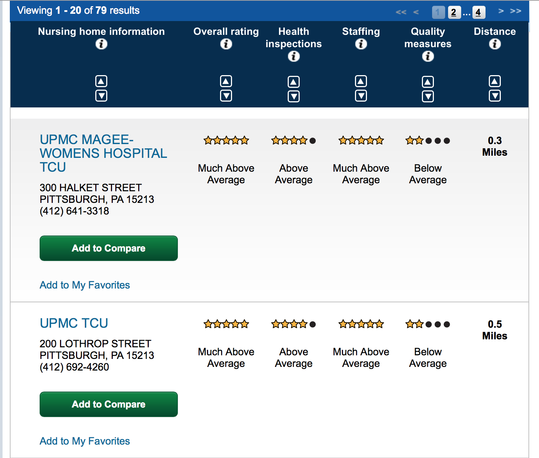

Another nice feature from nursing home compare is that individuals can select up to three facilities they would be interested in, and then have the system place them side by side, allowing for consumers be able to distinguish the differences between the facilities. Nursing Home Compare also provides more details within the facility including the health inspection details and ownership information. Thanks to this system, consumers can now make a more educated decision on where they would like to go for their long term services.

Table 2. Nursing Home Compare: Compare System
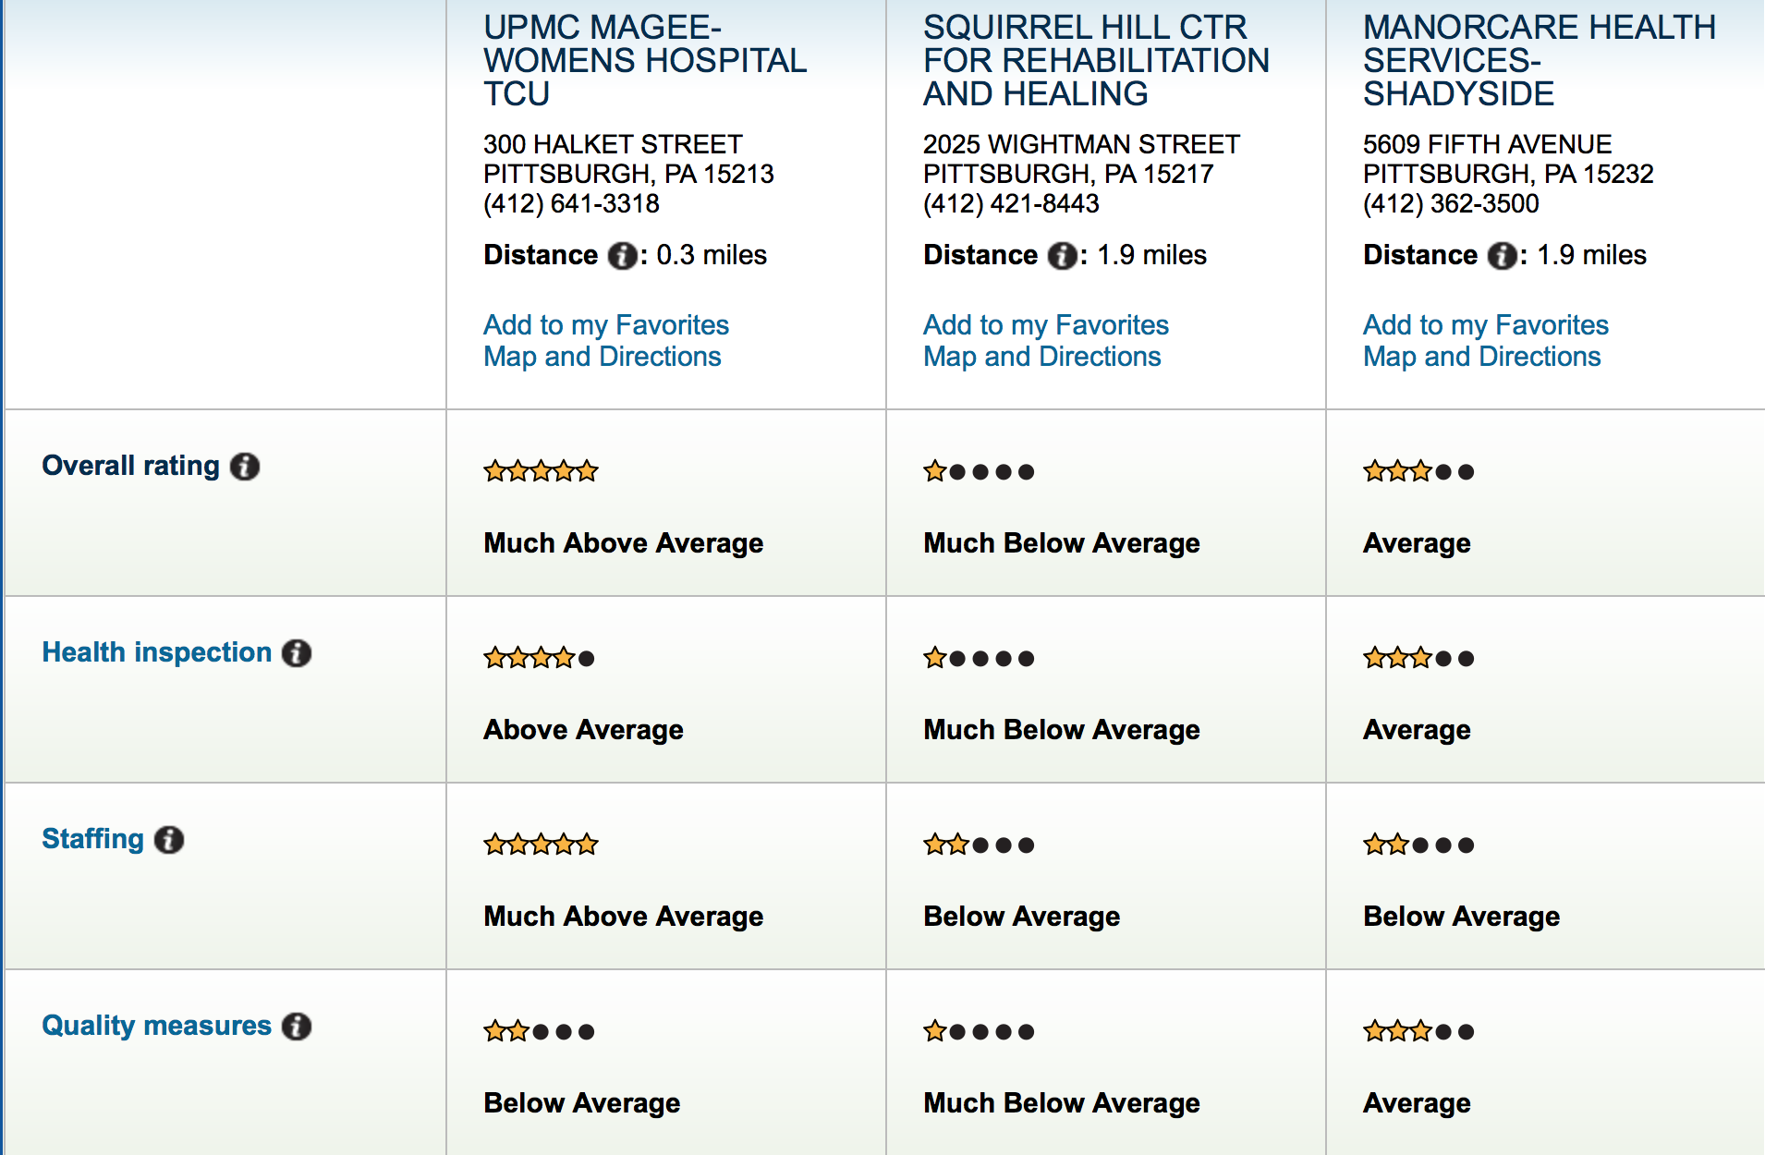

THe need of medicare and medicaid for nursing facilities
Nursing facilities are a major provider in long term care in the United States. These facilities provide a broad range of services including: medical, skilled nursing, therapy and rehabilitative services. They also help provide assistance to those in need of help performing daily activities, such as dressing themselves and bathing. The recipients of this type of care are generally the elder population. The services that nursing homes provide are a necessity for many, however, their high costs are unattainable to many. In order for the costs to be taken care of, many turn to Medicaid and Medicare. Medicare services are very limited, for this reason majority of the costs are financed through Medicaid. In 2010 the nation as a whole spent $143 billion dollars across all three types of payers.
In 2010 only 13% of the United State’s population was over the age of 65 years old, in 2040, however, it is projected that 20 percent of the population will be over the age of 65 years. This change has caused many policymakers to shift their attention to nursing facilities. As the demand increases for nursing facilities, capacity and quality of care comes into question. These are the primary sources of concern for policymakers.
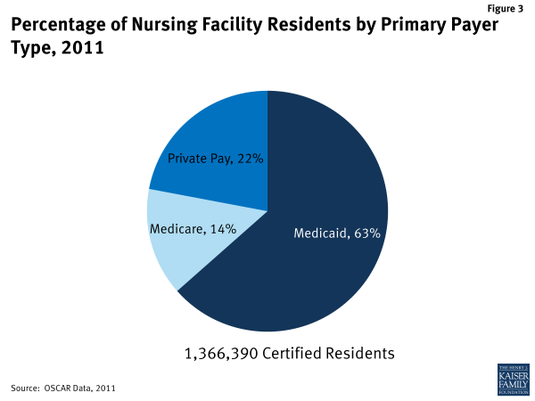
Figure 1. Nursing Facility Payers

In 2011, 63% of the residents in nursing facilities had Medicaid as their primary payer, 14% had Medicare and 22% had private pay. It is important to note that the percentage of Medicaid users has steadily decreased over time, mostly because nursing facilities have started to switch to Medicare and private pay rather than Medicaid due to their low reimbursement rates. Medicare currently covers long term nursing home care at approximately $500 to $600 per day, while Medicaid covers long-term nursing home care at about $125 a day (Glekman, 2013) The advantage to having more Medicare as a payer over Medicaid is quite prominent financially.
There has been an increasing trend in the percentage of Medicare dollars spent towards skilled nursing facilities. In the year 2000, 6% of Medicare dollars were spent towards skilled nursing facilities, but by 2011 there was an increase to 8.8% of Medicare dollars being spent towards nursing facilities. A primary reason for this is the decrease in length of stay at hospitals for the frail and elderly.

Massachusetts in Health Care
Massachusetts has been one of the principal states to embrace and lead changes in healthcare. In 2006, Massachusetts was the first state to mandate the health care reform plan. This plan allowed for the state to increase its percentage of residents to 98%, which was the highest in the nation. The main idea was to have sick and healthy individuals pay the same amount for insurance. Due to the high percentage of healthy people, we do not expect to see an increase in prices for sick people. This model was used by the Obama administration for implementing the Affordable Act Care across the nation.
More recently, Massachusetts has launched a new comprehensive digital health initiative across the state. The initiative will create a comprehensive public-private partnership designed to accelerate the competitiveness of the state’s digital healthcare industry. The hope is that the initiative will increase patient care and lower health care costs as well as put Massachusetts in the position of becoming a global leader in digital health care.
Looking into the future, Massachusetts is also the first state to try to create a more transparent look into nursing facilities. One major change they are undergoing is adopting patient satisfaction into their system for comparing nursing homes. This will be an effective measure for third party contractors when making a decision on which facilities they want to form partnerships with. Many of these contractors want to make sure that their customers have a great experience, so this new adaptation of patient satisfaction into the system will be a big player in assisting with this decision.

Methods
Each week a list of patients which have been discharged from nursing facilities in Massachusetts is sent to the University of Pittsburgh. Each person on that list than receives a standardized survey which was created by Dr. Castle as a way to measure the quality of care given to patients. The standard questions asked are as follows:

Table 4: Standardized National Survey Questions
- In recommending this facility to your friends and family, how would you rate it overall?

- Overall, how would you rate the staff?
- How would you rate the care you received?
- How would you rate how well your discharge needs were met?

Respondents have five responses they can choose from for the four questions: 1) Poor,
2) Average, 3) Good, 4) Very Good, and 5) Excellent. Based on these four questions, a Core Q score is calculated. This Core Q score measure helps understand what each person found to be important during their overall stay at their respective nursing facility. It is more informative than just an average score of answers. The score is calculated using a formula to find an average of each respondent’s responses. [Numeric Score Question 1 + Numeric Score Question 2 + Numeric Score Question 3 + Numeric Score Question 4]/4. The number of respondents with an average score of three or higher is then divided by the total.

Table 5. Survey Results
 |  | CORE Q
Resident
Responses
 | Resident | Resident | Resident | Resident
Core Q Items | A | B | C | D
Question #1 | 1 | 1 | 5 | 4
Question #2 | 2 | 5 | 5 | 3
Question #3 | 3 | 5 | 4 | 1
Question #4 | 2 | 5 | 4 | 4
Total | 8 | 16 | 18 | 12
Core Q Question Averages (Individual experience with all four items) | 8 /4 | 16 /4 | 18 /4 | 12/3.07
 | 2.0 | 4 | 4.5 | 3.9
There are only three residents in this example with scores >= 3.0, resident B, C, and D. They had scores of: 4, 4.5, 3.9. Therefore, the CORE Q Score for this facility is: 3/4 = 75%. This score is then benchmarked against the average CORE Q score from all participating facilities in Massachusetts.
Along with a CORE Q score, the facility can also compare their facility as a whole to other facilities. An “all facilities” score is calculated based off of the average score on a CORE Q item calculated from all participating Massachusetts facilities. “Your score” is calculated representing the score of the individual facility based off of the facility’s survey responses. The overall score for the question represents the average score when Poor = 1, Average = 2, Good = 3, Very Good =4, and Excellent =5 is converted to a 0-100 scale. This allows for the individual facilities to see where they stand against the rest of the facilities. They have the ability to see if they are better than the average facility in Massachusetts or not, and focus in on areas for improvement.

results

- In recommending this facility to your friends and family, how would you rate it overall?

Table 6. Question 1 Results
 | Poor | Average | Good | Very Good | Excellent | Overall Score for this question
All Facilities | 5% | 9% | 14% | 38% | 34% | 78
Your Score | 0% | 17% | 21% | 45% | 17% | 72

- Overall, how would you rate the staff?
Table 7. Question 2 Results
 | Poor | Average | Good | Very Good | Excellent | Overall Score for this question
All Facilities | 4% | 10% | 15% | 34% | 36% | 81
Your Score | 0% | 16% | 22% | 52% | 10% | 71

- How would you rate the care you received?
Table 8. Question 3 Results
 | Poor | Average | Good | Very Good | Excellent | Overall Score for this question
All Facilities | 4% | 9% | 12% | 41% | 34% | 80
Your Score | 7% | 14% | 24% | 43% | 12% | 77

- How would you rate how well your discharge needs were met?

 | Poor | Average | Good | Very Good | Excellent | Overall Score  for this question
All Facilities | 4% | 10% | 15% | 34% | 36% | 79
Your Score | 7% | 14% | 24% | 43% | 12% | 68
Table 9: Question 4 Results

Along with these summaries, the report also generates important information in regards to the amount of surveys sent, received, and the response rate. The response rate is calculated by dividing the surveys received by the surveys sent out. If necessary a note is written next to your surveys sent, your surveys received, and your response rate if a recommendation is made based on the numbers, such as telling you that your facility has a response rate which is less than the state’s response rate.

Conclusion
Patient satisfaction has continued to grow, from patient outcomes to encompassing the patient and loved one’s experience throughout their journey in a health system. Due to the extremely high costs of nursing facilities, Medicaid and Medicare, are looking closely into the quality of care given to their consumers. If the quality of care is not at least average, contractors will not want to affiliate with those facilities. More and more measures are being taken to make facilities more transparent to contractors as well as future consumers. Mechanisms such as Nursing Home Compare and the new CORE Q measure allows for facilities to be more transparent with their care and for individuals to be knowledgeable of their choice of facility. By increasing the focus on patient satisfaction, health care is increasing the accountability of health facilities to improve the overall quality of care for consumers. This has a huge impact on the betterment of public health. More people will be receiving the care they deserve, in a timely manner, and with less hassle.

bibliography
Brown, June Gibbs. "Improving the Quality of Care in Nursing Homes." (1986): n. pag. Department of Health and Human Services. Web.

"Overview of Nursing Facility Capacity, Financing, and Ownership in the United States In 2011." Overview of Nursing Facility Capacity, Financing, and Ownership in the United States in 2011. Kaiser Family Foundation, 28 June 2013. Web.

Nazir, Arif, Milta O. Little, and Greg W. Arling. "More Than Just Location: Helping Patients and Families Select an Appropriate Skilled Nursing Facility." More Than Just Location: Helping Patients and Families Select an Appropriate Skilled Nursing Facility. Annals of Long Term Care, 12 Aug. 2014. Web.

Hirschkorn, Phil, and Jeff Glor. "Massachusetts' Health Care Plan: 6 Years Later." CBSNews. CBS Interactive, n.d. Web.

"Massachusetts Launches Comprehensive Digital Health Initiative - Massachusetts It's All Here." Massachusetts Its All Here. N.p., 12 Jan. 2016. Web.

Brown, June Gibbs. "Improving the Quality of Care in Nursing Homes." (1986): n. pag. Department of Health and Human Services. Web.
"Overview of Nursing Facility Capacity, Financing, and Ownership in the United States In 2011." Overview of Nursing Facility Capacity, Financing, and Ownership in the United States in 2011. Kaiser Family Foundation, 28 June 2013. Web.
"Overview of Nursing Facility Capacity, Financing, and Ownership in the United States In 2011." Overview of Nursing Facility Capacity, Financing, and Ownership in the United States in 2011. Kaiser Family Foundation, 28 June 2013. Web.
"Overview of Nursing Facility Capacity, Financing, and Ownership in the United States In 2011." Overview of Nursing Facility Capacity, Financing, and Ownership in the United States in 2011. Kaiser Family Foundation, 28 June 2013. Web.
Nazir, Arif, Milta O. Little, and Greg W. Arling. "More Than Just Location: Helping Patients and Families Select an Appropriate Skilled Nursing Facility." More Than Just Location: Helping Patients and Families Select an Appropriate Skilled Nursing Facility. Annals of Long Term Care, 12 Aug. 2014. Web.
Hirschkorn, Phil, and Jeff Glor. "Massachusetts' Health Care Plan: 6 Years Later." CBSNews. CBS Interactive, n.d. Web.
"Massachusetts Launches Comprehensive Digital Health Initiative - Massachusetts It's All Here." Massachusetts Its All Here. N.p., 12 Jan. 2016. Web.

