IMPLICATIONS OF HEALTH LITERACY ATTRIBUTES: THE PROVIDER’S AND HEALTH PROFESSIONAL’S PERSPECTIVE

by
Alexandra Ibewuike
BS, University of Maryland, College Park, 2012

Submitted to the Graduate Faculty of
Health Policy and Management
Graduate School of Public Health in partial fulfillment
of the requirements for the degree of
Master of Health Administration

University of Pittsburgh
2016

UNIVERSITY OF PITTSBURGH
GRADUATE SCHOOL OF PUBLIC HEALTH

This essay is submitted
By
Alexandra Ibewuike
on
April 1, 2016

and approved by

Essay Advisor:
Wesley Rohrer, PhD, MBA _________________________________
Vice Chair of Education
Director of MHA Program
Health Policy and Management
Graduate School of Public Health
University of Pittsburgh

Essay Reader:
Mary Hawk, DrPH, LSW _________________________________
Assistant Professor
Behavioral and Community Health Sciences
University of Pittsburgh

Essay Reader:
Kevin Progar, Project Manager _________________________________
Regional Health Literacy Coalition
University of Pittsburgh

Copyright © Alexandra Ibewuike
2016
Wesley Rohrer, PhD, MBA

IMPLICATIONS OF HEALTH LITERACY ATTRIBUTES: THE PROVEIDER’S AND HEALTH PROFESSIONAL’S PERSPECTIVE
Alexandra Ibewuike, MHA
University of Pittsburgh, 2016

ABSTRACT

Post-Affordable Care Act (ACA), consumers are empowered to have more control over their healthcare than ever before, giving patients more voice and choice with their plans for healthcare. Health literacy becomes increasingly important because navigating through the health care system is already difficult. With an improvement in health literacy levels, we can see an improvement in patient health outcomes, patient satisfaction, and a decrease in hospital readmissions and costs. This has public health relevance because it contributes to the efforts of disease prevention, health promotion, and prolonging life among the population as a whole. For the aforementioned reasons, an increase in health literacy can improve health outcomes and improve quality of life.
A survey was conducted to understand the provider’s perspective of the current climate and effectiveness of the 10 Attributes of a Health Care Organization developed by the Institute of Medicine (IOM). This survey was administered through a Health Literacy email listserv that includes over 1500 providers and health professionals, of which 48 responded. Results show that 83% of respondents perceive that less than 25% of their employees are aware of the IOM 10 Attributes. Additionally, 56% perceive their leadership prioritizes health literacy at a rating of 6-10 (scale from 1(lowest) – 10 (highest)), with a mean score of 6. When asked, “How strongly do you feel you understand the attributes and their aims?” 77% reported comprehension levels ranging from 6 to10 with a mean score of 7.
Results suggests that providers understand the attributes but portrays not many of their employees do so. The survey results also suggest that providers and their organizations are not utilizing all 10 Attributes to their fullest potential to create a health literate organization. I have proposed that the federal government incentivize healthcare leaders to appoint a Health Literacy Champion within their organizations. For example, if hospitals want to continue benefiting from Medicare programs, then they should be required add the 10 Attributes to their quality metrics. It should be the hospital’s responsibility to either adopt the teach-back method or create its own intervention to help patients understand and communicate better with providers.

TABLE OF CONTENTS

- INTRODUCTION …………………………………..……………………….………... 1
1.1 PUBLIC HEALTH RELEVANCE ……………………………………………..... 3
2 FOCUS OF STUDY & PROBLEM STATEMENT ………..………………………….... 5
3 ORGANIZATIONAL CONTEXT ……………………..………………………………… 7
4 LITERATURE REVIEW ……………………………..……………………………..….... 9
4.1 VA HEALTH LITERACY STUDY (NORTH FL, SOUTH GA AREA).…….. 11
4.2 BLUE SHIELD OF CALIFORNIA FOUNDATION ………………………….. 13
4.3 HEALTH CONFIDENCE ARTICLE ………………………………………..… 13
4.4 PARTICIPATION IN MASS COMMUNICATION …………………………... 14
5 DESIGN & METHODS ………………………………...……………………………….. 15
5.1 LIMITATIONS ………………………………………………………………..…. 15
6 FINDINGS/ANALYSIS ……………………………...…………………………………... 17
6.1 SURVEY QUESTIONS & RESULTS ……………………………………….…. 17
7 DISCUSSION …………………………………...……………………………………...… 30
8 CONCLUSION ……………………………...………………………………………….... 32
APPENDIX: HEALTH LITERACY CLIMATE SURVEY………....................................... 34
BIBLIOGRAPHY ………………………...……………………………………………........... 37
LIST OF TABLES

Table 1: Why Are Health Literacy Skills Important? .................................................................... 4
Table 2: Most Used/Implemented of the 10 Health Literacy Attributes ...………………..…… 22
Table 3: Percentages of Attributes with the Most Impact ………..………………..………….... 24
Table 4: Respondents Reported Health Literacy Activities They have Witnessed ……….....… 29

LIST OF FIGURES

Figure 1: Survey Organization Type Pie Chart ………………………………………….……. 18
Figure 2: Size of Organizations Representing Respondents’ Organizations ……………..…… 19
Figure 3: How Strong Of A Priority Is Health Literacy for Your Leadership- Response Distribution ………………………………………………………………………………….… 20
Figure 4: Percent of Employees Aware of 10 Attributes …………………………………….... 20
Figure 5: Respondents who are Aware of the 10 Attributes ………………………………..…. 21
Figure 6: Number of Attributes Used ……………………………………………………….…. 22
Figure 7: Pie Chart of Respondents Who Are Aware Of Health Literacy Programs ……...…... 23
Figure 8: Respondents Who Have Used the 10 Attributes …………………………………….. 23
Figure 9: How Strongly Respondents feel they understand the 10 Attributes …………..….….. 25
Figure 10: When Respondents Started Implementing Health Literacy ..…………………….… 26
Figure 11: Impact on Metrics from Improving Health Literacy ……………………………….. 27
Figure 12: Percentage of Respondents Who would Implement Health Literacy with More Information on Health Literacy Benefits ………………………………………………………. 28

- INTRODUCTION

Health literacy is defined as “the degree to which individuals have the capacity to obtain, process, and understand basic health information and services needed to make appropriate health decisions” (DHHS, 2010). It has been reported that only 60% of adults in the U.S. can read above a sixth-grade level. Additionally, 77 million U.S. adults have difficulty with common health tasks such as reading instructions on a prescription drug label. For instance, less than 50% of all adults are unable to read a body mass index graph to find their health, weight, or to understand a vaccination chart (Alpher, 2015)
Health literacy impacts both the consumer and provider sides of healthcare. Low health literacy (LHL) affects hospital readmission since studies suggests emergency room patients with LHL are twice as likely to be hospitalized as those with adequate literacy. LHL is costly for patients since studies also suggest individuals with low health literacy levels have an average annual health care cost of $13,000 compared to the patients with high health literacy levels who average a cost of $3,000 annually (Haun, 2015). The economy is affected by LHL since health literacy costs the U.S economy about $238 billion annually. If nothing is done to address this problem, emergency department visits will continue to rise, readmissions will continue to climb, and expenses will remain high for both the hospital and patients (GSW Inventiv Health, 2016).
Today, the healthcare system is shifting towards a patient-centered model. Table 1 displays why both consumers and providers need health literacy skills in a patient-centered model. Assessing and addressing health literacy levels now will improve the provider’s approach to health care delivery in the future and empower patients to be more involved in their plan of care. A greater understanding of their diagnoses, medications etc., is consistent with, and should support the patient-centered model.
Post-Affordable Care Act (ACA), consumers are empowered to have more control over their healthcare than ever before. The ACA emphasizes patient satisfaction, quality care, physician ratings, health insurance markets, and healthcare delivered with a patient-centered approach, which gives patients more voice and choice with their plans for health care. Health literacy and patient education become increasingly important because navigating through the health care system with all of its opaqueness and complexities is already difficult. Consumers need to comprehend everything from nutrition, obtaining health insurance, interpreting medical bills, understanding their diagnoses, and even how to take their prescribed medication. For instance, about two-thirds of readmissions result from poor medication management. With an improvement in health literacy levels and patient education, we can expect improvement in patient health, patient satisfaction, and a decrease in hospital readmissions.
Unfortunately, health literacy may be paced at the bottom of an already long and ever-growing laundry list of provider responsibilities. As Dr. Stephen Somers, author of Health Literacy Implications of the Affordable Care Act, stated, health literacy was “certainly not a featured concern of the health care reform legislation in early 2010” (Somers, 2010). With the white-coat-syndrome still affecting older and less educated consumers, it is extremely rare to hear a patient request such services to improve their literacy. Providers, innovators, and leaders in health and public health have shared responsibility to combat health literacy issues before they arise and become a costly burden to both the patient and the healthcare system. If we want to shift healthcare towards a patient-centered model, we should equip patients with the knowledge they need to play an active role to make better healthcare choices.
The Institute of Medicine (IOM) and the Centers for Disease Control and Prevention (CDC) both implemented the 10 Attributes of a Health Literate Organization. The IOM established the attributes while the CDC has a similar list with somewhat different priorities. In combination with the attributes, providers can use teach-back methods of education to reinforce the level of comprehension from their patients. This should not only be done by pharmacies regarding medication or with physicians regarding diagnosis but also by health insurance companies as they issue coverage for consumers.
This report is an analysis based on responses/perceptions collected from the Health Literacy Climate Survey. The survey was conducted to assess the understanding and application of IOM’s health literacy attributes outlined in the document “Ten Attributes of Health Literate Health Care Organization.”

1.1 PUBLIC HEALTH RELEVANCE:
Health literacy is relevant to public health because it contributes to the efforts of disease prevention, health promotion, and prolonging life among the population as a whole. For the aforementioned reasons, an increase in health literacy can improve health outcomes and improve quality of life.

Table 1: Why are health literacy skills important?
Anyone who needs health information/services should be able to | Anyone who provides health information/services should be able to
Find information and services  Communicate their needs and preferences and respond to information and services  Process the meaning and usefulness of the information and services  Understand the choices, consequences and context of the information and services  Decide which information and services match their needs and preferences so they can act | Help people find information and services  Communicate about health and healthcare  Process what people are explicitly and implicitly asking for  Understand how to provide useful information and services  Decide which information and services work best for different situations and people so they can act

Note. Adapted from The Centers for Disease Control and Prevention. 2015.

- FOCUS OF STUDY & PROBLEM STATEMENT

This paper covers the importance and impact of health literacy attributes based on a survey of healthcare providers who responded to a listserv for professionals invested in health literacy. In 2012, the IOM created a list of 10 attributes of a health care organization, which characteristics “make it easier for people to navigate, understand, and use information and services to take care of their health” (Brach, 2012). This list includes:
- Has leadership that makes health literacy integral to its mission, structure, and operations.
- Integrates health literacy into planning, evaluation measures, patient safety, and quality improvement.
- Prepares the workforce to be health literate and monitors progress.
- Includes populations served in the design, implementation, and evaluation of health information and services.
- Meets the needs of populations with a range of health literacy skills while avoiding stigmatization.
- Uses health literacy strategies in interpersonal communications and confirms understanding at all points of contact.
- Provides easy access to health information and services and navigation assistance.
- Designs and distributes print, audiovisual, and social media content that is easy to understand and act on.
- Addresses health literacy in high-risk situations, including care transitions and communications about medicines.
- Communicates clearly what health plans cover and what individuals will have to pay for services (Brach, 2012).
As health literate organizations implement these attributes, the question of overall effectiveness of the attributes across the health care continuum comes into question. It has been indicated that low health literacy contributes to increasing health care costs. For example, the Department of Veterans Affairs (VA) patient study, as described in the following sections, has demonstrated that the costs of care for patients with low health literacy rates were almost double that of patients with adequate health literacy levels (Haun, 2015). Tremendous effort has been applied to the health care field to decrease cost and overutilization. Health literacy needs to play a more vital role in the discussions and efforts between providers, leaders, and health executives about how to combat these issues.

- ORGANIZATIONAL CONTEXT
The study presented in this report is supported by the Regional Health Literacy Coalition (RHLC) in Western Pennsylvania. RHLC “serves as a trusted resource that health care providers and the public can turn to for best practices in health literacy information” (RHLC, 2016). The RHLC aided in the creation and disbursement of the Health Literacy Climate Survey.
In 2010, the University of Pittsburgh's Institute of Politics (IOP) held a town hall meeting to talk about health literacy. Regional health and human service leaders came together with a goal to improve health literacy in Western Pennsylvania. Along with others committed to health literacy they created an advocacy group, the Regional Health Literacy Coalition (RHLC, 2016).
The mission of RHLC is to promote health literacy and help providers and patients find ways to better understand each other by:
- Working with nonprofit organizations, government agencies, and others in southwestern PA to raise awareness about health literacy
- Identifying best practices and ensuring that community partners have the tools necessary to effect positive change in health literacy
- Developing meaningful policy options related to health literacy using evidence-based research (RHLC, 2016)

The vision at RHLC is working to make the regional health care system more person-centered, health literate and easy to use for all by the year 2020. The Coalition uses the U.S. Department of Health and Human Services 2010 National Action Plan to Improve Health Literacy as a model (DHHS, 2010). This action plan includes seven goals that will improve health literacy and strategies for achieving them:
- Develop and disseminate health and safety information that is accurate, accessible, and actionable.
- Promote changes in the health care system that improve health information, communication, informed decision-making, and access to health services.
- Incorporate accurate, standards-based, and developmentally appropriate health and science information and curricula in child care and education through the university level.
- Support and expand local efforts to provide adult education, English language instruction, and culturally and linguistically appropriate health information services in the community.
- Build partnerships, develop guidance, and change policies.
- Increase basic research and the development, implementation, and evaluation of practices and interventions to improve health literacy.
- Increase the dissemination and use of evidence-based health literacy practices and interventions.
The RHLC hosts skill building and training programs such as Plain Language Writing Workshops, Teach Back Technique Training, and SHARE Approach Workshops.

- LITERATURE REVIEW

In the study on VA patients’ health literacy, those considered to have low health literacy were more likely to have higher utilization rates. When comparing these patients with those with a “normal” health literacy rate, it was shown that the latter grou[ had lower healthcare costs (Haun, 2015).
Another study relevant to this topic was the 2012 Health Literacy Survey of Southwestern Pennsylvania. This study, conducted by the University of Pittsburgh University Center for Social and Urban Research (UCSUR), surveyed 1,003 people in a seven county area. Based on the three criteria; Reading; Understanding and; Completing forms, this study assessed the health literacy levels using these criteria for a sample of respondents in Southwestern Pennsylvania. UCSUR found that for the “reading” criteria, LHL rates are prevalent among an estimated 238,000-351,000 people in Southwestern Pennsylvania (UCSUR 2012).
First, rates of LHL were assessed across age, race, marital status, socioeconomic status (SES), language, sex, and county. USCUR reported individuals were most likely to have LHL if they also:
    - Took multiple medications
    - Had two or more disabilities
    - Reported their health as poor or fair
    - Reported bad mental health days
    - Were restricted in doing usual activities due to health
    - Had psychomotor problems
    - Had two or more ER visits
    - Were uninsured
    - Had Medicaid or Medicare coverage
    - Were without private health insurance
Secondly, UCSUR reported that the best demographic predictors of LHL in Southwestern Pennsylvania were:
  - Qualifying for Highmark Special care
  - Education level
  - Race
Third, UCSUR reported that the best predictors for LHL in health (applying reading and understanding criteria only) are:
  - Rating of overall health
  - Having Medicare coverage
  - Two or more disabilities
  - Two or more health conditions
Fourth, UCSUR reported health information resources (using the question, who do you consult for clarification?) as the following:
  - Most chose doctor/nurse/pharmacist
  - 65+ or married consult children
  - Males were less likely to choose doctor/pharm/nurse or child compared to females
In summary, the UCSUR study suggests that about 1 in 6 persons in the seven counties surrounding Pittsburgh has a health literacy problem. This study noted that people with lower socioeconomic status (SES), including those income-eligible for SpecialCare¹ and those with less education, have higher rates of LHL. A person with poorer health is more likely to have a problem with health literacy. Persons without insurance have higher rates of LHL as compared to those who have insurance. The primary health information resources for participants in the UCSUR case study are doctors, nurses, and pharmacists, family members, and Internet or printed materials. The choice of health information resource varies significantly based on several demographic and health-related variables. Lastly, the study suggests that persons with no health insurance and those who are income-eligible for SpecialCare are less likely to cite healthcare providers (doctor/nurse/pharmacist) and Internet or printed materials, and more likely to cite family members as health information resources. It is worth noting that 15.7% of Pittsburgh metropolitan statistical area (MSA) residents reported needing someone to help them read instructions, pamphlets, or other written material from doctors or pharmacies at least sometimes (UCSUR, 2012). It is important to recognize the correlation between literacy and SES. For example, LHL was associated with low SES in a study by Adler as reported in the Columbia Journalism Review (Adler, 2104).
4.1 VA Health Literacy Study (North FL, South GA area)
Prior to 2015, health literacy levels had not been analyzed within the Department of Veterans Administration (VA). The VA Health Literacy study was conducted in the North FL/South GA region in fiscal years 2007-2009, which surveyed 92,749 patients.
- SpecialCare is a lower cost limited benefit plan for those overqualified for medical assistance and have no access to group health insurance created by Highmark.
The research team conducted surveys with 4 questions:
  - How often do you have someone help you read hospital material?
  - How confident are you filling out medical forms?
  - How often do you have problems understanding your medical conditions because of difficulty understanding written information?
  - How often do you have a problem understanding what is told to you about your medical condition?
Response options were scored on a five point Likert scale for each item. The score from responses were broken down into three levels of literacy: Inadequate (4-12), Marginal (13-16), and Adequate (17-20). The results are summarized as follows:
- Participants with inadequate and marginal health literacy levels on average had higher costs of care, $32,000 and $23,000 respectively, (and higher rates of utilization) compared to those with adequate health literacy levels ($17,000).
- Costs of participants with marginal and inadequate health literacy levels actually increased over the three-year study.
- Those with inadequate and marginal health literacy make up 17% of the 92,749 patients surveyed from 2007-2009.
It is important to note that these findings indicating high rates of utilization and cost associated with LHL patients also affect healthcare delivery outside of the VA Health System, especially since veterans can seek non-VA Choice program providers. Solutions to improve rates of LHL proposed by the study’s authors include best practices like writing and speaking in plain language to improve health information accessibility and effective use. (Haun, 2015).

4.2 Blue Shield of California Foundation
In 2012, Blue Shield California Foundation (BSCF) surveyed the community to assess the role information and communication play in achieving goals of patient-centered care. The survey was conducted by landline and cellular telephone interviews among a random statewide sample of 1,024 Californians age 19-64 years. BSCF found 4 in 10 respondents say they prefer to leave health care decisions to their doctors while the remaining 6 in 10 say they want an equal say in their care. Another survey question demonstrated that if guidance about treatment options was offered, 8 in 10 said they would like an equal role.
The BSCF report ultimately concluded that more connectedness and continuity leads to an empowered patient. This empowerment allows patients to feel more informed about their health, more comfortable asking questions, more confident in making healthcare decisions. Patients benefit from a provider who explains Medicaid information in an understandable way (BSCF, 2012).
4.3 Health Confidence Article
In 2014, an article by Wasson (2014) provided a case study of health confidence from the perspective of a 90-year-old widow, Mrs. A, and her experience with health literacy. Mrs. A was admitted into the hospital for congestive heart failure, a new health condition. After her discharge, Mrs. A had numerous health encounters including:
- 2 hospital admissions,
- 4 emergency department visits (without admission),
- 7 office visits and
- 21 telephone contacts with her primary care provider
Mrs. A over-utilized health services while operating at a 1 out of 10 rating level for knowledge about her condition and a 4 out of 10 for health confidence. After assessing her confidence level and understanding, Mrs. A underwent an intervention involving patient education where she was able to receive more personalized care from her provider to address those issues. Mrs. A’s visits dropped dramatically and she achieved 9 out of 10 for understanding her condition and an 8 out of 10 for overall health confidence (Wasson, 2014). Although one case example cannot be generalized broadly, this provides some evidence of the impact of LHL and the effects of improving it.
4.4 Participation in Mass Communication
Another relevant article by Dr. Neuhauser (2009) reported that individuals with Medicaid coverage, disability, and senior citizens as being among the most vulnerable populations in health care. These vulnerable populations are associated with limited literacy skills, English proficiency, and/or impeding physical/cognitive conditions. These same groups have more difficulty making complex decisions about their care as fewer than 25% could do so in this study.
The authors’ proposed solution was to develop a user-made guide book for Medicaid beneficiaries. Since the currently available printed materials are at a high reading level and difficult to comprehend, this book was created based on readability, usability, suitability, and efficacy. Dr. Neuhauser and her team were able to publish and distribute the book in English, Spanish, and Chinese for those receiving disability-related support and Medicaid coverage in California (Neuhauser, 2009).
- DESIGN AND METHODS
The design of this study was based on an online survey sent to health care professionals via an email listserv. Those who subscribed to the email listserv were providers who are invested in health literacy. Participants could only access the survey if given the URL link created using Google Form. Multiple announcements were sent through the listserv to solicit responses from health care professionals. A sample of the survey can be found in Figure 1.
The survey was designed to gauge the current climate of the IOM’s 10 Attributes on Health Literacy and their effectiveness from the provider’s perspective. Respondents were asked to respond to 14 questions, noted in Figure 1. All survey responses were anonymous as the survey did not ask for any identifiable information.
Of the 14 survey questions, two questions allowed for open-ended responses. The remaining 12 were multiple choice or multi-select questions that allowed for the option “other” if the responses did not pertain to them. If respondents had questions about the survey, they were provided with an email address to request additional information. Refer to Appendix A for the survey instrument. Both quantitative and qualitative data were collected and analyzed using descriptive statistics and percentage frequencies as presented in Section 6: Findings/Analysis.
5.1 Limitations:
First, the sample size for this survey was relatively small and only solicited responses through one avenue. Forty-eight respondents may not a fairly represent the perception of all providers; however, these findings do provide some evidence as to the current climate surrounding health literacy among participants sampled. A longer period of time allotted for responses and/or a follow up request might have resulted in a greater response rate. Second, since no demographic data was requested of the respondents (there is no known regional area that the respondents identify with), it will be difficult to compare differences and similarities if a similar study were conducted. In addition, some responses from open-ended questions were disregarded due to lack of relevancy in the answers. Conclusions were drawn based on the remaining complete responses from this small sample which may not reflect the opinions of all users of the listserv.
Additionally, the 10-point Likert scale may have been confusing for the respondents. Offering a smaller scale from 1 to 5 accompanied with a key of what each number on the scale represents would have been more clear and concise, yielding more valid responses. Fourth, keeping the survey anonymous was both favorable and unfavorable. The anonymity allowed for candid responses but there were ambiguous responses that would benefited from a follow up for clarification. Offering an option for name and contact information would have been beneficial for data collection and verification purposes.
Finally, obtaining key demographics on the respondents and verification would have allowed for understanding the population that responded to the survey. Recording information on the age group of respondents, gender, race/ethnicity, occupational distribution, level of employment, and demographics of population the provider serves will help make sense of the information gathered from the survey. In the future, focusing the survey to one type of population at a time (i.e., hospital providers vs. public health agency, etc.), with follow up reminders should provide more information that will be more useful and easier to analyze. The assessment tool was newly developed by our team and we did not conduct an assessment of psychometric properties. These are the most significant threats to internal validity of the data collected.
- FINDINGS/ANALYSIS
Much research has been conducted to understand the health literacy levels of patients navigating through the health care system. Healthcare providers have some responsibility to help their patients decode and better understand some of the medical jargon that would otherwise be difficult or nearly impossible to understand and therefore prove useless. The results of this survey are from providers and health care leaders who are familiar the 10 Health Literacy Attributes. This analysis shares some of the respondents’ perspectives on what aspects of the literacy attributes have been useful and what may need improvement.
The survey named “Health Literacy Climate Survey” was distributed via email through a health literacy listserv. The survey was released on January 27, 2016 and it remained open for responses until February 15, 2016. Although the survey potentially reached over 1500 people only 48 responded. The responses are organized by question to show the pattern of responses.
6.1 Survey Questions and Results
Question 1: Which best describes your organization?
The multiple choice responses for this questions were Public Health Agency, University, Health System, Insurer, or other. Figure 2 shows that of the 48 respondents, 35% described their organization as a Health System, about 21% described their organization as a University, 8% described their organization as a Public Health Agency, and 2% described its organization as an Insurer. The remaining 34% of responses were spread among the following types of organizations; Non Profit, Network of Community Health Centers, Public Library, Academic Health Center, Coverage Advocate, Pharmacy, Physician Office, Insurer, Physician, Cooperative Extension, Cancer Center, Hospital, Australian Government, and Other.

Figure 1: Survey Organization Type Pie Chart

Question 2: How many employees work at your organization?
The multiple choice responses are <50, 50 to 100, 100 to 500, 500 to 1000, and >1000. Figure 3 shows that of the responses collected, 56% have >1000 employees, about 17% have <50 employees, 10% have 500 to 1000employees, 10% have 100 to 500 employees, and the remaining 6% have 50 to 1000 employees.

Figure 2: Size of Organizations Representing Respondents’ Organizations

Question 3: On a scale from 1 (lowest) to 10 (highest), how strong of a priority is health literacy for the leadership of your organization?
The survey allows respondents to select their responses on a 10-point scale based on their perceptions of leadership priorities. Figure 4 shows the most frequent response (21%) was an 8 on a scale from 1 to 10. Overall, 43.75% rated their leadership’s health literacy priority between 1 and 5. The other 56.25% would rate their leadership’s health literacy priority between 6 and 10, with the mean response at 6.

Figure 3: How Strong Of A Priority Is Health Literacy for Your Leadership- Response Distribution

Question 4: What percent of your staff is aware of the 10 Health Literacy Attributes?
Figure 5 shows that of the 48 respondents, 83% of respondents perceive that less than 25% of their staff is aware of the 10 Health Literacy Attributes.

Figure 4: Percent of Employees Aware of 10 Attributes

Question 5: Are you currently AWARE of CDC/IOM’s 10 Health Literacy Attributes?
For this binary response (yes or a no), 83% of respondents selected yes as Figure 6 shows.

Figure 5: Respondents who are Aware of the 10 Attributes

Question 6: If you have used or implemented CDC/IOM (/NAM) 10 attributes in your organization, which one(s)?
Figure 7 shows that 71% of respondents reported that 0 to 4 attributes were used in their organization. Additionally, 25% reported using 5 to 8 attributes, and 4% reported that 9 to10 attributes were used in their organization.

Figure 6: Number of Attributes Used

The respondents also selected which particular attributes were implemented. The top 3 most frequently implemented attributes are listed in Table 2 below.
Table 2: Most Used/Implemented of the 10 Health Literacy Attributes
Attribute | Percentage
Designing Easy to use materials | 17.65%
Plan/Evaluate/Improve | 12.41%
Communicates Effectively | 11.76%
Leadership | 9.8%
Includes Consumers | 9.8%
Meets Needs of All | 9.8%
Prepares Workforce | 8.5%
Targets High Risks | 7.19%
Explains Coverage & Costs | 6.54%
Ensures Easy Access | 6.54%

It is interesting to note that over 40% of the respondents reported that designing easy to use materials, planning/evaluating/improving, and communicating efficiently were the most used/implemented attributes.

Question 7: Are you aware of the benefits of health literacy programs?
Figure 8 shows that the majority of respondents, 94%, are aware of health literacy programs.

Figure 7: Pie Chart of Respondents Who Are Aware Of Health Literacy Programs

Question 8: Have you USED the CDC/IOM (/NAM) 10 Health Literacy Attributes?
Respondents’ results are displayed in Figure 9. The majority of respondents, 62%, have used the 10 Attributes.

Figure 8: Respondents Who Have Used the 10 Attributes
Question 9 (Open-ended): Of the attributes you selected, which one had the most impact? Why?
A large portion of the respondents either were not sure of the impact, felt that no attribute contributed to the impact, or the impact was unknown/not measured. Surprisingly, 13% answered the question with irrelevant answer. An example of an irrelevant answer was a response explaining the need for policy changes. Additionally, the question did not apply to 19% of respondents who may have not implemented any attributes or similar reasons. One respondent felt that all attributes had an impact but this response was not included when calculating frequencies because the answer was not precise enough.

Table 3: Percentages of Attributes with the Most Impact
Attribute | Percentage
Question Not Applicable* | 19%
Design Easy to Read Material | 15%
Did Not Answer Correctly | 13%
Unknown Attribute Used | 13%
Leadership | 11%
Targets High Risks | 9%
Communication | 6%
Include Customers | 4%
Explain Coverage and Costs | 2%
Prepare Workforce | 2%
Plan/Evaluate | 2%
No Attribute Used | 2%
Blank | 2%

It is interesting to note that 41% perceived that designing easy to read materials, leadership, targeting high risk populations, and communication were the attributes providing the most impact in their organizations.
*This question is not applicable to those who previously answered No to the question “Have you USED the CDC/IOM (/NAM) 10 Health Literacy Attributes?”
Question 10: On a scale of 1 (lowest) to 10 (highest), how strongly do you feel you understand the attributes and their aims?
The results in Figure 10 shows that 27% selected a 10 from the scale indicating they fully understand the 10 Attributes. Additionally, 23% of respondents selected a 5 or lower on the scale, indicating they do not fully understand the 10 Attributes and their aims. When separated in to Low (1-4), Medium (5-7), and High (8-10) they are 21%, 20%, and 58% respectively. The mean selected response was 7.

Figure 9: How Strongly Respondents feel they Understand the 10 Attributes

Question 11: When did your organization begin to implement health literacy programs? (Optional)
Figure 11 shows that responses to this question ranged from 2001-2016. This question was asked to know how experienced organizations are with Health Literacy methods. The highest percentage of respondents, 50%, started implementing Health Literacy methods in 2013 or later.
Figure 10: When Respondents Started Implementing Health Literacy

Question 12: In the years you began to implement health literacy programs, what changes were observed?
The largest percent of respondents, 29%, reported that implementing the attributes affected the improvement of patient outcomes, while 17% responded that the attributes helped reduce readmissions.

Figure 11: Impact on Metrics from Improving Health Literacy
*Other responses noted were the following:
- Improved consumer confidence and capability
- Greater understanding Importance of health literacy
- Provide training
- People return for help
- Insurance reimbursement
- Patient engagement
- Ability to do self-care
- Magnet (Perhaps becoming a magnet institution)
- Accreditation criteria
Question 13: If given more information about health literacy and the benefits of a program, would you be more inclined to implement a program in your organization?
Similar to the BSCF study, if given more information and guidance, respondents expressed their belief that individuals would be more inclined to participate in health literacy efforts. Figure 13 displays that 71% of respondents would be more willing to implement health literacy methods if they knew the benefits of the programs.

Figure 12: Percentage of Respondents Who would Implement Health Literacy with More Information on Health Literacy Benefits

Question 14 (2 Open-ended questions): What type of work have you done/witnessed that promotes health literacy and what suggestions do you have to improve health literacy? Responses are listed in Table 4. Collectively, the respondents provided 69 types of activities. The most frequently reported activity was “teach back” which represented about 25% of the activities mentioned.

Table 4: Respondents Reported Health Literacy Activities They have Witnessed
Health Literacy Promoting Activities

Education  - Statewide training Programs  - Direct Patient Education  - Educators/Researchers  - Educate Medical and Nursing Students and Health Professional  - Present info at State Libraries  - HL Advocate at Universities and Government Agencies  - ACA Information Training  - Trained Librarians | Communication  - Re-create All Communication Materials  - Standardize Patient Communication  - Website Re-design with Health Literacy  - Flyers and Workshops Promoting Health Literacy  - Discuss Health Literacy on TV Program  - Call Back System  - Plain Language  - Work with Legal to Improve Readability
Organization/Services  - Health literacy Listserv  - Health Literacy Taskforce  - Provide Resources for limited English Proficiency Patients  - Work with Rural Elderly  - Host a Health Literacy Forum  - Leadership buy-in  - Provider buy-in | Methods  - Administer Surveys  - Teach Back Methods  - Institution-wide Assessment  - Evaluate Socioeconomic Factors  - Hands-on Projects  - Patient Empowerment programs  - Ask Me 3  - Ask-Tell-Ask  - Mock Visits  - Evaluate Effectiveness  - System Collaborations
Policy
- Health Literacy Policies
- Principles of Writing Health Literate Patient Information
- Add Health Literacy to Quality Improvement Projects

- DISCUSSION

Studies suggest that of the 7 million readmissions that occur each year, about 12% of them are preventable (Network for Excellence, 2015). Not all readmission are caused by patient misapprehension but, as mentioned earlier in this report, about 33-69% of hospital readmissions ware due to patient error. The current methods of prevention, like teach-back and patient education, help reduce cost and risk of mortality by 35% and reduce readmission rates (Quality Improvement for Institutions, 2016). The key take-away from this report is understanding the impact an organization’s leadership has on the work environment and culture. If a company’s leader is not in full support of a proposal or intervention, then it will not be performed in the employee’s daily operations. Interestingly, the respondent’s perceptions of how high their leadership prioritizes health literacy on a scale from 1-10 was fairly high (56% rated between 6 and 10) and the mean response was 6. The survey results also show a majority of survey respondents have a comprehension level on the 10 Attributes from 6-10 with a mean response of 7. However, the perception of the majority is that less than 25% of the organizations’ employees actually understand the 10 Attributes. More surprisingly, 77% of respondents reported that 4 or fewer attributes were used in their organization. This suggests that providers understand the attributes but not many of their employees do. The survey results also suggest that provider organizations are not utilizing all 10 Attributes to their fullest potential to create health literate organizations. Perhaps these results suggest that leadership in provider organizations are not doing enough in their organization to ensure their employees fully understand and implement all 10 of the attributes.
I am proposing that effect incentives be provided for leadership to participate in improving health literacy in their organizations. An example is to leverage Medicare reimbursement in participating health institutions. If healthcare systems want to continue benefiting from Medicare programs, then they should add health literacy to their quality metrics. It should be the hospital’s responsibility to either adopt the teach-back method or create their own intervention to help their patients understand and communicate better with providers. Hospitals would benefit by reducing readmissions, costs of overutilization, and increasing patient satisfaction. Patients would also benefit from an increased sense of empowerment and control over their health, feel more confident when communicating with providers, experience fewer visits to the emergency room, and deceased risk of mortality caused by lack of knowledge on their health status.

- CONCLUSION

In conclusion, the respondents from this survey are fairly confident in their understanding of the 10 IOM attributes. However, not all attributes are implemented and some organizations may not use any of the 10 Attributes. Also, the most common method of improving health literacy that was reported was through “teach back.” Even though teach back is widely known to be effective, the extent to which it is used is not known based on the survey alone. From this sample we can conclude that the providers’ perceive health literacy to improve patient’s outcomes and readmission rates and decrease costs. Although Healthy People 2020 noted health literacy as one of the areas to improve in health care, it seems that there needs to be more work done to achieve the commitment of leadership. As noted in one of the survey responses, “Without leadership buy-in, it will be hard to promote and sustain an intervention.”
It is predicted that in the future, technology will help make health information more accessible and perhaps more personalized (Alper, 2015). This begs the question, “What about the populations that are more vulnerable and not tech savvy?” Such populations should have the benefit of specialized care by using a communication style that caters to their needs and only involving technology (like computerized programs) if the patient is comfortable doing so. Although libraries may still be the best unbiased resource for many consumers, the Internet is a powerful tool to provide valid and useful information that if presented effectively should be comprehensible and easily accessible to health literate consumers (Alper, 2015). A recommendation I propose is to create incentives to establish a Health Literacy Champion at all Medicaid/Medicare participating facilities. This will encourage leaderships to make health literacy a priority and in turn benefit from the impact of such an intervention (i.e. decrease in readmissions, increased patient satisfaction etc.), creating a win-win situation for both patients and providers. A second recommendation I propose is for the providers’ organizations to train staff on the purpose, use, and implementation of the 10 Attributes to make their organization a health literate health care organization. A fully trained staff in combination with the Health Literacy Champion will ensure the organization’s served population will be more informed about their health, more comfortable asking questions, more confident in making healthcare decisions.

APPENDIX

HEALTH LITERACY CLIMATE SURVEY

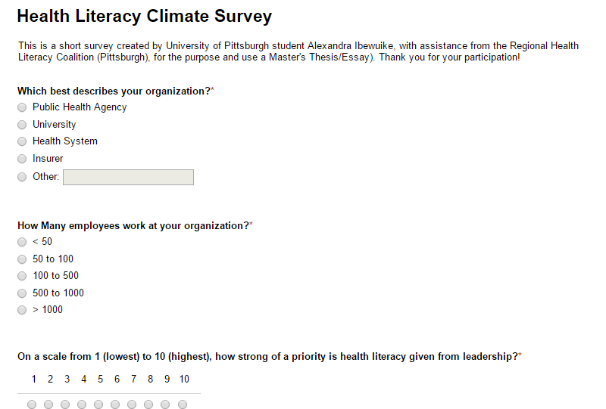
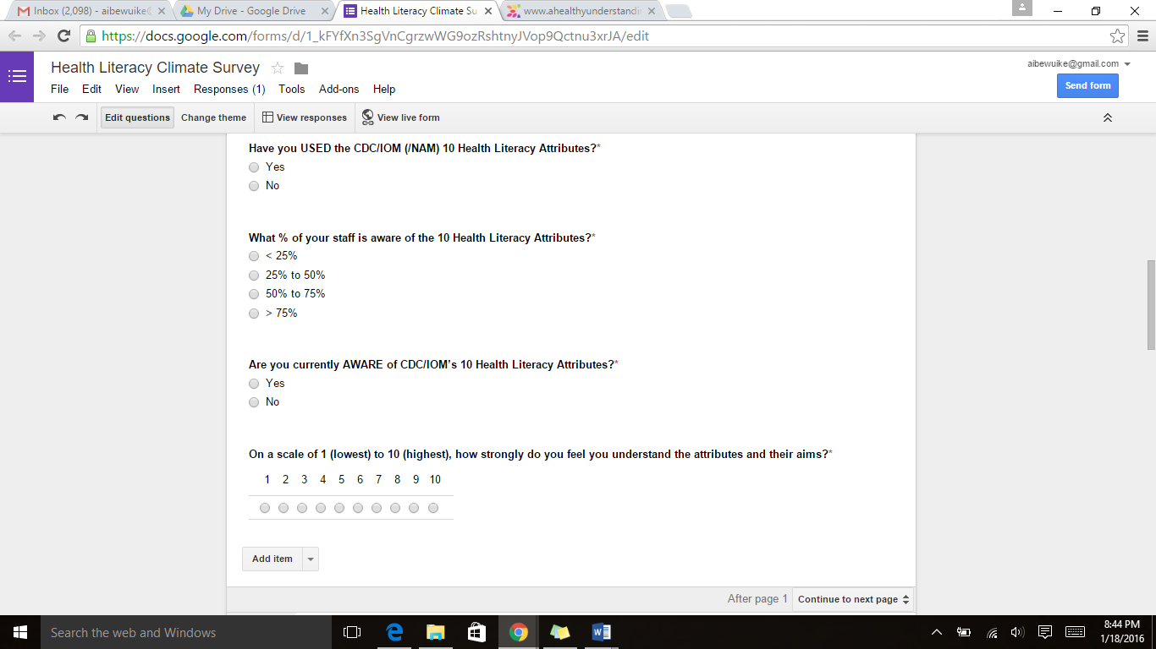
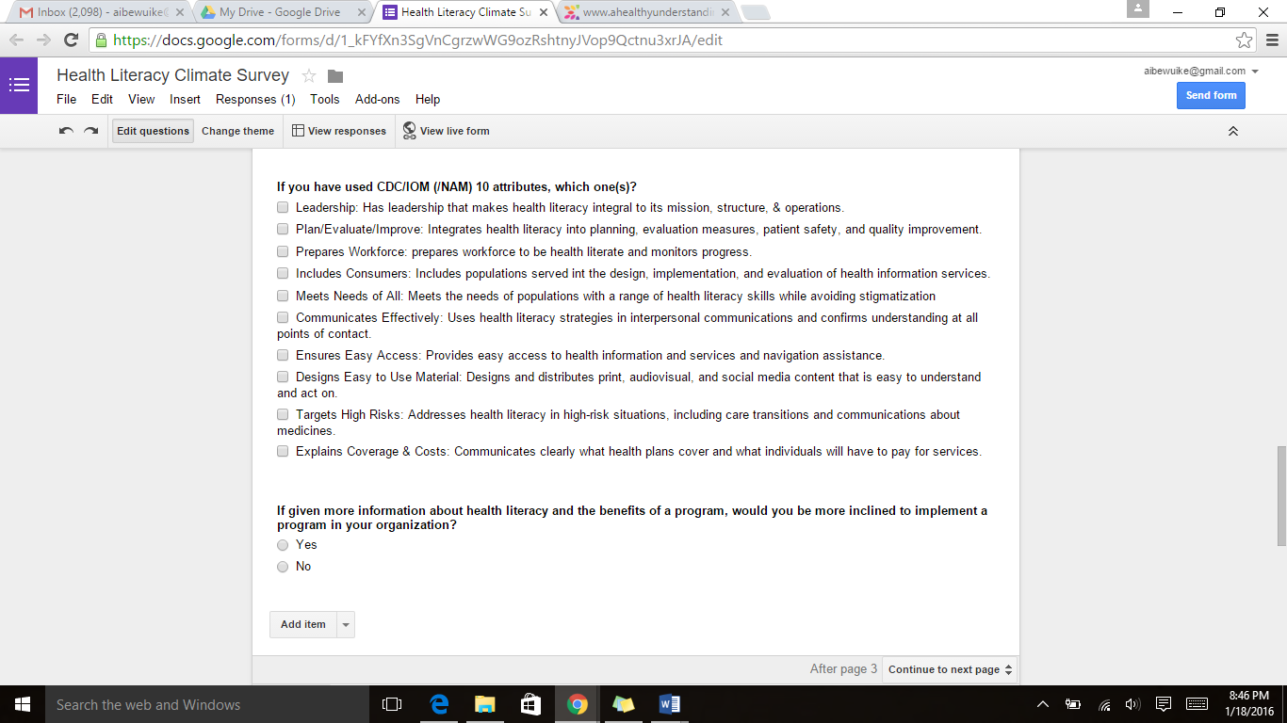
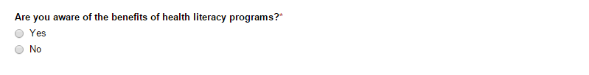
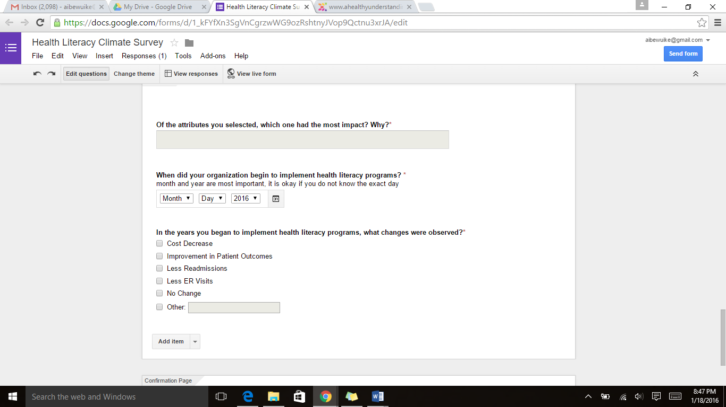
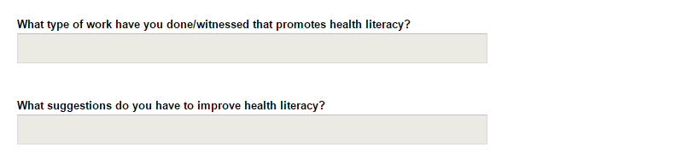

BIBLIOGRAPHY

- Adler, Ben. News Literacy Declines Without Socioeconomic Status. Columbia Journalism Review. (2104). Web. 23 April 2016.

- Alper, Joe. Health Literacy Past, Present, and Future: Workshop Summary. The National Academic Press. 2015. Web. 22 April 2016. <http://www.nap.edu/read/21714/chapter/7>

- Blue Shield of California Foundation Survey. Empowerment and Engagement among Low-Income Californians: Enhancing Patient-Centered Care. 2012 Blue Shield of California Survey. (Sept. 2012).

- Brach, Cindy et al. Ten Attributes of Health Literate Health Care Organization. June 2012. Institute of Medicine. Web. 19 Dec 2015 <http://www.ahealthyunderstanding.org/Portals/0/Documents1/IOM_Ten_Attributes_HL_Paper.pdf>

- Centers for Disease Control and Prevention. Learn About Health Literacy. 30 Sept. 2015. Web. 27 March 2016 <http://www.cdc.gov/healthliteracy/learn/>

- GSW Inventiv Health. Health Literacy Infographic. 2016. Web. 27 March 2016 <http://whatcouldbeday.com/infographics/140613_gsw_healthliteracy_infographic.pdf>

- Haun, Jolie. Association between Health Literacy and Medical Care Costs In an Integrated Healthcare System: A Regional Population Based Study. BMC Health Services. (2015).

Neuhauser, Linda DrPH et al. Participatory Design of Mass Health Communication in Three Languages for Seniors and People with Disabilities on Medicaid. Dec 2009. Web. 19 Dec. 2015 <http://www.ncbi.nlm.nih.gov/pmc/articles/PMC2775764/>

- Quality Improvement for Institutions. The Importance of Early Medication Management to Reducing Readmissions. 2016. Web. 28 March 2106 <http://cvquality.acc.org/~/media/QII/H2H/Getting%20Ready/3%20Med%20Management%20Evidence%20Slides.ashx>

- Regional Health Literacy Coalition. About Us. (2016). Web. (March 2016). <http://www.ahealthyunderstanding.org/about-us>

- Somers, Stephen and Mahadevan, Roopa. Health Literacy Implications of the Affordable Care Act. Centers for Health Care Strategies, Inc. (Nov. 2010).

- The Network for Excellence in Health Innovation. Preventing Hospital Readmissions: A $25 Billion Opportunity. 2015. Web. 27 March 2016 < http://www.nehi.net/bendthecurve/sup/documents/Hospital_Readmissions_Brief.pdf>

- University Center for Social and Urban Research. Health Literacy Survey of the Pittsburgh Metropolitan Statistical Area. Regional Health Literacy Coalition (September 2012).

- U.S. Department of Health and Human Services, Office of Disease Prevention and Health Promotion. (2010). National Action Plan to Improve Health Literacy. Washington, DC: Author. Web. 2016. <http://health.gov/communication/initiatives/health-literacy-action-plan.asp>

- U.S. Department of Health and Human Services, Office of Disease Prevention and Health Promotion. Health Literacy Basics. 2016. Web. 27 March 2016 <http://health.gov/communication/literacy/quickguide/factsbasic.htm>

- Wasson, John M.D., Eric Coleman, M.D MPH. Health Confidence: A Simple, Essential Measure for Patient Engagement and Better Practice. 2014.

