[1]

**CASE STUDY ANALYSIS OF THE CHALLENGES FACED WITH IMPLEMENTATION OF EHR SYSTEM**

by

Aishwarya Mohan

BEng, Anna University, India, 2013

Submitted to the Graduate Faculty of

Health Policy and Management

Graduate School of Public Health in partial fulfillment

of the requirements for the degree of

Master of Health Administration

University of Pittsburgh

2016

**ABSTRACT**

UNIVERSITY OF PITTSBURGH

GRADUATE SCHOOL OF PUBLIC HEALTH

This essay is submitted

by

Aishwarya Mohan

on

April 7, 2016

and approved by

Essay Advisor:

Wesley M Rohrer, PhD ___________________________

Assistant Professor

Vice Chair of Education and Director MHA Program

Health Policy and Management

Graduate School of Public Health

University of Pittsburgh

Essay Readers:

Ann-Margaret Samler ___________________________

Lecturer

Industrial Engineering

Swanson School of Engineering

University of Pittsburgh

Robert Richard Calabrisi, ScD ____________________________

Instructor/Adjunct Faculty

Health Policy and Management

Graduate School of Public Health

University of Pittsburgh

Copyright © by Aishwarya Mohan

2016

Implementation of the electronic health record (EHR) among hospitals has increased substantially within the recent years, but concerns still remain regarding the unique challenges that hospitals face in adopting and achieving meaningful use (MU) of EHRs. EHR implementation initiatives tend to be driven by the promise of enhanced integration and availability of patient information, which can improve efficiency and cost-effectiveness, through changing the physician-patient relationship into a shared care team approach to deal with the rapidly changing environment. The challenges in implementing a system wide EHR system mainly include a range of factors from the organizational and technological standpoint such as organizational structure, human skills, culture, technical infrastructure, financial restraints and synchronization. This essay is a case study analysis of a real time EHR implementation to identify the challenges and increase understanding of the technical and behavioral management difficulties faced. The public health relevance is that successful EHR implementation is a moving target and so having strong individual and organizational commitment, end-user engagement, desire to improve, resources and knowledge will help provide excellent quality of care to patients and in turn improve the community’s overall health status.

Wesley M Rohrer, PhD

**CASE STUDY ANALYSIS OF THE CHALLENGES FACED WITH IMPLEMENTATION OF EHR SYSTEM**

Aishwarya Mohan, MHA

University of Pittsburgh, 2016

TABLE OF CONTENTS

1.0 INtroduction 1

1.1 Organizational Context 2

2.0 Literature Review 5

3.0 Design and Analysis of the case study 9

3.1 Design of CASe Study 9

3.2 Methodology 11

3.3 Data Analysis 12

3.4 Results 13

3.5 Discussion 19

4.0 RECOMMENDATIONS 23

Appendix A : SURVEY 26

Appendix B : PILOT SURVEY 29

Appendix C : SURVEY CHARTS 32

bibliographY 37

list of Figures

Figure 1: Role/Title of the participants 13

Figure 2: Experience working on EHR system VS. working at the practice 14

Figure 3: Number of hours willing to devote for training in learning the new system 15

Figure 4: Acceptance rate to close office to conduct training program 15

Figure 5: Knowledge regarding EHR systems 16

Figure 6: Expectations of the new EHR systems 16

Figure 7: Key stakeholders responsible for successful EHR implementation 17

Figure 8: Improvement in productivity and effectiveness in work using EHR system 17

Figure 9: Use of EHR to accomplish tasks 18

Figure 10: Recommend new EHR system to other providers 19

Figure 11: Patient Relations 32

Figure 12: Complete patient information to provide care 33

Figure 13: EHR has decreased time spent on interacting with patients 34

Figure 14: Disappearing of patient information 34

Figure 15: Useful Format 35

Figure 16: Helpful in monitoring care 35

Figure 17: Adherence to clinical practice guidelines 36

Figure 18: Disruptions in workflow 36

# INtroduction

The American Recovery and Reinvestment Act enacted on February 2009 increased the urgency for EHR implementation. By establishing incentive payments to healthcare professionals including hospitals, and critical access hospitals and Medicare Advantage Organizations, the aim was to promote the adoption and meaningful use of interoperable health information technology and qualified electronic health records. The term qualified electronic health record constitutes to an electronic record of health-related information on an individual with demographics and clinical health information. These incentive payments are part of a broader effort under the HITECH Act to accelerate the adoption of HIT and utilization of qualified EHRs ("EHR Incentive Program," 2013).As more organizations adopt the EHR systems, healthcare professionals will have greater access to complete patient information, allowing faster and accurate care.

The management team must commit to endorse and implement a strategic approach to improve clinical and operational improvements. Implementing information systems in hospitals is challenging because of the complexity of medical data, data entry problems, maintaining security and protecting confidentiality (Berg, 2001). Selecting an EHR system is a major decision entailing a considerable financial investment: management team is usually faced with opposition from the physicians, hospital staff and also the community they serve. This results in delays in planning, design and selection of the appropriate system. In contrast, the lost time could be better used to identify and address the barriers to EHR implementation to position the hospital for long-term success and enhancing patient care. Implementing an EHR is about more than the technology; as it is almost always entails cultural change.

A case study analysis of an organization that had undertaken the EHR implementation will help to better understand more fully the cultural, technological and operational challenges faced. The objective of this essay is to identify, categorize, and analyze the findings in the real time EHR implementation processes in hospitals with emphasis on the behavioral and technical changes among the medical staff that had to adapt to the EHR system. This could contribute to greater insight into the underlying patterns and complex relationships involved in EHR implementation and could identify ways to tackle EHR implementation problems.

## Organizational Context

A case study analysis for the impact on behavioral change due to EHR implementation was performed in an outpatient facility at the University of Pittsburgh Medical Center (UPMC). UPMC is a world-renowned health care provider and insurer for inventing new models of accountable, cost-effective, patient-centered care. As Pennsylvania’s largest nongovernmental employer, with more than 60,000 employees, UPMC is comprised of more than 20 hospitals, 5,100 licensed beds, 500 doctors' offices and outpatient sites (UPMC, 2015). UPMC is closely affiliated with its academic partner, the University of Pittsburgh. As of 2015, UPMC is ranked 13th nationally among the best hospitals by US News & World Report and ranked in 13 of 16 specialty areas, including six specialties for which UPMC placed in the top 10 rankings.

At UPMC, the provider services includes a comprehensive array of tertiary, community, and regional hospitals; specialty service lines, such as transplantation, women's health, behavioral health, pediatrics, UPMC Cancer Centers, and rehabilitation; in-home care and retirement living options; contract services, including pharmacy and clinical laboratories; and nearly 3,400 employed physicians and associated practices. The outpatient facility analyzed is part of Department of Urology under the University of Pittsburgh Physicians Division at UPMC. The facility is located at UPMC Mercy Hospital. The Department of Urology consists of more than 40 physicians, clinical and administrative support staff ("UPMC Urology Services," 2015).

An early adopter of EHR system, UPMC has invested more than $1.5 billion in the past five years in technology to support clinical excellence and administrative efficiency and has committed $100 million in a multi-year effort to develop advanced analytics capabilities across its system (Grafius, 2014). Between 2005 and 2006, UPMC began implementing EHRs in its biggest ambulatory settings, setting a standard for health IT. UPMC has spent five years and more than $1 billion on information technology systems to implement EHR system well ahead of Obamacare. UPMC's early attempts to create a universal EHR system, such as its ambulatory electronic medical records and now the EHR System at UPMC uses a number of different vendors for its medical and IT systems, leaving the integration largely up to the IT staff.

Cerner Core is the EHR system used only at the inpatient side of core hospitals and serves as the only source for nursing documentation, vitals and medication administration times. EpicCare is the EHR system used in the outpatient settings and serves as the only source for outpatient nursing documentation, vitals, diagnoses, etc. UPMC’s EpicCare solution provides varying levels of EHR sophistication and connectivity to meet the needs of both large and small private practices ("UPMC EHR Solutions," 2015). The EHR system has 29,000 users, including more than 5,000 physicians employed by or affiliated with UPMC.

UPMC has acquired Three Rivers Urology, a specialty physicians group with offices uptown and in Wexford. The acquisition took place in 2014 and the practice comprised of 6 board certified physicians, practice manager, physician extenders and staff members. The physicians see patients at offices located in the UPMC Mercy Professional Building and at Wexford Office. The group continues its affiliation with UPMC Passavant Hospital in McCandless. The EHR system used by the physician group was offered by Medent, software development and services company focused on automating medical practices with EHR, Patient Portal and Practice Management system. The transition from current EHR system to UPMC's EHR system outlines the focus of this case study analysis in understanding the impact of the transition in behavioral aspect among staff members and physician extenders.

# Literature Review

Electronic Health Record (EHR) and Electronic Medical Record (EMR) are terms that are often used interchangeably, which can lead to confusion. However, there are distinct differences between the EHR and EMR. EHR is most commonly defined as a repository of patient data stored in a digital format. EHR contains retrospective, current and in some cases prospective information regarding the patient's medical condition. According to CMS, the EHR is defined as an electronic version of a patient’s medical history that is maintained by the provider over time. The EHR may include all of the key administrative clinical data relevant to that person’s care under a particular provider, including demographics, progress notes, problems, medication, vital signs, past medical history, immunizations, laboratory data and radiology reports (Garrett, 2011). An EMR is a digital version of a patient’s chart under the control of a single practice that contains the patient’s medical history, diagnoses and treatments by a particular physician, nurse practitioner, specialist, dentist, surgeon or clinic.

The importance of EHR systems can be better understood when transferring patients between health care providers and facilities, as timely and accurate exchange of patient information can improve the care provided. By providing access to medical information among different providers enables health care professionals from different organizations to work together and offer the appropriate care for the patients. Due to HIPAA and data security reason, information contained in the EHR is securely stored and accessible only to authorized users.

Prior to the introduction of EHR, medical information was stored on paper records, which had many disadvantages such as legibility in handwriting, data ambiguity and incompleteness, fragmentation of data all which made it difficult to view and analyze all clinical information pertinent to patient treatment and health status. In addition, each organization stores its own records, which contain information on their patients’ interactions only with that specific practice which was also considered to impede the continuity and quality of care, since there was no sharing of medical information between providers. The need for efficient tracking and repository of all relevant information is the main driver for investment in EHR systems. By the use of integrated EHR, connecting all participating health providers has been shown to be cost effective and time efficient. The transition to the digital format enables such transfers to occur practically in real-time.

Interoperability is critical to health information exchange which enables the transfer of medical information as needed between various IT systems and EHR system to improve patient care. Implementation of an interoperable health information technology infrastructure such as the EHR system can help improve the quality and efficiency of health care. The electronic data in the EHRs is fed from diverse sources such as pharmacy, laboratory, radiology, transcription, billing, and electronic document management systems. Key characteristics of the EHR system are interoperability and accurate mapping of patient data as EHRs serve as the legal health record containing individually identifiable information describing the healthcare services delivered to a patient. Each patient has an electronic health record that consists of a series of smaller record segments generated and held by individual provider offices such as the primary care provider, surgeon, or gastroenterologist. A special segment of the EHR is designated with privacy protections outlined by the HIPAA Privacy Rule, would contain electronic records associated with behavioral health or substance abuse treatment.

The “meaningful use criteria” of EHRs are defined by the Centre of Medicare & Medicaid Services (CMS) as achieving a set of predefined objectives for eligible professionals and hospitals. The term meaningful use means providers need to show they are using certified EHR technology in ways that can be measured significantly in quality and in quantity. This helps in encouraging patient engagement approaches in their decisions with the care coordination team to improve health outcomes and empower individuals. The robust EHR system maintains privacy and security of patient’s PHI with increased transparency and efficiency in providing quality care. The objectives set for achieving meaningful use evolve in three stages over the next 5 years to quality for CMS Incentive programs (HealthIT.gov, 2014).

In the past, transitioning to electronic health records was prohibitively expensive for organizations and physician practices. Now through the EHR incentive program, Medicare supports and recognizes the benefits of EHRs in providing quality care and improving outcomes. The EHR incentive programs offer eligible physicians incentive payments to implement certified EHRs and demonstrate meaningful use of them. This process compels the management team to be fully cognizant of the requirements and plan to ensure that meaningful use criteria are met.

EHR systems are considered as a promising means to control costs and improve quality, the two crucial challenges in the US Healthcare system. With the rising healthcare spending as a percentage of the nation’s GDP, it is difficult for patients, employers and providers to render appropriate care within reimbursement limits. Findings from *Crossing the Quality Chasm* and *To Err is Human* provide evidence that the quality of health care in the US is far less effective than what patients expect and in comparison to other wealthy nations that spend less per capita with better outcomes. In dealing with the complexity of EHR implementation in hospitals, it is also helpful to know which factors are seen as important in the literature and to capture the existing knowledge on EHR implementation in hospitals.

# Design and Analysis of the case study

## Design of CASe Study

Implementing EHR systems require a significant change in clinical and administrative processes, which has never before been a core competency in health care. The implementation of the EHR system is not merely a technological change, but rather a socio-technical change involving the EHR itself, clinical and support staff across the organization. The health care providers and clinical support staff are the end-users of the EHR system, having them involved from the beginning of implementation avoids future conflicts, and involving them in product selection and implementation should reduce obstacles to implementation and use. The clinical support staff’s inputs along with the processes of an organization have to be taken into consideration to maximize the chance of success during implementation. It is also essential to have positive and realistic expectations from the start of the implementation process to get high acceptance of primary users of the new EHR in later phases.

At the organizational level, several possible obstacles to successful implementation of EMR systems have been identified including poor managerial skills and inflexibility of the interfacing systems. In addition, individual physicians face a number of other obstacles with the fully functional EMR system raising a concern about the acceptance level of EHR among physicians. The clinical support staff is often forced to comply with the physician’s work culture or way of practice and hence the willingness of the medical staff in planning for EHR implementation is essential. Consequently, clinical support staff should be involved early in the process as their responsibilities includes preparing charts, present information to physicians and handle patients over the phone. Hence implementation of a successful EHR system can only be achieved with involvement of the clinical support staff, appointment schedulers, physicians and other healthcare providers.

Emphasis on training in the new EHR systems is essential for complete acceptance and utilization. Often the importance of training is undervalued and failure to implement it effectively pose many challenges to smooth transition during the “go-live” period. The vendors typically suggest that clinical support staffs to spend 6 hours of training and for physicians 4 hours to train, educate and familiarize themselves with how the system works. The EHR system is a complicated environment with many regulations, coding specifications, and documentation that requires sufficient time for proper training. New hires and existing staff should only be granted access to work on the EMR system after successful completion of training. Mandatory training sessions should be regularly conducted to educate the end-users on the changes, improvements and regulations of the EMR system.

Management must realize that successful adoption can only be accomplished through monitoring and managing the involvement and expectations of the end-user. Therefore, it is advisable to elicit the expectations of users in the local situation before the start of an actual implementation. Based on the feedback from end-users, management can anticipate problems and plan interventions, which improve effective involvement and support of end-users during the implementation. In terms of best practice, the organization can conduct a pre and post implementation survey to evaluate the expectations and identify areas for improvement. Hence the focus of this case study is to evaluate the EHR system from the standpoint of behavioral and technical skill level of clinical support staff including patient information coordinators, medical assistants, physician assistants, nurses and appointment schedulers.

## Methodology

Based on literature review and observations, the author created a survey of 25 questions for medical professionals to measure demographic characteristics, professional experience, technical and computer skills, expectations, experience working with EHR systems and perceptions. A pilot survey was developed and circulated at one of the Urology practices to test the effectiveness of the questions. Out of the 7 responses from participants of the survey and through interview, the questions were modified to identify and analyze their skillset and experience working with the EHR system. The pilot survey was also made available as open source and hence few unknown participants from different specialty had completed the survey. From the responses, the author analyzed the differences in implementation of EHR system and its impact from different specialty other than Urology.

The revised survey was launched at another urology practice and the responses were tabulated and reviewed. The survey is designed to measure perceptions of clinical support staff concerning the usefulness and accessibility of the system functionalities based on level of comfort and ease to work on it.

Refer to Appendix A for the survey.

Interviews were conducted with few of the participants in the survey which comprised of medical assistants, patient information coordinators and practice manager. The interview questions were structured in a comparative manner between the existing and new EHR system regarding the technical functionalities, user-friendliness, adaptability, interoperability, robustness and changes in workflow. The interview also included questions regarding the transition in the pre and post implementation of the EHR system, training sessions attended, hands on experience and adaptability speed in every individual based on their basic computer skills and knowledge. The physicians’ involvement in adapting to the new EHR system was also explored to understand their transition rate as opposed to the clinical support staff and if there was a delay in time. The support from the practice manager as they play an active role on helping the team with strategies during the implementation. The manager's understanding of the business uses of the data in the record and identify elements such as demographics, advanced directives, and information used for billing and coding.

## Data Analysis

The responses from the survey and interview were collected and tabulated into charts to understand the composition of responses from the participants. This involved reading and reviewing qualitative and quantitative data to identify emerging patterns. Through this process, general technological challenges emerged as an important area of experience for the practice and identified a range of challenges and workarounds observed with regard to EHR use as it related to delivery of integrated care at the practice. The comparative approach used in the data analysis provided the understanding of how effective the EHR system implementation has been so far and also understand the impact of the changes in the workflow among the participants.

## Results

In order to understand the nature to understand the impact of behavioral change among the employees with the implementation of the EHR system, it is important to know their role and capacity at the practice in order to access their respective responsibilities and work processes.

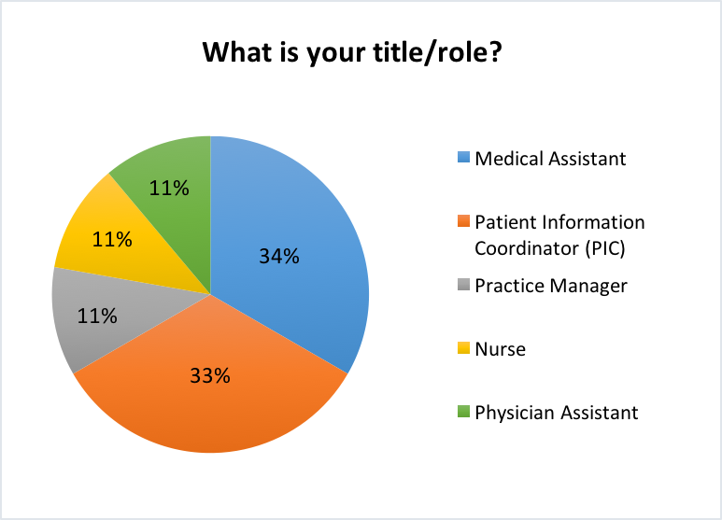

Figure 1: Role/Title of the participants

As shown in Figure 2: Usage of EHR system at practice vs. practice years, most of the participants have been introduced to the EHR system since the beginning of their work at the practice. This shows that the practice had a process in place to train employees on the EHR (existing/new) system before start of work so that they are well acquainted with the system.

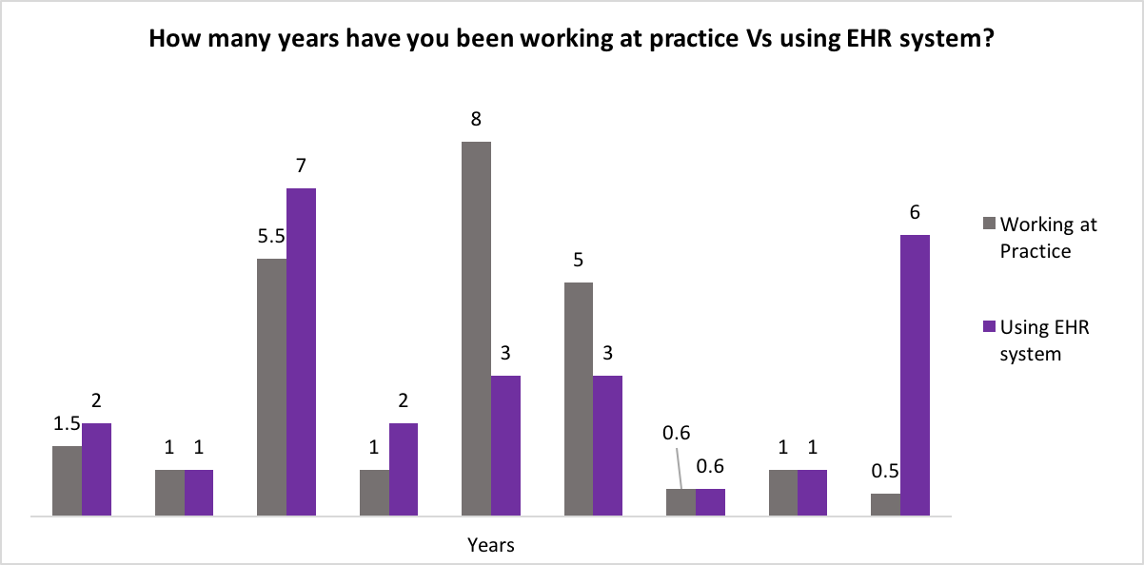

Figure 2: Experience working on EHR system VS. working at the practice

With respect to training hours, the responses were divided between 4-8 hours and as long as required with 45% on each. As training is an essential component to the success of the EHR implement, participants were willing to spend more hours on training sessions.

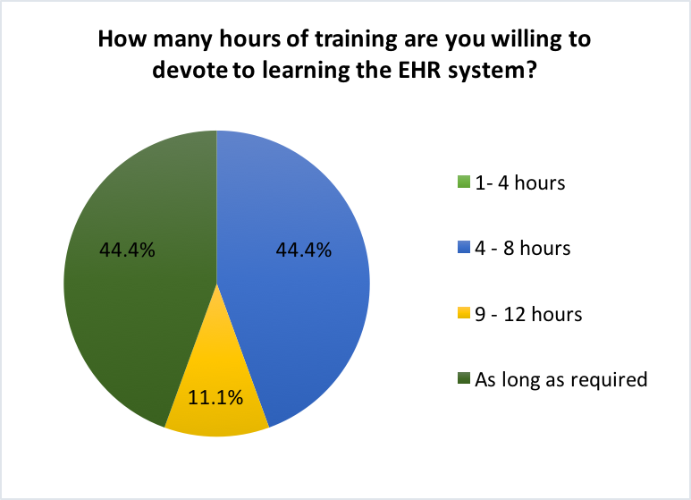

Figure 3: Number of hours willing to devote for training in learning the new system

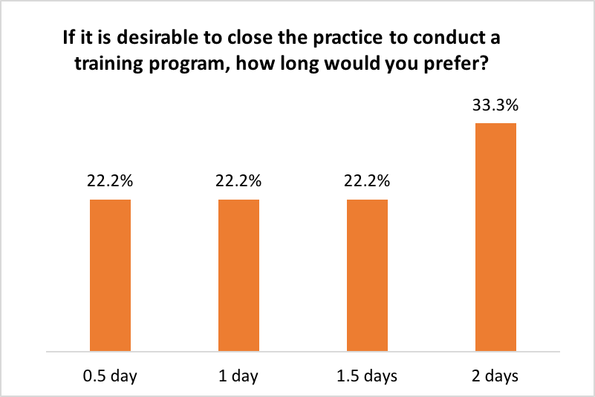

Figure 4: Acceptance rate to close office to conduct training program

Prior to training their knowledge on the EHR system was accessed in order to understand if the training session was the only source employees depended on gaining experience and exposure to the EHR system. This question was tailored to assess the adaptability rate of clinical support staff to learn new systems/skills at workplace.

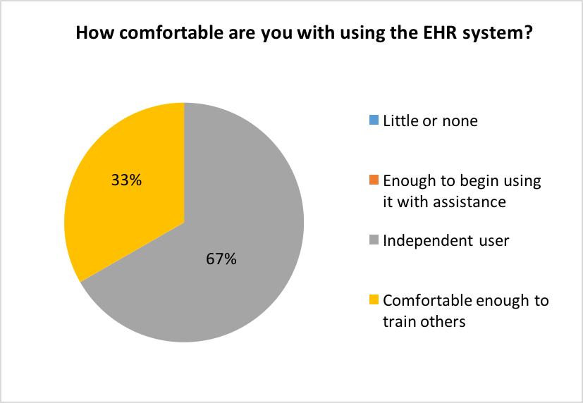

Figure 5: Knowledge regarding EHR systems

Sixty-seven percent of the responses corresponded to the expectation of the EHR system to improve productivity and efficiency once the practice is accustomed to the system over time. In addition to the involvement of the clinical support staff, role of management team/practice manager is crucial for successful implementation in terms of planning, execution and coordinating with the team.

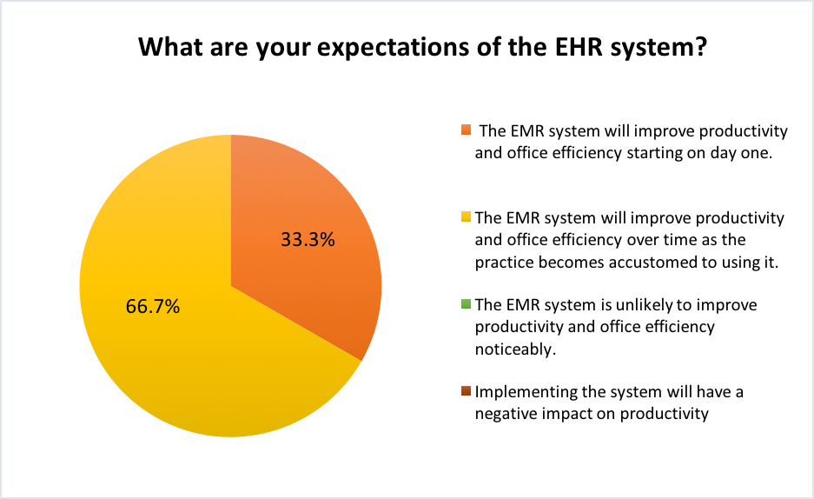

Figure 6: Expectations of the new EHR systems

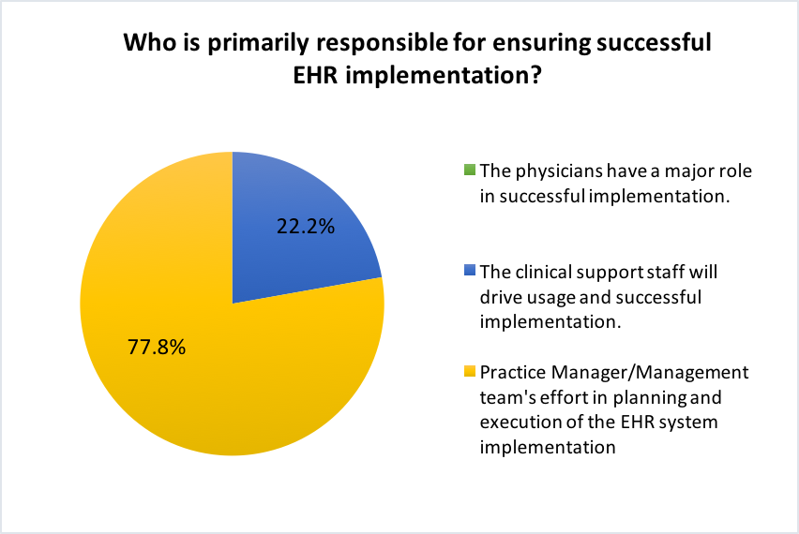

Figure 7: Key stakeholders responsible for successful EHR implementation

In terms of productivity and efficiency level in the participants’ workflow with the EMR system the following responses were collected. The charts represent both the positive and negative impact of using the EHR system in their day-to-day activities at the practice.

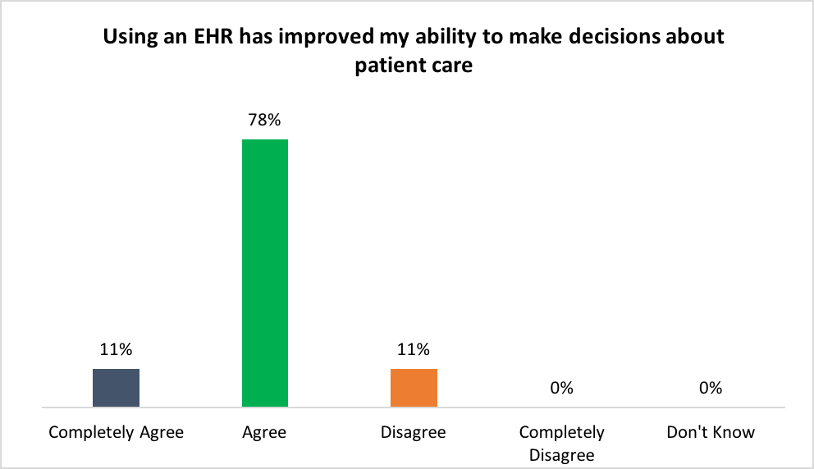

Figure 8: Improvement in productivity and effectiveness in work using EHR system

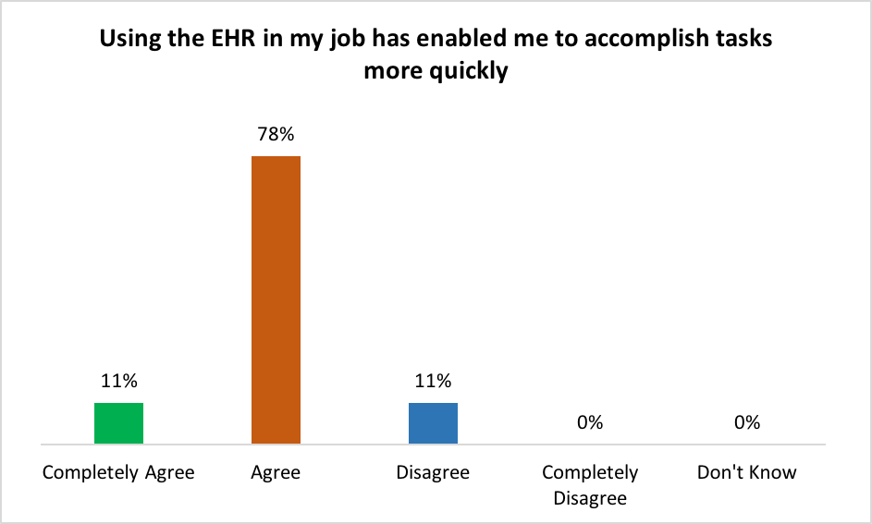

Figure 9: Use of EHR to accomplish tasks

The EHR systems had minimum disruptions and patient information was present in useful format. Customization of screen was an attractive feature available in the new system. Participants were in favor of recommending the new EHR system to other practices looking to adopt EHR systems based on their experience and features.

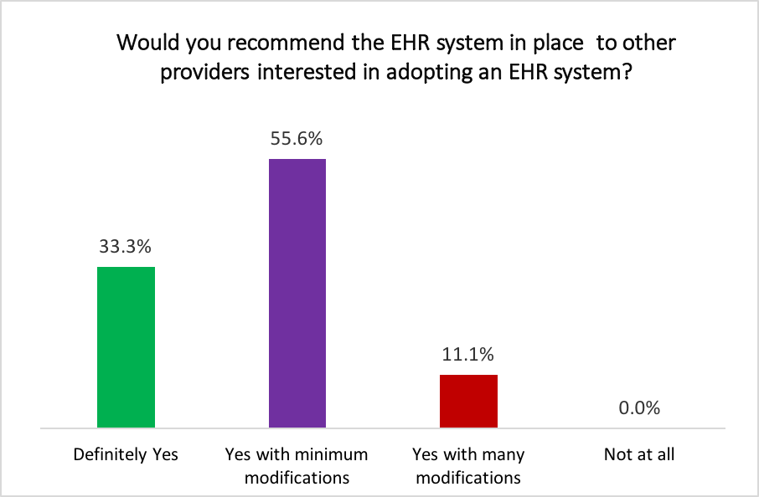

Figure 10: Recommend new EHR system to other providers

## Discussion

Based on the information collected through survey, interview and direct observation from clinical support staff on their EHR-related experiences, the author discusses the challenges, workarounds, and recommendations that emerged as the practice implemented the new EHR system. Three challenges identified were faced during all stages of implementation in integrating the system to the practice. First, patient information transfer from the existing EHR system (Medent) to the new EHR system (EpicCare) was not near to completion. Abstracters from third party vendors were hired to perform patient chart abstracting to expedite the process. Even at this speed, the complete transition did not take place during the go-live period.

Second, clinical support staff were asked to pool in to cover the lag and hence they had to additionally learn how to abstract patient charts. Guidelines were developed and clinical support staff started to work after clinic hours and on weekends. This created stress and frustration among them in addition to learning to the new EHR system. The shortage in personnel to perform patient chart abstracting has led to this challenge and it continues to affect the workflow in clinical support staff and physicians due to incomplete patient information. Third, updating new information in patient records is difficult as the patient data available is not accurate, duplicated and does not contain the most recent patient information. This leads to reliance on patient or physician to recall inaccessible clinical information. These challenges have impacted the workflow in the practice and negatively influenced the expectations of the clinical personnel and staff towards the EHR system.

Other than the challenges, 2 workarounds followed were identified in the practice in response to the challenges described above: 1) duplicate data entry and 2) scanning documents. In order to update patient information efficiently into the new EHR system, the clinical support staff scanned patient records of individuals scheduled for the next 3-4 weeks and abstracted the charts based on priority. This method had proven to be helpful and minimum disruptions within the workflow. But if the patient were scheduled for a follow up in a short time period from his/her first appointment, their records were printed again and abstracted. This causes duplication of patient information in their record and review of the records has not been carried out effectively to eliminate the duplicated entry.

Patient chart abstracting is the process of collecting important information from a patient’s medical record and transcribing that information into discrete fields or locations within the new EHR. Due to the challenges present in transferring the patient information to the new EHR system, all the documents printed out from the exiting patient record has uploaded as one attachment. This presented its own challenges in terms of searching for relevant information from one attachment as opposed to the segregating information into the respective fields of the new EHR system by standard guidelines of patient chart abstracting. Tracking and identifying patient records abstracted as one attachment is difficult and hence it was enforced on abstracters, the clinical support staff who performed abstracting were asked to strictly adhere to the guidelines developed for each document within the patient record. Random checks were made from the patient records abstracted to ensure the process and guidelines were followed properly.

Apart from the challenges and workarounds, the EHR system presents many positive aspects within the practice. The participants were pleased with the new EHR system in comparison to the existing EHR because of the additional features, organized, interoperable, user friendly and professional EHR system implemented within the practice. As the clinical support staff were working on an existing EHR system earlier on, the transition to a new EHR system was much smoother as opposed to employees transitioning from paper based records to EHR systems. The clinical support staff attended training sessions for 12 hours in total ranging over three days with each session covering different features of the EHR system. Demonstration, hands on experience in a simulated environment and materials were provided during the training sessions. Due to the extensive training, the transition was not difficulty and accustoming the system to their workflow and process over time improved their productivity and effectiveness.

The use of new EHR system helped them to accomplish tasks quickly and accurately. The alerts and red flags in the EHR system helped them to ensure continuity of patient care and make decisions as required. Even though majority responded that the success of the implementation was due to the clinical support staff, physician buy in was essential to encourage them to adapt to the new system. The training sessions were tailored uniquely to the activities and workflow for physicians and clinical support staff. The limitations in access to patient records ensured protected health information for the patients were secure and monitored for HIPAA compliance.

A highly organized plan was critical to the successfully implementation of the new EHR system. The combined effort and collaboration of the practice manager, executive administrator of the department, IT team, EHR system team, physicians, clinical support staff were carried out in the planning stages of the implementation. For next steps, the practice is focused on optimization and modifications, as it is a continuous process. During the early stages the practice had to troubleshoot their system and find solutions. To optimize the use of the EHR system, the practice will need to continuously customize and update the system to meet user and patient needs, train staff on an ongoing basis and use the system to meet organizational goals and improve outcomes.

# RECOMMENDATIONS

Typically organizations that successfully implemented EHRs set forth a number of things early on, such as:

* Engage staff at all levels
* Invest in workflow analysis and careful redesign in order to customize and effectively   
  integrate new technology among users
* Design systems for quality improvement and implementation and information exchange
* Allocate resources for ongoing maintenance and technical support of the system, system   
  adjustments, and continual staff training and engagement

Literature suggests, organizations that were able to engage end users and all ancillary personnel during the planning and development stage had more success selecting an EHR system that staff would accept and successfully work with. End users should be engaged from the start by including clinicians on the oversight committee that is responsible for decision-making and implementation progress. Developing strict guidelines and training personnel on the new EHR system and also with patient chart abstracting would help in effective transition with minimal delay or disruptions during the go-live phase of implementation. Anticipation of discrepancies and mitigation plans should be discussed at all stages of the implementation, particularly during the planning phase in order to tackle the expected “unexpected” situations better.

I would like to focus particularly on the importance of investing heavily on upfront training for all staff members to avoid negative impacts on workflow, costly setbacks, and productivity losses. The post-implementation support is often limited and organizations would benefit from a lengthy post “go-live” period in which hands-on support is available. Training best practices include obtaining organizational commitment to invest in training, assessing users' skills and training needs, selecting appropriate training staff, matching training to users' needs, using multiple training approaches, leveraging the skills of role models (clinical leaders, champions, super-users, training coordinators), providing training support throughout the implementation process, and retraining to optimize use of the EHR.

Another aspect I would recommend is to promote the EHR implementation and optimization process, planning and modifications should be continuously monitored to address technological, professional, and organizational perspectives. While optimization is included as a step in the implementation process, one important lesson is that optimization is an ongoing process that needs to be incorporated into each organization’s structure and culture. Optimization of EHR system should be a planned phase of every project implementation and should be seen as a top priority. It creates the perfect opportunity to significantly improve productivity through a detailed assessment of the newly implemented EHR system as it will allow the organization to reveal general issues that if addressed could help in improving physician and clinical support staff EHR satisfaction. By researching best practices and identifying the workflows, it will allow organizations to better position themselves for approaches in the future. In summary, the EHR implementation does not occur in a stepwise fashion with discrete phases, but is rather an ongoing process with overlapping stages that occur simultaneously and involve a wide variety of activities.

* + - * 1. **: SURVEY**

1. What is your title/role?
2. Medical Assistant
3. Patient Information Coordinator
4. Practice Manager
5. Nurse
6. Nurse Practitioner
7. Physician Assistant
8. What is your primary clinical specialty?
9. Specialty - Urology
10. Family Practice
11. General Practice
12. Internal Medicine
13. How many years have you been working at practice?
14. How long (years/months) have you used EHR system?
15. How many patients do you see in a typical day at the practice?
16. How comfortable are you with using the EHR system?
17. Little or none
18. Enough to begin using it with assistance
19. Independent user
20. Comfortable enough to train others
21. What are your expectations of the new EMR system?
22. The EMR system will improve productivity and office efficiency starting on day one
23. The EMR system will improve productivity and office efficiency over time as the practice becomes accustomed to using it.
24. The EMR system is unlikely to improve productivity and office efficiency noticeably
25. Implementing the system will have a negative impact on productivity

1. Please rate your computer skills with working on EHR system.  
   a. Poor  
   b. Adequate  
   c. Excellent
2. How many hours of training are you willing to devote to learning the new system?  
   a. 1- 4  
   b. 5-8  
   c. 9 -16  
   d. As long as required
3. Who is primarily responsible for ensuring successful EHR implementation?
4. The practice’s physicians have a major role in successful implementation.
5. The clinical support staff will drive usage and successful implementation.
6. Practice Manager/Management team's effort in planning and execution of the EHR system implementation
7. If it is desirable to close the practice to conduct a training program, how long would you prefer?
8. 0.5 day
9. 1 day
10. 1.5 days
11. 2 days
12. During implementation, patient volumes were reduced in the initial weeks which results decrease in efficiency. How much impact will this have on patient scheduling and care?
13. No impact
14. Little impact
15. Some impact
16. Significant impact
17. Do you believe the new EMR system will affect patient relations (communication)?  
    a. Yes   
    b. No
18. How do you believe the new EMR system will affect patient care?
19. No impact
20. Little impact
21. Some impact
22. Significant impact
23. Would you recommend the EHR system in place to other providers interested in adopting an EHR system?
24. Definitely Yes
25. Yes with minimum modifications
26. Yes with many modifications
27. Not at al

|  |  |  |  |  |  |
| --- | --- | --- | --- | --- | --- |
|  | Completely Agree | Agree | Disagree | Completely Disagree | Don't Know |
| 16. The EHR provides me with all the information I need to take care of the patient |  |  |  |  |  |
| 17. The information in the EHR is presented in a useful format |  |  |  |  |  |
| 18. The information in the EHR seems to disappear or change unpredictably |  |  |  |  |  |
| 19. Using the EHR in my job has enabled me to accomplish tasks more quickly |  |  |  |  |  |
| 20. Using the EHR has enhanced my effectiveness in my job |  |  |  |  |  |
| 21. Using an EHR has decreased the amount of time I spend talking to my patients |  |  |  |  |  |
| 22. Using an EHR helps me adhere to clinical practice guidelines |  |  |  |  |  |
| 23. Using an EHR has caused disruptions to my work flow |  |  |  |  |  |
| 24. Using an EHR has improved my ability to make decisions about patient care |  |  |  |  |  |
| 25. The EHR has helped me monitor how many of my patients are receiving appropriate care |  |  |  |  |  |

 {Lulejian, 2013 #1}

* + - * 1. **: PILOT SURVEY**

1. How long have you been using an EHR at this practice? ______ months

1. What is your title?
2. MD
3. Nurse Practitioner
4. Physician Assistant
5. Other (please specify): _____________________________

1. What is your primary clinical specialty?
2. General Practice
3. Family Practice
4. Internal Medicine
5. Ob/Gyn
6. Pediatrics
7. Behavioral specialist
8. Other (please specify): _____________________________

1. How many years have you been in practice? ______ years

1. In a typical week, how many patients do you see per day at the practice? ______ patients

1. How much do you know about electronic medical record (EMR) systems?  
   a. Almost nothing  
   b. Somewhat  
   c. A few things  
   d. A great deal

1. What are your expectations of the new EMR system?  
   a. The EMR system will improve productivity and office efficiency starting on day one.  
   b. The EMR system will improve productivity and office efficiency over time as the practice becomes accustomed to using it.  
   c. The EMR system is just a replacement for traditional paper-based patient folders.  
   d. The EMR system is unlikely to improve productivity and office efficiency.
2. Please rate your computer skills.  
   a. Poor  
   b. Adequate  
   c. Excellent

1. How many hours of training are you willing to devote to learning the new system?  
   a. 4  
   b. 8  
   c. 12  
   d. 16 or more
2. What should be the staff’s role in ensuring successful EMR implementation?  
   a. The practice’s physicians have a major role in successful implementation.  
   b. The nurses and staff will drive usage and successful implementation.  
   c. Physicians can use paper charts, and the staff will transfer the patient information to the EMR system.
3. Is it acceptable to close the office to conduct a training program?  
   a. Yes  
   b. No
4. During implementation, to what degree should patient volume be reduced during the initial weeks using the new EMR system?  
   a. Up to 5%   
   b. 5% to 10%  
   c. 10% to 15%  
   d. 15% to 20%
5. Do you believe the new EMR system will affect patient relations (communication)?  
   a. Yes   
   b. No
6. Do you believe the new EMR system will affect patient care?  
   a. Yes  
   b. No

1. Would you recommend your current EHR to other providers interested in adopting an EHR?

|  |  |  |  |  |  |
| --- | --- | --- | --- | --- | --- |
|  | Completely Agree | Agree | Disagree | Completely Disagree | Don't Know |
| 16. The EHR provides me with all the information I need to take care of the patient |  |  |  |  |  |
| 17. The information in the EHR is presented in a useful format |  |  |  |  |  |
| 18. The information in the EHR seems to disappear or change unpredictably |  |  |  |  |  |
| 19. Using the EHR in my job has enabled me to accomplish tasks more quickly |  |  |  |  |  |
| 20. Using the EHR has enhanced my effectiveness in my job |  |  |  |  |  |
| 21. Using an EHR has decreased the amount of time I spend talking to my patients |  |  |  |  |  |
| 22. Using an EHR helps me adhere to clinical practice guidelines |  |  |  |  |  |
| 23. Using an EHR has caused disruptions to my work flow |  |  |  |  |  |
| 24. Using an EHR has improved my ability to make decisions about patient care |  |  |  |  |  |
| 25. The EHR has helped me monitor how many of my patients are receiving appropriate care |  |  |  |  |  |

{Lulejian, 2013 #1}

* + - * 1. **: SURVEY CHARTS**

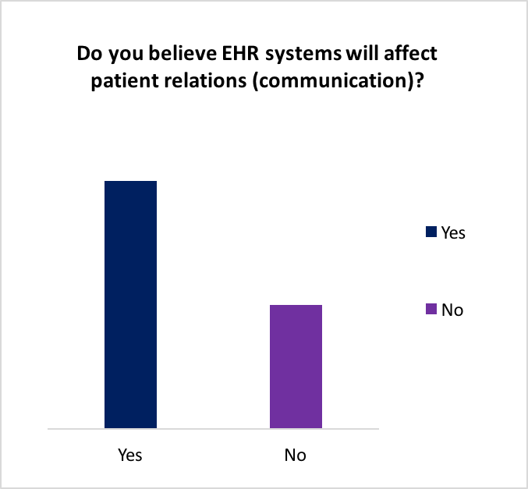

Figure 11: Patient Relations

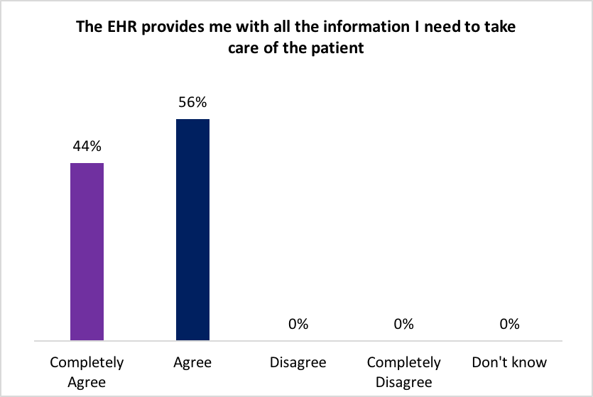

Figure 12: Complete patient information to provide care

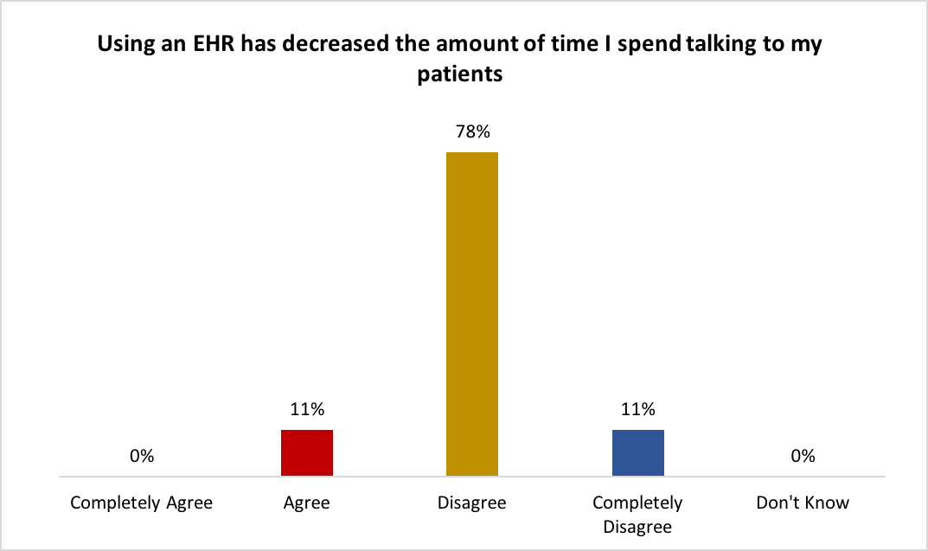

Figure 13: EHR has decreased time spent on interacting with patients

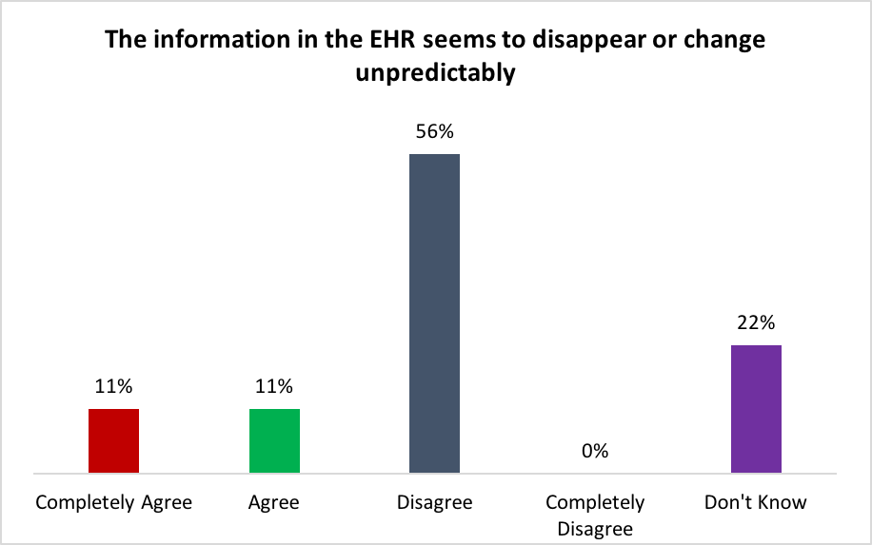

Figure 14: Disappearing of patient information

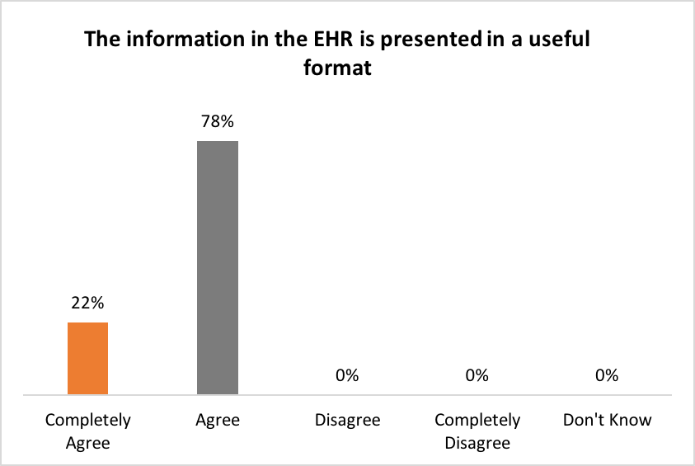

Figure 15: Useful Format

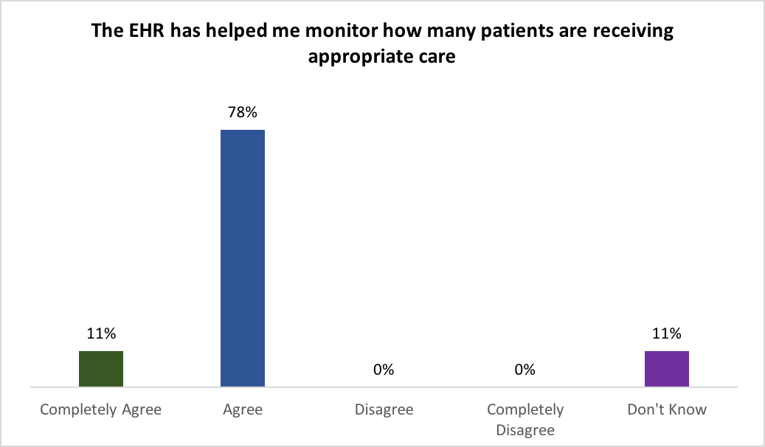

Figure 16: Helpful in monitoring care

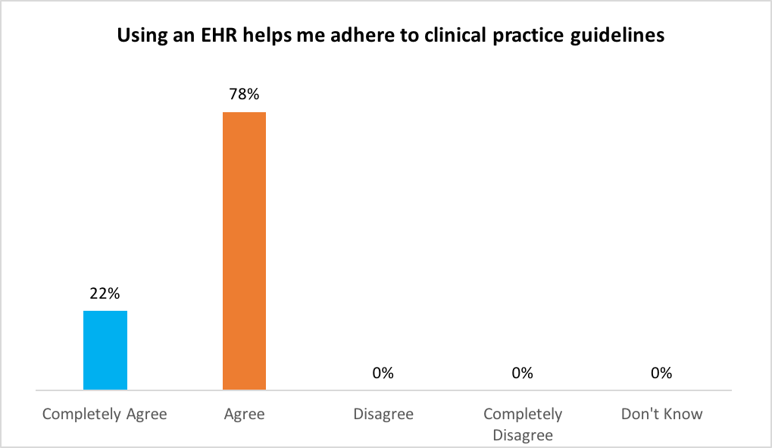

Figure 17: Adherence to clinical practice guidelines

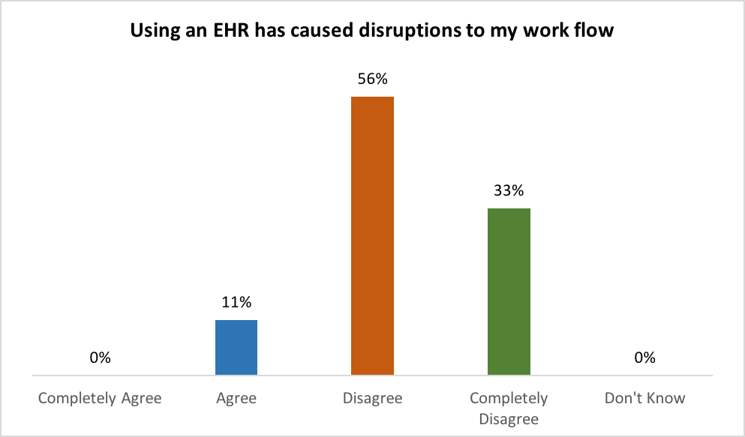

Figure 18: Disruptions in workflow

# bibliographY

Berg, M. (2001). Implementing information systems in health care organizations: myths and challenges. *Int J Med Inform, 64*(2-3), 143-156.

EHR Incentive Program. (2013). from https://[www.healthit.gov/providers-professionals/ehr-incentive-programs](http://www.healthit.gov/providers-professionals/ehr-incentive-programs)

Garrett, P. (2011). EMR vs EHR - What is the Difference?

Grafius, W. (2014). UPMC's ‘Convergence' Recognized For Improving EHR Access. from <http://www.healthitoutcomes.com/doc/upmc-s-convergence-recognized-for-improving-ehr-access-0001>

HealthIT.gov. (2014, April 4, 2014). EHR Incentives & Certification. from https://[www.healthit.gov/providers-professionals/ehr-incentives-certification](http://www.healthit.gov/providers-professionals/ehr-incentives-certification)

UPMC. (2015). UPMC Facts. from <http://www.upmc.com/about/why-upmc/pages/default.aspx>

UPMC EHR Solutions. (2015). from <http://www.upmc.com/healthcare-professionals/physicians/practice-solutions/ehr/Pages/default.aspx>

UPMC Urology Services. (2015). from <http://www.upmc.com/Services/urology/Pages/default.aspx>

1.