**PREFRONTAL CORTEX ACTIVATION DURING DUAL TASK CONDITIONS IN OLDER AND YOUNGER ADULTS**

by

**Joshua Leon Paley**

BS, Binghamton University, State University of New York, 2016

Submitted to the Graduate Faculty of

the Department of Epidemiology

Graduate School of Public Health in partial fulfillment

of the requirements for the degree of

Master of Public Health

University of Pittsburgh

2016

UNIVERSITY OF PITTSBURGH

GRADUATE SCHOOL OF PUBLIC HEALTH

This essay is submitted

by

Joshua Leon Paley

on

April 28, 2016

and approved by

Essay Advisor:

Nancy W. Glynn, Ph.D. ______________________________________

Assistant Professor

Department of Epidemiology

Graduate School of Public Health

University of Pittsburgh

Essay Reader:

Andrea Rosso, Ph.D., MPH ______________________________________

Assistant Professor

Department of Epidemiology

Graduate School of Public Health

University of Pittsburgh

Essay Reader:

Howard Aizenstein, M.D., Ph.D. ______________________________________

Professor of Psychiatry, Associate Professor of Bioengineering and

Clinical and Translational Science

Department Psychiatry and Department of Bioengineering

School of Medicine and Swanson School of Engineering

University of Pittsburgh

Copyright © by Joshua L. Paley

2016

Nancy W. Glynn, Ph.D.

**PREFRONTAL CORTEX ACTIVATION DURING DUAL TASK CONDITIONS IN OLDER AND YOUNGER ADULTS**

Joshua Leon Paley, MPH

University of Pittsburgh, 2016

**ABSTRACT**

Mobility limitations in the elderly are associated with morbidities and premature death. Although the effects of age-related changes in brain structure on gait are well described, little is known about age related functional changes. The prefrontal cortex (PFC) contributes to attention, planning and complex gait tasks. We compared the PFC activation while performing simultaneous tasks (dual tasks) in young and old adults. We hypothesized that older adults have greater activation of the PFC under dual-task conditions. Healthy younger (n=15, 18-41 years) and older (n=15, 65-76 years) adults were matched on education and gender. Participants walked on an instrumented treadmill at a self-selected pace with a 0% slope while subtracting from predetermined three digit numbers by seven (Serial7). PFC activation was measured by near infrared spectroscopy and estimated by general linear models. T-tests compared Serial7 scores and PFC activation between groups. Analyses showed that older adults did not walk slower (p=0.13), and performed as well on the serial7 task (p=0.15) as the younger adults. There was a greater activation (for HbO2 t=4.1, p<0.001) of the left dorsolateral PFC in older compared to younger adults. This study demonstrated that older adults show greater activation of the PFC while performing a difficult dual task compared to young adults suggesting increased reliance on attention for motor control. This research has public health significance, as it could lead to the development of brain based interventions to improve mobility performance in older adults and therefore overall health.

**TABLE OF CONTENTS**

1. **INTRODUCTION……………………………………………………………………. 1**
   1. **MOBILITY………………………………………………………………………. 2**
      1. **Mobility Disability and the Consequences……………………………….. 2**
      2. **Risk Factors of Mobility Limitation……………………………............... 3**
      3. **Gait Variability…………………................................................................ 3**
   2. **NEUROLOGICAL DIFFERENCES BETWEEN OLD AND YOUNG…...... 4**
      1. **Cognition........................................................................................................ 4**
      2. **Executive Function………………………………………………………… 5 4**
         1. **Attention…………………..................................................................5**
         2. **Working Memory………………………...........................................6**
   3. **BRAIN ANATOMY AND PHYSIOLOGY………………………….................8**
      1. **Grey Matter…………………………………...............................................8**
      2. **White Matter…………………………………………….............................8**
      3. **Biochemical Dopaminergic Effects……………………………………….. 9**
   4. **BRAIN FUNCTION……………………………………………………………. 10**
      1. **Dedifferentiation Theory…………………………………………………. 10**
      2. **Neural Efficiency Theory………………………………………………... 11**
      3. **Compensation Theory……………………………………………………. 11**
   5. **NEUROIMAGING INSTRUMENTATION…………………………………. 12**
      1. **Magnetic Resonance Imaging……………………………………………. 12**
      2. **T2-Weighted Fluid Attenuated Inversion Recovery………..………….. 13**
      3. **Diffusion Tensor Imaging ……………………………………………….. 14**
      4. **Functional Near-Infrared Spectroscopy………………………………... 14**
   6. **GAIT AND COGNITION……………………………………………………... 16**
      1. **Dual Task Paradigm……………………………………………………... 16**
      2. **Gait and Cognition Interplay……………………………………………. 17**
      3. **Summary of Previous fNIRS Research…………………………………. 17**
         1. **Gap in Knowledge………………………………………………… 22**
   7. **PUBLIC HEALTH SIGNIFICANCE …..…………………………………… 22**
2. **OBJECTIVES……………………………………………………………………….. 23**
3. **METHODS…………………………………………………………………………... 23**
   1. **RERUITMENT………………………………………………………………… 23**
   2. **PROCEDURES………………………………………………………………… 26**
   3. **ASSESSMENT OF THE PFC……………………….………………………... 27**
   4. **ASSESSMENT OF GAIT……………………………………………………… 29**
   5. **PROCESSING AND ANALYSIS OF THE fNIRS GAIT DATA…………… 29**
4. **RESULTS……………………………………………………………………………. 30**
5. **DISCUSSION………………………………………………………………………... 38**

**BIBLIOGRPAHY…………………………………………………………………… 41**

List of tables

Table 1. fNIRS Studies Utilizing Dual Task Paradigms in Older and Younger Adults………... 20

Table 2. Sample Demographics………………………………………………………………… 30

Table 3. Performance on Complex Serial7 Task and Gait Speed………………………………. 31

Table 4. HbO2 Concentration during Serial 7 Single Task Condition in Old verse Young…… 35

Table 5. HbO2 Concentration during Serial7 Dual Task Condition in Old verse Young………. 35

Table 6: HbO2 Concentration during Serial7 Dual Task Compared to Single Task in Old…….. 36

Table 7: HbO2 Concentration during Serial 7 Dual Task Compared to Single Task in Young… 36

List of figures

Figure 1. Recruitment Schematic………………………………………………………………... 25

Figure 2. Task Paradigm………………………………………………………………………… 26

Figure 3. fNIRS Machine and Cap………………………………………………………………. 27

Figure 4.fNIRS Channels……………………………………………………………………….. 28

Figure 5. Counting Single or Dual Task in Older and Younger Participants…………………… 33

Figure 6. Serial7 Single or Dual Task in Older and Younger Participants……………………… 34

Figure 7. Comparison between Complex Single Task and Dual Task Within and Between Age

Groups…………………………………………………………………………………………… 37

**1.0 INTRODUCTION**

As a result of the baby boomer generation and increased longevity, the number of older adults (aged 65 and older) has increased significantly. By 2030, one in five Americans will be age 65 years or older, which is approximately 70 million people (Lang et al., 2006). Consequently, the challenge for public health officials will be to develop more efficient strategies and effective policies to promote quality health and well-being by preventing unnecessary disease among older adults. In turn, the establishment for what the Centers for Disease Control and Prevention’s Healthy Aging Research Network considers “healthy aging”, defined as the “developmental and maintenance of optimal physical, mental and social well-being and function in older adults”, (Lang et al., 2006; Satariano et al., 2012) is essential. The reduction in the rate of motor decline is one component of this healthy aging concept. Decrements occur in sensorimotor function that vastly affect older adults ability to maintain and sustain their independence (Seidler et al., 2010). At one time, gait had been considered to be a relatively simple function; however, contemporary research has shown that gait is a multifactorial behavior engaging numerous other systems, including the central nervous, peripheral nervous, musculoskeletal, and circulatory systems. Therefore, there are numerous factors contributing to the decline in mobility with age.

With advancing neuroimaging techniques, researchers have started to explore the impact of age-related brain differences on mobility. The purpose of this paper is twofold. First is to provide a comprehensive review of age-related mobility changes and the impact on mobility of age-related changes in brain function, structure and biochemistry. The paper will review the relationship between cognitive function and gait and the neuroimaging modalities that led to our current state of knowledge, and summarize current research utilizing a novel neuroimaging technique. The second part of this paper is an experimental study that examines the relationship between gait and cognitive function in old and young adults in a complex multitasking scenario.

* 1. **MOBILITY**

Mobility is critical for the healthy everyday living and well-being of older adult populations. Mobility is described as an individual’s ability to meet and adapt to the challenges of the environment, given their capabilities of moving within and between environments (Marko, Neville, Prince, & Ploutz-Snyder, 2012; Prohaska, Anderson, Hooker, Hughes, & Belza, 2011). Mobility can be assessed in terms of “life space”, defined as the distance a person can travel away from their home (Parker, Baker, & Allman, 2002; Peel et al., 2005). The impairment of mobility is associated with negative health outcomes such as falling, resulting in injuries and even death(Hausdorff, Rios, & Edelberg, 2001). In 2004, approximately 15.4 million Medicare beneficiaries with limited mobility accrued over $42 billion in additional health care burdens and over $2 million in hospitalizations (Hardy, Kang, Studenski, & Degenholtz, 2011). Therefore, public health preventative intervention efforts that promote “optimal mobility”, which describes the ability to freely transverse the environment (Satariano et al., 2012), are essential for a healthy aging population.

**1.1.1 Mobility Disability and its Consequences**

Mobility disability is the inability of an individual’s physical capability to move through environmental challenges such as walking up and down stairs or walking on uneven surfaces (C. J. Brown & Flood, 2013; Marko et al., 2012). Mobility disability can range in severity from preclinical to severe; for example, limitations in only difficult environmental challenges to complete loss of independence in bedbound individuals (Rivera, Fried, Weiss, & Simonsick, 2008; Wolinsky, Miller, Andresen, Malmstrom, & Miller, 2005). These motor limitations that occur in older adults include impaired coordination, increased variability of movement, slowing of movement and difficulties with gait and balance in comparison to younger adults (Rubenstein & Josephson, 2002). Mobility limitations are common among older adults as indicated by 31.7% self-reporting difficulty walking three city blocks.(Control & Prevention, 2009). The consequences for mobility limitations are substantial, affecting all aspects of life, including the physical, psychological and social components (C. J. Brown & Flood, 2013; Groessl et al., 2007; James, Boyle, Buchman, & Bennett, 2011). More specifically, mobility limitations reduce an individual’s access to goods and services, and lead to sedentary behavior which is associated with poor health outcomes; for example, obesity and cardiovascular disease, and social isolation (Satariano et al., 2012).

**1.1.2 Risk Factors for Mobility Limitation**

There are numerous risk factors that have been investigated in relation to reduced mobility. Studies have examined the association between poor mobility outcomes and the following risk factors: age, low physical activity, increased body mass index, decreased strength and balance, and diseases such as diabetes (Al Snih et al., 2005; Gill, Gahbauer, Murphy, Han, & Allore, 2012; Koster et al., 2008; Koster et al., 2007). Other researchers have found an association with age-related cognitive decline and poor gait(Atkinson et al., 2007).

**1.1.3 Gait Variability**

As previously mentioned, gait is influenced by different components from the central nervous, musculoskeletal and other physiological systems (Schaefer, Brach, Perera, & Sejdić, 2014). In healthy individuals, stability in walking is maintained by the cohesive interaction of all the locomotor components(Schaefer et al., 2014). However, gait patterns eventually change with age. Gait variability, defined as the fluctuation in spatiotemporal characteristics between steps, is an indicator for gait deficits(Balasubramanian, Clark, & Gouelle, 2015; Hausdorff, 2005). These changes are seen in correlates of gait pattern, which includes the decrease of swing time, swing time variability, stride time variability and walking speed, and an increase of cadence, step length and stride time(Mills & Barrett, 2001; Schrager, Kelly, Price, Ferrucci, & Shumway-Cook, 2008).The majority of literature reports a change variability in older adults that are related to mobility deficits(Balasubramanian et al., 2015; Brach, Berlin, VanSwearingen, Newman, & Studenski, 2005; Hausdorff, 2005). This paper will focus on the gait correlate stride time (gait cycle). Stride time is defined as the time elapsed between the initial contact of the first foot to the subsequent contact of the same foot (Hausdorff et al., 2001). In healthy young adults, stride variability is not typically susceptible to random fluctuations or acute influences. Fluctuations in stride are statistically correlated with the variations of previous strides. This suggests that stride variability is intrinsic to a healthy locomotor system; these fluctuations will remain regardless of walking speed (Hausdorff et al., 1997). However, aging can have significant effects on physiological functional outcomes such as gait. The common consequence of age-related gait variability is increased stride time (Hausdorff et al., 2001; Schaefer et al., 2014).

**1.2 NEUROLOGICAL DIFFERENCES BETWEEN OLD AND YOUNG**

**1.2.1 Cognition**

Cognition has been broken down into domains. Some of these domains include memory, attention, visuospatial functioning, language and executive function. Although these domains were created to categorize separate aspects of cognition, individual activities usually entail the use of multiple domains. Executive function is multifaceted, encompassing functions that typically deal with the execution of a particular task. Furthermore, members of the neurologic scientific community express their understanding of executive function a bit differently, resulting in a variety of answers to the question “what is executive function?” For example neurologists consider executive function to be “*a variety of loosely related higher-order cognitive processes including initiation, planning, hypothesis generation, cognitive flexibility, decision making, regulation, judgment, feedback utilization, and self-perception that are necessary for effective and contextually appropriate behavior*”(Spreen & Strauss, 1998). A psychometric view states that executive function is "*an umbrella term comprising a wide range of cognitive processes and behavioral competencies which include verbal reasoning, problem solving, planning, sequencing, the ability to sustain attention, resistance to interference, utilization of feedback, multitasking, cognitive flexibility, and the ability to deal with novelty*" (Chan, Shum, Toulopoulou, & Chen, 2008; Yuan & Raz, 2014). The greatest commonality among the various definitions is that executive function is a multifaceted cognitive phenomena. Simply put, executive function is a higher order cognitive paradigm involved in self-regulation of “goal-directed behavior” and “effective organization” of information (Hayden & Welsh-Bohmer, 2012).

**1.2.2 Executive Function**

Executive function is associated with both functional and structural characteristics of the prefrontal cortex (PFC). The PFC is the primary region for executive performance. A caveat is that no one region of the brain alone is responsible for doing a single task. It is the harmonious and cohesive activation of different regions that allow for fluid performance. Executive function has also been found to be associated with the parietal and other regions of the brain. With that said, this paper will primarily focus on PFC, as this is the region of interest for our study. The structure of the frontal lobes is important for the quality of function. The volume of the PFC is correlated with the performance on tests of executive function. A larger PFC in healthy adults, specifically the lateral regions, is correlated with better executive outcomes (Yuan & Raz, 2014). However, during the normal aging process, the structure of the brain typically changes. The atrophying of the brain does not occur uniformly across regions (Drag and Bieliauskas). The frontal cortex has been shown to be more structurally affected during aging as compared with other regions of the brain(Drag & Bieliauskas, 2010). This is significant because the PFC volume partially explains the variability in executive function performance (Elderkin-Thompson, Ballmaier, Hellemann, Pham, & Kumar, 2008). This suggests that PFC integrity is a mediator for age related executive performance (Drag & Bieliauskas, 2010). It has been illustrated that various executive performance tasks were associated with various structures of the PFC (Raz, Gunning-Dixon, Head, Dupuis, & Acker, 1998), illustrating that the PFC is a heterogeneous structure (Hayden & Welsh-Bohmer, 2012). This paper will focus on attention and working memory which are components of executive function.

**1.2.2.1 Attention**

Attention is a complex cognitive domain of limited capacity that processes information from the environment (Niogi, Mukherjee, Ghajar, & McCandliss, 2010; Woollacott & Shumway-Cook, 2002; Yogev-Seligmann, Hausdorff, & Giladi, 2008). Functionally, it is the cooperation between multiple processes invested in attending to stimuli and determining the correct response (Yogev-Seligmann et al., 2008). A brief overview of the cognitive psychology definition of attention is ideal to understand the relationship between the function of attention and anatomical structure in order to interpret their changes.

Posner et al pioneered and vastly influenced how psychology approaches the domain of attention by categorizing it into three subgroups: orienting, alerting, and executive attention (Niogi et al., 2010; Posner & Petersen, 1990). Comparable to other cortical functions, each unique attentional network is contingent on multiple cortical regions, cortical thickness and white matter fiber tracts to optimally operate (Fan, McCandliss, Fossella, Flombaum, & Posner, 2005; Niogi et al., 2010; Posner, Sheese, Odludas, & Tang, 2006; Westlye, Grydeland, Walhovd, & Fjell, 2011). Although all three domains are essential for attention, executive attention will be the primary focus within this paper. Executive attention involves the detection and mediation of conflicting stimuli between brain regions (Mahoney, Verghese, Goldin, Lipton, & Holtzer, 2010; Niogi et al., 2010; Posner & Petersen, 1990). It is associated with activity in the anterior cingulate cortex, medial frontal cortex, lateral prefrontal cortex and dopaminergic networks (Bush, Luu, & Posner, 2000; Callejas, Lupianez, Funes, & Tudela, 2005; Fan et al., 2005; MacDonald, Cohen, Stenger, & Carter, 2000; Niogi et al., 2010; Posner et al., 2006) As previously mentioned, executive function relies heavily on the PFC. Additionally, dopamine plays an integral part with the function of the PFC. Therefore, it is reasonable to hypothesize that executive attention and executive function are closely intermingled.

**1.2.2.2 Working Memory**

Grasping what working memory is, the structures involved, and how it was employed in this study is integral to comprehending the collective results. Working memory refers to higher order cognitive functions including reasoning, planning and problem solving, which allows us to maintain, monitor and manipulate information in the short term (Barbey, Koenigs, & Grafman, 2013; Duncan et al., 2000; Goel & Grafman, 1995; Muller, Machado, & Knight, 2002; Prabhakaran, Rypma, & Gabrieli, 2001; Rypma, Berger, & D'Esposito, 2002). Working memory involves information processing and is attentionally demanding. An example of working memory is the ability to manipulate numbers. This paper will primarily focus on the association between the lateral regions of the PFC and working memory. The lateral PFC consists of three subregions that differ in anatomical connectivity and cytoarchitecture (Petrides, Tomaiuolo, Yeterian, & Pandya, 2012). These subdivisions include: ventromedial, dorsolateral and ventrolateral regions (Muller et al., 2002). Consequently, it has been speculated that different regions of the lateral PFC have different mechanisms for working memory (Rypma et al., 2002). The domain-general model suggests that the lateral PFC is functionally organized according to the type of working memory operations engaged. This model posits that the dorsolateral PFC (dlPFC) is responsible for the computational mechanisms for monitory and manipulating information (Barbey et al., 2013; Duncan et al., 2000; Miller & Cohen, 2001; Muller et al., 2002; Owen, Evans, & Petrides, 1996; Petrides et al., 2012; Rypma et al., 2002). Comparatively, the domain-specific models stipulate that the lateral PFC is functionally organized in relation to the domain of information being processed. The domain-specific advocates posit that the function of the dlPFC is specialized for visuospatial information in working memory (Barbey et al., 2013). It is important to recognize that there are different components that are congruent to working memory and that each component of working memory may be tested differently.

The results of the study by Barbey et al who recruited participants that suffered brain damage from penetrating head injuries, suggests that the dlPFC is important for manipulating representations in working memory and reasoning, which is consistent with domain-general models of processing. Interestingly, they found that there was a difference between the left and right hemispheres for the dorsolateral prefrontal cortices; the left dlPFC being necessary for the manipulation of verbal and spatial knowledge and the right dlPFC being responsible for the employed test of verbal and spatial reasoning. Simply put, the left is responsible for tasks such as, letter-number sequencing and spatial span backwards, while the right is significantly activated for arithmetic and matric reasoning tasks (Barbey et al., 2013).

As previously noted, the integrity of the structure of the PFC has implications on the integrity of the function. Not one region of the brain is responsible for the cohesive and fluid articulation of performing different tasks. This targeted fluidity of performance is dependent upon the integrity of white matter fiber tracks that mobilizes information across neural systems. For example, voxel based lesion studies have shown the importance of interregional communication provided by white matter fiber tracts, which subserve the integration and symbiosis of working memory with other cognitive processes (Barbey et al., 2012; Barbey et al., 2013; Glascher et al., 2010; Jung & Haier, 2007).

**1.3 BRAIN ANATOMY AND PHYSIOLOGY**

**1.3.1 Grey Matter**

The occurrence of cerebral volume loss is the result of reduced neuronal complexity and loss of connections (Borghesani et al., 2013). As to why this occurs, it is essential to understand the temporal changes of grey and white matter. The grey matter of the brain is composed of the neuronal cell bodies. Grey matter volume declines after the age of 20 most prominently in the PFC (Terry & Katzman, 2001). The grey matter volume loss may be a result of the death of the neurons themselves, which are not replaced due to the infrequency of cell division (C. N. Harada, Natelson Love, & Triebel, 2013). Furthermore, the grey matter volume decline may be explained not only by cell death, but by the decrease is neuronal size and the decrease in synaptic density (Raz et al., 1998; Terry & Katzman, 2001). In a normal aging process, the neurons undergo morphologic changes that contribute directly to decreased synaptic density. The morphologic changes are described as fewer complex dendrite arborization, shorter dendrite length and decreased neuritic spines (Dickstein et al., 2007; C. N. Harada et al., 2013).

**1.3.2 White Matter**

White matter is composed of nerve fibers and myelin. It has different functions which include forming the connection between nerve cells, insulating the axon and accelerating electrical impulse conduction. Coordination of the cortical activity, both local and global, relies on the cortical connections that are comprised from white matter. It has been shown that white matter integrity is vital for normal cognitive function. Additionally, the loss of this integrity is a contributor to age-related cognitive decline (Bartzokis et al., 2003). The reduction in volume may be a result of deterioration of the myelin sheath, typically occurring around the age of 40 years. Similar to grey matter the frontal lobes are prominently affected; specifically the PFC. It is speculated that the later development of myelination of this region is the reason for the magnitude of degeneration. Additionally, the PFC is greatly susceptible to white matter hyperintensities (Tullberg et al., 2004) (Bartzokis et al., 2003) (Peters, 2006) which are indicative of damage to the white matter integrity. White matter integrity is associated not only with cognitive changes, but also with gait (Peters, 2006).

**1.3.3 Biochemical Dopaminergic Effects**

In addition to the differences of brain structure between old and young, there are also notable differences in brain chemistry that are influential in the aging process. Although the study described in this paper did not examine neurotransmitter variations, it is favorable to understand the implications related to age-related neurochemical denervation. Modulations of neurotransmitters may disrupt neural processes and inhibit normal functioning. One fundamental neurotransmitter known to be associated with numerous processes is dopamine. Researchers have shown the dopaminergic system to be highly influential in the aging process and directly associated with functional aspects of the PFC and other cortical regions.

During the normal aging process, significant deterioration in dopamine transmission and binding mechanisms occurs as a result from multiple causes (S. C. Li, Lindenberger, & Sikstrom, 2001). More specifically, older adults present with a decrease of various dopamine receptors and dopamine transporters as compared to young adults (Dyck et al., 1995; Garnett, Firnau, & Nahmias, 1983; Inoue et al., 2001). Reduction of dopamine receptors such as the D1 and D2 subtypes occur at a rate of 10% per decade starting from the age of 20 years, due to dopaminergic mechanisms in the nigrostriatal region (Wong, Young, Wilson, Meltzer, & Gjedde, 1997) and attenuated extrastriatal glucose metabolism (Volkow et al., 2000). These dopaminergic declines occur in various extrastriatal regions such as the frontal cortex (de Keyser, De Backer, Vauquelin, & Ebinger, 1990; Kaasinen et al., 2000). It is the association between dopamine and the frontal cortex that is important for this study. Researchers have suggested that dopaminergic modulations affect the ability of the PFC to circumvent constant nonessential environmental cues and regulate attention towards appropriate stimuli(Arnsten, 1998). Additionally, since the nigrostriatal area is interconnected to the PFC, declines in the nigrostriatal dopamine mechanisms could be related to PFC dysfunction (Arnsten, 1998; Graybiel, 1990; S. C. Li et al., 2001; Rubin, 1999). In summary, these dopaminergic modulations have implications for cognitive functions such as attention and working memory, which will be discussed in the upcoming sections. It is also important to recognize that there is an association between striatal dopamine transmission and gait and balance in aging(Cham, Studenski, Perera, & Bohnen, 2008), however, this paper will not delve into this relationship.

**1.4 BRAIN FUNCTION**

As previously mentioned, there are notable temporal structural changes of the brain, both in grey and white matter. These structural changes are not without consequence that propagates in the function of the brain. It has become increasingly important to apprehend the association between the structure and function of the brain to fathom cognitive aging. The scientific community has theorized different functional-structural models to posit explanations of the mechanistic underpinnings for cognitive aging. Three theories will be reviewed in this paper, for they pertain to the study described in this paper. It should be noted, that none of these models are mutually exclusive and there is evidence supporting all of them (Maillet & Rajah, 2013) .

**1.4.1 Dedifferentiation Theory**

The first theory is dedifferentiation, which posits that there is a loss of specificity or reduced distinctiveness of neural representation in the aging brain (Abdulrahman, Fletcher, Bullmore, & Morcom, 2015; S.-C. Li & Lindenberger, 1999; S. C. Li et al., 2001). In accordance with this theory, the age related neurologic modulations of the PFC and parietal region may be an outcome of decreasing catecholaminergic availability. Therefore, decrements of regional specialization and signal-to-noise ratio occur (Baltes, Staudinger, & Lindenberger, 1999). It has been speculated that greater neural noise is a consequence of grey matter and/or neurotransmitter deterioration (Maillet & Rajah, 2013). Further research has provided evidence that compliments the dedifferentiation theory being a process at a network level. This evidence concludes that at lower levels of working memory load older adults will recruit more cognitive resources as compared to young adults. Additionally, a reduction of neural activity in older adults will appear at high levels of working memory load, indicating a ceiling effect (Burianova et al., 2015; Maillet & Rajah, 2013). In summary, older adults will have varying but typically greater recruitment of regions related to executive control than needed due to age-related dysregulation of the frontal executive functions as compared to young adults (Dirnberger, Lang, & Lindinger, 2010).

**1.4.2 Neural Efficiency Theory**

The second theory is the neural efficiency theory, which posits an “inefficiency of neural circuitry” (Haier et al., 1988). This theory speculates that it is the neural efficiency, not the neural resources that produce variability in age-related cognitive functioning. Speculations induced by this theory suggest that better connective neuronal connectivity between task-critical brain regions correspond to a decline of neural activation and improved performance (Rypma, Prabhakaran, Desmond, Glover, & Gabrieli, 1999). Moreover, experimental results have implicated that the PFC is an instrumental component of this theory, stating that lower activation of the dlPFC is indicative of faster and more accurate performance (Burzynska et al., 2013; Rypma & Prabhakaran, 2009). Additionally, the grey matter volume of the dlPFC and quality of the white matter tracts are prominently important (Burzynska et al., 2013). Age- related differences have shown increased PFC recruitment to be detrimental to performance as seen in older adults (Maillet & Rajah, 2013).

**1.4.3 Compensation Theory**

Lastly, the compensation theory posits that recruitment of compensatory networks occurs with increased insults to the primary related networks of the brain (Barulli & Stern, 2013). Arguably, this theory is more complex in comparison to the other two as researchers have developed different models for this theory. The first two models, hemispheric asymmetry reduction in older adults (HAROLD) (Pashler & Christian) and posterior-anterior shift in aging (PASA), are the earliest formulations. HAROLD postulates that there is an increased bilateral activation and a decrease unilateral activation as a result of neurocognitive decline. It has been speculated that unilateral activation declines in effectiveness, therefore, the contralateral hemispheric homologous region is recruited to make up for this neural deficit (Cabeza, Anderson, Locantore, & McIntosh, 2002). It has been shown that older adults recruit contralateral regions of the dlPFC, therefore using both sides of the PFC, during cognitive loading tasks as compared to younger adults (P. A. Reuter-Lorenz et al., 2000; Patricia A Reuter-Lorenz, Stanczak, & Miller, 1999). PASA posits that as a consequence of age-related changes, increased activation of the PFC and the deactivation of the occipital cortex will occur during cognitive loading (Grady et al., 1994). Research has illustrated that older adults have greater bilateral activation of the PFC and decreased occipital activation as compared to younger adults. These neurocognitive changes are believed to be a result of age related changes and not the difficulty of the task (Davis, Dennis, Daselaar, Fleck, & Cabeza, 2008).

The next two models of the compensation theory are Compensation-related utilization of neural circuits (CRUNCH) and the scaffolding theory of aging and cognition (STAC). These models are more contemporary hypotheses. The CRUNCH hypothesis posits that compensatory recruitment is essential in older adults to perform equally well on task demands compared to younger adults. Additionally this compensatory activation is only effective at low cognitive load for older adults. At high levels of cognitive demand, the compensatory activation becomes ineffective, implying that a resource ceiling has been reached (Carp, Gmeindl, & Reuter-Lorenz, 2010; Patricia A Reuter-Lorenz & Cappell, 2008). The last model is STAC, which posits that there is recruitment of circuitry to enhance brain structure and function despite neural challenges and functional deterioration. This hypothesis subsumes previous models of compensation in addition to processes of plasticity. Furthermore, it has been clarified that this scaffolding process is a normal occurrence across a lifespan and not a response to normal aging (Maillet & Rajah, 2013; Park & Reuter-Lorenz, 2009; Scheller, Minkova, Leitner, & Kloppel, 2014).

* 1. **NEUROIMAGING INSTRUMENTATION**

**1.5.1 Magnetic Resonance Imaging**

Although this study does not utilize magnetic resonance and related neuroimaging technologies, a brief overview is necessary to establish a foundation for understanding age-related cerebral pathology that impacts gait performance. MRI imaging works by utilizing a superconducting magnet that transmits radio frequency waves into the body. As a result of their strong magnetic moment, hydrogen atoms will line up in the direction of the magnetic field produced by the machine. When the radio frequency pulse is applied the unmatched protons absorb the energy and spin at a specific Larmour frequency. It is also at this point when the machine alters the main field to the local level that it slices in the region of interest. These slices are only a few millimeters thick. Once the magnet is turned off, these hydrogen atoms release the energy from the radio frequency which is then converted into structural images of the region of interest (Weishaupt, Köchli, & Marincek, 2008). This technique is useful for imaging grey matter volume.

**1.5.2 Diffusion Tensor Imaging**

Diffusion tensor imaging (DTI) is a three-dimensional neuroimaging technique used to map and characterize diffusion of water as a function of spatial location. DTI is used to estimate white matter connectivity patterns in the brain (Alexander et al.). Furthermore, it is capable of detecting abnormalities in white matter that would appear normal in a conventional MRI(Gallo, Rovaris, Riva, & et al., 2005). The integrity of the microstructure may be determined by quantitative indexes. These indexes include the mean diffusivity that is affected by the cellular size and integrity, and the fractional anisotropy, which indicates the degree of alignment of cellular structures within fiber tracts (Gallo et al., 2005). Specifically, DTI has three eigenvalues that describes the direction and diffusivities along the axes of diffusion (Alexander, Lee, Lazar, & Field, 2007). The first eigenvalue is the axial diffusivity that shows the diffusion of water parallel to myelinated axons and is positively correlated with axonal degeneration. The averages of the second and third eigenvalues are used to determine radial diffusivity, which is modulated by myelin in white matter. Regions where axial diffusivity are present include fibers of the frontal-striatal circuits of the dlPFC, indicating the effect of white matter integrity on executive function (Alexander et al., 2007) (Borghesani et al., 2013) (Bennett & Madden, 2014). Furthermore, greater deterioration of white matter has been associated with gait disturbances (de Laat et al., 2011; Koo, Bergethon, Qiu, & et al., 2012). Although this neuroimaging modality is very useful in imaging white matter integrity, it does not measure brain activation or allow for free mobility during acquisition.

**1.5.3 T2-Weighted Fluid Attenuated Inversion Recovery**

Fluid attenuated inversion recovery (FLAIR) is a structural T2-weighted MRI that is suitable for detecting white matter hyperintensities. As previously stated, white matter hyperintensities are correlated with poor gait performance and increased risk of falls (Rosano et al., 2010; Srikanth et al., 2009; Srikanth et al., 2010; Zheng et al., 2012). The difference between FLAIR and other types of MRI imaging is that it uses very long inversion time values that allow for nearly complete suppression of the signal from the cerebral spinal fluid; therefore this technique is excellent in detecting signals from brain tissue.

**1.5.4 Functional Near-Infrared Spectroscopy**

Functional magnetic resonance imaging (fMRI) is a noninvasive neuroimaging technique that measures blood oxygenation level signals dependent upon neural activation (Ogawa, Lee, Kay, & Tank, 1990). Until recently, fMRI modality was the golden standard for measuring activation in the brain. The studies that utilized this technology implemented imagined gait to research functional correlates of actual gait in participants (Hamacher, Herold, Wiegel, Hamacher, & Schega, 2015). The most prominent limitation of the neuroimaging modality is the restriction of actual gait.

Although there are these neuroimaging technologies the question of age-related neurologic deficits and actual gait has yet to be answered due to the limitations of these neuroimaging modalities. However, a novel neuroimaging technique has been established that doesn’t have the limitations of requiring the participant to be supine and motionless. The functional Near-Infrared Spectroscopy (fNIRS) neuroimaging modality now enables participants to move freely, which allows researchers to continue their examination of this important relationship.

fNIRS is a non-invasive neuroimaging modality that uses low levels (<0.4 W/cm2) of light that measures changes of hemoglobin oxygenation in the brain. The fNIRS instrument utilizes different continuous wavelengths of light to measure both oxygenated and deoxygenated hemoglobin changes. The near-infrared light is able to penetrate approximately 5-8mm of brain tissue. The fNIRS light enters the brain from optode sensors place on the scalp and absorption is measured by detectors through fiber optic cables that are connected to the CWS machine. By using the Modified Beer-Lambert Law, the measured light that is detected is converted in the target oxy- and deoxy-hemoglobin information. Furthermore, since the fNIRS system is portable with sensors that allows for upright movement, it is well suited for studies involving locomotion and postural function. This functional contrast for fNIRS brain imaging is based on regional changes in cerebral blood flow and oxygen metabolism that is associated with cortical activity similar to fMRI. Furthermore, fNIRS can provide functional neurologic information that can be directly related to fMRI (Theodore J. Huppert, Hoge, Dale, Franceschini, & Boas, 2006; T. J. Huppert, Hoge, Diamond, Franceschini, & Boas, 2006; Karim, Schmidt, Dart, Beluk, & Huppert, 2012).

Although this novel neuroimaging modality eliminates the mobility limitations, there are other limitations that must be considered. The biggest limitations of NIRS include the shallow penetration depth of the lasers that only allow for measurements of the outermost brain regions and the low spatial resolution which is described as the resolution of the activated brain. Additionally, the continuous wavelengths should be noted because it does not allow for quantitative measurements of hemoglobin oxygenation. Therefore, it requires a control condition and we can only measure change. Another limitation is the assumption that the NIRS measurement of the skin is the same under the control and the task conditions. However, we can assume that the hemoglobin concentrations remain constant in the skin. Consequently, the hemodynamic concentration of the skin is able to be subtracted out when looking for just the hemodynamic change of the brain. Lastly, the imaging region is limited by the number of optodes applied, resulting in a limited imaging frame. Consequently, the only region of brain activation being measured in our study is the PFC.

**1.6 GAIT AND COGNITIVE FUNCTION**

It is important to understand the relationship between cognitive function and gait to comprehend them in a healthy aging process. A number of neuroimaging studies have found empirical evidence that supports that actual (T. Harada, Miyai, Suzuki, & Kubota, 2009), imagined (Bakker et al., 2008) and simulated gait (Francis et al., 2009) is associated with activation of areas associated with higher cognitive control. The dual task methodology, as described later, can explore the relative cognitive demand of gait control(Al-Yahya et al., 2011).

**1.6.1 Dual Task Paradigm**

The study design that researchers have typically utilized to assess the attentional resource allocation to a task is the dual task paradigm. This dual task paradigm was initially implemented to study the limitations in attention and multitasking interference (Boisgontier et al., 2013; I. Brown, Tickner, & Simmonds, 1969), but was later adapted to examine the degree of automaticity in performing a main task by examining the performance of a secondary task (Schneider & Shiffrin, 1977). In this usage of the dual task paradigm, the differences in the ratio of attentional capacity to a task cost would be observed when comparing the performance between single- and dual-task conditions (Boisgontier et al., 2013). Simply put, there is a disproportionately greater deficit in age-related performance of a dual task as compared to the additive costs of performing the two tasks separately(Seidler et al., 2010). The theory originates from the idea that there is a finite amount of attention and processing capacity. Therefore, performing two tasks require more capacity than allotted resulting in performance deterioration of one or both tasks; suggesting that the two tasks share attentional resources (Woollacott & Shumway-Cook, 2002). As an aside, researchers have postulated different theories, such as the capacity theory (Kahneman, 1973), bottleneck theory (Pashler & Christian, 1994) and the constraint action theory (Wulf & Prinz, 2001) to explain the findings in dual task studies.

* + 1. **Gait and Cognition Interplay**

Previous evidence suggests that gait is influenced by higher order cognitive and cortical control mechanisms. When examining the relationship between cognitive function and gait, studies typically focus their attention around executive function and attention and found that worse scores on these cognitive measures are associated with poorer gait performance(Atkinson et al., 2007; Ble et al., 2005; Watson et al., 2010). Furthermore, findings suggest that cognitive function acts as a mediating factor during dual task paradigm (Al-Yahya et al., 2011; K. Z. Li, Lindenberger, Freund, & Baltes, 2001; Lindenberger, Marsiske, & Baltes, 2000). Interestingly, much like older adults, younger adults show some level of decrements during the task during complex dual task paradigms,(Hausdorff, Schweiger, Herman, Yogev-Seligmann, & Giladi, 2008; Lindenberger et al., 2000; Teasdale & Simoneau, 2001). Regarding gait deficits, the evidence points to both age groups, old and young adults, see decreased gait speed during complex dual task paradigms, however older adults have more of a decline when compared to young adults(Lindenberger et al., 2000; Yogev-Seligmann et al., 2008).

**1.6.3 Summary of Previous fNIRS Research**

As fNIRS technology is fairly new, there have only been a few published papers that utilize fNIRS to examine the relation between the PFC function and gait. Consequently, there has not been an established methodology to provide consistency within the field. Therefore, this summary will focus on previous studies that utilized fNIRS neuroimaging, an actual walking or simulated walking dual task paradigm and in either healthy old or young adults or both. This summary’s purpose is to give an overview of previous work (n=8; to my knowledge) in order to establish the gap in knowledge this paper is addressing.

From the previous literature two papers included just an older adult population (mean combined age=77 years) (Clark, Rose, Ring, & Porges, 2014; Holtzer et al., 2015), three included just younger adults (mean combined age= 25.7 years) (Koenraadt, Roelofsen, Duysens, & Keijsers, 2014; Lu, Liu, Yang, Wu, & Wang, 2015; Mirelman et al., 2014) and three recruited both old and young of similar ages as the other noted studies (Beurskens, Helmich, Rein, & Bock, 2014; Roee Holtzer et al., 2011; Ohsugi, Ohgi, Shigemori, & Schneider, 2013). Consistency with the walking task and the number of NIRS channels was apparent. The walking task included either walking on the ground or walking on a treadmill, however there were differences with the distances the participant had to walk. The number of fNIRS channels range between 6 to 16 channels place around the PFC, pre-motor cortex (PMC) and the supplementary motor area (SMA) (Beurskens et al., 2014; Clark et al., 2014; Roee Holtzer et al., 2011; Holtzer et al., 2015; Koenraadt et al., 2014; Lu et al., 2015; Mirelman et al., 2014). There was however one outlier that had their participants perform a seated stepping task and had 47 channels but in the same location as the others (Ohsugi et al., 2013).

The variation in methodology between studies was mainly in the selection of the secondary task within the dual task paradigm. Three of the studies had the participants say alternative letters of the alphabet (Beurskens et al., 2014; Roee Holtzer et al., 2011; Holtzer et al., 2015). Three studies had participants subtract decrements of 7 from an indicated number (Lu et al., 2015; Mirelman et al., 2014; Ohsugi et al., 2013). Of the last two studies, one study had participants doing a verbal fluency task in different intensities of light brightness (Clark et al., 2014) and the other study implemented a task where the participant was required to step on predefined spots (Koenraadt et al., 2014). I hypothesize that the reason for these different secondary task is due to the range of tasks that test for different aspects of executive function.

The studies that had recruited just the young adults and performed a complex (walking+serial7) dual task found that there was increased oxygenation saturation during the complex walking task compared to either control or simple task conditions (Lu et al., 2015; Mirelman et al., 2014). Furthermore, during this task gait speed decreased(Mirelman et al., 2014) stride time and stride length decreased and cadence increased (Lu et al., 2015); suggesting reallocation of resources due to attention demand as described in a previous section of this paper. Studies including only older adults also found an increase activation of the PFC (Clark et al., 2014; Holtzer et al., 2015); however, the secondary tasks were relatively simple compared to the serial 7. Furthermore, both of these studies reported a longer stride length and better cognitive performance in those with higher oxygen levels in the PFC (Clark et al., 2014; Holtzer et al., 2015). There were differences in findings regarding the studies that included both the old and the young groups. Two of the studies reported an decrease (Roee Holtzer et al., 2011) or little change (Beurskens et al., 2014) in PFC activation during the dual task in older adults and that in the younger adults, there was either no change (Beurskens et al., 2014) in PFC activation or increase activation (Roee Holtzer et al., 2011). It was reported that gait velocity decreased in both groups during dual task(Roee Holtzer et al., 2011). The third study reported the opposite results. They found that oxygen levels increased in both age groups and that oxygen levels were higher in the older group after completing the dual task (Ohsugi et al., 2013) (Reference Table 1.6.1).

**Table 1.** fNIRS Studies Utilizing Dual Task Paradigms in Older and Younger Adults

|  |  |  |  |  |  |
| --- | --- | --- | --- | --- | --- |
| **Reference** | **Age groups** | **Number of NIRS channels and location** | **Walking or posture task** | **Secondary task** | **Findings** |
| Clark et al 2014 | Old: n=16(77.2 ± 5.6yrs)  *mild mobility deficits | # channels=N/A High on forehead for left and right PFC | Walking on Ground | Verbal fluency, dim lighting, obstacle task, weighted vest task. | Prefrontal cortical activity elevated during preparation stage of complex walking task (CWT) and stayed elevated during complex stage. Larger increased in prefrontal activation link to preserved gait quality during CWT. |
| Holtzer et al 2015 | Old: n=348 (76.8 SD =6.8) | #=16 Forehead | Walking on Ground: 90m total(18mx5) | Alternate letters of alphabet | Bilateral PFC oxy increased during dual task compared to just walking or just cognitive interference task. Increased oxygen concentration in PFC let to greater stride length and better cognitive performance, but not faster gait velocity. |
| Koenraadt et al 2013 | Young: n=11 (m=23 SD=4) | #-6 Left Hemisphere: sensorimotor (S1/M1), supplemental motor areas (SMA) and pre-SMA; PFC; International forehead | Walking on Treadmill (3k/h) | Predefined Spots | PFC activation first half of task,  SMA increased activation prior to start of both task.  SMA, M1, S1had no significant difference between tasks |
| Mirelman et al 2014 | Young: n=13 (30.9 ± 3.7) | #=6 left and right frontal cortex regions | Walking on Ground 30m | Serial 7  Counting | Significant difference of oxygenation levels between conditions. No differences between any walking and standing or between standing with or without serial7. Oxygen hemoglobin concentration significantly increased. No walking<counting<serail7 (less significance). |
| Lu et al 2015 | Young: n=17(23.1 ± 1.5yrs) | #=14 PFC, Premotor cortices (PMC) and SMA | Walking on Ground 5.5m | Serial7, carrying weight | Strongest activation during cognitive task compared to no walking and motor task. Increased activation in SMA and PMC during cognitive and motor task. Decreased in walking speed. Dual task increased activation of PMC and SMC is correlated with decreased gait performance. |
| Holtzer et al 2011 | Both: n=22  Young: n= 11 (19-29yrs)  Old: n= 11 (69-88yrs) | #=16  Entire forehead (frontal cortex, PFC) | Walking on Ground: 6x15feet | Alternate letters of the alphabet | Oxy levels increased in PFC during dual task compared to just walking in young verse old. Older adults underutilized PFC in dual task. |
| Beurskens et al 2013 | Both: n=25  Young: n=15 (24.5 ± 3.3 years)  Old: n=10 (71 ± 3.8 years) | # channels=14  Middle and superior frontal gyrus; left and right hemisphere | Walking on Treadmill (30s) | Checking boxes: pen in dominant hand (30s).  Talking: every second letter A then B (30s). | Little change of PFC from single/ dual task walking in young. In old, PFC activation decreased during dual task walking with complex visual task |
| Ohsugi et al 2013 | Both: n=35  Young: n= 20 (mean age=26 SD=3.6)  Old: n=15 (mean age=77.9 SD=5.3) | #-47Forehead ( Fp1-Fp2) (lowest probes) | Seated stepping in place | Serial7 | Oxy level significantly increased for dual task in both groups. Oxygenated hemoglobin levels were higher in older during post task period for dual task. Negative correlation between both task performance accuracy and oxygenated hemoglobin values during dual task. |

*This list is to the best of our knowledge as of April 20, 2016 date

**Table 1** Continued

**1.6.3.1 Gaps in Knowledge**

The findings of the previous studies were mostly consistent. The converging evidence shows that during a dual task there is an increased activation of the frontal cortex and a decrease in gait during a dual task for both groups. These findings are consistent with the theories which suggest cognitive modulation resulting in the reallocation of resources and that there is a decrease in performance of one or both task due to the attentional demands (review above). However, the previous research shows discrepancies regarding the differences between old and young adults in the degree of activation. Furthermore, the regional activation is still unclear regarding the specific regions of activation.

**1.7 PUBLIC HEALTH SIGNIFICANCE**

A major public health concern is of the health burdens in an aging population. Much of the rapid increase of the aging population is due to the baby boomer generation. The decline of mobility is a major concern in an aging population. The decline in mobility is detrimental to healthy living and well-being of older adults. Healthy mobility enables individuals to transverse their living environment and is associated with many factors such as independent living, mental health and physical health (Satariano et al., 2012).

Mobility limitations are common among older adults as indicated by a 31.7% of older adults self-reported difficulty walking three city blocks (Control & Prevention, 2009). The consequences of mobility disability range in severity from preclinical to severe that include limitations such as challenges in walking to complete loss of mobility (Rivera et al., 2008; Wolinsky et al., 2005). Falling as a result of mobility decrements is a major concern of upmost importance. Falls affect greater than 30% of individuals 65 years and older leading to morbidities as well as death. In 2006, as a result of falls in older adults, 16,650 deaths and 1.84 million visits to the hospital (Stevens, Baldwin, Ballesteros, Noonan, & Sleet, 2010) . Furthermore, the health cost of falls is staggering with $42 billion in additional health care costs (Hardy et al., 2011).

Understanding why mobility declines occur is essential for the development of interventions. As previously noted, the brain is highly involved with aging and mobility and it is important for public health to understand this relationship to develop brain based interventions to help reduce the incidence of falls.

1. **OBJECTIVE**

The objective of this research was to utilize fNIRS to compare the activity in the PFC during performance of a dual task in different age groups. It was hypothesized that during identical tasks, older adults will utilize bilateral PFC activation compared to unilateral activation in young adults. The second hypothesis of this study was to evaluate if the strength of activation in the older population is stronger than the young population.

1. **METHODS**

**3.1 RECRUITMENT**

The recruitment scheme can be found in Figure 1. The younger adult participants were recruited by strategically placing flyers around the University of Pittsburgh, Pittsburgh, PA campus. A total of 37 individuals responded to the advertisement and of those 37, 17 younger adults were scheduled to participate, however two individuals did not participate. The participants were screened over the phone for any neurological pathology and mobility abnormalities prior to scheduling a study time. After the younger participants were recruited, the older participants were matched to the younger participants based on education level and gender. The older adult participants were recruited from the Pepper Center Research Registry, which provided a list of 753 names based on the exclusion criteria of using an assistive device to walk or reporting having: stroke, current cancer treatment, or Parkinson’s disease. The participants confirmed the absence of any neurological pathology and mobility abnormalities. Furthermore, participants were required to have completed at least a high school education level to participate in the study.

Of the 753 names provided by the registry, 265 individuals were excluded, for they did not fall within the age limit (65-80 years) of the study. From the 488 individuals that remained, 257 individuals were contacted. A screening process occurred over the telephone for both cohorts prior to scheduling an appointment. Of the 257 individuals that were screened, a total of 242 individuals were not included in the project. Reasons why participants declined the offer to participate included no response (n=173), not interested in the study (n=36), inconvenience of study time (n=16), inconvenience of travel distance (n=10), walking difficulty (n=4), believed the risk of the study was too great (n=1) and did not want to participate as it would mess up their hair (n=2). As a result of the recruitment process, fifteen older adults, ages 65-76 and 15 young adults, ages 18-41, participated in our study (Figure 1).

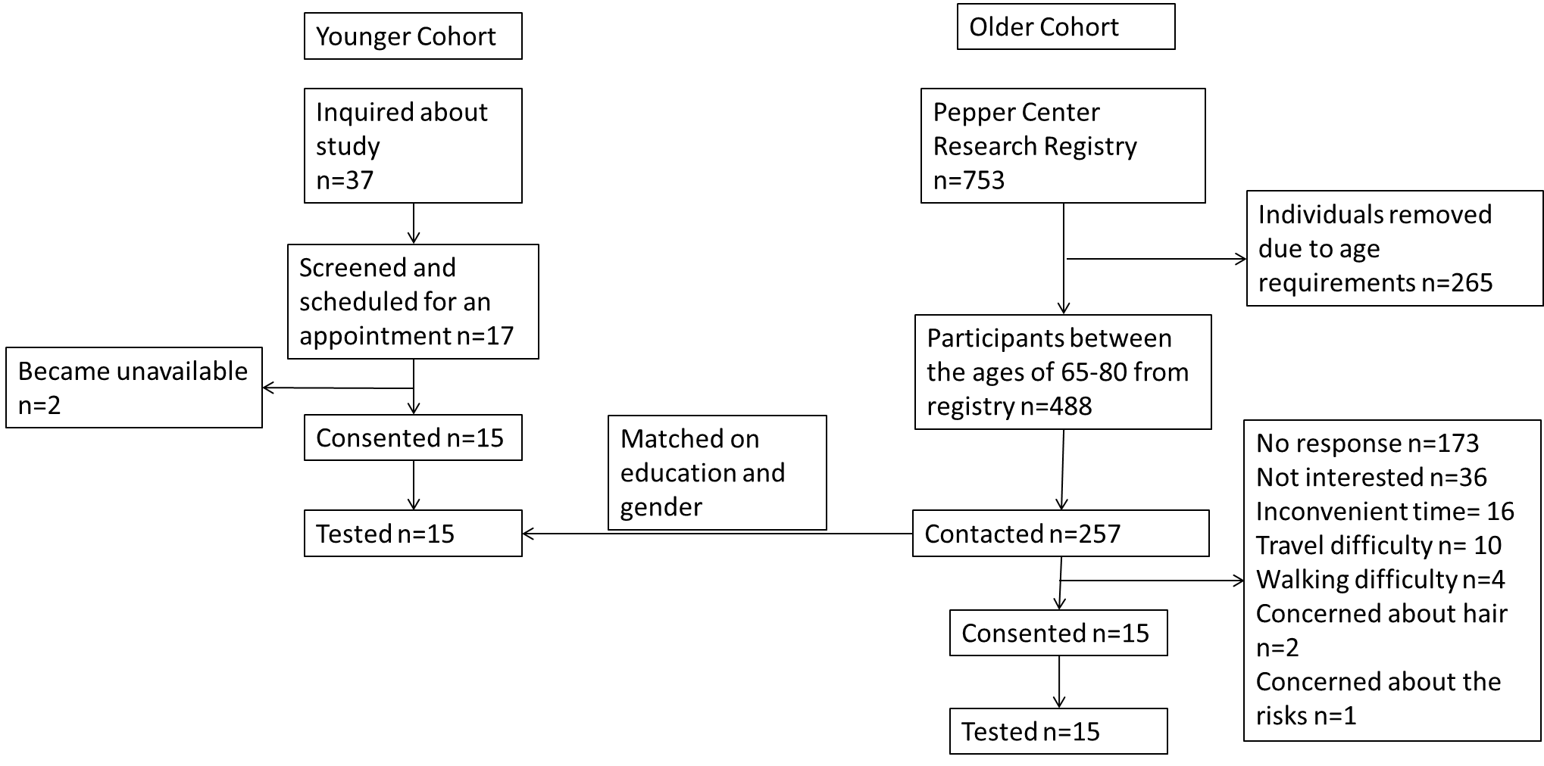

**Figure 1.** Recruitment Schematic

**3.2 PROCEDURES**

Eligible participants were invited to the University of Pittsburgh, Benedum Hall for a one hour long visit. At the time of the study, all of the participants provided informed written consent as approved by UPMC at Pittsburgh ethics committee. The participants were instrumented to the fNIRS machine by placing a cap on their head that contained the fNIRS optodes. The fNIRS lasers were turned on and adjusted for optimal light concentration. Once the participant was ready, we asked the participant to select a comfortable walking pace on the Noraxon MR3 treadmill. This pace was kept throughout the study. The participants were asked to stare at a black cross placed on the wall in front of them and to stay silent when unless otherwise instructed. Participants performed six simple and complex paradigms that included a simple counting task and a complex task defined as subtractions by decrements of 7 from a predetermined three digit number. The following is the list of the tasks: 1) standing and counting, 2) walking and counting, 3) standing and serial7, 4) walking and serial7, 5) walking and serial7 out loud, 6) walking and serial7 out loud. Each paradigm was a total of 2 minutes, including four, twenty seconds of the task and six, twenty seconds of rest periods (Figure 2).



The simple single task consisted of standing and counting. The complex single task was standing and serial7. The simple dual task consisted of walking and counting. The complex dual task consisted of walking and serial7. A single trial was made up of alternating on and off tasks that were 2 seconds durations. Each of the trials lasted three minutes, starting and ending in rest periods.

**Figure 2.** Task Paradigm

**3.3 ASSESSMENT OF THE PFC**

Activation of the PFC was assessed using a 10-channel continuous wave functional near-infrared spectroscopy instrument (CW6). Each channel is defined as a pairing of a sensor and a detector (Figure 4). The CW6 instrument utilized two different wavelengths at 690 nm (12 m) and 830 nm (8mW) to provide sensitivity for both the oxygenated and deoxygenated hemoglobin change. The light was carried through flexible optic fibers and distributed through sensor optodes positioned in a neoprene cap worn on the head. The positioning of the cap was done so that the cap was centered with the nose and above the eyebrow line, to measure the prefrontal and anterior temporal cortices of the left and right hemispheres (Figure 3). The measurements were made at a sample rate of 4 Hz using custom acquisition software. Stimulus events were manually marked using a feature in the same acquisition software. The light absorption was converted into optical density.

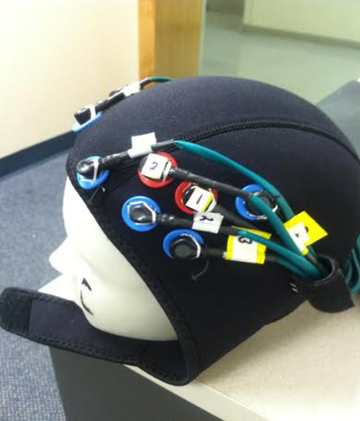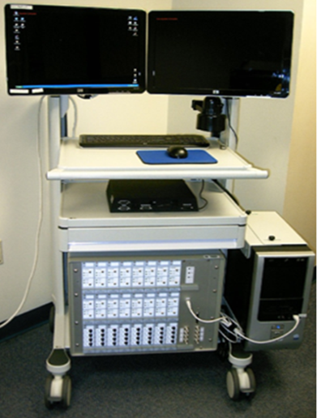

**Figure 3.** fNIRS Machine and Cap

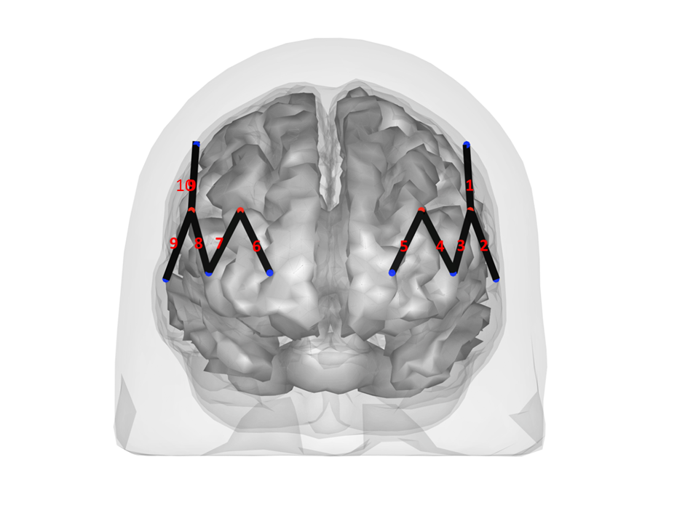

**L**

**R**

**Figure 4.** fNIRS Channels

The numbered lines are the individual channels that comprise of a sensor (the red dots) and a detector (the blue dots). There a 10 channels for the wavelength of light for detecting either oxy- or deoxy- hemoglobin absorption. The image is of the person facing towards the reader.

**3.4 ASSESSMENT OF GAIT**

Participants were asked to walk at a self-selected pace on a Noraxon© treadmill, which uses capacitive sensor technology to analyze individual foot pressure (ranging from 1-120 N/cm2) at a sampling frequency of 100 Hz to observe stride time. The treadmill data was recorded and extracted using Noraxon’s software.

**3.5 PROCESSING AND ANALYSIS OF THE fNIRS AND GAIT DATA**

The raw data were converted into oxy- and deoxy- hemoglobin estimates by utilizing the Beer-Lambert law. A custom MATLAB script was used to process the fNIRS data. Analysis of the changes in hemoglobin per source-detector pair was analyzed by a general linear regression model. The general linear model was solved by using an iteratively whitened weighted regression model, which addressed the correlated noise due to systemic physiology. Statistical outliers were addressed by utilizing robust regression. Furthermore, robust regression was used because it is well suited to reduce motion artifacts. Additionally, a transformation was used to remove drift within the fNIRS data. Group level analysis was done by a t-test and the Benjihami-Hochburg (BH) multiple comparison correction was used. The step time was measured for the participants gait by measuring the time that there were pressure readings on each side of the treadmill. The step time was converted into the mean, standard deviation and coefficient of variation of each on and off task and then was analyzed for differences in gait variability by age group using a Wilcoxon non-parametric t-test.

1. **RESULTS**

A total of 30 healthy older adults (n=15) and younger adults (n=15) participants were enrolled in the study. The mean age of the older adults was 70.7(3.62) with a range from 65-76 and the mean age of the younger adults was 25.3(5.71) with a range of 18-41. For both age groups, the gender and education distributions were 53% female and 36% had completed a degree above high school (Table 2).

**Table 2.** Sample Demographics

|  |  |  |
| --- | --- | --- |
|  | Young n=15 | Old n=15 |
|  | Mean (SD) | Mean (SD) |
| Age (Range) | 18-41 25.33 (5.71) | 65-76 70.73 (3.62) |
| Gender F to M | 8 to 7 | 8 to 7 |
| Education Years> high school | 11 | 11 |

Gait speed and performance on the dual task can be found in Table 3. The average gait speed for the younger adults was 2.03 (SD=.31) miles per hour (mph), while the average gait speed for the older adults was 1.69 (SD=0.73) mph. However, there was no statistically significant difference of gait speed (p= 0.13) between the old and young groups (Table 3).

The serial 7 task was performed as both a single and dual task for both age groups. The younger adults mean percent correct score during standing+serial7 is 95% (SD=7.77) correct, while the older adult perform 84% (SD=26.71) correct. There was no statistically significant difference (p=.13) for the standing+serial7 performance between the older and younger adults (Table 3).

The younger adults mean percent correct score during walking+serial7 was 94% (SD=7.77) correct, while the older adult perform 83% (SD=26.51) correct. There was no statistically significant difference (p=.15) for the dual task performance between the older and younger adults. There was no statistical difference between the performance of the single and dual task in both the older (p=0.71) and younger adults (p=0.37) (Table 3).

There is no statistically significant difference in gait variability while performing the simple dual task (counting+walking) to the complex dual task (serial7+walking) for either the older (1.43(SD=0.28) )(p=0.97) or younger adults (1.33(SD=.17)) (p=.97).

**Table 3.** Performance on Complex Serial7 Task and Gait Speed

|  |  |  |  |
| --- | --- | --- | --- |
|  | Young n=15 | Old n=15 |  |
|  | Mean (SD) | Mean (SD) | P-value |
| Walking out loud total correct | 20.5 (7.42) | 18 (11.34) | 0.5 |
| Walking out loud percent correct | 94.36% (7.57) | 83.19% (26.51) | 0.15 |
| Standing out loud total correct | 23.07 (7.09) | 19.67 (12.04) | 0.34 |
| Standing out loud percent correct | 94.91% (7.77) | 83.89% (24.71) | 0.13 |
| Gait speed | 2.03 mph (0.31) | 1.69 mph(0.73) | 0.13 |
| T-test of serial7 performance for both complex single and complex dual task comparing older and younger adult participants. | | | |
|

There were no significantly activated channels in the older adults for the simple counting compared to no counting in either the standing or walking paradigms. However, there was a statistically significant activation (channel 2 p=.009) in the younger adults during counting+standing compared to no counting+standing. After applying the BH multiple comparisons correction, no statistically significant difference within either of the age groups survived (Figure 5).

The older adults had no significant activation when comparing serial 7 and no serial standing paradigm. However, the younger adults had statistically significant activation (p=.002), but, this result did not survive after applying BH. Conversely, there were statistically significant results for both the older and younger adults for serial7+walking tasks when compared to no serial7+walking tasks. The older adults showed greater activation of the right medial PFC (channel 6 p=.0002). The younger adults showed a statistically significant reduction of activation during the complex dual task at the left dlPFC (channel 2 p=.0002) (Figure 6).

When comparing the older and younger adults in the standing and serial7 task, there were no statistically significant differences in activation of the PFC (Table 4). Conversely, three channels did show statistically significant (channel 1 p=.002, channel 2 p<.0001, channel 4 p=.04) differences in oxygenated hemoglobin when comparing the older adults to the younger adults for the serial7 dual task condition (Table 5)(Figure 7). However, after applying BH multiple comparisons correction only channel 2 remained statistically significant. These channels are located on the left dlPFC.

There were no statistically significant oxygenated hemoglobin concentration differences in the older adults during serial7 dual task compared to no serial7 single task (Table 6). Conversely, there were two channels showing statistically significant difference in oxygenated hemoglobin in the younger adults for walking+serial7 compared to standing+serial7 (channel 1 and 2 p<.001). These channels are located at the left dlPFC (Table 7)(Figure 7).

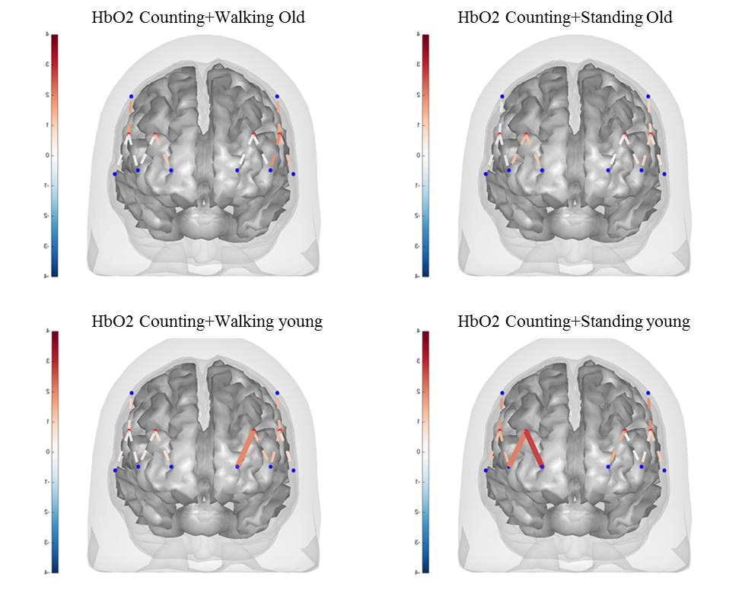

**R**

**L**

**Figure 5.** Counting Single or Dual Task in Older and Younger Participants

The colored bars on the left of the brain images indicate the t-scores of the activation and the dashed line represents (p>.05) and the solid line respresents (p<.05)

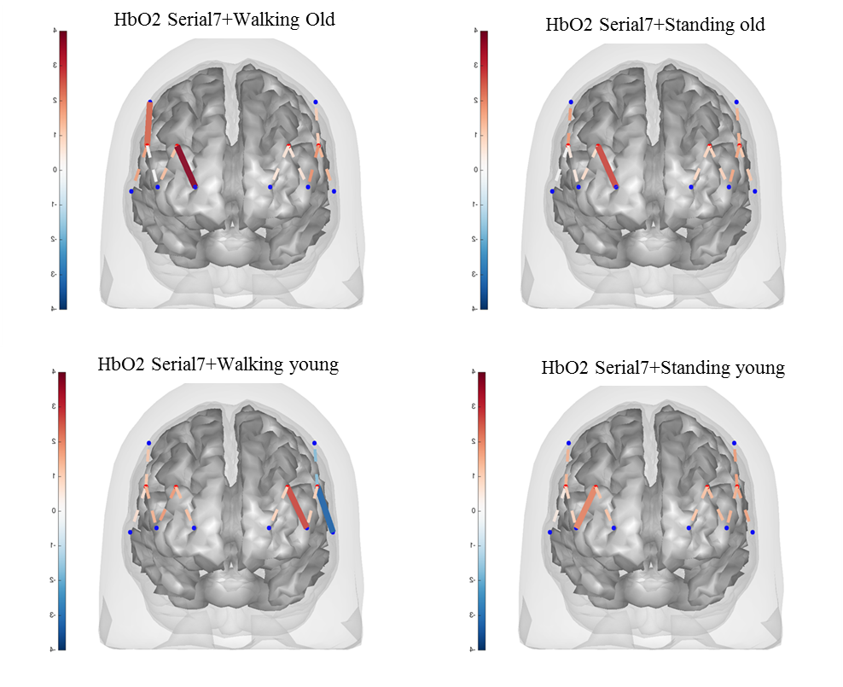

**R**

**L**

**Figure 6.** Serial7 Single or Dual Task in Older and Younger Participants

The colored bars on the left of the brain images indicate the t-scores of the activation and the dashed line represents (p>.05) and the solid line respresents (p<.05)

**Table 4.** HbO2 Concentration during Serial 7 Single Task Condition in Old verse Young

|  |  |  |  |  |
| --- | --- | --- | --- | --- |
| channel | beta | se | tstat | pvalue |
| 1 | -0.26 | 0.3 | -0.86 | 0.39 |
| 2 | -0.28 | 0.35 | -0.8 | 0.425 |
| 3 | -0.14 | 0.26 | -0.55 | 0.582 |
| 4 | 0.033 | 0.25 | 0.13 | 0.893 |
| 5 | -0.16 | 0.28 | -0.59 | 0.557 |
| 6 | 0.05 | 0.22 | 0.23 | 0.82 |
| 7 | -0.08 | 0.26 | -0.3 | 0.765 |
| 8 | -0.17 | 0.25 | -0.68 | 0.497 |
| 9 | -0.08 | 0.16 | -0.5 | 0.615 |
| 10 | -0.48 | 0.41 | -1.17 | 0.244 |
| Comparison of Linear Mixed Models that examined whether the HbO2 concentration between old and young during Serial7 while standing compared to HbO2 concentration during no task *p<.05 **p<.0001 | | | | |
|
|

**Table 5.** HbO2 Concentration during Serial7 Dual Task Condition in Old verse Young

|  |  |  |  |  |
| --- | --- | --- | --- | --- |
| channel | beta | se | tstat | pvalue |
| 1 | 1.02 | 0.36 | 3.04 | *0.002 |
| 2 | 1.4 | 0.33 | 4.1 | **<0.0001 |
| 3 | 0.2 | 0.24 | 0.84 | 0.4 |
| 4 | -0.48 | 0.24 | -2.02 | *0.04 |
| 5 | -0.23 | 0.28 | -0.82 | 0.41 |
| 6 | 0.11 | 0.2 | 0.57 | 0.57 |
| 7 | -0.09 | 0.27 | -0.32 | 0.75 |
| 8 | -0.12 | 0.28 | -0.45 | 0.66 |
| 9 | 0.03 | 0.18 | 0.14 | 0.89 |
| 10 | -0.36 | 0.45 | -0.81 | 0.42 |
| Comparison of Linear Mixed Models that examined the HbO2 concentration between old and young during Serial 7 walking condition *p<.05 **p<.001 | | | | |
|
|

**Table 6.** HbO2 Concentration during Serial7 Dual Task Compared to Single Task in Old

|  |  |  |  |  |
| --- | --- | --- | --- | --- |
| channel | beta | se | tstat | pvalue |
| 1 | -0.08 | 0.14 | -0.58 | 0.56 |
| 2 | 0.11 | 0.15 | 0.7 | 0.47 |
| 3 | -0.07 | 0.12 | -0.59 | 0.55 |
| 4 | -0.18 | 0.19 | -0.96 | 0.37 |
| 5 | -0.08 | 0.18 | -0.47 | 0.64 |
| 6 | 0.08 | 0.11 | 0.79 | 0.43 |
| 7 | 0.1 | 0.23 | 0.46 | 0.65 |
| 8 | 0.003 | 0.22 | 0.02 | 0.99 |
| 9 | 0.16 | 0.1 | 1.66 | 0.09 |
| 10 | 0.07 | 0.21 | 0.34 | 0.73 |
| Comparison of Linear Mixed Models that examined the HbO2 concentration of old participants during Serial 7 walking compared to Serial 7 standing *p<.05 **p<.0001 | | | | |
|
|

**Table 7.** HbO2 Concentration during Serial 7 Dual Task Compared to Single Task in Young

|  |  |  |  |  |
| --- | --- | --- | --- | --- |
| channel | beta | se | tstat | p |
| 1 | -1.36 | 0.4 | -3.37 | *<.001 |
| 2 | -1.52 | 0.44 | -3.49 | *<.001 |
| 3 | -0.42 | 0.31 | -1.36 | 0.17 |
| 4 | 0.33 | 0.25 | 1.3 | 0.19 |
| 5 | -0.02 | 0.32 | -0.05 | 0.96 |
| 6 | 0.02 | 0.24 | 0.095 | 0.93 |
| 7 | 0.11 | 0.27 | 0.42 | 0.68 |
| 8 | -0.04 | 0.27 | -0.17 | 0.87 |
| 9 | 0.06 | 0.15 | 0.37 | 0.71 |
| 10 | -0.05 | 0.54 | -0.083 | 0.93 |
| Comparison of Linear Mixed Models that examined the HbO2 concentration of young participants during Serial 7 walking compared to Serial 7 standing *p<.05 **p<.0001 | | | | |
|
|

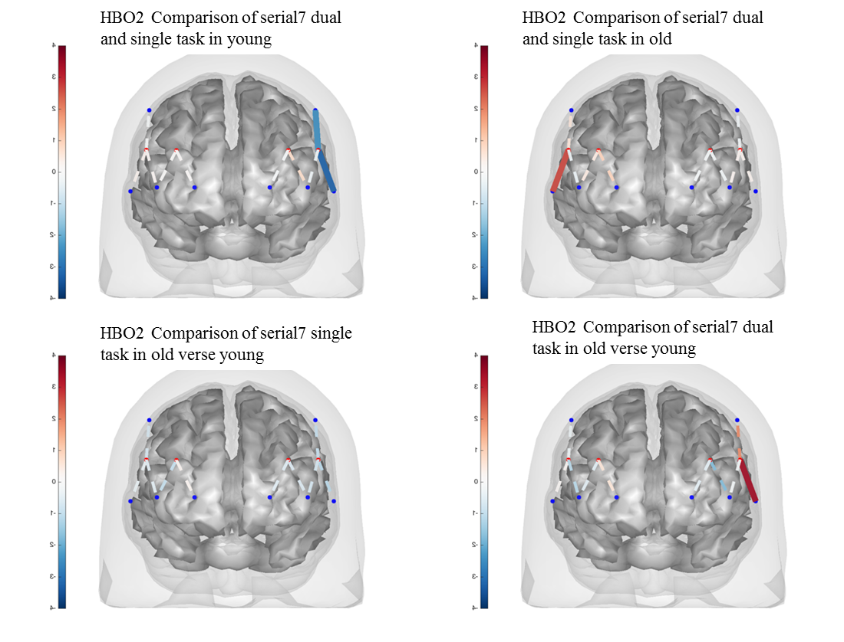

**R**

**L**

**Figure 7.** Comparison between Complex Single Task and Dual Task Within and Between Age Groups

The colored bars on the left of the brain images indicate the t-scores of the activation and the dashed line represents (p>.05) and the solid line respresents (p<.05)

**5.0 DISCUSSION**

The present study showed that there are differences of PFC activation during complex dual tasks between healthy old and young adults. The usage of the non-invasive imaging method, fNIRS, is fairly novel, and only a few studies have applied this technique to walking dual task paradigms. Hence, the current study addressed a major gap in knowledge regarding the difference in involvement of PFC between age groups during a walking dual task paradigm.

Consistent with the first hypothesis, this study provided evidence that older adults have bilateral activation of the PFC as compared to the unilateral activation of the younger adults. It is noteworthy to mention that the younger adults had a decrease in activation during the walking+serial 7 compared to standing+serial7. Furthermore, we observed significantly greater activation of the left dlPFC during walking+serial7 dual task in the older adults compared to the younger adults. This study also found that there was no significant difference in the serial 7 performance between age groups. Additionally, the study found no significant activation of the frontal cortex during the walking+counting dual task for either group. Taken together, these findings suggest that greater PFC activation occurs in both age groups during a complex dual task paradigm; however, the older adults have a higher resource necessity in the PFC to perform just as well as the young adults.

As previously noted, this study has found a bilateral activation of the PFC in older adults when doing a complex dual task. This was shown by a lack of significant activation of either side of the PFC when compared to one another, implying that there was an overall increase. However, it should be noted that there was a significant activation of the right medial PFC, yet, this does not negate a bilateral usage. This finding is in line with previous research (Roee Holtzer et al., 2011), and is consistent with the role of the PFC in monitoring and allocating attention resources during competing tasks in older adults and has been found in other studies (Cabeza et al., 2002; P. A. Reuter-Lorenz et al., 2000; Patricia A Reuter-Lorenz et al., 1999) .

Conversely, the younger adults had a significant decrease of the left dlPFC during the walking+serial7 task. This observation is consistent with other studies findings (Mirelman et al., 2014) however, a concise reasoning for this has not been established. I speculate that this occurrence is a result of the roles of different regions within the PFC; meaning different regions of the PFC are activated during different types of tasks. Barbey and colleagues proposed that the left dlPFC is primarily responsible for letter number sequencing and spatial span backwards, while the right is responsible for arithmetic and matric reasoning (Barbey et al., 2013). Furthermore, it is consistent with the theory that lower activation of the dlPFC allows for more accurate and faster performance (Burzynska et al., 2013; Maillet & Rajah, 2013; Rypma & Prabhakaran, 2009). With this hypothesis, the decrease in activation of the left dlPFC in healthy young adults may be a result of recruiting resources away from unnecessary regions or this could represent a processing shift to regions of the brain that we were not measuring.

This study also found that there was a significantly higher activation of the left dorsolateral PFC in the older adults compared to the younger adults during the walking+serial7 dual task. This finding is consistent with only one previous paper (Ohsugi et al., 2013). The opposite results occurred in previous studies (Beurskens et al., 2014; Roee Holtzer et al., 2011). I propose that the difference in findings is due to the complexity of the dual task that was implemented in the study. In our study, we utilized a serial7 task, similar to Ohsugi and colleagues (Ohsugi et al., 2013) that involved the subtraction by decrements of seven while walking. The two studies mentioned previously utilized a less complex task of reciting every other letter of the alphabet. The differences in these dual tasks are important to note. Other possibilities include the education level of the participants. The education level of the participants is important to note as well because it may be a good indicator for better health. There is a noticeable contrast between the levels of education attainment in this study compared to Holtzer et al (R. Holtzer et al., 2011). The mean age of the participants between the previously mentioned fNIRS studies is not very different then this current study, however, this should not suggest that age is not an important factor to assess for differences. For this study, I propose that a ceiling effect was not reached in the older adults therefore a decline in activation was not seen. Additionally, the difference may also be a result from specification of either the total activation of the PFC or specific regions within the PFC.

There are several major strengths in this study. The primary strength of the study is the novel neuroimaging technique, fNIRS. fNIRS technology enabled us to have free mobility during the dual task paradigm performed by the old and young groups. The second main strength of this study is having both the older and younger adults perform both a simple (counting) and complex (serial7) dual task paradigms. A third strength of the study was the use of the Noraxon treadmill that provided precise gait data. There are limitations in this study. Gait variability was not found in this study as previously mentioned. I propose that walking on the treadmill inhibits the variability, which we would have found if the participant was freely walking. This is consistent with previous work (Hausdorff et al., 1997). Additionally, the variability in stride time may not have been found due to the duration of the task on/off paradigm being too short. Being underpowered due to sample size may have contributed to the lack of this statistically significant result. There may be bias with the recruited participants with regards to a high proportion having advanced education and that all the participants were relatively healthy; therefore, significant variability was not observed. However, the participants were matched on education, thus, reducing any bias. Limitations regarding the fNIRS system include the inability to look at the entire brain when completing the task. However, fNIRS strengths outweigh this limitation by allowing actual movement, such as walking, while performing the task, unlike a fMRI. A future direction for this research is to utilize a wireless fNIRS system where the participant is able to freely walk in their environment and to measure challenges of everyday life.

In conclusion this study found that there is bilateral activation of the PFC in older adults and unilateral activation in young adults. Furthermore, there was a significant increased activation of the left dlPFC in the older adults compared to younger adults, despite similar or slightly worse performance on the serial7 task. This study helped expand the current knowledge and helped provide evidence to fill the current gaps in knowledge. Furthermore, these findings have substantial public health significance as they provide a foundation for brain related interventions to improve gait and reduce the risk of falls.

**BIBLIOGRAPHY**

Abdulrahman, H., Fletcher, P. C., Bullmore, E., & Morcom, A. M. (2015). Dopamine and memory dedifferentiation in aging. *Neuroimage*. doi: 10.1016/j.neuroimage.2015.03.031

Al-Yahya, E., Dawes, H., Smith, L., Dennis, A., Howells, K., & Cockburn, J. (2011). Cognitive motor interference while walking: a systematic review and meta-analysis. *Neuroscience & Biobehavioral Reviews, 35*(3), 715-728.

Al Snih, S., Fisher, M. N., Raji, M. A., Markides, K. S., Ostir, G. V., & Goodwin, J. S. (2005). Diabetes mellitus and incidence of lower body disability among older Mexican Americans. *The Journals of Gerontology Series A: Biological Sciences and Medical Sciences, 60*(9), 1152-1156.

Alexander, A. L., Lee, J. E., Lazar, M., & Field, A. S. (2007). Diffusion tensor imaging of the brain. *Neurotherapeutics, 4*(3), 316-329. doi: 10.1016/j.nurt.2007.05.011

Arnsten, A. F. (1998). Catecholamine modulation of prefrontal cortical cognitive function. *Trends Cogn Sci, 2*(11), 436-447.

Atkinson, H. H., Rosano, C., Simonsick, E. M., Williamson, J. D., Davis, C., Ambrosius, W. T., . . . Harris, T. B. (2007). Cognitive function, gait speed decline, and comorbidities: the health, aging and body composition study. *The Journals of Gerontology Series A: Biological Sciences and Medical Sciences, 62*(8), 844-850.

Bakker, M., De Lange, F., Helmich, R. C., Scheeringa, R., Bloem, B. R., & Toni, I. (2008). Cerebral correlates of motor imagery of normal and precision gait. *Neuroimage, 41*(3), 998-1010.

Balasubramanian, C. K., Clark, D. J., & Gouelle, A. (2015). Validity of the Gait Variability Index in older adults: Effect of aging and mobility impairments. *Gait Posture, 41*(4), 941-946.

Baltes, P. B., Staudinger, U. M., & Lindenberger, U. (1999). Lifespan psychology: theory and application to intellectual functioning. *Annu Rev Psychol, 50*, 471-507. doi: 10.1146/annurev.psych.50.1.471

Barbey, A. K., Colom, R., Solomon, J., Krueger, F., Forbes, C., & Grafman, J. (2012). An integrative architecture for general intelligence and executive function revealed by lesion mapping. *Brain, 135*(Pt 4), 1154-1164. doi: 10.1093/brain/aws021

Barbey, A. K., Koenigs, M., & Grafman, J. (2013). Dorsolateral prefrontal contributions to human working memory. *Cortex, 49*(5), 1195-1205. doi: 10.1016/j.cortex.2012.05.022

Bartzokis, G., Cummings, J. L., Sultzer, D., Henderson, V. W., Nuechterlein, K. H., & Mintz, J. (2003). White matter structural integrity in healthy aging adults and patients with Alzheimer disease: a magnetic resonance imaging study. *Arch Neurol, 60*(3), 393-398.

Barulli, D., & Stern, Y. (2013). Efficiency, capacity, compensation, maintenance, plasticity: emerging concepts in cognitive reserve. *Trends Cogn Sci, 17*(10), 502-509. doi: 10.1016/j.tics.2013.08.012

Bennett, I. J., & Madden, D. J. (2014). Disconnected aging: cerebral white matter integrity and age-related differences in cognition. *Neuroscience, 276*, 187-205. doi: 10.1016/j.neuroscience.2013.11.026

Beurskens, R., Helmich, I., Rein, R., & Bock, O. (2014). Age-related changes in prefrontal activity during walking in dual-task situations: A fNIRS study. *International Journal of Psychophysiology, 92*(3), 122-128.

Ble, A., Volpato, S., Zuliani, G., Guralnik, J. M., Bandinelli, S., Lauretani, F., . . . Ferrucci, L. (2005). Executive function correlates with walking speed in older persons: the InCHIANTI study. *Journal of the American Geriatrics Society, 53*(3), 410-415.

Boisgontier, M. P., Beets, I. A., Duysens, J., Nieuwboer, A., Krampe, R. T., & Swinnen, S. P. (2013). Age-related differences in attentional cost associated with postural dual tasks: increased recruitment of generic cognitive resources in older adults. *Neuroscience & Biobehavioral Reviews, 37*(8), 1824-1837.

Borghesani, P. R., Madhyastha, T. M., Aylward, E. H., Reiter, M. A., Swarny, B. R., Schaie, K. W., & Willis, S. L. (2013). The association between higher order abilities, processing speed, and age are variably mediated by white matter integrity during typical aging. *Neuropsychologia, 51*(8), 1435-1444. doi: 10.1016/j.neuropsychologia.2013.03.005

Brach, J. S., Berlin, J. E., VanSwearingen, J. M., Newman, A. B., & Studenski, S. A. (2005). Too much or too little step width variability is associated with a fall history in older persons who walk at or near normal gait speed. *Journal of neuroengineering and rehabilitation, 2*(1), 1.

Brown, C. J., & Flood, K. L. (2013). Mobility limitation in the older patient: A clinical review. *JAMA, 310*(11), 1168-1177. doi: 10.1001/jama.2013.276566

Brown, I., Tickner, A., & Simmonds, D. (1969). Interference between concurrent tasks of driving and telephoning. *Journal of applied psychology, 53*(5), 419.

Burianova, H., Marstaller, L., Choupan, J., Sepehrband, F., Ziaei, M., & Reutens, D. (2015). The relation of structural integrity and task-related functional connectivity in the aging brain. *Neurobiol Aging, 36*(10), 2830-2837. doi: 10.1016/j.neurobiolaging.2015.07.006

Burzynska, A. Z., Garrett, D. D., Preuschhof, C., Nagel, I. E., Li, S. C., Backman, L., . . . Lindenberger, U. (2013). A scaffold for efficiency in the human brain. *J Neurosci, 33*(43), 17150-17159. doi: 10.1523/JNEUROSCI.1426-13.2013

Bush, G., Luu, P., & Posner, M. I. (2000). Cognitive and emotional influences in anterior cingulate cortex. *Trends Cogn Sci, 4*(6), 215-222.

Cabeza, R., Anderson, N. D., Locantore, J. K., & McIntosh, A. R. (2002). Aging gracefully: compensatory brain activity in high-performing older adults. *Neuroimage, 17*(3), 1394-1402.

Callejas, A., Lupianez, J., Funes, M. J., & Tudela, P. (2005). Modulations among the alerting, orienting and executive control networks. *Exp Brain Res, 167*(1), 27-37. doi: 10.1007/s00221-005-2365-z

Carp, J., Gmeindl, L., & Reuter-Lorenz, P. A. (2010). Age differences in the neural representation of working memory revealed by multi-voxel pattern analysis. *Front Hum Neurosci, 4*, 217. doi: 10.3389/fnhum.2010.00217

Cham, R., Studenski, S., Perera, S., & Bohnen, N. (2008). Striatal dopaminergic denervation and gait in healthy adults. *Experimental Brain Research, 185*(3), 391-398.

Chan, R. C., Shum, D., Toulopoulou, T., & Chen, E. Y. (2008). Assessment of executive functions: review of instruments and identification of critical issues. *Arch Clin Neuropsychol, 23*(2), 201-216. doi: 10.1016/j.acn.2007.08.010

Clark, D. J., Rose, D. K., Ring, S. A., & Porges, E. C. (2014). Utilization of central nervous system resources for preparation and performance of complex walking tasks in older adults. *Front Aging Neurosci, 6*.

Control, C. f. D., & Prevention. (2009). Prevalence and most common causes of disability among adults--United States, 2005. *MMWR: Morbidity and mortality weekly report, 58*(16), 421-426.

Davis, S. W., Dennis, N. A., Daselaar, S. M., Fleck, M. S., & Cabeza, R. (2008). Que PASA? The posterior-anterior shift in aging. *Cereb Cortex, 18*(5), 1201-1209. doi: 10.1093/cercor/bhm155

de Keyser, J., De Backer, J.-P., Vauquelin, G., & Ebinger, G. (1990). The effect of aging on the D 1 dopamine receptors in human frontal cortex. *Brain Research, 528*(2), 308-310.

de Laat, K. F., Tuladhar, A. M., van Norden, A. G. W., Norris, D. G., Zwiers, M. P., & de Leeuw, F.-E. (2011). Loss of white matter integrity is associated with gait disorders in cerebral small vessel disease. *Brain, 134*(1), 73-83. doi: 10.1093/brain/awq343

Dickstein, D. L., Kabaso, D., Rocher, A. B., Luebke, J. I., Wearne, S. L., & Hof, P. R. (2007). Changes in the structural complexity of the aged brain. *Aging Cell, 6*(3), 275-284. doi: 10.1111/j.1474-9726.2007.00289.x

Dirnberger, G., Lang, W., & Lindinger, G. (2010). Differential effects of age and executive functions on the resolution of the contingent negative variation: a reexamination of the frontal aging theory. *Age (Dordr), 32*(3), 323-335. doi: 10.1007/s11357-010-9134-z

Drag, L. L., & Bieliauskas, L. A. (2010). Contemporary review 2009: cognitive aging. *J Geriatr Psychiatry Neurol, 23*(2), 75-93. doi: 10.1177/0891988709358590

Duncan, J., Seitz, R. J., Kolodny, J., Bor, D., Herzog, H., Ahmed, A., . . . Emslie, H. (2000). A neural basis for general intelligence. *Science, 289*(5478), 457-460.

Dyck, C. H. v., Seibyl, J. P., Malison, R. T., Laruelle, M., Wallace, E., Zoghbi, S. S., . . . Hoffer, P. B. (1995). Age-Related Decline in Striatal Dopamine Transporter Binding with Iodine-123-b-CIT SPECT. *Journal of Nuclear Medicine, 36*(7), 1175-1181.

Elderkin-Thompson, V., Ballmaier, M., Hellemann, G., Pham, D., & Kumar, A. (2008). Executive function and MRI prefrontal volumes among healthy older adults. *Neuropsychology, 22*(5), 626-637. doi: 10.1037/0894-4105.22.5.626

Fan, J., McCandliss, B. D., Fossella, J., Flombaum, J. I., & Posner, M. I. (2005). The activation of attentional networks. *Neuroimage, 26*(2), 471-479. doi: 10.1016/j.neuroimage.2005.02.004

Francis, S., Lin, X., Aboushoushah, S., White, T. P., Phillips, M., Bowtell, R., & Constantinescu, C. S. (2009). fMRI analysis of active, passive and electrically stimulated ankle dorsiflexion. *Neuroimage, 44*(2), 469-479.

Gallo, A., Rovaris, M., Riva, R., & et al. (2005). DIffusion-tensor magnetic resonance imaging detects normal-appearing white matter damage unrelated to short-term disease activity in patients at the earliest clinical stage of multiple sclerosis. *Arch Neurol, 62*(5), 803-808. doi: 10.1001/archneur.62.5.803

Garnett, E., Firnau, G., & Nahmias, C. (1983). Dopamine visualized in the basal ganglia of living man.

Gill, T. M., Gahbauer, E. A., Murphy, T. E., Han, L., & Allore, H. G. (2012). Risk factors and precipitants of long-term disability in community mobility: a cohort study of older persons. *Annals of internal medicine, 156*(2), 131-140.

Glascher, J., Rudrauf, D., Colom, R., Paul, L. K., Tranel, D., Damasio, H., & Adolphs, R. (2010). Distributed neural system for general intelligence revealed by lesion mapping. *Proc Natl Acad Sci U S A, 107*(10), 4705-4709. doi: 10.1073/pnas.0910397107

Goel, V., & Grafman, J. (1995). Are the frontal lobes implicated in "planning" functions? Interpreting data from the Tower of Hanoi. *Neuropsychologia, 33*(5), 623-642.

Grady, C. L., Maisog, J. M., Horwitz, B., Ungerleider, L. G., Mentis, M. J., Salerno, J. A., . . . Haxby, J. V. (1994). Age-related changes in cortical blood flow activation during visual processing of faces and location. *J Neurosci, 14*(3 Pt 2), 1450-1462.

Graybiel, A. M. (1990). Neurotransmitters and neuromodulators in the basal ganglia. *Trends in neurosciences, 13*(7), 244-254.

Groessl, E. J., Kaplan, R. M., Rejeski, W. J., Katula, J. A., King, A. C., Frierson, G., . . . Pahor, M. (2007). Health-related quality of life in older adults at risk for disability. *American journal of preventive medicine, 33*(3), 214-218.

Haier, R. J., Siegel Jr, B. V., Nuechterlein, K. H., Hazlett, E., Wu, J. C., Paek, J., . . . Buchsbaum, M. S. (1988). Cortical glucose metabolic rate correlates of abstract reasoning and attention studied with positron emission tomography. *Intelligence, 12*(2), 199-217. doi: <http://dx.doi.org/10.1016/0160-2896(88)90016-5>

Hamacher, D., Herold, F., Wiegel, P., Hamacher, D., & Schega, L. (2015). Brain activity during walking: A systematic review. *Neuroscience & Biobehavioral Reviews, 57*, 310-327. doi: <http://dx.doi.org/10.1016/j.neubiorev.2015.08.002>

Harada, C. N., Natelson Love, M. C., & Triebel, K. L. (2013). Normal cognitive aging. *Clin Geriatr Med, 29*(4), 737-752. doi: 10.1016/j.cger.2013.07.002

Harada, T., Miyai, I., Suzuki, M., & Kubota, K. (2009). Gait capacity affects cortical activation patterns related to speed control in the elderly. *Experimental Brain Research, 193*(3), 445-454.

Hardy, S. E., Kang, Y., Studenski, S. A., & Degenholtz, H. B. (2011). Ability to walk 1/4 mile predicts subsequent disability, mortality, and health care costs. *Journal of general internal medicine, 26*(2), 130-135.

Hausdorff, J. M. (2005). Gait variability: methods, modeling and meaning. *Journal of neuroengineering and rehabilitation, 2*(1), 1.

Hausdorff, J. M., Mitchell, S. L., Firtion, R., Peng, C.-K., Cudkowicz, M. E., Wei, J. Y., & Goldberger, A. L. (1997). Altered fractal dynamics of gait: reduced stride-interval correlations with aging and Huntington’s disease. *Journal of applied physiology, 82*(1), 262-269.

Hausdorff, J. M., Rios, D. A., & Edelberg, H. K. (2001). Gait variability and fall risk in community-living older adults: a 1-year prospective study. *Archives of physical medicine and rehabilitation, 82*(8), 1050-1056.

Hausdorff, J. M., Schweiger, A., Herman, T., Yogev-Seligmann, G., & Giladi, N. (2008). Dual-task decrements in gait: contributing factors among healthy older adults. *The Journals of Gerontology Series A: Biological Sciences and Medical Sciences, 63*(12), 1335-1343.

Hayden, K. M., & Welsh-Bohmer, K. A. (2012). Epidemiology of cognitive aging and Alzheimer's disease: contributions of the cache county utah study of memory, health and aging. *Curr Top Behav Neurosci, 10*, 3-31. doi: 10.1007/7854_2011_152

Holtzer, R., Mahoney, J. R., Izzetoglu, M., Izzetoglu, K., Onaral, B., & Verghese, J. (2011). fNIRS study of walking and walking while talking in young and old individuals. *J Gerontol A Biol Sci Med Sci, 66*(8), 879-887. doi: 10.1093/gerona/glr068

Holtzer, R., Mahoney, J. R., Izzetoglu, M., Izzetoglu, K., Onaral, B., & Verghese, J. (2011). fNIRS study of walking and walking while talking in young and old individuals. *The Journals of Gerontology Series A: Biological Sciences and Medical Sciences, 66*(8), 879-887.

Holtzer, R., Mahoney, J. R., Izzetoglu, M., Wang, C., England, S., & Verghese, J. (2015). Online fronto-cortical control of simple and attention-demanding locomotion in humans. *Neuroimage, 112*, 152-159.

Huppert, T. J., Hoge, R. D., Dale, A. M., Franceschini, M. A., & Boas, D. A. (2006). Quantitative spatial comparison of diffuse optical imaging with blood oxygen level-dependent and arterial spin labeling-based functional magnetic resonance imaging. *Journal of biomedical optics, 11*(6), 064018-064018. doi: 10.1117/1.2400910

Huppert, T. J., Hoge, R. D., Diamond, S. G., Franceschini, M. A., & Boas, D. A. (2006). A temporal comparison of BOLD, ASL, and NIRS hemodynamic responses to motor stimuli in adult humans. *Neuroimage, 29*(2), 368-382. doi: 10.1016/j.neuroimage.2005.08.065

Inoue, M., Suhara, T., Sudo, Y., Okubo, Y., Yasuno, F., Kishimoto, T., . . . Tanada, S. (2001). Age-related reduction of extrastriatal dopamine D 2 receptor measured by PET. *Life sciences, 69*(9), 1079-1084.

James, B. D., Boyle, P. A., Buchman, A. S., & Bennett, D. A. (2011). Relation of late-life social activity with incident disability among community-dwelling older adults. *The Journals of Gerontology Series A: Biological Sciences and Medical Sciences*, glq231.

Jung, R. E., & Haier, R. J. (2007). The Parieto-Frontal Integration Theory (P-FIT) of intelligence: converging neuroimaging evidence. *Behav Brain Sci, 30*(2), 135-154; discussion 154-187. doi: 10.1017/S0140525X07001185

Kaasinen, V., Vilkman, H., Hietala, J., Någren, K., Helenius, H., Olsson, H., . . . Rinne, J. O. (2000). Age-related dopamine D2/D3 receptor loss in extrastriatal regions of the human brain. *Neurobiol Aging, 21*(5), 683-688.

Kahneman, D. (1973). *Attention and effort*: Citeseer.

Karim, H., Schmidt, B., Dart, D., Beluk, N., & Huppert, T. (2012). Functional near-infrared spectroscopy (fNIRS) of brain function during active balancing using a video game system. *Gait Posture, 35*(3), 367-372. doi: <http://dx.doi.org/10.1016/j.gaitpost.2011.10.007>

Koenraadt, K. L., Roelofsen, E. G., Duysens, J., & Keijsers, N. L. (2014). Cortical control of normal gait and precision stepping: an fNIRS study. *Neuroimage, 85*, 415-422.

Koo, B., Bergethon, P., Qiu, W., & et al. (2012). Clinical prediction of fall risk and white matter abnormalities: A diffusion tensor imaging study. *Arch Neurol, 69*(6), 733-738. doi: 10.1001/archneurol.2011.2272

Koster, A., Patel, K. V., Visser, M., Van Eijk, J. T. M., Kanaya, A. M., De Rekeneire, N., . . . Harris, T. B. (2008). Joint effects of adiposity and physical activity on incident mobility limitation in older adults. *Journal of the American Geriatrics Society, 56*(4), 636-643.

Koster, A., Penninx, B. W., Newman, A. B., Visser, M., Gool, C. H., Harris, T. B., . . . Simonsick, E. M. (2007). Lifestyle Factors and Incident Mobility Limitation in Obese and Non‐obese Older Adults. *Obesity, 15*(12), 3122-3132.

Lang, J. E., The Healthy Aging Research Network Writing, G., Anderson, L., James, L., Sharkey, J., Belansky, E., . . . Goins, R. T. (2006). The Prevention Research Centers Healthy Aging Research Network. *Preventing Chronic Disease, 3*(1), A17.

Li, K. Z., Lindenberger, U., Freund, A. M., & Baltes, P. B. (2001). Walking while memorizing: Age-related differences in compensatory behavior. *Psychological Science, 12*(3), 230-237.

Li, S.-C., & Lindenberger, U. (1999). Cross-level unification: A computational exploration of the link between deterioration of neurotransmitter systems and dedifferentiation of cognitive abilities in old age *Cognitive neuroscience of memory* (pp. 103-146): Hogrefe & Huber.

Li, S. C., Lindenberger, U., & Sikstrom, S. (2001). Aging cognition: from neuromodulation to representation. *Trends Cogn Sci, 5*(11), 479-486.

Lindenberger, U., Marsiske, M., & Baltes, P. B. (2000). Memorizing while walking: increase in dual-task costs from young adulthood to old age. *Psychology and aging, 15*(3), 417.

Lu, C.-F., Liu, Y.-C., Yang, Y.-R., Wu, Y.-T., & Wang, R.-Y. (2015). Maintaining Gait Performance by Cortical Activation during Dual-Task Interference: A Functional Near-Infrared Spectroscopy Study. *PLoS One, 10*(6), e0129390.

MacDonald, A. W., 3rd, Cohen, J. D., Stenger, V. A., & Carter, C. S. (2000). Dissociating the role of the dorsolateral prefrontal and anterior cingulate cortex in cognitive control. *Science, 288*(5472), 1835-1838.

Mahoney, J. R., Verghese, J., Goldin, Y., Lipton, R., & Holtzer, R. (2010). Alerting, orienting, and executive attention in older adults. *J Int Neuropsychol Soc, 16*(5), 877-889. doi: 10.1017/S1355617710000767

Maillet, D., & Rajah, M. N. (2013). Association between prefrontal activity and volume change in prefrontal and medial temporal lobes in aging and dementia: a review. *Ageing Res Rev, 12*(2), 479-489. doi: 10.1016/j.arr.2012.11.001

Marko, M., Neville, C. G., Prince, M. A., & Ploutz-Snyder, L. L. (2012). Lower-extremity force decrements identify early mobility decline among community-dwelling older adults. *Physical therapy, 92*(9), 1148-1159.

Miller, E. K., & Cohen, J. D. (2001). An integrative theory of prefrontal cortex function. *Annu Rev Neurosci, 24*, 167-202. doi: 10.1146/annurev.neuro.24.1.167

Mills, P. M., & Barrett, R. S. (2001). Swing phase mechanics of healthy young and elderly men. *Human movement science, 20*(4), 427-446.

Mirelman, A., Maidan, I., Bernad-Elazari, H., Nieuwhof, F., Reelick, M., Giladi, N., & Hausdorff, J. M. (2014). Increased frontal brain activation during walking while dual tasking: an fNIRS study in healthy young adults. *Journal of neuroengineering and rehabilitation, 11*(1), 1.

Muller, N. G., Machado, L., & Knight, R. T. (2002). Contributions of subregions of the prefrontal cortex to working memory: evidence from brain lesions in humans. *J Cogn Neurosci, 14*(5), 673-686. doi: 10.1162/08989290260138582

Niogi, S., Mukherjee, P., Ghajar, J., & McCandliss, B. D. (2010). Individual Differences in Distinct Components of Attention are Linked to Anatomical Variations in Distinct White Matter Tracts. *Front Neuroanat, 4*, 2. doi: 10.3389/neuro.05.002.2010

Ogawa, S., Lee, T.-M., Kay, A. R., & Tank, D. W. (1990). Brain magnetic resonance imaging with contrast dependent on blood oxygenation. *Proceedings of the National Academy of Sciences, 87*(24), 9868-9872.

Ohsugi, H., Ohgi, S., Shigemori, K., & Schneider, E. B. (2013). Differences in dual-task performance and prefrontal cortex activation between younger and older adults. *BMC neuroscience, 14*(1), 1.

Owen, A. M., Evans, A. C., & Petrides, M. (1996). Evidence for a two-stage model of spatial working memory processing within the lateral frontal cortex: a positron emission tomography study. *Cereb Cortex, 6*(1), 31-38.

Park, D. C., & Reuter-Lorenz, P. (2009). The adaptive brain: aging and neurocognitive scaffolding. *Annu Rev Psychol, 60*, 173-196. doi: 10.1146/annurev.psych.59.103006.093656

Parker, M., Baker, P. S., & Allman, R. M. (2002). A life-space approach to functional assessment of mobility in the elderly. *Journal of Gerontological Social Work, 35*(4), 35-55.

Pashler, H., & Christian, C. L. (1994). Bottlenecks in planning and producing vocal, manual, and foot responses. *Center for Human Information Processing Technical Report*.

Peel, C., Baker, P. S., Roth, D. L., Brown, C. J., Bodner, E. V., & Allman, R. M. (2005). Assessing mobility in older adults: the UAB Study of Aging Life-Space Assessment. *Physical therapy, 85*(10), 1008-1019.

Peters, R. (2006). Ageing and the brain. *Postgrad Med J, 82*(964), 84-88. doi: 10.1136/pgmj.2005.036665

Petrides, M., Tomaiuolo, F., Yeterian, E. H., & Pandya, D. N. (2012). The prefrontal cortex: comparative architectonic organization in the human and the macaque monkey brains. *Cortex, 48*(1), 46-57. doi: 10.1016/j.cortex.2011.07.002

Posner, M. I., & Petersen, S. E. (1990). The attention system of the human brain. *Annu Rev Neurosci, 13*, 25-42. doi: 10.1146/annurev.ne.13.030190.000325

Posner, M. I., Sheese, B. E., Odludas, Y., & Tang, Y. (2006). Analyzing and shaping human attentional networks. *Neural Netw, 19*(9), 1422-1429. doi: 10.1016/j.neunet.2006.08.004

Prabhakaran, V., Rypma, B., & Gabrieli, J. D. (2001). Neural substrates of mathematical reasoning: a functional magnetic resonance imaging study of neocortical activation during performance of the necessary arithmetic operations test. *Neuropsychology, 15*(1), 115-127.

Prohaska, T. R., Anderson, L. A., Hooker, S. P., Hughes, S. L., & Belza, B. (2011). Mobility and aging: transference to transportation. *Journal of aging research, 392751*.

Raz, N., Gunning-Dixon, F. M., Head, D., Dupuis, J. H., & Acker, J. D. (1998). Neuroanatomical correlates of cognitive aging: evidence from structural magnetic resonance imaging. *Neuropsychology, 12*(1), 95-114.

Reuter-Lorenz, P. A., & Cappell, K. A. (2008). Neurocognitive aging and the compensation hypothesis. *Current directions in psychological science, 17*(3), 177-182.

Reuter-Lorenz, P. A., Jonides, J., Smith, E. E., Hartley, A., Miller, A., Marshuetz, C., & Koeppe, R. A. (2000). Age differences in the frontal lateralization of verbal and spatial working memory revealed by PET. *J Cogn Neurosci, 12*(1), 174-187.

Reuter-Lorenz, P. A., Stanczak, L., & Miller, A. C. (1999). Neural recruitment and cognitive aging: Two hemispheres are better than one, especially as you age. *Psychological Science, 10*(6), 494-500.

Rivera, J. A., Fried, L. P., Weiss, C. O., & Simonsick, E. M. (2008). At the tipping point: predicting severe mobility difficulty in vulnerable older women. *Journal of the American Geriatrics Society, 56*(8), 1417-1423.

Rosano, C., Sigurdsson, S., Siggeirsdottir, K., Phillips, C. L., Garcia, M., Jonsson, P. V., . . . Launer, L. J. (2010). Magnetization transfer imaging, white matter hyperintensities, brain atrophy and slower gait in older men and women. *Neurobiol Aging, 31*(7), 1197-1204. doi: <http://dx.doi.org/10.1016/j.neurobiolaging.2008.08.004>

Rubenstein, L. Z., & Josephson, K. R. (2002). The epidemiology of falls and syncope. *Clin Geriatr Med, 18*(2), 141-158.

Rubin, D. C. (1999). Frontal-striatal circuits in cognitive aging: evidence for caudate involvement. *Aging, Neuropsychology, and Cognition, 6*(4), 241-259.

Rypma, B., Berger, J. S., & D'Esposito, M. (2002). The influence of working-memory demand and subject performance on prefrontal cortical activity. *J Cogn Neurosci, 14*(5), 721-731. doi: 10.1162/08989290260138627

Rypma, B., & Prabhakaran, V. (2009). When less is more and when more is more: The mediating roles of capacity and speed in brain-behavior efficiency. *Intelligence, 37*(2), 207-222. doi: 10.1016/j.intell.2008.12.004

Rypma, B., Prabhakaran, V., Desmond, J. E., Glover, G. H., & Gabrieli, J. D. (1999). Load-dependent roles of frontal brain regions in the maintenance of working memory. *Neuroimage, 9*(2), 216-226. doi: 10.1006/nimg.1998.0404

Satariano, W. A., Guralnik, J. M., Jackson, R. J., Marottoli, R. A., Phelan, E. A., & Prohaska, T. R. (2012). Mobility and aging: new directions for public health action. *Am J Public Health, 102*(8), 1508-1515. doi: 10.2105/AJPH.2011.300631

Schaefer, A., Brach, J. S., Perera, S., & Sejdić, E. (2014). A comparative analysis of spectral exponent estimation techniques for 1/f β processes with applications to the analysis of stride interval time series. *Journal of neuroscience methods, 222*, 118-130.

Scheller, E., Minkova, L., Leitner, M., & Kloppel, S. (2014). Attempted and successful compensation in preclinical and early manifest neurodegeneration - a review of task FMRI studies. *Front Psychiatry, 5*, 132. doi: 10.3389/fpsyt.2014.00132

Schneider, W., & Shiffrin, R. M. (1977). Controlled and automatic human information processing: I. Detection, search, and attention. *Psychological review, 84*(1), 1.

Schrager, M. A., Kelly, V. E., Price, R., Ferrucci, L., & Shumway-Cook, A. (2008). The effects of age on medio-lateral stability during normal and narrow base walking. *Gait Posture, 28*(3), 466-471.

Seidler, R. D., Bernard, J. A., Burutolu, T. B., Fling, B. W., Gordon, M. T., Gwin, J. T., . . . Lipps, D. B. (2010). Motor control and aging: links to age-related brain structural, functional, and biochemical effects. *Neuroscience & Biobehavioral Reviews, 34*(5), 721-733.

Spreen, O., & Strauss, E. (1998). A compendium of neurological tests: New York: Oxford University Press, Inc.

Srikanth, V., Beare, R., Blizzard, L., Phan, T., Stapleton, J., Chen, J., . . . Reutens, D. (2009). Cerebral white matter lesions, gait, and the risk of incident falls A prospective population-based study. *Stroke, 40*(1), 175-180.

Srikanth, V., Phan, T. G., Chen, J., Beare, R., Stapleton, J. M., & Reutens, D. C. (2010). The location of white matter lesions and gait—A voxel‐based study. *Annals of neurology, 67*(2), 265-269.

Stevens, J. A., Baldwin, G. T., Ballesteros, M. F., Noonan, R. K., & Sleet, D. A. (2010). An older adult falls research agenda from a public health perspective. *Clin Geriatr Med, 26*(4), 767-779.

Teasdale, N., & Simoneau, M. (2001). Attentional demands for postural control: the effects of aging and sensory reintegration. *Gait Posture, 14*(3), 203-210.

Terry, R. D., & Katzman, R. (2001). Life span and synapses: will there be a primary senile dementia? *Neurobiol Aging, 22*(3), 347-348; discussion 353-344.

Tullberg, M., Fletcher, E., DeCarli, C., Mungas, D., Reed, B. R., Harvey, D. J., . . . Jagust, W. J. (2004). White matter lesions impair frontal lobe function regardless of their location. *Neurology, 63*(2), 246-253.

Volkow, N. D., Logan, J., Fowler, J. S., Wang, G.-J., Gur, R. C., Wong, C., . . . Hitzemann, R. (2000). Association between age-related decline in brain dopamine activity and impairment in frontal and cingulate metabolism. *American Journal of Psychiatry*.

Watson, N., Rosano, C., Boudreau, R., Simonsick, E., Ferrucci, L., Sutton-Tyrrell, K., . . . Satterfield, S. (2010). Executive function, memory, and gait speed decline in well-functioning older adults. *The Journals of Gerontology Series A: Biological Sciences and Medical Sciences*, glq111.

Weishaupt, D., Köchli, V. D., & Marincek, B. (2008). *How does MRI work?: an introduction to the physics and function of magnetic resonance imaging*: Springer Science & Business Media.

Westlye, L. T., Grydeland, H., Walhovd, K. B., & Fjell, A. M. (2011). Associations between regional cortical thickness and attentional networks as measured by the attention network test. *Cereb Cortex, 21*(2), 345-356. doi: 10.1093/cercor/bhq101

Wolinsky, F. D., Miller, D. K., Andresen, E. M., Malmstrom, T. K., & Miller, J. P. (2005). Further evidence for the importance of subclinical functional limitation and subclinical disability assessment in gerontology and geriatrics. *The Journals of Gerontology Series B: Psychological Sciences and Social Sciences, 60*(3), S146-S151.

Wong, D. F., Young, D., Wilson, P. D., Meltzer, C. C., & Gjedde, A. (1997). Quantification of neuroreceptors in the living human brain: III. D2-like dopamine receptors: theory, validation, and changes during normal aging. *Journal of Cerebral Blood Flow & Metabolism, 17*(3), 316-330.

Woollacott, M., & Shumway-Cook, A. (2002). Attention and the control of posture and gait: a review of an emerging area of research. *Gait Posture, 16*(1), 1-14.

Wulf, G., & Prinz, W. (2001). Directing attention to movement effects enhances learning: A review. *Psychonomic bulletin & review, 8*(4), 648-660.

Yogev-Seligmann, G., Hausdorff, J. M., & Giladi, N. (2008). The role of executive function and attention in gait. *Mov Disord, 23*(3), 329-342; quiz 472. doi: 10.1002/mds.21720

Yuan, P., & Raz, N. (2014). Prefrontal cortex and executive functions in healthy adults: a meta-analysis of structural neuroimaging studies. *Neurosci Biobehav Rev, 42*, 180-192. doi: 10.1016/j.neubiorev.2014.02.005

Zheng, J. J., Lord, S. R., Close, J. C., Sachdev, P. S., Wen, W., Brodaty, H., & Delbaere, K. (2012). Brain white matter hyperintensities, executive dysfunction, instability, and falls in older people: a prospective cohort study. *The Journals of Gerontology Series A: Biological Sciences and Medical Sciences*, gls063.