PROCESS IMPROVEMENT: A CASE STUDY ON REDESIGNING A RESIDENT PHYSICIAN PAGING SYSTEM

by

Kevin J. MacDonald

BS, Slippery Rock University, 2014

Submitted to the Graduate Faculty of Department of Health Policy and Management
Graduate School of Public Health in partial fulfillment of the requirements for the degree of
Master of Health Administration

University of Pittsburgh 2016

UNIVERSITY OF PITTSBURGH GRADUATE SCHOOL OF PUBLIC HEALTH

This essay is submitted by
Kevin MacDonald on
April 20, 2016 and approved by

Essay Advisor:
Nicholas Castle, PhD Professor
Department of Health Policy and Management Graduate School of Public Health
University of Pittsburgh

Essay Reader:
Ann Samler, PhD Professor
Department of Industrial Engineering Swanson School of Engineering University of Pittsburgh

Copyright © by Kevin MacDonald 2016

Nicholas Castle, PhD

PROCESS IMPROVEMENT: A CASE STUDY ON REDESIGNING A RESIDENT PHYSICIAN PAGING SYSTEM

Kevin MacDonald, MHA University of Pittsburgh, 2016

ABSTRACT

Hospital communication is a complex and vital part of hospital care. UPMC McKeesport had an outdated and unreliable system for paging medical residents, which placed unnecessary stress and added work on the residents and nurses. A multidisciplinary process improvement team formed to find a solution to meet the needs and desires of all stakeholders. To find the ideal solution to the problem, the Plan, Do, Check, Act (PDCA) framework was used to guide the team along the way. A well planned and executed education process allowed for smooth roll out and integration into daily operations. After roll out, minor adjustments were made based on feedback from end users. Ultimately, the system that is currently in place is operating at a much higher reliability level and complaints have significantly reduced from the residents and the nurses. Continual evaluation and adjustment will keep the system functioning at a high level into the future. This project impacts public health in that it improves the resident physician training experience, which helps the hospital recruit these physicians to the area. Also, the process and system allows for better, more coordinated care of patients which improves outcomes.

TABLE OF CONTENTS

  - INTRODUCTION 1
  - PUBLIC HEALTH IMPACT 2
  - BACKGROUND 2
  - IMPORTANTACE OF HOSPITAL COMMUNICATION 3
  - THE PROCESS IMPROVEMENT PROCESS 4
1.4.1 Evaluating the Current Process 4
  - PLAN, DO, CHECK, ACT 7
  - PLAN 8
2.2 DO 12
    - Technology 13
    - Nurse Education 13
    - Resident and Physician Education 15
    - Go-Live and Roll Out 15
  - CHECK AND ACT 16
  - DISCUSSION 18
APPENDIX A : LETTER TO MEDICAL STAFF 22
APPENDIX B : UPMC MCKEESPORT PERFORMANCE IMPROVEMENT POLICY 24 BIBLIOGRAPHY 34

LIST OF FIGURES

Figure 1. The PDCA Cycle (Lean Enterprise Institute) 7

Figure 2. UPMC McKeesport ED and AODs Contact Sheet V1 11

Figure 3. McKeesport Patient Units Contact Sheet v1 12

Figure 4. Process Change Screensaver 15

Figure 5. McKeesport Patient Units Contact Sheet v2 17

Figure 6. Steps of the Virtual Pager Process Improvement Process 18

Figure 7. Virtual Pager Project PDCA Cycle 19

INTRODUCTION

Hospitals are complex systems comprised of multiple moving parts that must interact, react, and mutually adjust twenty-four hours a day, 365 days per year. Communication is used between physicians, nurses, administration, housekeeping, maintenance, and many other departments in order to care for patients during their hospital stays. When looking at hospital communication structures, one can often find both formal and informal communication routes. A project was undertaken in July of 2015 to create a new formal communication structure for the purpose of contacting resident physicians at UPMC McKeesport. This structure was intended to replace the former formal structure, along with the informal structure that developed over time, both of which were identified by the residents and nurses as outdated, difficult to use, unreliable, and creating communication problems that hindered patient care. A multi-disciplinary group was formed to address the current issues and to devise a solution that would achieve high-reliability with minimum decision making and time. The Plan, Do, Check, Act (PDCA) cycle formed a framework for the group to operate in and facilitated the project’s success (American Society for Quality, n.d.).

PUBLIC HEALTH IMPACT

This project has a significant public health impact for the residents of McKeesport and the patients of UPMC McKeesport. First, UPMC McKeesport plays a significant role in the training of medical residents. These internal medicine and family medicine residents are a crucial part of the healthcare system and will treat patients for many years to come. Specifically, the McKeesport area is designated as a medically underserved area or “MUA”. This means that this difficult to treat area has a low number of medical providers. When UPMC McKeesport can train residents in this community and give them a great experience, there is a higher chance of recruiting these residents to stay in the community (Kutscher, 2013). This provides essential primary care and helps to keep the hospital staffed and patients coming through the door, all located right in the community. The project helps with recruitment by making sure that the residents are satisfied with the communication system and do not get frustrated, which leads to a good experience. Another public health impact is in the treatment of the patients. Hospital care is one critical link in the health care system of the US. To treat these patients and get them healthy, the residents who are caring for them must have seamless and reliable communication with the nurses who are also caring for the patient.

BACKGROUND

UPMC McKeesport is part of the UPMC Health System. UPMC is a world-renowned health care provider and insurer based in Pittsburgh, PA. UPMC operates more than 20 academic, community, and specialty hospitals, more than 500 doctors' offices and outpatient sites, employs

nearly 3,600 physicians, and offers an array of rehabilitation, retirement, and long-term care facilities. UPMC is also the largest non-governmental employer in the state of Pennsylvania with over 60,000 employees (UPMC).
UPMC McKeesport is a non-profit acute care community hospital located in McKeesport, Pa. With a long tenure in the historic Mon Valley, being founded in 1894, UPMC McKeesport is an essential community resource. The hospital has 216 total beds, which consist of medical, surgical, rehabilitation, critical care, skilled nursing, behavioral health, and long-term acute care (UPMC). The hospital provides extensive outpatient services as well, including an Emergency Department that was renovated in 1999 which sees over 45,000 visits per year. A critical part of UPMC McKeesport’s mission is teaching. The hospital trains both internal medicine and family practice residents, as well as being a clinical site for pharmacy, nursing, respiratory therapy, and physical therapy students.

IMPORTANTACE OF HOSPITAL COMMUNICATION

As mentioned, hospitals operate 24 hours and day and 365 days a year. During this time, patients are admitted, tested, treated, and discharged. Effective communication during this continuum of care is critical to the safe, efficient, and effective care of the patient. Yet lack of communication and miscommunication continues to exist within hospitals and is known to be a major source of errors within healthcare (Wu, et al., 2012). Specifically, the Joint Commission tells us that the main root cause of sentinel events is inadequate communication between care providers or between care providers and patients/families (The Joint Commission, 2007). Communication problems were the most common cause of preventable disability or death in a

review of 14,000 hospital admissions (Wu, et al., 2012). Knowledgable of the severe consequences of communication errors, our group at UPMC McKeesport set out to create a process that would facilitate timely, accurate, and effective communication between the nurses on the floor and the residents.

THE PROCESS IMPROVEMENT PROCESS

1.4.1 Evaluating the Current Process

For any project to get off of the ground there has to be some force behind it that is driving the change. In the case of this project, both the residency programs as well as nursing were looking for process improvement. We heard loud and clear from nursing that the current system for paging the residents was confusing and did not allow them to do their job efficiently and effectively. There was confusion as to what service to page, when to page the resident versus when to page the attending physician, and which resident to page at which number. These problems only get exacerbated by the fact that residents rotate with different preceptors, facilitating the need to re-learn which resident is covering which service. This inevitably leads to mix-ups, missed pages, and delays in care. Not to mention the stress and frustration experienced by doctors and nurses over something as simple as paging a resident. Anecdotally, we heard from nursing staff that it was extremely difficult for new nurses to learn the process for paging resident physicians. During the six month orientation period for nurses, they are bombarded with information on hospital processes, where items are stored, how to care for patients, and generally what it means to be a nurse. As such, as patient status changes, physicians must be notified. For

a new nurse to be stressed over such a routine and “easy” task, it does not make their first impressions of UPMC McKeesport a positive one. This can result in burn out and increased turnover.
We decided as a group to try to make the nurse’s job easier and give them the tools that they need to reach the residents. Malissa Guzik, unit director of 5 Mansfield and 3 Crawford at UPMC McKeesport, and a member of the process improvement team, said, “The old system was not reliable. When the nurses wanted to page a resident they did not know who to call. They were not sure which residents were on what service. This is a severe problem with new nurses in particular. Coming from a non-teaching hospital myself, I had trouble working with who to contact from the residency program, as it was a new experience for me. Using the old system multiplied the issues. New nurse orientation is a stressful experience for any new nurse. When they are stuck utilizing a complicated and un-reliable system it makes it that much harder which leads to burnout and turnover” (Guzik, 2016).
Surprisingly, the residency programs were not satisfied with the current processes either. Oftentimes in process improvement, a failed process benefits one group, or there is reluctance to change from a group. This is not the case for this project. In talking with the residents, they had a similar frustration with the process. For them, they want to be easily paged by the nursing staff. They are caring physicians who want to be consulted when nursing has questions or when their patient’s status changes. Furthermore, they want this to be seamless and without a learning curve when they begin a new rotation. If the nurses cannot get in touch with the resident and the need is urgent, they would contact the attending physician. This could happen in the middle of the night, when the resident working and could have handled it without bothering the attending physician. This would clearly be a major physician dissatisfier. Family medicine resident

Sivajanani Sivarajah, MD stated during the project that the virtual pagers would become more efficient than the current system and that, “Having a virtual pager for attending on call will decrease confusion in the ED when they are trying to reach the attending with admissions.” Clearly, all parties involved were behind a change to the current process.

PLAN, DO, CHECK, ACT

According to the UPMC McKeesport Policy and Procedure Manual, policy number MCKLD0121, “The primary approach used for continuous performance improvement is the Plan-Do-Check-Act (PCDA) model which is utilized throughout the organization”. Please see Appendix B for this policy. The policy goes on to define the PDCA steps:
- Plan- Recognize an opportunity and plan a change.

- Do- Test the change by completing small tests of change.

- Check- Review the test and analyze the results.

- Act- Take action based on the results of the changes.
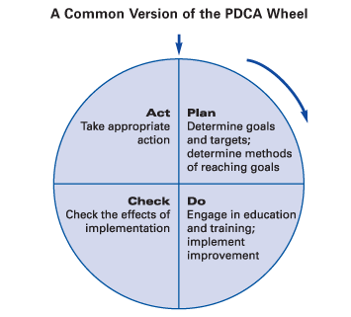

Figure 1. The PDCA Cycle (Lean Enterprise Institute)

The PDCA cycle can trace its roots back to Walter Shewhart in the 1930s and 1940s, being modified along the way, specifically by W. Edwards Deming (Johnson, 2002). The PDCA cycle is a well-known model for continual process improvement (Johnson, 2002).
The American Society for Quality, or ASQ, gives us 6 times when we should use the PDCA cycle, they are (American Society for Quality):
- As a model for continuous improvement.

- When starting a new improvement project.

- When developing a new or improved design of a process, product or service.

- When defining a repetitive work process.

- When planning data collection and analysis in order to verify and prioritize problems or root causes.
- When implementing any change.

In starting our process improvement project, we utilized the PCDA cycle to not only comply with policy, but more importantly to provide a structured framework and allow for continuous adjustment and improvement.

PLAN

As previously mentioned, there was clear consensus at the hospital for the need to change the process. To accomplish this project, we decided it was best to form a multi-disciplinary team from the beginning to create the best solution for all parties. Our team originally consisted of the Director of Physician Services, Program Director of the Internal Medicine Residency Program, Unit Director of 5 Mansfield nursing unit, Unit Director of 3 Crawford nursing unit, Sr. Manager

of Information Systems, and Administrative Resident. As the project moved on, we realized we needed more help from other departments and added them to our meetings.
During our first couple of meetings, we were looking to get an understanding of the current problems. Once we found these problems, we all agreed that a solution that made life easy for the nurses was the best route. It seemed like the best way to accomplish this would be to establish one pager number for each of the residency rotations. By doing this, these numbers would remain static even when the residents rotate in and out through the rotations.
The first proposed solution to accomplish this was to have a dedicated pager for each rotation. Once we met with the residents to hear their concerns and problems, we found that simply “passing” the pager from one person to the next would not be feasible for several reasons. First, oftentimes due to human error the pager inadvertently gets taken home. This creates obvious problems and delays before the pager is returned to the correct person. Secondly, if a pager breaks, it is not a fast fix to get a new pager with that number assigned to it. If a replacement pager is to be used, all of the nurses would have to know the new number to page. It is not easy to disseminate this information quickly and accurately, especially at night. Finally, the residents informed us that they are required to cover multiple services overnight. If each service had its own unique pager, then during the night one resident would have to have upwards of three pagers on their belt. It became clear that this was far from an ideal solution.
The idea of virtual pagers was then suggested by our IT team. With a virtual pager solution, each service gets one static number assigned to it. The residents then call into the software and assign themselves to that pager number. Essentially, when the virtual pager is paged it then forwards the page on to the signed in pager. When the next resident’s shift starts, they sign themselves in and it automatically signs the previous resident off. Virtual pagers do not

permit more than one resident to cover a pager at the same time. The virtual pager solution also allows one resident to sign themselves into several pager numbers, essentially forwarding all of the pages to those virtual pagers to their pager. This solved our problem for multiple coverages at night.
Once the team was in agreement that this virtual pager solution was the best way to design our system, we again sat down with the two residency programs to design the structure of the virtual pager numbers. We ironed out the details of how many services there were and how many pager numbers would be necessary. The family medicine residency program was simple, only needing four pagers for the group. For the internal medicine residency program however, they needed 18 virtual pager numbers. Some of the services have 24 x 7 coverage, while other services only cover Monday through Friday from 8:00 AM to 5:00 PM. This would create for some confusion for the nurses if it is not clearly stated.
To accomplish our goal of simplicity for the nurses and clarity on the different type services and their availability, the team created a color coded one page breakdown of the pager numbers. Our intention was to have this laminated and available at every nurses station and workstation on wheels (WOWs). This would enable the nurses to have access to the pager numbers at arms reach and quickly and efficiently get in touch with the resident that they needed. We decided on creating two versions of the contact sheets. One for the nurses and one for the Emergency Department (ED), Administrators on Duty (AODs), and Unit Directors. The nursing contact sheets did not contain the residency faculty pager numbers as we did not want the nurses paging the faculty on call physicians, they should page the residents. If problems arise, their superiors could page the faculty members. Please see figures 1 and 2 for our original designs.

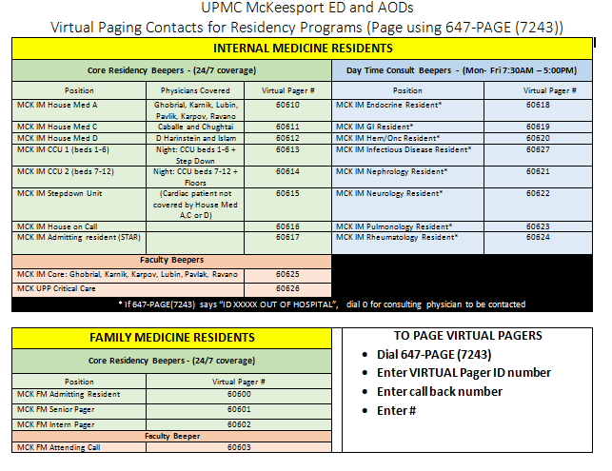

Figure 2. UPMC McKeesport ED and AODs Contact Sheet V1

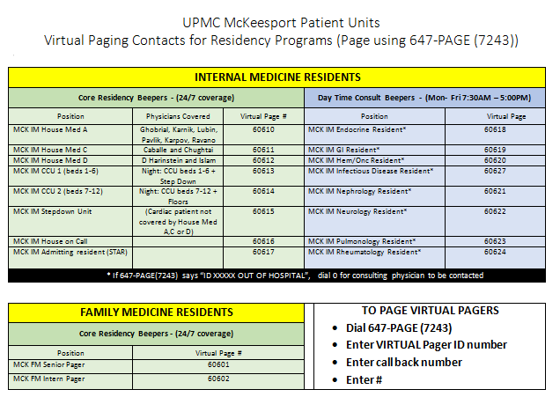
Figure 3. McKeesport Patient Units Contact Sheet v1

DO

As with any project with an ambitious scope, the “do” part of the PDCA cycle is critically important. As previously mentioned, we formed a very strong multi-disciplinary team to tackle the problem and to work through the solution. There were multiple steps involved in getting the virtual paging system up and running and operational.

Technology

The virtual pager solution was very reliant on technology. To set up the new process, our information technology team consisting of Joyce Krut, Senior Manager of Information Systems, and Mary Roberts, Senior Systems Analyst worked diligently to set up the pagers. The virtual pager solution is part of our already owned and utilized AMCOM communications software. AMCOM offers many solutions via their operator dashboard and allows for paging, on call coverage, one-way and two-way messaging, among many other features. AMCOM is utilized by many industries such as hospitals, government, casinos, hotels and resorts, corporate, higher education, senior living and aged care, and industrial and manufacturing (Company Overview of Amcom Software Inc.). Joyce and Mary worked to set up virtual pager accounts based on the schematic that the team developed in the planning stage. Joyce stated that once it was decided which pagers needed to be created, actually setting them up took minimal time and effort (Krut, 2016).

Nurse Education

We realized early on that a major factor in the success of this project was the buy in and understanding of the nurses. Considering this, we had our nursing education team of Jennifer Weimer and Rob Bauer participating with the team from an early date. They were critical in informing the rest of the group of how nurses learn best and how information gets disseminated out to the units. They created PowerPoint presentations that detailed when the change-over was going to occur, how to use the new system, and who to contact should any problems arise. This information was sent out to the units in packets, and they educated the unit directors and

clinicians on how to use the system. The unit directors (UDs) and clinicians then taught the nurses and each nurse signed the packet to show that they had received the information and understood the new process. We wanted to make sure that we fully trained critical departments, such as the Emergency Department. They page the residents on all of the new admissions to the hospital from the Emergency Department (ED). We met with the ED unit director and two of the Health Unit Coordinators (HUCs) to make sure that they understood the system and that we had their buy in. Once apprehensive of process change, after they understood the system and how to use it they were supportive of the new change.
As a final reminder of the new process change, several days before the go live we posted a screensaver reminder on the clinical desktops. It is pictured below. As a team we felt that the nursing staff and departments felt comfortable with the new process.
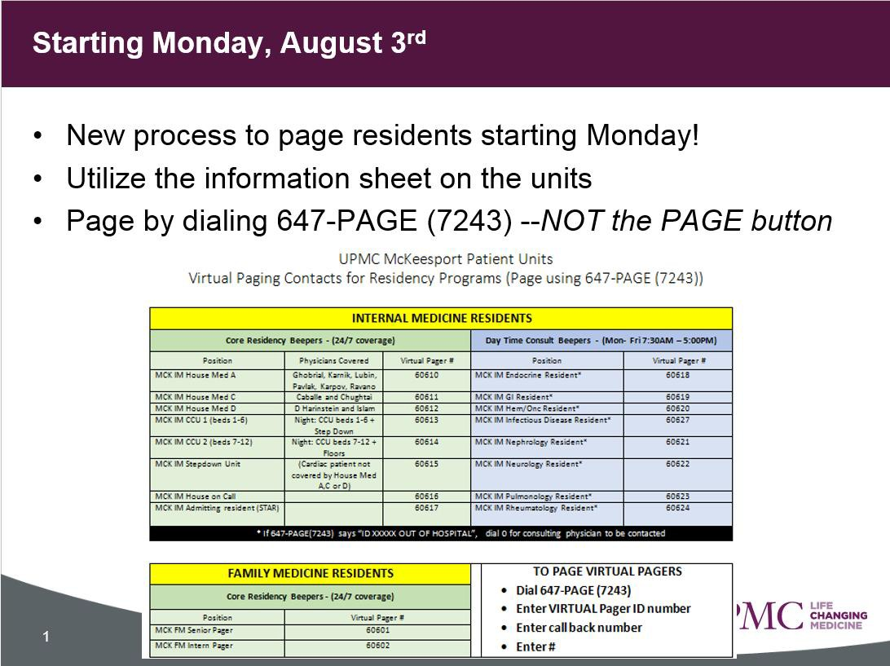
Figure 4. Process Change Screensaver

Resident and Physician Education

Physicians were another key stakeholder that needed to understand the process and be able to use the new system. With a medical staff that is mixed between private practice and employed physicians, some of which only come to the hospital several times a year, we knew it would be difficult to educate all of them. We felt that the best method would be to send a letter from the Vice President of Medical Affairs detailing the new process. Please see appendix A for a copy of the letter. We also created slides to display on the digital message boards in the doctor’s lounge.
To educate the residents on the new process, we relied heavily on the residency program director, who was a member of our process change team from the start. To educate the residents on how to sign in and out of the pagers, our IT team of Joyce and Mary met with the residents two times during their team meeting and gave detailed instructions and demonstrations. These instructions were later emailed to all of the residents to ensure they were always available to them.

Go-Live and Roll Out

Feeling confident that we had educated and trained all of the key stakeholders and that all was ready to go, the final step was to simply wait for the go live date. Once the go-live happened, we monitored the virtual pager numbers to make sure that all of the residents were signing in. Several forgot, and we placed calls with the residency program director and very quickly all residents were signed in. Some nurses called with questions on the system, which were

explained. Overall, the roll out of the new system was very smooth, mostly due to our extensive planning and education work.

CHECK AND ACT

Even though the process had been planned and implemented, our work was still not complete. Our team continued to meet for several weeks after the go-live of the virtual paging system. We did this for the important “Check” stage of the PDCA cycle. Once we found what was not working right, or not working the best it could, we came to a consensus as a team and acted to find an acceptable solution. It was our team’s intention to make sure that the virtual paging solution was working well for all of the groups that use it. To accomplish this, we talked with our representatives from nursing, the residency programs, and IT. What we heard very quickly was that there were issues with the residents not logging themselves on to the system. We brainstormed and decided that an email from the residency program director to all residents with instructions, along with talking to them during their daily huddle should drive home the importance. To help them remember to sign in and how to do it, we posted the instructions in the residency workroom, break room, and lounge next to the phones. We found that these solutions helped to reduce the number of times the residents were forgetting to sign on.
After a couple of months, we realized that the design of the pagers to the services was not ideal for the residents. The residency director had brought back to the group feedback from the residents who felt that only having one pager number for House Medicine D was resulting in too many pages for that one resident to handle. They were able to share the consults among themselves, but one resident was getting all of the pages, which was overwhelming. The group

convened and, while not an ideal solution, we decided to assign separate pager numbers for Dr. Harinstein and Dr. Islam’s residents. While they are both still part of House Medicine D, and can share consults between themselves, it results in less pages going to one resident. To make the change, we re-printed the virtual pager contact sheets, but realized that we had no way of ensuring version control. To improve the sheets and to help with version control, we added a “last updated on” distinction to the sheet. The updated sheet can be seen below.

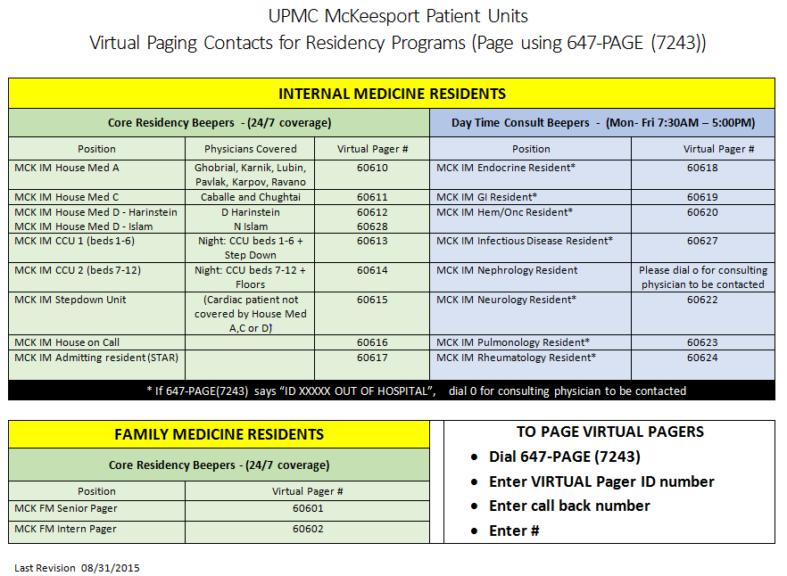

Figure 5. McKeesport Patient Units Contact Sheet v2

Although for the moment, the virtual pager process and system that we put it place seems to be working and suiting the needs of all key stakeholders, the process remains fluid. As new

physicians, residents, and nurses come to UPMC McKeesport, and as our organization changes and the technology changes, we will continue to go through the PDCA cycle to adapt and improve the resident paging process to be as reliable and efficient as possible to give our associates the tools they need to care for patients.
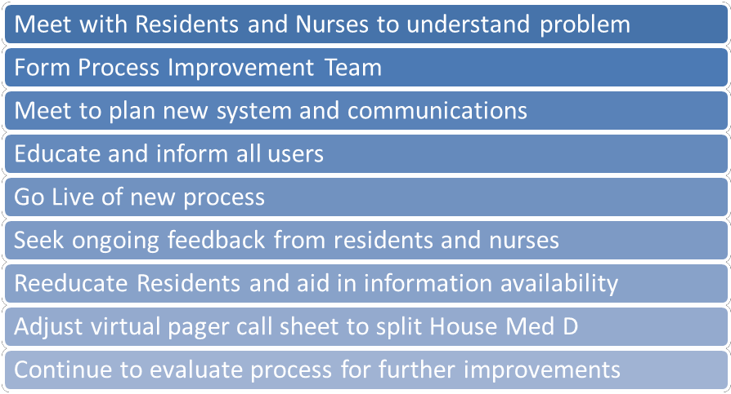

Figure 6. Steps of the Virtual Pager Process Improvement Process

DISCUSSION

Hospital communication systems are complex and difficult due to many factors. The unique needs and desires of physicians, nurses, and the technical constraints imposed by communication technology all dictate a framework in which systems must be designed. At UPMC McKeesport, the system that was in place created an unnecessary burden on paging resident physicians. This burden had many ill effects on the residents themselves, but also to the nursing staff at the hospital. As we know, many errors in the hospital can be attributed to communication errors.

Caring for patients and communicating between providers is a difficult task already, without the added burden of a complex system to navigate.
Our process improvement team formed with the intention of improving the system for all users, the nurses, preceptors, residents, and patients. To accomplish this, we followed the UPMC McKeesport process improvement policy, which directed us to use the Plan, Do, Check, Act (PDCA) cycle. Our team sorted through different options, but came to the conclusion that a virtual pager technology solution would work best for all parties. To implement, we educated the nurses, the physicians and residents, and rolled out the new process. The team got feedback after the roll out and made adjustments as needed. The process is still evolving, but the team considers the new process to be successful. The system is much more reliable and user friendly than the previous system. For the project, our own PDCA diagram can be found below.

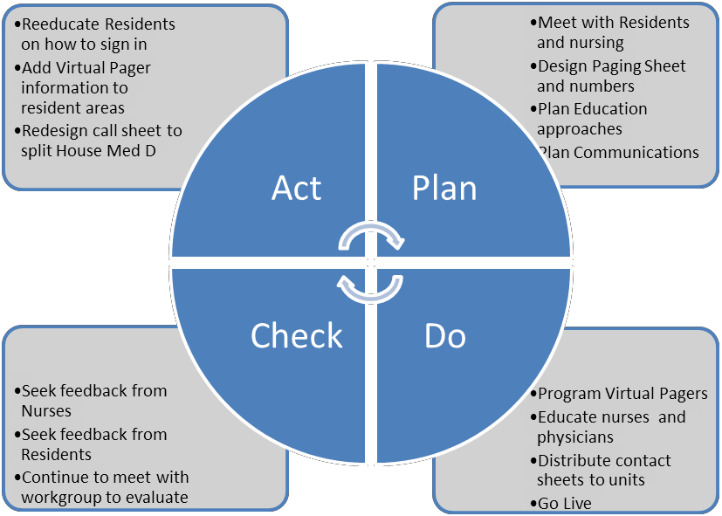

Figure 7. Virtual Pager Project PDCA Cycle

One of the biggest lessons learned from this project was the importance of getting the right people together on the team from the beginning and having their buy in. This allowed us to get end user feedback throughout the entire process. If we did not have access to this information, we could have tried to implement a process that would not work and would have been doomed to failure from the very beginning. Furthermore, since there was ownership of the process from the individual representatives, they were very willing to actively promote and defend the process change in order to spread acceptance among the residents and nurses. The PDCA cycle also gave us a strong framework to implement the process change. By ensuring that we followed the steps and had planned all aspects, we ensured a smooth roll out.
Keeping close tabs on the process and actively seeking feedback allowed us to make rapid improvements to meet the needs and expectations of the end users. Although we planned extensively, vetted our plans with end users, we still found that some adjustments needed to be made. This is to be expected, and is why we were in regular communication through email and phone between team members and encouraged end users to give feedback on the system. Once we heard there were problems, changes were instituted the next day to help the residents to remember to sign in. To split House Medicine D, the change took a couple of weeks of meetings to decide, plan, and implement the change.
Overall, I attribute the success of this project to the strong team that we formed at the beginning of the project. Without having these important stakeholders at the table over the course of this two month project, we would not have had the success that we did. This group was dedicated, had a clear vision, and everyone did their part to contribute to the success of the project as a whole. Utilizing the PDCA cycle gave us the framework and allowed us to be nimble

to implement these changes in the hospital environment in real time. In closing, the virtual pager system continues to function today and has been built to remain flexible and function well into the future.

APPENDIX A: LETTER TO MEDICAL STAFF

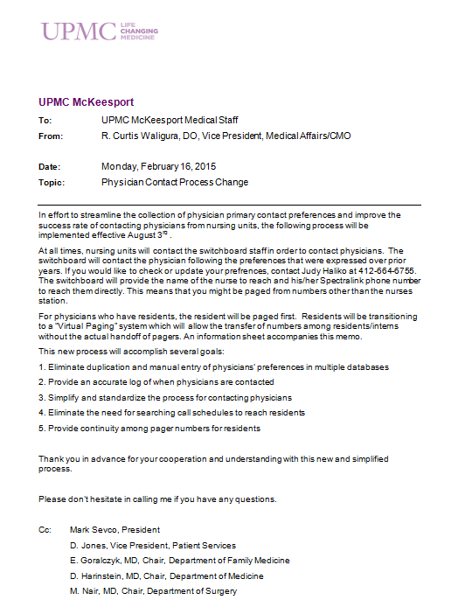

APPENDIX B: UPMC MCKEESPORT PERFORMANCE IMPROVEMENT POLICY

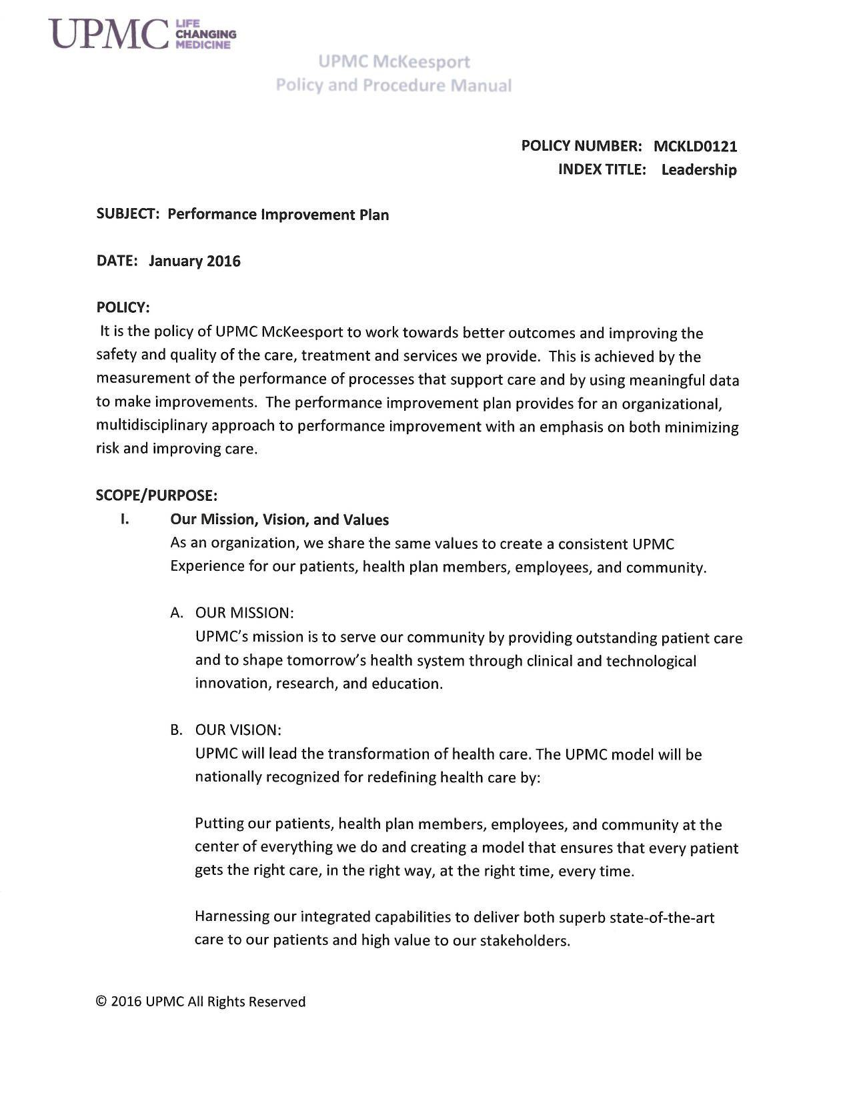

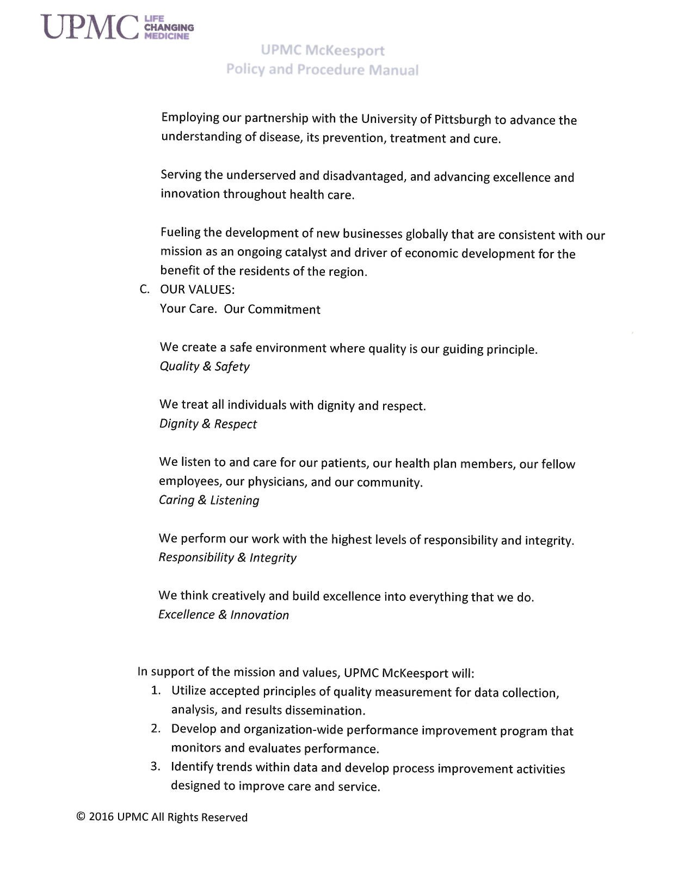

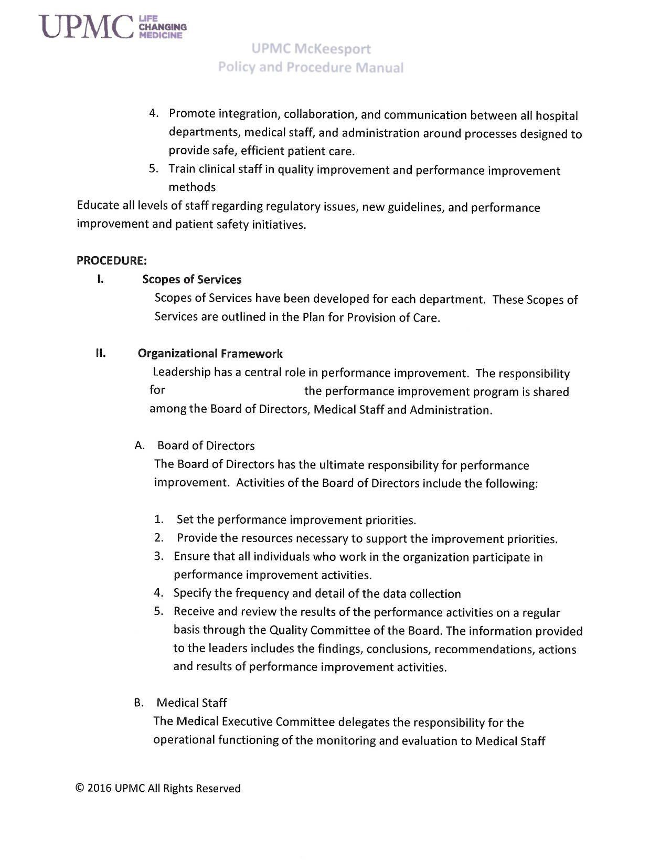

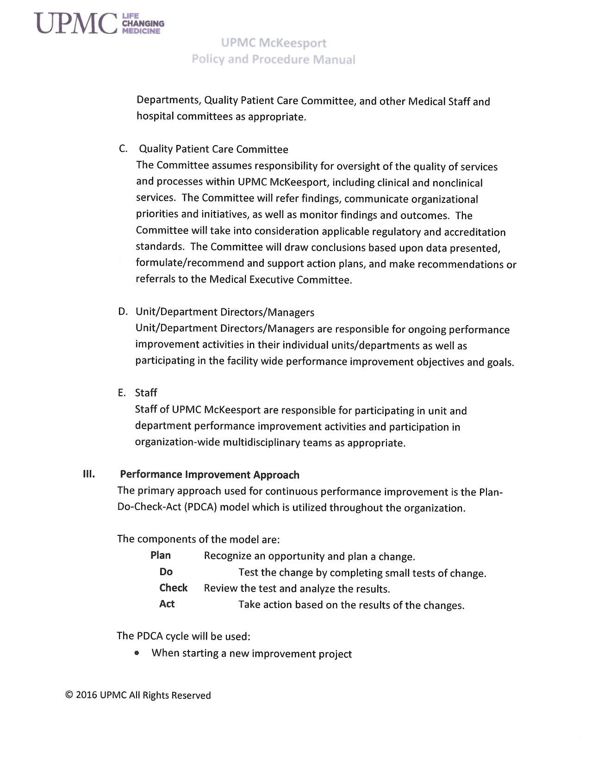

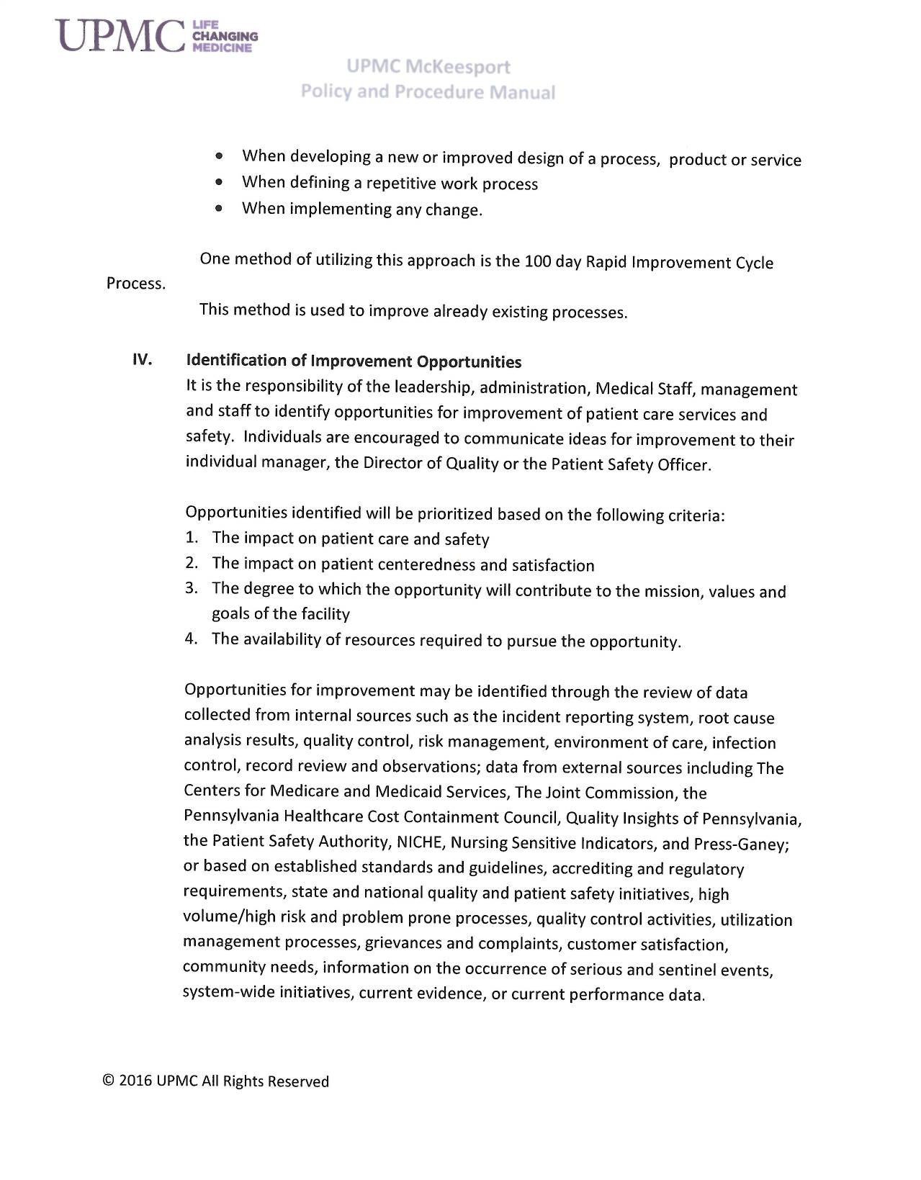

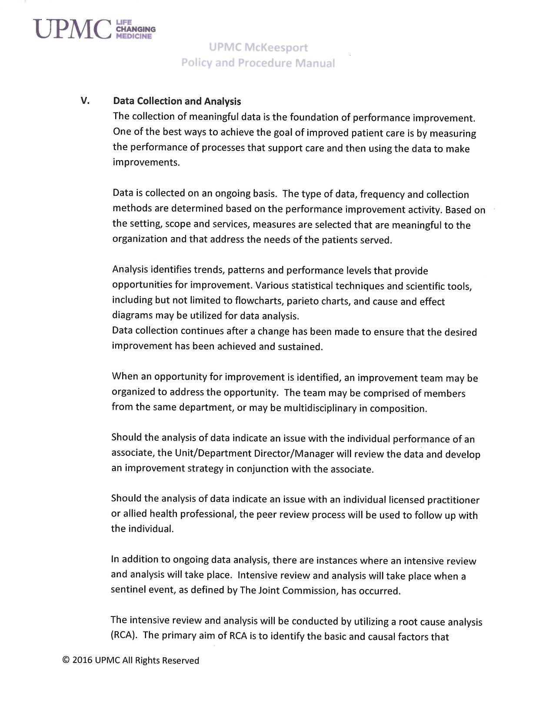

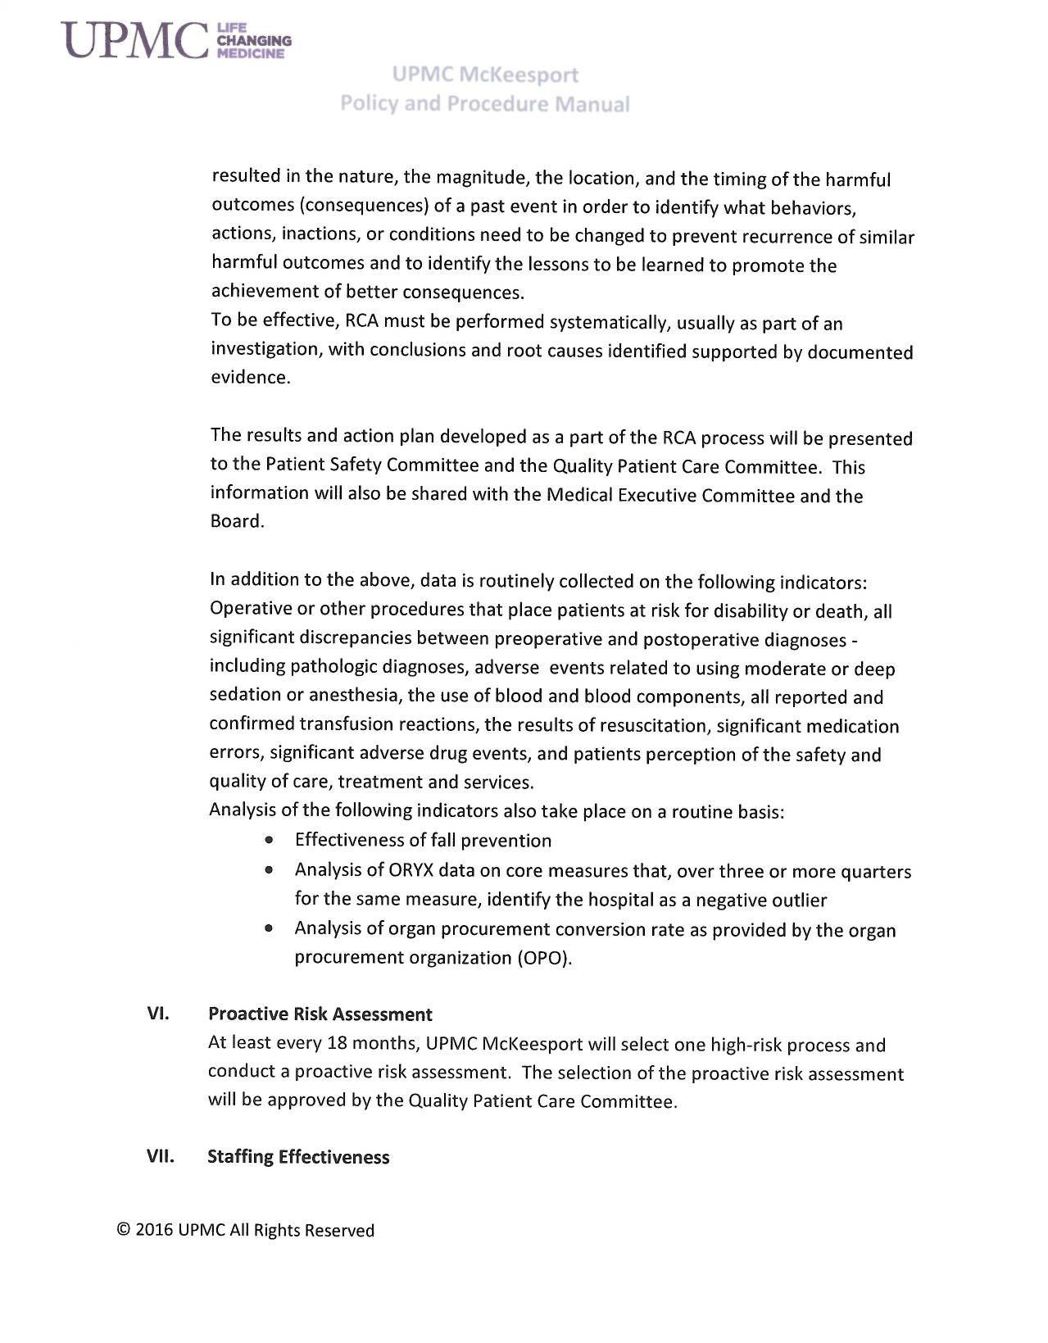

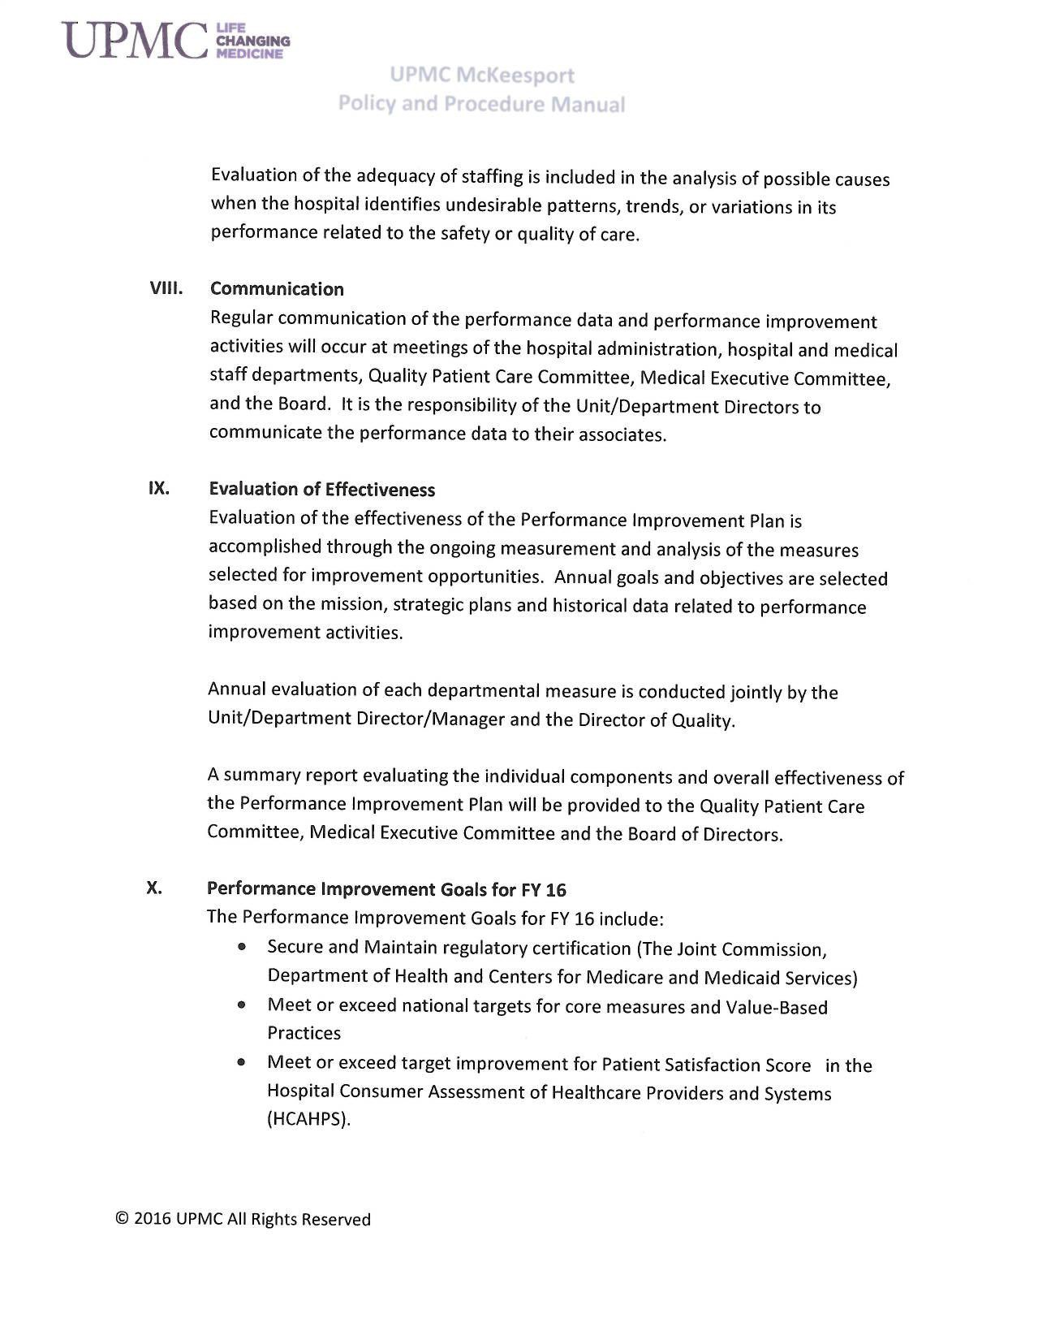

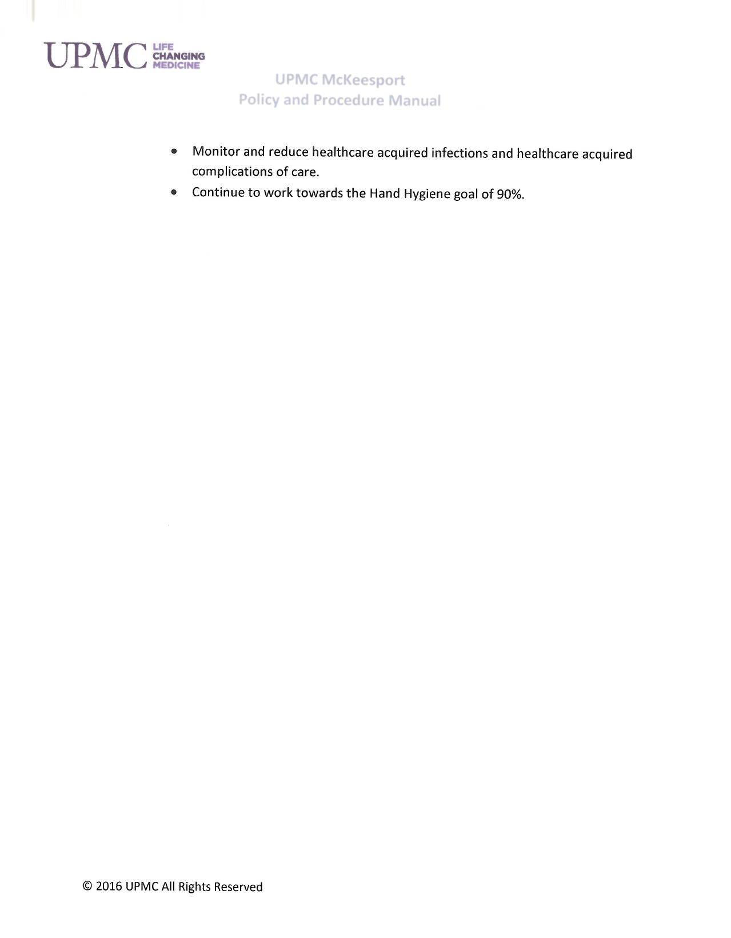

BIBLIOGRAPHY

American Society for Quality. (n.d.). Plan-Do-Check-Act (PDCA) Cycle. Retrieved from American Society for Quality: http://asq.org/learn-about-quality/project-planning- tools/overview/pdca-cycle.html

Company Overview of Amcom Software Inc. (n.d.). Retrieved from Bloomberg Business: http://www.bloomberg.com/research/stocks/private/snapshot.asp?privcapId=4693028

Guzik, M. (2016, March 3). Nursing View of Resident Page Project. (K. MacDonald, Interviewer)

Johnson, C. (2002, May). The Benefits of PDCA. Retrieved from Quality Progress, American Society for Quality: http://asq.org/quality-progress/2002/05/problem-solving/the- benefits-of-pdca.html
Krut, J. (2016, March 2). Technology Aspect Of Virtual Pagers. (K. MacDonald, Interviewer) Kutscher, B. (2013, May 4). The Rural Route. Retrieved from Modern Healthcare:
http://www.modernhealthcare.com/article/20130504/MAGAZINE/305049953

Plan, Do, Check, Act. (n.d.). Retrieved from Lean Enterprise Institute: http://www.lean.org/lexicon/plan-do-check-act

The Joint Commission. (2007). Improving America's Hospitals: The Joint Commission's Annual Report on Quality and Safety. The Joint Commission.

UPMC McKeesport. (n.d.). Our History at UPMC McKeesport. Retrieved from UPMC: http://www.upmc.com/locations/hospitals/mckeesport/about/Pages/history.aspx

UPMC. (n.d.). UPMC Facts and Stats. Retrieved from UPMC.com: http://www.upmc.com/about/facts/pages/default.aspx

Wu, R. C., Tran, K., Lo, V., O'Leary, K. J., Morra, D., Quan, S. D., & Perrier, L. (2012). Effects of clinical communication interventions in hospitals: A systematic review of information and communication technology adoptions for improved communication between clinicians. International Journal of Medical Informatics, 723-732.

