A COMPARISON OF METHODS TO ESTIMATE CASE NUMBER
FOR LYME DISEASE IN ALLEGHENY COUNTY, PENNSYLVANIA, 2014

by
Xirun Chen
B.S., Economics, Guangdong University of Finance & Economics, China, 2008

M.S., Statistics, University of Vermont, 2013

Submitted to the Graduate Faculty of
Epidemiology
Graduate School of Public Health in partial fulfillment
of the requirements for the degree of
Master of Public Health

University of Pittsburgh
2016

UNIVERSITY OF PITTSBURGH
GRADUATE SCHOOL OF PUBLIC HEALTH

This essay is submitted
by
Xirun Chen

on

May 10th, 2016
and approved by

Essay Advisor:
Nancy W. Glynn, PhD ______________________________________
Assistant Professor
Epidemiology
Graduate School of Public Health
University of Pittsburgh

Essay Reader:
Brenda F. Kurland, PhD ______________________________________
Research Associate Professor
Biostatistics
Graduate School of Public Health
University of Pittsburgh

Essay Reader:
Jennifer Fiddner, MPH ______________________________________
Epidemiology Research Associate
Bureau of Assessment, Statistics and Epidemiology
Allegheny County Health Department
Copyright © by Xirun Chen
2016
ABSTRACT

Background: Lyme disease is the most commonly reported tick-borne illness in the United States. The Allegheny County Health Department is challenged by progressively increasing reports of Lyme cases recently. Most reports require follow-up investigation by public health officials with laboratories and providers to obtain missing clinical information. Due to this burgeoning burden, it is imperative to seek alternative surveillance approaches to monitor Lyme disease. The purpose of this study was to examine the accuracy of sampling and modeling methods for predicting, the number of cases for Lyme disease in Allegheny County, using 2014 data.
Nancy W. Glynn, PhD

A COMPARISON OF METHODS TO ESTIMATE CASE NUMBER
FOR LYME DISEASE IN ALLEGHENY COUNTY, PENNSYLVANIA, 2014
Xirun Chen, MPH
University of Pittsburgh, 2016

Methods: A 20% sample of the laboratory reports was selected by R program. The estimate of sampling method was calculated by multiplying the number of cases resulting from sample by five. Univariate logistic regression models were conducted to determine the significant predictors related to final case status. The estimate of modeling method was generated from predicted probabilities which were computed by multivariate logistic regression model based on a 20% sample. Both methods were simulated for 1,000 times to reduce variance.
Results: Univariate logistic regression analysis demonstrated that greater odds of being classified as “confirmed” were revealed for investigations with more positive test results (OR = 2.29, CI 1.91-2.73), and those involving patients aged 60 or older (OR = 1.71, CI 1.31-2.26). Sampling and modeling methods yielded identical (758 with a standard deviation of 36.2) estimated numbers of confirmed and probable cases. For both methods, 96.7% simulated case counts were within the 10% margin of error of the 758 true cases. Modeling method did not improve the accuracy of the sampling results. 20% sampling rate was found better suited than rates of 10% and 33% in terms of reducing follow-up burden and tracking trends of Lyme cases.
Conclusions: Sampling estimation was efficient and accurate in estimating case occurrences and alleviating investigative burden. The public health significance was highlighted as future application of sampling could conserve limited surveillance resources by reducing follow-up efforts while providing precise estimates. SAS macros were provided to implement this approach for 2015 Lyme surveillance.

TABLE OF CONTENTS
preface ix
1.0 Introduction 1
1.1 EPIDEMIOLOGY OF LYME DISEASE 1
1.2 CLINICAL SYMPTOMS AND DIAGNOSIS OF LYME DISEASE 2
1.3 SURVEILLANCE OF LYME DISEASE 3
1.4 PUBLIC HEALTH SIGNIFICANCE 4
2.0 OBJECTIVE 6
3.0 Methods 7
3.1 DATA SOURCE 7
3.2 STATISTICAL ANALYSIS 8
4.0 RESULTS 11
5.0 DISCUSSION 16
bibliography 19
List of tables
Table 1. Characteristics of the Lyme Disease Groups, Allegheny County, PA, 2014* 11
Table 2. Odds Ratios for Confirmed Lyme case from Univariate Regression Analysis* 12
Table 3. Confirmed Lyme Disease Characteristics Comparison - Observed versus Estimated cases, Allegheny County, PA, 2014 15
List of figures
Figure 1. Steps and procedures involved in Lyme disease surveillance 5
Figure 2. Study flow chart indicating simulation and repeated generating procedure 10
Figure 3. Density of final estimates from sampling and modeling methods 13
Figure 4. Observed and Estimated Lyme Case Number, Allegheny County, PA, 2014 14
preface
I am very fortunate to have a committee consisting of experts in their respective fields. I would like to thank every member on this committee. Thank you for your time and efforts in guiding my study and helping me obtain the ability of critical thinking. I would like to thank my advisor: Dr. Nancy Glynn for the help with constructive reviews of this essay. I thank Dr. Brenda Kurland for the advice on analysis plan and programming.
I would like to express my special thanks to Jennifer Fiddner, MPH and Dr. Kristen Mertz from the Allegheny County Health Department for introducing me to the topic of Lyme disease surveillance as well for the support on the way. I would also like to thank the volunteers and public health professionals that worked with me on the Allegheny County Lyme disease surveillance project. I also thank Kristin Komazec from the University of Pittsburgh Graduate School of Public Health for the help of gathering follow-up dataset. I thank Thom Stulginski and John Kokenda from the Allegheny County Health Department for providing the information of residency.

Introduction

EPIDEMIOLOGY OF LYME DISEASE
Lyme disease (LD) is the most common vector-borne disease in the United States. In 2014, it was the fifth most common nationally notifiable disease. Lyme disease is caused by the bacterium Borrelia burgdorferi and is transmitted to humans through the bite of infected blacklegged ticks. Each year, approximately 30,000 new Lyme disease cases are reported to the Centers for Disease Control and Prevention (CDC) by state health departments. This number has grown three fold over the past two decades, from 9908 confirmed cases in 1992 to 27,203 confirmed and 9104 probable cases in 2013[1-3]. This is attributed to a true increase in Lyme disease incidence and increased detection due to widely applied laboratory testing [2]. A total of 96% of confirmed Lyme disease cases were reported from 14 states that are localized primarily in the northeast and upper Midwest [3]. The risk factors of Lyme disease are determined by the geographic distribution of the infected ticks. Specific risk factors include areas which are suitable tick habitats (e.g., woodlands, grassy areas, leaf litter), deer density, and outdoor activities, such as gardening and hiking [4]. Certain occupations also increase the risk of infection. Outdoor workers, soldiers, and hunters have higher rates of infection [5]. There is a bimodal age distribution for the incidence of Lyme disease, with peaks among children 5–9 years old and among adults 45–59 years old, but patients of all ages are at risk [1].

CLINICAL SYMPTOMS AND DIAGNOSIS OF LYME DISEASE
Erythema migrans (EM) rash, also referred to as a ‘bull’s-eye’ rash, occurs in 70–80% of patients infected after a delay of 3 to 30 days [6]. EM is often accompanied by flu-like symptoms, such as fever, headache, muscle ache, tiredness [6]. If the patient was left untreated, Lyme neuroborreliosis might develop within weeks [6]. Possible symptoms include severe headaches and neck stiffness, unilateral or bilateral facial palsy, and inflammation of the brain and spinal cord [6]. In some rare cases, which is about 5% of untreated patients, Lyme carditis may develop after several weeks of infection. The common symptoms are shortness of breath, heart palpitations and chest pain. Further, about 60% of untreated patients will begin to have arthritis related symptoms after months of infection [6].
The diagnosis of Lyme disease is usually based on the recognition of the characteristic clinical symptoms and a history of exposure in an area where the disease is endemic [6]. Laboratory blood testing is often employed to assist or confirm diagnosis. However, the positive laboratory test results alone cannot be used to determine infection unless the appropriate clinical symptoms are present since patients who have spirochetal infection, rheumatoid diseases or infectious mononucleosis may have false-positive reactions [7]. In addition, antibody response may persist for many years after antibiotic treatment. Evidence shows that immunoglobulin M or immunoglobulin G antibody response still could be tested as positive among patients who had Lyme disease 10-20 years earlier [8].

SURVEILLANCE OF LYME DISEASE
For surveillance purposes, the CDC classifies Lyme disease as three groups: confirmed, probable and suspected. A confirmed case is defined as (1) a physician diagnosed EM with a known exposure; (2) an EM without a known exposure but with laboratory evidence of infection; (3) a case with late stage symptoms and with laboratory evidence of infection. Probable cases are any other physician diagnosed case of Lyme disease with laboratory evidence of infection. A suspected case is defined as an EM where there is no known exposure and no laboratory evidence, or a case with laboratory evidence but no clinical symptom information [9]. Cases failing to meet any of the above criteria are classified as non-cases. CDC defines ‘exposure’ as the patient having been in the area of a Lyme disease endemic county. According to the Pennsylvania Department of Environmental Protection (DEP)’s study, it is confirmed that every county in the commonwealth has blacklegged ticks carrying the Borrelia burgdorferi [10]. In other words, all counties in Pennsylvania are considered as endemic, and all reported cases in Pennsylvania are considered as having a known exposure. The criteria for a confirmed case in Pennsylvania can be simplified as (1) a case of EM; (2) a case with late stage symptoms and with laboratory evidence of infection.

PUBLIC HEALTH SIGNIFICANCE
In practice, healthcare providers and laboratories submit reports to the local health department by electronic report through the state based surveillance system, or by mailed and/or faxed paper report. Few of these cases are directly diagnosed by physicians without ordering laboratory tests. Most of reports are in the form of a laboratory report with a test result indicating possible Lyme disease. This could include a positive or equivocal unspecified antibody screen or EIA/FIA, a positive IgM immunoblot or positive IgG immunoblot, or any combination of these laboratory tests. Since there is no mandatory reporting for related clinical symptoms, it requires follow-up investigations by public health professionals to contact providers and obtain missing clinical information. This has become a significant burden to many state health departments. Figure 1 presents the steps and procedures which are involved in Lyme disease surveillance. Consequently, some states have modified components of their systems to reduce the number of laboratory cases that are followed up. For example, the Wisconsin Department of Health Services recommended local health departments only to follow-up provider reported EM cases to obtain exposure and clinical symptoms information, which would reduce about 70% of the Lyme disease caseload for the public health system and 30%~50% of the workload for healthcare providers. However, this approach would lead to a loss of 24% of confirmed cases and 15% of probable cases [11]. As a result, Lyme disease cases are grossly underreported. Such an alternative approach might fail to provide sufficient evidence to describe the trends of Lyme disease for the purpose of public alerts.
Figure 1. Steps and procedures involved in Lyme disease surveillance
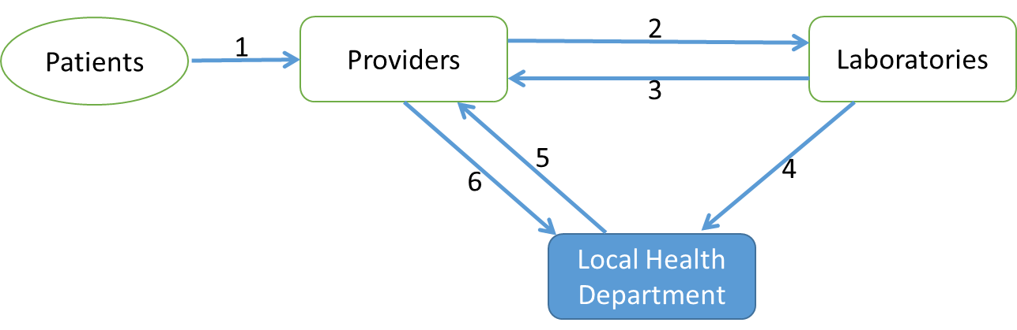
After (1) receiving patients, healthcare providers will (2) order test from clinical laboratories. Laboratories will (3) send back the test results to providers and (4) report positive results to local health department. If clinical information is not present in the report, local health department will (5) contact providers to request missing information. Providers will (6) send back missing clinical information to local health department. Finally, the case is classified by the specific algorithm on all collected data.

In recent years, Pennsylvania has led the nation in the number of Lyme disease cases, with 7,457 reported in 2014 [12]. The Allegheny County Health Department (ACHD) has been facing the challenge of progressively increasing number of Lyme cases. During 2014, among a total of 1,455 positive laboratory reports, ACHD was able to verify 822 confirmed and probable cases of Lyme disease. Based on this trend, in 2015, ACHD estimated more than 2,000 investigations of positive laboratory reports. This pronounced surveillance burden prompted the development of an alternative approach to reduce the workload of public health professionals while effectively maintaining the ability to track Lyme disease trends.

OBJECTIVE
Using data collected through the 2014 ACHD Lyme disease surveillance project, this study compared the estimates from sampling and logistic regression modeling methods in order to explore an alternative surveillance solution to reduce the investigative burden.

Methods

DATA SOURCE
Surveillance data were extracted from Pennsylvania's version of the National Electronic Disease Surveillance System (PA-NEDSS) for the year 2014. There were 1,455 positive laboratory reports extracted (756 confirmed and 66 probable cases), each of which had at least one positive laboratory test result (among EIA or IFA, IgG and IgM immunoblot, DNA test for bacteria, and others). The analytical dataset was different from the ACHD published documents. By reviewing investigation documents, 96 reports (96 non-case) were excluded since providers were not able to be reached. An additional 50 (34 confirmed, 1 probable and 15 suspected/non-case) reports were excluded due to lack of investigation records. Further, 29 of the known EM cases were also dropped from all laboratory reports since those were confirmed cases by definition thus not needing follow-up investigations. Among the 1,280 finalized laboratory reports, 693 cases were classified as confirmed and 65 were classified as probable cases after investigations based upon CDC case definition. (Figure 2)

STATISTICAL ANALYSIS
Application of Sampling method in Lyme disease surveillance was evaluated by New York State Health Department since 2006 [13]. Retrospective analyses in five counties showed that the estimated results and case characteristics were rarely significantly different from observed results [13]. By 2013, 19 (33%) counties in New York State were conducting the sampling strategy [13]. The sampling method used by New York State was adapted in this study. According to ACHD’s 2014 Lyme disease surveillance data, it was assumed that 60% of laboratory reports would be confirmed or probable cases. Since 20% of sampling rate would provide an estimate within 5% margin of error of observed results [14], it was applied in this study. The detailed analyses are as follows. Firstly, 20% of the laboratory reports were selected by R program (version: 3.2.5) [15]. The selection was implemented using the function “sample_n” in “dplyr” package with simple random sample method [16]. For sampling method, it was assumed that the other 80% of cases had identical results with the 20% sample. Therefore, the estimate was calculated by multiplying the number of cases resulting from sample by five (the inverse sampling fraction).
As a comparison to utilizing sampling method alone, an additional logistic regression modeling procedure was conducted. One possible advantage of this procedure is that it may improve estimate accuracy by incorporating additional information from the remaining reports. The modeling procedure started with building univariate logistic regression models using full 2014 data to determine the significant predictors related to final case status, and then multivariate logistic regression model was fitted based on the 20% sample to predict probabilities of being a case for the other 80% reports. Finally the binary case status for the 80% was generated from predicted probabilities by “rbinom” function in R [15]. The generating procedure was repeated for 500 times to obtain a greater precision. Estimation of logistic regression modeling was the average case numbers from 500 generated results plus the true case number of the 20% sample.
In order to reduce variance, both methods were simulated for 1,000 time. The final estimates of sampling and modeling methods were the means of case number from 1,000 repeated simulation results. Details of the simulation procedure and repeated generating procedure are shown in Figure 2.
The binary final case classification was coded as the outcome variable in the simulation procedure. In the current study, “confirmed” and “probable” cases were combined as the “confirmed” group since their classification criteria were approximately the same. Similarly, “non-case” and “suspected” cases were also combined into “non-case” group. Total number of positive test results, age (0-29, 30-59, >=60), gender (female, male) and residency (inside/outside city of Pittsburgh) were examined by a univariate logistic regression model using the full data (n=1,280). Residency was classified according to the zip code of the patients’ home addresses. The accuracy of estimation was determined by the percentage of estimated case numbers from simulation procedure which were within 10% margin of error of the actual case count.
After having compared the estimation of two methods from simulation procedure, further analysis using sampling method alone with 10%, 20% and 33% of sampling rate was conducted to evaluate the representativeness.
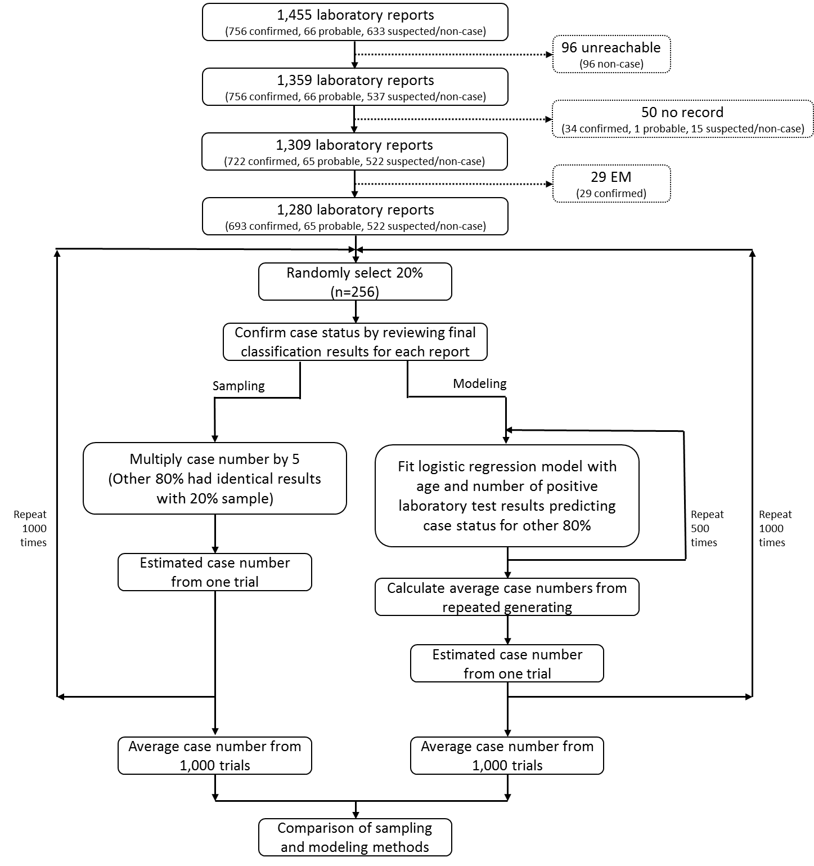
Figure 2. Study flow chart indicating simulation and repeated generating procedure

RESULTS
Table 1 shows the characteristics of the cases in each class. A total of 59% (758 of 1,280) of the reports had been classified as confirmed or probable cases after investigation. Averagely, the reports in the confirmed group (including probable cases) had more than two positive laboratory results (2.3, SD=0.7), which were notably higher than those in the non-case group (p<0.0001). The distribution of age in confirmed and non-case groups was also significantly different (p=0.0003). Non-case group had more patients in 30-59 age group (45.8%). Gender and residency were not markedly associated with case classification but p values were moderate (at 0.1 level). They were still included into univariate logistic regression analysis to examine significance.
Table 1. Characteristics of the Lyme Disease Groups, Allegheny County, PA, 2014*
Predictors | Confirmed (including probable)  (n=758) | Noncase (including suspect)  (n=522) | p - value**
Total positive results, mean (SD) | 2.3 (0.7) | 1.9 (0.6) | <0.0001
Age group, n (%) |  |  | 0.0004
0-29 | 232 (30.6) | 150 (28.9)
30-59 | 270 (35.6) | 239 (45.8)
>=60 | 256 (33.8) | 132 (25.3)
Gender, n (%) |  |  | 0.0935
Female | 315 (42.2) | 245 (48.0)
Male | 431 (57.8) | 266 (52.0)
Residency, n (%) |  |  | 0.1329
Inside Pittsburgh | 566 (74.7) | 370 (70.9)
Outside Pittsburgh | 192 (25.3) | 152 (29.1)
*The analytical dataset (n=1,280) was different from ACHD published documents
** p value for two sample t-test.
The results of the univariate logistic regression model are presented in Table 2. The total number of positive results and age had a significant association with the final confirmed case status in crude model. The records that contained one more positive lab test result had 2.29 (95% CI=1.91, 2.73) times of the odds to be a confirmed Lyme disease case. The odds to be classified as confirmed cases for senior patients (60 years or older) were 1.71 (95% CI= 1.31, 2.26) times of the odds of patients who were 30-59 years old. Moreover, the model showed that gender and residency were not significantly related to the final classification. Total positive results and age group were included to multivariate logistic regression model in simulation procedure.
Table 2. Odds Ratios for Confirmed Lyme case from Univariate Regression Analysis*
Predictors |  | Crude OR(95%CI)
Total positive results |  | 2.29 (1.91, 2.73)
Age group
30-59 |  | Reference
0-29 |  | 1.36 (1.04, 1.78)
>=60 |  | 1.71 (1.31, 2.26)
Gender
Female |  | Reference
Male |  | 1.26 (0.99, 1.58)
Residency
Inside Pittsburgh |  | Reference
Outside Pittsburgh |  | 0.83 (0.64, 1.06)
*The analytical dataset (n=1,280) was different from ACHD published documents

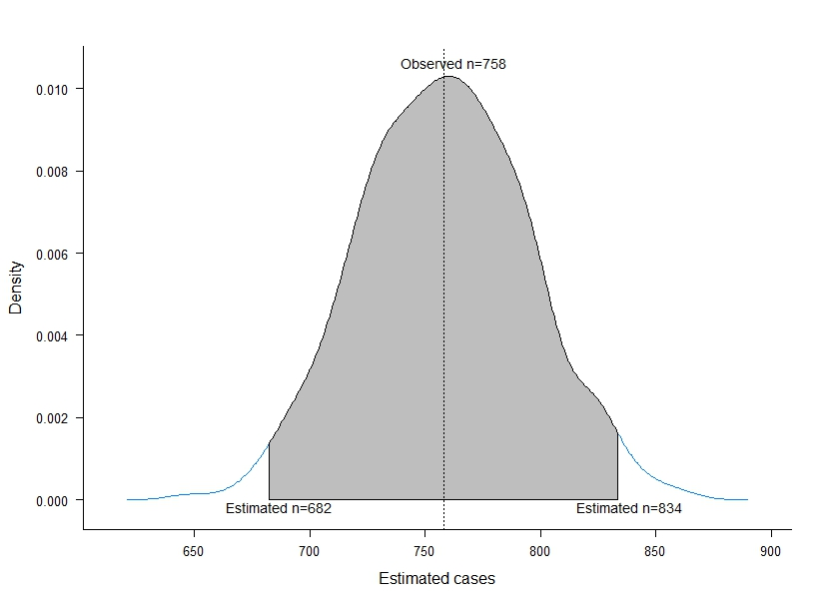
Figure 3 presents the density of 1,000 estimates from sampling and modeling methods. Since the distributions from both methods were indistinguishable, the curves in Figure 3 were overlapped. Both methods yielded identical estimated numbers of confirmed and probable cases, with the mean being 758.4 and a standard deviation of 36.2. For both methods, 96.7% of estimates (967 of 1,000, shaded areas in Figure 3) were within 10% margin of error of observed cases (682 to 834).
Figure 3. Density of final estimates from sampling and modeling methods
Samples of 10%, 20% and 33.3% were extracted from the 1,280 reports with EM status unknown prior to investigation. Estimates were calculated by multiplying the number of cases resulting from sample by 10, 5 and 3 (the inverse sampling fraction) respectively. Figure 4 illustrates the estimated results of sampling methods with different sampling rates. Sample of 10% provided an estimate of 680 confirmed cases, which was close to observed 693 cases, however the calculated 50 probable and 60 suspected cases were significantly different from observed. On the other hand, samples of 20% and 33% estimated 665 and 705 confirmed cases respectively that were close to observed results. Moreover, their estimated proportions of probable and suspected cases were not significantly different from observed numbers.

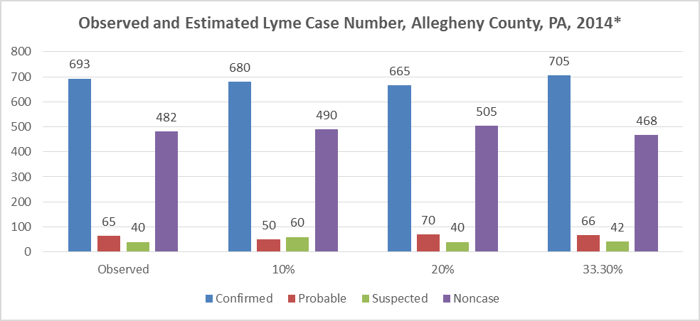
*The analytical dataset (n=1,280) was different from ACHD published documents

Figure 4. Observed and Estimated Lyme Case Number, Allegheny County, PA, 2014
The representativeness of observed and estimated proportions was also examined and shown in Table 3. The estimated proportion of confirmed cases which were in Pittsburgh from 10% sample was 64.7% which was significantly different from the observed results. All of other characteristics, including age group, gender and proportion of EM related cases were not significantly different at the p<0.05 level in Chi-square test.

Table 3. Confirmed Lyme Disease Characteristics Comparison - Observed versus Estimated cases, Allegheny County, PA, 2014
Characteristics | Observed | Estimated from sample
Characteristics | Observed | 10% | 20% | 33.30%
Age Group
0-29 | 31.8% | 26.5% | 28.6% | 31.9%
30-59 | 36.5% | 44.1% | 45.1% | 35.3%
>=60 | 31.7% | 29.4% | 26.3% | 32.8%
Gender
Female | 42.9% | 45.6% | 43.6% | 41.3%
Residency
Inside Pittsburgh | 74.5% | 64.7%** | 72.2% | 72.3%
EM related cases | 68.3% | 72.1% | 69.9% | 69.8%
*The analytical dataset (n=1,280) was different from ACHD published documents
* Significantly different from observed results

DISCUSSION
The results of this methodological study indicated that simple random sampling provided an accurate estimation of Lyme disease cases, and logistic regression modeling (number of positive tests, age) did not improve the estimates. Moreover, the sampling method had the capability to estimate “probable” and “suspected” Lyme disease cases comparing to modeling method. Further analysis of representativeness for 10%, 20% and 33% sampling rates indicated that the results from 20% samples were highly representative of the observed characteristics of Lyme cases. Thus, a 20% sampling rate is recommended for future Lyme disease surveillance as it could conserve limited resources by reducing follow-up efforts while providing precise estimation.
Interestingly, logistic regression models for estimation are frequently applied in the higher education realm [17]. For example, studies used logistic regression modeling to predict student's’ admission, enrollment and retention [18-20]. Whereas in public health and the medical research field, logistic regression is more widely used to identify risk factors in term of odds ratios. From the results of logistic regression modeling approach, several points should be highlighted. First, the more positive test results one report had, the more likely it would be a confirmed case. Especially among the reports whose IgG immunoblot test were positive, 85.8% of them were confirmed cases (data not shown). Second, there were no significant gender differences for the confirmed Lyme disease, which concurred with the findings in previous studies [21, 22]. Third, older patients (≥60) were more likely to be confirmed cases compared with others. In addition, there were no significant differences between residents inside or outside the City of Pittsburgh for the probability of being classified as a confirmed case. It is reasonable since place of residence was not always the place of infection, so it would not truly reflect the geographical risk of Lyme disease.
The main disadvantage of the logistical regression analysis is that the accuracy of the prediction was extremely limited by the lack of patients’ information. Only age, gender, residency and lab test results in PA-NEDSS were available as predictors, and limited negative lab tests results were reported to PA-NEDSS. Under such circumstance, the model fit was difficult to be improved. Additionally, it was assumed that cases status was independent in the logistic regression modeling. However, in reality, Lyme disease cases might occur in clusters. Another limitation is that the predictors which were used in model were determined through complete 2014 data. It is questionable to apply retrospective model prospectively to estimate future incidence considering the risks of Lyme disease, e.g., climate, which might change dramatically year by year.
Similar retrospective studies undertaken in New York State and Minnesota showed that 20% samples of laboratory reports produced estimated confirmed case counts that were similar to the observed counts [13, 23]. These results coupled with our study findings revealed that the sampling method could provide accurate estimates with only 20% of previous follow-up efforts. This study also showed that most of the characteristics of estimate cases from sampling method were not significantly different from observed cases. These characteristics could be used to describe the burden and risk factors of Lyme disease in Allegheny County.
However, there are several limitations to the sampling method. First, this study was only conducted retrospectively for one year. The consistence of accuracy for the estimation still calls for more data to verify. Second, although the estimates of Lyme disease can be used for public alert and education, the practice of sampling surveillance is still in controversy. Currently, Centers for Disease Control and Prevention (CDC) and Council of State and Territorial Epidemiologists (CSTE) have not supported the publication of estimates for Lyme disease [13].
Overall, although using logistic regression modeling did not improve the estimates, the sampling method alone still provided efficient and accurate estimation of Lyme disease cases at the county level. Utilizing this approach to estimate cases appears to be a suitable means to reduce the investigative burden, and also to provide sufficient data to describe the trends of Lyme disease which can be utilized for tickborne disease prevention and control.
At the end of this study, a set of SAS macros was provided to the ACHD to implement this sampling method to reduce investigative burden. The macros firstly drop the known EM cases out of the reports, then check duplicated records with the records of a previous year or quarter, and finally output the sample list which will be used for investigation. The macros also allow the change of sampling rate to adapt for the change of total number of reports in the future. The ACHD has already successfully applied this approach during 2015’s Lyme disease surveillance and has allowed these public health professionals to redirect their limited resources towards other higher priority activities.

bibliography

