VACCINES: HOW REQUIREMENTS AND EXEMPTIONS AFFECT VACCINATION RATES, DISEASE PREVALENCE, AND HERD IMMUNITY WITHIN THE UNITED STATES

by
Megan Ziegler
BS in Kinesiology, Pennsylvania State University, 2014

Submitted to the Graduate Faculty of
Health Policy and Management
Graduate School of Public Health in partial fulfillment
of the requirements for the degree of
Master of Public Health

University of Pittsburgh
2016

UNIVERSITY OF PITTSBURGH
GRADUATE SCHOOL OF PUBLIC HEALTH

This essay is submitted
by
Megan Ziegler

on

April 26, 2016
and approved by

Essay Advisor:
Elizabeth Van Nostrand, JD ______________________________________
Director, JD/MPH Program and
Assistant Professor
Health Policy and Management
Associate Director for Law and Policy
Center for Public Health Practice
Graduate School of Public Health
Adjunct Professor
School of Law
University of Pittsburgh

Essay Reader:
Willem G. van Panhuis, MD PhD ______________________________________
Assistant Professor
Epidemiology
Graduate School of Public Health
Biomedical Informatics
School of Medicine
University of Pittsburgh

Copyright © by Megan Ziegler
2016

ABSTRACT
Elizabeth Van Nostrand, JD
VACCINES: HOW REQUIREMENTS AND EXEMPTIONS AFFECT VACCINATION RATES, DISEASE PREVALENCE, AND HERD IMMUNITY WITHIN THE UNITED STATES
Megan Ziegler, MPH
University of Pittsburgh, 2016
The aim of this essay is to discuss and examine the vaccine requirements as well as exemptions to those requirements in four selected states: California, Connecticut, Mississippi, and Pennsylvania. These states were selected based on their varying requirements and exemptions to vaccines. Exemption types include medical, religious, and philosophical. California was found to have the least stringent vaccine requirements as of 2015 that was accompanied by the highest exemption rate of the four selected states. Mississippi was the only state of the selected to just allow for religious exemptions and also had the lowest vaccine exemption rate. It was determined that the best practice policy to stimulate vaccine used in these four states is to only allow for medical exemptions. Until further research is conducted this statement cannot be generalized to all 50 states. Vaccinations prove significant to public health because of their contribution to disease prevention and overall contribution to a healthier population.

TABLE OF CONTENTS
1.0 Introduction 1
1.1 History of vaccines 1
1.2 necessary terminology 2
1.2.1 Vaccine Exemptions 2
1.2.2 Herd Immunity 5
2.0 literature review 7
3.0 Policy Analysis: vaccination requirements & Allowable Exemptions 13
3.1 State required vaccinations 15
3.2 VACCINATION COVERAGE BY STATE 16
3.2.1 California 20
3.2.2 Connecticut 21
3.2.3 Mississippi 21
3.2.4 Pennsylvania 22
4.0 discussion 23
4.1 Public Health Relevance 25
5.0 conclusion 26
bibliography 27

List of tables
Table 1. The Exemptions Allowable in Each of the Selected States of 2015 13
Table 2. Vaccines Required for Public School Kindergarten 16

List of figures
Figure 1. States by Quartile of Exemption Law Effectiveness Index, 2012 12
Figure 2. Exemption Rate (Percentage of School-Aged Children Exemept in each State) 14
Figure 3. Number of People Exempted from Vaccines by Exemption Type and State 15
Figure 4. Estimated Vaccination Coverage of MenACWY 17
Figure 5. Estimated Vaccination Coverage of Varicella Vaccine 18
Figure 6. Estimated Vaccination Coverage of MMR Vaccine 19
Figure 7. Estimated Vaccine Coverage of Tdap Vaccine 20

Introduction
The debate between vaccine requirements and school-aged children within the United States has long been a topic of great interest. Even after the fear that certain vaccines may cause autism was raised and then discredited, some people continue to oppose vaccinations. Although the US has come a long way in lowering infectious disease rates and has even stopped seeing some diseases such as poliomyelitis which, unlike smallpox that has been eradicated worldwide, is still prominent in other countries such as India, the vaccination requirements as well as exemptions to those requirements differ from state to state. With these interjurisdictional differences come varying vaccination and disease rates among school-aged children.
This paper will address these differences and propose the recommendations for vaccination policies based on the evidence to be discussed in the following sections. Previous literature related to this topic will be summarized. State vaccination requirements as well as exemptions will be analyzed to examine how they affect vaccination rates that in turn impact states’ disease rates and herd immunity.

History of vaccines
Immunizations are considered by the Centers for Disease Control and Prevention (CDC) to be one of the 10 great public health accomplishments of the 20th century ("Ten Great Public Health Achievements in the 20th Century," 2013). Thanks to this great success of vaccines we no longer live in fear of certain debilitating diseases that used to plague the US and are still prominent in other countries, and yet unfortunately this success has also lead people to overlook the importance of vaccines. Measles, rubella, tetanus, diphtheria and Haemophilus influenza type b (HIB) are all among diseases that used to be prevalent in the US but are now under control because of vaccinations ("Ten Great Public Health Achievements in the 20th Century," 2013).

necessary terminology
In order to fully comprehend some of the data and policies that will be covered in this analysis, certain background terminology is needed. For instance the term “vaccine exemption” can be used broadly or may refer to a specific type of exemption that will be covered below. Other essential terms will also be explained.

Vaccine Exemptions
Medical, religious, and philosophical exemptions differ between each state in both wording and whether or not they are offered. While all 50 states allowed for medical exemptions in 2014, 48 allowed religious vaccine exemptions and only 17 allowed for philosophical exemptions (“Vaccine Laws," 2016). In this section each of these exemptions will be discussed in detail along with where they are permissible.
Medical Exemptions
As previously mentioned, a medical exemption is the only vaccine related exemption allowed in all 50 states. However obtaining a medical exemption to vaccination is not as simple as claiming you experience adverse reactions to vaccines. According to the National Vaccine Information Center (NVIC), most states require a medical doctor (M.D.) or doctor of osteopathy (D.O.) provide a written medical exemption; however, “some states allow other state-designated health care workers to certify that the administration of one or more state mandated vaccines would be detrimental to the health of an individual” (“Vaccine Laws," 2016). Depending on the state these designated health care workers may be someone from the state or a local health department who specializes in vaccinations and is well learned in all of the related policies.
Medical exemptions are difficult to obtain because government and medical trade officials have eliminated most medical reasons for delaying or refusing a vaccine. Federal guidelines published by CDC are used by most medical personnel to identify what is to be considered a medical contraindication to vaccination. For instance many of the contraindications to vaccinations listed on the CDCs web page include a severe allergic reaction to a previous dose of a multi-dose vaccine, such as the Hepatitis A and B vaccines. Other contraindications include known severe immunodeficiency, pregnancy, or a severe allergic reaction to a vaccine component ("Chart of Contraindications and Precautions to Commonly Used Vaccines," 2014).
Finally, some states allow public health officials to review medical exemptions to determine if the exemption follows the CDC guidelines for vaccine contraindication and to revoke it if it is not valid (“Vaccine Laws," 2016).
Religious Exemptions
Mississippi and West Virginia are the only two states that do not allow for religious exemptions to vaccination. The “Free Exercise” clause of the First Amendment states “Congress shall make no law respecting an establishment of religion, or prohibiting the free exercise thereof...” meaning that federal or state laws cannot force someone to go against their religious beliefs. However, in certain instances, a compelling state interest can infringe upon an individual’s right to exercise religious beliefs. For example, in 1905 in the case of Jacobson v. Massachusetts, Jacobson had claimed that both himself and his son had adverse reactions to earlier vaccinations and that the mandatory vaccine was an invasion of his privacy. After being fined $5 for refusal of the vaccine Jacobson took his case to the United States Supreme Court where it was ruled that it was within a state’s police power to enact legislation to protect the health, safety, and morals of its citizenry, including requiring vaccinations. ("Jacobson v. Massachusetts," 1905).
What exactly constitutes a religious exemption? Must the individual, or parent of the individual, claiming religious exemption be an active member of a religious organization, or does it suffice that they claim a vaccination is against their religious or spiritual beliefs? While some states define religious exemptions more broadly, others require a “written tenet prohibiting vaccination or other invasive medical procedures” from the church from which the individual claiming the exemption is a member of (“Vaccine Laws," 2016). State laws differ in what proof is necessary to file an exemption for sincerely held religious or spiritual beliefs. Some allow the parent to sign a notarized statement attesting to their religious beliefs against vaccination while others go a step further by requiring a signed affidavit from the pastor or spiritual advisor (“Vaccine Laws," 2016). In the case of McCarthy v. Boozman “the parent sued alleging that the religious exemption scheme unconstitutionally infringed on his First Amendment rights” after his request for a religious exemption for his child was denied because he was not a member of a recognized religious sect. The Supreme Court had previously upheld that “a law which on its face grants a denominational preference may only be justified by a compelling state interest” and because no compelling interest could be found the court struck down the religious exemption scheme ("McCarthy v. Boozman," 2002).
Philosophical Exemptions
Philosophical exemptions, often referred to as conscientious or personal belief exemptions, are allowable in the following 17 states: Arizona, Arkansas, California, Colorado, Idaho, Louisiana, Maine, Michigan, Minnesota, North Dakota, Ohio, Oklahoma, Texas, Utah, Vermont, Washington, Wisconsin.
Some states, require parents or children old enough to give consent to object to receiving all vaccines, not just one or two in particular. Other states, such as Washington and Oregon, require a signature from a medical doctor or other state-designated healthcare worker in order to file for an exemption. Oregon takes it another step further and requires those filing for exemption to complete a vaccine education program ("Vaccine Laws," 2016). As of 2015 California and Vermont enacted legislation to repeal personal belief or philosophical exemptions, which in California will also include religious exemptions. The new laws will go into effect on July 1, 2016 (Legislators, 2016).

Herd Immunity
When a percentage of a community is vaccinated against a specific disease, herd immunity is created. Herd immunity limits the spread of the disease and indirectly protects those individuals not vaccinated. The more people vaccinated in a community the stronger the effect of the herd immunity because it is harder to maintain a chain of infection when a certain percentage of the population is vaccinated. The necessary percentage of the population vaccinated for herd immunity to exist is referred to as the herd immunity threshold. Like most disease related aspects, this varies from disease to disease. For some diseases, herd immunity occurs when as little as 40% of the population vaccinated whereas for others vaccination rates may need to be upwards of 80% for herd immunity to exist, this depends on the contagiousness of a disease. For instance due to the high infectivity of measles, 19 out of every 20 people need to be vaccinated against it for herd immunity to occur ("Community Immunity," 2015).
If, on the other hand, a disease enters a community where immunization is lacking many members may become infected, potentially including some of whom had received a vaccination. Only 99.7% of those who receive the MMR vaccine are immune to measles, meaning there is still a small amount of vaccinated individuals who may still be susceptible to the disease if an outbreak occurs. An individual’s immune system largely impacts their susceptibility to disease. For instance a very young child or the elderly may be more susceptible due to defects in their immune system ("Community Immunity," 2015). It is also important to note that not all of those unvaccinated made the choice to do so. Some individuals may be forced to forgo vaccinations due to medical restrictions, such as compromised immune systems or known allergies, and therefore rely on herd immunity to protect them from disease. If herd immunity does not exist within their community they are not indirectly protected and run a much higher risk of becoming infected.

literature review
Many studies have been conducted to test the relationship between vaccination laws, exemptions rates, and disease outbreaks within the US. Although the findings vary slightly, the studies agree that there is a correlation between vaccination and exemption requirements and disease outbreaks. This section will address previous studies and provide a detailed account of their findings as well as the methods used to investigate the correlations that were found to exist.
A systematic review published in the American Journal of Public Health analyzed school vaccination requirements and the correlation of non-medical exemptions with higher incidences of vaccine preventable disease. Four electronic databases were searched for empirical articles published between 1997 and 2013 from which the relevant data was extracted and results were synthesized. Selected studies suggested that vaccination exemption rates are on the rise and tend to occur in clusters (Eileen Wang, 2014). More relaxed state-level exemption mandates had a direct impact on these rates as well as individual and community disease risk. An example mentioned in the article stated that “pertussis incidence from 1986 to 2004 was 41% higher in the 6 states that accepted parental signature as sufficient proof of immunization than in the 45 states and the District of Columbia that required medical records” (Eileen Wang, 2014). These findings suggest that exemption policies affect not only vaccination rates but disease incidence as well; however, mean vaccination rates are still above 90%. The study also showed that while most of those who chose to exempt from vaccines questioned vaccines safety, some did so simply out of convenience including poor access to immunizations. Studies were excluded if they did not refer to exemption from school mandate vaccines (Eileen Wang, 2014).
Since the early 2000’s, concerns about the safety of vaccines have begun to increase and an increasing number of parents are choosing to either refuse or delay vaccines. This hesitancy along with the increase in non-medical exemptions it caused has promoted some states to enact new exemption laws to combat the decreasing vaccination rates. For example, some states which previously had lenient exemption policies such as Washington and California recently took the steps to strengthen those policies by requiring a “signed statement from a health care practitioner that the parent had been informed of the risks and benefits of immunization” with the hopes that this new requirement would cause more parents to choose to vaccinate their children, therefore increasing vaccination rates once again (Eileen Wang, 2014). Three states proposed bills to abolish or tighten non-medical exemptions in the 2011-2012 legislative cycle while other states were proposing bills to allow or expand non-medical exemptions. This is not the only case of states expanding upon the non-medical exemptions offered. In 2003, both Arkansas and Texas began to allow for philosophical exemptions under certain conditions (Eileen Wang, 2014).
Of the studies selected 19 focused specifically on non-medical – religious and philosophical – exemption prevalence. From 2006-2013 many states experienced an approximate doubling of exemption rates, including California even though efforts had been made to strengthen its policies. Non-medical exemption rates between states vary greatly, for instance in 2013 they ranged from a low of 0.0% in Delaware to a high of 6.4% in Oregon (Eileen Wang, 2014). Within- state variation is even greater and as mentioned earlier exemption rates tend to occur in clusters. School-level exemption rates ranged from 0% to 68% in Arizona for the 2011-2012 school year, meaning that while some schools had no children with exemptions at least one school had 68% of its population exempt from receiving vaccinations. Studies showed that parents who were white, college educated, and had a higher income tended to refuse, exempt, or delay vaccines more often than others. This statement is supported by another study that found that the clusters were linked with higher socioeconomic status characteristics. Data gathered through surveys also suggest that an alternative living lifestyle (i.e. vegetarianism, use of natural healing remedies, etc.…) may also impact whether or not a parent chooses to get their child vaccinated (Eileen Wang, 2014).
Individuals exercising exemptions are at a 22- to 35-times higher risk for measles and a 6-times higher risk for pertussis than those who are vaccinated (Eileen Wang, 2014). In many cases where vaccine preventable diseases occurred in the US the affected children were unvaccinated for one reason or another, whether that be a medical exemption or parental philosophical or religious beliefs. When the measles outbreak occurred in Utah in 2011 it was discover that 9 of the 13 people infected were unvaccinated due to personal belief exemptions (Eileen Wang, 2014).
A study conducted to assess procedures for exempting schoolchildren found that nonmedical exemption rates were more than twice as high in states with simpler immunization procedures (Nina R. Blank, 2013). The study divided states into three different levels of complexity for exemptions: easy, medium, and difficult.
- Easy – “parents were required only to complete a standardized form, available on the state health department’s website or at the child’s school” (Nina R. Blank, 2013).
- Medium – “parents had to obtain a standardized form from the local health department, attend a vaccine education session with a school nurse, or compose an original statement of their objections to immunization on religious or philosophical grounds” (Nina R. Blank, 2013).
- Difficult – “at a minimum, parents had to complete a standardized form (obtained from the child’s school, the local health department, or the state health department’s website) or write a letter explaining their opposition to immunization, as well as having the form or letter notarized by a notary public” (Nina R. Blank, 2013).
Those states that could not be categorized were listed as indeterminate. Fourteen states were categorized as easy, fifteen as medium, and fifteen as difficult. An inverse pattern was found to exist between the complexity level of obtaining an exemption and exemption rates (Nina R. Blank, 2013). The more difficult it was to obtain a vaccine the exemption, the fewer exemptions were granted.
Because the definition of a religious exemption varies from state to state, the legal definitions were analyzed. The article recommends that if a policy maker is interested in controlling exemption rates to achieve public health goals nonmedical exemptions should be made more stringent and vaccine education components should be in some way added to the procedures. It is evident that government is already working toward lowering exemptions rates judging from the bills passed in 2011-2013 to tighten exemptions. From a previous section we have already discussed that Washington mandated parents who requested a religious or philosophical exemption to be educated on vaccination risks and benefits. California then passed a similar law that became effective in 2014. The final piece of legislation that passed was in Vermont and required parents applying for an exemption to first read educational material online (Nina R. Blank, 2013).
A similar study examined not only how state vaccination laws affect exemption rates but also how they contribute to disease outbreaks within the US. Focused specifically on kindergarten vaccination exemption laws and using the CDC’s annual school assessment reports, results suggest that the more rigorous policies had a substantial role in lowering vaccine exemptions. These policies included such procedures as requiring a physician to sign approval of nonmedical exemptions and having “criminal or civil punishments for noncompliance with immunization requirements.” Eighteen states with the most effective policies and nine with the least effective were identified (Mandich, 2014). Figure 2 illustrates how the states compare, ranging from those that have the least effective vaccination policies in the darkest blue to those with the most effective policies in the lightest shade of blue. States with no index ranking in terms of the effectiveness of their vaccination policies are in tan.

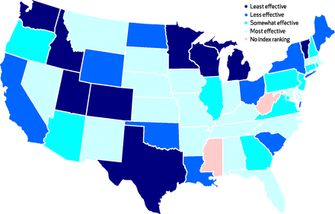
(Mandich, 2014)
Figure 1. States by Quartile of Exemption Law Effectiveness Index, 2012

Lower incidences of pertussis occurred in states with the most effective vaccine exemptions laws. This supports the connection between vaccine laws and their influence on disease incidence. In 2015 a measles outbreak was raced to Disneyland in California. California is classified as enacting less effective exemption laws. Seven total cases occurred in California and Utah, six of which occurred in people who had not been vaccinated. By March, 2015, the number of confirmed cases totaled 133 in California alone, 57 occurring in unvaccinated patients (Mandich, 2014).

Policy Analysis: vaccination requirements & Allowable Exemptions
Four states were selected to compare and contrast how the type of exemptions offered affect exemption rates. Selected states include California, Connecticut, Mississippi, and Pennsylvania. These particular states were chosen based on their varying exemption types and differing required vaccines for public school kindergartners. Table 1 shown below displays what exemptions are available in each of the selected states.

Table 1. The Exemptions Allowable in Each of the Selected States of 2015
 | Medical | Religious | Philosophical
California
Connecticut
Mississippi
Pennsylvania
(Legislators, 2016)

California allows all three types of exemptions and also has the highest exemption rate (3.3) of all the selected states as can be seen in Figure 3 below. Mississippi is the only selected state that allows only for medical exemptions and has a virtually nonexistent exemption rate of 0.1 (Frankel, 2015). Figure 3 below illustrates the exemption rates. It is important to note here the pronounced difference in population size between the two states. As of 2014 California had a population of 38.8 million whereas Mississippi had 2.99 million people ("Population Estimates," 2015). This means that while it does not seem to be that big of a jump from an exemption rate of 0.1 to 3.3 the difference in the number of people exempt from receiving vaccines is a difference of thousands.
Pennsylvania also allows for all three types of exemptions whereas Connecticut allows for Medical and Religious exemptions yet both have similar exemption rates, 2 and 1.9 respectively (Frankel, 2015). The state of Connecticut had 3.59 million people in 2014 and Pennsylvania had 12.8 million ("Population Estimates," 2015). Due to the difference in population size a disparity still exists in the shear amount of people exempt in each of the specific states and is demonstrated in Figure 4.

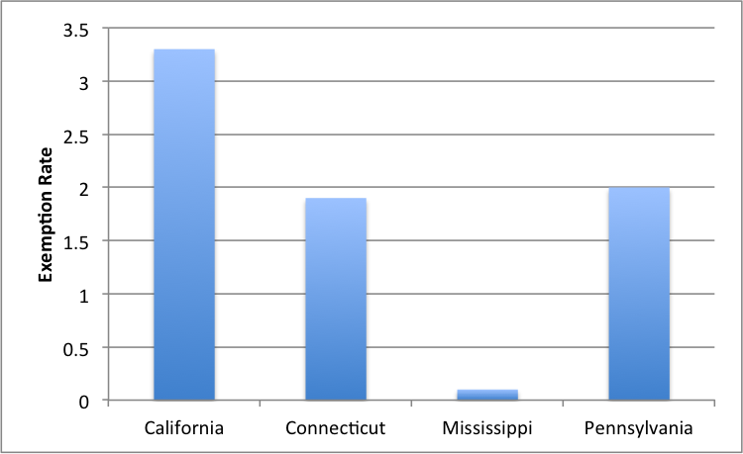
(Frankel, 2015)
Figure 2. Exemption Rate (Percentage of School-Aged Children Exemept in each State)
As is illustrated in Figure 3, there are approximately 15,000 more people exempt from receiving vaccines in California than any of the other selected states. A large proportion of this number comes from religious and philosophical exemptions. This disparity could have contributed to the passing of a bill at the end of last year that abolished religious and philosophical exemptions in said state. This figure also demonstrates how few of vaccine exemptions are for medical reasons.

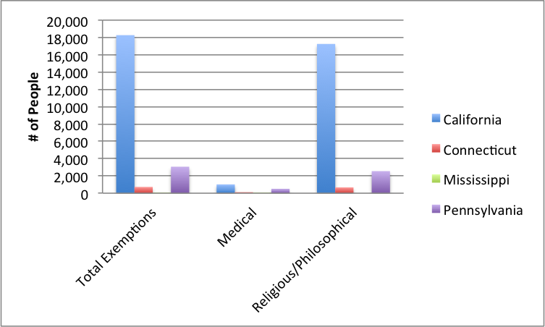
(Frankel, 2015)
Figure 3. Number of People Exempted from Vaccines by Exemption Type and State

State required vaccinations
Not only do exemptions vary from state to state, but the type and dosage amount of vaccinations required differ as well. Connecticut is the only state in the US to require ten different vaccines including the flu vaccine whereas that state of Pennsylvania only requires four. The immunizations required for school entry for each state will be discussed along with incidences of specific diseases.

Table 2. Vaccines Required for Public School Kindergarten
 | Hep B | DTaP | Hib | PCV | IPV | Flu | MMR | Varicella | Hep A | Men
California
Connecticut
Mississippi
Pennsylvania

("State-by-State: Vaccinations Required for Public School Kindergarten," 2014)

VACCINATION COVERAGE BY STATE
How big of an impact on vaccination coverage do the state requirements actually have? The figures below published by the CDC show estimated vaccination coverage by state of adolescents aged 13-17 years in 2014. The first map shows vaccination coverage percentages of ≥1 doses of MenACWY. Connecticut is the only of the four selected states to require this vaccine for entry to school and yet Pennsylvania has the equal estimated coverage to Connecticut at 95%. California and Mississippi have estimated coverage’s of 79% and 46% respectively (Prevention, 2014).

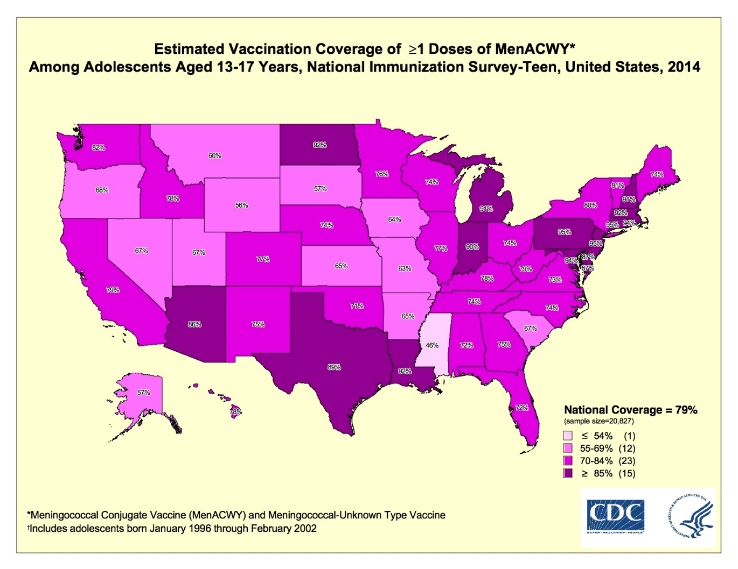
(Prevention, 2014)
Figure 4. Estimated Vaccination Coverage of MenACWY

The second map illustrates the estimated vaccination coverage of ≥ 2 Doses of Varicella vaccine. Although Pennsylvania is the only one of the four selected states to not require this vaccine it once again has a high estimated coverage at 94%, falling behind Connecticut at 95%. California and Mississippi had estimated coverage’s 82% and 57% respectively (Prevention, 2014).
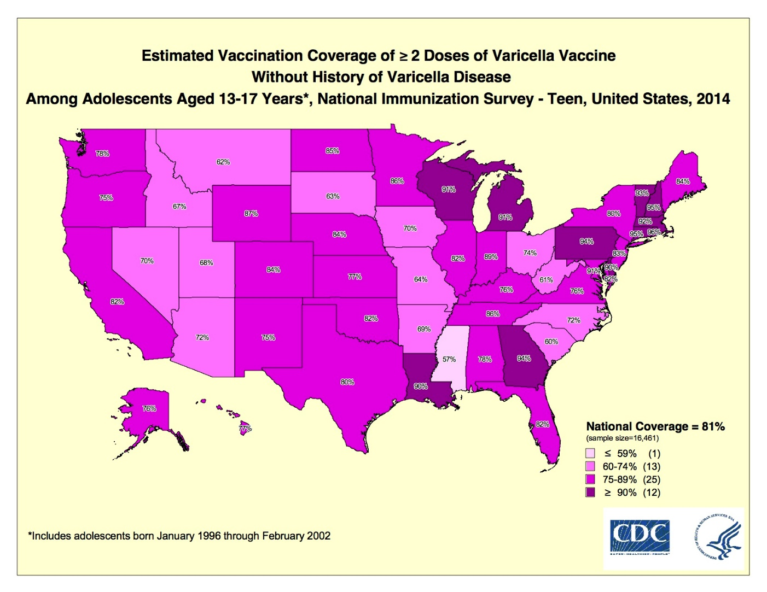
(Prevention, 2014)
Figure 5. Estimated Vaccination Coverage of Varicella Vaccine

The final two maps show estimated vaccination coverage percentages for ≥ 2 doses of MMR vaccine and ≥ 1 doses of Tdap vaccine. Both of these vaccines are required for school entry in all four of the selected states. MMR vaccine had the highest estimated coverage in Connecticut at 98%, Mississippi and Pennsylvania 93%, and California 91%. Tdap vaccine had an estimated coverage of 95% in Connecticut, 93% in Pennsylvania, 88% in California, and 71% in Mississippi (Prevention, 2014).
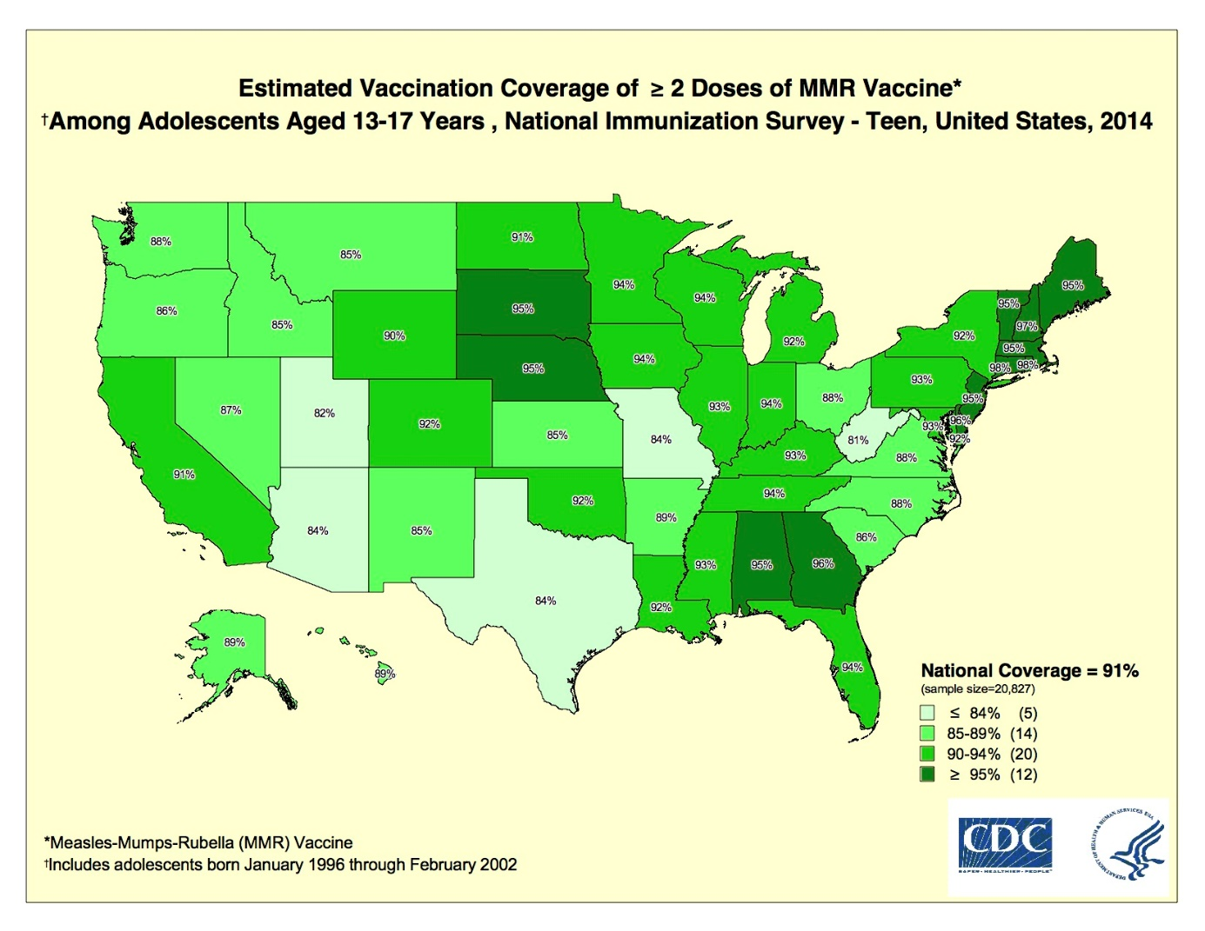
(Prevention, 2014)
Figure 6. Estimated Vaccination Coverage of MMR Vaccine
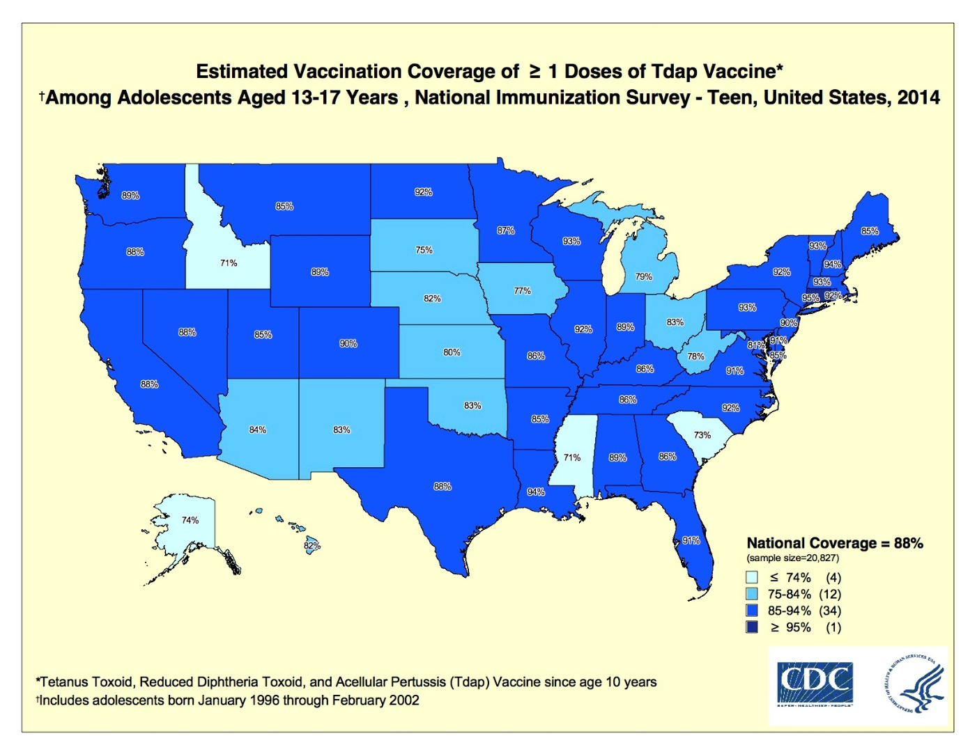
(Prevention, 2014)
Figure 7. Estimated Vaccine Coverage of Tdap Vaccine

California
The California Department of Public Health requires that all parents submit a physician’s written statement of a medical exemption for missing vaccination (doses). It also allows a child to be conditionally admitted to school if he/she is missing a dose in a vaccine series but the dose is not yet due. However, once the deadline for the next dose has passed a child may no longer be admitted ("Guide To Immunizations Required For School Entry," 2015).

Connecticut
Although Table 2 identifies the influenza vaccine as required for entrance to public school kindergarten in Connecticut, it is only required for preschool ("Immunization Requirements of Enrolled Students in Connecticut Schools," 2016). For the 2014-2015 influenza season 7,879 positive cases for reported for Connecticut ("Influenza Final Surveillance Summary for 2014-2015 Influenza Season," 2015). This is more than the number of cases reported in Pennsylvania for the same year and shows that just because those children who attend kindergarten in Connecticut are required to get the influenza vaccine that has no impact on whether or not parents choose to continue to vaccinate against the flu in future years.

Mississippi
Mississippi has what are arguably the most stringent vaccinations requirements of all the 50 states. In order for a child to enroll in public or private school at any grade, a District Health Officer, physician, or nurse must sign a Certificate of Immunization Compliance Form. This form is only required for school enrollment and is not necessary on a yearly basis unless a child transfers schools. If the child is medically exempt from one or more vaccines they must present a Certificate of Medical Exemption signed by the District Health Officer ("Mississippi School Immunization Requirements," 2015).

Pennsylvania
The State of Pennsylvania allows for provisional admittance to school for kindergarten through 12th grade if a child has received at least one dose of each antigen for a multiple dose vaccine series and evidence of this is presented along with a parents or guardians plan for completion of immunizations to be made part of the child’s health record. The same plan for completion is required for single dose vaccines as well. This plan will be periodically reviewed (every 60 days) until the 8-month provisional period for receiving the required vaccines is up. If at this time requirements are still not met the school administrator may choose whether or not to admit the child to school ("Subchapter C. IMMUNIZATION,").

discussion
There are so many factors that contribute to a state’s disease prevalence rate that it is hard to pinpoint what, if any, factors have a bigger impact than others. Using all the information presented here however it is possible to come to some conclusions.
Mississippi is the only one of the four states explicitly studied that only allowed for medical exemptions from vaccinations. Mississippi also happens to be the state with fewest number of unvaccinated people and the lowest exemption rate at only 0.1 between the four states. For the 2013-14 school year a total of 17 students in Mississippi had medical exemptions from receiving vaccinations (Frankel, 2015). California, one of two of the four states that allowed for all three types of exemptions as of 2015 – medical, religious, and philosophical – had the highest exemption rates by a landslide compared to the other three. In California 1,017 students had medical exemptions and another 17,253 had either a religious or philosophical exemption, making it the state with the greatest number of students exempt in the entire country (Frankel, 2015). This data shows that a state that offers multiple exemption types will also have higher exemption rates, proving that people are keen to take advantage of such options when available.
A higher incidence of exemptions from vaccines leads us into how this affects disease prevalence and herd immunity. Judging from the measles outbreak that began in Disney World and then quickly spread within California as well as in other states we can conclude that lenient exemption policies directly effects herd immunity and therefore can impact disease prevalence. Some may argue that because this did not happen in Mississippi where exemption policies are strict, or even in Connecticut or Pennsylvania that we cannot predict how the disease would have spread in these states. Although their vaccination policies vary, Mississippi, Connecticut, and Pennsylvania all have comparable vaccination coverage percentages, meaning that an outbreak such as the one that occurred in California could have occurred in any of the four specified states.
Finally there is the matter of Connecticut being the only one of fifty states to require ten different vaccinations including the flu vaccine for those entering kindergarten. While disease prevalence rates were not specifically examined in this paper, confirmed cases of the flu in 2014 for Connecticut and Pennsylvania were reported. Connecticut requiring the flu vaccine for those entering preschool and kindergarten did not impact whether or not parents choose to vaccinate their children against the flu in later years. Pennsylvania, who never required the flu vaccine for any stage of school children, had much lower flu incidence rates across the state in 2014 compared to Connecticut.
Whether or not a vaccination is required for school entry within a selected state does not seem to be indicative of vaccination coverage within that state. Mississippi had one of the lowest vaccination coverage percentages for the Tdap vaccine that was required for school entry within the state whereas Pennsylvania had high vaccination coverage for MenACWY, even though it was not required for school entry. The cause of this discrepancy cannot be concluded without further research.
For the four states discussed specifically in this paper it can be concluded that the best vaccination policies for school age children seem not to be those that require a greater number of different types of vaccinations, but those that have strict policies with few exemptions. The harder it is to obtain a vaccine exemption in a state the less likely parents are to do so, resulting in lower vaccine exemption rates in states with stringent exemption policies. Whether or not the same can be said for every state more thorough research would need to be conducted and examined.

Public Health Relevance
Public health’s most important goal is focused on prevention: the prevention of catastrophes, the prevention of injuries, and the prevention of infectious disease through the use of vaccines. The prevention of these things, among others, allows public health to protect and promote the health and wellbeing of people and communities. Vaccines prove significant because they do just that. Thanks to vaccines the risk of becoming infected with smallpox is nonexistent and the risk of many other infectious disease has decreases drastically as well. Therefore vaccines requirements and their exemptions prove relevant to public health because the more people vaccinated against a disease, the safer the community as a whole.

conclusion
It is unrealistic to think that every state would be willing to alter their vaccine policies in an attempt to increase vaccination rates and improve the safety of the general public simply because a large portion of the general public may be opposed to this. Some parents may still wrongly fear the risk of autism; others make the claim that a natural immune system should be enough to ward off infectious diseases. Yet it is still important for a best practice policy to be agreed upon so that if and when a state does decide to take the steps toward improving their vaccination rates they know in what direction they need to go to do so. Not allowing for exemptions other than doctor approved medical exemptions seems to be the best practice policy for increasing vaccination rates and improving herd immunity within a state.

bibliography
Chart of Contraindications and Precautions to Commonly Used Vaccines. (2014, January). Retrieved March 23, 2016, from http://www.cdc.gov/vaccines/recs/vac-admin/contraindications-vacc.htm
Community Immunity. (2015, April 16). Retrieved January 23, 2016, from http://www.vaccines.gov/basics/protection/
Eileen Wang, J. C., Cecilia Davis-Hayes and Alison Buttenheim. (2014). Nonmedical Exemptions From School Immunization Requirements: A Systematic Review. American Journal of Public Health, 104(11), 62-84.
Frankel, T. C. (2015, January 30, 2015). Mississippi - yes , Mississippi - has the nation's best child vaccination rate. Here's why. The Washington Post. Retrieved from https://http://www.washingtonpost.com/news/storyline/wp/2015/01/30/mississippi-yes-mississippi-has-the-nations-best-child-vaccination-rate-heres-why/
Guide To Immunizations Required For School Entry. (2015, November 2016). Retrieved February 7, 2016, from http://eziz.org/assets/docs/IMM-231.pdf
Immunization Requirements of Enrolled Students in Connecticut Schools. (2016). Retrieved February 7, 2016, from http://www.bridgeportedu.com/health/docs/2015-2016/School_Immunizations-2015-16.pdf
Influenza Final Surveillance Summary for 2014-2015 Influenza Season. (2015, October 15). Retrieved February 7, 2016, from http://www.ct.gov/dph/lib/dph/infectious_diseases/flu/stats/2014-2015_flu_season_summary.pdf
Jacobson v. Massachusetts, 70, JUSTIA (U.S. Supreme Court 1905).
Legislators, N. C. o. S. (2016, January 21). States with Religious and Philosophical Exemptions from School Immunization Requirements. Retrieved March 23, 2016, from http://www.ncsl.org/research/health/school-immunization-exemption-state-laws.aspx
Mandich, W. D. B. a. A. (2014). Some State Vaccination Laws Contribute To Greater Exemption Rates And Disease Outbreaks In The United States. Health Affairs, 34(8), 1383-1390. doi: 10.1377/hlthaff.2014.1428
McCarthy v. Boozman, Supp. 2d 945 (The United States District Court Western District of Arkansas 2002).
Mississippi School Immunization Requirements. (2015, January 12). Retrieved February 7, 2016, from http://msdh.ms.gov/msdhsite/_static/resources/2029.pdf
Nina R. Blank, A. L. C. a. C. C. (2013). Exempting Schoolchildren From Immunizations: State With Few Barriers Had Highest Rates Of Nonmedical Exemptions. Health Affairs, 32(7), 1282-1290. doi: 10.1377/hlthaff.2013.0239.
Population Estimates (U. S. C. Bureau, Trans.). (2015).
Prevention, C. f. D. C. a. (2014). Maps/Figures 2014 Estimated Coverage by State.
State-by-State: Vaccinations Required for Public School Kindergarten. (2014, September 3). Retrieved February 16, 2016, from http://vaccines.procon.org/view.resource.php?resourceID=005979
Subchapter C. Immunization. Retrieved February 7 http://www.pacode.com/secure/data/028/chapter23/subchapCtoc.html
Ten Great Public Health Achievements in the 20th Century. (2013, April 26, 2013). Retrieved 1-26-16, 2016, from http://www.cdc.gov/about/history/tengpha.htm
Vaccine Laws. (2016). Retrieved 1/15, 2016, from http://www.nvic.org/vaccine-laws.aspx

