THE INTERSECTION OF THE OCCUPATIONAL SAFETY AND HEALTH ACT AND THE ENVIRONMENTAL PROTECTION ACT: AN EXAMINATION OF NATIONAL EMISSION STANDARDS FOR HAZARDOUS AIR POLLUTANTS

by
Sara B. Brooks
B.A. in Spanish, Carnegie Mellon University, 2008

Submitted to the Graduate Faculty of
Department of Environmental and Occupational Health
Graduate School of Public Health in partial fulfillment
of the requirements for the degree of
Master of Public Health

University of Pittsburgh
2016

UNIVERSITY OF PITTSBURGH
GRADUATE SCHOOL OF PUBLIC HEALTH

This essay is submitted
by
Sara B. Brooks

on

April 25, 2016
and approved by

Essay Advisor:
James Peterson, PhD in Chemistry ______________________________________
Associate Professor
Environmental and Occupational Health
Graduate School of Public Health
University of Pittsburgh

Essay Reader:
Candace Kammerer, PhD in Genetics ______________________________________
Associate Professor
Human Genetics
Graduate School of Public Health
University of Pittsburgh

Copyright © by Sara B. Brooks
2016

ABSTRACT

Although the Occupational Safety and Health Administration (OSHA) and the Environmental Protection Agency (EPA) have distinct missions, they both have a responsibility to protect the health of residents of the United States. The EPA recently promulgated a new National Emissions Standard for Hazardous Air Pollutants (NESHAP) that covers ferroalloy facilities, specifically those that process manganese for use in steelmaking. Exposure to manganese fumes over long periods of time causes manganism, a debilitating, chronic condition with symptoms similar to Parkinson’s disease. Ambiguities in required control technology in the new ferroalloys NESHAP allow for fume hood placement that may increase employee exposure to manganese and other hazardous substances. Air quality sampling data, medical surveillance records, and OSHA inspection records from ferroalloys facilities in the United States show that permissible exposure limits (PELs) of airborne contaminants, as defined by OSHA, are regularly exceeded, and that personal protective equipment is often poorly maintained or inaccessible. The economic as well as social consequences of workers who are forced to trade their health for a paycheck has broad public health significance. In order to protect the health of both workers and members of the general public, OSHA and the EPA must work together more closely to ensure that regulations do not provide protections to a specific group of people at the expense of another.
James Peterson, PhD
THE INTERSECTION OF THE OCCUPATIONAL SAFETY AND HEALTH ACT AND THE ENVIRONMENTAL PROTECTION ACT: AN EXAMINATION OF NATIONAL EMISSION STANDARDS FOR HAZARDOUS AIR POLLUTANTS
Sara B. Brooks, MPH
University of Pittsburgh, 2016

TABLE OF CONTENTS
preface ix
1.0 Introduction 1
2.0 THE INDUSTRIAL REVOLUTION 3
3.0 OSHA and the EPA 5
4.0 Manganese and Steelmaking 8
5.0 Manganese and Public Health 10
6.0 NESHAPs and the Regulatory Process 13
7.0 Health and Safety in the Steel Industry 17
8.0 NESHAPs: Costs and Benefits 20
9.0 Health and Safety at Felman Production and Eramet Marietta 23
10.0 CONCLUSIONS 31
BIBLIOGRAPHY 33
List of figures
Figure 1: Location of Eramet Marietta and Felman Production 7
Figure 2: 2011 Airborne Manganese Levels 23
Figure 3: 2012 Airborne Manganese Levels 24
Figure 4: 2011 Employee Blood Manganese Levels 25
Figure 5: 2015 Employee Blood Manganese Levels 26

LIST OF abbreviations
ADHD - Attention Deficit Hyperactivity Disorder
CAA - Clean Air Act
CDC - Centers for Disease Control and Prevention
COPD - Chronic Obstructive Pulmonary Disease
DDT - dichlorodiphenyltrichloroethane
EPA - Environmental Protection Act/Administration
FDA - Food and Drug Administration
HAP - hazardous air pollutant
L - liter
m³ - cubic meter
MACT - Maximum Achievable Control Technology
mcg - microgram
mg - milligram
MOU - memorandum of understanding
MSHA - Mine Safety and Health Act/Administration
NESHAP - National Emission Standards for Hazardous Air Pollutants
OSHA - Occupational Safety and Health Act/Administration
PAH - polycyclic aromatic hydrocarbon
PEL - Permissible Exposure Limit
PM - particulate matter
PPE- personal protective equipment
PM₁₀ - particulate matter with a diameter of less than 10 mcg
PM_{2.5} -particulate matter with a diameter of less than 2.5 mcg
RTR - Risk and Technology Review

preface

Thank you to the Health, Safety and Environment Department at United Steelworkers for their guidance and support throughout this project.

Introduction
The Environmental Protection Agency (EPA) is a federal government agency established in 1970 by President Richard Nixon. It brought a variety of regulatory duties and functions together under the oversight of a single department. It included projects that were previously managed by the Department of Agriculture, Department of the Interior, Atomic Energy Commission, Federal Radiation Council, Council on Environmental Quality, and Department of Health, Education and Welfare. The environmental issues that led to widespread bipartisan support and public enthusiasm for a federal agency solely tasked with protecting the environment, and by proxy the people who live in it, had been slowly building momentum.
In 1962, Rachel Carson, an American biologist and conservationist, published Silent Spring. It contained a harsh criticism of the widespread and indiscriminate use of pesticides and garnered enthusiastic criticism from chemical companies and industry representatives (Carson et al, 1962). Although the book focused on the effects of DDT on local ecosystems, it acted as a call to action for the American public. Spurred on by the horrors of Agent Orange as a deforestation technique and tool of war in Vietnam, environmental conservationism gained significant ground and popularity in the late 1960s. The health of the environment and the health of humankind were slowly becoming viewed as inextricably linked.
The Clean Air Act, signed into law at the close of 1970, gave the EPA power to establish national air quality standards and regulate industrial sources of pollution. The EPA has since expanded from a single office in Washington, D.C. to a nationwide presence with over 15,000 full-time employees and a 2014 budget of over $8 billion. With an official mission of “protect[ing] human health and the environment” (US EPA, 2016), the EPA divides its time and resources among several initiatives, including developing and enforcing regulations, conducting research, funding external research, and promoting environmental education.
The EPA has recognized that one of the largest contributors to air pollution, aside from vehicular traffic, comes from stationary industrial sources. These sources are categorized as “major” or “area” according to the amount of pollution they produce. A major source emits over 10 tons of a specific hazardous air pollutant (HAP) per year, or over 25 tons of a mixture of HAPs per year. An area source is any facility that falls under both of these limits. Although each individual area facility accounts for a small percentage of the HAPs emitted in the United States each year, when considered collectively, they contribute a significant burden, especially when located in urban areas.

THE INDUSTRIAL REVOLUTION
Although the EPA has been referred to as “the extended shadow of Rachel Carson” (US EPA, 2016, About EPA), it is more directly a response to the rapid expansion of the industrial capacity of the United States in the first half of the twentieth century. Although the boom in production in the US and other Allied countries during World War II and immediately afterward ushered in a new era of economic abundance, it also set the stage for a new set of public health concerns. The burden of infectious disease in the United States had been dropping steadily due to a series of medical breakthroughs and an increased understanding of the role of hygiene in disease, but health problems with environmental causes would soon begin to emerge as a growing concern.
On December 5, 1952, a dense fog descended on London, England. A product of years of coal combustion by local industry, as well as increased household coal consumption due to an unusually cold winter, a perfect storm of environmental factors turned a light evening fog into a “pea-souper” by nightfall. A temperature inversion trapped the smog close to the ground for almost five days, with visibility so poor that transportation was brought to a city-wide standstill (Angelo, 2008).
This smog was primarily made up of tar, black soot, and sulfur dioxide. Particulate matter in the air with a diameter of less than 10 micrometers (PM₁₀) was estimated to be 50 times higher than normal, and sulfur dioxide levels were estimated to be up to seven times higher than usual. An estimated 12,000 people died during the smog or in the weeks that followed. Most deaths were due to pneumonia, asphyxiation, bronchitis, and heart failure. Infants, the elderly, and those with asthma, heart disease, or tuberculosis were hit especially hard.
In the fog’s aftermath, the British government began to pay more attention to the environmental causes of health problems. In the United States and around the world, people were also beginning to realize that many illnesses and cancers were not purely the result of luck or genetic weakness. Around the same time as the London smog, doctors and researchers were first starting to link cigarette smoking with poor health outcomes. However, it took nearly twenty years after this discovery for the rate of smoking in the US population to begin to drop (Garfinkel, 1997).

OSHA and the EPA
In the years since the establishment of the EPA, a series of studies by universities and government bodies have found increasingly persuasive evidence that air pollution has a direct effect on human health. The landmark ‘Harvard Six Cities’ study (Dockery et al, 1993) was one of the first to establish a link between air pollution and an increased risk of mortality. In fact, rates of asthma, lung cancer, and Chronic Obstructive Pulmonary Disorder (COPD) are all higher in areas with significant air pollution sources (Kurt et al, 2016). Occupational diseases like mesothelioma and silicosis are now recognized to be the direct result of exposure to asbestos and silica, and exposure to pollution in all media has been associated with health outcomes as diverse as ADHD (Perera, 2014) and infertility (Joffe, 2003).
While the EPA was designed to protect the general public from the hazards of pollution, the Occupational Safety and Health Act (OSHA), also signed into law by President Nixon shortly after the creation of the EPA, was created to protect employees from safety and health hazards in their workplaces. OSHA’s General Duty Clause states that “Each employer shall furnish to each of his employees employment and a place of employment which are free from recognized hazards that are causing or are likely to cause death or serious physical harm” (Occupational Safety and Health Act, 1970). This solidifies the right of an employee to a workplace that is free of excess pollution. To that end, OSHA publishes Permissible Exposure Limits (PELs) for almost 500 different hazardous compounds.
OSHA and EPA were both designed to protect human health, and a 1990 memorandum of understanding (MOU) between the two agencies states that “[t]here will be the fullest possible cooperation and coordination between EPA and OSHA, at all organizational levels, in developing and carrying out training, data and information exchange, technical and professional assistance, referrals of alleged violations, and related matters concerning compliance and law enforcement activity to ensure the health and well-being of the Nation's workforce, the general public, and the environment” (US OSHA, 1990, Memorandum of Understanding). However, as can be expected with two government agencies operating under somewhat different mission statements, there are times when the activities of the EPA and OSHA clash.
Although it may seem somewhat counterintuitive, some activities required by the EPA’s National Emissions Standards for Hazardous Air Pollutants (NESHAPs) can put workers at a higher risk of injury or occupational illness. For example, 40 CFR part 63, “National Emission Standards for Hazardous Air Pollutants for Coke Ovens: Pushing, Quenching, and Battery Stacks,” finalized in 2003, requires employees of coke batteries to ignite the emissions coming out of open standpipes during soaking, the period when an oven is vented to the atmosphere before the product is removed. When the proposed rule was open for public comment, several commenters raised concerns over the fact that emissions coming out of a standpipe are not always visible, and that the person charged with igniting it could be seriously injured.
Although the final rule modifies its requirements to cover only standpipes where emissions are visible, it recognizes that several plants require workers to ignite standpipe emissions manually, and that this can be dangerous. However, it concludes that “the work practice standard requires owners or operators to train workers in the procedures to reduce soaking emissions, and each plant should address all aspects of safety.” This is a vague and unsatisfactory approach to employee safety, and does not take into account the fact that employee training is left to the discretion of each individual workplace, and has come under criticism at many companies as inadequate or rushed (Michaels, 2010).
Each worker is by definition also a member of the public, and is entitled to protections under both OSHA and the EPA. On May 20, 1999, the EPA published a NESHAP containing air toxics emissions limits for stationary sources in the ferroalloys industrial sector under the authority granted to them by the Clean Air Act. This standard covers two facilities, Eramet Marietta in Ohio and Felman Production in West Virginia. These two facilities were, and still are, the only two locations in the United States that produce manganese alloys, specifically silicomanganese and ferrosilicomanganese, for steelmaking purposes. Figure 1 below shows their location.
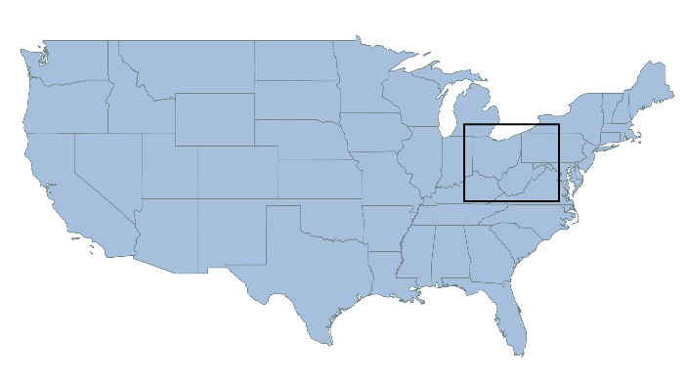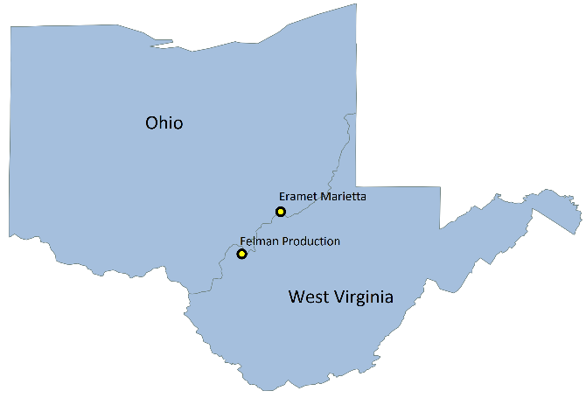
Figure 1: Location of Eramet Marietta and Felman Production

Manganese and Steelmaking
An updated version of the ferroalloys NESHAP was finalized in June of 2015. It is intended to protect the public from toxic emissions, primarily of manganese, from these two facilities. Manganese is a transition metal used in steel production that the EPA has identified as a danger to public health when inhaled or ingested in excessive quantities. Although manganese has multiple industrial uses, metallurgical and otherwise, 77-90% of manganese ore consumed in the United States is used in steelmaking (United States Geological Survey, 2012, 2010 Minerals Yearbook). There are no domestic manganese mines, making the US completely dependent on imports. Most ore is sourced from Gabon, Australia, South Africa, and Brazil (United States Geological Survey, 2014, Manganese – It Turns Iron into Steel). Ore with at least 35% manganese is considered valuable, and commercially significant manganese ores include pyrolusite, romanechite, hausmannite, and rhodochrosite.
Manganese is a hard, brittle transition metal with a silvery-gray appearance, and is naturally occurring and abundant throughout the earth’s crust. It was isolated from pyrolusite in 1774 by a Swedish mineralogist named Johan Gottlieb Gahn, and was first used in steelmaking in 1856 as a component of the Bessemer process. The parent of modern steelmaking techniques, the Bessemer process was first developed in Pittsburgh, Pennsylvania in 1847 by the businessman William Kelly. Although perfected several years later in England by Henry Bessemer, this was the first modern manufacturing process that allowed steel to be cheaply produced from pig iron in large quantities (Misa, 1995).
Steel is an alloy made up primarily of iron and less than 2% carbon, and there are currently over 3,500 different grades. The Bessemer process uses streams of oxygen blown through the molten iron to oxidize impurities so that they will rise to the top to be skimmed off as slag. Manganese serves a variety of purposes as a steel additive. It can act as an oxidizer, especially when combined with silicon, binding excess oxygen into a particle that rises to the top for easier removal. Although oxygen from the atmosphere dissolves into steel as it is melted, a sufficient amount must be removed before cooling and solidification or it will aggregate and form “bubbles” that weaken the final product.
Manganese can also act as a desulfurizer, binding sulfur in the molten metal that would otherwise collect at the edges of the microscopic crystalline “grain” structures present in cooled metal, reducing structural integrity. However, perhaps the most important role of manganese is as an alloy. Although brittle in its elemental form, manganese increases the hardness and tensile strength of steel and helps it resist abrasion. Certain types of steel with high manganese content, such as Hadfield steel (10-14% manganese), are known for their ability to be work-hardened, or made stronger and tougher as they are subjected to physical strain (Downing, 2016).

Manganese and Public Health
Although it is toxic in higher concentrations, small amounts of manganese are necessary for the proper biological function of both plants and animals. Plants take up manganese from water in the soil, and it plays an important part in photosynthesis, chlorophyll synthesis, and the manufacture of nutrients that contribute to structural integrity (Eramet Marietta, 2016).
Manganese also forms the building blocks of many important enzymes in the human body. These enzymes are essential to normal bone and cartilage development and to the production of collagen, which plays a vital role in wound healing. Several metabolic pathways also rely on enzymes containing manganese, leading those with manganese deficiencies to show symptoms similar to metabolic syndrome, the precursor to diabetes (Higdon, 2010). Manganese forms part of an antioxidant enzyme in human cells called manganese superoxide dismutase, which converts free radicals into less harmful compounds that the body can easily eliminate. Free radicals, harmful oxygen compounds that are the product of cellular energy production, have been shown to damage DNA and cause changes in the body that lead to cancer (Liou et al, 2010).
Manganese is naturally occurring in many staple food items such as beans, green leafy vegetables, fruits, rice, wheat, and tea. The FDA’s recommended daily value for manganese is 2mg (National Institute of Health, 2015). This quantity is easy to get from most normal diets. Manganese deficiency is usually only found in hospitalized patients who cannot eat on their own and rely on intravenous feedings (Nagatomo, 1999). These feedings sometimes contain manganese as a supplement, but many medical professionals shy away from adding it to the solution because it has contributed to toxic manganese levels in several patients in the past.
Dietary exposure to toxic levels of manganese is rare in healthy adults. Only about 1-5% of the manganese eaten by an adult without other health conditions is absorbed into the bloodstream (Davis et al, 1993), and it is excreted as needed in the bile. There is evidence that the body absorbs iron and manganese through the same transport pathway, so severe iron deficiency can cause the intestines to absorb inappropriate amounts of manganese to compensate. Similarly, patients with liver disease may have an impaired ability to secrete manganese into the bile. However, manganese toxicity in an otherwise healthy adult is almost always a result of occupational exposure to inhaled manganese particles.
Manganese particles that are absorbed through the lungs or nasal cavity have a unique ability to bypass the body’s normal defense mechanisms. Instead of being processed and secreted by the liver, like many external compounds, inhaled manganese enters the bloodstream and is carried directly to the brain. In fact, manganese has been shown to remain in the brain much longer than in any other body tissue (Cossgrove, et al, 2004). Not surprisingly, some of the most devastating symptoms of manganese toxicity are neurological, although it can also affect lung function (Higdon et al, 2010).
Manganese toxicity, sometimes referred to as manganism, is a neurodegenerative disorder with symptoms similar to Parkinson’s disease. The progression of the disease is slow and symptoms do not appear all at once, instead presenting over a period of months or years. A 2004 study of welders in China suggested that the average time of onset is 7-16 years, although this is heavily dependent on the amount of manganese a worker is exposed to on a daily basis (Cossgrove, 2004).
Manganese has a relatively short half-life in the blood compared to the brain, where it persists for much longer and causes the most damage. However, there is no way to measure manganese levels in brain tissue without removing a piece of brain to sample, so medical professionals rely on blood tests as an indicator. A thorough occupational physician will make their diagnosis based on a full examination of symptoms, blood manganese levels, and the patients’ recollection of exposure and employment history. Some diagnoses may be assisted by an MRI of the brain, which can highlight abnormalities in certain brain structures.
Early symptoms of manganese toxicity include fatigue, headaches, insomnia, muscle cramps, and behavioral changes like increased aggressiveness, irritability, or emotional instability (Cossgrove, 2004). These can progress to include exaggerated tendon reflexes, memory loss, trouble speaking, difficulty walking, and excessive muscle contractions and tremors, especially in the hands and face. Many patients also have trouble walking or walk with a distinctive forward-leaning, hunched-over gait.
Although the exact mechanism by which manganese affects specific structures of the brain is not currently well-understood, evidence suggests that the globus pallidus and striatum, two brain structures located next to each other in the center of the brain, are primarily affected. The globus pallidus helps regulate voluntary movement, and the striatum is involved in motivation and reward processing (Neuroscientifically Challenged, 2015).
Manganism is a progressive disease, and there is no cure. If you are diagnosed with manganism, there is an overwhelming chance that you are either the employee of a facility that processes manganese, or a resident of the surrounding community. Both of these groups of people are entitled to protections under the law, although the legal entities that guarantee their protections are distinct.

NESHAPs and the Regulatory Process
Emissions standards for HAPs proposed by the EPA, charged with protecting the public, go through a two-step regulatory process. The first step begins with an identification of “major sources” of specific HAPs as outlined in section 112(b) of the Clean Air Act. Industry-specific emissions standards are then calculated based on maximum achievable control technology (MACT), that is, the maximum reduction in toxic emissions that the EPA has concluded can reasonably be achieved with available technology.
In practice, control technology has taken a variety of forms, although modifying an existing process is usually less expensive than designing a new one from scratch. When possible, certain work processes can be fully enclosed. When full enclosures are not reasonable, well-placed fume hoods can capture and direct the majority of emissions to scrubbers or baghouses that filter off HAPs. In some cases, certain materials can be replaced with less dangerous ones, and waste products can be chemically treated before discharge into the environment.
There are certain minimum standards that must be fulfilled by control technology regardless of cost, referred to as MACT floor requirements. For example, if a new facility were to begin manufacturing ferroalloys, their MACT standards would have to be at least as stringent as similar sources in the same industry for it to operate legally. However, based on the authority granted by 112(d)(2) of the Clean Air Act, the EPA may establish stricter emissions standards that extend past the floor requirement. The cost, practicality, and efficiency of available technology must be taken into consideration when establishing standards extending past the floor. In practice, companies must meet minimum floor requirements to operate, but if they pollute in excess of the MACT emissions standards designed with cost and feasibility in mind, they will be subject to a fine. Unfortunately, many companies find that it is cheaper to pay intermittent fines than to invest in adequate control technology, evidenced by the large number of OSHA citations designated as “repeat” violations.
The second step in the EPA regulatory process for emissions standards is based on a Residual Risk and Technology Review (RTR). Once a standard is published, a RTR must take place at least every eight years. The ultimate goal is to ensure the standard stays current with regard to technological advances and work practices. A RTR considers the risk to public health and the environment that remains after MACT requirements have been met.
A RTR takes a variety of factors into account when deciding if an emissions standard should be updated. Using current and actual emissions data, the goal is to “provide an ample margin of safety to protect public health...[or] to prevent, taking into consideration costs, energy, safety, and other relevant factors, an adverse environmental effect” (Clean Air Act, 1963). The EPA’s first consideration is to establish an “acceptable” level of risk to public health, since there is no activity that is entirely without risk of any kind. This risk is considered in the context of the individual and the environment, can include cancer and non-cancer health effects, and must incorporate any uncertainties into the final calculation. Health and environmental outcomes, and not the cost of proposed regulation, must be the deciding factors in determining “acceptable” risk. Once a RTR has quantified an acceptable risk (for example, a lifetime risk of cancer of 20-in-1-million), an “ample margin of safety” is determined. This margin does take into account the cost and availability of technology and control equipment, with the ultimate goal of minimizing the acceptable risk as much as possible given the industry’s financial abilities and limitations.
“National Emissions Standards for Hazardous Air Pollutants: Ferroalloys Production; Final Rule” is a result of the RTR undertaken to revise the 1999 standard of the same name. Made final on June 30, 2015, it contains revisions to the amount of particulate matter (PM) a facility may discharge, operations standards for electric arc furnaces and crushing operations, new requirements for emissions control and capture technology, and a change in the way facilities must measure emissions opacity. It also institutes a completely electronic reporting tool and new standards for previously unregulated HAPS, including mercury, polycyclic aromatic hydrocarbons (PAHs), formaldehyde, and hydrogen chloride.
This new NESHAP, although it is careful to quantify risks to public health and the environment, does not explicitly address the risks to employees of ferromanganese or silicomanganese processing facilities. Indeed, the duty of the EPA is not to address occupational health issues. However, employees are members of the public and often of the surrounding community. In practice, protecting employees cannot be rigidly separated from protecting the public. To enable the “fullest possible cooperation and coordination between EPA and OSHA,” as established in OSHA’s 1990 Memorandum of Understanding, the two agencies must commit to a working relationship that recognizes employees as a vulnerable population.
The only two facilities in the United States that produce either ferromanganese or silicomanganese, Felman Production LLC, a subsidiary of Georgian American Alloys, Inc., and Eramet Marietta, owned by the Eramet Group, are both located along the Ohio River. Felman Production is headquartered in Letart, WV and claims an annual production of about 105,000 metric tons of combined ferromanganese and ferrosilicomanganese (Felman Production LLC, 2013). Eramet Marietta is about 60 miles upstream in Marietta, Ohio, and reported a yearly production of 169,000 tons of combined ferromanganese and ferrosilicomanganese in 2000 (United States Geological Survey, 2004). Both facilities fall under the new ferroalloys NESHAP, as they produce ferromanganese and/or silicomanganese using specific equipment as defined in part §63.1620.

Health and Safety in the Steel Industry
Federal regulations affecting the steel industry are not a new phenomenon, and for good reason. The steel industry has traditionally been one of the most dangerous industries to work in. Before accident and fatality reporting was mandated by OSHA in 1970, it was difficult to know exactly how many people were injured or killed at work in the mills. Nevertheless, William B. Hard, a journalist investigating the industry in 1907, estimated that about 1,200 men died every year out of a total workforce of 10,000 (United States Department of Labor, Progressive Era Investigations). Company owners and managers had an incentive to downplay accidents and injuries to keep public opinion in their favor, but gruesome stories of death on the job circulated among family and friends. Accidents in steel mills could easily claim arms or legs, costing the employee their livelihood. Deaths in steel mills were, and continue to be, horrific, undignified, and agonizing. Recent immigrants were some of the hardest-hit, most likely because of language and communication barriers. In the first decade of the 20th century, at US Steel’s South Works mill in Chicago, a fourth of immigrant workers were estimated to be either injured or killed on the job every year.
Health and safety initiatives and government regulation in the second half of the 20th century made huge leaps in guaranteeing the right of workers under OSHA to ”a place of employment which [is] free from recognized hazards that are causing or are likely to cause death or serious physical harm.” Most safety improvements came as a result of automating dangerous jobs, using machine guards where appropriate, and formalizing lock-out/tag-out procedures. However, injuries and deaths were not eliminated. There were eight total fatalities in the steel industry in 2003 among a total workforce of about 100,000, and 7.1 work-related injuries or illnesses per 100 full-time employees (Occupational Safety and Health Administration, 2006).
Fatalities in the steel industry, which had dropped steadily over the second half of the twentieth century, reversed course and began to rise in 2006 (Maher, 2008). Labor unions theorize that increased demand for steel caused facilities to put more production pressure on employees. Although the number of people working in the industry remained steady, the rate of overtime rose by 20% in 2008. Employee fatigue, combined with “lean” production goals, more frequent turnover, inadequate or rushed training, and the reorganization and combination of jobs and job duties likely contributed to many of these injuries. After the Great Recession, many employers were again forced to cut corners, and many safety and health programs suffered as a result.
Moreover, many employers engage in “injury discipline,” which involves writing employees up or firing them for reporting on-the-job injuries, even though this is in direct violation of OSHA (Fairfax, 2010). Some workplaces also have safety incentive programs that reward every employee in a specific production area that goes a certain length of time without an injury. Employees who get hurt because of faulty equipment, unrealistic production schedules, or fatigue hide their injuries to avoid being blamed for the entire production area’s loss of an incentive, and the hazard that caused the injury remains uncorrected.
The same factors and aspects of unhealthy workplace “culture” that contribute to injuries and fatalities also contribute to occupational illnesses, although most of these illnesses develop slowly over a period of years. Employers are required to provide employees working in areas where the concentration of HAPs exceeds OSHA’s permissible exposure limit with regularly-serviced respirators. However, respirators are expensive and servicing them regularly means that they must be temporarily removed from use, interrupting production. Most OSHA fines do not exceed $10,000, and can be negotiated downward. To some companies, providing insufficient personal protective equipment or exceeding the PEL of hazardous substances and paying the resultant fine may unfortunately be more financially advantageous than providing a safe workplace. Jim Maddux, the retired director of the OSHA wing overseeing the construction industry, confirmed that, for many companies, OSHA fines are “just another cost of doing business” (Wireless Estimator, 2016).
The EPA has more regulatory clout than OSHA, which is most obvious in the dollar amount of EPA fines. OSHA does not have the ability to shut down production at a plant deemed to have unsafe conditions, in contrast with the Mine Safety and Health Administration (MSHA), which can close down and evacuate a mine until inspectors are satisfied with the steps taken to abate any given hazard. All three agencies recognize that the most effective way of preventing the discharge of airborne HAPs into the environment involves removing them from the air at the source. However, some of the specifics of the new ferroalloys NESHAP don’t do enough to ensure that the health burden from air pollution is eliminated, rather than simply transferred from the general public to plant employees.

NESHAPs: Costs and Benefits
The new ferroalloys final rule will cut HAPs emissions at the two facilities by 60%, or about 77 tons per year. Furthermore, these facilities must be in compliance with all emissions, work practice, recordkeeping, monitoring, and reporting standards by June 30, 2017. Since the costs associated with this reduction are not expected to exceed $100 million, the EPA did not perform a regulatory impact analysis. From an economic perspective, the benefits of each regulation passed into law should outweigh the costs.
The costs of upgrading equipment and operations at the Eramet Marietta and Felman Productions facilities will cover materials to contain fugitive emissions from furnace tops, fume hood improvements in furnace tapping operations, the installation of secondary capture hoods, fans, and filters. The total cost per year is estimated to be $5.6 million at Eramet Marietta and $2.1 million at Felman Productions for a total cost of approximately $52 per pound ($7.7 million/74 tons) of captured HAPs.
When considering the health impact of HAPs, $52/pound is a reasonable and appropriate cost, especially given that the cost of control measures for other substances, like mercury, can reach $40,428/pound (United States National Emissions Standards for Hazardous Air Pollutants from Coal- and Oil-fired Electric Utility Steam Generating Units and Standards of Performance for Fossil-Fuel-Fired Electric Utility, Industrial-Commercial-Institutional, and Small Industrial-Commercial-Institutional Steam Generating Units, 2011). Thousands of people work in, and leave near, these two facilities. Particulate matter with a diameter of less than 2.5 micrometers (PM_{2.5}), a major component of HAPS, has been associated with cardiovascular disease, cancer, heart attacks, and respiratory problems, including asthma and COPD (Franklin et al, 2007). It has also been implicated in some preterm births (Hansen et al, 2006). The EPA’s cost estimate for the ferroalloys NESHAP of $52/pound of HAPs takes into account the financial cost to individual companies, which is an important factor when considering an institution’s continued profitability and the livelihoods of its employees, but it does not incorporate financial estimates of the benefits of the regulation to taxpayers.
The ferroalloys NESHAP requires that emissions, which contain HAPs, PM_{2.5}, and PM₁₀, be captured “using a system of primary hoods (that capture process fugitive emissions near the source) and/or secondary capture of fugitives (which would capture remaining fugitive emissions near the roof-line)” (pg. 37376). However, a system capturing emissions near the roof-line essentially turns the entire building into a fume hood. Instead of containing HAPs at the source by pulling them away from workers, they are allowed to fill the building and the air that employees breathe. Employee health is sacrificed as the cost of compliance, and taxpayers, through their subsidies of Medicaid, Medicare, and workers’ compensation, must pick up the tab (US OSHA, 2015).

Health and Safety at Felman Production and Eramet Marietta
The wording of the regulation, which allows for primary hoods “and/or” secondary roof-line capture, gives companies the discretion to institute either or both systems as long as at least 95% of process fugitive emissions are captured before leaving the building. A system of primary hoods that could capture that percentage alone would be ideal, as it would remove the emissions both from the environment and from the air that employees breathe. A system of primary hoods that capture nearly 95% of emissions, with roof-line capture as backup, could also be a workable solution. However, giving employers the option to use only roof-line capture, trapping employees in a toxic environment that the regulation has acknowledged causes harmful health effects, is a dangerous gamble.
Employees in both ferroalloys facilities are represented by United Steelworkers (USW), one of the largest industrial labor unions in the United States and Canada. With the support and guidance of USW’s Health, Safety and Environment Department, a collection of air quality testing data and de-identified health records were provided. Publicly available information on OSHA citations at the two facilities were also accessed using OSHA’s online establishment search tool.
Air quality testing data was provided for the period of 2011-2012 and is shown below in Figures 2 and 3. All air samples were captured from within the employees’ breathing zones by a qualified technician and analyzed for contaminants in a lab. Although not a representative sample, as the data is limited to what the facilities were willing to make available for this project, it provides a rough idea of the efficacy of air quality engineering controls in practice.

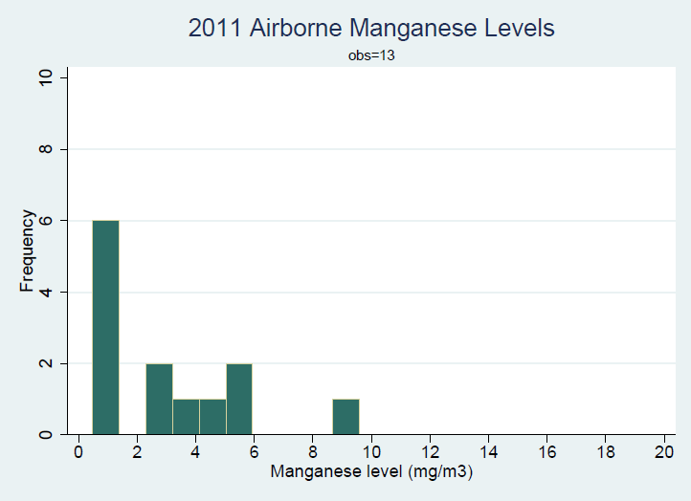
Figure 2: 2011 Airborne Manganese Levels

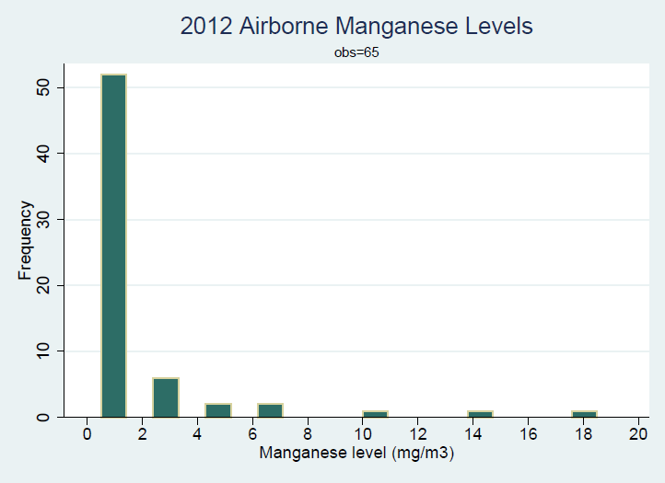
Figure 3: 2012 Airborne Manganese Levels

OSHA defines the PEL for manganese to be 5 mg/m³. Although the National Institute for Occupational Safety and the American Conference of Governmental Industrial Hygienists have recommended smaller exposure limits, they do not carry the force of law, so OSHA’s PEL is considered the gold standard. In 2011, three samples (23% of the total) exceeded the 5 mg/m³ limit. The highest sample showed a manganese level of 9.58 mg/m³.
In 2012, seven samples (11% of the total) exceeded the OSHA PEL. The highest sample showed a manganese level of 19 mg/m³. Although the overall proportion of samples exceeding the PEL decreased from 2011 to 2012, the highest level sampled almost doubled from one year to the next. Of course, different areas of a plant are not always comparable. The location of most samples was not provided, but it is safe to assume that production areas, where furnaces are located, produce more manganese fumes than areas like break rooms, although dust and fumes can be transported throughout a facility by human activity.
These air quality sampling data show that, for the time periods provided, engineering controls failed to keep HAPs emissions and manganese fumes in check. However, many facilities use personal protective equipment (PPE) to minimize employees’ actual exposure to harmful substances, so air quality samples must translate to poor health outcomes in order to be of concern. Blood samples are a good way of quantifying actual employee exposure, although they give a better idea of short-term exposure due to manganese’s short half-life in the blood and tendency to accumulate in brain tissue. De-identified employee blood tests were provided for 2011 and 2015. Figures 4 and 5 below show the distribution of manganese levels in samples of employees’ blood.

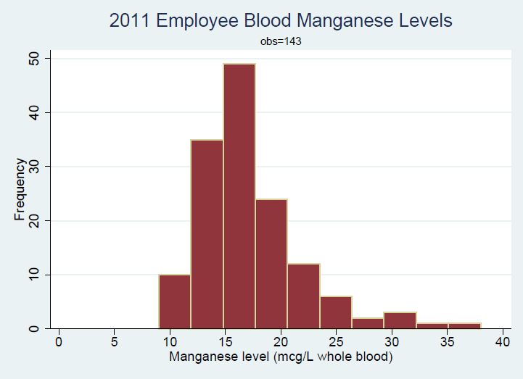
Figure 4: 2011 Employee Blood Manganese Levels

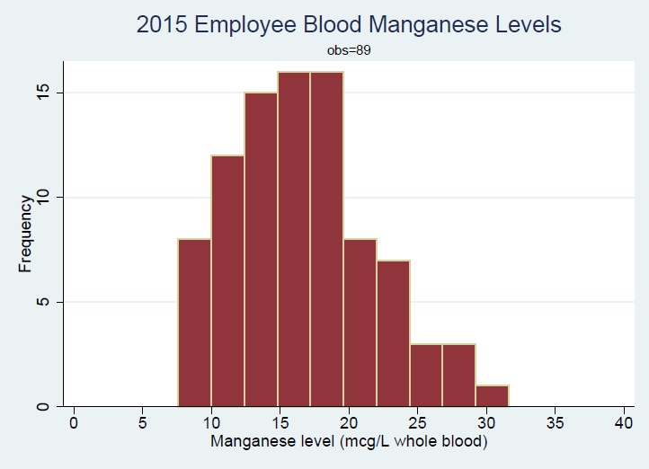
Figure 5: 2015 Employee Blood Manganese Levels

The Centers for Disease Control (CDC) defines a “normal” level of blood manganese as between 4-15 mcg/L of whole blood. In 2011, 68% of 143 employees sampled had a blood manganese level that exceeded 15 mcg/L. In 2015, 52% of 89 employees sampled had a blood manganese level exceeding 15 mcg/L. Although this is best seen as an estimate of short-term exposure, it demonstrates that the majority of employees have an unacceptably high level of manganese in their system, and if they are longer-term employees, they most likely have high levels in their brain tissue as well.
Even more troubling is the way this information was presented to employees after the 2015 blood tests. Lab results that were mailed to employees were accompanied by a cover letter from the medical center that examined them summarizing the results and recommended follow-up. The lab that processed the blood tests defines a “normal” level of manganese as 8-17 mcg/L, which is slightly higher than the levels defined by the CDC, but more or less similar. However, employees whose blood manganese levels exceeded 17 mcg/L, the laboratory’s upper limit, were told that “[y]our manganese level was outside the normal limit established by the laboratory but still within the acceptable limits of normal established by OSHA for intervention or action. No further follow-up is needed at this time.”
This is a dangerous and misleading statement. Although OSHA establishes a PEL for manganese in the air, it has never presented any guidelines for a normal or safe level of manganese in human blood. Tellingly, the letter does not define OSHA’s supposed “acceptable limit of normal.” Multiple calls and messages to the medical office that processed the tests and issued the cover letters were not returned.
Combined, this data and the way it was presented to employees does not paint a favorable picture of working conditions. An examination of the OSHA citations received by Felman Production and Eramet Marietta between 4/1/2010 and 4/1/2016 yields similar results. Felman received a total of 26 citations over three separate inspections during this time period. An inspection on 5/12/2010 was the result of a dumpster fire and subsequent explosion that caused minor injuries to three employees and serious burns to a fourth, resulting in overnight hospitalization. The employees were not able to put out the dumpster fire with an all-purpose, ABC-rated fire extinguisher, so one employee threw water onto the dumpster. Since the source of the fire was strontium, a highly reactive metallic element, the water caused a larger explosion. If the employees had been properly advised as to the dumpster’s contents, and trained on how to respond to different types of hazardous material fires, the explosion would most likely have been averted.
The OSHA inspection triggered as a result of the explosion resulted in 24 citations, all classified as “serious,” for a total of $44,000. That amount was later negotiated down to $33,000. The standard cited for each violation showed a pattern, with 10 out of 24 (42%) being related to employee exposure to harmful substances. There were also four citations that were related to respiratory protection, respirator maintenance, and respirator use training, and three citations related to hearing conservation.
Felman’s second inspection during this time period took place on 3/12/2011. It resulted in two citations, also “serious,” related to overhead cranes and flammable oxygen cylinder storage. The total fine of $13,860 was negotiated down to $9,702. A third inspection at Felman on 12/07/2015 did not result in any citations.
Eramet Marietta had only one inspection during this time period, which took place on 5/26/2011 and resulted in nine citations for a total of $30,269, later negotiated down to $18,161. Two of these citations were related to fire extinguisher maintenance, two were related to platform railings, and two were related to labeling and safety tags. One of these citations was originally classified as “repeat,” meaning that previous OSHA inspections had recorded the same hazardous condition and it had remained uncorrected. However, after Eramet Marietta appealed, this particular citation was reclassified as “other.”
In the case of Felman Production, the timeline of these citations shows a relative improvement. However, the circumstances of the inspections and the standards cited show a general lack of attention to employee exposure to hazardous substances. In light of Felman’s documented carelessness adhering to PELs and their inability to either provide or properly maintain respirators, one must conclude that they may not be willing or able to install the control equipment required by the ferroalloys NESHAP in a way that does not further jeopardize employee health. In the case of Eramet Marietta, OSHA citations are not quite as indicative of institutionalized carelessness regarding employee health, but they are not encouraging either, especially in light of the violations related to safety labeling and hazard communication. Considering the data as a whole, there is little evidence to suggest Eramet would perform any better than Felman in their implementation of the ferroalloys NESHAP.

CONCLUSIONS
Although the EPA and OSHA each have distinct regulatory duties, their basic missions are similar. The 1991 Memorandum of Understanding between the two agencies set the foundation for collaboration and cooperation, but progress has been slow. Companies are willing to make changes to their manufacturing processes to comply with EPA regulations when they are compelled by law to do so, at least where the cost and likelihood of fines exceeds the cost of technological updates, but this is not enough. In OSHA’s case, a new federal budget that will take effect in August 2016 will raise OSHA fines in line with inflation. This will create a greater incentive to abate known hazards before they cause injury, but that incentive will be limited by the institutional cost of implementing control technology.
The ferroalloys NESHAP requires “local or roof-line capture.” When roof-line capture, which relies on a single, roof-level “hood,” is cheaper than installing multiple hoods closer to the source of hazardous fumes, company management must make a choice. Air sampling results, as well as OSHA citations at Felman, indicate that OSHA PELs at the two facilities are regularly exceeded, and that PPE is often poorly maintained or unavailable. This is especially worrisome considering that OSHA’s PELs have not been updated in 40 years and indicate “the bare minimum of protection” (Minnesota Department of Labor & Industry, 2014).
When an EPA regulation requires control technology that will put workers at an even higher risk of exposure to hazardous substances, and OSHA regulations are insufficient to compel the company to reduce that exposure, there is a serious problem. In order to serve communities as a whole, and not just selected subgroups, OSHA and EPA must reaffirm their commitment to working together, and to creating regulations that do not inadvertently undermine each other. The facilities covered by the ferroalloys NESHAP provide the livelihoods of many families in their local communities, but a worker should not be forced to trade in their health for a paycheck. The EPA works to assure clean, breathable air to people in the United States, and this commitment should remain equally strong once those same people arrive at their workplace.

BIBLIOGRAPHY
Agency for Toxic Substances and Disease Registry. (2012). Public Health Statement for Manganese. Retrieved February 23, 2016 from http://www.atsdr.cdc.gov/PHS/PHS.asp?id=100&tid=23
Angelo, L. (2008). London Smog Disaster, England. The Encyclopedia of Earth. Retrieved February 23, 2016 from http://www.eoearth.org/view/article/154281/
Aschner, J. L., & Aschner, M. (2005). Nutritional aspects of manganese homeostasis. Molecular Aspects of Medicine, 26(4-5), 353-362. Retrieved February 21, 2016 from http://www.ncbi.nlm.nih.gov/pubmed/16099026
Carson, R., Darling, L., & Darling, L. (1962). Silent Spring. Boston: Houghton Mifflin.
Crossgrove, J., & Zheng, W. (2004). Manganese toxicity upon overexposure. NMR in Biomedicine, 17(8), 544–553. Retrieved February 12, 2016 from http://doi.org/10.1002/nbm.931http://www.ncbi.nlm.nih.gov/pmc/articles/PMC3980863/
Davis, C. D., Zech, L., & Greger, J. L. (1993). Manganese metabolism in rats: an improved methodology for assessing gut endogenous losses. Proceedings of the Society for Experimental Biology and Medicine, 202(1), 103-108. Retrieved February 12, 2016 from http://www.ncbi.nlm.nih.gov/pubmed/8424090

Dockery, D. W., et al. (1993). An Association between Air Pollution and Mortality in Six U.S. Cities. New England Journal of Medicine, 329(24), 1753-1759. Retrieved February 12, 2016 from http://www.nejm.org/doi/full/10.1056/NEJM199312093292401

Downing, J. H. (2016). Manganese Processing. Encyclopedia Britannica. Retrieved February 23, 2016 from http://www.britannica.com/technology/manganese-processing

Eramet Marietta. (2016). Manganese and Photosynthesis. Retrieved February 22, 2016 from http://www.erametmarietta.com/manganese-and-photosynthesis

Fairfax, Richard E. (2010). Memorandum: Employer Safety Incentive and Disincentive Policies and Practices. US OSHA. Retrieved February 23, 2016 from https://www.osha.gov/as/opa/whistleblowermemo.html

Felman Production LLC. (2013). Our Company. Retrieved February 21, 2016 from http://www.fpiwv.com/

Franklin, M., Zeka, A., Schwartz, J. (2007). Association between PM_{2.5} and all-cause and specific-cause mortality in 27 US communities. Journal of Exposure Science and Environmental Epidemiology, 17, 279–287. Retrieved February 23, 2016, from http://www.nature.com/jes/journal/v17/n3/abs/7500530a.html

Garfinkel, L. (1997). Trends in cigarette smoking in the United States. Preventive Medicine, 26(4), 447-450. Retrieved February 12, 2016 from http://www.ncbi.nlm.nih.gov/pubmed/9245664

Hansen, C., Neller, A., Williams, G., & Simpson, R. (2006). Maternal exposure to low levels of ambient air pollution and preterm birth in Brisbane, Australia. BJOG: An International Journal of Obstetrics & Gynaecology, 113(8), 935-941. Retrieved February 12, 2016 from http://onlinelibrary.wiley.com/doi/10.1111/j.1471-0528.2006.01010.x/full

Higdon, J., Drake, V., & Aschner, M. (2010). Micronutrient Information Center: Manganese. Linus Pauling Institute at Oregon State University. Retrieved February 22, 2016 from http://lpi.oregonstate.edu/mic/minerals/manganese

Joffe, M. (2003). Infertility and environmental pollutants. British Medical Bulletin, 68, 47-70.
Retrieved February 12, 2016 from http://www.ncbi.nlm.nih.gov/pubmed/14757709

Kurt, O. K., Zhang, J., & Pinkerton, K. E. (2016). Pulmonary health effects of air pollution. Current Opinion in Pulmonary Medicine, 22(2), 138-143. Retrieved February 12, 2016 from http://www.ncbi.nlm.nih.gov/pubmed/26761628

Liou, G.-Y., & Storz, P. (2010). Reactive oxygen species in cancer. Free Radical Research, 44(5), 10.3109/10715761003667554. Retrieved February 12, 2016 from http://doi.org/10.3109/10715761003667554

Maher, K., and Matthews, R. G. (2008). On-the-job deaths vex steel industry. The Wall Street Journal. Retrieved February 23, 2016 from http://www.wsj.com/articles/SB121694425800683001

Michaels, David. (2010). OSHA’s Return to Basics. US OSHA. Retrieved February 23, 2016 from https://www.osha.gov/pls/oshaweb/owadisp.show_document?p_table=SPEECHES&p_id=2305

Minnesota Department of Labor & Industry. (2014). Occupational Safety and Health Advisory Council Meeting Minutes: February 7, 2014. Retrieved April 19, 2016 from https://www.dli.mn.gov/PDF/oshac/oshac_0214min.pdf

Misa, Thomas J. (1995). A Nation of Steel: The Making of Modern America, 1865-1925. Johns Hopkins University Press. Retrieved February 23, 2016 from http://www.tc.umn.edu/~tmisa/NOS/1.2_invent.html

Nagatomo, S., et al. (1999). Manganese intoxication during total parenteral nutrition: report of two cases and review of the literature. Journal of the Neurological Sciences, 162(1), 102-105. Retrieved February 12, 2016 from http://www.ncbi.nlm.nih.gov/pubmed/10064179

National Institute of Health. (2015). Daily Value. Retrieved February 21, 2016 from http://www.dsld.nlm.nih.gov/dsld/dailyvalue.jsp

Neuroscientifically Challenged. (2015). Know your brain: Striatum. Retrieved February 21, 2016 from http://www.neuroscientificallychallenged.com/blog/know-your-brain-striatum

Occupational Safety and Health Administration. (2006). Profile: Primary Metals and Basic Steel Products. Retrieved February 12, 2016 from https://www.osha.gov/dep/industryprofiles/p_profile-331.html

Perera, FP, et al. (2014). Early-life exposure to polycyclic aromatic hydrocarbons and ADHD behavior problems. PLoS One, 9(11). Retrieved February 12, 2016 from http://journals.plos.org/plosone/article?id=10.1371/journal.pone.0111670

United States Clean Air Act of 1963, 42 U.S.C. § 7401 et seq.

United States Department of Labor. (n.d.) Progressive Era Investigations. Retrieved February 12, 2016 from http://www.dol.gov/dol/aboutdol/history/mono-regsafepart05.htm

United States Environmental Protection Agency. (2016). About EPA. Retrieved February 12, 2016 from http://www.epa.gov/aboutepa/

United States Geological Survey. (2004). Flow Studies for Recycling Metal Commodities in the United States. Retrieved February 22, 2016 from https://play.google.com/store/books/details?id=ZP8kAQAAIAAJ&rdid=book-ZP8kAQAAIAAJ&rdot=1

United States Geological Survey. (2012). 2010 Minerals Yearbook. Retrieved February 21, 2016 from http://minerals.usgs.gov/minerals/pubs/commodity/manganese/myb1-2010-manga.pdf

United States Geological Survey. (2014). Manganese – It Turns Iron into Steel (And Does So Much More). Retrieved February 21, 2016 from http://pubs.usgs.gov/fs/2014/3087/pdf/fs2014-3087.pdf

United States Occupational Safety and Health Act of 1970, 29 U.S.C. § 651 et seq.

United States National Emissions Standards for Coke Oven Batteries; Final Rule, 40 C.F.R § 63. (2005).

United States National Emissions Standards for Hazardous Air Pollutants from Coal- and Oil-fired Electric Utility Steam Generating Units and Standards of Performance for Fossil-Fuel-Fired Electric Utility, Industrial-Commercial-Institutional, and Small Industrial-Commercial-Institutional Steam Generating Units, 40 CFR § 63. (2011).

United States National Emissions Standard for Hazardous Air Pollutants: Ferroalloys Production; Final Rule, 40 C.F.R. § 63. (2015).

US OSHA. (1990). Memorandum of Understanding Between the US Department of Labor Occupational Safety and Health Administration and the US Environmental Protection Agency Office of Enforcement. Retrieved February 23, 2016 from https://www.osha.gov/pls/oshaweb/owadisp.show_document?p_id=237&p_table=MOU

US OSHA. (2015). Adding Inequality to Injury: The Costs of Failing to Protect Workers on the Job. Retrieved April 19, 2016 from http://www.dol.gov/osha/report/20150304-inequality.pdf

Wireless Estimator. (2016). Former OSHA Construction Safety Chief Believes Some Companies See Agency’s Fines as a ‘Business Cost.’ Retrieved March 21, 2016 from http://wirelessestimator.com/articles/2016/osha-construction-safety-chief-leaves-a-record-of-helping-to-reduce-tower-climber-deaths/

Worldsteel Association. (n.d.) About Steel. Retrieved February 23, 2016 from https://www.worldsteel.org/faq/about-steel.html

