ANALYSIS AND OPTIMIZATION OF LOCATION OF AUTOMATED EXTERNAL DEFIBRILLATOR IN PITTSBURGH

by
Kanica Yashi
MBBS, Kasturba Medical College Manipal, India, 2013

Submitted to the Graduate Faculty of
Epidemiology
Graduate School of Public Health in partial fulfillment
of the requirements for the degree of
Master of Public Health

University of Pittsburgh
2016

[year]

UNIVERSITY OF PITTSBURGH
GRADUATE SCHOOL OF PUBLIC HEALTH

This essay is submitted
by
Kanica Yashi

on

April 25th, 2016
and approved by

Essay Advisor:
Iva Miljkovic, MD, PhD ______________________________________
Assistant Professor
Department of Epidemiology
Graduate School of Public Health
University of Pittsburgh

Committee Member:
David D. Salcido, PhD ______________________________________
Research Instructor
Department of Emergency Medicine
University of Pittsburgh

Copyright © by Kanica Yashi
2016
ABSTRACT
Iva Miljkovic, MD, PhD

ANALYSIS AND OPTIMIZATION OF LOCATION OF AUTOMATED EXTERNAL DEFIBRILLATORS IN PITTSBURGH

Kanica Yashi, MPH
University of Pittsburgh, 2016

Background: Out-of-hospital cardiac arrests (OHCA) is one of the leading causes of mortality in the United States. According to the AHA in 2013, 400,000 people experienced OHCA and the mortality is as high as 9 out of every 10 cases. Using Automated External Defibrillator (AED) is the only effective treatments for restoring a regular heart rhythm during a sudden cardiac arrest. The aim of this study is to elaborate the importance of using AEDs in decreasing mortality due to OHCA in the city of Pittsburgh, PA.
Hypothesis: 1) The AED density increases with the density of cardiac arrest.
2) Census tracts with Low socioeconomic status (Below the poverty line) is associated with lower number of AEDs in Allegheny County.
3) Census tracts with higher number of individuals over age 60 is associated with lower number of AEDs in Allegheny County
Methods: AEDs were located through the HeartMap, which is a multicity community improvement project. A total of 979 AEDs were identified. Cardiac Arrest case data were obtained from the Resuscitation Outcome Consortium (ROC). During 2010 – 2014, a total of 3188 cardiac arrests were determined. We used the “American community survey”, 2013 to obtain below poverty line income levels and percentage of people above age 60 for each census tract. Maps were created to demonstrate the distribution of AEDs, OHCA, age demographics,
and socio economic status. Association between AEDs and OHCA / demographics / socioeconomic status were explored at the census tract level in Allegheny County. Data was analyzed using geospatial plotting, an analysis tool created in MATLAB. We linearly regressed AED density and cardiac arrests density to find an association between the two, and found an inverse relationship between the two variables (P = 0.027, coeff – 0.003). There was no statistically significant difference between AEDs density and socioeconomic status or population over age 60 (P > 0.05).
Result: As cardiac arrest density increased, AED density decreased. Census tracts with low socioeconomic status and individuals over age 60 were not significantly associated with lower number of AEDs. Preventing mortality due to OHCA with a help of an AED is an important step that needs to be taken from a public health stand point.
TABLE OF CONTENTS
1.0 Introduction 1
2.0 HYPOthesis 4
3.0 METHODOLOGY 5
3.1 AED Data 5
3.2 Cardiac Arrest Data 6
3.3 Study Population 7
3.4 Analysis 8
4.0 results 10
5.0 DIscussion 15
6.0 CONclusion 17
bibliography 18
List of tables
Table 1. Inclusion – exclusion criteria for OHCA data……………………………………….......7
Table 2. Summary of steps involved in analysis of the study ……………………………............9

List of figures
Figure 1. Pittsburgh, Pennsylvania neighbourhoods ……………….11
Figure 2. AED distribution of Pittsburgh ……………….12
Figure 3. AED location in census tracts based on cardiac arrest ……………….12
Figure 4. AED location in census tracts based on socioeconomic status ……………….13
Figure 5. AED location in census tracts based on age demographics ……………….13
Figure 6. Graph of AED density versus cardiac arrest density ……………….14

Introduction
Sudden cardiac arrest is one of the leading causes of death in adults over age 40 in the United States. [1]. Sudden cardiac arrest accounts for 400,000 – 500,000 deaths annually in the U.S. A large percentage of sudden cardiac arrest occurs outside a hospital setting, that is, Out-of-hospital cardiac arrest (OHCA). According to the American Heart Association (AHA) in 2013, 424,000 people experienced sudden cardiac arrest out of which 400,000 were out-of-hospital cardiac arrests and the mortality is as high as 9 out of every 10 cases, which means that approximately 90% of individuals die before reaching a hospital. It is also said that the survival after experiencing OHCA is about 6% compared to a survival of 24%, had the cardiac arrest occurred inside a hospital [2].
First and foremost, cardiac arrest treatment is a community issue – with the help of local resources and personnel a high-quality of care is required to save the life of a community member. Following a cardiac arrest, each minute without treatment increases the risk of mortality and therefore the time between onset of arrest and provision of care becomes important. Specific action can be taken during this time to reduce the risk of death.
An abnormal heart rate rhythm, usually a consequence of some underlying pathology, can lead to a sudden cardiac arrest. A ventricular fibrillation, leading to a cardiac arrest, sees a sudden stop in blood circulation which leads to pulselessness.
At this time, using a defibrillator is the only effective treatment for restoring a regular heart rhythm. A defibrillator is a device that is designed to transmit electricity to the heart indirectly through the chest wall. This exogenous electrical impulse puts the heart back into a normal rhythm by ceasing the abnormal electrical activity that resulted in cardiac arrest.
According to the AHA, a timely use of a defibrillator during a cardiac arrest can increase the chances of survival of the victim by more than 50%. AED or an Automated External Defibrillator, “is a portable light weight device that checks the heart rhythm and can send an electric shock to the heart to try to restore a normal rhythm. AEDs are used to treat sudden cardiac arrest and are found in various places like university buildings, school, offices, airports etc” [21]. In the event of a cardiac arrest, community involvement in the emergency response system of which AED’s are a fundamental part, is essential. This is because it is seen that the average time between 9-1-1 called by the first responder to the shock time is approximately 9 minutes [3].
Public access defibrillation (PAD) programs place AEDs in the community. By placing more AEDs in the community they can increase the probability of first responder to be able to help save a life at the time of cardiac arrest.
One study proposes that community participation programs which include cardio pulmonary resuscitation (CPR) and AED training, increase the speed of AED response by rescuers and can result in a long term survival rate of 40% for OHCA victims. Promoting community participation programs like CPR and AED training for rescuers can lead to quick and easy access to the AEDs in the community when required. Demonstration of long term survival of up to 40% from OHCA is seen by promoting such community program [4]. It is also evidenced that 60% of cardiac arrests are witnessed, and so having an AED nearby increases the chances of receiving early defibrillation [5]. It is evidenced that having an onsite AED doubles the chances of survival from cardiac arrest compared to receiving a dispatched one [6]. However, simply placing AEDs in the community is not enough. It is important that the public has awareness about this life saving device. Not only do we understand that increasing public education, training, and potential inventions can prove to be important in saving lives in an emergency but there is evidence to support it [7].
Various factors can influence the incidence of cardiac arrests. It has been evidenced that age, gender, race, income, socioeconomic status, whether a cardiac arrest is witnessed or not, and in-hospital care can influence the incidence and survival after a cardiac arrest [8].
Studies have concluded that AED location can impact the outcome of cardiac arrest [6] [9] [10] One such study concludes that increasing AED effective range can improve cardiac arrest coverage [11]. Another study highlights the importance and difficulties faced during the accessibility of AEDs in public buildings in urban cities [12]. Yet another study indicates the regional variations in incidence of OHCA and its outcome, and the need to investigate the factors for such variations [13]. It has also been found that presence of an AED in a place which sees a high turnover of individuals and places where individuals are more susceptible to have a cardiac arrest like casinos, pubs, recreational places, sporting grounds, and other public buildings can prove very crucial because of its efficacy in the early management and survival of cardiac arrest patients [14].
It can be inferred how various factors such as time to AED access, geographic locations and variations of AEDs, community AED programs can all influence the access to AEDs and thus influence mortality due to OHCA. Similarly, demographic factors of a city may also influence access to AEDs and their impact on mortality due to OHCA

HYPOthesis
The aim of this study is to elaborate the importance of using AEDs in decreasing the OHCA mortality rate in the city of Pittsburgh, PA. AEDs need to be present in areas where they are most likely to be used, which means where OHCA is likely to occur. We need to further investigate the factors that determine where AEDs are needed. It was mentioned earlier that elderly individuals have higher chances of experiencing cardiac arrests. Individuals who live in areas with low socio economic status are predisposed to experiencing higher incidence of cardiac arrest due to factors like an unhealthy life style, unhealthy dietary habits and inadequate access to health care. Therefore, it is imperative to investigate the need for having a higher number of AEDs in such areas.
With this in mind, we hypothesized that:
1) The AED density should increase with the density of cardiac arrest in Pittsburgh.
2) Census tracts with low socioeconomic status (Below the poverty line) should be associated with lower number of AEDs in Allegheny County.
3) Census tracts with higher number of individuals over the age of 60 should be associated with a lower number of AEDs in Allegheny County

METHODOLOGY

AED Data
The AED’s for this study were located through the HeartMap Challenge. The HeartMap Challenge is an FDA-funded public health surveillance. This is a project taking place in many cities in the US, aimed at reducing OHCA by planting more number of publically accessible AEDs [15]. In this project, the participants report AEDs found within the community. On finding an AED, the participant is required to label that particular AED with a quick response code (QR code), so that they can be tracked, and this information can be used to help improve access to the AEDs when by standers witness cardiac arrest. This QR code on the AEDs is scanned using a smart phone which directs to a page where information regarding the AED, such as the location, person responsible, the brand, the serial number, if the AED has been used in past or not, and working condition is noted down. The motive of Heart Map is to create an AED registry, conduct regular surveillance of AED utilization, and improve access to AEDs.
To locate the AEDs in Pittsburgh, a Scavenger hunt was organized in October, 2014 by the University of Pittsburgh, Department of Emergency Medicine in association with University of Washington and other sponsors. The hunt allowed University of Pittsburgh students to form groups which were required to find the location of AEDs in the city of Pittsburgh. The hunt lasted for one month and offered a cash prize of $5000 for the party finding the maximum number of AEDs. A total of 979 publically accessible AEDs were located through this scavenger hunt.
Other AEDs were located from other sources. Another program, called Pittsburgh PULSE program had installed 925 AEDs in the city by Feb, 2008. Pulse Program is a nonprofit organization in the city of Pittsburgh which has placed over 925 free AEDs in the city [16]. 647 AEDs were also identified through Resuscitation Outcome Consortium (ROC). However, for our study, we used a total of 979 AEDs which were identified through HeartMap in the city of Pittsburgh to avoid possible duplicates, missing and publically inaccessible AEDs.

Cardiac Arrest Data
Cardiac arrest data was obtained from the Pittsburgh site of the Resuscitation Outcome Consortium (ROC). ROC is a network of eleven clinical sites and data coordinating centers spread over the U.S. and Canada [17]. ROC conducts observational and experimental studies and keeps a record of OHCA incidence, treatment and outcomes. Data from the ROC Epistry supplemented by local EMS agency records were used to find the total number of cardiac arrests in the city of Pittsburgh between 2010- 2014. A total of 3188 OHCA were determined.

Table 1. Inclusion – exclusion criteria for OHCA data
Inclusion criteria | Exclusion criteria
- OHCA experienced by any male or female of any age between 2010 – 2014  - OHCA experienced within the city limits of Pittsburgh  - All OHCA included irrespective of whether an AED was applied or not or whether CPR was received or not.  - All OHCA included, irrespective of the survival outcome.  - All OHCA included whether any treatment was tried at the time of the event, where “treatment” constitutes attempted resuscitation | - None of those OHCA where included which occurred outside of the city limits of Pittsburgh.

Study Population
Demographic details were obtained from United Stated Census Bureau [18]. We used American Community Survey, 2013, US to find the number of houses that fell at median and below poverty line income for each census tract in Allegheny County. The annual income threshold for being counted as living below poverty line was $11,490 for a person and $23,550 for a family of four in 2013 [19]. For our study here, we assumed the below poverty income as $23,000 and a family size of 4 for all the Census tracts. To calculate the percentages of below poverty line for each census tract, we first found out the number of houses which fell below the poverty income for a particular census tract and then divided it by the total number of houses in that census tract to obtain a percentage for the same. We did this same process for all 93 census tracts that come under the city of Pittsburgh.
Similarly, we used the US Census community survey, 2013 to find the percentage of people above 60 years for each census tract. We first found the total number of people over age 60 for each census tract and then divided it by the total population of that census tract. We further converted this number into a percentage and repeated the same process for all 93 census tracts in Pittsburgh.

Analysis
A map was created to show the distribution of AEDs in the city of Pittsburgh using Google Maps. To create this map, latitudes and longitudes of the street addresses of the AED, were determined which were then used to plot the exact location on the AEDs on the map. This map showed locations of all the AEDs located in Pittsburgh through HeartMap, Pulse Point database and ROC. Not only did this map show the distribution, but it also showed clustering of AEDs in the city. To create these maps, we used the software Q GIS (Creative Commons Attribution-ShareAlike 3.0 licence (CC BY-SA). The color variations in each map correlate with the levels of each variable. After creating these maps, we plotted the AEDs locations on them. Visual association between AEDs and OHCA; AEDs and socio economic status; AEDs and age demographics were explored at census tract level.
To find the statistical association between these variables we linearly regressed AED density with cardiac arrest density; AED density with percent poverty level status of each census tract and AED density with percent population over age 60 for each census tract. We conducted our analysis using STATA (© Copyright 1996–2016 StataCorp LP ). The cut off for statistical significance was P = 0.05.

Table 2. Summary of steps involved in analysis of the study
- Located AEDs
Showed the distribution of AEDs in Pittsburgh on a map
- Obtained cardiac arrest data from ROC
Showed the distribution of cardiac arrests in Pittsburgh on a map
- Obtained data for % below poverty income for census tracts
Showed the distribution of below poverty income census tracts in Pittsburgh on a map
- Obtained data for % population above 60 years for census tracts
Showed distribution of population above 60 years for census tracts in Pittsburgh on a map
- Compared AED distribution with distribution of cardiac arrests in Pittsburgh
- Compared AED distribution to distribution of socio economic status in Pittsburgh
- Compared AED distribution to distribution of population over age 60 in Pittsburgh

results
Figure 1 is a map of Pittsburgh showing its neighborhoods [20]. Figure 2 shows distribution of AEDs in the city of Pittsburgh. In Figure 3, the AED location is concentrated in the Downtown and the Oakland, Shadyside area, however, the cardiac arrests are more in the center of the City, southern part of the city and in the Squirrel Hill area. In Figure 4, upon eyeballing we can see that the areas with low socio economic status are associated with lower number of AEDs. In figure 5, we see that areas containing a larger population of people over the age of 60, have lower number of AEDs.

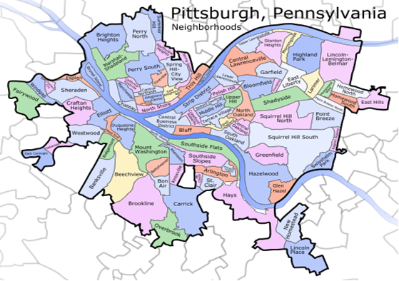

Figure 1. Pittsburgh, Pennsylvania neighborhoods map

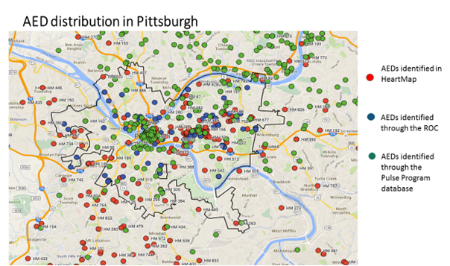
Figure 2. AED distribution in Pittsburgh

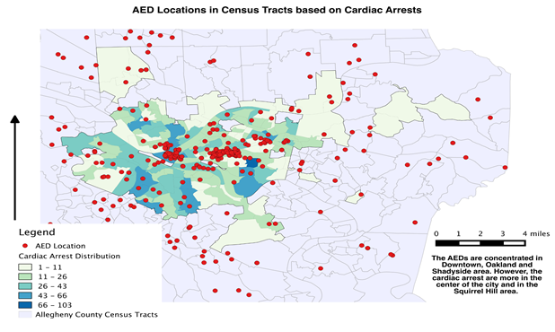
Figure 3. AED location in census tracts based on cardiac arrests

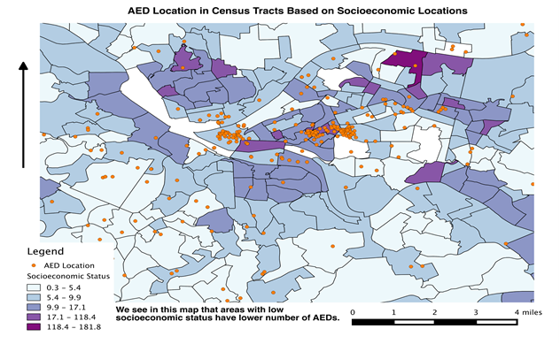
Figure 4. AED location in census tracts based on socioeconomic status
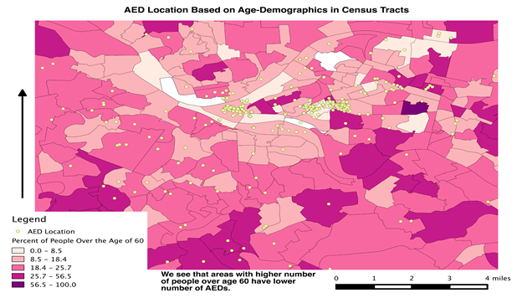Figure 5. AED location in census tracts based on age demographics

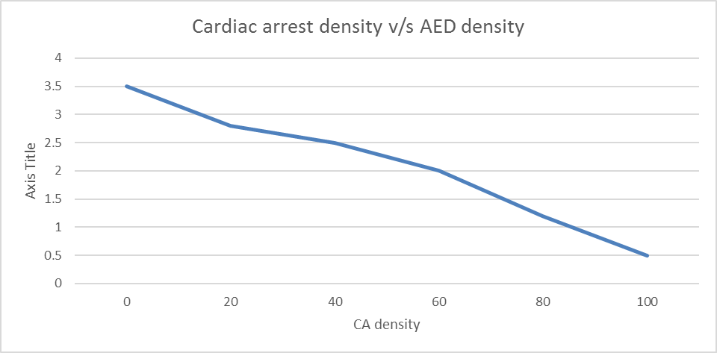
Figure 6. Graph of AED density versus cardiac arrest density

On linearly regressing the cardiac arrest density and AED density we found an association between the two, and found an inverse relationship between the two variables (P = 0.027, coeff – 0.003). However, we did not find any statistically significant association between AEDs density and socioeconomic status or AED density and population over age 60 (P > 0.05).

DIscussion
It is estimated that improved access to AEDs could save 40,000 lives a year in the U.S. (American Heart Association. 2004 Heart and Stroke Statistical Update. Dallas, Texas: American Heart Association, 2003.) It is thus important to strategize the placement of AEDs in the city. AEDs are not present in those areas where most cardiac arrests are taking place [12]. It will not be in correct to say that there is more tendency for a cardiac arrest to take place in an area which is highly populated compared to area which is not. In other words, the number of cardiac arrests reported in an area of high population density increase simply because the number of reported cases will be more. It can be noticed in Figure 3, that Downtown Pittsburgh is one such area. Even though not a lot of people reside in downtown, it is typically seen that the density of population is high from 9am – 6pm time frame given the large number of employees working in commercial and financial offices at that time. This puts the Downtown area at a risk, where more cardiac arrests occur and are thus reported. Another point that can be noticed is that since most buildings there are commercial buildings, the density of AEDs is also high, as these buildings are required to install AEDs by law. Clustering of AEDs can also be noticed in Oakland, which is due to most of the universities being located in these areas. All of these university buildings have AEDs installed. However, there are not many cardiac arrests taking place in Oakland, due to a low risk population comprising mostly young students. Squirrel Hill area is another area with a high number of cardiac arrests and high number of elderly population, but low number of AEDs.
One other important point to highlight is the accessibility of the AED. Even though an area might have a large number of AEDs, it does not necessarily mean that they are accessible. For ex: having an AED on the 30th floor of a building might not be useful for someone who is experiencing a cardiac arrest on the road right outside the building. Sometimes even if there is an AED is present inside the building, not every one might have access to the building. There is also a lack of education and knowledge about AEDs among general public. One study conducted in Philadelphia by Merchant in 2013, describes door-to-door surveying being a time-consuming technique for identifying AEDs in high employment area but a workable one. It also points towards how many AEDs are not visualized in these buildings and raises concern about their availability during an emergency.
To decrease mortality due to OHCA incidence, it is important to focus on educating and increasing awareness among the public. It is also important to utilize resources and investigate those factors that can help prevent mortality due to OHCA.

CONclusion
In this study it was seen that as OHCA density increases, the AED density decreases. Census tracts with low socio economic status are not associated with lower number of AEDs in Allegheny county. Census tracts with higher number of individuals over age 60 is not associated with lower number of AEDs in Allegheny county.
The lack of AEDs in the community is a concern, but a concern which is preventable. At the same time more research in needed to investigate those factors that can determine where AEDs need to be placed in the city.

bibliography
[1] Heart Disease and Stroke Statistics, American Heart Association, 2013
Go, Alan S., Dariush Mozaffarian, et al. "Heart Disease and Stroke Statistics - 2013 Update A Report from the American Heart Association." Circulation .127 (2013): 1-241. Web. 19 Apr. 2016.

[2] Strategies to Improve Cardiac Arrest Survival A Time to Act, Institute of Medicine, June2015
McCoy, Margaret A. Strategies to Improve Cardiac Arrest Survival. Rep. New York: Institute of Medicine, 2015. Web. 19 Apr. 2016.

[3] Mosesso, VN Jr, EA Davis, et al. "Use of Automated External Defibrillators by Police Officers for Treatment of Out-of-hospital Cardiac Arrest." Annals of Emergency Medicine 32.2 (1998): 200-07. Web. 19 Apr. 2016.

[4] Capucci, Alessandro, et al. "Community-based Automated External Defibrillator Only Resuscitation for Out-of-hospital Cardiac Arrest Patients." American Heart Journal 172 (2016): 192-200. Web. 19 Apr. 2016.

[5] Thomas, Rea. "Training Seniors in the Operation of an Automated External Defibrillator: A Randomized Trial Comparing Two Training Methods." Annals of Emergency Medicine 38.3: 216-22. Web. 19 Apr. 2016.

[6] Berdowski, Jocelyn, et al. "Impact of Onsite or Dispatched Automated External Defibrillator Use on Survival After Out-of-Hospital Cardiac Arrest." Circulation 124 (2011): 2225-232. Web. 19 Apr. 2016.

[7] Gonzales, M, et al. "Public Knowledge of Automatic External Defibrillators in a Large U.S. Urban Community." Resuscitation 6th ser. 92.101 (2015): 101-06. Web. 19 Apr. 2016.

[8] Graham, Robert, Margaret A. McCoy, and Andrea M. Schultz. "Understanding the Public Health Burden of Cardiac Arrest: The Need for National Surveillance." Strategies to Improve Cardiac Arrest Survival: A Time to Act. Washington DC: National Academies (US), 2015. Web. 19 Apr. 2016.

[9] Jacobs, Ian, et al. "Cardiac Arrest and Cardiopulmonary Resuscitation Outcome Reports." Circulation 110 (2004): 3385-397. Web. 19 Apr. 2016.

[10] "Every Second Counts: Rural and Community Access to Emergency Devices." American Heart Association. 19 Apr. 2016. Web.

[11] Siddiq, AA, SC Brooks, and TC Chan. "Modeling the Impact of Public Access Defibrillator Range on Public Location Cardiac Arrest Coverage." Resuscitation 87.7 (2013): 904-09. Web. 19 Apr. 2016.

[12] Leung, AC, et al. "Where Are Lifesaving Automated External Defibrillators Located and How Hard Is It to Find Them in a Large Urban City?" Resuscitation 84.7 (2013): 910-14. Web. 19 Apr. 2016.

[13] Nichol, G, et al. "Regional Variation in Out-of-hospital Cardiac Arrest Incidence and Outcome." JAMA 300.12 (2008): 1423-431. Web. 19 Apr. 2016.

[14] Weisfeldt, MS. "Survival after Application of Automatic External Defibrillators before Arrival of the Emergency Medical System: Evaluation in the Resuscitation Outcomes Consortium Population of 21 Million." Journal of the American College of Cardiology 55.15 (2010): 1713-720. Web. 19 Apr. 2016.

[15] "HeartMap." HeartMap. Web. 20 Apr. 2016.
https://heartmap.uwctc.org/

[16] "PULSE." PULSE. Web. 20 Apr. 2016.
http://pulsepittsburgh.org/

[17] "Resuscitation Outcomes Consortium." ROC. Web. 20 Apr. 2016.

[18] "United States Census Bureau." Census.gov. Web. 20 Apr. 2016.

[19] "2013 Poverty Guidelines." ASPE. 2015. Web. 20 Apr. 2016.

[20] List of Pittsburgh neighborhoods, Wikipedia, 15 Nov, 2015

[21]"What Is an Automated External Defibrillator?" - NHLBI, NIH. Web. 07 May 2016

