MODELING AND SPATIAL ASSESSMENT OF A BYSTANDER NOTIFICATION SYSTEM FOR OUT OF HOSPITAL CARDIAC ARRESTS IN PITTSBURGH, PA

by
Sanjana Srinivasan
BS, University of North Carolina at Chapel Hill, 2014

Submitted to the Graduate Faculty of
Environmental and Occupational Health Department
Graduate School of Public Health in partial fulfillment
of the requirements for the degree of
Master of Public Health

University of Pittsburgh
2016

ABSTRACT
UNIVERSITY OF PITTSBURGH
GRADUATE SCHOOL OF PUBLIC HEALTH

This essay is submitted
by
Sanjana Srinivasan

on

May 9, 2016
and approved by

Essay Advisor:
Claudette M. St. Croix, PhD ______________________________________
Associate Professor
Department of Environmental and Occupational Health
Graduate School of Public Health
University of Pittsburgh

Essay Reader:
David D. Salcido, PhD ______________________________________
Research Instructor
Department of Emergency Medicine
School of Medicine
University of Pittsburgh

Copyright © by Sanjana Srinivasan
2016

Background: Out-of-hospital cardiac arrest (OHCA) is a substantial public health burden. Rapid cardiopulmonary resuscitation (CPR) or defibrillation with an automated external defibrillator (AED) can increase OHCA survival. Bystander notification systems (BNS) aim to facilitate this. PulsePoint, is a BNS that directs trained responders to OHCAs to initiate CPR. This project was conducted to assess the viability of PulsePoint if it were deployed in Pittsburgh, PA.
Claudette M. St. Croix, PhD

MODELING AND SPATIAL ASSESSMENT OF A BYSTANDER NOTIFICATION SYSTEM FOR OUT OF HOSPITAL CARDIAC ARRESTS IN PITTSBURGH, PA
Sanjana Srinivasan, MPH
University of Pittsburgh, 2016
Methods: Simulations incorporating actual AEDs, OHCAs, and population characteristics were run to assess bystander deployment strategies. Weighting factors to calculate number of bystanders in each census tract were: fixed random points, population, population density, shape area, cardiac arrest incidence, cardiovascular disease mortality (CVD) and age over 65. Maps were created for each factor calculating total distance and time for a layperson to travel to an AED and then an OHCA. Repeated simulations produced statistical summaries for distance and time. Using the estimator with the lowest distance, spatial analysis was conducted to determine the difference in response time between deployed bystanders and emergency medical services, and then estimate then change in one-month survival outcomes using PulsePoint.
Results: CVD and Fixed Random Points produced the lowest total distance. Among 92% of the census tracts, bystanders arrived prior to EMS. The survival outcome model predicts that 17.2% (Median = 17.1%, Standard Error = 3.7%) of victims will survive when assessed by layperson and 7.9% (Median = 7.9%, Standard Error = 0.179) with EMS.
Conclusion: Bystander notification systems with the use of PulsePoint show potential to increase survival after an OHCA.
.

TABLE OF CONTENTS
1.0 Introduction 1
1.1 objectives 2
2.0 BACKGROUND 3
2.1 EPIDEMIOLOGY 4
2.2 TREATMENT AND SURVIVAL 4
2.3 BYSTANDER NOTIFICATION SYSTEMS 5
3.0 EvIDENCE FOR BNS 7
4.0 AN ASSESSMENT IN PITTSBURGH 10
5.0 DISCUSSION 20
6.0 CONCLUSION 23
bibliography 24

List of tables
Table 1: Summary Statistics for Total Distance Traveled in Miles from Bystander to AED and to the OHCA 14
Table 2: One-Month Survival Percentage 19

List of figures
Figure 1: Flow Chart of Study Design 10
Figure 2: Distance from Cardiac Arrest to Nearest AED 12
Figure 3: Distance from Bystander to Cardiac Arrest 13
Figure 4: Spatial PulsePoint Model in Pittsburgh, PA 17
Figure 5: Survival Outcome Model 18

Introduction
According to the American Heart Association, over 424,000 out-of-hospital cardiac arrests (OHCA) events have occurred since 2014 and 90% of the cases were fatal⁹. An OHCA is defined as the cessation of cardiac activity and circulation and occurs outside of the hospital². Many factors play a role in the risk of having an OHCA.
Early bystander initiated cardiopulmonary resuscitation (CPR) and the use of automated external defibrillators (AED) can prevent death, major neurological damage, and disability during these events. Efforts to increase public awareness have been implemented but are lacking in substantial results. Moreover, knowledge on the use and locations of AEDs varies and AEDs are not distributed based on need thereby reducing accessibility⁴.
Bystander notification systems (BNS) have been installed in cities to achieve a greater success rate in survival. Using a system that allows laypersons to provide treatment during an OHCA has the potential to increase the outcome. (SOURCE) One example, PulsePoint, is a mobile application that enlists responders who are qualified to aid during an OHCA event. PulsePoint uses radial distance from the location of the suspected cardiac arrest to alert registered responders, including information of the nearest AEDs and location of the OHCA³.

objectives
The objectives of this paper were to assess the feasibility of BNS like PulsePoint in Pittsburgh, PA by simulating models to calculate the total time and distance a layperson would travel to the nearest AED and OHCA. Bystander locations were generated across all census tracts to calculate distance. We also aimed to calculate the survival outcome to compare results between bystander and EMS assessed OHCA. Data for these simulations consisted of actual AED and cardiac arrest locations in Pittsburgh, PA from various sources.

BACKGROUND
An OHCA causes a change in the electrical distribution and rhythm in the heart.⁴ On the electrocardiogram, this can present as ventricular fibrillation, pulseless ventricular tachycardia, pulseless electrical activity or asystole⁸. Blood flow is halted to the brain and other organs. The brain is at a loss of oxygen rich blood, resulting in permanent neurological damage⁴. During an OHCA, successful cardiopulmonary resuscitation (CPR) and defibrillation using an automated external defibrillator (AED) will increase the chances of survival.
Presence of heart conditions has the potential to lead to an OHCA. This includes: coronary heart disease previous heart problems such as heart attacks, congenital heart disease, blood pressure, and heart vessel/valve abnormalities^{2,4}. However, the immediate cause is usually associated with an abnormal heart rate. The most common presentation is ventricular fibrillation. The lower part of the heart, the ventricles, fibrillates in a series of quivers where the result is all cardiac output ceases.²
Individuals considered to be healthy and active may experience OHCA. Physical stress may also have intense impacts on the heart, changing the electrical system. Family history is a contributing factor. Lastly, external risk factors like smoking, recreational drug use and sudden trauma/blow to the chest can also play a role in the incidence of OHCA².

EPIDEMIOLOGY
Among 190 countries, it has been estimated that heart disease is the number one cause of death. Approximately 17.3 million deaths globally, have been associated with heart disease. This trend is expected to increase to 23.6 million deaths by the year, 2030. As of 2013, the reported incidence for OHCA is 359,400.¹⁸
The median age for an OHCA is 66 years. Approximately 70% of all OHCA occur in residential area. Sudden OHCA varies by race where the incidence is 10.1 for blacks, 5.8 among whites and 6.5 among Hispanics⁴. The survival rate after an OHCA is 11%.

TREATMENT AND SURVIVAL
Immediate treatment consists of CPR and/or the use of an Automated External Defibrillator. During an event of an OHCA, early defibrillation within three to five minutes is a predictor for long-term survival and neurologic function. Defibrillation produces an electric shock to the heart and reintroduces normal heart conduction by establishing depolarization. Therefore, prompt actions by bystanders are vital to decrease mortality rates.⁴
The use of an Automated External Defibrillator (AED) can quickly restore the rhythm of the heart of a person experiencing ventricular fibrillation. An AED is a user-friendly portable device that delivers an electric shock through the chest to the heart to restore normal rhythm. Bystanders regardless of training can use an AED during an event of an OHCA. The AED provides instructions to bystanders regarding the procedure^{2,4}.
During an event of an OHCA, only 30% of the victims receive CPR and 2% receive defibrillation from AEDs. The use of an AED is underwhelming low and has not been employed pervasively. An AED has a very low probability of harming the user. The instrument is set up in a manner that ensures that electricity flows from one pad to the other and to the chest of the victim to restore normal heart rhythm. With the use of bystander CPR or an AED, the chances of survival increases by approximately 38%. Moreover, after every minute without proper CPR or defibrillation the chances of survival decrease by 7-10%.^{2,9.}

BYSTANDER NOTIFICATION SYSTEMS
Significant amount of resources and time have been spent to increase awareness yet, immediate bystander action is lacking for many reasons. The use of registries that track cardiac arrest incidence and locations of AEDs have been employed in various areas. Having a registry that acknowledges the locations of AEDs can be use to facilitate information between Emergency Medical Services (EMS) and 911-dispatch to bystanders at the scene. Aggregating information to create registries is time intensive to ensure accuracy^{2,11}.
The use of BNS can be presented through mobile applications and a text messaging system. The use of BNS through mobiles is present in several cities. The use of BNS alerts available bystanders with the use of the dispatch system to facilitate by tracking user and event locations. Volunteers have the ability to arrive at the scene early enough to provide immediate treatment until the presence of the EMS.¹²
Connecting immediate help to a cardiac arrest using a mobile phone application is a healthcare innovation that can increase survival rates. PulsePoint is an application that aims to do this using the method of crowdsourcing. Using BNS or Volunteer Notification System (VNS) volunteers are localized for immediate help and treatment.¹² A method that incorporates BNS should not inhibit or interfere with emergency services. Rather this method serves to supplement the present system with coordinated communication by providing an option for persons to make the decision to offer help.¹
PulsePoint dispatches lay responders that are trained in CPR using mobile phone positioning system to provide preliminary resuscitation during an OHCA. When an event of a cardiac arrest is reported to the dispatch agency, PulsePoint will activate the available users within 400 meters (1312 feet, ~¼ mile) to provide support. Location of the cardiac arrest, the nearest AED and EMS/Fire Station will be known. Currently, PulsePoint is restricted to public areas. EMS is notified when an individual volunteers to go provide help to the victim in a safe manner. Upon arrival of EMS, the notification is no longer available for other users^{3,1}. PulsePoint has been implemented in several cities and has been reported in prior studies.

EvIDENCE FOR BNS
PulsePoint and other bystander notification systems have been used in several cities. An overview of preliminary data will provide further details to predict whether the bystander intervention is functioning as expected and improving rates of survival.
Brooks et al. in 2015 conducted a prospective study using web-based surveys to understand challenges of PulsePoint from August 7, 2012 to June 16, 2014. Responses from CPR trained volunteers, excluding healthcare professionals, were used. Recruitment consisted of 6,868 survey invitations. Based on eligibility, a total of 1,274 responses were included for the purpose of the study. The overall response rate was 21.4%. When asked on CPR background, 97% of the users said that they received formal training. PulsePoint notifications were received by 68% of the respondents and 23% confirmed their arrival at the scene of the event. The results illustrated that in 80% of the cases, CPR was attempted. ³
Survey questions on timing of notifications at the time of an OHCA were sent to understand the efficacy PulsePoint. There were several reasons why responders did not activate or respond to PulsePoint, this includes: not being able to receive a notification, not activating the application, silencing any notification and unable to receive proper cellular signal. Other day-to-day reasons consisted of, unavailability to respond due to other commitments. Promoting awareness and registration of PulsePoint increases recognition of interventions to decrease deaths due to OHCA.
During many events when users responded to PulsePoint, EMS was present at the scene of the OHCA. This could be attributed to the fact that the EMS arrived by vehicle while PulsePoint users traveled by foot. Also, users of PulsePoint are not on stand-by like the EMS. The exact radius or distance that is considered optimal for PulsePoint has not been established but is currently set to 400 meters. This study evaluated that optimization and implementation of PulsePoint gives the ability to increase the rate of survival.³
Another study in 2014 by Zijlstra et al. analyzed the use of a text message system and out of hospital cardiac arrests in the Netherlands. Part of the Amsterdam Resuscitation Studies (ARREST), this prospective study used available registries in the region where organizations and individuals can register an AED. In an event of a cardiac arrest, two ambulances from a single tier, equipped with a defibrillator and first responders, are sent to the location. Using the text message system, participants are allowed to register their availability. CPR and defibrillation training is required. During an OHCA, dispatchers will notify text message users with relevant information regarding the location of an AED and the victim. Two types of alert system are employed to cover a greater distance to increase participation rates. The first system identifies respondent within 500 meters (1640.42 feet, 0.31 miles) who are given the location of the closest AEDs and the cardiac arrest. In the second system, users within 1000 meters (3280.84 feet, 0.62 miles) are given instructions to attend to the victim directly to administer CPR.
Data collected from the text message responders was used to find the time range that it took for users to respond to a cardiac arrest in comparison to emergency medical services. It was seen that text message responder’s time of arrival was lower in comparison to the EMS significantly (p-value = 0.001). Text message responders used AEDs in 16.5% of the cases and were the first to connect to an AED in 12.3% of the cases. Text message responders in 71.3% of the cases gave the first shock using an AED.⁵ Among 12% of OHCA text message responders arrived first to the scene. The goal of this system is to aid emergency medical services to shorten time to first defibrillation to alleviate mortality. However to efficiently achieve this target, recruitment of this system should be disseminated further in the community.⁵ There are many variables that affect the results from the use of PulsePoint but can improve time of arrival during an OHCA and increase the survival outcome rate.

AN ASSESSMENT IN PITTSBURGH
A simulation of PulsePoint in the city of Pittsburgh, PA was modeled to assess the average total time for a bystander to arrive to the nearest AED and to the suspected OHCA. Exploring various deployment strategies and models provided preliminary analysis of the application and the time it will take for a victim to receive first CPR or defibrillation. This simulation analyzed response rate and travel time in Pittsburgh, PA where in an event of an OHCA, bystanders with the mobile application within 400 meters of the victim will receive a notification and information regarding the location of the event and the closest AED.
Figure 1: Flow Chart of Study Design
Geocoded AED and OHCA locations
Generated random bystanders for each weighted estimator
Calculated distance from OHCA to nearest AED
Calculated distance from bystander to nearest AED
ADD
A simulation for 500 runs was used to calculate total bystander distance traveled for each weighted factor
Time from EMS to OHCA was calculated for comparison to bystander time
One-month survival outcome for bystander and EMS assessed OHCA was calculated

The flow chart in Figure 1 displays the design for this study. The locations of OHCA from 2009-2014 were obtained from the Pittsburgh Site for Resuscitation Outcomes Consortium (n = 2912). The Resuscitation Outcomes Consortium consists of 10 regional clinical centers where research is conducted on OHCA and trauma including clinical trials, epidemiological investigations and quality improvement studies. Database with past cardiac arrests and details are continuously recorded from EMS and pre hospital providers. Results from randomized trials have made contributions that will provide better pre hospital healthcare. ^{13,16}
Locations of AEDs (n = 955) were collected from the HeartMap Challenge and Pittsburgh PULSE Program. Spatial analysis for this assessment was conducted using Quantum GIS (QGIS). The Pittsburgh United For Life Saving Emergencies Program (PULSE) was a community effort to supply AEDs and provide maintenance for existing devices that placed several hundred AEDs in the Pittsburgh area in 2000s.¹⁴ The HeartMap Challenge is an FDA funded project in collaboration with other universities that has been creating a comprehensive registry with information on locations and details of AEDs in Allegheny County, PA using crowdsourcing. Locations and details of present AEDs were identified through contests held in cities where participants had the chance to report devices.¹⁵
Using QGIS, AED and cardiac arrest locations were geocoded on census tract maps of Pittsburgh, PA.¹⁷ A matrix was created to calculate the distance from a cardiac arrest to the nearest AED in decimal degrees and illustrated using the tool Hub Lines through MMQGIS. This tool, unique to QGIS, displays the crow flies distance from a cardiac arrest to an AED. A crow flies distance is the closest average distance from one point to a desired location.
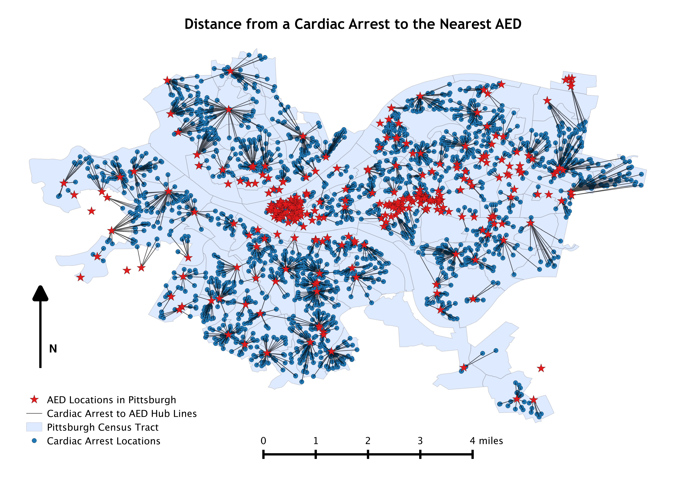
Figure 2: Distance from Cardiac Arrest to Nearest AED
Figure 1 displays the distance map with the locations of cardiac arrests and AEDs in Pittsburgh, PA. The map illustrates the dispersion of AEDs and cardiac arrests. There are clusters of AEDs in various locations, such as in the center of the city (Ex: downtown) while in other areas the devices are limited. In several regions, the hub lines from cardiac arrests converge to the same AED abiding to the closest proximity restriction, but reflecting the need for optimization. Using the information present on OHCA incidence, further deployment of AEDs has the potential to reduce mortality rates.
PulsePoint modeling was accomplished by simulating randomly located, registered bystanders and their total travel time to the AED and OHCA by creating weighted estimators using MATLAB (Mathworks, INC). The estimators across all census tracts were: creating a set number of registered bystanders in each tract, using a proportional relationship to population density, population alone, geographical shape area, previously known cardiovascular incidence, cardiovascular disease mortality and age distribution over 65 in Pittsburgh, PA. For example, using the set registrants in each census tracts ensures that a fixed value of bystanders is generated in across tracts. Alternatively, the number of bystanders based on population density increases directly with the concentration of people per census tract. From each OHCA, a distance matrix to the nearest bystander and then to the nearest AED was calculated and converted into feet. The AED devices were used as a joining factor, to ensure that the bystanders use the device closest to an OHCA.
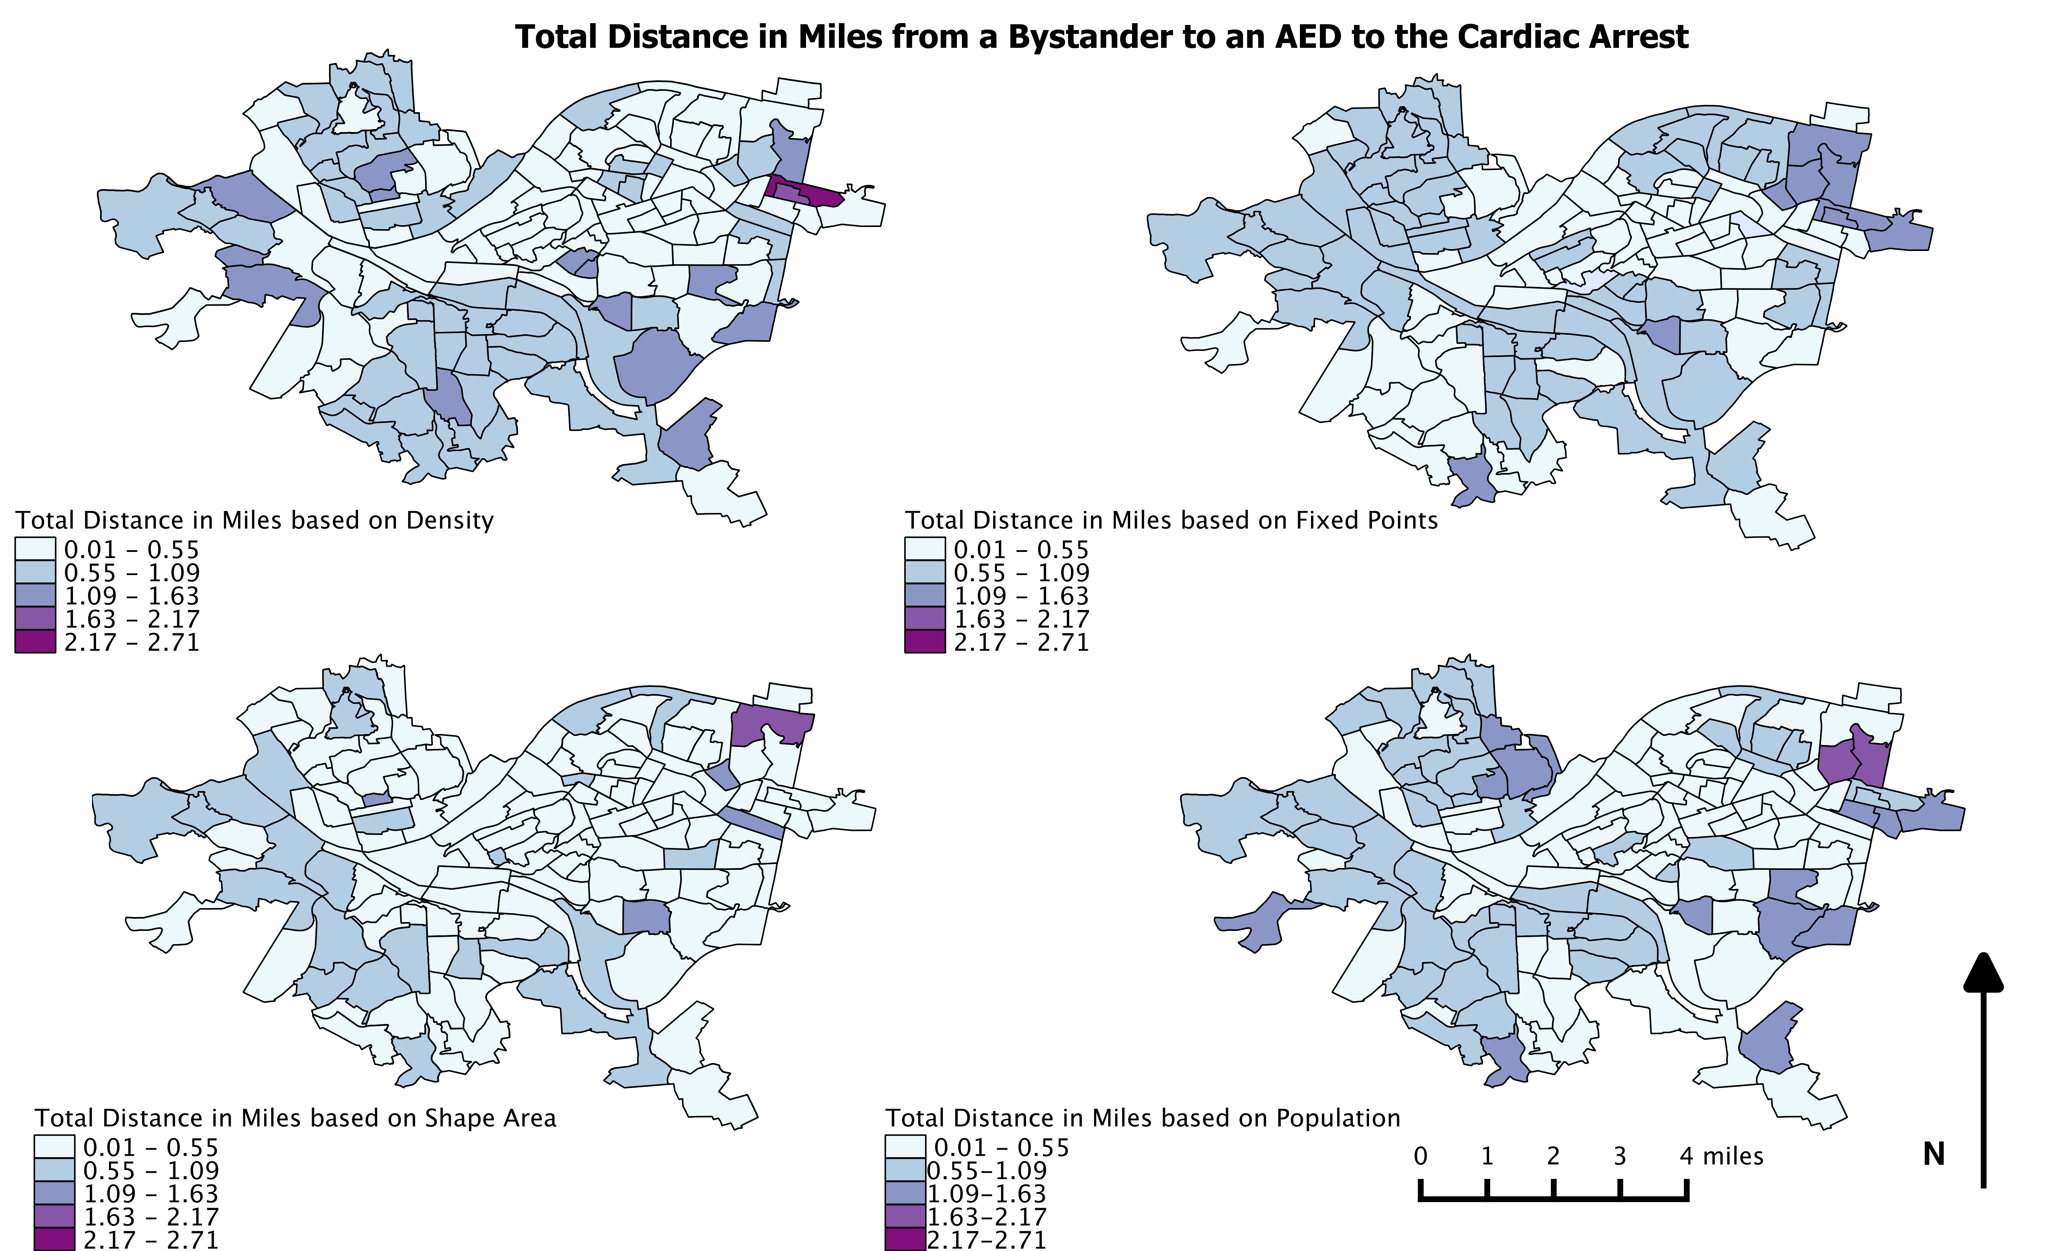
Figure 3: Distance from Bystander to Cardiac Arrest
The maps in Figure 2 display net distance traveled by a layperson based on estimators (population (n) = 2112, population density (n) = 3250, shape area (n) = 2782, fixed points (n) = 3450). The gradation of colors designates total distance in miles that a bystander travels to the nearest AED and to the event of the OHCA. The darker shades indicate greater distance traveled. These maps present the variation based on the weighted factor. Based on the legend, the total distance traveled ranges from 0.01-2.71 miles. Spatially, the lightest shade (least distance) is present in the center of the city while darker colors (greater distance) generally occur towards the city boundary. Large variation in total distance traveled is present, however, the least variation is present when bystanders are placed based on the shape area.

Table 1: Summary Statistics for Total Distance Traveled in Miles from Bystander to AED and to the OHCA

Variable | Mean | Median | Minimum | Maximum | Standard Deviation | Standard Error
Fixed Variable K = 25
Bystander to AED To OHCA | 0.554 | 0.444 | 0.023 | 2.898 | 0.442 | 0.020
Fixed Variable K =100
Bystander to AED To OHCA | 0.552 | 0.444 | 0.019 | 2.902 | 0.443 | 0.019
Fixed Variable K =250
Bystander to AED To OHCA | 0.550 | 0.441 | 0.016 | 2.902 | 0.444 | 0.019
Population K = Population/1000
Bystander to AED To OHCA | 0.613 | 0.502 | 0.043 | 2.755 | 0.428 | 0.019
Population K = Population/500
Bystander to AED To OHCA | 0.587 | 0.474 | 0.037 | 2.826 | 0.432 | 0.019
Population K = Population/100
Bystander to AED To OHCA | 0.558 | 0.448 | 0.025 | 2.895 | 0.434 | 0.021
Population Density K = Population Density/1000
Bystander to AED To OHCA | 0.583 | 0.472 | 0.032 | 2.822 | 0.435 | 0.019
Population Density K = Population Density/500
Bystander to AED To OHCA | 0.554 | 0.444 | 0.021 | 2.901 | 0.442 | 0.019
Population Density K = Population Density/100
Bystander to AED To OHCA | 0.913 | 0.852 | 0.088 | 2.774 | 0.426 | 0.019
Table 1 Continued
Shape Area K = Shape Area/5000000
Bystander to AED to OHCA | 0.717 | 0.620 | 0.068 | 2.640 | 0.419 | 0.019
Shape Area K = Shape Area/500000
Bystander to AED to OHCA | 0.561 | 0.451 | 0.028 | 2.898 | 0.438 | 0.019
Shape Area K = Shape Area/50000
Bystander to AED to OHCA | 0.553 | 0.441 | 0.017 | 2.933 | 0.444 | 0.022
Cardiac Arrest Incidence
Bystander to AED to OHCA | 0.554 | 0.443 | 0.019 | 2.902 | 0.443 | 0.018
Cardiovascular Disease
Bystander to AED to OHCA | 0.552 | 0.443 | 0.021 | 2.901 | 0.443 | 0.022
Age Distribution (Over The Age Of 65)
Bystander to AED to OHCA | 0.557 | 0.445 | 0.031 | 2.922 | 0.474 | 0.025

Using a MATLAB program, a simulation of PulsePoint that would generate bystanders with the application was created and repeated 500 times for each estimator mentioned above among all census tracts. For each of the 500 runs, the statistical summary was calculated and the average of all runs are displayed above with the total net crow flies distance in miles from the bystander to an AED and then to the OHCA. For the variables: set registrants per census tract, population, population density and shape area, multiple trials using different scales in each census tract were produced.
Fixed registrants per census tract (k) were generated so that random 25, 100 and 250 laypersons would have the application in each census tract. In the variables population and population density, the k value was scaled by 1000, 500 and 100 people in each census tract to create more points in areas with higher population and population density. The shape area variable accounted the geographical size of each census tract and generated bystander points for every 2,500,000, 250,000 and 25,000 square meters. Lastly, using data on previous, cardiac arrest incidence, cardiovascular disease mortality and demographical age distribution of people above 65 were also considered for this simulation where more points were placed in areas with higher percentage of these estimators. Table 1 displays the averages of all the summary statistics calculated to assess which estimator best predicts the shortest net distance that a layperson with the PulsePoint application may have to travel.
The smallest mean distance is present in fixed values (k=250) per census tract (mean = 0.550 miles, standard error = 0.019 miles, median = 0.444 miles) and in areas with greater cardiovascular disease burden (0.552 miles, standard error = 0.018 miles, median = 0.443 miles). When more people are randomly distributed per census tract and with greater CVD mortality, distance traveled is less.
The greatest net distance traveled/or largest mean value is present in shape area k =area/5000000 (mean= 0.717 miles, standard error = 0019, median = 0.620) and population density/100 (mean = 0.913 miles, standard error = 0.019 miles, median = 0.853 miles). When bystanders with PulsePoint are further apart in distance, the likelihood of response to an OHCA is lower since the distance traveled is greater. Likewise, when population density is divided by 100 the presence of laypersons significantly decreases, increasing total distance traveled to the OHCA.
The variation in values from this simulation is low, however, certain estimators may offer a better prediction of real data. Laypersons who do have the application may vary by census tract and a differential model could then be used with real data to conduct additional simulations.
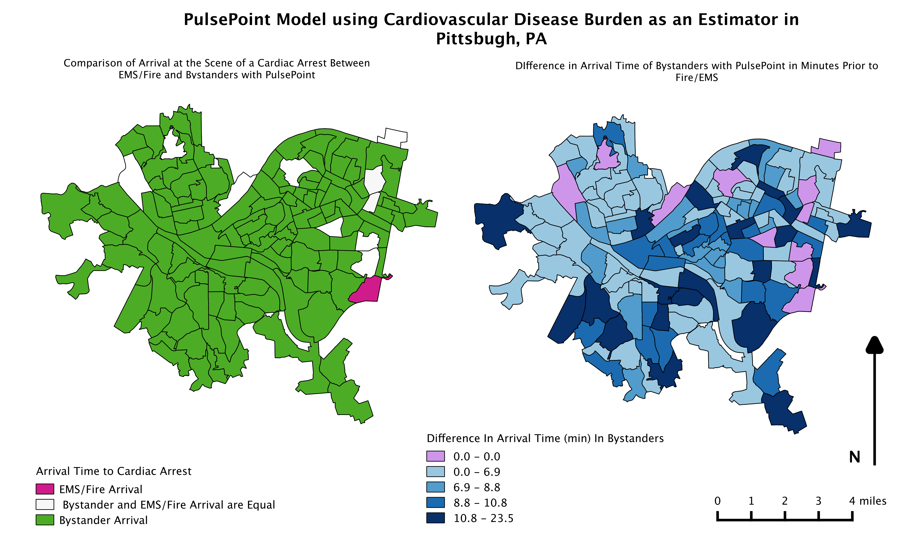
Figure 4: Spatial PulsePoint Model in Pittsburgh, PA
From the repeated simulation model, the shortest net distance traveled from bystander to AED and to the OHCA is present when cardiovascular disease burden is used as an estimator. The total distance traveled was converted from feet to time. For this purpose, the conversion value of 1 mile in 8 minutes was used to convert distance to time. Information from the Resuscitation Outcomes Consortium provides time of arrival of EMS/Fire (2009-2014) from dispatch to the scene of the cardiac arrest event; a comparison of efficiency to bystander arrival was assessed spatially. In Figure 3, the map on the left compares time of arrival of bystander to EMS per census tract. In one census tract, EMS/Fire time of arrival is faster and in among 10 census tracts the times are about equal. Overall, in 92% of census tracts, bystanders with PulsePoint arrive prior to EMS/Fire.
The second map on the right illustrates the degree of difference in minutes that bystanders will respond in comparison to EMS/Fire. The darker colors show a greater difference denoting a significantly earlier presence of bystanders at the scene when notified by PulsePoint. Among 28% of all census tracts in Pittsburgh, PA, laypersons will be able to arrive at the scene between 8.8-23.5 minutes quicker than EMS/Fire.
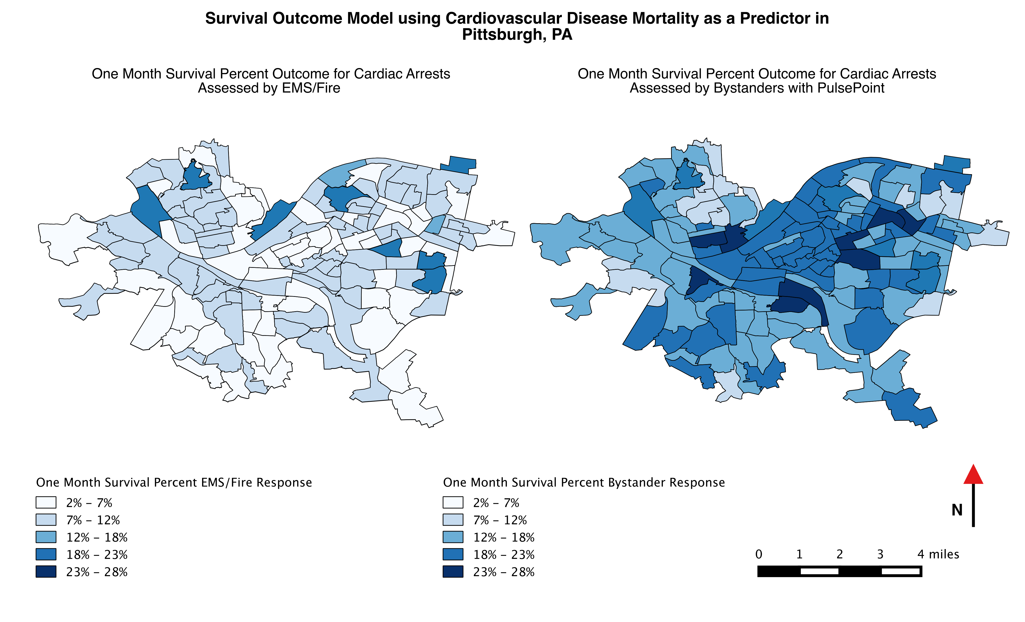
Figure 5: Survival Outcome Model

Lastly, using total time to arrival to OHCA, a survival outcome model was created to show the difference in rates when assessed by bystanders and EMS. A logarithmic regression equation was used calculate the outcome and survival after one month as a percentage against collapse to CPR interval time derived from using time of arrival of EMS. This equation is from the study by Koike et al. where the variable x is the total time in minutes from collapse to arrival. The equation is as follows: y = -0.059ln(x) + 0.2101.¹⁰
The two maps in Figure 4 illustrate the differences in terms of percent survival after one month using cardiovascular disease mortality as an estimator. The map on the right displays the variation in outcome after one month when an OHCA has been assessed by a layperson with the PulsePoint application. Spatially the majority of the map is comprised of darker census tracts and time of arrival of bystander is considerable quicker. In these census tracts, a great proportion of people may survive due to early treatment. The map on the left shows the of OHCA survival rates with the intervention of EMS; the survival rate is low and could be attributed to longer time to arrival and resuscitation.
Table 2: One-Month Survival Percentage
 | One Month Survival Percent when Assessed by Bystanders with PulsePoint | One Month Survival Percent when Assessed with EMS/Fire
Mean | 17.196 % | 7.907 %
Median | 17.085 % | 7.853 %
Standard Deviation | 3.698 % | 2.102 %
Standard Error | 0.315 % | 0.179 %
Minimum | 8.871 % | 2.190 %
Maximum | 27.906 % | 17.542 %

From the survival outcome model for each census tract, the summary statistics were tabulated for comparison. Overall from Table 2, the percent survival is greater with the response of bystanders for first resuscitation. The difference between bystander intervention and professional medical services varies but has the potential to decrease mortality due to OHCA.

DISCUSSION
Spatial analysis was restricted to ensure that distance was calculated from a cardiac arrest to the closest AED. The estimators, fixed registrants in each census tract and cardiovascular disease burden, produced the lowest total distance traveled. PulsePoint models and maps were created using cardiovascular disease burden as a predictor. The maps display large spatial variation per census tract but the simulation calculations show a slight difference in total distance traveled.
Time of arrival of bystanders is less in comparison to that of the EMS. In 10 census tracts, the difference in time ranges from 10.8-23.5 minutes prior arrival of bystanders. The survival outcome model after one month varied significantly between bystander and EMS/Fire assessed. The percent survival outcome after one month with bystander assessed is 17.2%. Since OHCA treatment is provided by EMS or the Fire Department from different units, variation in success and response may affect the outcome.
In Zijlstra et al., early connection using the TM system was present in 12.3% cases and treatment was provided within 6 minutes of the event.⁵ In 13.8% of all census tracts in this study, bystanders arrived 6.9–8.8 earlier than the EMS. This calculation was specifically found using cardiovascular disease burden as the factor. Brooks et al. found that in 61% of the cases, EMS was present before bystanders with the PulsePoint application.³ Nonetheless, this study also found that in 92% of all census tracts, bystanders would arrive earlier. In only one census tract, the EMS arrived faster using cardiovascular disease burden. The variation in results can be attributed to the difference in time of arrival of EMS and the actual time of bystander response.
There are several limitations in this study. Distances for each component, such as from the random bystander to the AED and from that device to the cardiac arrest, was calculated using crow flies distance. The crow flies distance is measured linearly on a map rather than using routes through roads which can affect the time and distance traveled since laypersons arrive by foot. A more accurate time can be calculated, and the difference in time of arrival can vary based on other factors, such as vehicular traffic and construction, using road distances. The generated bystanders are plotted randomly on a map of Pittsburgh, PA census; the locations of these users with PulsePoint in this simulation can be stationed at any elevation and in any point in the city, which requires further adjustment with real data. In this method, all bystanders are assumed to have the application and are willing to attend to the victim at the scene. The spatial maps and the statistical modeling method generated for this study is restricted to the city boundary of Pittsburgh, PA. This limitation may inhibit bystanders and AEDs that are in very close proximity to the city boundary who are at a more optimized location to attend to the victim experiencing an OHCA. The equation used to calculate the survival outcome of the model was adapted from a study in Japan, which differs in many ways from Pittsburgh, PA. This equation was also derived using EMS assessed times. It is plausible that a derived equation unique to Pittsburgh, PA will provide a better insight of survival outcome after one month.
Implementation of PulsePoint in Pittsburgh, PA should be preceded with similar trials with real points to assess the efficiency and the survival rate using this application. Barriers stated by prior studies apply to Pittsburgh, PA as well. For example, some of these barriers include: the inability to receive notifications by PuslePoint, cellular network problems, and delayed responses due to other commitments.³ Problems associated with network range is difficult to solve, but using real data will provide a model that will illustrate the extent of this variability.

CONCLUSION
A bystander notification system has the ability to contribute to earlier defibrillation in OHCA patients. Immediate and long-term survival outcomes will improve with the help of laypersons. A mobile application such as PulsePoint allows willing nearby participants to provide treatment during an event of an OHCA. This study looked at simulating these bystanders with the PulsePoint application. Though calculations were conducted using one estimator for each trial, the results provide preliminary data that illustrates the overall survival outcome is greater when OHCA is bystander assessed. Technical factors may impede PulsePoint. However, this was difficult to report since this study used generated bystander points. Using real data that accounts for these variables will provide a better assessment of these possible barriers. Applications like PulsePoint that enlist bystanders may have the potential to increase survival outcomes but needs to be determined with further studies.

bibliography
¹Public-access defibrillation and survival after cardiac arrest. (2004). ACC Current Journal Review, 13(10), 42.
²About SCA. (n.d.). Retrieved February 18, 2016, from http://www.sca-aware.org/about-sca#_edn9
³Brooks, S. C., Simmons, G., Worthington, H., Bobrow, B. J., & Morrison, L. J. (2016). The PulsePoint Respond mobile device application to crowdsource basic life support for patients with out-of-hospital cardiac arrest: Challenges for optimal implementation. Resuscitation, 98, 20-26.
⁴Cardiac Arrest. (n.d.). Retrieved February 18, 2016, from http://www.heart.org/HEARTORG/Conditions/More/CardiacArrest/Cardiac-Arrest_UCM_002081_SubHomePage.jsp
⁵Zijlstra, J. V., Stieglis, R., Riedijk F ., Smeekes M ., Van Der Worp W.E., & Koster, R., (2014). Local lay rescuers with AEDs, alerted by text messages, contribute to early defibrillation in a Dutch out-of-hospital cardiac arrest system. Resuscitation, 85.
⁶Ringh, M., Rosenqvist, M., Hollenberg, J., Jonsson, M., Fredman, D., Nordberg, P., . . . Svensson, L. (2015). Mobile-Phone Dispatch of Laypersons for CPR in Out-of-Hospital Cardiac Arrest. New England Journal of Medicine N Engl J Med, 372(24), 2316-2325.
⁷McNally, B. (2011, July 29). Out-of-Hospital Cardiac Arrest Surveillance --- Cardiac Arrest Registry to Enhance Survival (CARES), United States, October 1, 2005--December 31, 2010. Retrieved April 17, 2016, from http://www.cdc.gov/mmwr/preview/mmwrhtml/ss6008a1.htm
⁸Bloom, H. L., Shukrullah, I., Cuellar, J. R., Lloyd, M. S., Dudley, S. C., & Zafari, A. M. (2007). Long-term survival after successful inhospital cardiac arrest resuscitation. American Heart Journal, 153(5), 831-836. doi:10.1016/j.ahj.2007.02.011
⁹Ibrahim, W. H. (2007). Recent advances and controversies in adult cardiopulmonary resuscitation. Postgraduate Medical Journal, 83(984), 649-654. doi:10.1136/pgmj.2007.057133
¹⁰Koike, S., Ogawa, T., Tanabe, S., Matsumoto, S., Akahane, M., Yasunaga, H., . . . Imamura, T. (2011). Collapse-to-emergency medical service cardiopulmonary resuscitation interval and outcomes of out-of-hospital cardiopulmonary arrest: A nationwide observational study. Critical Care Crit Care, 15(3). doi:10.1186/cc10219
¹¹Bobrow, B. J. (2913). Using AED Registries to Increase Bystander CPR and AED Use. Journal of Emergency Medical Services. Retrieved April 21, 2016.
¹²Elsner, J., Schneiders, M., Haberstroh, M., Schilberg, D., & Jeschke, S. (2014). An Introduction to a Transnational Volunteer Notification System Providing Cardiopulmonary Resuscitation for Victims Suffering a Sudden Cardiac Arrest. Automation, Communication and Cybernetics in Science and Engineering 2013/2014, 579-591. doi:10.1007/978-3-319-08816-7_44
¹³Tisherman, S. A., Powell, J. L., Schmidt, T. A., Aufderheide, T. P., Kudenchuk, P. J., Spence, J., . . . Hoyt, D. (2008). Regulatory Challenges for the Resuscitation Outcomes Consortium. Circulation, 118(15), 1585-1592. doi:10.1161/circulationaha.107.764084
¹⁴St. Margaret Foundation and PULSE Join Forces to Save More Lives in Pittsburgh. (2007, April 8). Retrieved May 3, 2016, from http://www.sca-aware.org/sca-news/st-margaret-foundation-and-pulse-join-forces-to-save-more-lives-in-pittsburgh
¹⁵HeartMap. (n.d.). Retrieved May 03, 2016, from https://heartmap.uwctc.org/
¹⁶Nichol, G., Thomas, E., Callaway, C., Hedges, J., Powell, J., Aufderheide, T., . . . Stiell, I. (2008). Regional Variation in Out-of-Hospital Cardiac Arrest Incidence and Outcome. Jama, 300(12), 1423. doi:10.1001/jama.300.12.1423
¹⁷Geographic Information Systems. (n.d.). Retrieved May 04, 2016, from http://pittsburghpa.gov/dcp/gis/
¹⁸ Cardiac Arrest Statistics. (n.d.). Retrieved May 04, 2016, from http://cpr.heart.org/AHAECC/CPRAndECC/General/UCM_477263_Cardiac-Arrest-Statistics.jsp

