Nick Grieneisen

A Case Study of 15th-Century Gregorian Chant Leaves

Introduction

The University of Pittsburgh’s Hillman Library Special Collections Department holds 29 individual Gregorian chant leaves ranging from the 12th to 17th centuries from multiple locations in Western Europe. One set of six leaves (which will be referred to as 3A-3F[[1]](#footnote-1)) of Dutch provenance, dating to the 15th century, is particularly interesting in that large portions of the originally scribed neumes, and in certain cases the originally scribed text, were erased and either replaced by newly scribed neumes and/or lines of text, or just left blank. Fortunately, the scribe(s) who made these edits were unable to completely remove the originally scribed neumes and text, which are still completely visible and legible, although severely faded. Consequently, these chants provide a rare opportunity to analyze the musical differences between different scribes in intricate detail with relative ease.

The edits seem to fall into two categories: those involving deleting long melismatic extensions, shortening and simplifying melodies, and altering the text relationship with melodies, all of which seem to deviate from the standard canon as laid out in the *Liber Usualis*; and those involving text manipulation, scribing styles, and transpositions, all of which are more reflective of standardization. However, there is no specific information, such as records or other leaves of chant from the same manuscript, which sheds light onto what may have motivated the scribes to make these edits. While it would be easy to label these changes as personal or regional compositional styles, it would be shortsighted to divorce these specific musical examples from the greater context of the socio-cultural atmosphere surrounding the Catholic Church during that time.

The 15th century was a period of fragmentation within the church hierarchy and increased participation of the laity, which resulted in regionalization of dioceses across Western Europe and a weakening influence of the Vatican which would eventually lead to the Reformation. Certain practices and rituals, such as plainchant, were no doubt affected by this regionalization, which represented a deviation from the standard practices set by the papacy. I argue that in this particular set of six chants, despite certain edits which represent continental trends toward standardization, the bulk of the edits, especially those involving simplifying and shortening melodies, were a product of a regionalized style that was both reflective of social movements within the Church laity which emphasized personal piety and individual participation in Church practices, as well as indicative of the Vatican’s waning power and subsequently its weakening influence on church practices. Although the bulk of this paper will be devoted to an analysis of the musical and aesthetic differences between the pre-edited and edited versions of the chants, many of which cannot be fully explained by historical context, it is important to note that the potential reasons that these edits were made are crucial for a comprehensive understanding of these musical and aesthetic differences.

Methods of Research

I initially had the intention of finding the exact location that these chants originated from and perhaps the exact scribe who made the edits, but this quickly proved to be an improbable task, as there was no information left by the collector, Theodore M. Finney, regarding their origin, nor are there any unique markings on any of the six manuscript pages that indicate a specific diocese or scribe. After consulting the Berkeley Digital Scriptorium[[2]](#footnote-2) and the Cantus Database[[3]](#footnote-3) as well conducting simple internet searches for “Dutch Gregorian chant erasures” and similar phrases, I was unable to find any specific examples that had been scribed and edited in a similar style to those which I was researching. I then turned my attention to broader trends regarding social movements within the church and within the Netherlands during the 15th century, as well as how these trends affected the performance practice of chant, in order to place the chants into a broader context and perhaps find some information on what the intentions might have been for editing them. This proved to be successful, as the socio-cultural trends seemed to be mirrored by the edits made to the chants.

To conduct a musical analysis on the differences between the originally scribed and edited versions of the chants, I transcribed both versions into modern notation using Sibelius notation software. Though this might not have been completely necessary, seeing as the differences were easily distinguishable on the chant leaves, working through each individual neume was beneficial in that it forced me to check every single detail—including phrasing, syllabic distribution, clef changes, etc.**—**which illuminated many minute intricacies, especially those relating to notational and scribing styles, which I might not have noticed had I not transcribed each leaf. The nature in which the original neumes had been scratched out allowed for me to transcribe them with relative ease, as their faded, brownish color made them easily distinguishable from the unerased original neumes, the new neumes (which were also easily distinguishable from the unerased original neumes), and the neumes that had bled through the vellum from the other side. Thankfully, another scholar, Debra Cashion, had already discovered where each of the graduals from the chant leaves was located in the *Liber Usualis*, which saved hours of searching through the canon on my own. Not only did this aid in determining how the original and edited versions of each individual chant line compared to the standard canon versions, but it also helped immensely in proper transcription of the phrasing, as well as the text, which was difficult to read in certain spots, especially with the multitude of abbreviations used by the scribes.

Historical Context

The Catholic Church in the 15th century experienced greater, more enthusiastic participation by the laity, whose inherited religion had become a part of their identity. Though they were fully devoted to the ideals and practices of the church, the laity sought to appropriate these practices in order to fulfill their own desires and personal quests for piety, which resulted in “battling for their place in a ritual procession, for familial gain in a church, for sacred relics or a holy hermit in their local” (Van Engen, 312). The laity also sought to gain political power through the hierarchy of the church, which at that point in time was just as much a stable and powerful entity, if not more so, than secular governments. Church councils were open for “all parties, political, ecclesiastical, [and] intellectual,” (that is, not solely the clergy) to discuss and decide on “deliberative and administrative work” within the church (Van Engen, 315).

The local laity’s ability to have a stake in the church’s decision making caused the church to experience slightly more fractured regionalization, with local peoples’ interests holding as much weight as the Vatican’s. Although the church was never truly uniform throughout Western Europe, despite its near complete conversion a millennia prior, the growing influence of varying regional practices put a strain on the Vatican’s attempts to hold power and continuity through a political hierarchy and uniform ritual. One of the most widespread phenomena of regionalization which disregarded ritual uniformity was the attempt to make church practices less formal and more appealing and empathetic to the common people, and was disparagingly referred to by the Vatican as “vulgarization.” Vulgarization manifested itself in subversive art and music styles, more frequent use of and lower standards for indulgences, and, perhaps most importantly, translation of holy texts and songs from Latin into local vernacular language.

The effects of individual participation, regionalization, and vulgarization on church practices, especially music, can be seen in the Devotio Moderna, a movement that was developed largely by Geert Groote, a pastor and scholar, in the late-14th century in the Netherlands. The movement grew out of the Brothers and Sisters of the Common Life, an organization whose members lived monastic lifestyles together in small communities within cities, yet took no vows. Their purpose was to live simpler, more devoted lives to mirror the lifestyles of early Christians, and dedicated the majority of their time to manual labor and meditation, which often involved broader concepts central to Christian theology, such as “hell, heaven, death, and the Passion of the Christ,” as the community members were more concerned with the original teachings of Jesus and their personal spiritual relationship with Christ rather than hierarchical rule and political powers (Hascher-Burger and Joldersma, 319). This focus on individual participation and disregard for certain standard Latin practices resulted in massive efforts to translate religious texts and songs to Middle Dutch. As the majority of Brothers and Sisters of the Common Life, as a well as the laity in general, were not literate in Latin, this helped them connect with the teachings of Jesus to a greater degree, as well as helped spread the movement throughout the Low Countries.

The Devotio Moderna also had an effect on church music. According to the movement’s followers, music was meant to aid in meditation, and melodies were not meant to be so complex as to overshadow the text. As can be assumed by the efforts to translate church songs to Middle Dutch so those singing would be able to understand what they were singing, the text was the most important aspect of church song. As such, new polyphonic chants composed during the time were very simple, “emphasising the text of a song and not the melodic part for its own sake,” (Hascher-Burger and Joldersma, 324-25).

Although there is very little information regarding the Devotio Moderna’s effect on Gregorian chant standards that had already been composed, it is quite possible that this movement or similar movements within the church influenced certain scribes to make changes to chants in the standard canon such that their melodies would better reflect the community’s philosophies. As mentioned earlier, the majority of edits made on 3A-3F involve erasing long melismatic extensions of single syllables and simplifying melodies by removing certain notes, which fits neatly into the Devotio Moderna’s view that complicated melodies should not be emphasized over the text. Moreover, in almost every case regarding 3A-3F, the originally scribed melodies matched exactly with their counterparts in the *Liber Usualis* and the edited versions of the chants are deviations from the standard canon, giving evidence that whoever made these edits was influenced stylistically by regional developments rather than those coming from the Vatican.

This theory is augmented by evidence that the church hierarchy addressed these kinds of edits in various councils and meetings during that time period. The Synod of Schwerin in 1492 decreed that chant should be sung “from beginning to end, with nothing subtracted, diminished, or revised,” while the Counsel of Basel in 1503 decreed that chants “must not be truncated but should be sung out to the end completely, maturely, and honestly,” (Fellerer, 578). The Synod of Schwerin also mentions that there should be no “vulgar response or song in the place of those prescribed,” (Fellerer, 578). Although this does not apply to 3A-3F, it is clear that “truncating” chant melodies often occurred in conjunction with “vulgarization,” both of which were characteristic of regionalized trends.

While there is no absolute evidence that links the Devotio Moderna and other regionalized trends to 3A-3F, the musical edits involving melodic simplification and shortening are certainly symbolic and characteristic of many of the movement’s beliefs and practices. Although many of the edits in 3A-3F follow the route of standardization, the majority represent deviation from the standard and are unique to this particular set of chants.

Musical Analysis

1. Deleting Melismatic Extensions

The most dramatic and prevalent type of edit, occurring multiple times on each of the chant leaves (around sixty total times throughout the entire collection), is the complete erasure of extended single-syllable melismatic passages. This edit, along with the edits which simplify melodies, provides the most evidence that the editing scribes favored simplicity over complexity and their own regionalized style of the standard canon. The majority of these edits involve erasing 5 to 30+ consecutive neumes, which are sung on a single syllable of text (though the first few neumes of the syllable are left unedited to be sung), and either left completely blank, or replaced by two-to-four neumes that conclude the melody and lead into the next word or syllable. For the most part, these edits can be separated into two categories: melismas sung on a word’s last syllable, and melismas sung on a syllable that is not the last syllable.

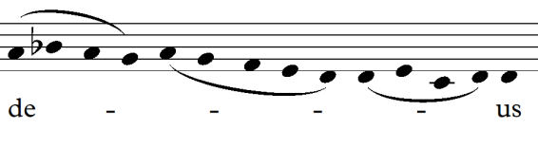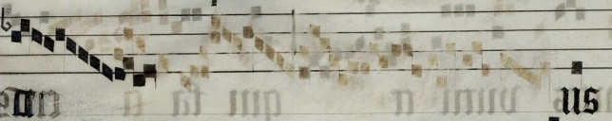 This example from 3F shows one of the more extensive non-ending syllable melisma erasures:

Edited version:

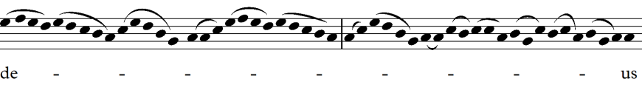

Original unedited version:

The first ten neumes of the syllable “de-” remain intact, 39 neumes from the melismatic extension are erased and replaced with three neumes, which are actually the same neumes that lead into the word’s second syllable, “us”. This particular edit may have been made as a result of the repetition of the first ten neumes of “de-” which are repeated later in the melismatic extension. The scribe(s) likely thought that this repetition was unnecessary, and that ten neumes would be sufficiently complex for one syllable.

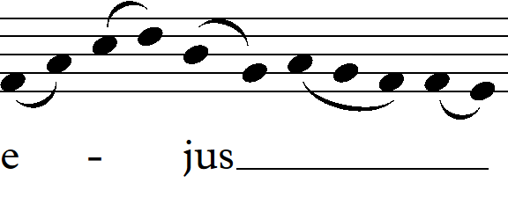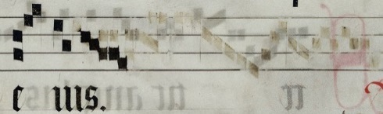 This example, again from 3F, shows the erasure of a melisma that is sung on the final syllable of the word:

Edited version:

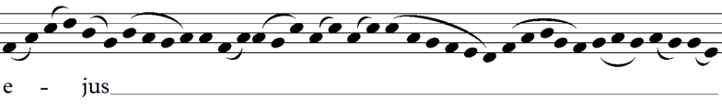

Original unedited version:

Again, after erasing 29 neumes extending from “-us,” the scribe adds five neumes on the end of the syllable to end the melodic passage. Though these neumes are not the exact same neumes scribed in the original melodic ending, they take a similar melodic shape and end on the same final note as the original.

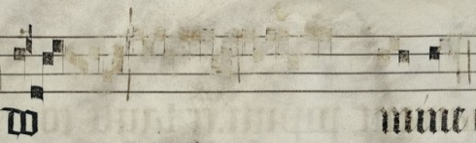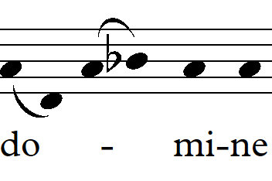Maintaining the original melodic continuity is evidently still very important to the editing scribe(s) despite the drastic edits. In this example from 3E, 24 neumes are erased from the syllable “do-” and two neumes are erased from the next syllable, “mi-”:

Edited version:

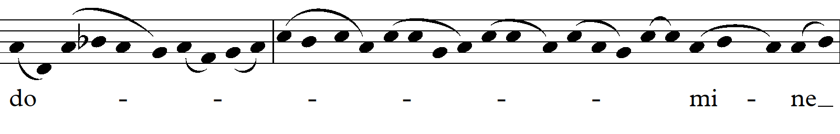

Original unedited version:

Unlike the previous two examples, no new neumes were scribed, but the last neume of “do-” is on the same note which, in the originally scribed melody, leads to the note on which the final neume of “mi-” is sung (which is the only “mi-” neume retained after the edits). This trend of keeping the melodic continuity is present in practically every instance in which a melisma has been erased.

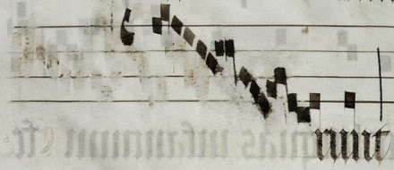 Almost every deleted melisma follows the same pattern of only rewriting a few notes, or none at all, for the sake of melodic continuity. However, there is one unique spot in 3B in which a melisma is erased and replaced by a new, albeit shorter, melisma:

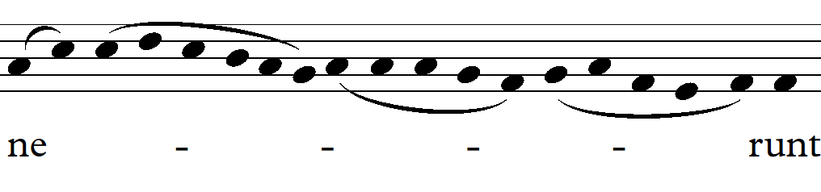

Edited version:

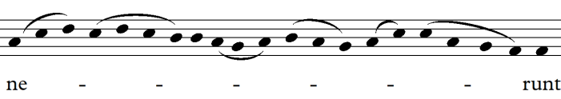

Original unedited version:

This melisma has a completely different melodic shape than the one it has replaced, starting on C and gradually descending downward, ascending briefly, then descending again, while the original melody descends and ascends four times. This edit and the edits in the previous examples exhibit favorability towards simplicity, which is also exhibited on a smaller scale.

2. Melodic simplification

In addition to the large scale melodic reduction via deleting melismas, the editing scribe(s) attempted to simplify the melodies by deleting smaller groups of neumes within melodies and either replacing those neumes with new neumes, or just leaving the remaining original neumes as they were. These types of edits occur on every chant leaf in the set and vary greatly in how exactly they simplify the melody.

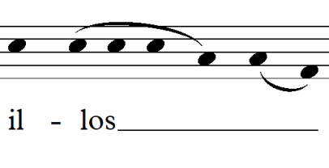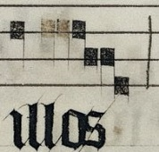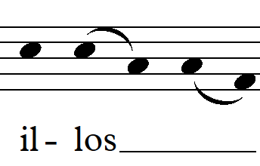 One of the more prominent edits involves deleting one or two neumes in a distropha or tristropha set and only leaving one neume intact, thereby reducing the length of the sung syllable. An example of this can be seen here (3A recto):

Edited version:

:

Original unedited version:

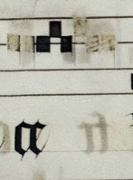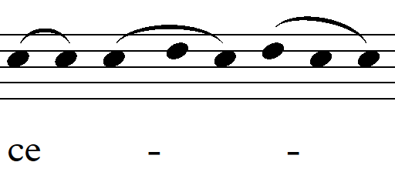This type of edit often appears in conjunction with other edits. The following example shows a tristropha reduction, along with the deletion of three neumes at the end of the sequence, which were erased presumably because the repetition of the melodic structure was deemed unnecessary by the scribe(s) (3B verso):

Original unedited version:

Edited version:

:

Another common trend is erasing more complex melodic passages and replacing them with distrophas or tristrophas. The following examples show melodies of varying degrees of complexity that have been reduced to distrophas and/or tristrophas (3C verso):

Edited version:

Original unedited version:

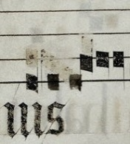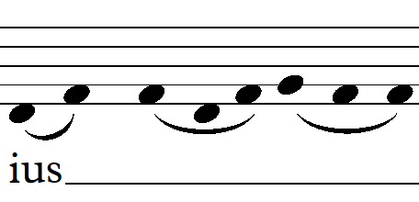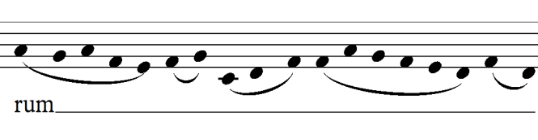

Edited version:

Original unedited version:

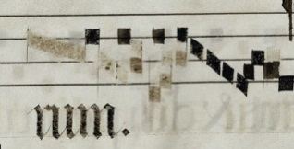

Similarly, there are many instances in which multiple neumes sung on a single syllable are replaced with or reduced down to a single neume (3A recto, 3B verso, 3E recto):

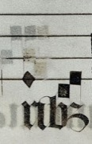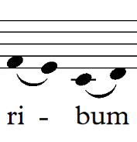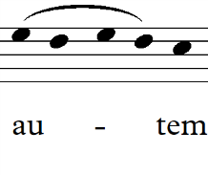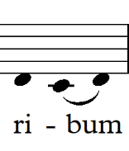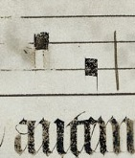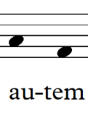

Original unedited version:

Original unedited version:

Edited version:

Edited version:

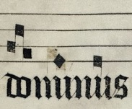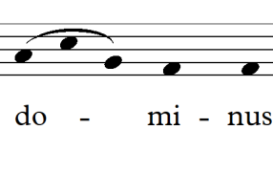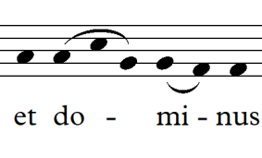

Edited version:

Original unedited version:

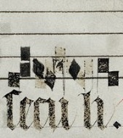Many edits are much more complex, with several neumes being erased and replaced, reducing the complexity of the melody and/or the overall number of notes sung (3E verso, 3A recto):

Edited version:

Original unedited version:

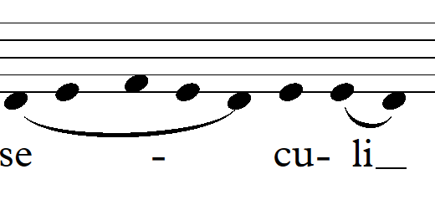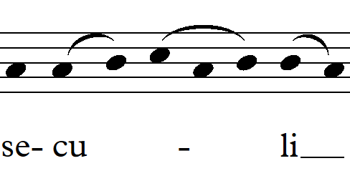

Edited version:

Original unedited version:

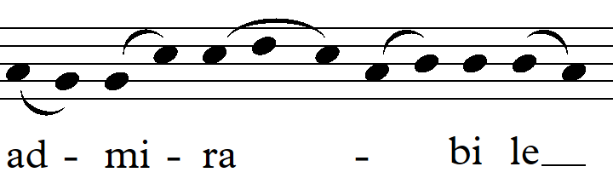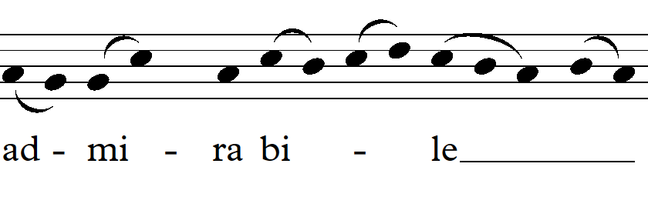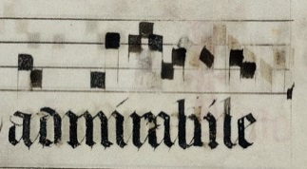

There are a few rare edits in which the editing scribe has added more neumes than he has erased, but the melody is ultimately made simpler. In the following example, the scribe erases one neume then adds two neumes to the melody, making the passage slightly easier to sing, as it ascends by 2nds instead of by a fourth (3B verso):

Original unedited version:

Edited version:

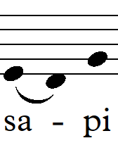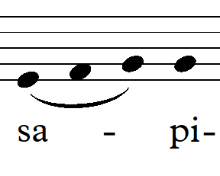

3. Rearranging neumes and text

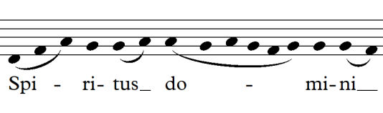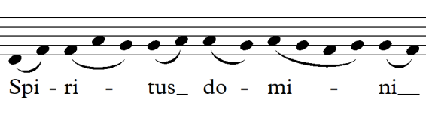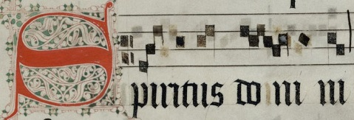 Some of the more uncommon types of edits in 3A-3F are those in which neumes are erased and replaced, but instead of the original melody being changed, the neumes are rearranged and sung on different text syllables than they were originally. In the following example, the neumes over the words “Spiritus domini” appear to be heavily edited, yet the transcription reveals that the melody is almost exactly the same and the groups of notes sung on each syllable are rearranged (3C recto):

Edited version:

Original unedited version:

While the original arrangement featured two-to-four notes sung on each syllable, the syllable “do-” is emphasized and given six notes in the new arrangement,

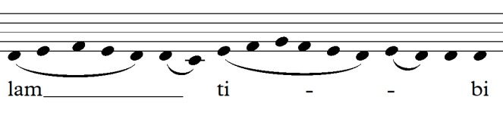 Similarly, there are a few instances in which a text syllable is erased and rescribed in a different place within the melodic line, while the neumes remain generally unchanged. The following example shows the syllable “ti-” being moved from a position adjacent to “bi,” featuring one neume, to a position adjacent to “-lam” at the beginning of the melodic line, featuring eight neumes (3F verso):

Edited version:

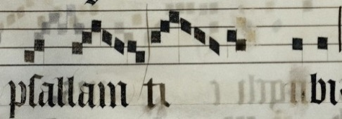

Original unedited version:

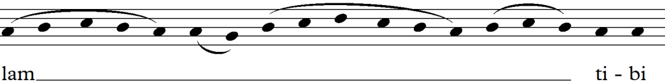

A similar example, further down on the same leaf, shows the syllable “bu-” being moved from a position adjacent to “ri-” to a position adjacent to “-lum.” Unlike the previous example, this edit gives the migrated syllable less neumes rather than more.

Original unedited version:

Edited version:

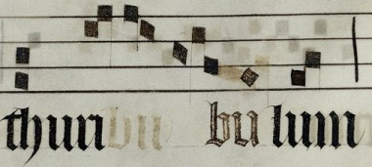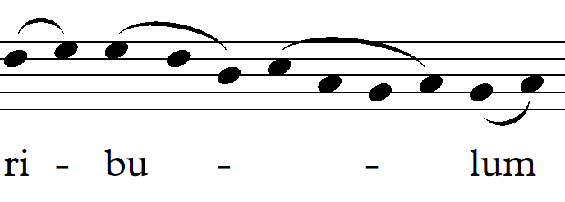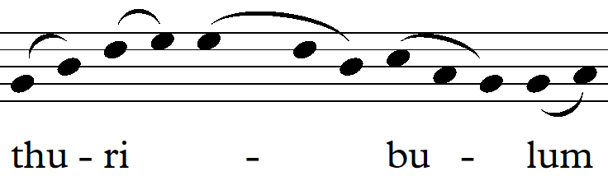

4. Replacing text (and repurposing melodies)

The set of chants contains two instances in which a line of text was completely erased and replaced by a new text, along with the accompanying neumes. The first instance occurs on the front side of 3C, in which the text and neumes from the bottom four systems have been erased and replaced with new text and neumes (the edit is made obvious by the change in script style, which will be discussed in a later section). This edit presents one of the more complicated situations in the collection, as the originally scribed chant, the edited version, and the standard version in the *Liber Usualis* are all noticeably different from one another. The text for each version is as follows:

|  |  |  |
| --- | --- | --- |
| 3C Original: | 3C Edited: | *Liber* *Usualis*: |
| Spiritus domini replevit orbem terrarum, alleluia: et hoc quod continet omnia scientiam habet vocis, alleluia, alleluia, alleluia. Omnium est enim artifex omnem habens virtutem omnia prospiciens.[[4]](#footnote-4) | Spiritus domini replevit orbem terrarum: et hoc quod continet omnia scientiam habet vocis.  Exurgat deus et dissipentur inimici ejus: et fugiant qui oderunt eum facie eius.[[5]](#footnote-5) | Spiritus domini replevit orbem terrarum, alleluia: et hoc quod continet omnia scientiam habet vocis, alleluia, alleluia, alleluia. Exurgat deus et dissipentur inimici ejus: et fugiant qui oderunt eum facie eius.[[6]](#footnote-6) |

The 3C Edited and *Liber Usualis* versions are different only in that the 3C Edited lacking the four “alleluias” which are present in the standard canon. Otherwise, these two versions are identical. The originally scribed text features a completely different second text line (which I was unable to find in the *Liber Usualis*, but which was present on the Cantus Database) from the other two, yet its first line is identical to the *Liber Usualis* version, including all “alleluias.”

This section is also unique in that the edited version took small melodic sections that were notated on the pre-edited version’s “alleluia”s (which are absent in the edited version) and repurposed them on different words. The first following example shows the melodic shapes from the words “terrarum” and “alleluia” from the pre-edited version being fused together into a new melody for the word “terrarum” in the edited version. This happens again on the word “vocis:”

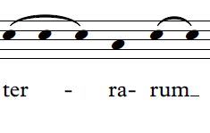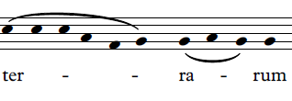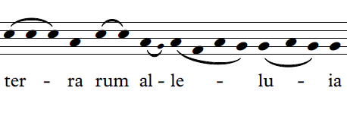

*Liber Usualis* version:

Edited version:

Original unedited version:

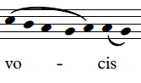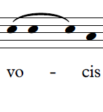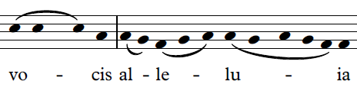

*Liber Usualis* version:

Edited version:

Original unedited version:

This edit exhibits creativity from the editing scribe, and actually makes the edited version more complex than the standard canon version (which, for the first text line, is identical to the pre-edited version), which is quite uncommon in the set.

The second instance in which text is erased and replaced is not nearly as complex as the example in 3C. On the front side of 3D, text is erased in three systems (again, easily seen by the different script style, which will be discussed below) and replaced by the same text that had been originally scribed, as well as an extension to that line of text. Interestingly enough, the newly scribed text is identical to the text in the Liber Usualis version, while the originally scribed text leaves out the extension which is present in the other two versions. The text is as follows:

|  |  |  |
| --- | --- | --- |
| 3D Original | 3D Edit | Liber Usualis |
| Quam dilecta tabernacula tua domine virtutem. Gloria patri.[[7]](#footnote-7) | Quam dilecta tabernacula tua domine virtutem concupiscit deficit anima mea in atria domini. Gloria e u o i a e. [[8]](#footnote-8) | Quam dilecta tabernacula tua domine virtutem concupiscit deficit anima mea in atria domini. Gloria e u o i a e. [[9]](#footnote-9) |

These changes in text represent the only instances in which the *Liber Usualis* matches with the edited version of the chant rather than the pre-edited version of the chant. This may indicate that while melodic composition was becoming more regionalized, text was becoming more standardized throughout Europe.

Scribing Styles

Differing script styles between the original scribe and the scribes who edited 3A-3F manifest themselves in the font of the text, the way in which the neumes are notated, and the way in which the clefs are notated. In some cases these styles represent evolving aesthetic principles which reflected changing philosophical concepts during the 15th century, while in other cases, they represent aesthetic standardization based on practicality.

 The most glaringly obvious of these script changes are present in the previously discussed text replacement edits on 3C and 3D. These two edits actually exhibit two different script styles, both of which differ from the originally scribed gothic textualis, which was the standard script style from the 12th to 17th centuries:

The 3D edit features Fraktur, the organically developed sequel to textualis, whose slightly rounder and more angular character fixed many of textualis’s legibility issues, especially those regarding minims:

The 3C edit, on the other hand, features humanist miniscule, a drastically different script developed from Italian Renaissance humanists’ attempts to revive Carolingian script (which they supposedly had mistaken for old Roman script) in order to express their humanist values.

These two different script styles are evidence that there were at least two different scribes from different aesthetic backgrounds who made edits to the collection. Although the text scribing styles are drastically different, there is no noticeable difference between the way in which the neumes are edited on 3C and 3D, both in the changes to the melodies and the script styles of the neumes, which seem to be consistent throughout both of these chant leaves, as well as through the entire set. This could imply a number of things regarding the authorship of the edits--could there have been more than two scribes making the edits? Were the scribes working together to edit the melodies? Did they edit the chants independently at different points in time? These questions are seemingly unanswerable with the amount of evidence present in 3A-3F, yet it is very likely that, despite the difference in text style, the style in which the neumes were edited is not characteristic of a solo effort, but represents multiple scribes who followed the same ideology regarding melodic style.

As mentioned earlier, the way in which new neumes were scribed is consistent throughout 3A-3F. In general, the newly notated neumes tend to be more hastily scribed than the originally scribed neumes, having rougher, rounder edges than the crisp, precise originals. It also looks as though a slightly different type of ink was used, which has a grayer, more watery quality than the original neumes. This ink also appears to be less prone to fading, though this may be a result of the originally scribed neumes having more time to fade than the newer neumes.

In addition to the physical appearance of the ink, the newly scribed neumes also exhibit Western notation’s gradual evolution through the use of new neume styles and the abandonment of old ones. The porrectus is one such neume that is used liberally by the original scribe but completely absent from the newly-scribed neumes. Here is an example in which the editing scribe erases a melodic passage and rewrites the same exact passage, using a scandicus-torculus combination in place of the originally scribed porrectus (3C recto):

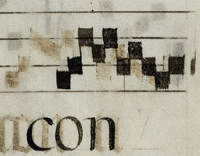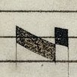

Porrectus replaced by scandicus-torculus:

Standard porrectus:

On the contrary, the following neume, which appears to be a filled-in breve, is absent from the originally scribed neumes yet is utilized by the editing scribe (3A recto):

This neume is only used in a few places throughout the collection, and though it appears to be a breve, it seems unlikely that a full breve would be sung in those places, so it may just be a variation on a punctum.

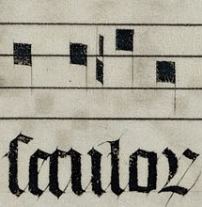 Evolving notation style can also be seen in notating B-flats. In the original notation of 3A-3F, the flat symbol is notated as such:

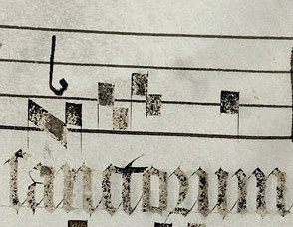At first glance, this symbol almost looks like an epiphonus neume, and I was only able to discern that it was, in fact, a flat symbol after determining that a certain clef, which I had been reading as a C clef, was actually a variation on a Fa clef. This flat symbol was not used by the editing scribe (perhaps because the older style was more confusing), who instead used the modern flat symbol, as can be seen here:

C:\Users\Nick\AppData\Local\Microsoft\Windows\Temporary Internet Files\Content.Word\PPiU.PITTMS3_B_RA.JPG Clef symbols were also affected by the evolving notation style. The original scribe’s C clef symbol appears as two punctum lined up vertically on either side of a staff line, while the editing scribe(s)’s C clef is shaped like the letter “C”:

C:\Users\Nick\AppData\Local\Microsoft\Windows\Temporary Internet Files\Content.Word\PPiU.PITTMS3_C_VA.JPG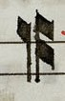The original scribe’s Fa clef symbol, similar to his flat symbol notation, is drastically different than the style of those succeeding him. Instead of the standard Fa clef, the originally scribed symbol looks like a C clef with another thinner C clef immediately adjacent to the first. This notation is not used by the editing scribe, who instead uses what would become the standard Fa clef notation:

The editing scribe(s)’s use of the Fa clef is peculiar in that every new Fa clef (aside from one exception) had originally been scribed as a C clef and was subsequently converted by the new scribe(s) using the Fa notation. The following two examples show the Fa symbol being scribed over top of the originally scribed text letter, next to an originally scribed C clef (3D recto, 3E recto):

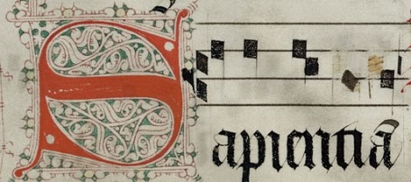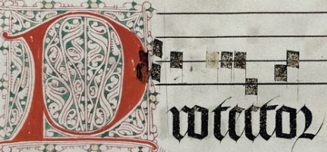

Original unedited version:

Edited version:

Original unedited version:

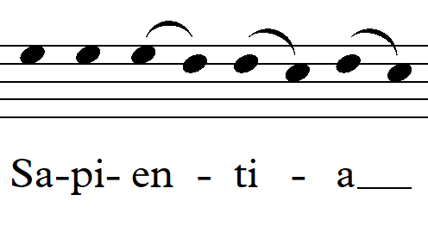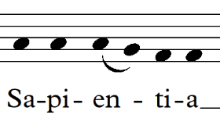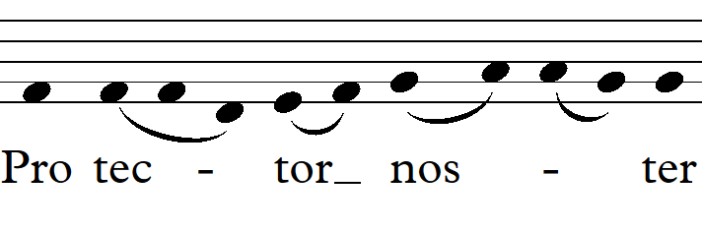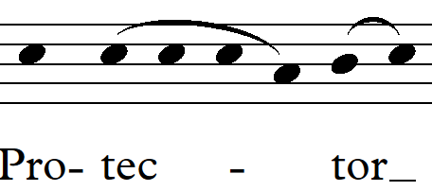

Edited version:

This actually happens quite frequently—newly converted Fa clefs are present on 3C, 3D, 3E, and 3F. In each of these instances, the neumes follow the Fa clef are transposed a fourth up (or a fifth down) from their original positions, as they had originally followed a C clef. The newly transposed melodies are the same as their counterparts in the *Liber Usualis*, while the originally scribed melodies are all a fourth down (or a fifth up). This implies that the editing scribe(s) were fixing mistakes made by the original scribe, or they were transposing the chant so it would fit into the standard canon. Either way, these edits exhibit standardization rather than regionalization in these particular edits.

Conclusion

This brief analysis only begins to scratch the surface of these chants and their place within history. Although many of the edits seem to indicate a subversive attitude towards standard church practices, many other edits show the opposite—a decided effort towards conformity and universal understanding between chant scribes. The intentions behind each of the edits become even more complicated when considering that at least two scribes were making their own changes to the chant. Although it is improbable that there will be any concrete evidence of what the scribes’ intentions were for making such extensive edits, this seemingly small manuscript set is so rich in detail that it acts as a summary of evolving musical trends during the 15th century in the Netherlands.

Bibliography

Fellerer, K. G. and Moses Hadas. “Church Music and the Council of Trent,” *The Musical Quarterly.* Oxford: Oxford University Press. 1953. Web.

The primary focus of this source is on the Council of Trent’s attempts to combat what they thought to be improper uses of and abuses to the music of the Catholic Church. Though the Council of Trent did not convene until 1545 (half a century after the edits to these chants were probably made), Fellerer references earlier, smaller councils, the 1492 Synod of Schwerin and the 1503 Council of Basel, which had attempted to correct what they thought were corruptions of the musical standard in the Church. In Fellerer’s main body of text, these councils are briefly mentioned but they are explained in more detail in extended footnotes. The disdain with which the two small councils address shortened chant melodies provides the most direct evidence that the edits made to 3A-3F were based on a regional or individual style rather than standardization by the Church hierarchy.

Hascher-Burger, Ulrike and Hermina Joldersma. “Music and the Devotio Moderna,” *Church History and Religious Culture*. Leiden: E.J. Brill, 2008. Web.

This source is part of a compilation of essays on the relationship between Church music and the Devotio Moderna. While many of the essays go into great detail about very specific subjects (such as personal piety expressed in lyrics, or adaptations of Dutch folk songs), I focused my attention on the introductory essay, which summarized the Devotio Moderna’s founding, its ideals, and some of the musical trends associated with the movement, and related these aspects of the movement to 3A-3F. I chose to discuss the Devotio Moderna among other social movements because of its historical significance and popularity, its close proximity to the provenance of 3A-3F, and its philosophical and musical ideals, which seemed to closely align with the edits made to 3A-3F.

Van Engen, John. “The Church in the 15th Century,” *Handbook of European History 1400-1600*. Leiden: E.J. Brill, 1994. Print.

This source is part of a compilation of essays which detail various facets of European history throughout the late middle ages / Renaissance. I found virtually all of the information used in the paper regarding general trends in the Catholic Church from this source. I based much of my hypothesis regarding the relationship between the edited chants and the general trends in the Church on Van Engen’s detailed summary of the fragmentation and regionalization of the Church, as well as increased participation by the laity. This essay also explicitly mentions the Devotio Moderna as somewhat of a microcosm of many of the changes that were happening within the Church during the 15th and 16th centuries.

1. An abbreviation of their designations in the Special Collections Department, as well as the Berkeley Digital Scriptorium.

   URL for 3A at Hillman Library: <http://pittcat.pitt.edu/cgi-bin/Pwebrecon.cgi?v1=74&ti=51,74&Search_Arg=gregorian%20chant&Search_Code=FT%2A&CNT=50&REC=0&RD=0&RC=0&PID=hrxtlZ8ho3kvM0iJk8dhJA834FL&SEQ=20160624224329&SID=1>

   Last Accessed: 21 May 2016 [↑](#footnote-ref-1)
2. The Berkeley Digital Scriptorium contains images of medieval manuscript pages belonging to various institutions and universities, including 3A-3F. Berkeley Digital Scriptorium URL: <http://vm133.lib.berkeley.edu:8080/xtf22/search?rmode=digscript&smode=bid&bid=36&docsPerPage=30>.

   Last Accessed: 21 May 2016 [↑](#footnote-ref-2)
3. The Cantus Database contains bibliographical information of chants held by institutions from around the world, including diocese location and scribing date. Cantus Database URL: <http://cantusdatabase.org/>

   Last Accessed: 21 May 2016 [↑](#footnote-ref-3)
4. “The Spirit of the Lord hath filled the whole world, alleluia, and that which containeth all things hath knowledge of the voice, alleluia, alleluia, alleluia. He is an architect, having all power, overseeing all things.” [↑](#footnote-ref-4)
5. “The Spirit of the Lord hath filled the whole world, and that which containeth all things hath knowledge of the voice. Let God, and let His enemies be scattered , and let them that hate Him flee from His face. [↑](#footnote-ref-5)
6. “The Spirit of the Lord hath filled the whole world, alleluia, and that which containeth all things hath knowledge of the voice, alleluia, alleluia, alleluia. Let God, and let His enemies be scattered, and let them that hate Him flee from His face.” [↑](#footnote-ref-6)
7. “How lovely are thy dwellings, O Lord of hosts. Glory.” [↑](#footnote-ref-7)
8. “How lovely are thy dwellings, O Lord. The desires of my soul hath fainted for the courts of the power of the Lord. Gloria e u o i a e.” [↑](#footnote-ref-8)
9. “How lovely are thy dwellings, O Lord. The desires of my soul hath fainted for the courts of the power of the Lord. Gloria e u o i a e.” [↑](#footnote-ref-9)