CASE STUDY: AN ANALYSIS OF A TUBERCULOSIS POST-EXPOSURE CONTACT INVESTIGATION ORIGINATING FROM AN UNDIAGNOSED ONCOLOGY PATIENT

by
Emily A Robbins
B.S., State University of New York at Geneseo, 2014

Submitted to the Graduate Faculty of
Infectious Diseases and Microbiology Department
Graduate School of Public Health in partial fulfillment
of the requirements for the degree of
Master of Public Health

University of Pittsburgh
2016

ABSTRACT
UNIVERSITY OF PITTSBURGH
GRADUATE SCHOOL OF PUBLIC HEALTH

This essay is submitted
by
Emily A Robbins

on

November 18, 2016
and approved by

Essay Advisor:
Linda Rose Frank, PhD, MSN, ACRN, FAAN ___________________________________
Associate Professor of Public Health, Medicine & Nursing
Department of Infectious Diseases and Microbiology
Graduate School of Public Health
School of Medicine
School of Nursing
University of Pittsburgh

Essay Readers:
Mohamed H Yassin, MD, PhD ______________________________________
Division of Infectious Diseases
School of Medicine
University of Pittsburgh

Marian Pokrywka, MS ______________________________________
Infection Preventionist
UPMC Mercy Hospital

Copyright © by Emily A Robbins
2016

Immunosuppressed patients, such as those undergoing chemotherapy and radiation, are at greater risk of developing tuberculosis (TB). Without prompt diagnosis the risk of nosocomial transmission is increased for patients and the staff providing care for them. At a large university-associated hospital an oncology patient developed pulmonary tuberculosis and went undiagnosed for several weeks. The patient exposed numerous other immunosuppressed patients to active TB. The infection control (IC) department of the hospital performed a contact investigation in an effort to prevent further transmission.
Linda Rose Frank, PhD, MSN, ACRN, FAAN
CASE STUDY: AN ANALYSIS OF A TUBERCULOSIS POST-EXPOSURE CONTACT INVESTIGATION ORIGINATING FROM AN UNDIAGNOSED ONCOLOGY PATIENT
Emily A Robbins, MPH
University of Pittsburgh, 2016
This study is a retrospective analysis of the tuberculosis contact investigation conducted. The results of the contact investigation are reviewed, including the compliance rate of Tuberculosis Skin Test (TST) testing among notified patients as well as TST conversions due to the exposure. Quality improvement recommendations are suggested and an algorithm for use in future tuberculosis exposure events was developed and described.
One hundred forty-two patients were identified as potential contacts and of these patients, 120 were successfully notified of the exposure. Among these patients, 39 (32.5%) completed the recommended testing and 81 patients (67.5%) were lost to follow-up. Of the 39 patients who completed the testing, there were no conversions as a result of the exposure. However, latent tuberculosis infection (LTBI) was identified in 3 patients.
This study is of public health significance because it identified three important points related to infection control practices: First, a low testing compliance rate limits the full recognition of potential conversions. New patient notification methodologies should be adopted for future tuberculosis exposure events in an effort to improve compliance with recommended testing. Secondly, there were multiple cases of LTBI identified among patient contacts, which emphasizes the importance of TB screening in high-risk populations, such as oncology patients. Finally, the contact investigation conducted was highly resource intensive. Therefore, improved policy driven practices should be implemented and prioritized in hospital settings for TB control activities. The tuberculosis Contact Investigation Algorithm developed in response to this study is a useful tool for IC practitioners in future exposure events to prevent further transmission of TB.

TABLE OF CONTENTS
1.0 Introduction 1
1.1 index case description 1
1.2 contact investigation & Need for follow-up 3
1.3 algorithm development 3
2.0 review of relevant literature 4
2.1 Epidemiology 4
2.2 Microbiology 4
2.3 Clinical manifestation & Symptoms 5
2.4 Diagnostic testing 6
2.5 Treatment 7
2.6 current situation in the united states 8
2.7 transmission in hospital settings 9
3.0 methods 11
3.1 quality improvement project 11
3.2 contact investigation description 12
3.3 contact investigation review 13
3.4 method limitations 16
4.0 results 17
4.1 Contact investigation results 17
4.2 patient demongraphics 20
4.3 testing compliance and conversions 21
4.4 tst testing results of patient tested sample 22
4.5 algorithm developed 23
5.0 discussion 25
6.0 conclusions 28
bibliography 30

List of tables
Table 1: Patient Sample Tested, n=39 20
Table 2: Entire Patient Population, N=142 21
Table 3: TST Testing of Entire Patient Population 22
Table 4: TST Testing of Patients Who Successfully Received Notification Letter 22
Table 5: TST Testing Results 23

List of figures
Figure 1: Timeline of the Index Patient at the Hospital Before Diagnosis 2
Figure 2: Charlson Comorbidity Index Form 15
Figure 3: Contact Investigation Results 19
Figure 4: Tuberculosis Contact Investigation Algorithm 24

Introduction

index case description
During the fall of 2015, a 57-year-old patient was diagnosed with pulmonary tuberculosis while undergoing routine treatment for metastatic neural endocrine cancer of the GI tract at Hospital A, a 495-bed university affiliated medical center. The tuberculosis infection in this patient was undiagnosed for several weeks. Consequently, numerous other hospital patients in the oncology, radiology and emergency departments were exposed. In response to this exposure event, the department of Infection Control conducted a retrospective tuberculosis contact investigation.
Prior to being diagnosed with active tuberculosis, the patient was undergoing oncology treatment and attended routine medical oncology visits on August 4, 11 and 18. Then, on September 3, the index case presented to the emergency department (ED) at Hospital A with lethargy, malaise, difficulty standing up and functioning independently and a productive cough. The ED physician reviewed a CT scan that was completed earlier in the day. In previous CT scans, providers made note of a cavitary lesion that was thought to be a result of the patient’s metastatic disease. Ultimately, the patient was admitted as an inpatient under no TB precautions and was discharged on September 5. The patient again attended a routine medical oncology visit on September 8. On all of these dates, other patients may have been exposed to infectious tuberculosis.
On September 16 the patient returned to the ED with a subjective fever, productive cough and night sweats, which was reported to have been occurring for a few weeks. She was again admitted as an impatient, but this time the patient was placed in a negative pressure room under tuberculosis airborne precautions. The attending physician ordered various tuberculosis testing; including a sputum culture and three AFB sputum smears. The patient also underwent testing for HIV, which was negative.
On September 17, the pulmonary department and the infectious disease department evaluated the patient. The pulmonary physician made note of “significant progression of metastatic disease involving left upper and lower lobes with multiple areas of cavitation.” By September 21, all three sputum smears had come back positive and treatment for Mycobacterium tuberculosis (MTB) was initiated. The patient was discharged on September 23. On September 25, the microbiology lab confirmed the case as culture positive. Ultimately, the immunosuppressed patient was diagnosed with pulmonary tuberculosis. Upon discharge, the County Health Department assumed responsibility for overseeing the patient’s treatment. Finally, on December 30, the index patient was evaluated at the County Health Department and was confirmed to no longer be infectious. Figure 1 below summarizes the timeline of the index case.
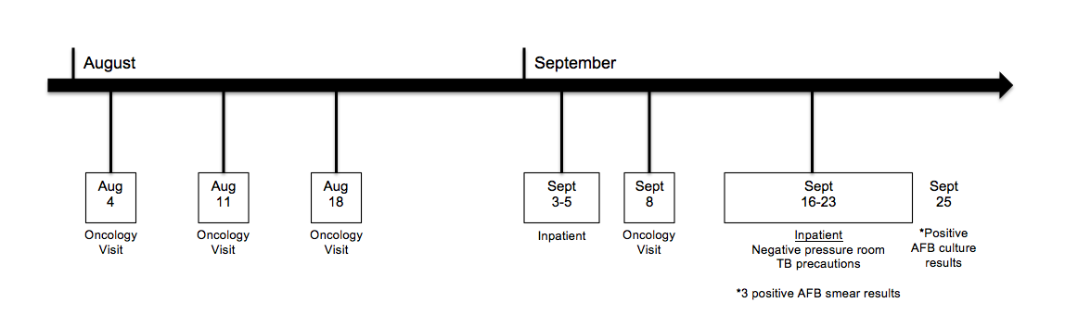
Figure 1: Timeline of the Index Patient at the Hospital Before Diagnosis

contact investigation & Need for follow-up
This case of pulmonary tuberculosis in this patient was undiagnosed for several weeks and exposed other patients, many whom are immunocompromized, to an active infection. As part of Infection Control’s responsibilities, the department initiated a contact investigation after a tuberculosis diagnosis was confirmed. A review of each patient contact is necessary in order to conclude the contact investigation and determine if any patient conversions occurred. Furthermore, understanding the demographics, comorbidities and risk factors of those exposed will provide further insight about this population.
Determining the rate of recommended testing compliance among patient contacts is of important. Testing compliance can provide insight into the effectiveness of the current contact notification methodology and determine if new methods should be adopted to improve outcomes. Comparing testing compliance rates with similar studies is especially valuable.

algorithm development
Currently, there is no written tuberculosis contact investigation algorithm available for use within this hospital system. The development of an algorithm for use by professional infection control practitioners as a guide in future exposure events in the hospital and outpatient settings was needed. Such an algorithm is a useful to streamline contact investigation processes and ensure all appropriate steps are taken in order to protect the health of patients and staff alike.

review of relevant literature

Epidemiology
Tuberculosis (TB) is one of the leading causes of death globally due to an infectious disease (1). Every 21 seconds, a person dies as a result of tuberculosis and therefore it has become one of the largest biological threats worldwide (2). In 2014 alone, TB caused 1.5 million deaths and 9.6 new infections globally (1). Similarly to other infectious diseases, TB is most prevalent in low- and middle-income countries, especially among those living in poverty-stricken areas. Overall, these countries account for about 95% of tuberculosis related deaths (1). However, high-income countries, such as the United States, are also still struggling with the control of this disease.

Microbiology
Tuberculosis infection is caused by Mycobacterium tuberculosis, a non-motile, acid-fact, rod-shaped bacterium. TB is an aerosol-transmitted disease and aerosolization occurs when an infected person coughs, sneezes or talks releasing infected droplets into the air (3). When a susceptible individual inhales the infected respiratory droplets suspended in the air, new TB infections can occur (3). Because the disease is respiratory in nature, the bacterium most often invades the lung parenchyma, known as pulmonary tuberculosis (4). However, M. tuberculosis can affect other organs as well including the pleura, brain, bones, lymph nodes and kidneys; this is known as extra-pulmonary tuberculosis (4).

Clinical manifestation & Symptoms
When someone becomes infected with the M. tuberculosis pathogen, the disease can manifest in several different ways; remain latent, become active or progress from latent TB to active TB later in life (5). A person with a latent tuberculosis infection (LTBI) is infected with M. tuberculosis but does not develop clinical disease and is incapable of spreading tuberculosis to others (1). These individuals do not feel ill or experience any TB-related symptoms, however they do react positively to diagnostic tests (6). Individuals with latent TB generally have a 10% lifetime risk of later developing tuberculosis disease through the reactivation of M. tuberculosis that previously infected the individual (6). However, the likelihood of undergoing endogenous reactivation of a latent TB infection decreases with the age of the latent infection (5). Currently, about one-third of the human population is infected with latent tuberculosis (7).
Active TB occurs when M. tuberculosis overcomes the immune system and symptomatic disease occurs (6). Individuals with a compromised immune system are at higher risk for developing active tuberculosis (6). Furthermore, studies have shown that patients with immunodeficiencies are particularly vulnerable to progression from LTBI to active disease (8).
Common symptoms of an active TB infection include a cough with sputum, hemoptysis (blood with cough), chest pain, general weakness, weight loss, fever and night sweats (1). Unlike latent TB, those with active TB are capable of spreading the disease to others. Over the course a year, an active TB case can potentially infect 10-15 other people of whom they are in close contact with (1).

Diagnostic testing
When tuberculosis is suspected, several diagnostic measures are typically initiated. There are two methods to determine if a person has been infected with M. tuberculosis, the Mantoux tuberculin skin test (TST) or an interferon-gamma release assay (IGRA) (9). A negative result from the TST or IGRA indicts that both LTBI and active disease are not likely (9). However, a positive TST or IGRA result confirms that the person has been infected with M. tuberculosis, but the results do not specify if the patient has latent TB or active disease (9). Therefore, additional tests are needed.
All persons suspected of active TB disease should undergo sputum smear and culture testing (10). Smear microscopy is the quickest way to detect acid-fast bacilli (AFB) in the sputum and therefore typically provides the initial bacteriologic evidence of active tuberculosis (10). If AFB is detected under microscopic evaluation, the sample is classified as smear-positive, but this only permits a presumptive diagnosis of TB (10, 11). Patients with smear-positive results are more infectious and proven to increase M. tuberculosis transmission compared to patients with smear-negative results (12). The infectious period of patients with smear-positive results is three months whereas a patient with smear-negative results is one month duration (13). However, not all persons with active pulmonary TB have smear-positive results, so a smear-negative result should not exclude TB disease (3).
Airborne precautions are initiated based on clinical suspicion of TB. A patient is kept in airborne isolation until three sputum smears are negative. These three specimens must be collected at least eight hours apart and one of them has to be collected in the morning. If three AFB smears are negative, the airborne precautions can be lifted prior to receiving culture results.
Mycobacterial cultures are performed on all specimens of suspected TB disease regardless of sputum smear results (10). Solid mycobacterial cultures are time-intensive and take an average of six weeks. Microscopic examination and liquid mycobacterial allows for faster identification of positive mycobacterial cultures, an average of two weeks. In high-burden countries, rapid molecular diagnostic tools have been developed for detection of MTB and any drug-resistance. Such tools allow for MTB detection within two hours (14).
Once there is growth of mycobacterium, the culture is sent for a DNA probe to identify the species as mycobacterium tuberculosis or mycobacterium avium. Mycobacterial cultures are also beneficial in identifying susceptibility to different TB medications.
Clinical presentation and chest radiographs also help to distinguish between LTBI and active infections. Cavitary lesions in the chest x-rays indicate that the infection has invaded the respiratory system, signifying active pulmonary TB disease (10).

Treatment
The treatment of latent TB is either 9 months of daily isoniazid (INH) or 12 weekly doses of INH and rifapentine (15, 16). Both regimens are equally effective with reasonable safety profile. Effective drug treatment for active TB typically lasts 6-9 months for non-drug resistant TB and includes two distinct phases of drug treatment. The initial phase aims to kill actively growing bacteria and decrease the risk of TB transmission to others. This phase lasts two months and includes four drugs: isoniazid (INH), rifampin (RIF), pyrazinamide (PZA) and ethambutol (ETB) (16). The second phase of treatment, known as the continuation phase, should include INH and RIF for four or more months (16). Overall, studies have shown that treatment regimens shorter than six months result in a high rate of relapse, therefore it is important for TB patients to complete 6 or more months of treatment in order to prevent further tuberculosis cases.

current situation in the united states
The United States is classified as a low tuberculosis incidence country. Low tuberculosis incidence countries have been defined as those with a crude case notification rate <10 (all cases) per 100,000 inhabitants and declining (17). However, in the US between 1985 and 1991 there was a significant resurgence in tuberculosis cases; during this time period all forms of TB increased by 18.4% (18). Several factors contributed to this dramatic increase in TB rates, including the HIV epidemic, the emergence of multidrug resistant (MDR) TB, increased immigration to the US and increased use of mass transport (5). Furthermore, the CDC describes TB transmission in congregate settings as a factor that fueled the resurgence of TB in the United States (10). Fortunately, since 1992 the incidence of TB has declined annually (19).
The decrease in TB incidence can be attributed to increased use of antiretroviral therapy (ART) and significant reduction in HIV/AIDs. There is a close interaction of TB and HIV epidemics. Since the decline in HIV incidence in the mid-1990s, there has also been a reduction in TB incidence (20).
Currently, immigration and foreign travel continues to pose a specific threat to tuberculosis control in the United States. In 2002, for the first time, TB cases among foreign born persons accounted for a majority (51.2%) of TB cases in the US (10). The percentage of TB cases attributable to immigrants increased from 29% to 63% in 1992 to 2012 (7). Additionally, the number of states that reported that 50% or more of their cases were among foreign born persons increased from 23 states in 2001 to 34 states ten years later (10). Although the US can do its best effort to eliminate tuberculosis throughout the country, individuals emigrating from high tuberculosis burden countries will continue to import in new infections with them. Specifically, Asians had the highest TB rates in the United States from 2003 to 2011 (10). Furthermore, large urban areas have the highest rate of tuberculosis incidence in the United States (21).

transmission in hospital settings
The risk of obtaining nosocomial tuberculosis is high for both healthcare workers (HCW) and patients, alike (22). According to the World Health Organization, those who live or work in congregate settings, such as hospitals, nursing homes or prisons, have a greater incidence of tuberculosis infection than the general population (23). Specifically, HCWs are three times more likely to obtain TB than the general population (24). A systematic review completed by Hatherill et al. found that the annual incidence of TB disease among HCWs in countries with low TB prevalence is 67 per 100,000 whereas the median incidence rate in the general population of 33 per 100,000 (25). This statistic demonstrates the public health significance of TB transmission in health-care facilities and thus the importance of infection control practices to protect both patients and staff from infection.
The transmission of TB within a health-care setting occurs when a TB case goes undiagnosed and appropriate airborne precautions are not adopted, thus exposing numerous other individuals to active disease. Highly infectious cavitary or endobronchial TB cases were reported to be associated with the largest nosocomial outbreaks (19). Tuberculosis contact investigations are an effective epidemiological method focused on breaking the chain of infection transmission. Early detection of exposed individuals using LTBI methods (TST or IGRA) and offering LTBI therapy is very effective in preventing active TB.
In a hospital setting, contact investigations are typically initiated when possible person-to-person transmission among patients and/or HCWs occurs or in situations when “persons with active tuberculosis were not promptly identified and isolated” (13). During a contact investigation, persons potentially exposed to the infectious TB case (contacts) are identified, notified of the exposure and then diagnostically evaluated for tuberculosis infection. Most commonly, contacts are assessed using TST or IGRA testing to determine if they have been infected with M. tuberculosis. Contact investigations, while resource intensive, are an effective tool for preventing the transmission of M. tuberculosis within health-care settings because they are focused on the early identification of infection, thus reducing disease severity and transmissibility to others.

methods
This is a retrospective observational epidemiological study describing and analyzing a tuberculosis contact investigation that was recently conducted at a large, university-associated hospital. In this review, the contact investigation is first summarized, including the methodology taken by the Infection Control department. Second, the patient contact population is described and reviewed to determine if any conversions occurred as a result of exposure to the index patient. Hospital employee contacts are also briefly reviewed for potential conversions. Finally, a developed algorithm is presented based on this review for use in future tuberculosis exposure events.

quality improvement project
The hospital’s total quality council reviewed and approved this project, titled “TB Exposure in Inpatient and Outpatient Facility: QI Study.” The study, Project ID: 682, was conducted under the sponsorship of the Infection Control Medical Director. According to the University of Pittsburgh’s Guidance on Activities Not Under the Jurisdiction of the Institutional Review Board, “quality assurance and improvement projects do not require IRB review and approval except when they involve ‘Research’ as defined by the federal regulations” (28). The researcher was

required to sign a Health Insurance Portability and Accountability Act (HIPAA) agreement to maintain confidentially of any records reviewed for this study.
Quality improvement projects are systematic and continuous actions focused on improving health care to a specific patient population or within a specific setting, such as a hospital (29). In general, the information gained from such projects is used to improve services rather than provide generalizable information. This study is classified as a quality improvement project and was submitted to the hospital’s quality council review because the objective of this study is to review and evaluate a recent tuberculosis contact investigation and not intended to draw generalizable conclusions.

contact investigation description
In this event, Hospital Infection Control (IC) monitored all patients that were potentially exposed and Employee Health (Occunet) monitored all staff members potentially exposed. Once notified of the confirmed case, IC compiled a list of patient contacts by acquiring patient visitation logs according to date from the oncology, radiology and emergency departments. To determine potential contacts, exposure periods were set by the IC Medical Director based on the index patient’s appointment times. All those seen in the oncology, radiology and emergency departments within the following timeframe were included as contacts; approximately one hour before the index patient’s appointment, the time spent by the index patient in the waiting and treatment rooms and up to one hour after the index patient’s appointment was over. Based on those criteria, IC identified 142 patient contacts.
Once a list of patient contacts was compiled, Infection Control contacted all exposed patients with a notification letter sent via certified mail. The letter informed contacts about the potential exposure to TB and advised them to see their primary care physician for TST testing. Also explained in the letter was that TST testing costs not covered by the patient’s insurance will be reimbursed by the hospital when submitted properly. On October 13, 2015, Infection Control sent all notification letters to patient contacts, 18 days after confirmation that the index case was culture positive.

contact investigation review
In an effort to describe the exposed population, patient demographic data, comorbidities, risk factors and TST testing results were collected from the hospital’s electronic medical record system—Cerner PowerChart®. Patients were searched for in the system by name and birth date and each chart was reviewed. At the initiation of this contact investigation review, IC collected information regarding employee contacts from Employee Health, (Occunet). The following patient data was collected and entered into a HIPPA protected Excel Spreadsheet:
- Age | - Hospital Location
- Gender | - Discharge Diagnoses
- Race | - Charlson Comorbidity Score
- Zip Code | - Returned Notification Letter
- Height | - Completion of TST Test
- Weight | - Results of TST Test
- BMI | - Completion of Chest X-Ray
- Exposed Visitation Date(s) | - Diagnosed with HIV
- Reason for Visit(s) | - Smoking Status

The Charlson Comorbidity Index is a useful score for describing the overall health of a patient, which includes the cumulative severity of a patient’s chronic comorbidities in addition to the patient’s age. In the first component, the index categorizes comorbidity components, each of which is assigned a weighted score from 1-6 based on adjusted risk of mortality (26). Each component is only counted once, even if the patient has a history of two or more of the component specifications. All component scores are summed together to determine a patient’s Comorbidity Component Score.
The second component is the Age Index Score, which is based on the patient’s age. The two components, the Comorbidity Component Score and the Age Index Score, are added together to get the Total Comorbidity Score. A higher score indicates more severe comorbidities and thus poorer health, whereas a score of zero signifies the patient has no chronic comorbidities and is in good health. The Charlson Comorbidity Index is a valuable tool for describing the overall health of patients. The form used to calculate the Comorbidity Score of each patient is shown below in Figure 2.
Data analysis was performed using Stata/SE 12.1 (27). Summary and descriptive statistics are given for patient demographics and testing performed. Frequency and percentage are presented for categorical variables, including smoking status, race and gender. The frequency and percentage of TST testing among the patient population and TST results are also shown. The mean and 95% confidence interval are presented for continuous variables, including age, BMI and Charlson Comorbidity Index score.

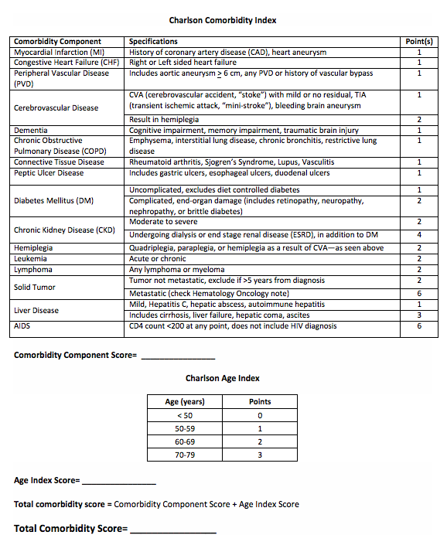
Figure 2: Charlson Comorbidity Index Form

method limitations
This is an observational epidemiological case study and conclusions drawn from the study cannot be generalized. Information gathered from the individuals that underwent recommended testing cannot be applied to the entire exposed patient population. This is because bias could arise due to the potential differences among those who underwent recommended testing and those who did not.
Additionally, various forms of error related to the collection of patient demographics and test results are possible. There is potential for information bias related to the compilation of patient information, including accidental failure to recognize and collect certain medical data.
This study only collected information from the hospital system’s electronic medical record system. Any medical information or test results not reported to or stored in the hospital’s system could be missing in the analysis.

results

Contact investigation results
From this contact investigation, a total of 202 individuals were identified as potential contacts. Infection Control identified 142 patients and Employee Health identified 60 staff members. IC was unable to contact 15.5% (n=22) of the patient contacts; 20 patient letters were undeliverable/returned to sender and two individuals died prior to the start of exposure notifications. Therefore, 84.5% (n=120) of all patient contacts were successfully notified.
Of the 120 patients successfully notified, 32.5% (n=39) completed TST testing and the remaining 67.5% (n=81) of patients were lost to follow-up. 71.8% (n=28) of patients who complied with the recommended testing had negative TST results and required no further follow-up. 20.5% (n=8) of patients who underwent TST had no results recorded in their electronic chart; this could be because these patients did not return for the results reading. The remaining 7.7% of test compliant patients (n=3) had positive TST results. These three patients were referred to the Infectious Disease Clinic. Upon further evaluation, all three patients with positive TST results were confirmed to have latent tuberculosis infection (LTBI) from previous exposures and were not a result of the recent nosocomial exposure.
Employee Health identified 60 staff members from the following departments: cancer center, radiology, emergency medicine, phlebotomy, environmental services, dietary and CT scan. Among these individuals, Employee Health confirmed there were no conversions due to the TB exposure. The results of the contact investigation conducted are depicted visually in Figure 3 below.
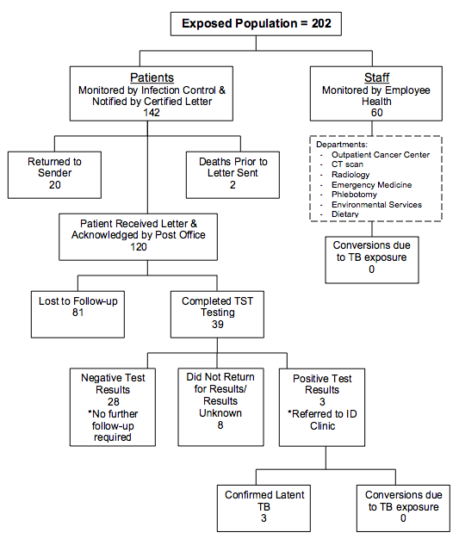
Figure 3: Contact Investigation Results

patient demongraphics
Although the tested patient sample is not identical to the entire exposed patient population, the two groups are very similar. The mean age of the two groups are very similar, sample mean age is 58.59 years and population mean age is 55.10 years. The average BMI of the two groups are also similar, 29.53 and 29.31 respectively. This puts the average individual of each group at the border of overweight and obese. The mean Charlson Comorbidity Index of each group shows that the average overall health of the patients is similar as well, 4.69 and 4.16. Furthermore, smoking status, race/ethnicity and gender composition of both groups is comparable. Patient demographics of both groups are depicted in Table 1 and Table 2 below.
Table 1: Patient Sample Tested, n=39
Variable | Mean | 95% CI
Age | 58.59 | 52.60 - 64.58
BMI | 29.53 | 26.30 - 32.76
Charlson Comorbidity Index | 4.69 | 3.63 - 5.75
Variable | Percentage (%) | 95% CI
Smoking Status
Current Smoker | 10.26 | 4.65 - 31.06
Never Smoker | 35.90 | 28.02 - 63.53
Former Smoker | 33.33 | 25.33 - 60.59
Not Listed | 20.51 | 10.27 - 36.79
Race
African American | 17.95 | 8.51 - 33.98
White | 79.49 | 63.21 - 89.73
Asian | 2.56 | 0.33 - 17.37
Gender
Male | 43.59 | 28.49 - 59.98
Female | 56.41 | 40.02 - 71.51

Table 2: Entire Patient Population, N=142
Variable | Mean | 95% CI
Age | 55.10 | 51.97 - 58.23
BMI | 29.31 | 27.69 - 30.92
Charlson Comorbidity Index | 4.16 | 3.60 - 4.71
Variable | Percentage (%) | 95% CI
Smoking Status
Current Smoker | 17.61 | 12.13 - 24.86
Never Smoker | 40.14 | 32.32 - 48.50
Former Smoker | 28.17 | 21.31 - 36.22
Not Listed | 14.08 | 9.22 - 20.92
Race
African American | 16.20 | 10.95 - 23.30
White | 81.69 | 74.36 - 87.28
Asian | 0.70 | 0.10 - 4.94
Not Listed | 1.41 | 3.47 - 5.54
Gender
Male | 45.77 | 37.67 - 54.11
Female | 54.23 | 45.89 - 62.33

testing compliance and conversions
In total, 142 patients were identified as potential contacts. If the entire population is considered, 27.46% of patient contacts complied with the recommended testing. However, as discussed above, 20 patient letters were returned as undeliverable and two patients died prior to the start of the investigation. Table 3 outlines this data below. Therefore, it is more appropriate to only consider patients who successfully received the notification letter in TST compliance rate calculation. When considering the 120 patients who successfully received the notification letter, 32.5% (n=39) complied with the recommended testing and 67.5% (n=81) were lost to follow-up. This data is outlined in Table 4 below.
Table 3: TST Testing of Entire Patient Population
TST Testing | Count | Percentage | 95% CI
Yes | 39 | 27.46 | 20.68 - 35.48
No | 81 | 57.04 | 48.68 - 65.02
Died prior to investigation | 2 | 1.41 | 0.35 - 5.54
Letter Returned to Sender | 20 | 14.08 | 9.22 - 20.92
Total | 142

Table 4: TST Testing of Patients Who Successfully Received Notification Letter
TST Testing | Count | Percentage | 95% CI
Yes | 39 | 32.50 | 20.83 - 35.71
No | 81 | 67.50 | 48.35 - 64.76
Total | 120

tst testing results of patient tested sample
Of the 39 patients that complied with the recommended testing, 71.79% (n=28) had negative test results. According to patient medical records, another eight patients underwent TST testing but the test results are unknown. Probable causes are the patient did not return for results or the test results were not entered into the hospital’s electronic medical system. These patients with unknown TST test results represent 20.51% of patients who underwent testing. Finally, 7.69% (n=3) patients had positive TST results and thus were referred to the infectious disease clinic for evaluation. This data is shown in Table 5. As discussed previously, after evaluation all three patients were confirmed to have latent tuberculosis infection due to previous exposures. All three patients were treated appropriately. From the patient data collected, there are no known conversions as a result of exposure to the index patient.
Table 5: TST Testing Results
TST Results | Count | Percentage | 95% CI
Negative | 28 | 71.79 | 55.09 - 84.08
Positive | 3 | 7.69 | 2.37 - 22.22
Unknown/Did not return | 8 | 20.51 | 10.27 - 36.79
Total | 39

algorithm developed
As no written Tuberculosis Contact Investigation outline currently exists in this hospital system, an algorithm was developed in response to this case study review. The algorithm was developed in collaboration with one of the IC department’s Infection Preventionists by mapping out all activities needed to complete a thorough contact investigation. The developed outline involves stakeholders at all levels of the institution and community. It also ensures that all exposed patients are included in the investigation and incorporates the completion of a final report to conclude the contact investigation.
The algorithm developed has potential to be a beneficial tool for professional infection control practitioners to use as guide in future exposure events. In the future, infection control practitioners and other hospital staff may refer to the document to guide activities in an organized and systematic manner. The algorithm created will be presented at a hospital-wide system meeting in October 2016. Once a month, all infection control managers and coordinators of the hospital system gather for a systems meeting to share new ideas and make decisions regarding infection control practices. The algorithm created is shown in Figure 4 below.
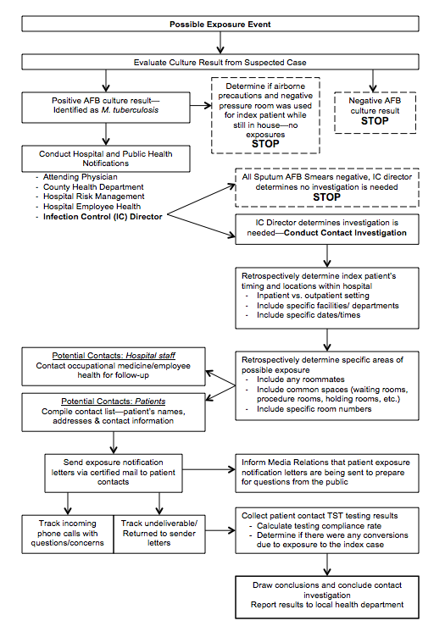
Figure 4: Tuberculosis Contact Investigation Algorithm

discussion
Failure to identify potential tuberculosis cases, including diagnosis and initiation of appropriate treatment and precautions, can result in the transmission of tuberculosis. Due to the delay in diagnosis of the index patient, numerous other individuals were exposed to active tuberculosis infection within a hospital setting. Therefore, IC initiated a contact investigation in order to identify and notify exposed patients of the incident. The analysis of this tuberculosis case study allows conclusions to be drawn about the contact investigation conducted.
As the result of this investigation, it was found that there are no known conversions as a result of exposure to the index patient. However, the low testing compliance rate of notified patients of 32.5% limits the complete identification of potential conversions. A similar case study of a tuberculosis exposure within an emergency department waiting room showed similar patient testing compliance; less than one-third of non-staff complied with the recommended testing (30). This shows that the testing compliance rate of this study is comparable to that of similar studies.
A significant implication for infection control practitioners and the hospital IC program is the low testing compliance of this contact investigation. With such a low testing compliance rate, infection control practitioners should adopt new methodologies for patient contact notification in an effort to improve testing compliance. With improved testing compliance, the IC department will gain a better understanding of contact investigation completed, including the potential for transmission and the overall extent to which transmission of TB occurred. Outbreak management focuses on reducing the prevalence of tuberculosis in the hospital population. A high testing compliance rate ensures early detection of tuberculosis patients, thereby limiting the potential for transmission.
For future contact investigations, additional modes of notification could be adopted in an effort to improve testing compliance among patient contacts. In addition to contacting and notifying each patient, contacting and notifying each patient’s primary care provider (PCP) of the potential exposure has the potential to improve adherence to TST testing recommendations. With additional support and encouragement from patients’ PCPs and clinical staff, patients may be more likely to adhere to testing recommendations. Moreover, calling patients individually in addition to sending letters via certified mail may improve the number of patients successfully notified. In instances such as the tuberculosis case described in this paper, improved testing compliance could not only lead to improvements in infection control within the hospital but also in the community setting.
A significant contribution of this contact investigation study was the identification of 3 previously unknown cases of LTBI. These three LTBI cases represent 9.67% of the patients with known testing results, which emphasizes the importance of TB screening among high-risk populations, such as oncology patients. This is a significant implication for health professionals and hospital staff. As previously discussed, immunosuppressed patients such as those undergoing chemotherapy and radiation are at greater risk of developing active tuberculosis from a latent tuberculosis infection (8). This research emphasizes the importance of screening for LTBI and active TB in order identify and treat tuberculosis infections earlier rather than later.
Finally, the contact investigation conducted was highly resource intensive, including personnel and hospital funds. Therefore, this study reinforces the importance of public health policy and administration. In contrast to outbreak management, prevention measures are an easier and more effective approach to tuberculosis control. The World Health Organization “recommends utilizing administrative controls to establish and implement a written facility plan for all tuberculosis infection control activities” (24). Focusing on more stringent policies and procedures and use of an algorithm should remain as a primary tool for infection control measures in hospital settings.

conclusions
As discussed, the aim of tuberculosis contact investigations is to reduce tuberculosis morbidity, prevent further transmission and provide preventative treatment of infected individuals to prevent development of TB disease (11). Therefore, the goal of the contact investigation described was to notify any patient contacts of the exposure and to identify any conversions as a result of the exposure. With this effort, the hope is to stop the chain of transmission. Fortunately, there are no known conversions as a result of exposure to the index patient. However, the low compliance rate of recommended testing among patient contacts is of concern and limits the full recognition of any potential conversions. Therefore, new methodologies for patient notification should be adopted for any future tuberculosis exposure events.
Furthermore, the high rate of LTBI among patient contacts that complied with recommended testing should not be ignored. As discussed, immunosuppressed patients, such as oncology patients, are more susceptible to developing tuberculosis. Therefore, the findings of this study emphasize the importance of screening high-risk populations for tuberculosis.
Finally, the contact investigation conducted was highly resource intensive and prevention measures are a more effective method for tuberculosis infection control. Additionally, as recommended by the WHO, administrative and policy driven practices should be implemented in hospital settings for tuberculosis infection control activities (24). Therefore, the Tuberculosis Contact Investigation Algorithm developed in response to this analysis is a useful tool for IC practitioners in future exposure events.

bibliography
- World Health Organization. (2016, March). Tuberculosis (TB). Retrieved August 12, 2016, from http://www.who.int/mediacentre/factsheets/fs104/en/
- Evans, T. G., & Bekker, L. (2016, May 15). Tuberculosis and Healthcare Workers in Underresourced Settings. Clinical Infectious Diseases, 62(Supplement 3), S229-S230. doi:10.1093/cid/ciw015
- Centers for Disease Control and Prevention. (2012, March 13). Basic TB Facts. Retrieved August 11, 2016, from http://www.cdc.gov/tb/topic/basics/default.htm
- World Health Organization. (2010). Guidelines for treatment of tuberculosis, fourth edition. Retrieved August 11, 2016, from http://www.who.int/tb/publications/2010/9789241547833/en/
- Ozcaglar, C., Shabbeer, A., Vandenberg, S. L., Yener, B., & Bennett, K. P. (2012, March 1). Epidemiological models of Mycobacterium tuberculosis complex infections. Mathematical Biosciences, 236(2), 77-96. doi:10.1016/j.mbs.2012.02.003
- Centers for Disease Control and Prevention. (2014a). Fact Sheets. Retrieved August 11, 2016, from http://www.cdc.gov/tb/publications/factsheets/general/ltbiandactivetb.htm
- Lin, S. & Melendez-Torres, G. J. (2016). Systematic review of risk factors for nonadherence to TB treatment in immigrant populations. Transactions of The Royal Society of Tropical Medicine and Hygiene, 110(5), 268-280. doi:10.1093/trstmh/trw025
- Sester, M., Leth, F. V., Bruchfeld, J., Bumbacea, D., Cirillo, D. M., Dilektasli, A. G., . . . Lange, C. (2014, November 15). Risk Assessment of Tuberculosis in Immunocompromised Patients. A TBNET Study. American Journal of Respiratory and Critical Care Medicine, 190(10), 1168-1176. doi:10.1164/rccm.201405-0967oc
- Centers for Disease Control and Prevention. (2014b). Testing for Tuberculosis (TB). Retrieved August 11, 2016, from http://www.cdc.gov/tb/publications/factsheets/testing/tb_testing.htm
- Centers for Disease Control and Prevention. (2013). Core Curriculum on Tuberculosis: What the Clinician Should Know (6th ed.). Atlanta, Georgia. Retrieved from http://www.cdc.gov/tb/education/corecurr/
- Bartu, V. (2016). Importance of TB contact investigations. Respiratory Medicine Case Reports, 18, 87-89. doi:10.1016/j.rmcr.2016.05.001
- Nania, J. J., Skinner, J., Wilkerson, K., Warkentin, J. V., Thayer, V., Swift, M., . . . Talbot, T. R. (2007, June). Exposure to Pulmonary Tuberculosis in a Neonatal Intensive Care Unit: Unique Aspects of Contact Investigation and Management of Hospitalized Neonates. Infection Control and Hospital Epidemiology, 28(6), 661-665. doi:10.1086/517975
- Jensen, P. A., Lambert, L. A., Iademarco, M. F., Ridzon, R., & CDC. (2005). Guidelines for Preventing the Transmission of Mycobacterium tuberculosis in Health-Care Settings, 2005. Morbidity and Mortality Weekly Report: Recommendations and Reports, 54(RR 17), 32-36. Retrieved from www.cdc.gov/mmwr/PDF/rr/rr5417.pdf
- Boehme C.C., Nabeta, P., Hillemann, D., Nicol, M.P., Shenai. S., Krapp, F., et al. (2010). Rapid molecular detection of tuberculosis and rifampin resistance. The New England Journal of Medicine, 363(11), 1005-1015. dio:10.1056/NEJMoa0907847
- Sterling T.R., Villarino, M.E., Borisov A.S., Shang, N., Gordin, F., Bliven-Sizemore, E., et al. (2011). Three months of rifapentine and isoniazid for latent tuberculosis infection. The New England Journal of Medicine, 365(23), 2155-2166. dio:10.1056/NEJMoa1104875
- Tuberculosis Coalition for Technical Assistance (TBCTA). 2009. International Standards for Tuberculosis Care (2nd ed.). Retrieved from http://www.who.int/entity/tb/ISTC_Report_2ndEd_Nov2009.pdf
- Broekmans, J. F., Migliori, G. B., Rieder, H. L., Lees, J., Ruutu, P., Loddenkemper, R., & Raviglione, M. C. (2002). European framework for tuberculosis control and elimination in countries with a low incidence. European Respiratory Journal, 19(4), 765-775. doi:10.1183/09031936.02.00261402
- Menzies, D., Fanning, A., Yuan, L., & Fitzgerald, M. (1995, January 12). Tuberculosis among Health Care Workers. New England Journal of Medicine, 332(2), 92-98. doi:10.1056/nejm199501123320206
- Andre, M., Ijaz, K., Tillinghast, J. D., Krebs, V. E., Diem, L. A., Metchock, B., . . . Mcelroy, P. D. (2007, March). Transmission Network Analysis to Complement Routine Tuberculosis Contact Investigations. American Journal of Public Health, 97(3), 470-477.
doi:10.2105/ajph.2005.071936
- Murray, C. J. L., Ortblad, K. F., Guinovart, C., Lim, S. S., Wolock, T. M., Roberts, D. A., … Vos, T. (2014). Global, regional, and national incidence and mortality for HIV, tuberculosis, and malaria during 1990–2013: a systematic analysis for the Global Burden of Disease Study 2013. Lancet, 384(9947), 1005–1070. http://doi.org/10.1016/S0140-6736(14)60844-8
- Scales, D., Brownstein, J. S., Khan, K., & Cetron, M. S. (2014). Toward a County-Level Map of Tuberculosis Rates in the U.S. American Journal of Preventive Medicine, 46(5), e49–e51. http://doi.org/10.1016/j.amepre.2014.02.001
- Cutsem, G. V., Isaakidis, P., Farley, J., Nardell, E., Volchenkov, G., & Cox, H. (2016, May 15). Infection Control for Drug-Resistant Tuberculosis: Early Diagnosis and Treatment Is the Key. Clinical Infectious Diseases, 62(Supplement 3), S238-S243. doi:10.1093/cid/ciw012
- World Health Organization. (2009). WHO Policy on TB Infection Control in Health-Care Facilities, Congregate Settings and Households. Retrieved August 29, 2016, from
http://www.who.int/tb/publications/2009/infection_control/en/
- Verkuijl, S., & Middelkoop, K. (2016, May 15). Protecting Our Front-liners: Occupational Tuberculosis Prevention Through Infection Control Strategies. Clinical Infectious Diseases, 62(Supplement 3), S231-S237. doi:10.1093/cid/civ1184
- Hatherill, M., Scriba, T. J., Udwadia, Z. F., Mullerpattan, J. B., Hawkridge, A., Mahomed, H., & Dye, C. (2016, May 15). BCG and New Preventive Tuberculosis Vaccines: Implications or Healthcare Workers. Clinical Infectious Diseases, 62(Supplement 3), S262-S267. doi:10.1093/cid/ciw025
- University of Manitoba. (2014, October 6). Term: Charlson Comorbidity Index. Retrieved from http://mchpappserv.cpe.umanitoba.ca/viewDefinition.php?definitionID=102410
- StataCorp LP. (2016). STATA Special Edition (Version 14.1). [Software]. Available from http://www.technology.pitt.edu/software/stata-for-students
- University of Pittsburgh. (2011). Guidance on Activities Not Under the Jurisdiction of the Institutional Review Board. Retrieved from http://www.irb.pitt.edu/sites/default/files
/Guidance%20on%20Activities%20Not%20Under%20the%20Jurisdiction%20of%20the%20Institutional%20Review%20Board_0.pdf
- U.S. Department of Health & Human Services, Health Resources and Services Administration (2011, April). Quality Improvement. Retrieved from http://www.hrsa.gov/quality/toolbox/methodology/qualityimprovement/
- Parada, J., Varma, G., Trulis, E., & Fearon, L. (2016). If only they had given him a mask!! A large tuberculosis post-exposure investigation originating from emergency department waiting room. American Journal of Infection Control, 44(6), S122-S123. doi:10.1016/j.ajic.2016.04.145

