FAMILY CAREGIVER SUPPORT: A COMPARATIVE ANALYSIS ON THE IMPLEMENTATION OF THE CARE ACT:
THE IMPORTANCE OF POLICY DESIGN & REGULATION

by
Yara T. Elbeshbishi
BS, University of Pittsburgh, 2015

Submitted to the Graduate Faculty of
the Department of Health Policy and Management
Graduate School of Public Health in partial fulfillment
of the requirements for the degree of
Master of Public Health

University of Pittsburgh
2016

ABSTRACT
UNIVERSITY OF PITTSBURGH
GRADUATE SCHOOL OF PUBLIC HEALTH

This essay is submitted
by
Yara T. Elbeshbishi

on

December 1, 2016
and approved by

Essay Advisor:
Nicholas Castle, PhD, MHA ______________________________________
Professor
Department of Health Policy and Management
Graduate School of Public Health
University of Pittsburgh

Essay Readers:

Mary Crossley, JD, BA ______________________________________
Professor
Department of Law
School of Law
University of Pittsburgh

A. Everette James, JD, MBA ______________________________________
Professor
Department of Health Policy and Management
Graduate School of Public Health
University of Pittsburgh
Copyright © by Yara T. Elbeshbishi
2016

One of the implications of the baby boomer and aging population is that family caregiving is gradually increasing thus the current push in caregiver research and policy. The Caregiver Advise, Record and Enable (CARE) Act provides some support to family caregivers and was introduced by the American Association of Retired Persons (AARP) to assist those caregivers with the transition of care through discharge planning from hospitals to long-term care facilities. The CARE Act requires hospitals to (1) Record the name of the family caregiver on the medical record (2) Inform the family caregivers when the patient is to be discharged and (3) Provide the family caregiver with education and instruction of the medical tasks he or she will need to perform for the patient post-discharge.
Nicholas Castle, PhD, MHA

FAMILY CAREGIVER SUPPORT: A COMPARATIVE ANALYSIS ON THE IMPLEMENTATION OF THE CARE ACT:
THE IMPORTANCE OF POLICY DESIGN & REGULATION
Yara T. Elbeshbishi, MPH
University of Pittsburgh, 2016
As of April 2016, the Act has been passed and implemented in 32 states where each individual state has different regulatory capacities, structures and resources. The scope of this comparative essay is to evaluate the implementation of the Act while looking at the importance of policy design, state regulation, stakeholder involvement and overall limitations as it varies from state to state given their capacities. This policy initiative relates to public health as it applies to population health and takes into account the emerging fields of healthcare and public health. The public health significance forecasts the concern that the aging population needs sufficient care and this legislation’s progress is dependent on public health principles of monitoring, regulation and promotion by the states. The effectiveness of the implementation of this Act directly ensures that the aging population is provided care that is specifically designed for each individual Data sources include bills published through individual state legislatures, stakeholder and state resources, in addition to publications pertaining to research related topics.

TABLE OF CONTENTS
1.0 Background on Underlying Area of Concern: The Aging Population 1
2.0 Introduction of the CARE Act 3
3.0 Landscape of Population Affected 5
4.0 AARP’s Role: Model State Bill 7
5.0 Selection of States 10
6.0 Policy Design 12
6.1 Quality Assurance 15
7.0 CARE Act: Summary of 5 States 18
7.1 California 19
7.2 Oklahoma 19
7.3 Pennsylvania 20
7.4 Washington 20
7.5 West Virginia 20
8.0 Implementation Limitations 24
9.0 Stakeholder Involvement 26
10.0 Comparative Analysis 30
11.0 Conclusion 34
12.0 Future Projections 36
BIBLIOGRAPHY 37

List of tables
Table 1. Additional Caregiving Related Resources Reported by AARP 8
Table 2. Overview of CARE Act in the 5 selected states 18
Table 3. Guidance from Caregiver Acts in Selected States: Part 1 22
Table 4. Guidance from Caregiver Acts in Selected States: Part 2 23

List of figures
Figure 1. Population Counts and Percentages for Elderly Populations 2
Figure 2. Selected Websites that Promote the Role of Family Caregivers in Discharge Preparation 29

Background on Underlying Area of Concern: The Aging Population
It is predicted that 19.6 percent of the U.S. population in 2030 will be over the age of 65, whereas in 2000, that percent was 12.3.¹ In 2011, the older generation commonly referred to as the baby-boomer generation (born in 1946-1965), began to surpass the age of 65—also, the age of eligibility for Medicare. Consequently, the number of people eligible for Medicare has increased significantly and will continue, causing the Medicare program to cover more of the population.
The shift in CMS defined elderly age groups is especially concerning for the Center for Medicare and Medicaid (CMS), a federal agency housed under the Department of Health and Human Services. The costs per capita age groups are changing because of the increase in care of cost as individual ages resulting in an alarming rise in Medicare expenditures (See Figure 1)¹. It is important to understand the scope of the underlying repercussions with a rapidly increasing aging population and the significance of care that informal caregivers provide for this population.

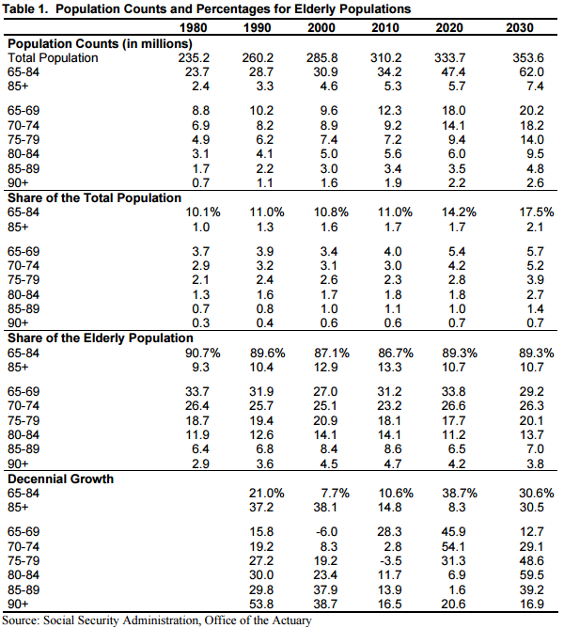

Figure 1. Population Counts and Percentages for Elderly Populations

Introduction of the CARE Act
The Caregiver Advise, Record and Enable (CARE) Act was introduced through a model state bill by the American Association of Retired Persons (AARP). AARP has been an advocacy and stakeholder organization for older populations, particularly for those who need care. The primary purpose of this Act is to provide assistance to care recipients and caregivers to understand and be well-informed about the discharge process with the transition of care from hospitals to long-term care facilities and/or home. The Act encompasses 3 major parts: ²
- The name of the family caregiver is recorded when a loved one is admitted into a hospital or rehabilitation facility.
- The family caregiver is notified if the loved one is to be discharged to another facility or back home.
- The hospital or rehabilitation facility must provide an explanation and live instruction of the medical tasks—such as medication management, injections, wound care and transfers that the family caregiver will perform at home.

While there are specific components that must be included in the state law, the states that have passed this Act have differences that are highlighted in the context of this comparative analysis essay. These differences are due to individual states’ capabilities, population demographics and evidence-based research. A key aspect about this Act to note is that because it has not been introduced in all 50 states it creates a window of opportunity to assess the progress of not only the Act but discharge planning for quality and process improvement. This allows states with the passed legislation to create the standards of this Act, on the other hand, the states that have not passed the Act will get a better understanding of what other measures states have been taking to implement this policy.
This assessment of the Act will begin with providing background information of the population that will be affected. Then the comparative analysis will begin with an overview of a primary stakeholder’s involvement, AARP’s proposed model state bill and their contributing resources, followed by an overview breakdown of the CARE Act in five selected states: California, Oklahoma, Pennsylvania, Washington and West Virginia. This analysis per individual state will evaluate whether this enacted law was an amendment to a previous Act, followed by an in-depth assessment of differentiating factors in each individual bill. Additionally, the analysis will address the significance of policy design and how numerous studies have established the landscape of discharge planning. Quality assurance will then be addressed as it was found to be a differentiating factor in one of the selected states. This analysis will then conclude with an overview of implementation limitations and stakeholder involvement in a few of the selected states where there were pertinent resources found at the time of the analysis.

Landscape of Population Affected
A significant issue that our healthcare system is currently facing is the dramatic increase in the aging population. This is “a growing number of Americans who want to age in peace at home and will have limited ability to care for themselves due to chronic conditions, trauma, or illnesses as well as inadequate personal savings.” ³ More commonly, it is seen that informal caregivers are family members who take care of this aging population, however it is not a sustainable solution due to lack of compensation and related health and financial hardships that ensue.
The recommendation of the CARE Act was a way towards addressing this issue by providing the sufficient tools that family members can adapt as an alternative to expensive formal caregiving services. This Act does not solve the entire issue at hand given the various, however, this is a start to begin to have options and support for caregiving. Public policy addresses the equality, efficiency, security and liberty of any particular area of interest to attempt to solve the issue at hand. In this case, with the increase in the aging population and the design of the Act, we are taking a look at how well the policy works and what recommendations can be proposed that can ensure that care recipients and caregivers are given the priority they need. This healthcare issue is rather unique in itself due to both the care recipients and caregivers being affected and making a point that the scope of this issue is much larger than anticipated. Care recipients are not able to get the quality care they may need due to their health condition while caregivers, more specially, family caregivers are not able to provide the care they need to because of circumstances such as employment, health and financial impact.
“The economic cost of dependency at older ages is large and projected to grow rapidly as the number of older adults increases in the coming decades, and reduced well-being for individuals facing loss of functioning and their families, who provide the bulk of uncompensated care, also is an important societal concern.” ⁴ As this aging population is seen to double by 2050, family caregivers will still continue to provide the bulk of the care and therefore the caregiver policy landscape is expanding and must change to keep up with the shifts.

AARP’s Role: Model State Bill
A vital stakeholder that advocates for aging population is AARP who developed components of a model state bill for the CARE Act. The model bill encouraged state lawmakers to endorse the three fundamental components of the Act to ensure that the message of education and improved discharge planning was delivered. AARP’s role has centralized characteristics due to its ample support to provide resources and its initiating approach to advance policy options. While the purpose of the CARE ACT is to provide support/training to family caregivers when their family member is transitioning home or to a long-term facility from the hospital, there have also been additional caregiving related practices that states have adopted to ensure that the goal of providing support to family caregivers is a priority. AARP work closely with involved stakeholders to report what caregiving related practices are available (See Table 1)⁵.

Table 1. Additional Caregiving Related Resources Reported by AARP
Resources | Type of Resource | Purpose
The Uniform Adult Guardianship and Protect Proceedings Jurisdiction Act | Financial Caregiving Bill | Ensures adult guardianship laws are consistent and honored from state to state.
The Uniform Power of Attorney Act | Financial Caregiving Bill | Ensures power of attorney laws help protect vulnerable adults and provide their caregivers with the tools they need to make important financial decisions.
Caregiver tax credit | Financial Caregiving Bill | Family caregivers relief when using their own money to care for a loved one.
Home and Community-Based Care | Access to Services | “It is significantly increasing –or protecting against significant decreases in the number of older adults who have access to state-funded services at home, like home care and adult day care across the nation.”
Nurse Scope and Delegation | Caregiving Bill | “Bills to cut through the red tape and allow nurses to have the gull authority to heal.” Increased scope of practice allows advanced practice registered nurses (APRNs) to serve as the primary prover of record. Nurse delegation allows burses to delegate certain tasks and transfer authority to trained home care professionals in regular direct contact with patients.
Registry of Home Care Workers | Caregiving Bills and Regulations | “Bills and regulations to allow family caregivers access to private-pay workers who can help provide care in the home.”
Respite Care | Access to Services | “Significantly increasing services that allow family caregivers access to private-pay workers who can help provide care in the home.”

While these other policies and practices are aimed to assist in family caregiving, they do not offer the educational component directly to the family member who will be providing the care. These additional caregiving related practices are at different phases in individual states but it is important to note that these opportunities that could provide possible assistance to family caregivers also strengthens the claim of the CARE Act’s necessity to assist family caregivers due to this gap in the healthcare sector.

Selection of States
This analysis of the CARE Act is focused on five states: California, Oklahoma, Pennsylvania, Washington and West Virginia. California, Pennsylvania and Washington were selected using several criteria; these three states have “the largest populations of older adults, [provide a] geographical representation of the U.S regions and [have a] substantial as well as limited previous involvement in caregiver-support services.” ⁶ California also has stronger stakeholder involvement, which will be beneficial to assess and compare to the other selected states. Oklahoma was selected due to it being the first state in the nation to implement this act. Pennsylvania was selected as a highlighted state due to the comprehensive and unique aspects that are encompassed in the caregiver educational component in discharge planning in its version of the Act it adopted. West Virginia was a selected state because of its noted lack of support to family caregivers. In contrast, Washington is one of the few states that have the strongest support measures to family caregivers, both prior and after the passage of the Act, particularly noted in quality assurance and evaluation.
These states are initially evaluated at whether this enacted law was an amendment to a previous Act in their state health and safety code. This is a significant part to the analysis because it differentiates the states that had formal legislation addressing the discharge planning procedure. Then an in-depth assessment of differentiating factors in each individual bill will be detailed to provide a thorough overview of the scope of support and implementation of the Act and focus on the importance of the policy design that each of these states adopted through evidence-based off available studies and research.

Policy Design
The differentiating factors in the enacted law represent individual states’ capabilities, population demographics and evidence based research that are demonstrated in the policy design. This portion of the comparison analysis addresses the significance of how research through numerous studies have established the landscape of discharge planning and how it relates and applies to caregiving and the CARE Act.
The presence of advocacy organizations, such as AARP, has been imperative to the initiation of the CARE Act. It is safe to say that the successful progress of the Act thus far is due to the guidance and support these advocacy organizations have provided. As previously mentioned, AARP set the stage with developing a model bill for states to understand the scope of what the requirements for the Act should entail.
This Act is a way that caregivers are given more consideration as part of the treatment process for providing care to their loved ones. With the growing population of baby boomers, this Act is also anticipating the support caregivers will need to ensure adequate preparation for after-care post-discharge. There have been studies conducted recently that assess not only the quality of transitional care but the evaluation of discharge practices from the perspectives of patients and their caretakers.

A study conducted in 2010 targeted patients 65 and older who were admitted to the hospital for acute coronary syndrome, heart failure or pneumonia. The purpose of the study was to gather patient perspectives and perceptions on discharge planning, and assessments were conducted from follow-up appointments to gather how well post-discharge instructions were met. The study concluded that “patient perceptions of discharge care quality and self-rated understanding were high and written discharge instructions were generally comprehensive though not consistently clear.” The outcomes did not support those perceptions and evidence from follow-up appointments supported that health setbacks occurred. “Advance discharge planning were [concluded to be] deficient, and patient understanding of key aspects of post-discharge care was poor.”⁷
This type of study provides evidence that potentially supported the discharge planning component of the policy design when this Act was in the developmental stage. This is seen in numerous states, for example California, West Virginia and Pennsylvania, as well as other states that are not the focus of this review. California, as noted as part of its comprehensive design of their discharge educational component, ensures that the designated caregiver is provided with information on public or nonprofit agencies that are dedicated to providing services that meet the care recipient’s needs for referral purposes. West Virginia has a similar component in its policy design with providing community, long-term resources and support options for the caregiver to have the opportunity to reach out for assistance if necessary. Pennsylvania, as part of its policy design structure, states that caregivers would be consulted on determining a discharge protocol and would also be supplied with live and/or recorded demonstration of the discussed tasks and post-discharge tasks.
Additional research that influenced policy designs were evidence-based, which assisted in determining what was significant for hospital discharge for the caregivers. This study, the Transition of Care for Hospitalized Elderly Patients—Development of a Discharge Checklist for Hospitalists provided a comprehensive analysis to ideally work toward transforming hospital care for vulnerable populations (i.e. elderly patients) who need further care post-discharge.⁸ This assessment was strategized and completed through the national Hospital Quality and Patient Safety (HQPS) Committee which began with a thorough literature review. The review then supported a discharge checklist draft and then an expert review of the discharge checklist. The development of the checklist continued to a peer review and then a presentation panel was introduced at the Society of Hospital Medicine (SHM) annual meeting where participants voted on the approval of the checklist. Lastly, the Hospital Quality and Patient Safety (HQPS) Board and the Society of Hospital Medicine (SHM) Board approved the final checklist and hospitals were urged and recommended to integrate the essential identified components.
The checklist has numerous date elements (i.e. recommendations to sub-specialists, key findings and test results) as well as three domains defined as significant in the discharge process, for example, discharge summary, patient instructions and communication to follow-up clinician on day of discharge. ⁸ While this study provided a comprehensive view on the significant factors that should be included in the discharge checklist, there were identified limitations. These limitations “of the checklist development process include the paucity of randomized, controlled trials focused on the study of health care delivery processes and the lack of an industry ‘gold’ standard.” ⁸ Another limitation is the heterogeneity of the vast health care delivery systems with myriad local issues preventing the recommendation of specific interventions. Nevertheless, the insight and recommendations that were suggested from health care experts “serve as a starting point for developing discharge transition standards for older adults.” ⁸ Relating it back to the CARE Act policy design, this type of analysis was significant for states to note what was suggested as significant in the discharge planning process on a national level and allowed them to have a margin of comparison to what they could replicate, given their resources and individual barriers.

Quality Assurance
Quality assurance in every realm of healthcare is essential to guarantee that the health services provided are kept within industry standards, preferably above that threshold. While the CARE Act has only been adapted to hospitals, the quality of transitional care, which includes discharge practices, patient perspectives and understanding has been studied for several years and has provided ample support for the design of this act.
In a recent study conducted at an academic medical center in New Haven, Connecticut, a multifaceted evaluation of transitional care from a patient-centered perspective was assessed. One main conclusion from the study was based on the results of gaps in transition care from the three areas of focus—discharge process, patient understanding and patient centered care. The argument was that these three areas of focus do not provide sufficient metrics to ensure that the transition of care is effective. A potential solution to fill the gap is the redesign of the discharge process and to assure that patients and their caregivers fully understand the needs for transitional care which would involve assessments that are tailored for each individual. The study also concluded that “advance discharge planning were deficient, and patient understanding of key aspects of post-discharge care was poor.”⁷ These results put the quality of discharge planning into question and results of this study also supported the idea that there needs to be additional services provided by the hospital. While it is early in some states to see a fully developed process, there are numerous states, for example California, Oklahoma, Pennsylvania and Washington that have begun to prioritize the need to involve stakeholders and the possibility of additional services for caregivers. These states all have workshops for caregiver support available in collaboration with stakeholders, a comprehensive discharge protocol post the instructional period and even close communication with state hospital associations for monitoring progress.
One quality assurance measure that has differentiated Washington from other states who have adapted the CARE Act is with their utilization of caregiving surveys conducted by AARP. ⁹ While the Act went into effect June 2016, this survey assessed the support, importance and relevance of caregiver need and support prior to implementation to get a better idea of the scope of caregiver support and their needs with the expectation that this survey will be conducted following the full adaptation of the Act. The areas of focus for this survey included:
- Support for Proposals to Help Family Caregivers When Loved Ones Go into Hospitals among Washington Registered Voters
- Importance of Receiving Training or Instruction on Medical Tasks to Be Performed After Hospitalization of Loved Ones
- Daily Activities that Washington Caregivers Age 45+ Are Providing or Have Provided Respondents Who Are Current or Past Caregivers
- Where Do Washington Registered Voters Age 45+ Want to Live When Basic Life Tasks Become More Difficult?
- Caregiving Experiences
- Importance of Having Services that Allow People to Stay in Their Own Homes as they Age
- Importance of Having More Resources and Training for Caregivers
- Experience of Washington Caregivers Age 45+

The vast majority of participants (approximately a total of 800 registered voters responded), supported the initial proposals of requiring hospitals to demonstrate medical tasks to caregivers, keeping them informed of major decisions and to keep a thorough record once patients are admitted. Other key survey results include that 98% of caregivers find training and receiving instruction on medical tasks that they have to perform extremely/very important. Over 90% of participants age 45+ prefer to live at home with caregiver assistance when basic life tasks become more difficult and the importance is highly noted when having the option for health services to be conducted in the comfort of their own home. ⁹ This quality measure not only allows for caregivers and care recipients to feel a sense of involvement in the developmental stage but this measure also serves as a point of reference when decisions have to be made as this Act further progresses in the state.

CARE Act: Summary of 5 States
The following table provides a snapshot of the Act, whether the selected states included those components and noted key differences.
Table 2. Overview of CARE Act in the 5 selected states
 | CA | OK | PA | WA | WV
Model Bill Components
The name of the family caregiver is recorded when a loved one is admitted into a hospital or rehabilitation facility.
The family caregiver is notified if the loved one is to be discharged to another facility or back home.
The hospital must provide an explanation and live instruction of the medical tasks
Key Differences | - One of the largest populations of older adults  - Active stakeholder involvement | - First state in the nation to implement Act | - Comprehensive educational discharge components  - Caregiver research focus  - One of the largest populations of older adults | - One of the largest populations of older adults  - Lack of caregiver support  - Quality assurance and evaluation focus | - Strong support with additional services  - Active stakeholder involvement

California
The CARE Act in California was legislatively proposed to amend Section 1262.5 of the Health and Safety Code, relating to health facilities. The Act begins by defining that the existing law requires “hospitals, among other things, to have a written discharge planning policy and process that requires appropriate arrangements to be made for post-hospital care” (S. 675, Ch 494 § 1). A unique factor that contributes to this act is that the California Constitution requires the state to reimburse local agencies and school districts for certain costs mandated by the state. The amended caregiver act, identified as Senate Bill 675¹⁰ which was passed on October 4, 2015 and became effective on January 1, 2016 encompasses essential requirements noted in the individual states act comparison (See Tables 3, 4).

Oklahoma
Oklahoma is an important state to assess the policy design and implementation of the CARE act mainly due to the state’s accomplishment of being the first in the nation to pass this act on May 9, 2014. The act became effective on November 5, 2014. As stated in Senate Bill 1536¹¹, the state of Oklahoma enacted significant information in correspondence of the caregiver policy initiative that set the stage with caregiver assistance (See Table 3, 4).

Pennsylvania
The policy design and implementation of Pennsylvania’s version of the CARE Act is such an important one to assess given its discharge plan and caregiver educational requirements. This state will provide significant insight from the perspective that this act was not effective at the time of initial assessment so Pennsylvania is at the frontline of its initiative to begin adapting to requirements. The House Bill 1329¹², which was approved in April 2016 and will go into effect April 2017, addresses the significant information in correspondence of the caregiver policy initiative that Pennsylvania enacted (See Table 3, 4).

Washington
Washington has a history of being a strong supporter of family caregivers therefore the analysis of the CARE Act will demonstrate what capabilities and advantages the state of Washington had when designing and implementing this act. The Substitute Senate Bill 6327¹³, which was approved on April 1, 2016 and effective on June 9, 2016. This state act thoroughly identifies its stance on the caregiver initiative (See Tables 3, 4).

West Virginia
The state of West Virginia is seen to offer little community and non-medical support to family caregivers, which provides a contrast perspective on the design and implementation compared to states that are also being highlighted. The bill, identified as House Bill 2100¹⁴ was passed on March 10, 2015 and went into effect ninety days from passage in June 2015. The enactment of this bill discusses key guidance that is essential to understand the current stage of the caregiver initiative (See Tables 3, 4).
Table 3. Guidance from Caregiver Acts in Selected States: Part 1
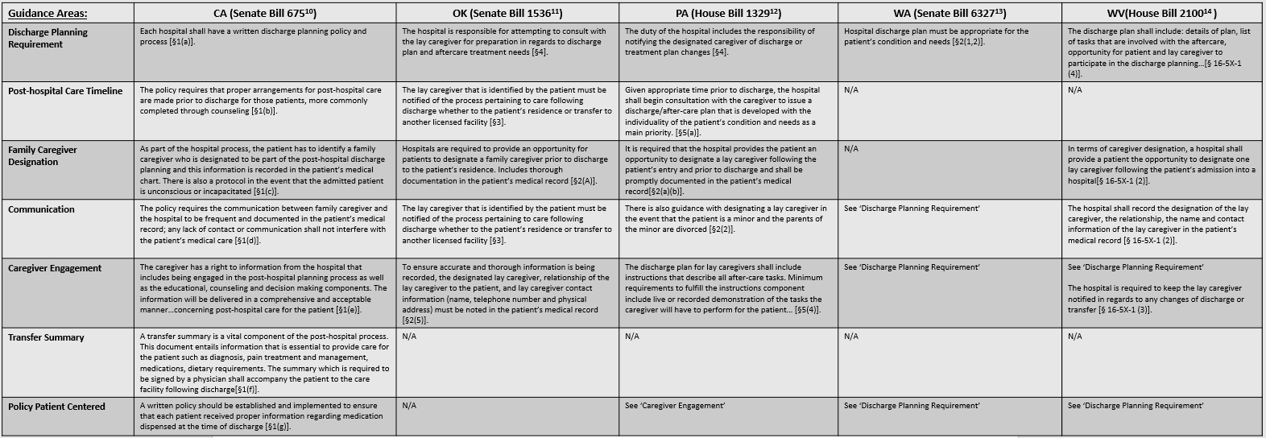
Table 4. Guidance from Caregiver Acts in Selected States: Part 2
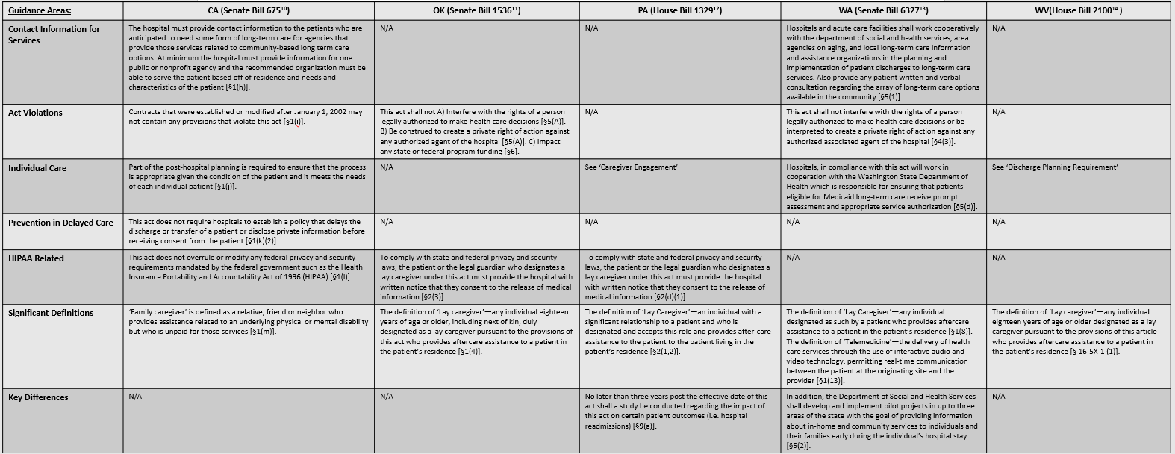

Implementation Limitations
While this Act has made significant progress on a national level, there are worthwhile restrictions that have prohibited the further development and advances of this law. This caregiver initiative was introduced primarily to support family caregivers and is significantly assisting with the economic cost the government would have been responsible for with long-term care on Medicaid budgets. The CARE Act began to fill the gap “in the absence of a substantial federal long-term care strategy.” ¹⁵ This Act is unique because state legislator support comes from personal experiences with caregiving, this is especially the case for Oklahoma’s sponsor, Senator Brian Crain. Oklahoma being the first in the nation to pass the law in 2014 was off to a slow start due to not having the support they needed from the Oklahoma Hospital Association. The Oklahoma Hospital Association opposed the Act because they felt as if the level of support and education to caregivers was already sufficient. Oklahoma Hospital Association quickly withdrew their opposition and concluded that their goal is to make their services more patient friendly because of their realization that more could be done with education and discharge planning. ¹⁵
While the Hospital Association eventually supported the passing of the CARE Act, there was still hesitation within the hospital system because of the understanding before the bill’s enactment that hospitals in Oklahoma were already complying with Medicare requirements to “ensure patients and their representatives understand their discharge instructions and medical orders, and have a smooth transition to the next level of care.” ¹⁶ Oklahoma acknowledged this disconnect and while they have extensive requirements and protocols for Medicare related discharge planning, hospitals have been working to integrate the CARE Act with daily resources hospitals utilize, such as reprogramming changes to electronic medical records, which is noted to take significant time. ¹⁶
Additional implementation challenges that apply are caregivers’ unpreparedness to perform certain tasks in certain situations where the patient need a licensed medical professional and even financial preparedness. The increase in demand of care for the aging population raises the concern that caregivers might not address the needs sufficiently and thoroughly. Regardless of Oklahoma being the first state to pass the CARE Act, the implementation process has been a work in progress ever since. The concern has been with caregivers balancing their jobs, families; finances and caring for a loved one where they feel often feel that they do not have the necessary skills to do so. While Oklahoma is being highlighted here, it is also important to note that each state has had their fair share of concerns and it is predicted that the attempts in developing methods to implement this Act will be used by other states as evidence to help with their adoption of the Act. To address this concern the Oklahoma Cooperative Extensive Service has developed a caregiving education curriculum that provides training for caregivers and hospital discharge planners. “The curriculum [was designed to] include areas such as nutrition and food safety and positive financial behavior that prevent exploitation and abuse.” ¹⁶

Stakeholder Involvement
The CARE Act is unique legislation because the initial progress in each individual state was dependent on the driving force. It was previously mentioned that Oklahoma’s sponsor, Senator Brian Crain supported the bill because of his personal experiences with caregiving; others states that are not analyzed in this capacity but worth noting were Oregon and Massachusetts. They also had support from State Representatives who sponsored the bill as quickly as possible because of their personal experiences with caregiving. The stakeholder ties with the CARE Act extends from individual to organization. As previously mentioned, American Association of Retired Persons (AARP) is one of the largest stakeholders that not only provides support for the CARE Act but for caregiving in general. Other stakeholders include the Alzheimer’s Association, the Caregiver Action Network, a nonprofit that aims to educate and support caregivers; National Hospital Associations, State Hospital Associations, nursing homes and the public. ¹⁷ While there was some initial skepticism about the legislation when it was first introduced, over time there has been realization and accrued support that this Act benefits the healthcare sector in more than one way. These benefits include the financial incentive that hospitals receive to keep patients from being readmitted even improved coordination in care. This financial incentive is merely the result from investing more time and funds to discharge planning and educating caregivers, which significantly decreases the possibility that the same population will be readmitted into the hospital. Financially speaking, the hospital is not penalized for readmission cases and the capacity of admissions has room for other patients.
West Virginia was the fourth state in the nation to pass the CARE Act which went into effect June 8, 2015 and is noted to not to have significant support services to caregivers, in comparison with other states. With that being said, stakeholder involvement is a key component for the progress the state has made with caregiver education as an essential part of the Act. The Alzheimer’s Association, West Virginia chapter hosted a forum to present and receive insight on the newly effective Act back in June 2015. It is reported that as of June 2015, there were over 40,000 individuals who are diagnosed with Alzheimer’s Disease and the need for individual based care was more necessary than ever. ¹⁸ Prior to the passing of the Act, the association has been offering ‘free training and community workshops throughout the state along with 17 support groups in West Virginia.”¹⁸ Members of The Alzheimer’s Association find that the Act will provide more assistance and support that will prioritize coordination of care within the community and stakeholders.
Another side to caregiver and CARE Act stakeholders involve the work that educational based centers complete in support of caregiver research and ideally policy initiatives to address this emerging concern. The University of Pittsburgh Stern Center for Evidence-Based Policy within the Health Policy Institute has published reports looking at how significant economic and health risks relate to the caregiver experience and how those risks have not been addressed by current policy efforts, on both the federal and state levels.³ In the report, Addressing the Needs of Caregivers at Risk: A New Policy Strategy, the analysis discussed the problem of caregivers at risk in correlation with the current caregiver policy landscape. This analysis covered the landscape that was defined in a previous report, Addressing the Health Needs of an Aging America also published by the Health Policy Institute.¹⁹ This stakeholder support is identified as a strength with the development and design of the CARE Act in Pennsylvania but also on a national level. While the Act has not gone into effect in the state of Pennsylvania, the passed proposal has comprehensive aspects that are part of the caregiver educational component in the discharge planning process. One particular unique aspect that speaks on the background of the issue and especially the research based stakeholders is that as part of the Act, Pennsylvania requires that no later than three years after the effective date there must be a study conducted to assess the effectiveness and impact based off of patient outcomes.
Another educational based stakeholder is the Division of Health Care Policy and Research at the University of Colorado Denver. The Division most recently published a perspective, Family Caregivers as Partners in Care Transitions: The Caregiver Advise Record and Enable Act, which was intended to “provide guidance to hospitalist and hospital clinical leadership on how to implement” the CARE Act. ²⁰ This perspective also identified and provided a thorough list of stakeholder organizations that promote the role of family caregivers in discharge preparation (Figure 2) ²⁰.

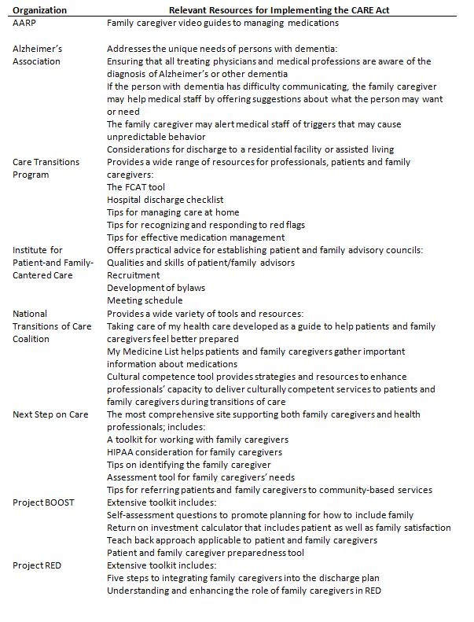
Figure 2. Selected Websites that Promote the Role of Family Caregivers in Discharge Preparation

Comparative Analysis
While the purpose of this Act primarily focuses on the provider side with bringing more support to family caregivers and ultimately providing better care for those elderly patients, it is important to examine the public policy side in a comparative perspective. “Public policy scholars have stressed the importance and need for “comparing” since the 1970s—including comparing different policies, inputs, outputs, and outcomes across institutional settings.
Comparative public policy boasts a rich history of comparing cases across systems in order to establish general empirical connections between the characteristics of the system and the phenomenon under investigation” ²¹ In this section, the status of the states in regards to the CARE Act will be compared to the progress these states have made with caregiver support.
Given the “dramatic increase in the aging population, a growing number of Americans who want to age in place at home will have limited ability to care for themselves due to chronic conditions, trauma, or illnesses as well as inadequate personal savings. Family and friends provide the vast majority of care to this population,” thus the adoption of the Act was introduced to help in alleviating the stress involved with informal caregiving. ³ The fundamental components of the Act were addressed in each focused state (see Table 1). This comparative overview will focus on the key differences that the selected states have developed prior and post to the enactment of the Act.
California, Pennsylvania and Washington are states that are recognized with having larger populations of older adults in comparison with other states in the nation. What is significant to note with California and Washington in relation to this Act is that there is an active level of stakeholder involvement and caregiver support within the state of California whereas that is not the case in Washington. Washington has established a theme of focusing on quality assurance and evaluation measures through surveys to involve caregivers and care recipients in the process to assess what is significant from their perspectives with providing care to their family members. However, there is little data to acknowledge the use of this quality assurance measure being put into practice with additional services and support provided. California on the alternative side has active stakeholder involvement with both the financial and accessing services sides. The California Constitution requires the reimbursement to local agencies that incur costs due to policies that are mandated by the state, for example, this Act. This Act in California also has involvement with providing caregivers with contact information to public/nonprofit organizations where they are able to have additional access of care and support if they may need it post-discharge of their care recipient. Pennsylvania is an interesting state to include in this comparative analysis due to its detailed nature of educational discharge components. This state followed a more comprehensive approach with the development of their Act. This bill that went into effect April 2017 has more precision when it came to defining the scope of the Act itself and the process of discharge planning. Pennsylvania is a state with strong affiliations with national hospital councils, such as the National Hospital Quality and Patient Safety (HQPS) and the studies they conduct for discharge related topics provided evidential support to this Act.
Oklahoma provides a unique perspective to this landscape because of its early enactment of the Act. While Oklahoma was the first state in the nation to pass this Act in May of 2014, there have been little to no developments to support the implementation.
Much like California, West Virginia has active stakeholder involvement but from a different perspective. Before the Act was passed in June of 2015, throughout the state of West Virginia, there were community workshops being held with collaboration of 17 caregiver support groups, such as the Alzheimer’s Association, for example. Following the enactment of the law, the West Virginia chapter of the Alzheimer’s Association held a forum to present and receive insight on the Act itself. This state also has strong ties with the communities to be able to provide support through additional services for the caregiver and care recipient that has not been seen in any other focused state.
While the CARE Act can be summarized around the concept that it assists family caregivers with the transition of care through discharge planning from hospitals to long-term care facilities or even to their personal homes, each state, especially the selected states in this analysis have distinguishing components as interpreted from the individuals acts themselves. Within the selected states, this comparative analysis assessed the components each individual bill covers that distinguishes one state from another (See Table 3 and 4). The areas of focus include guidance that addressed discharge planning requirements, post-hospital care timeline, family caregiver designation, communication, caregiver engagement, transfer summary, policy patient centered, contact information for services, act violations, individual care, prevention in delayed care, HIPAA related and significant definitions.
Through this analysis it was noted that California was very thorough and the only state out of the five selected states to have a detailed description about what the transfer summary report should entail given the situation that the patient would need to be transferred to another facility. Other key distinguishing factors include Oklahoma’s lack of patient centered guidance, which the other four states included in their individual bills. Additionally, Pennsylvania has guidance enforcing their strength of research in which a study shall “be conduct[ed] regarding the impact of this act on certain patient outcomes” no longer than 3 years post the enactment of the bill.¹² Washington’s act is notable through its partnership with the Department of Social and Health Services in effort to develop and implement pilot projects in effort to provide information about in-home and community services in the future to individuals who may need the care. West Virginia’s act supports the claim that the state has little community and non-medical support to caregivers given the lack of in-depth guidance that was presented the bill itself.

Conclusion
This comparative analysis provided a basic overview of the aging population, its implications it has on our healthcare and public health worlds, an overview of the CARE Act with a directed focus on five states: California, Oklahoma, Pennsylvania, Washington and West Virginia. Throughout the comparison it was determined that the policy design had lasting results of how the implementation process within hospitals advanced. The implementation limitations that were discussed as well as the stakeholders and their involvement had a significant role in the strides the Act has made in the individual states. This Act is still progressing as time goes on and once there is more consistent passing of the Act across the nation, there will be suggested measures and recommendations proposed by stakeholders who take part in developing and implementing this process.
While the Act and its development are just in the beginning stages, these five states are frontrunners in pursuing the advancement of caregiving support. Through this thorough analysis, by taking a look at such a widespread wealth of information on not only the Act but research pertaining to the core of discharge planning, one can conclude that the current development these five states have made so far have been significant advancement for caregiver support. One might argue that the passing of the Act is not prevalent in all 50 states and that the implementation in these frontline states is not fully developed, while they would have a fair dispute this view would not be looking at the whole picture. A little over two years ago there was not a sole comprehensive caregiver policy encouraging the full support of caregivers and even concerning educational mechanisms until the CARE Act was introduced by AARP. These states that have passed the Act, particular these five states provide a measure of comparison to those states that are going to pass the Act in the future. These focused states have also identified the groundwork in terms of limitations, policy design, research and stakeholder involvement that have proven to be essential for the future development of this Act.

Future Projections
It is safe to say that the implementation of this Act in these five states have provided states who have yet to adopt this Act some evidence and support that will be utilized and built upon for more comprehensive policies in the future. Some possible lessons that other states can draw from the experiences of the focused five states include the understanding of the caregiver perspective, what challenges hospitals/councils will face with adopting this Act and the recognition of the importance of quality and evaluation metrics. Given that this model bill was introduced through AARP, once every state in the nation passes and begins to implement this Act it is predicted that the organization will develop new advisement and recommendations due to the uniformity the caregiver support arena will see.
This guidance will most likely come from a thorough analysis measuring before and after trends relating to caregiver satisfaction and hospital procedure. Also, it is projected that there will be more collaboration and research conducted with state and national hospital associations and councils to ensure that better care is provided and less federal funds are spent on facilities with the elderly population growing. The CARE Act is moving caregiver support, research and initiative in the right direction.

BIBLIOGRAPHY
- Calfo, S., Smith, J., & Zezza, M. (n.d.). Last Year of Life Study. Retrieved from https://www.cms.gov/Research-Statistics-Data-and-Systems/Research/ActuarialStudies/downloads/last_year_of_life.pdf

- Ryan, E. (2014).The CARE Act: Caring for Family Caregivers. AARP. Retrieved from http://blog.aarp.org/2014/03/10/the-care-act-caring-for-family-caregivers/

- James, E., Hughes, M., Rocco, P. (2016). Addressing the Needs of Caregivers at Risk: The Policy Landscape. The Stern Center for Evidence Based Policy.

- Freedman, V., & Spillman, B. (2011). Disability and Care Needs of Older Americans: An Analysis of the 2011 National Health and Aging Trends Study. Retrieved from https://aspe.hhs.gov/report/disability-and-care-needs-older-americans-analysis-2011-national-health-and-aging-trends-study

- AARP. (2016, June). Fighting for Family Caregivers - AARP. Retrieved from http://www.aarp.org/politics-society/advocacy/caregiving-advocacy/info-2014/aarp-fights-for-family-caregivers.html

- Feinberg, L., & Newman, S. (n.d.). A Study of 10 States Since Passage of the National Family ... Retrieved, from http://gerontologist.oxfordjournals.org/content/44/6/760.long?related-urls=yes&legid=geront;44/6/760

- Horwitz, L. I., Moriarty, J. P., Chen, C., Fogerty, R. L., Brewster, U. C., Kanade, S., . . . Krumholz, H. M. (2013). Quality of Discharge Practices and Patient Understanding at an Academic Medical Center. JAMA Internal Medicine. doi:10.1001/jamainternmed.2013.9318

- Halasyamani, L., Kripalani, S., Coleman, E., Schnipper, J., Walraven, C. V., Nagamine, J., . . . Manning, D. (2006). Transition of care for hospitalized elderly patients—Development of a discharge checklist for hospitalists. Journal of Hospital Medicine, 1(6), 354-360. doi:10.1002/jhm.129

- 2016 AARP Washington Caregiving Survey: The Caregiver ... (2016). Retrieved from http://www.aarp.org/content/dam/aarp/research/surveys_statistics/ltc/2016/2016-caregiving-wa-45plus-care-act-rc-ltc.pdf

- S. 675, Chapter 494 (2015) (enacted).

- S. 1536 (2014) (enacted).

- H.R. 1329 (2016) (enacted).

- S.6327 (2016) (enacted).

- H.R. 2100 (2015) (enacted).

- Martinez JC. New state laws support millions of Americans who minister to aging relatives and form the backbone of the nation’s longterm care system. Available at: http://www.ncsl.org/research/humanservices/helping-the-helpers.aspx

- Killackey, J. (2015, December 5). Despite new legislation, some family caregivers in Oklahoma worry they don't have necessary skills. Retrieved from http://newsok.com/article/5464782

- Milligan, S. (2015, June 22). In Some States, a New Focus on Family Caregivers. Retrieved from http://www.pewtrusts.org/en/research-and-analysis/blogs/stateline/2015/6/22/in-some-states-a-new-focus-on-family-caregivers

- Hodousek, C. (2015, June 8). CARE Act takes effect to provide support to family caregivers. Retrieved from http://wvmetronews.com/2015/06/08/care-act-takes-effect-to-provide-family-caregiver-support/

- The Stern Center for Evidence Based Policy. (2015). Addressing the Health Needs of an Aging America. Retrieved from http://www.healthpolicyinstitute.pitt.edu/sites/default/files/SternCtrAddressingNeeds.pdf

- Coleman, E. A. (2016). Family caregivers as partners in care transitions: The caregiver advise record and enable act. J. Hosp. Med. Journal of Hospital Medicine. doi:10.1002/jhm.2637

- Gupta, K. (2012). Comparative Public Policy: Using the Comparative Method to Advance Our Understanding of the Policy Process. Policy Studies Journal, 40, 11-26. doi:10.1111/j.1541-0072.2012.00443.x

