PHYSICIAN FACTORS ASSOCIATED WITH POLYPHARMACY AND POTENTIALLY INAPPROPRIATE MEDICATION USE AMONG FAMILY MEDICINE RESIDENCY PRACTICES

by
Kenya Ie
MD, Chiba University School of Medicine, Japan, 2004

PhD in Family Medicine, Mie University Graduate School of Medicine, Japan, 2016

Submitted to the Graduate Faculty of
Multidisciplinary MPH Program
Graduate School of Public Health in partial fulfillment
of the requirements for the degree of
Master of Public Health

University of Pittsburgh
2017

UNIVERSITY OF PITTSBURGH
GRADUATE SCHOOL OF PUBLIC HEALTH

This essay is submitted
by
Kenya Ie

on

April 21, 2017
and approved by

Essay Advisor:
David N. Finegold, MD ______________________________________
Professor
Pediatrics, Medicine, Human Genetics
Director, Multidisciplinary MPH Program
Medical School, Graduate School of Public Health
University of Pittsburgh

Essay Reader:
Steven Albert, PhD ______________________________________
Professor and Chair,
Department of Behavioral and Community Health Sciences
Graduate School of Public Health
University of Pittsburgh

Copyright © by Kenya Ie
2017
ABSTRACT

Background: Despite accumulating evidence about the impact of polypharmacy on public health, few studies have investigated factors related to polypharmacy. The objective of this study was to explore factors related to physician prescribing behavior.
David N. Finegold, MD
PHYSICIAN FACTORS ASSOCIATED WITH POLYPHARMACY AND POTENTIALLY INAPPROPRIATE MEDICATION USE
AMONG FAMILY MEDICINE RESIDENCY PRACTICES
Kenya Ie, MPH
University of Pittsburgh, 2017

Methods: We conducted a physician survey at five family medicine residency practices and a linked health record review of their patients 65 years or older. The determinants of physicians’ mean number of prescriptions and potentially inappropriate medications (PIMs) were examined using a generalized linear model.
Results: A total of 61 physicians (38 residents and 23 fellows/faculty) completed the survey and 2,103 visits by 932 patients seen by these physicians were analyzed. The mean prescription and PIM numbers per visit per physician were 9.50 and 0.46, respectively. After controlling for patient race and age, low prescribers were more likely to consider number of medications (p=0.007) and benefit/risk information for deprescribing (p=0.017) in prescribing decisions. Low PIM prescribers also considered these two factors and the Beers list (p=0.05). Physicians’ sex, length of experience, and perceived confidence were not associated with prescribing patterns.
Public Health Significance: Conscious consideration concerning the number of medications and benefit/risk information, as well as using the Beers list, were associated with less polypharmacy and PIMs use. Our results warrant further research and education to address prescription-related problems among older patients, especially with a focus on enhancing deprescribing to improve patient outcomes while reducing inappropriate healthcare utilization and costs.
TABLE OF CONTENTS
preface ix
1.0 Introduction 1
1.1 Polypharmacy and its public health impact 1
1.2 Polypharmacy in family medicine 1
1.3 Deprescribing—A new concept to guide prescription optimization 3
2.0 METHODS 5
2.1 Physician survey 5
2.2 Health record review 6
2.3 Statistical analysis 6
3.0 RESULTS 8
3.1 Physician survey results 8
3.2 Patient characteristics 10
3.3 Factors associated with physician’s prescribing behavior 12
4.0 DISCUSSION 14
5.0 CONCLUSION 17
APPENDIX: PHYSICIAN SURVEY 18
bibliography 22
List of tables
Table 1. Physician Survey Responses (N=61) 9
Table 2. Characteristics of Patients Seen by 61 Participating Physicians 10
Table 3. Prescription Characteristics of Patients Seen by 61 Participating Physicians 11
Table 4. Multivariable Regression: Factors Associated with Physician's Mean Number 12

List of figures
Figure 1. The Number of Prescription Orders for Oral Medications Among Patients Age ≥ 65 Years who have ≥ 2 Chronic Index Conditions (N=1,036) 2
preface

This research was supported by the Japan Primary Care Association (the grant number: 28-02-003). First of all, I would like to express my sincere appreciation to my mentors, Dr. Steven Albert and Dr. David Finegold. I would also like to give special thanks to Drs. Vince Balestrino, Linda Hogan, and Patricia M. Klatt for their suggestions regarding the development of the questionnaire, EPIC data development team and CARe for their support for data extraction, Dr. Jeanine M. Buchanich, Clair N. Smith, Sifang Zhao, and Shu Wang for their statistical assistance, and Nippon Foundation for their support for this project.

Introduction

Polypharmacy and its public health impact
Polypharmacy is the use of more drugs than are clinically indicated,^{1,2} or more descriptively, the use of more than a certain number of drugs (e.g. ≥5). ^{1,3} It has become more common among the elderly⁴ and is related to several problems, including increased risk of being prescribed potentially inappropriate medication (PIM),⁵ which are delineated in several drug lists such as the American Geriatrics Society Beers criteria.⁶ Both polypharmacy and PIM usage increase adverse drug events, worsen physical function, and result in excess healthcare utilization.^{5,6,7} In 2014, 20% of total National Health Expenditures (NHE) was spent for Medicare, and nearly half of the Medicare expenditure involved prescription drug-related costs.⁸ Medication misuse and polypharmacy cost the US more than $177 billion every year.⁹

Polypharmacy in family medicine
Family physicians need to be aware of these medication-related problems within their own practice, since geriatric care in family medicine practices (FMPs) is likely to become more prevalent and important with increasingly aging populations.¹⁰ The first published data of PIM prevalence in the US found PIM use in approximately 23% of patients 65 years or older who visited clinics at least twice over a two-year period.¹¹ Polypharmacy prevalence in primary care has been reported in several countries.^{12,13} To our knowledge, however, no report has been published with a focus on polypharmacy in US FMPs.
Based on our unpublished internal quality data of older adults who visited UPMC-affiliated FMPs more than once a year and had two or more chronic conditions (N=1,036), the mean number of medication orders was 9.04 (SD 4.36) and 1.57 (SD 0.92) for PIMs. Among these older patients, 86.1% met polypharmacy standards (≥5 medications), and 33.4% were prescribed one or more PIMs.

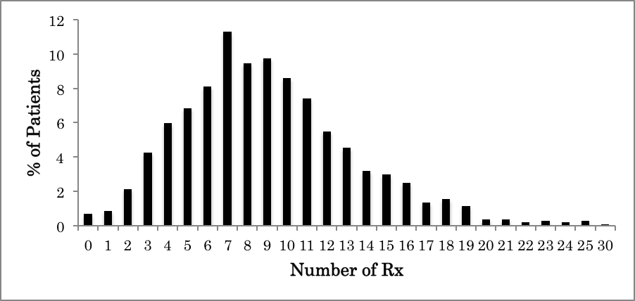

Figure 1. The Number of Prescription Orders for Oral Medications Among Patients Age ≥ 65 Years who have ≥ 2 Chronic Index Conditions (N=1,036)

Distribution of the number of prescription medications at one visit among the multimorbid older adult patients. Rx indicates medical prescription. The number of medications was limited to orally administered medications. Non-drug equipment (e.g. inhaler, needles, and glucose monitors) was excluded.

Among patients that met polypharmacy or PIM criteria, less than half experienced a reduction in the amount of prescription medication or PIM during a year. Thus, polypharmacy and PIMs are an important problem that should be addressed in family medicine.

Deprescribing—A new concept to guide prescription optimization
Deprescribing refers to the process of tapering, stopping, discontinuing, or withdrawing drugs, with a goal of managing polypharmacy and improving outcomes.¹⁴ Deprescribing with a focus on certain types of PIMs (e.g. NSAIDs, benzodiazepines) has been shown to improve patient outcomes,¹⁵ and can be done safely.¹⁶ However, evidence is inconclusive about the effect of deprescribing that focuses on reducing the number of overall medications. A 2014 Cochrane review found inconsistent results among deprescribing studies that used either the Beers list, a pharmacist-led approach, or a multidisciplinary deprescribing intervention.¹⁷
In addition to the lack of evidence, there are many practical challenges in deprescribing. Qualitative studies found that physicians tend to avoid discussing deprescribing with their elderly patients.^{18,19} Some reasons they highlighted were: “preventive medication is not easy to reduce,”^{18,19} “lack of benefit/risk information of deprescribing,”^{18,19} “guideline pressure,”¹⁸ “medications initiated by specialists,”¹⁹ and “patients may feel it’s a sign of giving up.”¹⁸ Furthermore, the appropriateness of the prescribed medications is multifactorial in most cases. Previously known factors associated with physicians’ attitudes towards deprescribing include: patient age, life expectancy, functional and cognitive status, comorbidity, expected medication adherence, insurance coverage, budgetary concerns, and the wishes of the patient and family.²⁰ However, these studies did not address the association between potential factors and actual prescription behaviors.
The objectives of this study were to investigate variability in prescription patterns for multimorbid elderly patients across family physicians and to explore factors related to prescription pattern variation with the goal of informing interventions to reduce potentially harmful prescription.

METHODS
We conducted a physician survey and a linked health record review of their patients 65 years or older who visited five residency-affiliated FMPs.

Physician survey
From June to July 2016, family medicine residents, fellows, and faculty seeing patients at one of the five UPMC-affiliated FMPs were asked for survey responses and permission to review patient records. Those who gave written consent for study participation and electronic health record review, and had at least one active patient note of patients aged 65 years or older during October 1st, 2015 to June 6th, 2016 were included in the final analyses.
Survey items were selected based on literature review^{18,19,20} and a consultation process among researchers (two family physicians and two clinical pharmacists who specialize in geriatric medicine). The preliminary questionnaire underwent several pilot tests, and the items were revised as appropriate. We evaluated physician demographics, their perceived importance and confidence in deprescribing, perceived importance of deprescribing triggers and barriers,^{18,19,20} and the use of Beers list⁶ and STOPP criteria.²¹ Level of deprescribing importance/confidence and the importance of triggers/barriers were assessed using 5-point Likert-type scales ranging from 1 (not at all) to 5(very much) for importance/confidence and 1 (not important) to 5 (very important) for triggers/barriers (see the Appendix).

Health record review
Electronic health records of patients who were 65 years or older and visited one or more of five FMPs at least once from October 2015 to June 2016 were extracted from a reporting database by a systems analyst who also served as an honest broker. We extracted data on patient age group, sex, race, and the six most prevalent comorbidities (>30%) in our practices (hypertension, hyperlipidemia, osteoarthritis, gastroesophageal reflux, diabetes mellitus, and depression). The number of both prescription medications and PIMs were counted per each visit. For this study, we counted the total number of prescription and PIM orders at each visit. The list of PIMs in this study were defined based on medications recommended to “avoid” in Table 2 of 2015 American Geriatrics Society Beers Criteria for Potentially Inappropriate Medication Use in Older Adults.⁶

Statistical analysis
To test the representativeness of patients included in the final analysis among FMP patients, we first stratified patients into two groups of those seen by participating physicians and those seen by non-participating physicians. We only used the aggregate patient data of non-participating physicians as a means to compare characteristics between participating doctors’ and non-participating doctors’ patient panel. For the main analyses, the mean number of prescription medications and PIM orders per visit per physician were calculated as main response variables. These response variables were treated as continuous variables. Physicians’ age, years since graduation and responses to 5-point Likert-type scales were treated as continuous, assuming that the variables have the same interval properties. Physicians’ sex, board certification status, and the use of Beers list and STOPP criteria were treated as binary, and practicing sites was treated as nominal. Univariable and multivariable regressions were used to determine the association of each variable to the mean prescription numbers and mean PIM orders per visit per physician. In addition, the proportion of minority patients and the age distribution of patients seen by the physicians were used as covariates. Since our main analyses were exploratory multivariable regression analyses, we did not calculate specific sample size. Instead, we expected a minimum of 50 physician responses to allow us multivariable linear regression with approximately 5 explanatory variables in our model. We used a significance level of 0.05 for hypothesis testing. Adjusted R-squared (R²) statistic and the Akaike’s information criterion (AIC) were used where appropriate for model selection. Multicollinearity was tested based on the variance inflation factor with a cutoff at 10. Statistical analyses were performed using STATA/SE 14.2.
The study protocol was approved by the University of Pittsburgh Institutional Review Board (PRO15120091).

RESULTS

Physician survey results
Of the 117 family physicians invited to participate and who had at least one active patient note at the five FMPs during October 1st, 2015 to June 6th, 2016, 61 completed the survey and agreed to patient data review, a 52% response rate. Table 1 contains the physicians’ responses to the survey.
Of the 61 physicians included in our analyses, there were 38 residents and 23 fellow/faculty physicians with an overall mean of 9.7 years after medical school graduation. Overall, participating physicians were highly aware of the importance of deprescribing in outpatient settings. However, the level of confidence was not on the same level as their perceived importance. Among the triggers for deprescribing, “symptoms possibly related to medication,” “cognitive impairment,” and “limited life expectancy,” were ranked as more important than “number of medications,” “(patient’s) older age,” “budgetary considerations,” and “number of chronic conditions.” As for barriers, participating physicians ranked “the beliefs of the patients that drugs might help,” “lack of time,” and “medications started by other doctor” higher than “lack of benefit/risk information about deprescribing,” “lack of experience,” and “the beliefs of the patients that you are giving up on them.”

Table 1. Physician Survey Responses (N=61)
Physician Characteristics | N=61
Age – mean years (SD) | 36.1 (10.6)
Sex – no. of physicians (%)
Female | 30 (49.9)
Years since graduation – mean years (SD) | 9.7 (10.1)
Position – no. of physicians (%)
Resident | 38 (62.3)
Fellow/Faculty | 23 (37.7)
Characteristics of Patient Panelª – mean % (SD)
Proportion of patients 75 years or older | 34.1 (17.6)
Proportion of minority patients (Black and others) | 46.0 (24.7)
Perceived importance^{b}/confidence^{c} for deprescribing – mean (SD)
(1=not at all, 5=very much)
How important is it for you to deprescribe for patients 65 years or older in outpatient settings? | 4.4 (0.7)
How confident are you in deprescribing for patients 65 years or older in outpatient settings? | 3.7 (1.0)
Importance of 9 triggers for deprescribing^{b} – mean (SD)
(1=Not important, 5=Very important)
Symptoms possibly related to medication | 4.8 (0.5)
Cognitive impairment | 4.6 (0.7)
Limited life expectancy | 4.6 (0.7)
Wishes of patient/family | 4.5 (0.8)
Functional dependency | 4.4 (0.7)
Number of medications | 4.4 (0.8)
Older age | 4.2 (0.9)
Budgetary considerations | 4.2 (0.9)
Number of chronic conditions | 4.1 (0.9)
Importance of 6 barriers for deprescribing^{c} – mean (SD)
(1=Not important, 5=Very important)
Patients belief that drugs might help | 3.6 (0.9)
Lack of time | 3.5 (1.1)
Medications started by other doctor | 3.5 (1.0)
Lack of benefit/risk information about deprescribing | 2.9 (1.2)
Lack of experience | 2.6 (1.4)
Patients belief that you are giving up on them | 2.6 (1.2)
ª Data obtained from health record review.
^{b} “How important are the following factors for you to consider deprescribing?”
^{c} “To what extent do the following factors make you less likely to
deprescribe?”

Patient characteristics
Among a total of 4,810 clinic visits by 1,900 patients at the five FMPs from October 2015 to June 2016, 2,103 visits (43.7%) by 932 patients (49.1%) were seen by the 61 participating physicians. Table 2 reveals the characteristics of patients seen by participating physicians.

Table 2. Characteristics of Patients Seen by 61 Participating Physicians
Patient characteristics | N=932 patients
Age group – no. of patients (%)
65-74 years | 625 (67.1)
75 years and above | 307 (32.9)
Sex – no. of patients (%)
Female | 591 (63.4)
Race – no. of patients (%)
White | 521 (55.9)
Black | 380 (40.8)
Others* | 31 (3.3)
Index conditions – no. of patients (prevalence (%))
Hypertention | 794 (85.2)
Hyperlipidemia | 618 (66.3)
Osteoarthritis | 506 (54.3)
Gastroesophageal reflux | 363 (38.9)
Diabetes mellitus | 334 (35.8)
Depression | 315 (33.8)
* Others includes “Asian” and “Others”.

On average, approximately one third of elderly patients were 75 years or older. The patients 65 years or older participating in our study included a higher proportion of racial minorities (Black and others = 46.0%.), compared to the US general population (non-White = 22.9%).²²
The prescription pattern among the older patients seen by participating physicians are summarized in Table 3.

Table 3. Prescription Characteristics of Patients Seen by 61 Participating Physicians
Prescription characteristics | N=2,103 visits
Number of prescription per visit – no. of visits (%)
0-4 | 283 (13.5)
5-9 | 774 (36.8)
10-14 | 690 (32.8)
15+ | 356 (16.9)
Number of PIMs per visit – no. of visits (%)
0 | 1357 (64.5)
1-3 | 712 (33.9)
4-6 | 33 (1.6)
7+ | 1 (0.1)
Commonly prescribed PIMs* – no. of patients (%) | N=932 patients
1. Cyclobenzaprine | 45 (4.8)
2. Meclizine | 39 (4.2)
3. Hydroxyzine | 35 (3.8)
4. Estrogens | 33 (3.5)
5. Clonazepam | 29 (3.1)
6. Paroxetine | 29 (3.1)
7. Diphenhydramine | 28 (3.0)
8. Lorazepam | 26 (2.8)
9. Amitriptyline | 24 (2.6)
10. Zolpidem | 16 (1.7)
*PIMs were defined based on the table 2 of 2015 American Geriatrics Society Beers Criteria
for Potentially Inappropriate Medication Use in Older Adults.⁶

The prevalence of polypharmacy (5≥ medications) and PIM use among elderly patients treated by participating physicians were 86.5% and 35.5%, respectively. This prevalence was consistent with our previous data (unpublished) despite the different timeframe and the transition of coding system (ICD9-CM in the previous data and ICD10 in this study). Among PIMs observed, the most common three and their frequency per visits were cyclobenzaprine (4.8%), meclizine (4.2%), and hydroxyzine (3.8%). The mean and SD for total and PIM prescriptions per visit per physician were 9.50 (SD 1.94) and 0.46 (SD 0.29), respectively.
The patient characteristics were similar between patients seen by participating physicians and those seen by non-participating physicians in terms of patient demographics, comorbidity, and prescription patterns.

Factors associated with physician’s prescribing behavior
The multivariable regression model for the mean number of prescriptions and PIMs is displayed in Table 4.

Table 4. Multivariable Regression: Factors Associated with Physician's Mean Number
of Prescriptions and PIM Orders
Variables | Number of Prescriptions  β (SE) | Number of  PIM Orders  β (SE)
Lack of benefit/risk information about deprescribing* | -0.40 (0.16)† | -0.06 (0.03)†
Number of medications* | -0.67 (0.24)† | -0.07 (0.04)
Proportion of minority patients | -3.72 (0.81)† | -0.34 (0.14)†
Proportion of Patients 75+ | -2.92 (1.13)† | -0.45 (0.20)†
Use of the Beers criteria** |  | -0.17 (0.08)
Intercept | 16.31 (1.32)† | 1.40 (0.24)†
Adjusted R² (AIC) | 0.3939 (228) | 0.2062 (12.4)
PIM: Potentially Inappropriate Medication
All variables included in the fitted models are reported in this table.
*The importance of triggers/barriers were assessed using 5-point Likert scales ranging from 1(Not important) to 5(very important).
**Reference group = not using the Beers criteria
† p<0.05

After controlling for patient race and age, physicians who prescribe less were significantly more likely to rank benefit/risk information of deprescribing (p=0.017) and number of medications (p=0.007) as more important than those who prescribed more medications. Low PIM prescribers tended to place higher importance on benefit/risk information about deprescribing (p=0.028) and number of medications (p=0.075), and were more likely to use the Beers list (p=0.05). There was no multicollinearity between independent variables included in both fitted models. Physicians’ sex, length of experience, and perceived confidence were not associated with the prescription pattern.

DISCUSSION
We found that physicians who ranked the number of medications and benefit-to-risk information regarding deprescribing as more important compared to their peers, prescribed fewer medications and PIMs after controlling for patient race and age. The use of Beers criteria was associated with less PIM prescribing but with borderline significance. Physicians’ sex, length of clinical experience, and perceived confidence levels had no effect on their prescription numbers.
Our results, especially if further replicated in other FMPs, suggest several potential implications for quality improvement of geriatric care in FMPs. Firstly, the number of prescriptions would be an important clinical indicator for the quality of geriatric care in FMPs. A recent large sample cohort study of US Medicare beneficiaries found that the strongest predictor of PIM use among factors studied was the number of drugs dispensed.²³ Similarly, multiple studies have consistently revealed that taking more prescription medications increases the risk of PIM exposure.^{24,25} The number of prescription medications, as well as PIMs themselves, could be a reasonable red flag that warrants deprescribing for older multimorbid patients in FMPs.
Secondly, physicians’ emphasis on the benefit-to-risk information of deprescribing was found to be related to less prescriptions and PIMs per visit. A lack of evidence for the benefit/risk of deprescribing has been known to be a common reason for PIM prescription²⁶ or as a barrier for deprescribing.^{18,19} Medication optimization criteria, such as the Beers list, can be a resource for clinicians as a summary of the current best evidence regarding PIMs. Thus, increasing the use of the Beers list at FMPs could reduce the risk of PIM prescription by promoting evidence-based medication usage in elderly patients.
Such medication optimization criteria can be fundamental for evidence-based medicine, which encompasses whole-person care. However, physicians sometimes use these evidence-based tools in a reductionist approach. For instance, a qualitative study found that physicians perceived drug-oriented criteria as “not encompassing clinical judgment, or the quality of life, societal and family-related contexts of prescribing.”¹⁹ According to Sackett et al., however, evidence based medicine is defined as “a systematic approach to clinical problem solving which allows the integration of the best available research evidence with clinical expertise and patient values.”²⁷ Thus, it may be worthwhile to remind clinicians that the adequate use of evidence-based tools can facilitate the whole-person approach, not being against to it.
In addition to the physician level factors, patient’s older age and having a minority background had protective effects on both number of prescriptions and PIMs, similarly to previous studies.^{23,28,29,30} The lower medication exposure among these vulnerable population could reflect a trade-off between polypharmacy and undertreatment. Multimorbidity is also shown to be an independent trigger for potential prescribing omissions.²⁵ Family physicians who treat multimorbid older adults at FMPs with high proportion of racial minority patients need to be aware of their potential bias towards both polypharmacy and undertreatment.
Our study had several limitations. First, our results may not be generalizable to US family medicine patients in general, since the data was limited to family medicine residency programs where the majority of respondents were residents. It is possible that the prescribing patterns of residents are still being developed and that their attending physicians might have affected their prescribing behavior. However, we confirmed that the results were similar between residents and fellow/faculty based on stratified analyses. Furthermore, the similar prevalence across five FMPs serving different socioeconomic groups suggests consistency across the health system. Secondly, the small sample size of the physician survey has limited statistical power, although our multivariable regression model revealed a satisfactory model fit. Finally and most importantly, the appropriateness of the prescribed medications was not evaluated. For the future research, the appropriateness of prescribed medications, as well as the prescription number as a risk factor, should be taken into consideration.

CONCLUSION
Polypharmacy and the use of PIMs were extremely common among patients 65 years or older who visited FMPs. Physicians attuned to the number of medications and benefit-to-risk information prescribed fewer medications and PIMs after controlling for patient race and age. Our results warrant further research and education to address prescription-related problems among older patients in FMPs, especially with a focus on enhancing deprescribing to improve patient outcomes while reducing inappropriate healthcare utilization and costs.
APPENDIX: PHYSICIAN SURVEY
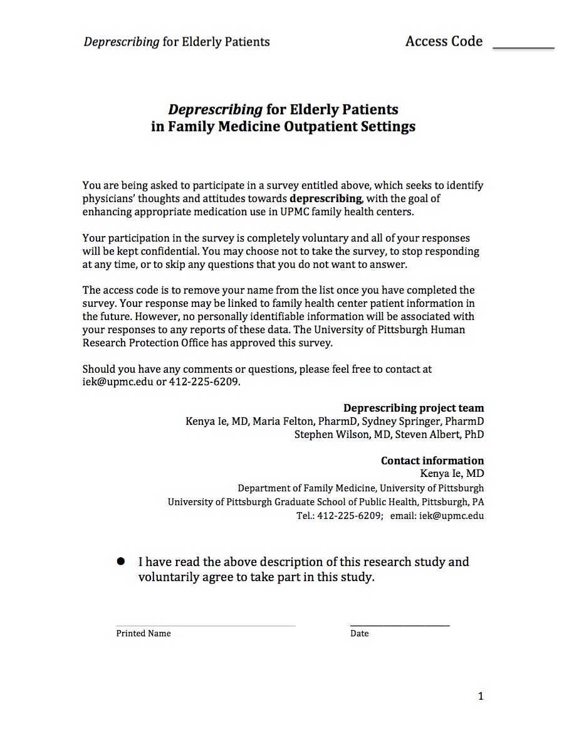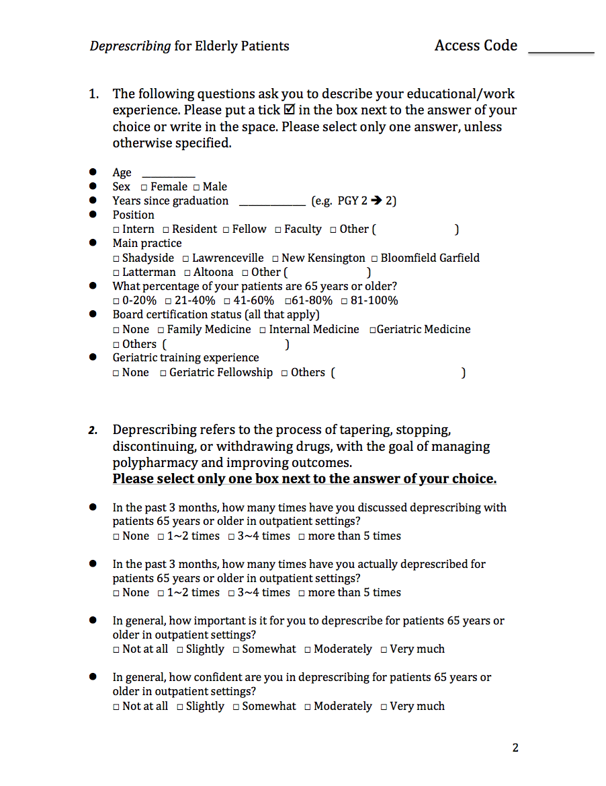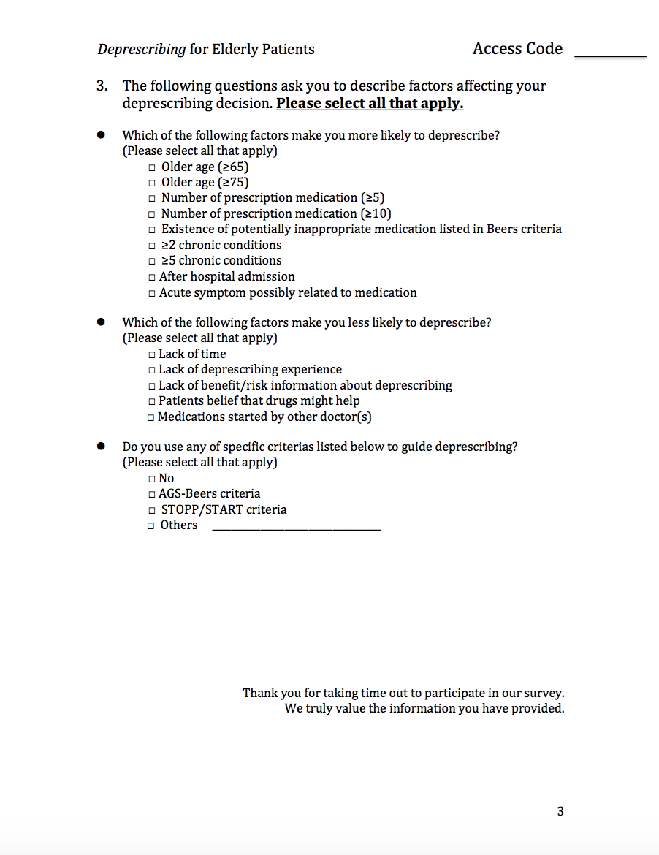
bibliography
1. Fulton MM, Allen ER. Polypharmacy in the elderly: a literature review. J Am Acad Nurse Pract. 2005;17(4):123-132. doi:10.111/j.1041-2972.2005.0020.x.

2. Zarowitz BJ, Pharm D, Stebelsky LA, et al. Reduction of High-Risk Polypharmacy Drug Combinations in Patients in a Managed Care Setting. 2005;25(11):1636-1645.

3. Viktil KK, Blix HS, Moger TA, Reikvam A. Polypharmacy as commonly defined is an indicator of limited value in the assessment of drug-related problems. Br J Clin Pharmacol. 2007;63(2):187-195. doi:10.1111/j.1365-2125.2006.02744.x.

4. Charlesworth CJ, Smit E, Lee DSH, Alramadhan F, Odden MC. Polypharmacy Among Adults Aged 65 Years and Older in the United States: 1988-2010. J Gerontol A Biol Sci Med Sci. 2015;70(8):989-995. doi:10.1093/gerona/glv013.

5. Goulding MR. Inappropriate Medication Prescribing for Elderly Ambulatory Care Patients. October. 2004;164(3):305-312. http://jamanetwork.com/journals/jamainternalmedicine/fullarticle/216620.

6. Samuel MJ. American Geriatrics Society 2015 updated beers criteria for potentially inappropriate medication use in older adults. J Am Geriatr Soc. 2015;63(11):2227-2246. doi:10.1111/jgs.13702.

7. Gyllensten H, Rehnberg C, Jönsson AK, Petzold M, Carlsten A, Andersson Sundell K. Cost of illness of patient-reported adverse drug events: a population-based cross-sectional survey. BMJ Open. 2013;3(6):1-12. doi:10.1136/bmjopen-2013-002574.

8. Medicaid C for M&. NHE Fact Sheet. http://web.archive.org/web/20160325101526/https://www.cms.gov/research-statistics-data-and-systems/statistics-trends-and-reports/nationalhealthexpenddata/nhe-fact-sheet.html. Published 2015.

9. Veehof L, Stewart R, Haaijer-Ruskamp F, Jong BM. The development of polypharmacy. A longitudinal study. Fam Pract. 2000;17(3):261-267. http://www.ncbi.nlm.nih.gov/pubmed/10846147.

10. Peterson LE, Bazemore AW, Jr RLP. Family Physicians ’ Present and Future Role. Am Fam Physician. 2009;80(10):1072. http://dx.doi.org/.

11. Buck MD, Atreja A, Brunker CP, et al. Potentially inappropriate medication prescribing in outpatient practices: prevalence and patient characteristics based on electronic health records. Am J Geriatr Pharmacother. 2009;7(2):84-92. doi:10.1016/j.amjopharm.2009.03.001.

12. Payne RA, Avery AJ, Duerden M, Saunders CL, Simpson CR, Abel GA. Prevalence of polypharmacy in a Scottish primary care population. Eur J Clin Pharmacol. 2014;70(5):575-581. doi:10.1007/s00228-013-1639-9.

13. Junius-Walker U, Theile G, Hummers-Pradier E. Prevalence and predictors of polypharmacy among older primary care patients in Germany. Fam Pract. 2007;24(1):14-19. doi:10.1093/fampra/cml067.

14. Thompson W, Farrell B. Deprescribing: what is it and what does the evidence tell us? Can J Hosp Pharm. 2013;66(3):201-202.

15. Reeve E, Shakib S, Hendrix I, Roberts MS, Wiese MD. The benefits and harms of deprescribing. Med J Aust. 2014;201(7):9-12. doi:10.5694/mja13.00200.

16. Iyer S, Naganathan V, McLachlan AJ, Le Couteur DG. Medication withdrawal trials in people aged 65 years and older: a systematic review. Drugs Aging. 2008;25(12):1021-1031.

17. Patterson S. Interventions to improve the appropriate use of polypharmacy for older people (Review) www.cochranelibrary.com. Cochrane Database Syst Rev. 2014;(10). doi:10.1002/14651858.CD008165.pub3.

18. Schuling J, Gebben H, Veehof LJG, Haaijer-Ruskamp FM. Deprescribing medication in very elderly patients with multimorbidity: the view of Dutch GPs. A qualitative study. BMC Fam Pract. 2012;13(1):56. doi:10.1186/1471-2296-13-56.

19. Magin P, Goode S, Pond D. GPs, medications and older people: A qualitative study of general practitioners’ approaches to potentially inappropriate medications in older people. Australas J Ageing. 2014. doi:10.1111/ajag.12150.

20. Ní Chróinín D, Ní Chróinín C, Beveridge A. Factors influencing deprescribing habits among geriatricians. Age Ageing. 2015;44(4):704-708. doi:10.1093/ageing/afv028.

21. O’mahony D, O’sullivan D, Byrne S, O’connor MN, Ryan C, Gallagher P. STOPP/START criteria for potentially inappropriate prescribing in older people: Version 2. Age Ageing. 2015;44(2):213-218. doi:10.1093/ageing/afu145.

22. United States Census Bureau. United States QuickFacts. https://www.census.gov/quickfacts/table/PST045215/00. Published 2015. Accessed November 22, 2016.

23. Jirón M, Pate V, Hanson LC, Lund JL, Jonsson Funk M, Stürmer T. Trends in Prevalence and Determinants of Potentially Inappropriate Prescribing in the United States: 2007 to 2012. J Am Geriatr Soc. 2016;64(4):788-797. doi:10.1111/jgs.14077.

24. Alhmoud E, Khalifa S, Bahi AA. Prevalence and predictors of potentially inappropriate medications among home care elderly patients in Qatar. Int J Clin Pharm. 2015;37(5):815-821. doi:10.1007/s11096-015-0125-0.

25. San-José A, Agustí A, Vidal X, et al. Inappropriate prescribing to the oldest old patients admitted to hospital: prevalence, most frequently used medicines, and associated factors. BMC Geriatr. 2015;15:42. doi:10.1186/s12877-015-0038-8.

26. Voigt K, Gottschall M, Köberlein-Neu J, et al. Why do family doctors prescribe potentially inappropriate medication to elderly patients? BMC Fam Pract. 2016;17(1):93. doi:10.1186/s12875-016-0482-3.

27. David L Sackett, William M C Rosenberg, J A Muir Gray, R Brian Haynes WSR. Evidence based medicine: what it is and what it isn’t. BMJ. 1996;312:71-72.

28. Institute Of Medicine. Unequal Treatment.; 2002. doi:10.17226/10260.

29. Duran-Tauleria E, Rona RJ, Chinn S, et al. Influence of ethnic group on asthma treatment in children in 1990-1: national cross sectional study. BMJ. 1996;313(7050):148-152. doi:10.1136/bmj.313.7050.148.

30. Ryall AH, Abdulah DR, Rios D, Wei JY, Hausdorff JM. Undertreatment of cardiovascular disease in ethnically diverse older adults: Who should receive an electrocardiogram? [2]. J Am Geriatr Soc. 2001;49(11):1573-1574. doi:10.1046/j.1532-5415.2001.4911259.x.

