POLICY CRITIQUE ON THE WORLD HEALTH ORGANIZATION’S BURIAL PRACTICES USED DURING EBOLA OUTBREAK OF 2014-2015

by
Carrie Law
B.A. Geography, Communications and Humanities, University of Pittsburgh 2014

Submitted to the Graduate Faculty of
the Department of Health Policy & Management
Graduate School of Public Health in partial fulfillment
of the requirements for the degree of
Master of Public Health

University of Pittsburgh
2017

UNIVERSITY OF PITTSBURGH
GRADUATE SCHOOL OF PUBLIC HEALTH

This essay is submitted

by

Carrie Law

on

April 10, 2017
and approved by

Essay Advisor:
Gerald M. Barron, MPH _______________________________________
Associate Professor
Director, MPH Program
Department of Health Policy & Management
Graduate School of Public Health
University of Pittsburgh

Essay Reader:
William B. Kory, PhD _______________________________________
Associate Professor
Director
Department of Geography
University of Pittsburgh at Johnstown
Copyright © by Carrie Law
2017
Gerald M. Barron, MPH

POLICY CRITIQUE ON THE WORLD HEALTH ORGANIZATION’S BURIAL PRACTICES USED DURING EBOLA OUTBREAK OF 2014-2015

Carrie Law, MPH
University of Pittsburgh, 2017
ABSTRACT
Ebola has been a known virus since the 1970s and has been responsible for killing thousands of people. In the most recent outbreak during 2014 and 2015 many international aid organizations attempted to lend help. The World Health Organization developed a protocol to direct WHO affiliated burial teams on the proper ways to conduct a dignified burial that will help to decrease disease transmission. The protocol focuses on Christian and Muslim specific burials and does not address any other religions or regional burial customs.
The rules of the protocol will be observed and critiqued. Emphasis will be made on what worked well and what in the policy needed to be reevaluated. Finally, it will address recommendations for future use of the policy.
Public Health Statement: This policy is not applicable to other locations, so the main objective is to understand why it is important to create policies with specific regions or cultural factors in mind. It also shows why it is important to have living documents during an emergency situation so that edits can be made quickly that will improve outcomes for team members and communities.

TABLE OF CONTENTS
1.0 Introduction 1
1.1 Public Health Relevance 3
2.0 Literature Review 4
3.0 Ebola Outbreak background 6
3.1 Ebola Virus 6
3.2 The first case 7
3.3 Outbreak 7
3.4 Symptoms and statistics 8
3.5 Treatment options 9
3.6 Preventative Efforts 9
3.7 The aftermath 10
4.0 modern west african culture 12
4.1 Geography 12
4.2 History and Colonization 13
4.3 Predominant religions 14
4.4 Statistics 15
5.0 WHO policy for the burial of Ebola victims 16
5.1 Overview 16
6.0 Critique 17
6.1 What works and why? 17
6.2 What partially works and why 21
6.3 What does not work? 26
7.0 Reccomendations 28
8.0 Methods 34
9.0 Conclusion 35
APPENDIX: WORLD HEALTH ORGANIZATION BARRIER PROTOCOL 37
BIBLIOGRAPHY 55

List of tables
Table 1. Country Statistics 15

List of figures

Figure 1. West Africa Map 12

Introduction
One size does not fit all. When discussing health policy, this point is important to keep in mind. A policy can be a powerful tool in public health, but is useless when it is not created with care and skill. To create a policy that is intended as a way to govern a health practice in another nation and culture is extremely difficult, and no policy will ever be perfect.
The things that work in one culture will not always work in another. We share similarities and through globalization, some of our cultures have begun to blend and mesh in unique ways that were not seen a century or two ago, but with the blending of cultures also comes conflict. These conflicts can create tension between a community and policy makers from another region. If people do not feel that their beliefs are being valued and respected, then they might not want to listen and comply with the regulations being proposed.
Understanding the cultural importance of certain traditions and practices will only help to create a more successful policy. Burial practices are often steeped in tradition and are considered to be a core ritual. When a loved one is dying, the society understands what the following steps will be whether that means praying by the person’s side, touching the body after they have passed or holding a special ceremony to honor their life. During the Ebola virus disease outbreak, many of these traditions had to be suspended, leaving communities even more devastated. It is also important to understand the colonization of African nations that occurred during the 18th and 19th centuries and how this history caused the lasting stigma that is attached to having policies and regulations implemented by outsiders.
What is the goal of the policy? Who is it for? Why? What is the endgame? Answering these questions requires knowledge of the population the policy will serve. The geography, cultural traditions, religions, and relevant statistics should all be carefully considered. The policy should not feel like a law being imposed on the land, but instead a useful and positive tool that guides people, and teaches safe practices, or helps the community to improve health outcomes.
When the Ebola virus disease outbreak of 2014-2015 occurred, people everywhere were understandably frightened. This was especially true for the West African Nations that were hit the hardest by the disease. Many were scared for themselves, loved ones, and their community. Scared that it would spread to other cities and countries. Scared that it would take the lives of thousands of people like previous epidemics have done. When a policy was made by the World Health Organization to dictate how burials were to be performed by aid workers, a few important cultural points were left out of the policy. Working with a family after the loss of a loved one in any atmosphere is difficult, so the emergence of a contagious and fatal disease made the situation that much more difficult to confront. Multiple parts of the community need to be represented when a policy is being created.
Finding ways to encourage communities to comply with a policy is vital to the success of the policy itself. That is why efforts should always be focused on determining a safe policy that also makes community members want to cooperate with those who enforce to policy at the highest level. Community compliance will not always be achieved, but in emergency cases, compliance is needed and can sometimes be a matter of life and death for the people involved with implementation.

Public Health Relevance
The topic of burial policies and protocols surrounding the most recent Ebola epidemic is very relevant to the field of public health. It is important to look at former policies in order to learn from successes and mistakes. While a policy built to address burials in West African nations might not be applicable to other regions, it is helpful to see ways in which another culture’s customs and traditions can be honored while still protecting the health of the community at risk. It is also important to learn from the outcomes observed after the policy has been implemented. Some policies need to be seen as a living document that can change to better serve a target population. Lastly, it is easy to forget about the people who succumb to disease, but in some cases knowing how to handle death will help others to survive.

Literature Review
Improving Burial Practices and Cemetery Management During an Ebola Virus Disease Epidemic: This report discusses the burial practices that were being implemented in areas experiencing high volumes of death due to the Ebola virus. It assesses many aspects of the burial practices being implemented. Through interviews and data collection it tries to show the picture of what was occurring at the time. It lists the number of burial teams in different locations, their experience levels, the average number of burials they performed in a day, and more.⁸
The burial teams found that communities were very upset with teams that did not try to preform dignified burials. Some burials were done in unmarked graves without the participation of the family. There were also issues with graves being dug to very shallow depths, that were unsafe considering the circumstances surrounding the contagious nature of the disease. They also observed teams during the process to see which procedures were being done well, and which ones needed to be improved. The study found that the disinfecting of the homes after the removal of the deceased was not as thorough as it should be. In many cases, items like mattresses and clothing that should have been removed for incineration were left behind.⁸
The report provides many recommendations about how to best improve practices. The writer first recommends having a more diverse team that has members who are able to run swab tests or conduct case investigations. The report also suggests the implementation of safe and dignified medical burials.⁸

Ebola Outbreak: A Timeline of The Worst Epidemic of The Virulent Disease in History: This ABC News source provides a detailed timeline of events in chronological order. It begins with the first suspected case and follows the outbreak for a year. It details when certain countries began to see suspected cases, confirmed cases, and deaths. It also shows calculated totals for the number of people infected and the number that died. It shows the response from the medical field and times when health officials became involved.⁴

Ebola Outbreak background

Ebola Virus
Ebola Virus is a deadly disease that affects humans and other primates. It is formally called Ebola hemorrhagic fever, and its virulence varies from one strain to another. Currently there are at least five different known strains of the virus. Four of the strains have proven to be deadly to humans.³ The virus is named after the Ebola river that it was first discovered near in 1976. It was originally going to be named Yambuku after the village it was discovered in. Researchers decided to name it after a nearby river so that the village would not become stigmatized by the name.⁶
All but one of the types of the virus occur in native African animals. The transmission of the virus occurs through contact with bodily fluids from an infected person or through the consumption of infected meat.³ It also occurs through contact with infected primates or fruit bats. It is still unknown what the host reservoir of Ebola is. Most research points towards fruit bats as the host. Ebola can have up to a 90% mortality rate.³
Those who survive Ebola face many medical challenges in the months and years following their initial illness. Post-Ebola Syndrome is described by many survivors. Those who suffer from the syndrome report experiencing headaches, vision problems, and chronic joint pain. It is still unknown if the virus can be dormant in the body for a period of time and then become activated.¹⁰

The first case
The largest known outbreak of Ebola virus officially began in March of 2014. According to the World Health Organization, it is estimated that the first case of Ebola occurred in a 14-month old baby who died in late December of 2013 in Meliandou, Guinea.⁸ There is no definitive proof of where the child came in contact with the virus, but it was most likely through contact or consumption of infected meat. There were then a small handful of cases in the same community but they were not determined to be official Ebola virus disease cases until months later.⁸

Outbreak
In February of 2014, a healthcare worker that previously worked in Meliandou, Guinea died in a neighboring community. It was not until March 2014 that 87 suspected cases and 61 deaths were confirmed as Ebola by a French biology lab. Later in March, Liberia announced its first two cases of the virus and Sierra Leone announced suspected, yet unconfirmed cases.¹ Aid organizations began to prepare for a large outbreak. The World Health Organization said that the number of cases were small while Doctors Without Borders worried that it was spreading at an alarming pace.¹ Shortly after healthcare organizations began their involvement to help the sick, a mob of people attacked a treatment center. The mob was suspicious of the organization’s involvement. In May and June of 2014, Sierra Leone and Liberia began reporting numerous Ebola deaths. By the end of July, the epidemic was said to be out of control by various care organizations. In the first week of August, the World Health Organization declared Ebola as a “public health emergency of international concern”.¹ At the end of August 2014, officials were having difficulty controlling quarantine sites. In Liberia, officers fired shots and tear gas into a crowd of quarantined people who were trying to break out. Out of fear of transmission, multiple African nations closed all boarders to people coming from countries affected by the virus.¹
By September, close to 2,000 people had died and the death toll more than doubled in the following weeks. Sierra Leone began to shut down different districts in the country in an attempt to isolate cases. Airports began screening passengers flying from West Africa for symptoms.¹ In November World leaders began discussing what needs to be done to end the epidemic. Australia, the United States, and European nations send funding for clinics as well as aid workers. Drug companies are reluctant to work on medications due to how rare the disease is during normal circumstances. Eventually a company decides to invest in a possible vaccine for the virus.¹

Symptoms and statistics
Ebola Shares many symptoms with common ailments such as the flu or food poisoning. Fever, Headaches, muscle pain, fatigue, irregular bowel movements, vomiting, and abdominal pain are all symptoms of the virus.¹⁰ Two of the only symptoms that are unique are the unexplained bruising and hemorrhaging that occurs later in the virus’s progression. A laboratory test is needed in order to confirm any Ebola case.¹⁰ On average, these symptoms will begin to appear 8-12 days after an exposure has occurred. In male survivors, the virus can be detected in semen anywhere from 14 days – over 500 days after they are declared Ebola free. More research needs to be done to determine what risk factors are present in relation to survivors and the possibility of sexually transmitting the virus to other people.¹¹

Treatment options
Currently, there are no approved drugs or vaccines that can fight or prevent Ebola virus disease. Drugs are being developed and some have been through limited testing. When a person contracts Ebola, the best care plan is to treat symptoms as they occur. Hydration is very important both orally and through the use of intravenous fluids.⁴

Preventative Efforts
Controlling and preventing the spread of Ebola virus requires the implementation of multiple control measures through the cooperation of many people and organizations. Educating communities about safe meat handling processes is an important step.⁴ Clearly explaining the risks involved with coming into contact with fruit bats or primates that could carry the virus can help people understand where the virus comes from. It is also important to discourage the handling and consumption of meat that was found after it has died.⁴
To help to reduce the transmission from person to person it is important to have caretakers wash their hands immediately after being in contact with someone who is ill and to wear appropriate protective gear such as gloves, a face mask and a full protective suit wen appropriate or available.⁴
Safe and hygienic burials are very important in preventing the spread of the virus. There is a high risk of transmission after a person has died from Ebola, during the time that burial preparations are being made.⁸ When a person dies from the virus, their bodily fluids are still contagious for up to a week after their death which means prompt burials are ideal.¹⁰ If a person has died at home from the virus, all people who were in contact with the deceased should be monitored for the development of symptoms for at least three weeks.⁴ Workers in the community may decide to isolate people who could be infected so that the virus will be less likely to spread. This can be met by opposition from some people who do not wish to be isolated for a period of time.
Ongoing surveillance is needed to detect cases long before they spread to other regions.⁸ Proper reporting from hospitals and health clinics can help to identify illness patterns, or a cluster of unusual cases. Health care workers should know the symptoms and know how to properly notify authorities that a potential or confirmed case has been found so that emergency preparedness plans can be put into action if needed.⁸
Education and communication are vital tools to ending an outbreak. Educating communities about what to look for, when to get help, and how to handle the deceased can prevent transmission. Communication is important because it is a channel that goes in many directions. When open communication is established in a community, it helps in the education process so that questions can be asked and answered. Open communication also means that organizations can learn about the communities they are helping and can make better connections and relationships that will hopefully improve compliance among the locals.

The aftermath
After months of fear and uncertainty in West African nations, the epidemic began to slow and was eventually over. The countries are still recovering today. Groups like Unicef are trying to provide food and housing for children who lost parents and family members. Unicef also tried to provide kits that help families to rebuild their lives in Sierra Leone.⁶ The largest number of deaths occurred in Liberia, Sierra Leone, and Guinea.⁵

modern west african culture

Geography
West Africa is home to 17 nations, but for the purpose of this paper only Sierra Leone, Guinea, and Liberia will be discussed. Guinea, Sierra Leone, and Liberia are bordered by the Atlantic Ocean to the West.¹² Guinea and Sierra Leone experience one rainy season a year that can last up to six months. Parts of Liberia experience two rainy seasons a year. Niger River, the largest river in West Africa, begins in Guinea and runs inland. Most of West Africa is a flat region close to sea level except for the highland region of Guinea. Swamplands are very common along the coastal regions of the three nations.¹²

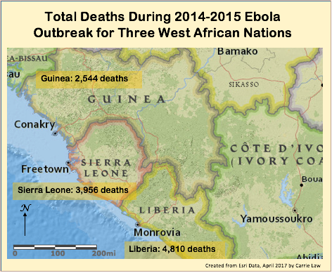
Figure 1. West Africa Map

History and Colonization
Sierra Leone: Sierra Leone was colonized by the British during the 17th century. The British took resources such as wood and ivory from the country for trade and eventually entered into the slave trade. Sierra Leone became one of the major departure points for slaves being transported away from the continent. After slavery in the US was outlawed, some former slaves were relocated to Sierra Leone where the capital Freetown was established.¹² The country gained independence from British rule in the early 1960s. A civil war during the 1990’s displaced about 30% of the population and resulted in thousands of deaths. The diamond trade helped to fund years of conflict eventually helping to contribute to the term “blood diamonds.” Today, the country works towards increasing job opportunities and quality of life.¹² There are recent government efforts to regulate the trade of gems.
Liberia: In 1847 Liberia was founded and designated as a location for freed slaves to return to. Rubber production greatly supported the country’s economy starting in the 1920s. The country experienced years of intercountry conflict which has left the economy unstable for many years. During the 1990’s warlords recruited children to fight in their armies and used drugs as a method to keep them under control. Since the mid 2000’s, the country has been trying to recover from the many years of unrest. In recent years, religious tension between Christians and Muslims has resulted in violence and political instability.
Guinea: The French colonized Guinea during the 17th century.¹² The country remained under colonial rule until it gained independence in 1958. Since liberation, the country has been controlled by multiple military backed regimes through a series of rigged elections and corrupt government deals.¹² Guinea is very rich in natural resources, but has been unable to profit due to corruption, conflict between ethnicities, and the burden of thousands of refugees from mainly Sierra Leone and Liberia.

Predominant religions
Christianity and Islam are the two largest religions practiced in Sierra Leone, Guinea, and Liberia. There are also many people who practice religions that are native to the region. It is very common to see individuals practicing a mixture of mainstream and native religions. The blurring of these religions means that cultural customs such as weddings and funerals are very different when compared to other parts of the world.¹⁴
A typical Christian burial will take place a few days after the death. Family members may gather for a wake that lasts for a day or two. Loved ones will take time to remember the deceased and say goodbye. This can sometimes be a large celebration that involves carrying the body through the village and touching the body with bare hands. The body is then closed in a vessel and buried with a grave marker. In some cases, a memorial service will be held at a later date.¹⁴
A typical Muslim burial involves burying the deceased as soon as possible. Some regions in West Africa have beliefs regarding the time of day that a burial can be performed. The body must be washed and then wrapped in a shroud. Only women or close male family members are to prepare another female for burial. When the body is buried, the head must face Mecca.¹⁴
While all religions have specific customs surrounding death, it is reasonable to expect that during a time of emergency some of these customs can be altered to ensure the safety of others.

Statistics
Table 1. Country Statistics
 | Liberia | Sierra Leone | Guinea
Population | 4.2 million | 6 million | 12 million
Population % below age 25 | 61.2% | 60.47% | 61.37%
Life Expectancy (years) | 59 | 58.2 | 60.6
% of dependent population | 82.9% | 81.9% | 83.8%
Birth Rate  (Births/1,000 population) | 33.9 | 36.7 | 35.4
Death Rate  (Deaths/1,000 population) | 9.5 | 10.6 | 9.2
Population Growth Rate | 2.44% | 2.36% | 2.62%
Infant Mortality Rate  (Deaths/1,000 live births) | 65.8 | 70 | 51.7
Maternal Mortality Rate  (Deaths/ 100,000 births) | 725 | 1,360 | 679
Fertility Rate (born/woman) | 4.6 | 4.76 | 4.82
% Vaccinated  2013  2014  2015 | 87%  73%  74% | 99%  90%  90% | 95%  82%  75%
Physicians/1,000 population | 0.01 | 0.02 | 0.1
Literacy rate of population of age 15 | 47.6% | 48.1% | 30.4%
Top 3 causes of death | 1.Lower Respiratory Infection  2. Malaria  3. TB | 1. Malaria  2.Lower Respiratory Infection  3.Malnutrition | 1.Lower Respiratory infection  2. Malaria  3.Diarrheal Disease
GDP/Capita (2016) | $900 | $1,700 | $1,300
Gross GDP (2016) | $3.88 Billion | $10.64 Billion | $16.08 Billion
Religion  % Muslim  %Christian  % Other | 12.2%  85.6%  1.6% | 60%  10%  30% | 86.7%  8.9%  4.4%
Statistics provided by world factbook

WHO policy for the burial of Ebola victims

Overview
The World Health Organization developed a policy that dictates the protocol for safe and dignified burials of Ebola victims. The policy outlines everything aid workers need to do between arriving in a village and returning back to their headquarters. Two sections outline the expectations for Muslim and Christian burials. The religious sections detail the way a generic burial should be performed for a person of a certain religion. Other religions are not discussed.
The policy outlines the type of equipment needed to perform a burial as well as the team members that are needed. It also states the types of disinfectant sprays that are needed to keep workers and families safe and materials needed for the safe disposal or sterilization of used materials.
The protocol goes through many steps and tries to be sensitive towards cultural traditions. There are many great parts about the policy, but also room for improvement. The protocol used as the official guidelines produced by the World Health Organization can be found in the appendix. The following is a personal critique of the document.

Critique

What works and why?
The World Health Policy Did a lot of things right and made a clear attempt to consider different religious factors that surround the burial of an Ebola victim.

- Outlining the procedure from the preparation of protective gear before arriving at a site all the way to the final disinfecting and incinerating of disposable materials at a staging location or hospital.
- The policy was named, “How to conduct safe and dignified burial of a patient who has died from suspected or confirmed Ebola virus disease.” The naming of the policy was very well done. Clearly indicating that it is a guideline for safe and dignified burials lets workers and community members know that all parties are being considered whether they are an aid worker, family member, or the deceased. It implies that a level of respect is still present even in the time of a crisis. It also communicates with the community that the goal of the burial is to help all of those involved, and may help to further open communication between communities and healthcare workers.
- Reminding workers that the death and burial process is a difficult time for friends and family of the deceased may seem like a superfluous statement, but when some workers have to bury multiple people in a day, it is an important fact to keep in mind.
- The Short overview of the 12 steps involved with the safe and dignified burial is a great outline, and can be an easy checklist for workers to use if/when needed.
- On the bottom of first page, there is contact information for two different people who work for The World Health Organization. They are identified as people to contact if changes or corrections need to be made to the procedure. This is extremely important because it allows workers to give feedback in real time based on their experiences in the field. It means that the policy can be changed to better serve diverse communities as needed, and acknowledges that the policy is not a perfect document.
- Listing the required personnel and what they are to be wearing helps to outline the initial team organization expectations.
- Listing and giving pictures of each personal protection item needed for each team member gives an important visual reminder of all the things needed to keep an individual worker safe.
- The step three title states that an evaluation of risks is to take place. This is really good because it is a reminder that team members are not jumping right into the work. They first need to be aware of their surroundings.
- The inclusion of a family representative and faith leader helps to establish respect for the deceased and the community.
- Explaining how a dignified Christian burial will be conducted helps to set expectations for the family, and allows them to see how the burial of an Ebola victim might differ from the normal burial ceremonies conducted in their communities.
- Allowing the local religious leader to conduct the ceremony in the most normal way possible allows the family to have a more normal funeral experience. It is important because it brings their cultural traditions back into focus.
- Stating that deceased Muslims are not to be cremated is important because it helps to set a standard and will keep teams from even offering cremation as an option, which could upset some families and cause a loss in compliance.
- Detailing the shrouding process from start to finish is very useful in getting all burial teams to provide the same services in the same manner.
- Allowing the family to place items in the coffin is a good way to show cultural sensitivity during the situation.
- Disinfecting commonly used items like dishware is important, and shows the family that the team is trying to do a thorough job. It is also important the team is going through the house and collecting the deceased’s items that need to be disposed of so that the family members are not forced to do such a difficult task minutes after they began the burial process of a loved one. It also helps to ensure that all potentially infected items are removed.
- Stating that the team will replace burned items sets a quality of care standard for the process.
- Step eight shows the removal process of the personal protective equipment. The pictures and listed steps are easy to follow.
- The repetitive use of the word “hand hygiene” may seem redundant but is needed when trying to fully convey the importance of following all steps to keep all people healthy and safe while moving forward.
- Step nine part five specifically mentions the importance of having patience’s when the family is possibly conducting speeches, songs, or grieving traditions.
- Not allowing family member in the cabin of the truck is vital because there is always a possibility of a family member beginning to show symptoms. It sets an easy policy standard so the team will not feel obligated to drive someone to the burial site. It also keeps family members safe by keeping them away from potentially hazards things in the cabin used by the medically trained staff.
- Respecting the traditional expressions of grief during the procession is important, and team members should be thoroughly briefed on what these expressions may entail in differing communities.
- In step 11 once the body has been safely placed in the grave, the team is asked again to respect the time it takes the family to preform prayers, speeches and other ceremonial customs such as shoveling soil onto the coffin. This helps to create a time and space for them to say goodbye at their own pace.
- Placing identification on the grave at the end of the process with the family present allows the family to put a visual marker to where their loved one now rests. Teams not affiliated with the World Health Organization did not always put identification on grave sites.
- Providing disinfecting hand solution for the team members, all family members, and funeral service attendants is an easy way to show the community the value in proper and diligent hand hygiene when living in a community effected by the Ebola virus.
- Thanking the family members at the end of the service is a goodwill gesture that easily shows sympathy for the situation the family is in.
- The final disinfection and incineration processes are clearly explained. All final expectations for the team in the conclusion of the process help to ensure a continued standard of safety.

What partially works and why
- Including pictures of the different team members wearing appropriate protective gear and equipment helps to set expectations. The pictures could be more detailed and could depict a few other protective measures such as the use of tape to seal boots or the consistent use of rubber gloves.
- The preparation of the disinfectant solution is an important rule, but should be formally assigned as a job to a team member. If a team member is not responsible for the preparation of the solutions, then the policy should clearly state who is responsible for distributing the solutions and the appropriate quantity that should be taken for a single burial.
- In the description of biohazard bags needed, there should be an outlined example of what qualifies as a reusable or disposable item so that all teams can be conducting practices in the exact same manner.
- The policy states that the team leader is to brief the team on proper burial expectations for the religious and social context present. This poses an issue because later in the policy only two religions are discussed, and it is not clear if specific regional customs were accounted for.
- Not wearing full personal protection gear and equipment upon arrival helps to humanize the team. It aids in creating a personal eye to eye connection between the grieving community and workers. It also might help community members feel a little more hopeful about the situation because it proves that they are not at risk of catching the disease from simply breathing the air.
- Obtaining a “formal agreement” from a family member is an extremely important step for a variety of reasons. It shows that everyone is willing to work together and that the team can proceed with their work in a safe manner. The only issue is that there is no description of what a formal agreement entails.
- Verifying that the grave has been dug and/or having it dug should be a more detailed step in the process.
- Proposing to have family members watch the preparation of the body is an understandable option, but there are no specifications of how close the family members can be or if they are to be wearing protective gear. There also could be issues with compliance when family members are experiencing heightened emotions.
- Allowing members of the family to prepare some type of grave marker is important in the grieving process. It is unclear if they are expected to obtain or create this item quickly at the time of burial or if any kind of generic marker will be provided until a family is able to obtain one that meets their needs.
- Asking the family if they have specific request to aid in the facilitation of a dignified burial shows that the team is acknowledging the family’s needs. It can pose problems when some requests are unable to be met for health and safety reasons.
- Providing family members alternatives to physically touching the deceased could have good or bad outcomes in regards to compliance. Some families might feel like they are being told what to do, or feel that their deep rooted cultural traditions are being challenged. This is a very difficult step in the process because chances of exposure are high.
- The incorporation of local religious leaders is an excellent way to further involve the community in the process. The policy does not discuss the briefing that these leaders will need before beginning the process so that they can be a liaison between the team and family.
- The policy discusses the identification of a burial site agreed upon by the family and team. It then states that the family can dig the grave if wished and place their grave marker at the location. In some communities this practice was controversial, or not allowed.
- In regards to Muslim burials, it is good that the team seeks the approval and signature of a local Imam or religious representative, however this is a step that should also involve the family directly.
- Asking Muslim families how to best conduct the service helps to build trust and communication, but can also cause issues if not all expectations can be met.
- Stating that female members of the team should be responsible for shrouding female patients is culturally sensitive, but there are no alternatives provided if there are no female team members.
- Using the body bag in place of a shroud might not be aligned with family wishes.
- The description of how to perform the dry ablution needs to be carried out very carefully. Some families might be upset that the traditional ritual is being altered. The local faith leader will play an important role in comforting the family and helping the ceremony to run smoothly.
- During the initial evaluation of the home, there should be a step that reminds the team to be on the lookout for possible safety hazards to the team, or to be observant of family members for possible symptoms.
- Having the family show the team all of the areas a deceased patient used is helpful, but it should still be recommended to disinfect the whole home because it is possible that the family is mistaken or unaware of all of the deceased person’s recent actions in the home.
- Putting on the personal protective equipment in front of the family could be good or bad. It helps the family to see and know who they are working with, but could also make them feel fearful that they do not have personal protective equipment and are living in a home where a family member just died from Ebola. There is really no good way of doing this step.
- The protocol should state if a family member or faith leader should be present when the team removes the body from the home.
- Having family members who are handling the coffin wear protective gloves ensures their safety, however the policy does not state if they should be wearing any other protective gear or if they are allowed to ask the team for any protective gear such as masks or goggles during the burial process.
- The policy says how to place the body in the truck if a coffin is not available. It does not discuss the proper way to secure it in the truck and the decontamination process required in that specific transportation situation.
- In step seven, the policy calls for a collection of sharps that had been used on the patient. There is no indication of how thoroughly these items should be searched for. Many of those items were probably disposed of by the family, which would require digging through trash and risking a puncture through gloves.
- Burning mattresses that were soiled by the deceased must be done to ensure the family’s safety, however the policy does not mention how to establish an appropriate burn site that the family, community, and workers can all agree upon.
- At the end of step seven there is a reminder to the team before removing personal protective equipment to make sure that all items of the deceased have been properly removed or burned. There is no checklist for all of the things that should have been done by this point in the process.
- During the funeral procession step it is stated that the truck may have funeral signs such as bundles of palm trees on it. There should be a specification of who is allowed to put these items on the truck, or if they are provided by the team.
- Carrying the coffin or body bag to the grave in most cases should not be an issue, but could become difficult in certain types of terrain. These instances should be accounted for.
- Stepping into the grave to lower the coffin or body bag should only be done when absolutely needed.
- In step ten there is mention of opening a node on the coffin depending on traditions in the area. This could create safety issues and should only be done by a team member. There should be detailed instructions about how to do this process in a safe way.
- At the end of the final step, there is bold print that encourages teams to use a checklist to make sure all tasks during the process have been completed. There are no official checklists provided.

What does not work?
- In the third step of the process, there are no indicators listed for how to properly evaluate risks in the area or how to handle them. This is bad because there are a wide range of risks that could be present such as health risks to workers and family members or unrest among the community. In some situations, burial teams were met with non-compliant citizens, and people who were vocally or physically resisting their assistance.
- Only discussing two religions in the document is an issue because both religions are an umbrella to many diverse customs and traditions that could change regionally or be influenced by indigenous religions. The descriptions are generic, and do not consider many alternatives
- In the section detailing Muslim burials, there is no mention of appropriate times of day for burial. Some Muslims in the region believe that burials can only be conducted during certain hours of the day and in certain times of light.
- The decontamination step of the coffin, after family members have closed it, seems to be out of order.
- The policy talks about “clean water” but does not mention what qualifies as clean water.

Reccomendations
The following recommendations come from the writer of this document and are not affiliated with the World Health Organization.
- Risk Reduction: The first step in the protocol should have the team evaluate the area for risks that could cause harm to members of the team. They should be aware of any community unrest or protests against the work they are doing. They should also monitor how previous interactions with the community have been received. When they meet the family and walk into the home, they should be looking for signs or symptoms of illness. If they believe that another family member is sick, they should understand how to safely address the situation so that the family member can be cared for and so that the team can carry on with their work in a safe manner.
- Agreement requirements: There should be a formal document drafted for the agreement that can be saved after the event. This document could be electronic or paper. The agreement should detail the process so that a signer can read and understand what is about to happen. It could also be read to the signer. It is important to begin the process by giving the family and representatives as much information as possible so that the team can run through their operations smoothly.
- Grave Digging: In step three the policy states that the burial location must be confirmed and prepared. It does not give guidelines about where the sites should be located in relation to the community. A site that WHO deems acceptable might not be acceptable to the family or community. The team should have clear guidelines on what works as an appropriate burial site and the dimensions needed for each burial. The team should also be brief on potential controversy that could arise regarding the chosen location so that they will be ready to work with local authorities to resolve the issue quickly before it grows into a larger dispute between the burial team and community members.
- Observation of preparation: A family member or family representative should be allowed to witness the initial preparation of the body before being removed from the house. This adds transparency to the process. It is also very important during certain religious practices, such as the Muslim belief that only women are to handle the body of a deceased female patient.
- Appropriate team members: The team should be aware ahead of time what the gender and religion of the deceased is. This will help in assembling the best team for the particular job. This is especially important for the burial of a Muslim woman. It could be difficult to convince a Muslim family that an all-male team can conduct the burial of a female family member in a dignified way that honors the individual’s religious beliefs.
- Grave identification: The protocol needs to clearly define who is responsible for the grave identification. The burial team should bring along markers that can be temporarily used to mark a grave until a family has time to create their own.
- Requests for dignified burial from the family: The family might make requests that cannot be accommodated. The team should be aware ahead of time about what some of these requests might be so they can have answers and alternatives prepared to alleviate tension as quickly as possible. The family requests might differ by religion or geographic region, and teams should be briefed before arrival on the customs of their destination.
- Briefing local religious leaders: Religious leaders in the area should be contacted as soon as possible. It is important to have the religious leader act as a connection between the team and community. The team might need to rely on the religious leader to encourage families to not partake in certain burial practices for the safety of the family and community. The family might be more open to listening to a well trusted leader of the community as opposed to the team that just showed up at their home.
- Family digging grave: Digging of the grave by family members should only be done when absolutely necessary. When possible, the grave should be dug before the arrival of the team carrying the coffin or body bag so that this part of the process will require less contact with the coffin or body bag.
- Coffin Decontamination: The decontamination seems to be occurring after the family has aided in closing
- Religious based descriptions: Only two religions are discussed in the document. Islam and Christianity account for most of the religions in West Africa, however it is important to provide information about other indigenous practices observed in the area. It is especially important because some regions will use a combination of common religious burial practices and practices that were developed within the indigenous cultures.
- There need to be guidelines about what qualifies as an acceptable grave site. The distance from a community or natural land features, such as swamps, should be clearly stated. There should be a detailed list for the team to follow. There also needs to be guidance about how to agree upon a site within a specific community. Lastly, the team should be briefed on what to do when a community refuses to bury Ebola victims in or near their communities and how to diffuse the situation in a safe and reasonable manner.
- Cremation: When appropriate, the team can suggest cremation as an alternative. Some people will not want to discuss this option which is why it should be only used in situations where religious beliefs do not have strong feelings against the practice of cremation. The team could explain the process and allow the family to ultimately decide.
- Auxiliary information: There should be extra information available that details practices, beliefs, and traditions that are specific to certain areas. The information could provide team members the reasoning behind some of the practices so that they will be able to have a greater understanding of the culture before arriving in the area. It will help them to be more sensitive and to understand social norms. It might also help to prevent them from unintentionally breaking social norms that could result in a loss of compliance from family members and communities.
- Delayed Memorials: Talking with local religious leaders about the possibility of delaying memorial services until a later date after the virus is no longer a threat to the community is a practical option. It will allow friends and family to safely travel to the memorial service location without increasing the risk of transmission. It also gives the family more time to plan the ceremony that they most wish to have. Faith leaders would be able to highlight the benefits in delaying the service without too much involvement from the burial team.
- Sharps: There should be more details regarding the collection and removal of “sharps.” A team should know if they are expected to go through trash at the home to find sharps or if they are only collecting the ones that are visibly sitting out in the home. It would also be wise to direct families on what to do with any sharps that might be found after the burial team has departed, so that they will remain safe.
- Clean water: The term “clean water” is a very vague term and its definition can change depending on the location. Since not all locations have access to “clean water” in accordance to Western medical standards, it is important to define what is actually meant. If teams are expected to bring water to villages that meet filtration expectations, then that needs to be stated. There also could be the option of using a portable water filtration system to purify local water so that it can be used for sanitation purposes. Whichever process is deemed acceptable; it needs to be clearly discussed in the official procedure.
- Mattress burn sites: There is very little guidance given regarding where mattresses can be burned. The policy should have information that explains what a safe distance from a home/community is and if certain geographic conditions will change how the practice is conducted. There should also be guidance on how to work with the family and community to find a location that they are satisfied with. Some communities might want mattresses to be burned outside of their town in more rural areas. The team must know if they are able to transport items in the truck to a distant location, or if that practice is strictly forbidden.
- Replacement of destroyed items: The team will remove and destroy or bury most of the deceased’s items and then replace them. The policy should specifically appoint who is responsible for replacement procedures. It is important that the team can tell the family on the spot how items will be replaced. It is unclear if it is only a monetary reimbursement or if items will be replaced with other items of similar quality and value. Being able to give a family answers about this issue will help the removal of possibly virus infected items much easier and more efficient.
- Checklists: At the end of the document there is a line that encourages teams to make checklists to follow as they go about the burial process. These checklists should be created by the World Health Organization and included as an attachment to the literature. Since bringing checklists into the field might be difficult to do, perhaps they could be printed on large stickers that can be stuck to the sleeves of the Personal Protective gear that is disposed of at the end of the process. The stickers would serve as a reminder of the process that can be glanced at as needed. The stickers could be customized depending on the community or religious practices that will influence the process.
- Distribution of gloves: Household gloves should be distributed by the team much earlier in the process or at least by request. Since the family might still be in and out of the house the team should do all they can to protect them while they are on location. Since the gloves are distributed at the burial site anyways, it will not matter if they are handed out upon the team’s arrival.
- Standing in grave: Family members standing in the grave should be a limited practice. If there are any mistakes during the lowering of the coffin, or bag, it could result in an injury and at worst, transmission of infection.
- Official Checklist: An official check list should be included at the end of the document that can be kept in the cabin of the truck and referenced if needed.
- Disclaimer at End: The end of the document should contain a disclaimer that separates the WHO and WHO affiliated teams from other groups that are not following the guidelines created by WHO. This will help to keep the institutions integrity and public image.

Methods
Studies for this essay were selected based on subject content and its relevance to the topic of burial practices in West Africa during the Ebola crisis. News articles were included as supporting information because they provided an up-close and real-time perspective of the situation as it unfolded. The news articles are vital to the subject because they document small and large events that were occurring as the situation took shape.

Conclusion
The World Health Organization created a policy with the intention of being mindful about the needs and expectations surrounding the population it aimed to help. The policy had many positive aspects, but also had areas that could be improved. If the policy is needed again in the future, it will be important to revise it using feedback from community leaders, religious leaders, aid workers, and policy creators. Being open to criticism is one of the best ways to improve the document.
When creating a policy, it is important to consider cultural differences, and the way the policy will be perceived by other populations. If policy makers do not take time to research the culture or work with experts, then there is a high chance that part of the policy will not be implemented successfully. Remembering that culture can’t be changed easily, but a policy can be molded to be respectful of a culture while still accomplishing a goal is key.
The World Health Organization placed many positive and helpful guidelines into the policy. It was well organized and followed the process from start to finish. It also acknowledged some of the cultural differences that should be expected. The policy does a good job with distinguishing differences between Christens and Muslims and their expectations during the burial process.
They had multiple areas where the policy could have been improved. More details were needed in many of the sections to help clarify expectations. There should have been information provided about the hybrid of cultures and how it changes burial practices. It would also be helpful to provide an example of how traditional burials are conducted when Ebola is not a concern. It would also be helpful to include some history about the traditions. This could help team members gain a better understanding of the communities they are working with.
Policy making is not a perfect science. It is important to always be open to criticism, and to be willing to find creative solutions to solve problems when they are encountered. Anticipating multiple outcomes is needed so that further problems can be avoided. Language clarity is key for a policy that has direct life and death implications, such as the one created by the World Health Organization.
Policies need to serve a purpose. If they are not serving their intended purpose, then they need to be revised. In some ways, a policy can be seen as a living document that continuously changes until it reaches a goal.

APPENDIX: WORLD HEALTH ORGANIZATION BARRIER PROTOCOL

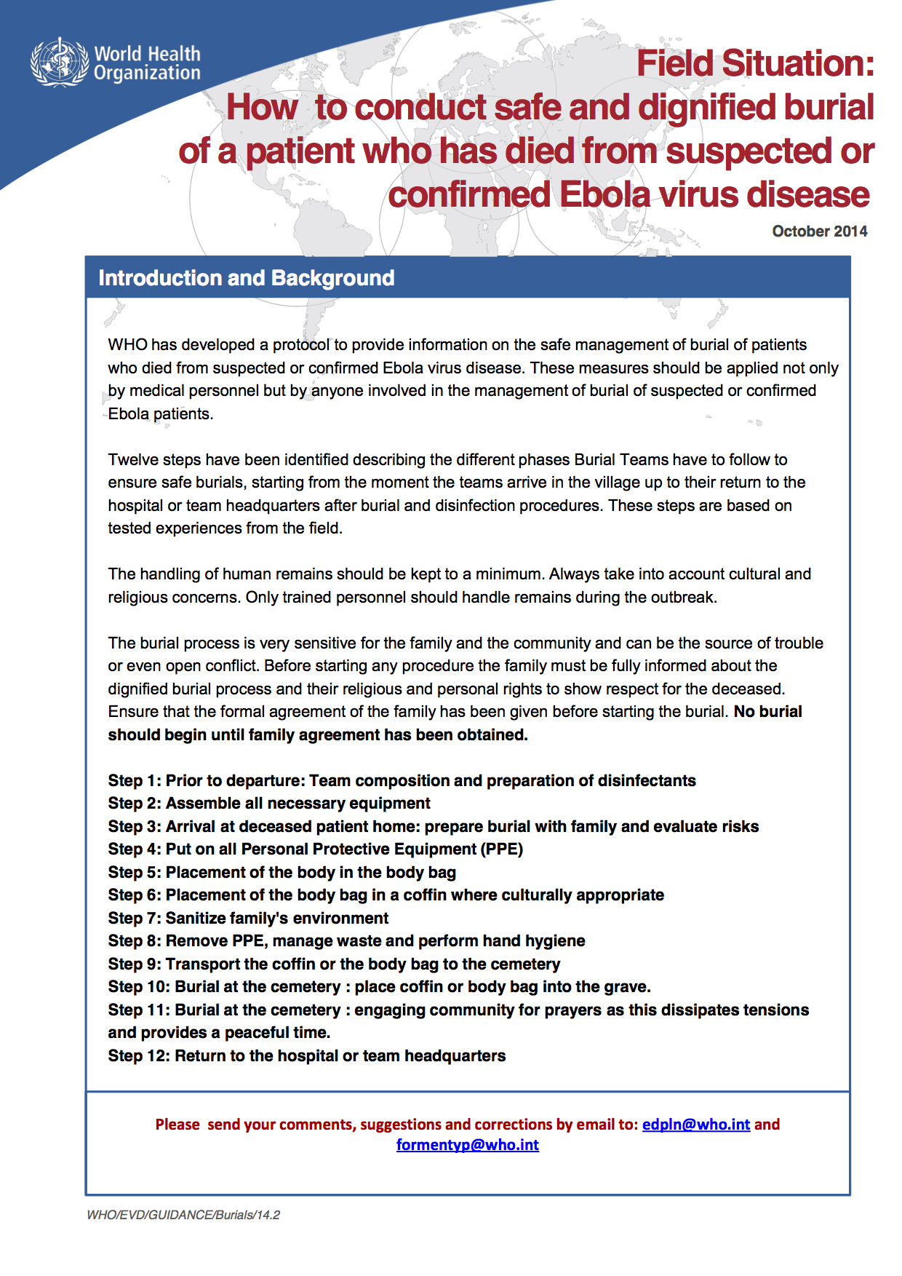
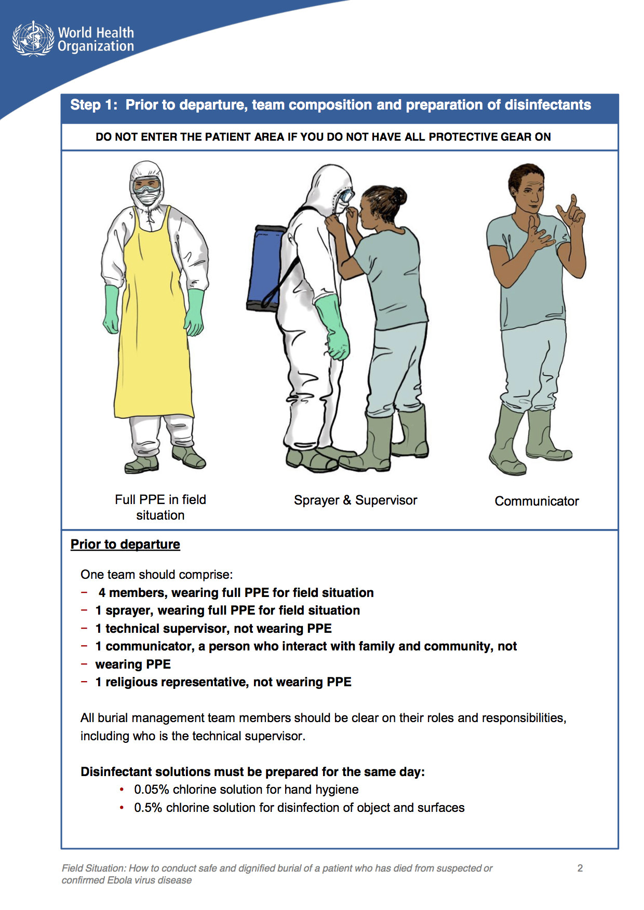
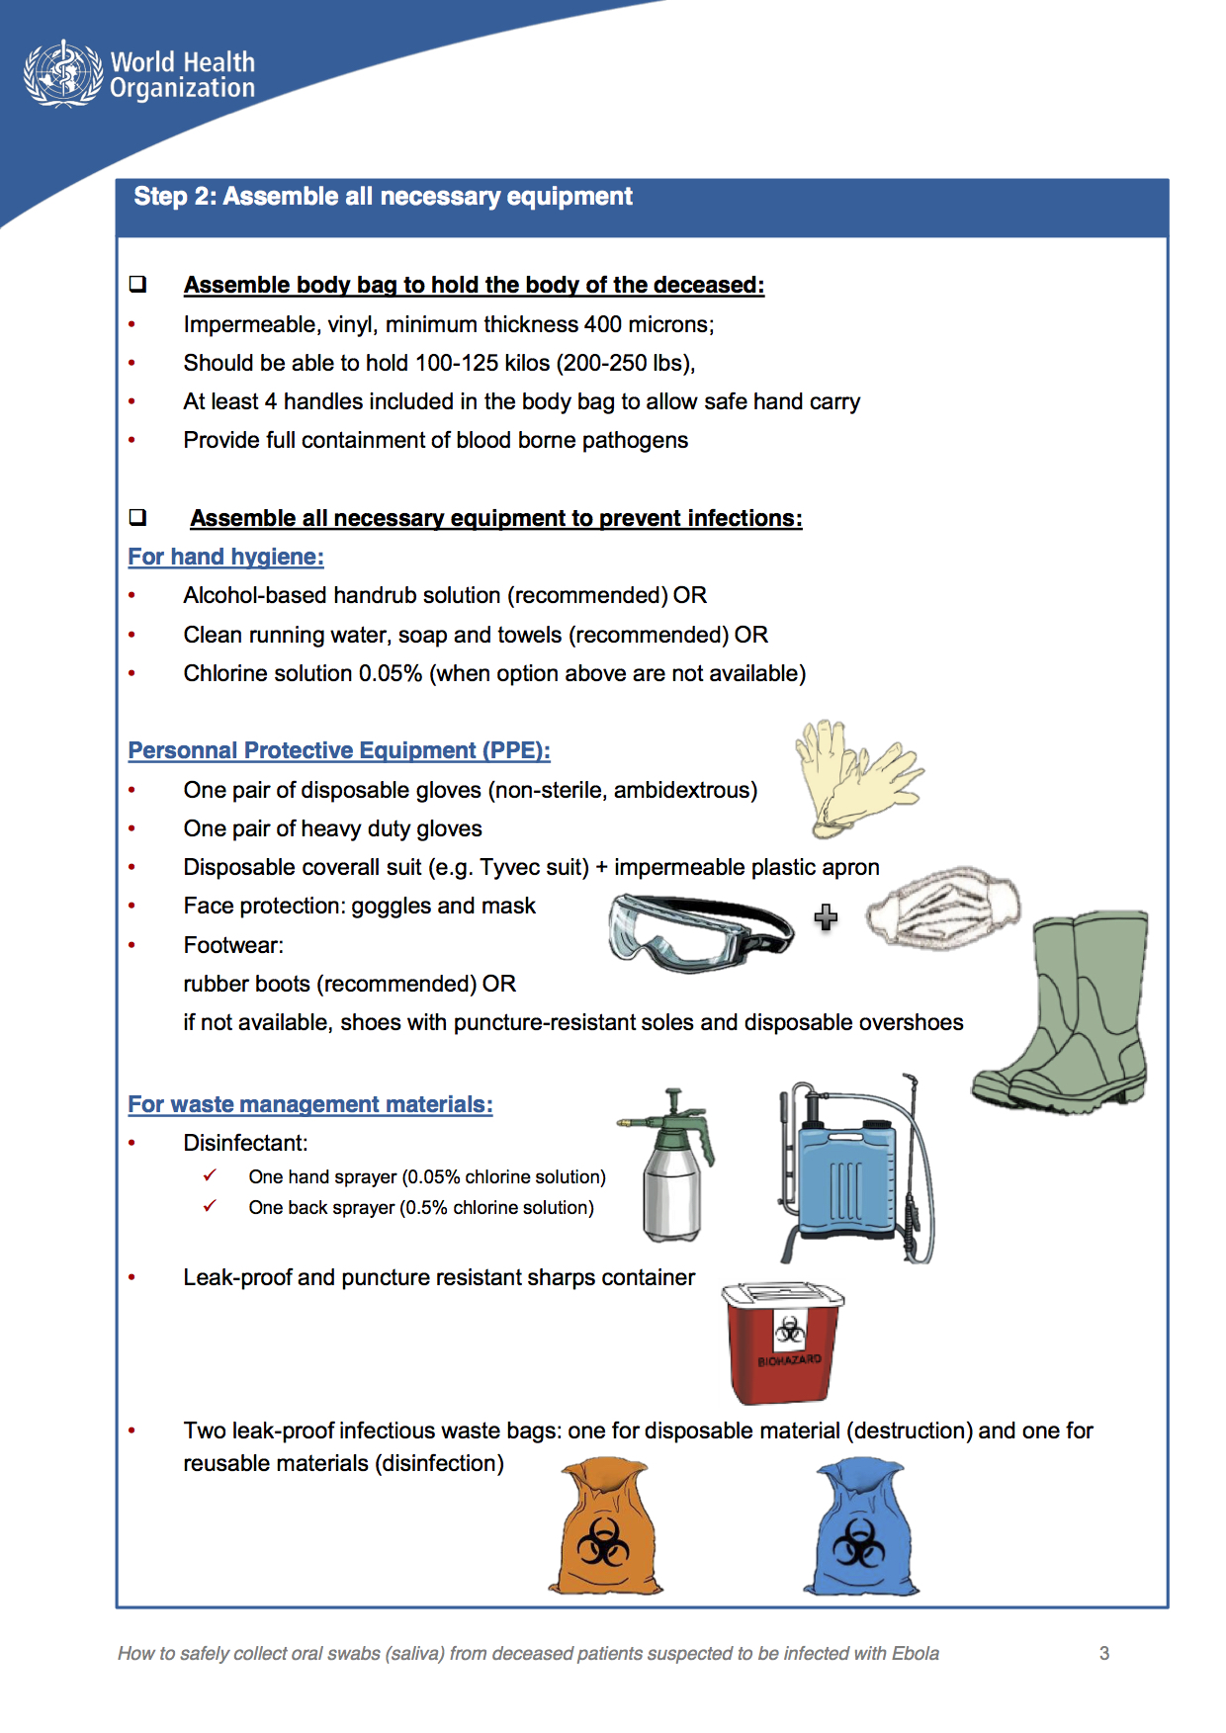
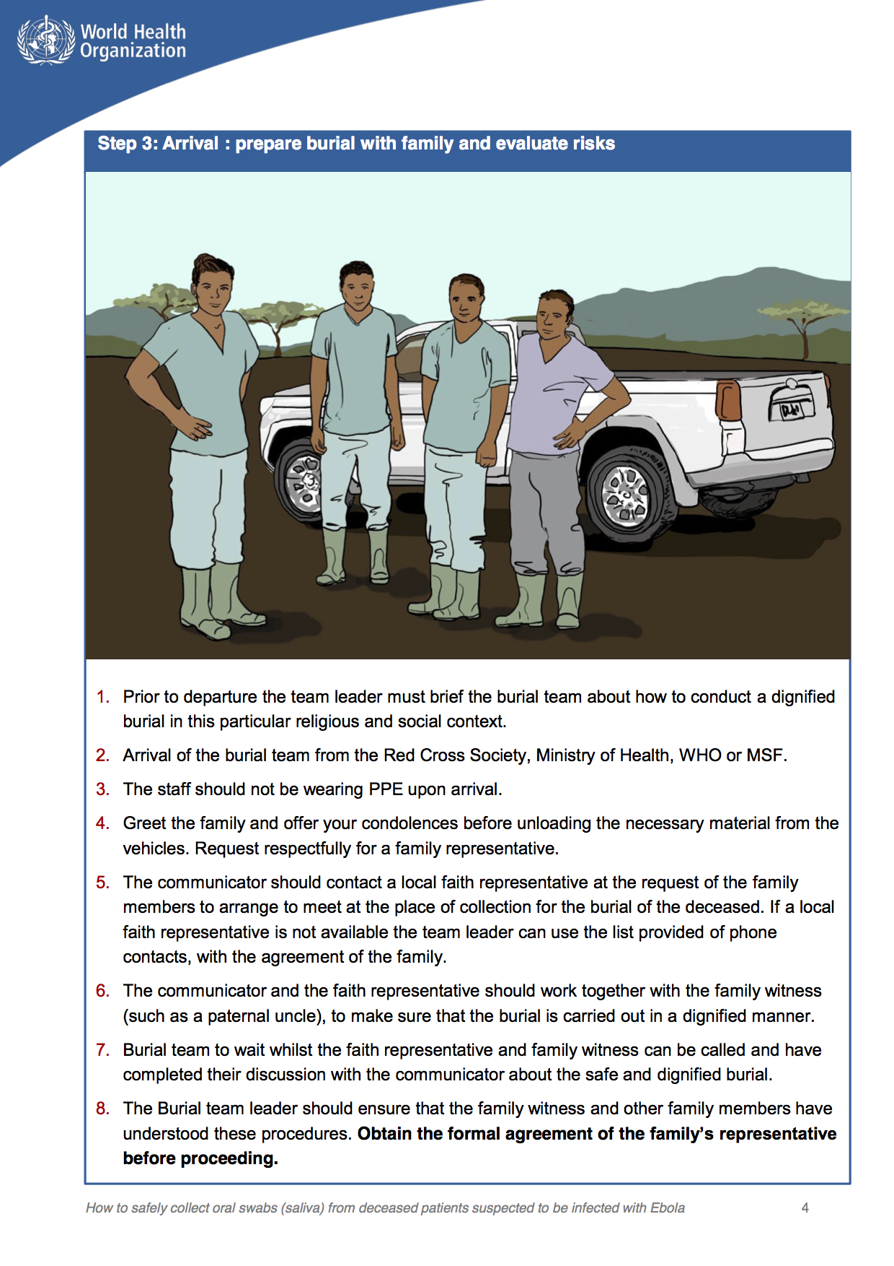
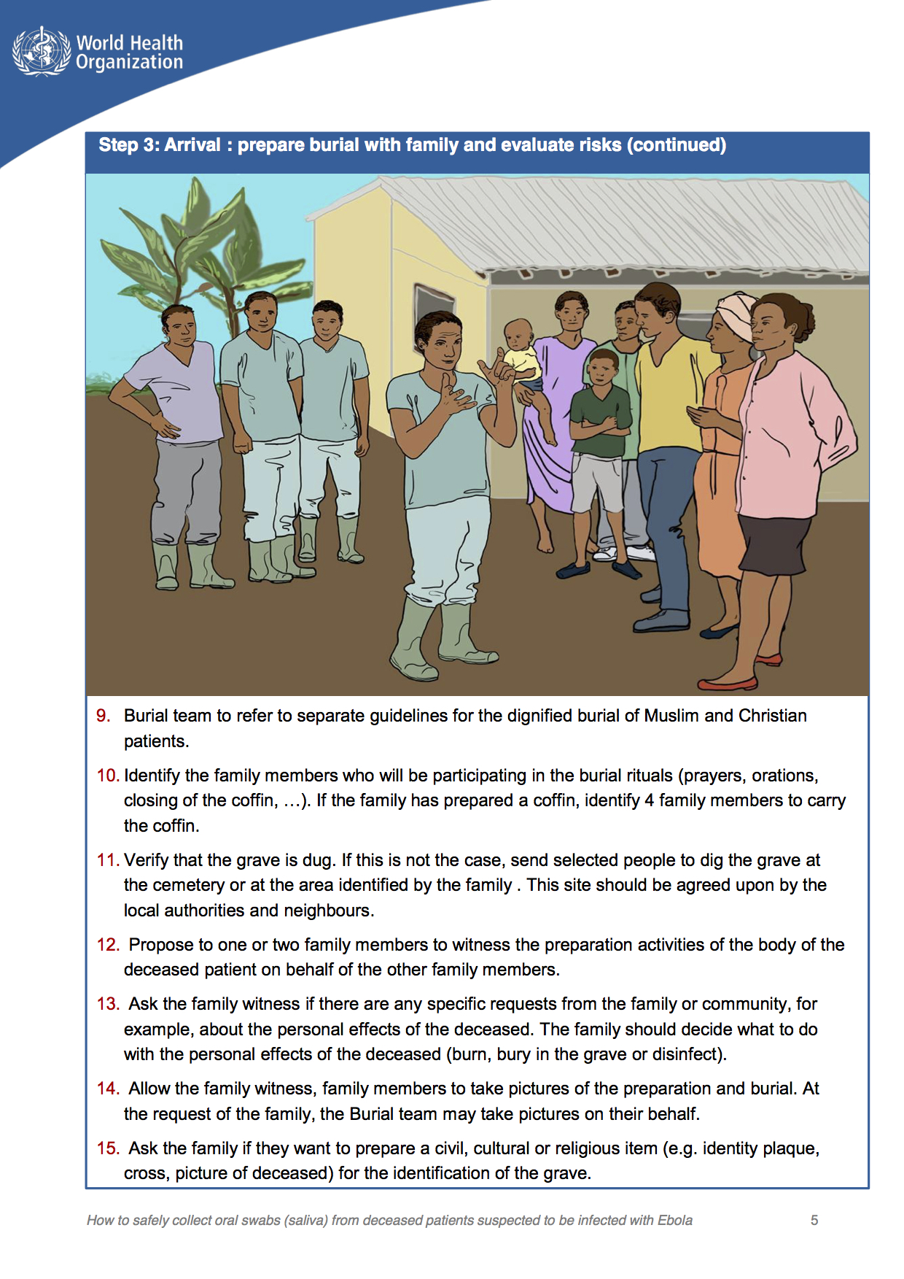
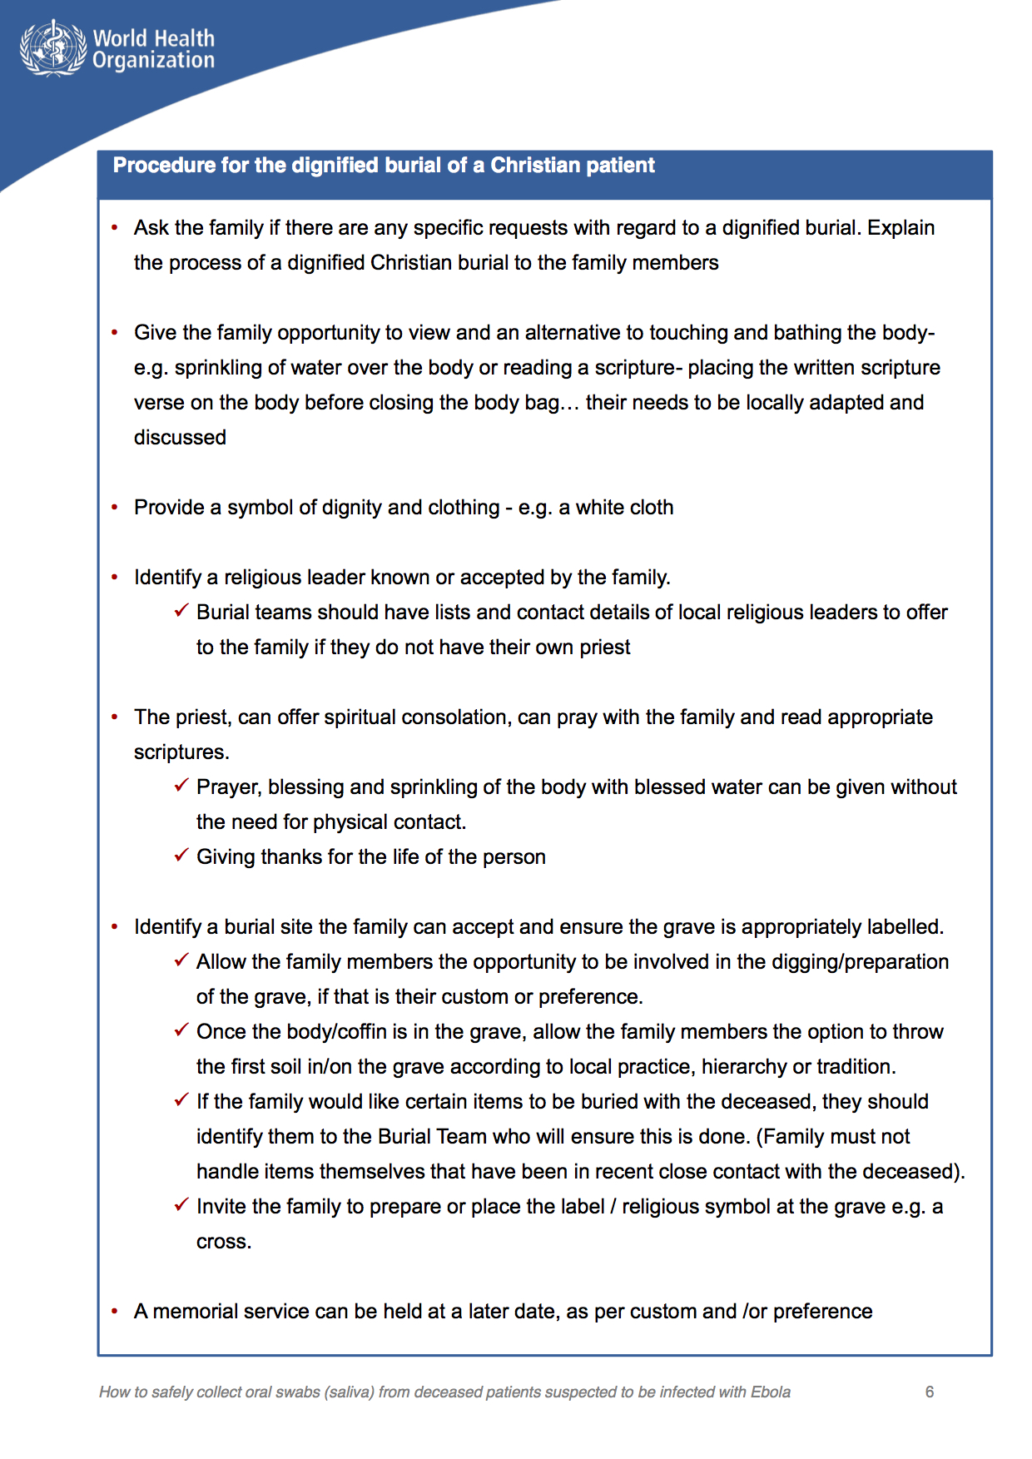
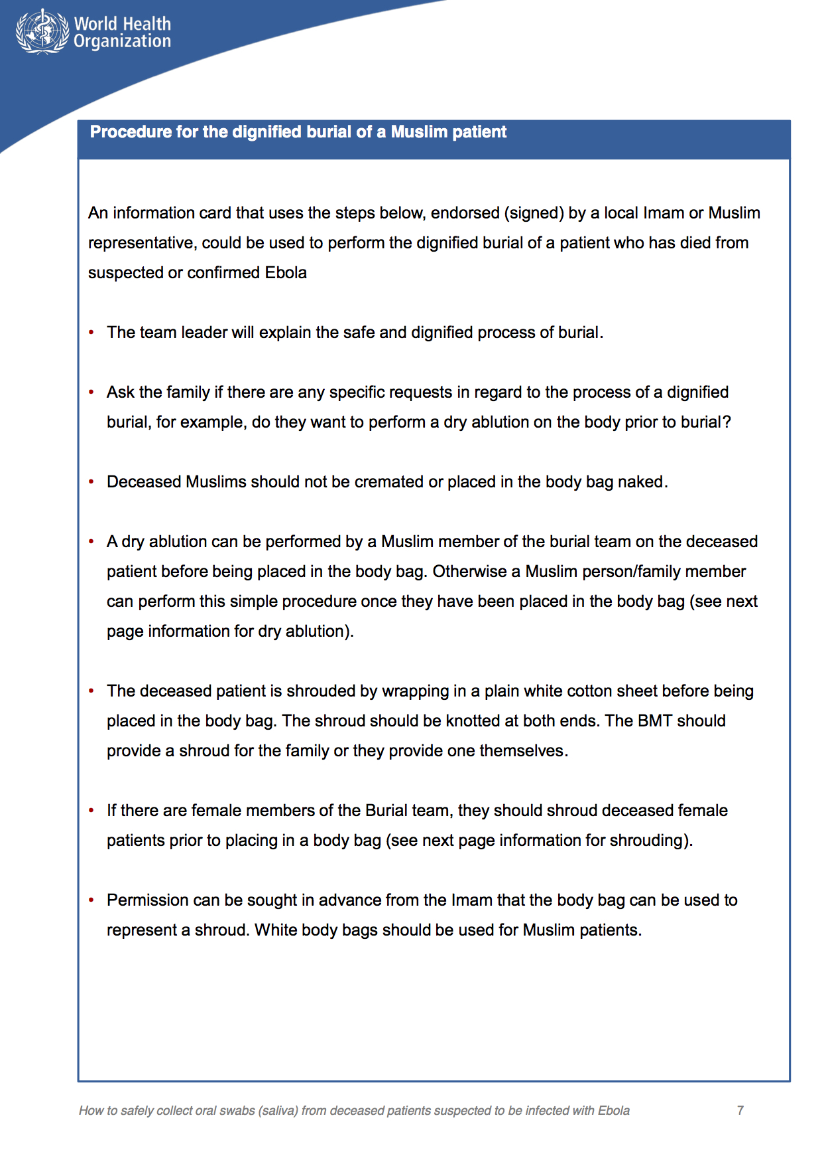
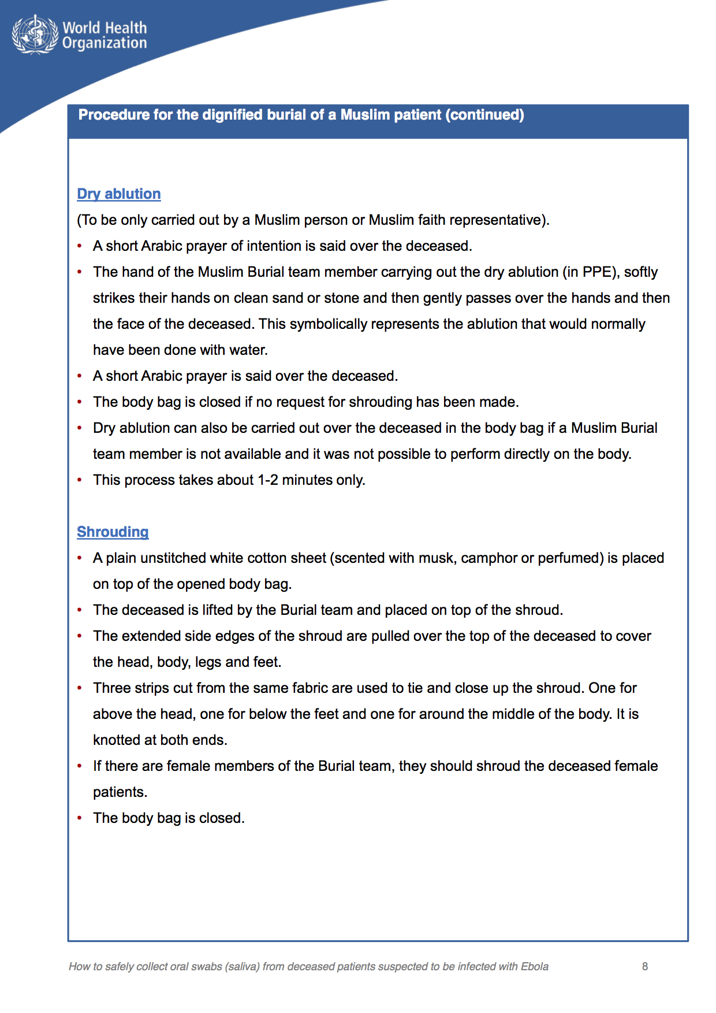
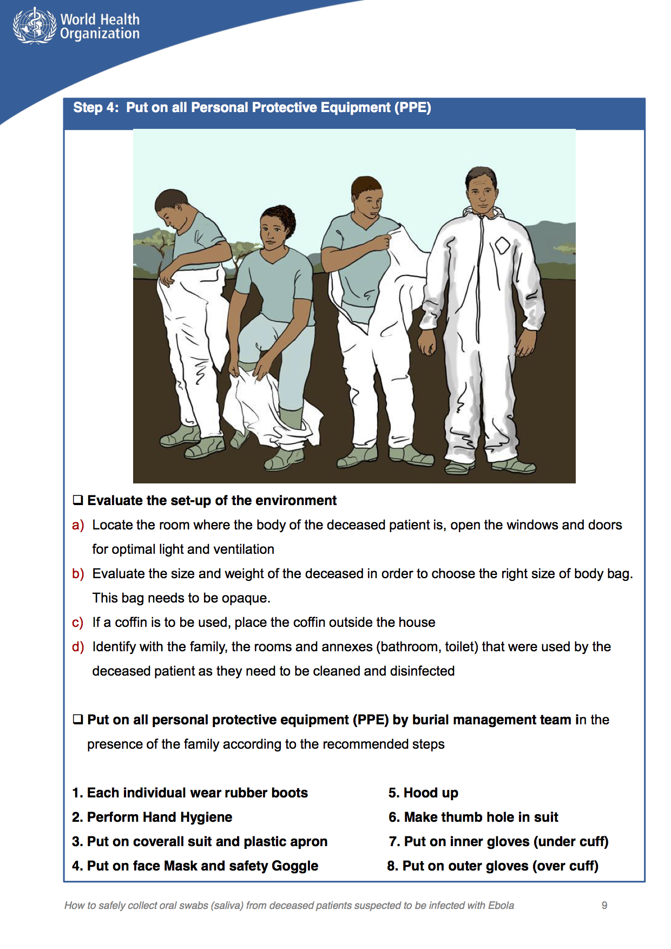
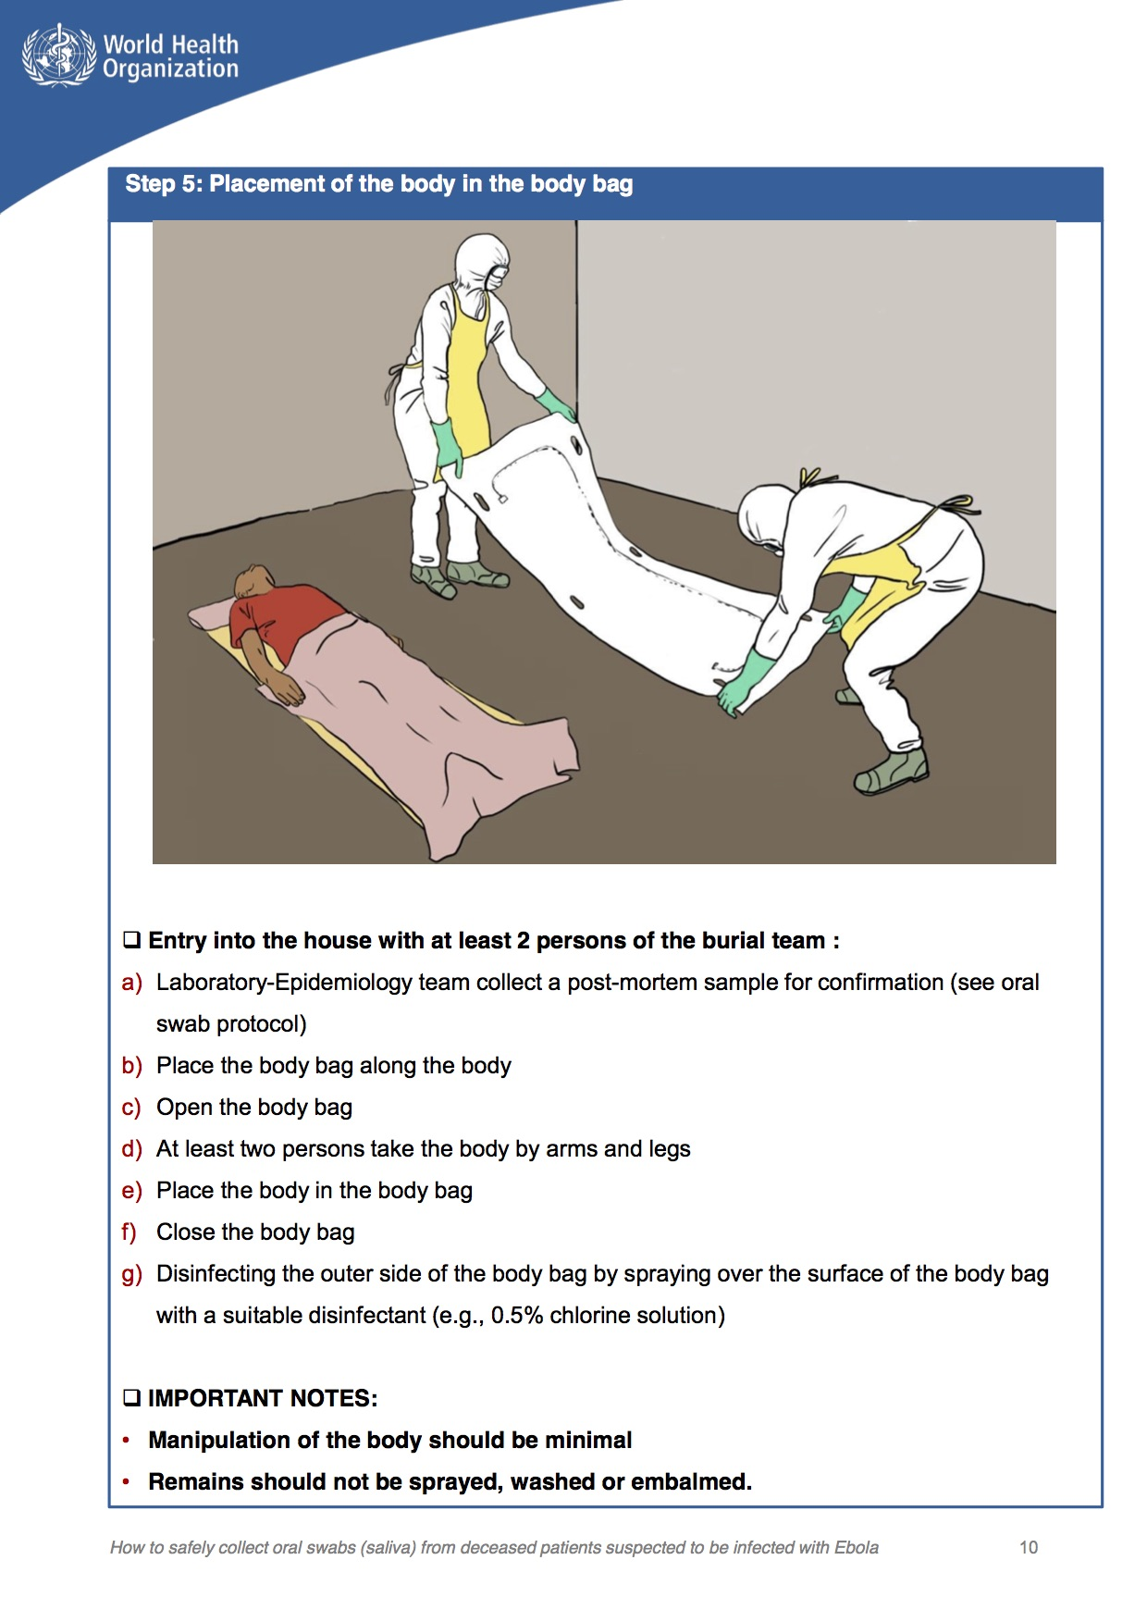
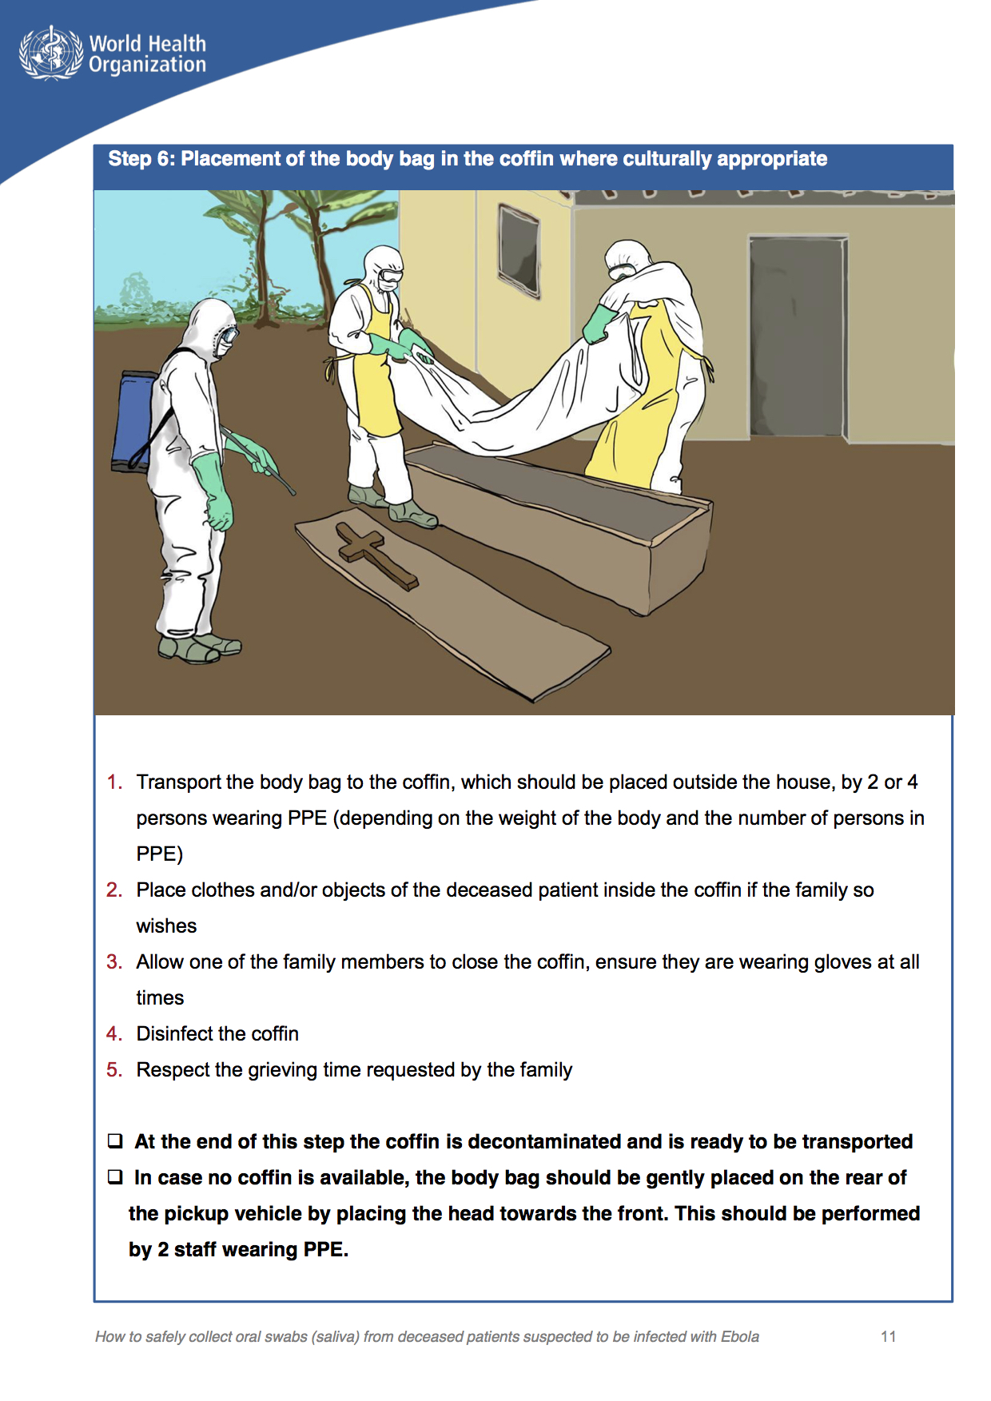
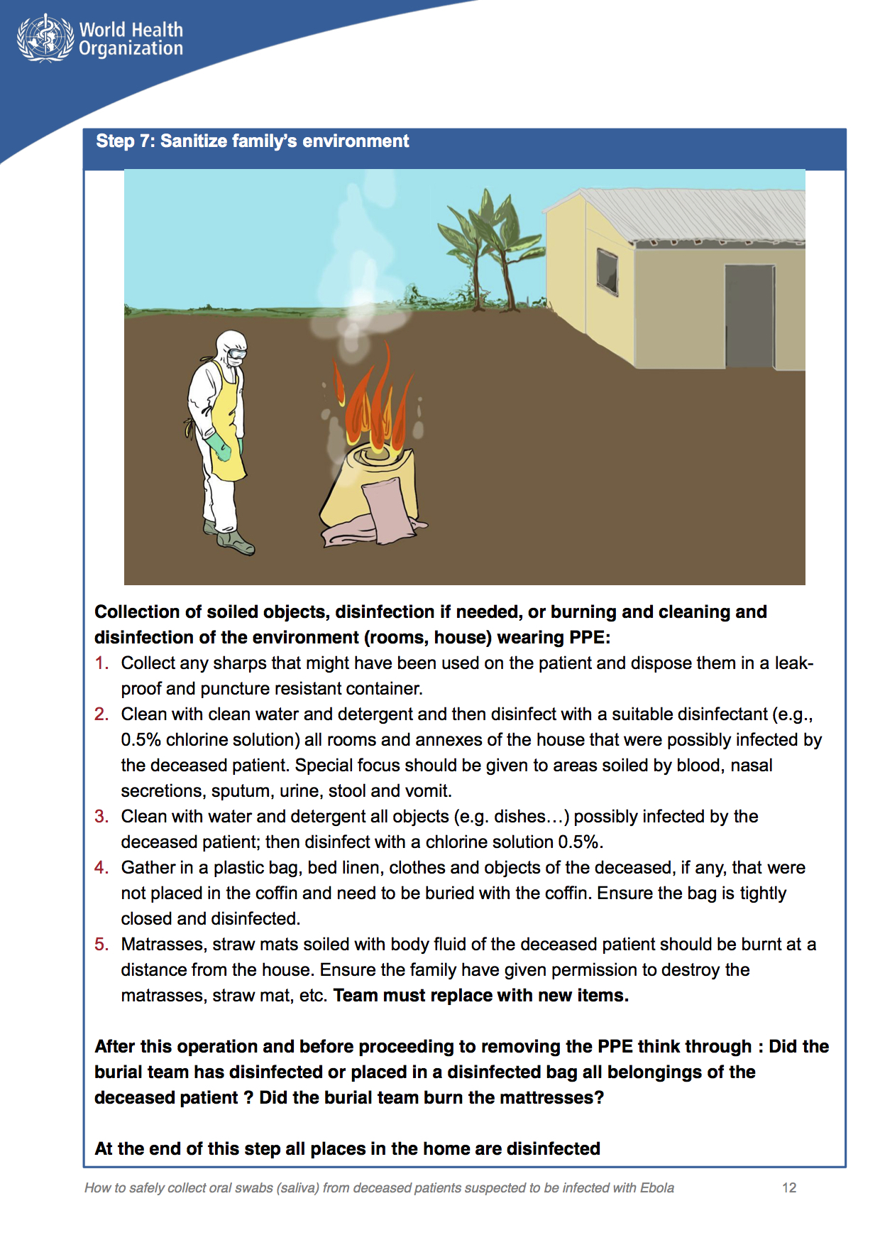
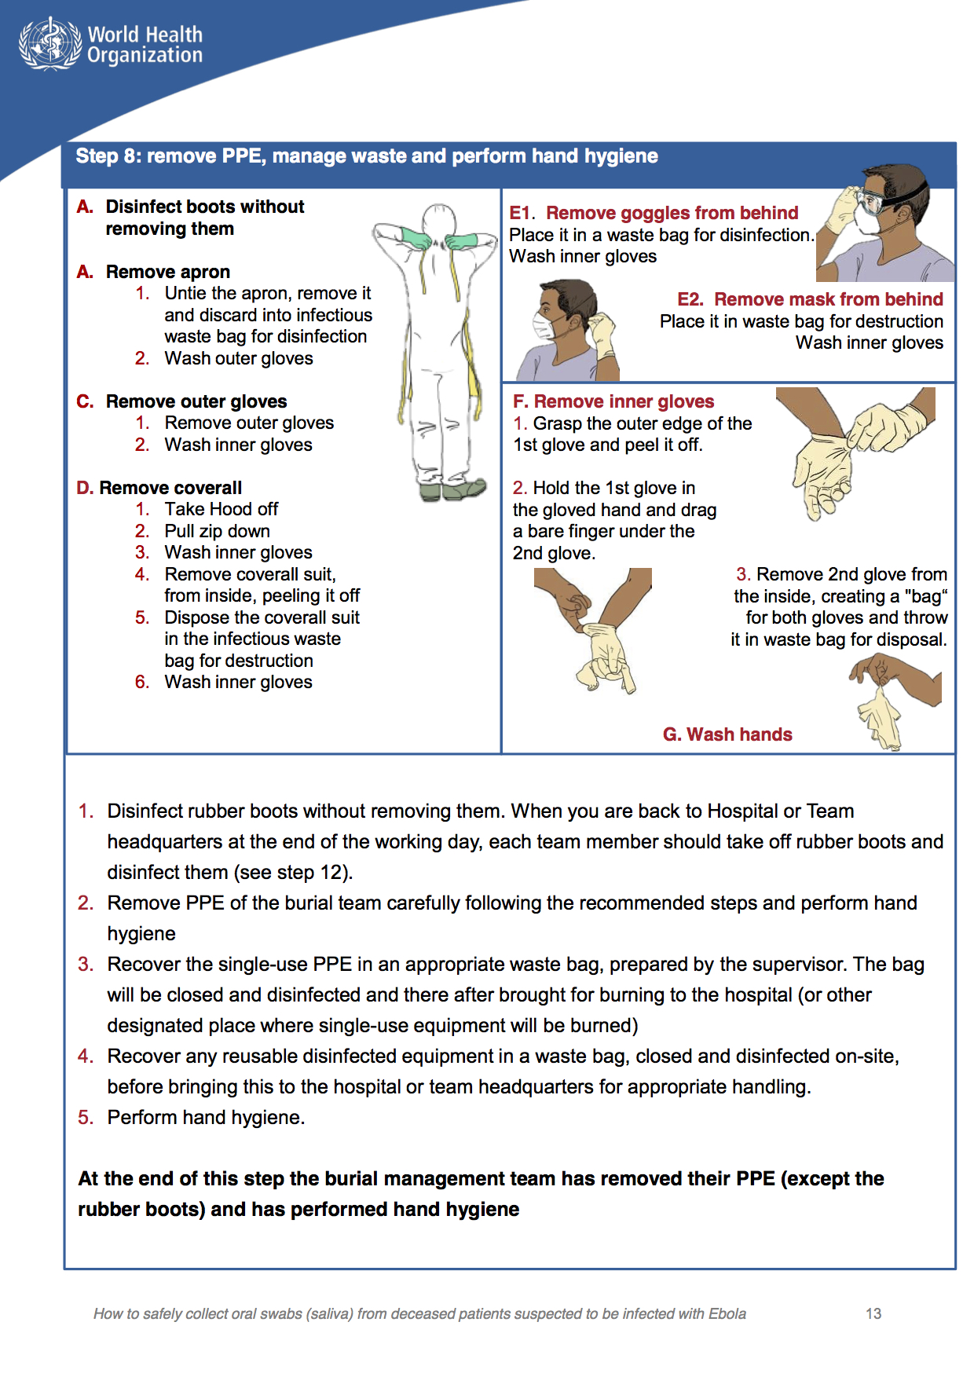
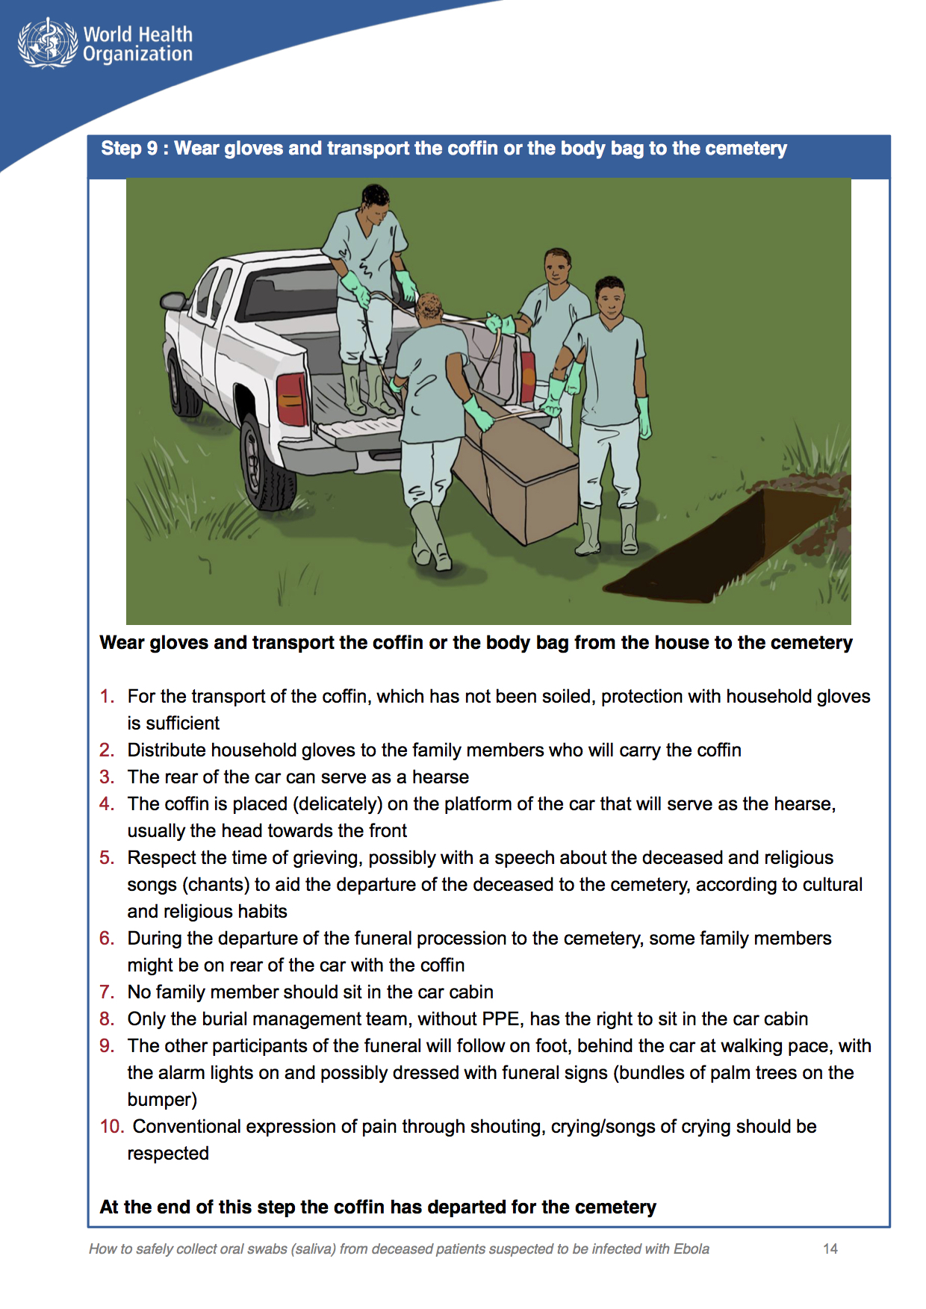
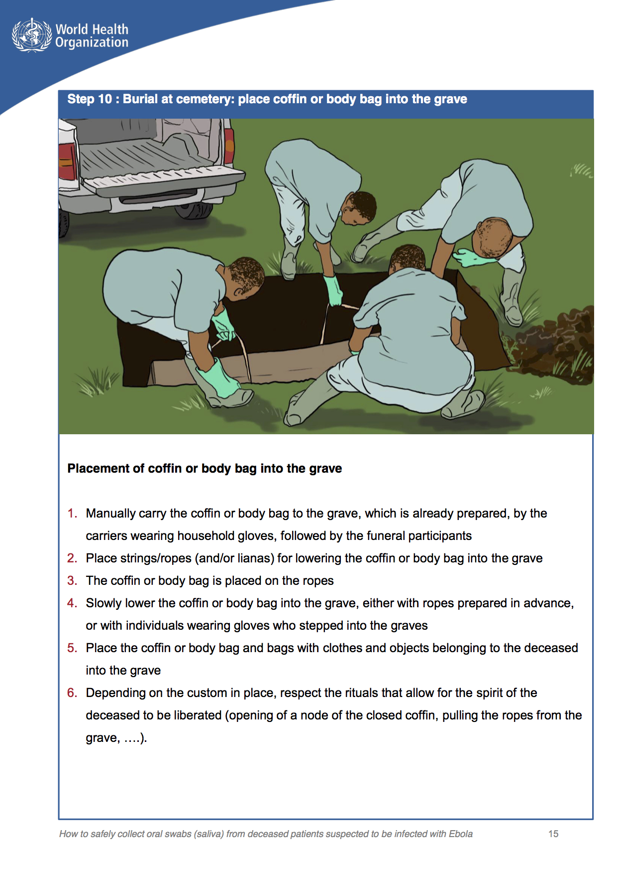
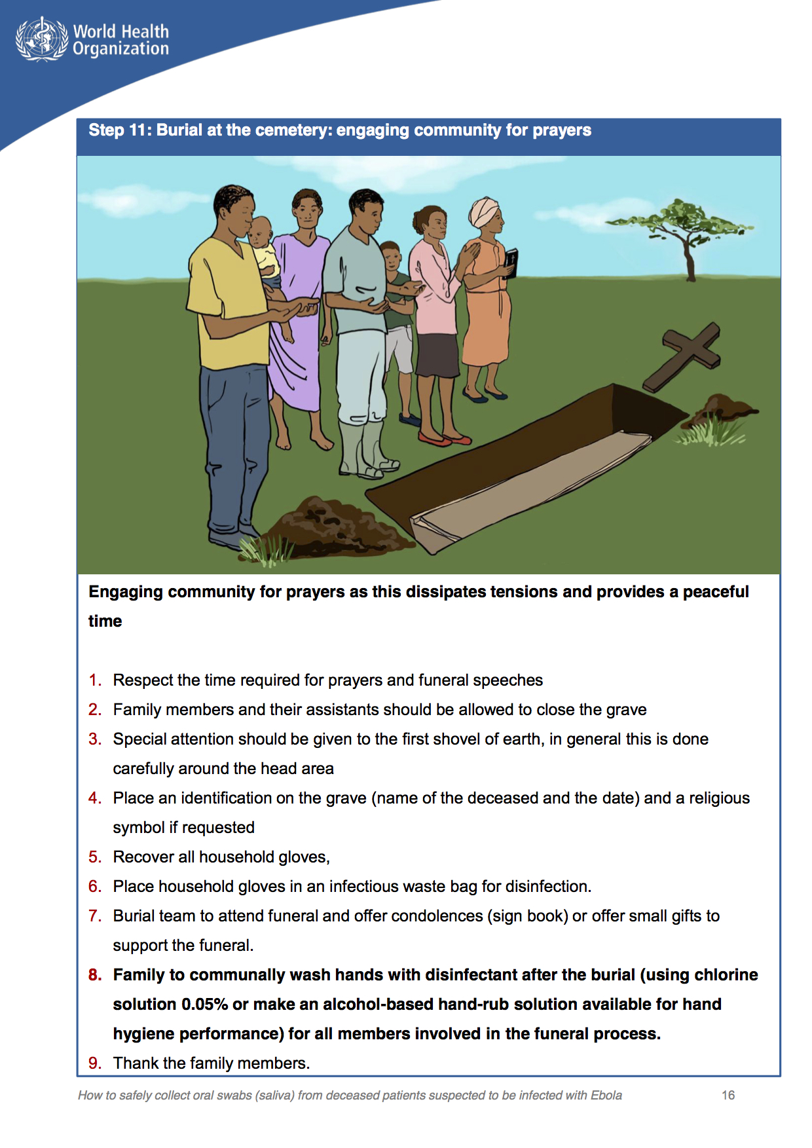
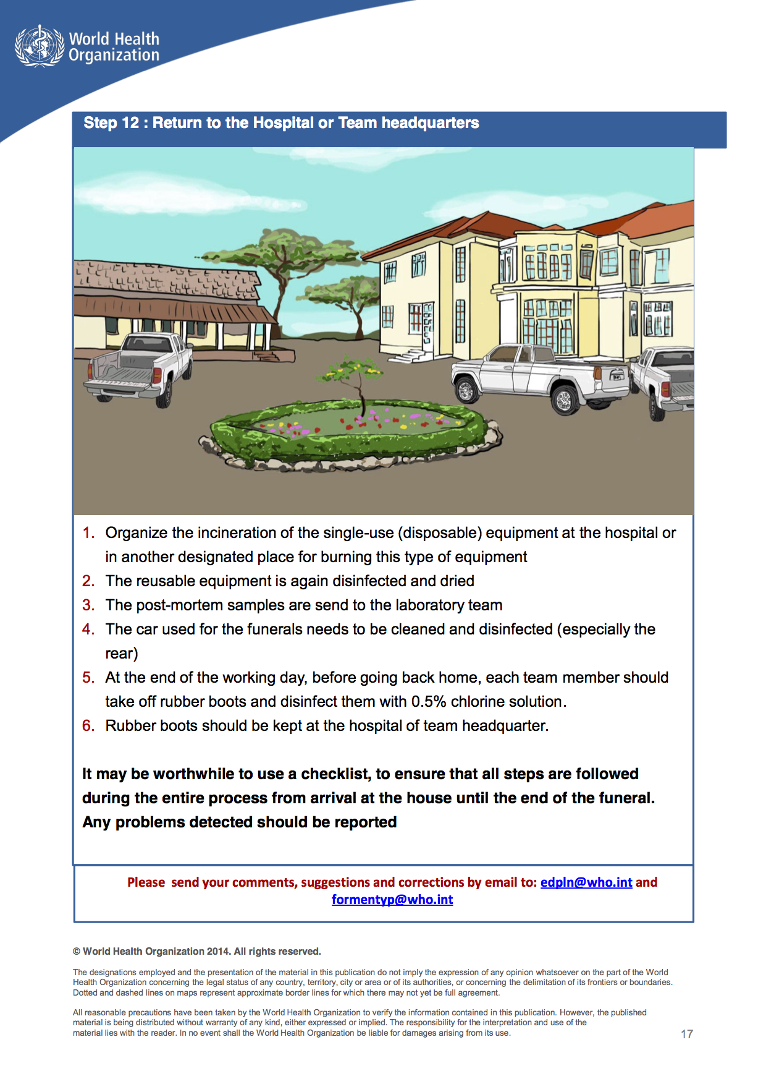

BIBLIOGRAPHY
- A timeline of the Ebola outbreak. (2014, November 29). Retrieved January 10, 2017, from http://www.abc.net.au/news/2014-10-22/ebola-timeline-worst- outbreak-in- history/5831876
- About Ebola Virus Disease. (2016, February 18). Retrieved January 10, 2017, from https://www.cdc.gov/vhf/ebola/about.html
- Ebola outbreak: A timeline of the worst epidemic of the virulent disease in history. (2014, November 29). ABC News. Retrieved January 10, 2017, from http://www.abc.net.au/news/2014-10-22/ebola-timeline-worst-outbreak-in- history/5831876
- Ebola virus disease. (2016). Retrieved January 10, 2017, from http://www.who.int/mediacentre/factsheets/fs103/en/
- Ebola: Mapping the outbreak. (2016, January 14). Retrieved January 10, 2017, from http://www.bbc.com/news/world-africa-28755033
- Gholipour, B. (2014, October 9). How Ebola Got Its Name. Retrieved March 23, 2017, from http://www.livescience.com/48234-how-ebola-got-its-name.html
- Impact of Ebola. (2016). Retrieved January 12, 2017, from https://www.unicef.org/emergencies/ebola/75941_76129.html
- Nielsen, C. F., Kidd, S., Sillah, A. R., E. D., Mermin, J., & Kilmarx, P. H. (2015, January 16). Improving Burial Practices and Cemetery Management During an Ebola Virus Disease Epidemic — Sierra Leone, 2014. Retrieved January 08, 2017, from https://www.cdc.gov/mmwr/preview/mmwrhtml/mm6401a6.htm
- Origins of the 2014 Ebola epidemic. (2015, January). Retrieved February 01, 2017, from http://who.int/csr/disease/ebola/one-year-report/virus-origin/en/
- Scott, J. T., Sesay, F. R., Massaquoi, T. A., Idriss, B. R., Sahr, F., & Semple, M. G. (2016). Post-Ebola Syndrome, Sierra Leone. Emerging Infectious Diseases, 22(4), 641-646. doi:10.3201/eid2204.151302
- Signs and Symptoms. (2014, November 02). Retrieved January 05, 2017, from https://www.cdc.gov/vhf/ebola/symptoms/index.html
- Traces of Ebola Virus Linger Longer than Expected in Semen. (2016, August 24). Retrieved January 14, 2017, from https://www.cdc.gov/media/releases/2016/p0830-ebola-virus-semen.html
- West Africa: Land Use and Land Cover Dynamics. (n.d.). Retrieved January 10, 2017, from https://eros.usgs.gov/westafrica/physical-geography
- World Factbook, Central Intelligence Agency. (2017). Retrieved January 15, 2017, from https://cia.gov/library/publications/the-world-factbook

