**A CROSS-SECTIONAL STUDY ON ASTHMA HOSPITALIZATION RATES AND UNHEALTHY AIR QUALITY INDEX FREQUENCY IN PENNSYLVANIA**

by

**Kristin Selker**

BS Biology, Clarion University, 2015

Submitted to the Graduate Faculty of

Graduate School of Public Health in partial fulfillment

of the requirements for the degree of

Master of Public Health

University of Pittsburgh

2017

by

**Kristin Selker**

BS Biology, Clarion University, 2015

Submitted to the Graduate Faculty of

Graduate School of Public Health in partial fulfillment

of the requirements for the degree of

Master of Public Health

University of Pittsburgh

2017

UNIVERSITY OF PITTSBURGH

GRADUATE SCHOOL OF PUBLIC HEALTH

This essay is submitted

by

Kristin Selker

on

April 25, 2017

and approved by

Essay Advisor:

Brenda Diergaarde, PhD ______________________________________

Associate Professor of Epidemiology

Department of Epidemiology

Graduate School of Public Health

Center for Bioethics and Health Law

University of Pittsburgh

Essay Readers:

Evelyn Talbott, DrPH, MPH ______________________________________

Professor of Epidemiology

Department of Epidemiology

Graduate School of Public Health

University of Pittsburgh

Aaron Barchowsky, PhD ______________________________________

Professor of Environmental and Occupational Health

Department of Environmental and Occupational Health

Graduate School of Public Health

University of Pittsburgh

Copyright © by Kristin Selker

2017

Brenda Diergaarde, PhD

**A CROSS-SECTIONAL STUDY ON ASTHMA HOSPITALIZATION RATES AND UNHEALTHY AIR QUALITY INDEX FREQUENCY IN PENNSYLVANIA**

Kristin Selker, MPH

University of Pittsburgh, 2017

**ABSTRACT**

Asthma is a growing health concern in the United States. Air quality, obesity, smoking, and socioeconomic factors have been associated with increased pulmonary and cardiovascular health problems and have been specifically linked to asthma exacerbations. Not only does asthma affect a person’s ability to breathe properly, it negatively impacts our national, and local economies when it leads to hospitalization. To address asthma’s growing public health relevance this essay aims to evaluate the relationship between unhealthy air quality index (AQI) frequency, a novel measure, and age-adjusted asthma hospitalization rates by race for counties in Pennsylvania from 2007-2014 while accounting for confounding factors (smoking, obesity, high school education, and median income). We created a novel indicator of pollution levels, unhealthy AQI frequency, by taking the number of days that the AQI was at a level of 101-300 and dividing it by the number of days that an AQI was reported. This was done at the county level annually for 2007-2014 for 34-36 counties that had an air monitor. Age-adjusted rates for asthma hospitalizations by race were calculated and estimates of smoking, obesity, high school education, and median income were gathered. Our results showed Allegheny County as having the highest unhealthy AQI frequency for every year, however it did not have the highest hospitalization rates. We hypothesize that access to alternative medical facilities and care could be contributing to Allegheny county’s lower rates. A spatial lag regression model was run after determining that our variables of interest were spatially dependent. We found in 2013 that our dependent variable, unhealthy AQI frequency, was significantly related to white age-adjusted asthma hospitalization rate when controlling for smoking. For six of the eight annual models smoking was significantly related to hospitalizations when controlling for unhealthy AQI frequency (p <0.05). Further studies are needed with larger sample sizes to determine the significance of unhealthy AQI frequency as an indicator of pollution level and its relationship with asthma hospitalization rates.

TABLE OF CONTENTS

preface xi

1.0 Introduction 1

1.1 Asthma in the United States 1

1.2 Biology of Asthma 2

1.3 Risk Factors for Asthma 3

1.3.1 SOCIO-ECONOMIC STATUS 3

1.3.2 OBESITY AND SMOKING 4

1.4 Asthma Exacerbations and Hospitalizations 5

1.4.1 AIR QUALITY STANDARDS 5

1.4.2 OUTDOOR AIR POLLUTION 6

1.5 Asthma in Pennsylvania 8

1.6 Public Health Significance 10

1.7 Objective 11

2.0 Methods 12

2.1 Study Population 12

2.2 Ozone and PM2.5 Averages 12

2.3 Air Quality Index Report Data 13

2.3.1 UNHEALTHY AQI FREQUENCY 14

2.4 Covariate Data 15

2.5 Age-Adjustment 15

2.6 Data Analysis 16

3.0 Results 18

3.1 Age-Adjusted Asthma Hospitalization Rates for Counties in Pennsylvania by Race 18

3.2 Unhealthy AQI Frequency 20

3.3 Association Between Adjusted Hospitalization Rates and unhealthy AQI frequency 23

3.4 Covariate Data 24

3.5 Spatial Analysis 28

4.0 Discussion 32

APPENDIX A: SUPPLEMENTARY TABLES 35

36

APPENDIX B: SUPPLEMENTARY EQUATIONS 50

BIBLIOGRAPHY 51

List of tables

Table 1 Spearman’s correlation between unhealthy AQI frequency, average ozone ,and particulate matter by year, (Spearman’s rho***, p-value**, and number of counties* shown in table). 22

Table 2 Spearman’s correlation, across the entire 8-year period, between unhealthy AQI frequency, average ozone, and particulate matter (Spearman’s rho***, p-value**, and number of counties* shown in table). 22

Table 3 Spearman’s correlation between unhealthy AQI frequency and age-adjusted asthma hospitalization rates by race and year, (**rho and *p-value shown). 23

Table 4 Spearman correlation matrix between independent, dependent, and covariate variables, (**Spearman’s rho, and *p-value shown). 25

Table 5 Univariate Moran’s I test for spatial dependence, p-values shown. 30

Table 6 White age-adjusted asthma hospitalization rates modeled with spatial lag regression (34-36 counties) beta coefficient (p-value) shown. 31

Table 7 Pollutant level break points for AQI categories and corresponding health concerns [37]. 36

Table 8 Age-adjusted asthma hospitalization rates per 10,000 by county and year 37

Table 9 Unhealthy AQI frequency by county and year for 2007-2014. 43

List of figures

Figure 1 Location of air quality monitors in Pennsylvania as of 2008 [35]. 13

Figure 2. Age-adjusted asthma hospitalization rates per 10,000 for white and non-whites in Pennsylvania for years 2007-2014. 19

Figure 3 Industrial county’s white age-adjusted asthma hospitalization rates per 10,000 by year. 19

Figure 4 Industrial county’s non-white age-adjusted asthma hospitalization rates per 10,000 by year. 20

Figure 5 Unhealthy AQI frequency for select industrial counties of PA by year. 21

Figure 6 Modeled estimates of the proportion of smokers, 18 years and over, across Pennsylvania counties for 2010. 26

Figure 7 Modeled estimate of obesity prevalence aged 18 and over by county in Pennsylvania for 2010. 26

Figure 8 Median household income across Pennsylvania for 2010. 27

Figure 9 Percentage of residents that completed high school aged 18 and over by county in Pennsylvania in 2010. 27

Figure 10 Unhealthy AQI frequency as a percentage of days the AQI, across Pennsylvania for 2010. 29

Figure 11 White age-adjusted asthma hospitalization rates per 10,000 for 2010. 30

List of equations

Equation 1 Age-adjusted asthma hospitalization rate per 10,000 individuals based on 2000 U.S. standard million population. 16

Equation 2 Air quality index equation[37]. 50

# preface

I would like to express my appreciation to my academic advisor, Professor Brenda Diergaarde for her constant support and guidance throughout my graduate studies and the process of writing this essay.

My gratitude and appreciation also goes out to Professor Evelyn O. Talbott without whom this essay would not have been possible.

# Introduction

## Asthma in the United States

Asthma has been a persistent and growing public health problem in the United States. For the period from 2001 to 2010 the Centers for Disease Control and Prevention (CDC) reports that prevalence increased at a rate of 1.5% per year, and in 2015, the prevalence of asthma among adults (ages 18+) was 8.8% [1, 2]. Moreover, over 22 million subjects under the age of 18 also suffer from asthma in the United States [3, 4]. The highest burdened age group with a prevalence of 10.6% are 15 to 19 year olds. Among children, boys are more likely to have the disease; among adults, females are almost twice as likely as males to have asthma [3, 4].

Disparities exist in the prevalence of asthma across races in the United States. Non-Hispanic whites have the lowest burden with a 7.6% prevalence while in African Americans the prevalence rate is 9.9%. The disparity becomes even more prominent when examining mortality rates. African Americans have a mortality rate almost three times that of non-Hispanic whites (25.4 versus 8.8 per million) and are hospitalized for asthma-related causes at a similar disproportionate rate [3].

In addition to health complications, asthma negatively affects the national economy through health care costs and loss of productivity from missed school and workdays. The United States spends approximately $56 billion annually on direct costs from asthma [5]. This amount includes the cost of the 1.8 million visits to emergency departments, and the 1.3 million hospital outpatient department visits with asthma as the primary diagnosis annually [3]. However, this estimate does not include the loss in productivity from absenteeism. The CDC reports that in 2008 there were 14.2 million missed work days and 10.5 million missed school days due to asthma related causes [5]. Almost 50% of children 5-17 years old with asthma reported missing at least one school day for an asthma-related cause in 2013 [6]. Due to the increasing economic burden and negative health implications understanding and addressing asthma and its burden has become increasingly imperative for the United States.

## Biology of Asthma

Asthma is a chronic lung disease characterized by inflammation and the narrowing of the airways. Asthma can develop at an early age or later in life. Symptoms include recurrent wheezing, chest tightness, shortness of breath, and coughing. Asthma is diagnosed by a physician by listening to the patient’s lungs while breathing and discussing symptoms. Once diagnosed, medications are often prescribed to ease symptoms [7].

The primary medical concern for those with asthma are exacerbations, commonly referred to as asthma attacks. Exacerbations are episodes during which symptoms become more intense and the patient requires medication or medical care to relieve the symptoms and to breathe properly again. In some cases, without proper medical care these episodes can be fatal. Exacerbations can be triggered by an inhaled irritant or substance such as: allergens from dust, animal fur, pollens, workplace dust, sulfites in food and drinks, and air pollutants. Triggers vary from person to person and those with asthma are urged to avoid triggers if possible [7, 8].

The exact biological cause of asthma has not yet been determined. However, there are several known factors that contribute to its development including parental history of the condition, respiratory infections during childhood, and contact with certain exposures in early childhood while the immune system is developing. It is theorized that the increased emphasis on hygiene and sanitation in today’s society has played a part in the increase in prevalence by limiting the environmental exposures children encounter in early life while their immune system is developing [7, 8].

The severity of the illness varies from subject to subject and can be diminished by the use of medication. The CDC defines two groups of severity, intermittent and persistent. The intermittent severity group is composed of those who have their asthma under control and do not require long-term medication. Persistent asthma is characterized by the need for long term medication in order to keep the asthma under control and this group includes those who do not use medication and have uncontrolled asthma [9]. In the United States, among those with asthma, the majority has persistent asthma (64.8% of adults and 60.3% of children) [9, 10]; of those 38.4% of children and 50% of adults have uncontrolled asthma [11].

## Risk Factors for Asthma

### SOCIO-ECONOMIC STATUS

Socioeconomic status (SES) is a key risk factor for many diseases and is thought to be a mechanism via (or maybe through) which the racial disparities seen in asthma prevalence operate [12, 13]. A cross-sectional study on the effects of SES factors and area of residence on race and asthma prevalence was conducted in 1998 using data from the Epidemiology of Home Allergens and Asthma Study for the Boston metropolitan area. The study used a parental and offspring cohort with measures of education attainment, total family income before taxes, and area of residence [12]. Area of residence is an important factor when examining the relationship as SES influences the area which families can afford to live. Often, lower SES neighborhoods are in closer proximity to industrial plants and have lower air quality than high SES neighborhoods. However, one should not be used as a proxy for the other [13]. The study conducted in the Boston metropolitan area showed in the univariate model an odds ratio of 2.9 (95% C: 1.0, 8.0) for having asthma for African American children and an odds ratio of 5.3 (95% CI: 1.6, 17.5) for Hispanic children compared to white children. However, when controlling for maternal and paternal asthma, age, gender, and SES variables the odds ratios were reduced or became non-significant. The study concluded that low levels of educational attainment, household income, and area of residence in a high poverty area largely explains the disparity that exists between races [12]. In California, a study which examined similar SES factors also found them to have a significant impact on asthma. They found evidence that children from families with lower SES were exposed to higher levels of pollution due to their location of residence, and suffered more adverse health effects than those from families with higher SES when exposed to similar levels of pollutants [13].

### OBESITY AND SMOKING

Obesity is an important risk factor for developing asthma. Obesity has been linked to the development of asthma, the worsening of symptoms, and poor control [14, 15]. However, the direction of the causal pathway between obesity and asthma is somewhat ambiguous [16]. Often obesity can cause a decline in lung function and these alterations may mimic asthma symptoms but do not always fulfill the criteria for asthma [17]. According to the CDC, approximately 38.8% of those with asthma are also obese [14]. Smoking is another important risk factor for asthma. Smokers with asthma can experience higher numbers of asthma attacks due to irritation caused by the inhalation of cigarette smoke. Smoking also significantly decreases lung function and can cause emphysema which presents similar symptoms to asthma and can result in misdiagnosis. Of those who have asthma, 21% also smoke despite smoking leading to an increase in asthma severity and exacerbations [18, 19].

## Asthma Exacerbations and Hospitalizations

### AIR QUALITY STANDARDS

Air pollutants have been well documented to shorten the life span, decrease lung function, and increase asthma hospitalizations [13, 20-23].In an effort to reduce negative health effects of air pollution the Clean Air Act of 1970 was passed. The Act established national ambient air quality standards for so-called criteria pollutants which include particulate matter, ozone, sulfur dioxide, nitrogen dioxide, carbon monoxide, and lead. The Act’s standards have been subsequently revised in 1977 and 1990 [23]. In addition to this measure, the Environmental Protection Agency (EPA) established the Air Quality Index (AQI) as a daily air quality yardstick to measure air pollution. The index runs from 0 to 500 with anything indexed below 101 considered to be satisfactory. Air pollutant data for the AQI are collected from air monitor stations throughout the country and alerts are issued to areas when the monitors report values that warrant health concerns for residents [24]. These alerts are critical for people with respiratory diseases and problems, such as those with asthma, because it allows them to take precautionary measures to limit exposure to pollutants and avoid adverse health effects.

### OUTDOOR AIR POLLUTION

Ozone and particulate matter are considered the pollutants which present the largest threat to overall health. These pollutants have been found in many studies to significantly impact asthma exacerbations and rates of hospitalization [21, 25]. Ozone is generated from chemical reactions between oxides of nitrogen and volatile organic compounds in the presence of sunlight. Combustion of fossil fuels and the emissions from vehicles and industrial factories are the largest contributors of ozone [22, 26]. Particulate matter is a mixture of extremely small and liquid droplets in air that are capable of gaining access to the respiratory system through inhalation. Particulate matter with a diameter of 10 μm (PM10), such as dust and pollen, can penetrate the lower respiratory system. Fine particle matter with a diameter of 2.5μm (PM2.5) is capable of entering the gas-exchange region of the lungs. This particulate matter is generated from combustion and chemical reactions [22, 27]. Particulate matter is typically measured in two ways, year round or short term. Year round particulate matter is measured by the annual average of the pollutant level while short-term levels are measured by 24 hour averages [28].

An iconic case relating air pollution and respiratory health is the Utah Valley steel mill strike. In 1987, a steel mill in Utah Valley went on strike for an extended period of time. During the strike hospital admissions for respiratory related illnesses significantly decreased. In addition, it was noticed that during the strike particulate matter pollution also decreased. However, after the strike ended and the steel mill became operational again respiratory related hospital admissions returned to the rate from before the strike [22].

Since the observed effect of the Utah Valley steel mill strike, there have been multiple studies conducted that aimed to prove the link between air pollutants and respiratory health. The AHSMOG Study is a prospective cohort study in California which examined the long term effects of ambient air pollution. An analysis was conducted based on data from this study to determine the effects of ambient ozone exposure and adult onset asthma. Spirometry and peak expiratory flow measures were used to assess lung function. Incident cases of asthma were determined based on self-report of having a physician diagnosis. Male asthma cases were found to be significantly associated with ozone concentrations with a relative risk of 2.05 (95% CI: 1.01-4.13). Female asthma development was not found to have a significant association with ozone concentrations. In order to confirm that the relationship was real and not confounded by other air pollutants, additional criteria pollutants were substituted into the model and used in two pollutant models. There were no significant variations in the two pollutant models and the investigators concluded that the increase in risk for asthma was attributed to the ozone concentration [21].

One of the few studies conducted in an east coast state was a case-cross over study conducted in Allegheny County, Pennsylvania. The study examined the relationship between asthma emergency department visits, identified through ICD code, and ambient ozone and PM2.5 levels for 2002-2005[29].

Logistical regression was used to evaluate the risk of ozone and PM2.5 separately and combined. Lag-day pollutant levels were used as the exposure to account for the effect of pollutant levels prior to the emergency department visit. The study uses exposure up to a 5 day lag exposure, as well as a 6 day average in analysis to account for cumulative effect. There was a significant increase of 2.5% in risk for emergency department visits related to a 10 ppb increase in ozone level two days prior (OR = 1.025; 95% CI, 1.006–1.044). The increase in risk was also significant in the model that included PM2.5 (OR =1.021; 95% CI, 1.001–1.042), while an increase of 10 *μ*g/m3 increment in PM2.5 one day prior to a visit was associated with a 3.6% increase in risk of a visit (OR = 1.036; 95% CI, 1.001–1.073). Stronger effects of PM2.5 were observed on emergency department visits for African Americans compared to Caucasians [29].

A similar but larger study used Medicaid claims data over a course of 5 years and examined asthma and pollutant levels in Cincinnati, Columbus, and Cleveland Ohio (reference). Using the average daily values for pollutants for each city and other weather-related variables as confounders, this study observed a significant association between pollutants and emergency department visits with asthma as the first diagnosis. In Cincinnati and Columbus there was a 5% increase in emergency department asthma diagnosis cases per 0.01 ppb increase in ozone levels. In Cleveland there was a 12% change in asthma related emergency department visits when PM 10 increased by 0.50 μg/m3. However, there was no significant effect from particulate matter on emergency department visits in Cincinnati, even when pollution levels reached that which caused an increase in emergency department visits in other cities [30].

Over 80% of people’s time in the developed world is spent indoors. This brings into question the validity of using ambient air pollution measures as means of assessing exposure. However, ambient air pollution levels have been shown to be significantly correlated with personal exposure and are valid to use as surrogate measures, despite the time spent indoors [22].

## Asthma in Pennsylvania

The current study focusses on asthma in Pennsylvania. Pennsylvania’s asthma rate exceeds the national average with currently an adult prevalence of 10.2%, which is a significant increase from the rate of 9.8% reported in 2014 [2]. The disparities of adverse health effects from asthma are prominent in Pennsylvania with a mortality rate for adult African Americans nearly 5 times that of non-Hispanic Whites.Among children under the age of five, hospitalizations also reflect this disparity. African American infants are 7e times more likely to be hospitalized for asthma than white children in Pennsylvania [31]. The economic costs of asthma in Pennsylvania are also substantial. In 2013, Pennsylvania spent 500 million dollars on total charges for asthma inpatient hospitalization [32]. Uncontrolled asthma cases cost approximately twice as much as patients with controlled asthma and in Pennsylvania 49.6% of adults and 26.7% of children asthma cases are uncontrolled [9, 10, 33]

Air quality is a significant contributing factor to these statistics. Pennsylvania has been heavily targeted by the natural gas industry with over 6000 natural gas wells throughout the state that have been associated with increased asthma exacerbations [20]. In addition, many cities and areas in Pennsylvania are home to industrial powerhouses and facilities that have negatively affected the air quality and the health of residents in the areas near steel plants, foundries, and coke plants. The American Lung Association State of the Air 2016 report, which ranks US cities based on pollution measures, included Pittsburgh, Philadelphia, Lancaster, Harrisburg, York, Newark area and Lebanon Pennsylvania in the top 25 cities most polluted by short term particulate matter. Several areas of Pennsylvania were also named to be the most polluted by year round particulate matter and most ozone-polluted cities [28].

These unsettling air quality measures and the increasing asthma prevalence in Pennsylvania is staging the state for a heavy economic burden when it comes to asthma, especially from hospitalizations. While asthma is not considered to typically require frequent visits to the emergency department, many who suffer from it see the hospital as their only resource when experiencing an increase in symptoms [34]. If air quality is not addressed to reduce triggers for exacerbations which send asthmatics to the hospital, Pennsylvania will likely see an increase in hospitalizations and mortality due to asthma.

## Public Health Significance

As discussed above, asthma is a growing public health concern. Not only does the disease have adverse health effects but it also presents a large cost and strain on the healthcare system. For being an ambulatory care sensitive disease there still remain large numbers of individuals utilizing the emergency department for care in cases of asthma exacerbation [34]. Air pollutants such as ozone and particulate matter commonly trigger visits to the hospital due to exacerbation. It is of public health importance that research is conducted to understand the relationship between air quality and exacerbations which lead to hospitalization. Asthma is a complex disease, AQI is only one factor which contributes to this multifactorial issue. Therefore, we will use multiple risk factors in an effort to explain its relationship with county asthma hospitalization rates. The majority of studies in this area are conducted on the west coast with very few involving an eastern state. It is important to expand this research to other states such as Pennsylvania and explore potentially important air quality measures to understand the problem and improve public health.

## Objective

The objective of this essay is to explore the relationship between age-adjusted asthma hospitalization rates for whites, non-whites, and unhealthy AQI frequency while controlling for obesity and smoking, other both well-known risk factors for asthma. We will complete tests of association between all variables and assess spatial dependence of hospitalization rates and unhealthy AQI frequency for counties in Pennsylvania for the period 2007-2014.

.

# Methods

## Study Population

Asthma hospitalization data defined as ICD-9 code 493 for the period of January 1st 2007- December 31st 2014 was obtained from the Pennsylvania Health Care Cost Containment Council (PHC4). The original data set included information on pseudo ID, quarter of hospitalization for each year (i.e., Jan-March, April-June, etc.), patient’s age, gender, race, ZIP code and county. A count of patients was generated by quarter of each year by race and gender for each county [35]. The data was further aggregated for each county by year and race. Race was defined as being white or non-white.

## Ozone and PM2.5 Averages

Annual average levels of PM2.5 and average 8 hour daily maximum values of ozone were calculated from the provided quarterly means for 2007-2014. Quarterly mean levels were calculated as the mean of the daily values throughout the quarter based on air pollution levels provided from monitors located in each county (Figure 1). If there were two or more monitors that provided data through the entire time period for the same county, the mean of the values was used [35].



Figure Location of air quality monitors in Pennsylvania as of 2008 [35].

## Air Quality Index Report Data

Air Quality Index reports for Pennsylvania by county were obtained from the EPA website for years 2007-2014. Reports included the number of days each year that the overall AQI was reported in the range of ‘good’ (0-50), ‘moderate’ (51-100), ‘unhealthy for sensitive groups’ (101-150), ‘unhealthy’ (151-200), and ‘very unhealthy’ (201-300) along with the number of days that an AQI was calculated. The number of days which the primary pollutant was ozone, nitrogen dioxide, sulfur dioxide, carbon monoxide, PM10 , andPM2.5 were also reported [36].

Increasing levels of AQI correspond with increasing health concerns. The EPA calculates a daily index for each criteria pollutant (ozone, nitrogen dioxide, sulfur dioxide, carbon monoxide, PM10 , andPM2.5) using concentrations of the pollutant measured by monitors located throughout Pennsylvania (Figure 1) and an equation created by the EPA (Appendix B, Equation 2). After all indices are calculated for the pollutants, the pollutant with the highest AQI is considered the ‘primary pollutant’ and its corresponding AQI is assigned for that day. The concentration break points for each pollutant and the corresponding AQI category and health concerns are found in Table 1 in Appendix A [24, 37].

The counties in Pennsylvania included for analysis are restricted to areas included in the Air Quality Index Reports for which we also had asthma hospitalization rates. The counties used in this analysis, which vary by year, are: Adams, Allegheny, Armstrong, Beaver, Berks, Blair, Bucks, Bradford, Cambria, Centre, Chester, Clearfield, Cumberland, Dauphin, Delaware, Erie, Franklin, Greene, Indiana, Lackawanna, Lancaster, Lawrence, Lehigh, Luzerne, Lycoming, Mercer, Monroe, Montgomery, Northampton, Perry, Philadelphia, Schuylkill, Somerset, Tioga, Washington, Westmoreland, and York.

### UNHEALTHY AQI FREQUENCY

Data from the Air Quality Index Report was used to create an AQI frequency variable for use in analysis. First, the frequency of days at which the AQI was indexed at a level of 101-300 (‘unhealthy for sensitive groups’ to ‘very unhealthy’) was calculated by dividing the number of days with AQI 101-300 by the total number of days reported for that particular year. This was done at the county level by using the mean number of days the AQI was 101-300 divided by the mean number of days an AQI was reported. The frequency was calculated to account for variation in number of days per year for which an AQI was measured across counties. The variable created will be referred to as unhealthy AQI frequency as it indicates the frequency which the level of pollution warranted health concern. The annual average ozone and PM2.5 levels were used to validate the unhealthy AQI frequency as a measure of pollution level. We converted the frequency to a percent in the regression models for ease of interpretation.

## Covariate Data

Predicted obesity and smoking prevalence for the counties were obtained from Hinojosa et. al. [38]. Hinojosa et. al. gathered data from the Behavioral Risk Factor Surveillance System telephone survey and U.S. Census and utilized a combined approach of lasso-based variable selection procedure followed by a two-level random effects regression with a Poisson link cluster. They also examined spatial and temporal trends for the area as well as factors such as age, gender, race, and SES which influence smoking and obesity [38]. County level median income and percentage of high school education attainment was obtained from the 2010 US Census.

## Age-Adjustment

Annual age-adjusted rates for asthma hospitalization by race per 10,000 people were calculated using the 2000 U.S. standard million population for each county. An overall age-adjusted rate for Pennsylvania was also calculated using the available county data for each year from 2007-2014. The age groups were defined as: 0-9 years, 10-19 years, 20-29 years 30-39 years, 40-49 years, 50-59 years, 60-69 years, 70-79 years, and 80 years or older.

We calculated the age-adjusted rates by first determining age specific rates for each race by taking the counts of hospitalizations for each age group and dividing it by the population of each age group. This rates was then multiplied by the standardized population of the age group to give the expected number of hospitalizations in a standard population. We then summed the expected number of hospitalizations together, divided it by 1 million and then multiplied it by 10,000 to get the age-adjusted asthma hospitalization rate per 10,000 (Equation 1). This was done for each county and for Pennsylvania for years 2007-2014.

Equation Age-adjusted asthma hospitalization rate per 10,000 individuals based on 2000 U.S. standard million population.

$${Age-Adjusted Rate}_{x-y} per 10,000=\left[\frac{\frac{\sum_{i=x}^{y}{\left[\left(\frac{{hospital count}_{i}}{{pop}_{i}}\right)x s{tdpop}_{i}\right]}}{\sum_{j=x}^{y}{{[stdpop}_{j}}]}}{1,000,000}\right]x 10,000$$

## Data Analysis

Descriptive statistics were generated using SAS 9.4 to summarize age-adjusted rates, unhealthy AQI frequency, smoking estimates, obesity estimates, percentage of high school education attainment, and median household income across counties annually. To determine the validity of the unhealthy AQI frequency variable we conducted a Spearman’s correlation test between it and average annual PM2.5 and ozone levels. Spearman’s correlation test was also used to explore the association between age-adjusted asthma hospitalization rates by race and the unhealthy AQI frequency annually as well as the association between covariate variables.

GeoDA (v1.8.16.4) was used to map out covariate data for a visual representation of 2010 rates as well as run diagnostics for the presence of spatial dependence. First, we ran Moran’s I test for each year for the variables of white and non-white asthma hospitalizations and the unhealthy AQI frequency to determine if spatial autocorrelation was present. We then ran univariate spatial error and lag regression models with a Queen’s weight matrix between unhealthy AQI frequency and white age-adjusted asthma hospitalization rates for each year. The best fit model was chosen based on R-squared and the log likelihood number. The final spatial lag model chosen controlled for estimated smoking prevalence at the county level. Non-white adjusted hospitalization rates were not used in regression models due to concerns of sample size and stability of rates.

# Results

## Age-Adjusted Asthma Hospitalization Rates for Counties in Pennsylvania by Race

Figure 2 shows the overall age-adjusted rate for asthma hospitalizations per 10,000 people in Pennsylvania for years 2007-2014 by race. The hospitalization rate for non-whites is consistently significantly higher than that of whites. Across the period non-whites have approximately, a four times higher rate of hospitalization. While the rate for whites appears to be consistently decreasing from 2008 onward, the rate for non-whites increased from 2010 to 2011.

Table 4 in Appendix A displays the age-adjusted rates for all counties by year and race. There were nine counties identified as having significantly low non-white populations (<20,000) making the rates calculated unstable. These rates were excluded from the table and use in analysis. Rates for Pennsylvania’s top industrial counties: Allegheny, Philadelphia, and Dauphin are shown in Figure 3 and 4. While Philadelphia, Westmoreland, and Allegheny county’s rates are trending downwards from 2008, Dauphin county’s rates have been increasing since 2011. Rates for non-white asthma hospitalizations for Allegheny, Philadelphia, and Dauphin appear stable across the 2007-2014 period. The highest rates of white adjusted asthma hospitalizations were in Lawrence County for years 2007- 2010, Greene County in 2011, and Philadelphia 2012-2014.

Figure . Age-adjusted asthma hospitalization rates per 10,000 for white and non-whites in Pennsylvania for years 2007-2014.

Figure Industrial county’s white age-adjusted asthma hospitalization rates per 10,000 by year.

Figure Industrial county’s non-white age-adjusted asthma hospitalization rates per 10,000 by year.

## Unhealthy AQI Frequency

Table 9 in Appendix A shows the unhealthy AQI frequency for each county by year. Allegheny County had the highest frequency of unhealthy AQI for every year evaluated (Figure 4). The lowest frequencies were observed in a number of counties across the years. Blair, Lawrence, Centre, Monroe, Luzerne, Perry, Lycoming, and Tioga Counties had some of the lowest rates of unhealthy AQI frequency.

In order to validate the unhealthy AQI frequency variable as a valid indicator of pollution level at the county level we conducted Spearman’s correlation test with average ozone and particulate matter levels to assess the association. While the p-value fluctuates in significance across the years and by pollutant used, we did see significant associations and when the test was conducted across all years there was a strong association with a p-value <0.0001 (Table 3 and 4) . Therefore, we will consider this variable a valid indicator of pollution level.

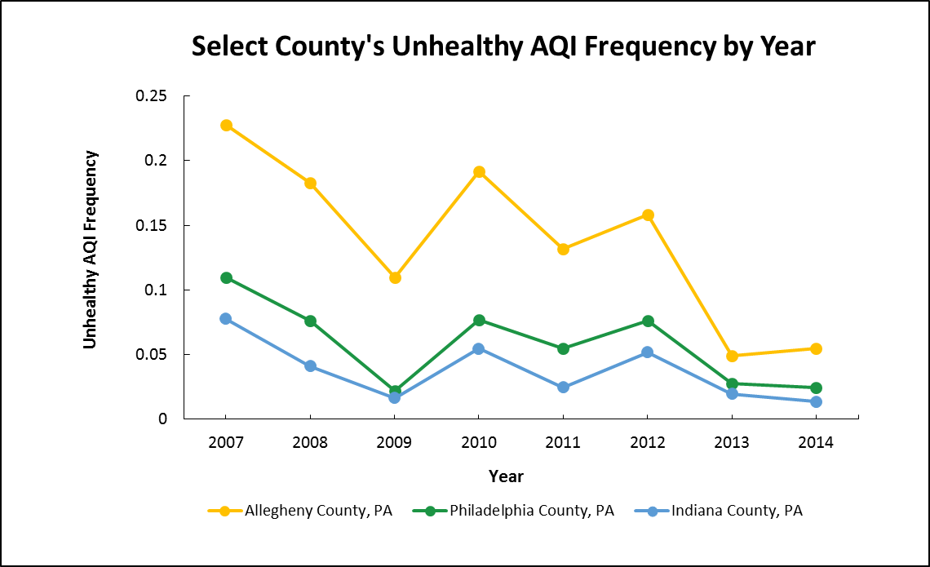

Figure Unhealthy AQI frequency for select industrial counties of PA by year.

Table Spearman’s correlation between unhealthy AQI frequency, average ozone ,and particulate matter by year, (Spearman’s rho***, p-value**, and number of counties* shown in table).

|  |  |  |  |
| --- | --- | --- | --- |
| **Variable** | **Year** | **Average Ozone (ppb)** | **Average Particulate Matter** |
| **Unhealthy AQI Frequency** | 2007 | |  | | --- | | 0.13856***  0.4419**  33* | | |  | | --- | | 0.49756  0.0217  21 | |
| 2008 | |  | | --- | | 0.41789  0.0155  33 | | |  | | --- | | 0.48327  0.0265  21 | |
| 2009 | |  | | --- | | 0.18596  0.3001  33 | | |  | | --- | | 0.31778  0.1495  22 | |
| 2010 | |  | | --- | | 0.20132  0.261  33 | | |  | | --- | | 0.292  0.167  24 | |
| 2011 | |  | | --- | | 0.20962  0.234  34 | | |  | | --- | | 0.26651  0.1978  25 | |
| 2012 | |  | | --- | | 0.38663  0.026  33 | | |  | | --- | | 0.32397  0.114  25 | |
| 2013 | |  | | --- | | 0.065  0.714  34 | | |  | | --- | | 0.279  0.176  25 | |
| 2014 | |  | | --- | | 0.256  0.145  34 | | |  | | --- | | 0.557  0.003  26 | |

Table Spearman’s correlation, across the entire 8-year period, between unhealthy AQI frequency, average ozone, and particulate matter (Spearman’s rho***, p-value**, and number of counties* shown in table).

|  |  |  |
| --- | --- | --- |
| **Variable** | **Average Ozone** | **Average Particulate Matter** |
| **Unhealthy AQI Frequency** | |  | | --- | | 0.27097***  <0.0001**  267* | | |  | | --- | | 0.53238  <0.0001  189 | |

## Association Between Adjusted Hospitalization Rates and unhealthy AQI frequency

Spearman’s correlation test was used to determine the presence of association between adjusted hospitalization rates and unhealthy AQI frequency (Table 5). We chose the Spearman’s test due to the non-normal distribution of the data based on Shapiro-Wilk test statistics and inspection of normal probability plots. We did not find a significant association between the white adjusted rates and unhealthy AQI frequency. Correlations were run using counties that had stable rates for non-white adjusted hospitalizations and were not significantly associated with the unhealthy AQI frequency.

Table Spearman’s correlation between unhealthy AQI frequency and age-adjusted asthma hospitalization rates by race and year, (**rho and *p-value shown).

|  |  |  |  |
| --- | --- | --- | --- |
| **Variable** | **Year** | **White** | **Non-White** |
| **Unhealthy AQI Frequency** | 2007 | 0.133**  0.453* | 0.23491  0.2480 |
| 2008 | 0.108  0.541 | 0.10260  0.6180 |
| 2009 | 0.316  0.068 | 0.15084  0.4620 |
| 2010 | 0.213  0.224 | 0.19531  0.3390 |
| 2011 | 0.078  0.654 | 0.44601  0.0197 |
| 2012 | 0.317  0.060 | 0.22439  0.2605 |
| 2013 | 0.232  0.172 | 0.28080  0.1560 |
| 2014 | 0.205  0.229 | 0.14238  0.4787 |

## Covariate Data

A Spearman’s correlation test was conducted between all covariate variables, see Table 6, to determine if any were significantly associated with each other. All covariate variables were significantly associated with each other with an α <0.05 (Table 6). However, obesity was not correlated with unhealthy AQI frequency while percent of high school graduates was not associated with the white asthma hospitalization rate.

The covariate data is presented in Figures 5-8 for 2010 across Pennsylvania. In support of the results of the correlation tests, counties that have high rates of smoking also appear to have high rates of obesity, such as Armstrong and Clearfield counties. We noticed that areas with the highest median income per household are centered around Philadelphia county while the counties with the highest percentage of high school graduates are grouped in central and western Pennsylvania.

Table Spearman correlation matrix between independent, dependent, and covariate variables, (**Spearman’s rho, and *p-value shown).

|  |  |  |  |  |  |
| --- | --- | --- | --- | --- | --- |
|  | **High School**  **Graduation** | **Obesity** | **Smoking** | **Median Income** | **Unhealthy AQI Frequency** |
| **Obesity** | 0.72111**  <0.0001* | ─ | ─ | ─ | ─ |
| **Smoking** | 0.63050  <0.0001 | 0.58158  <0.0001 | ─ | ─ | ─ |
| **Median Income** | -0.64864  <0.0001 | -0.73571  <0.0001 | -0.64749  <0.0001 | ─ | ─ |
| **Unhealthy**  **AQI Frequency** | -0.23494  <0.0001 | -0.06924  0.2499 | -0.21173  0.0004 | 0.15864  0.0080 | ─ |
| **White**  **Adjusted Asthma**  **Hospitalization Rate** | -0.05955  0.3225 | 0.14755  0.0138 | 0.25205  <0.0001 | -0.27930  <0.0001 | 0.27504  <0.0001 |
| **Non-White**  **Adjusted Asthma Hospitalization Rate** | -0.10162  0.1403 | 0.20771  0.0024 | 0.15502  0.0240 | -0.28201  <.0001 | 0.21146  0.0020 |

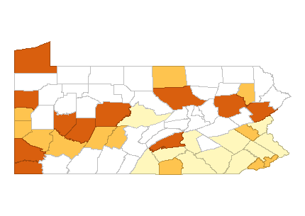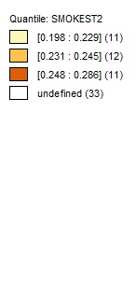

Figure Modeled estimates of the proportion of smokers, 18 years and over, across Pennsylvania counties for 2010.

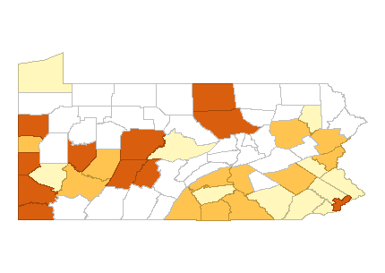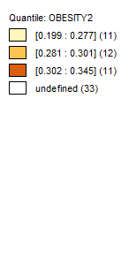

Figure Modeled estimate of obesity prevalence aged 18 and over by county in Pennsylvania for 2010.

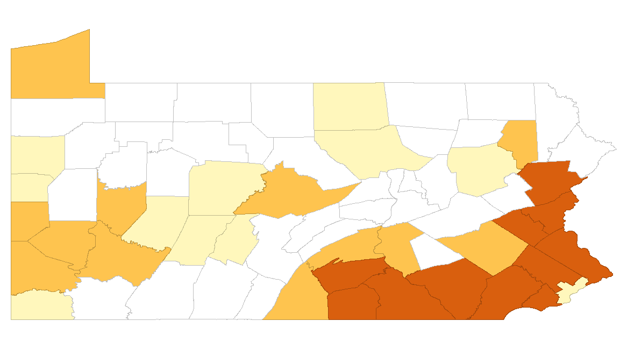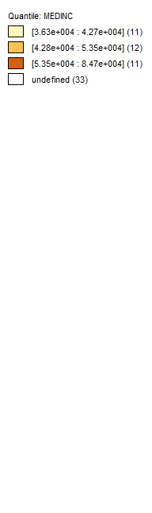

[36,300-42,700]

[42,800-53,500]

[53,500-84,700]

Figure Median household income across Pennsylvania for 2010.

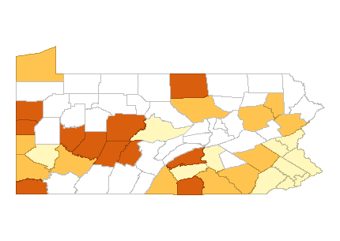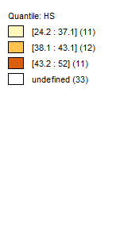

Figure Percentage of residents that completed high school aged 18 and over by county in Pennsylvania in 2010.

## Spatial Analysis

In order to determine if there is significant spatial autocorrelation for age-adjusted asthma hospitalizations of whites and unhealthy AQI frequency for each year, we conducted univariate Moran’s I test. Table 7 shows the p-values by year where a value of >0.05 indicates spatial dependence. The results showed that each of the variables across the years had strong spatial dependence that will need addressed in the regression models. Non-white adjusted hospitalization rates were also tested for spatial autocorrelation. Years 2007-2011 show the rates to be spatially dependent. However, in years 2012 and 2013 the p-values were negative indicating dispersion rather than clustering and in 2014 there was no spatial dependence (p-value=0.007).

We quantified the spatial relationship by running univariate spatial error and spatial lag models. We selected the spatial lag as the best fit model for reporting based on the likelihood ratio test and R squared values. Next, we ran multivariate spatial lag models for each year including smoking estimates as a confounding variable. Only one covariate was included due to concerns of multicollinearity. Due to the inconsistency in results from the univariate Moran’s I test, we did not run regression models for non-white asthma hospitalization rates. The beta coefficients and p-values for the white adjusted rates are reported in Table 8.

In our univariate model unhealthy AQI frequency was not a significant predictor of the white age-adjusted asthma hospitalization rate for any of the years. Smoking was then added into the model and unhealthy AQI frequency was a significant predictor of the white adjusted asthma hospitalization rate for 2013 and approaching significant in 2014. In 2013 an increase in unhealthy AQI frequency of 1% was associated with a significant increase in white age-adjusted asthma hospitalization rate of 0.190, when adjusting for smoking. Smoking was significant covariate in all models except for 2009 and 2012. Obesity followed a similar trend when run in the regression model and was close to statistical significantly in five out of the eight years (results not shown).

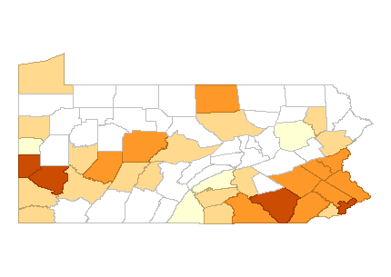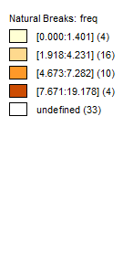

Figure Unhealthy AQI frequency as a percentage of days the AQI, across Pennsylvania for 2010.

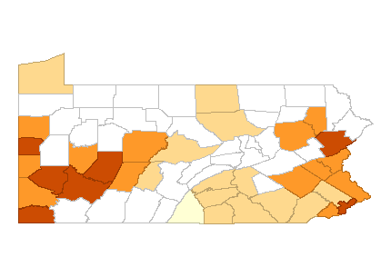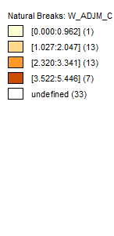

Figure White age-adjusted asthma hospitalization rates per 10,000 for 2010.

Table 5 Univariate Moran’s I test for spatial dependence, p-values shown.

|  |  |  |  |
| --- | --- | --- | --- |
|  | **White Adjusted Asthma Hospitalization Rate** | **Non- White Adjusted Asthma Hospitalization Rate** | **Unhealthy AQI Frequency** |
| **2007** | 0.558 | 0.117 | 0.352 |
| **2008** | 0.556 | 0.165 | 0.243 |
| **2009** | 0.442 | 0.073 | 0.388 |
| **2010** | 0.552 | 0.241 | 0.089 |
| **2011** | 0.442 | 0.064 | 0.243 |
| **2012** | 0.340 | -0.104 | 0.353 |
| **2013** | 0.248 | -0.196 | 0.296 |
| **2014** | 0.1229 | 0.007 | 0.214 |

Table White age-adjusted asthma hospitalization rates modeled with spatial lag regression (34-36 counties) beta coefficient (p-value) shown.

|  |  |  |  |
| --- | --- | --- | --- |
| **Year** | **Model 1** | **Model 2** | |
| **Unhealthy AQI Frequency** | **Unhealthy AQI Frequency** | **Smoking** |
| **2007** | 0.020 (0.507) | 0.027 (0.359) | 0.134 (0.041) |
| **2008** | 0.012 (0.797) | 0.032 (0.485) | 0.166 (0.032) |
| **2009** | 0.048 (0.501) | 0.055 (0.429) | 0.131 (0.088) |
| **2010** | 0.032 (0.467) | 0.053 (0.205) | 0.157 (0.017) |
| **2011** | 0.019 (0.742) | 0.064 (0.271) | 0.152 (0.023) |
| **2012** | 0.059 (0.131) | 0.061 (0.116) | 0.067 (0.213) |
| **2013** | 0.126 (0.129) | 0.190 (0.025) | 0.093 (0.0489) |
| **2014** | 0.082 (0.274) | 0.126 (0.084) | 0.0902(0.031) |

# Discussion

We found unhealthy AQI frequency to be a significant predictor of white age-adjusted asthma hospitalization rates in 2013 when controlling for smoking at the county level. Smoking was found to be a significant predictor of white adjusted asthma hospitalization rates for all years except 2009 and 2012. None of univariate regression models showed unhealthy AQI frequency to be predictive.

The spatial dependence of asthma hospitalizations and pollution levels have been studied in previous literature [35]. However, studies done without a spatial component have also continued to support the link between ambient air pollution levels, especially for ozone and particulate matter, and asthma hospitalizations [20-22, 29]. All of our models, except one, had non-significant values for our indicator of pollution, which contradicts the literature. Our generalized indicator of air pollution level, unhealthy AQI frequency, as well as the limited sample size likely influenced our results. We will discuss these factors in our limitations section. Smoking is a well-studied risk factor of asthma and asthma exacerbations leading to hospitalization [18]. Our results support the literature that smoking is predictive of asthma hospitalization rates. While in 2009 and 2012 smoking was non-significant in the model the p-values were approaching significance and could have been influenced by small sample size or an unknown factor, which may warrants further study.

While Allegheny County had the highest unhealthy AQI frequency, the highest rates of white age-adjusted asthma hospitalizations were found in Lawrence, Greene, and Philadelphia. Allegheny County is a hotbed for medical corporations and is home to numerous large health systems, such as UPMC. Residents of Allegheny County may have access to alternative options other than the hospital for care when they are unable to contain an asthma attack. This difference in access to care has been found to be a significant factor in hospitalization rates for a variety of health issues, especially considering asthmatics visit the hospital as a last resort [34]. This is a possible explanation for the high pollution levels in Allegheny, but apparent lower levels of hospitalization for asthma.

The strengths of our study are that we used a novel measure, unhealthy AQI frequency, as the predictive variable, and this is one of the few studies conducted in an eastern state on asthma hospitalization rates. However, we had significant limitations such as sample size and our measure of pollution.

There are 67 counties in Pennsylvania; we had data available for 34-36 counties (depending on the year) for use in analysis. Our small sample size affected our ability to detect a significant difference in our statistical analyses due to lack of power. In our spatial regression models we used a Queen’s weight matrix to give spatial weight to counties which touch one another. The matrix is extremely important for spatial regression. Due to the limited sample Erie County was neighbor-less, did not receive any spatial weight, and could not be properly used by the model. Other counties were also influenced by missing data for adjacent counties limiting the generalizability and validity of the results. While we did observe significant spatial dependence, these may also be underestimates due to sample size.

In 2010, 81.9% of Pennsylvania’s population was white, leaving 18.1% of the population as non-white [39]. While counties such as Allegheny and Philadelphia have substantial non-white populations, a number of counties, which we had data on, have less than 20,000 and even less than 5,000 non-white residents. We considered the rates of hospitalizations for these counties as unstable and did include them in the correlations conducted. This further limited sample size and raised concerns of validity. Therefore, we did not carry out regression models with the non-white hospitalization data.

While we had a variety of covariate variables available to include in our regression models (median income, smoking estimate, obesity estimate, and high school graduation rate), due to concerns of multicollinearity smoking was chosen. While smoking was highly associated with the other variables we were not able to include we could have residual confound not controlled for in the model. In addition, by not incorporating a time varying covariate we were only able to run regression models for each year, from 2007-2014, independently. Therefore, we could not make any conclusions about the change in relationship between the variables over time.

We chose to use the metric of unhealthy AQI frequency, as a measure of pollution and validated it with annual ozone and particulate matter levels. However, this measure is a broad generalization of the air pollution levels that an area experiences over the year. It does not account for acute effects on any given day, the difference of health affects by pollutant, or the variations in pollution levels due to seasonality and temperature.

Future studies exploring unhealthy AQI frequency as a measure of pollution should incorporate a time varying covariate, and be done with a larger sample. Also having a monitor in each county would help appreciably with the ability to include all PA residents in future analyses. Integrating a time varying covariate will allow a span of years (i.e. 2007-2014) to be used in a regression model together accounting for the effect of time. A conclusion about the relationship between variables over this span of years can then be made. Using a larger sample will limit concerns of lack of power and increase the validity of the spatial models. We should continue to conduct exploratory studies such as this in an effort to expand research and help us gain information and insight in the hopes of improving public health.

**APPENDIX A: SUPPLEMENTARY TABLES**

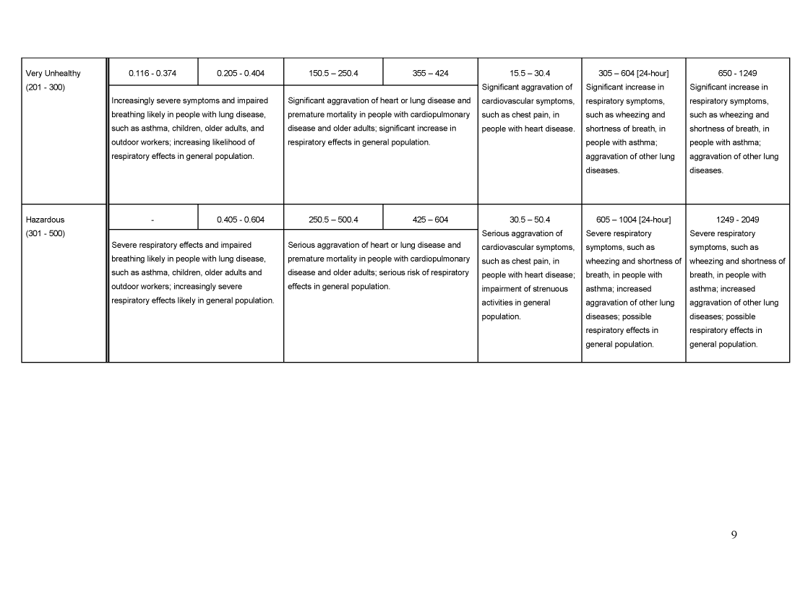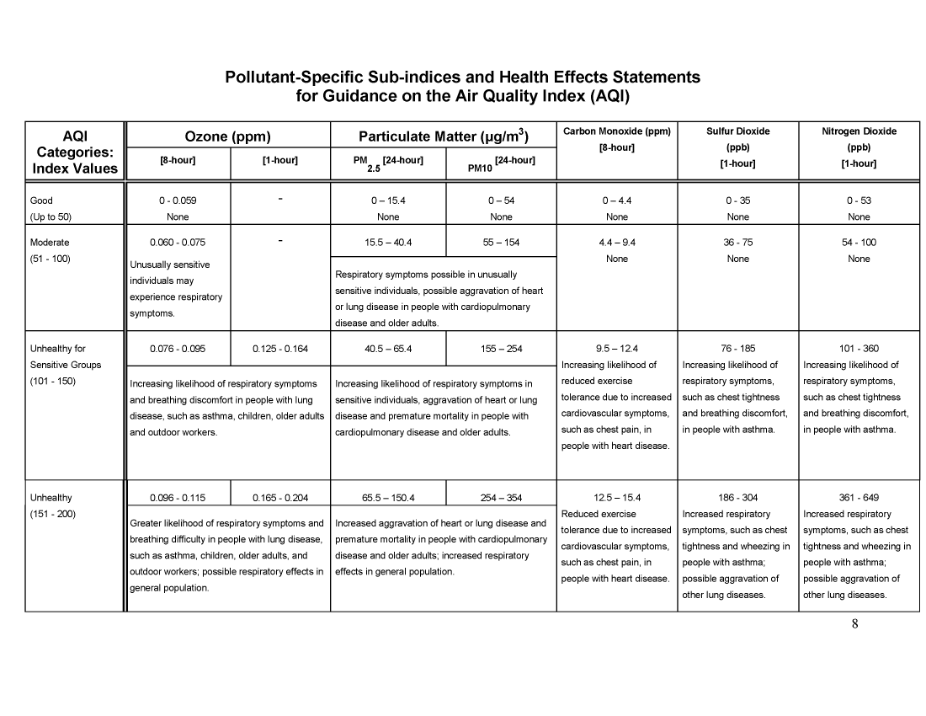

Table Pollutant level break points for AQI categories and corresponding health concerns [37].

Table Age-adjusted asthma hospitalization rates per 10,000 by county and year

|  |  |  |  |
| --- | --- | --- | --- |
| County | Year | White Adjusted Asthma Hospitalization Rate | Non-White Adjusted Asthma Hospitalization Rate* |
| Adam | 2007 | 1.48 | 2.89 |
| 2008 | 1.88 | 4.03 |
| 2009 | 2.19 | 4.94 |
| 2010 | 1.40 | 2.17 |
| 2011 | 1.15 | 4.98 |
| 2012 | 0.91 | 6.45 |
| 2013 | 0.97 | 7.27 |
| 2014 | 1.13 | 2.39 |
| Allegheny | 2007 | 3.69 | 10.50 |
| 2008 | 4.01 | 11.03 |
| 2009 | 3.61 | 11.19 |
| 2010 | 3.52 | 11.05 |
| 2011 | 3.25 | 10.90 |
| 2012 | 2.82 | 9.50 |
| 2013 | 2.63 | 8.41 |
| 2014 | 2.30 | 8.52 |
| Armstrong | 2007 | 2.80 | ꟷ |
| 2008 | 3.59 | ꟷ |
| 2009 | 3.11 | ꟷ |
| 2010 | 3.29 | ꟷ |
| 2011 | 2.80 | ꟷ |
| 2012 | 2.18 | ꟷ |
| 2013 | 1.51 | ꟷ |
| 2014 | 1.17 | ꟷ |
| Beaver | 2007 | 3.66 | 6.98 |
| 2008 | 4.58 | 9.12 |
| 2009 | 3.31 | 5.74 |
| 2010 | 3.13 | 6.53 |
| 2011 | 3.36 | 6.84 |
| 2012 | 2.30 | 4.79 |
| 2013 | 1.88 | 3.80 |
| 2014 | 1.55 | 3.66 |
| Berks | 2007 | 2.67 | 8.37 |
| 2008 | 3.04 | 7.33 |
| 2009 | 3.15 | 7.71 |
| 2010 | 2.66 | 8.02 |
| 2011 | 3.11 | 9.22 |
| 2012 | 2.81 | 9.57 |
| 2013 | 2.60 | 14.20 |
| 2014 | 2.27 | 15.63 |
| Blair  Table Age-adjusted asthma hospitalization rates per 10,000 by county and year*, continued* | 2007 | 2.13 | 9.14 |
| 2008 | 2.06 | 3.23 |
| 2009 | 1.97 | 5.41 |
| 2010 | 1.39 | 5.86 |
| 2011 | 1.61 | 2.94 |
| 2012 | 1.86 | 1.95 |
| 2013 | 1.80 | - |
| 2014 | 1.39 | 4.82 |
| Bradford | 2013 | 1.32 | ꟷ |
| 2014 | 1.92 | ꟷ |
| Bucks | 2007 | 3.11 | 5.27 |
| 2008 | 2.94 | 5.68 |
| 2009 | 3.23 | 6.16 |
| 2010 | 2.64 | 5.68 |
| 2011 | 2.56 | 6.19 |
| 2012 | 2.18 | 6.09 |
| 2013 | 2.29 | 4.71 |
| 2014 | 2.14 | 4.60 |
| Cambria | 2007 | 2.76 | 4.28 |
| 2008 | 2.83 | 5.48 |
| 2009 | 2.68 | 6.54 |
| 2010 | 2.69 | 3.52 |
| 2011 | 2.45 | 5.02 |
| 2012 | 2.45 | 6.40 |
| 2013 | 1.71 | 7.30 |
| 2014 | 1.86 | 5.07 |
| Centre | 2007 | 1.99 | ꟷ |
| 2008 | 2.33 | ꟷ |
| 2009 | 2.10 | ꟷ |
| 2010 | 1.56 | ꟷ |
| 2011 | 2.24 | ꟷ |
| 2012 | 1.55 | ꟷ |
| 2013 | 1.67 | ꟷ |
| 2014 | 1.59 | ꟷ |
| Chester | 2007 | 1.72 | 3.38 |
| 2008 | 1.65 | 3.82 |
| 2009 | 1.90 | 3.92 |
| 2010 | 1.67 | 4.36 |
| 2011 | 1.51 | 3.32 |
| 2012 | 1.45 | 4.51 |
| 2013 | 1.42 | 3.48 |
| 2014 | 1.36 | 4.00 |
| Clearfield | 2007 | 3.03 | ꟷ |
| 2008 | 2.94 | ꟷ |
| 2009 | 2.85 | ꟷ |
| 2010 | 2.86 | ꟷ |
| 2011 | 2.66 | ꟷ |
| 2012 | 2.11 | ꟷ |
| 2013 | 1.86 | ꟷ |
| 2014 | 1.68 | ꟷ |
| Cumberland  Table Age-adjusted asthma hospitalization rates per 10,000 by county and year*, continued* | 2007 | 1.72 | 1.87 |
| 2008 | 1.64 | 2.64 |
| 2009 | 1.57 | 3.08 |
| 2010 | 1.33 | 3.64 |
| 2011 | 1.60 | 1.99 |
| 2012 | 1.17 | 3.11 |
| 2013 | 1.78 | 4.52 |
| 2014 | 1.48 | 2.26 |
| Dauphin | 2007 | 1.85 | 5.78 |
| 2008 | 1.34 | 4.91 |
| 2009 | 1.78 | 6.22 |
| 2010 | 1.50 | 4.94 |
| 2011 | 1.28 | 6.84 |
| 2012 | 1.42 | 6.32 |
| 2013 | 1.54 | 7.78 |
| 2014 | 1.82 | 6.13 |
| Delaware | 2007 | 2.95 | 9.39 |
| 2008 | 3.53 | 10.22 |
| 2009 | 3.72 | 11.89 |
| 2010 | 3.17 | 9.61 |
| 2011 | 2.93 | 9.32 |
| 2012 | 2.48 | 8.07 |
| 2013 | 2.31 | 8.16 |
| 2014 | 2.15 | 8.52 |
| Erie | 2007 | 1.66 | 4.07 |
| 2008 | 1.57 | 4.25 |
| 2009 | 1.64 | 4.21 |
| 2010 | 1.45 | 3.80 |
| 2011 | 1.48 | 3.34 |
| 2012 | 1.11 | 4.66 |
| 2013 | 1.11 | 2.74 |
| 2014 | 1.54 | 4.98 |
| Franklin | 2007 | 1.66 | 3.15 |
| 2008 | 1.51 | 4.33 |
| 2009 | 1.55 | 3.44 |
| 2010 | 0.96 | 2.88 |
| 2011 | 1.31 | 3.65 |
| 2012 | 1.16 | 3.30 |
| 2013 | 0.96 | 2.56 |
| 2014 | 1.39 | 2.44 |
| Greene | 2007 | 4.20 | ꟷ |
| 2008 | 4.48 | ꟷ |
| 2009 | 4.16 | ꟷ |
| 2010 | 3.91 | ꟷ |
| 2011 | 5.01 | ꟷ |
| 2012 | 3.31 | ꟷ |
| 2013 | 3.00 | ꟷ |
| 2014 | 3.33 | ꟷ |
| Indiana  Table Age-adjusted asthma hospitalization rates per 10,000 by county and year*, continued* | 2007 | 4.01 | ꟷ |
| 2008 | 5.42 | ꟷ |
| 2009 | 5.08 | ꟷ |
| 2010 | 3.95 | ꟷ |
| 2011 | 3.51 | ꟷ |
| 2012 | 3.00 | ꟷ |
| 2013 | 3.53 | ꟷ |
| 2014 | 2.59 | ꟷ |
| Lackawanna | 2007 | 3.57 | 5.50 |
| 2008 | 3.70 | 6.66 |
| 2009 | 3.45 | 8.77 |
| 2010 | 2.70 | 6.80 |
| 2011 | 2.90 | 5.19 |
| 2012 | 2.41 | 8.59 |
| 2013 | 2.32 | 4.77 |
| 2014 | 2.33 | 6.50 |
| Lancaster | 2007 | 1.82 | 2.95 |
| 2008 | 1.92 | 3.05 |
| 2009 | 2.02 | 4.36 |
| 2010 | 1.76 | 3.50 |
| 2011 | 1.70 | 3.56 |
| 2012 | 1.88 | 3.54 |
| 2013 | 1.64 | 3.78 |
| 2014 | 1.65 | 3.37 |
| Lawrence | 2007 | 5.24 | 8.83 |
| 2008 | 6.27 | 15.99 |
| 2009 | 6.24 | 13.97 |
| 2010 | 5.45 | 17.63 |
| 2011 | 4.30 | 11.99 |
| 2012 | 3.88 | 14.44 |
| 2013 | 2.73 | 9.33 |
| 2014 | 3.25 | 10.26 |
| Lebanon | 2011 | 1.02 | 8.79 |
| 2012 | 1.46 | 4.66 |
| 2013 | 1.28 | 6.15 |
| 2014 | 1.68 | 9.78 |
| Lehigh | 2007 | 2.04 | 6.45 |
| 2008 | 2.28 | 9.93 |
| 2009 | 2.42 | 10.43 |
| 2010 | 2.32 | 7.94 |
| 2011 | 2.61 | 9.06 |
| 2012 | 2.63 | 7.02 |
| 2013 | 2.25 | 6.60 |
| 2014 | 2.32 | 5.12 |
| Luzerne  Table Age-adjusted asthma hospitalization rates per 10,000 by county and year*, continued* | 2007 | 3.66 | 4.86 |
| 2008 | 4.05 | 5.26 |
| 2009 | 3.48 | 5.24 |
| 2010 | 3.13 | 4.89 |
| 2011 | 2.93 | 6.08 |
| 2012 | 2.40 | 4.76 |
| 2013 | 2.54 | 8.38 |
| 2014 | 2.13 | 9.06 |
| Lycoming | 2007 | 1.85 | 7.43 |
| 2008 | 1.98 | 6.02 |
| 2009 | 1.99 | 6.94 |
| 2010 | 1.74 | 4.33 |
| 2011 | 1.38 | 4.63 |
| 2012 | 1.05 | 6.86 |
| 2013 | 1.12 | 4.37 |
| 2014 | 1.23 | 7.05 |
| Mercer | 2007 | 3.00 | 5.14 |
| 2008 | 3.18 | 8.21 |
| 2009 | 2.92 | 7.51 |
| 2010 | 2.54 | 8.63 |
| 2011 | 1.88 | 5.55 |
| 2012 | 1.52 | 5.27 |
| 2013 | 2.00 | 4.74 |
| 2014 | 1.94 | 4.66 |
| Monroe | 2007 | 4.63 | 5.04 |
| 2008 | 4.30 | 3.48 |
| 2009 | 3.91 | 3.18 |
| 2010 | 3.71 | 3.58 |
| 2011 | 2.81 | 3.95 |
| 2012 | 2.10 | 4.49 |
| 2013 | 1.79 | 4.10 |
| 2014 | 2.14 | 4.08 |
| Montgomery | 2007 | 2.30 | 5.86 |
| 2008 | 2.36 | 5.36 |
| 2009 | 2.59 | 6.52 |
| 2010 | 2.05 | 5.26 |
| 2011 | 2.17 | 5.63 |
| 2012 | 2.15 | 5.76 |
| 2013 | 2.02 | 4.84 |
| 2014 | 1.69 | 5.13 |
| Northampton | 2007 | 2.63 | 12.07 |
| 2008 | 2.80 | 13.30 |
| 2009 | 3.30 | 13.35 |
| 2010 | 2.81 | 10.26 |
| 2011 | 2.44 | 12.44 |
| 2012 | 2.33 | 10.29 |
| 2013 | 2.16 | 7.33 |
| 2014 | 2.17 | 5.48 |
| Perry  Table Age-adjusted asthma hospitalization rates per 10,000 by county and year*, continued* | 2007 | 0.70 | ꟷ |
| 2008 | 0.98 | ꟷ |
| 2009 | 1.47 | ꟷ |
| 2010 | 1.09 | ꟷ |
| 2011 | 1.42 | ꟷ |
| 2012 | 1.20 | ꟷ |
| 2013 | 1.70 | ꟷ |
| 2014 | 1.71 | ꟷ |
| Philadelphia | 2007 | 5.03 | 18.79 |
| 2008 | 5.20 | 18.47 |
| 2009 | 5.24 | 19.16 |
| 2010 | 4.22 | 16.33 |
| 2011 | 4.28 | 17.78 |
| 2012 | 4.12 | 16.85 |
| 2013 | 3.59 | 15.40 |
| 2014 | 3.34 | 14.26 |
| Tioga | 2007 | 2.16 | ꟷ |
| 2008 | 1.63 | ꟷ |
| 2009 | 1.44 | ꟷ |
| 2010 | 1.08 | ꟷ |
| 2011 | 1.15 | ꟷ |
| 2012 | 1.59 | ꟷ |
| 2013 | 1.69 | ꟷ |
| 2014 | 1.56 | ꟷ |
| Washington | 2007 | 3.76 | 8.53 |
| 2008 | 3.46 | 10.26 |
| 2009 | 3.76 | 4.50 |
| 2010 | 3.34 | 6.50 |
| 2011 | 2.76 | 6.44 |
| 2012 | 2.33 | 5.03 |
| 2013 | 2.16 | 5.14 |
| 2014 | 2.02 | 4.11 |
| Westmoreland | 2007 | 4.24 | 18.75 |
| 2008 | 4.69 | 23.18 |
| 2009 | 4.43 | 12.21 |
| 2010 | 4.28 | 6.64 |
| 2011 | 3.70 | 7.24 |
| 2012 | 3.19 | 7.12 |
| 2013 | 2.79 | 7.66 |
| 2014 | 2.42 | 5.56 |
| York | 2007 | 1.22 | 4.75 |
| 2008 | 1.65 | 4.84 |
| 2009 | 1.75 | 4.89 |
| 2010 | 1.03 | 2.95 |
| 2011 | 1.34 | 5.14 |
| 2012 | 1.12 | 4.71 |
| 2013 | 1.19 | 5.59 |
| 2014 | 1.47 | 4.89 |

*Counties with unstable non-white age-adjusted rates are excluded from the table.

Table Age-adjusted asthma hospitalization rates per 10,000 by county and year*, continued*

Table Unhealthy AQI frequency by county and year for 2007-2014.

|  |  |  |
| --- | --- | --- |
| County | Year | Unhealthy AQI Frequency |
| Adams | 2007 | 0.071 |
| 2008 | 0.037 |
| 2009 | 0.003 |
| 2010 | 0.030 |
| 2011 | 0.014 |
| 2012 | 0.030 |
| 2013 | 0.008 |
| 2014 | 0.005 |
| Allegheny | 2007 | 0.227 |
| 2008 | 0.183 |
| 2009 | 0.110 |
| 2010 | 0.192 |
| 2011 | 0.132 |
| 2012 | 0.158 |
| 2013 | 0.049 |
| 2014 | 0.055 |
| Armstrong | 2007 | 0.122 |
| 2008 | 0.079 |
| 2009 | 0.018 |
| 2010 | 0.023 |
| 2011 | 0.011 |
| 2012 | 0.041 |
| 2013 | 0.019 |
| 2014 | 0.005 |
| Beaver | 2007 | 0.178 |
| 2008 | 0.150 |
| 2009 | 0.096 |
| 2010 | 0.090 |
| 2011 | 0.060 |
| 2012 | 0.087 |
| 2013 | 0.019 |
| 2014 | 0.014 |
| Berks | 2007 | 0.073 |
| 2008 | 0.057 |
| 2009 | 0.019 |
| 2010 | 0.071 |
| 2011 | 0.030 |
| 2012 | 0.036 |
| 2013 | 0.033 |
| 2014 | 0.022 |
| Blair  Table Unhealthy AQI frequency by county and year for 2007-2014, *continued* | 2007 | 0.014 |
| 2008 | 0.014 |
| 2009 | 0.000 |
| 2010 | 0.025 |
| 2011 | 0.025 |
| 2012 | 0.038 |
| 2013 | 0.008 |
| 2014 | 0.005 |
| Bradford | 2013 | 0.000 |
| 2014 | 0.000 |
| Bucks | 2007 | 0.089 |
| 2008 | 0.060 |
| 2009 | 0.022 |
| 2010 | 0.066 |
| 2011 | 0.036 |
| 2012 | 0.066 |
| 2013 | 0.038 |
| 2014 | 0.022 |
| Cambria | 2007 | 0.019 |
| 2008 | 0.014 |
| 2009 | 0.008 |
| 2010 | 0.030 |
| 2011 | 0.017 |
| 2012 | 0.019 |
| 2013 | 0.008 |
| 2014 | 0.005 |
| Centre | 2007 | 0.036 |
| 2008 | 0.027 |
| 2009 | 0.000 |
| 2010 | 0.022 |
| 2011 | 0.025 |
| 2012 | 0.025 |
| 2013 | 0.005 |
| 2014 | 0.000 |
| Chester | 2007 | 0.102 |
| 2008 | 0.077 |
| 2009 | 0.011 |
| 2010 | 0.066 |
| 2011 | 0.032 |
| 2012 | 0.054 |
| 2013 | 0.008 |
| 2014 | 0.011 |
| Clearfield  Table Unhealthy AQI frequency by county and year for 2007-2014, *continued* | 2007 | 0.030 |
| 2008 | 0.044 |
| 2009 | 0.015 |
| 2010 | 0.073 |
| 2011 | 0.021 |
| 2012 | 0.018 |
| 2013 | 0.000 |
| 2014 | 0.000 |
| Cumberland | 2007 | 0.018 |
| 2008 | 0.011 |
| 2009 | 0.016 |
| 2010 | 0.019 |
| 2011 | 0.011 |
| 2012 | 0.008 |
| 2013 | 0.025 |
| 2014 | 0.005 |
| Dauphin | 2007 | 0.093 |
| 2008 | 0.063 |
| 2009 | 0.019 |
| 2010 | 0.033 |
| 2011 | 0.038 |
| 2012 | 0.025 |
| 2013 | 0.025 |
| 2014 | 0.011 |
| Delaware | 2007 | 0.058 |
| 2008 | 0.046 |
| 2009 | 0.017 |
| 2010 | 0.025 |
| 2011 | 0.039 |
| 2012 | 0.060 |
| 2013 | 0.014 |
| 2014 | 0.011 |
| Erie | 2007 | 0.060 |
| 2008 | 0.016 |
| 2009 | 0.011 |
| 2010 | 0.025 |
| 2011 | 0.011 |
| 2012 | 0.052 |
| 2013 | 0.000 |
| 2014 | 0.003 |
| Franklin | 2007 | 0.085 |
| 2008 | 0.044 |
| 2009 | 0.000 |
| 2010 | 0.010 |
| 2011 | 0.006 |
| 2012 | 0.004 |
| 2013 | 0.012 |
| 2014 | 0.000 |
| Greene  Table Unhealthy AQI frequency by county and year for 2007-2014, *continued* | 2007 | 0.145 |
| 2008 | 0.039 |
| 2009 |  |
| 2010 | 0.042 |
| 2011 | 0.004 |
| 2012 | 0.049 |
| 2013 | 0.006 |
| 2014 | 0.006 |
| Indiana | 2007 | 0.078 |
| 2008 | 0.041 |
| 2009 | 0.017 |
| 2010 | 0.055 |
| 2011 | 0.025 |
| 2012 | 0.052 |
| 2013 | 0.020 |
| 2014 | 0.014 |
| Lackawanna | 2007 | 0.041 |
| 2008 | 0.030 |
| 2009 | 0.005 |
| 2010 | 0.022 |
| 2011 | 0.014 |
| 2012 | 0.011 |
| 2013 | 0.003 |
| 2014 | 0.000 |
| Lancaster | 2007 | 0.104 |
| 2008 | 0.052 |
| 2009 | 0.011 |
| 2010 | 0.077 |
| 2011 | 0.055 |
| 2012 | 0.055 |
| 2013 | 0.022 |
| 2014 | 0.041 |
| Lawrence | 2007 | 0.052 |
| 2008 | 0.008 |
| 2009 | 0.016 |
| 2010 | 0.014 |
| 2011 | 0.011 |
| 2012 | 0.027 |
| 2013 | 0.008 |
| 2014 | 0.005 |
| Lebanon | 2011 | 0.046 |
| 2012 | 0.033 |
| 2013 | 0.030 |
| 2014 | 0.022 |
| Lehigh | 2007 | 0.063 |
| 2008 | 0.044 |
| 2009 | 0.006 |
| 2010 | 0.055 |
| 2011 | 0.026 |
| 2012 | 0.028 |
| 2013 | 0.005 |
| 2014 | 0.003 |
| Luzerne  Table Unhealthy AQI frequency by county and year for 2007-2014, *continued* | 2007 | 0.033 |
| 2008 | 0.025 |
| 2009 | 0.000 |
| 2010 | 0.008 |
| 2011 | 0.000 |
| 2012 | 0.005 |
| 2013 | 0.003 |
| 2014 | 0.000 |
| Lycoming | 2007 | 0.036 |
| 2008 | 0.022 |
| 2009 | 0.000 |
| 2010 | 0.026 |
| 2011 | 0.003 |
| 2012 | 0.011 |
| 2013 | 0.000 |
| 2014 | 0.000 |
| Mercer | 2007 | 0.066 |
| 2008 | 0.041 |
| 2009 | 0.011 |
| 2010 | 0.025 |
| 2011 | 0.022 |
| 2012 | 0.068 |
| 2013 | 0.008 |
| 2014 | 0.011 |
| Monroe | 2007 | 0.034 |
| 2008 | 0.028 |
| 2009 | 0.000 |
| 2010 | 0.042 |
| 2011 | 0.000 |
| 2012 | 0.005 |
| 2013 | 0.003 |
| 2014 | 0.000 |
| Montgomery | 2007 | 0.068 |
| 2008 | 0.066 |
| 2009 | 0.008 |
| 2010 | 0.049 |
| 2011 | 0.044 |
| 2012 | 0.022 |
| 2013 | 0.016 |
| 2014 | 0.016 |
| Northampton | 2007 | 0.137 |
| 2008 | 0.044 |
| 2009 | 0.008 |
| 2010 | 0.071 |
| 2011 | 0.030 |
| 2012 | 0.038 |
| 2013 | 0.019 |
| 2014 | 0.008 |
| Perry  Table Unhealthy AQI frequency by county and year for 2007-2014, *continued* | 2007 | 0.022 |
| 2008 | 0.025 |
| 2009 | 0.003 |
| 2010 | 0.014 |
| 2011 | 0.006 |
| 2012 | 0.016 |
| 2013 | 0.000 |
| 2014 | 0.000 |
| Philadelphia | 2007 | 0.110 |
| 2008 | 0.077 |
| 2009 | 0.022 |
| 2010 | 0.077 |
| 2011 | 0.055 |
| 2012 | 0.077 |
| 2013 | 0.027 |
| 2014 | 0.025 |
| Tioga | 2007 | 0.034 |
| 2008 | 0.026 |
| 2009 | 0.000 |
| 2010 | 0.047 |
| 2011 | 0.007 |
| 2012 | 0.012 |
| 2013 | 0.003 |
| 2014 | 0.000 |
| Washington | 2007 | 0.093 |
| 2008 | 0.046 |
| 2009 | 0.036 |
| 2010 | 0.027 |
| 2011 | 0.019 |
| 2012 | 0.049 |
| 2013 | 0.011 |
| 2014 | 0.003 |
| Westmoreland | 2007 | 0.044 |
| 2008 | 0.027 |
| 2009 | 0.009 |
| 2010 | 0.028 |
| 2011 | 0.025 |
| 2012 | 0.041 |
| 2013 | 0.008 |
| 2014 | 0.003 |
| York | 2007 | 0.112 |
| 2008 | 0.085 |
| 2009 | 0.030 |
| 2010 | 0.055 |
| 2011 | 0.036 |
| 2012 | 0.038 |
| 2013 | 0.016 |
| 2014 | 0.003 |

Table Unhealthy AQI frequency by county and year for 2007-2014, *continued*

**APPENDIX B: SUPPLEMENTARY EQUATIONS**

$$I_{p}=\frac{I_{Hi}-I_{Lo}}{{BP}_{HI}-{BP}_{Lo}}{(C}_{p}-{BP}_{Lo})+I_{Lo}$$

Where Ip= the index for pollutant p

Cp= the rounded concentration of pollutant p

BPHi=the breakpoint from table X that is greater than or equal to Cp

BPLo= the breakpoint from table X that is less than or equal to Cp

IHi= the AQI value corresponding to BPHi

ILo= the AQI value corresponding to BPLo

Equation Air quality index equation[37].

# BIBLIOGRAPHY

1. Moorman JE, Akinbami LJ, Bailey DM, et al. *National Surveillance of Asthma: United States, 2001-2010. National Center for Health Statistics*. Vital Health Stat 3(35). 2012. <https://www.cdc.gov/nchs/data/series/sr_03/sr03_035.pdf>
2. State Health Facts. *Adult Self-Report Current Asthma Prevalence Rate*. Kiser Family Foundation; Available from: <http://kff.org/other/state-indicator/asthma-prevalence-among-adults/?activeTab=map&current>
3. Centers for Disease Control and Prevention. *Most Recent Asthma Data;* Available from: <https://www.cdc.gov/asthma/most_recent_data.htm>
4. Center for Disease Control and Prevention. *Asthma’s Impact on the Nation.* National Center for Environmental Health; Available from: <https://www.cdc.gov/asthma/impacts_nation/asthmafactsheet.pdf>
5. American College of Allergy, Asthma, and Immunology. *Asthma Management and the Allergist: Better Outcomes at Lower Cost (2015) The Scope and Impact of the Asthma Epidemic.* <http://college.acaai.org/sites/default/files/Resources/Infographics/asthma_epidemic_infographic.pdf>
6. Centers for Disease Control and Prevention*. Asthma related missed school days among children aged 5-17 Years*; Available from: <https://www.cdc.gov/asthma/asthma_stats/missing_days.htm>
7. National Heart, Lung, and Blood Institute. *What Is Asthma?*; Available from: <https://www.nhlbi.nih.gov/health/health-topics/topics/asthma/>
8. American Lung Association. *Heart & Lung Diseases: Asthma;* Available from: <http://www.lung.org/lung-health-and-diseases/lung-disease-lookup/asthma/asthma-symptoms-causes-risk-factors/asthma-risk-factors.html>
9. Centers for Disease Control and Prevention. *Asthma Severity among Children with Current Asthma;* Available from: <https://www.cdc.gov/asthma/asthma_stats/severity_child.htm>
10. Centers for Disease Control and Prevention. *Asthma Severity among Adults with Current Asthma;* Available from: .<https://www.cdc.gov/asthma/asthma_stats/severity_adult.htm>
11. Centers for Disease Control and Prevention. *Uncontrolled Asthma among Persons with Current Asthma;* A*vailable from:* <https://www.cdc.gov/asthma/asthma_stats/uncontrolled_asthma.htm>
12. Litonjua A. Augusto. *Race, Socioeconomic Factors, and Area of Residence Are Associated With Asthma Prevalence*. Pediatric Pulmonology 1999. 28, 394-401
13. Neidell, Matthew J. *Air Pollution Health and Socioeconomic Status: The Effect of Outdoor Air Quality on Childhood Asthma.* Journal of Health Economics 2004. 23(6), 1209-1236.
14. Centers for Disease Control and Prevention. *Asthma and Obesity;* Available from: <https://www.cdc.gov/asthma/asthma_stats/asthma_obesity.htm>
15. Brisbon, Nancy Plumb, James Brawer, Rickie Paxman, Dalton. *The asthma and Obesity Epidemics: The role played by the build environment-a public health perspective*. The Journal of Allergy and Clinical Immunology, 2005. 115(5), 1024-1028.
16. Frey U, Latzin, P. Usemann, J. Maccora, J. Zumsteg, U. & Kriemler S. *Asthma and obesity in children: current evidence and potential systems biology approaches.* European Journal of Allergy and Clinical Immunology, 2014 70(1), 26-40.
17. Shaheen, S., Sterne, J., Montgomery, S., & Azima, H. (1999). *Birth weight, body mass index and asthma in young adults*. Thorax, 54(5), 396–402.
18. Stapleton, Megan…. Smoking and Asthma. Journal of the American Board of Family Medicine, 2011. 24(3) 313-322. <http://www.jabfm.org/content/24/3/313.full>
19. Centers for Disease Control and Prevention. *Percentages of People with Asthma who Smoke*; Available from: <https://www.cdc.gov/asthma/asthma_stats/people_who_smoke.htm>.
20. Rasmussen SG, Ogburn EL, McCormack M, Casey JA, Bandeen-Roche K, Mercer DG, Schwartz BS. *Association Between Unconventional Natural Gas Development in the Marcellus Shale and Asthma Exacerbations*. JAMA Intern Med. 2016;176(9):1334-1343. doi:10.1001/jamainternmed.2016.2436
21. McDonnell, William F. *Long-Term Ambient Ozone Concentration and the Incidence of Asthma in Nonsmoking Adults: The Ashmog Study*. Environmental Research, 1999. 80(2), 110-121.
22. Brunekreef, Bert Holgate, Stephen T. *Air Pollution and Health*. The Lancet, 2002; 360(931). doi: http://dx.doi.org/10.1016/S0140-6736(02)11274-8.
23. United States Evnironmental Protection Agency. *The Clean Air Act*; Available at: <https://www.epa.gov/clean-air-act-overview/clean-air-act-requirements-and-history>.
24. Air Now. *Air Quality Index (AQI) Basics*; Available at: <https://airnow.gov/index.cfm?action=aqibasics.aqi>
25. Neidell, Matthew. Kinney, Patrik L. *Estimates of the association between ozone and asthma hospitalizations that accoumt for behavioral responses to air quality information.* ElSEVIER Environmental Science & Policy 2010. 13(2), 97-103.
26. United States Environmental Protection Agency. *Ozone Pollution*; Available at: <https://www.epa.gov/ozone-pollution>
27. United States Environmental Protection Agency. *Particulate Matter (OM Pollution.* ; Available at: <https://www.epa.gov/pm-pollution/particulate-matter-pm-basics>.
28. American Lung Association. *State of the Air 2016;* Available from: <http://www.lung.org/assets/documents/healthy-air/state-of-the-air/sota-2016-full.pdf>.
29. Glad JA1, Brink LL, Talbott EO, Lee PC, Xu X, Saul M, Rager J. *The relationship of ambient ozone and PM(2.5) levels and asthma emergency department visits: possible influence of gender and ethnicity*. Arch Environ Occup Health. 2012;67(2):103-8. doi: 10.1080/19338244.2011.598888.
30. Jaffe, Dena H, Singer Mende E, Rimm, Alfred A*. Air pollution and emergency department visits for asthma among Ohio Medicaid recipients, 1991–1996*. Elsevier Environmental Researach, 2003. 91(1), 21-28.
31. Pennsylvania Department of Health. *Healthy People 2020 PA*. Available from: <http://www.statistics.health.pa.gov/HealthStatistics/HealthyPeople/Documents/Healthy_People_2020_PA.pdf>
32. Pennsylvania Department of Health. *2015 Pennsylvania Asthma Focus Report: Inpatient Hospitalizations with Asthma as the Primary Discharge Diagnosis.* Available from <http://www.health.pa.gov/My%20Health/Diseases%20and%20Conditions/A-D/Asthma/Documents/2015%20PENNSYLVANIA%20ASTHMA%20FOCUS%20REPORT%202009-2013%20INPATIENT%20%20HOSPITALIZATIONS%20WITH%20ASTHMA%20AS%20THE%20PRIMARY%20DISCHARGE%20DIAGNOSIS.pdf>
33. American College of Allergy, Asthma, and Immunology. Asthma Management and the Allergist: Better Outcomes at Lower Cost (2015) *The Scope and Impact of the Asthma Epidemic;* Available from: <http://college.acaai.org/sites/default/files/Resources/Infographics/asthma_epidemic_infographic.pdf>>
34. Lawson, Charlotte C, Carroll, Kate Gonzales, Rodalyn Priolo, Chantel Apter, Andrea J Rhodes, Karin V. “*No Other Choice”: Reasons for Emergency Department Utilization Among Urban Adults With Acute Asthma.* Academic Emergency Medicine, 2014. 21(1), 1-8.
35. Talbott, Evelyn O. Bilonick, Richard Sharma, Ravi K. Tager, Judith Duan, Emily. *Relationship between Air Pollution and Asthma with other Acute Respiratory Hospitalizations/Emergency Department Visits in Pennsylvania: Final Report*. Pennsylvania Department of Health. 2016.
36. United States Environmental Protection Agency. *About Air Data Reports: Air Quality Index Report*. Available from: <https://www.epa.gov/outdoor-air-quality-data/about-air-data-reports#aqi>.
37. National Service Center for Environmental Publications. *Technical Assistance Document for the Reporting of Daily Air Quality: The Air Quality Index (AQI)*, 2012. U.S. Environmental Protection Agency. Available from: http://www.health.pa.gov/My%20Health/Environmental%20Health/Environmental%20Public%20Health%20Tracking/Documents/Indiana%20County%20Health%20Profiles%20Revised-2.pdf
38. Ortega Hinojosa, A. M., M. M. Davies, S. Jarjour, R. T. Burnett, J. K. Mann, E. Hughes, J. R. Balmes, M. C. Turner and M. Jerrett (2014*). "Developing small-area predictions for smoking and obesity prevalence in the United States for use in Environmental Public Health Tracking.*" Environ Res 134: 435-452.
39. United States Census Bureau. *Quickfacts: Pennsylvania*. Available from: https://www.census.gov/quickfacts/table/PST045216/42.