**MITIGATING THE OPIOID EPIDEMIC IN DENTAL PRACTICE BY PROMOTING PROVIDER EDUCATION AND PATIENT COUNSELING**

by

**Taru Gupta**

BDS, Manipal University, Karnataka, India, 2010

MDS, Rajiv Gandhi University of Health Sciences, Karnataka, India, 2014

Submitted to the Graduate Faculty of

Department of Health Policy and Management

Graduate School of Public Health in partial fulfillment

of the requirements for the degree of

Master of Public Health

University of Pittsburgh

2017

UNIVERSITY OF PITTSBURGH

GRADUATE SCHOOL OF PUBLIC HEALTH

This essay is submitted

by

Taru Gupta

on

April 4, 2017

and approved by

Essay Advisor:

Gerald Barron, MPH ________________________________________

Associate Professor and MPH Director

Health Policy and Management

Graduate School of Public Health

University of Pittsburgh

Essay Readers:

Deborah E. Polk, PhD _________________________________________

Assistant Professor Dental Public Health

School of Dental Medicine

Adjunct Professor

Behavioral and Community Health Science

Graduate School of Public Health

University of Pittsburgh

Paul A. Moore, BS, DMD, MS, PhD, MPH _________________________________________

Professor

Dental Public Health

School of Dental Medicine

University of Pittsburgh

Copyright © by Taru Gupta

2017

**ABSTRACT**

Gerry Barron, MPH

**MITIGATING THE OPIOID EPIDEMIC IN DENTAL PRACTICE BY PROMOTING PROVIDER EDUCATION AND PATIENT COUNSELING**

Taru Gupta, MPH

University of Pittsburgh, 2017

The United States is suffering from an opioid prescription crisis that has resulted in severe drug abuse, misuse and diversion leading to addiction and overdose deaths. Opioid overdose deaths have become the leading cause of death having surpassed motor vehicle accidents, the previous known most common cause for injury related deaths. Opioid prescription drugs are abused significantly for non-medical purposes more than all other illegal drugs combined, including heroin and cocaine. The crisis has serious public health significance since opioids have accounted for tragic loss of lives across all socioeconomic and income groups, added enormous burden on healthcare costs and astronomically increased emergency department visits. Dentists have been identified as a crucial provider group ranking fifth in prescribing opioid analgesics. The opioid drugs most commonly prescribed by dentists are hydrocodone and oxycodone, which also have the highest potential for abuse. Dentists are also a frequent provider group that usually prescribes adolescents their first opioid prescription, mostly after extraction of third molar wisdom teeth. Since adolescence is a vulnerable age for prescription drug abuse, misuse and diversion, dental prescribers have an obligation to use opioids only after trying alternative medications such as non-steroidal anti-inflammatory drugs (NSAIDs) for pain management. There are many strategies, recommendations and initiatives at every level of the government to curb the opioid crisis. In addition to government efforts, a variety of programs are being implemented by the professional national, state and local organizations. The goal of this paper is to critically analyze the information currently available on dental provider prescribing behaviors and practices, patient attitudes and behaviors as it relates to proper opioid use, safe storage and disposal and various strategies to remediate the opioid issue. The objectives are to identify and discuss gaps existing in dental prescribing practices and recommendations that can reduce opioid abuse and misuse in the dental practice. Dental prescribers are in a prominent position to reduce opioid abuse and misuse by following best prescribing practices and diversion by judicious use of prescription drug monitoring programs. They can counsel patients on every dental visit about the risks associated with opioid therapy.

TABLE OF CONTENTS

preface x

1.0 INTRODUCTION 1

1.1 Problem statement 2

1.2 Public Health Relevance 6

2.0 Literature Review 11

2.1 Opiates and their effects 11

2.2 Why are prescription opioids abused and why do they lead to addiction? 12

2.3 Terminology associated with nonmedical use of opioids 12

2.4 Why opioid prescribing increased? 13

2.5 Scope of the problem 14

2.6 Impact on adolescents (12 to 17 years old) 15

2.7 Economic Impact of Opioid Epidemic 16

2.8 Prescription Opioid Abuse as the First Step Towards Heroin 16

2.9 Dentists, a crucial opioid prescriber group 17

2.10 Dental Prescribing Practices 17

2.11 Why do dentists prescribe opioids? 20

2.11.1 Direct contributing factors 20

**2.11.1.1 Traditional practice habits 20**

**2.11.1.2 Clinical dilemma in assessing the intensity of pain 20**

**2.11.1.3 Suboptimal doses of APAP prescriptions 21**

**2.11.1.4 Patient attitudes and presumptions 21**

**2.11.1.5 Dearth of scientific research 21**

2.11.2 Indirect contributing factors 22

**2.11.2.1 Classification of opioids as Schedule II drugs 22**

**2.11.2.2 Subjective feeling of well being 22**

2.12 Abuse, Misuse and Diversion 23

2.13 Extent of the problem due to leftover prescriptions 24

2.14 Sources of Prescription Opioids for Nonmedical Use 25

2.15 Leftover prescription opioid storage and disposal 26

2.16 Impact of dental prescriptions on adolescents 27

2.17 GAPS IN DENTAL PRACTICE to address THE OPIOID CRISIS 28

2.18 Current efforts from the dental community to curb the opioid crisis 29

2.19 NATIONAL Prescription DRUG ABUSE PLAN 30

2.20 fda RISK EVALUATION AND MITIGATION STRATEGY 31

2.21 RISK EVALUATION AND MITIGATION STRATEGY FOR EXTENDED-RELEASE AND LONG ACTING OPIOIDS 32

2.22 Latest evaluation results - RISK EVALUATION AND MITIGATION STRATEGY FOR EXTENDED-RELEASE AND LONG ACTING OPIOIDS 34

2.23 Effectiveness of patient education and counseling 36

2.24 INFORMED CONSENT 37

2.25 STATES Legislation to mitigate the opioid epidemic 38

2.26 ROLE OF DENTAL PROVIDERS IN CURTAILING THE OPIOID EPIDEMIC 38

3.0 Methodology 40

4.0 Discussion 42

5.0 Recommendations 48

5.1 PRESCRIBER EDUCATION 48

5.2 PATIENT COUNSELING 49

5.3 INFORMED CONSENT 55

5.4 Research 55

6.0 CONCLUSIONS 57

APPENDIX A: FIGURES 59

APPENDIX B: CONSENT TO PRESCRIBE OPIOID MEDICATION TO A MINOR 64

APPENDIX C: PATIENT COUNSELING DOCUMENT 65

BIBLIOGRAPHY 66

LIST OF FIGURES

Figure 1. Compares the number of opioid pain reliever related deaths with deaths that can be attributed to all other illegal drugs across the different age groups. 59

Figure 2. The total number of U.S. overdose deaths attributed to heroin from 2002-2015. There was a 6.2 fold increase in the total number of deaths. 59

Figure 3. Increasing evidence that users of prescription opioids are switching to heroin after the introduction of an abuse deterrent in OxyContin. 60

Figure 4. Chemical structural similarity between prescription opioids and heroin molecule. 60

Figure 5. Number of Deaths from Prescription Opioid Pain Relievers (excluding non-methadone synthetics which is category dominated by illicit fentanyl). It shows a 1.9-fold increase in the total number of deaths from 2002-2011, and has remained stable since then. 61

Figure 6. Trend showing the rise in the number of opioid prescriptions from 1991-2013. 61

Figure 7. Increase in OPR sales is positively associated to increased OPR deaths. 62

Figure 8. National Overdose Deaths—Total number of U.S. overdose deaths involving all drugs from 2002 to 2015 that shows an increase by 2.2-fold. 62

Figure 9. Total number of U.S. overdose deaths involving opioid drugs from 2002 to 2015 that includes opioid analgesics, along with heroin and illicit synthetic opioids. From 2002 to 2015 there was a 2.8-fold increase in the total number of deaths. 63

Figure 10. The bar graph compares the percentage of adolescents who abused illegal drugs and prescription medication. 63

# preface

I am grateful to my essay advisor Professor Barron and my readers Dr. Polk and Dr. Moore who guided me throughout the process and were thorough with their feedback. I greatly appreciate their time and investment in this important milestone of my degree.

I am thankful to my husband for his constant support and reviewing many drafts of this essay. I am blessed to have the two set of parents, my own and my in-laws who always have my back.

I am indebted to the Department of Health Policy and Management that gave me countless opportunities to excel and develop lifelong professional skills. The support and love that I received is unmatched and I will always be thankful for the platform given to me.

# INTRODUCTION

The United States Centers for Disease Control and Prevention (CDC) declared that the uncontrolled spike in the consumption of opioid prescription led to the “worst drug overdose epidemic in (US) history.”1 According to CDC, in 2008 more people died from prescription opioid overdoses than all other drugs combined, that including illegal drugs like heroin and cocaine2 **(Figure 1).**

Over the past 20 years, the liberalization of laws governing the prescription of opioids to treat chronic non-cancer pain led to the dramatic spike in opioid use.3 It was also accompanied with escalation in use of therapeutic opioids to treat acute pain with a 146% increase in the ER opioids from 2002 to 2009. Approximately 12% of the prescriptions were issued to patients aged 10-29 years.4

In 2014, the National Survey on Drug Use and Health (NSDUH) reported that almost 2% of the population in the United States, approximately 4.3 million people aged 12 years or older, has used prescription painkillers for nonmedical purposes.5 Almost 2 million people out of these were found to be suffering from substance use disorder attributable to prescription medications.5

There is ample literature demonstrating the association between increased opioid analgesic abuse and heroin addiction.6 In 2011-2013, the NSDUH reported that people who are addicted to prescription opioid painkillers have a 40 times greater risk of being addicted to heroin.7 The rate of heroin-related overdose deaths almost quadrupled between 2002 and 2013, and more than 8,200 people died in 20138 **(Figure 2)**. Furthermore, there has been a spike among opioid prescription abusers switching to heroin as opioid prescriptions became less prone to abuse with the introduction of an abuse deterrent9 **(Figure 3)**.

Prescription opioids are a semi-synthetic derivative of the active opiate alkaloids found in the opium poppy plant.10 They are the most potent analgesics currently known to humankind, and when prescribed appropriately, they can significantly improve a patient’s quality of life.11 The pharmacological and physiological effects of these medications are similar to those seen with heroin use; they act on neural receptors–resulting in feelings of euphoria and relaxation **(Figure 4)**. These euphoric effects predispose users of prescription opioids to abuse and addiction. When taken in higher doses, opioids elicit continuous alteration in dopaminergic pathways of the brain that urges the individual to use the drug repeatedly.12There are several factors that contributed to the opioid epidemic – economic stagnation; physician attempts at symptomatic cure of chronic pain; drug patent and monopoly that incentivized pharmaceutical industry to conceal the harmful effects, coupled with aggressive marketing of prescription painkillers to both doctors and patients that escalated the sale of the drugs exponentially.13

## Problem statement

According to the CDC report in 2012, 259 million prescriptions of painkillers were written by healthcare providers; these were enough for every adult in America to have a personal bottle of pills.14 Data suggests that geography influenced the healthcare providers’ prescribing practices, and the 10 highest painkiller-prescribing were found in the South. Areas with higher opioid prescribing practices are also associated with more overdose deaths.14

The most commonly prescribed painkillers are immediate release opioids-hydrocodone and oxycodone.15 Immediate release opioids have also been shown to have the highest abuse potential.16,17 Among prescribers, dentists are recognized as the fifth leading prescriber of opioid painkillers – behind family practitioners, internists, general practitioners, and surgeons.18

Non-steroidal anti-inflammatory drugs (NSAIDs) remain the first-line drug therapy of choice for all dental pain including dental procedure related pain, infection, and tissue damage.19 However many dental providers are reluctant to use NSAIDs as the first line of treatment for dental pain.20 American Dental Association (ADA) has advocated that dentists should consider NSAIDs as the first-line therapy for acute pain management in a recent ‘ADA Statement on the Use of Opioids in the Treatment of Dental Pain.’21 Potential factors influencing excessive opioid prescribing among dentists could be – limited guidelines for appropriate drug and dosage for specific dental procedures, complexity of dental pathology, lack of awareness of pharmacological principles and treatment options, prescribing for the most severe outcome, patient’s expectations and assertiveness, perception of pain severity, patient or provider convenience and availability.20,22

The most commonly performed dental procedure that requires acute pain control is third molar extraction, estimated to occur 3.5 million times per year.23 A self-reported survey of oral surgeons regarding their prescribing practices following a third molar extraction indicated that 85% dentists almost always prescribed an opioid, most often a combination of hydrocodone and acetaminophen. They counsel their patients to take medications for pain on an as needed basis.23 A survey of general dentists in West Virginia reported that dentists most frequently wrote prescriptions for hydrocodone with acetaminophen (73%) when prescribing opiates. The average number of pills prescribed after third molar extraction varied between 10-20 doses, averaging out to 4-5 days if taken every 6 hours.24

Analysis of data from the South Carolina Prescription Drug Monitoring Program (PDMP) reported that a “notable minority of dental patients had incidents of multiple preexisting opioid prescriptions”.25 However, the study also reported that although dental providers represented a minority (8.9%) of the prescribers, almost half (44.9%) of the new opioid prescriptions were prescribed by a dental provider and nearly all of these (99.9%) were immediate release formulations.25 12.5% of the patients that received opioids from dental prescriptions were less than 21 years of age. This age group also accounted for 11.2% of total volume of the dentist prescribed opioids dispensed.25 Although these medications were initially intended for chronic pain relief, they are being prescribed to a younger generation for acute dental pain.

Despite of all the efforts in place, dentists were identified as the main opioid prescribers for adolescents, the most vulnerable group for opioid misuse, abuse and diversion.17,26 According to a study conducted by the National Institute of Drug Abuse in 2009, dentists were the top prescribers (30.8%) for opioid prescriptions for patients aged 10 to 19 years, with 0.7 million scripts. Dentists were also the highest prescribers (70%) for new opioid prescriptions.4 Another analysis of the Medicaid claims national database from 2000-2010, which included more than 2.75 million patients who had surgical dental extraction, showed that the highest proportion of filled prescriptions (61%) were for 14 to 17 year old patients, with hydrocodone (78%) being the most commonly dispensed opioid.15 A recent study concluded that high school students who legitimately use opioids prescriptions are more likely to misuse the drug by the age of 23 by more than one-third times than those with no history of opioid prescription.27

Data collected from high school students in a self-reported survey indicated that 37% of the students used prescription opioids for recreational use and that they obtained them from their leftover medications from a legitimate prescription.26 Approximately 27% of the adolescents reported that they obtained this prescription from a dental provider.26 In another study that oversampled households with at least one adolescent sibling 12 years and older, children aged 1 to 21 used less than half (42%) of the opioid medication.28 The most troubling finding was that 82% of the parents were not counseled to dispose the leftover medication, and it was sitting in the medicine cabinet waiting to be misused.28

ADA recommends that “dentists should have a discussion with patients regarding their responsibilities for preventing misuse, abuse, storage and disposal of prescription opioids.21 As frequent prescribers of opioid analgesics, dentists are in a unique position to promote and prevent opioid misuse, abuse and diversion by following safe prescribing guidelines and proper patient counseling and education.11

In the wake of the new opioid epidemic that has swept the nation, national and state regulatory boards continue to promote “best practices” for pain management and more evidence based literature is being published to judiciously treat dental pain.20 In 2015, the American Dental Association (ADA) published the ‘Practical guide to Substance Use Disorders and Safe Prescribing” to help dental practitioners be fully prepared to manage patients with complex pain management needs and substance abuse disorders, and protect their practices from drug diversion activities.20

The dental community has been working collaboratively with the medical community to tackle the epidemic for more than a decade now.29 In October 2016, the ADA published a ‘Statement on the Use of Opioids in the Treatment of Dental Pain’ listing ten key points to be practiced while prescribing opioids in dental practice.21 For many years, the ADA has been diligently conducting seminars and provider education on safe prescribing habits in order to limit the drug misuse and diversion while maintaining legitimate access to individuals whose quality of life can be improved by opioid analgesics.29 The triumph of these efforts can be estimated by the fact that the opioid prescriptions dispensed by dental providers reduced by 5.7% between 2007-2012 – the greatest percentage decrease second only to emergency medicine (8.9%).18

## Public Health Relevance

Overdose deaths from substance abuse, an ever-growing problem in the United States led the CDC to declare opioid overdose prevention as one of its top five public health challenges in 2014.30,9 **(Figure 5)**. The well-known reason for the rise of prescription abuse is the staggering number of opioid pills legitimately prescribed by the medical professionals12 **(Figure 6)**. Since 1999, the average number of opioid prescriptions has nearly quadrupled, with a dramatic increase in the strength of the average dose prescribed.3 Studies have shown an astonishingly positive correlation between overdose deaths, treatment admissions and opioid sales **(Figure 7)**. In 2014, the number of deaths caused by drug overdoses surpassed motor vehicle crashes, the previously known number one cause for injury related mortality in US, by more than one and a half times31 **(Figure 8)**.

The total economic burden of prescription opioid overdose, abuse and dependence is estimated to be $78.5 billion in 2013.32 Prescription opioid epidemic composes the equivalent of one-third of the total healthcare cost, with one-fourth of the opioid associated expenditure borne by the public sector.32 This cost calculation took into account the direct healthcare costs, costs incurred due to loss of productivity, and costs to the criminal justice system.33 The rapid increase in emergency room visits related to opioid consumption for nonmedical reasons has added to this healthcare expenditure.34 In fact, there was a striking 900% increase in persons seeking treatment for opioid addiction from 1997 to 2011.35

In 2010, 16,652 Americans died due to an opioid analgesic overdose36, and in 2015, 52000 deaths occurred due to drug overdose.13 In 2011, there were more than 366,000 emergency department visits due to non-medical use of opioid analgesics.34 A report in 2010 that analyzed data from 2002-2003 estimated that a minimum of 430.61 million doses of opioids were used non-medically per year.37 This made up a quarter of all prescription opioid doses dispensed – roughly 2,150 doses each day, used in a manner that was not intended when prescribed.38 National Survey on Drug Use and Health (NSDUH) 2012 data indicates that 1.9 million Americans used an opioid analgesic for the first time for non-medical use. Data also report that 6.8 million people aged 12 years and older used psychotherapeutic drugs for non-medical purposes, and 4.9 million out of these were users of prescription painkillers.39

Data from the 2009 NSDUH survey reported that in 2008 and 2009, people 12 years and older who used prescription drugs for nonmedical purposes got them for free from a friend or family member (55%), paid money for the drugs to the friend or family member (10%), stole from the friend or family member (5%), and got them through a legitimate prescription from a provider (17%).16

A survey in Utah on adults 18 years and older reported that 72% of the adults had leftover opioid medications, and 71% did not dispose of the leftover pills.40 Another study conducted by Johns Hopkins reported that 57.2% of the respondents had or expected leftover opioid prescriptions, and 48.8% kept prescription pills for future use.41 The most intriguing finding was that 48.7% received no proper storage information, and 45.3% received no proper disposal information.41

Previous studies have reported that patients frequently tell providers about their leftover pills from past prescriptions or sharing their painkiller dose with someone else.26,40,41 A study attempting to understand patient practices regarding disposal of unused medication found that less than 20% patients were informed about medication disposal by a healthcare provider. It also concluded that previous counseling was significantly associated with the return of unused medications both to the pharmacy and to the healthcare provider.42

With the number of narcotic prescriptions exceeding 238 million, hydrocodone topped the list as the most prescribed drug, with 136.7 million prescriptions in 2011.3 In 2013, a combination of hydrocodone and acetaminophen sold under the tradenames of Vicodin®, Lorcet®, Norco® etc was the highest prescribed drug in the US.43 The other frequently prescribed opioid, a combination of oxycodone and acetaminophen sold under the trademark Percocet®, ranked as 35th most prescribed medication.43

Many interventions to curb the opioid epidemic have focused primarily on extended release opioid prescriptions.44 The primary focus of the Food and Drug Administration (FDA) program called Risk Evaluation and Mitigation Strategy (REMS) for ER and long-acting (ER/LA) opioids is provider education on safe prescribing and patient counseling and patient education.45 Along with that FDA also works with pharmaceutical companies to develop abuse deterrent formulations (ADFs) that render ER opioids unavailable for abuse.44 However ER opioids constitute only 10% of the US market share, with immediate release (IR) opioids accounting for the remaining 90% of opioid prescriptions dispensed.46 Majority of patients who abuse prescription opioids initiated their abusive habits with IR opioids prescribed by primary care physicians for acute pain.47,48 Despite prevalent prescriptions of IR opioids, these painkillers do not have any REMS or other regulatory requirements associated with these prescriptions.44

US dental professionals constitute a significant prescriber group, dispensing approximately 1 to 1.5 billion dosage units of opioids annually.24 The preferred drug prescribed by oral surgeons in the United States is Vicodin®, the most frequently prescribed drug after third molar extractions.23 Since dentists are frequent prescribers of opioid painkillers, it is crucial for dentist to be aware of the currently available opioid analgesics and their proper indication, specific dosage and regimen.11 The average number of pills prescribed following the extraction of third molars is 20 doses, which can last for about 3 days.24 However studies have shown that dental patients typically use less than half the medications prescribed, leaving the rest in bathroom cabinets for misuse and diversion.28,49,50 A recent study concluded that more than 100 million pain pills prescribed following dental extractions are left unused.50 This is particularly troubling since research shows that people who abuse prescription opioids usually get leftover pills from family and friends.26,51,52

It is a common contention that since dentists typically prescribe opioids in low doses and for short durations of time for acute pain management, they do not increase the risk of abuse, misuse or diversion.11 Dental practitioners can be victims of “doctor shopping”, a common form of diversion in which patients visits multiple clinics for a prescriber to write more painkiller scripts.49 There have been prior studies documenting positive geographical associations between accessibility to dentists and opiate abuse.53 Patients’ explanations for doctor shopping are usually inconvenient clinic hours or unavailability of the providers physically or emotionally.54 Analysis of South Carolina’s PDMP found that on 324 occasions dentists prescribed opioids to patients who had 10 or more opioid prescriptions dispensed in the past 30 days.25 Prescription Drug Monitoring Programs (PDMPs) can be a very useful tool for a dental provider when prescribing opioid painkillers.54

Dentists can contribute significantly to alleviating the opioid epidemic by reducing the number of opioid prescriptions dispensed, curbing the misuse, abuse and diversion of drugs by patient education.24 Variability in provider prescribing practices in dentistry will reduce as more evidence-based acute and chronic orofacial pain management studies are published in the dental literature. They will also be influenced by the national and state regulatory boards that promote “best practices” when prescribing for pain control.20

In 2016, the CDC introduced new opioid prescribing guidelines for chronic pain, recommending best practices for prescribers treating non-cancer-related pain.55 In June, 2015, Drug and Alcohol Programs (DDAP) and the PA Department of Health released its third set of prescribing guidelines to give dentists guidance and support when prescribing narcotics for both acute or chronic head and oral-facial pain.56 There are a variety of resources available to the dental practitioner - drug screening tools, assessment tools, educational videos, motivational interviewing techniques, treatment prevention literature and opioid prescribing resources - offered through the National Institute on Drug Abuse’s Medical & Health Professionals website.11,57 These freely available tools can help the dentist stay abreast with the latest developments in the field and increase competency and training when treating patients with complex analgesics/sedative needs.11

Dentists must use the opportunity at every patient visit to educate patients about the abuse potential of opioids, counsel them not to share their medications with someone else and discard any unused medication once the treatment is complete to avoid any potential for abuse, misuse and diversion.40 This paper will analyze different approaches to tackle the opioid epidemic in the dental practice.

# Literature Review

## Opiates and their effects

Opioids is the term that collectively refers to the naturally occurring opiates derived from the opium poppy (Papaver somniferum), and synthetic and semi-synthetic derivatives like hydrocodone, oxycodone and fentanyl that act by binding to the opioid receptors.10 Opioid receptors are found in the central and peripheral nervous system and the gastrointestinal tract, which mediate psychoactive and somatic effects of opioids. The effect of opioids is mediated by specific subtypes of opioid receptors (mu, delta and kappa), which are activated by the body’s own endorphins.

On the neurological level, they weaken pain signals from the body and create a sense of well-being.12 However they can produce side effects like drowsiness, mental confusion, nausea and constipation.58 When taken in high doses, they produce feelings of intense euphoria and extreme relaxation.59 Depending on the amount taken, opioids can depress respiration, which can affect the amount of oxygen reaching the brain, leading to hypoxia.2 Mild hypoxia can result in damage to the brain’s white matter and affect the decision making abilities in the long term.60 Severe hypoxia can be fatal and result in cardiac arrest and mortality.2

## Why are prescription opioids abused and why do they lead to addiction?

Prescription opioids are chemically similar to heroin **(Figure 4)** and act on the same opioid receptors, producing similar neurological effects.9 They trigger a cascade of molecular events which impacts areas of the brain related to reward regulation by causing a pleasurable increase in the amount of dopamine.59 The feelings of euphoria and profound relaxation are the foundation of opioid abuse and addiction. These pleasant sensations reinforce the drug seeking behavior that compels the person to take opioids again and again to achieve the same pleasurable effects.12 When used repeatedly over time, opioids induce tolerance, which means that the body does not respond to the dose in the same way. That requires the individual to consume a higher amount or a more potent drug to achieve the same effect.61 As substance dependence develops, the user starts experiencing significant psychological and physiological effects like anxiety and cravings, causing opioid withdrawal. The abuser might start to attempt to escalate the euphoric effects by crushing the pill and snorting, dissolving the pills to inject the powder, or combining the pills with other drugs and alcohol.9 Contrary to popular belief, opiate withdrawal is not known to be fatal.

## Terminology associated with nonmedical use of opioids

It is important to distinguish between opioid misuse, abuse, dependence, addiction and tolerance to understand the magnitude of the problem.12

**Opioid misuse –** using the medication prescribed for medical purposes in a way other than directed or indicated whether or not harm ensues.49

**Opioid abuse –** any use of prescription opioids for non-medical purposes such as being taken in a way other than prescribed, being taken by someone other than the patient for whom they were prescribed, or being taken at a dose other than prescribed.62

**Opioid addiction-** persistent compulsive drug seeking behaviors and cravings that lead to continued use despite the adverse effects and harm associated with these drugs.12

**Dependence –** physiological, behavioral, and cognitive phenomena in which the individual gives a higher priority to substance use than to other behaviors that once had a greater value.63

**Tolerance –** occurs when a person no longer responds to the drug, which makes it necessary to take higher amounts to achieve the same pleasurable effects.61

**Prescription drugs** – collectively referred to pharmaceutical drugs like adderall, opioids, tranquilizers, sedatives, cough, medicine, oxycontin and ritalin.2

## Why opioid prescribing increased?

In the 1990s, there was public outcry in the United States spearheaded by advocacy groups and pain specialists who alleged undertreatment of pain was a major national epidemic.3 The dramatic increase in the number of opioid prescriptions in the past 20 years is a consequence of liberalization of laws by the state medical boards that regulate prescribing opioids for treatment of chronic non-cancer pain.64 In 2000, Joint Commission on the Accreditation of Healthcare Organizations (JCAHO) introduced new pain management standards for medical care, and pain was introduced as the fifth vital sign to be included in the complete patient assessment.65 There were guidelines that promoted prescribing, which can be demonstrated in the language such as “no disciplinary action will be taken against a practitioner based solely on the quantity and/or frequency of opioids prescribed.”64 This was simultaneously accompanied by increased awareness of the right to pain relief, physician groups promoting opioids, and the support of various organization asserting that pain is undertreated, which in turn obligated physicians to write more prescriptions.3

A major contributing force was also aggressive marketing by the pharmaceutical companies that advertised opioids to physicians and consumers as completely safe and quoting literature that had shown risk of addiction in “less than one percent” of the treated patients.66 All these positions were not based on rigorous scientific studies but entirely rested on traditions, expert opinion, anecdotes and practical experience.67 They were also accompanied by erroneous assumptions that opioids are highly effective and safe without any adverse effects when prescribed by physicians.3

## Scope of the problem

The prescriptions of opioids have skyrocketed in the past two decades9 **(Figure 6)**.Opioids are the most prescribed medication in any drug category in the United States with a rapid escalation of opioid prescriptions from 76 million in 1991 to nearly 207 million in 2013.This makes United States the highest global consumer, accounting for 100 percent of the world’s total hydrocodone (e.g., Vicodin®) and 81% of oxycodone (e.g., Percocet®).68 The increased availability has been accompanied by tragic adverse effects leading to prescription drug overdose deaths and addiction.69

In 2015, out of the 20.5 million Americans 12 years and older who had a substance use disorder, 2 million were abusing prescription pain relievers, and 591,000 were addicted to heroin.70 55,403 lethal drug overdoses were reported in 2015, with 20,101 overdose deaths related to prescription pain relievers, and 12,990 overdose deaths related to heroin71 **(Figure 9)**.

According to the recent CDC report, more overdose deaths were recorded in 2014 from drug overdoses than any other preceding year – half a million people between 2000-2014.8 About 61% of all the drug overdose deaths could be attributed to opioid prescription overdoses – triple the number since 2000.8 Since 2000, there has been a 200% increase in the rate of drug overdose deaths that have involved opioid pain relievers and heroin.8 More overdose deaths can now be attributed to opioids than heroin and cocaine combined.72

A 2009 analysis by Substance Abuse and Mental Health Services Administration (SAMHSA) found an increase of 98.4% in emergency department (ED) visits related to prescription drug misuse and abuse since 2004.16

## Impact on adolescents (12 to 17 years old)

In 2015, 276,000 adolescents used prescription painkillers for non-medical purposes, with 122,000 addicted to prescription painkillers.70 In the same year, an estimated 21,000 adolescents reported using heroin in the past year, with an estimated 5,000 current heroin abusers.70

In 2014, an estimated 6,000 adolescents had a heroin use disorder.71 The 2014 National Survey on Drug Use and Health (NSDUH) survey reported that an estimated 27 million Americans 12 years and older used an illicit drug in the past month, of which 4.3 million reported nonmedical use of prescription painkillers.5 Abusing prescription drugs for nonmedical use was second only to marijuana (and alcohol) **(Figure 10),** the most commonly abused substances by Americans 14 years and older.2

The prescription opioids legitimately written for medical purpose has doubled among adolescents and young adults from 1994 to 2007.73

## Economic Impact of Opioid Epidemic

An estimated total expenditure of $38.6 billion has been reported related to OxyContin abuse in the U.S. from 1996-2007. The costs incurred included - abuse treatment, medical complications, productivity loss (minus mortality), and criminal justice proceedings.74 A study published in 2016 analyzed data from 1999 to 2012 from the Medical Expenditure Panel Survey (MEPS) to understand the expenditure on prescription opioids and the respective share of public and private payers.75 The authors concluded that spending for prescription opioids more than tripled between 1999 and 2012 — from $2.3 billion to $7.4 billion. The out-of-pocket cost for patients dropped from 53 percent in 1999 to 18 percent in 2012. Thus, insurance companies are covering the majority of the prescription drug costs.75 Public insurance – Medicare and Medicaid pay a significantly large proportion of costs, that increased from 9% in 1999 to 35% in 2012.The amount of money spent on opioids did not change during 2006-2012, although the number of prescriptions doubled.75

## Prescription Opioid Abuse as the First Step Towards Heroin

According to a 2015 analysis by the CDC, people who are addicted to prescription painkillers are 40 times more likely to be addicted heroin.7 Heroin use has increased across the US among most age groups, gender and income levels, which has resulted in increased heroin-related overdose deaths.8,76 Research has shown that people who abuse prescription opioids have been switching to heroin as the availability of the prescription drug has decreased (Figure 1).77 Three recent surveys found that almost half of the young people who presently reported using heroin started by abusing prescription opioids. They also reported the reason for switching to heroin was because it was more accessible and cheaper than prescription opioids.77

## Dentists, a crucial opioid prescriber group

The increased prescriptions written by providers to effectively treat pain recently has resulted in easy accessibility and availability to opioids - leading to this major public health crisis.49 Dentists are ranked as the fifth provider group prescribing 6.4% of opioids analgesics – behind family practitioners (18.2%), internists (15.1%), general practitioners (11.2%), and surgeons (9.8%).18 Dentists prescribe immediate release opioids for short term pain management in both clinical and emergency settings.19 This is extremely problematic since immediate release opioids like hydrocodone and oxycodone have the maximum potential for abuse.16

## Dental Prescribing Practices

Dental procedures are frequently followed by acute postoperative pain that needs to be effectively managed by the dental providers. The most common dental procedure that requires pain management is third molar extraction, that has an estimated annual incidence of 3.5 million.23 Past literature has shown that dentists prescribe mainly hydrocodone and oxycodone,49 with Vicodin®, a fixed-dose combination of APAP and hydrocodone, being the most commonly prescribed pain medication in the U.S. after third molar extraction.23 These narcotic combinations are currently the most abused prescription drugs yet the most prescribed pain relieving analgesics.78

NSAIDs are highly effective in treating inflammatory pain caused by dental trauma and infection since they are potent inhibitors of prostaglandin synthesis. Evidence-based clinical research and best practices recommend the use of NSAIDs as the first choice of analgesic for postoperative dental pain.19,79 ADA has strongly recommended considering NSAIDs as the first-line therapy for acute pain management.21 In spite of scientific evidence, surveys have shown that opioids continue to be the preferred drug to manage acute pain among the dental community.23,80

An 8-question survey administered to 600 oral and maxillofacial surgeons showed that only 2 of the 384 (64%) respondents reported that they did not prescribe a narcotic after the surgical removal of an impacted third molar.81 The most frequently prescribed narcotic was hydrocodone 5 mg, followed by oxycodone and codeine. Most the practitioners prescribed 20 tablets, however, 22% prescribed more, with 40 practitioners prescribing more than 30 tablets.81

Another self-reported survey attempted to understand dental prescribing practices among oral and maxillofacial surgeon after third molar extractions. A majority (85%) of the oral surgeons always prescribed a centrally acting opioid analgesic, giving preference to a hydrocodone combination. An average number of 20 tablets of hydrocodone and acetaminophen combination are prescribed with instructions to “take as needed for pain”.23 Another statewide survey that helped in understanding the opioid prescribing practices, drug diversion and abuse was conducted among the dental providers in West Virginia. The results from the 52% who responded, predominantly general dentists, reported that the most frequently prescribed non-opioid analgesic was nonsteroidal anti-inflammatory drugs (NSAIDs) in 64% cases followed by acetaminophen (APAP) (28%). The combination of Hydrocodone/APAP was the highest prescribed opioid analgesic (73%).24

A recent study conducted in South Carolina using the Prescription Drug Monitoring Program (PDMP) found that dentists represented a minority (8.9%) of prescribers, yet 44.9% of new opioids were attributed to a dental provider.25 The results from the data collected from South Carolina PDMP program from January 1, 2012 through December 31, 2013 showed that on average, dental providers prescribed more than 150 opioid prescriptions per year, per dentist.25 99.9% of all dispensed dental opioid prescriptions were immediate release opioids with 76.1% hydrocodone and 12.2% oxycodone combination products.

There is no literature to support that the currently most frequent practice of prescribing APAP-hydrocodone combination is more effective than NSAIDs.22 Recent systematic reviews conducted by Cochrane that assessed the efficacy and adverse effects of oral analgesics concluded that NSAIDs are significantly effective in treating postoperative operative pain. The analysis also concluded that there are higher incidences of adverse effects like nausea and vomiting associated with opioid analgesic combinations.22 Best practices recommendations suggest that opioid analgesics should be used as the last resort in cases where optimal dose of NSAIDs, APAP or ibuprofen do not provide adequate pain relief.25

## Why do dentists prescribe opioids?

Despite compelling literature that favors use of NSAIDs for post extraction pain management, dentists continue to prescribe opioid combinations for both patient-driven and practice-driven reasons.22 These can be classified as direct and indirect contributing factors-

### Direct contributing factors

#### Traditional practice habits

Dentists continue to provide practice-tested therapies that are taught during professional school and specialty training. The efficacy of the analgesic effects of NSAIDs was discovered 10 years after APAP-opioid combination. Thus, a lot of dental and medical schools instruct prescribing APAP-opioid combinations such as Vicodin for pain management. It is also difficult to change traditional thinking, and healthcare providers prefer to stay with the practices best known and trusted.22

#### Clinical dilemma in assessing the intensity of pain

During the postoperative period when the dentist has to be make the decision regarding the type, dose and regimen of pain pills to be prescribed, the patient is still numb under the effect of anesthesia. The dentist makes subjective judgements depending on the length of the procedure and severity of surgical trauma.80 It is a predicament to determine which patient might need opioid prescription and for whom NSAIDs will be enough for pain-free healing. Thus, dentists end up prescribing excess opioids to 80% of the patients who might never need them to help those 20% patients with the most painful outcomes.22

#### Suboptimal doses of APAP prescriptions

APAP-opioid combinations contain APAP in suboptimal doses of 325 mg as instructed by the US Food and Drug Administration in an effort to reduce APAP-induced hepatic toxicity.82 The reduced APAP dose prevents the liver damage but also has a reduced analgesic effect. Thus, dental offices end up prescribing 16-24 Vicodin and Percocet pills for effective pain management, with instructions to consume 1 tablet every 4-6 hours as needed.15,23,80

#### Patient attitudes and presumptions

Patients expect the best possible treatment and painless recovery during the healing phase after the dental procedure. Providers that do not prescribe opioids for pain control are perceived as nonchalant and disinterested by the patients. To satisfy the patient, dental providers feel obligated to prescribe opioids for pain management. Effective pain management is crucial to patient satisfaction; if not addressed adequately, it can result in poor ratings or bad social media reviews for the practice.83 The clinical skills of a doctor are often evaluated based on these ratings, and refusal to prescribe opioids is likely to result in poor ratings from enraged patients.83 These can influence the referrals of new or continuing patients as well as referrals from other providers in a private practice.

#### Dearth of scientific research

There is more research needed to guide dentists in making the most effective use of opioid and non-opioid painkillers. In absence of sufficient data to back up their decisions, dentists feel obligated to prescribe in greater amounts and for longer durations than needed.

### Indirect contributing factors

#### Classification of opioids as Schedule II drugs

The US Drug Enforcement Administration changed the classification of APAP-hydrocodone analgesics from Schedule III to Schedule II effective from October 2014,84 thus increasing the perception of its strength and potency. Due to the high abuse potential of Schedule II drugs, these medications cannot be obtained from a pharmacy without a written or electronic prescription. Refills of the drugs are prohibited and prescription orders cannot be called in to pharmacies except in case of an emergency.22APAP-hydrocodone combinations are prescribed to avoid after-hour emergencies and also because the provider is well acquainted with the efficacy of the drug.62

#### Subjective feeling of well being

Previous literature has shown that the commonly prescribed dose of Percocet (oxycodone 5 mg with APAP) is only as good as a placebo in pain management.79 In clinical trials testing the efficacy of new analgesics, the placebo response of pain prescriptions following simple extractions is often greater than 40%.22 The psychological belief of patients in the potency of opioids in pain remediation enhances the placebo effect, especially in less severe pain episodes.22 The cultural attitude of Americans towards suffering urges healthcare providers to trust patient’s expression of pain experienced and respond appropriately and effectively.83 Dentists who shy away from prescribing opioids are considered callous and indifferent by some patients. The opioid prescriptions are accompanied with additional inconveniences like a trip to the pharmacy, extra overhead costs for the medication, and requirement of a written prescription by a provider, all of which boost the perception of its potency above over-the-counter medications, like ibuprofen.22

## Abuse, Misuse and Diversion

Deemed as the Holy Grail for pain management in 1980s and 1990s by pain crusaders, opioids are associated with serious public health problems such as abuse, addiction, diversion and deaths due to opioid overdose.85 Prescriptions drugs are most commonly abused and diverted in three ways – obtained from friends and family for a nonmedical purpose; taken in a way other than as prescribed; or taken for a reason different from what they were prescribed.62 Abuse, misuse and diversion have led to the fatal opioid epidemic in the United States that spans across all the age groups irrespective of socioeconomic status, education and geographic distribution.86 The perception that prescription drugs are safer than illicit drugs because they are medically prescribed has greatly contributed to the opioid disaster.77

An analysis of the National Survey of Drug Use and Health (NSDUH) projections estimated that 10.89 million individuals reported having used opioids for nonmedical purposes during the past year in the United States.37 The South Carolina PDMP analysis found that 20.9% of the patients who were prescribed opioids had at least one preexisting opioid prescription dispensed within the past 30 days of dental prescribing, 28.8% within the past 90 days, and 34.7% in the past 180 days of dental opioid prescribing.25 Patients who had 10 or more opioid prescriptions dispensed within 30 days before the dental visit were prescribed opioids by the dentist on 324 occasions.25

A study conducted by Johns Hopkins Bloomberg School of Public Health to understand opioid sharing habits of U.S. gave some startling results. The authors concluded that one in five adults in U.S. has shared their prescribed opioid medication with someone else.41 Out of 1,032 adults who were prescribed opioids within the past year, 20.7% shared their pain medication with another person to help them with their pain management. The reasons explained were also that the other person lacked insurance and could not afford to pay for the prescription opioid pills.41

Another self-reported study carried out at an outpatient clinic in a dental school in the state of Ohio tried to estimate the nonmedical opioid diversion and misuse.52 Results indicated that 37.9% of the participants used opioid pills for nonmedical purposes in some form in the past 30 days. On further analysis, the researchers examined the diverse ways that the drug had been abused non-medically. 23.6% took more prescription pills than prescribed, and 15.5% used the drug for reasons other than pain relief.52

A study that examined 92 counties in Indiana to understand the socio-ecological context on prescription drug abuse concluded that access to dentists and pharmacists in particular, increased the availability of prescription opioids in communities.53 Community level access to dental care increases the availability of prescription opioids which is associated with high levels of opioid abuse.53

## Extent of the problem due to leftover prescriptions

Patients frequently inform clinicians about their ‘leftover’ medications from previous prescriptions or sharing the pills with someone in the family. Recent medication changes or noncompliance to specific dosage and regimen might also contribute to the extra pain pills lying accessible in households.87

A recent study from University of Pennsylvania reported that more than half of the opioid pills prescribed are left unused by patients after the postsurgical impacted tooth extraction.88 79 patients were followed up after dental tooth impaction surgery out of which 93% patients who did not have any postsurgical complications were prescribed an average of 28 opioid pills. However, these patients only took 13 pills during the three weeks following the surgery, leaving more than 1000 unused opioid pills. Results from the study show that within five days of surgery, most patients experience relatively little pain with more than half the number of opioid pills sitting in their medicine cabinets.88 When these findings are extrapolated to the U.S. population, the findings suggest that more than 100 million opioid pills prescribed for postsurgical impacted wisdom tooth pain management will be left unused.

Another study of adults 18 years and older conducted in Utah reported that 72% of adults had leftover opioid medications, and 71% did not dispose of the leftover medication.40 A survey collected from dentists in West Virginia concluded that 41% of the respondents anticipated that patients will have leftover prescription opioids after the tooth extraction.24

A study conducted by Johns Hopkins reported that 57.2% of the respondents had or expected to have leftover opioid medications, and 48.8% kept prescription opioids for future use.41 In another study, researchers interviewed 292 parents whose children aged between 1 to 21 years were prescribed opioids for pain management after an inpatient surgery. The study reported that after surgery many children used less than half (42%) the opioid medication.

## Sources of Prescription Opioids for Nonmedical Use

A study reported that 75% of those who began their opioid abuse in 2000 abused a legitimately prescribed drug as their first regular opioid.89 The Monitoring the Future (MTF) survey collected data pertaining to prescription drug diversion and misuse in 8th,10th and 12th grade students. Results of the study revealed that the students’ most common source for obtaining prescription drugs was a friend or relative, either for free or for money, or leftover from their own legitimate prescription for a medical condition.17

Similar findings were reported by the 2009 NSDUH survey which showed that between 2008 and 2009, 55% of people 12 years and older who used prescription drugs for nonmedical purposes got them for free from a friend or family member, 10% paid money for the drugs to the friend or family member, 5% stole from the friend or family member, and 17% got them through a legitimate prescription from a provider.16

A study conducted in an academic outpatient dental clinic in Ohio reported that 18.9% of respondents borrowed medications from someone else and 17.3% took someone else’s medication. In addition, 6.5% of the respondents admitted diverting the pills to others, with 1.7% selling the opioids to someone else and 5.4% giving them to someone else free of cost.52

Friends and family who share their prescriptions may believe that they are helping in treating an actual or perceived physical or psychological disease.51 In the process, the family members end up discounting the importance of evaluation by a healthcare practitioner, thus contributing to drug diversion. Drug diversion leaves users ignorant of the proper dosage, side effects, drug-drug interactions and allergies.49

## Leftover prescription opioid storage and disposal

A study attempting to understand patient practices regarding disposal of unused and expired medication reported that less than 20% of patients were ever given advice about medication disposal by a healthcare provider.42

In the recent Johns Hopkins survey that included 1032 adults who had been prescribed opioids in the past year, the researchers purposely oversampled households with at least one child. The study reported that 48.7% of the respondents received no proper storage information with respect to opioids, and 45.3% reported that they receive no proper opioid disposal information.41

A study that interviewed 292 parents whose children were prescribed opioids after inpatient surgery found that 82% of the parents were not told anything about the leftover medication and how to dispose of it, and only 6% of the parents disposed of the leftover pain pills. Almost half of the patients had a teenage sibling 12 years and older who could be at risk of drug abuse due to diverted pills.28

## Impact of dental prescriptions on adolescents

Most adolescents are introduced to their first opioid prescription pain medication following postsurgical dental extraction.50 An analysis of 2000-2010 Medicaid health claims national database, which included more than 2.75 million patients who had surgical dental extractions showed that the highest proportion of filled prescriptions (61%) were for 14 to 17 year old patients followed by 52% for patients aged 18-24 years.15 Hydrocodone (78%) was the most commonly dispensed opioid, followed by oxycodone (15.4%), propoxyphene (3.5%) and codeine (1.6%).15

The PDMP study from South Carolina found that 12.5% of the patients receiving dispensed opioids from dental prescriptions were children and adolescents (classified in the study as patients younger than 21 years of age).25

Dentists are suspected to be an important group of prescribers of opioids that are frequently misused, abused and diverted.90 Data collected from self-administered questionnaires from high school students revealed that 37% of adolescents consumed prescription opioids for nonmedical use from their own previous legitimate prescriptions, and approximately 27% of the students obtained the prescription from a dental provider.26

## GAPS IN DENTAL PRACTICE to address THE OPIOID CRISIS

Previous studies have dentists reporting that they have limited exposure to addiction training and lack adequate tools for screening, intervention and referrals to addiction treatment.91 There is only one study (to the author’s knowledge) that has investigated the knowledge, training experiences, and implementation of opioid prescribing risk mitigation strategies in dental providers.91 This online survey conducted on 86 dentists reported that majority (84%) perceived diversion to be “either not much or not at all a problem in their practice.” Very few dentists reported being trained in identification of opioid diversion in dental school (n=7), residency (n=7) and continuing education (n=17).91 However majority of them reported an interest in getting trained in opioid prescribing, identification of drug abuse and addiction as well as drug diversion, and use of PDMP.

The study reported inconsistent patient education regarding risks associated with opioid misuse for the variation in patient counseling can be attributed to various reasons depending on the dentist’s perception of patient’s knowledge.50% of the dentists believed that the patient already knew the information, 44% believed that it was not necessary to educate the patient for short-term prescriptions, 42% believed that patients would not pay attention, 14% were not comfortable having the conversation with the patient, and 14% believed that the patient would not understand the information.91 Only one in three dentists reported that they consistently reviewed the potential side-effects of opioids with their patients. Very few dentists reported engaging patients for appropriate use, safe disposal and storage of opioids. There was also variable and limited use of PDMPs prior to opioid prescriptions.91

## Current efforts from the dental community to curb the opioid crisis

Between 2007-2012, dentists showed a remarkable reduction in opioid prescriptions that decreased by 5.7%, second only to emergency medicine (8.9%).18 The study that corroborated the reduction in dental prescribing practices was conducted by Levy et al. who used the IMS Health’s National Prescription Audit (NPA) data to estimate pharmaceutical prescriptions dispensed in the U.S. by different specialties from 2007-2012.18 The results showed that out of the total 4.2 billion prescriptions written by all specialties in 2012, 289 million (6.8%) were opioids. Dental providers prescribed 6.4% of all opioids prescriptions in 2012. Dentists prescribed 1.5% of total prescriptions of which 29% were opioids. The researchers found that although the opioid prescribing rates increased during 2007-2010, they have consistently declined thereafter.

The reduction in dental opioid prescriptions can be attributed to the multipronged approach adopted by dental providers and organizations that have been working together to combat the opioid epidemic. ADA has recently introduced its ten point statement guiding dental practitioners on the use of opioids when managing dental pain.21 The American Dental Association (ADA) has been collaborating with American Academy of Addiction Psychiatry (AAAP) and the American Medical Association (AMA) Task Force to decrease opioid abuse, misuse and diversion.29 The ADA offers continuing education seminars on pain management and right opioid prescribing practices to enhance the dentists’ competency in relieving suffering and prevention addiction and substance abuse. In 2015, the ADA published a practical guide for safe prescribing and treating substance use disorders for dentists as a reference when prescribing for pain control.20

In September 2015, the National Institutes of Health Pain Consortium selected 11 health professional schools for pain management curriculum development for professional healthcare students.92 These schools, designated as Centers of Excellence in Pain Education (CoEPEs), are tasked with the development, evaluation and distribution of pain management resources that give young professionals in medical, nursing, dental, pharmacy and other schools tools to appropriately deliver proper care.92 This NIH grant will lead to the creation of case modules that will be used at all levels of dental school training to emphasize the importance of pain management principles and substance abuse problems. These will supplement pain education that will empower the dental students in thoroughly assessing, diagnosing and managing acute dental pain, TMDs, and orofacial neuropathic pain. The dental community has been working closely with the medical community to prevent and mitigate the opioid prescription abuse for more than a decade.29

## NATIONAL Prescription DRUG ABUSE PLAN

In 2011, the Prescription Drug Abuse Prevention Plan was introduced by the Obama administration to fight the opioid epidemic in the United States.93 The Plan has four focus areas - education, monitoring, proper disposal, and enforcement. The first area is education of the public including parents, adolescents, patients and healthcare providers to raise awareness about the risks associated with prescription drug opioids.93 It also includes raising awareness about the ways to appropriately dispense, store and discard controlled substance pills. The second area is monitoring by increased utilization of prescription drug monitoring programs (PDMP) to crack down “doctor shopping” and prevent duplicate prescribing of the same drugs.93 Third is the proper disposal with development of prescription drug disposal programs which will curb diversion and help patients discard their leftover medications. Fourth is enforcement which emphasizes the importance of support needed by law enforcement agencies to shut down “pill mills” and recognize ‘doctor shoppers”.93

## fda RISK EVALUATION AND MITIGATION STRATEGY

“Under the Food and Drug Administration Amendments Act of 2007 (FDAAA), the FDA can now require drug manufactures to submit a safety plan called ‘‘Risk Evaluation and Mitigation Strategy’’(REMS).”94 REMS were introduced by FDA to ensure that the benefits of the drug outweigh the risks associated with it.95 REMS are specific requirements while prescribing a drug that reduces the risk of serious adverse effects.94 REMS can include any of the following – medication guide, patient package insert, a communication plan, elements to assure safe use, and an implementation system, and must include a timetable for assessment of the REMS.94

The rationale behind REMS is to distribute the drug to the patients in the safest manner possible. The idea behind REMS approach is to find the right balance between the potential harm incurred by the drug with the possible benefits to the patients that need to be treated with it.

## RISK EVALUATION AND MITIGATION STRATEGY FOR EXTENDED-RELEASE AND LONG ACTING OPIOIDS

The ER/LA opioid analgesics REMS is a part of the National Prescription Abuse Plan. The FDA took a comprehensive approach while drafting the REMS for ER/ LA opioids. Multiple advisory public meetings with stakeholders including the pharmaceutical industry, patients, and health professionals were held. Multiple meetings with drug manufacturers were held to discuss the design and implementation of REMS that will minimize the risk of ER/LA opioids without unreasonable burden on the healthcare system. Provider education was identified as a priority consistently among all the different stakeholder groups.96

On July 9,2012 the Food and Drug Administration (FDA) approved the Risk Evaluation and Mitigation Strategy (REMS) for extended-release and long-acting (ER/LA) opioids.45 The goal of the REMS is to decrease the adverse effects of inappropriate prescribing, misuse and abuse of ER/LA opioids, while ensuring access to patients who are need of these medications for adequate pain control.97 The FDA concluded the risk associated with ER tablets is enhanced because of its composition that has an increased amount of drug with longer period of drug release which if taken incorrectly can result in serious side effects like overdose and deaths.98

REMS encourages prescribers to follow a multifaceted approach prior to prescribing opioids. It has the following components45 –

1. Education : Prescribers (e.g., physicians, nurse practitioners, physician assistants) must complete a REMS-compliant educational program pertaining to their specialty.
2. Patient counseling : Patients must be educated on the risks, safe use, secure storage and disposal of the medications every time when prescribed.
3. Medication guides : Every patient should be provided and a comprehensive medication guide with each prescription refill and ensure that they understand it.

Under the REMS, manufacturers of the ER/LA opioid analgesics have an obligation to offer mandatory prescriber education to all DEA registered prescribers, including prescribers of ER/LA opioid analgesics. The sponsors will do so by funding educational grants to accredited continued education providers, who will in turn train prescribers at no or nominal cost.98 The prescriber education is based on the blueprint provided by the FDA. The companies are also responsible for distribution of educational material to the providers and the patients that focus on the safe use of opioid medication.96

“Prescriber education includes drug information on ER/LA opioid analgesics; information on assessing patients for treatment with these drugs; initiating therapy, modifying dosing, and discontinuing use of ER/LA opioid analgesics; managing therapy and monitoring patients; and counseling patients and caregivers about the safe use of these drugs. Additionally, prescribers will learn how to recognize evidence of and potential for opioid misuse, abuse, and addiction.”98

“The ER/LA opioid analgesics REMS also includes a patient counseling document for prescribers to give to patients, helping prescribers to properly counsel patients on their responsibilities for using these medicines safely. Patients will receive from their pharmacist an updated one-page Medication Guide along with their prescription that contains consumer-friendly information on the safe use and disposal of ER/LA opioid analgesics. Included in the guide are instructions for patients to consult their health care professional before changing doses, signs of potential overdose and emergency contact instructions, and advice on safe storage to prevent accidental exposure to family members.”98

In 2012 when REMS for ER/LA opioids was approved there was an estimated number of 3,20,000 prescribers of ER/LA opioid analgesics in the United States. The target was set for the companies to train 25% of these prescribers at the end of the first year following implementation of the program, 50% after two years, and 60% of them within four years of the start of training that was available to prescribers from March 1,2013.98

As a part of REMS, FDA reviews the reports provided by companies on actions taken to implement the REMS, “including training provided by continuing education providers, the number of grants that the companies have awarded to providers, the number of prescribers trained, and other relevant information about the program.”98

The training as of now is not mandatory since linking DEA registration to prescriber education requires legislative changes which are absent in the current system.96

## Latest evaluation results - RISK EVALUATION AND MITIGATION STRATEGY FOR EXTENDED-RELEASE AND LONG ACTING OPIOIDS

A survey conducted from February 2015 to April 2015 to assess the knowledge and behaviors of ER/LA prescribers related to the safe use and appropriate prescribing of ER/LA opioids reported that prescribers who completed REMS-complaint training program had higher knowledge scores.99 These prescribers who completed REMS compliant training also reported that they used the Patient Counseling Document (PCD) more often when prescribing ER/LA opioids compared to their counterparts who did not complete the REMS-compliant training.99

A survey was conducted for commercially insured patients who had at least one ER/LA opioid between September 2013 and August 2014. The goal of the survey was to assess the receipt and understanding of the medication guide and patient counseling document as well as awareness of the risks associated with ER/LA opioids.99 Almost all the respondents (99%) reported that they received or read the medication guide, of whom 98% reported that they understood more than half of the information. However less than half of the respondents (46%) reported that they received the PCD. Knowledge of safe use was high with 74% of the respondents having a score above 80% on the assessment of understanding of risks associated with taking ER/LA opioids.99 Factors that affected high knowledge scores included self-reported understanding of the PCD, prescription of ER/LA opioid from a pain specialist, being a female, and completed a college degree.

The respondents scored less than 80% on questions pertaining to the need to store ER/LA opioids away from other household medications, knowledge on never splitting or crushing the medication, and contacting the healthcare provider if the patient develops a fever when using opioid patches for treatment.99

The same study also reported a 44% reduction in the rates of ER/LA opioid abuse and statistically significant decrease of 4.3% in ER/LA opioid prescription volume after REMS implementation.99

The latest year to date evaluation report on ER/LA opioid analgesics REMS attributes the decrease in opioid abuse, overdose and death after REMS implementation as the combined effect of many complimentary initiatives. State and health system level requirements for use of Prescription Drug Monitoring Programs (PDMPs), pain management trainings for prescribers, exclusive pain specialist consultation for chronic pain, along with the abuse deterrent formulations (ADFs) of several ER/LA opioids have resulted in the decline of opioid abuse.99 All the progress made in remediating the opioid epidemic cannot be causally attributed to the REMS.99

## Effectiveness of patient education and counseling

The Safe and Competent Opioid Prescribing Education of Pain provides readily available online modules and freely available printed materials for patient awareness and provider education.100 Besides that the American Academy of Pain Medicine has released an 8-point guide to opioid safety principles for patients and caregivers.101 The FDA released an extensive document on how to dispose of unused opioids to raise patient awareness and education to affect this critical behavior.102

A study analyzing patient attitudes and practices pertaining to safe opioid usage found that patient counseling was significantly associated with returning unused medications to a pharmacy (45.8%vs 17.1%) and was the variable most associated with returning medication to a provider (28.8% vs 10%).42

Another study that examined the effect of informing patients of pharmacy-based opioid disposal program and providing a small incentive for the returned medication reported that there was a 22% increase in the proportion of patients who disposed or reported intent to dispose of unused prescription opioids.88

A web-based educational intervention on 62 patients at dental and pain management outpatient health clinics found that patient knowledge regarding safe prescription opioid use, storage and disposal improved significantly after the 15-minute Script Safety intervention.103 There was sustained improvement in knowledge even after a month of follow up compared to the baseline.

Patient education can be critical especially when it comes to adolescent patients who are often unfamiliar with what behaviors constitute opioid misuse and the risks associated with these behaviors.103 A recent story that reported the plight of a former addict concluded that the now 27- year old was introduced to her first opioid prescription at the age of 16 by a dentist following her wisdom tooth extraction.104 The 30-day supply of opioid that was sitting on her drawer outlasted her pain. The continuous use instilled euphoria and in less than a month left her craving for the drug. There was no conversation about the risks or associated abuse potential of the prescribed opioid.104 Patient education and counseling becomes particularly important for adolescent patients and their families because of the high potential of opioid misuse in this particular age group.26

## INFORMED CONSENT

Pennsylvania is the latest state to introduce a consent form when prescribing opioid prescriptions to a minor in most non-emergency circumstances **(Appendix B).**105 The consent form outlines the list of items that the provider must discuss with “the minor, with the minor’s parents, guardian or an adult who has a valid health care proxy to consent to the minor’s medical treatment.”105 The prescriber educates the adult and minor-patient on four key areas related to opioids – risk of addiction and overdose; increased risk of addiction to individuals with mental or substance abuse disorders; dangers of mixing opioids with benzodiazepines, alcohol and other central nervous system depressants; and any other information deemed necessary. The adult accompanying the minor must add his/her initials next to the four education points and acknowledge by signing that the provider discussed the risks associated with opioid medication with him/her and the minor patient.

The form records the name of medication, quantity prescribed, amount of initial dose and number of refills - which are limited to a single 72-hour supply if the consenting adult is someone other than parent or guardian and indicates on the prescription the quantity that must be dispensed. The prescriber signs and dates the form to confirm that he was engaged in patient counseling and education. The form is maintained in the minor’s record with the prescriber.105

Ohio is another state that in 2014 introduced informed consent form that needs to be signed by parent or guardian before the minor is prescribed an opioid medication.106

## STATES Legislation to mitigate the opioid epidemic

Recently state legislators have pursued laws limiting the number of opioid pills that can be prescribed by providers.107 State officials are promoting laws that restrict the duration or dosage of the opioid prescriptions. Most states like Massachusetts have agreed to 7-day limit on first-time prescriptions for adult patients being treated on outpatient basis. “Other states that have passed laws with prescribing limits within the last year include Connecticut, Maine, New York, Rhode Island, and Vermont.”107 The law also restricts any opioid for a minor to 7 days.

States have also expanded the implementation of PDMPs which are nearly present in all states now. In Maryland, all prescribers are required to register by mid-2017 at the latest and refer the database for the most recent opioid prescriptions and at least every 90 days for long-term use.107

## ROLE OF DENTAL PROVIDERS IN CURTAILING THE OPIOID EPIDEMIC

Dental providers are in a unique position to contribute towards curtailing overprescribing and lowering opioid misuse, abuse and diversion.49 Dentists can take a number of steps in this direction. They can identify possible substance abuse disorders by recording proper medical and drug histories, inform patients about drug recovery programs, prescribe the right amount of pain pills needed for postoperative pain, educate patients not to divert medication to family and friends, guide parents to identify signs of abuse potential among adolescents, and educate patients regarding the proper storage and disposal of unused medication.20

Dentists can take steps to educate the patients and help in reducing the number of leftover opioids that end up sitting in the medicine cabinets that can be easily abused and diverted. Our study attempts to provide recommendations to enhance dental provider education and patient awareness regarding the correct use of prescription drugs including opioids as prescribed by the dentist and proper disposal of leftover medication to avoid misuse, abuse and diversion.

# Methodology

A literature search was carried out using PubMed, MedlinePlus, Google Scholar for articles covering the years 1997-2017 using the keywords “dental pain,” “dental pain management,” “opioid prescriptions,” “patient counseling,” “patient education,” “patient counseling document,” “informed consent”, “consent form”, “patient agreement forms”. The references of identified articles, the indexes of journals from which the articles were retrieved, important reviews and texts pertaining to strategies for reducing opioid abuse and misuse in dental practice were also searched. A subject matter expert was consulted for guidance who provided expert advice and directed towards important papers pertinent to opioid use in dental practice. Majority of the literature review was based on the key articles provided by the expert and the secondary references retrieved from those articles. An online search was done to review opioid related recommendations and action plans on websites of reputed agencies such as CDC, FDA and NIDA.

Inclusion criteria included studies and articles published in the timeframe between 1997 to 2017, only printed in English and limited to United States. Papers that focused on dental opioid prescribing behaviors, patient’s knowledge and practices related to opioid proper storage and disposal, and patient counseling when prescribed opioids were included. The strategies that focused on proper prescribing and safe use were included.

Exclusion criteria included strategies related to substance abuse and addiction. Studies that focus on opioid prescribing habits in specialties other than dentistry. Although few relevant studies that focused on opioid prescribing practices in the medical field were included.

The goal of this paper is to provide a critical synthesis of the information currently available on dental opioid prescribing practices and patient behavior as it relates to proper opioid use, safe storage and disposal and various strategies to curb the opioid crisis. Based on the current information gathered, we will discuss gaps existing in dental prescribing practices and give recommendations that can reduce opioid abuse and misuse in dental practice.

# Discussion

Our analysis found that there is a wealth of literature with many strategies and recommendations to control the opioid epidemic at every governmental level. These range from state legislature enforcing laws on the number of pills that can be prescribed for a certain duration, prescriber education to limit the number of opioid pills dispensed, use of prescription drug monitoring program, use of abuse-deterrent formulations in opioids and opioid addiction treatment, to name some of the recommendations. Because of these widespread approaches, the 2016 Pew Charitable Trust reported a drop in the opioid prescribing by 10% between 2013 and 2015, falling in every state except South Dakota.108

Dentists form an important prescriber group of immediate release opioids for acute pain especially for young patients in whom wisdom tooth extraction is fairly common.25 Dentists prescribe approximately one of every ten immediate release opioids and majority of the dental prescriptions constitute opioids.22,91 Based on the analysis of the available literature we concluded that in spite of the crucial role played by the dental providers, this group has been historically neglected from specific targeted interventions. Majority of dentists have never received training relevant to addiction and lack access to screening, intervention and referral for addiction treatment.109,110 It appears that most of the efforts for provider risk mitigation strategies are focused towards primary care practitioners. This assertion is supported by other studies that have shown that primary care practitioners are the focus of risk mitigation strategies since they are the predominant prescribers of opioids for chronic pain.111,112

On April 2011, FDA announced the need of a class-wide Risk Evaluation and Mitigation Strategy (REMS) to reduce the adverse effects of inappropriate prescribing, misuse and abuse of extended release/long acting opioids.111 The goal of the strategy is to remediate the adverse outcomes of the opioid epidemic like addiction, unintentional overdose, and death while maintaining patient access to pain medications.100 The REMS approach is two pronged – educating the healthcare providers on safe prescribing, and educating patients on safe use of extended release/long-acting opioids.111 Again primary care practitioners have been the main target for REMS.111

Immediate release opioids like hydrocodone and oxycodone are the most commonly abused opioids especially among adolescent groups and majority of dental prescriptions are immediate release opioids.25,49 However immediate release opioids were overlooked in the FDA REMS approach emphasizing the importance of LA/IR opioids. The rationale was that immediate release opioids act for short durations and have lesser associated risk compared to LA/ER opioids.113

The U.S. Food and Drug Administration (FDA) recognizes that prescribing practices and patient education are critical to address the opioid epidemic public health problem.113 Based on the only study that has reported the dentists’ awareness of prescription opioid abuse and diversion, majority of the dentists expressed interest in continuing education opportunities.91

National dental organizations like ADA have collaborated with state and local organizations to promote dental provider continuing education programs.21The State of Pennsylvania released the guidelines on the use of opioids in dental practice in collaboration with Pennsylvania Dental Association.56 The ADA also released the “ADA Practical Guide to Substance Use Disorders and Safe Prescribing”.20 ADA provides free resources and prior webinars where dental providers can educate themselves on safe opioid prescribing practices and abuse prevention.114 The caveat with all these approaches is that the onus lies on the provider to participate in CE programs and avail the enormous information available to them. This is just a piece of the vast expanse of diverse resources that are at the disposal of the provider. Federal agencies like CDC and FDA have their own set of proposals to mitigate the opioid crisis. In 2016, CDC released its latest opioid prescribing guideline for prescribers.115 CDC also offers a plethora of free resources where providers can become more informed about safe prescribing practices. It seems like there are a lot of information sources that can help dental provider with judicious opioid prescribing. However, there appears to be lack of a systematic approach to condense this unlimited universe of information and make it available to the provider in a manner that is feasible to integrate in the clinical practice. We need to be pragmatic and sensitive of the time available to a clinical dental practitioner to take the initiative and find the right tools through the convoluted information available on opioids.

PDMPs have been recognized as helpful tool to identify patients who are “doctor-shopping”. The ADA urges all dental prescribers to use the state’s PDMP to prevent misuse and diversion in their practice.114 Twenty-nine states have enhanced their prescription drug monitoring to restrict “doctor shopping”.108 Pennsylvania opened its PDMP registration to the providers last year by giving all prescribers and pharmacist’s access to patient’s drug history.116 Currently there are no penalties on the provider for not using the state PDMP. However, a critical piece of provider education and dentists’ perception of diversion at their practice is missing from the voluntary use of PDMPs. A prior self-reported study concluded that only a minority of dentists consistently use PDMPs.91 Dentists’ prior training in drug diversion has shown to be associated with the regular use of PDMPs. Based on the results of just one study reported so far, majority of the dentists did not perceive diversion to be a problem associated with their practice.91 It is essential take these factors into consideration when urging dentists to regularly use PDMPs. An effective strategy could be to integrate provider education on opioid diversion and emphasizing the usability of PDMPs during dental training.

Patient counseling is another strategy that has been extensively explored as a mitigation strategy. There is no dearth of literature that provides patient counseling tips and information that can assist with safe prescribing practices for Extended Release/ Long-Acting Opioids.45,100,101,117 A significant component of the REMS is the Patient Counseling Document (PCD) which records patient specific information, precautions while using opioids, safe use and disposal information, and instructions for emergency situations100 **(Appendix C)**. Dentists have an opportunity to counsel the patient at every visit about the addiction potential of opioids and the risk of sharing it with others.49 They also need to emphasize the significance of safe storage and proper disposal of unused medication after the disease episode has resolved.49 Few studies have looked at the effectiveness of patient counseling and its impact on patient behavior.42,88,103 The results of these studies appear to be promising and report a positive change in patient behavior related to disposal of unused leftover prescriptions drugs. However, there is not enough literature to argue the effectiveness of this strategy. There needs to be more dedicated research to study the impact of counseling on patient behavior.

Pennsylvania recently introduced the consent form for minor that needs to be signed by parent/ guardian when opioid is being prescribed for non-emergent conditions.105 A similar form was introduced by Ohio in 2014.106 The Massachusetts law requires the patient and prescriber to sign a written pain management treatment agreement for ER/LA opioids.107 The intent behind these efforts is to safeguard the patient from the risks associated with opioid use. The effectiveness of this strategy is still questionable. A systematic review that reported the results of 11 studies found the impact of treatment agreement on patient behavior to be insignificant. New efforts targeted towards opioid crisis should have an evidence based foundation. Every questionable approach presented to the dentist takes off precious time that could have been invested more prudently. Policymakers should also be mindful of the added administrative and resource burden that such provisions will ensue on providers. We need to be cognizant that dental prescribers who are being presented with the treatment agreement intervention are already pressed for time to consult a set number of patients to break even under value based reimbursement models.

Different states have introduced different legislations and have their unique plans to limit the opioid problem. Sixteen states have expanded the use of overdose antidote naloxone and at least nine require that Medicaid and private insurance pays for addiction services.108 State lawmakers in five states have set limits on the number of opioid pills a provider can prescribe to a patient for the first time. The passage of state legislative laws restricting the number of prescribed pills suggest that the voluntary and continuing education efforts to impact the prescriber behavior have not been entirely successful. This reiterates the significance of population-based strategy for prevention which aims to affect the societal norms to bring behavior change.118 The implementation of these restrictions from upstream factors at the legislative level is more likely to translate into downstream effects such as safe prescribing behaviors. Population-based approach should be more effective as opposed to actions aimed at influencing individual prescriber behavior.

There are unlimited tools that can be tried to curb the opioid catastrophe. No single approach will work and it will be an amalgamation of different efforts directed towards prescribers, patients, law enforcement, policymakers, and the community. There needs to be focused research and evaluation to understand the convoluted information that is easily accessible but not readily usable due to lack of sufficient evidence.

# Recommendations

## PRESCRIBER EDUCATION

Dentists prescribe more than twice the percentage of opioid prescriptions compared to all the other prescriptions combined and constitute one of the highest opioid prescribing group.49,91 The majority of adolescents are also introduced to their first opioid prescription by a dentist after third molar extraction.50 This age group has been identified to be particularly vulnerable to opioid abuse and misuse.119 Despite being an important opioid prescriber group, extension of opioid prescribing risk mitigation strategies has been very limited when it comes to the dental community.91,120

Data shows that despite of proven efficacy, dentists are uncomfortable in prescribing NSAIDs.20 Past literature shows that majority of the dentists always prescribe an opioid after third molar extractions,23,81 thus we are skeptical if patients are appropriately informed about NSAIDs being at least as effective as a narcotic-acetaminophen combination. It is intuitive that patients will opt for the drug that is more effective in dental pain relief like NSAIDs and does not have the side effects and risk of dependence and addiction like opioid combinations.

* Dental training should include rigorous training in pain management since dentists are frequently exposed to patients suffering from chronic pain that need to be treated for dental conditions.20,49
* Appropriate education on addictive disease for screening, intervention and referral to addiction treatment.91
* Dentists need to trained to be mindful of the inherent abuse potential of opioids while prescribing to the patients who need them.20
* Training prescribers in implementation of risk mitigation strategies, like PDMP use and patient education that aligns with a key component of national strategy that aims to reduce opioid abuse and diversion.91

## PATIENT COUNSELING

Based on the scant information available, dental patients have consistently reported leftover prescription opioids that can significantly contribute to abuse and diversion50, dental patients are susceptible to personal abuse and misuse40, and increased access to dental care has been significantly associated with easy availability of opioids that are rampantly abused by the community.53

A survey concluded that only one-third of the dentists reported that they consistently review the potential side effects of opioids with patients and far fewer engaged the patient in discussing the appropriate use of the medication.91

Vicodin is the most commonly prescribed medication in the dental practice.22 Vicodin is a fixed-dose combination drug of acetaminophen and hydrocodone bitartrate.22 Both hydrocodone and acetaminophen pose serious risks if consumed in absence of proper medical advice..49 Acetaminophen has been historically associated with serious liver damage and poisoning if taken in an increased dosage than prescribed.121 Previous studies have showed that patients discharged with narcotic-acetaminophen combination are not instructed to reduce or discontinue other products containing acetaminophen.122 The lack of written instructions increase the potential risk of unintentional acetaminophen overdosing in patients prescribed a narcotic-acetaminophen combination.122

Dentists being a leading prescriber group of hydrocodone-acetaminophen combination have an obligation to counsel and educate the patient about the drug and discharge them with appropriate written instructions.

The second proposal is to focus on rigorous patient counseling when prescribing immediate release opioids like Vicodin for dental treatment that includes giving the patient a printed form with –

• necessary drug specific information, regimen and dosage;

• explanation of risks over benefits of a narcotic medication;

• identification and action in emergent situations;

• guidance on safe use and disposal.

All forms should be in printed in a language understandable to the patient – English or patient’s native language.

The proposal is to use the Patient Counseling Document (PCD) of Extended-Release/ Long-Acting Opioid Analgesics created by the U.S. Food and Drug Administration (FDA) as a reference tool. The FDA created the PCD on Extended-Release/ Long-Acting Opioid Analgesics as a component of a class-wide Risk Evaluation and Mitigation Strategy (REMS) **(Appendix C)**. The PCD is well structured and consists most of the desired sections that we recommend it for patient counseling for immediate release opioids. It will be an excellent reference document for the dental community and can be customized for immediate release opioid prescriptions like Vicodin®.23 It will assist the clinician and clinical staff while providing verbal instructions during discharge and serve as a reference tool for the patient and the caregiver at home.

The PCD entails an exhaustive list of Do’s and Don’ts when taking long acting/extended release opioids.113 The Do’s list provides instructions to the patient to read the medication guide which reinforces the importance of strict adherence to the prescribed dosage and regimen for safe consumption.100 We recommend incorporating a similar medication guide for the immediate release opioids like Vicodin®, that educates the dental patients on the indications, contraindications and warnings like risk of addiction and misuse of narcotic-acetaminophen combinations123.

The to Do list instructs the patient to store opioid pills in a safe place where they cannot be accidentally accessed by children or adolescents or is exposed to the risk of being stolen.124,125 It is of particular relevance to incorporate proper storage information and highlight the risk of misuse and diversion in the immediate release opioid PCD. Past studies have shown that patients did not receive proper storage information which is of particular importance for dental patients who use less than half the pills prescribed.28,41,50 Past literature shows that patients have significant number of leftover pills that they save for future use.40,41 It is crucial that patients are counseled on the risk of abuse, misuse and diversion of the leftover pills that is particularly important in households that have adolescents that has been identified as a vulnerable group for opioid misuse and diversion.2,5,70 In the surging opioid epidemic that is sweeping the nation leading to addiction and overdose deaths, it is an ethical responsibility of the dentist to warn patients to get rid of any extra pills that remain on completion of their therapy.

The next to Do item on the PCD on extended release/long acting opioid is to flush unused pills down the toilet. We recommend that the immediate release PCD should instruct the patient to follow any specific disposal instructions on the prescription label and not to flush the prescription drugs unless specifically instructed by the label or accompanying patient information. This recommendation is in compliance with the US Food and Drug Administration guidelines for disposal of prescription drugs.102,126 Patients should be encouraged to use community “take-back” programs that collect unused drugs at a central location for appropriate disposal. The dental office personnel can contact local law enforcement agencies, city or county government’s household trash and recycling service who can provide information on medication disposal options and guidelines in the area which can be printed on the PCD.126 Patients can be directed to the Drug Enforcement Administration (DEA) site and furnished with contact information that provides a list of authorized sites that serve as take-back programs in the community.126 If no instructions are available on the prescription label and no community programs are available in the area, patients can be given a list of medications that can be flushed. If the medication is not on the list, leftover medication should be discarded by mixing in household trash after mixing with kitty litter or coffee beans that makes them unattractive for pets and children.102,127,128 A study reported that very few dentists consistently educated their patients on proper storage and safe disposal of their medication.91

Proper education on disposal of medications is extremely relevant as past literature shows that majority of the patients never dispose their leftover pills.28,40-42 In fact less than one tenth of the patients were told anything about leftover medication and how to dispose it away.28,42 These findings clearly underscore the absolute necessity to educate dental patients on the appropriate methods of disposal of their prescription medication. Past literature has reported that dentists deliver inconsistent patient education based on their assumption that the patient was already aware of the information and they did not need to educate them for short-term opioid prescriptions.91 Previous studies have also reported counseling to be a significant factor in returning leftover medications to pharmacy opioid based disposal program and to the provider.42,88

The next section provides a list of circumstances when the patient should immediately contact the emergency services like over dosage, troubled breathing and accidental ingestion by a child. Since immediate release opioid is Schedule II medication with a high risk of adverse events, the PCD should include this pertinent information.22 The patient is also advised to contact the healthcare provider if there is discomfort or insufficient pain relief. Immediate acting opioids are recommended to be taken exactly as prescribed to undermine the risk of side effects.113 However, literature shows that patients abuse the medication by taking the pills in a manner other than prescribed and are not concerned about the safety of opioids irrespective of the dose.62,77 Thus it is critical to educate patients to contact the healthcare provider if there is incomplete pain relief or any other side effects and not alter the dose at their discretion.100 Patients should also be counseled regarding new policies such as the David’s Law of Pennsylvania and recognizing features of acute opiate overdose.

The Don’ts gives unequivocal instructions to the patient not share their medications with anyone else.113 There is sufficient literature to prove that patients share their medications with family members and friends.16,26,41,42,51 Patients believe that they are looking out for friends who either cannot afford medication or are in dire need of it.41,42,51 They however do not take into account the importance of medical consultation, medical and drug history and physiological interactions that will do more harm than good to the family or friend sharing the medication.42,51 A cross-sectional survey among dental providers reported that dentists perceived abuse and diversion being “not much” or “not at all” a problem for their dental patients.91

The Don’ts also recommend not to take the medication unless it was prescribed for the patient concerned and not to stop abruptly without consulting the healthcare provider.113 Past studies have shown that people borrow or obtain prescription drugs from family and friends.16,41,52 This can be dangerous for a variety of reasons already discussed and thus increasing patient awareness is crucial.

Both the PCD and the medication guide outline the risks associated with physically altering the drug like breaking, crushing, or chewing the tablet and advise against drinking alcohol while taking this medication.45,113 Surveys conducted among young people reported that crushing prescription opioid pills either to snort or inject the residual powder led them into these methods of drug administration.2 Previous studies have reported concomitant use of alcohol and central nervous system like benzodiazepines with prescription abuse.129,130 Since adolescents are usually exposed to their first opioid prescription during a dental visit, counseling them not to tamper with the prescription form can prevent them abusing the pills. Similarly, every patient, especially adolescents should be judiciously educated about the life-threatening complications that can ensue using prescription pills with CNS depressant and alcohol.

A comprehensive explanation of the specific dose and regimen, side effects, precautions and warnings when using opioids should be preceded by educating patients about the efficacy and potency of using NSAIDs in remediation of dental pain. A separate section that explains the efficacy and potency of NSAIDs in relieving dental pain and inflammation should be included which gives the patient a first-hand knowledge that these over the counter drugs are best suited to relieve dental pain.22 We did not come across any study that reported that dental patients were informed of NSAIDs as the first line of treatment for dental pain relief. There is also lack of data on patient participation in analgesic prescription practices.

## INFORMED CONSENT

A consent form can potentially be a valuable tool in the dental practice since dentists constitute an important narcotic prescriber group for adolescents who are exposed to their first opioids during wisdom tooth extractions.50 Educating adolescents and their parents or guardians on the potential risk of addiction, abuse, dependence and abuse with a checklist will reinforce the absolute necessity of caution that needs to be exercised when dealing with opioid painkillers.

The consent form for minor used by the Pennsylvania Department of Health prior to opioid prescribing can be used as a template by dental clinics.

## Research

There is a dearth of literature in the dental arena for information on dental provider’s awareness of opioid misuse, abuse and diversion, knowledge, training experiences, current opioid prescribing practices and implementation of opioid prescribing risk-mitigation strategies. There are no studies that have demonstrated the patients’ preference when given a choice between narcotic combinations and NSAIDs. Very few studies have been reported that study the effects of intervention and counseling on patients’ behavior related to safe disposal of prescription medication.42,50 There is a gap in the research on both ends - provider practices and patient habits. The following areas need further studies to better inform the scientific community of the current practices and make informative decisions to execute evidence based interventions.49

* Effectiveness of counseling and patient education to assess behavior related to proper storage and safe disposal of unused opioids to prevent abuse, misuse and diversion in adolescents.103
* The impact of medication guide and printed PCD on patient’s knowledge related to the risks with opioid use.
* The impact of consent form on minor’s and parent’s knowledge, attitude and behavior when using opioids.
* Dental provider practicing habits and knowledge of pain management based on specialty and practice setting.49
* Dentists’ awareness of the opioid epidemic and their role in mitigating the problem.91
* Evaluate the impact of continuing education on risk mitigation strategies on provider practice habits.99

# CONCLUSIONS

In conclusion, there is an abundance of information related to safe opioid prescribing practices and use for prescribers and patients. There is serious lack of data to definitively support any single strategy. There has been a significant decrease in the number of opioid prescriptions in the last five years. This decline in opioid prescribing can be attributed to the multipronged approach at different levels of interventions due to the increased lawmakers and public awareness. Prescribers have been identified as crucial points of intervention by the National Institute on Drug Abuse and Office of National Drug Control Policy in controlling the prescription drug abuse epidemic.9,91 Dental practitioners being an important group prescribing narcotic medications are in a crucial position to continually educate themselves about the appropriate use of opioid medications.49 Being cognizant of its addiction potential, dental practitioners can practice responsible prescribing and prevent abuse and diversion.

Dentists regularly encounter patients with addiction and can be victims of ‘doctor shopping’ and should be vigilant in prescribing opioids that can be misused and diverted.91 Adhering to best prescribing practices and aptly adopting risk mitigation strategies, including PDMP use and patient education can assist the dental community in becoming instrumental force in the face of the opioid crisis.49 Continuing education seminars with policy changes should encourage dentists to consider non-opioid medications for pain management, use PDMP in regular day to day practice and implement a universal precautions approach in which every patient is educated regarding safe use, storage and disposal of leftover opioid medication.

There is an absolute need to thoroughly evaluate the strategies before making them a mandatory part of the provider practice.

**APPENDIX A: FIGURES**

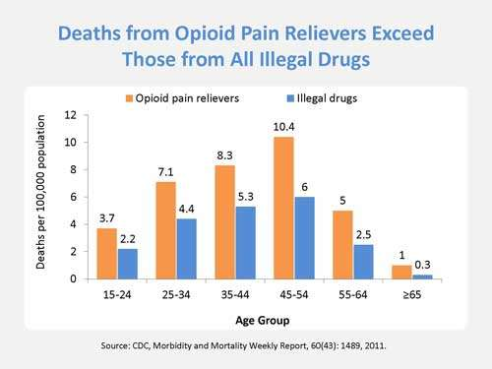

Figure . Compares the number of opioid pain reliever related deaths with deaths that can be attributed to all other illegal drugs across the different age groups.

**Source: 2**

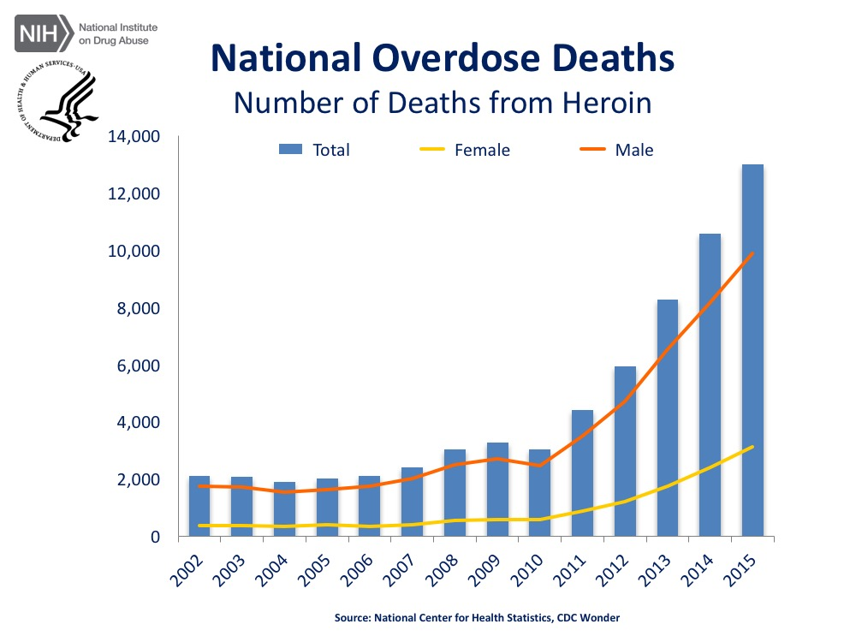

Figure . The total number of U.S. overdose deaths attributed to heroin from 2002-2015. There was a 6.2 fold increase in the total number of deaths.

**Source:8**

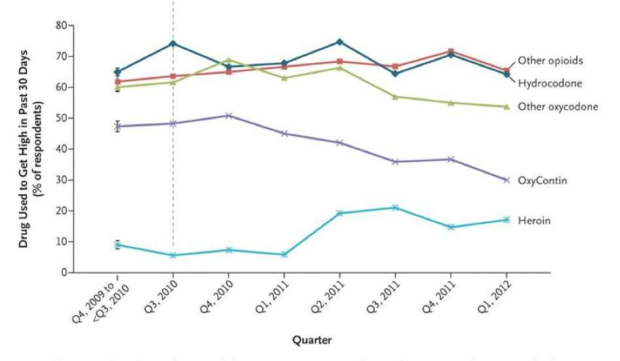

**Figure 3. Increasing evidence that users of prescription opioids are switching to heroin after the introduction of an abuse deterrent in OxyContin.**

**Source: 9**

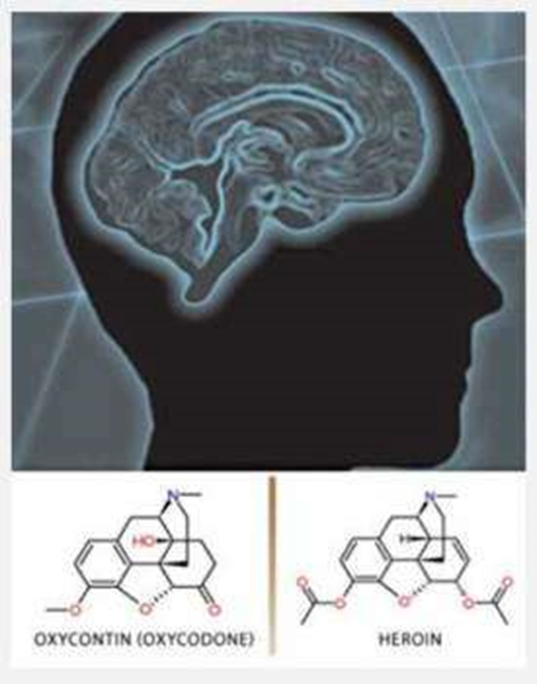

**Figure 4. Chemical structural similarity between prescription opioids and heroin molecule.**

**Source: 9**

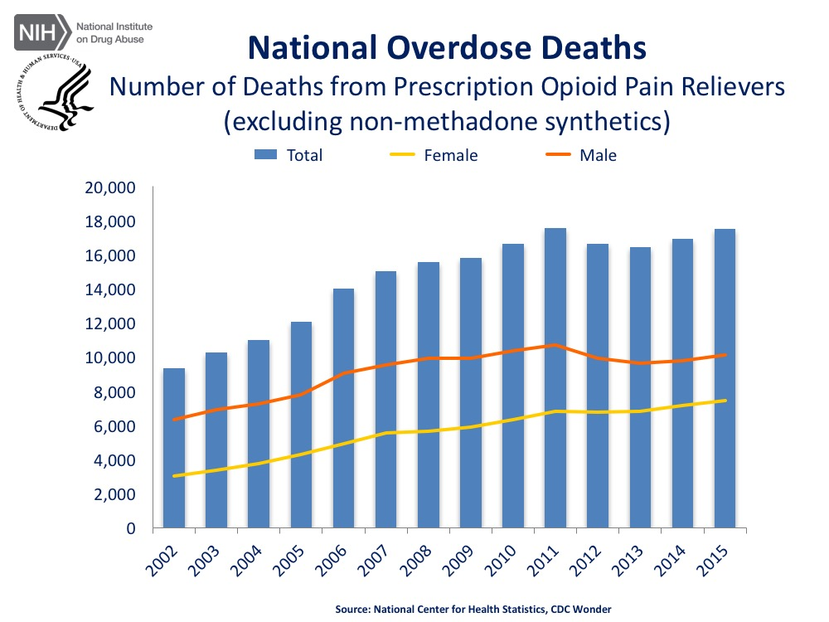

**Figure 5. Number of Deaths from Prescription Opioid Pain Relievers (excluding non-methadone synthetics which is category dominated by illicit fentanyl). It shows a 1.9-fold increase in the total number of deaths from 2002-2011, and has remained stable since then.**

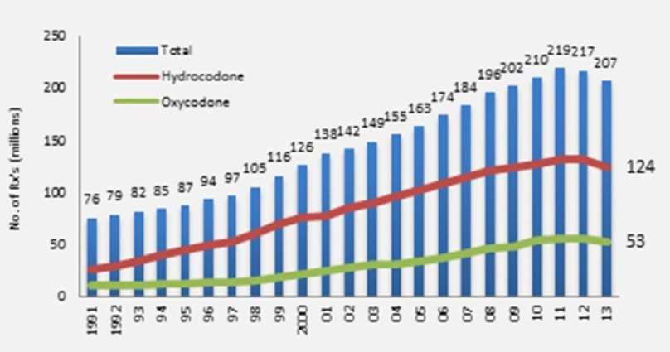

**Figure 6. Trend showing the rise in the number of opioid prescriptions from 1991-2013.**

**Source: 9**

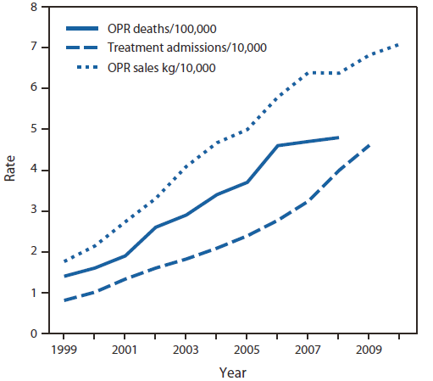

**Figure 7. Increase in OPR sales is positively associated to increased OPR deaths.**

**Source: 35**

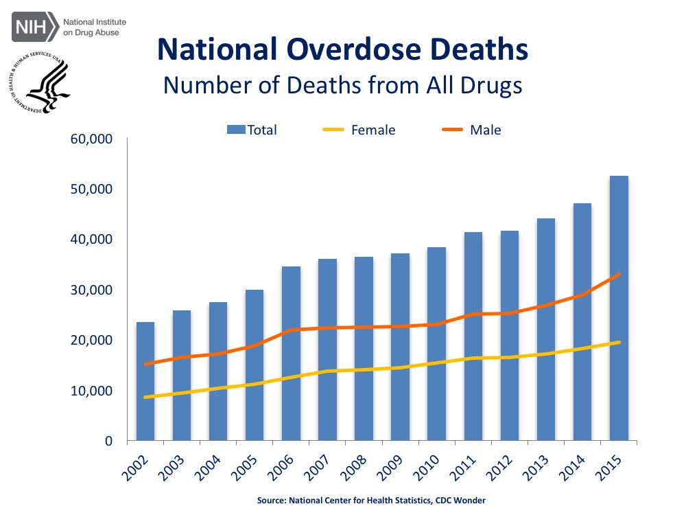

**Figure 8. National Overdose Deaths—Total number of U.S. overdose deaths involving all drugs from 2002 to 2015 that shows an increase by 2.2-fold.**

**Source: 9**

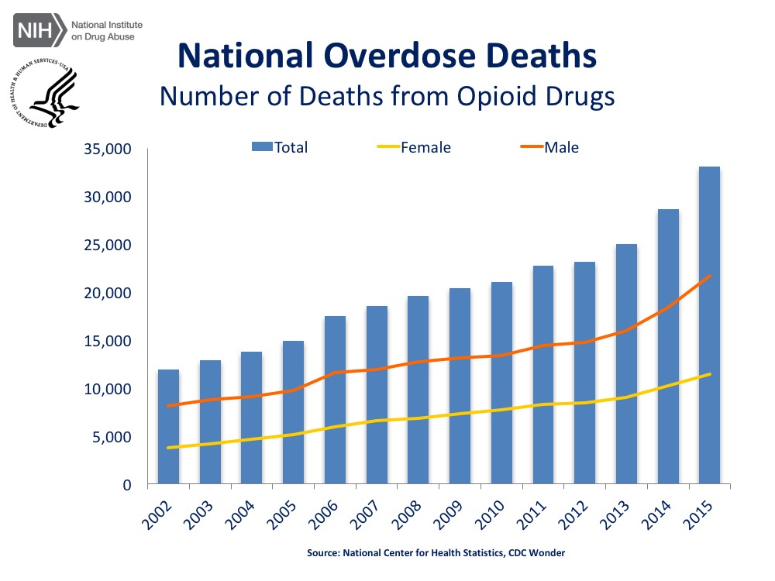

Figure . Total number of U.S. overdose deaths involving opioid drugs from 2002 to 2015 that includes opioid analgesics, along with heroin and illicit synthetic opioids. From 2002 to 2015 there was a 2.8-fold increase in the total number of deaths.

Source: 6



Figure . The bar graph compares the percentage of adolescents who abused illegal drugs and prescription medication.

Source: 2

**APPENDIX B: CONSENT TO PRESCRIBE OPIOID MEDICATION TO A MINOR**

***Background***: Pennsylvania law requires that in most non-emergency circumstances, a minor may only be prescribed opioid medications (morphine-like drugs) if the prescriber first discusses the potential risks associated with the medication with the minor and also with the minor’s parent, guardian, or an adult who has a valid health care proxy to consent to the minor’s medical treatment. This consent form memorializes that the prescriber discussed the risks associated with opioid medications with you and the minor-patient. Please review the information listed and put your initials next to each item after you and the minor-patient have discussed the risks with the prescriber and feel you understand and accept what each statement says.

|  |
| --- |
| Patient Name: |
| Patient’s Date of Birth: |
| Name of Parent/Guardian/Authorized Adult: |

Signature of parent/guardian/authorized adult Dated

Circle the appropriate relationship

|  |
| --- |
| Name of Medication (brand or generic name): |
| Quantity: |
| Amount of initial dose: |
| Number of refills: * |

*The medication being prescribed above is a controlled substance containing an opioid. This means the medication has been identified by the United States Drug Enforcement Administration as having a potential for abuse, dependence or misuse.*

As the responsible prescriber, I certify that I have discussed with both the minor, as well as with the minor’s parent/guardian/authorized adult the following items:

Adult Initial

1. The risks of addiction and overdose associated with the controlled substance containing an opioid.­­­­­­­­­­­­­
2. The increased risk of addiction to controlled substances to individuals suffering from mental or substance use disorders.
3. The dangers of taking a controlled substance containing an opioid with benzodiazepines, alcohol or other central nervous system depressants.
4. Any other information in the patient counseling information section of the labeling for controlled substances containing an opioid that I deemed necessary.

Signature of prescriber Dated

* If the adult consenting to treatment is someone other than a parent or guardian (i.e. an authorized adult acting pursuant to a valid health care proxy), the prescription for an opioid-containing drug must be limited to not more than a single, 72-hour supply and must indicate on the prescription the quantity that is be dispensed pursuant to the prescription. (35 Pa.C.S. 52A04(c))

**This form must be maintained in the minor’s record with the prescriber. Source:105**

**APPENDIX C: PATIENT COUNSELING DOCUMENT**

|  |
| --- |
| **Patient Counseling Document on Extended- Release / Long-Acting Opioid Analgesics** |
| **Patient**  **Name:** |
| **The DOs and DON’Ts of**  **Extended-Release / Long - Acting Opioid Analgesics** |
| **DO:**   * Read the **Medication Guide** * Take your medicine exactly as prescribed * Store your medicine away from children and in a safe place * Flush unused medicine down the toilet * Call your healthcare provider for medical advice about side effects. You may report side effects to FDA at 1-800-FDA-1088. |
| **Call 911 or your local emergency service right away if:**   * You take too much medicine * You have trouble breathing, or shortness of breath * A child has taken this medicine |
| **Talk to your healthcare provider:**   * If the dose you are taking does not control your pain * About any side effects you may be having * About all the medicines you take, including over-the- counter medicines, vitamins, and dietary supplements |
| **DON’T:**   * **Do not** give your medicine to others * **Do not** take medicine unless it was prescribed for you * **Do not** stop taking your medicine without talking to your healthcare provider * **Do not** break, chew, crush, dissolve, or inject your medicine. If you cannot swallow your medicine whole, talk to your healthcare provider. * **Do not** drink alcohol while taking this medicine |
| For additional information on your medicine go to:  **dailymed.nlm.nih.gov** |

|  |
| --- |
| **Patient Counseling Document on Extended- Release / Long-Acting Opioid Analgesics** |
| **Patient Name:** |
| **Patient Specific Information** |
|  |
|  |
|  |
|  |
|  |
|  |
| **Take this card with you every time you see your healthcare provider and tell him/her:**   * Your complete medical and family history, including any history of substance abuse or mental illness * The cause, severity, and nature of your pain * Your treatment goals * All the medicines you take, including over-the- counter (non-prescription) medicines, vitamins, and dietary supplements * Any side effects you may be having   **Take your opioid pain medicine exactly as prescribed by your healthcare provider.** |

Patient Counseling Document (PCD) for Extended Release/ Long-Acting Opioids. Source: 113

# BIBLIOGRAPHY

1. Chen LH, Hedegaard H, Warner M. Drug-poisoning deaths involving opioid analgesics: United States, 1999-2011. *NCHS data brief.* 2014(166):1-8.

2. Prescription and Over-the-Counter Medications:drug facts.National Institute on Drug Abuse; National Institutes of Health; U.S. Department of Health and Human Services. https://www.drugabuse.gov/publications/drugfacts/prescription-over-counter-medications. Published November 2015. Accessed January 8,2017.

3. Laxmaiah Manchikanti M, Standiford Helm I, MA JWJ, PhD VP, MSc JSG, DO P. Opioid epidemic in the United States. *Pain physician.* Vol 152012:ES9-ES38.

4. Volkow ND, McLellan TA, Cotto JH, Karithanom M, Weiss SR. Characteristics of opioid prescriptions in 2009. *Jama.* 2011;305(13):1299-1301.

5. *Center for Behavioral Health Statistics and Quality (CBHSQ). Behavioral health trends in the United States:Results from the 2014 National Survey on Drug Use and Health.September 2015.CBHSQ,Rockville, MD.*https://www.samhsa.gov/data/sites/default/files/NSDUH-FRR1-2014/NSDUH-FRR1-2014.pdf*. Accessed December 22,2016.*

6. Pradip et al. Associations of Nonmedical Pain Reliever Use and Initiation of Heroin Use in the US. Center for behavioral Health Statistics and QualityData Review. SAMHSA (2013) http://www.samhsa.gov/data/2k13/DataReview/DR006/nonmedical-pain-reliever-use-2013.htm. Accessed January 7,2017.

7. Today’s Heroin Epidemic: More people at risk, multiple drugs abused.Centers for Disease Control and Prevention. https://www.cdc.gov/vitalsigns/heroin/index.html. Published July 7, 2015.Accessed December 22,2016.

8. *Centers for Disease Control and Prevention (CDC).Increases in Drug and Opioid Overdose Deaths — United States, 2000–2014.January 2016. CDC,Atlanta, GA.* https://www.cdc.gov/mmwr/preview/mmwrhtml/mm6450a3.htm*. Accessed December 22,2016.*

9. National Institute on Drug Abuse(NIDA).America’s addiction to opioids: heroin and prescription drug abuse. https://www.drugabuse.gov/about-nida/legislative-activities/testimony-to-congress/2016/americas-addiction-to-opioids-heroin-prescription-drug-abuse. Published on May 14,2014. Accessed January 7,2017.

10. Opioid. Wikipedia.https://en.wikipedia.org/wiki/Opioid#cite_note-:. Published 17-122 December 2016. Accessed December 22,2016.

11. Dionne R, Moore P. Opioid Prescribing in Dentistry: Keys for Safe and Proper Usage. *Compendium of continuing education in dentistry (Jamesburg, NJ: 1995).* 2016;37(1):29-32; quiz34.

12. Lauren Brande.Prescription opioid addiction: what is causing the epidemic? Drugabuse.com. http://drugabuse.com/library/prescription-opioid-addiction/. Accessed December 26,2016.

13. Levitz E. The Opioid Epidemic Is a Symptom of Toxic Greed.*New York magazine.*December 21, 2016.http://nymag.com/daily/intelligencer/2016/12/the-opioid-epidemic-is-a-symptom-of-toxic-greed.html. Accessed December 22,2016.

14. Opioid Painkiller Prescribing: Where You Live Makes a Difference.Centers for Disease Control and Prevention. https://www.cdc.gov/vitalsigns/opioid-prescribing/index.html. Published July 1, 2014. Accessed December 22,2016.

15. Baker JA, Avorn J, Levin R, Bateman BT. Opioid Prescribing After Surgical Extraction of Teeth in Medicaid Patients, 2000-2010. *Jama.* 2016;315(15):1653-1654.

16. Substance Abuse and Mental Health Services Administration. Results from the 2009 National Survey on Drug Use and Health: volume 1: summary of national findings. Rockville, MD: US Department of Health and Human Services, Substance Abuse and Mental Health Services Administration, Office of Applied Studies; 2010. Available at http://oas.samhsa.gov/nsduh/2k9nsduh/2k9resultsp.pdf . Accessed on December 22,2016.

17. Johnston LD, O’Malley PM, Bachman JG, Schulenberg JE. Secondary School Students: 2009. Bethesda, Md.: National Institute on Drug Abuse; 2010:6. National Institutes of Health publication 10-7584. Monitoring the Future: National Results on Drug Use, 1975-2009; vol 1.

18. Levy B, Paulozzi L, Mack KA, Jones CM. Trends in opioid analgesic–prescribing rates by specialty, US, 2007–2012. *American journal of preventive medicine.* 2015;49(3):409-413.

19. Hersh E, Kane W, O'Neil M, et al. Prescribing recommendations for the treatment of acute pain in dentistry. *Compendium of continuing education in dentistry (Jamesburg, NJ: 1995).* 2011;32(3):22, 24-30; quiz 31-22.

20. O'Neil M, Association AD. The ADA practical guide to substance use disorders and safe prescribing. *Hoboken (NJ): Wiley-Blackwell.* 2015.

21. American Dental Association. Statement on the Use of Opioids in the Treatment of Dental Pain. http://www.ada.org/en/about-the-ada/ada-positions-policies-and-statements/statement-on-opioids-dental-pain. Published October 2016. Accessed February 20, 2017. .

22. Moore PA, Dionne RA, Cooper SA, Hersh EV. Why do we prescribe Vicodin? *The Journal of the American Dental Association.* 2016;147(7):530-533.

23. Moore P, Nahouraii H, Zovko J, Wisniewski S. Dental therapeutic practice patterns in the US II. Analgesics, corticosteroids, and antibiotics. *General dentistry.* 2005;54(3):201-207; quiz 208, 221-202.

24. Tufts Health Care Institute Program on Opioid Risk Management. Executive Summary. The Role of Dentists in Preventing Opioid Abuse. Tufts Health Care Institute Program on Opioid Risk Management 12th Summit Meeting. March 11-12, 2010. Available at: www.thci.org/opioid/mar10docs/executivesummary.pdf. Accessed December 23,2016.

25. McCauley JL, Hyer JM, Ramakrishnan VR, et al. Dental opioid prescribing and multiple opioid prescriptions among dental patients: Administrative data from the South Carolina prescription drug monitoring program. *J Am Dent Assoc.* 2016;147(7):537-544.

26. Sean Esteban McCabe BTW, Carol J. Boyd. Leftover prescription opioids and nonmedical use among high school seniors: a multi-cohort national study. *Journal of Adolescent Health.* 2013;52:480-485.

27. Miech, R. A., Johnston, L. D., O'Malley, P. M., Keyes, K. M., & Heard, K. (2015, October 28). National press release, "Prescription pain relievers place teens at greater risk for future drug misuse." University of Michigan News Service, Ann Arbor, 2 pp.

28. Theresa Pablos.Kids use less than half of prescribed opioids.DrBicuspid.com. http://www.drbicuspid.com/index.aspx?sec=sup&sub=apm&pag=dis&ItemID=318826. Published November 18, 2015. Accessed December 25,2016.

29. Moore PA.Second Opinion: Response to 'JAMA: Too many opioids prescribed for extractions'.DrBicuspid.com. http://www.drbicuspid.com/index.aspx?sec=wom&pag=dis&ItemID=319531. Published April 7, 2016. Accessed December 25,2016.

30. Control CfD, Prevention. CDC’s top ten: 5 health achievements in 2013 and 5 health threats in 2014. *Atlanta, GA: CDC* http://blogs *cdc gov/cdcworksforyou24-7/2013/12/cdc% E2.* 2014;80.

31. Wide-ranging online data for epidemiologic research (WONDER). Centers for Disease Control and Prevention, National Center for Health Statistics. http://wonder.cdc.gov. Accessed December 22,2016.

32. Florence CS, Zhou C, Luo F, Xu L. The economic burden of prescription opioid overdose, abuse, and dependence in the United States, 2013. *Medical Care.* 2016;54(10):901-906.

33. Costs of US prescription opioid epidemic estimated at $78. 5 billion. ScienceDaily. https://www.sciencedaily.com/releases/2016/09/160914105756.htm. Published September 14, 2016. Accessed January 10, 2017.

34. US Department of Health and Human Services. Drug Abuse Warning Network, 2011: National Estimates of Drug-Related Emergency Department Visits. http://www.samhsa.gov/data/2k13/DAWN2k11ED/DAWN2k11ED.htm. Accessed December 26,2016.

35. Kolodny A, Courtwright DT, Hwang CS, et al. The prescription opioid and heroin crisis: a public health approach to an epidemic of addiction. *Annual review of public health.* 2015;36:559-574.

36. Jones CM, Mack KA, Paulozzi LJ. Pharmaceutical overdose deaths, united states, 2010. *Jama.* 2013;309(7):657-659.

37. Nathaniel P. Katz HGBAC. Volume of Prescription Opioids Used Nonmedically in the United States. *Journal of Pain & Palliative Care Pharmacotherapy.* 2010;24(2):141-144.

38. Jacqueline Mitchell.Prescription for Trouble : with painkillers easily subject to abuse, dentists are trying to rein in overuse by patients.TuftsNow. http://now.tufts.edu/articles/prescription-trouble. Published April 13, 2012.Accessed December 26,2016.

39. US Department of Health and Human Services. Results from the 2012 National Survey on Drug Use and Health: Summary of National Findings. http://www.samhsa.gov/data/NSDUH/2012SummNatFindDetTables/NationalFindings/NSDUHresults2012.htm. Accessed December 26,2016.

40. Centers for Disease Control and Prevention. Adult use of prescription opioid pain medications: Utah, 2008.MMWRMorbMortalWkly Rep 2010;59:153-7.

41. Pablos T. 1 out of 5 adults shares opioid medication.DrBicuspid.com. http://www.drbicuspid.com/index.aspx?sec=sup&sub=apm&pag=dis&ItemID=319956. Published June 22,2016. Accessed December 24, 2016.

42. Seehusen DA, Edwards J. Patient practices and beliefs concerning disposal of medications. *The Journal of the American Board of Family Medicine.* 2006;19(6):542-547.

43. Top 200 Drugs–US Only. RxList website. http://www.rxlist.com/script/main/hp.asp. Accessed December 26,2016.

44. Iwanicki JL, Severtson SG, McDaniel H, et al. Abuse and Diversion of Immediate Release Opioid Analgesics as Compared to Extended Release Formulations in the United States. *PloS one.* 2016;11(12):e0167499.

45. The Extended-Release and Long-Acting Opioid Analgesics Risk Evaluation and Mitigation Strategy (REMS). http://www.er-la-opioidrems.com/IwgUI/rems/products.action. Updated January 11, 2017. Accessed January 22, 2017. .

46. IMS Government Solutions, Inc., National Prescription Audit (NPA), 2012.

47. Cicero TJ, Ellis MS, Harney J. Abuse prevalence and preference of immediate release versus extended release opioids.RADARS® System Technical Report, 2015-Q3.

48. Lankenau SE, Teti M, Silva K, Bloom JJ, Harocopos A, Treese M. Initiation into prescription opioid misuse among young injection drug users. Int J Drug Policy. 2012; 23(1):37–44.

49. Denisco RC, Kenna GA, O’Neil MG, et al. Prevention of prescription opioid abuse: the role of the dentist. *The Journal of the American Dental Association.* 2011;142(7):800-810.

50. Domino D. 100M opioids unused annually after oral surgery. DrBiscuspid.com. http://www.drbicuspid.com/index.aspx?sec=ser&sub=def&pag=dis&ItemID=320461. Published October 7, 2016. Accessed December 24,2016.

51. Hannah KL. Understanding the cultures of prescription drug abuse, misuse, addiction, and diversion. *West Virginia Medical Journal.* 2010;106(4):64-71.

52. Ashrafioun L, Edwards PC, Bohnert AS, Ilgen MA. Nonmedical use of pain medications in dental patients. *The American journal of drug and alcohol abuse.* 2014;40(4):312-316.

53. Wright ER, Kooreman HE, Greene MS, Chambers RA, Banerjee A, Wilson J. The iatrogenic epidemic of prescription drug abuse: county-level determinants of opioid availability and abuse. *Drug Alcohol Depend.* 2014;138:209-215.

54. Sansone RA, Sansone LA. Doctor shopping: a phenomenon of many themes. *Innovations in clinical neuroscience.* 2012;9.

55. Dowell D, Haegerich TM, Chou R. CDC guideline for prescribing opioids for chronic pain—United States, 2016. *Jama.* 2016;315(15):1624-1645.

56. Pennsylvania guidelines on the use of opioids in dental practice. PA Department of Health. https://www.padental.org/Images/OnlineDocs/ResourcesPrograms/Practice%20Management/opioid_dental_prescribing_guidelines3_13_15.pdf. Published June 15,2015.Accessed December 26,2016.

57. NIDAMED: Medical & Health Professionals.National Institute of Drug Abuse. https://www.drugabuse.gov/nidamed-medical-health-professionals. Accessed December 26,2016.

58. Mattoo SK, Singh SM, Bhardwaj R, Kumar S, Basu D, Kulhara P. Prevalence and correlates of epileptic seizure in substance‐abusing subjects. *Psychiatry and clinical neurosciences.* 2009;63(4):580-582.

59. Le Merrer J, Becker JA, Befort K, Kieffer BL. Reward processing by the opioid system in the brain. *Physiological reviews.* 2009;89(4):1379-1412.

60. The Effects of Opiates on the Mind and Body. Rebos. http://www.rebostreatment.com/effects-opiates-mind-body/. Published December 17, 2015. Accessed January 29, 2017.

61. Williams JT, Ingram SL, Henderson G, et al. Regulation of µ-opioid receptors: Desensitization, phosphorylation, internalization, and tolerance. *Pharmacological reviews.* 2013;65(1):223-254.

62. Muller GJ, 2nd. Addressing after-hours requests for prescription drugs. *J Am Dent Assoc.* 2014;145(4):389-390.

63. O'Shea J, Law F, Melichar J. Opioid dependence. *BMJ Clinical Evidence.* 2009;2009.

64. Federation of State Medical Boards of the US. Model guidelines for the use of controlled substances for the treatment of pain: A policy document of the Federation of State Medical Boards of the United States, Inc. Dallas, TX, 1998.

65. Phillips DM. JCAHO pain management standards are unveiled. *JAMA: The Journal of the American Medical Association.* 2000;284(4):428-429.

66. Quinones S. Dreamland: The true tale of America’s opiate epidemic. *Health Affairs.* 2015;34:9.

67. A fresh view of opioids. The BackLetter 2011; 26:4, 37.

68. Board INC. *Report of the International Narcotics Control Board for.* United Nations Publications; 1968.

69. Rudd RA, Aleshire N, Zibbell JE, Gladden RM. *Increases in Drug and Opioid Overdose Deaths--United States, 2000-2014.*  Jan 01 2016. 0149-2195.

70. Center for Behavioral Health Statistics and Quality. (2016). Key substance use and mental health indicators in the United States: Results from the 2015 National Survey on Drug Use and Health (HHS Publication No.SMA 16-4984, NSDUH Series H-51). Retrieved from http://www.samhsa.gov/data/. Accessed on January 8,2017.

71. Centers for Disease Control and Prevention, National Center for Health Statistics. Underlying Cause of Death 1999-2015 on CDC WONDER Online Database, released December, 2016. Data are from the Multiple Cause of Death Files, 1999-2015, as compiled from data provided by the 57 vital statistics jurisdictions through the Vital Statistics Cooperative Program. http://wonder.cdc.gov/ucdicd10.html. Accessed on January 8,2017.

72. Centers for Disease Control and Prevention(CDC). Vital Signs: Overdoses of Prescription Opioid Pain Relievers --- United States, 1999--2008. November, 2011. CDC, Atlanta,GA. https://www.cdc.gov/mmwr/preview/mmwrhtml/mm6043a4.htm. Accessed December 22,2016.

73. Fortuna RJ, Robbins BW, Caiola E, Joynt M, Halterman JS. Prescribing of controlled medications to adolescents and young adults in the United States. Pediatrics. 2010;126(6):1108-1116. .

74. Ravi Katari DB. Patent Monopolies and the Costs of Mismarketing Drugs. *Center for Economic and Policy Research.* April 2015. http://cepr.net/documents/publications/mismarketing-drugs-2015-04.pdf. Accessed December 22,2016.

75. Chao Zhou CSF, Deborah Dowell. Payments For Opioids Shifted Substantially To Public And Private Insurers While Consumer Spending Declined, 1999–2012. *Health Affairs.* 2016;35(5):824-831.

76. National Institute of Drug Abuse: Ovedose Death rates. https://www.drugabuse.gov/related-topics/trends-statistics/overdose-death-rates. Updated on January,2017. Accessed on January 25,2017.

77. InfoFacts N. Heroin. *National Institute on Drug Abuse* https://wwwdrugabusegov/publications/research-reports/heroin/how-heroin-linked-to-prescription-drug-abuse *Accessed January 8,2017.* 2010;29.

78. Hydrocodone. Available at: http://www.deadiversion.usdoj.gov/drug_chem_info/hydrocodone.pdf. Accessed December 22, 2016.

79. Becker DE. Pain Management: Part 1: Managing Acute and Postoperative Dental Pain. *American Dental Society of Anesthesiology.* 2010;Anesth Prog 57:67-79.

80. Mutlu I, Abubaker AO, Laskin DM. Narcotic prescribing habits and other methods of pain control by oral and maxillofacial surgeons after impacted third molar removal. *Journal of Oral and Maxillofacial Surgery.* 2013;71(9):1500-1503.

81. Moore PA, Hersh EV. Combining ibuprofen and acetaminophen for acute pain management after third-molar extractions: translating clinical research to dental practice. *The Journal of the American Dental Association.* 2013;144(8):898-908.

82. US Food and Drug Administration. Acetaminophen prescription products limited to 325 mg per dosage unit: drug safety communication. Available at: www.fda.gov/Safety/MedWatch/SafetyInformation/SafetyAlertsforHumanMedicalProducts/ucm239955.htm. Accessed December 24, 2016.

83. Lembke A. Why doctors prescribe opioids to known opioid abusers. *New England Journal of Medicine.* 2012;367(17):1580-1581.

84. Hydrocodone drugs reclassified.California Dental Association. http://www.cda.org/news-events/hydrocodone-drugs-reclassified. Published August 22,2016. Accessed December 24,2016.

85. Volkow ND, McLellan TA. Curtailing diversion and abuse of opioid analgesics without jeopardizing pain treatment. *Jama.* 2011;305(13):1346-1347.

86. Evaluating an Individual’s Treatment Needs: Addiction among Socioeconomic Groups.American Addiction Centers.http://sunrisehouse.com/addiction-demographics/socioeconomic-groups/. Accessed December 22,2016.

87. Gandhi T, Best K. Educate Patients about Proper Disposal of Unused Rx Medications-For Their Safety. *Current Psychiatry.* 2015;14(4):60.

88. Brandon C. Maughana EVH, Frances S. Shoferd, Kathryn J. Wannerd, Elizabeth Archerd, Lee R. Carrascoc, Karin V. Rhodes. Unused opioid analgesics and drug disposal following outpatient dental surgery: a randomized controlled trial. *Drug and Alcohol Dependence* 2016;168:328-334.

89. Cicero TJ, Ellis MS, Surratt HL, Kurtz SP. The changing face of heroin use in the United States: a retrospective analysis of the past 50 years. *JAMA Psychiatry.* 2014;71(7):821-826.

90. Rigoni GC. Drug Utilization for Immediate- and Modified Release Opioids in the US. Silver Spring, Md.: Division of Surveillance, Research & Communication Support, Office of Drug Safety, Food and Drug Administration; 2003. http://slideplayer.com/slide/4816132/. Accessed December 23,2016.

91. McCauley JL, Leite RS, Melvin CL, Fillingim RB, Brady KT. Dental opioid prescribing practices and risk mitigation strategy implementation: Identification of potential targets for provider-level intervention. *Substance abuse.* 2016;37(1):9-14.

92. NIH Pain Consortium Centers of Excellence in Pain Education sponsored by the National Institute on Drug Abuse, NIH, Contract # HHSN271201500075C. Centers of Excellence in Pain Education (CoEPEs). Reference #: NO1DA-15-4427,2015. http://painconsortium.nih.gov/NIH_Pain_Programs/CoEPES.html. Accessed December 25, 2016.

93. White House.Epidemic : Responding to America's Prescription Drug Abuse Crisis. https://obamawhitehouse.archives.gov/sites/default/files/ondcp/policy-and-research/rx_abuse_plan.pdf. Accessed on March 19th, 2017.

94. Stephen B. Maebius JAW, David Rosen, Sean Tu. *Patenting Risk Evaluation & Mitigation Strategies For Pharmaceuticals: A New Life Cycle Management Target for Patents?*  01/02/2009 2009.

95. Masoudi, G.F. ‘‘Legal Developments in the Enforcement of Food and Drug Law’’ 63 Food Drug L.J. 585 at 586 (2008).

96. Scudder L, Dal Pan GJ. The New Opioid REMS: The FDA View. Medscape. http://www.medscape.com/viewarticle/770644#vp_1. Published September 19, 2012. Accessed March 19, 2017. .

97. FDA. Risk Evaluation and Mitigation Strategy (REMS) for Extended-Release and Long-Acting Opioids.Silver Spring, MD: FDA; 2015.

98. U.S. Food and Drug Administration.Questions and Answers: FDA approves a Risk Evaluation and Mitigation Strategy (REMS) for Extended-Release and Long-Acting (ER/LA) Opioid Analgesics. https://www.fda.gov/Drugs/DrugSafety/InformationbyDrugClass/ucm309742.htm. Last updated March 1st, 2013. Accessed March 19th, 2017.

99. Cepeda MS, Coplan PM, Kopper NW, Maziere J-Y, Wedin GP, Wallace LE. ER/LA Opioid Analgesics REMS: Overview of Ongoing Assessments of Its Progress and Its Impact on Health Outcomes. *Pain Medicine.* 2016:pnw129.

100. Extended Release/Long-Acting Opioids: Basic Patient Counseling Talking Points. Resources | SCOPE of Pain (Safe and Competent Opioid Prescribing Education) | Continuing Medical Education | School of Medicine | Boston University. https://www.scopeofpain.com/tools-resources/. Accessed January 19, 2017.

101. The American Academy of Pain Medicine. Eight Opioid Safety Principles for Patients and Caregivers. http://www.painmed.org/files/eight-opioid-safety-practices-for-patients-and-caregivers.pdf. Accessed on January 27,2017.

102. How to Dispose of Unused Medicines . FDA Consumer Health Information. http://www.fda.gov/downloads/Drugs/ResourcesForYou/Consumers/BuyingUsingMedicineSafely/UnderstandingOver-the-CounterMedicines/ucm107163.pdf. Published December 2013. Accessed January 22, 2017. .

103. McCauley JL, Back SE, Brady KT. Pilot of a brief, web-based educational intervention targeting safe storage and disposal of prescription opioids. *Addictive behaviors.* 2013;38(6):2230-2235.

104. Snow K, Deo P. The Deadly Triangle: Dentists, Drugs and Dependence. NBCNews.com. http://www.nbcnews.com/health/health-news/deadly-triangle-dentists-drugs-dependence-n596601. Published June 21, 2016. Accessed March 6, 2017. .

105. Pennsylvania Department of Health. Professional Licensing.Consent to prescribe opioid medication to a minor. http://www.dos.pa.gov/ProfessionalLicensing/BoardsCommissions/Documents/Act%20125-Consent%20to%20Prescribe%20Opioid%20Medication%20to%20Minor%2020170123.pdf. Published February 4, 2017. Accessed February 20, 2017.

106. New Opioid Consent Form Now Required. Ohio AAP. http://ohioaap.org/opioid-consent-form. Published October 1, 2014. Accessed March 19, 2017. .

107. Huff C. States aim to limit opioid prescriptions. ACP Internist. https://acpinternist.org/archives/2016/10/laws.htm. Published October 1, 2016. Accessed March 19, 2017. .

108. Vestal C. In States, Some Resistance to New Opioid Limits. The Pew Charitable Trusts. http://www.pewtrusts.org/en/research-and-analysis/blogs/stateline/2016/06/28/in-states-some-resistance-to-new-opioid-limits. Published June 28, 2016. Accessed March 20, 2017. .

109. Ilgen M, Edwards P, Kleinberg F, Bohnert AS, Barry K, Blow FC. The prevalence of substance use among patients at a dental school clinic in Michigan. *J Am Dent Assoc.* 2012;143(8):890-896.

110. McNeely J, Wright S, Matthews AG, et al. Substance-use screening and interventions in dental practices: survey of practice-based research network dentists regarding current practices, policies and barriers. *J Am Dent Assoc.* 2013;144(6):627-638.

111. Gudin JA. The changing landscape of opioid prescribing: long-acting and extended-release opioid class-wide Risk Evaluation and Mitigation Strategy. *Therapeutics and clinical risk management.* 2012;8:209-217.

112. Cheatle MD, Barker C. Improving opioid prescription practices and reducing patient risk in the primary care setting. *Journal of pain research.* 2014;7:301-311.

113. US Food and Drug Administration. Extended-release (er) and long-acting (la) opioid analgesics risk evaluation and mitigation strategy (REMS). http://www.fda.gov/downloads/Drugs/DrugSafety/PostmarketDrugSafetyInformationforPatientsandProviders/UCM311290.pdf. Accessed January 22,2017.

114. American Dental Association. Dentistry's role in preventing the opioid abuse. http://www.ada.org/en/publications/ada-news/2016-archive/july/a-message-from-the-ada-president. Published July 5, 2016. Accessed March 22,2017.

115. Centers for Disease Control and Prevention. CDC Guideline for Prescribing Opioids for Chronic Pain — United States MM, 2016 / 65(1);1–49. Acccessed March 20, 2017.

116. Pennsylvania Dental Association. Pennsylvania Prescription Drug Monitoring Program. https://www.padental.org/Online/Resources___Programs/Opioids/Pennsylvania_Prescription_Drug_Monitoring_Program.aspx. Accessed March 22, 2017. .

117. Department of Veteran Affairs (VA) and Department of Defense (DoD). Taking opioids responsibly for your safety and the safety of others : Patient information guide on long-term opioid therapy for Chronic pain. http://www.healthquality.va.gov/guidelines/Pain/cot/OpiodTheraphyforChronicPainPatientTool20May2013print.pdf. Accessed on January 27, 2017.

118. Rose G. Sick individuals and sick populations. *International journal of epidemiology.* 2001;30(3):427-432.

119. Compton WM, Volkow ND. Major increases in opioid analgesic abuse in the United States: concerns and strategies. *Drug and alcohol dependence.* 2006;81(2):103-107.

120. Oakley M, O'Donnell J, Moore PA, Martin J. The rise in prescription drug abuse: raising awareness in the dental community. *Compendium of continuing education in dentistry (Jamesburg, NJ : 1995).* 2011;32(6):14-16, 18-22; quiz 24, 36.

121. Zyoud SH, Waring WS, Al-Jabi SW, Sweileh WM, Awang R. The 100 most influential publications in paracetamol poisoning treatment: a bibliometric analysis of human studies. *SpringerPlus.* 2016;5(1):1534.

122. Osborne ZP, Bryant SM. Patients discharged with a prescription for acetaminophen-containing narcotic analgesics do not receive appropriate written instructions. *The American journal of emergency medicine.* 2003;21(1):48-50.

123. Vicodin. http://www.rxlist.com/vicodin-drug.htm. Accessed on January 29,2017.

124. Medication guide. OXYCONTIN (oxycodone hydrochloride controlled-release) Tablets. Stamford, CT: Purdue Pharma LP; 2010.

125. Medication guide. EXALGO (hydromorphone HCl) Extended-release tablets. Hazelwood, MO: Mallinckrodt Inc, a Covidien company; 2010.

126. U.S. Department of Health and Human Services. How to Dispose of Unused Medicines. http://www.fda.gov/ForConsumers/ConsumerUpdates/ucm101653.htm. Updated January 19, 2017. Accessed January 23, 2017. .

127. US Food and Drug Administration. Medication disposal: questions and answers. http://www.fda.gov/Drugs/ResourcesForYou/Consumers/BuyingUsingMedicineSafely/EnsuringSafeUseofMedicine/SafeDisposalofMedicines/ucm186188.htm. Accessed January 22, 2017.

128. US Food and Drug Administrat ion. Disposal of unused medicines: what you should know. http://www.fda.gov/Drugs/ResourcesForYou/Consumers/BuyingUsingMedicineSafely/EnsuringSafeUseofMedicine/SafeDisposalofMedicines/ucm186187.htm. Accessed January 22, 2017.

129. Peacock A, Bruno R, Larance B, et al. Same-day use of opioids and other central nervous system depressants amongst people who tamper with pharmaceutical opioids: A retrospective 7-day diary study. *Drug and alcohol dependence.* 2016;166:125-133.

130. Jones CM, Paulozzi LJ, Mack KA. Alcohol Involvement in Opioid Pain Reliever and Benzodiazepine Drug Abuse–Related Emergency Department Visits and Drug-Related Deaths — United States, 2010. Centers for Disease Control and Prevention. https://www.cdc.gov/MMWr/preview/mmwrhtml/mm6340a1.htm. Published October 10, 2014. Accessed January 23, 2017. .