Public Policy in Green Spaces:

Striving for Environmental Justice

by
Emily Grace Hendrickson
B. S., Chatham University 2008

Submitted to the Graduate Faculty of
Department of Behavioral and Community Health Sciences
Graduate School of Public Health in partial fulfillment
of the requirements for the degree of
Master of Public Health

University of Pittsburgh
2017

UNIVERSITY OF PITTSBURGH
GRADUATE SCHOOL OF PUBLIC HEALTH

This essay is submitted
by
Emily Grace Hendrickson

on

April 25, 2017
and approved by

Essay Advisor:
Mark Friedman, MPA, MSW, PhD ______________________________________
Assistant Professor
Behavioral and Community Health Sciences
Graduate School of Public Health
University of Pittsburgh

Essay Reader:
Leslie Horton, MA, PhD ______________________________________
Assistant Professor
Department of Psychiatry
University of Pittsburgh

Copyright © by Emily Grace Hendrickson
2017
ABSTRACT

Both social work and public health rely on the socio-ecological model of health, where the individual, household, community, political arena, economy, built and natural environments, and climate can all interact to enhance or challenge health. Green and open space, as part of the built and natural environments, plays a significant role in public health. Green space can improve the environment by cleaning the air and filtering water. Additionally, parks and green space may facilitate physical activity and could contribute to mental health and well-being. Literature is mixed, however, on whether these potential benefits are equitably distributed. Vulnerable populations may not enjoy equal access to green and open space, although access varies widely by city and there are limitations to study methods. Pittsburgh, like many cities, strives to balance the economic, environmental, and health benefits of open space with social and environmental justice through effective open space policy. Literature on green and open space can help inform policy to maximize community and public health benefits. Perfecting that green policy is of clear public health importance.
Mark Friedman, MPA, MSW, PhD

Public Policy in Green Spaces:

Striving for Environmental Justice

Emily Hendrickson, MPH
University of Pittsburgh, 2017

TABLE OF CONTENTS

1.0 Introduction 1
2.0 Value of Parks and Green Space 5
2.1 Environmental Benefits of Green Space 5
2.2 Economic Benefits of Green Space 7
2.3 Public Health Benefits of Green Space 8
3.0 Access to parks and green space 10
3.1 Proximity 11
3.2 Park Features 13
3.3 Qualitative Measures 14
4.0 Perceptions about parks and Green Space 25
4.1 Social 25
4.2 Park Design 26
5.0 Environmental Gentrification 27
6.0 Implications for Green Space Management 33
6.1 “Just Green Enough” 33
6.2 Participatory Approach 34
6.3 Urban Planning 35
6.4 Policy 36
6.5 Economics 37
7.0 Pittsburgh Green Space Policy 38
8.0 Conclusion 41
bibliography 42

List of tables

Table 1. Summary of literature examining access to green space and physical activity, benefits of green space. 16
List of figures

Figure 1: The socio-ecological model of health 2
Figure 2: Planner's Triangle of Sustainable Development 26
Figure 3: The Waterfront development in Homestead, PA. 29
Figure 4: The Almono development site in Hazelwood 31
Figure 5: Green and Open Space goal for Pittsburgh 39

Introduction
One of the main tenets of social work holds that the individual does not exist absent his or her social environment. “Fundamental to social work is attention to the environmental forces that create, contribute to, and address problems in living” (NASW, 2008). Likewise, public health recognizes the role that both individuals and social determinants play in health. Both fields point to the socioecological model of health (Figure 1) (Barton & Grant, 2006; Dahlgren & Whitehead, 1991). Rather than acting alone, an individual exists within a household, a community, culture, economy, political system, and natural and built environments. All these forces contribute to or challenge our health and well-being.
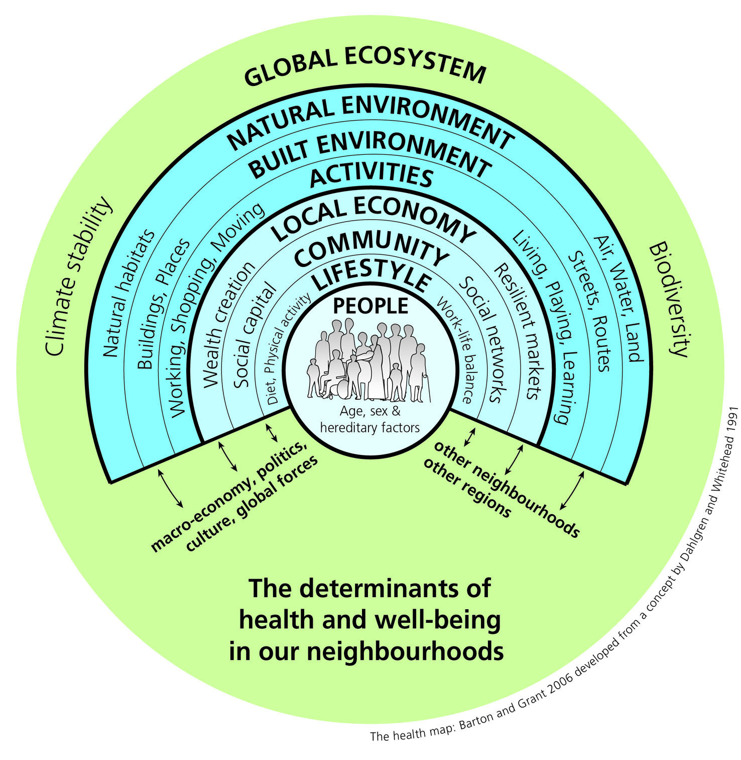
Figure 1: The socio-ecological model of health
This model demonstrates the complicated relationships between individuals and their communities, institutions, and environment. Health and well-being are intricately connected to the built and natural environments (Barton & Grant, 2006; Dahlgren & Whitehead, 1991).

Historically, the built environment has played an especially important role in public health. In the earliest days of epidemiology, John Snow used maps and logic to pinpoint the source of a London cholera epidemic as the Broad Street Pump. Despite the prevailing wisdom of “miasma” and bad air, he identified contaminated water as the source of disease. The city closed the well and saved countless lives (Kukaswadia, 2013). Since then controlling infectious disease became one of the 20th century’s great public health achievements. Urban infrastructure elements such as sewage disposal, solid waste disposal, and chlorination of drinking water help prevent diseases that were once fatal (Centers for Disease Control and Prevention, 1999a). Later, the built environment helped define another great public health achievement, motor vehicle safety. In the 1960s, a public health physician applied epidemiological principles to highway safety, resulting in improved road markings, breakaway signs and poles, better lighting, and the addition of guard rails and barriers. These efforts, along with improved regulations and safer driver behavior, drastically reduced the death rate of motor vehicle crashes (Centers for Disease Control and Prevention, 1999b). The built environment continues to play an essential role in public health. Now, many call for that historic connection between urban planning and public health to be rekindled (Koohsari, Badland, & Giles-Corti, 2013).
One key piece of the urban environment receiving increased attention from public health practitioners and urban planners is public green and open space. Definitions of green space vary. A UK study defined green space as any parcel of land with a natural surface, including municipal parks, public gardens, cemeteries, and school fields (Barbosa et al., 2007). Others separate private green space such as yards or school grounds from public places that are more easily accessible (Crawford et al., 2008). Straddling the line between the built and natural environments, green space such as parks and open wild areas are credited with numerous public health and social benefits. From mental and physical health, to traffic calming and mitigating the effects of climate change, there are many benefits attributed to such places. Moreover, the health effects and improved quality of life are considered accessible to all. National programs such as ParkRx seek to advance the use of parks and public lands to improve health and wellness among individuals and communities (ParkRX, 2017). At the state and local levels, lawmakers recognize the role that green space may play in public health and social well-being. Policies encouraging green space expansion and accessibility are becoming more common.
With the increased attention to green space in public health and policy, a growing body of literature tests assumptions about its benefits and accessibility. Measuring the impact of green space is challenging, and varies by location and environment. In addition, it is not always clear whether those benefits are distributed equitably within the community. A key pillar of environmental justice is that everyone has the right to quality of life, regardless of race, income, culture, and gender (Gauna, 2008). Environmental justice includes not only the freedom from environmental contaminants, but also access to environmental benefits, such as those attributable to green space. Studies examining accessibility should inform policy around green space to ensure environmental justice and maximum public health benefit.

Value of Parks and Green Space
Urban green space has been linked to social well-being, economic benefit, traffic calming, improved air quality, reduction in noise pollution and emissions, and better microclimate, representing an important aspect of urban planning (De Ridder et al., 2004). In children, physical well-being- especially lower levels of obesity- mental health, and spirituality are all positively associated with time spent in nature (Louv, 2005), such as in open and green space. Quantifying these benefits is challenging, however. Measuring the value that parks and open space add to urban areas is difficult, as cross-sectional study designs do not allow researchers to draw causal inferences and randomized experiments are not possible with existing infrastructure. Still, studies point to relationships between green space and environmental, economic, and public health benefits.

Environmental Benefits of Green Space
One of the most obvious advantages of urban green spaces are environmental benefits. Studies have found that green space is associated with reduction of urban heat effects, reduced erosion, and improved water quality through filtering (Ngom, Gosselin, & Blais, 2016).
In a study of parks in Rome, green space was found to be a significant source of carbon sequestration, with a capacity of 3.6% of total annual greenhouse gas emissions for the city. The type of open space was important, with mixed hardwood forests most efficient, although even tree-lined streets and hedges contribute a non-negligible level of CO₂ sequestration within the city (Gratani, Varone, & Bonito, 2016).
Tree-lined streets have also been found to improve air quality by removing particulate matter (PM) from the air. In Lancaster, UK, researchers measured PM under 10 µm (PM₁₀) before and after installing birch saplings along the sidewalk, and found a 50% reduction inside homes (Maher, Ahmed, Davison, Karloukovski, & Clarke, 2013). Researchers in Strasbourg, France demonstrated that public trees, consisting of trees in parks and public open space as well as publicly managed street trees, removed 88 tons of pollutants from the air in a year. This included 7%, or 12 tons, of the PM₁₀ emitted in the city (Selmi, 2016). Since atmospheric PM₁₀ can largely be attributed to motor vehicle emissions, the value of trees to the urban environment cannot be overestimated.
Urban vegetation, as found in parks and green space, helps regulate temperature, mitigating the urban heat island effect. A modeling study found lower surface air temperatures in vegetated areas of Berlin during extreme heat events. The effect was especially pronounced at night, due to trees’ ability to store heat throughout the day. This could help reduce mortality associated with heat waves, as it reduces the minimum temperature reached during extreme heat events (Schubert & Grossman-Clarke, 2013).
In addition to air quality and temperature, open space may improve water quality in urban areas as well. An ecological preserve in New York significantly reduced levels of inorganic nitrogen downstream and increased macroinvertebrate life (a key indicator for water quality), indicating efficient water filtration in green space (Cunningham et al., 2010). Green infrastructure projects that utilize open space and vegetation are able to filter stormwater and treat it in place, mitigating flooding of combined sewage overflow systems, replenishing groundwater, and improving watershed health (Environmental Protection Agency, 2010).

Economic Benefits of Green Space
While it is possible to empirically measure many of the environmental benefits of green space, it is more difficult to measure economic impacts. Economic value added by urban parks and green space can be subjective and difficult to measure accurately. Just as an individual exists within the social and political forces in the socioecological model, parks operate within local political systems, climate, and market forces that can make isolating their effects challenging. Despite these challenges, studies have suggested there is an economic benefit.
In addition to the environmental benefits of carbon sequestration by urban trees in Rome, one study found that the trees in parks there add an estimated $23,537 per hectare worth of carbon sequestration. The study calculated trees’ capacity for sequestration by measuring tree cover and leaf surface area, then comparing the cost for handling carbon dioxide emissions without trees (Gratani et al., 2016). Vegetation and green space as part of green infrastructure can reduce energy costs by shading buildings and lowering urban ambient temperatures (Odefey et al., 2012; Schubert & Grossman-Clarke, 2013). Green infrastructure and green space can also save municipalities money by reducing flooding and capturing and filtering rainwater, before it is treated through combined sewer systems (Odefey et al., 2012).
Other economic benefits of green space include raised property values in areas with more open space. A study in Portland, OR, found that homes located near open space sold for $3845 higher on average than homes farther away (in 2016 dollars). In addition, each acre of nearby open space added $51.76 to home sales (Bolitzer & Netusil, 2000). It is also important to note that this can lead to environmental gentrification, where lower income families are displaced by rising property values. Balancing economic benefit of green space with displacement can be a challenge (See page 25 on environmental gentrification). Preserving and promoting environmental justice for vulnerable communities is vital for sustainable development. While the study points to higher property values near green space, it did not control for other factors that might have also influenced home sales.

Public Health Benefits of Green Space
Much of the literature on public health and green space focuses on open space as an opportunity for physical activity (PA). The connection between activity and health is well established, but it is less clear how green and open space might contribute. Many studies hypothesize that parks and green space are facilitators for exercise, which leads to better health outcomes. While the body of literature is still developing around green and open space, it is clear that there is a complex relationship between physical activity and the built environment (Dahmann, 2009). A summary of literature examining PA and parks is presented in Table 1.
Many studies focus on the opportunity for increased physical activity when public open and green space are ample. Indeed, a study of adolescents in Southern California found that both physical access to parks, but most especially recreational programming, were associated with lower BMI. The effect was even more pronounced in walkable areas, and in neighborhoods with higher levels of poverty (Wolch et al., 2011). People in high poverty neighborhoods might not enjoy as many opportunities for physical activity without free and open public space.
Results examining physical health and open space are inconsistent. Since almost all the studies are of a cross-sectional design, there is little causal evidence of direct links. Further, as the built environment and availability of green and open space varies so widely between cities and regions, it is unclear how generalizable results are.
In addition to the potential health benefits of green and open space to physical activity, studies have demonstrated psychological benefits as well. One qualitative study found that the most important benefit for students living next to a park in Newark, Delaware, was “passive nature,” encompassing aesthetics, contact with nature, stress relief, and environmental variety. This held true even for park nonusers. This group reported that “I like having it there because I know I can use it if I have to,” demonstrating the psychological construct of perceived control (Ulrich, 1981). Louv (2005) coined the term “nature deficit disorder” to describe detrimental effects in children who do not spend adequate time outside in green and open space. He found that children display fewer symptoms of Attention Deficit Disorder and form stronger spiritual connections when given the opportunity to engage in free play outside.

Access to parks and green space
Given the potential benefits for a community afforded by green and open space, it is important to determine whether these amenities are distributed equitably across racial and economic groups. An intersection of economics (lower rents), policy (especially zoning), and political power have made already vulnerable communities victims of environmental racism and injustice.
For over 30 years, the U.S. government has recognized the undue burden among socially vulnerable communities by environmental hazards. One aspect that has received considerable attention in the literature is the disproportionate burden on historically marginalized communities of locally unwanted land use (LULU). In a report on hazardous waste landfills, the Government Accountability Office found that 75% were located in majority minority communities, a result of institutional racism through the housing market, zoning laws, and lack of oversight (U.S. Government Accountability Office, 1983). Minority and low-income populations suffer greater environmental harm from industrial sites, waste facilities, and other contaminants compared to white and high-income communities (Anguelovski, 2016).
Do these communities, which already bare a greater burden of environmental harms, share in the environmental benefits of green space? Many studies on access to green space by social strata use distance from open space as a proxy for access, and have found mixed results (Table 1). Some studies have found a correlation between poverty and less access to open space, while others have found the opposite. Inconsistencies suggest that access to parks and green space varies greatly by city. Fewer studies have tackled the social and perceived barriers to access through qualitative research.

Proximity
Results of studies about distance to parks and green space, and associated physical activity, are somewhat mixed. Many studies use mapping and GIS data to measure accessibility. In a Danish national study, people were much more likely to use green space frequently the closer they lived to it. Those with lower education levels and those from non-Western countries were less likely to visit green space (Schipperijn et al., 2010). An investigation of Los Angeles recreation programs and classes found significant negative relationships with low income, non-white neighborhoods, and population density, suggesting fewer opportunities for physical activity (Dahmann, 2009). One factor that could help explain these disparities is the required infrastructure for active recreation. Many of the structured programs rely on built elements like pools or gyms, which may be less likely to be located in high poverty, non-white neighborhoods. The authors note that less formal activities do not require specialized facilities, but would also likely require less physical exertion. Similarly, one study of a small Midwestern city noted that high-SES neighborhoods were associated with greater numbers of free-for-use physical activity resources, such as parks, although there was no difference in availability of pay-for-use facilities like gyms or dance studios (Estabrooks, Lee, & Gyurcsik, 2003).
A national study of adolescents in the US found more physical activity facilities, including parks, in neighborhoods with higher education levels and higher proportion of white residents. The number of these facilities were further linked to obesity levels and physical activity (Gordon-Larsen, 2006). When examining both objectively (GIS) and subjectively (parent perception) measured availability of nearby recreational facilities, having two or more such facilities in the neighborhood was associated with greater physical activity among seventh and eighth graders in London, Ontario (Tucker et al., 2009).
To arrive at an objectively measured representation of access to parks and green space, one study weighed costs and distance related to travel networks connecting parks in Quebec, including metro and bus access, walkability and bike access, and driving distances (Ngom et al., 2016). The study found that less densely populated urban areas had greater access to parks, while areas with low SES had less access. Interestingly, the type of green space mattered to access, as linear parks (namely walking and bike trails) along rivers led to greater access, likely because long paths border more neighborhoods.
Other research contradicts studies finding associations between distance to open space and access. These studies found no disparity in access among minority groups or even closer proximity of parks. A study in Sheffield, UK, examined proximity to green space across social groups. Contrary to their hypothesis, the authors found that the wealthiest population actually resided farthest from public green space, but noted that more private green space correlated with decreased access to public space (Barbosa et al., 2007). There are important social implications for park and green space use in public places versus private, including promotion of diverse interactions and social inclusion. Analysis of public open space density in Melbourne, Australia, found no difference in availability of parks and open space across neighborhood socioeconomic status (Timperio, Ball, Salmon, Roberts, & Crawford, 2007). One study examining distal relationships across urban and rural regions in the US found no spatial disparity between race, SES and proximity to parks in urban areas, although the reverse was true rurally (Wen, Zhang, Harris, Holt, & Croft, 2013). A study from Norwich, UK, found no evidence of increased population-level physical activity based on self-reports of middle-aged adults and GIS data describing road distance to public parks (Hillsdon, Panter, Foster, & Jones, 2006). However, the study did not account for types of parks (open space or fields for organized sports or trails).
A key limitation to an approach based on proximal relationships is that reliance on physical distance does not serve as an adequate proxy for access. Even the standard measurement of green space surface area per population fails to account for quality and access (Ngom et al., 2016). It is possible that less wealthy populations occupy urban centers, with a greater density of municipal parks, while wealthier groups tend to live in more suburban environments, with more private yards and gardens.
Another limitation when using simple distal relationships is the possibility of physical or social barriers to access. Pittsburgh’s topography, for example, means that many green open spaces are located on steep hillsides, or include barriers like rivers, highways, or railways that make pedestrian access complicated or impossible. Other factors, like quality of the space or features, could also play a role in equitable access.

Park Features
A few studies have examined associations with specific park and open space features and physical activity levels, but results have been inconsistent. Among children and adolescents in Melbourne, Australia, young boys were more likely to participate in moderate to vigorous physical activity when playgrounds were nearby, but this trend was not seen across any other groups. Adolescent girls were more active when proximal open space had shade trees (Timperio et al., 2008).
In Melbourne, Australia, although parks and open spaces were evenly distributed across socioeconomic levels, wealthier neighborhood parks had more amenities such as trails, ponds, shade trees, and picnic benches (Crawford et al., 2008). Parks in wealthy areas had more features promoting physical activity, supporting the hypothesis that sedentary behavior among low-SES individuals could be partly attributed to lack of opportunity for physical activity. Parks in that study were not analyzed for quality of features, however. Although the study represents a very localized effect, the authors did note the even distribution of low SES neighborhoods throughout the metropolitan area.
Some studies rely on the assumption that access to parks and public open space relies on distance, adjusted for the desire and ability to overcome barriers preventing use. An observational study and survey in Western Australia revealed several factors that make parks more attractive to users. Although distance to the park was the most important variable in park use, the size of the space also contributed substantially; larger parks encouraged more active pursuits like running and walking. This is likely because larger parks offer more amenities like paths or natural space that seemed to attract more users (Giles-Corti et al., 2005).

Qualitative Measures
Perhaps a better measure of accessibility includes quantitative and qualitative measures of park features across neighborhoods. Active living research holds that proximity and access to recreation facilities, as well as perceptions of those facilities, can be key factors for physical activity in urban settings (Dahmann, 2009). A Danish study on parks found that reasons for visiting green space included getting fresh air, relaxation/stress reduction, exercise, social pursuits, and observing flora and fauna (more important with increasing age) (Schipperijn et al., 2010).
Perceptions of a neighborhood’s built- and social environments can be associated with physical activity levels among adolescents. For girls, the perception of available free or low-cost recreational facilities was associated with greater PA. This was especially important for girls who tend to be less active than boys. For boys, the perception of others being physically active within the neighborhood was associated with greater PA. In general, boys perceive more recreational facilities than girls, regardless of physical activity levels (Santos, Page, Cooper, Ribeiro, & Mota, 2009).
Table 1: Summary of literature examining access to green space and physical activity, benefits of green space.
Paper | Study Design | Independent Variable | Dependent Variable | Proximity/PA Results | Other Results | Strength of Relationship | Study Population
Crawford et al. 2008 | Cross-Sectional | Neighborhood SES | Public Open Space (POS) features | Although the number of POS was consistent across neighborhoods, high-SES POS had more amenities thought to encourage physical activity in children | Public open spaces in high-SES areas had more amenities like shade trees, water features, paths | N/A | Children in Melbourne, Australia
Estabrooks et al. 2003 | Cross-sectional | Census tract SES | Number of PA resources, both free-for-use and pay-for-use | Low-SES and Medium-SES neighborhoods had fewer free-for-use PA resources than High-SES neighborhoods |  | N/A | Small US Midwestern City (not specified)
Eyre et al. 2014 | Qualitative: survey and focus groups | Culture; Access to outdoor space | Children's physical activity | Families live within walking distance to parks and other outdoor places to play | Parents' perception of physical and social environment affect PA opportunities for children. Safety perceptions, poor maintenance, and aesthetics prevent parents from allowing children to play in the parks | N/A | Southeast Asian fourth grade children and their parents in low SES neighborhood in Coventry
Giles-Corti et al. 2005 | Cross-Sectional survey | Distance to POS, adjusted for attractiveness and size | Physical activity | Greater accessibility to POS associated with greater physical activity | Attractiveness of POS + distance did not increase PA trends, but size was especially important | High: OR 1.5-2.05 | Adults in Perth, Australia
Gordon-Larsen et al. 2006 | Cross-sectional | Census block group SES, minority status, education | Number of PA facilities per block group; Amount of PA, BMI | More PA facilities per block group associated with lower BMI and greater PA | Fewer PA facilities were located in neighborhoods with lower education levels and higher minority percentages | Moderate: BMI OR 0.68 and PA OR 1.26 | US Adolescents
Gratani et al. 2016 | Cross-Sectional | Plant ground cover/ type of vegetation | Carbon sequestration (CS), measured through photosynthetic leaf surface area |  | CS was highest for mixed hardwood forests and tree-lines avenues. CS was lower in hedges and lawns | High: p<0.00001 | Four urban parks in Rome
Hillsdon et al. 2006 | Cross-sectional | Road distance to green space, size of green space, and quality of green space | Self-reported hours of physical activity per week | No significant relationship between physical activity and access to green space |  | N/A | Middle-aged adults in Norwich, UK
Kooshari et al. 2013 | Cross-Sectional | Metric distance to POS (nearest POS, number of POS, and total area); POS integration in the neighborhood | Walking to and within POS | No association between metric distance and walking behavior to or within POS |  | N/A | Adults in Melbourne, Australia
Powell et al. 2004 | Observational/cross-sectional | Socioeconomic status, race, demographics | Availability of Parks, green spaces, bike paths, sports area, pools/beaches | Black or Hispanic areas had significantly fewer areas for physical fitness, as well as areas of high poverty | SES not associated with availability of pools or sports areas; higher income areas had more diverse physical activity places | N/A | Neighborhoods around US middle and high schools
Powell et al. 2006 | Cross-Sectional | Socioeconomic status, race, demographics | Availability of physical activity facilities | Black, Hispanic, and low-SES neighborhoods associated with fewer and farther physical fitness facilities | Racial make-up of a neighborhood associated with fewer and more distant facilities | Low: OR 0.14-0.4 | US
Santos et al. 2009 | Cross-sectional | Perceptions about neighborhood (17 item survey) | PA | Girls who perceive more available rec facilities and boys who perceive more active people in the neighborhood are more physically active | Social support for physical activity could influence teens' activity levels | N/A | Adolescents in Portugal
Schipperijin et al. 2010 | Qualitative survey | Distance to nearest green space | Use of green space | As distance from green space increases, frequency of use decreases. | Individuals with shorter education and from non-Western backgrounds were less likely to frequent green space | Medium: OR 0.38 - 0.81 | Adults in Denmark
Timperio et al. 2007 | Cross-sectional | Neighborhood SES | Number of freely available open spaces |  | No significant relationship | N/A | Melbourne, Australia
Timperio et al. 2008 | Cross-sectional | Features of nearest POS | Moderate to vigorous physical activity measure with accelerometer | Inconsistent findings. Although some features were associated with PA, there was no pattern across age/sex | Playgrounds were positively associated with young boys' PA; shade trees associated with adolescent girls' PA | Low | Children and adolescents in Melbourne, Australia
Tucker et al. 2008 | Cross-sectional | Perceived (by parents) recreational opportunities, objective neighborhood environmental factors | Level of moderate to vigorous physical activity | Presence of two or more objectively and subjectively measured recreation facilities in the neighborhood associated with greater levels of PA | Percent park coverage and land use mix were not associated with PA | High: OR 1.65-2.04 | Seventh and Eighth graders in London, Ontario
Wen et al. 2013 | Cross-Sectional | "Neighborhood percentages of Non-Hispanic whites, blacks, Hispanics, and others"; Neighborhood SES; degree of urbanization | Population-weighted distance (PWD) to the closest 7 parks; Green space accessibility | No racial or economic disparity in urban areas, but differences do exist in rural areas |  | N/A | US
Wolch et al. 2010 | Longitudinal cohort | Access to recreational programming and access to parks | Change in BMI over eight years | Access to both parks and recreational programming reduces the risk of elevated BMI at age 18 | Recreation programs were more effective than parkland, although both were significant | Low | Children and adolescents in Los Angeles County

Perceptions about parks and Green Space
Traditionally, measuring attitudes and behaviors about urban green space has been a challenge. As we have seen, park and greenspace use depends on more than simple distal relationships with communities and instead incorporates individual and community knowledge, attitudes, and behaviors. One study designed a survey to reliably measure attitudes about urban green space, integrating collaborative GIS and traditional surveys to better understand these complex relationships. Multi-method approaches that tackle the problem of measuring attitudes about green space can provide more useful data for urban planning within a community (Balram & Dragićević, 2005)

Social
One study compared attitudes about urban parks in Portland, OR, between park users and non-users. Predictably, park users were more likely to express positive attitudes about parks than non-users. Authors did find that non-users who enjoyed behaviors like wildlife observation or gardening also valued parks. Interestingly, social networks were influential in negative attitudes by non-users, but had no influence on park users (Baur, Tynon, & Gómez, 2013).
Another study about physical activity among low-income children and their parents found that perceptions about condition and safety of parks were paramount to parents’ willingness to allow outdoor play. Although parks existed nearby, those parks were often in a state of disrepair, housed antisocial behavior such as drug use, racism, and off-leash dogs. Parents also questioned the safety of routes to and from these parks (Eyre, Duncan, Birch, & Cox, 2014).

Park Design
Different age groups express varying preferences in park design. Older adults are less likely to visit parks with many sets of stairs, and are less likely to visit parks in all seasons, compared to younger park users. Conversely, people younger than 25 prefer parks close to home, while older groups may have more time or increased access. Users prefer natural materials for benches and walkways and a balance of grassy open space and wooded cover across all age groups (Ozer & Baris, 2013).

Environmental Gentrification
Unfortunately, urban environmental remediation often accompanies displacement and shifting power dynamics for the original residents. When minority and low-income communities do take on “greening” initiatives, neighborhood improvements can lead to displacement of the original population as property values rise (Anguelovski, 2016), leading to environmental gentrification. Environmental gentrification refers to the tendency of privileged groups to reap greater benefit from community environmental improvements in poor neighborhoods, rather than the original residents. “As the neighborhood amenity improves, wealthier households may move in, driving up rents. If the poor do not own their homes, landlords would capture the capital appreciation of the local housing, while the poor would pay higher rents. This ‘environmental gentrification’ may more than offset the direct gain of the environmental improvement, leaving the original residents worse off” (Banzhaf, 2006). Even when the motive of development is to correct environmental injustice, environmental gentrification can occur (Wolch, Byrne, & Newell, 2014). Catalysts for such gentrification can include green space development, land restorations, new bike infrastructure like bike lanes, and even healthy food stores new to a neighborhood (Pearsall & Anguelovski, 2016).
Management of green space goes hand in hand with sustainable development. Figure 2 illustrates the three main conflicts involved in such development through the “Planner’s Triangle” of sustainability (Campbell, 1996). Economic growth conflicts with social justice and income equality in a property conflict. A development conflict forms between social justice and environmental protection. A resource conflict also exists between economic growth and environmental stewardship. Balancing these three conflicts leads to equitable, profitable, and green sustainable development.

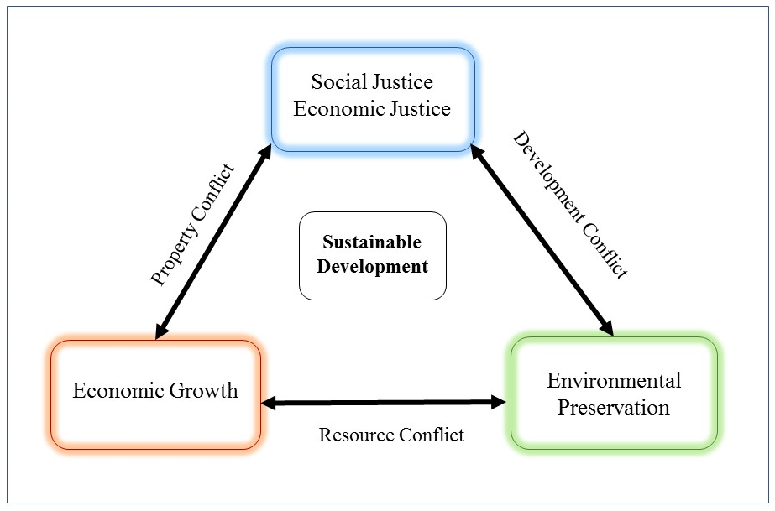
Figure 2: Planner's Triangle of Sustainable Development
Conflicting goals involving social justice, economic growth, and the environment form the “Planner’s Triangle” of sustainable development (based on work from Campbell, 1996).

This phenomenon is seen in Pittsburgh communities such as Lawrenceville, where once industrial, working class neighborhoods transform into upper-class hotspots, displacing more socially vulnerable residents (property conflict). While Lawrenceville’s gentrification lacks a specific environmental driver, it is disingenuous to ignore the role that desirable built and natural environments play in neighborhood livability and desirability.
A case study on sustainable development in Seattle, Washington, mirrors some of the gentrification issues facing Pittsburgh. Although Seattle was quite progressive with early adoption of a sustainability plan, development has been uneven and has placed a greater environmental burden on vulnerable populations. At question was whether Seattle’s gentrification has been environmental in nature wherein cleaner neighborhoods and reduction in industrial sites attracts gentrification, or industrial in nature wherein gentrification of neighborhoods drives industry out (Abel, White, & Clauson, 2015). The authors found that shifts in land use were primarily either driven by gentrification or in parallel: “industrial displacement through gentrification.” Further, the authors found that the most toxic facilities were clustered in some of the most socially vulnerable neighborhoods in the city which faced higher asthma hospitalizations, lower life expectancy, and higher mortality rates than other parts of town (Seattle King County Department of Health, 1997). Though the city touted sustainable, equitable development, investment has been uneven (a development conflict). “Until Seattle’s leaders recognize the connections between gentrification, zoning, affordable housing, and skewed air pollution exposures, the city’s economic stratification and environmental injustice will continue to tarnish the Emerald City’s brand of sustainability” (Abel et al., 2015).
Policy in Pittsburgh faces some of the same challenges. Even with the many luxury condos cropping up throughout once industrial neighborhoods like Lawrenceville and the Strip District, Pittsburgh faces a gap of 17,241 affordable housing units needed for households making below 50% of the median income (Affordable Housing Task Force, 2016). In addition, the region’s industrial roots unevenly affect public health. There are higher rates of childhood asthma in neighborhoods near facilities like steel mills or coke plants, another example of a development conflict (Schneider, 2016).
Environmental gentrification issues are also seen in a brownfield redevelopment of riverfront property in Spokane, WA. For decades, a contaminated industrial site was characterized by environmental injustice and disinvestment of the surrounding community. Despite concerns from residents about affordable housing and their eventual displacement in favor of luxury housing on the site of the former railyard, policymakers ignored possible negative outcomes of the project, failing to see a connection between the environmental and socioeconomic impacts (Bryson, 2012). Although brownfield clean-up is unequivocally positive for public health, ecosystem well-being, and economic viability, there are real social and economic impacts as well.
Redevelopment of riverfront brownfield sites is also a process familiar in Pittsburgh. Fifteen years ago, the Waterfront in Homestead opened (Figure 3), touting the economic opportunities in retail and hospitality for the distressed communities of Homestead and West Homestead. The development involved extensive soil remediation and touted up to 5,000 jobs for the nearby communities. These hospitality jobs are largely part-time, however, and residents remember the 15,000 union jobs that disappeared when the mills closed in 1987. In addition, train tracks physically separate the development from the surrounding community, and locally-owned businesses along Homestead’s main thoroughfare suffer trying to compete with the chains that opened at the Waterfront (Elliott, 2001). Although the development involved extensive soil remediation, it is largely impervious pavement with very little open and green space.

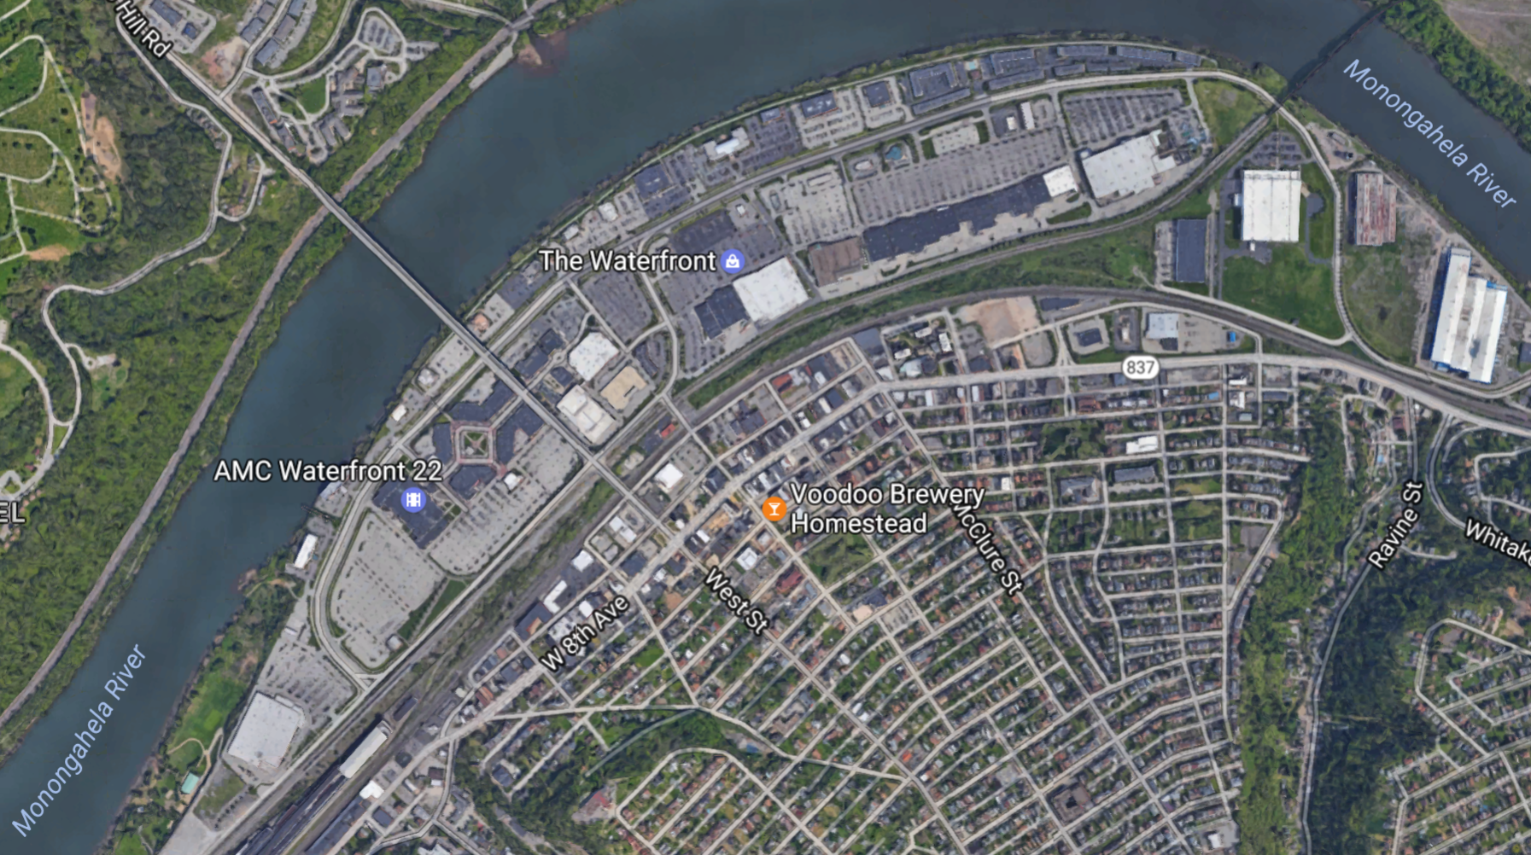
Figure 3: The Waterfront development in Homestead, PA.
The site is a remediated brownfield, retaining only the smokestacks from Homestead Steel Works. Train tracks form physical separation from the community (Google Maps, 2017b).

Currently, brownfield remediation and development in Hazelwood faces similar challenges with community development. The Almono site (Figure 4), consisting of 178 acres of riverfront property formally the Hazelwood Coke Works, touts green space and sustainable development as primary goals for the project. Developers are courting tech companies and apartments for the space, while building green infrastructure and bike paths along the street. Through the planning process, they held over 100 public meetings with the community (Smit, 2015). However, residents of Hazelwood and Lower Greenfield worry about disenfranchisement and rising property values as the future development attracts students and workers commuting to Oakland and Downtown (property conflict) (Raulerson & Kovash, 2016). Residents worry mistakes from the Waterfront will repeat in Hazelwood, where train tracks and a shuttle to Oakland (bypassing the neighborhood) might keep the site separate from the Second Avenue business district. Managing conflicts between social justice, environmental protection, and emerging economic interests will be a continuing challenge for the site.

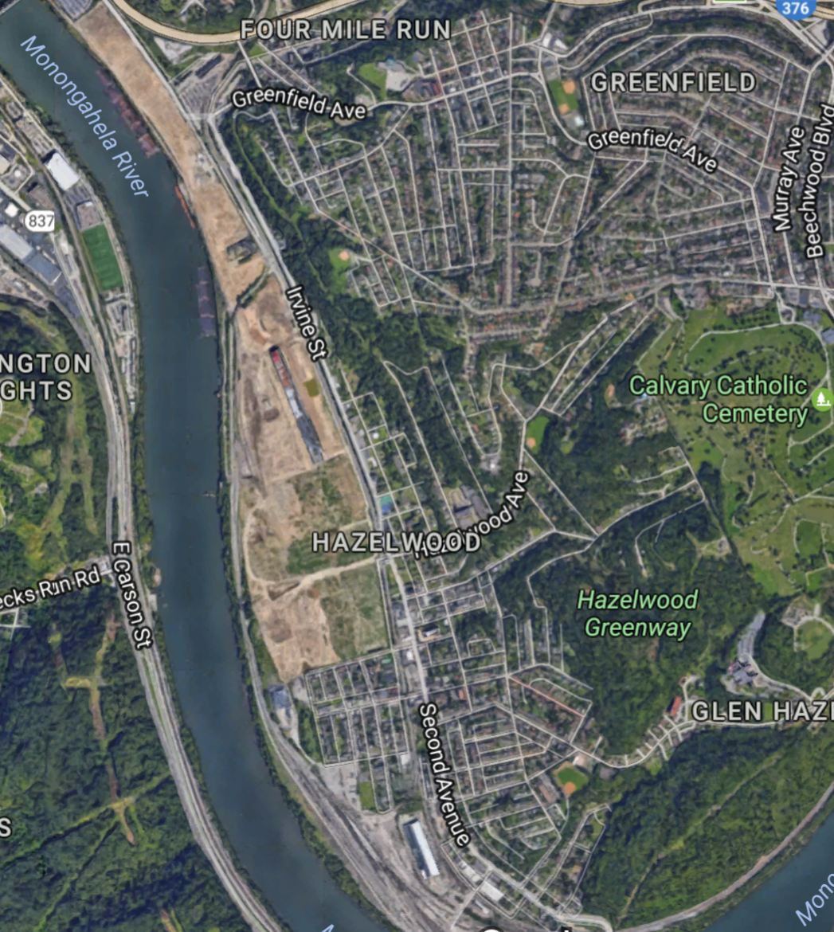
Figure 4: The Almono development site in Hazelwood
After brownfield remediation, residents worry about environmental gentrification of the area (Google Maps, 2017a).

Implications for Green Space Management
Avoiding Environmental Gentrification is an important challenge for sustainable development of green space. Community groups leverage a number of strategies against the marginalization and displacement typical of environmental gentrification that mirror social justice techniques. Community organizing, coalition building, and direct action such as lawsuits have all proven successful in challenging green development leading to displacement (Pearsall & Anguelovski, 2016). Successes in projects can inform best practice for green space management locally and at the state level, maximizing benefit while minimizing potential harms of environmental and green space development.

“Just Green Enough”
To combat environmental gentrification, some communities pursue development that is “Just Green Enough:” environmental projects that improve the community without disenfranchising or displacing residents (Pearsall & Anguelovski, 2016). Community needs and desires shape Just Green Enough development, rather than purely economic or ecologic motivations (Wolch et al., 2014).
Approaches in a Just Green Enough strategy of development might limit changes in land use, perhaps preserving industrial use in a community in tandem with environmental clean-up. Other strategies involve development of community space like urban agriculture/gardens instead of parks, to address concerns like food insecurity. Small-scale greening projects scattered throughout a neighborhood resist environmental gentrification more than grand projects that concentrate resources (Wolch et al., 2014). These strategies require strong community activism to maintain political capital within the community, but ultimately can successfully resist displacement while still maintaining environmental improvements.

Participatory Approach
Balram et al. (2005) highlights the importance of including community members when setting priorities for land use and green space. The authors developed a participatory model that found shared values between multiple stakeholder groups. The study identified priorities and uses shared by conservation groups, community members, and municipal officials that could form a basis for land use policy development. Collaboration across municipalities found shared value in stewarding common natural resources in the larger context of neighboring communities (Balram & Dragićević, 2005).
Erixon, Aalto and Ernstson (2017) use several case studies to explore civic value of urban green space, how the design can be driven by the community, and the use of narrative to demonstrate the value of conservation projects. In the creation of New York’s High Line park, citizen-driven civic groups used photo narrative to build community buy-in for the park project. They demonstrated the value of the rail line’s unique habitat that had developed organically since it had been abandoned in the 1980s (Erixon Aalto & Ernstson, 2017). Related community-driven techniques such as Photovoice could serve communities well as policymakers in sharing vision and goals (Wang & Burris, 1997).
A participatory approach should also inform targeted outreach for green space planning and development. Bauer et al. (2013) note the importance of park nonusers in informing planning processes, as these groups represent possible areas of growth in political capital. In their study, nonusers valued urban wildlife viewing, opening a possible connection to parks and green space. As previously discussed, resilient communities with active organizations to promote political capital can promote green development that caters to community desires, rather than market forces, to resist environmental gentrification (Wolch et al., 2014).

Urban Planning
Successful green space management also requires smart urban planning. Giles-Corti et al. (2005) point out that in addition to access to parks, the design of the park is also important to maximize the benefits offered by green space. Redesigning parks for informal use can attract more users, as organized sports fields are underutilized and do not offer enough interest to encourage sustained active use from walkers and joggers.
The type of park and green space is important for maximum community benefit. Heavily wooded areas are most efficient in carbon sequestration (Gratani et al., 2016), which could offset urban heat island effects if implemented in key locations. However, green spaces like urban gardens could address additional concerns for the community like food insecurity.

Policy
Policy in many places already encourages access to green space. The European Environment Agency, for example, recommends that people should live within a 15-minute walk of green space. English Nature further suggests that people in more urban areas live within 5 minutes walking to accessible green space, although many residents do not meet this guideline (Barbosa et al., 2007). Unfortunately, these policies are under threat from increasing urban population density.
Other policies can influence green space creation by developers by offering incentives. Philadelphia, Pennsylvania, bills stormwater treatment based on impervious surface for run-off, rather than on the amount of water used as is in place in Pittsburgh (Environmental Protection Agency, 2010). Large buildings and especially parking lots that do not use much water add stormwater to the combined sewer systems of the city, but those costs are subsidized by residents who pay sewage based on water used. Incentivizing green space on private land such as parking lots can reduce the amount of stormwater in the system, filter that water in place, and eventually help lower urban temperatures through evaporative cooling.
Brand (2007) connects environmental policy progressing mostly in urban areas, rather than nationally or globally, with the urbanization of neoliberalism. Environmentalism can conflict with the idea of neoliberal economic development, except where it is used to foster a green image and one of global responsibility (Brand, 2007). Thus, local policy could potentially produce global impact. Local policy is often easier to pass and implement, and gives communities more political capital. This bottom-up approach to policy is also a hallmark of “just green enough” environmental policy to limit displacement.

Economics
Although often hard to quantify, there are measurable benefits to adding green and open space to municipalities in the form of increased tax revenue, as homes proximal to green space sell at higher prices (Bolitzer & Netusil, 2000). New York’s High Line park, for example, raised nearby property values by over 100% between 2003 and 2011 despite the concurrent recession, and inspired $2 billion in other property investments (Wolch et al., 2014). These windfalls must balance the protection of vulnerable communities and preserve affordable housing, however. As seen in Figure 2, economic development often conflicts with economic justice in a property conflict (Campbell, 1996).
Environmental benefits of green and open space discussed previously (see page 6) also carry economic implications for green space management. Although green space projects can be costly to implement, policy makers should weigh the less obvious cost savings made possible with ample urban green space. Street trees and green spaces, as well as green roofs, can help mitigate the urban heat effect, reducing individual heating and cooling costs for buildings (Odefey et al., 2012). Green infrastructure, including green space, can also reduce flooding, and prevent costs of treating stormwater by collecting stormwater before it is treated through combined sewer systems (Odefey et al., 2012). These savings are difficult to quantify, but can be significant for cities with aging infrastructure like Pittsburgh.

Pittsburgh Green Space Policy
The City of Pittsburgh recognizes the important role that green and open spaces play for the region and outlines benefits in recreation, natural resources, water and air quality, and community identity through its Open Space PGH report (OpenSpacePGH, 2013). The report values Pittsburgh’s parks and open spaces at $2 billion, but much of that benefit comes from the increased property values of homes near parks. Although the report emphasizes equality as a benefit of Pittsburgh’s open spaces, that economic value is not equitably distributed. Another report identifies a “green premium” for housing prices within 2000 feet of large parks (Aiello et al., 2010). Although the authors recommend building more large parks to increase the area of the green premium for maximum economic benefit, that strategy ignores environmental justice by displacing residents. Pittsburgh is one of the country’s most racially segregated cities, partially a result of income inequality and housing discrimination (Simms, McDaniel, Fyffe, & Lowenstein, 2015). Green space policy that ignores these realities is not in the city’s best interest.
Still, Pittsburgh did take on a participatory approach to its Open Space PGH plan. Community engagement was key to the report. Residents expressed that green and open space in Pittsburgh is “critical to the civic identity of the city and its individual neighborhoods, and to the overall quality of life” (OpenSpacePGH, 2013). Unsurprisingly given the region’s industrial past, participants prioritize restoration and protection of the natural environment, and prefer cost-effective projects with multiple benefits. These goals could align well with sustainable development that avoids environmental gentrification. The city would benefit from continued public participation and smaller-scale green space development at the neighborhood level. Utilizing vacant land and development driven by communities could maximize green space without threatening neighborhood identity.
Open Space PGH noted inequality in access to Pittsburgh parks and open spaces. The report relied on GIS-measured distance to parks and not social barriers found to be important to access. However, some neighborhoods are better connected to green and open spaces than others. The report envisions a connected city through its open spaces, as depicted in Figure 5. A connected open space network with trails and greenways connecting parks could provide access to more people (Ngom et al., 2016).

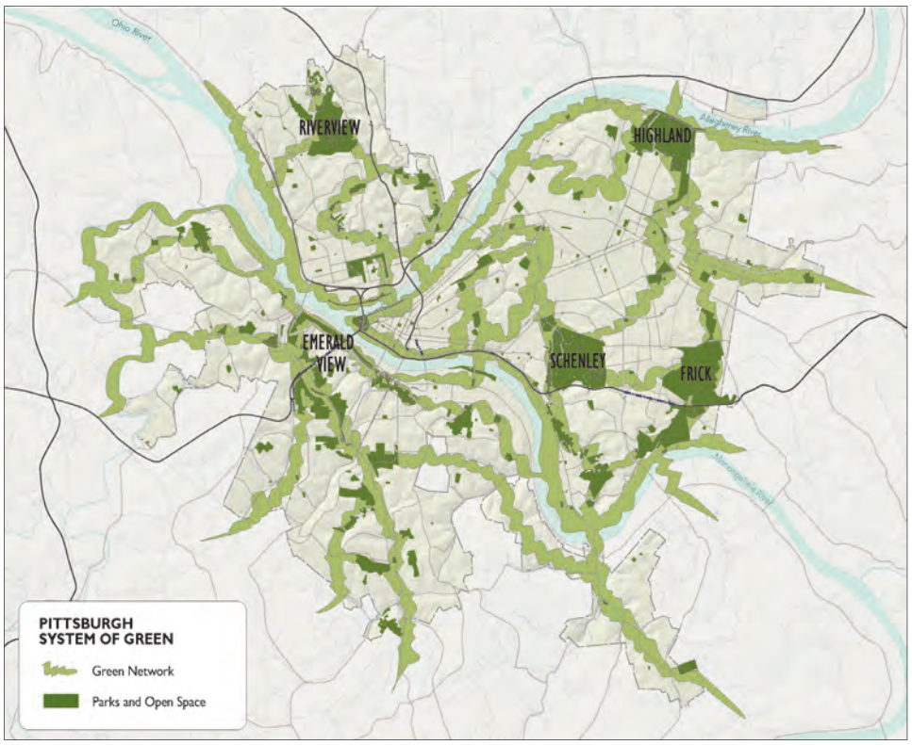
Figure 5: Green and Open Space goal for Pittsburgh
The city envisions connecting residents from all neighborhoods to parks and green space (Open Space PGH, 2013)

Conclusion
Healthy People 2020 seeks to address social determinants of health by creating “social and physical environments that promote good health for all” (Office of Disease Prevention and Health Promotion, 2017). The natural and built environment plays a key role in public health, both historically and today. The ecological model in social work demonstrates the complicated connections between an individual, the community, the environment, and policy. Green and open space has potential to improve air and water quality, forge social connections, save money, and provide an avenue for physical activity.
Access to green space is not always equitable, however. Data on access to green space are somewhat inconsistent. Often, results are local and not generalizable. While national studies suggest a disparity in access for communities of color or low SES, other regional studies have not found differences in access. Measuring access has also proven challenging in the literature. In addition, studies are cross-sectional rather than longitudinal, so it is difficult to show causal relationships in the data.
Green space development often risks environmental gentrification, however, where residents of a community undergoing green projects are displaced as property values rise. Benefits of redevelopment often fall to wealthier white residents who move in. Pittsburgh faces some of these challenges in past and future developments, and in gentrification currently underway. Policy development around green and open space must anticipate and prevent such environmental gentrification as it seeks to increase access to green space.

bibliography
.

