ENHANCING CARE DELIVERY MODELS
THE IMPLEMENTATION OF GEOGRAPHIC PATIENT PLACEMENT

by
Matthew G. Bauer
BS, Slippery Rock University, 2013

Submitted to the Graduate Faculty of
Graduate School of Public Health in partial fulfillment
of the requirements for the degree of
Master of Health Administration

University of Pittsburgh
2017

UNIVERSITY OF PITTSBURGH
GRADUATE SCHOOL OF PUBLIC HEALTH

This essay is submitted
by
Matthew G. Bauer

on

March 30, 2017
and approved by

Essay Advisor:
Samuel Friede, MBA ________________________
Assistant Professor
Health Policy Management
Graduate School of Public Health
University of Pittsburgh

Essay Reader:
Carrie Leana, BA, PhD _______________________________
George H. Love Professor of Organizations
and Management
Professor of Business Administration, of Medicine,
and of Public Health and International Affairs
Director, Center for Healthcare Management
University of Pittsburgh

Copyright © by Matthew G. Bauer
2017
ABSTRACT

Enhancing care delivery models within hospitals promotes patient-centric care, improves communication between care team members (i.e. physicians, nurses, care managers, and social workers) and engages the patient and their family in the development of a treatment plan. It is the expectation that enhancing care delivery models will improve patient and staff satisfaction and increase the hospital’s operational capacity.
Samuel A. Friede, MBA, FACHE

ENHANCING CARE DELIVERY MODELS
THE IMPLEMENTATION OF GEOGRAPHIC PATIENT PLACEMENT
Matthew G. Bauer, MHA
University of Pittsburgh, 2017

Today, Hospitals are struggling with fragmented service lines, poor care team communication, poor discharge planning and non-centralized patient placement. The United States’ healthcare system is fraught with wasteful spending and average – at best – medical outcomes. This study was a prospective intervention study that lasted six months (July 2016 – December 2016). It focused on the development, implementation, and progression of a unit based care model known as Geographic Patient Placement.
Although the primary objectives of the study were not met, the adoption of Geographic Patient Placement positively impacted the hospital’s operational capacity. All parties involved (hospital staff, administrators, patients and their families) reported higher levels of satisfaction. The enhanced communication among care team members created a cohesive atmosphere, promoted accountability and responsibility, and allowed for improvements in discharge planning.
Public Health Significance: Enhancing care delivery models while engaging patients and their loved ones in the creation of their treatment plan will reduce un-wanted side effects of hospitalization, promote patient-centricity, and improve the hospital’s capability to deliver appropriate, high-quality medical care.

TABLE OF CONTENTS
1.0 Introduction 1
1.1 Geographic Patient Placement 1
1.2 Author’s role 2
2.0 Literature review 3
3.0 TBDH 5
4.0 methodology 7
5.0 results 10
5.1 Length of Stay 10
5.2 Regionalization 13
5.3 Efficient Care Delivery 15
5.4 Discharge 17
6.0 Discussion 19
6.1 successes 20
6.2 barriers 20
6.3 suggestions 21
7.0 Conclusion 22
APPENDIX: SUPPLEMENTAL MATERIAL 23
bibliography 25
List of tables
Table 1: Goals of Geographic Patient Placement Initiative 6
Table 2: Physician Team and Unit Details 7
Table 3: Rounding Schedule 9
Table 4: Unit 5C 17
Table 5: Unit 6A 17
Table 6: Unit 8A 18
Table 7: Initiative Timeline 23
List of figures

Figure 1: Stakeholders, Implementation Team and Project Champions 6
Figure 2: Hospital Units, Physician Teams and Bed Assignments 8
Figure 3: LOS index Medicine Team A 11
Figure 4: LOS index Medicine Team B 11
Figure 5: LOS index Medicine Team C 11
Figure 6: LOS index Hospitalist Team 1 12
Figure 7: LOS index Hospitalist Team 2 12
Figure 8: TBDH’s LOS 2015 vs. 2016 12
Figure 9: Regionalization Team A 13
Figure 10: Regionalization Team B 13
Figure 11: Regionalization Team C 14
Figure 12: Regionalization Team 1 14
Figure 13: Regionalization Team 2 14
Figure 14: Units and Patients Team A 15
Figure 15: Units and Patients Team B 15
Figure 16: Units and Patients Team C 16
Figure 17: Units and Patients Team 1 16
Figure 18: Units and Patients Team 2 16
Figure 19: Census Effect on Regionalization 24

Introduction
The goal of every healthcare organization is to provide high-quality, patient-centric care. The Institute of Medicine (IOM) estimates the United States’ healthcare system wastes $765 billion annually. $130 billion can be attributed to inefficient delivery services, $210 billion in unnecessary services, $190 billion in excess administrative costs, and $55 billion in missed opportunities for disease prevention. As a result, hospital executives are being pressed to develop strategies that improve the ability of a hospital to care for their patients in a timely manner, provide appropriate treatment, and operate with a patient-centric mentality. ⁽¹²⁾

Geographic Patient Placement
Geographic Patient Placement (GPP), otherwise known as Unit Based Care (UBC), is a care delivery model adopted by many hospitals throughout the country as a means to combat the alarming statistics highlighted by the IOM. Simply put, GPP is the strategic alignment of patients and physicians on specified hospital units (a.k.a. home units). The goal of such a care delivery model is to align multidisciplinary teams on home units and engage patients and their families in the creation of a treatment plan. Implementing such a model allows for enhanced coordination of care among hospital staff and promotes communication between care team members and their patients. Multidisciplinary teams typically include case management, nursing supervisors, physician leaders, and executive administrators.

Author’s role
Throughout the initiative the author attended all meetings pertaining to the GPP initiative, performed data collection and analysis, created the GPP initiative dashboard, and supported stakeholders and implementation team with various tasks as they arose. The initiative provided the author an opportunity to enhance his analytical thinking, communication, professionalism, leadership, strategic orientation, performance measurement and process improvement skills. ⁽¹¹⁾

Literature review
For years, hospitalists have pushed for medicine patients to be geographically aligned using UBC models. The nature of their work used to demand significant travel time throughout the hospital because of the erratic placement of their patients. ⁽¹⁶⁾ As a result, hospitalists felt their ability to communicate with other clinical staff was suffering and the ability to operate effectively as a care team was non-existent. Administrators, nursing staff, care management and physicians acknowledge the potential benefits of GPP. Healthcare professionals believe the enhanced coordination and communication between care team members will drastically improve important hospital operating metrics, increase operational capacity and improve the overall quality of care being provided.
Two prominent healthcare systems in the United States - Brigham and Women’s Hospital located in Boston, MA and Emory Hospital located in Atlanta, GA - have implemented unit based care models. The reasoning and justification for implementing UBC models differed between institutions. Goals from both organizations included decreasing LOS and mortality rates, seeking consistency and predictability, improved employee and patient satisfaction, earlier bed availability, staff cohesiveness, unit regionalization, and earlier discharge times. ^{(2, 16)}
Emory Hospital (EH) successfully decreased the mortality rate in their 24-bed pilot by 53.1% (2.3 deaths to 1.1 deaths per 100 encounters) when compared to the 12 months pre and post intervention. They successfully decreased their LOS on the same 24-bed pilot from 5.0 days to 4.5 days and improved their Press Ganey patient satisfaction scores by 2.3 points (approximately 30% increase). Unmeasurable benefits experienced by EH included improved cohesiveness, better communication and improved predictability. ⁽¹⁶⁾
Brigham and Women's Hospital (BWH) implemented unit based care models with their seven (7) general medicine service teams. They successfully improved their regionalization in year one to consistently meet their goal of 80%. Additionally, they were able to increase the number of discharges before noon (12:00 PM) by approximately 7% (p-value<0.01). Unlike EH, BWH was unsuccessful in their attempt to lower LOS in their first year. BWH identified unmeasurable benefits including improved teamwork, face-to-face communication, and presence at the patient's bedside. ⁽²⁾
It is evident that individuals who have had experience in both unit based and non-unit based care models prefer the former.⁽¹⁶⁾ It does not go without noting; the process to implement such a model of care is challenging and often time requires several attempts by an organization before it is perfected. A successful implementation is usually accompanied by a passionate project champion, employee engagement and stakeholder support. GPP holds each unit accountable for their performance metrics. The sense of responsibility created as a result of unit based care models promotes healthy competition and has proven to increase the operational capacity of various hospitals. ⁽¹⁶⁾

TBDH
The challenges TBDH (To Be Determined Hospital) was facing included fragmented service lines, poor care team communication, and non-centralized patient placement. As we are all aware, these challenges are not unique in the healthcare industry. The sporadic placement of physician’s patients increased the time physicians were required to travel to see their patients, subsequently decreasing the time doctors could spend with the patient and their family. Nurses and patient’s families struggled to locate and communicate with the physician at the patient’s bed side, contradicting the hospital’s efforts to provide patient-centric care. Social Work and Care Management were communicating ineffectively with one another exacerbating the hospitals inability to identify barriers to a safe and effective patient discharge. The totality of these challenges – fragmented service lines, poor communication, and non-centralized patient placement - made it difficult to create a reliable plan of care for their patients or improve their discharge process.
Directors, managers, clinicians and physicians were tasked by executive leadership to create strategies aimed at improving patient, family, and staff satisfaction, promoting care coordination by way of improved staff communication, and advance the hospital’s capability to safely and efficiently discharge patients. It was the belief that if TBDH was successful in these efforts they would see a reduction in their overall (hospital wide) length of stay. The solution: assemble an implementation team and accompanying project champions to assist stakeholders (Figure 1) in the creation and adoption of GPP at TBDH. A complete list of metrics and objectives identified by the stakeholders and implementation team can be found in Table 1.
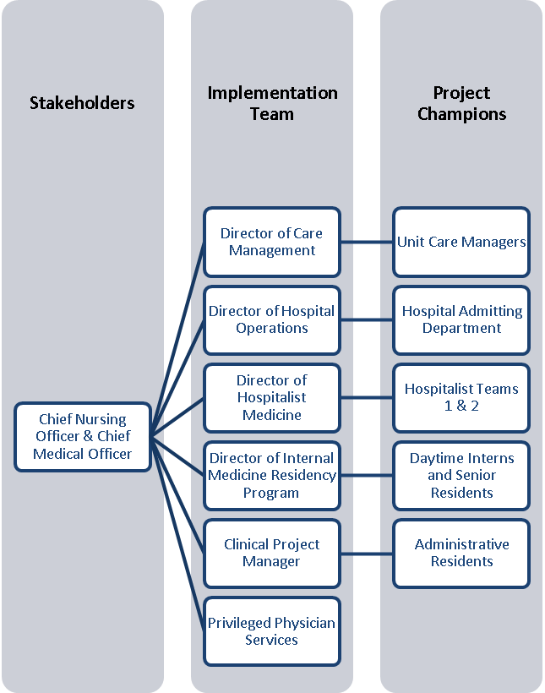
Figure 1: Stakeholders, Implementation Team and Project Champions

Table 1: Goals of Geographic Patient Placement Initiative
METRIC | OBJECTIVE
Length of Stay (LOS) | - Physician Team LOS Index = 1.15*  - Decrease in Hospital LOS
Regionalization | - 80% of physician patients on specified unit
Efficient Care Delivery | - Decrease number of units physicians travel to
Discharge | - 50% of orders written by 11:00 am  - 20% of discharges by 1:00 pm
*Equation 1: LOS index = ALOS/GMLOS

methodology
The initiative lasted a total of six (6) months, beginning in July 2016 and ending in December 2016. The study itself was a prospective intervention study. Details related to physician teams, home units, and types of services (i.e. private or teaching) can be found below in table 2.

Table 2: Physician Team and Unit Details
TEAM | UNIT ASSIGNED | SERVICE
Medicine Team A | 6A/7A | Private
Medicine Team B | 8A/7A | Teaching
Medicine Team C | 8A/7A | Teaching
Hospitalist Team 1 | 5C/7A | Teaching
Hospitalist Team 2 | 5C/7A | Teaching

Each unit was staffed with nurses, care managers, social workers, and ancillary staff. Physician teams were assigned to home units (5C, 6A, & 8A). Data was collected by administrative residents in one of two ways: utilizing EPIC’s electronic health records system (EHR) or TBDH’s monthly financial reports. Data related to regionalization, discharge efficiency, and delivery of care efficiency was gathered from EPIC’s EHR. Data related to physician team’s LOS was collected using TBDH’s monthly financial report. Data was reported to stakeholders and implementation team during regularly scheduled meetings.
Four of the five physician teams were teaching services and one was private. Of the four teaching services, two teams were medicine teaching teams and two were hospitalist teaching teams. Teams could have no more than16 patients assigned to them. Figure 2 illustrates the breakdown of the three home units, five physician teams and total number of beds dedicated to this initiative. Unit 7A was determined by the implementation team to positively count toward a physician team’s regionalization, but would not be considered a “home unit”. The decision to count patients placed on 7A favorably toward regionalization could be justified by the fact that it is a “transition unit”, and moving patients placed on 7A away from a teaching service (Medicine Teams A & B and Hospitalist Teams 1 & 2) would deny residents a valuable educational opportunity.
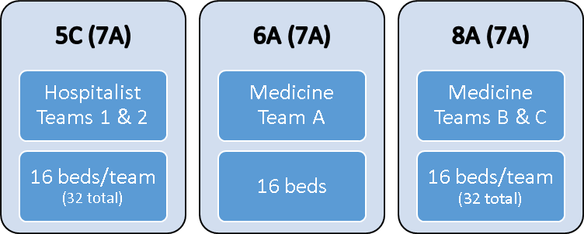
Figure 2: Hospital Units, Physician Teams and Bed Assignments
Interdisciplinary rounding schedules were created by the implementation team to ensure all necessary parties were involved in delivering appropriate care to their patients. Unit-based care teams worked closely with existing unit staff to follow the interdisciplinary rounding schedules created as part of the GPP initiative. Schedules varied from unit-to-unit and team-to-team, but each schedule contained the same primary components found in Table 3.

Table 3: Rounding Schedule
TIME | ACTION
7:00 am – 7:30 am | Physician Sign-out Rounds
7:30 am – 9:15 am | Physician Pre-Round
9:15 am – 9:25 am | Morning Huddle at Nurses Station
9:30 am – 11:00 am | Bedside Teaching Rounds
11:00 am – 11:30 am | Rounding for Non-Geographically Placed Patients
12:00 pm – 1:00 pm | Resident Noon Conference
1:15 pm – 1:30 pm | Afternoon Huddle
7:00 pm – 7:00 am | Night Float Team Covers All Medicine Patients

results
The data suggests the initial implementation of GPP at TBDH failed to meet the objectives set forth by Stakeholders and the Implementation Team. This, however, does not allude that TBDH failed in their efforts to implement GPP at TBDH.

Length of Stay
Medicine Team A (figure 3) reached the LOS index goal of 1.15 three (3) times throughout the initiative during the months of September, October, and November. Medicine Team B (figure 4) successfully lowered their LOS index below 1.15 during the first five (5) months of the initiative (July – November). Medicine Team C (figure 5), like Medicine Team A, successfully reached or beat the LOS index goal during the months of September, October and November. Hospitalist Team 1(figure 6) was able to achieve the LOS index goal of 1.15 during all months of the initiative except November, and Hospitalist Team 2 (figure 7) met the LOS index goal for the first five (5) months of the initiative (July – November). Figure 8 illustrates TBDH’s inability to sustain a lower LOS throughout the hospital when compared to the same months in the previous year.

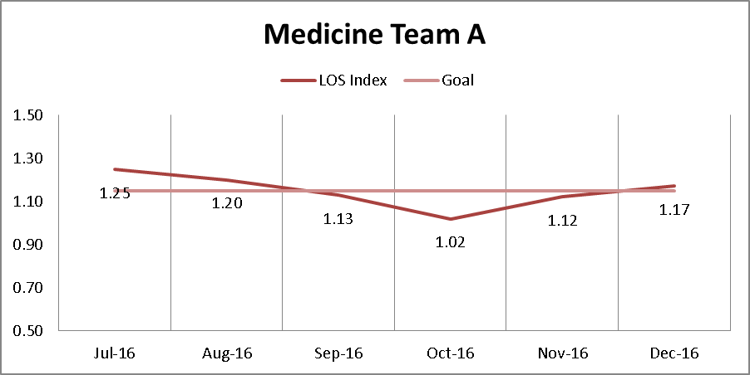
Figure 3: LOS index Medicine Team A
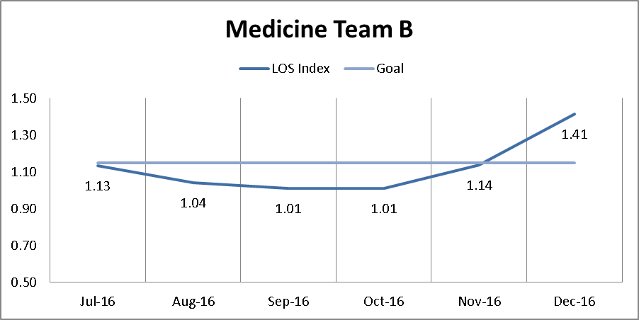
Figure 4: LOS index Medicine Team B
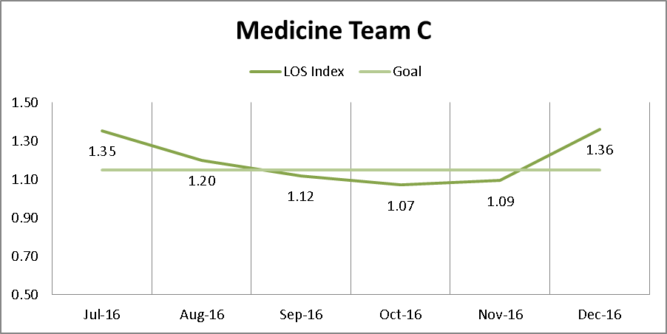
Figure 5: LOS index Medicine Team C
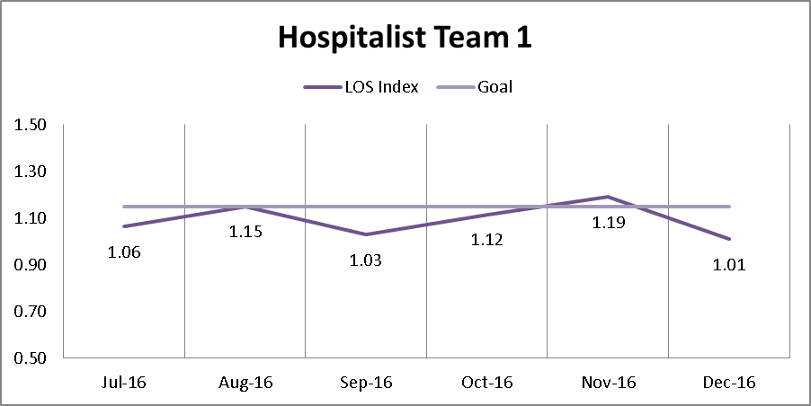
Figure 6: LOS index Hospitalist Team 1
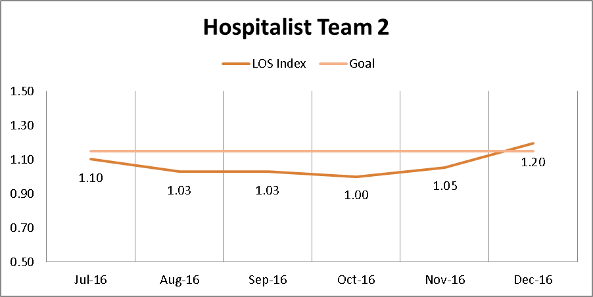
Figure 7: LOS index Hospitalist Team 2
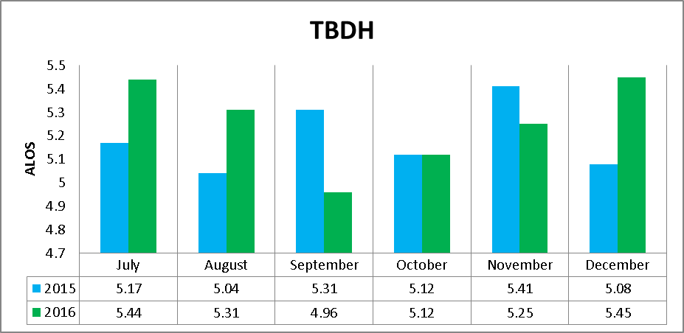
Figure 8: TBDH’s LOS 2015 vs. 2016

Regionalization
Medicine Teams A, B, and C (figures 9 – 11) did not reach the regionalization goal of 80% at any point during the initiative. Their six (6) month regionalization averages were 56%, 61%, and 63% respectively. Hospitalist Team 1 (12) reached 80% regionalization during the month of September and had a six (6) month average regionalization of 75%. Hospitalist Team 2 (figure 13) reached the regionalization target once during the month of October and had a six (6) month average regionalization of 74%.
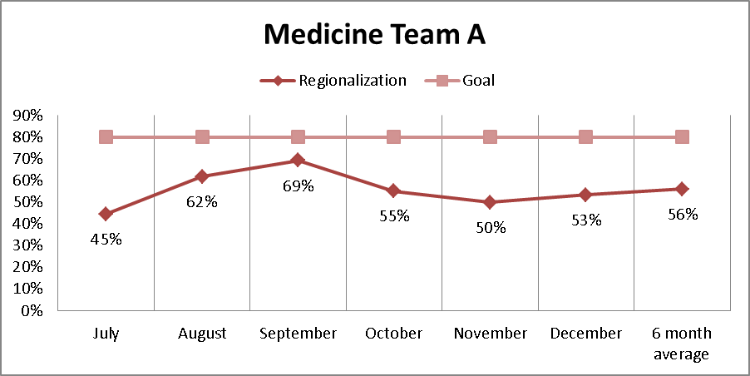
Figure 9: Regionalization Team A
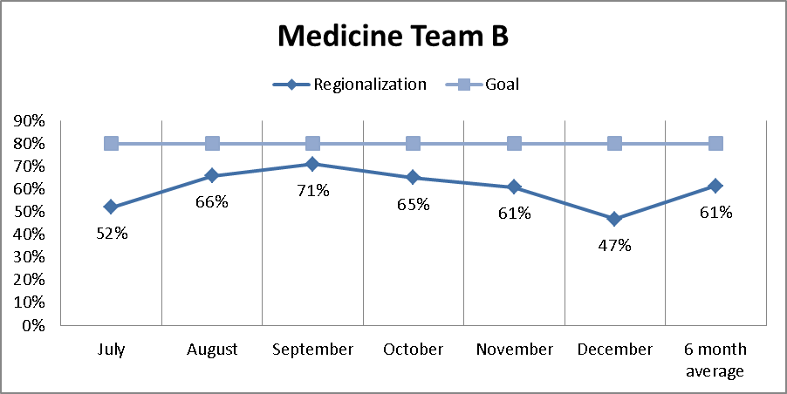
Figure 10: Regionalization Team B
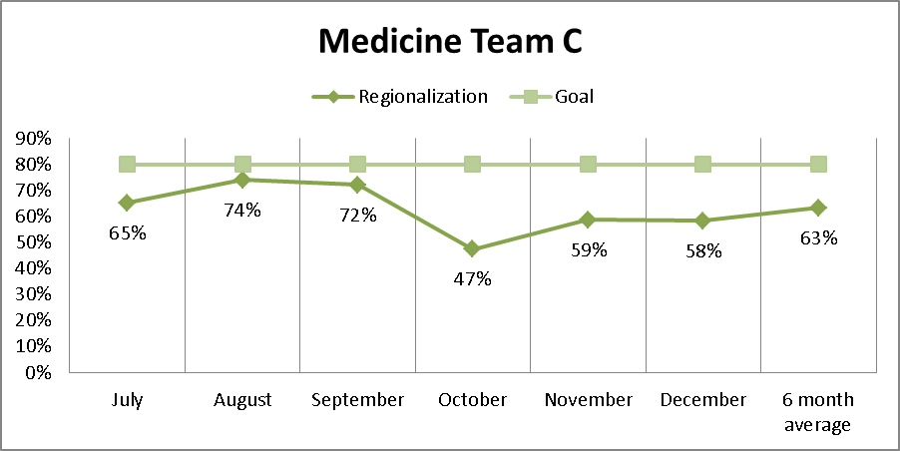
Figure 11: Regionalization Team C
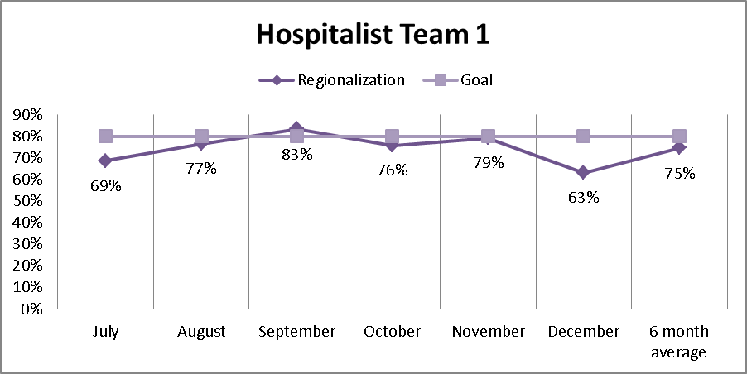
Figure 12: Regionalization Team 1
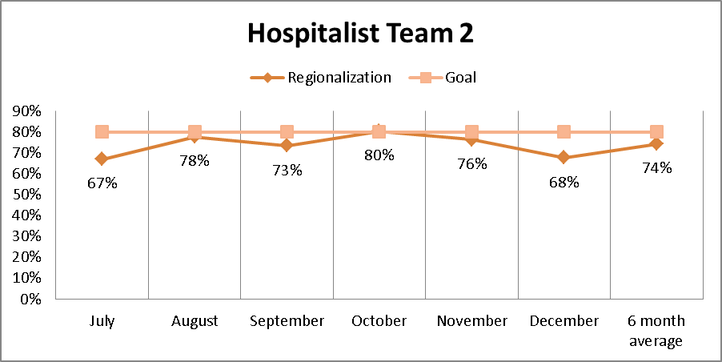
Figure 13: Regionalization Team 2

Efficient Care Delivery
Medicine Team A’s (figure 14) six (6) month average regarding the number of units traveled to is lower than the first month of the initiative. The six (6) month averages of Medicine Team B (figure 15) and Hospitalist Teams 1 and 2 (figures 17 & 18) were the same as the initial month of the initiative. Medicine Team C’s (figure 16) six (6) month average was higher than it was during the month of July.
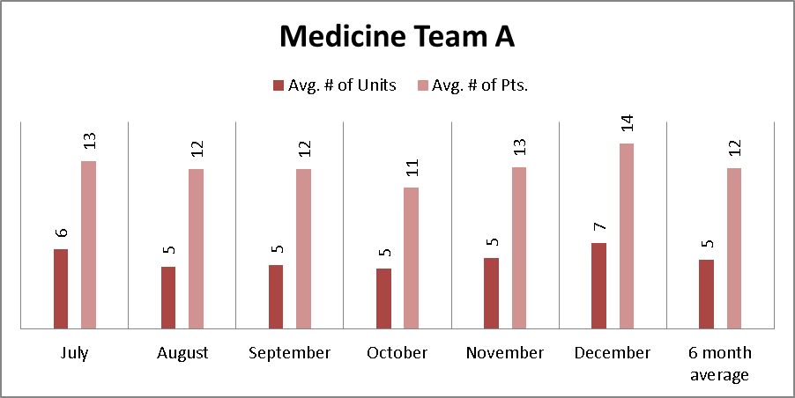
Figure 14: Units and Patients Team A
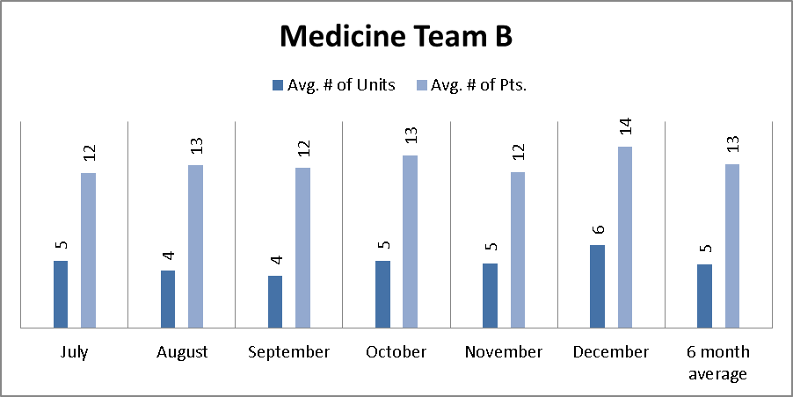
Figure 15: Units and Patients Team B
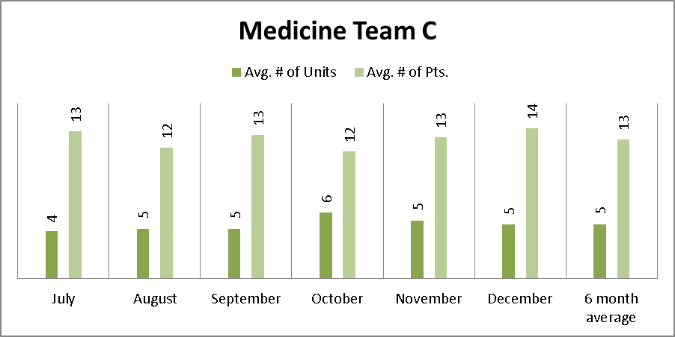
Figure 16: Units and Patients Team C
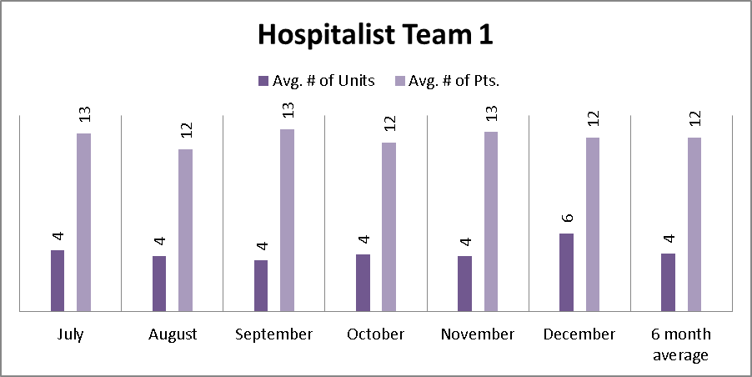
Figure 17: Units and Patients Team 1
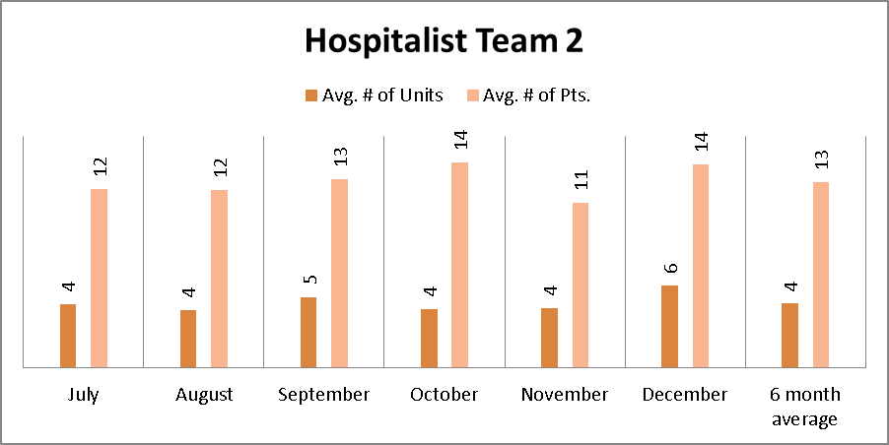
Figure 18: Units and Patients Team 2

Discharge
Tables 4-6 below illustrate the inability of all home units involved to meet the discharge goals of 20% orders written before 11:00 am and 50% of patient discharged before 1:00 pm.

Table 4: Unit 5C
Discharge Orders Written |  | Patient Discharged
Month | Before 11:00 am | Month | Before1:00 pm
May | 8% | May | 8%
June | 8% | June | 5%
July | 14% | July | 8%
August | 19% | August | 12%
September | 15% | September | 11%
October | 7% | October | 6%
November | 13% | November | 10%
December | 12% | December | 7%

Table 5: Unit 6A
Discharge Orders Written |  | Patient Discharged
Month | Before 11:00 am | Month | Before 1:00 pm
May | 12% | May | 7%
June | 9% | June | 10%
July | 9% | July | 13%
August | 17% | August | 12%
September | 18% | September | 16%
October | 20% | October | 8%
November | 19% | November | 10%
December | 15% | December | 9%

Table 6: Unit 8A
Discharge Orders Written |  | Patient Discharged
Month | Before 11:00 am | Month | Before 1:00 pm
May | 19% | May | 10%
June | 12% | June | 5%
July | 11% | July | 6%
August | 10% | August | 8%
September | 11% | September | 6%
October | 9% | October | 4%
November | 11% | November | 6%
December | 15% | December | 11%

Discussion
Although the initiative focused on three home units, concerns from various departments were expressed prior to implementation. Such concerns included the potential for longer patient waiting times in the emergency department (i.e. decreased throughput), lack of bed availability on designated home units, an inability to appropriately place patients on geographic units, effects of an elevated hospital census, and the fear from administrators that GPP will do nothing more than ease the physician’s workload. Administrators were not convinced the initiative would positively affect the hospital’s LOS (i.e. reduce LOS) because of the limited amount of units selected for the initiative. Physicians and other clinicians were concerned their workflows would be disrupted, and medical residency supervisors were apprehensive that residency work hour requirements would be violated.
The progress of the initiative was discussed in detail at regularly scheduled meetings. Table 7, found in the Appendix, provides an exhaustive timeline of the six (6) month GPP initiative. The successes, barriers, and suggestions to follow were derived from meeting notes and email interviews with all those involved ^{(3-10 & 13-15).}

successes
With every few exceptions, the data suggests the initiative failed to meet the primary objectives of decreasing LOS, improving regionalization and efficiency of care, or enhancing the discharge process set forth by stakeholders and the implementation team. This is not to say, however, that the initiative was unsuccessful. Based upon responses from stakeholders and individuals on the implementation team, ^{(3-10 & 13-15)} it is evident that GPP improved many operational aspects of TBDH. The overwhelming majority of those involved believed the GPP model implemented by TBDH improved physician and nurse communication, families’ access to hospital staff and the quality of care being provided to patients. Additionally, families enjoyed seeing their physicians multiple times a day. The close interaction with residents created better teaching opportunities. Staff on home units enjoyed a cohesive, team-like environment. Care team members communicated with one another face-to-face, which enhanced coordination of care and improved their ability to create a comprehensive discharge plan. Physicians in particular benefited from the decreased travel time when regionalization goals were met. GPP allowed for effective collaboration across multiple units of the hospital ⁽⁸⁾ and actively engaged patients and their families in the creation of the treatment plan.

barriers
There were several factors that impeded the success of GPP at TBDH. The first, and most influential, were the unfulfilled promises regarding the number of beds each physician team would have access to on units 6A and 8A. The cause can be attributed to a number of factors, but was primarily the result of other hospital services (i.e. Trauma, Oncology, & Hospice) needing equipment found on those units. Those same service lines were uncooperative in adjusting their rounding times which negatively impacted the ability of GPP physician teams to follow the designed rounding schedule. This small action prevented beds from opening, reduced regionalization and increased the number of units physician teams had to travel to in order to see their patients. Figure 19 in the Appendix illustrates how TBDH’s elevated census negatively impacted regionalization. Finally, there needs to be more support and buy-in from executive leadership. One of the two primary stakeholders is no longer with TBDH. Without additional support, TBDH will fail in their attempts to successfully adopt GPP and will miss the opportunity for operational improvements UBC models provide an organization.

suggestions
Moving forward, the GPP implementation team needs to create process maps that illustrate how patients are to be placed on home units regardless of how they enter the hospital (i.e. direct admits, emergency department admits, or transfers from other organizations). By doing so, bed placement will have standards to follow when they are admitting patients. In order to assess the true success of discharge planning it is imperative to adjust how we are recording/measuring this metric. Focusing on metrics such as when the order for discharge was placed and when the patient physically is discharged proved fruitless in increasing the efficiency of discharging a patient. Expanding the initiative to other units would alleviate the issues experienced on units 6A and 8A and may improve TBDH’s overall LOS. Moreover, anecdotal evidence surrounding staff communication, patient and staff satisfaction, and quality of care is not enough. The implementation team should work to create questionnaires that track satisfaction scores and perceived level of communication. Patients and families should have the opportunity to rate or grade their quality of care immediately after service was provided (while still inpatient status) and post discharge.

Conclusion
In response to the inefficiencies and waste the United States’ healthcare industry is demonstrating, executive leadership at TBDH decided to implement GPP. The ultimate goal of the initiative was to positively impact the hospital’s operational capacity. The premise and assumption surrounding GPP is that centralizing physicians and their patients will positively impact TBDH’s ability to provide high quality - patient centric care, ease the burden physicians face from traveling across the hospital, improve communication between staff, patients and their family, and enhance communication amongst care team members.
The data reported illustrates TBDH failed to achieve the primary objectives of the initiative. They (TBDH) were, however, successful in their attempt to implement GPP. Sometimes, in the face of chaos, consistency can be and should be considered a success. UBC models have proven to be successful in other institutions across the country with thoughtful effort and after several attempts. Given more time and the opportunity to address the identified barriers, the author, stakeholders, and members of the implementation team feel strongly that GPP will continue to work well, even within a complicated health system such as TBDH. ⁽⁵⁾

APPENDIX: SUPPLEMENTAL MATERIAL
Table 7: Initiative Timeline
Date | Action
May 12, 2016 | Brigham and Women’s Hospital Presentation. First GPP initiative meeting
May 20, 2016 | GPP planning committee meeting
May 23, 2016 | GPP initiative introduced to discharge planning committee
May 26, 2016 | GPP initiative meeting. Determined Emergency Department should be consulted.
June 2, 2016 | GPP initiative meeting re. data collection and reporting
June 10, 2016 | GPP initiative meeting re. unit update to Executive leaders and stakeholders
June 14, 2016 | GPP initiative meeting re. Emergency Department throughput
June 16, 2016 | “Pre go-live” meeting
June 17, 2016 | “Prep week” email sent by Director of Internal Medicine Residency Director
June 18, 2016 | Soft start
June 30, 2016 | Final “pre go-live” meeting re. EPIC reports and discharge planning
July 1, 2016 | Project start date: “Go-live”
July 7, 2016 | Post implementation follow up meeting (#1)
July 14, 2016 | Post implementation follow up meeting (#2)
July 19, 2016 | GPP initiative meeting re. process mapping
July 21, 2016 | Post implementation follow up meeting (#3)
July 28, 2016 | Post implementation follow up meeting (#4)
August 4, 2016 | Post implementation follow up meeting (#5)
August 9, 2016 | GPP initiative meeting re. simple discharges
Table 7 Continued
August 18, 2016 | Post implementation follow up meeting (#6); shadowed bed placement
September 1, 2016 | GPP initiative meeting re. initiative progress (#1)
September 15, 2016 | GPP initiative meeting re. initiative progress (#2)
October 6, 2016 | GPP initiative meeting re. initiative progress (#3)
October 28, 2016 | Three (3) month review presented to TBDH’s Executive Leadership
October 31, 2016 | GPP initiative meeting re. defining next steps
December 12, 2016 | Construction on 8A began
December 20, 2016 | GPP initiative meeting re. initiative progress (#4)

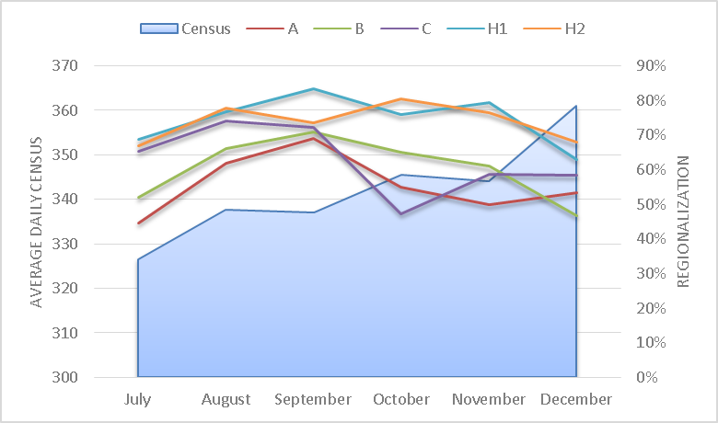
Figure 19: Census Effect on Regionalization
bibliography
- Average Length of Stay (LOS): What is the difference between. (2015, November 09). Retrieved February 27, 2017, from http://hospitalanalytics.org/length-of-staywhat-is-the-difference-between-average-and-geometric-mean/
- Boxer, Rober MD, PHD (2016). 5th Times a Charm: Creation of Unit-Based Teams at BWH. Slides provided by Brigham and Women’s Hospital
- Brannigan–Thieman, M. MD (2017, January). Email Interview
- Cobaugh, S. (2017, January). Email Interview
- DeFail, A. DO (2017, January). Email Interview
- DiCuccio, M. (2017, January). Email Interview
- Dobbins, L. (2017, January). Email Interview
- Goldfarb, I. MD (2017, January). Email Interview
- Griffin, L. (2017). Email Interview
- Head, M. (2017, January). Email Interview
- Health Policy and Management. (2017). Retrieved March 06, 2017, from http://www.publichealth.pitt.edu/health-policy-and-management/academics/mha/mha-competencies
- Institute of Medicine. The healthcare imperative (2010)
- Pusateri, D. MD (2017, January). Email Interview
- Rebholz, P. (2017, January). Email Interview
- Reilly, J. MD (2017, January). Email Interview
- Stein, J, & Vermoch, K. (2014). Emory Hospital Unit Redesigned for Teamwork Sees Improved Outcomes. Emory Healthcare
- What's the sweet spot for unit-based staffing? (2016, September 29). Retrieved February 02, 2017, from http://www.todayshospitalist.com/whats-the-sweet-spot-for-unit-based-staffing/

Regionalization is the ratio of appropriately placed patients compared to the total number of patients assigned to a physician teams (Regionalization = patients appropriately geographically placed/total patients * 100%)
Data collected using EPIC’s Electronic Health Record system showed physicians were required to travel in excess of 6 hospital units per day
GMLOS (Geometric Mean Length of Stay) is the geometric length of stay associated with specific MS – DRG codes; used to account for potential outliers when measuring LOS (Average Length of Stay). ⁽¹⁾

