UNIVERSITY OF PITTSBURGH
HISTORY AND EVALUATION OF OUTPATIENT ANTIMICROBIAL
PARENTERAL ANTIBIOTIC THERAPY

by
Sarah Elizabeth Miller
BS Biology, Gannon University, 2015

Submitted to the Graduate Faculty of
Health Policy and Management
Graduate School of Public Health in partial fulfillment
of the requirements for the degree of
Master of Health Administration

University of Pittsburgh
2017

GRADUATE SCHOOL OF PUBLIC HEALTH

This essay is submitted
by
Sarah E. Miller

on

April 14, 2017
and approved by

Essay Advisor:
Mark Roberts, MD, MPP ______________________________________
Professor
Health Policy and Management
School of Public Health
University of Pittsburgh

Essay Readers:

Tiffany Gary-Webb, PhD, MHS ______________________________________
Associate Professor
Behavioral and Community Health Science and Epidemiology
School of Public Health
University of Pittsburgh

Kathleen Sheridan, DO ______________________________________
Clinical Assistant Professor of Medicine
Infectious Diseases
School of Medicine
University of Pittsburgh

ABSTRACT
Copyright © by Sarah Miller
2017

In healthcare, there has been a growing emphasis on establishing quality care at a low price. To achieve this, the industry trend is to deliver care in the outpatient setting. A therapy that has been used in this setting since the 1970’s is Outpatient Parenteral Antibiotic Therapy (OPAT), which is a therapeutic practice to deliver intravenous or prolonged antimicrobial therapy in the outpatient or home setting. With the rise in utilization of this therapy two recommended guidelines have been published, Good Practice Recommendations for Outpatient Parenteral Antimicrobial Therapy (OPAT) in Adults in the UK and Practice Guidelines for Outpatient Parenteral Antimicrobial Therapy Today (IDSA). Literature regarding the obstacles and successes of OPAT has been published nationally and internationally, but have lacked breadth and consistency. This paper looks to identify the consistent and inconsistent trends in literature allowing for the identification of best practices that should be incorporated into OPAT programs. Furthermore, it evaluates the success of OPAT in the University of Pittsburgh Medical Center (UPMC) system, noted by the reduction in readmissions and improvement in cost effectiveness. The study of OPAT is relevant to public health, as it gives an alternative to inpatient care that could provide quality care with higher patient satisfaction. The literature, as well as the study at UPMC, supports OPAT as an effective and alternative therapy to inpatient care.
Mark S. Roberts, MD, MPP

HISTORY AND EVALUATION OF OUTPATIENT ANTIMICROBIAL PARENTERAL ANTIBIOTIC THERAPY
Sarah Miller, MHA
University of Pittsburgh, 2017

TABLE OF CONTENTS
preface vii
1.0 Introduction 1
1.1 Literature Review 2
1.1.1 Terms 3
1.2 Best practices 3
1.2.1 Consensus in Literature 9
2.0 OPAT at UPMC 14
2.1 Structure 14
2.2 Challenges 16
2.2.1 Electronic Health Record 16
2.2.2 Data Collection 17
2.2.3 Funding 18
2.3 DATA ANALYSIS 19
2.3.1 Discussion 22
2.3.2 Limitations 24
2.4 FUTURE OF OPAT 25
2.4.1 TELEMEDICINE 25
2.4.2 INCREASED SCOPE 25
3.0 Conclusion 27
APPENDIX: LITERATURE SOURCES 28
bibliography 36

List of tables
Table 1. Common Conditions Treated by OPAT 4
Table 2. Common Antibiotics Used in OPAT 4
Table 3. Data Collection Categories 18
Table 4. Presence of ID Physicians 20
Table 5. OPAT Program versus Control 21

List of Figures
Figure 1. OPAT Program Recommended Components 6

preface
Thank you to Dr. Kathleen Sheridan for allowing me to become involved with the OPAT program. A special thanks to my mentors at UPMC, especially Annmarie Lyons, teachers at the University of Pittsburgh, and my friends and family for the support over the past two years.

Introduction
When a patient is diagnosed with an infection that oral antibiotics alone could not cure, it may be decided that intravenous antibiotics (IVAB) are the most efficacious mode of treatment. The use of IVAB in the outpatient setting as a method of treatment dates to the 1970’s, when those who lacked insurance to cover an inpatient hospital stay were offered hospital discharge with daily OPAT [1]. At the onset of OPAT four challenges were identified: (1) insurance coverage for medical expenses and drug supplies, (2) the need for multidisciplinary teams that take a collaborative approach, (3) importance of patient selection and education, and (4) the necessity of criteria for laboratory monitoring and measurement of outcomes [1]. These challenges are still present due to the healthcare environment and must be addressed by OPAT programs. Despite these challenges, the utilization of OPAT increased during the late 1900’s in Canada, Europe, Australia, New Zealand, and the US. As previously mentioned, development and implementation of OPAT programs could be guided by the two published guidelines. These guidelines came at a time when there was an increased desire to implement an OPAT program due to concerns of acquiring nosocomial infections, multidrug- resistant infections, and the emphasis on “patient-centered care” [1]. It is important to note that these guidelines are not required for OPAT to be prescribed, therefore, there is variation within the practice of OPAT. Because of this, it is important to have a thorough understanding of the literature, despite few published studies, which is the primary aim of this paper. The secondary aim is to assess the OPAT program at UPMC to identify challenges, determine if it has been successful, and make recommendations for future improvements.

Literature Review
A literature review on OPAT was conducted to gain a deeper understanding of associated best practices, to identify trends in published literature, and ascertain where there were gaps. The search was conducted on PubMed and used the search string “outpatient parenteral antimicrobial therapy OR outpatient parenteral antibiotic therapy”. There are interchangeable terms for antimicrobial and antibiotic therapy, but since these are the broadest terms they were used to return the most results. The results were filtered for human subjects, which produced 521 results. All titles were scanned and those pertaining to pediatrics, drug specific interactions, or use of OPAT for a specific disease were not included. A total of 74 articles (Appendix A) were identified, and 63 were read and utilized as the basis for this essay.
OPAT is a widely-used practice outside of the US, as shown by the 14 different countries that have published articles on OPAT. Published literature on OPAT dates back to 1978, however, the 32 years from 1978-2010 holds only 47% of the published literature and the most recent 7 years contain the other 53%. This could be indicative of the trend in healthcare to quantify the cost effectiveness of alternative therapies.

Terms
OPAT stands for Outpatient Parenteral Antibiotic Therapy. “Outpatient” refers to a setting aside from a hospital inpatient stay. A patient is considered an outpatient if they are receiving therapy in their home, an ambulatory center, skilled nursing facility (SNF), or infusion center. “Parenteral” is the way the antibiotic is administered to the patient. This can be through intravenous, subcutaneous, or intramuscular methods. Antibiotic, antimicrobial, antiviral, antifungal or antimycobacterial are all terms used to describe the therapy. “Caregivers” are also associated with OPAT as this refers to the person (usually significant other or family) who can learn the proper technique in assisting the patient when administering IVAB. The caregiver is also important in communicating abnormal events (such as a fever) to the OPAT team [2].

Best practices
The IDSA guidelines, originally published in 1997, were updated in 2004 as those receiving OPAT reached 1 in 1,000 in the US. It is important to guidelines to be kept current as OPAT places more responsibility on the patient and should be a monitored form of therapy. With several confounding variables, it is important to increase the number of prospective studies looking at quality, cost effectiveness, and patient satisfaction. Because of the lack of evidence-based studies, guidelines were developed by those in the IDSA committee with collaboration from similar organizations. There were nine topics highlighted in the guidelines, the ninth will not be discussed as it pertained to pediatrics [2].
The [mostly] retrospective literature supports the effectiveness of OPAT for various infections. This information comes from the OPAT Network, which compiled relevant data from OPAT programs from 1996-2002, and studied OPAT outcomes in different hospitals [2]. A list of common conditions that were treated with OPAT, per the literature, are shown in Table 1. The specific conditions treated showed some variation by country [3]. There is a range of IVAB that are used for these infections and preferences have changed over time. The appropriate treatment is determined by the infection, the patient’s history, and cost. A table of common antibiotics used, according to literature, can be found in Table 2.
Table 1. Common Conditions Treated by OPAT
Infections Treated with OPAT
Abscess | Bacteremia
Cellulitis | Endocarditis
Lyme Disease (late stage) | Meningitis
Osteomyelitis | Pyelonephritis
Musculoskeletal | Septic arthritis/bursitis
Skin and soft tissue | Sinusitis/mastoiditis
Wound | Urinary tract infection (upper and lower tract)

Source: (Williams, Baker et al. 2015) and (Tice, Rehm et al. 2004)
Table 2. Common Antibiotics Used in OPAT
Antibiotics utilized in OPAT
Carbapenems
Daptomycin
First, second and third-generation cephalosporins
Ceftriaxone
Penicillins (all)
Aminoglycosides
Vancomycin
All other antibiotics
Source: (Williams, Baker et al. 2015) and (Tice, Rehm et al. 2004)

After it is identified through a medical assessment that the patient needs to receive OPAT, it is determined where they will be discharged based on their self-care ability. Highly automatous patients, with the appropriate support system, may be discharged home where a caregiver or themselves are trained to administer the antibiotics. In the home setting, a home nursing agency/infusion company plays a role in the care of the patient. Patients needing more skilled care are discharged to a [skilled] nursing facility. Because OPAT shifts the responsibility of care to the patient and the antibiotics can be associated with adverse events, it is critical to evaluate the ability of the patient or caregiver. A study conducted by Eaves et al. assessed the retention of training to patients and caregivers and while it found overall retention to be adequate, there was room for improvement in administering with the sterile technique [4]. Questions such as “Is the patients home environment adequate to provide medical care in?” and “Is the patient or caregiver able to use sterile technique to safely and reliably administer therapy?” should be documented and routinely asked of patients being considered for OPAT [2]. Being conscious of these questions and all factors in determining if OPAT is appropriate, can minimize the under or over utilization of OPAT.
There are distinguishing characteristics of OPAT that separate it from other therapies. First, the team-based care approach underlies OPAT, but requires extensive communication and follow up. The team is led by a physician and it can be beneficial for the physician to be trained in Infectious Diseases (ID), but is not required. The physician brings together the other team members who may include infusion nurses, pharmacists, social workers, and dieticians. OPAT programs should have documented procedures and policies with the role of each team member. Second, patient and caregiver informational materials specific to the program should be used. Key suggested OPAT program components are shown in Figure 1.

Figure 1. OPAT Program Recommended Components

Source: (Tice, Rehm et al. 2004)

Each person involved in the OPAT program plays a unique role. The physician diagnoses the illness, decides if OPAT is appropriate, selects the antibiotic, orders the monitoring tests, and provides follow up visits. The continual monitoring by the physician is important to identifying adverse reactions, drug toxicity, vascular access, and to determine if care is completed or should be continued. The guidelines suggest that telemedicine may be a valuable tool here, but there is currently no supporting literature. Currently, there is no physician certification or credentialing required to administer OPAT, although it is standard knowledge in ID training programs. The infusion nurse provides the recommendation of which vascular access device is appropriate for the patient and then provides education, training, and monitoring. If the patient is receiving care in the home, they are the link between the hospital and home. They can provide an initial home assessment, ensure the delivery of medication, and provide oversight care. The usual role of the pharmacist is to acquire, store, compound, dispense, and deliver the antibiotics. Based on follow up care, the pharmacist also monitors for adverse events and drug interactions. Pharmacists can also take on the role of educating patients on the chosen antibiotic and possible side effects. Lastly, the patient and caregiver should be at the center of the OPAT program. If the patient elects to not go to a SNF, the patient and caregiver are opting to provide their own, although monitored, care. They must demonstrate competency on IV delivery, adhere to follow up care, and communicate with other team members [2].
Proper antibiotic selection is also discussed in the IDSA guidelines. Some of the factors to be considered include the infecting organism, drug stability, and the pharmacodynamics and pharmacokinetic properties of the drugs. It is common that drugs used in OPAT only require administration once or twice a day. This minimizes disruption to daily life and possibility for complications, but the appropriate antibiotic should be chosen for its efficacy not convenience. After identification of the antibiotic, the first dose should be given in a supervised setting, typically the hospital although an office or ambulatory care center is also appropriate [2].
Last in the outlined recommendations, is the importance of regular clinical and labatory monitoring as well as outcomes reporting to determine effectiveness. Monitoring can be completed by blood work at frequent intervals during the length of therapy, usually once or twice a week. Recommended lab tests and frequency are unique to each prescribed antibiotic. For example, on vancomycin renal function labs should be done once a week, but with an aminoglycoside IVAB testing should be twice a week [2]. In addition to blood work, consistent follow up visits should be incorporated. Depending on the severity of the infection and co morbidities, visits with the managing physician should take place daily, or once or twice weekly [2]. Published recommendations iterate that nurse and pharmacist assessment should not be a substitute for the face-to-face visits by the physician. At the completion of therapy, the patient should see the managing physician to ensure therapy was effective without adverse events. According to the UK guidelines adverse events (from mild to life threatening) are common in about 25% of patients and this can cause discontinuation of OPAT in up to 10% of patients [5].
Measuring outcomes allows each OPAT program to identify areas of possible process improvement and ensure providers and patients of the safety, efficacy, and cost of the OPAT program. There are no outlined outcomes that are required to be measured or benchmarks to say where OPAT outcomes should fall in to. Outcomes related to clinical status, the targeted infection, if OPAT was completed, adverse events, and vascular access complications are a few of the recommended outcomes [2].

Consensus in Literature
In addition to examining the published guidelines for OPAT, it was necessary to look at the consistencies and inconsistencies within literature. Literature was evaluated to focus on cost effectiveness, the suggested clinical best practices, as well as concerns that are raised.

Cost Effectiveness
The reimbursement structure in different countries leads to varying results in the cost effectiveness of OPAT. Only 24 out of the 63 papers discussed some variability of cost. This ranged from a theoretical economic cost analysis, single program crude analysis, or how some variable of OPAT produced cost savings. The first study of OPAT in 1978 realized a decrease in average daily cost of care from $243.22 to $69.35 [2, 6]. The small sample size of 13 in the intervention group and 7 in the control, date of the study, and medical knowledge at that time, make the study valuable from a historical perspective, but no longer relevant. The multiple variables affecting cost are necessary to account for when evaluating cost avoidance/effectiveness. Depending on the mode of OPAT treatment, either in the home, infusion center, or care facility, there will be different costs. If the patient is admitted home, the cost of home care nursing (or labor at the infusion center), infusion drugs, and the potential readmission must be considered. Facilities (such as skilled nursing) come with these similar costs, as well as transportation to follow up appointments. Because OPAT focuses on keeping patients out of the hospital, it creates a vacant bed that may be filled with another patient. A particular study cites that there may be less cost avoidance during periods of low occupancy as another [of equal or higher acuity] patient may not fill the vacant bed [7].
In the articles that mention cost effectiveness variable results are reported. This variability can be attributed to different infections treated, the preferred antibiotic, sample size, and structure of OPAT program. Some report savings in terms of patient days saved, but because of the complexity of cost, it is best to also consider total cost of care. Two separate studies (both within the USA) reported 228 avoided hospital days for 99 patients within one year [8], while the other stated 66 courses of OPAT saved 1,542 patients days over one year [9]. Variability also consists in the literature among cost data. A recent study from 2013 within the Veterans Administration Medical Center referenced a savings of $16,347, 824 over 4 years with 393 courses of OPAT [10] while another discussed savings of $366,000 in one year [8].
There are a few articles that question the cost effectiveness of OPAT as a whole [11-14]. The articles attributed the lack of effectiveness to differences in reimbursement and the cost of antibiotics. Variation is anitibitocs is due to inpatient versus outpatient setting, pharmaceutical contracts and utilization of certain high cost drugs. Our review revealed that there has not been a true cost effectiveness analysis conducted within the USA in the past 10 years. A recent article by Paladino and Poretz brings up the point that the cost benefit of OPAT must be considered by each stakeholder; from the payor, to provider (being physician), patient, and hospital administrator [15]. The few and inconsistent findings regarding the cost of OPAT highlight that this is an area that needs further analysis. It is important to take in account all factors, not just patient days saved, when conducting the analysis.

Best Clinical Practices
There are two clinical practices that have been shown in the literature to increase of effectiveness of the OPAT itself: incorporating ID consults and having follow up care. ID physicians are not required for OPAT programs, but nine articles encouraged the use of ID to promote appropriate treatment decisions regarding OPAT [16-24]. This is, however, not the practice across the board and in a survey of physicians within the Emerging Infections Network, 246 out of the 484 respondents said ID had no, rare, or occasional participation in the oversight of patients on OPAT [16]. There are serval studies to support this recommendation though. A study from Baystate Medical Center had 44 patients that were given orders for OPAT. After the ID consult, 88.6% of the orders where changed: 17% were switched to oral antibiotics, 29.6% to a different parenteral antibiotic, 11.4% had a change in dose, and 6.8% were given a change in duration. The ID consults saved about $500 per patient after accounting for the charges of the ID physician [17]. Furthermore, the Cleveland Clinic conducted a study with a larger sample size, 263 patients. After an ID consult, 52% of patients had a significant alteration to their prescription. In 27% of the patients, OPAT was determined not to be appropriate [21]. Given the risk of OPAT, it is important to know the patient is receiving the proper treatment. Being trained in ID also increases the physician’s confidence in prescribing OPAT with the appropriate antibiotic as suggested by a study out of Kaiser Permanente health system in California. Results showed that ID physicians were more likely to prescribe OPAT, and switch patients to oral antibiotics sooner producing more cost avoidance [23].
The IDSA guidelines for OPAT recommend follow up care after the patient has been discharged from the hospital. While post discharge is a widely-understudied area, three articles discussed the positive association [27,24,25]. A study out of a large academic medical center with 216 patients showed that of patients who did not have a readmission on OPAT (173), 41.6% of them had a primary care physician (PCP) for follow up. In the patients that did have a readmission (43), only 23.3% had a PCP [27]. Follow up care should pay close attention to renal, hematologic parameters, access issues, and gastrointestinal allergies [25]. The final study highlighted that the transitional service within OPAT improved outpatient follow up and labatory tests being received, but did not affect readmissions [24]. This will be discussed later as it relates to the data from the UPMC OPAT program.

Concerns
Although OPAT is a straightforward concept, there are unknown variables such as the compliance of the patient with the therapy and adverse events (from a mild fever to serious event such as renal failure), that must be addressed. The identification of these areas is necessary to highlight as areas that need future studies, one hospital in the UK took on this task. Here, the OPAT team convened for four separate sessions and used Failure Mode Effect Analysis to map OPAT. From this, 6 processes with 217 failures were identified. The area identified for greatest risk was patient selection, necessity for the involvement of a multidisciplinary team, and thorough communication [26]. It would be advised that best practices for these areas be created and integrated into OPAT programs.
There is much variability within hospital readmission data for OPAT. While majority of studies found a readmission rate of around 1-5%, more recent studies found readmissions to be between 20 and 26% [27] [28]. It was found that four factors affect likelihood of 30 day readmissions: age, history of drug-resistant organisms, prior hospitalization in the past 12 months, and aminoglycoside use [28] . Another study suggests that patients with a previous hospital admission in the past 12 months, history of malignant lymphoma, and increased planned OPAT duration were found as the highest predictors of a readmission [27]. With the increased use of prediction modeling, focused guidelines can now be created to deal with these higher risk populations.

OPAT at UPMC
UPMC is a large, not-for-profit, academic health system located mainly in Southwestern Pennsylvania. It includes 25 academic, community, and specialty hospitals with 600 outpatient sites, 3,500 physicians as well as rehabilitation, retirement, and long term care facilities. For relevance of this paper it is worth mentioning that UPMC Presbyterian, Magee-Womens, and Northwest are the three OPAT program hospitals. It is within these hospitals that the Department of Medicine ID physicians consult on and follow patients on OPAT.
In addition to an expansive network of hospitals, UPMC is a fully integrated delivery and financing system (IDFS). UPMC Insurance Services Division currently ensures over 3 million lives throughout Pennsylvania, eastern Ohio, and northern West Virginia. There are plans for individuals, employees and dependents, as well as those that qualify for Medicare, Medicaid, and CHIP. The insurance competent to the health system is essential to the implementation of an OPAT program and will be discussed later.

Structure
Structured monitoring of patients discharged on IVAB initially began in the ID Division in 2012 as a quality improvement project. At that time, the baseline data showed the readmission rate to be 32% for patients discharged on IVAB. The high readmission rate identified this as an area for improvement and a 6-month OPAT pilot program began in 2013. The team involved a ID physician, part time pharmacist, pharmacy technician, and 2 nurse coordinators. After just 6 months, there was a 14% drop in the readmission rate. Because of the success in a short time period, UPMC Health Plan fully funded the program for two years beginning in July of 2015. The program was structured per the IDSA guidelines previously outlined. After becoming fully staffed with an ID trained pharmacist, the program became functional in September 2015.
A patient enters the OPAT program at UPMC only once they are already admitted to the hospital. The patient may be directly identified by the ID team or by another physician within the hospital that requests an ID consult. If it is decided that IVAB are necessary given the severity of the infection, the patient is first asked if they agree to receive OPAT then assessed to determine in what setting they should receive it in. If the patient has an able caregiver or can administer the IVAB themselves, they are given the option to be discharged home for their course of treatment. In the absence of an able caregiver and/or if the patient has a history of IV drug use, they must go to a skilled nursing facility to receive their care. In the elderly population, the patient may elect to go to a nursing home.
Next, the susceptible organism is identified and the appropriate IV therapy is chosen by the ID physician. The corresponding “ID Antibiotic Discharge Note” note is filled out. This note is integrated into the electronic health record and used to identify patients on OPAT. From here, the infusion company comes to educate the patient on the chosen pump and process for IV administration. The first dose in given in the hospital then the patient is discharged home. The infusion nurse meets the patient in the home, answers any question from the patient or caregiver, and sets up the delivery of the IVAB. Within 3-7 days from discharge from the hospital (whether they are discharged home or to a SNF), they are called by the pharmacy technician to make the first follow up appointment in the ID clinic. This follows the best practices from the IDSA.
Once a week the infusion nurse draws labs on the patient. The role of the ID pharmacist is to monitor these labs to identify any abnormalities that could lead to an adverse reaction. Additionally, the pharmacist can detect any potential drug to drug interactions. During this time, the pharmacy technician will also follow up with any facility that a patient is discharged to make sure labatory work is received. With some variation, 4-6 weeks is the general length of time a patient remains on OPAT. The physician will see the patient prior to the end of their treatment to make sure there were no adverse reactions and confirm the therapy was effective. During the time of therapy, the nurse coordinators are available to answer any questions from the patients.

Challenges

Electronic Health Record
Prior to the implementation of the program, operational barriers within the electronic health record (EHR) had to be addressed. The EHR is integral to identifying a patient receiving OPAT care. This identification is made through completion of the “ID Antibiotic Discharge Note” and it was not until February 2013 that it was fully integrated into Cerner. The note not only identifies that a patient is receiving OPAT, but who the consulting physician is, and the medication and dosage the patient should be on. It is crucial to the process flow of OPAT and is intended to be used by other physicians, home nursing, and nursing facilities. This note, however, does not automatically print with the hospital discharge papers. Because of this the note does not always make it to the skilled nursing facility. The OPAT team developed a process flow chart to identify when labs are not received. This process must be improved to ensure quality of care for the patient.

OPAT Data Collection
Data collection began in 2013 to track the effectiveness of the OPAT program, but was inconsistent early on. By September 2014, consistent demographic and clinical categories (such as antibiotic used and explanation of adverse events) were identified to be extracted for future analysis. Categories were organized in an Excel database for documentation purposes and can be found in table 3. Because the EHR cannot automatically pull the information, chart review (conducted by a pharmacy student who was hired) was the only feasible method to retrieve the information, this introduced opportunity for error.
Barriers with data collection included the functionality of Excel with large data sets, the manual chart review process, clinical understanding required to pull the information, and proper documentation of patients with multiple encounters. After consulting an internal biostatistician in December 2016, the OPAT data was put into a functional Access database. The database allows for simplified data input, risk stratification, and the use of automated queries.
In addition to the Access database, a separate clinical analytics group assisted with OPAT data interruption because they could pull data on patients throughout the health system. This allowed for the identification of a control group and, therefore, the data they provided was used for this analysis. A separate analysis team was used to gather cost data. Cost data could only be provided on patients insured by UPMC Health Plan and is not representative of all patients provided with OPAT care.

Table 3. Data Collection Categories
Categories
Patient Demographics
- Patient Name (ID)
- DOB
- Male/Female
- Primary and Secondary Insurance
- History of IV Drug Use
- Transplant Patient (Yes/No)
Discharge Information
- Discharge Date
- Discharge Location (home, skilled nursing facility)
- ID Diagnosis
Antibiotic Information
- Antibiotic 1/2/3
- Planned Antibiotic Stop Date 1/2/3
- Adverse Event due to Antibiotic (Yes/No, if yes, description)
- Issues with PICC line (Infection, pulled, replaced, etc.)
Follow-Up Care/Readmissions
- Outpatient ID Appointment Scheduled (Yes/No)
- Outpatient ID Appointment Kept (Yes/No)
- Readmitted 30 days, 60 days (Yes/No)
- Readmission due to Antibiotic (Yes/No)
- ER/Urgent Care Visit 30 days (Yes/No)
- Reason for ER Visit
- Death on IVAB (Yes/No)
Outcomes
- Therapy Completed on Time (Yes/No, if no, why)
- Date Therapy Completed
- Comments

Funding
As previously mentioned, a barrier to OPAT is funding. Because of the IDFS structure of UPMC, there is a unique incentive for treating patients with the highest quality of care for the lowest cost. It allows the health system to be innovative and flexible, by creating new reimbursement models and funding streams that encourage new models of care. The health plan benefits from healthy individuals who are not in the hospital or when individuals can receive quality care not in the hospital, but in their home or a skilled nursing facility. UPMC does offer care to those on commercial insurance (Aetna, United, etc.), and has continuity of care for patients with Highmark coverage. Because insurers other than UPMC do not have a way to reimburse patients not in the hospital receiving care, it is not as attractive for those patients to receive OPAT. It is important to note; a patient’s insurance carrier does not exclude them from receiving care in OPAT. If the patient will benefit from receiving care in this way and understands the cost, OPAT can be delivered regardless.

DATA ANALYSIS
Unlike in other hospitals where a patient may start OPAT in a physician’s outpatient clinic, patients only enter the OPAT program at UPMC through a hospital admission with an ID consult. As previously mentioned, patients throughout the UPMC system are discharged on IVAB, but not all are in the OPAT program due to inability to capture all patients. The OPAT program hospitals are UPMC Presbyterian, Magee, and Northwest. Because any physician (such as a pulmonologist) can prescribe OPAT, patients may be discharged from one of these three hospitals but not followed by the OPAT program. The control group to the program hospitals include: UPMC Mercy, Passavant, Shadyside, Cranberry, and Western Pennsylvania Psychiatric Institute. Data could be gathered by calculating the number of ID Antibiotic Discharge Note’s notes that were written.

Table 4. Presence of ID Physicians
 | ID | No ID
Discharged patients | 1496 | 71
30-day return rate | 32.8% | 35.2%
Percent follow up ID clinic | 26.3% | 16.9%
ID clinic 30-day return rate | 12.2% | 16.7%
Program hospitals (UPMC Presbyterian, Magee, and Northwest), 2016
Within the program hospitals, differences in readmission rates when an ID group was involved, versus cases that did not involve ID, were evaluated. In 2016, 1496 discharged patients had ID involved with their inpatient care and an overall 30-day return rate of 32.8%. This group had 26.3% of patients follow up in an ID office which showed a lowered 30-day readmission rate of 12.2%. In the same period, 71 patients were discharged without an ID consult from the program hospitals and had an overall 30-day return rate of 35.2%. Despite not having ID involved during inpatient care, 16.9 % of the 71 had an ID office visit which also showed a lowered readmission rate of 16.7%. The data shows that ID consults are commonplace at UPMC when discharging a patient on OPAT as shown by the patient volume. Additionally, ID involvement may be a contributing factor to a lower 30-day return rate and the likelihood that a patient has a follow up appointment with ID. An area of further research, is statistically verifying if an ID office visit truly lowers readmission rates. There are multiple confounding variables to consider, such as how sick the patients are, type of antibiotic, and demographics. To control for these factors, it is suggested that patients are matched and the stratified based on original diagnosis code.

Table 5. OPAT Program versus Control
 | Program Hospitals |  | Non Program
 | ID | No ID | ID | No ID
Discharged patients | 1496 | 71 | 216 | 551
Percent follow up in ID clinic | 26.3% | 16.9% | 6.5% | .4%
ID clinic 30-day return rate | 12.2% | 16.7% | 7.1% | 0%
No follow up 30-day return rate | 42.1% | 44.6% | 36.3% | 45.7%
2016
Next, trends between the program and non-program hospitals were analyzed. In the non- program hospitals, there were 767 patients discharged on OPAT. ID was involved in some way with 216 patients and not involved on the other 551. Of the 216 patients, 6.5% were scheduled for an ID follow up with a 7.1% 30-day return rate, and .4% of the 551 had an ID follow up with a 0% 30-day return rate. Those that followed up with their PCP/other had a return rate around 17%. However, almost half of discharged patients had no recorded follow up care with a 30-day return rate of 36.3% and 45.7%. In the program hospitals, 1496 patients had ID involved and 71 did not. Of the 1496 patients, 26.3% had ID follow up care with a 12.2% 30-day return rate, and of the 71, 16.9% had ID follow up with a 16.7% 30-day return rate. Those that followed up with their PCP/other had a return rate around 22%. Approximately half of the patients had no follow up care with a return rate around 42.1% and 44.6%. These readmission rates show that the value of the OPAT program is both the ID consult and follow up ID care. For these differences to be significant, OPAT must focus on the discharge process and getting patients to ID follow up visits.
The data shows that a way to increase follow up care could be telemedicine. Although a very small sample size, 19 patients received telemedicine follow up visits in 2016. The 19 patients scheduled had 100% adherence rate. Of these, only 15.8% had a readmission.
A separate total cost analysis was ran using data from UPMC Presbyterian and Magee from December 2013 through October 2016. The baseline group to mirror the intervention group was from UPMC Mercy, Passavant and Shadyside from December 2010 to November 2013. This analysis only included patients that were insured by UPMC Health Plan and had a sample size of 542 patients over the three years. Data showed that $417 was saved per discharge on OPAT, but this was not statistically significant.

Discussion
The OPAT program at UPMC was developed based on the IDSA guidelines and therefore follows most of the best clinical practices identified within the literature, including having an ID physician, interdisciplinary team, and follow up care for the patient. Because the readmission rate is higher at UPMC (between 12 and 18%) than reported in other literature (1-5% according to IDSA guidelines), there is room for improvement. Below are suggestions based on observations of the program:
- Establish written protocols

A higher readmission rate could be due to sicker patients or indicative that patients should be more thoroughly assessed for self-care ability. Having written patient selection criteria could ensure that the appropriate patients receive OPAT. Established criteria for medical and home assessments should also be written and shared with third parties involved. It is important for home and infusion nurses to provide consistent care. Additionally, with turnover it is important to have written job descriptions with outlined duties so new hires can follow best practices.
- Centralization of all physicians discharging patients on OPAT

UPMC is an expansive healthcare system with multiple ID groups prescribing OPAT. UK Guidelines mention the importance that “OPAT services have a robust clinical governance structure and are subjected to the same rigor of inspection and risk assessment. this requires central coordination of services… run by a single team through a central hub” [5]. It would be beneficial for UPMC to have a single coordinated program that follows the same written policies and procedures. This would standardize the clinical pathway, improve communication, and allow for data sharing.
- Improving data reporting

It would be valuable to gather complete data on all patients discharged on OPAT, both at the program and non-program hospitals. In fact, the IDSA is currently developing out come measures that OPAT programs will have to submit to the PQRS (Physician Quality Reporting System) for monitoring. To fully understand the effectiveness of the OPAT, cost data would have to be gathered on not just UPMC Health Plan patients. The data being currently gathered is very thorough but the UK Guidelines also mention the importance of the subjective patient experience specifically measuring quality of life [5]. A scale to assess this would be valuable for OPAT reporting.
- Continuity for care

The role of the pharmacist technician is to ensure that follow up visits are made, and the value of this is exhibited in the literature as well as UPMC data. It does appear that there is room for improvement as not all OPAT patients are scheduled for or attend their follow up visit. Although the patient is to be contacted within 3 days to make an appointment, the patient may be unable to be reached. It should be evaluated if that patient could be scheduled for an appointment prior to being discharged from the hospital. Despite an appointment scheduled, the patient may be a no show, cancel their appointment because they are feeling better, or are not able to get transportation to their appointment. The importance on follow up care should be included in written materials that are given to the patient.

Limitations
There were numerous limitations associated with the OPAT program at UPMC. The first is regarding access to available data. UPMC has both private and employed physicians but follow up data is only able to be collected on employed physicians. The data will show when a patient is discharged by either a private or employed physician, but if the private physician has the patient follow up in their office, this is not accounted for. Furthermore, data can only be seen in patients that return to UPMC for their follow up care. It is thought that patients may see private physicians or be readmitted to another health system and these cannot be accounted for. The Access database additionally has a wealth of information, but there are not dedicated resources able to coherently extract it, therefore, what is provided is disjointed. Regarding cost data, UPMC can only get total cost data for patients that are insured through their health plan. To understand the true value of OPAT, there must be total cost data collected for all involved in the problem. The challenges with the EHR were previously highlighted. In a large system, not all initiatives can be prioritized so although there has been progress, there is more to be made. Communication with skilled nursing facilities has also been identified as a limitation and area for process improvement. There are numerous facilities that patients are discharged and not a high concentration of patients within just one. Until more patients are followed by the OPAT program, facilities will not have an interest in improving the communication process for a small population of patients. Lastly, there have been efforts to expand telemedicine, but issues with reimbursement and identifying the correct delivery platform has slowed the process. Although there have been efforts to overcome hurdles, other projects have been prioritized.

FUTURE OF OPAT

TELEMEDICINE
In the IDSA guidelines, it is suggested that telemedicine and interactive home monitoring may be helpful for the compliance of OPAT [2]. OPAT is working on expanding telemedicine by using home health for those discharged home, and Curavi for those discharged to a skilled nursing facility. Telemedicine would remove transportation barriers and allow the physician (or possibly an advance practice provider or nurse practitioner) identify any adverse reactions that are taking place. OPAT is in the early to mid-stages of establishing this implementation.

INCREASED SCOPE
As previously mentioned, OPAT is established at three hospitals. These hospitals have the highest volume and often treat patients with higher acuity conditions. There is an interest in expanding the OPAT service to other hospitals within the system that discharge a significant number of UPMC insured patients on OPAT. The program would still be centralized at its current location, and would not mean patients would need to leave their primary her physician. It would include providing additional support to the consulting physicians and discharged patient, including communication and remote monitoring of lab work for abnormalities. ID physicians coming into the centralized OPAT program would also receive the benefit of additional methods to monitor patients.

Conclusion
OPAT practice has had documented success in the literature. Best practices can serve as guidelines for those setting up programs, but further studies need to be done regarding how to optimize OPAT programs in place. Leveraging prediction modeling could be instrumental to this optimization. Data shows that there should be emphasis placed on integrating ID physicians and facilitating adherence to follow up visits. Additional research should be conducted on follow up care, specifically the value of using telemedicine. The high cost of readmissions should negate any cost associated with telemedicine use for appropriate follow up. Because OPAT patients are [usually] extremely sick and receiving strong medication the risk for readmission is high, therefore, follow up care is necessary. There is a definite value to the use of OPAT but it is a therapy that must be given great consideration.

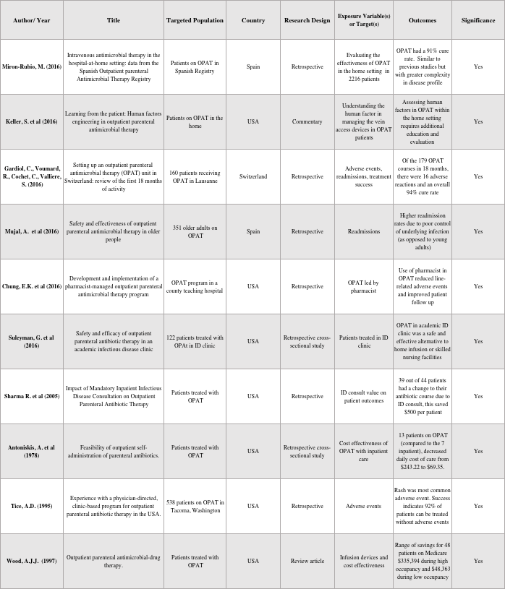
APPENDIX: LITERATURE SOURCES
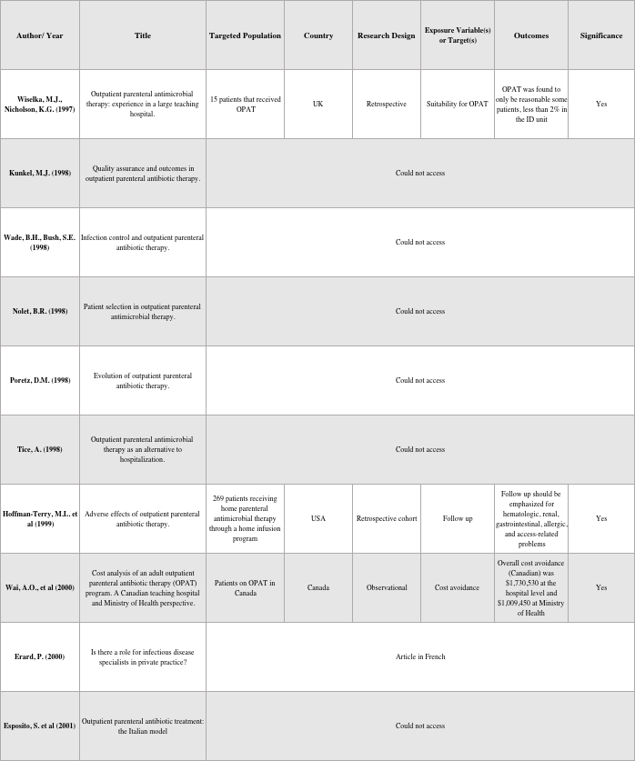
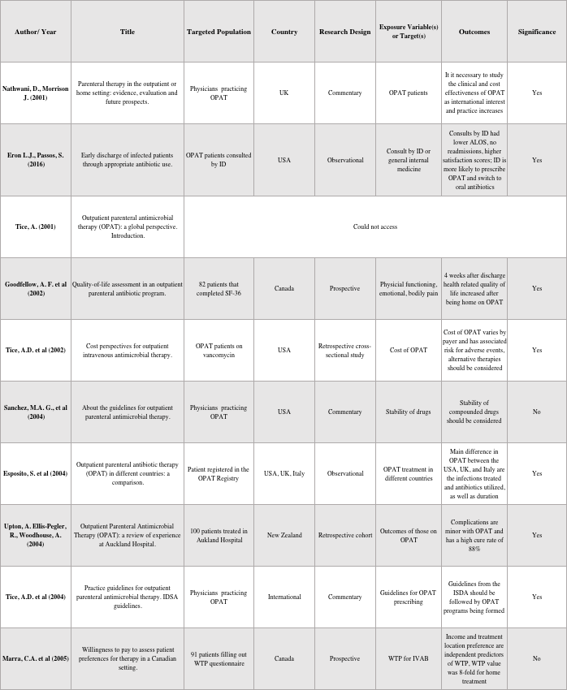
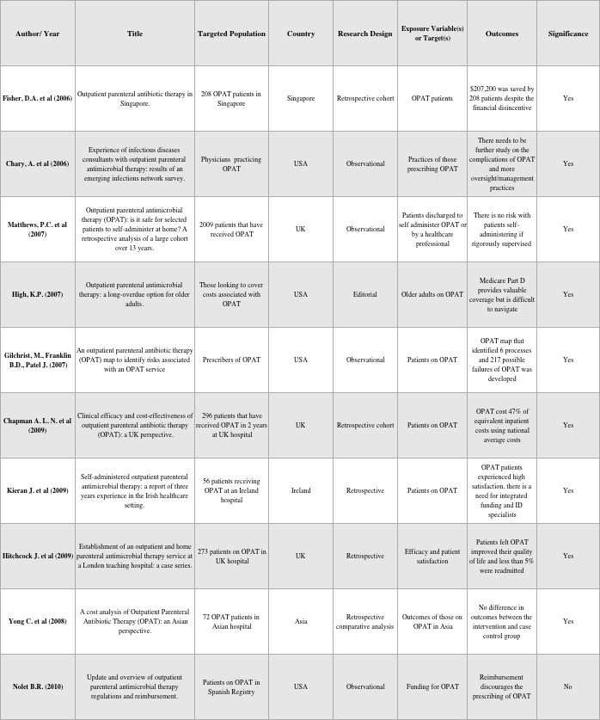
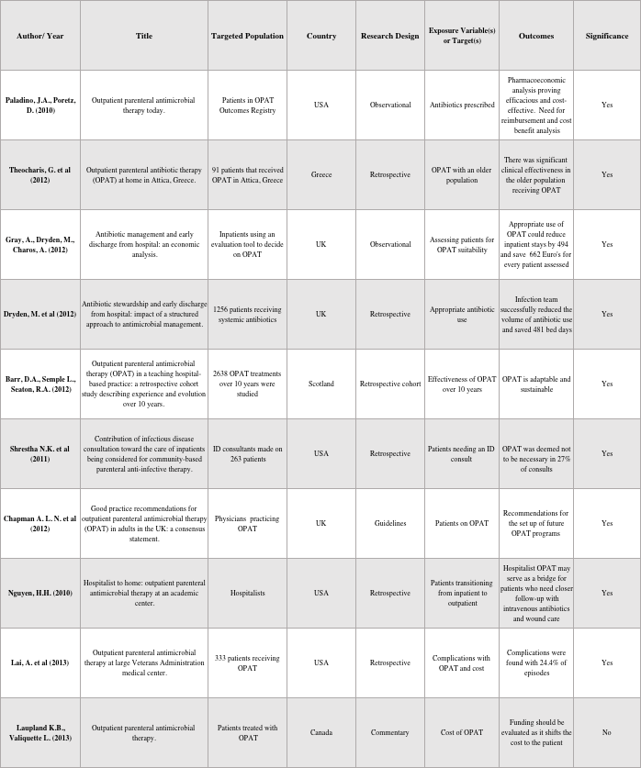
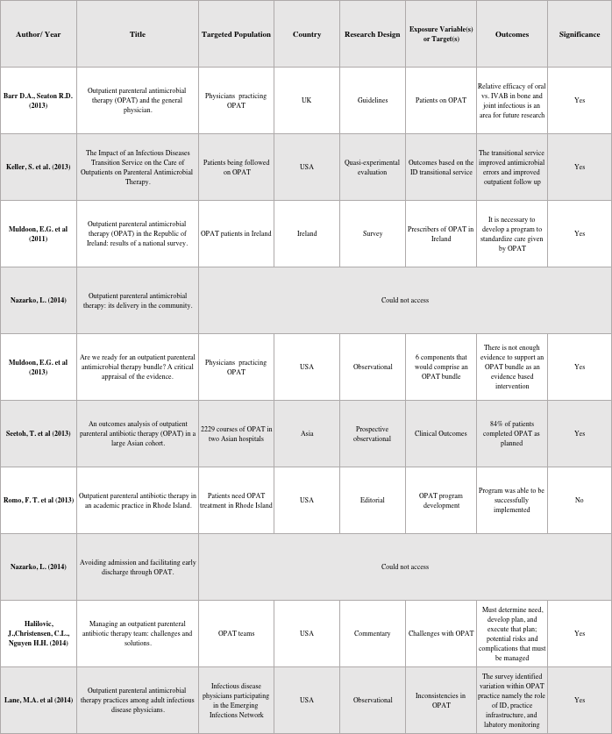
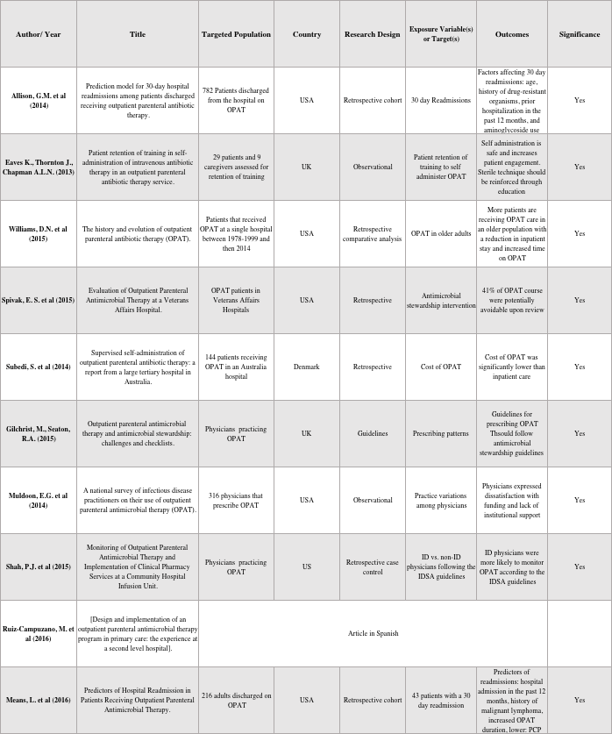
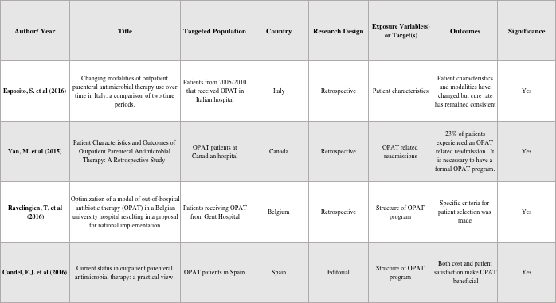

bibliography
1. Williams, D.N., et al., The history and evolution of outpatient parenteral antibiotic therapy (OPAT). Int J Antimicrob Agents, 2015. 46(3): p. 307-12.
2. Tice, A.D., et al., Practice guidelines for outpatient parenteral antimicrobial therapy. IDSA guidelines. Clin Infect Dis, 2004. 38(12): p. 1651-72.
3. Esposito, S., et al., Outpatient parenteral antibiotic therapy (OPAT) in different countries: a comparison. Int J Antimicrob Agents, 2004. 24(5): p. 473-8.
4. Eaves, K., J. Thornton, and A.L. Chapman, Patient retention of training in self-administration of intravenous antibiotic therapy in an outpatient parenteral antibiotic therapy service. J Clin Nurs, 2014. 23(9-10): p. 1318-22.
5. Chapman, A.L., et al., Good practice recommendations for outpatient parenteral antimicrobial therapy (OPAT) in adults in the UK: a consensus statement. J Antimicrob Chemother, 2012. 67(5): p. 1053-62.
6. Antoniskis, A., et al., Feasibility of outpatient self-administration of parenteral antibiotics. West J Med, 1978. 128(3): p. 203-6.
7. Gilbert, D.N., et al., Outpatient parenteral antimicrobial-drug therapy. N Engl J Med, 1997. 337(12): p. 829-38.
8. Shah, P.J., et al., Monitoring of Outpatient Parenteral Antimicrobial Therapy and Implementation of Clinical Pharmacy Services at a Community Hospital Infusion Unit. J Pharm Pract, 2015. 28(5): p. 462-8.
9. High, K.P., Outpatient parenteral antimicrobial therapy: a long-overdue option for older adults. J Am Geriatr Soc, 2007. 55(5): p. 792-3.
10. Lai, A., et al., Outpatient parenteral antimicrobial therapy at large Veterans Administration medical center. Am J Manag Care, 2013. 19(9): p. e317-24.
11. Tice, A.D., et al., Cost perspectives for outpatient intravenous antimicrobial therapy. Pharmacotherapy, 2002. 22(2 Pt 2): p. 63S-70S.
12. Nathwani, D. and J. Morrison, Parenteral therapy in the outpatient or home setting: evidence, evaluation and future prospects. J Infect, 2001. 42(3): p. 173-5.
13. Kieran, J., et al., Self-administered outpatient parenteral antimicrobial therapy: a report of three years experience in the Irish healthcare setting. Eur J Clin Microbiol Infect Dis, 2009. 28(11): p. 1369-74.
14. Yong, C., et al., A cost analysis of Outpatient Parenteral Antibiotic Therapy (OPAT): an Asian perspective. Int J Antimicrob Agents, 2009. 33(1): p. 46-51.
15. Paladino, J.A. and D. Poretz, Outpatient parenteral antimicrobial therapy today. Clin Infect Dis, 2010. 51 Suppl 2: p. S198-208.
16. Chary, A., et al., Experience of infectious diseases consultants with outpatient parenteral antimicrobial therapy: results of an emerging infections network survey. Clin Infect Dis, 2006. 43(10): p. 1290-5.
17. Sharma, R., W. Loomis, and R.B. Brown, Impact of mandatory inpatient infectious disease consultation on outpatient parenteral antibiotic therapy. Am J Med Sci, 2005. 330(2): p. 60-4.
18. Suleyman, G., et al., Safety and efficacy of outpatient parenteral antibiotic therapy in an academic infectious disease clinic. J Clin Pharm Ther, 2017. 42(1): p. 39-43.
19. Muldoon, E.G., et al., Outpatient parenteral antimicrobial therapy (OPAT) in the Republic of Ireland: results of a national survey. Eur J Clin Microbiol Infect Dis, 2013. 32(11): p. 1465-70.
20. Lane, M.A., et al., Outpatient parenteral antimicrobial therapy practices among adult infectious disease physicians. Infect Control Hosp Epidemiol, 2014. 35(7): p. 839-44.
21. Shrestha, N.K., et al., Contribution of infectious disease consultation toward the care of inpatients being considered for community-based parenteral anti-infective therapy. J Hosp Med, 2012. 7(5): p. 365-9.
22. Dryden, M., et al., Antibiotic stewardship and early discharge from hospital: impact of a structured approach to antimicrobial management. J Antimicrob Chemother, 2012. 67(9): p. 2289-96.
23. Eron, L.J. and S. Passos, Early discharge of infected patients through appropriate antibiotic use. Arch Intern Med, 2001. 161(1): p. 61-5.
24. Keller, S.C., et al., The Impact of an Infectious Diseases Transition Service on the Care of Outpatients on Parenteral Antimicrobial Therapy. J Pharm Technol, 2013. 29(5): p. 205-214.
25. Hoffman-Terry, M.L., et al., Adverse effects of outpatient parenteral antibiotic therapy. Am J Med, 1999. 106(1): p. 44-9.
26. Gilchrist, M., B.D. Franklin, and J.P. Patel, An outpatient parenteral antibiotic therapy (OPAT) map to identify risks associated with an OPAT service. J Antimicrob Chemother, 2008. 62(1): p. 177-83.
27. Means, L., et al., Predictors of Hospital Readmission in Patients Receiving Outpatient Parenteral Antimicrobial Therapy. Pharmacotherapy, 2016. 36(8): p. 934-9.
28. Allison, G.M., et al., Prediction model for 30-day hospital readmissions among patients discharged receiving outpatient parenteral antibiotic therapy. Clin Infect Dis, 2014. 58(6): p. 812-9.

