A CASE CONTROL STUDY OF RISK FACTORS ASSOCIATED WITH CRE/CRO AND ESBL

by
Corrine Bozich
BS, University of Pittsburgh at Johnstown, 2015

Submitted to the Graduate Faculty of
Infectious Diseases and Microbiology
Graduate School of Public Health in partial fulfillment
of the requirements for the degree of
Master of Public Health

University of Pittsburgh
2017

UNIVERSITY OF PITTSBURGH
GRADUATE SCHOOL OF PUBLIC HEALTH

This essay is submitted
by
Corrine Bozich

on

April 21, 2017
and approved by
Essay Advisor:
Jeremy Martinson, DPhil ______________________________________
Assistant Professor
Infectious Diseases and Microbiology/ Human Genetics
Graduate School of Public Health
University of Pittsburgh

Essay Reader:
Mohamed Yassin, MD, PhD ______________________________________
Director of Infection Control
UPMC Mercy
University of Pittsburgh

Essay Reader:
Catherine Haggerty, PhD, MPH ______________________________________
Associate Professor
Epidemiology
Graduate School of Public Health
University of Pittsburgh

Copyright © by Corrine Bozich
2017
Jeremy Martinson, DPhil

A CASE CONTROL STUDY OF RISK FACTORS ASSOCIATED WITH CRE/CRO AND ESBL
Corrine Bozich, MPH
University of Pittsburgh, 2017
ABSTRACT
Antibiotic resistance is a growing problem that affects public health. Antibiotic resistance is prominent at large medical centers with complicated medical care and need for prolonged use of broad spectrum antibiotics. Multi-drug resistant Gram negative rods (GNR-MDRO) are a group of bacteria that pose a particular threat, as they cause life-threatening infections with limited options for treatment.
This is a case-control study that aims at answering questions regarding MDRO origin and risk factors. We are including in this study three types of MDRO; Extended-spectrum β-lactamases (ESBL) (used as the control), Carbapenem-Resistant Enterobactericiae (CRE) and other Carbapenem-Resistant Organisms (CRO) such as lactose non-ferments (mostly Pseudomonas and Acinetobacter).
Factors such as indwelling urinary or intravenous catheter upon admission, tracheostomy/ventilator, and chronic wound were found to be significant in a univariate analysis, however, only chronic wound presence (OR: 5.58; 95% CI: 1.87-16.63) and history of tracheostomy/ventilator (OR: 27.06; 95% CI: 3.20-229.15) were significant after entry into a multivariable logistic regression model, meaning that the presence of a chronic wound and/or history of tracheostomy/ventilator is associated with MDRO colonization, specifically CRE/CRO.
Hospitals should practice extra care with patients with a chronic wound and/or with a history of a tracheostomy or being on a mechanical ventilator. These patients should be screened for CRE/CRO both upon admission and during their hospital stay in order to provide optimal prevention of CRE colonization and spread.

TABLE OF CONTENTS
preface ix
1.0 Introduction 1
1.1 cre/cro 4
1.2 esbl 8
2.0 methods 15
2.1 ASSOCIATions WITH cre/cro vs. Esbl, impact differences, and hospital onset 16
3.0 results 18
3.1 univariate analysis 19
3.2 Multivariable Analysis 21
4.0 discussion 23
5.0 conclusion 27
APPENDIX: CHARLESTON COMORBIDITY INDEX SCORING 29
bibliography 30
List of tables
Table 1. Characteristics of CRE/CRO Patients Vs. ESBL Patients 18
Table 2. Risk Factors Being Studied in Association with CRE/CRO 19
List of figures
Figure 1. Timeline of Deployment/Resistance of Antibiotics 1
Figure 2. KPC Cases reported to CDC in US as of January 2017 5
Figure 3. Unique Beta-lactamase enzymes Identified Since Antibiotic Introduction 10
Figure 4. Comparison of Percentage of Patients Exhibiting Significant Risk Factors in CRE/CRO and ESBL Groups 20
Figure 5. Hospital Onset 22
preface
Special thanks to Kathleen Shutt for help with statistical analysis and Mohamed Yassin for project guidance.

Introduction
Since the implementation of penicillin as treatment for bacterial infection in 1942, the production and distribution of new antibiotics has been followed by bacterial evolution of significant resistance in just a few years after initial antibiotic employment (Figure 1). This is a battle we are still fighting today, as the Infectious Disease Society of America suggests that as much as 70% of hospital-acquired infections in the United States are resistant to at least one antibiotic, if not more [1].

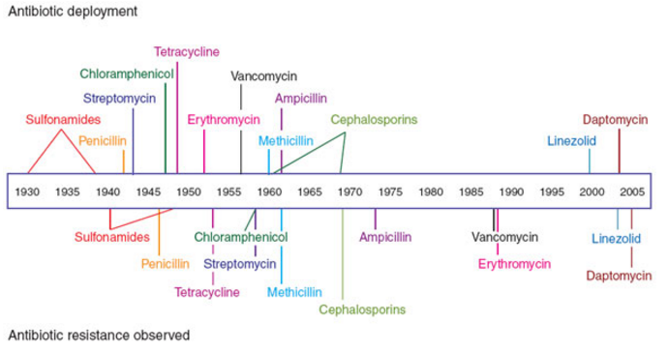
Figure 1. Timeline of Deployment/Resistance of Antibiotics

There are two key functions that are characteristic of traditional antibiotics. These antibiotics can usually perform either one or both functions, which include being bacteriocidal, or having the ability to kill bacteria, and/or being bacteriostatic, or having the ability to stop bacterial growth [1]. They operate by inhibiting bacterial functions that are critical for the growth and survival of bacteria, such as cell wall synthesis, DNA replication, RNA transcription, and protein synthesis. Although these have proven to be successful targets for antibiotics in the past, these mechanisms tend to enforce a selective pressure that can facilitate the growth of antibiotic resistance [1].
Resistance to multiple, or even all, available broad-spectrum antimicrobials is becoming a quickly emerging global problem, especially in the healthcare setting [2]. The burden of Gram-negative rod multidrug-resistant organisms (GNR-MDRO) bacteria in particular continues to increase worldwide, with pathogens, such as Acinetobacter baumannii, Pseudomonas aeruginosa, and Enterobacteriaceae, being associated with increased lengths of hospitalization, higher health care costs, and greater mortality rates [3].
According to the CDC, the use of antibiotics is considered the most important factor leading to antibiotic resistance around the world. In fact, it is stated that resistance is created merely by using antibiotics [4]. Antibiotics are the most commonly prescribed human drugs and have been used successfully to manage bacterial infections, however, the prescription of antibiotics is often very liberal. For example, antibiotics are not optimally prescribed up to 50% of the time and are often prescribed when they are not needed, such as to patients with a viral infection. Similarly, they are often prescribed with a less than optimal dosing or duration period [4]. There is also a well-known problem with patient compliance to antibiotic regimens, where patients do not complete the antibiotics given for the prescribed duration.
Antibiotic resistance in healthcare settings remains a significant public health issue. The vast majority of the United States is affected, as most Americans will receive care in a medical setting at some point in their lives [4]. Resistance can also be spread to individuals in these settings by improper hand hygiene by medical staff, improper sanitation of hospital rooms, unsuitable sterilization of hospital equipment, or by contaminated food or water [5].
Antibiotic resistance is a huge global concern, due to the extreme difficulty in treatment and the various negative impacts on infected patients. In fact, in the United States alone, more than 20 thousand patients die each year resulting from infections caused by multi-drug resistance, with over 20 billion dollars a year being spent to control the spread of antibiotic-resistant strains [6].
Multi-drug resistance is very difficult to treat, often requiring administration of extremely powerful drugs that frequently result in adverse side effects. These colonizations are also incredibly problematic to track, as they are not a notifiable disease.
The aim of this case control study is to identify risk factors most associated with Carbapenem-Resistant Enterobacteriaceae and Carbapenem-Resistant Organisms (CRE/CRO), determine if there is a difference in impact on patients with CRE/CRO as opposed to Extended-Spectrum β-lactamases (ESBLs), and to determine if these resistant infections are mostly community-acquired or hospital-acquired. A case control model was used to compare CRE/CRO to ESBL, as it is an inexpensive and effective way to study multi-drug resistance.

cre/cro
Carbapenem Resistant Enterobacteriaceae (CRE) are a group of gram negative bacteria that are resistant to carbapenems, a group of broad-spectrum antimicrobials that are used as the last resort of life-threatening healthcare associated infections [7]. Carbapenems were first developed in the 1980s, and are derivatives of thyanamycin. Common carbapenems include Imipenem and Meropenem [8].
Multi-drug resistant Enterobacteriaceae are a common cause of both community-acquired and hospital-acquired infections. Although this large family of Gram-negative bacillus bacteria includes over 70 genera, the health-care–associated Enterobacteriaceae most commonly reported to CDC's National Healthcare Safety Network (NHSN) surveillance system are Klebsiella, Enterobacter, and E. Coli [9].
CRE are a huge threat to public health, being resistant to most, if not all, antibiotics, with investigations reporting a mortality rate as high as 40% to 80% from resulting infections. The emergence of these organisms is relatively recent in the United States, having been moderately uncommon before 2000 [9]. In the United States, the incidence of CRE has quadrupled in the past decade, being reported in nearly every state. They’ve been detected in 3.9% of hospitals and 17.8% of long-term acute care facilities [10].
Compared to other antibiotic resistant organisms, such as methicillin-resistant Staphylococcus aureus (MRSA), carbapenem resistance is more complex [9]. Where MRSA is inclusive of only one bacterial species and resistance is mediated by a single mechanism, carbapenem resistance can occur in numerous Enterobacteriaceae species and can mediate resistance via several mechanisms, including the production of carbapenemases, enzymes that inactivate carbapenems [9].
CRE typically harbor genes that encode carbapenem-hydrolyzing beta-lactamases or carbapenemases. Klebsiella pneumoniae carbapenemases (KPCs) are the most common in the United States [11], having been reported most consistently over the last 15 years in countries such as the United States, Greece and Israel [12]. As Shown in Figure 1, as of January 2017, the vast majority of the United States has reported at least one case of just KPC alone.

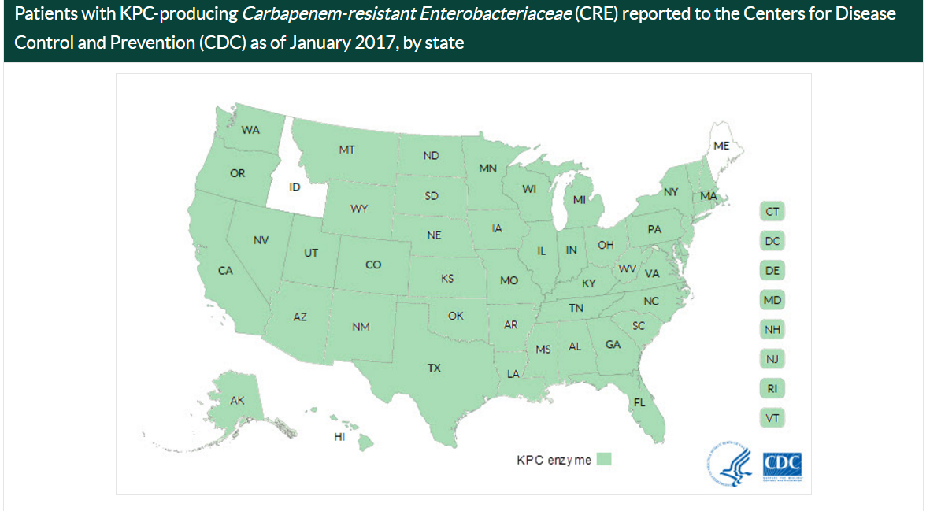
Figure 2. KPC Cases reported to CDC in US as of January 2017

The mortality rates due to carbapenem resistant K. Pneumoniae infections alone are high, ranging from 26% to 44% and as high as 70% in cases of bacteremia. However, the reported deaths associated with these infections do include cases in which patients had an underlying disease, so it is difficult to determine if the resistant K. Pneumoniae infection was the ultimate cause of death [13]. K. Pneumoniae is both the fourth and fifth most common cause of pneumonia and bacteremia among intensive care units, newborn units, and in immunocompromised patients. In hospital settings, the Klebsiella species survive and multiply in wet environmental sites and colonize the human bowel, bladder, upper respiratory tract and skin [14]. Furthermore, reports of carbapenem resistant K. Pneumuniae have emerged from other parts of the world, with some associated with receipt of medical care in the United States. This suggests intercontinental spread of these organisms, which could be very dangerous [10].
Although CRE have primarily been reported in health care settings, Enterobacteriaceae are common causes of both health care and community infections, raising the possibility of spread of CRE into the community [10]. The possibility of community-acquired infections, coupled with the high transmission and limited treatment options, make CRE a very important current public health issue.
Carbapenems are crucial in the management of life-threatening infections. Of all the different β-lactams, carbapenems possess the broadest spectrum of activity and greatest potency against both Gram-positive and Gram-negative bacteria, leading them to be the last resort of the most life-threating nosocomial infections [15]. However, due to recent emergence and spread of CRE, the utility of these antibiotics as a viable treatment option is under threat.
This group of carbapenem-resistant Enterobacteriaceae are capable of producing carbapenemases, which hydrolyze carbapenems, and are also capable of undergoing the loss of outer membrane proteins, both of which mechanisms allow the bacteria to gain resistance to carbapenem antibiotics [7]. The bacteria’s tendency to colonize various surfaces, its intrinsic resistance to common disinfectants, and its ability to spread to other species [16] make hospital-acquired infections more probable, and identification of such infections necessary.
Carbapenem Resistant Organisms (CRO) other than Enterobacteriaceae include Acinetobacter and Pseudomonas, and are very similar to CRE in their resistance to carbapenems and their threat to hospitals and other healthcare facilities. Acinetobacter baumannii is one of the more common organisms that can confer resistance to carbapenems. It is an opportunistic pathogen that is responsible for numerous nosocomial infections, including respiratory infections, such as ventilator-associated pneumonia (VAP), urinary tract infections, bacteremia, soft and skin tissue infections, burn wound infections and even secondary meningitis [17]. Carbapenem resistance in A. baumannii has been an emerging problem world-wide for the past decade [17].
Carbapenem resistance remains a huge threat to healthcare facilities, as these infections are extremely difficult to treat with their high levels of resistance, contributing to the death of up to 50% of those who become infected [18]. CRE/CRO also have the potential to spread antibiotic resistance via plasmid transfer to other bacterial species, including common human flora and potential pathogens such as Escherichia coli [10].
Infections caused by carbapenem resistance have often been found to be associated with factors such as age, cancer, heart disease, diabetes, intensive use of antibiotics, and invasive procedures such as hemodialysis, mechanical ventilation, catheter, and tracheostomy [19]. However, to our knowledge, no studies have assessed the differences of these associations with carbapenem resistance and smaller-spectrum resistance, such as resistance to β-lactams.
CRE/CRO prevalence is increasing, becoming a more threatening problem and a huge public health concern. As of 2013, CRE was deemed to be of an urgent threat level by the CDC, meaning that these resistant organisms are of high consequence and have the potential to become widespread, requiring urgent public health attention [20]. Laboratories have confirmed that 44 states have had at least one type of CRE in a healthcare facility [20]. CRE/CRO colonization and infection is rare, however, the prevalence is increasing. The CDC states that of an estimated 140,000 Enterobacteriaceae infections that occur in the United States each year, about 9,300 infections and 600 deaths are attributed to CRE [20].
Current prevention strategies for CRE/CRO are based solely on the identification of colonized or infected patients. Only then can proper implementation and contact precautions occur [9]. Detection of colonization is typically done through rectal surveillance cultures of patients who were exposed to known cases of CRE/CRO. After a case is identified, the colonized or infected patient, as well as any healthcare personnel who care for that patient, is segregated from the uncolonized or uninfected population to control CRE/CRO in healthcare settings [9].
Patients who become colonized or infected with CRE/CRO are often treated and cared for in numerous other healthcare institutions during the length of their illness. For this reason, having a multi-institutional strategy in prevention and identification is critical, both in regions of higher CRE/CRO prevalence and in areas where CRE/CRO is just emerging and not yet recognized [9]. Identification of risk factors most associated with CRE/CRO colonization and infection is key in providing early detection of the condition, thus implementing isolation and prevention strategies to most effectively control the spread to other hospitalized patients.

esbl
β-lactams are the most commonly prescribed antibiotics to treat infections. They are also often used as a prophylactic treatment before surgeries [21]. Although these antibiotics have proven to be an effective treatment for many bacterial infections, most Gram-negative bacteria have been found to produce β-lactamases as a defense mechanism against these antibiotics [22]. The β-lactamase family is divided into 4 different groups. These subgroups include penicillinases, extended-spectrum-β-lactamases (ESBLs), carbapenemases, and AmpC-type cephalosporinases. Of these β-lactamase groups, ESBLs contain the largest and most prevalent group of enzymes [23].
Extended-spectrum β-lactamases are β-lactamase enzymes produced by some Gram-negative bacteria in the Enterobacteriaceae family, giving the bacteria the ability to confer resistance to β-lactams via hydrolysis [22]. Resistance to β-lactams includes resistance to penicillin, cephalosporin, and monobactam aztreonam [22]. Co-resistance to aminoglycosides, fluoroquinolones, tetracyclines, chloramphenicol, and sulfamethoxazole and trimethoprim can also be found [21]. ESBLs are not, however, resistant to carbapenems or cephamycins [24]. β-lactam antimicrobials, which are less potent and therefore less severe than carbapenems, are considered first line drugs against bacterial infections in humans [15].
There has been a history of evolution and dissemination of ESBLs since the 1960s, when the first plasmid-mediated β-lactamase in Gram-negative bacteria was described in Greece, being given the name TEM-1, after a patient by the name of Temoniera, from whom TEM-1 was first isolated via blood culture [25]. TEM-1 enzymes are transposon and plasmid mediated, allowing it to spread worldwide. They are now found in many species of Enterobacteriaceae, including Pseudomonas aeruginosa [25].
Sulphydral variable type 1 (SHV-1) was another β-lactamase that was identified and found to be in Enterobacteriaceae such as Klebsiella and Escherichia coli [25]. Over time, newer β-lactam antibiotics were created and distributed in clinical settings, resulting in the evolution of new variants of β-lactamases [25].
In the 1980s, third-generation, extended-spectrum cephalosporins were produced and distributed into clinical practice to defend against the increasing prevalence and spread of β-lactamases. This introduction was met with a quick emergence of resistance, with an SHV-2 enzyme capable of hydrolyzing these cephalosporins being reported in Germany in 1983. Due to their increased spectrum of activities, these emerging enzymes came to be known as Extended-Spectrum β-Lactamases [25].
Since the introduction of the first β-lactam antibiotics, there has been a constant battle against resistance, and it is a battle we are losing. The number of variants of β-lactamases has been consistently increasing since the 1970s with every introduction of novel β-lactam antibiotics [26]. There have been up to 900 unique β-lactamase enzymes reported in 2010 alone (Figure 3), and with every new β-lactam produced to fight this resistance, new β-lactamases emerge.

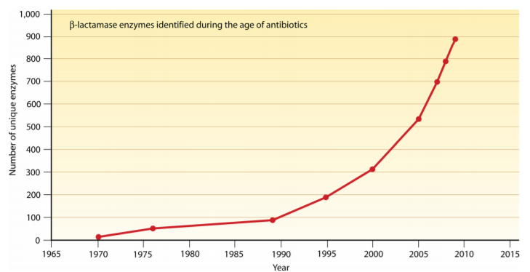
Figure 3. Unique Beta-lactamase enzymes Identified Since Antibiotic Introduction

The countless number of unique β-lactamases are divided into different groups. Having over 150 different types, the largest groups of ESBLs are the mutants of TEM and SHV β-lactamases. This group differs from the traditional TEM and SHV enzymes in their ability to hydrolyze third-generation, or oxyimino, cephalosporins. Where traditional TEM and SHV enzymes lack the ability to significantly hydrolyze these cephalosporins, their mutants can, enabling resistance to their host strains [25].
The second largest group of ESBLs is the CTX-M enzymes, which are categorized into five different subgroups, each containing approximately 40 different types. These enzymes have evolved and migrated to mobile DNA, which could result in their further evolution [25]. CTX-M enzymes specifically have been identified largely in community settings, most of which are the results of urinary tract infections. According to various reports of ESBLs, these enzymes may be the most frequent type worldwide [25].
Another type of β-lactamases are the OXA-type β-lactamases, named for their oxacillin-hydrolyzing abilities. Although these enzymes are largely found in Pseudomonas aeruginosa, they have also been detected in other Gram-negative bacteria. OXA-type ESBLs were originally identified in Pseudomonas aeruginosa isolates from Turkey [25].
Resistance to β-lactams can be inherent in some bacterial species, however, resistance can also be acquired through spontaneous mutation or DNA transfer [25]. Common β-lactam resistance mechanisms include the production of β-lactamases, impermeability, and efflux and target alteration [25]. Genes encoding ESBLs are commonly housed on plasmids, allowing spreading resistance to various other species of Gram-negative bacteria [27].
The prevalence of ESBL-producing bacteria has increased over the past decade, with ESBL-producing organisms having been detected in every inhabited continent in the world [28]. In a 2013 report, the CDC states ESBL to be of a serious threat level, which is one tier below the threat level of CRE, meaning that although not at an urgent threat level, the problem of ESBLs will likely worsen, having the potential of becoming urgent without public health monitoring and prevention [20]. Almost 26,000 (19%) healthcare-associated Enterobacteriaceae infections and 1,700 deaths were the result of ESBLs. Moreover, patients with ESBL-associated blood stream infections are 57% more likely to die than those with blood stream infections that aren’t associated with ESBL [20]. Patients with ESBL-producing Enterobacteriaceae result in excess hospital charges of over $40,000 every year for each occurrence [20].
Treatment of ESBL-producing Enterobacteriaceae is limited, and like CRE treatment, initial therapeutic treatments are often times ineffective and associated with a higher risk of mortality [29]. Carbapenems are usually used as treatment for ESBL, however, with the rising emergence of CRE, the use of carbapenems to treat ESBL may be hindered [30]. There are currently hundreds of organisms that can contain ESBL, including E. Coli and Klebsiella [15], with the most common being Klebsiella pneumoniae [31].
The most common infections with ESBL-producing organisms involve the gastrointestinal tract, including urinary tract infections, peritonitis, cholangitis and intra-abdominal abscesses. However, colonization of the upper respiratory tract and skin of critically hospitalized patients is also quite common, being found to be a common cause of nosocomial pneumonia and central venous line-related bacteremia [31].
Since ESBLs have been isolated from domestic animals, food products, and even sewage and human stool samples from healthy individuals, it is unsurprising that they are often implicated as caused of community-acquired infections [29]. Emergence of community-associated ESBL infections have been reported in both Europe and the United States [15], however, ESBL-producing organism infections are most commonly hospital-acquired, being most common in intensive care units, with nursing homes also being a potential reservoir [31]. Carbapenems are the drug of choice to treat these infections [31].
ESBL-producing bacteria have gained special attention in hospital and other healthcare settings due to limited treatment options, which results in poor clinical outcomes for patients, as well as an increased risk in causing hospital-acquired infections [22]. Hospital patients easily acquire these bacteria and act as a reservoir, thus, early detection of ESBL is critical in the control and prevention of ESBL-related nosocomial outbreaks in healthcare settings [22].
Because ESBL-producing bacteria is not a notifiable condition, the prevalence is unknown, both in the United States and worldwide [22]. Furthermore, ESBL-related infections can be difficult to track, since ESBLs are usually encoded by genes that are located on various genetic elements. This allows for several different epidemiologic patterns, from sporadic cases to large-scale outbreaks [32].
ESBLs share many characteristics with CRE/CRO, as both are associated with increased length of hospital stay and poor clinical outcomes for patients. The main difference of these two antibiotic resistant bacteria groups is that where ESBL-producing bacteria are only resistant to β-lactams, CRE/CRO-producing bacteria confer resistance to virtually all antibiotics, including both β-lactams and carbapenems. This makes ESBL slightly less threatening than CRE/CRO, as they can still be treated with carbapenems. CRE/CRO-producing bacteria is much difficult to treat, however, as they possess more resistance.
Another difference between ESBL and CRE/CRO is that while ESBL-producing bacteria appears to occur mostly in community settings, CRE/CRO is predominantly associated with hospital-acquired infections.
ESBLs and CRE/CRO are very similar in nature, with poor patient outcomes and costliness that is associated with longer lengths of stays and higher use of hospital resources. However, the differences in severity, as well as differences in acquisition (hospital-acquired versus community-acquired) could result in a difference in patients who exhibit risk factors most associated to antibiotic resistance. To our knowledge, there has been no prior study that compares the associated risk factors of patients colonized with ESBLs and those colonized with CRE/CRO.

methods
The objectives of this study were to identify risk factors most associated with CRE/CRO using ESBL as a baseline; to determine if there is a difference in impact on patients with CRE/CRO as opposed to ESBL; and to determine if these resistant infections are mostly community-acquired or hospital-acquired.
We conducted a case control study conducted in Pittsburgh, Pennsylvania at UPMC Mercy, a 500-bed, tertiary university affiliated healthcare facility. We decided to use ESBL as a control rather than an uninfected patient population in order to make the two patient groups more comparable. After much consideration and collaboration with multiple health professionals, it was determined that ESBL would be the best control for this particular study.
A patient list of MDRO-positive patients was obtained from Theradoc, a software that provides patient information for clinical surveillance in healthcare settings in the United States. Medical records of 105 patients who tested positive for a CRE/CRO or ESBL colonization between January 2014 and December 2015 were analyzed via Cerner PowerChart. Patients were given a unique identification code to ensure anonymity. Duplicate cultures were eliminated from the sample and only the first culture of patients with duplicates was analyzed. Patients were also eliminated from the list if they did not stay overnight in the hospital or only had intermediate resistance.
The age, sex, and length of stay (LOS), of each patient was recorded and compared between the two groups to determine similarity in cohorts. The Charleson Comorbidity Index Score was also collected for each patient. This comorbidity score allows for the most effective evaluation of comorbid conditions in patients, allowing us to objectively assess the level of healthiness for each patient, with a higher score being associated with poorer health (Appendix A). We also identified exposure to antibiotics and mortality of patients within admission period. After a very few number was found, exposure to antibiotics was dropped from the risk factor analysis of the study, however, both antibiotic exposure and mortality were still included in the univariate analysis. The origins from which the cultures (site of isolation) were taken were also noted and categorized as urine, blood, sputum, or other. SAS 9.3 software was used to analyze the data.
The MDRO-positive patients used in the study were from the time period of 2014 to 2015. A total of 60 CRE/CRO-colonized patients (34 CRE and 26 CRO) were counted as one group. Although a 1:1 ratio of the two groups was strived for, time constraints led to 45 patients colonized with ESBL being randomly selected and used as the control. ESBL was used as a control rather than patients with no MDRO colonization in order to identify the differences in impact of CRE/CRO compared to a simpler drug resistant organism.

ASSOCIATions WITH cre/cro vs. Esbl, impact differences, and hospital onset
Based on previous studies, six risk factors were determined to be most characteristically associated with CRE/CRO colonization and were specifically looked for upon review of the patients’ medical records. These risk factors include readmission to the hospital within 30 days of being discharged, admission to the hospital from a nursing home, a chronic wound lasting more than 30 days, admission to the hospital with the presence of an indwelling urinary or intravenous catheter, a history of a tracheostomy or being on a ventilator, and a history of an ostomy. Variables such as age, sex, recent antibiotic exposure, Charleson Comorbidity Index Score, hospital onset, mortality, LOS, and sit of isolation (blood, urine, sputum, or other) were also measured in order to determine possible associations with CRE/CRO vs. ESBL.
A univariate logistic regression was first done on the risk factors and the other mentioned variables to determine association. All variables with a p-value of less than 0.2 were then entered into a stepwise multivariable logistic regression model. The factors in the multivariable model with a p-value of less than 0.05 were determined to be significant.
The patient characteristics in the CRE/CRO group were compared to patients in the ESBL group. The percentage of patients possessing the risk factors that were found to be statistically significant in the CRE/CRO patient group were compared to those found in the ESBL group.
Characteristics such as sex, age, LOS, and Charleson Comorbidity Index Score were recorded in each patient group and then compared to assess any differences between the CRE/CRO and ESBL groups.
The hospital onset variable was used to determine if colonization was hospital-acquired or community acquired. We defined a patient as having a hospital-acquired, or “hospital onset” of infection rather than a community-acquired infection if he or she had a positive culture taken at 3 days or longer after admission. The percentage of patients with a time to culture of longer than 3 days after admission in the CRE/CRO patients was then compared to the percentage in the ESBL group.

results
After collecting basic demographic information, it was determined that the patients in each group were overall similar, and therefore could be fairly compared, using ESBL as a baseline. The percentage of men and women in each group was almost even, with the CRE/CRO group having a slightly higher percentage of men and the ESBL group having a higher percentage of women (Table 1). The age range of the patients were comparable for each group, with the age median and range being between 60 and 70 in both the CRE/CRO and ESBL patients. The Comorbidity Score of the two groups was also comparable, with the patients of the CRE/CRO group scoring a median of 3.5 and the ESBL group scoring a median of 4. However, the median LOS was much higher in the CRE/CRO group than in that of the ESBL group.

Table 1. Characteristics of CRE/CRO Patients Vs. ESBL Patients
MDRO | % Men | % Women | Total Number of Patients | Age |  | LOS (Days) |  | Median Comorbidity Score
 |  |  |  | Median | Range | Median | Range | Median Comorbidity Score
CRE/CRO | 60 | 40 | 60 | 60 | 73 | 21 | 106 | 3.5
ESBL | 42.2 | 57.8 | 45 | 64 | 78 | 5 | 139 | 4

univariate analysis
Of the six risk factors being analyzed in this study, three were determined to be statistically significant in a univariate analysis with p<0.05. These significant risk factors included the presence of an indwelling urinary or intravenous catheter upon admission, a history of tracheostomy or being on a ventilator, and the presence of a chronic wound that lasted more than 30 days. The odds ratio for urinary/intravenous catheter and chronic wound were similar, being about 4. The odds ratio for history of tracheostomy/ventilator, was significantly greater, being over 20 (Table 2).

Table 2. Risk Factors Being Studied in Association with CRE/CRO
Risk Factor | n |  | Odds Ratio | p-Value | 95% CI
Risk Factor | CRE/CRO (n=60) | ESBL  (n=45) | Odds Ratio | p-Value | 95% CI
Readmission within 30 days | 30 | 23 | 0.96 | 0.9103 | (0.44, 2.07)
Admission from nursing home | 13 | 4 | 2.84 | 0.0878 | (0.86, 9.38)
Chronic wound | 26 | 7 | 4.15 | 0.0035 | (1.60, 10.78)
Indwelling urinary/intravenous catheter | 29 | 8 | 4.33 | 0.0017 | (1.73, 10.82)
Tracheostomy/ventilator | 19 | 1 | 20.39 | 0.0040 | (2.61, 159.25)
Ostomy | 19 | 12 | 1.27 | 0.5787 | (0.54, 3.00)

When compared to the ESBL group, the three statistically significant risk factors in the CRE/CRO group appeared to occur at a higher percentage. The percentage of patients in the CRE/CRO group that experienced these risk factors was higher than those who exhibited the risk factors in the ESBL group (Figure 1). The percentage of patients in the CRE/CRO group that had a chronic wound was 43.3% compared to the 15.6% of patients in the ESBL group. Similarly, 31.7% of CRE/CRO patients had a history of tracheostomy or being on a ventilator, and 48.3% had an indwelling/intravenous catheter upon admission compared to the 2.2% and 17.8% of ESBL patients respectively.

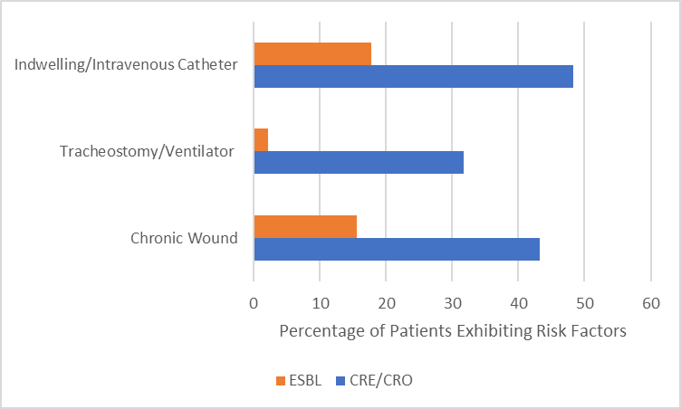
Figure 4. Comparison of Percentage of Patients Exhibiting Significant Risk Factors in CRE/CRO and ESBL Groups

Other variables besides risk factors found to be significant included gender, admission from a nursing home, chronic wound, indwelling/intravenous catheter, tracheostomy/ventilator, hospital onset, site of isolation (from blood, urine, sputum, or other), LOS and age. Hospital onset was also deemed significant in the univariate analysis, with p<0.002 (OR 3.9; 95% CI 1.67-8.89) and entered into a multivariable regression model with the significant risk factors found.

Multivariable Analysis
The variables from the univariate analysis that were eligible to be entered in a multivariable model, as previously mentioned, were gender, admission from a nursing home, chronic wound, indwelling/intravenous catheter, tracheostomy/ventilator, hospital onset, site of isolation (from blood, urine, sputum, or other), LOS and age. Only chronic wound presence, history of tracheostomy/ventilator, and hospital onset had a significant association after entry into this model.
The risk factor of presence of a chronic wound was associated with over a five-and-a-half-fold increased risk of CRE/CRO (OR 5.6; 95% CI 1.87-16.63). Patients undergoing a tracheostomy or on a ventilator were also significantly more likely to acquire CRE/CRO (OR 27.1; 95% CI 3.20-229.15). No other predictors were found to be significantly associated with CRE/CRO in the multivariable model.
Patients with a positive culture more than 3 days after admission were considered to have “hospital onset” of infection. Patients with a positive CRE/CRO culture were more likely than those with a positive ESBL culture to have such evidence of hospital onset/acquisition (58.3% vs. 26.7%, Figure 5). After entry into the multivariable regression model, CRE/CRO-positive patients were found to be five times as likely as ESBL patients to have evidence of hospital onset (OR 5.1; 95% CI 1.90-13.53).
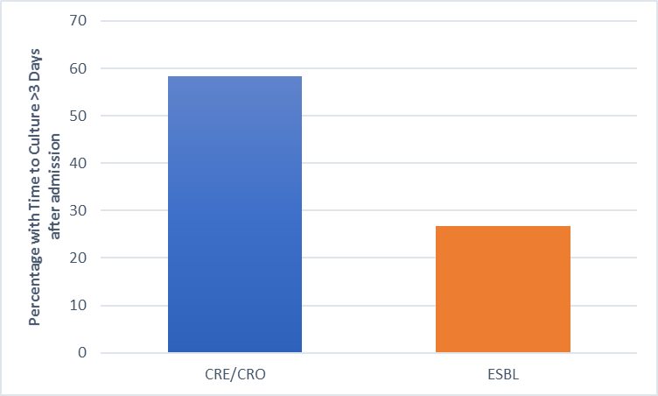
Figure 5. Hospital Onset

These results suggest that the majority of CRE/CRO colonizations were hospital-acquired while most of the ESBL colonizations were community-acquired.

discussion
Incidence of carbapenem resistance has been increasing, both in the United Sates and globally, in the last decade. Klebsiella pneumoniae carbapenemase was first discovered from a Klebsiella isolate in 2001, and since then, it has spread widely throughout the United Sates, as well as the rest of the world. Since this identification of KPC, a number of additional carbapenemases have emerged, being identified throughout the world [9].
In our study, the carbapenemase-producing Enterobacteriaceae that were found in patients were Klebsiella Pneumoniae and Klebsiella oxytoca, Enterobacter aerogenes and Enterobacter cloacae, and Escherichia coli, with the most common being K. Pneumoniae. The two carbapenem-resistant lactose non-ferments were Pseudomonas aeruginosa and Acinetobacter baumannii. Our ESBL patients were made up of E. Coli and K. Pneumoniae and K. oxytoca colonizations.
While several studies have been focusing on different laboratory-based techniques to identify carbapenem resistance, very few have gathered data on the analysis of the possible risk factors associated with acquiring carbapenem resistant bacteria [33]. Although evidence-based guidelines to prevent transmission of CRE exist, they do not account for the mobility and potential spread of resistance through plasmid transfer, which complicates tracking nosocomial infections [10]. Furthermore, because of the sheer rarity of CRE/CRO, which is supported by our small sample size, not every patient in a hospital setting is tested for colonizations of resistance. Thus, identification of risk factors associated with CRE/CRO would be instrumental for implementing effective infection prevention strategies, decreasing the risk of the spread in resistance in a hospital setting and decreasing prevalence in hospital settings.
Because of the high transmission rate of CRE/CRO and the challenge of identifying colonized patients before transmission has occurred continues to plague hospitals in the United States. In 2011, a patient colonized with carbapenemase-producing K. Pneumoniae was transferred to the NIH Clinical Center. Soon after, 17 additional patients became colonized, and six severely ill patients died from bloodstream infections attributable to the multidrug-resistant organism [10]. Risk factor-based screening could be a revolutionary tool for early identification of these infections to effectively implement preventative measures before the spread of the organism.
Our results match those of other horizontal surveillance studies, in which factors such as ventilation and indwelling devices have been found to be associated with CRE/CRO [33]. According to other studies, the presence of an indwelling device, such as an indwelling or intravenous catheter, seems to be one of the most possible associated risk factors, with one study citing that CRE is responsible for approximately 11% of all indwelling device-related nosocomial infections [11]. The presence of an indwelling device was found to be significant in our study by a univariate analysis, with 29 patients in the CRE/CRO group (48.3%) and 8 ESBL patients (17.8%) having an indwelling catheter, however, using ESBL as a baseline, it was deemed insignificant upon a multivariable logistic regression model. Our findings could be due to a small sample size, with our CRE/CRO group containing only 60 patients from 2014 to 2015.
Since underlying comorbidities, which are common in patients who experience antibiotic resistant bacteria colonization, may be substantial confounders, appropriate adjustment was necessary to determine a true association between risk factors and CRE/CRO infections. We therefore entered the eligible variables into a multivariable analysis.
CRE/CRO colonizations appear to have a higher impact on the length of stay of patients in comparison to ESBL, with CRE/CRO patients having a median LOS of 21 days versus a median of 5 days for the ESBL patients (Table 1). Likewise, less ESBL patients experienced risk factors associated with multi-drug resistance than those colonized with CRE/CRO (Figure 2). CRE/CRO colonizations also appeared to be more hospital acquired than ESBL, with ESBL colonizations seeming to be more community acquired in this study. These differences in CRE/CRO and ESBL colonizations show that CRE/CRO patients require more hospital resources, generally having a longer LOS than ESBL patients. The overall health of the patients in each group upon admission seem to be similar, with the CRE/CRO group having a median Charleson Comorbidity Index score of 3.5 and the ESBL group having a score of 4.
The fact that CRE/CRO colonization seems to be mostly hospital acquired is promising, as infected patients are more likely to be detected and isolated from the rest of the population, controlling and preventing the spread and transmission of the infection, as opposed to a community setting, where resistance can be present in a population longer, allowing for optimal spread.
As depicted in other studies, patients with multi-drug resistant colonizations have a higher risk of readmission to the hospital after discharge. This requires additional use of hospital resources and is costly. In our study, the risk factor of readmission within 30 days was not found to be statistically significant through univariate analysis. Although it is unclear how much relation carbapenem resistance has with readmission, in comparison to ESBL, there is no significant difference in readmission. Admission from a nursing home was also found not to be significant.
Although indwelling urinary or intravenous catheter upon admission, tracheostomy/ventilator, and chronic wound were found to be significant through a univariate analysis, only chronic wound presence (OR: 5.580; 95% CI: 1.87-16.63) and history of tracheostomy/ventilator (OR: 27.061; 95% CI: 3.20-229.15) were found to be significant after entry into a multivariable logistic regression model.
In this study, the mortality rate of 11.7% was associated with patients infected with CRE/CRO and a mortality rate of 2.2% was associated with patients infected with ESBL, however this was not found to be significant via univariate analysis, and as underlying illness is also associated with MDRO infections, there is no way to tell if CRE/CRO or ESBL was the ultimate cause of death. Similarly, 30% of CRE/CRO-infected patients and 31.1% of ESBL-infected patients were exposed to antibiotics within 30 days of culture, but this was also not found to be significant via univariate analysis.
There were some limitations to this study. There was a very small sample size, which can be attributed to the rarity of the infection, however, more studies done with a larger sample size would be beneficial. Although we initially aimed to have a sample ratio of 1:1 in each group, time constraints limited our ability to thoroughly analyze all ESBL patients on the patient list.
CRE/CRO have become globally endemic, and the incidence of these infections has been increasing for the last 10 years. Identification of risk factors associated with CRE/CRO could be critical in directing resources to high-risk patients, planning interventions, and ultimately preventing mortality from infections resulting from these colonizations.

conclusion
The presence of a chronic wound and tracheostomy or ventilation are particularly suggestive of carbapenem resistant colonization or infection. This study could support the use of these clinical criteria as a more effective way of surveillance and application of necessary contact precautions. Previous studies have already noted that invasive procedures, such as mechanical ventilation, catheter, and tracheostomy are associated with CRE/CRO colonization [19].
To utilize these findings in the detection of CRE/CRO, patients being admitted with a chronic wound or a history of tracheostomy or being on a ventilator should be screened for these resistant bacterial colonizations before being placed with other patients to provide optimal prevention in the spread of resistant bacteria.
Since the results suggest that the CRE/CRO colonizations in this study were hospital acquired, special care should be taken in the sanitation of hospital rooms and the sterilization of equipment, as well as immediate isolation of infected and exposed patients.
The differences in the results observed in the CRE/CRO patients and the ESBL patients indicate that CRE/CRO does have a higher negative impact on individuals compared to those with ESBL colonizations.
Future studies to validate these results and aid in the development of any future CRE/CRO patient screening program in hospitals or other healthcare settings are needed. Identification of associated risk factors could be key in preventing mortality from infections resulting from CRE/CRO colonizations.
APPENDIX: CHARLESTON COMORBIDITY INDEX SCORING
Purpose: To assess whether a patient will live long enough to benefit from a specific
screening measure or medical intervention

Scoring: Comorbidity Component (Apply 1 point to each unless otherwise noted)
1. Myocardial Infarction
2. Congestive Heart Failure
3. Peripheral Vascular Disease
4. Cerebrovascular Disease
5. Dementia
6. COPD
7. Connective Tissue Disease
8. Peptic Ulcer Disease
9. Diabetes Mellitus (1 point uncomplicated, 2 points if end‐organ damage)
10. Moderate to Severe Chronic Kidney Disease (2 points)
11. Hemiplegia (2 points)
12. Leukemia (2 points)
13. Malignant Lymphoma (2 points)
14. Solid Tumor (2 points, 6 points if metastatic)
15. Liver Disease (1 point mild, 3 points if moderate to severe)
16. AIDS (6 points)

Scoring: Age
1. Age <40 years: 0 points
2. Age 41‐50 years: 1 points
3. Age 51‐60 years: 2 points
4. Age 61‐70 years: 3 points
5. Age 71‐80 years: 4 points

Interpretation: Calculate Charlson Score or Index (i)
1. Add Comorbidity score to age score
2. Total denoted as 'i' below
2. Calculate Charlson Probablity (10 year mortality)
1. Calculate Y = e^(i * 0.9)
2. Calculate Z = 0.983^Y
3. where Z is the 10 year survival
bibliography

