THE EFFECTS OF AGING ON PLATELET BIOENERGETICS

by
Catherine Corey
BS in Biochemistry, Grove City College, 2004

Submitted to the Graduate Faculty of
the Department of Epidemiology
Graduate School of Public Health in partial fulfillment
of the requirements for the degree of
Master of Public Health

University of Pittsburgh
2017

UNIVERSITY OF PITTSBURGH
GRADUATE SCHOOL OF PUBLIC HEALTH

This essay is submitted
by
Catherine Corey

on

July 31, 2017
and approved by

Essay Advisor:
Nancy W. Glynn, PhD
Assistant Professor, Department of Epidemiology
Graduate School of Public Health
University of Pittsburgh

Essay Readers:

Sruti Shiva, PhD
Associate Professor, Department of Pharmacology & Chemical Biology
School of Medicine
University of Pittsburgh

Paul M. Coen, Ph.D
Investigator, Translational Research Institute for Metabolism & Diabetes
Florida Hospital

Copyright © by Catherine Corey
2017
Nancy W. Glynn, PhD

THE EFFECTS OF AGING ON PLATELET BIOENERGETICS
Catherine Corey, MPH
University of Pittsburgh, 2017

ABSTRACT

Background:
In a rapidly aging population, functional decline is a considerable public health burden. Studies suggest that increased fatigue has a negative impact on function. Additionally, diminished mitochondrial function associated with aging has been associated with higher fatigue. Platelets represent a minimally invasive source of mitochondria in which bioenergetic profiles can be measured. Identification of bioenergetic dysfunction associated with aging could elucidate novel biomarkers or targets and lead to interventions aimed at ameliorating the public health burden of functional decline.
Methods:
As part of the Health Aging and Body Composition (Health ABC) study, venous blood and muscle biopsy samples from the vastus lateralis were taken from a subset of the cohort to measure bioenergetics. The Health ABC participants also completed a 400m long-distance corridor walk and fatigability questionnaire. We compared the Health ABC participants (n=32, 88±2 yrs) to a race, gender and body mass index matched younger cohort (n=32, 26±5 yrs) to identify differences in platelet bioenergetics that could be attributed to aging.

Results:
Older adults showed 228.2 ± 20.39 pmolO₂/min/5x10⁷platelets maximal respiration and 39.15 ± 2.849 pmolO₂/min/5x10⁷platelets proton leak, both significantly higher (p=0.0492; p=0.0446) than in younger adults (177.4 ± 15.01 pmolO₂/min/5x10⁷platelets maximal respiration; 31.48 ± 2.39 pmolO₂/min/5x10⁷platelets proton leak). We also observed significantly lower (p=0.0496) baseline oxygen consumption rates in older adults (107.4 ± 5.294 pmolO₂/min/5x10⁷platelets) compared with younger (123.6 ± 6.083 pmolO₂/min/5x10⁷platelets). Amongst older adults, platelet glycolytic rate did not significantly correlate with LDCW time (p=0.2213), however there was a significant positive correlation (r=0.398; p=0.0359), between basal glycolytic rate and fatigability. Additionally, significant correlations were evident in older adults between non-ATP linked respiration in platelets and muscle state 4 respiration (r=0.489, p=0.0178) and in maximal respiration between platelets and muscle (r=0.444, p=0.034). Discussion:
These data demonstrate that systemic alterations in bioenergetics experienced by aged adults could contribute to fatigability and subsequent functional decline. Additionally, platelets can function as a surrogate measure of mitochondrial function in lieu of more invasive procedures. Future studies will elucidate possible racial disparities in bioenergetics and the specific mechanisms underlying the age-associated differences in bioenergetics. This work could lead to potential interventions aimed at attenuating the public heath burden of functional decline in older adults.
TABLE OF CONTENTS
1.0 INTRODUCTION 1
1.1 Aging and Disability in Older Adults 1
1.2 Fatigue and Fatigability in Older Adults 2
1.3 Bioenergetics and Aging 4
1.4 Measures of Mitochondrial Function 6
1.5 Public Health Significance 7
1.6 Objectives 8
2.0 Methods 9
2.1 Study Population 9
2.2 Platelet Isolation 10
2.3 Measurement of Platelet Bioenergetics 11
2.4 Muscle Biopsy Procedure and Permeabilized Fiber Bundle Preparation 11
2.5 Measurement of Skeletal Muscle Mitochondrial Respiration 12
2.6 Clinical Measurements 13
2.6.1 Physical Fatigability 13
2.6.2 Long Distance Corridor Walk (LDCW) 13
2.6.3 Other Covariates 14
2.7 Materials 14
2.8 Statistical Analyses 15
3.0 Results 16
3.1 Demographic Characteristics of the Older (Health ABC) and Younger Adult Cohorts 16
3.2 Oxidative Phosphorylation in Platelet Mitochondria in Young vs. Old Subjects 17
3.3 Associations between Glycolytic Rate, Physical Function, and Fatigability 20
3.4 Correlation Between Aging Platelet and Skeletal Muscle Bioenergetics 22
4.0 Discussion 24
Bibliography 29
List of tables
Table 1: Characteristics of the Older (Health ABC) and Younger Adult Cohorts 16

List of figures
Figure 1: Conceptual Model of the Bioenergetic Dysfunction Associated with Aging and its Subsequent Effects on Older Adults 6
Figure 2: Older Adults (n=32) Show Lower Basal Respiration, and Higher Proton Leak and Maximal Respiration than Younger Adults (n=32). African American Older Adults (n=12) Show Higher Basal Respiration than Caucasian (n=20) Older Adults 19
Figure 3: Platelet Glycolytic Rates and Relationships in Adults 21
Figure 4: Correlations in Older Adults between Platelet Non-ATP-linked and Muscle State 4 Respiration and in Maximal Respiration between Platelets and Muscle 23

INTRODUCTION

Aging and Disability in Older Adults
Current projections anticipate 24% of the United States population will be 65 years or older by 2060, an increase over an already high 15% in 2015[1]. In addition, the population over 85 years old is estimated to triple from 6.3 to 19 million over the next 45 years, comprising approximately 5% of the total US population by 2060[1]. The projected increase in number and proportion of older adults in the United States, propagated by the baby boomer generation and Americans living longer than ever, is unprecedented and a cause of great concern to public health and the health care system. These increases drive continued rises in the burden of age-related health care costs and make it vitally important to pursue interventions leading to better health for our aging population.

The reduction and prevention of disablement is integral to healthy aging. This is evident by the continued identification of freedom from disability as an overarching goal by Healthy People 2020[2]. As one of the 4 major facets of the disablement model described by Nagi[3-5] and amended by Verbrugge and Jetti[6], physical function is susceptible to an age-associated decline in adults [7]. According to NHANES (National Health and Nutrition Examination Survey) 48% of 60-69 year olds, 55% of 70-79 year olds, and 64% of 80+ year olds are living with functional limitations[8]. Functional disability has been shown to cost an additional $10,000 per 2 years in healthcare expenditures in community-dwelling adults as compared to the functionally independent[9]. Further, older adults who are more vulnerable to adverse functional outcomes are more likely to experience longer durations of disability and more episodes, leading to less independence and more time spent in disabled states[10]. Notably, in 3,024 well-functioning participants of the Health, Aging and Body Composition prospective cohort (mean age 73.6), participants demonstrating limitations in physical performance measures had a 2.5 fold higher risk of mortality[11]. In our aging population, declines in physical function lead to disablement and premature death and place increased strain on the health care system. Interventions aimed at attenuating functional decline in older adults possess potential for ameliorating this public health burden.

Fatigue and Fatigability in Older Adults
In order to mitigate declining physical function in older adults, it is important to identify factors which contribute to this decline. In older adults, fatigue has been shown to have a significant negative impact on function[12], and declining physical function has been associated with increased fatigue [7, 13-15]. The causal direction and temporality of the relationship between fatigue and function varies across published studies, in part due to the multifactorial origins of fatigue and the variations in how it is defined[13]. Fatigue has been described in many ways, often with reference to a persistent overall lack of energy that is not alleviated with rest, and leads to a decline in functional performance of daily living activities[12, 13]. Fatigue is often associated with a variety of acute and chronic conditions[16-19]; however, there is also an age-related increase in fatigue apart from disease[12, 20, 21]. Some of the central causes of the increases in fatigue with aging include, but are not limited to, neurotransmitter degradation, inflammation, and oxidative stress[13]. Since fatigue is considered to be an energy disorder[13], and mitochondria are the energy generators of the cell, it is conceivable that dysfunction within the mitochondria could contribute to fatigue. It has been shown that lower mitochondrial capacity and efficiency have been associated with slower walking speed[22]. Also, gait speed (a measure of physical function/mobility) correlates with the respiratory control rate of mitochondria isolated from skeletal muscle as well as both maximal and spare respiratory capacity in peripheral blood mononuclear cells[23]. In Tyrrell et al., although they examine the relationship of cellular bioenergetics and mitochondrial respiration in relation to physical function, they do not directly correlate the two. They measured gait speed in two independent cohorts (n=17 each) of overweight/obese, well-functioning, community-dwelling older adults (aged 69.1±3.69 years) and compared the gait speed of one cohort to skeletal muscle bioenergetics and the second cohort’s gait speed to peripheral blood mononuclear cellular bioenergetics. Additionally, in a study conducted in 146 healthy men and women aged 18 – 89 years, by Short et al., they demonstrated mtDNA and mRNA along with mitochondrial ATP production all decline with advancing age[24]. However, this study did not outline the mechanism leading to the decline. Furthermore, though lower oxidative phosphorylation in the quadriceps has been associated with higher fatigability[25], the relationship between other mechanisms of energy production and fatigability has not been explored.

As fatigue is a broadly defined, global and subjective measure, we propose to examine the novel characteristic of fatigability for this study, as measured by the Pittsburgh Fatigability Scale[26]. Physical fatigability is a more accurate reflection of functional limitations as it assesses whole-body fatigue as a function of an activity of standardized duration and intensity [14]. It is especially important to use a metric normalized to intensity and duration for elderly patients as they regularly practice self-pacing in an effort to compensate for declines in function and increases in fatigue[14, 26].

Bioenergetics and Aging
Mitochondrial dysfunction and the associated imbalance in bioenergetics have long been considered a hallmark of aging[27]. Oxidative phosphorylation, the bioenergetic pathway in the mitochondria in which ATP is synthesized from ADP using energy obtained by electron transport during aerobic respiration, is the most prolific ATP generation mechanism producing up to 34 ATP per mole of glucose. Studies show that age associated mitochondrial dysfunction contributes to functional decline in muscle[28], and to a decreased mitochondrial bioenergetic capacity[29]. The extent of mitochondrial impairment correlates to physical function in the elderly[28].

Idiopathic Chronic Fatigue, ICF, is characterized by impairments in mitochondrial number, biogenesis, and electron transport chain activity[30]. As previously reported, respirometric profiles of blood cells have been shown to be associated with physical function and strength in overweight/obese older adults[31]. Cells experiencing mitochondrial dysfunction can undergo a shift in their metabolism to glycolysis to meet their energy demands, as seen in disease states such as Parkinson's[32, 33] and Alzheimer's[34]. They resort to glycolysis, which allows them to generate enough ATP to survive, albeit via a less efficient pathway.

Glycolysis, the bioenergetic pathway in which glucose is converted to pyruvic or lactic acid and the energy stored in the phosphate bonds of ATP via a series of intermediate metabolites, is the other major pathway for cellular energy metabolism. In contrast to the potential 34 ATP generated by oxidative phosphorylation, glycolysis only generates 2 ATP per mole of glucose. When cells utilize glycolysis as their main source of ATP or to compensate for a deficiency in the oxidative phosphorylation pathway, they are energy-limited due to the significantly lower yield of ATP per mole of glucose by glycolysis. Elevations in the level of glycolysis have been implicated in many disease states with higher levels of fatigue such as Parkinson’s, multiple sclerosis, and cancer[35-41]. Though high levels of fatigue and glycolysis coexist in many disease states, there is limited research to connect the two. The conceptual framework displayed in Figure 1 illustrates our hypotheses regarding bioenergetic dysfunction associated with aging and its subsequent effects on older adults.
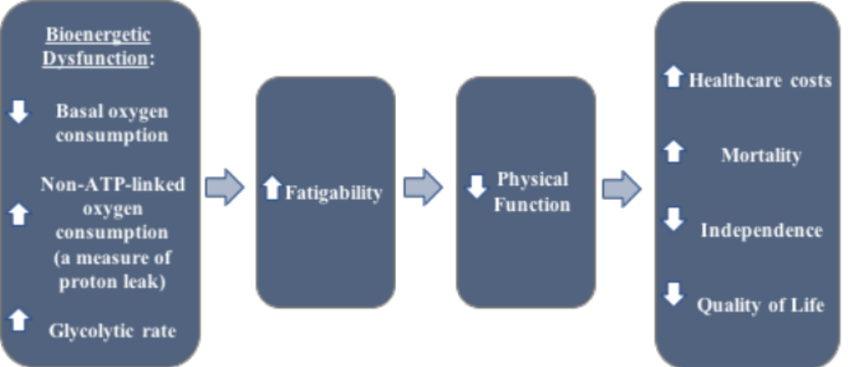
Figure 1: Conceptual Model of the Bioenergetic Dysfunction Associated with Aging and its Subsequent Effects on Older Adults

Measures of Mitochondrial Function
While mitochondrial function measurements are numerous and informative[42], respirometric measurements can provide details about the electron transport chain activity[23]. The most commonly reported are respiratory control rates, or RCRs, which are defined as state 3_{ADP}/state 4, where state 3_{ADP} is controlled by the activity of ATP turnover and substrate oxidation and state 4 is controlled predominantly by proton leak[42]. These measurements are generally performed using a muscle biopsy or skin graft. The need for fresh tissue in which to measure mitochondrial function poses a major barrier for the use of bioenergetics for diagnostic or longitudinal study purposes, especially on a vulnerable population such as the elderly.

Platelets represent a minimally invasive source of mitochondria in which bioenergetic profiles can be measured[43]. Compared to biopsies, a venous blood draw is less burdensome and invasive for the patient in addition to being less costly for a research study and could be better integrated into large scale epidemiologic studies of the biology of aging. The extracellular flux (XF) analysis allows measurement of basal respiration, ATP-linked respiration, proton leak, maximal respiration, spare respiratory capacity, and non-mitochondrial respiration, in addition to basal glycolytic rate, on intact live cells. Additionally, previous studies indicate an association between respiration in blood cells with skeletal and cardiac muscle bioenergetics in African green monkeys[44]. However, a gap in the knowledge exists in that a direct comparison between muscle mitochondrial bioenergetics and blood cell bioenergetics have yet to be measured in an entire human cohort.

Public Health Significance
The increase in number and proportion of the aging population in the United States has placed a great burden on the health of our nation. Functional decline and fatigability are particularly detrimental to the health of our older adults with up to 68% reporting they experience fatigue[26]. Additionally, functional disability in older adults has been shown to cost on average an additional $5,000 per year in healthcare spending as compared to functionally independent older adults[9]. These data seek to characterize and identify the underlying bioenergetics and mitochondrial dysfunction that could be associated with declining physical function and increasing fatigue in our aging population. This work could lead to potential interventions aimed at attenuating the public heath burden of functional decline in older adults.

Objectives
In this study, we sought to identify the age-associated differences in platelet bioenergetics by comparing the bioenergetic profiles of younger (aged≤35) and older (aged≥75) adults, hypothesizing lower baseline oxygen consumption in older as compared to younger and increases in the markers of bioenergetic dysfunction (higher non-ATP-linked respiration and lower spare respiratory capacity) in older adults. Additionally, we correlated physical fatigability and measures of physical function to oxidative phosphorylation and glycolytic measurements in our older adult population, anticipating dysfunction in platelet bioenergetics would be associated with worse fatigue and physical function. Finally, we compared our platelet bioenergetic measurements to the skeletal muscle respiration measurements in the older adult cohort to determine if the effects of aging on bioenergetics are systemic and platelets can serve as an alternative measure of mitochondrial function to skeletal muscle.

Methods

Study Population
The young adult cohort, consisting of 32 individuals aged 27±6 years, was drawn from a registry in the Shiva Lab at the University of Pittsburgh Vascular Medicine Institute, Center for Metabolism and Mitochondrial Medicine. The young adult cohort was matched to the older (Health ABC) cohort according to gender, race, and BMI.

The cohort of older adults was a subset of the national Health, Aging and Body Composition, or Health ABC prospective cohort[45, 46], which consisted of 3,075 nondisabled black (41.7%) and white men and women (51.5%) aged 70-79 at baseline from the Pittsburgh, PA and Memphis, TN areas. This ancillary study consisted of 32 participants, aged 88±2 years, from the Pittsburgh, PA area, who recently completed a muscle biopsy as part of Health ABC study Visit 16. The eligibility criteria for the baseline Health ABC cohort included no self-reported difficulty walking a quarter mile, climbing 10 steps, or performing mobility-related activities of daily living, no reported use of a walking aid, and no active cancer treatment. A complete description of the eligibility criteria for the Health ABC study can be found in Goodpaster et al.[45] The only additional eligibility criteria for the ancillary study was that a participant could safely complete a 31P magnetic resonance spectroscopy (MRS). To safely complete MRS, participants needed to be free of MR unsafe metal or other implants, bilateral joint replacements, and tattoos, and to be able to lie in a supine position for 1 hour as determined by the magnetic resonance imaging (MRI) center. This study was approved by the University of Pittsburgh Institutional Review Board (IRB960212), and written informed consent was obtained from all participants in accordance with the Declaration of Helsinki.

Platelet Isolation
Platelets were isolated from peripheral blood samples obtained by standard venous blood draw without a tourniquet when possible, to avoid platelet activation. The blood was drawn into BD vacutainer CPT mononuclear cell preparation tubes (BD Biosciences, San Jose, CA), shortly after the participant’s arrival and consent was obtained, prior to the 400m Long Distance Corridor Walk (LDCW) and fatigability questionnaire. The whole blood was centrifuged in the presence of 0.1M Sodium Citrate for 10 minutes at 150xg to obtain platelet-rich plasma (PRP), with the brake off to avoid artificial activation. The PRP was transferred to a new tube and platelets were subsequently pelleted in the presence of PGI₂ (1 mg/mL) by centrifugation at 1500g with the brake off, for 10 minutes. The platelets were then washed two times in erythrocyte lysis buffer containing PGI₂. The final platelet sample was resuspended in modified Tyrode buffer containing: 20 mM HEPES, 128 mM NaCl, 12 mM NaHCO₃, 0.4 mM NaH₂PO₂, 5 mM glucose, 1 mM MgCl₂, and 2.8 mM KCl, at pH 7.4, for further analysis. The purity of the isolated platelet sample was determined by measurement of CD41a expression using flow cytometry [43].

Measurement of Platelet Bioenergetics
Platelets were isolated from human blood (5x10⁷ cells/well) immediately following the blood draw and loaded into an XF24 microplate to measure oxygen consumption rate (OCR) and extracellular acidification rate (ECAR) (Agilent Seahorse Technologies, Santa Clara, CA). Basal OCR and ECAR levels were recorded within 2 hours of platelet isolation, followed by consecutive additions of 2.5μM oligomycin A (to measure ATP-linked and oligomycin-A insensitive respiration), 0.7μM carbonyl cyanide p-(trifluoro-methoxy) phenyl-hydrazone (FCCP; to measure maximal respiration and spare respiratory capacity), and 15μM rotenone (to measure non-mitochondrial respiration) using the XF24 Seahorse system. The assay was performed in unbuffered Dulbecco’s Modified Eagle Medium (DMEM) supplemented with 25 mM glucose, 1mM pyruvate, and 2 mM glutamine.

Muscle Biopsy Procedure and Permeabilized Fiber Bundle Preparation
All skeletal muscle biopsy procedures occurred within 6 months of the blood draws for platelet bioenergetic measurements and fatigability questionnaire administration. Participants were instructed to fast overnight and not engage in physical exercise for 48 hours prior to the biopsy procedure. Percutaneous muscle biopsy samples were obtained under local anesthesia (2% buffered lidocaine) at the University of Pittsburgh’s Clinical Translational Research Center and prepped for mitochondrial respiration measurements as previously described [22, 47]. Briefly, biopsy samples were procured from the medial vastus lateralis and immediately blotted dry and trimmed of visible connective and adipose tissue using a standard dissecting microscope (Leica EZ4; Leica Microsystems, Heerbrugg, Switzerland). The individual muscle fibers in the sample (~10mg) were then teased apart in cold BIOPS solution (10 mM Ca–EGTA buffer, 0.1 M free calcium, 20mM imidazole, 20mM taurine, 50mM potassium 2-[N-morpholino]-ethanesulfonic acid, 0.5mM dithiothreitol, 6.56mM MgCl₂, 5.77mM ATP, and 15mM phosphocreatine [PCr], pH 7.1) and permeabilized with saponin (2mL of 50 ug/mL saponin in BIOPS solution) for 20 minutes at 4°C on an orbital shaker. Following this the muscle fibers were then washed twice for 10 minutes on an orbital shaker at 4°C with Mir05 respiration medium (0.5mM EGTA, 3mM MgCl₂·6H₂O, 60mM K-lactobionate, 20mM taurine, 10mM KH₂PO₄, 20mM HEPES, 110mM sucrose, and 1g/L BSA, pH 7.1), prior to being placed in the chambers of an Oxygraph 2K (Oroboros Inc., Innsbruck, Austria) for respiration measurements.

Measurement of Skeletal Muscle Mitochondrial Respiration
After permeabilization, the muscle fiber bundle was placed into the respirometer chamber of an Oxygraph 2K (Oroboros Inc., Innsbruck, Austria) and the assay protocol run at 37°C and between 220–150 nmol O₂/mL with blebbistatin (25 mM) as previously described [22, 47]. Once a stable baseline was acquired, 5mM pyruvate was added to measure state 4 respiration (a measure of uncoupling). After a state 4 rate was established, 4mM ADP was added to elicit state 3 respiration (a measurement of oxidative phosphorylation). Finally, 2mM FCCP (carbonyl cyanide-p-trifluoromethoxyphenylhydrazone) was added to determine maximal uncoupled respiration. Following the assay, steady state oxygen flux for each respiratory state was determined and normalized to dried bundle weight.

Clinical Measurements

Physical Fatigability
Perceived physical fatigability was measured in the Health ABC cohort using the Pittsburgh Fatigability Scale (PFS) developed by Glynn et al. [26] The PFS was self-administered within two hours of the blood draw to measure platelet bioenergetics, after the 400m Long Distance Corridor Walk (LDCW) and within 6 months of the skeletal muscle biopsy. This 10-item questionnaire assesses whole body tiredness as a function of duration and intensity of activity. Each item is scored from 0, indicating no fatigue, to 5, indicating extreme fatigue. The 10 items are summed with PFS scores ranging from 0 to 50 with higher score indicating higher fatigability.

Long Distance Corridor Walk (LDCW)
The Long Distance Corridor Walk (LDCW), an endurance walking test, was administered to the Health ABC cohort as previously described[48]. Participants were excluded from this test if their systolic blood pressure exceeded 200mmHg, resting heart rate was greater than 120 beats per minute, or if they had an electrocardiogram abnormality, cardiac surgery, worsening of chest pain, or shortness of breath in the prior 3 months. Additionally, during the test, if their heart rate exceeded 135 beats per minute or they experienced dizziness, chest pain, shortness of breath, leg pain, or were light headed, the test was stopped immediately. The test was administered immediately after the blood draw for platelet bioenergetic measurements and prior to the fatigability assessment. The participants were asked to walk 10 laps around traffic cones placed 20 meters apart in a dedicated corridor for a total of 400 meters. They were given a 2-minute warm-up period where they were instructed to cover as much ground as possible and then asked to perform the LDCW as quickly as possible at a pace that can be maintained. The following information was recorded: blood pressure at the end of the test, heart rate at each lap, the distance walked for the 2-minute warm-up, and completion time for the 400 meter LDCW.

Other Covariates
Body weight (kg) and height (cm) were measured on a calibrated balance beam scale, in lightweight clothing, without shoes, and used to calculate body mass index (BMI; kg/m²) on the same day as the 400m walk. Age, gender, and race were all self-reported by questionnaire.

Materials
Unless otherwise noted, chemicals were obtained from Sigma-Aldrich (St. Louis, MO).

Statistical Analyses
All old vs. young comparisons were made using unpaired student's t-tests except for the basal ECAR comparison where we used a non-parametric Mann-Whitney test (young adult ECAR values were not normally distributed according to Shapiro-Wilk and D'Agostino & Pearson normality tests). Analytics for oxygen consumption rate comparisons between old and young adults was complete with 32 participants. Due to incomplete fatigability data, the comparison between glycolytic rate and fatigability was restricted to 28 subjects (the 4 subjects without complete data were consistent with the mean demographics). The five Health ABC participants who did not complete the LDCW were excluded from analyses comparing LDCW to basal glycolytic rate for n=23. An additional, albeit exploratory aim to compare skeletal muscle to platelet bioenergetics was limited to n=23 due to missing skeletal muscle data. Statistical outliers were removed using Grubb's test (two-sided, α=0.05). Pearson correlations were used to determine the linearity of the relationship between variables with the exception of correlations including time to walk 400m where we used a Spearman correlation (time to walk 400m values were not normally distributed according to Shapiro-Wilk and D'Agostino & Pearson normality tests). For all statistical tests, a two-tailed p-value<0.05 was considered significant and the data are presented as the means ± standard error of the mean (SEM) unless otherwise notated. All statistics, analyses, and figures were generated using Prism 7 (GraphPad Software Inc., La Jolla, CA).

Results

Demographic Characteristics of the Older (Health ABC) and Younger Adult Cohorts
Demographic characteristics of the older adult (subset of the Health ABC cohort) and younger adult participants are presented in Table 1. By design there were an equal number of participants in the older and younger cohorts. Using a cut point of ≤15 on a 50 point scale as established by Glynn et al. (personal communication), 82% of the Health ABC cohort meet the criteria for high fatigability.

Table 1: Characteristics of the Older (Health ABC) and Younger Adult Cohorts
Characteristic | Older Adults  (Age≥75)  n=32 | Younger Adults (Age≤35)  n=32
Age, yrs | 88±2* | 26±5
Female | 20 (62.5) | 20 (62.5)
Race  Caucasian  African American | 20 (62.5)  12 (37.5) | 20 (62.5)  12 (37.5)
Body Mass Index, kg/m² | 27±3.9 | 27±4.8
Physical Fatigability Score | 22±7.9
*numbers in table denote mean±SD or n(%)

Oxidative Phosphorylation in Platelet Mitochondria in Young vs. Old Subjects
We characterized the aging Health ABC cohort (n=32) platelet bioenergetic profile as it compares to a younger adult cohort's (n=32) by measuring baseline oxygen consumption, followed with consecutive injections of modulators to measure specific mitochondrial parameters of oxidative phosphorylation. We observed a significantly lower (p=0.0496) basal oxygen consumption rate (OCR) in older adults (107.4 ± 5.294 pmolO₂/min/5x10⁷platelets older; 123.6 ± 6.083 pmolO₂/min/5x10⁷platelets younger) (Figure 2A). Following baseline measurements, we added 2.5μM oligomycin-A, an ATP synthase inhibitor, to measure oxygen consumption not linked to ATP production that results from proton leak and 0.7μM carbonyl cyanide-ρ-trifluoromethoxy phenyl hydrazone (FCCP), an ionophore that increases the proton permeability of the inner-mitochondrial membrane, and uncouples oxidation from phosphorylation in mitochondria, allowing us to determine maximal respiration capacity. Older adults showed a rate of oxygen consumption not linked to ATP production of 39.15 ± 2.849 pmolO₂/min/5x10⁷platelets and a maximal respiration rate of 228.2 ± 20.39 pmolO₂/min/5x10⁷platelets, both significantly higher (p=0. 0446; p=0. 0492) than in younger adults (31.48 ± 2.39 pmolO₂/min/5x10⁷platelets; 177.4 ± 15.01 pmolO₂/min/5x10⁷platelets) (Figure 2B & C). A two-sided Grubb's test, with α=0.05, indicates an outlier in the maximal respiration data for older adults (653.55 pmolO₂/min/5x10⁷platelets). When this outlying data point is removed, the difference between maximal respiration in older and younger adults is no longer significant (p=0.0916).

In general, we saw no difference in the respiration rates according to race or gender with the exception of basal respiration in older adults. African American older adults showed significantly higher basal respiration than Caucasian older adults (120.8 ± 8.4 pmolO₂/min/5x10⁷platelets African American; 99.39 ± 6.295 pmolO₂/min/5x10⁷platelets Caucasian; p=0.0486) (Figure 2D).

From the OCR data, we calculated the routine control ratio (R/E), a coupling control ratio (CCR) that measures oxygen flux in intact cells at the basal respiratory control state with reference to the maximal respiration, to yield a normalized value with 0 and 1 as the upper and lower limits, respectively. The R/E ratio allows us to assess how close the routine operations of the cell are to the electron transport system's (ETS) capacity with 1.0 indicating 100% capacity or operating at maximal respiration. Older adults have an R/E ratio of 0.33±0.02 as compared to the younger adult's R/E ratio of 0.56±0.05, meaning older adults are operating at 33% of their ETS capacity whereas younger adults are operating at 56% of their ETS capacity.

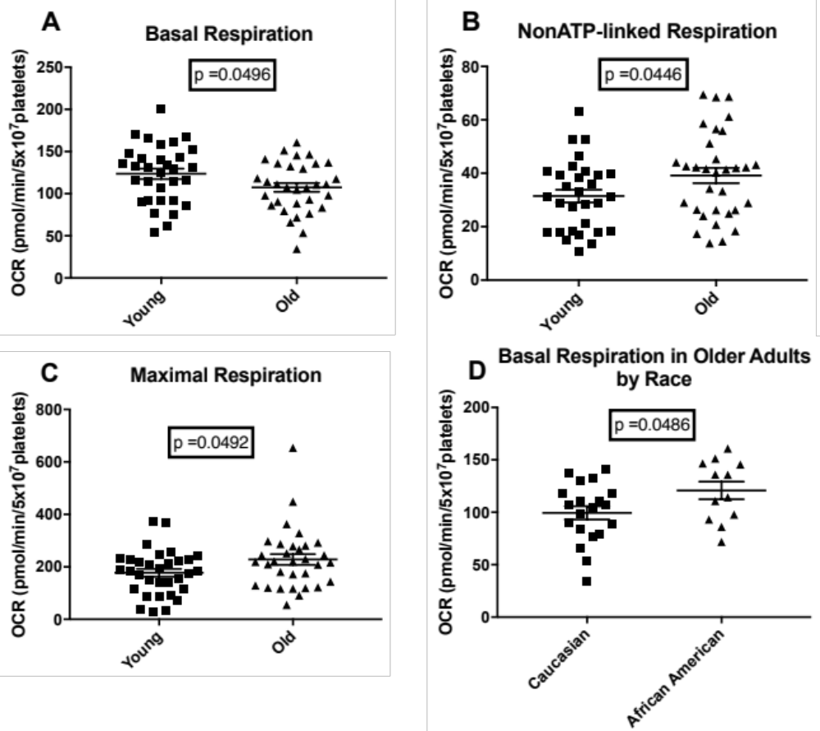
Figure 2: Older Adults (n=32) Show Lower Basal Respiration, and Higher Proton Leak and Maximal Respiration than Younger Adults (n=32). African American Older Adults (n=12) Show Higher Basal Respiration than Caucasian (n=20) Older Adults
(A) Basal respiration for young (squares) and old (triangles) participants. p=0.0496 (B) Non-ATP-linked respiration for young (squares) and old (triangles) participants. p=0.0446 (C) Maximal respiration for young (squares) and old (triangles) participants. p=0.0492 (D) Basal respiration for Caucasian (squares) and African American (triangles) older adult participants. p=0.0486

Associations between Glycolytic Rate, Physical Function, and Fatigability
In addition to characterizing the age-related differences in platelet mitochondrial oxidative phosphorylation, we also compared the rate of glycolysis in the platelets of our aging and younger adult populations. To do this, we measured the protons exported from the cell along with lactate derived from glycolysis, in the form of the extracellular acidification rate (ECAR; mpH/min). Though older adult platelets exhibit a higher baseline ECAR, the difference is not significant as compared to younger adults (p=0.088; 6.38 mpH/min/5x10⁷platelets older vs 4.47 mpH/min/5x10⁷platelets younger) (Figure 3A). Additionally, amongst older adults, there was a positive moderate correlation between platelet basal ECAR and physical function, as measured by the 400m Long Distance Corridor Walk (LDCW), but it didn't reach statistical significance, (r=0.348; p=0.1037) (Figure 3B). There was, however, a significant positive correlation (r=0.398; p=0.036) (Figure 3C) between basal glycolytic rate and physical fatigability in the Health ABC cohort.
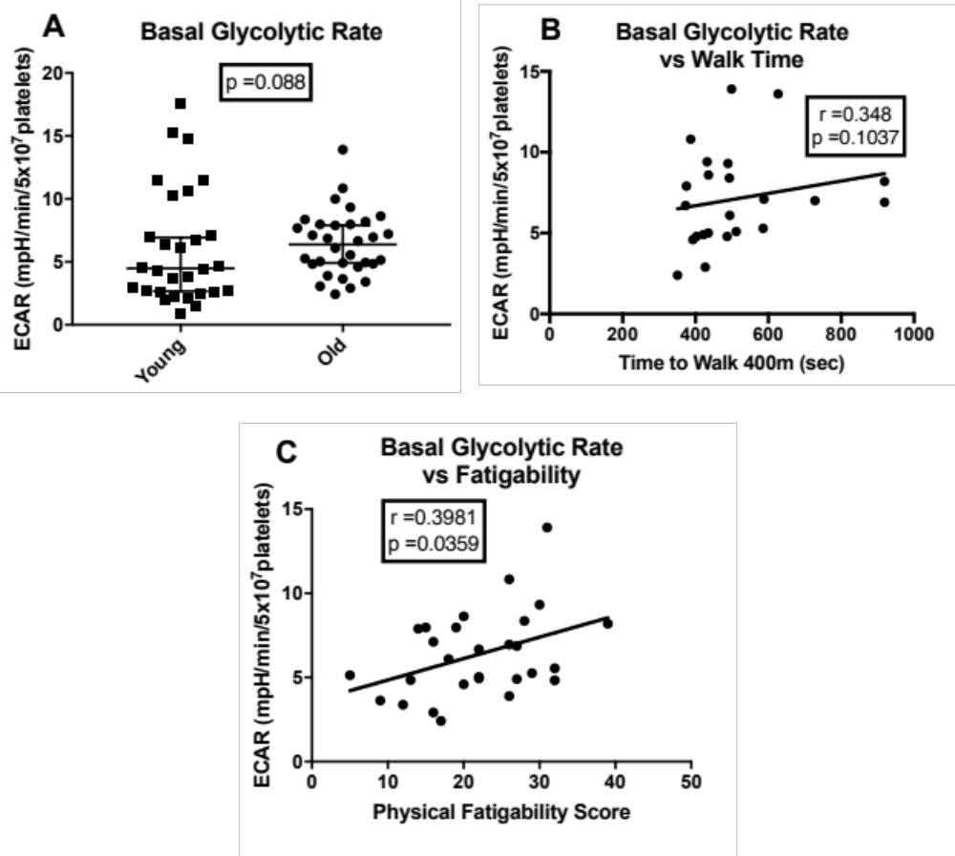
Figure 3: Platelet Glycolytic Rates and Relationships in Adults
(A) Basal glycolytic rate in platelets for young (n=29; squares) and old (n=32; circles) participants. Bars represent median with 95% CI. (B) Spearman correlation between platelet basal glycolytic rate and time to walk 400m (LDCW) in older adults (n=23; r=0.348; p=0.1037). (C) Pearson correlation between platelet basal glycolytic rate and physical fatigability in older adults (n=28; r=0.398; p=0.036).

Correlation Between Aging Platelet and Skeletal Muscle Bioenergetics
We compared our non-ATP-linked and maximal respiration platelet bioenergetic values to state 4 and maximal respiration in the skeletal muscle of our aging population to determine if platelets can serve as a surrogate for muscle tissue in bioenergetic studies. Our results yielded significant correlations in older adults between non-ATP-linked respiration in platelets and muscle state 4 respiration (r=0.489, p=0.0178). We compared these parameters as the non-ATP-linked (oligomycin-A insensitive) rate of oxygen consumption and state 4 (substrate-only oxygen consumption in the absence of ADP) respiration are both measures of oxygen consumption due to proton leak (Figure 4A). Further, we see a strong correlation (r=0.444, p=0.034) between maximal respiration (resulting from the addition of FCCP, an uncoupler of oxidation from phosphorylation in mitochondria) in platelets and muscle (Figure 4B).

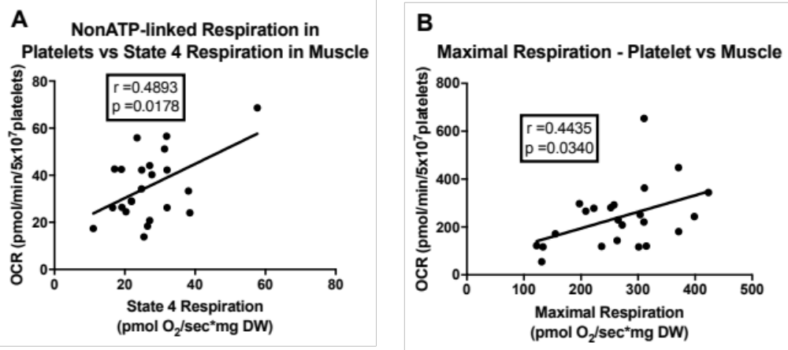
Figure 4: Correlations in Older Adults between Platelet Non-ATP-linked and Muscle State 4 Respiration and in Maximal Respiration between Platelets and Muscle
(A) Correlation between non-ATP-linked respiration rate in platelets and state 4 respiration rate in muscle in older adults (n=23; r=0.4893; p=0.0178) (B) Correlation between maximal respiration in platelets and muscle in older adults. (n=23; r=0.4435; p=0.0340)

Discussion
This study draws important connections between bioenergetics, fatigability, and physical function in the elderly. By elucidating the bioenergetic dysfunction associated with aging and its potential role in functional decline in older adults, these results could lead to novel biomarkers and intervention targets, lessening the public heath burden associated with disablement in the elderly. We filled important gaps in knowledge by showing that dysfunction in the bioenergetic profile of older adult platelets are associated with worse fatigability, and platelets can be used as a measure of bioenergetics in lieu of more invasive methods in older adults. Specifically, we found bioenergetics differences associated with aging by comparing older adults’ platelet bioenergetic profiles to younger adults as well as an association between more glycolytic activity and high fatigability. A final key finding of this study was the significant positive relationship between respiration in platelets and muscle in older adults, paving the way for platelets to be used as systemic measures of bioenergetics in future studies.

We demonstrate that older adults exhibit lower basal respiration, and higher non-ATP-linked and maximal respiration compared to young adults. The significantly lower basal respiration and higher non-ATP-linked respiration (a measure of proton leak or uncoupled respiration) seen in older adult platelets could be indicative of mitochondrial dysfunction or inefficiency associated with aging and are consistent with findings in other tissues including human skeletal muscle[49], and rat heart, liver, and kidney[50]. The influence of proton leak on energy homeostasis in aging has been a topical subject. Recent findings hypothesize that a small amount of uncoupling with age is beneficial for reactive oxygen species (ROS) reduction[51, 52]. It is unclear, however, whether the extent of the uncoupling we see here disrupts homeostasis and exacerbates dysfunction, damaging the cells.

The outlier in maximal respiration can be removed based on statistical (Grubb's test) and biological evidence [43, 53-55] as the value is much higher than any other published OCR value for platelets. Even with the outlier removed, there is still a trend toward higher maximal respiration in aging platelets, which was unexpected, and could indicate a potential compensatory mechanism to offset lower basal respiration levels. The higher level of maximal respiration in older adults contributes to the lower R/E ratio seen in older adults indicating they are functioning at less of their ETS capacity than younger adults. Further studies would be necessary to examine potential causes for higher maximal respiration values in older adults.

Our data also reveal higher basal respiration in older African American adults compared to Caucasians. Racial differences in mitochondrial function have been studied within the context of cancer disparities[56], but there is a paucity of evidence regarding potential racial differences in bioenergetics. Maternal inheritance and ethnic diversity contribute to variation in the mitochondrial genome (mtDNA). However, evidence from cancer research suggests that genetic variation in mtDNA across different ethnic groups might account for differences in the bioenergetic performance of cells from persons of different races. Additional studies and a large sample size are necessary to further understand this interesting finding.
Another key finding was examining the novel relationship between basal glycolytic rate and physical fatigability in older adults. Higher levels of fatigability have been associated with diminished mitochondrial function[25], but though high fatigue and glycolytic levels are common to many disease states, the relationship between glycolysis and fatigability remains unclear. This could be due in part to the lack of a standardized mechanism for measuring both. The proportion of our study population exhibiting high fatigability (82%) was consistent with unpublished data from the Long Life Family Study (Glynn, personal communication) which reported 84% exhibiting high fatigability (mean age 92 years). These data reveal a trend toward increased basal glycolytic rate in older adult platelets as compared to younger, and a moderate positive correlation between physical function, as measured by the LDCW, and basal glycolytic rate. This study lacked power to confirm these relationships and these findings should be examined in a larger population. There was a significant correlation between the basal glycolytic rate and physical fatigability. The trend toward higher basal glycolytic rate in older adults and strong correlation between basal glycolytic rate and fatigability may be indicative of a metabolic shift from oxidative phosphorylation to anaerobic respiration. The switch to glycolysis, a less energy efficient pathway for ATP production, could explain the increased fatigability as the body is not able to meet the energy demand as readily. This concept is further corroborated by the lower baseline OCR demonstrated in the older (Health ABC) adults. These data indicate that physical fatigability could be a potential early indicator of bioenergetic dysfunction likely leading to future functional decline.

While research in other species suggests that blood cell bioenergetics could be used to report on tissue bioenergetic capacity[44], this study is the first to compare skeletal muscle mitochondrial function directly to blood cell bioenergetics in a human cohort. The significant correlations evident in older adults between platelet oligomycin and muscle state 4 respiration and in maximal respiration between platelets and muscle, indicate that platelets may be able to be used in lieu of biopsies to examine bioenergetic mechanisms underlying age-related increased fatigability and declining physical function in older adults. This finding has a significant impact on potential study design and resource limitations in clinical and epidemiologic studies. This would allow for the measurement of bioenergetics repeatedly over a longitudinal study and in vulnerable populations where repeated muscle biopsies are not an option. In combination with fatigability measurements, as a predictor of functional decline, these measures would significantly reduce the burden on the physicians and patients and lead to substantial cost savings if extensive physical function tests and muscle biopsy procedures could be eliminated and replaced with less-invasive biomarkers.

This study had several strengths. First, bioenergetics were measured in an intact whole cell model using platelets and Seahorse technology, allowing for oxidative phosphorylation and glycolytic measurements as opposed to only mitochondrial measurements in permeabilized membranes from skeletal muscle biopsies. Additionally, platelets represent a metric of systemic energy changes, not limiting the analysis to one tissue's mitochondrial health. Notably, this study is the first complete older human cohort in which bioenergetics were measured in both skeletal muscle and platelets. This study also has some limitations. There are very promising results, but this study was conducted with a small number of participants and should be repeated in a larger cohort to confirm these findings. To reduce potential confounding from BMI, gender, and race, we matched our young cohort to our older adults according to these variables). This could reduce the generalizability of our findings as the Health ABC cohort has a larger proportion of African Americans than the general elderly population and includes no other ethnic minorities. Also, these data are subject to survivor bias as these are the last remaining members of the Health ABC prospective cohort. These findings were in a low functioning, highly fatigued population and should be replicated in a wider age, function and less fatigued group to improve generalizability to all older adults. An additional limitation of this study is that we do not yet have enough information to detail the causal pathway between bioenergetic dysfunction and decline in physical function and increased fatigability. Future studies should be undertaken to illuminate potential contributing factors to mitochondrial dysfunction and subsequent bioenergetic changes in older adults. Despite these limitations, this work provided important novel insights into the relationships between aging, bioenergetics, fatigability, and decline in physical function.

In conclusion, our study has shown that bioenergetic changes occur with age, and are associated with fatigability and diminishing physical function. Additionally, we demonstrated the ability to measure bioenergetics in platelets as a surrogate for skeletal muscle mitochondrial function in an aging population. These data form the basis for further investigations into potential bioenergetic pathway targets as novel therapeutic aims and future studies to further elucidate the underlying biological mechanisms for fatigability and diminished physical function. This work is of significant public health relevance as understanding the underlying biological mechanisms for fatigability and diminishing physical function in older adults could lead to identifying potential biomarkers to use in designing treatments and determining novel therapeutic targets to slow the downward spiral of disablement.
Bibliography

