**RELATING NEUROPATHIC SYMPTOMS AND IMPAIRED MONOFILAMENT DETECTION TO KNEE OSTEOARTHRITIS PATIENTS FOLLOWING TOTAL KNEE REPLACEMENT**

by

**George M. Kimmel**

BS, Slippery Rock University, 2013

Submitted to the Graduate Faculty of

Epidemiology

Graduate School of Public Health in partial fulfillment

of the requirements for the degree of

Master of Public Health

University of Pittsburgh

2017

UNIVERSITY OF PITTSBURGH

GRADUATE SCHOOL OF PUBLIC HEALTH

This essay is submitted

by

George M. Kimmel

on

August 11, 2017

and approved by

Essay Advisor:

Nancy W. Glynn, PhD ______________________________________

Assistant Professor

Department of Epidemiology

Graduate School of Public Health

University of Pittsburgh

Essay Reader:

Elsa Strotmeyer, PhD, MPH ­­­­­­­­­­­­­­­______________________________________

Associate Professor

Center for Aging and Population Health

Department of Epidemiology

Graduate School of Public Health

University of Pittsburgh

Essay Reader: ­­­­­­­­­­­­­­­______________________________________

Sara Piva, PhD, PT

Associate Professor

Department of Physical Therapy

School of Health and Rehabilitation Sciences

University of Pittsburgh

Copyright © by George Kimmel

2017

Nancy W. Glynn, PhD

**RELATING NEUROPATHIC SYMPTOMS AND IMPAIRED MONOFILAMENT DETECTION TO KNEE OSTEOARTHRITIS IN TOTAL KNEE REPLACEMENT PATIENTS**

George Kimmel, MPH

University of Pittsburgh, 2017

[MPH or MHA]

University of Pittsburgh, [year]

**ABSTRACT**

Knee osteoarthritis (OA), the most common form of arthritis in the US, carries a lifetime risk of 45% in older adults. Knee OA has been associated with neuropathic symptoms, such as pain and loss of sensation, and reduced sensory peripheral nerve function (PNF). However, the relationship between knee OA and peripheral nerves remains poorly understood. We examined PNF using monofilament detection (insensitivity: unable to detect 3/4 touches of 1.4-g, 4-g and 10-g at dorsum of right and left big toe) in patients aged ≥60 years with knee OA who had unilateral total knee replacement (TKR). Patients (N=126) were 63.5% women; age 69.8±6.5 years; 2-4 months post-surgery, and had a mean Western Ontario and McMaster Universities Arthritis Index (WOMAC) score: 20.1±7.8. Conditional logistic regression was used to compare between knee differences of patients’ TKR and non-surgical knee (NSK) in separate models for 1.4-g, 4-g and 10-g monofilament insensitivity. Monofilament insensitivity was similar in the TKR knee compared to NSK: 1.4-g (31.8% vs. 29.4%), 4-g (15.9% vs. 15.1%), and 10-g (8.7% vs. 10.3%), all NS. In conditional logistic regression models, monofilament insensitivity was not different for 1.4-g (OR=1.3; 95% CI: 0.57-3.0), 4-g (OR=1.2; 95% CI: 0.39-3.5) or 10-g (OR=0.50; 95% CI: 0.09-2.7) in patients’ TKR vs. NSK. Although light touch monofilament insensitivity was highly prevalent in TKR patients, lack of differences for TKR vs. NSK suggests that knee OA rather than surgery may be responsible for PNF impairments. Future studies should include more sensitive tests of PNF in TKR patients to further elucidate the public health importance of PNF and knee OA.

TABLE OF CONTENTS

preface ix

1.0 Introduction 1

1.1 knee OSTEOARTHRITIS 1

1.2 Total knee replacement 4

1.3 peripheral nerve function 5

1.4 Gaps in literature 10

1.5 public health significance 11

2.0 objectives 12

3.0 Methods 13

3.1 ReCruitment 13

3.2 Study population 14

3.3 Study measures 16

3.3.1 Monofilament testing 16

3.3.2 Demographic Characteristics 17

3.4 statistical analysis 17

4.0 Results 18

5.0 Discussion 20

Appendix A – WOMAC OSTEOARTHRITIS INDEX 27

bibliography 31

List of tables

Table 1. Results of Studies Used in Literature Review Examining PN Function in Older Adults (N=9) 23

List of figures

Figure 1. Peripheral Nerve and Knee OA Conceptual Model 3

Figure 2. Monofilament Testing Procedure 16

Figure 3. Monofilament Insensitivity Comparison for TKR vs NSK 24

Figure 4. Conditional Logistic Regression for Monofilament Insensitivity between Discordant Knees TKR vs. NSK 24

Figure 5. Conditional Logistic Regression for Monofilament Insensitivity between Discordant Knees TKR vs. NSK (Females) 25

Figure 6. Conditional Logistic Regression for Monofilament Insensitivity between Discordant Knees TKR vs. NSK (Males) 25

Figure 7. Conditional Logistic Regression for Monofilament Insensitivity between Discordant Knees TKR vs. NSK (≤70) 26

Figure 8. Conditional Logistic Regression for Monofilament Insensitivity between Discordant Knees TKR vs. NSK (>70) 26

# preface

I would like to thank my committee for assisting me with my essay and the completion of the program. Thank you Dr. Glynn for helping me map out my journey through the program and getting me from the beginning to the end. Thank you Dr. Strotmeyer for your firm but insightful guidance and for introducing me to the world of academic research. I appreciate your patience and I believe the work I did will prepare me for future endeavors. Thank you Dr. Piva for showing me this research topic from the patient and clinical standpoint in a way that I may not have looked at before. I would also like to thank the coordinators and students that helped me throughout this internship process.

# Introduction

## knee OSTEOARTHRITIS

Osteoarthritis (OA), the most common form of arthritis, is a significant health burden on the US population. Knee OA is the most common form of lower-body arthritis in the US1. Under normal circumstances, the cartilage and surrounding articular tissue in the knee allows the bone surfaces to glide along their articular surfaces without friction and pain. Knee OA develops when cartilage between the bones of the lower leg starts to wear down causing inflammation2. This wearing down of cartilage and subchondral bone can cause structural changes to occur in the joint causing pain and mobility impairment3,4. Severe cases of prolonged knee OA can eventually lead to painful bone on bone contact. Other symptoms of knee OA include decreased range of motion, bony enlargements around the knee joint, and elevated sensitivity to cold temperatures as well as humidity in the air5. Knee OA is attributed to 19% of disability among US adults1, of which pain associated with movement is the most likely contributing factor6.

While no single test to diagnose knee OA exists, most doctors diagnose the condition through a combination of physical exams and clinical history7. The primary symptom doctors consider when diagnosing arthritis is pain that increases during activity and recovers during rest8. The two different classifications of knee OA are symptomatic and radiographic. Symptomatic knee OA refers to indicators that a patient may feel and include pain, stiffness, and loss of motion2. Radiographic OA refers to a diagnosis by x-ray and involves the following criteria: narrowing of the joint space of the knee, the presence of osteophytes and/cysts, and subchondral sclerosis9. The most common radiological classification criteria comes from the Kellgren-Lawerence (K/L) radiographic grading scheme10. Developed in the 1957, this scale judges knee OA according to a five point scale ranging from 0-411. The scale classifies the severity of knee OA by the presence of narrowed joint space, sclerosis, cysts and/osteophytes, and malformation11. A classification of two or higher indicates the presence of arthritis in the knee and requires the incidence of osteophytes and distinct joint space narrowing11. Further classifications require more than one osteophytes in the knee along with further joint space narrowing11.

Knee OA affects all ages and ethnic backgrounds but predominately occurs in older populations. Murphy et. al. calculated the lifetime risk of developing knee OA by applying logistic regression and general estimation equations to a cohort of 3,068 participating in the Johnston County Osteoarthritis Project, a longitudinal study of men and women ages 45 and older living in rural North Carolina12. Findings showed a lifetime risk of developing knee OA of approximately 45%12. This study also showed that for those who had previous knee injuries, lifetime risk rose to 56.8% and, for those who with a BMI in the obese category, about two out of every three were at risk for knee OA. According to the National Health and Examination Survey (NHANES III), approximately 37% of those who participated in a representative U.S. survey reported doctor diagnosed radiographic OA13. A large meta-analysis that included 85 studies related to risk factors of developing knee OA showed that obesity was the leading contributor to knee OA (pooled OR 2.63, 95% CI: 2.28-3.05) followed by previous knee trauma (pooled OR 3.86, 95% CI: 2.61-5.70) including prolonged squatting14 and the presence of hand OA (pooled OR 1.49, 95% CI: 1.05-2.10)15. Studies have also shown female sex to be a risk factor in the incidence of knee OA16. In addition to age, several modifiable and non-modifiable risk factors for knee OA exist.

Diabetes and obesity are large contributors to both peripheral nerve (PN) decline and knee OA. Obesity, defined as a BMI >30 kg/m2, contributes largely to the progression of knee OA by placing mechanical stress on the joints which leads to the formation of lesions and cartilage damage (Figure 1)17. This added stress encourages the proliferation of osteophytes within the joints that creates a pathway to knee OA. Diabetes and other metabolic factors have also been shown to contribute to the progression of knee OA18. Both diabetes and knee OA are chronic conditions, have subclinical presentations that often are undiagnosed clinically during their onset, and increase as populations age18. Decreased PN function is also a common complication of

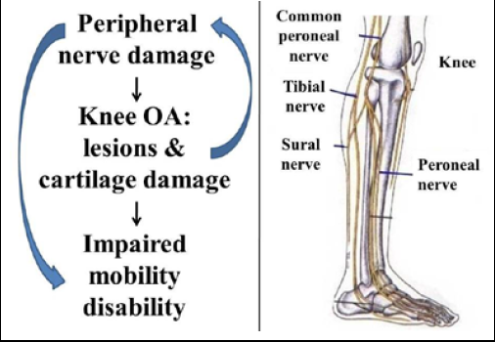

Figure 1. Peripheral Nerve and Knee OA Conceptual Model

diabetes, with approximately 45-50% of diabetes patients having a diagnosis of peripheral neuropathy19. Diabetic neuropathy may have similar symptoms and presentation to knee OA, including sensory axonal degeneration and loss of proprioception in the lower extremities.20 Leaverton et. al. hypothesized that the symptomatic pain in knee OA may possibly be explained in diabetes by neuropathy, as patients with diabetes-associated neuropathy suffered knee OA at an earlier age as well as with greater severity compared to study participants without diabetes18. Consideration of comorbid conditions such as diabetes and obesity may prove valuable to treating the pain and functional limitations that are associated with knee OA and PN decline.

## Total knee replacement

Total knee replacement (TKR), also known as a total knee arthroplasty, are common procedures performed on Americans each year. Annually, more than 700,000 TKRs are performed in the U.S., corresponding to a prevalence rate of 1.52%21,22. These numbers are expected to rise with the increase in baby boomers entering older adulthood as well as others medical advances that improve quality of life into old age. Over the past decade the amount of TKR surgeries has doubled23. By 2030, it is projected that the demand for TKRs will increase 673% to 3.48 million procedures23.

End-stage arthritis is the most common reason for TKR procedures. Over half of all people who have been diagnosed with knee OA will have a TKR surgery in their lifetime23. Many of the adults who opt for TKR have significant functional limitations and activity restrictions due to the pain associated with knee OA24–26. TKR surgeries involve removing the damaged tissue and articular cartilage from the end of the femur and the top of the tibia that become damaged due to arthritis27. A TKR may also involve removing parts of the patella, depending on the severity of the knee joint degeneration and at the surgeon’s discretion27. After removing the damaged tissue of the knee, prosthetic pieces (usually made of metal or plastic) are cemented into the knee and held in place27. These synthetic implants allow the joint to move around more freely and without risk of friction or inflammation.

Although patients often find relief from the persistent pain of knee OA following TKR surgery, 37% of patients still have persistent functional limitations one year after their surgeries28. Patients who undergo TKR have significantly decreased range of motion, decreased quadriceps strength, and slower walk time-tests compared to their healthy counterparts up to six months after surgery28. In addition, patients who undergo unilateral TKR often have additional surgeries in the contralateral knee to relieve knee OA symptoms. The surgery may also damage nerves within the knee, with consequences being decreased function of the mechanoreceptors which can impair movement and control29. With the changes that occur in TKR surgery, it is important to examine how they affect PN function in older populations with knee OA following TKR.

## peripheral nerve function

The peripheral nerve (PN) system of the body connects the brain and spinal cord to the rest of the body, acting as a transmission with the nervous system to the outer limbs of the body. Within the knee joint, nerves are classified by the nature with which they innervate the knee: articular branches that innervate the knee joint directly and minor articular branches that pass through the knee joint30. The knee joint has several major nerves that supply the knee: the posterior articular nerve which is the largest nerve supply to the knee and a terminal branch of the obturator nerve along with the sural nerve which supply the posterior afferent section31. The common peroneal, saphenous, and femoral nerves supply the anterior afferent section of the knee31. There are two types of peripheral neurons. Motor neurons carry neural impulses from the central nervous system (CNS) to muscles and glands and sensory nerves that carry neural impulses to the CNS via afferent nerve fibers32. Several different fibers and receptors aid in the transmission of signals to the CNS. Mechanoreceptors located in the ligaments, muscles, and bone that detect pressure and distortion which helps maintain balance and to perform normal daily activities33. Polypeptides also aid the PN system by detecting sensations such as pain30. Calcitonin and substance P among other neuropeptides have been localized as transmitters of pain sensations in the body. These neuropeptides may contribute to some of the discomfort experienced by people with knee OA30.

Aging and chronic conditions of aging are associated with a decline in PN function. The Health, Aging and Body Composition (Health ABC) study, a longitudinal observational study of 3,075 community-dwelling white and black cohort ages 70-79 with and without diabetes from Pittsburgh, PA and Memphis, TN, showed that half of the mobile adults in the cohort experienced some PN impairment34. Further work from this study has also linked decreased PN function to important late-life health outcomes such as worse physical performance35, walking endurance36, increased likelihood of falls37, and an onset of mobility limitations34. PN impairment has been shown to increase with age. Gregg et. al. estimated the prevalence of PN impairment from the NHANES survey38. The analysis, which included those with and without diabetes, found that 28% of adults 70-79 and 35% of adults ≥80 showing loss of 10-g monofilament detection in the US38. The findings of this study indicate an age gradient in PN impairment that should be studied further.

Sex may also be a contributing factor to PN impairment in the aging process. Older men tend to have slower nerve conduction compared to women due to greater height and potential hormonal effects and the nervous system39,40. Baldereschi et al. examined the epidemiology of distal symmetrical neuropathy (DSN) in a cohort 2,845 older Italians. Results showed that although both men and women experienced higher peripheral neuropathy rates with age, males experienced a rate of 9.02 cases of DSN per 1,000 person-years compared to 7.91 per 1,000 person-years for women at the end of the three year follow-up41. Sex differences in PN impairment should be investigated to understand the physiologic and biological differences.

The correlation between PN function and knee OA continues to be poorly understood. Previous studies have been cross-sectional and therefore have limitations in findings42,43. Studies of mice models have found that as age-related joint deterioration and subsequent decreased joint innervation occurs, the deterioration risk of developing knee OA increases44. Under normal circumstances, the creation and destruction of extracellular components of PN tissue in sensory neurons maintains an equilibrium to ensure healthy function absent of pain45. In patients who develop knee OA, the equilibrium is disrupted which leads to the destruction of cartilage. The body responds with an increased presence of chondrocytes, which eventually leads destruction of the cells and neural fibers45. These chondrocytes disrupt the sensory fibers found in the knee that further exacerbates the pain reception in the knees with OA46. Examining these PN changes in relation to knee OA remains a topic that needs to be explored further.

Several methods for testing PN function exist for older adults. A nerve conduction study (NCS) tests motor and sensory nerve function by sending electrical impulses that stimulate the nerves and assessing the response47. The results include the compound muscle action potential (CMAP) for motor nerves and the sensory nerve action potential amplitude (SNAP). This test evaluates both the amplitude of the response from the nerves and the speed at which the signal travels the length of the nerve being tested. Monofilament testing assesses sensory nerve function by applying a standard pressure via a nylon fiber to an extremity. The monofilament delivers different calibers of pressure when applied to skin surfaces and include 1.4-g, 2-g, 4-g, and 10-g levels of pressure. The monofilament test is used to test specific sensory nerve receptors, including the Pacinian corpuscle which perceives pressure in areas of the knee which can greatly affect mobility including balance48. The 10-g monofilament is a standard test used to detect peripheral neuropathy and can be used in both diabetic and non-diabetic populations35. In diabetic populations the 10-g monofilament test is also used to predict foot ulceration which can lead to skin infections and amputation49. The light 1.4-g monofilament is used to detect subclinical symptoms of peripheral neuropathy is both diabetic and non-diabetic populations35. The dorsum of the toe is usually tested due to the higher sensitivity at this site. The participant is asked to report when they feel the pressure from the monofilament being applied. The test is performed in multiple trials. Vibration detection threshold (VBT) is another measure that evaluates sensory nerve function. Participants begin the test by placing their large toe on a knob that is attached to a platform47. The platform begins to vibrate at a low intensity and is gradually increased until the participant reports detection47. Another example, the quantitative tuning fork, involves placing adjusted weights to a fork-like instrument that changes the vibration on a 0-8 scale47. The vibration decreases the longer it is placed on a skin surface until the participants reports when they can no longer feel it47. Together, these testing methods provide different information on PN impairment in older populations.

Several studies have evaluated the relationship between PN function and OA using these various testing methods (Table 1). Using vibration testing in the form of a vibration platform, Resnick et al. and Strotmeyer et al. both found significant cross-sectional associations with decreased vibration platform scores and standing balance, usual and fast paced walking speed, the ability to stand from a chair, the Short Physical Performance Battery (SPPB), mobility disability35,50. Both studies also found that after adjusting for diabetes, the relationship between poor sensory motor performance and these mobility outcomes remained significant. Resnick et al. found that diabetes was not found to be linked to any of the mobility measures after adjusting for sensory impairment in the Women’s Health and Aging Study50. While results from this study were promising, the study had limited generalizability due to the cohort being only disabled women50. In the Health ABC study, adjusting for PN function measurements attenuated only a portion of mobility outcomes (20.8% for usual walking speed, 26.5% for standing balance, and 25.1% for SPPB score)35. The implications of vibration and tuning fork testing can be used for future implications of sensory nerve impairment in older populations.

Using monofilament testing has also been used in previous studies of sensory nerve impairment. Ferrucci et al. tested a cohort of 818 Italian elders in the for PN impairment relating to mobility outcomes and falls37. From the cross-sectional study, results showed that after adjustment for sex and age, inability to detect 2-g and 4-g monofilament was related to slower walking speed (% difference (95% CI: -12% (-6% - -19%) and increased odds of not being able to walk 1 km OR=2.90 (95% CI: 1.40 – 5.90) when compared to the average of the cohort37. Using the 1.4-g and 10-g monofilament, Strotmeyer et al. found that greater monofilament detection (defined as ≥3 of 4 touches) was related to faster narrow walking speed (β=0.049, p=0.006) and faster speed in the repeated chair stand (β=0.015, p=0.007)35. Chiles et al. had similar findings, with inability to detect 2-g and 4-g monofilament resulting in a lower mobility outcomes including a lower SPPB score (β=0.05, p<0.05)51. 1.4-g and 10-g monofilament insensitivity also differed in diabetic and non-diabetic individuals. 1.4-g monofilament insensitivity was 19.2% vs. 10.4% (p ≤ 0.001) and 6.7% vs. 5.6% (p=NS) for diabetic vs. non-diabetic males and females, respectively51. Further, 10-g monofilament insensitivity was 61.9% vs. 50.4% (p ≤ 0.001) and 44.0% vs. 38.1% (p=NS) for diabetic vs. non-diabetic males and females51. Ward et al. examined 1.4-g and 10-g monofilament insensitivity (defined as <3 of 4 touches). 1.4-g monofilament insensitivity was 36.1% vs. 39.6% and 10-g monofilament insensitivity was 7.5% vs. 13.7% for non-diabetic and diabetic participants, respectively47. Using monofilament testing in diabetic and non-diabetic populations is important in examining PN impairment in more generalizable populations.

Peroneal CMAP and motor NCV tests were also used in previous literature to assess peripheral motor nerve measures and mobility outcomes. Strotmeyer et al. found from the Health ABC study that higher CMAP amplitude resulted in a higher performance battery score (β=0.105, p<0.001), faster usual walking speed (β=0.008, p=0.004), faster narrow walking speed (β=0.029, p<0.001), and higher standing balance ratio (β=0.014, p<0.001)35. Analyses were adjusted for demographics including body composition, lifestyle factors, and chronic conditions including diabetes35. Using the same methodology as Strotmeyer et al., Evans et al. found an association between worse CMAP scores and lower test scores in the Walking Impairment Questionnaire (WIQ) walking and stair climbing score52. Lower peroneal motor NCV was also found by Evans and colleagues to be related to decreased WIQ questionnaire scores52. Previous PN research has indicated that PN impairment leads to poorer mobility outcomes and decreased physical function in older adults.

## Gaps in literature

Important gaps exist in the current literature to be addressed for future studies on PN function and knee OA. Subclinical measures for peripheral nerve impairment need to be explored, especially those not diagnosed with diabetes38. Future studies should explore the prevalence and incidence of peripheral neuropathy in the population, not just those with diabetes, and include subgroups such as older populations and those with knee OA. Measures such as the tuning fork are less sensitive tests for PN impairment and are not typically used in subgroups of older populations. PN measures such as the 1.4-g monofilament are reliable testing measures for subclinical PN impairment and should be implemented. Previous literature has also shown that diabetes cannot fully explain to relationship between peripheral neuropathy and mobility limitations.34,53 Future studies in PN function and mobility disability need to include more diverse, generalizable populations. Other risk factors such as presence of knee OA, age and sex differences should continue to be studied to evaluate other contributors to PN impairment. Past prospective studies have indicated important findings on mobility outcomes such as falls and mobility disability from previous studies of sensory and motor nerve impairment35,47,54. Future prospective studies should examine PN impairment in high-risk subgroups such as those with knee OA. From these studies, we can explore how age and sex-related functional declines and knee OA affect PN function.

## public health significance

Knee OA continues to be burden on the US population in terms of economic costs, limited mobility because of pain, lost productivity, and overall poor health. Furthermore, the link between sensorimotor declines later in life needs to be explored further to gain better understanding. TKR surgery is the most widely used and a best practice for relieving symptoms. However, patients who undergo TKR surgery rarely return to normal function and are subsequently are at risk for mobility limitations and prolonged pain. By studying TKR surgery and PN function in patients with knee OA, we have the opportunity to gain knowledge that may lead to better health outcomes, reduced pain, prescription and exercise recommendations, and higher overall quality of life.

# objectives

The goal of this study is to understand the relationship of the sensory nerves to TKR surgery patients with knee OA using a standard clinical screen for peripheral neuropathy. Specifically, we will determine if impaired monofilament detection is related to the TKR knee vs. the non-TKR knee. The hypothesis is that impaired monofilament detection will be worse in the TKR knee compared to the non-surgical knee.

# Methods

## ReCruitment

Patients were recruited directly from University of Pittsburgh Medical Center (UPMC) surgeons who performed the TKRs. Following the surgery, letters were mailed out to patients providing information about the study. Surgeons who participated in recruitment for the study perform more than a thousand TKRs per year and have had success with study recruitment in previous studies. This method was the primary recruitment tool for participants as approximately 80% of all participants for the study were recruited from letters from surgeons. In addition, two research registries were used in the recruitment process. The University of Pittsburgh Clinical and Translational Science Institute (CTSI) Research Registry started in 2006 and has enrolled approximately 33,000 participants. One of the strengths of the registry is that it is reflective of the outreach CTSI has done to be inclusive of minority groups in the local Pittsburgh area. The University of Pittsburgh Pepper Center Registry started by the Claude D. Pepper Older Americans Independence Center includes 2,500 consenting participants and were specifically enrolled by the Pepper Center to reach out to urban neighborhoods with residents of lower socio-economic and minority status. Recruitment from these two registries accounted for approximately 10% of participants.

Recruitment was facilitated through media announcements and informational brochures posted at the Vintage Community Senior Center and the Squirrel Hill Jewish Community Center. Both of these locations are participating locations in the study and are designated community senior citizen centers by the Allegheny County Area Agency for Aging. Emails and print announcements from the two community center’s monthly newsletter were also sent out to potential participants. Recruiting through these senior centers accounted for approximately 10% all of participants. All participants were compensated $40 for their participation to offset lost wages and also received free parking.

## Study population

Participants enrolled in the study had to be above the age of 60 and have had a recent unilateral TKR surgery, between two to four months prior to the beginning of the study. No exclusions were made based on sex, race, or ethnicity. Due to the higher prevalence of knee OA and TKR in women compared to men (60% vs 40%), female enrollment was emphasized more compared to male recruitment. The participants were part of a larger randomized control trial, which is evaluating the effect of exercise to reduce the burden of physical limitations of patients who undergo TKR. The intervention trial compared usual care following TKR surgery to a clinic-based individual outpatient rehabilitative exercise and a community-based group exercise class. The aims of the parent study was to compare outcomes of physical function and physical activity between the three exercise groups and to identify baseline predictors of functional recovery for the clinical and community based exercise groups.

Participants also had to have a Western Ontario McMaster Universities Osteoarthritis Index (WOMAC) score of nine or higher (Appendix I) on the physical function (PF) portion to ensure that participants had a modest amount of functional limitations to be included in the study. The WOMAC index is a disease specific 24-item questionnaire designed to apply a quantitative score on self-reported physical function. The WOMAC has been extensively validated and is the recommended instrument in studies of knee OA55. Participants also had to be able to speak English, be willing to be randomized into one of three treatment groups, and have the appropriate medical clearances from their surgeon. Participants were excluded from the study if they had contraindications to exercise training as defined by the American College of Cardiology/American Heart Association standards: History of uncontrolled cardiovascular disease or hypertension, were unable to walk 50 meter without an assistance device, or were unable to comfortably bear weight on both their surgical knee and non-surgical knee56. Participants were excluded if they reported a history of any muscular disease (eg. muscular dystrophy) or any neurological disorder, which may affect lower body function (eg. Parkinson’s disease, clinical neuropathy, cerebrovascular accidents, multiple sclerosis). Participants who reported regular exercise activity were also excluded from the study. In an effort to maximize adherence, participants were excluded if they had an acute or terminal illness, were planning to have an additional joint replacement surgery (hip or knee) in the next year, or were planning to relocate out of the region within the next year. All study participants who were included in the parent study signed an informed consent document stating that they agreed to be involved in the study and were willing to be randomized into one of three exercise groups.

## Study measures

### Monofilament testing

Participants were tested for touch sensation using a monofilament. The monofilament is a small instrument made of a thin nylon thread that is attached to a pen-like handle (North Coast Medical, Inc.). When applied to a skin surface, the filament tests sensory nerve levels by delivering a standard, calibrated amount of force as the filament buckle into a “C” shape (Figure 2). Pressure is higher for nylon filaments with larger diameters. Three different monofilaments were used for this study: the 5.07 monofilament (delivering a standardized 10-g force), the 4.56 monofilament (providing a standardized 4-g force), and the 4.17 monofilament (providing a standardized force of 1.4-g). The 5.07 monofilament is the standard test for peripheral neuropathy57 while the 4.56

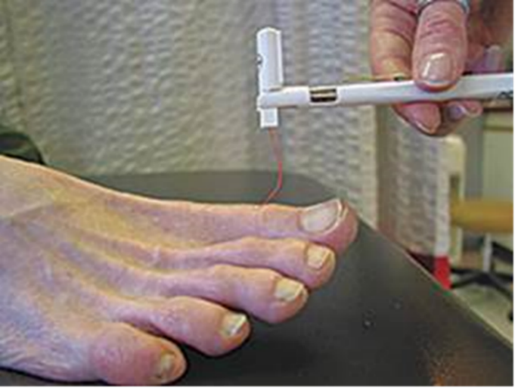

Figure . Monofilament Testing Procedure

has been used in studies as an intermediate measurement between the 4.17 and 5.0758. Monofilament screening has been shown to be reproducible59 and has been shown to predict musculoskeletal outcomes in older adults36,53. Participants were instructed to lay supine with their eyes closed. The monofilament was applied against the dorsum of the big toe surgical knee (SK) and non-surgical knee (NSK) between the nail and knuckle. Participants were tested four times per side, each time asked to indicate if they felt the monofilament. Inability to detect was defined as <3 of 4 touches per side. The protocol begins with the 4.17 monofilament, and if the participants failed to detect three or more touches, they were then tested with the 4.56. If they failed to detect the 4.56 monofilament, they were tested with the 5.07 monofilament.

### Demographic Characteristics

Demographic characteristics such as age, sex, and race/ethnicity were ascertained at baseline via questionnaire. During a clinical examination, participants were screened for their blood pressure, height, weight, and BMI.

## statistical analysis

The statistical approach for this cross-sectional study was to evaluate PN function in participants before the exercise intervention. The study aim of relating monofilament detection in the TKR-knee to the non-operative knee were analyzed through conditional logistic regression. Conditional logistic models were also stratified by sex and age (≤70 and >70) to test for differences based on previous research findings. Studies before have been conducted using conditional logistic regression for adults suffering from knee OA60. All analyses were performed using SAS version 9.4 (SAS institute, Cary, NC).

# Results

A total of 143 participants were enrolled for baseline testing. Participants were excluded from analyses if they did not have TKR and non-TKR sides tested, not having test results for both sides, or refusing to have testing done on both knees (N=17), leaving 126 participants who underwent monofilament testing on both knees at baseline and were included in the analysis. Participants were 63.5% women, mean age 69.8±6.5 years, had a mean WOMAC-PF score of 20.1±7.8, and a mean BMI of 31.29±5.8 kg/m2. Monofilament insensitivity between the TKR knee and non-surgical knee (NSK) respectively were as follows: 31.8% vs. 29.4% for 1.4-g monofilament, 15.9% vs. 15.1% for 4-g monofilament, and 8.7% vs 10.3% for 10-g monofilament (Figure 3). All differences between TKR and non-TKR knees were non-significant (p>0.05). Conditional logistic regression odds ratios are as follows: OR=1.30 (95% CI: 0.57 - 3.00) for 1.4-g, OR=1.20 (95% CI: 0.39 - 3.50) for 4-g and OR=0.50 (95% CI: 0.09 - 2.70) for 10-g monofilament (Figure 4). Although not significant, the odds of monofilament insensitivity in the TKR knee were 1.3 and 1.2 times higher for the 1.2-g and 1.4-g monofilament, respectively. Interestingly, the 10-g monofilament had a protective effect in regards to TKR, with the odds of monofilament insensitivity being 50% lower in the TKR-knee. After stratifying by sex, neither males nor females showed differences in monofilament detection. Conditional logistic models for females only models were OR=2.25 (95% CI: 0.69 – 7.31) for 1.4g and OR=1.50 (95% CI: 0.25 – 8.98) for 4-g monofilament (Figure 5). 10-g monofilament detection could not be analyzed due to small sample size for women. Stratified by males, conditional logistic models resulted in OR=0.67 (95% CI: 0.19 – 2.36) for 1.4-g, OR=1.00 (95% CI: 0.25 – 4.00) for 4-g, and OR=0.25 (95% CI: 0.03 – 2.24) for 10-g (Figure 6). Models were also stratified by age for those younger than and older than 70. For those 70 or younger, conditional logistic regression models were OR=1.40 (95% CI: 0.44 – 4.41) for 1.4g, OR=1.00 (95% CI: 0.20 – 4.95) for 4-g, and OR=1.00 (95% CI: 0.06 – 15.99) for 10-g monofilament (Figure 7). For those over 70 years of age, logistic models were as follows: OR=1.20 (95% CI: 0.37 – 3.93) for 1.4-g, OR=1.33 (95% CI: 0.30 – 5.96) for 4-g, and OR=0.33 (95% CI: 0.04 – 3.21) for 10-g monofilament (Figure 8).

# Discussion

The purpose of this study was to describe sensory nerve impairments in patients with knee OA who have undergone unilateral TKR surgery. Results from this study show that monofilament insensitivity remains highly prevalent in both the TKR knee and the NSK, though monofilament detection was similar in both knees. Factoring in age and sex into conditional logistic regression analyses between TKR and non-TKR knees did not attenuate overall results. Overall, the findings of the study did not support that impaired monofilament detection was worse in the TKR knee compared to the NSK. For monofilament insensitivity, knee OA rather than the TKR surgery may by more responsible for PN impairments.

Monofilament testing of sensory nerve function have not often been done in older populations with and without diabetes. In Health ABC, 1.4-g monofilament insensitivity was 36.8% and 10-g monofilament insensitivity was 8.9%36. The 4-g intermediate monofilament was not used for this study. Compared to our results, monofilament insensitivity is similar for 10-g and slightly lower for 1.4-g. This may be explained by age of participants for Health ABC vs. the current analyses. The median age of participants was 76.5±2.9 where our median age was lower at 69.8±6.5. This age difference is important due to previous research indicating higher PN impairment levels as individuals age38. More research is needed in diverse older adult populations to determine prevalence of sensory nerve loss. This study also adds to the literature of monofilament testing in populations that includes older adults with diabetes.

One of the main strengths of this study is that it contributes to research evaluating the role PN impairment has on knee OA has on older populations. More research in this area is needed to answer important questions such as whether PN impairments are reversible in knee OA. Monofilament testing is an affordable, reliable testing instrument36,53 that may be a useful indicator of both subclinical and protective sensation in other older populations with chronic diseases such as knee OA. In addition, this study is the first to our knowledge to look at PN function and TKR surgery in adults with knee OA. With the prevalence of knee OA and TKR surgeries expected to rise1,23, it is important to understand the underlying sensory nerve impairments in these populations to ensure patients who undergo TKR surgery are able to regain maximum function and quality of life. This study also was generalizable to a population affected by knee OA who underwent TKR. Participants recruited from UPMC represent a large, diverse surgery population of high-risk older adults. This research also looked at the effects on an age gradient and how sex differences have an effect on PN impairment and knee OA which is needed based on previous research findings38,61–63.

Our study had some limitations, namely tests that detect more sensitive PN decline were not done to further elucidate the relationship of PN function and TKR surgery. Only monofilament testing was included to assess sensory nerve function. Tests such as nerve conduction studies should be included in testing in the future to measure both motor and sensory nerve changes that occur after TKR surgery. Examining both motor and sensory nerve changes is important to determine etiology in this population. In addition, tests such as vibration detection threshold should also be included as an additional way to test sensory nerve function. Future studies should include OA duration in order to give detail to how this may affect PN changes. Higher duration of knee OA may lead to higher PN impairment, although further research in needed. Finally, clinical indicators of physical performance decline such as gait speed decline should be included in future studies of knee OA and PN decline. Examining these changes will be important to determine how important mobility outcomes such as walking speed is affected by PN impairment. The next step of this ancillary study is to conduct a prospective exercise intervention to examine whether exercise can reduce mobility limitations and PN decline in knee OA patients. Sensory PN impairments in older populations with knee OA remains an understudied topic, though should be further examined to reduce mobility limitations and lower risk of other health outcomes such as falls. The public health implications from this research include addressing mobility limitations among the older populations with chronic conditions, health outcomes following TKR surgery, and quality of life for adults throughout the aging process.



Table . Results of Studies Used in Literature Review Examining PN Function in Older Adults (N=9)

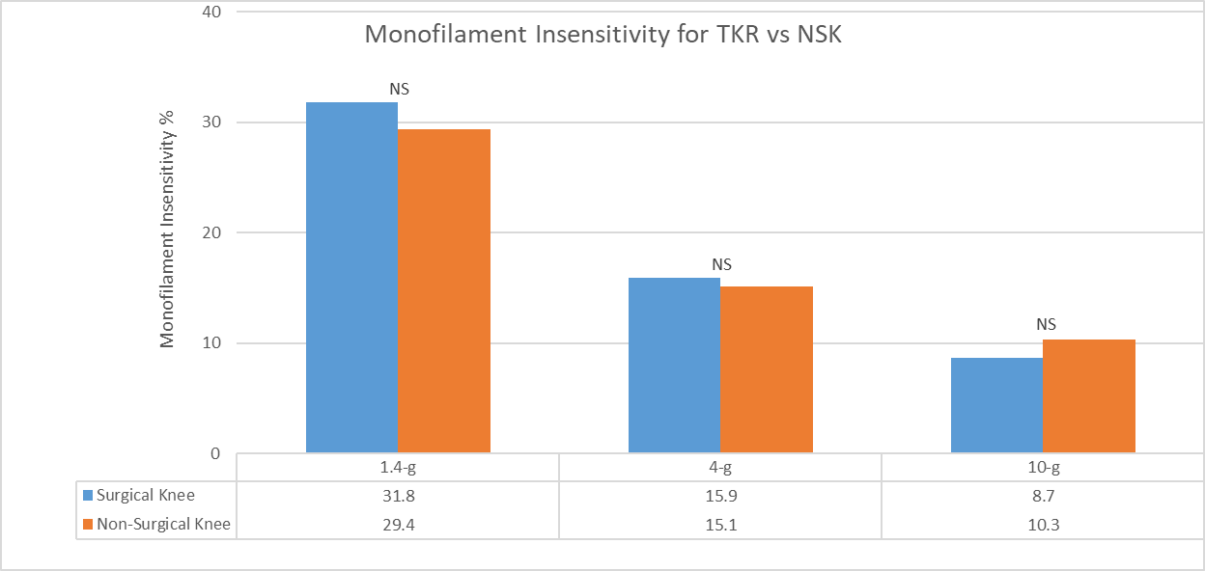

Figure . Monofilament Insensitivity Comparison for TKR vs NSK

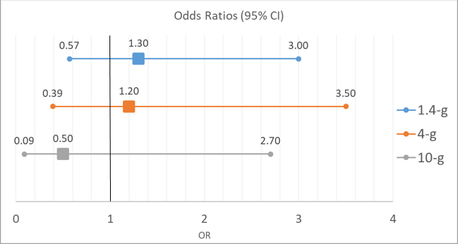

Figure . Conditional Logistic Regression for Monofilament Insensitivity between Discordant Knees

TKR vs. NSK

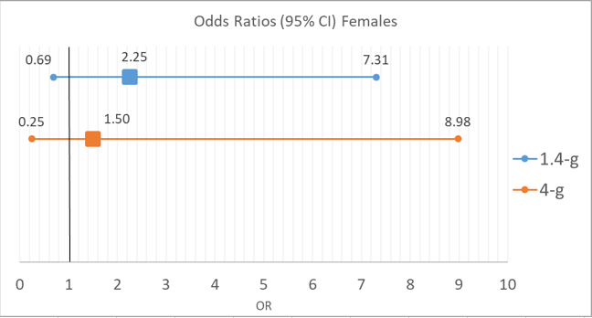

Figure 5. Conditional Logistic Regression for Monofilament Insensitivity between Discordant Knees

TKR vs. NSK (Females)

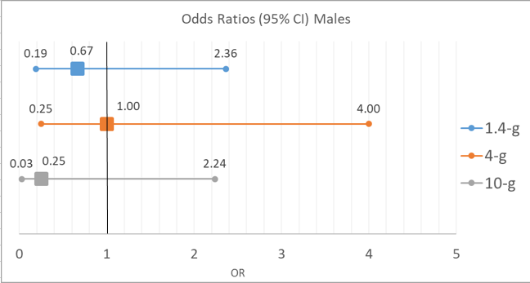

Figure . Conditional Logistic Regression for Monofilament Insensitivity between Discordant Knees TKR vs. NSK (Males)

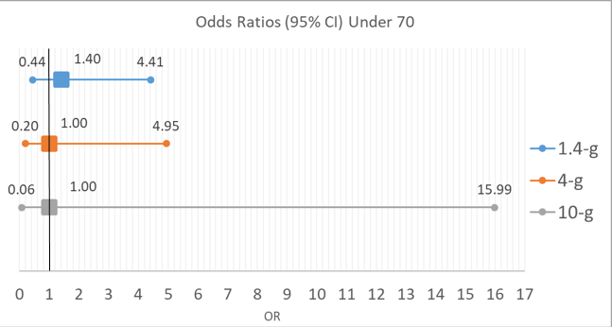

Figure . Conditional Logistic Regression for Monofilament Insensitivity between Discordant Knees

TKR vs. NSK (≤70)

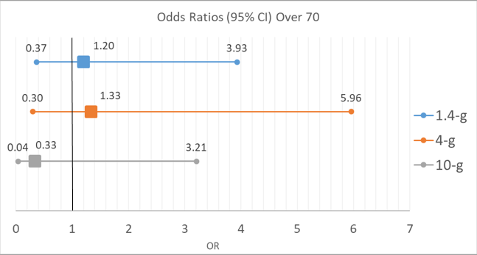

Figure . Conditional Logistic Regression for Monofilament Insensitivity between Discordant Knees

TKR vs. NSK (>70)

* + - * 1. **– WOMAC OSTEOARTHRITIS INDEX**

**Western Ontario and McMaster Universities (WOMAC) Osteoarthritis Index**

Section A

INSTRUCTIONS TO PATIENTS

The following questions concern the amount of pain you have experienced due to arthritis in your knee joint(s). For each situation please enter the amount of pain experienced in the last 48 hours. (Please mark your answers with and “X”.)

QUESTION: How much pain do you have?

1. Walking on a flat surface.

None Mild Moderate Severe Extreme

□ □ □ □ □

1. Going up or down stairs.

None Mild Moderate Severe Extreme

□ □ □ □ □

1. At night while in bed.

None Mild Moderate Severe Extreme

□ □ □ □ □

1. Sitting or lying.

None Mild Moderate Severe Extreme

□ □ □ □ □

1. Standing upright.

None Mild Moderate Severe Extreme

□ □ □ □ □

Section B

INSTRUCTIONS TO PATIENTS

The following questions concern the amount of joint stiffness (not pain) you have experienced in the last 48 hours in your knee joint(s). Stiffness is a sensation of restriction or slowness in the ease with which you move your joints. (Please mark your answers with and “X”.)

1. How severe is your stiffness after first wakening in the morning?

None Mild Moderate Severe Extreme

□ □ □ □ □

1. How severe is your stiffness after sitting, lying or resting later in the day?

None Mild Moderate Severe Extreme

□ □ □ □ □

Section C

INSTRUCTIONS TO PATIENTS

The following questions concern your physical function. By this we mean your ability to move around and to look after yourself. For each of the following activities, please indicate the degree of difficulty you have experienced in the last 48 hours due to arthritis in you knee joint(s). (Please mark your answers with and “X”.)

QUESTION: What degree of difficulty do you have?

1. Descending stairs.None Mild Moderate Severe Extreme

□ □ □ □ □

1. Ascending stairs.

None Mild Moderate Severe Extreme

□ □ □ □ □

1. Rising from sitting.

None Mild Moderate Severe Extreme

□ □ □ □ □

1. Standing.

None Mild Moderate Severe Extreme

□ □ □ □ □

1. Bending to floor.

None Mild Moderate Severe Extreme

□ □ □ □ □

1. Walking on flat.

None Mild Moderate Severe Extreme

□ □ □ □ □

1. Getting in/out of car.

None Mild Moderate Severe Extreme

□ □ □ □ □

1. Going shopping.

None Mild Moderate Severe Extreme

□ □ □ □ □

1. Putting on socks/stockings.

None Mild Moderate Severe Extreme

□ □ □ □ □

1. Rising from bed.

None Mild Moderate Severe Extreme

□ □ □ □ □

1. Taking off socks/stockings.

None Mild Moderate Severe Extreme

□ □ □ □ □

1. Lying in bed.

None Mild Moderate Severe Extreme

□ □ □ □ □

1. Getting in/out of bath.

None Mild Moderate Severe Extreme

□ □ □ □ □

1. Sitting.

None Mild Moderate Severe Extreme

□ □ □ □ □

1. Getting on/off toilet.

None Mild Moderate Severe Extreme

□ □ □ □ □

1. Heavy domestic duties.

None Mild Moderate Severe Extreme

□ □ □ □ □

1. Light domestic duties.

None Mild Moderate Severe Extreme

□ □ □ □ □

# bibliography

1. Centers for Disease Control and Prevention (CDC). Prevalence and Most Common Causes of Disability Among Adults - United States, 2005. *MMWR*. 2009;58(16):421-426. https://www.cdc.gov/mmwr/preview/mmwrhtml/mm5816a2.htm.

2. Heidari B. prevalence, risk factors, pathogenesis and features: Part I. *Casp J Intern Med*. 2011;2(2):205-212.

3. Conaghan PG, Peloso PM, Everett S V., et al. Inadequate pain relief and large functional loss among patients with knee osteoarthritis: evidence from a prospective multinational longitudinal study of osteoarthritis real-world therapies. *Rheumatology (Oxford)*. 2015;54(2):270-277. doi:10.1093/rheumatology/keu332.

4. Imamura M, Imamura ST, Kaziyama HHS, et al. Impact of nervous system hyperalgesia on pain, disability, and quality of life in patients with knee osteoarthritis: A controlled analysis. *Arthritis Care Res*. 2008;59(10):1424-1431. doi:10.1002/art.24120.

5. Arya RK, Jain V. Osteoarthritis of the knee joint: An overview. *Journal, Indian Acad Clin Med*. 2013;14(2):154-162. http://www.embase.com/search/results?subaction=viewrecord&from=export&id=L369286141http://sfx.umd.edu/hs?sid=EMBASE&issn=09723560&id=doi:&atitle=Osteoarthritis+of+the+knee+joint%3A+An+overview&stitle=J.+Indian+Acad.+Clin.+Med.&title=Journal%2C+Indian+Acad.

6. Guccione AA, Anderson JJ, Anthony JM, et al. The Effects of Specific Medical Conditions on the Functional Limitations of Elders in the Framingham Study. *Am J Public Health*. 1993;84(3):351-358.

7. Hyman G. Knee Osteoarthritis Diagnosis. Arthritis-Health. https://www.arthritis-health.com/types/osteoarthritis/knee-osteoarthritis-diagnosis. Published 2011.

8. Swagerty DL, Hellinger D. Radiographic Assessment of Osteoarthritis. *Radiol Decis*. 2001;64(2):279-286.

9. Eustice C. Symptomatic Osteoarthritis Versus Radiographic Osteoarthritis. VeryWell. https://www.verywell.com/symptomatic-osteoarthritis-radiographic-osteoarthritis-2552211. Published 2017.

10. Kellgren J, Lawrence J. *Atlas of Standard Radiographs. The Epidemiology of Chronic Rheumatism. Vol. 2*.; 1963.

11. Hayes B, Kittelson A, Loyd B, Wellsandt E, Flug J, Stevens-lapsley J. Assessing Radiographic Knee Osteoarthritis : An Online Training Tutorial for the Kellgren-Lawrence Grading Scale. *Assoc Am Med Coll*. 2016:18-21.

12. Murphy L, Schwartz TA, Helmick CG, et al. Lifetime Risk of Symptomatic Knee Osteoarthritis. *Arthritis Rheum*. 2015;59(9):1207-1213. doi:10.1002/art.24021.Lifetime.

13. Lawrence RC, Felson DT, Helmick CG, et al. Estimates of the Prevalence of Arthritis and Other Rheumatic Conditions in the United States, Part II. *Arthritis Rheum*. 2008;58(1):26-35. doi:10.1002/art.23176.Estimates.

14. Zhang Y, Hunter DJ, Nevitt MC, et al. Association of Squatting With Increased Prevalence of Radiographic Tibiofemoral Knee Osteoarthritis: The Beijing Osteoarthritis Study. *Arthritis Rheum*. 2004;50(4):1187-1192. doi:10.1002/art.20127.

15. Blagojevic M, Jinks C, Jeffery A, Jordan KP. Risk factors for onset of osteoarthritis of the knee in older adults: a systematic review and meta-analysis. *Osteoarthr Cartil*. 2010;18(1):24-33. doi:10.1016/j.joca.2009.08.010.

16. Srikanth VK, Fryer JL, Zhai G, Winzenberg TM, Hosmer D, Jones G. A meta-analysis of sex differences prevalence, incidence and severity of osteoarthritis. *Osteoarthr Cartil*. 2005;13(9):769-781. doi:10.1016/j.joca.2005.04.014.

17. Eymard F, Parsons C, Edwards MH, et al. Diabetes is a risk factor for knee osteoarthritis progression. *Osteoarthr Cartil*. 2015;23(6):851-859. doi:10.1016/j.joca.2015.01.013.

18. Leaverton PE, Peregoy J, Fahlman L, Sangeorzan E, Barrett JP. Does diabetes hide osteoarthritis pain? *Med Hypotheses*. 2012;78(4):471-474. doi:10.1016/j.mehy.2012.01.008.

19. Boulton AJM. Epidemiology of Diabetic Neuropathy. In: *The Epidemiology of Diabetes Mellitus: Second Edition*. ; 2008:565-576. doi:10.1002/9780470779750.ch34.

20. Zochodne D. Diabetes mellitus and the peripheral nervous system: manifestations and mechanisms. *Muscle Nerve*. 2007;36:144-166.

21. Maradit Kremers H, Larson DR, Crowson CS, et al. Prevalence of Total Hip and Knee Replacement in the United States. *J Bone Joint Surg Am*. 2015;97(17):1386-1397. doi:10.2106/JBJS.N.01141.

22. Kurtz S, Ong K, Lau E, Mowat F, Halpern M. Projections of primary and revision hip and knee arthroplasty in the United States from 2005 to 2030. *J Bone Joint Surg Am*. 2007;89:780-785. doi:10.2106/JBJS.F.00222.

23. Eckstein F, Boudreau R, Wang Z, et al. Comparison of radiographic joint space width and magnetic resonance imaging for prediction of knee replacement: A longitudinal case-control study from the Osteoarthritis Initiative. *Eur Radiol*. 2016;26(6):1942-1951. doi:10.1007/s00330-015-3977-8.

24. Brandes M, Ringling M, Winter C, Hillmann A, Rosenbaum D. Changes in physical activity and health-related quality of life during the first year after total knee arthroplasty. *Arthritis Care Res*. 2011;63(3):328-334. doi:10.1002/acr.20384.

25. de Groot IB, Bussmann JB, Stam HJ, Verhaar JAN. Actual everyday physical activity in patients with end-stage hip or knee osteoarthritis compared with healthy controls. *Osteoarthr Cartil*. 2008;16(4):436-442. doi:10.1016/j.joca.2007.08.010.

26. Holsgaard A, Roos EM, This A. Objectively measured physical activity in patients with end stage knee or hip osteoarthritis. 2012;48(4):577-585.

27. Total knee replacement. Arthritis Research UK. http://www.arthritisresearchuk.org/arthritis-information/surgery/knee-replacement/different-types/total-knee-replacement.aspx. Published 2017. Accessed January 6, 2017.

28. Bade MJ, Kohrt WM, Stevens-Lapsley JE. Outcomes before and after total knee arthroplasty compared to healthy adults. *J Orthop Sports Phys Ther*. 2010;40(9):559-567. doi:10.2519/jospt.2010.3317.

29. Attfield SF, Wilton TJ, Pratt DJ, Sambatakakis a. Soft-tissue balance and recovery of proprioception after total knee replacement. *J Bone Joint Surg Br*. 1996;78(4):540-545.

30. Hirasawa Y, Okajima S, Ohta M, Tokioka T. Nerve distribution to the human knee joint: anatomical and immunohistochemical study. *Int Orthop*. 2000;24(1):1-4. doi:10.1007/s002640050001.

31. Kennedy JC, Alexander IJ, Hayes KC. Nerve supply of the human knee and its functional importance. *Am J Sports Med*. 1982;10(6):329-335. doi:10.1177/036354658201000601.

32. Chawla J. Peripheral Nervous System Anatomy. Medscape. http://emedicine.medscape.com/article/1948687-overview. Published 2016. Accessed January 1, 2017.

33. Ribeiro F, Oliveira J. Aging effects on joint proprioception: The role of physical activity in proprioception preservation. *Eur Rev Aging Phys Act*. 2007;4(2):71-76. doi:10.1007/s11556-007-0026-x.

34. Ward RE, Boudreau RM, Caserotti P, et al. Sensory and motor peripheral nerve function and incident mobility disability. *J Am Geriatr Soc*. 2014;62(12):2273-2279. doi:10.1111/jgs.13152.

35. Strotmeyer ES, Rekeneire S, Schwartz A V., et al. The Relationship of Reduced Peripheral Nerve Function and Diabetes With Physical Performance in Older White and Black. *Diabetes Care*. 2008;31(9):1767-1772. doi:10.2337/dc08-0433.A.I.V.

36. Lange-Maia BS, Newman AB, Jakicic JM, et al. Relationship between sensorimotor peripheral nerve function and indicators of cardiovascular autonomic function in older adults from the Health, Aging and Body composition Study. *Exp Gerontol*. 2017;(2016). doi:10.1016/j.exger.2017.04.007.

37. Ferrucci L, Bandinelli S, Cavazzini C, et al. Neurological examination findings to predict limitations in mobility and falls in older persons without a history of neurological disease. *Am J Med*. 2004;116(12):807-815. doi:10.1016/j.amjmed.2004.01.010.

38. Gregg EW, Sorlie P, Paulose-Ram R, et al. Prevalence of Lower-Extremity Disease in the U . S . Adult Population ≥ 40 Years of Age with and without diabetes: 1999-2000 National Health and Nutrition Examination Survey. *Diabetes Care*. 2004;27(7):1591-1597.

39. Robinson LR, Rubner DE, Wahl PW, Fujimoto WY, Stolov WC. Influences of height and gender on normal nerve conduction studies. *Arch Phys Med Rehabil*. 1993;74(11):1134-1138. http://europepmc.org/abstract/med/8239949.

40. Norbury R, Cutter WJ, Compton J, et al. The neuroprotective effects of estrogen on the aging brain. *Exp Gerontol*. 2003;38:109-117. doi:S0531556502001663 [pii].

41. Baldereschi M, Inzitari M, Di Carlo A, Farchi G, Scafato E, Inzitari D. Epidemiology of distal symmetrical neuropathies in the Italian elderly. *Neurology*. 2007;68(18):1460-1467. doi:10.1212/01.wnl.0000260606.36443.29.

42. Bennell KL, Hinman RS, Metcalf BR, et al. Relationship of knee joint proprioception to pain and disability in individuals with knee osteoarthritis. *J Orthop Res*. 2003;21(5):792-797. doi:10.1016/S0736-0266(03)00054-8.

43. Hall MC. Relative impact of radiographic osteoarthritis and pain on quadriceps strength, proprioception, static postural sway and lower limb function. *Ann Rheum Dis*. 2005;65(7):865-870. doi:10.1136/ard.2005.043653.

44. Salo P, Seeratten R, Erwin W, Bray R. Evidence for a neuropathic contribution to the development of spontaneous knee osteoarthrosis in a mouse model. *Acta Orthop Scand*. 2002;73(1):77-84.

45. Lane NE, Brandt K, Hawker G, et al. OARSI-FDA initiative: Defining the disease state of osteoarthritis. *Osteoarthr Cartil*. 2011;19(5):478-482. doi:10.1016/j.joca.2010.09.013.

46. Felson DT. Developments in the clinical understanding of Osteoarthritis. *Arthritis Res Ther*. 2009;11(5):245. doi:10.1186/ar2762.

47. Ward RE, Caserotti P, Cauley JA, et al. Mobility-Related Consequences of Reduced Lower-Extremity Peripheral Nerve Function with Age: A Systematic Review. *Aging Dis*. 2016;7(4):466. doi:10.14336/AD.2015.1127.

48. Vinik A. The Approach to the Management of the Patient with Neuropathic Pain. *J Clin Endocrinol Metab*. 2010;95(11):4802-4811. doi:10.1210/jc.2010-0892.

49. Perkins BA, Orszag A, Ngo M, Ng E, New P, Bril V. Prediction of incident diabetic neuropathy using the monofilament examination: A 4-year prospective study. *Diabetes Care*. 2010;33(7):1549-1554. doi:10.2337/dc09-1835.

50. Resnick HE, Vinik AI, Schwartz A V., Leveille SG, Brancati FL, Balfour J. Independent Effects of Peripheral Nerve Dysfunction on Lower-Extremity Physical Function in Old Age The Women ’ s Health and Aging Study. *Diabetes Care*. 2000;23(11).

51. Chiles NS, Phillips CL, Volpato S, et al. Diabetes, peripheral neuropathy, and lower-extremity function. *J Diabetes Complications*. 2014;28(1):91-95. doi:10.1016/j.jdiacomp.2013.08.007.

52. Evans NS, Liu K, Criqui MH, et al. Associations of calf skeletal muscle characteristics and peripheral nerve function with self-perceived physical functioning and walking ability in persons with peripheral artery disease. *Vasc Med*. 2011;16(1):3-11. doi:10.1177/1358863X10395656.

53. Strotmeyer ES, Rekeneire N De, Schwartz A V, et al. Sensory and Motor Peripheral Nerve Function and Lower- Extremity Quadriceps Strength: The Health ABC Study. *J Geriatr Soc*. 2010;57(11):2004-2010. doi:10.1111/j.1532-5415.2009.02487.x.Sensory.

54. Inzitari M, Di Carlo A, Baldereschi M, et al. Risk and predictors of motor-performance decline in a normally functioning population-based sample of elderly subjects: The Italian longitudinal study on aging. *J Am Geriatr Soc*. 2006;54(2):318-324. doi:10.1111/j.1532-5415.2005.00584.x.

55. Bellamy N, Buchanan W, Goldsmith C, Campbell J, Stitt L. Validation study of WOMAC: a health status instrument for measuring clinically important patient relevant outcomes to antirheumatic drug therapy in patients with osteoarthritis of the hip or knee. *J Rheumatol*. 1988;15(12):1833-1840.

56. (ACC) AC of C, (AHA) AHA, Gibbons RJ. *ACC/AHA 2002 Guideline Update for Exercise Testing. A Report of the American College of Cardiology/American Heart Association Task Force on Practice Guidelines (Committee on Exercise Testing)*.; 2002. http://www.acc.org/qualityandscience/clinical/guidelines/exercise/exercise_clean.pdf.

57. Young D, Schuerman S, Flynn K, Hartig K, Moss D, Altenburger B. Reliability and Responsiveness of an 18 Site, 10-g Monofilament Examination for Assessment of Protective Foot Sensation. *J Geriatr Phys Ther*. 2011;34(2):95-98. doi:10.1519/JPT.0b013e31820aabe5.

58. McDermott MMG, Guralnik JM, Albay M, Bandinelli S, Miniati B, Ferrucci L. Impairments of Muscles and Nerves Associated with Peripheral Arterial Disease and Their Relationship with Lower Extremity Functioning: The InCHIANTI Study. *J Am Geriatr Soc*. 2004;52(3):405-410. doi:10.1111/j.1532-5415.2004.52113.x.

59. Perkins BA, Olaleye D, Zinman B. Simple screening tests for peripheral neuropathy in the diabetes clinic. *Diabetes Care*. 2001;24(2):250-256.

60. Neogi T, Felson D, Niu J, et al. Association between radiographic features of knee osteoarthritis and pain: results from two cohort studies. *BMJ*. 2009;339:b2844. doi:10.1136/bmj.b2844.

61. Newman AB, Brach J. Gender gap in longevity and disability in older persons. *Epidemiol Rev*. 2001;23(2):343-350.

62. Coutinho ES, Fletcher A, Bloch K V, Rodrigues LC. Risk factors for falls with severe fracture in elderly people living in a middle-income country: a case control study. *BMC Geriatr*. 2008;8:21. doi:1471-2318-8-21 [pii]\r10.1186/1471-2318-8-21.

63. Wojcik L a, Thelen DG, Schultz a. B, Ashton-Miller J a., Alexander NB. Age and gender differences in single-step recovery from a forward fall. *J Gerontol A Biol Sci Med Sci*. 1999;54(1):M44-M50. doi:10.1093/gerona/54.1.M44.